Supporting Information

Synthesis of N-arylacetamides via amination of aryltriazenes with acetonitrile under metal-free and mild conditions

Bin Wang^{a,#}, Dawei Cao^{a,#}, Xuecheng Maª, Yun Fengª, Lin Zhangª,

Yonghong Zhang^{a,b,}*, ChenJiang Liu^{a,b,}*
ª State Key Laboratory of Chemistry and Utilization of Carbon Based Energy Resources, Key Laboratory of Oil and Gas Fine Chemicals, Ministry of Education & Xinjiang Uygur Autonomous Region, Urumqi Key Laboratory of Green Catalysis and Synthesis Technology, College of Chemistry, Xinjiang University, Urumqi, 830046, Xinjiang, PR China.
^{b} Beijing National Laboratory for Molecular Sciences, Beijing 100871, P. R. China.
# These two authors contribute equally to this work.

Table of Contents
1. General Information | S2
- General Procedure for the Preparation of aryltriazenes | S2
General procedure for synthesis of N-Arylacetamides | S3
- Recycling experiments | S3
- Comparison of literature and this work methods for the synthesis of N-aryl amide with nitrile. | S4
6. Copies of NMR | S6
7. Copies of HRMS | S21
References | S22

General Information
¹H and ¹³C NMR spectra were recorded on a Varian Inova-400 MHz spectrometer at 25 ºC. Chemical shifts values are given in ppm and referred as the internal standard to TMS: 0.00 ppm. The peak patterns are indicated as follows: s, singlet; d, doublet; t, triplet; q, quartet; m, multiplet and bs, broad singlet. The coupling constants J, are reported in Hertz (Hz). High resolution mass spectrometry (HRMS) was obtained on a Q-TOF micro spectrometer. Melting points were determined with a Micromelting point apparatus without corrections. Organic solutions were concentrated by rotary evaporation below 40 °C in vacuum. TLC plates were visualized by exposure to ultraviolet light.
All the chemicals and solvents were purchased from commercial sources and used without further purification, unless otherwise noticed. All reactions were carried out in over-dried glassware.
- General Procedure for the Preparation of aryltriazenes
Aryltriazenes were prepared by the literature procedure with some modification.¹ Briefly, 4 mL concentrated HCl was added by dropwise to a dry 100 mL round flask containing a magnetic stir bar was charged with arylamine (20 mmol) at 0 ºC. The mixture was vigorously stirred in a 0 ºC ice bath for 10 min. Then, a solution of NaNO₂ (20 mmol) in water (3 mL) was added dropwise at 0 ºC. The resulting solution of the diazonium salt was stirred under ice bath for 10 min. Finally, a chilled solution of secondary amine (11 mmol) in 1 M K₂CO₃ (10 mL) was added to the above solution. The reaction mixture was stirred for 30 min in an ice bath and the resulting precipitate isolated by filtration. The damp solid was recrystallized from EtOH or by column chromatography to obtain the desired products.

General procedure for synthesis of N-arylacetamides (taking 3a as examples)

A mixture of IL4 (43.9 mg, 0.1 mmol), 1-(phenyldiazenyl)pyrrolidine 1a (17.5 mg, 0.1 mmol), CH₃CN (1 mL) and H₂O (0.5 mL) were added to a 10 mL reaction tube containing a magnetic stir bar, the reaction was stirred at RT for 6 h. After the reaction, 5 mL of water was added, and the resulting mixture was extracted with ethyl acetate (3×5 mL), the combined organic phase was dried over anhydrous Na₂SO₄, filtered, and all the volatiles were evaporated under reduced pressure. The resultant residue was purified by a preparative GF254 thin layer chromatography plate to afford the desired product 3a as a yellow solid (7.3 mg, 54% yield).
- Recycling experiments
To a dry 10 mL reaction tube containing a magnetic stir bar was charged with IL4 (43.9 mg, 0.1 mmol), 1-(phenyldiazenyl)pyrrolidine 1a (17.5 mg, 0.1 mmol), MeCN (1 mL) and H₂O (0.5 mL) sequentially. The reaction mixture was stirred at RT for about 6 hrs. After aryltriazenes was almost fully consumed (monitored by TLC), 5 mL of water was added, and the resulting mixture was extracted with ethyl acetate (3×5 mL), the combined organic phase was dried over anhydrous Na₂SO₄, filtered, and all the volatiles organic solvents were evaporated under reduced pressure. The resultant residue was purified by a preparative GF254 thin layer chromatography plate to afford the desired product 3a. Meanwhile, the promoter IL4 was recovered from aqueous via remove of water on a rotary evaporator, then the resulting residue was dried in vacuo. The recovered ILs was reused for next the run and the leakage of ILs were compensated by adding fresh promoter.
Run | Yield (%) | Run | Yield (%)
1 | 54 | 5 | 48
2 | 52 | 6 | 45
3 | 50 | 7 | 41
4 | 51 | 8 | 33
- Comparison of literature and this work methods for the synthesis of N-aryl amide with nitrile.
As N-arylacetamide is a kind of important intermediate, it can be used for the synthesis of natural products, medicines, functional materials and bioactive molecules. Therefore, there are a lot of synthetic methods have been developed for the synthesis of N-arylacetamide. Table 1 showed the reaction conditions for the synthesis of N-arylacetamide via the reaction of nitrile with different aryl precursor reported in the literature and this work. It can be seen that most of those synthesis procedure was considerably complicated, and volatile organic additives or inorganic regents with unpleasant odor, transition metal catalyst and high reaction temperature was involved. Furthermore, some methods require long reaction times, anaerobic reaction condition and large volumes of organic solvent, which greatly limit their green applications (entries 1, 2). Compared to other reported methods, our method has the advantage of transition-metal-free and minimal solvent conditions, using recyclable promoter. Moreover, the present reaction condition was fairly environmentally benign, of which carried out at room temperature under air.

Table 1. Comparison of literature and this work methods for the
synthesis of N-aryl amide with nitrile.
Entry | Aryl Precursor | Catalyst | Additive | Conditions | Solvent | Temp (°C) | Time  (h) | Yield (%) | Ref.
1 | ArB(OH)₂ | - | XeF₂ | Ar | RCN | 0 | 0.5-2.5 | 13-96 | 2
2 | ArX (X=Cl, Br, I) | CuI/DMEDA | KOH/Cs₂CO₃/  H₂O | Ar | RCN | 100 | 15 | 39-75 | 3
3 | ArNH₂ | - | p-TsOH/  t-BuONO/TBAB | - | ACN | 25-60 | 6-23 | 20-96 | 4
4 | ArNH₂ | TMSCl-KI | - | Microwave | ACN | 110 | 0.25 | 63-81 | 5
5 | ArN₂⁺BF₄⁻ | PdCl₂ | Ag₂O | - | ACN | 55 | 24 | 83-92 | 6
6 | Solid-Supported Aryltriazenes | - | HBF₄.Et₂O  or TFA | - | RCN | 80-100 | 12 | 3-58 | 7
7 | π-conjugated triazenes | - | TFA | 350 nm UV | RCN | RT | 4 | 5-99 | 8
8 | Aryltriazenes | - | BAIL | - | ACN/H₂O | RT | 6 | 25-62 | This work

- Copies of NMR
¹H NMR spectra of compound 3a
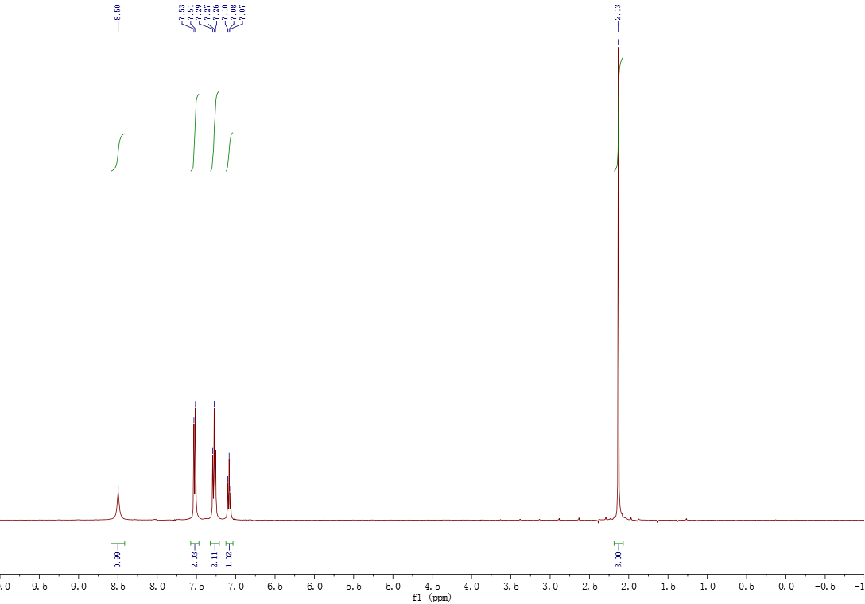

¹³C NMR spectra of compound 3a

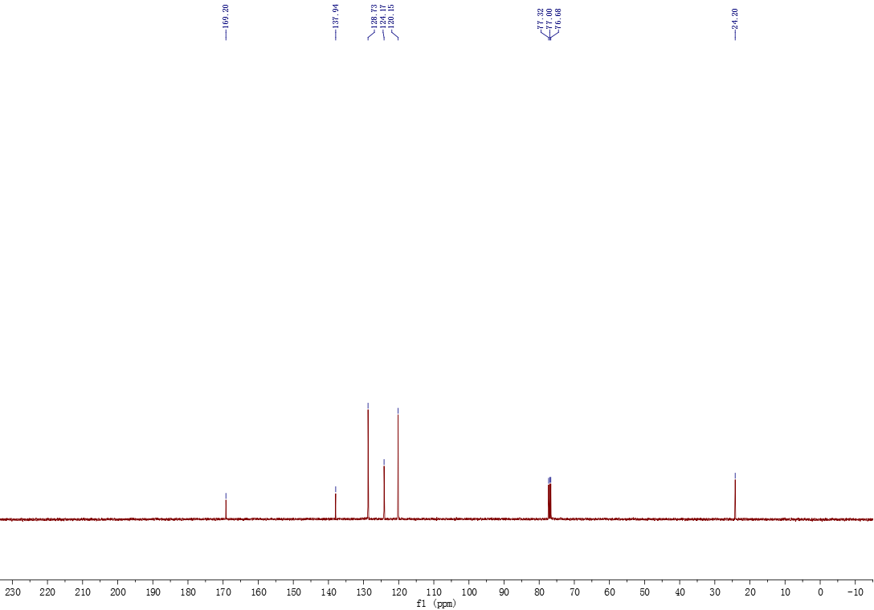

¹H NMR spectra of compound 3b
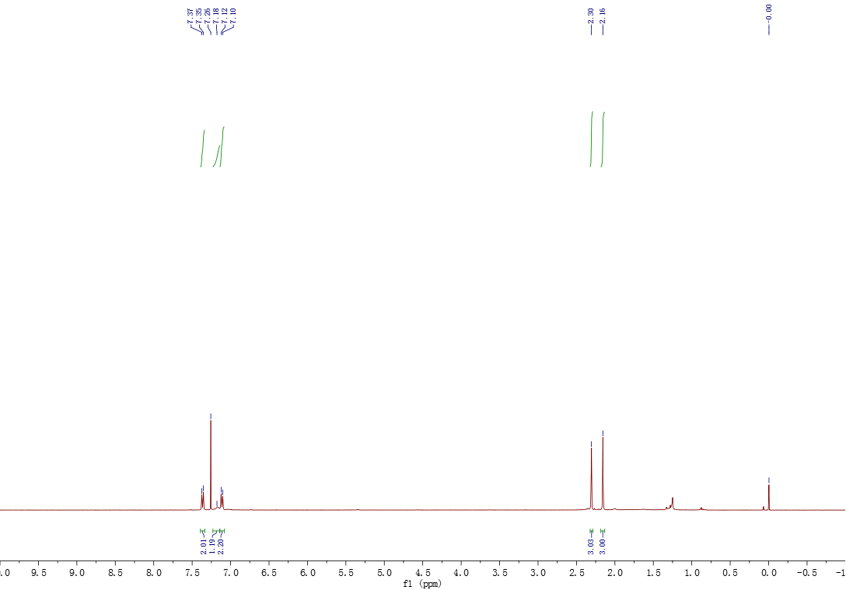

¹³C NMR spectra of compound 3b

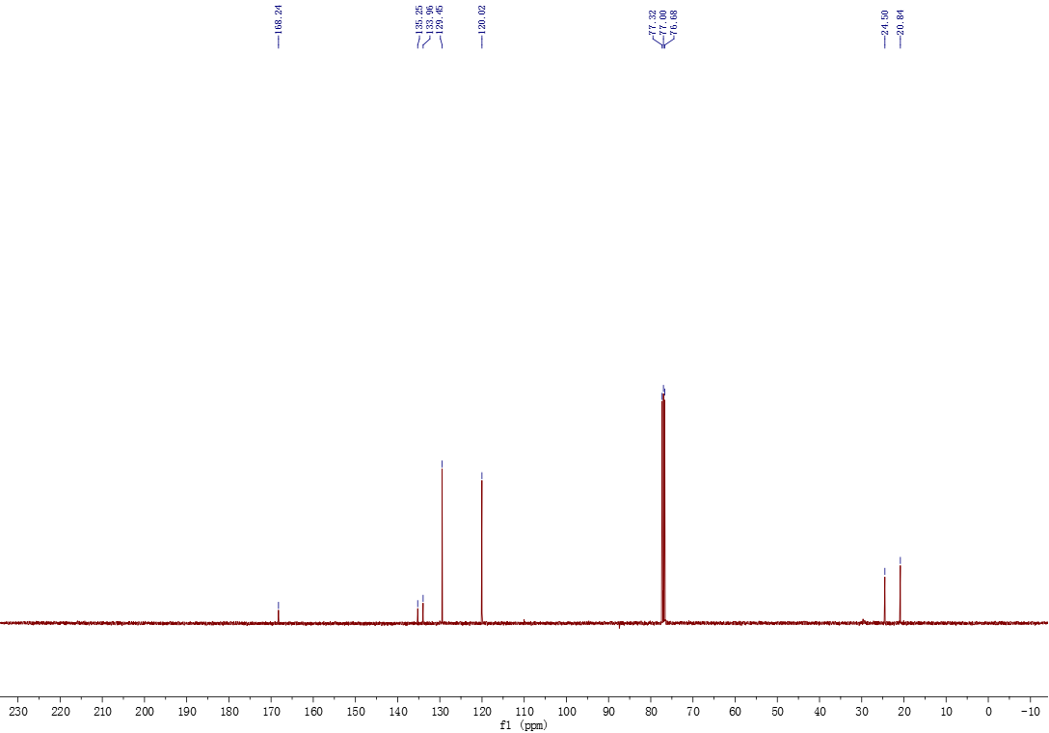

¹H NMR spectra of compound 3c

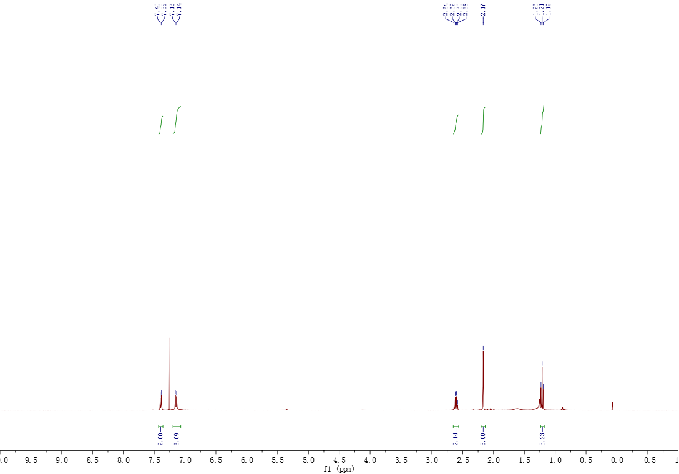

¹³C NMR spectra of compound 3c

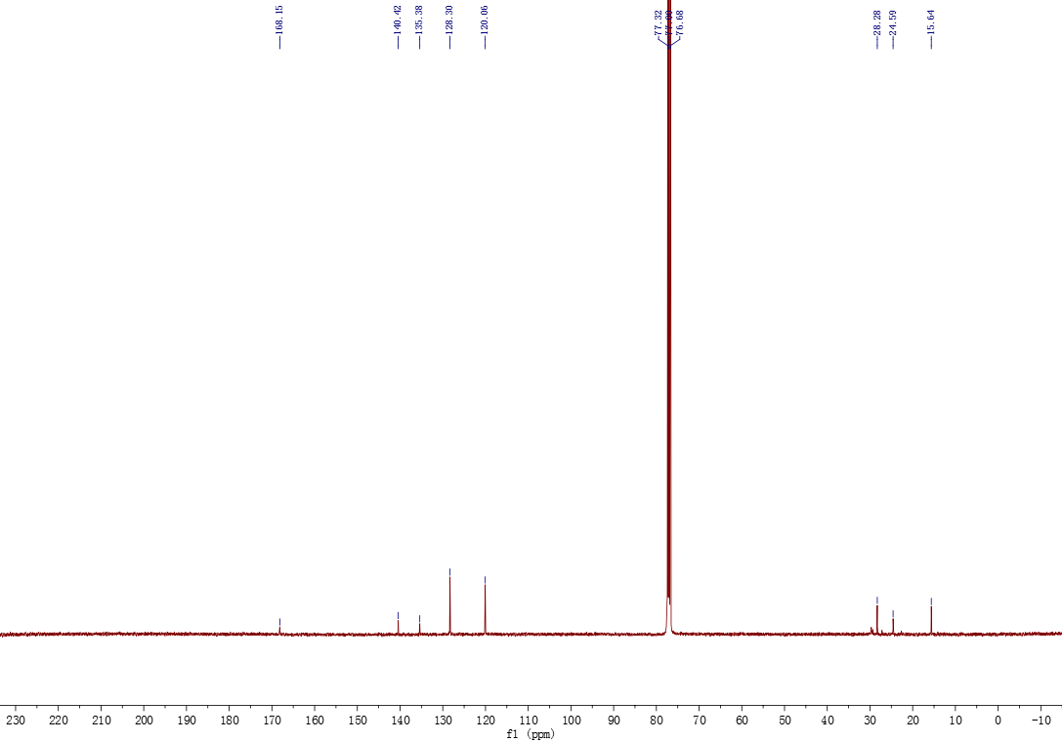

¹H NMR spectra of compound 3d

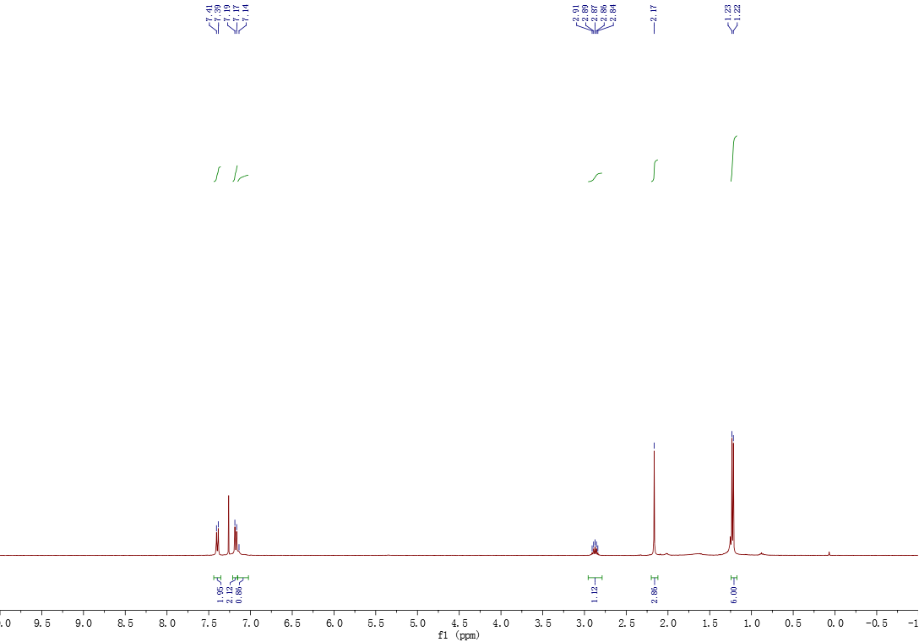

¹³C NMR spectra of compound 3d

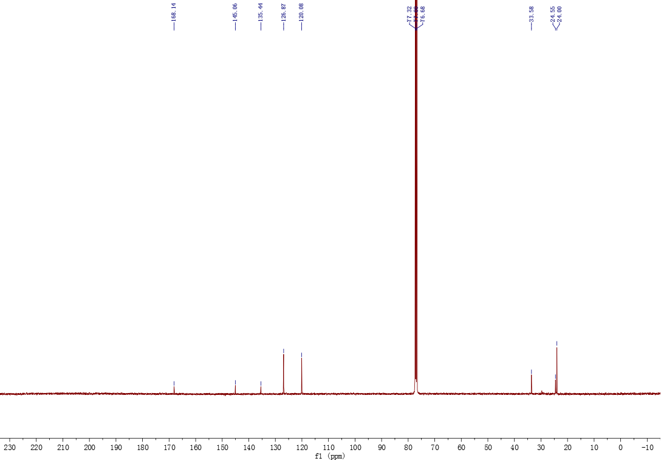

¹H NMR spectra of compound 3e

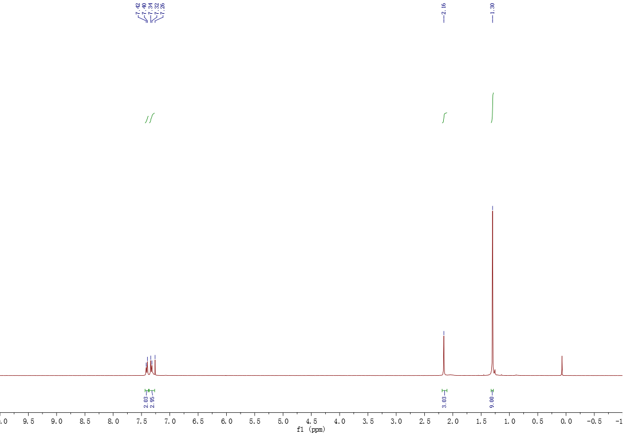

¹³C NMR spectra of compound 3e

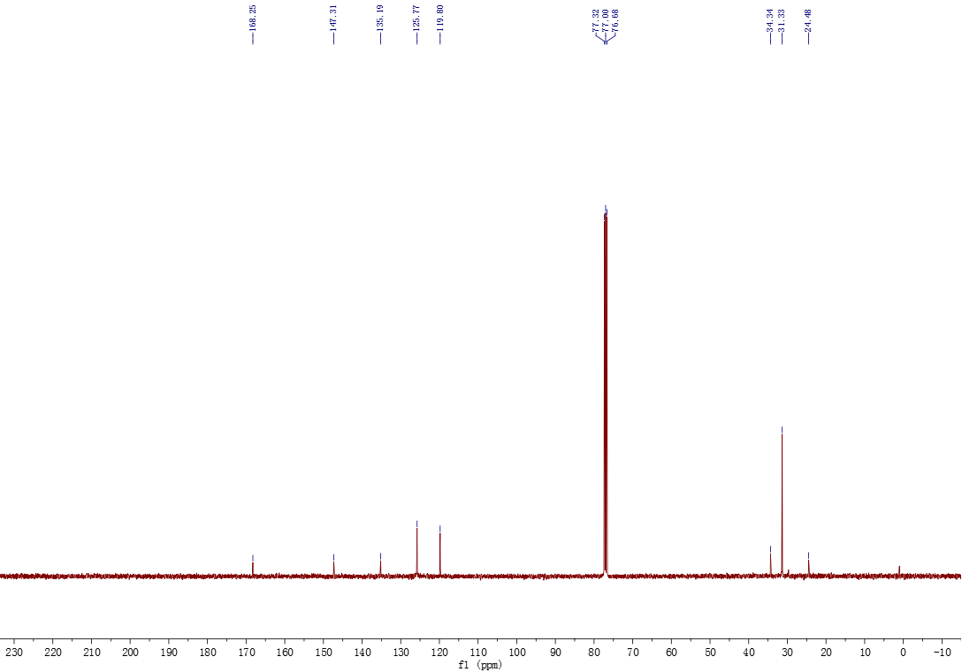

¹H NMR spectra of compound 3f

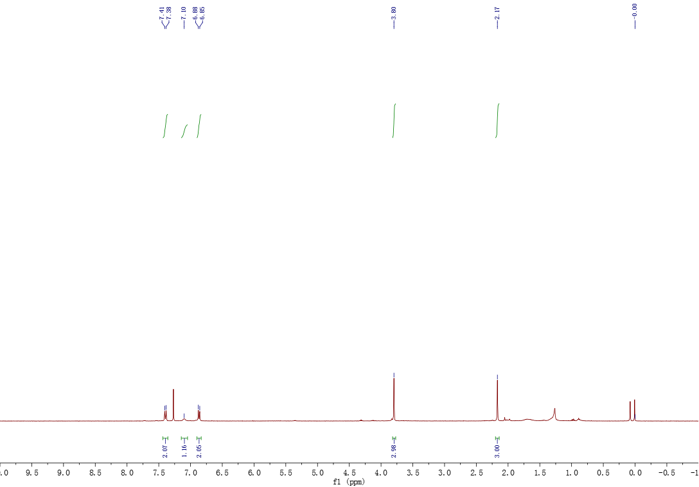

¹³C NMR spectra of compound 3f

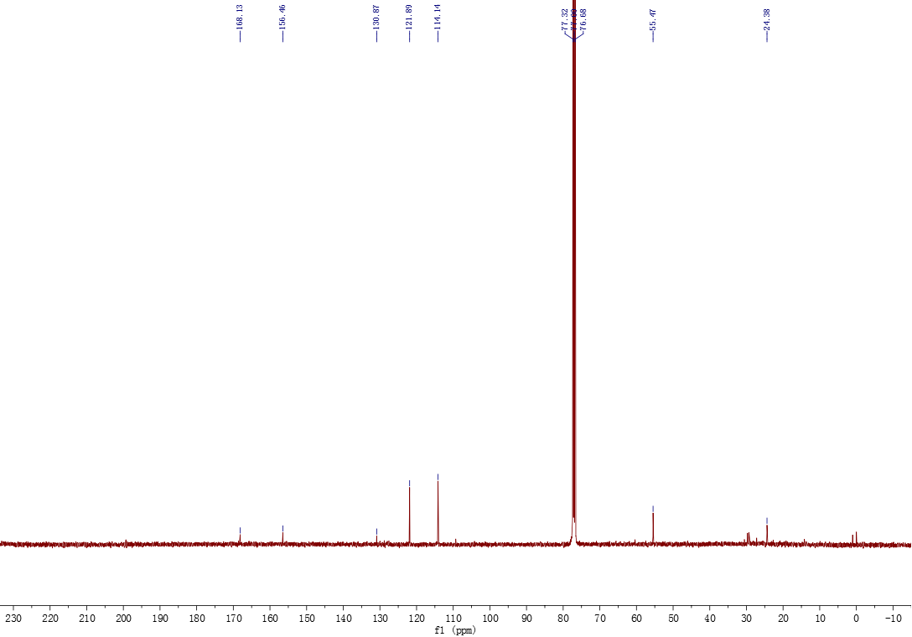
¹H NMR spectra of compound 3g

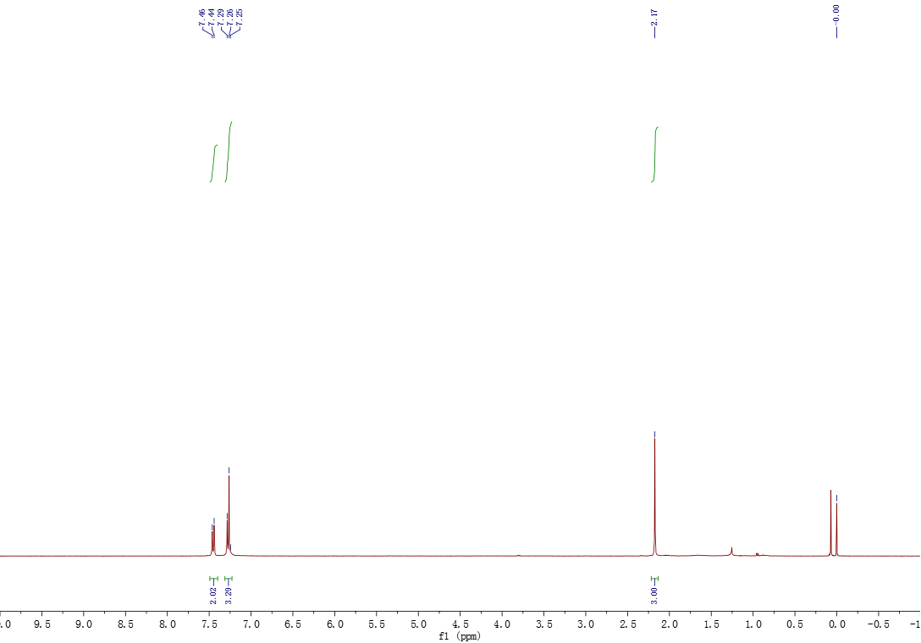

¹³C NMR spectra of compound 3g

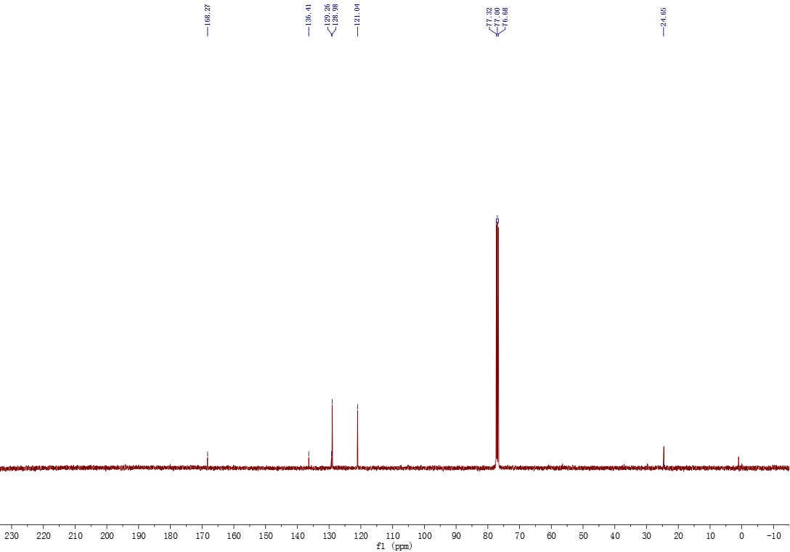

¹H NMR spectra of compound 3h

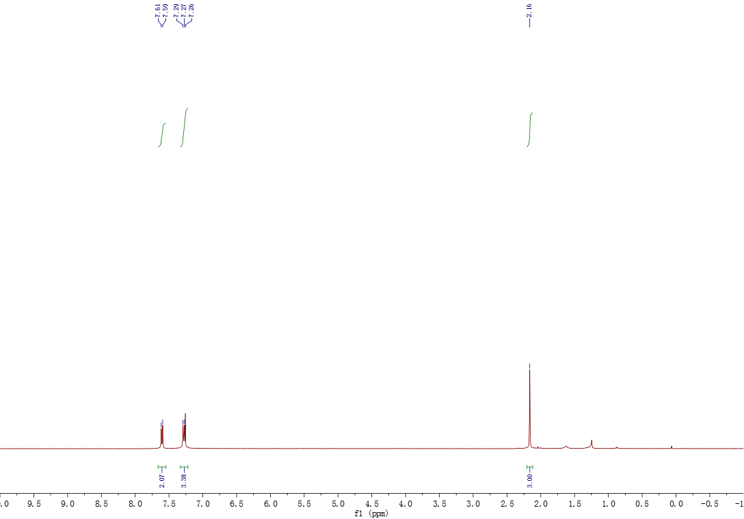

¹³C NMR spectra of compound 3h

¹H NMR spectra of compound 3i

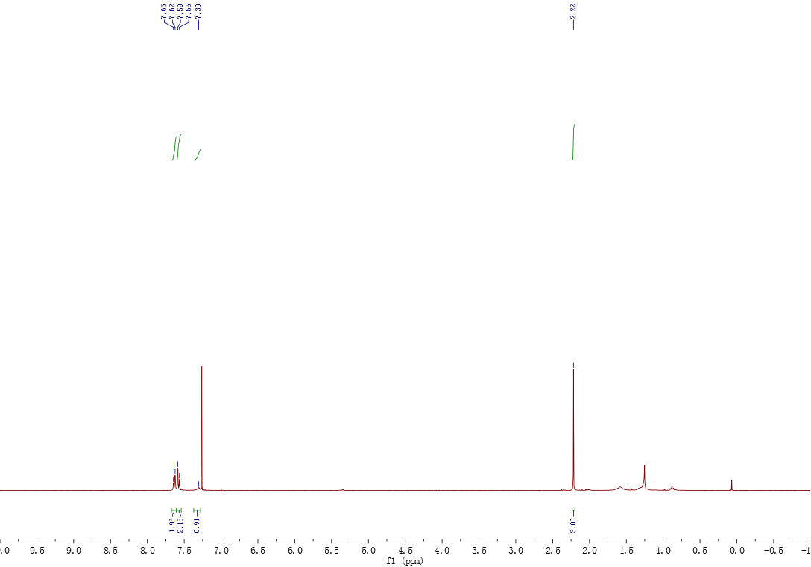

¹³C NMR spectra of compound 3i

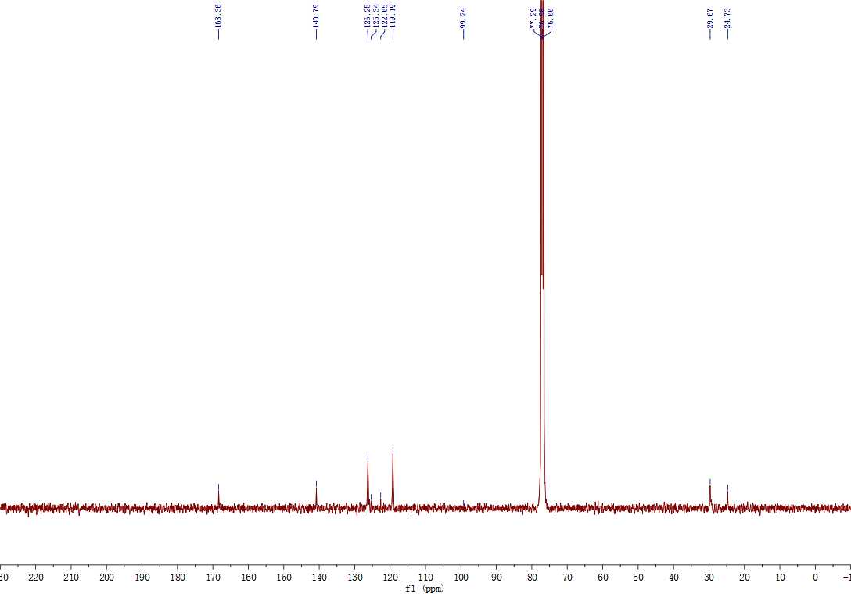

¹H NMR spectra of compound 3j

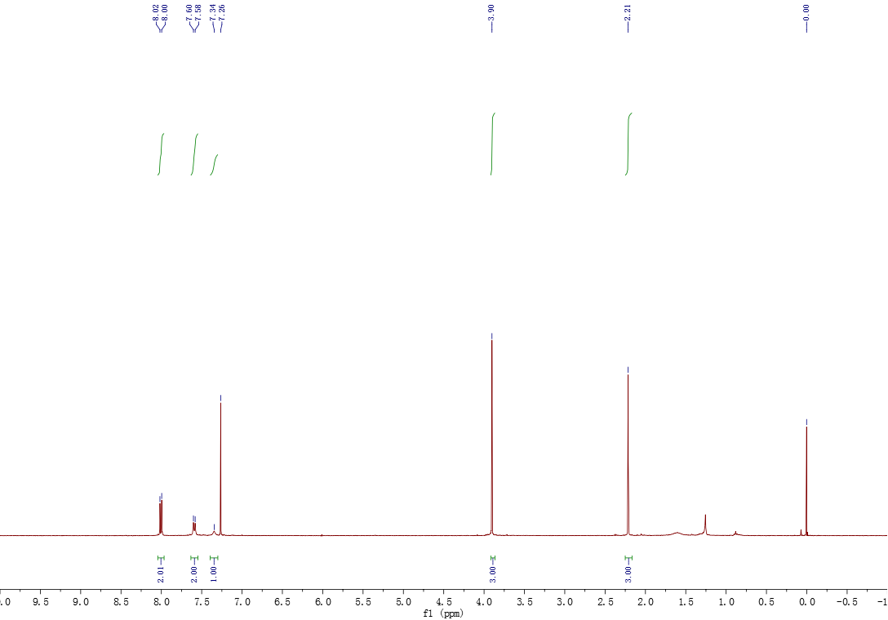

¹³C NMR spectra of compound 3j

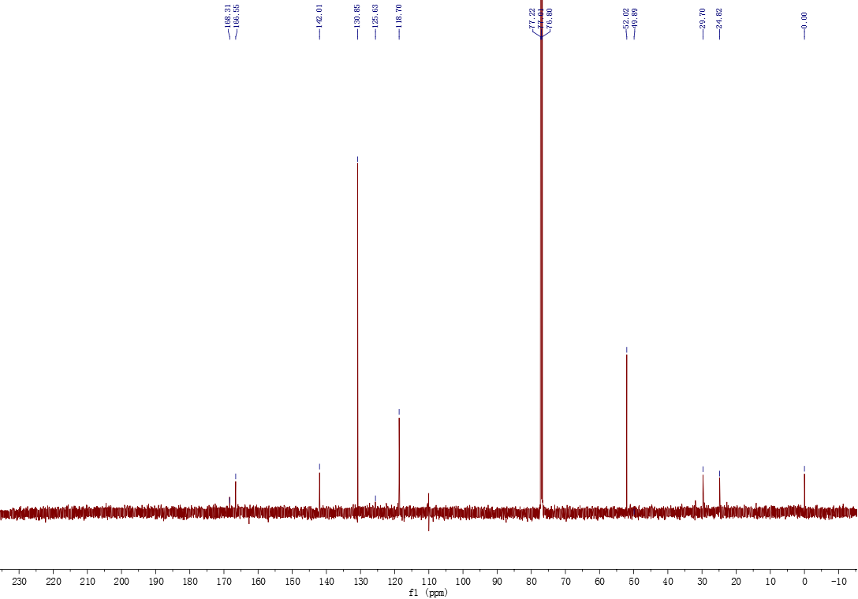
¹H NMR spectra of compound 3l

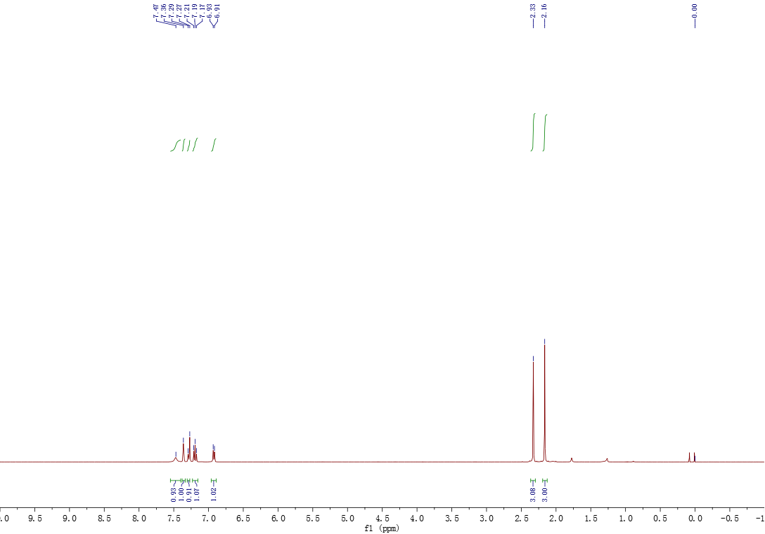

¹³C NMR spectra of compound 3l

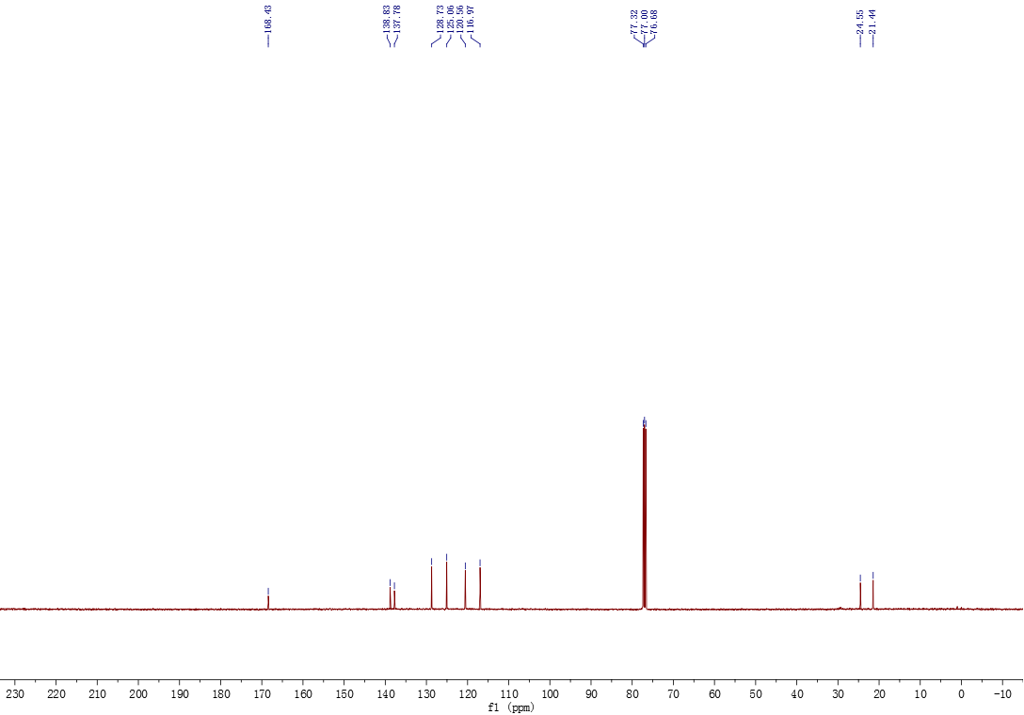

¹H NMR spectra of compound 3m

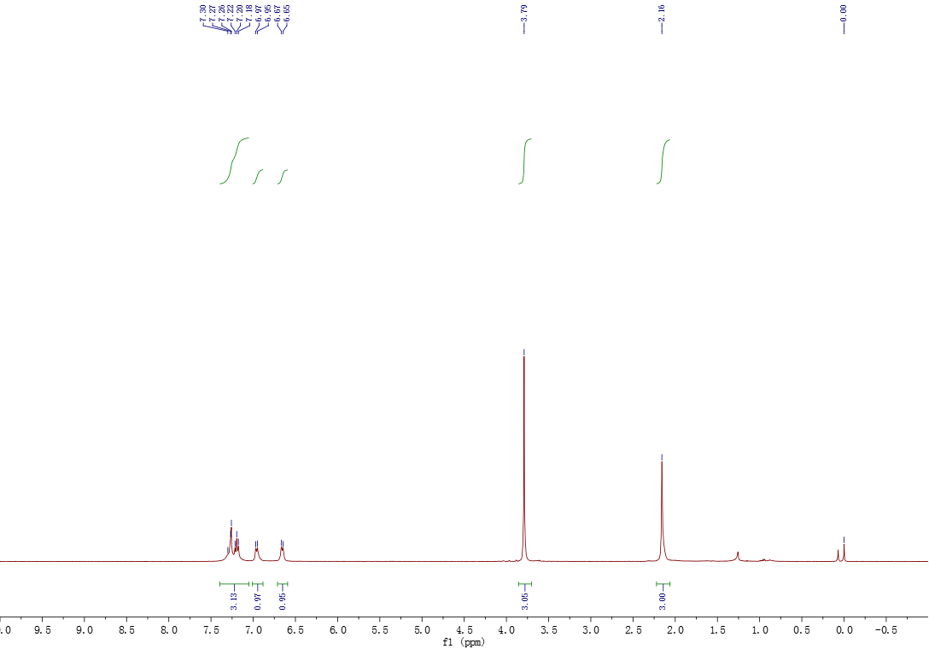

¹³C NMR spectra of compound 3m

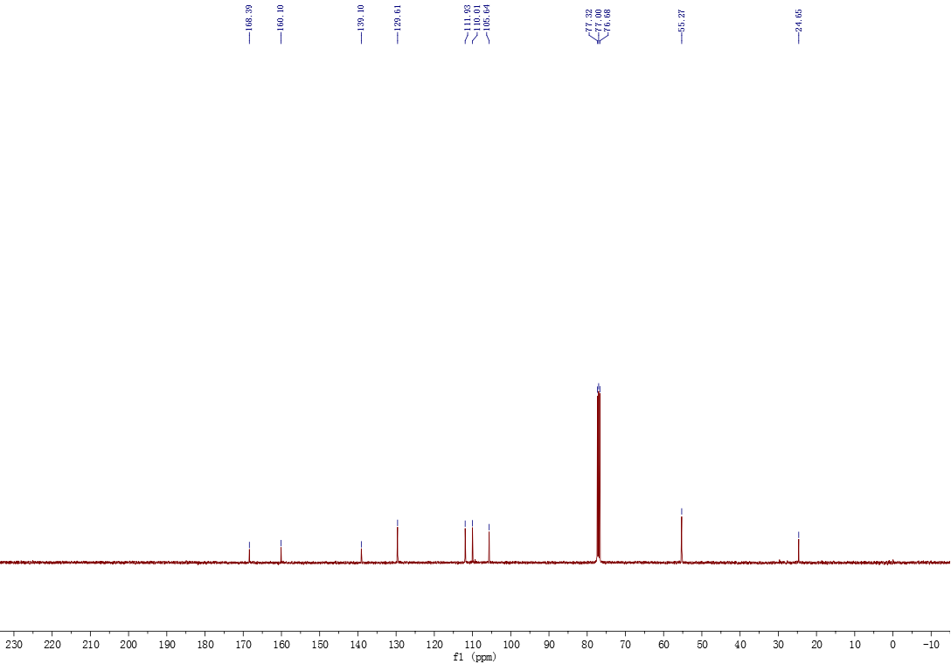

¹H NMR spectra of compound 3n

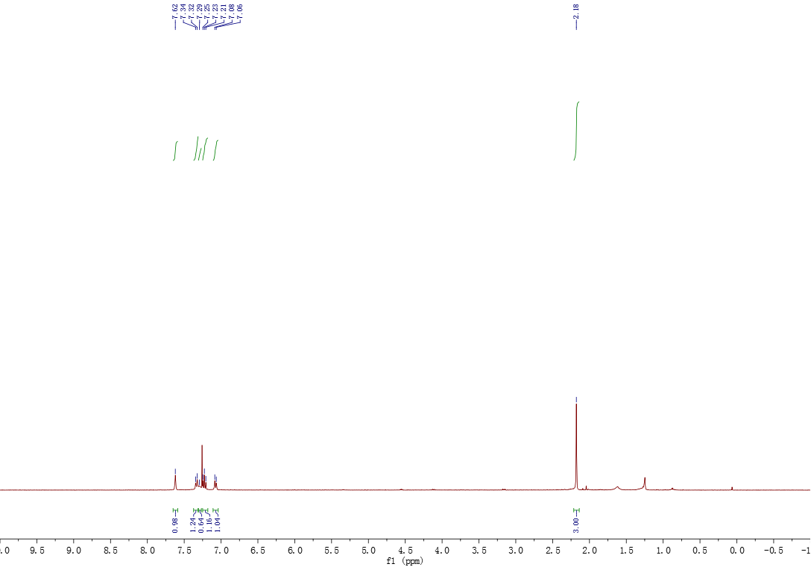

¹³C NMR spectra of compound 3n

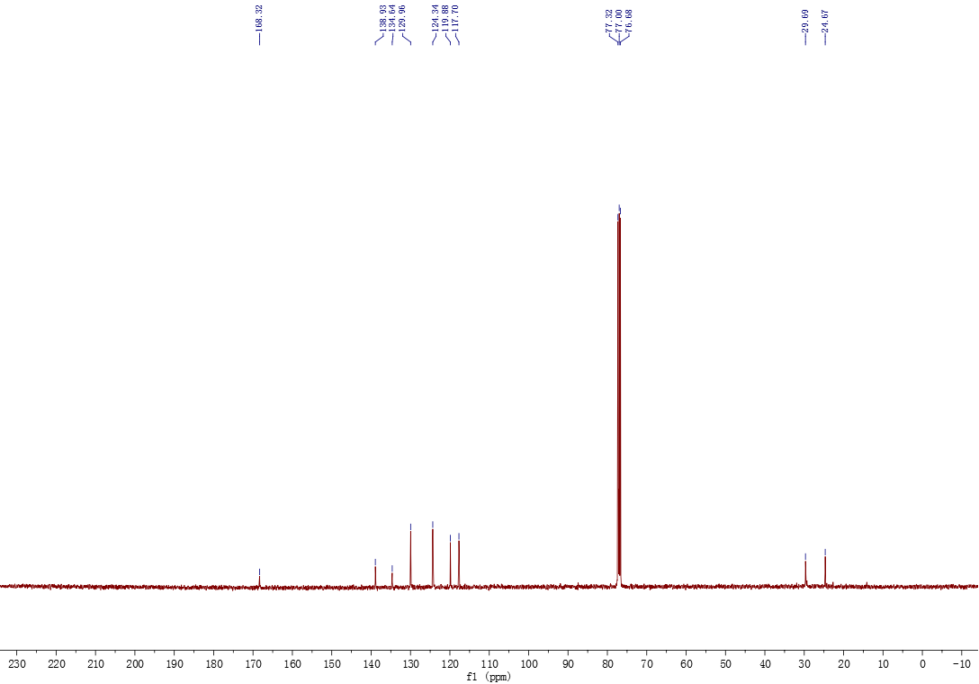

¹H NMR spectra of compound 3p

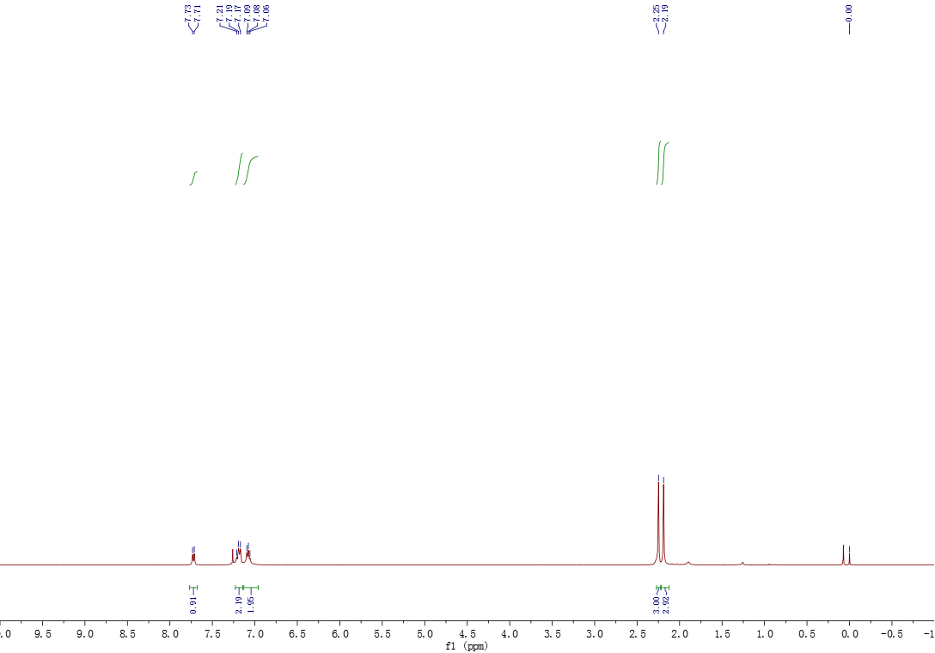

¹³C NMR spectra of compound 3p

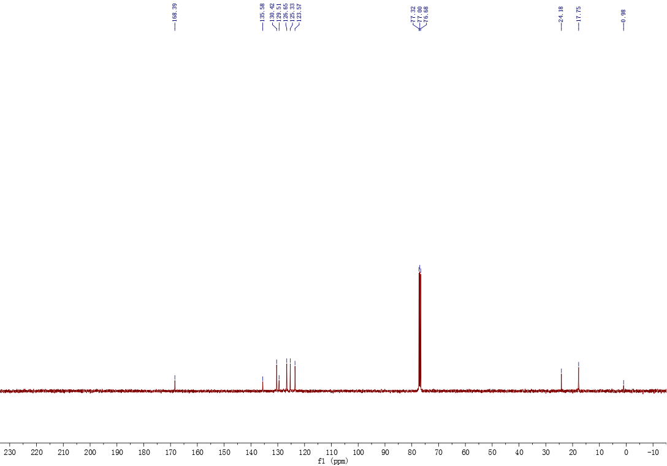

¹H NMR spectra of compound 3r

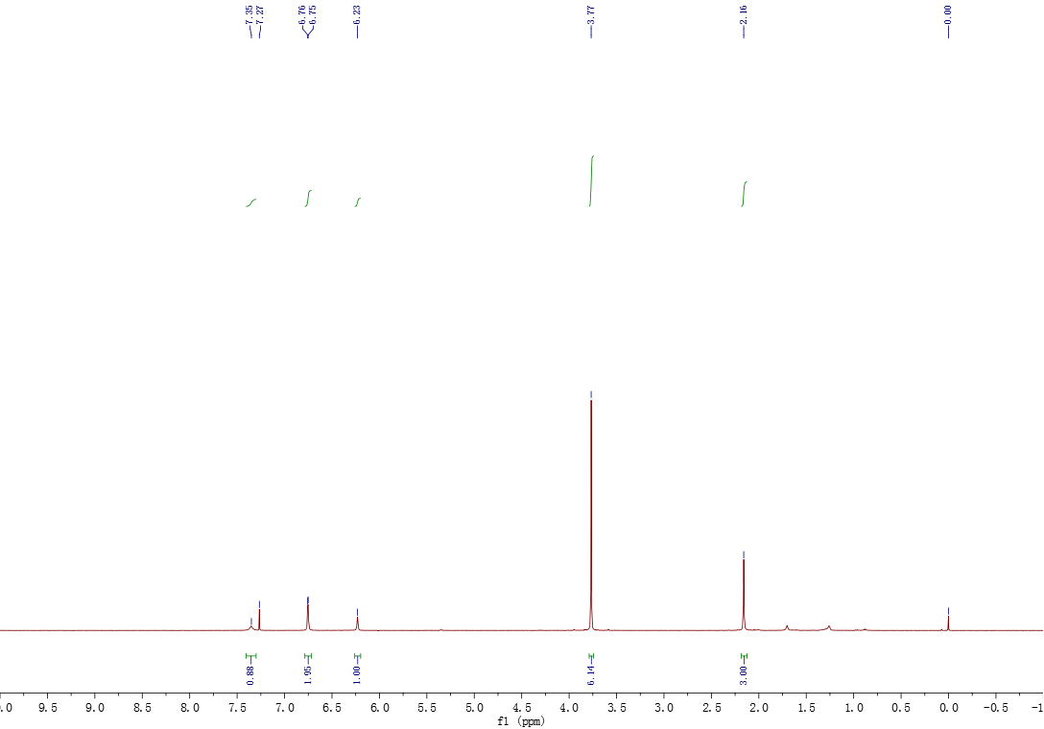

¹³C NMR spectra of compound 3r

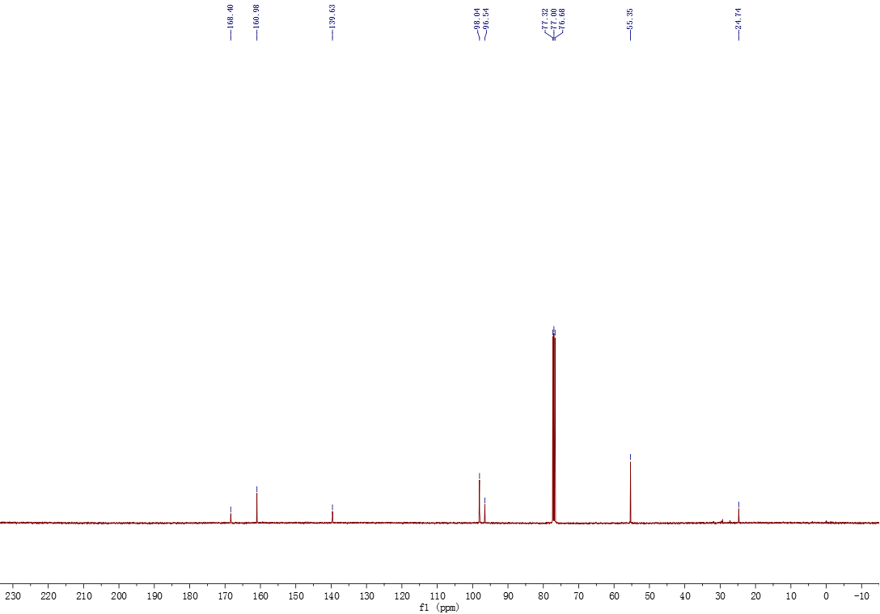

- Copies of HRMS

HRMS of compound 3a
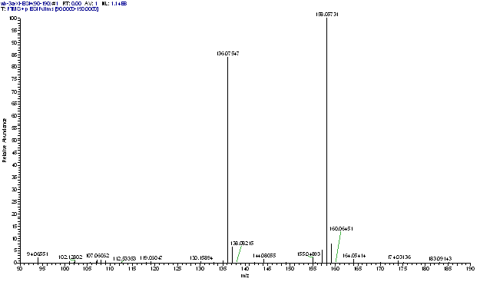

- References
[1] Gross, M.L., Blank, D.H., Welch, W. M., 1993. The Triazene Moiety as a Protecting Group for Aromatic Amines. J. Org. Chem. 58, 2104-2109.
[2] Surya Prakash, G.K., Moran, M.D., Mathew, T., Olah, G.A., 2009. Ipso-amidation of arylboronic acids: Xenon difluoride-nitriles as efficient reagent systems. Journal of Fluorine Chemistry. 130, 806-809.
[3] Xiang, S,. Zhang, D,. Hu, H,. Shi, J,. Liao, L,. Feng, C,. Wang, B,. Zhao, K,. Hu, P,. Yang, H,. Yu, W,. 2013. Synthesis of N-Arylamides by Copper-Catalyzed Amination of Aryl Halides with Nitriles. Adv. Synth. Catal. 355, 1495-1499.
[4] Lee,. Y.M,. Moon, M.E,. Vajpayee, Vaishali,. Filimonov, V.D., Chi, K.W,. 2010. Efficient and economic halogenation of aryl amines via arenediazoniumtosylate salts. Tetrahedron. 66, 7418-7422.
[5] Xu, W,. Xu, Q,. Li, J,. 2015. Sandmeyer cyanation of arenediazonium tetrafluoroborate using acetonitrile as a cyanide source. Org. Chem. Front.. 2, 231-235.
[6] Saikia, U.P,. Hussain, F.L., Suri, M,. Pahari, P., 2016. Selective N-acetylation of aromatic amines using acetonitrile as
acylating agent. Tetrahedron Lett. 57, 1158-1160.
[7] Wippert, N.A., Jung, N. Brase, S,. 2019. Synthesis of Arylamides via Ritter-Type Cleavage of Solid-Supported Aryltriazenes. ACS Comb. Sci. 21, 568-572.
[8] Barragan, Enrique,. Noonikara-Poyil, A,. Bugarin, A,. 2020. π-Conjugated Triazenes and Nitriles: Simple Photoinduced Synthesis of Anilides Using Mild and Metal-Free Conditions. Asian J. Org. Chem. 9, 593-599.

