**Tunable Electronic Properties of Free-standing Fe-doped GaN Nanowires as High-capacity Anode of Lithium-ion Batteries**

Kefeng Xie1,*, Jie Wang1, Sanchuan Yu3, Ping Wang3, and Changlong Sun2,*

1. School of Chemical and Biological Engineering, Lanzhou Jiaotong University, Lanzhou, 730070, Gansu, P. R. China.

2． College of Materials Science and Engineering, Qingdao University of Science and Technology, Qingdao 266042, Shandong, P. R. China.

3. Ningbo Sanbang Microfiber Co., Ltd, Ningbo 315000, Zhejiang, P. R. China.

Email: [xiekefeng@mail.lzjtu.cn](mailto:xiekefeng@mail.lzjtu.cn); [happysunchanglong@126.com](mailto:happysunchanglong@126.com);

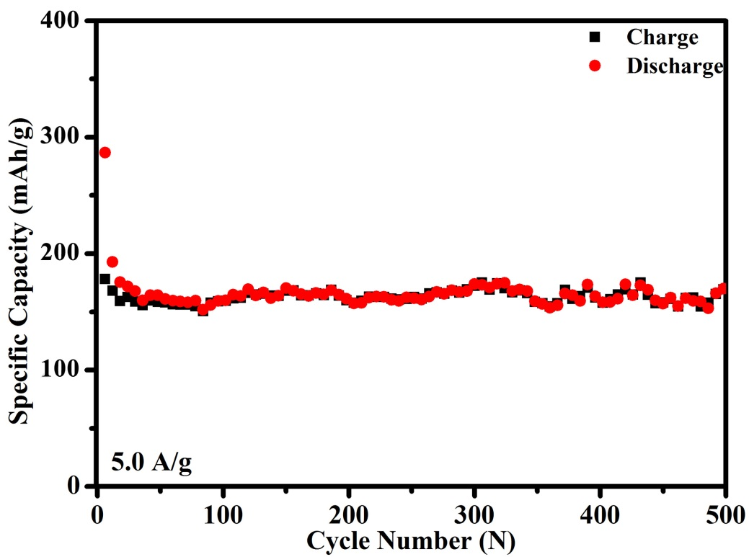

Fig. S1. Cycling property of intrinsic GaN electrode at 5.0 A g−1.

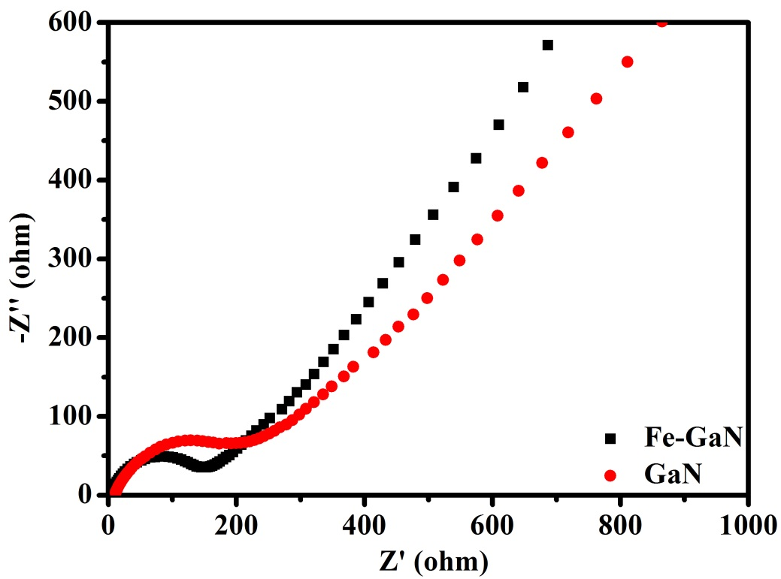

Fig. S2. Electrochemical impedance spectroscopy (EIS) of intrinsic GaN and Fe-GaN electrodes.

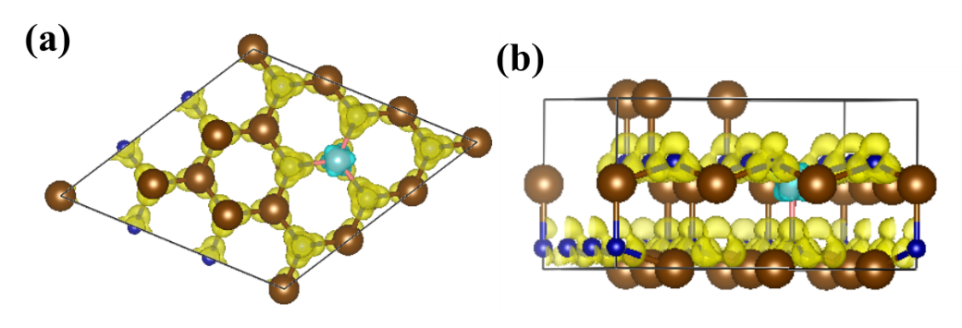

Fig. S3. Top view (a) and side view (b) of 3D electron density differences of Fe-GaN.

**Table S1.** Comparisons of the synthetic method, morphology, cycle number, current density, and capacity between Fe-GaN electrode and other previously reported metal nitrides-based or gallium compounds-based LIBs electrodes.

|  |  |  |  |  |  |
| --- | --- | --- | --- | --- | --- |
| Material  (areal loading  and areal) | Method | Morphology | Current density  (mA g−1) | Cycle number | Capacity (mAh g−1) |
| Fe-GaN NWs  (2.7 mg, 1.44 cm2) | CVD | nanowires | 100/5 000 | 200/500 | 612.3/338.2 |
| Ga2S3 ref.[1]  (no mention) | purchase | microparticles | 100 | 20 | ~450 |
| Cu3N ref.[2]  (no mention, 1.0 cm2) | nitrogen-thermal reaction | microparticles | 225 | 400 | 400 |
| Ge3N4/C ref.[3]  (no mention, 2.54 cm2) | hydrothermal | particles | 550 | 300 | ~670 |
| RuN ref.[4]  (no mention, 1.13 cm2) | pulsed magnetron sputtering | thin films | 117 | 70 | 330 |
| Mo2N ref.[5]  (no mention, 1.32 cm2) | ammonia calcination | nanobelts | 100/4000 | 20/10 | ~500/~240 |
| VN ref.[6]  (0.12 mg, 1.0 cm2) | direct current magnetron sputtering | thin films | 230 | 50 | ~800 |
| CoN ref.[7]  (no mention, 2.0 cm2) | amine-thermal reaction | nanoparticles | 250/1000 | 60/60 | ~660/~470 |
| CoN ref.[8]  (0.24 mg, 2.0 cm2) | radio frequency magnetron sputtering | nanoflake | 250/5000 | 80/50 | 1000/690 |
| CrN ref.[9]  (0.14 mg, 1.0 cm2) | radio frequency magnetron sputtering | thin films | 28 μA/cm2 | 30 | ~1200 |
| SiN ref.[10]  (no mention, 1.13 cm2) | pulsed laser deposition | thin films | 1200 | 100 | 700 |
| Mn3N2 ref.[11]  (0.83 mg, 4.0 cm2) | direct current magnetron sputtering | thin films | 80/160 | 110/300 | 463/365.4 |
| Sb3N ref.[12]  (no mention) | radio frequency magnetron sputtering | thin films | 28 mA/cm2 | 55 | ~700 |
| Fe2N@carbon textile ref.[13]  (1.7~2.0 mg, 1.0 cm2) | hydrothermal method and thermal treatment | nanoparticles composite | 1000/6000 | 100/300 | 650/240 |
| MoN/N doped CNT ref.[14]  (no mention, 1.13 cm2) | hydrothermal and calcination approach | nanocomposite | 100/1500 | 200/20 | 1232/989.5 |

**REFERENCES**

[1] H. Senoh, H. Kageyama, T. Takeuchi, K. Nakanishi, T. Ohta, H. Sakaebe, M. Yao, T. Sakai, K. Yasuda, J. Power Sources **2011**, 196, 5631.

[2] N. Pereira, L. Dupont, J. M. Tarascon, L. C. Klein, G. G. Amatucci, J. Electrochem. Soc. **2003**, 150, A1273.

[3] N. Pereira, M. Balasubramanian, L. Dupont, J. McBreen, L. C. Klein, G. G. Amatucci, J. Electrochem. Soc. **2003**, 150, A1118.

[4] B. Laïk, S. Bourg, J.-P. Pereira-Ramos, S. Bruyère, J.-F. Pierson, Electrochim. Acta **2015**, 164, 12.

[5] H.-C. Park, K.-H. Lee, Y.-W. Lee, S.-J. Kim, D.-M. Kim, M.-C. Kim, K.-W. Park, J. Power Sources **2014**, 269, 534.

[6] Q. Sun, Z.-W. Fu, Electrochim. Acta **2008**, 54, 403.

[7] B. Das, M. V. Reddy, G. V. S. Rao, B. V. R. Chowdari, J. Mater. Chem. **2012**, 22, 17505.

[8] B. Das, M. V. Reddy, P. Malar, T. Osipowicz, G. V. Subba Rao, B. V. R. Chowdari, Solid State Ionics **2009**, 180, 1061.

[9] Q. Sun, Z.-W. Fu, Electrochem. Solid-State Lett. **2007**, 10, A189.

[10] N. Suzuki, R. B. Cervera, T. Ohnishi, K. Takada, J. Power Sources **2013**, 231, 186.

[11] Q. Sun, Z.-W. Fu, Appl. Surf. Sci. **2012**, 258, 3197.

[12] Q. Sun, W.-J. Li, Z.-W. Fu, Solid State Sci. **2010**, 12, 397.

[13] M.-S. Balogun, M. Yu, Y. Huang, C. Li, P. Fang, Y. Liu, X. Lu, Y. Tong, Nano Energy **2015**, 11, 348.

[14] S. M. Abbas, R. Zia ur, U. A. Rana, S. U.-D. Khan, Z. Iqbal, N. Ahmad, Electrochim. Acta **2016**, 190, 988.