Appendix. Supplementary data

**Antibacterial action of** *Stryphnodendron pulcherrimum* **bark extract, a "barbatimão” species: evaluation of its use as a topical agent**

Paulo Wender Portal Gomes1, Thaiana Cristina Dias de Lima Pamplona2, Kely Campos Navegantes-Lima3, Lucas Benedito Gonçalves Quadros4, Ana Lígia de Brito Oliveira3, Sávio Monteiro dos Santos2, Consuelo Yumiko Yoshioka e Silva2,4, Maria Josierika Cunha da Silva5, Jesus Nazareno Silva de Souza6, Luis Manuel Quirós‑Guerrero7,8, Jean A. Boutin9,10, Marta Chagas Monteiro2,3, Milton Nascimento da Silva1

1Programa de Pós-graduação em Química, Instituto de Ciências Exatas e Naturais, Universidade Federal do Pará, 66075110, Belém, Pará, Brazil.

2Programa de Pós-graduação em Ciências Farmacêuticas, Instituto de Ciências da Saúde, Universidade Federal do Pará, 66075110, Belém, Pará, Brazil.

3Programa de Pós-graduação em Neurociências e Biologia Celular, Instituto de Ciências Biológicas, Universidade Federal do Pará, 66075110, Belém, Pará, Brazil.

4Faculdade de Farmácia, Instituto de Ciências da Saúde, Universidade Federal do Pará, 66075110, Belém, Pará, Brazil.

5Faculdade de Medicina, Instituto de Ciências da Saúde, Universidade Federal do Pará, 66075110, Belém, Pará, Brazil.

6Centro de valorização de compostos Bioativos da Amazônia (CVACBA) e Faculdade de Engenharia de Alimento (FEA), Universidade Federal do Pará, 66075110, Belém, Pará, Brazil.

7School of Pharmaceutical Sciences, University de Geneva, CMU, Rue Michel-Servet 1, CH-1206 Geneva 4, Switzerland

8Institute of Pharmaceutical Sciences of Western Switzerland (ISPSW), University of Geneva, CMU, Rue Michel Servet 1, 1206 Geneva 4, Switzerland

9Institut de Recherches Internationales Servier, 50 rue Carnot, 92284 Suresnes, France

10Present address: PHARMADEV (Pharmacochimie et biologie pour le développement), Université Toulouse 3 Paul Sabatier, Faculté de Pharmacie, 35 chemin des Maraîchers - 31062 Toulouse Cedex 9, France.

**Corresponding author**

Milton Nascimento da Silva

Instituto de Ciências Exatas e Naturais (ICEN), Universidade Federal do Pará, 66075110, Belém, Pará, Brazil.

Telephone: + 55 91 3201-7365

[yumilton@yahoo.com.br.br](mailto:yumilton@yahoo.com.br.br)

**Table S1.** Formula for manipulation of the ointment used in the animals of this study.

|  |  |
| --- | --- |
| **Components** | **Quantify** |
| Lanolin anhydrous | 30.00 g |
| Butylhydroxytoluene | 0.02 g |
| Solid petroleum jelly | 100.00 g |

**Table S2.** Scoring criteria for erythema and eschar formation and edema and cutaneous irritation

|  |  |
| --- | --- |
| **OECD Nº404** | |
| **Erythema and eschar formation** | **Score** |
| No erythema | 0 |
| Very slight erythema | 1 |
| Moderate to severe erythema | 3 |
| Severe erythema | 4 |
| **Edema** | **Score** |
| No edema | 0 |
| Very slight edema | 1 |
| Slight edema | 2 |
| Moderate edema | 3 |
| Severe edema | 4 |
| **Degree of cutaneous irritation** | **Values (mm)** |
| Notirritating | 0.0 – 1.0 |
| Moderateirritant | 1.0 – 2.0 |
| Severeirritant | 2.1 – 3.0 |
| Corrosive | 3.1 – 4.0 |

**Table S3.** Minimum inhibitory concentration (MIC) and minimum bactericidal concentration (MBC) of SPEE using the microdilution method

|  |  |  |  |  |  |
| --- | --- | --- | --- | --- | --- |
| **Compounds (µg/mL)** | | | | | |
| **Bacteria** | **SPEE 10** | | | **chloramphenicol** | **Gentamicin** |
| **MIC** | **MBC** | | **MIC** | **MIC** |
| *S. aureus* | 100 | | 200 | 50 | - |
| *P. aeruginosa* | 900 | | 900 |  | 10 |
| *E. coli* | 900 | | 900 |  | 10 |

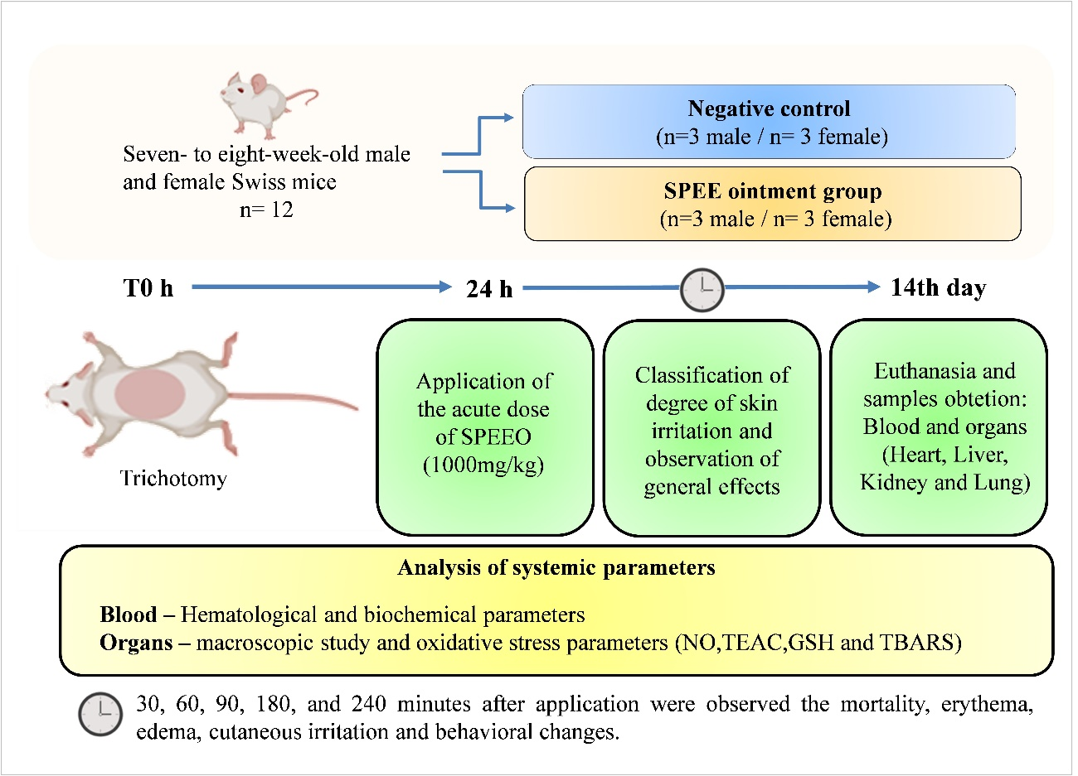

**Fig. S1**. Experimental design for acute dermal toxicity. SPEE: *S. pulcherrimum* ethanolic extract and SPEEO: *S. pulcherrimum* ethanolic extract ointment.

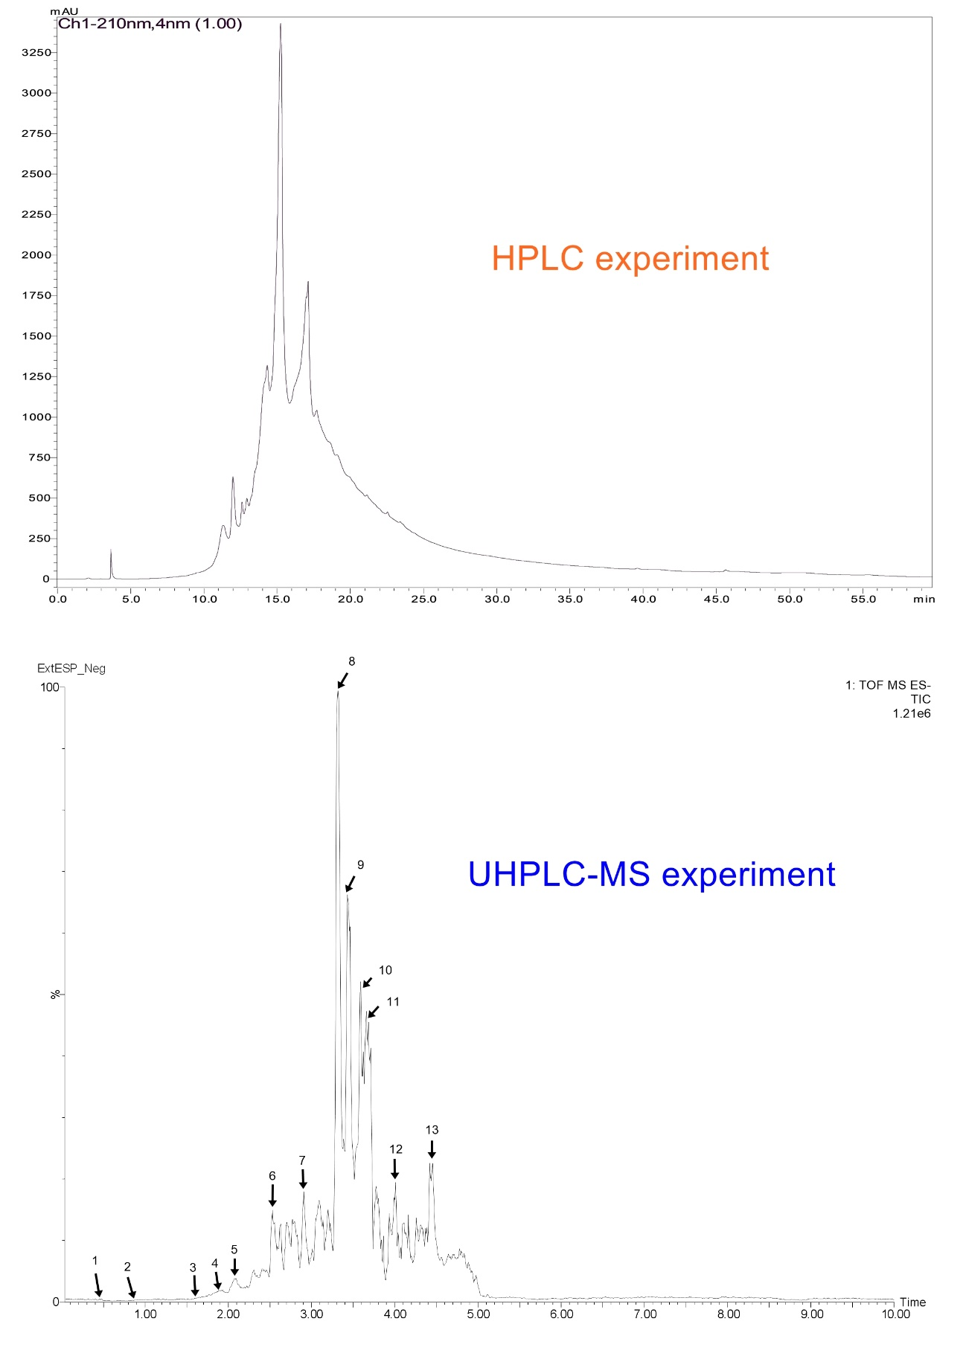

**Fig. S2.** Chromatogram (HPLC) and Total ion current (UHPLC-MS) of ethanolic extract of *S. pulcherrimum* bark.