SUPPLEMENTARY DATA OF

Two new cycloartanes from the leaves of Combretum quadrangulare growing in Vietnam and their biological activities

Huu-Hung Nguyenª, Thi-Phuong Nguyen^{b}, Nguyen Tien Trung^{c}, Cam-Tu D. Phan^{c}, Thi-Bich-Ngoc Dao^{d}, Dinh-Tri Mai^{e,f}, Jirapast Sichaem^{g}, Ngoc-Hong Nguyen^{h*}, Cong-Luan Tran^{k}, Thuc-Huy Duong^{d*}

ªFaculty of Technology, Van Lang University, 45 Nguyen Khac Nhu, District 1, Ho Chi Minh City, Vietnam
^{b}NTT Hi-Tech Institute, Nguyen Tat Thanh University, 300A Nguyen Tat Thanh, District 4, Ho Chi Minh City, Vietnam
^{c}Laboratory of Computational Chemistry and Modelling (LCCM), Quy Nhon University, Binh -Dnh 55100, Vietnam
^{d}Department of Chemistry, Ho Chi Minh City University of Education, 280 An Duong Vuong Street, District 5, Ho Chi Minh City 748342, Vietnam
^{e}Graduate University of Science and Technology, Vietnam Academy of Science and Technology, 18 Hoang Quoc Viet, Cau Giay, Ha noi, Vietnam
^{f}Institute of Chemical Technology, Vietnam Academy of Science and Technology, 1A TL29 Street, Thanh Loc ward, District 12, Ho Chi Minh City, Vietnam
^{g}Research Unit in Natural Products Chemistry and Bioactivities, Faculty of Science and Technology, Thammasat University Lampang Campus, 52190, Lampang, Thailand
^{h}CirTech Institute, Ho Chi Minh City University of Technology (HUTECH), 475 A Dien Bien Phu Street, Binh Thanh District, Ho Chi Minh City 700000, Vietnam
^{k}Faculty of Pharmacy and Nursery, Tay Do University, Can Tho, Vietnam
* Corresponding authors:
Dr. Thuc-Huy Duong. Department of Chemistry, Ho Chi Minh City University of Education, 280 An Duong Vuong Street, District 5, 748342 Ho Chi Minh City, Vietnam. Email: huydt@hcmue.edu.vn

Dr. Ngoc-Hong Nguyen, CirTech Institute, Ho Chi Minh City University of Technology (HUTECH), 475 A Dien Bien Phu Street, Binh Thanh District, Ho Chi Minh City 700000, Vietnam. Email: nn.hong@hutect.edu.vn

Abstract
Two novel cycloartanes, combretanones G and H (1 and 2), were isolated from the leaves of Combretum quadrangulare. Their structures were elucidated by applying a set of spectroscopic methods, while their relative configurations were determined using DFT-NMR chemical shift calculations and subsequent assignment of DP4 probabilities. Compounds 1 and 2 are C-23/C-24 stereoisomers of the previously-reported euphonerin E. Both exhibited moderate cytotoxicity against three human cancer cell lines. Compound 2 was shown to be a potent antiparasitic. Our results confirm the traditional medicinal uses of Combretum quadrangulare in Vietnam.
Key words: Combretaceae, Combretum quadrangulare, cycloartane, combretanones G and H, cytotoxicity, antiparasitic activity
Table S1 Criteria for evaluating antiparasitic activity of compound 2 on T. canis larvae.

State of larvae | Score (n)
Normal moving using whole body | 3
Moving with only a part of the body | 2
Immobile (not dead) | 1
Dead | 0

MI = ∑n Nn/∑Nn, where Nn: number of larvae with the score of n (1).
RM = MI_{sample}/MI_{control} × 100 (2).

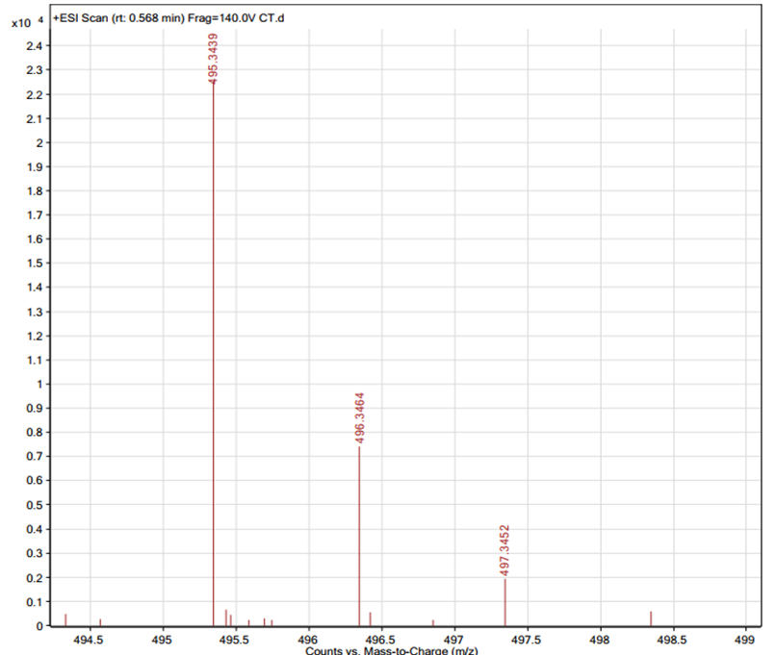

Figure S1. HRESIMS spectrum of compound 1.
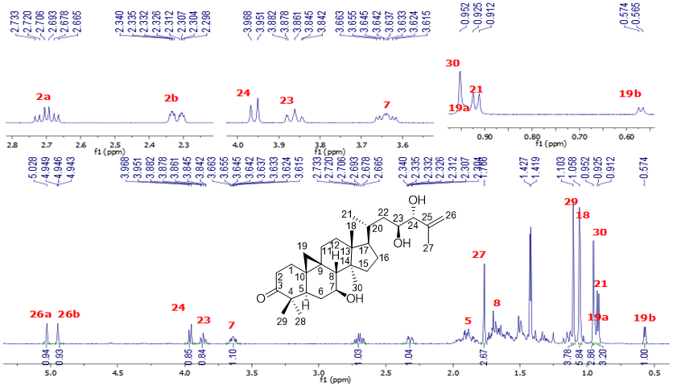
Figure S2. ¹H NMR (500 MHz) spectrum of compound 1 in CDCl_{3.}

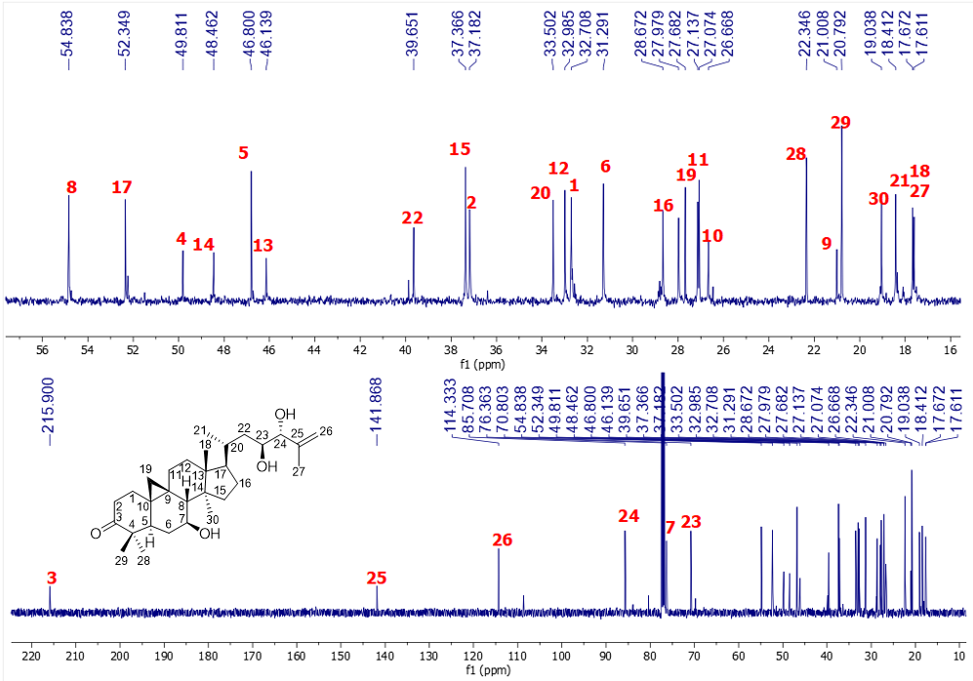

Figure S3. ¹³C NMR (125 MHz) spectrum of compound 1 in CDCl₃.
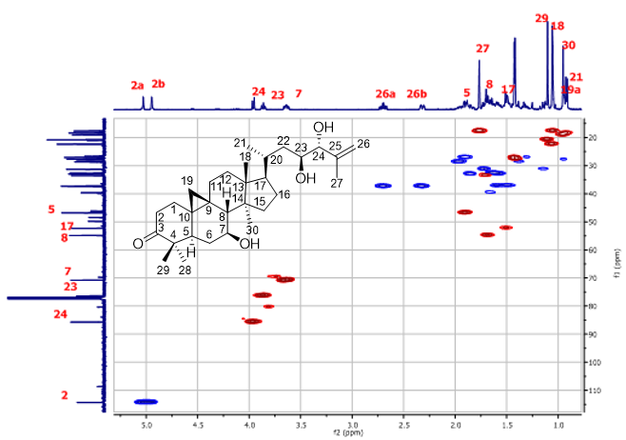.
Figure S4. HSQC spectrum of compound 1 in CDCl₃.
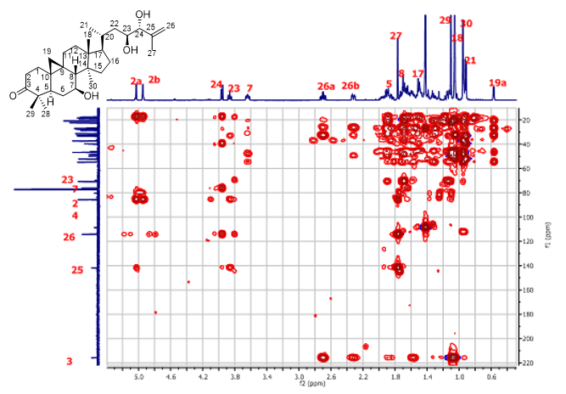
Figure S5. HMBC spectrum of compound 1 in CDCl₃.

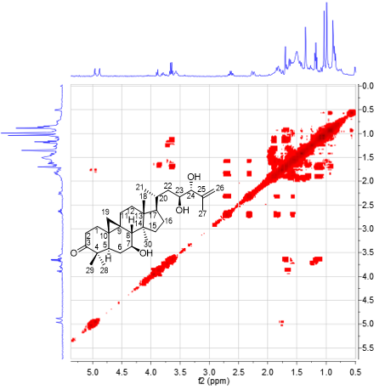

Figure S6. COSY spectrum of compound 1 in CDCl₃.

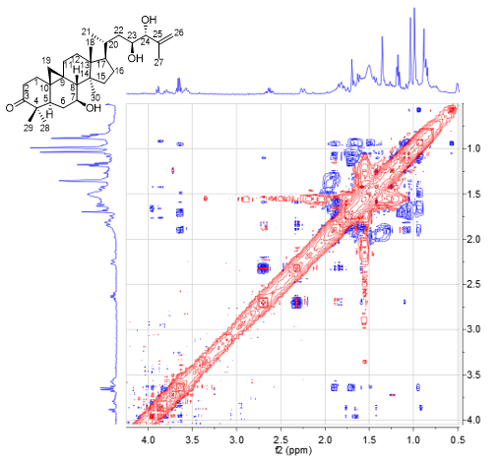
Figure S7. NOESY spectrum of compound 1 in CDCl₃.
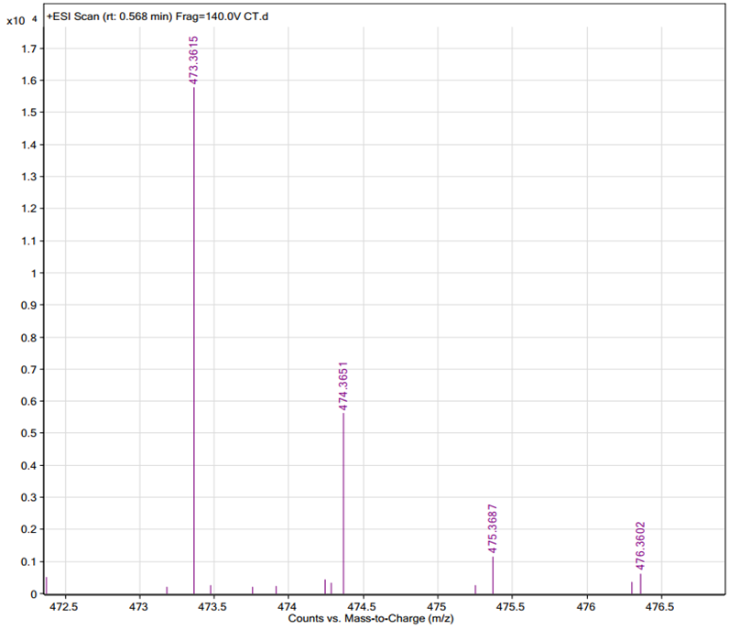
Figure S8. HRESIMS spectrum of compound 2.

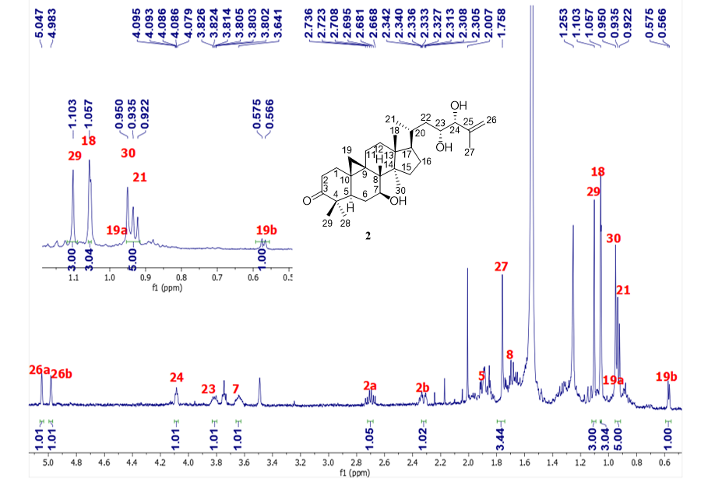 Figure S9. ¹H NMR (500 MHz) spectrum of compound 2 in CDCl₃.

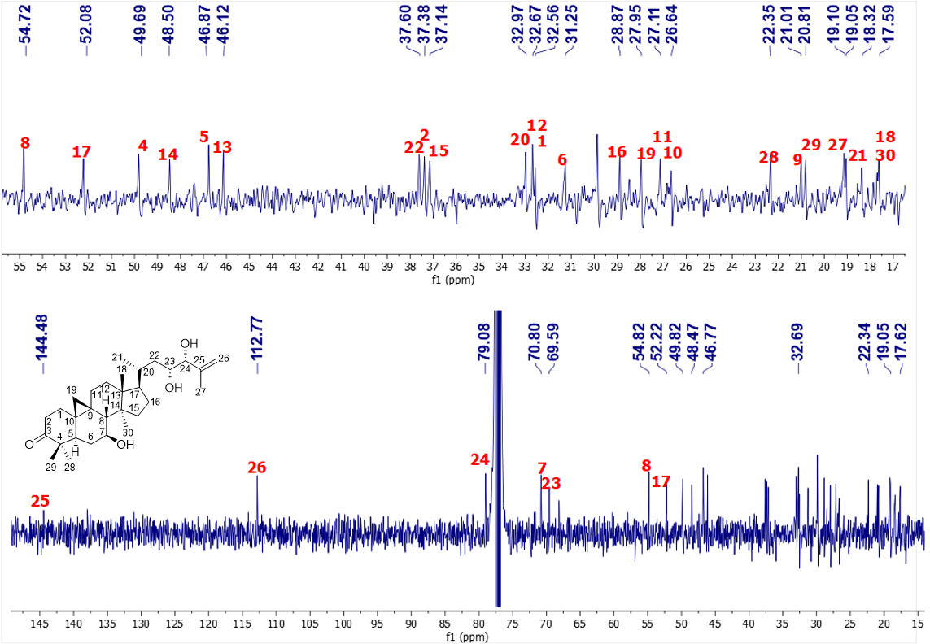Figure S10. ¹³C NMR (125 MHz) spectrum of compound 2 in CDCl₃.
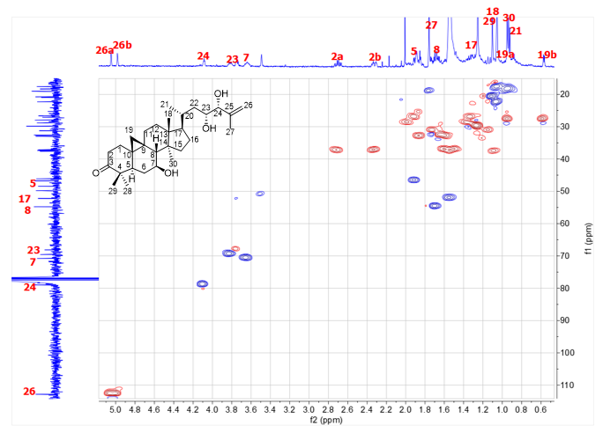
Figure S11. HSQC spectrum of compound 2 in CDCl₃.
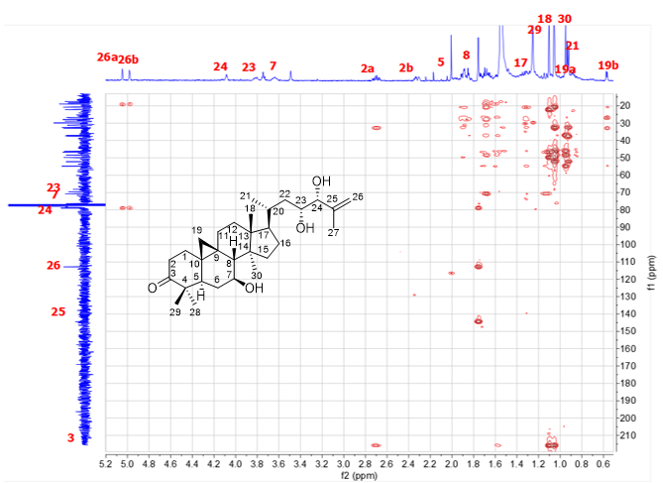 Figure S12. HMBC spectrum of compound 2 in CDCl₃.

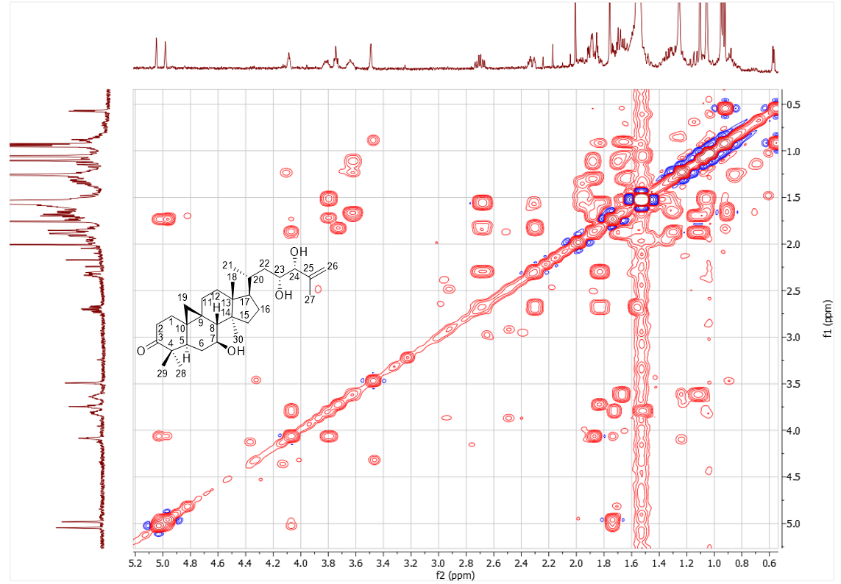 Figure S13. COSY spectrum of compound 2 in CDCl₃.

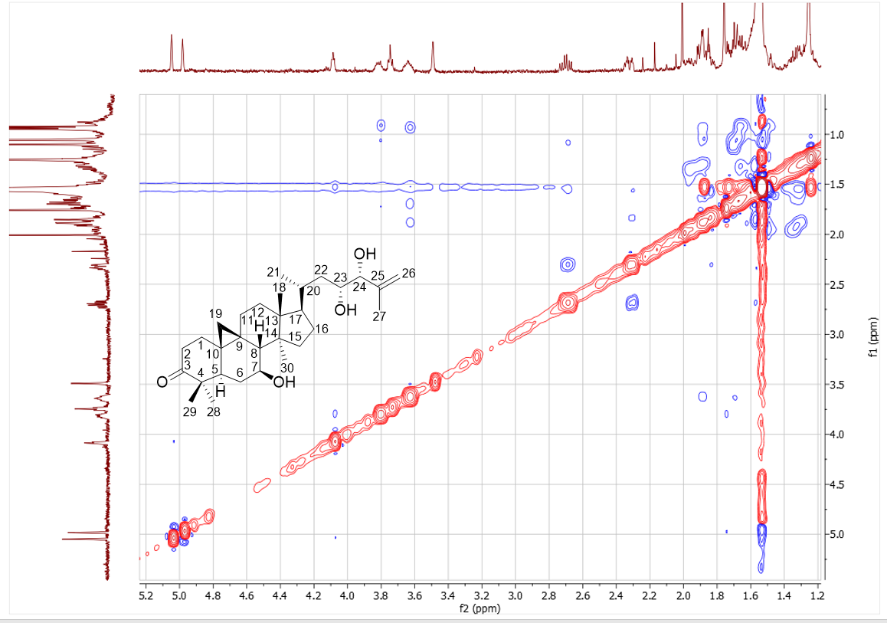 Figure S14. NOESY spectrum of compound 2 in CDCl₃.

Figure S15. The ¹H NMR spectrum of 2 in acetone-d_{6.}

Figure S16. The ¹³C NMR spectrum of 2 in acetone-d_{6.}

Figure S17. The HMBC spectrum of 2 in acetone-d_{6.}

DP4+ results
For anti-conformers (R-S and S-R)
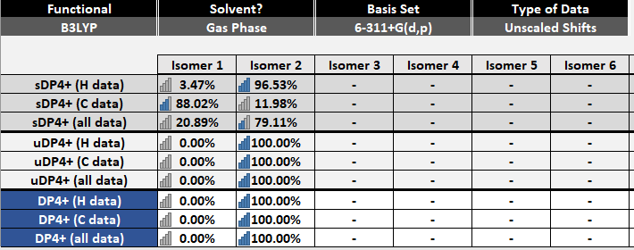

For syn-conformers (S-S and R-R)

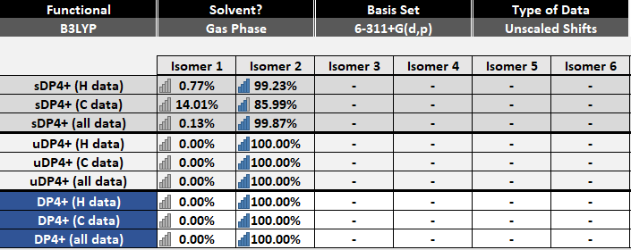
Coordinates of anti-conformers
Isomer 1 (23R-24S)
1a (70.6%)
C 4.390986 -1.959187 -0.810306
C 5.811863 -2.230713 -0.277894
C 6.696216 -0.992648 -0.302968
C 6.103149 0.304890 0.291727
C 4.647272 0.473326 -0.274720
C 3.946549 1.770917 0.142936
C 2.561905 1.867738 -0.504564
C 1.614503 0.809169 0.087477
C 2.233023 -0.626894 -0.004102
C 3.764513 -0.770114 -0.085792
C 1.398860 -1.681788 -0.747218
C -0.140527 -1.665103 -0.507651
C -0.663405 -0.365050 0.138890
C 0.147861 0.863169 -0.433898
C -0.687110 2.060191 0.087781
C -2.160384 1.577523 0.049941
C -2.143573 0.035078 -0.197478
C -0.508339 -0.487191 1.677178
C 3.037504 -1.061726 1.208698
C -3.310715 -0.694442 0.517896
C -3.295912 -2.216709 0.301837
C -4.664624 -0.106189 0.053268
C -5.860697 -0.505892 0.932210
C -7.189035 0.149129 0.481283
C -7.625385 -0.191901 -0.931882
C -7.634984 0.724473 -1.904333
C -8.070072 -1.616484 -1.153764
C 6.991962 1.489407 -0.122998
C 6.142437 0.167276 1.834341
C 0.116980 0.934887 -1.982803
O 7.823782 -1.036819 -0.760543
O 2.043829 3.194919 -0.396650
O -5.644547 -0.177357 2.301857
O -7.004787 1.550475 0.698855
H 4.442454 -1.750231 -1.887798
H 3.796453 -2.868267 -0.697657
H 6.318551 -3.013881 -0.847833
H 5.738899 -2.574796 0.762934
H 7.176384 0.038417 2.170619
H 5.753165 1.072973 2.309705
H 5.558310 -0.679899 2.199228
H 8.036198 1.274902 0.111888
H 6.932998 1.673663 -1.200562
H 6.699211 2.404456 0.399005
H 4.782861 0.558354 -1.366101
H 3.842321 1.841845 1.235057
H 4.528975 2.638567 -0.177784
H 2.676817 1.707749 -1.582867
H 1.554518 1.056396 1.157650
H 3.116767 -0.360258 2.035107
H 2.979705 -2.101500 1.525952
H 1.592905 -1.577172 -1.820823
H 1.771486 -2.674997 -0.485230
H -0.640079 -1.832131 -1.468555
H -0.410237 -2.519507 0.119587
H -0.397696 2.312143 1.114620
H -0.523441 2.958347 -0.510023
H 0.576888 1.871617 -2.308438
H 0.650653 0.116229 -2.469925
H -0.904861 0.935431 -2.368406
H -2.726587 2.095045 -0.729973
H -2.664100 1.806849 0.995674
H -2.285865 -0.147246 -1.271154
H -3.239046 -0.498574 1.594501
H -2.414362 -2.689489 0.739407
H -4.167380 -2.692449 0.762114
H -3.309316 -2.463705 -0.767064
H -4.862672 -0.411306 -0.983000
H -4.621855 0.986729 0.045874
H -6.003069 -1.591393 0.912789
H -7.955919 -0.230302 1.177527
H -7.969020 0.480537 -2.908359
H -7.295363 1.738791 -1.725143
H -8.852467 -1.905851 -0.440797
H -8.460686 -1.756673 -2.164609
H -7.243028 -2.323445 -1.013770
H 1.823669 3.348904 0.532555
H -5.761888 0.783772 2.353823
H -7.860395 1.984129 0.586471
H -0.808575 0.420824 2.207766
H -1.139268 -1.298633 2.049973
H 0.515843 -0.725569 1.969332
1b (16.6%)
C 4.378510 -1.996308 -0.737484
C 5.797339 -2.257068 -0.193937
C 6.688995 -1.025775 -0.263044
C 6.103016 0.294823 0.286088
C 4.649732 0.452717 -0.290006
C 3.957148 1.768918 0.079969
C 2.574122 1.852374 -0.572801
C 1.618988 0.821205 0.054223
C 2.227980 -0.621268 0.014625
C 3.758530 -0.777353 -0.058267
C 1.388271 -1.695820 -0.693313
C -0.151015 -1.662043 -0.455513
C -0.666196 -0.335864 0.142365
C 0.153421 0.866614 -0.471454
C -0.675196 2.085535 0.008200
C -2.151554 1.611507 -0.023277
C -2.142691 0.060405 -0.212164
C -0.515066 -0.402734 1.684317
C 3.027108 -1.017115 1.244382
C -3.313293 -0.636514 0.528785
C -3.301975 -2.166477 0.373970
C -4.670748 -0.074765 0.038749
C -5.841707 -0.348288 0.998592
C -7.201140 0.189587 0.477543
C -7.658771 -0.395396 -0.846157
C -8.062071 0.379193 -1.857654
C -7.681951 -1.902633 -0.934636
C 7.000367 1.459203 -0.165296
C 6.136625 0.208086 1.832481
C 0.125598 0.884621 -2.021935
O 7.815813 -1.092176 -0.719518
O 2.063747 3.185498 -0.511574
O -5.601276 0.231758 2.276281
O -7.166565 1.619798 0.494639
H 4.432393 -1.828035 -1.821912
H 3.778086 -2.896788 -0.591617
H 6.299506 -3.063207 -0.735085
H 5.721996 -2.563097 0.858594
H 7.169036 0.087867 2.176499
H 5.747817 1.129733 2.276510
H 5.549118 -0.625541 2.222320
H 8.042696 1.245304 0.078455
H 6.944611 1.608780 -1.248399
H 6.713193 2.392693 0.326332
H 4.788206 0.498048 -1.383286
H 3.851754 1.879121 1.168825
H 4.546106 2.620545 -0.270329
H 2.689309 1.654835 -1.644801
H 1.558734 1.107069 1.114719
H 3.108153 -0.285839 2.044379
H 2.962731 -2.044149 1.599548
H 1.583446 -1.628473 -1.769767
H 1.754633 -2.681910 -0.398035
H -0.650943 -1.861265 -1.410124
H -0.426218 -2.491202 0.202562
H -0.389986 2.366821 1.028394
H -0.502107 2.963605 -0.616030
H -0.895114 0.879634 -2.410790
H 0.594189 1.805343 -2.379120
H 0.653372 0.044753 -2.478133
H -2.704250 2.102680 -0.830126
H -2.663210 1.880161 0.907785
H -2.284137 -0.162109 -1.278291
H -3.246906 -0.391883 1.595672
H -3.281823 -2.454908 -0.684275
H -2.438594 -2.626744 0.858598
H -4.191963 -2.619325 0.822453
H -4.899593 -0.480328 -0.956547
H -4.595908 1.012468 -0.079891
H -5.941524 -1.424322 1.174885
H -7.941858 -0.071252 1.245502
H -8.400884 -0.050732 -2.795359
H -8.099765 1.460022 -1.774871
H -6.674552 -2.333073 -0.893625
H -8.244609 -2.337749 -0.099094
H -8.150231 -2.233027 -1.864892
H 1.860397 3.378915 0.414139
H -5.853143 1.164400 2.178836
H -6.626127 1.903292 -0.256785
H -1.152410 -1.194670 2.086649
H 0.506781 -0.638252 1.986303
H -0.808412 0.526568 2.180499
1c (3.3%)
C 4.542212 -1.781253 -0.915117
C 5.949466 -2.039841 -0.342625
C 6.768288 -0.766039 -0.192006
C 6.080735 0.431170 0.503117
C 4.646372 0.590772 -0.119207
C 3.859998 1.802626 0.392665
C 2.504004 1.902559 -0.311995
C 1.586499 0.742869 0.116329
C 2.282949 -0.644702 -0.088402
C 3.821756 -0.705312 -0.105841
C 1.542079 -1.657279 -0.975811
C -0.006142 -1.734898 -0.822995
C -0.625829 -0.536491 -0.074355
C 0.145408 0.781907 -0.473018
C -0.774768 1.876565 0.125597
C -2.216936 1.332749 -0.045639
C -2.105674 -0.172627 -0.449700
C -0.541574 -0.812878 1.448856
C 3.052817 -1.163460 1.114245
C -3.267496 -1.032514 0.112571
C -3.151426 -2.521323 -0.254808
C -4.626398 -0.476050 -0.383610
C -5.841426 -0.971120 0.400096
C -7.216838 -0.575691 -0.201403
C -7.424339 0.920845 -0.429086
C -7.196483 1.466979 -1.628076
C -7.941992 1.732290 0.732525
C 6.925532 1.693129 0.261421
C 6.055016 0.130154 2.022617
C 0.186037 1.015397 -2.005733
O 7.917265 -0.708401 -0.590609
O 1.910195 3.183579 -0.091911
O -5.786805 -0.580038 1.784399
O -8.233594 -1.122948 0.631872
H 4.631226 -1.458383 -1.961584
H 3.991202 -2.724088 -0.926280
H 6.521878 -2.732609 -0.964927
H 5.847340 -2.496647 0.651332
H 5.597454 0.959646 2.570679
H 5.499807 -0.778154 2.264565
H 7.077425 0.014167 2.396715
H 6.905907 1.990238 -0.792191
H 6.564405 2.532013 0.862485
H 7.967694 1.501902 0.523774
H 4.829169 0.797651 -1.187133
H 3.701279 1.753543 1.479547
H 4.411311 2.725366 0.193763
H 2.676858 1.866089 -1.393669
H 1.464982 0.874651 1.201853
H 3.058942 -0.546789 2.009204
H 3.035015 -2.231886 1.322072
H 1.784655 -1.438329 -2.021933
H 1.951574 -2.653189 -0.790637
H -0.446882 -1.817836 -1.822561
H -0.265217 -2.662835 -0.305345
H -0.550761 2.028057 1.187803
H -0.626741 2.840761 -0.363458
H -0.812695 1.004968 -2.448691
H 0.607192 2.003812 -2.207506
H 0.789378 0.281773 -2.544438
H -2.767944 1.903375 -0.799011
H -2.779548 1.437112 0.889883
H -2.183720 -0.243899 -1.542657
H -3.267926 -0.945551 1.206762
H -2.287191 -2.997421 0.211979
H -4.033554 -3.082373 0.067770
H -3.057041 -2.650352 -1.339786
H -4.759142 -0.736297 -1.443063
H -4.632234 0.619114 -0.349370
H -5.853760 -2.065498 0.439823
H -7.298194 -1.082054 -1.170903
H -7.330325 2.530052 -1.807789
H -6.875511 0.868570 -2.476658
H -8.916431 1.347087 1.049822
H -7.288804 1.667323 1.611164
H -8.050190 2.786280 0.465292
H 1.662075 3.234800 0.841629
H -5.539689 0.354799 1.814981
H -7.898402 -1.026615 1.537888
H -0.909986 0.021132 2.052884
H -1.149704 -1.685713 1.701962
H 0.477247 -1.036491 1.770281
1d (5.6%)
C -4.207098 -1.305211 1.580769
C -5.441649 -2.078770 1.078103
C -6.351347 -1.228912 0.203062
C -5.679804 -0.431115 -0.937050
C -4.415120 0.289215 -0.341984
C -3.678983 1.202487 -1.328014
C -2.512399 1.908076 -0.632815
C -1.404056 0.902884 -0.274968
C -1.968466 -0.315523 0.538042
C -3.467181 -0.654798 0.414553
C -1.307218 -0.620038 1.897506
C 0.233415 -0.402225 2.012818
C 0.834602 0.361342 0.820100
C -0.138022 1.520311 0.385527
C 0.774422 2.350172 -0.559360
C 2.202643 2.257402 0.052057
C 2.147380 1.143893 1.141279
C 1.076091 -0.658072 -0.321365
C -2.432400 -1.493153 -0.302622
C 3.449162 0.322710 1.382666
C 4.331799 1.040109 2.422320
C 4.287040 0.002274 0.121036
C 5.117668 -1.280942 0.275002
C 6.075726 -1.546833 -0.910436
C 7.113153 -0.466490 -1.155387
C 7.082828 0.302925 -2.247478
C 8.188444 -0.342177 -0.104438
C -6.686484 0.595879 -1.481471
C -5.331795 -1.437874 -2.062048
C -0.540727 2.449327 1.559720
O -7.553803 -1.197105 0.392652
O -2.029523 2.994137 -1.426285
O 4.282622 -2.427853 0.435965
O 5.220229 -1.781992 -2.032130
H -4.529522 -0.530808 2.290362
H -3.567678 -1.991896 2.139301
H -6.042322 -2.469798 1.903430
H -5.100817 -2.936368 0.482095
H -4.642964 -2.217582 -1.731397
H -6.244665 -1.920640 -2.426104
H -4.872616 -0.921550 -2.910847
H -6.901741 1.373170 -0.741086
H -6.307575 1.078468 -2.386412
H -7.632058 0.105143 -1.719630
H -4.819843 0.965010 0.430329
H -3.300278 0.642145 -2.194668
H -4.354850 1.969284 -1.715225
H -2.895705 2.385697 0.276033
H -1.070113 0.501153 -1.243524
H -2.335249 -1.409794 -1.381931
H -2.254249 -2.499251 0.073174
H -1.803072 -0.012319 2.663299
H -1.529110 -1.655839 2.166020
H 0.435243 0.143587 2.941357
H 0.737250 -1.369444 2.118231
H 0.771261 1.920450 -1.568019
H 0.424676 3.379243 -0.659543
H -1.102309 3.300578 1.166241
H -1.165122 1.957545 2.309335
H 0.330091 2.859623 2.076172
H 2.512502 3.212902 0.487595
H 2.934373 2.026415 -0.726533
H 1.954897 1.640022 2.099117
H 3.146360 -0.638341 1.817590
H 4.603262 2.045625 2.078576
H 3.813638 1.144517 3.381520
H 5.263311 0.495809 2.613726
H 4.959120 0.840045 -0.101728
H 3.656996 -0.122100 -0.762524
H 5.720674 -1.229833 1.188598
H 6.608453 -2.479012 -0.656557
H 7.842168 1.057747 -2.428428
H 6.290637 0.208968 -2.982393
H 8.677017 -1.306683 0.082927
H 8.954793 0.376326 -0.405034
H 7.775975 -0.008462 0.855652
H -1.568813 2.616856 -2.188469
H 3.962930 -2.632925 -0.456424
H 5.764702 -2.116079 -2.756541
H 1.842312 -1.373296 -0.011716
H 0.176960 -1.233589 -0.548635
H 1.415137 -0.189459 -1.249666
1e (2.2%)
C 4.514213 -1.998387 -0.651376
C 5.883614 -2.282614 -0.003459
C 6.790852 -1.061017 0.014384
C 6.177740 0.259723 0.533137
C 4.770844 0.439624 -0.143995
C 4.064379 1.755894 0.197702
C 2.731321 1.864460 -0.548601
C 1.726540 0.831235 -0.008483
C 2.325036 -0.615996 -0.031563
C 3.854913 -0.785367 0.001161
C 1.526971 -1.669039 -0.815395
C -0.024203 -1.626126 -0.678879
C -0.567594 -0.305271 -0.093750
C 0.300788 0.899749 -0.630388
C -0.547398 2.118861 -0.186614
C -2.022256 1.657473 -0.319589
C -2.013001 0.110955 -0.541343
C -0.523716 -0.399468 1.453667
C 3.031439 -1.041519 1.244446
C -3.240131 -0.590454 0.097787
C -3.225884 -2.118463 -0.073991
C -4.549201 -0.015134 -0.497735
C -5.805994 -0.305241 0.333212
C -7.092028 0.215538 -0.360661
C -8.364218 -0.106880 0.415210
C -9.102272 -1.176099 0.096920
C -8.740214 0.835165 1.529137
C 7.116003 1.419714 0.160293
C 6.100191 0.155361 2.077092
C 0.376159 0.944051 -2.178589
O 7.950059 -1.135189 -0.350653
O 2.229061 3.201180 -0.496171
O -5.688511 0.233608 1.652449
O -7.091619 -0.358901 -1.663639
H 4.654087 -1.811044 -1.724911
H 3.896462 -2.895286 -0.569638
H 6.418020 -3.087471 -0.514827
H 5.723083 -2.601273 1.035785
H 5.689961 1.075820 2.504041
H 5.478402 -0.676555 2.413511
H 7.104118 0.019530 2.492273
H 6.804180 2.350636 0.641535
H 8.136521 1.192071 0.473684
H 7.137758 1.582030 -0.922250
H 4.988555 0.501466 -1.223482
H 3.882048 1.848009 1.278045
H 4.684126 2.607643 -0.094198
H 2.918354 1.686905 -1.613977
H 1.596848 1.099072 1.050679
H 3.062600 -0.325643 2.061674
H 2.933699 -2.074398 1.573706
H 1.794040 -1.582175 -1.874981
H 1.865806 -2.663942 -0.516731
H -0.462950 -1.805121 -1.666807
H -0.348254 -2.463413 -0.054390
H -0.324682 2.383820 0.853380
H -0.327794 3.003865 -0.785960
H -0.616223 0.958873 -2.635180
H 0.877453 1.864557 -2.488980
H 0.923060 0.105391 -2.613834
H -2.523787 2.171322 -1.145138
H -2.585989 1.910018 0.586459
H -2.082045 -0.086746 -1.619340
H -3.249214 -0.363555 1.171424
H -3.131400 -2.393576 -1.131283
H -2.403355 -2.589695 0.467925
H -4.150757 -2.567925 0.299557
H -4.700057 -0.399405 -1.511862
H -4.476167 1.076974 -0.595319
H -5.938973 -1.381873 0.477079
H -7.002625 1.317166 -0.431583
H -10.016645 -1.411771 0.633129
H -8.805866 -1.853765 -0.697360
H -8.827837 1.866491 1.162366
H -9.693435 0.553648 1.984138
H -7.965447 0.833513 2.301744
H 1.973273 3.381494 0.419126
H -5.412917 1.157101 1.562520
H -7.960616 -0.185655 -2.050107
H -1.197543 -1.189522 1.795830
H 0.471595 -0.653019 1.823095
H -0.838758 0.525466 1.945127

Isomer 2 (23S-24R)
2a (4.6%)
C 4.484969 -1.839835 -0.792080
C 5.901712 -2.041975 -0.220331
C 6.713760 -0.755750 -0.192126
C 6.028190 0.492603 0.408501
C 4.581090 0.590399 -0.196903
C 3.793945 1.834063 0.229729
C 2.425295 1.868388 -0.457475
C 1.524432 0.739585 0.075421
C 2.229410 -0.655106 -0.027546
C 3.767985 -0.706082 -0.062552
C 1.483858 -1.739828 -0.820507
C -0.060680 -1.818639 -0.635549
C -0.680476 -0.567546 0.021147
C 0.075194 0.719732 -0.494119
C -0.845703 1.852364 0.026815
C -2.285303 1.287539 -0.084596
C -2.168859 -0.247243 -0.360321
C -0.571727 -0.717911 1.561227
C 3.019983 -1.070039 1.201476
C -3.315112 -1.066187 0.292078
C -3.186001 -2.582757 0.068824
C -4.688435 -0.562961 -0.228253
C -5.896563 -0.862505 0.680102
C -7.195541 -0.151120 0.210280
C -7.121367 1.363268 0.146392
C -7.496175 2.042062 -0.942043
C -6.652234 2.059401 1.401567
C 6.858779 1.734378 0.043709
C 6.032450 0.323487 1.948725
C 0.090994 0.829158 -2.041289
O 7.856465 -0.725939 -0.611444
O 1.824762 3.158575 -0.328412
O -6.193212 -2.250491 0.793862
O -7.631126 -0.759029 -1.009685
H 4.557661 -1.602633 -1.862425
H 3.941452 -2.784144 -0.718706
H 6.469541 -2.782649 -0.789393
H 5.817219 -2.412161 0.810691
H 7.062514 0.247425 2.311813
H 5.577590 1.193799 2.431803
H 5.489931 -0.564815 2.278593
H 6.502259 2.619401 0.577379
H 7.906983 1.572835 0.301999
H 6.817354 1.939838 -1.030862
H 4.741958 0.709887 -1.281622
H 3.653759 1.870123 1.319551
H 4.334885 2.741611 -0.051078
H 2.581020 1.747910 -1.535709
H 1.414688 0.956117 1.148313
H 3.031192 -0.384302 2.044847
H 3.014219 -2.118483 1.494389
H 1.707413 -1.600630 -1.884418
H 1.906038 -2.714857 -0.565664
H -0.517448 -1.989440 -1.616675
H -0.302584 -2.702135 -0.038577
H -0.609630 2.088940 1.070820
H -0.709775 2.775787 -0.538586
H 0.503247 1.799891 -2.328843
H 0.689321 0.057061 -2.529450
H -0.915211 0.778348 -2.463239
H -2.843680 1.790064 -0.880095
H -2.843030 1.469157 0.841885
H -2.261625 -0.413828 -1.441891
H -3.293755 -0.874316 1.374970
H -4.072753 -3.094415 0.445451
H -3.093432 -2.808092 -1.001194
H -2.310777 -3.001704 0.570150
H -4.868182 -0.995980 -1.223779
H -4.655001 0.522040 -0.369862
H -5.661039 -0.527696 1.697472
H -7.967658 -0.428108 0.940561
H -7.453861 3.126597 -0.971656
H -7.886872 1.544156 -1.822899
H -7.227771 1.727254 2.274706
H -5.598858 1.848360 1.620903
H -6.765224 3.142635 1.314272
H 1.582790 3.276676 0.600644
H -6.694782 -2.466404 -0.009029
H -7.040445 -0.450034 -1.711700
H -0.947270 0.155476 2.102351
H -1.159693 -1.578279 1.892256
H 0.454992 -0.896867 1.885149
2b (5.8%)
C 4.265015 -1.922075 -0.947248
C 5.711851 -2.235166 -0.519004
C 6.603949 -1.002781 -0.522848
C 6.062269 0.256548 0.190719
C 4.573448 0.468527 -0.266746
C 3.910349 1.736822 0.281632
C 2.489228 1.883280 -0.268966
C 1.571114 0.789877 0.305827
C 2.171846 -0.639173 0.078613
C 3.693922 -0.781382 -0.107762
C 1.288074 -1.639813 -0.683631
C -0.238050 -1.625573 -0.368824
C -0.708955 -0.377726 0.406113
C 0.077196 0.886926 -0.120804
C -0.714308 2.046866 0.538278
C -2.189298 1.568734 0.570961
C -2.198379 0.059667 0.181607
C -0.462937 -0.620416 1.917137
C 3.046986 -1.157774 1.207166
C -3.333090 -0.727889 0.884894
C -3.368016 -2.220868 0.514017
C -4.735078 -0.091615 0.671526
C -5.318939 -0.123228 -0.752828
C -6.803525 0.332306 -0.806043
C -7.769209 -0.503007 0.014310
C -8.628621 0.053356 0.873226
C -7.741587 -1.991221 -0.239135
C 6.931911 1.461319 -0.206252
C 6.204094 0.020298 1.715536
C -0.047482 1.072611 -1.655466
O 7.699207 -1.022767 -1.054586
O 1.990126 3.201608 -0.034588
O -4.590975 0.698426 -1.662990
O -6.863137 1.732686 -0.518564
H 4.254367 -1.641324 -2.009395
H 3.670344 -2.833799 -0.859812
H 6.175851 -2.985452 -1.164462
H 5.695905 -2.640667 0.501858
H 5.850962 0.892817 2.273930
H 5.644390 -0.849867 2.064496
H 7.258094 -0.128595 1.971899
H 6.806652 1.711172 -1.264722
H 6.679187 2.343854 0.387698
H 7.987239 1.229306 -0.051020
H 4.639409 0.628096 -1.356276
H 3.874131 1.733121 1.380352
H 4.478789 2.622236 -0.014677
H 2.533573 1.799650 -1.360973
H 1.579935 0.962534 1.392438
H 3.183687 -0.513842 2.072156
H 3.002368 -2.216735 1.455520
H 1.429200 -1.470301 -1.757156
H 1.662638 -2.650106 -0.501845
H -0.785266 -1.702717 -1.314417
H -0.491692 -2.526327 0.198284
H -0.352785 2.228235 1.557410
H -0.586758 2.983213 -0.007562
H 0.449269 0.289954 -2.233147
H -1.090481 1.105805 -1.977505
H 0.401114 2.028468 -1.938310
H -2.815797 2.139968 -0.119054
H -2.614682 1.715598 1.571041
H -2.402574 -0.010391 -0.889794
H -3.161353 -0.664848 1.968940
H -2.493985 -2.754576 0.893039
H -4.252957 -2.707880 0.940930
H -3.394755 -2.370337 -0.570652
H -4.712549 0.950774 1.012648
H -5.436079 -0.613428 1.336713
H -5.258305 -1.139384 -1.155872
H -7.098259 0.261741 -1.861785
H -9.326794 -0.552431 1.442840
H -8.688167 1.127450 1.011909
H -8.555041 -2.493845 0.289499
H -7.846534 -2.210194 -1.309239
H -6.798119 -2.447305 0.083127
H 1.836065 3.291316 0.916102
H -4.929451 1.596365 -1.515767
H -6.722528 1.837858 0.433422
H 0.574872 -0.883930 2.128915
H -0.722821 0.243844 2.535386
H -1.074733 -1.459300 2.262701
2c (23.3%)
C 4.257643 -1.945156 -0.921248
C 5.703661 -2.258477 -0.490467
C 6.601517 -1.030600 -0.515245
C 6.067264 0.242447 0.179223
C 4.578236 0.454138 -0.277729
C 3.921945 1.733510 0.253050
C 2.500391 1.877893 -0.297199
C 1.578265 0.797877 0.295929
C 2.172180 -0.637155 0.088622
C 3.693413 -0.789253 -0.098128
C 1.282840 -1.645254 -0.657323
C -0.243120 -1.618482 -0.342596
C -0.707169 -0.358176 0.415891
C 0.083887 0.895234 -0.129394
C -0.702056 2.067489 0.514433
C -2.179107 1.596057 0.556272
C -2.195470 0.081675 0.188362
C -0.459448 -0.581197 1.929692
C 3.046780 -1.143041 1.223189
C -3.332276 -0.691315 0.904615
C -3.371461 -2.189535 0.553786
C -4.732973 -0.054620 0.689704
C -5.318599 -0.114077 -0.730592
C -6.805520 0.316918 -0.790073
C -7.762946 -0.532475 0.025466
C -8.390889 -0.048351 1.101196
C -7.979822 -1.938674 -0.476737
C 6.941498 1.436599 -0.239258
C 6.211755 0.030381 1.707341
C -0.041458 1.059800 -1.666444
O 7.695697 -1.064232 -1.048684
O 2.008239 3.202266 -0.082837
O -4.599206 0.690958 -1.665160
O -6.805401 1.697370 -0.416998
H 4.246616 -1.680492 -1.987535
H 3.658801 -2.852609 -0.819114
H 6.163119 -3.021131 -1.124606
H 5.687292 -2.647607 0.536728
H 5.646845 -0.829893 2.071992
H 7.265413 -0.121352 1.963516
H 5.865968 0.914488 2.251909
H 7.996156 1.202245 -0.082887
H 6.814641 1.669990 -1.301312
H 6.694232 2.329688 0.341050
H 4.642361 0.597005 -1.369703
H 3.887956 1.746514 1.351705
H 4.493550 2.611926 -0.057668
H 2.542579 1.776643 -1.387853
H 1.590209 0.986352 1.379887
H 3.187840 -0.487219 2.078425
H 2.997348 -2.197973 1.487343
H 1.424562 -1.493594 -1.733483
H 1.652618 -2.654332 -0.459465
H -0.791009 -1.704586 -1.287022
H -0.502069 -2.510305 0.235972
H -0.338164 2.261600 1.530447
H -0.571364 2.995678 -0.044674
H 0.453838 0.268315 -2.233413
H -1.084688 1.089640 -1.988058
H 0.408647 2.010888 -1.962763
H -2.803424 2.162216 -0.139918
H -2.604110 1.759206 1.553509
H -2.401877 -0.003213 -0.881730
H -3.156929 -0.614571 1.987224
H -4.263280 -2.664760 0.979523
H -3.390747 -2.353705 -0.529182
H -2.503601 -2.724161 0.946047
H -4.730097 0.990817 1.013875
H -5.432556 -0.571135 1.358497
H -5.255777 -1.135774 -1.119397
H -7.091183 0.225192 -1.851712
H -9.094256 -0.653373 1.665439
H -8.207466 0.960863 1.453602
H -8.757439 -2.448890 0.096846
H -8.274422 -1.943697 -1.533787
H -7.063737 -2.537795 -0.404748
H 1.841859 3.302865 0.864645
H -4.859038 1.603322 -1.465192
H -7.681442 2.057078 -0.606869
H -1.074324 -1.412642 2.287127
H 0.577678 -0.845879 2.143620
H -0.715523 0.292177 2.536574
2d (17.2%)
C 4.490909 -1.839225 -0.782518
C 5.907235 -2.040013 -0.209279
C 6.719306 -0.753817 -0.184726
C 6.033714 0.496260 0.412105
C 4.586171 0.592335 -0.192702
C 3.798622 1.836293 0.232165
C 2.429921 1.869121 -0.455311
C 1.529151 0.741085 0.079220
C 2.234885 -0.653490 -0.021002
C 3.773474 -0.704069 -0.055694
C 1.489830 -1.739815 -0.812192
C -0.054575 -1.819072 -0.626914
C -0.675698 -0.567033 0.026798
C 0.079920 0.719542 -0.490455
C -0.841819 1.852670 0.028213
C -2.281172 1.286845 -0.081622
C -2.163897 -0.247981 -0.356183
C -0.567815 -0.714312 1.567240
C 3.025264 -1.065851 1.208928
C -3.312724 -1.066153 0.293384
C -3.178962 -2.582884 0.072976
C -4.680468 -0.561724 -0.238246
C -5.893108 -0.861120 0.658942
C -7.188239 -0.156849 0.179434
C -7.128716 1.358823 0.129506
C -7.148036 2.025103 -1.028919
C -7.081460 2.057262 1.465969
C 6.864071 1.736976 0.043181
C 6.038625 0.331885 1.952857
C 0.096030 0.826409 -2.037807
O 7.862129 -0.725287 -0.604053
O 1.829849 3.159700 -0.328027
O -6.186542 -2.250347 0.791250
O -7.485798 -0.757568 -1.083795
H 4.564346 -1.604312 -1.853322
H 3.947387 -2.783386 -0.707540
H 6.475396 -2.782619 -0.775523
H 5.821819 -2.406760 0.822906
H 7.068792 0.256099 2.315786
H 5.584587 1.204081 2.433278
H 5.495372 -0.554905 2.285586
H 6.507304 2.623656 0.573911
H 7.912372 1.576549 0.301858
H 6.822378 1.938871 -1.032059
H 4.746504 0.709905 -1.277732
H 3.658242 1.873884 1.321872
H 4.339098 2.743766 -0.049835
H 2.585944 1.746849 -1.533342
H 1.419170 0.959305 1.151811
H 3.035931 -0.378538 2.051018
H 3.019743 -2.113765 1.503794
H 1.713375 -1.601918 -1.876291
H 1.912673 -2.714251 -0.555922
H -0.511432 -1.992678 -1.607461
H -0.295610 -2.701308 -0.027762
H -0.605320 2.091734 1.071741
H -0.706457 2.774901 -0.539471
H 0.508806 1.796497 -2.326947
H 0.694027 0.053174 -2.524676
H -0.910219 0.775231 -2.459338
H -2.840820 1.787528 -0.877133
H -2.839302 1.468672 0.844278
H -2.255551 -0.414898 -1.437667
H -3.294240 -0.873401 1.376557
H -4.061841 -3.096588 0.455910
H -3.091310 -2.810660 -0.996860
H -2.300592 -2.998949 0.571561
H -4.865975 -0.977117 -1.237335
H -4.649054 0.523759 -0.367142
H -5.676824 -0.514392 1.676798
H -7.961446 -0.442977 0.912248
H -7.130031 3.110450 -1.057904
H -7.169039 1.501585 -1.978586
H -7.128917 3.142513 1.347687
H -7.915074 1.745726 2.108089
H -6.160934 1.820773 2.013904
H 1.571136 3.271475 0.597237
H -6.580505 -2.507266 -0.056762
H -8.371436 -0.475223 -1.346258
H -0.943684 0.160359 2.106048
H -1.157080 -1.573448 1.899147
H 0.458533 -0.893180 1.892774

2e (3.5%)
C 4.435323 -1.814602 -1.060907
C 5.859841 -2.160393 -0.586098
C 6.744047 -0.930668 -0.438891
C 6.158050 0.262112 0.350178
C 4.695382 0.511982 -0.170497
C 3.996709 1.729568 0.444728
C 2.611816 1.924430 -0.177832
C 1.662995 0.788259 0.245137
C 2.283302 -0.618733 -0.054590
C 3.814125 -0.746236 -0.164029
C 1.449631 -1.559023 -0.940585
C -0.092845 -1.567531 -0.719225
C -0.618033 -0.375051 0.106733
C 0.200895 0.920347 -0.272952
C -0.634485 2.031264 0.412773
C -2.108434 1.568678 0.283763
C -2.094530 0.077014 -0.181836
C -0.475878 -0.721454 1.611105
C 3.094450 -1.224145 1.078380
C -3.273751 -0.747544 0.402077
C -3.246286 -2.228070 -0.014210
C -4.620079 -0.091517 -0.004696
C -5.845594 -0.514132 0.814035
C -7.093360 0.411915 0.690687
C -7.603883 0.533250 -0.745642
C -8.524282 -0.313863 -1.221972
C -7.055805 1.663776 -1.582509
C 7.041537 1.496911 0.107448
C 6.214550 -0.106648 1.853725
C 0.183687 1.216181 -1.795143
O 7.865141 -0.903169 -0.913036
O 2.093299 3.218964 0.134386
O -6.282642 -1.857695 0.561555
O -8.078043 -0.093912 1.579026
H 4.477574 -1.448861 -2.096125
H 3.841535 -2.730973 -1.078709
H 6.360709 -2.852268 -1.268164
H 5.794239 -2.651432 0.394407
H 7.252656 -0.279250 2.155878
H 5.827178 0.713907 2.465614
H 5.638724 -1.003268 2.091162
H 6.754617 2.323367 0.763285
H 8.088386 1.251685 0.295867
H 6.970743 1.839612 -0.929969
H 4.821216 0.762705 -1.237344
H 3.894333 1.630575 1.534939
H 4.578905 2.636219 0.260778
H 2.725212 1.933539 -1.267872
H 1.599207 0.875840 1.340078
H 3.180429 -0.650056 1.997303
H 3.038368 -2.299055 1.240568
H 1.654893 -1.312511 -1.988572
H 1.814970 -2.580634 -0.811231
H -0.580261 -1.583737 -1.700144
H -0.376236 -2.503979 -0.230920
H -0.358167 2.122670 1.469342
H -0.458235 3.008430 -0.039488
H 0.639016 2.193025 -1.977785
H 0.728613 0.479973 -2.389555
H -0.833645 1.267016 -2.190050
H -2.656440 2.197285 -0.424821
H -2.627962 1.665742 1.244211
H -2.227000 0.052174 -1.271847
H -3.213538 -0.696002 1.499036
H -3.209332 -2.321829 -1.106987
H -2.377455 -2.752326 0.388955
H -4.143593 -2.741478 0.334618
H -4.806777 -0.282663 -1.071229
H -4.533269 0.994783 0.101671
H -5.581500 -0.513289 1.878285
H -6.820619 1.412197 1.052646
H -8.889908 -0.239378 -2.242114
H -8.987796 -1.062893 -0.588657
H -5.965661 1.631983 -1.677060
H -7.482647 1.655267 -2.588831
H -7.300525 2.628640 -1.119780
H 1.904546 3.237229 1.082963
H -6.588761 -1.879503 -0.360075
H -7.963267 -1.058006 1.560814
H -1.119254 -1.570001 1.858756
H 0.543430 -1.015112 1.868424
H -0.764269 0.104666 2.267369
2f (1.8%)
C 4.311332 -1.829426 -0.951093
C 5.787813 -2.038692 -0.565362
C 6.601355 -0.754503 -0.631143
C 6.002344 0.493082 0.058052
C 4.487279 0.594222 -0.349417
C 3.764045 1.834003 0.188358
C 2.316309 1.872736 -0.309184
C 1.494094 0.739132 0.330394
C 2.177311 -0.654126 0.118744
C 3.697305 -0.703667 -0.121904
C 1.333670 -1.732055 -0.580661
C -0.175260 -1.810757 -0.202017
C -0.700788 -0.569582 0.548895
C -0.018387 0.725322 -0.042419
C -0.862739 1.850365 0.609768
C -2.303861 1.281917 0.689752
C -2.223170 -0.241751 0.362966
C -0.389749 -0.742535 2.057215
C 3.125165 -1.082976 1.226376
C -3.273512 -1.071952 1.144372
C -3.196930 -2.585536 0.874271
C -4.727450 -0.564120 0.927028
C -5.329533 -0.757838 -0.468872
C -6.877969 -0.617085 -0.567753
C -7.384308 0.747524 -0.099286
C -7.511916 1.765094 -0.959480
C -7.766115 0.882589 1.354828
C 6.777320 1.735546 -0.411688
C 6.211554 0.320224 1.583621
C -0.206889 0.854582 -1.576403
O 7.682968 -0.725961 -1.189580
O 1.739052 3.161538 -0.089936
O -4.750570 0.108145 -1.457956
O -7.237264 -0.900166 -1.911905
H 4.247001 -1.580292 -2.019165
H 3.779831 -2.774209 -0.819142
H 6.277439 -2.776653 -1.206100
H 5.831555 -2.415792 0.465688
H 7.279789 0.228607 1.805423
H 5.838422 1.196084 2.123637
H 5.704212 -0.560502 1.982113
H 6.591826 1.944056 -1.470464
H 6.495474 2.619113 0.167287
H 7.850635 1.573344 -0.296824
H 4.504200 0.724207 -1.444672
H 3.769939 1.861013 1.287524
H 4.263481 2.744001 -0.154699
H 2.324711 1.761690 -1.399580
H 1.532870 0.945201 1.410593
H 3.251188 -0.407977 2.068848
H 3.159203 -2.135163 1.503281
H 1.420318 -1.584691 -1.663317
H 1.783157 -2.709330 -0.388831
H -0.753349 -1.962000 -1.119988
H -0.342424 -2.704471 0.406550
H -0.490101 2.077127 1.615447
H -0.805202 2.779725 0.040666
H 0.166067 1.829201 -1.901633
H 0.322852 0.089653 -2.148121
H -1.259543 0.807180 -1.864637
H -2.972958 1.790408 -0.010607
H -2.722660 1.444523 1.689915
H -2.459188 -0.375616 -0.696426
H -3.084670 -0.922833 2.216870
H -4.045372 -3.106082 1.333567
H -3.209138 -2.813061 -0.196906
H -2.287211 -3.026622 1.287000
H -4.796343 0.495530 1.198614
H -5.365479 -1.103587 1.640163
H -5.107376 -1.765979 -0.832038
H -7.336859 -1.395775 0.055932
H -7.865204 2.740240 -0.636835
H -7.332290 1.635356 -2.021493
H -6.944696 0.632878 2.033798
H -8.098649 1.898116 1.585157
H -8.588026 0.195251 1.593722
H 1.628996 3.274606 0.864419
H -5.006702 1.013096 -1.215361
H -6.505292 -0.554144 -2.447932
H 0.669123 -0.934843 2.238343
H -0.681020 0.126102 2.654777
H -0.935951 -1.603565 2.452706
2g (17.2%)
C 4.490909 -1.839225 -0.782518
C 5.907235 -2.040013 -0.209279
C 6.719306 -0.753817 -0.184726
C 6.033714 0.496260 0.412105
C 4.586171 0.592335 -0.192702
C 3.798622 1.836293 0.232165
C 2.429921 1.869121 -0.455311
C 1.529151 0.741085 0.079220
C 2.234885 -0.653490 -0.021002
C 3.773474 -0.704069 -0.055694
C 1.489830 -1.739815 -0.812192
C -0.054575 -1.819072 -0.626914
C -0.675698 -0.567033 0.026798
C 0.079920 0.719542 -0.490455
C -0.841819 1.852670 0.028213
C -2.281172 1.286845 -0.081622
C -2.163897 -0.247981 -0.356183
C -0.567815 -0.714312 1.567240
C 3.025264 -1.065851 1.208928
C -3.312724 -1.066153 0.293384
C -3.178962 -2.582884 0.072976
C -4.680468 -0.561724 -0.238246
C -5.893108 -0.861120 0.658942
C -7.188239 -0.156849 0.179434
C -7.128716 1.358823 0.129506
C -7.148036 2.025103 -1.028919
C -7.081460 2.057262 1.465969
C 6.864071 1.736976 0.043181
C 6.038625 0.331885 1.952857
C 0.096030 0.826409 -2.037807
O 7.862129 -0.725287 -0.604053
O 1.829849 3.159700 -0.328027
O -6.186542 -2.250347 0.791249
O -7.485798 -0.757568 -1.083796
H 4.564346 -1.604312 -1.853322
H 3.947387 -2.783386 -0.707540
H 6.475396 -2.782619 -0.775523
H 5.821819 -2.406760 0.822906
H 7.068792 0.256099 2.315786
H 5.584587 1.204081 2.433278
H 5.495372 -0.554905 2.285586
H 6.507304 2.623656 0.573911
H 7.912372 1.576549 0.301858
H 6.822378 1.938871 -1.032059
H 4.746504 0.709905 -1.277732
H 3.658242 1.873884 1.321872
H 4.339098 2.743766 -0.049835
H 2.585944 1.746849 -1.533342
H 1.419170 0.959305 1.151811
H 3.035931 -0.378538 2.051018
H 3.019743 -2.113765 1.503794
H 1.713375 -1.601918 -1.876291
H 1.912673 -2.714251 -0.555922
H -0.511432 -1.992678 -1.607461
H -0.295610 -2.701308 -0.027762
H -0.605320 2.091734 1.071741
H -0.706457 2.774901 -0.539471
H 0.694027 0.053174 -2.524676
H -0.910219 0.775231 -2.459338
H 0.508806 1.796497 -2.326947
H -2.840820 1.787528 -0.877133
H -2.839302 1.468672 0.844278
H -2.255551 -0.414898 -1.437667
H -3.294240 -0.873401 1.376557
H -4.061841 -3.096588 0.455910
H -3.091310 -2.810660 -0.996860
H -2.300592 -2.998949 0.571561
H -4.865975 -0.977117 -1.237335
H -4.649054 0.523759 -0.367142
H -5.676824 -0.514392 1.676798
H -7.961446 -0.442977 0.912248
H -7.130031 3.110450 -1.057904
H -7.169039 1.501585 -1.978586
H -7.128917 3.142513 1.347687
H -7.915074 1.745726 2.108089
H -6.160935 1.820773 2.013904
H 1.571136 3.271475 0.597237
H -6.580505 -2.507266 -0.056762
H -8.371436 -0.475223 -1.346258
H -0.943684 0.160359 2.106048
H -1.157080 -1.573448 1.899147
H 0.458533 -0.893180 1.892774
2h (17.2%)
C 4.490909 -1.839225 -0.782519
C 5.907235 -2.040013 -0.209280
C 6.719306 -0.753817 -0.184726
C 6.033714 0.496259 0.412105
C 4.586171 0.592335 -0.192702
C 3.798622 1.836293 0.232165
C 2.429921 1.869121 -0.455310
C 1.529151 0.741085 0.079220
C 2.234885 -0.653490 -0.021002
C 3.773474 -0.704069 -0.055694
C 1.489830 -1.739814 -0.812192
C -0.054575 -1.819072 -0.626914
C -0.675698 -0.567033 0.026798
C 0.079920 0.719543 -0.490455
C -0.841819 1.852670 0.028213
C -2.281172 1.286845 -0.081621
C -2.163897 -0.247981 -0.356183
C -0.567815 -0.714312 1.567240
C 3.025265 -1.065851 1.208927
C -3.312724 -1.066153 0.293385
C -3.178962 -2.582884 0.072976
C -4.680468 -0.561723 -0.238246
C -5.893108 -0.861120 0.658942
C -7.188239 -0.156849 0.179434
C -7.128716 1.358823 0.129505
C -7.148037 2.025102 -1.028920
C -7.081460 2.057262 1.465968
C 6.864072 1.736976 0.043182
C 6.038625 0.331884 1.952857
C 0.096030 0.826409 -2.037807
O 7.862129 -0.725287 -0.604053
O 1.829849 3.159700 -0.328027
O -6.186542 -2.250347 0.791251
O -7.485798 -0.757569 -1.083795
H 4.564345 -1.604311 -1.853323
H 3.947387 -2.783385 -0.707541
H 6.475396 -2.782619 -0.775524
H 5.821819 -2.406760 0.822905
H 7.068792 0.256098 2.315786
H 5.584588 1.204081 2.433278
H 5.495372 -0.554906 2.285586
H 6.507304 2.623656 0.573911
H 7.912372 1.576549 0.301858
H 6.822378 1.938871 -1.032059
H 4.746504 0.709905 -1.277732
H 3.658242 1.873883 1.321872
H 4.339098 2.743766 -0.049834
H 2.585944 1.746850 -1.533341
H 1.419170 0.959304 1.151812
H 3.035932 -0.378538 2.051018
H 3.019743 -2.113765 1.503794
H 1.713374 -1.601918 -1.876291
H 1.912673 -2.714251 -0.555923
H -0.511432 -1.992677 -1.607461
H -0.295610 -2.701308 -0.027762
H -0.605319 2.091734 1.071741
H -0.706457 2.774901 -0.539470
H -0.910219 0.775232 -2.459337
H 0.508806 1.796498 -2.326947
H 0.694027 0.053174 -2.524676
H -2.840820 1.787528 -0.877132
H -2.839302 1.468672 0.844279
H -2.255551 -0.414898 -1.437667
H -3.294240 -0.873401 1.376557
H -4.061841 -3.096588 0.455910
H -3.091310 -2.810659 -0.996860
H -2.300592 -2.998949 0.571561
H -4.865975 -0.977117 -1.237334
H -4.649053 0.523759 -0.367142
H -5.676824 -0.514391 1.676798
H -7.961446 -0.442977 0.912248
H -7.130032 3.110449 -1.057906
H -7.169039 1.501583 -1.978587
H -7.128919 3.142514 1.347685
H -7.915074 1.745727 2.108088
H -6.160935 1.820774 2.013903
H 1.571136 3.271475 0.597238
H -6.580505 -2.507266 -0.056760
H -8.371435 -0.475224 -1.346258
H -1.157080 -1.573448 1.899147
H 0.458533 -0.893181 1.892774
H -0.943684 0.160359 2.106048
2i (4.6%)
C 4.484969 -1.839836 -0.792080
C 5.901712 -2.041975 -0.220331
C 6.713760 -0.755750 -0.192126
C 6.028190 0.492603 0.408500
C 4.581090 0.590399 -0.196903
C 3.793945 1.834063 0.229729
C 2.425295 1.868388 -0.457475
C 1.524432 0.739585 0.075421
C 2.229410 -0.655106 -0.027546
C 3.767985 -0.706082 -0.062552
C 1.483858 -1.739829 -0.820506
C -0.060680 -1.818639 -0.635548
C -0.680476 -0.567546 0.021148
C 0.075194 0.719732 -0.494119
C -0.845703 1.852364 0.026815
C -2.285303 1.287539 -0.084595
C -2.168859 -0.247244 -0.360320
C -0.571727 -0.717910 1.561228
C 3.019983 -1.070038 1.201476
C -3.315112 -1.066187 0.292079
C -3.186001 -2.582757 0.068825
C -4.688435 -0.562961 -0.228253
C -5.896564 -0.862506 0.680101
C -7.195541 -0.151120 0.210279
C -7.121366 1.363268 0.146393
C -7.496173 2.042064 -0.942042
C -6.652234 2.059400 1.401569
C 6.858778 1.734378 0.043708
C 6.032451 0.323488 1.948725
C 0.090994 0.829157 -2.041289
O 7.856465 -0.725939 -0.611444
O 1.824762 3.158575 -0.328412
O -6.193213 -2.250491 0.793859
O -7.631125 -0.759027 -1.009688
H 4.557660 -1.602634 -1.862424
H 3.941452 -2.784144 -0.718705
H 6.469541 -2.782649 -0.789392
H 5.817219 -2.412160 0.810691
H 7.062515 0.247426 2.311812
H 5.577590 1.193800 2.431803
H 5.489931 -0.564814 2.278593
H 6.502259 2.619401 0.577378
H 7.906983 1.572835 0.301998
H 6.817354 1.939838 -1.030863
H 4.741958 0.709887 -1.281622
H 3.653759 1.870123 1.319550
H 4.334885 2.741611 -0.051078
H 2.581020 1.747909 -1.535709
H 1.414688 0.956117 1.148313
H 3.031192 -0.384301 2.044848
H 3.014219 -2.118483 1.494390
H 1.707413 -1.600630 -1.884417
H 1.906038 -2.714857 -0.565662
H -0.517448 -1.989441 -1.616674
H -0.302584 -2.702135 -0.038576
H -0.609630 2.088940 1.070820
H -0.709775 2.775787 -0.538586
H 0.503247 1.799890 -2.328843
H 0.689321 0.057060 -2.529449
H -0.915211 0.778347 -2.463238
H -2.843680 1.790064 -0.880095
H -2.843030 1.469157 0.841885
H -2.261625 -0.413828 -1.441890
H -3.293755 -0.874316 1.374971
H -2.310777 -3.001704 0.570152
H -4.072753 -3.094415 0.445452
H -3.093432 -2.808092 -1.001193
H -4.868181 -0.995980 -1.223780
H -4.655001 0.522040 -0.369861
H -5.661040 -0.527698 1.697472
H -7.967659 -0.428109 0.940559
H -7.453859 3.126598 -0.971654
H -7.886870 1.544159 -1.822898
H -5.598858 1.848359 1.620905
H -6.765224 3.142634 1.314275
H -7.227772 1.727252 2.274707
H 1.582790 3.276676 0.600644
H -6.694783 -2.466403 -0.009033
H -7.040443 -0.450031 -1.711702
H -0.947270 0.155477 2.102351
H -1.159693 -1.578279 1.892257
H 0.454992 -0.896866 1.885150
2j (4.6%)
C 4.484969 -1.839835 -0.792080
C 5.901712 -2.041975 -0.220331
C 6.713760 -0.755750 -0.192126
C 6.028190 0.492603 0.408501
C 4.581090 0.590399 -0.196903
C 3.793945 1.834063 0.229729
C 2.425295 1.868388 -0.457475
C 1.524432 0.739585 0.075421
C 2.229410 -0.655106 -0.027546
C 3.767985 -0.706082 -0.062553
C 1.483858 -1.739828 -0.820507
C -0.060680 -1.818639 -0.635549
C -0.680476 -0.567546 0.021147
C 0.075194 0.719732 -0.494119
C -0.845703 1.852364 0.026815
C -2.285303 1.287539 -0.084596
C -2.168859 -0.247243 -0.360321
C -0.571727 -0.717911 1.561227
C 3.019983 -1.070039 1.201476
C -3.315112 -1.066187 0.292078
C -3.186001 -2.582757 0.068824
C -4.688435 -0.562961 -0.228253
C -5.896563 -0.862505 0.680102
C -7.195541 -0.151120 0.210280
C -7.121367 1.363268 0.146392
C -7.496175 2.042062 -0.942043
C -6.652234 2.059401 1.401567
C 6.858779 1.734378 0.043709
C 6.032450 0.323487 1.948726
C 0.090994 0.829158 -2.041289
O 7.856465 -0.725939 -0.611444
O 1.824762 3.158575 -0.328412
O -6.193211 -2.250490 0.793862
O -7.631126 -0.759029 -1.009685
H 4.557661 -1.602633 -1.862425
H 3.941452 -2.784144 -0.718706
H 6.469541 -2.782649 -0.789393
H 5.817219 -2.412161 0.810691
H 7.062514 0.247425 2.311813
H 5.577590 1.193799 2.431803
H 5.489931 -0.564815 2.278593
H 6.817354 1.939838 -1.030862
H 6.502259 2.619401 0.577379
H 7.906983 1.572835 0.301999
H 4.741958 0.709887 -1.281622
H 3.653759 1.870123 1.319551
H 4.334885 2.741611 -0.051078
H 2.581020 1.747910 -1.535709
H 1.414688 0.956117 1.148313
H 3.031192 -0.384302 2.044847
H 3.014219 -2.118483 1.494389
H 1.707413 -1.600630 -1.884418
H 1.906038 -2.714857 -0.565664
H -0.517448 -1.989440 -1.616675
H -0.302584 -2.702135 -0.038577
H -0.609630 2.088940 1.070820
H -0.709775 2.775787 -0.538586
H 0.503247 1.799891 -2.328843
H 0.689321 0.057061 -2.529450
H -0.915211 0.778348 -2.463239
H -2.843680 1.790064 -0.880095
H -2.843030 1.469157 0.841885
H -2.261625 -0.413828 -1.441891
H -3.293755 -0.874316 1.374970
H -4.072753 -3.094415 0.445451
H -3.093432 -2.808092 -1.001195
H -2.310777 -3.001704 0.570150
H -4.868182 -0.995980 -1.223779
H -4.655001 0.522040 -0.369862
H -5.661039 -0.527696 1.697472
H -7.967658 -0.428108 0.940561
H -7.453861 3.126597 -0.971656
H -7.886872 1.544156 -1.822899
H -5.598858 1.848361 1.620903
H -6.765224 3.142635 1.314272
H -7.227771 1.727254 2.274706
H 1.582790 3.276676 0.600644
H -6.694782 -2.466404 -0.009029
H -7.040445 -0.450034 -1.711700
H 0.454992 -0.896867 1.885149
H -0.947270 0.155476 2.102351
H -1.159693 -1.578279 1.892256

Coordinates of syn-conformers
Isomer 1 (23S-24S)
1a (10.1%)
C 4.528478 -1.877297 -0.665858
C 5.921947 -2.068716 -0.036560
C 6.743202 -0.788286 -0.030161
C 6.049303 0.485353 0.503457
C 4.622609 0.572080 -0.150947
C 3.830866 1.834060 0.208405
C 2.485831 1.854206 -0.524624
C 1.559657 0.749654 0.016056
C 2.257726 -0.652007 -0.017488
C 3.795674 -0.714118 -0.000580
C 1.530019 -1.756897 -0.798663
C -0.019294 -1.822122 -0.655004
C -0.651512 -0.544816 -0.063127
C 0.129543 0.719463 -0.598699
C -0.799726 1.875113 -0.148021
C -2.239016 1.315568 -0.286170
C -2.123486 -0.228041 -0.505862
C -0.595114 -0.640222 1.484043
C 3.004787 -1.030973 1.249833
C -3.301214 -1.014116 0.131532
C -3.172320 -2.539156 -0.022080
C -4.638898 -0.509259 -0.468518
C -5.920575 -0.898297 0.272480
C -7.162959 -0.079945 -0.183185
C -7.103532 1.388831 0.190015
C -6.923707 2.324425 -0.747786
C -7.279248 1.725452 1.648911
C 6.900394 1.707832 0.120987
C 6.004533 0.371619 2.048350
C 0.194354 0.774490 -2.147472
O 7.898242 -0.781488 -0.415180
O 1.891042 3.151525 -0.459007
O -6.260634 -2.294370 0.146795
O -8.323110 -0.649256 0.405590
H 4.641044 -1.677864 -1.740395
H 3.975412 -2.814936 -0.579246
H 6.502607 -2.835509 -0.555845
H 5.796790 -2.396989 1.004410
H 7.022391 0.303483 2.445836
H 5.540478 1.261068 2.485667
H 5.447003 -0.501624 2.393314
H 6.892644 1.875822 -0.960848
H 6.535171 2.613475 0.612569
H 7.939127 1.548291 0.416070
H 4.819013 0.654333 -1.233255
H 3.654716 1.906336 1.291168
H 4.387401 2.728574 -0.083463
H 2.675633 1.696149 -1.592544
H 1.417472 1.003030 1.077110
H 2.994277 -0.317027 2.069241
H 2.982054 -2.068981 1.576929
H 1.784792 -1.650820 -1.859378
H 1.938561 -2.726118 -0.502804
H -0.449679 -2.027021 -1.641491
H -0.280915 -2.682210 -0.032491
H -0.596112 2.147218 0.894033
H -0.639286 2.777076 -0.740657
H 0.630461 1.728233 -2.455762
H 0.794624 -0.022994 -2.590016
H -0.799092 0.724713 -2.599032
H -2.769409 1.792814 -1.115529
H -2.825139 1.532219 0.614278
H -2.180285 -0.431608 -1.583907
H -3.324914 -0.778626 1.205551
H -4.055316 -3.042735 0.375326
H -3.073820 -2.815855 -1.079789
H -2.298836 -2.933535 0.500566
H -4.718495 -0.844407 -1.516026
H -4.628336 0.583035 -0.510781
H -5.790383 -0.755405 1.351097
H -7.214165 -0.157460 -1.285183
H -6.865504 3.379690 -0.496815
H -6.837157 2.068636 -1.800265
H -6.492099 1.277330 2.268247
H -7.261200 2.806199 1.810034
H -8.229596 1.325040 2.013705
H 1.623043 3.304498 0.457761
H -6.185635 -2.526407 -0.790514
H -8.130693 -1.600217 0.462212
H 0.417832 -0.821721 1.847921
H -0.974127 0.257646 1.980627
H -1.206595 -1.479376 1.827193
1b (7.3 %)
C 4.210387 -1.973247 -0.940806
C 5.658901 -2.315349 -0.541755
C 6.581102 -1.106217 -0.588075
C 6.087865 0.178341 0.115703
C 4.593731 0.420334 -0.309294
C 3.975913 1.713233 0.234636
C 2.546867 1.888301 -0.285562
C 1.614066 0.826689 0.324068
C 2.174217 -0.620690 0.108948
C 3.687774 -0.804393 -0.108419
C 1.249933 -1.614147 -0.614739
C -0.269958 -1.552454 -0.276166
C -0.692386 -0.279895 0.486027
C 0.115929 0.953682 -0.077723
C -0.633348 2.144453 0.573750
C -2.120204 1.707305 0.631873
C -2.176401 0.187455 0.281556
C -0.423192 -0.502125 1.996290
C 3.061840 -1.140740 1.227141
C -3.312286 -0.554552 1.033898
C -3.381379 -2.058956 0.718285
C -4.708489 0.095517 0.825570
C -5.356714 -0.030174 -0.554427
C -6.829278 0.467161 -0.586693
C -7.786527 -0.393000 0.215786
C -8.317085 0.059708 1.356127
C -8.114043 -1.752162 -0.348298
C 6.977140 1.353858 -0.323279
C 6.261322 -0.035684 1.640636
C -0.028695 1.113220 -1.613639
O 7.662943 -1.162929 -1.143803
O 2.084956 3.221425 -0.057532
O -4.638220 0.680892 -1.583871
O -7.269126 0.495398 -1.937162
H 4.181185 -1.710171 -2.007110
H 3.595681 -2.868251 -0.823626
H 6.088062 -3.087796 -1.185117
H 5.658322 -2.703299 0.486046
H 5.943002 0.854364 2.192217
H 5.689958 -0.886277 2.017818
H 7.317443 -0.205645 1.873931
H 6.830102 1.590945 -1.381930
H 6.763971 2.251551 0.263403
H 8.029848 1.096454 -0.192378
H 4.636952 0.561202 -1.402436
H 3.965306 1.726069 1.333850
H 4.559752 2.579151 -0.087942
H 2.564133 1.790036 -1.377020
H 1.647150 1.016927 1.407207
H 3.233894 -0.484686 2.076466
H 2.995913 -2.193390 1.496454
H 1.376672 -1.474800 -1.694398
H 1.600596 -2.629455 -0.414822
H -0.835196 -1.627554 -1.211234
H -0.540587 -2.436710 0.308276
H -0.255621 2.329027 1.585932
H -0.486510 3.069947 0.014715
H 0.452691 0.315251 -2.183045
H -1.075142 1.148957 -1.924771
H 0.425300 2.058952 -1.920628
H -2.727850 2.296902 -0.063735
H -2.536785 1.893011 1.628567
H -2.404297 0.086458 -0.783134
H -3.117521 -0.453222 2.110777
H -2.516337 -2.597805 1.110339
H -4.274197 -2.508833 1.167664
H -3.421213 -2.245942 -0.360050
H -4.672684 1.159824 1.096126
H -5.398597 -0.362718 1.543493
H -5.344015 -1.068988 -0.897174
H -6.836122 1.487376 -0.159997
H -8.993304 -0.547693 1.951025
H -8.100008 1.056269 1.730728
H -8.841500 -2.274592 0.277967
H -8.519729 -1.650642 -1.359103
H -7.221773 -2.385654 -0.430594
H 1.987049 3.336965 0.897915
H -4.469296 1.575417 -1.253461
H -6.476479 0.720286 -2.452333
H 0.611647 -0.788602 2.191633
H -0.647716 0.378775 2.604882
H -1.048588 -1.318498 2.369043
1c (15.0 %)
C 4.490434 -1.863550 -0.760316
C 5.809322 -2.194740 -0.035569
C 6.668824 -0.964072 0.216796
C 5.967339 0.265335 0.838026
C 4.616571 0.495096 0.067589
C 3.838892 1.740125 0.507490
C 2.573188 1.911965 -0.337681
C 1.561571 0.794119 -0.027428
C 2.209172 -0.624181 -0.175762
C 3.735674 -0.759675 -0.023153
C 1.523425 -1.588767 -1.156465
C -0.034646 -1.592856 -1.176213
C -0.676023 -0.373024 -0.482861
C 0.198230 0.910316 -0.771548
C -0.731555 2.040216 -0.261865
C -2.165688 1.579267 -0.626667
C -2.086294 0.066220 -1.013626
C -0.771408 -0.667997 1.036339
C 2.814809 -1.191521 1.097240
C -3.343586 -0.728656 -0.572895
C -3.275623 -2.222629 -0.935683
C -4.611625 -0.095725 -1.197645
C -5.931169 -0.455929 -0.509328
C -6.137737 0.273334 0.849208
C -7.371201 -0.269921 1.565686
C -8.506667 0.434479 1.621918
C -7.231649 -1.633493 2.197555
C 6.891390 1.486014 0.696302
C 5.762985 -0.036795 2.343834
C 0.420825 1.156009 -2.286634
O 7.857569 -0.964850 -0.046464
O 2.021400 3.218147 -0.164475
O -6.976767 -0.022961 -1.392070
O -6.203508 1.668880 0.608410
H 4.713523 -1.537985 -1.785603
H 3.900095 -2.778485 -0.845330
H 6.413155 -2.913745 -0.595352
H 5.573604 -2.648858 0.936896
H 5.288187 0.812339 2.845042
H 5.142322 -0.918350 2.516046
H 6.732209 -0.202529 2.825226
H 6.508244 2.339490 1.262153
H 7.889713 1.244849 1.066158
H 6.997020 1.786390 -0.351256
H 4.922139 0.699773 -0.972233
H 3.560874 1.689334 1.569895
H 4.451761 2.636484 0.381681
H 2.859953 1.876708 -1.395064
H 1.327639 0.921290 1.040041
H 2.746506 -0.585433 1.996953
H 2.725471 -2.260093 1.285044
H 1.889921 -1.368646 -2.165734
H 1.862556 -2.605768 -0.945431
H -0.364943 -1.643653 -2.219554
H -0.393032 -2.512696 -0.705066
H -0.634308 2.155597 0.823966
H -0.475554 3.005606 -0.701263
H 0.901702 2.127589 -2.425602
H 1.051282 0.402559 -2.763355
H -0.521601 1.189680 -2.837490
H -2.568237 2.171200 -1.453834
H -2.851776 1.731132 0.213840
H -2.054720 -0.012169 -2.108386
H -3.424403 -0.642690 0.519536
H -3.075241 -2.352684 -2.005584
H -2.494838 -2.751701 -0.385154
H -4.220540 -2.731249 -0.718350
H -4.693440 -0.407741 -2.246094
H -4.539975 0.994100 -1.197533
H -5.997062 -1.541833 -0.357603
H -5.263451 0.099072 1.490464
H -9.391594 0.046954 2.118372
H -8.559213 1.439970 1.219259
H -8.162683 -1.947154 2.676078
H -6.950446 -2.405561 1.471061
H -6.443748 -1.625501 2.961712
H 1.661954 3.268409 0.732170
H -7.818704 -0.242678 -0.962363
H -6.647302 1.752171 -0.252442
H -1.434226 -1.520365 1.209735
H 0.196851 -0.934419 1.463016
H -1.171864 0.173774 1.608243
1d (1.8 %)
C 4.258690 -1.882045 -1.058844
C 5.715713 -2.217883 -0.684953
C 6.613414 -0.989644 -0.666160
C 6.098025 0.241692 0.112449
C 4.598484 0.479107 -0.296099
C 3.957369 1.727496 0.319340
C 2.522469 1.901445 -0.187183
C 1.614170 0.790950 0.370169
C 2.202231 -0.630959 0.074143
C 3.717163 -0.771981 -0.160839
C 1.291238 -1.597984 -0.698603
C -0.221764 -1.595999 -0.327534
C -0.666283 -0.370922 0.498519
C 0.109043 0.908515 -0.009445
C -0.659688 2.047883 0.710442
C -2.135690 1.573855 0.765803
C -2.158356 0.078031 0.328270
C -0.380713 -0.661057 1.994203
C 3.105987 -1.195108 1.157224
C -3.280962 -0.726717 1.030688
C -3.325309 -2.210066 0.624163
C -4.683373 -0.079575 0.856779
C -5.293421 -0.071898 -0.548588
C -6.753947 0.429130 -0.549147
C -7.819910 -0.447986 0.085093
C -7.692342 -1.771904 0.230524
C -9.086591 0.281973 0.457144
C 6.963724 1.457859 -0.257019
C 6.277853 -0.059031 1.621853
C -0.061696 1.147453 -1.532314
O 7.692578 -0.992223 -1.230327
O 2.037867 3.212115 0.110284
O -4.541028 0.802008 -1.385493
O -7.142092 0.721113 -1.914829
H 4.219664 -1.560772 -2.108773
H 3.661823 -2.793872 -0.989446
H 6.156997 -2.943730 -1.372967
H 5.727947 -2.663688 0.319131
H 5.939395 0.788874 2.225358
H 5.725872 -0.943357 1.946821
H 7.337717 -0.219134 1.845313
H 6.810995 1.752941 -1.300147
H 6.732730 2.315629 0.380410
H 8.021559 1.214436 -0.141067
H 4.635953 0.680779 -1.379952
H 3.950236 1.680685 1.417665
H 4.522383 2.621479 0.042918
H 2.537894 1.859231 -1.282503
H 1.652669 0.923360 1.461795
H 3.269449 -0.583912 2.041078
H 3.063175 -2.262391 1.367251
H 1.394626 -1.382039 -1.768278
H 1.670041 -2.615483 -0.574427
H -0.803928 -1.649814 -1.253929
H -0.452746 -2.512446 0.224029
H -0.268657 2.193029 1.724836
H -0.542817 3.001788 0.193181
H 0.396349 0.373578 -2.152275
H -1.114133 1.215755 -1.815825
H 0.398652 2.102370 -1.799139
H -2.782662 2.164399 0.113071
H -2.532026 1.685687 1.782287
H -2.387678 0.041201 -0.739714
H -3.092254 -0.690800 2.113231
H -2.444407 -2.753998 0.971806
H -4.202878 -2.706176 1.055456
H -3.373700 -2.331511 -0.463437
H -4.659678 0.957571 1.208885
H -5.375727 -0.617298 1.514890
H -5.275399 -1.089564 -0.974248
H -6.757071 1.412603 -0.063353
H -8.503240 -2.370142 0.636645
H -6.787111 -2.307973 -0.033672
H -9.872964 -0.405047 0.779769
H -8.899635 0.995378 1.269798
H -9.455273 0.863902 -0.394880
H 1.887560 3.258824 1.064572
H -5.141729 1.031991 -2.113733
H -7.372579 -0.127195 -2.322178
H 0.660335 -0.938110 2.170911
H -0.617437 0.186339 2.644143
H -0.990069 -1.505274 2.331167
1e (1.3 %)
C 4.546863 1.888667 0.621618
C 5.940430 2.064410 -0.011620
C 6.763452 0.785631 0.021387
C 6.072920 -0.503377 -0.478413
C 4.643946 -0.574063 0.173648
C 3.853628 -1.845149 -0.155692
C 2.508027 -1.847909 0.576518
C 1.580910 -0.758310 0.008134
C 2.278311 0.644299 0.003755
C 3.816272 0.706925 -0.012529
C 1.549425 1.771812 0.751799
C -0.000896 1.829155 0.612794
C -0.631553 0.536192 0.055384
C 0.151834 -0.712131 0.623913
C -0.777352 -1.880547 0.206936
C -2.216829 -1.318338 0.332057
C -2.103134 0.230897 0.506958
C -0.575115 0.590348 -1.493541
C 3.027170 0.987619 -1.272714
C -3.280977 0.999867 -0.149936
C -3.158076 2.528066 -0.028572
C -4.619407 0.506001 0.455010
C -5.893498 0.974929 -0.259063
C -7.117654 0.101811 0.088421
C -7.150678 -1.328714 -0.422219
C -6.446287 -1.749731 -1.479197
C -8.118308 -2.228039 0.306378
C 6.924107 -1.713818 -0.059801
C 6.033065 -0.432468 -2.026056
C 0.219860 -0.723412 2.173332
O 7.917053 0.791040 0.410997
O 1.914875 -3.147451 0.541928
O -6.194914 2.309757 0.133240
O -8.316771 0.783409 -0.355740
H 4.658639 1.718855 1.701296
H 3.992743 2.822842 0.508932
H 6.519228 2.847370 0.485144
H 5.814973 2.361072 -1.061980
H 5.474884 0.429774 -2.396678
H 7.052152 -0.373340 -2.421915
H 5.572130 -1.334663 -2.439902
H 6.561361 -2.632973 -0.527685
H 7.963690 -1.561252 -0.355749
H 6.912815 -1.852209 1.026186
H 4.837381 -0.628467 1.258276
H 3.678027 -1.943639 -1.236474
H 4.410392 -2.732113 0.158116
H 2.696860 -1.663604 1.640397
H 1.437683 -1.039549 -1.045895
H 3.018760 0.250043 -2.070822
H 3.004148 2.015789 -1.629481
H 1.808772 1.700507 1.814424
H 1.954708 2.731914 0.423309
H -0.428160 2.055462 1.595611
H -0.269179 2.673044 -0.028488
H -0.575517 -2.180022 -0.828154
H -0.614633 -2.766245 0.823204
H 0.654871 -1.668711 2.508353
H 0.822779 0.085588 2.590630
H -0.772500 -0.657423 2.624904
H -2.745155 -1.770969 1.176545
H -2.804729 -1.562359 -0.560326
H -2.160757 0.464983 1.578549
H -3.300093 0.740014 -1.219382
H -2.299167 2.915933 -0.580990
H -4.056785 3.020764 -0.402916
H -3.042034 2.824987 1.020655
H -4.693036 0.829983 1.501886
H -4.626275 -0.587275 0.457976
H -5.735706 0.938923 -1.352715
H -7.210232 0.098428 1.181559
H -6.542629 -2.768145 -1.845263
H -5.747222 -1.113463 -2.011320
H -7.792684 -2.391101 1.341637
H -9.108329 -1.761565 0.356957
H -8.213222 -3.202693 -0.178892
H 1.636033 -3.316940 -0.368647
H -7.137056 2.425953 -0.073306
H -8.389192 0.617656 -1.307557
H -1.190188 1.417579 -1.857910
H 0.437287 0.765751 -1.862051
H -0.950497 -0.322276 -1.965601
1f (3.6 %)
C 4.186347 -1.956998 -0.978808
C 5.670239 -2.231607 -0.668025
C 6.542240 -0.994059 -0.821373
C 6.048146 0.301027 -0.138197
C 4.521013 0.472126 -0.470956
C 3.891809 1.765301 0.059435
C 2.424088 1.863933 -0.365539
C 1.579099 0.798624 0.356071
C 2.178452 -0.635882 0.161677
C 3.678014 -0.773706 -0.158142
C 1.243527 -1.692682 -0.450038
C -0.247372 -1.672594 0.002304
C -0.664946 -0.382213 0.736459
C 0.051200 0.852699 0.062384
C -0.697174 2.044074 0.715081
C -2.157790 1.556461 0.899473
C -2.175207 0.022780 0.619437
C -0.280056 -0.524600 2.231295
C 3.162608 -1.076021 1.232181
C -3.228629 -0.724092 1.477435
C -3.262615 -2.242898 1.229708
C -4.655785 -0.127235 1.336731
C -5.376929 -0.331838 -0.008661
C -6.849708 0.152969 0.071311
C -7.694232 -0.303975 -1.105920
C -7.987866 0.511708 -2.122650
C -8.181256 -1.729711 -1.045372
C 6.860824 1.487470 -0.682912
C 6.327753 0.157331 1.379046
C -0.211221 0.938063 -1.464096
O 7.588467 -1.037197 -1.443049
O 1.928548 3.189202 -0.165108
O -4.730894 0.320428 -1.095038
O -6.758603 1.575320 0.174203
H 4.074372 -1.739818 -2.049979
H 3.614622 -2.866855 -0.784211
H 6.084840 -3.013629 -1.309452
H 5.752640 -2.577870 0.371356
H 5.807169 -0.692102 1.825643
H 7.401488 0.027427 1.549237
H 6.017246 1.060684 1.913112
H 6.651188 2.401339 -0.120403
H 7.929078 1.274042 -0.613121
H 6.635387 1.673377 -1.738112
H 4.486338 0.566794 -1.569503
H 3.956239 1.828625 1.155027
H 4.417203 2.636483 -0.340618
H 2.370327 1.714625 -1.450008
H 1.684962 1.039738 1.424586
H 3.370156 -0.380013 2.040680
H 3.156942 -2.118313 1.546213
H 1.283409 -1.593319 -1.540860
H 1.649395 -2.685173 -0.238811
H -0.878465 -1.814479 -0.881383
H -0.434934 -2.537432 0.645673
H -0.253502 2.288641 1.687640
H -0.626538 2.947042 0.106108
H 0.250380 0.128409 -2.033760
H -1.278476 0.933056 -1.696151
H 0.190249 1.881070 -1.844488
H -2.844893 2.075307 0.225060
H -2.506965 1.770142 1.916586
H -2.475906 -0.128174 -0.420099
H -2.966350 -0.571187 2.534019
H -3.365245 -2.479145 0.165026
H -2.354710 -2.735444 1.584881
H -4.106996 -2.703894 1.756066
H -4.645474 0.944229 1.560022
H -5.279498 -0.592353 2.113377
H -5.384629 -1.397880 -0.260016
H -7.293455 -0.262867 0.991582
H -8.600420 0.180328 -2.955521
H -7.612379 1.528722 -2.164878
H -7.344535 -2.438741 -1.018483
H -8.774293 -1.910408 -0.139651
H -8.798047 -1.976279 -1.912856
H 1.850214 3.330987 0.788498
H -4.985372 1.253236 -1.020792
H -7.644299 1.936625 0.037434
H -0.489341 0.377367 2.813954
H -0.851737 -1.340002 2.684117
H 0.775016 -0.771660 2.363151
1g (2.9 %)
C 4.567350 -1.951241 -0.595276
C 5.944205 -2.182904 0.057444
C 6.816968 -0.937151 0.040471
C 6.170142 0.376257 0.534962
C 4.757124 0.504908 -0.141614
C 4.014943 1.807084 0.176701
C 2.680383 1.865428 -0.573080
C 1.702632 0.814373 -0.017098
C 2.341322 -0.615814 -0.007166
C 3.875121 -0.741718 0.029893
C 1.575455 -1.709823 -0.767211
C 0.022943 -1.704933 -0.641251
C -0.559567 -0.387326 -0.088462
C 0.279291 0.828788 -0.647626
C -0.605794 2.033079 -0.236953
C -2.065468 1.529978 -0.380409
C -2.013470 -0.022714 -0.554210
C -0.520840 -0.444173 1.461021
C 3.057905 -0.991953 1.278544
C -3.227254 -0.740118 0.096493
C -3.160542 -2.273614 -0.004892
C -4.545990 -0.225198 -0.539240
C -5.798020 -0.321678 0.353620
C -7.029783 0.316174 -0.345758
C -8.190122 0.569015 0.600690
C -9.238406 -0.256711 0.669360
C -8.080040 1.810889 1.448466
C 7.075807 1.553572 0.136567
C 6.099435 0.300921 2.081030
C 0.363194 0.839806 -2.196107
O 7.974611 -0.986416 -0.333830
O 2.141356 3.188505 -0.544575
O -6.124940 -1.645538 0.750113
O -7.355692 -0.591677 -1.400255
H 4.701533 -1.785141 -1.673021
H 3.974643 -2.862579 -0.491906
H 6.498985 -2.986244 -0.434183
H 5.792629 -2.478127 1.104823
H 5.501962 -0.540874 2.436646
H 7.107910 0.201310 2.495545
H 5.665301 1.218193 2.490720
H 7.088914 1.696219 -0.948846
H 6.741627 2.484775 0.602005
H 8.103252 1.358719 0.449536
H 4.970727 0.551863 -1.222730
H 3.828785 1.913099 1.255079
H 4.611331 2.670534 -0.129436
H 2.874594 1.674414 -1.634866
H 1.559372 1.100018 1.035732
H 3.068508 -0.256163 2.078320
H 2.988433 -2.019078 1.632094
H 1.847096 -1.644202 -1.827205
H 1.938666 -2.686961 -0.439908
H -0.404623 -1.914016 -1.627935
H -0.284457 -2.537316 -0.002420
H -0.403356 2.321675 0.800968
H -0.401476 2.912960 -0.849139
H 0.838153 1.767881 -2.525141
H 0.938451 0.008563 -2.608593
H -0.626291 0.812957 -2.658266
H -2.560765 2.005336 -1.232443
H -2.654898 1.797417 0.504318
H -2.070683 -0.255121 -1.626226
H -3.249266 -0.467622 1.162057
H -4.083432 -2.710035 0.379906
H -3.042543 -2.587614 -1.049562
H -2.326546 -2.693039 0.562358
H -4.736543 -0.757230 -1.480438
H -4.441051 0.832562 -0.804858
H -5.602135 0.228237 1.282677
H -6.716495 1.285440 -0.768797
H -10.067817 -0.064014 1.342981
H -9.294457 -1.159450 0.070040
H -7.989084 2.710899 0.826824
H -8.951861 1.928985 2.096255
H -7.189475 1.781436 2.088520
H 1.866791 3.372403 0.364534
H -6.562801 -2.040823 -0.020153
H -8.226436 -0.346094 -1.739644
H -0.861892 0.483600 1.929350
H -1.174762 -1.243657 1.818947
H 0.479254 -0.662302 1.840398
1h (1.4 %)
C 4.229775 -1.950465 -0.960095
C 5.681767 -2.281147 -0.563647
C 6.591188 -1.062114 -0.600592
C 6.085178 0.210919 0.114404
C 4.588552 0.441246 -0.308429
C 3.956834 1.723085 0.245347
C 2.525534 1.885916 -0.274110
C 1.604614 0.811364 0.330717
C 2.180288 -0.628224 0.103037
C 3.695271 -0.794302 -0.117648
C 1.265092 -1.623461 -0.628687
C -0.252499 -1.584984 -0.278129
C -0.688323 -0.322823 0.494185
C 0.102761 0.925642 -0.062693
C -0.659004 2.102921 0.601409
C -2.139714 1.645678 0.670802
C -2.175469 0.132832 0.298238
C -0.412308 -0.553864 2.001740
C 3.074096 -1.149410 1.215520
C -3.307161 -0.631737 1.030831
C -3.371216 -2.127395 0.674997
C -4.702380 0.025000 0.837923
C -5.318341 -0.019371 -0.561483
C -6.781070 0.496399 -0.589307
C -7.778077 -0.328076 0.201876
C -8.332830 0.163442 1.313959
C -8.117429 -1.706165 -0.315178
C 6.962243 1.399345 -0.314214
C 6.260700 -0.014435 1.637453
C -0.054257 1.098942 -1.595972
O 7.672703 -1.102817 -1.158796
O 2.052086 3.213594 -0.040651
O -4.557299 0.793007 -1.448729
O -7.174225 0.639958 -1.970927
H 4.198070 -1.678608 -2.024161
H 3.624272 -2.852675 -0.850676
H 6.119111 -3.044094 -1.212915
H 5.684748 -2.676938 0.461170
H 5.933137 0.867727 2.196214
H 5.697314 -0.873620 2.007077
H 7.318415 -0.176057 1.869752
H 8.017639 1.152979 -0.183273
H 6.814184 1.642502 -1.371337
H 6.737418 2.290225 0.278441
H 4.630345 0.591224 -1.400504
H 3.945893 1.728210 1.344524
H 4.530693 2.597999 -0.070908
H 2.544164 1.791723 -1.366103
H 1.640331 0.993317 1.415310
H 3.239889 -0.499409 2.070723
H 3.019762 -2.205250 1.474979
H 1.383131 -1.465800 -1.706894
H 1.630225 -2.637141 -0.446272
H -0.823583 -1.664036 -1.209431
H -0.505132 -2.476334 0.304229
H -0.271518 2.289836 1.610249
H -0.530660 3.031621 0.042590
H -1.103994 1.150926 -1.892854
H 0.406131 2.043168 -1.898181
H 0.413123 0.301397 -2.178093
H -2.778388 2.213950 -0.009366
H -2.538726 1.805330 1.679803
H -2.402364 0.052647 -0.768020
H -3.115651 -0.560173 2.111001
H -4.258537 -2.595738 1.117427
H -3.416640 -2.284161 -0.408197
H -2.500135 -2.671986 1.045523
H -4.668789 1.073972 1.152462
H -5.398786 -0.479487 1.518293
H -5.325506 -1.061795 -0.928944
H -6.773527 1.521324 -0.205451
H -9.036338 -0.416055 1.905241
H -8.101944 1.162185 1.673018
H -8.584253 -1.657937 -1.307837
H -7.228154 -2.341342 -0.408045
H -8.823259 -2.211257 0.348231
H 1.900110 3.307360 0.909929
H -5.160333 0.999723 -2.181922
H -7.261654 -0.247711 -2.347039
H 0.625904 -0.830696 2.194270
H -0.646270 0.320338 2.616227
H -1.028883 -1.379877 2.369045
1i (18.4 %)
C 4.526731 -1.868535 -0.688502
C 5.922017 -2.063421 -0.064133
C 6.741277 -0.781911 -0.047648
C 6.046334 0.486002 0.498078
C 4.618087 0.576218 -0.152454
C 3.825186 1.833513 0.220119
C 2.478368 1.858233 -0.509683
C 1.554970 0.747215 0.022092
C 2.255388 -0.652969 -0.024725
C 3.793578 -0.712459 -0.011582
C 1.527938 -1.753107 -0.813167
C -0.021329 -1.820936 -0.669966
C -0.654273 -0.550328 -0.065233
C 0.123812 0.719737 -0.590508
C -0.806830 1.869844 -0.127991
C -2.245344 1.307812 -0.265777
C -2.127787 -0.233145 -0.501881
C -0.594678 -0.660121 1.480941
C 3.005661 -1.041110 1.237767
C -3.302194 -1.030666 0.127418
C -3.167643 -2.553458 -0.042107
C -4.642998 -0.528329 -0.467931
C -5.909760 -0.932560 0.289948
C -7.140815 -0.103501 -0.139937
C -7.076243 1.381786 0.154726
C -7.167622 2.269757 -0.841435
C -6.947365 1.793264 1.600276
C 6.895013 1.712903 0.124469
C 6.004767 0.358978 2.042010
C 0.186607 0.788603 -2.138772
O 7.895878 -0.769917 -0.434225
O 1.882234 3.154378 -0.429138
O -6.202801 -2.304060 0.046911
O -8.239763 -0.710351 0.572259
H 4.636633 -1.659503 -1.761510
H 3.975088 -2.807593 -0.609057
H 6.502860 -2.824526 -0.591579
H 5.799783 -2.401425 0.974097
H 5.448304 -0.517519 2.380312
H 7.023441 0.288125 2.437020
H 5.540783 1.244282 2.487736
H 6.885436 1.889620 -0.955967
H 6.528891 2.613930 0.623783
H 7.934438 1.552664 0.416799
H 4.812002 0.668450 -1.234437
H 3.651337 1.895751 1.303839
H 4.379457 2.731711 -0.064760
H 2.666109 1.711173 -1.579557
H 1.414105 0.990613 1.085731
H 2.995615 -0.334208 2.063338
H 2.984808 -2.081871 1.556162
H 1.782716 -1.639455 -1.873164
H 1.937844 -2.723829 -0.523912
H -0.451816 -2.015917 -1.658246
H -0.283797 -2.687155 -0.056776
H -0.600206 2.134226 0.915668
H -0.650145 2.776867 -0.714201
H -0.807277 0.738233 -2.589100
H 0.618872 1.746580 -2.439611
H 0.789288 -0.003003 -2.588677
H -2.780655 1.792619 -1.087599
H -2.827725 1.512933 0.640092
H -2.185897 -0.424561 -1.581803
H -3.325885 -0.804507 1.204135
H -4.064243 -3.060047 0.317228
H -3.045887 -2.815533 -1.100198
H -2.306913 -2.952710 0.499199
H -4.740858 -0.881219 -1.503898
H -4.630862 0.564484 -0.510051
H -5.756772 -0.768704 1.370471
H -7.272933 -0.255158 -1.221096
H -7.137423 3.340282 -0.658298
H -7.268014 1.956037 -1.877135
H -7.075319 2.871995 1.719760
H -7.693784 1.277359 2.212460
H -5.964805 1.523098 2.006102
H 1.597975 3.288463 0.485628
H -7.102273 -2.434864 0.385503
H -9.061032 -0.366162 0.198272
H 0.418963 -0.844051 1.842051
H -0.974153 0.232612 1.986594
H -1.205555 -1.502842 1.815741
1j (5.6 %)
C 4.572404 -1.913643 -0.706546
C 5.946774 -2.187859 -0.065091
C 6.823373 -0.946004 0.003285
C 6.175752 0.339493 0.566606
C 4.767186 0.509441 -0.109756
C 4.027595 1.795086 0.275397
C 2.694384 1.897326 -0.471863
C 1.713796 0.820435 0.026522
C 2.347899 -0.609621 -0.046153
C 3.881320 -0.741862 -0.012751
C 1.580057 -1.652797 -0.871822
C 0.027729 -1.652683 -0.743936
C -0.552174 -0.369271 -0.112546
C 0.288500 0.876005 -0.598347
C -0.591884 2.055607 -0.113102
C -2.053512 1.565730 -0.282000
C -2.005686 0.026884 -0.554001
C -0.514258 -0.520507 1.430555
C 3.060082 -1.063548 1.216725
C -3.220691 -0.727605 0.051002
C -3.156902 -2.251006 -0.152631
C -4.539348 -0.165190 -0.544204
C -5.791136 -0.315442 0.341749
C -7.015627 0.378286 -0.308208
C -8.169438 0.653152 0.640560
C -8.526380 1.918134 0.890255
C -8.882489 -0.524890 1.256326
C 7.086531 1.534630 0.239203
C 6.095865 0.177791 2.105505
C 0.368879 0.980690 -2.143507
O 7.986033 -0.978563 -0.357007
O 2.158894 3.218487 -0.373127
O -6.111322 -1.670828 0.645451
O -7.405561 -0.502868 -1.376957
H 4.710290 -1.683666 -1.772032
H 3.976852 -2.827874 -0.659889
H 6.502641 -2.959011 -0.604779
H 5.791772 -2.550245 0.960548
H 5.662056 1.071968 2.563811
H 5.493329 -0.680405 2.409522
H 7.101564 0.051421 2.519436
H 8.111127 1.321076 0.549143
H 7.108469 1.735243 -0.836927
H 6.750148 2.440244 0.751070
H 4.987228 0.615076 -1.185422
H 3.840080 1.844758 1.357545
H 4.626861 2.671701 0.016023
H 2.889474 1.762834 -1.542103
H 1.575272 1.046620 1.094249
H 3.070965 -0.377652 2.059942
H 2.986085 -2.109777 1.507925
H 1.850965 -1.521378 -1.925831
H 1.941751 -2.649157 -0.606556
H -0.401051 -1.804290 -1.740722
H -0.279644 -2.520749 -0.154522
H -0.385209 2.281570 0.939404
H -0.387543 2.969923 -0.672645
H -0.621879 0.986465 -2.603894
H 0.846658 1.925297 -2.416451
H 0.939482 0.173774 -2.607788
H -2.550897 2.095177 -1.100244
H -2.638959 1.777512 0.620289
H -2.063197 -0.136654 -1.638467
H -3.239370 -0.526519 1.132228
H -3.047051 -2.495169 -1.216685
H -2.318396 -2.706522 0.378886
H -4.076166 -2.713182 0.209655
H -4.735775 -0.631295 -1.518959
H -4.428753 0.907269 -0.737324
H -5.599388 0.169633 1.306773
H -6.679050 1.339480 -0.722593
H -9.338501 2.158238 1.570784
H -8.012409 2.759262 0.432101
H -9.727287 -0.198400 1.868167
H -9.258047 -1.199537 0.478732
H -8.198045 -1.119128 1.868650
H 1.879814 3.352887 0.543218
H -6.551368 -2.011632 -0.149503
H -8.220800 -0.159245 -1.764351
H -1.166135 -1.342847 1.737291
H 0.485812 -0.758853 1.797574
H -0.859721 0.375372 1.954485
1k (20.1%)
C 4.183040 -1.958221 -0.969079
C 5.667642 -2.226804 -0.656637
C 6.536051 -0.987442 -0.816598
C 6.038337 0.309680 -0.139875
C 4.510982 0.474552 -0.474444
C 3.877779 1.769332 0.047346
C 2.409954 1.860588 -0.378962
C 1.568364 0.797923 0.350537
C 2.171340 -0.636015 0.164073
C 3.671277 -0.771856 -0.154921
C 1.238759 -1.697488 -0.442429
C -0.250720 -1.680683 0.014425
C -0.671593 -0.387026 0.741132
C 0.039659 0.846591 0.059374
C -0.711312 2.039209 0.706819
C -2.170763 1.549059 0.894755
C -2.183228 0.013525 0.624352
C -0.284803 -0.519697 2.236376
C 3.156489 -1.068392 1.236820
C -3.232547 -0.732081 1.487774
C -3.266732 -2.251453 1.245077
C -4.660511 -0.134874 1.356369
C -5.402486 -0.341885 0.034327
C -6.875192 0.156876 0.105537
C -7.645366 -0.286308 -1.135590
C -7.937370 0.576654 -2.114808
C -8.045532 -1.740466 -1.190617
C 6.847848 1.495665 -0.690226
C 6.317640 0.174477 1.378192
C -0.226568 0.924296 -1.466900
O 7.581981 -1.030769 -1.438626
O 1.909686 3.185495 -0.189868
O -4.744987 0.419155 -0.991749
O -6.873039 1.562062 0.288492
H 4.070578 -1.747298 -2.041458
H 3.614014 -2.868704 -0.769411
H 6.084548 -3.010958 -1.293929
H 5.750898 -2.567394 0.384516
H 6.003959 1.079445 1.907656
H 5.799837 -0.674454 1.828971
H 7.391705 0.049025 1.549491
H 6.622147 1.675943 -1.746344
H 6.635808 2.411675 -0.132124
H 7.916638 1.285403 -0.619280
H 4.476760 0.562487 -1.573577
H 3.941775 1.840269 1.142496
H 4.400773 2.639291 -0.358438
H 2.357490 1.702377 -1.462280
H 1.675047 1.045981 1.417290
H 3.362427 -0.367963 2.041882
H 3.153528 -2.109115 1.556051
H 1.275452 -1.600549 -1.533618
H 1.648095 -2.688253 -0.230034
H -0.883637 -1.831864 -0.866681
H -0.432629 -2.542008 0.664160
H -0.266649 2.290216 1.677229
H -0.643836 2.938918 0.092726
H -1.295008 0.927929 -1.693956
H 0.180125 1.862222 -1.853983
H 0.226614 0.107765 -2.033615
H -2.861497 2.058507 0.218027
H -2.517543 1.765570 1.912160
H -2.482125 -0.146308 -0.415055
H -2.966885 -0.575872 2.542711
H -4.106967 -2.712541 1.777651
H -3.375234 -2.491234 0.181491
H -2.355638 -2.741343 1.595374
H -4.651662 0.935992 1.577018
H -5.280788 -0.598785 2.134793
H -5.396298 -1.408042 -0.229883
H -7.356510 -0.282975 0.989827
H -8.470300 0.263855 -3.008047
H -7.700545 1.630534 -2.018128
H -7.185026 -2.415498 -1.108217
H -8.713702 -1.987416 -0.355591
H -8.567763 -1.974967 -2.121449
H 1.832681 3.336613 0.762414
H -5.240976 0.271417 -1.813119
H -6.103466 1.880530 -0.211535
H 0.771462 -0.761321 2.368128
H -0.497504 0.384473 2.814206
H -0.851951 -1.335516 2.694308
1l (10.1%)
C 4.528477 -1.877298 -0.665857
C 5.921947 -2.068716 -0.036559
C 6.743202 -0.788286 -0.030161
C 6.049303 0.485353 0.503457
C 4.622609 0.572079 -0.150947
C 3.830866 1.834060 0.208404
C 2.485831 1.854206 -0.524625
C 1.559657 0.749654 0.016055
C 2.257726 -0.652007 -0.017488
C 3.795674 -0.714118 -0.000580
C 1.530019 -1.756897 -0.798663
C -0.019295 -1.822122 -0.655003
C -0.651512 -0.544816 -0.063126
C 0.129543 0.719463 -0.598699
C -0.799725 1.875113 -0.148022
C -2.239015 1.315568 -0.286171
C -2.123486 -0.228041 -0.505862
C -0.595114 -0.640221 1.484043
C 3.004787 -1.030973 1.249833
C -3.301214 -1.014116 0.131532
C -3.172321 -2.539156 -0.022079
C -4.638898 -0.509258 -0.468518
C -5.920575 -0.898297 0.272479
C -7.162959 -0.079945 -0.183185
C -7.103532 1.388831 0.190016
C -6.923707 2.324426 -0.747784
C -7.279249 1.725450 1.648912
C 6.900394 1.707832 0.120987
C 6.004533 0.371620 2.048350
C 0.194355 0.774489 -2.147472
O 7.898242 -0.781488 -0.415180
O 1.891042 3.151525 -0.459008
O -6.260634 -2.294370 0.146793
O -8.323110 -0.649257 0.405588
H 4.641044 -1.677864 -1.740395
H 3.975412 -2.814937 -0.579245
H 6.502607 -2.835509 -0.555844
H 5.796789 -2.396988 1.004411
H 5.540478 1.261069 2.485667
H 5.447003 -0.501623 2.393314
H 7.022392 0.303483 2.445836
H 6.535171 2.613475 0.612568
H 7.939127 1.548291 0.416069
H 6.892644 1.875821 -0.960848
H 4.819013 0.654333 -1.233255
H 3.654716 1.906337 1.291167
H 4.387401 2.728574 -0.083464
H 2.675633 1.696149 -1.592545
H 1.417473 1.003030 1.077110
H 2.994277 -0.317026 2.069241
H 2.982054 -2.068980 1.576930
H 1.784792 -1.650820 -1.859377
H 1.938561 -2.726118 -0.502803
H -0.449679 -2.027021 -1.641490
H -0.280915 -2.682209 -0.032490
H -0.596111 2.147218 0.894032
H -0.639286 2.777076 -0.740658
H -0.799092 0.724713 -2.599032
H 0.630461 1.728232 -2.455763
H 0.794624 -0.022995 -2.590016
H -2.769409 1.792814 -1.115529
H -2.825139 1.532219 0.614278
H -2.180285 -0.431608 -1.583907
H -3.324915 -0.778625 1.205551
H -3.073820 -2.815854 -1.079789
H -2.298837 -2.933535 0.500566
H -4.055316 -3.042734 0.375327
H -4.718495 -0.844406 -1.516026
H -4.628336 0.583036 -0.510780
H -5.790383 -0.755407 1.351096
H -7.214164 -0.157459 -1.285183
H -6.865504 3.379690 -0.496812
H -6.837157 2.068638 -1.800263
H -7.261201 2.806197 1.810036
H -8.229598 1.325037 2.013706
H -6.492100 1.277327 2.268248
H 1.623043 3.304498 0.457760
H -6.185635 -2.526406 -0.790517
H -8.130693 -1.600218 0.462210
H -1.206595 -1.479375 1.827193
H 0.417832 -0.821721 1.847921
H -0.974127 0.257647 1.980627
Isomer 2 (23R-24R)
2a (17.2 %)
C 4.379442 -1.993124 -0.814852
C 5.787873 -2.310640 -0.275561
C 6.707845 -1.098236 -0.278830
C 6.147490 0.210201 0.324556
C 4.700941 0.425166 -0.250664
C 4.032922 1.738018 0.174112
C 2.656966 1.879533 -0.482334
C 1.675786 0.843180 0.093249
C 2.254965 -0.608734 -0.007885
C 3.782195 -0.794658 -0.081330
C 1.397008 -1.632786 -0.767000
C -0.143168 -1.575174 -0.539042
C -0.633757 -0.266657 0.116178
C 0.215996 0.943359 -0.438961
C -0.587950 2.159460 0.087615
C -2.073912 1.718398 0.036997
C -2.098856 0.179359 -0.228538
C -0.494264 -0.407917 1.654339
C 3.039048 -1.078360 1.205587
C -3.293149 -0.527285 0.465194
C -3.316335 -2.046927 0.234617
C -4.626058 0.098980 -0.014958
C -5.854295 -0.271451 0.816838
C -7.169205 0.379878 0.313137
C -7.617493 -0.122276 -1.045481
C -7.539779 0.665958 -2.122059
C -8.156760 -1.528680 -1.105450
C 7.072308 1.372748 -0.073205
C 6.172747 0.057045 1.866053
C 0.198956 1.029113 -1.987334
O 7.838139 -1.170477 -0.725544
O 2.174397 3.219531 -0.365980
O -5.687172 0.086121 2.202820
O -8.195629 0.118316 1.260362
H 4.443931 -1.773975 -1.889594
H 3.758613 -2.886166 -0.716095
H 6.276452 -3.101298 -0.850872
H 5.696866 -2.664766 0.760450
H 7.200310 -0.105283 2.207263
H 5.807522 0.969321 2.347971
H 5.562114 -0.776001 2.219853
H 7.026808 1.567894 -1.149506
H 6.801668 2.291113 0.454879
H 8.108305 1.126983 0.167225
H 4.847165 0.517208 -1.340076
H 3.922122 1.801524 1.266111
H 4.642091 2.591661 -0.134031
H 2.774855 1.726537 -1.561180
H 1.614831 1.082245 1.165197
H 3.134471 -0.387607 2.039249
H 2.949545 -2.119138 1.511827
H 1.602288 -1.524311 -1.838093
H 1.738791 -2.638537 -0.511408
H -0.639561 -1.718674 -1.505263
H -0.441614 -2.427701 0.077612
H -0.298786 2.395581 1.117971
H -0.395385 3.057305 -0.501600
H 0.713414 0.199957 -2.476972
H -0.819042 1.061480 -2.381923
H 0.686716 1.955246 -2.302296
H -2.621792 2.261878 -0.738610
H -2.573428 1.951261 0.985083
H -2.237381 0.014476 -1.305293
H -3.225634 -0.345846 1.545458
H -2.452670 -2.544368 0.679632
H -4.206114 -2.503638 0.677929
H -3.321314 -2.282546 -0.836454
H -4.811817 -0.181846 -1.059145
H -4.549031 1.194350 -0.011721
H -6.002941 -1.354927 0.843403
H -6.985401 1.467972 0.239215
H -7.838770 0.317418 -3.106517
H -7.180543 1.689278 -2.056074
H -8.491419 -1.780603 -2.114847
H -7.402280 -2.266786 -0.805452
H -8.995790 -1.639193 -0.412288
H 1.984841 3.382490 0.568507
H -5.401929 1.011801 2.228889
H -7.743881 0.115597 2.120514
H -0.767796 0.504365 2.192263
H -1.152286 -1.203172 2.015508
H 0.519943 -0.681441 1.950121
2b (6.5 %)
C 4.527864 -1.972511 -0.719619
C 5.895186 -2.271484 -0.074319
C 6.796122 -1.046753 -0.007030
C 6.172440 0.254077 0.548524
C 4.767997 0.447739 -0.130050
C 4.052204 1.748663 0.249298
C 2.721703 1.872597 -0.499358
C 1.720916 0.817563 0.004841
C 2.327807 -0.624540 -0.063978
C 3.858492 -0.786175 -0.029676
C 1.539717 -1.654156 -0.887472
C -0.012173 -1.625389 -0.755963
C -0.566976 -0.329351 -0.127211
C 0.295866 0.898693 -0.617860
C -0.561067 2.096493 -0.134531
C -2.033001 1.631687 -0.286624
C -2.013300 0.094536 -0.565469
C -0.529801 -0.478712 1.415847
C 3.030804 -1.089229 1.200168
C -3.239238 -0.635616 0.042603
C -3.223149 -2.153651 -0.200925
C -4.546853 -0.023179 -0.512430
C -5.818208 -0.427327 0.256459
C -7.070495 0.278700 -0.328000
C -8.376911 -0.310675 0.174791
C -9.072136 0.257996 1.164151
C -8.832785 -1.570414 -0.516816
C 7.106250 1.429852 0.215983
C 6.087911 0.101876 2.088146
C 0.375127 0.997947 -2.163379
O 7.959490 -1.104359 -0.361906
O 2.212140 3.204395 -0.408820
O -5.711642 -0.140461 1.642649
O -6.909445 1.655326 0.021296
H 4.672346 -1.747770 -1.785347
H 3.914719 -2.875053 -0.672054
H 6.437403 -3.054893 -0.610262
H 5.730658 -2.627788 0.951997
H 7.090413 -0.042802 2.503819
H 5.671838 1.007088 2.541226
H 5.467633 -0.742267 2.395710
H 6.785748 2.344525 0.721913
H 8.126086 1.198996 0.529210
H 7.133846 1.623819 -0.861250
H 4.991256 0.545150 -1.205830
H 3.864637 1.806147 1.331041
H 4.668003 2.612754 -0.013236
H 2.914651 1.728119 -1.568733
H 1.588403 1.050044 1.071954
H 3.054199 -0.401878 2.041878
H 2.937180 -2.133291 1.493475
H 1.810668 -1.527976 -1.942116
H 1.883644 -2.656930 -0.622658
H -0.445851 -1.773809 -1.751296
H -0.332384 -2.485822 -0.161551
H -0.342155 2.327077 0.914547
H -0.345357 3.002812 -0.702829
H -0.616581 1.026547 -2.620835
H 0.874036 1.930611 -2.439365
H 0.925369 0.176919 -2.627521
H -2.537291 2.171959 -1.093255
H -2.600701 1.846196 0.625746
H -2.075218 -0.063879 -1.650700
H -3.251666 -0.459866 1.124940
H -4.133320 -2.627021 0.179628
H -3.153921 -2.380891 -1.272030
H -2.383764 -2.644329 0.295765
H -4.665763 -0.309490 -1.568285
H -4.493496 1.069290 -0.493128
H -5.972546 -1.509332 0.184342
H -7.041422 0.163680 -1.424854
H -10.008542 -0.165439 1.514447
H -8.719173 1.152298 1.666805
H -8.090910 -2.372756 -0.418965
H -9.774522 -1.935258 -0.099919
H -8.974430 -1.405006 -1.592644
H 1.931857 3.348940 0.505595
H -5.860817 0.814965 1.717620
H -7.751136 2.099857 -0.144607
H 0.465902 -0.735930 1.781884
H -0.857949 0.424247 1.938401
H -1.197794 -1.287326 1.724977
2c (13.0 %)
C 4.545369 -1.944130 -0.758807
C 5.911519 -2.249050 -0.113934
C 6.802735 -1.019777 -0.007790
C 6.165154 0.261777 0.576207
C 4.764709 0.462195 -0.108834
C 4.037548 1.749400 0.294856
C 2.711167 1.881395 -0.459560
C 1.714679 0.807857 0.013255
C 2.331611 -0.628137 -0.085564
C 3.863244 -0.779770 -0.044450
C 1.556867 -1.643711 -0.938853
C 0.003595 -1.627023 -0.821438
C -0.564299 -0.351440 -0.163848
C 0.293060 0.894202 -0.616902
C -0.576095 2.073168 -0.109501
C -2.043245 1.603188 -0.289163
C -2.010618 0.072516 -0.601959
C -0.536951 -0.539532 1.374999
C 3.029368 -1.117784 1.172080
C -3.233854 -0.679282 -0.015965
C -3.205812 -2.192255 -0.290187
C -4.545948 -0.071729 -0.566658
C -5.804308 -0.447039 0.237430
C -7.068228 0.208844 -0.369653
C -8.382965 -0.378348 0.113859
C -9.188962 -0.994000 -0.758557
C -8.733155 -0.228428 1.573236
C 7.092679 1.452384 0.281270
C 6.069657 0.069052 2.110577
C 0.382734 1.032710 -2.158824
O 7.969274 -1.059857 -0.354532
O 2.191178 3.207029 -0.340751
O -5.667097 -0.083542 1.608744
O -6.955053 1.602885 -0.030770
H 4.693689 -1.692558 -1.817977
H 3.938616 -2.851961 -0.736454
H 6.463058 -3.013376 -0.667633
H 5.744382 -2.634542 0.901351
H 7.070044 -0.078300 2.530397
H 5.642475 0.958605 2.583886
H 5.453853 -0.787777 2.390733
H 7.127704 1.673754 -0.790475
H 6.761271 2.351608 0.807428
H 8.111596 1.221009 0.597112
H 4.995786 0.586317 -1.180212
H 3.842675 1.781564 1.376347
H 4.649132 2.623262 0.055838
H 2.912034 1.763627 -1.530740
H 1.574880 1.014510 1.084767
H 3.042286 -0.450556 2.030128
H 2.940792 -2.169112 1.440002
H 1.836474 -1.492476 -1.987911
H 1.904648 -2.650015 -0.693163
H -0.419548 -1.750265 -1.824638
H -0.318120 -2.504737 -0.253736
H -0.368873 2.275893 0.947714
H -0.360923 2.996149 -0.650593
H 0.945005 0.229071 -2.638944
H -0.605668 1.062510 -2.623440
H 0.874173 1.977014 -2.407230
H -2.540205 2.158116 -1.090412
H -2.624007 1.794033 0.620282
H -2.065343 -0.062200 -1.690701
H -3.252407 -0.523107 1.069302
H -3.110015 -2.395860 -1.363829
H -2.377384 -2.691624 0.216417
H -4.124485 -2.676035 0.055899
H -4.683472 -0.386531 -1.611614
H -4.489723 1.021010 -0.578397
H -5.954567 -1.531867 0.226961
H -7.018638 0.085024 -1.461392
H -10.131335 -1.437634 -0.449638
H -8.930130 -1.086992 -1.810195
H -7.990925 -0.724944 2.204981
H -8.724523 0.827371 1.866591
H -9.723936 -0.638249 1.785601
H 1.900193 3.326160 0.573980
H -5.825675 0.873184 1.635299
H -7.760218 2.047424 -0.325298
H -1.199942 -1.361388 1.658666
H 0.458182 -0.797754 1.741752
H -0.876829 0.347005 1.917742
2d (2.5%)
C 4.447292 -1.899727 -0.917067
C 5.862968 -2.211967 -0.394291
C 6.754259 -0.979889 -0.335581
C 6.164820 0.281060 0.336583
C 4.712999 0.492494 -0.227259
C 4.015446 1.765632 0.264759
C 2.636570 1.909783 -0.385158
C 1.679149 0.822339 0.133824
C 2.291166 -0.608691 -0.042586
C 3.822455 -0.755048 -0.122971
C 1.458194 -1.610502 -0.857429
C -0.084275 -1.596607 -0.637263
C -0.605716 -0.339831 0.090880
C 0.217123 0.918043 -0.392987
C -0.614338 2.084158 0.200236
C -2.090047 1.614061 0.123230
C -2.080753 0.092550 -0.230997
C -0.465811 -0.566760 1.618280
C 3.085006 -1.122541 1.146149
C -3.259725 -0.676556 0.421050
C -3.258508 -2.177927 0.091131
C -4.601752 -0.035505 -0.011182
C -5.825160 -0.525337 0.767532
C -7.115358 0.230424 0.395228
C -7.699455 0.021417 -0.991179
C -7.456124 -1.062980 -1.736259
C -8.658312 1.099327 -1.432231
C 7.061923 1.484121 0.000888
C 6.195193 0.046765 1.867684
C 0.198437 1.091011 -1.933957
O 7.884357 -1.001619 -0.788468
O 2.124702 3.230837 -0.198808
O -5.575994 -0.310970 2.151707
O -8.130485 -0.074094 1.384126
H 4.505978 -1.623842 -1.979053
H 3.847360 -2.810779 -0.865021
H 6.369295 -2.960853 -1.008850
H 5.780037 -2.620006 0.622309
H 5.605647 -0.818854 2.176084
H 7.226793 -0.108188 2.200196
H 5.807754 0.922355 2.397773
H 6.768523 2.367832 0.573938
H 8.103299 1.251257 0.230861
H 7.012827 1.732404 -1.064254
H 4.856586 0.644837 -1.310426
H 3.903068 1.770063 1.358308
H 4.604649 2.648151 0.002393
H 2.758533 1.816266 -1.470414
H 1.614478 1.002972 1.216998
H 3.163635 -0.473742 2.014693
H 3.019231 -2.179633 1.397756
H 1.666685 -1.442620 -1.920200
H 1.820449 -2.620617 -0.651512
H -0.571912 -1.691126 -1.613822
H -0.369289 -2.490112 -0.074506
H -0.330408 2.267529 1.242983
H -0.441559 3.017967 -0.337462
H 0.663175 2.045497 -2.194771
H 0.732798 0.303941 -2.470240
H -0.820483 1.121098 -2.326202
H -2.649397 2.187966 -0.621725
H -2.596953 1.778529 1.080513
H -2.214117 -0.014005 -1.316253
H -3.194360 -0.561412 1.508939
H -4.129694 -2.679236 0.523402
H -3.280534 -2.344884 -0.993046
H -2.376144 -2.685681 0.485247
H -4.762964 -0.209090 -1.082525
H -4.551491 1.048805 0.131515
H -5.991199 -1.601230 0.585853
H -6.918440 1.298524 0.548812
H -7.938860 -1.198444 -2.700201
H -6.770649 -1.845992 -1.430100
H -9.421717 1.267790 -0.664518
H -8.133863 2.053339 -1.570712
H -9.155161 0.843466 -2.371431
H 1.900590 3.329044 0.737003
H -6.451427 -0.325378 2.571314
H -8.490443 -0.942304 1.149198
H -0.768263 0.303793 2.207034
H -1.103377 -1.399503 1.928122
H 0.554677 -0.829027 1.903209
2e (39.0%)
C 4.511562 -1.979308 -0.730363
C 5.879880 -2.288532 -0.092200
C 6.788815 -1.069563 -0.023793
C 6.175205 0.233935 0.537042
C 4.769430 0.437656 -0.135676
C 4.062921 1.742406 0.248389
C 2.730301 1.875275 -0.494815
C 1.725152 0.826133 0.012899
C 2.322970 -0.619495 -0.061327
C 3.852735 -0.790813 -0.034196
C 1.524786 -1.642088 -0.883617
C -0.026068 -1.605237 -0.742694
C -0.570420 -0.306323 -0.110021
C 0.297796 0.917206 -0.603176
C -0.548898 2.120114 -0.114543
C -2.024663 1.664647 -0.257426
C -2.015492 0.128357 -0.541141
C -0.527082 -0.458185 1.432588
C 3.028672 -1.091603 1.198618
C -3.245633 -0.593713 0.068784
C -3.247503 -2.110380 -0.179159
C -4.540898 0.045628 -0.486741
C -5.843012 -0.444960 0.146847
C -7.074369 0.374684 -0.336222
C -8.369276 -0.293659 0.117720
C -9.085598 0.201193 1.132871
C -8.782308 -1.533236 -0.637376
C 7.114825 1.404759 0.203439
C 6.095818 0.078817 2.076648
C 0.370132 1.018327 -2.148951
O 7.950926 -1.133923 -0.381432
O 2.229342 3.209992 -0.402194
O -5.733290 -0.267568 1.566363
O -6.944380 1.707336 0.128703
H 4.652424 -1.752456 -1.796117
H 3.893137 -2.878255 -0.682510
H 6.415177 -3.073097 -0.633377
H 5.717776 -2.647879 0.933452
H 5.687171 0.985619 2.533330
H 5.471574 -0.762150 2.384915
H 7.099046 -0.072969 2.487971
H 8.134388 1.167245 0.512516
H 7.139663 1.600793 -0.873483
H 6.801543 2.320260 0.712392
H 4.989169 0.535642 -1.212114
H 3.880112 1.799601 1.330988
H 4.682934 2.603007 -0.015605
H 2.918051 1.729879 -1.564963
H 1.599040 1.057897 1.080909
H 3.060328 -0.406343 2.041741
H 2.929967 -2.135767 1.489946
H 1.790185 -1.513980 -1.939360
H 1.864449 -2.647694 -0.624161
H -0.466530 -1.752017 -1.735315
H -0.346062 -2.464346 -0.145970
H -0.322513 2.349601 0.933150
H -0.331102 3.024990 -0.684162
H -0.623498 1.056767 -2.601464
H 0.875362 1.947323 -2.425566
H 0.910970 0.193694 -2.617617
H -2.533254 2.210308 -1.057601
H -2.583020 1.878896 0.660735
H -2.082964 -0.026852 -1.626503
H -3.249331 -0.424089 1.151788
H -2.387101 -2.603096 0.277237
H -4.140194 -2.579543 0.245322
H -3.228383 -2.337652 -1.252359
H -4.605472 -0.141963 -1.568236
H -4.510653 1.130952 -0.361419
H -6.000166 -1.506391 -0.086971
H -7.065979 0.412379 -1.434520
H -9.998596 -0.280052 1.471408
H -8.804188 1.132916 1.611034
H -9.699090 -1.963346 -0.226434
H -8.962557 -1.297643 -1.694163
H -8.009022 -2.310828 -0.621285
H 1.960770 3.359406 0.514965
H -6.562906 -0.586825 1.955260
H -6.503680 1.628962 0.991418
H -0.848187 0.445677 1.957946
H -1.197296 -1.264521 1.743596
H 0.469040 -0.721015 1.793286
2f (13.0%)
C 4.545369 -1.944130 -0.758807
C 5.911519 -2.249050 -0.113934
C 6.802735 -1.019777 -0.007791
C 6.165154 0.261777 0.576207
C 4.764709 0.462195 -0.108834
C 4.037548 1.749400 0.294856
C 2.711167 1.881395 -0.459560
C 1.714679 0.807857 0.013255
C 2.331611 -0.628137 -0.085563
C 3.863244 -0.779770 -0.044450
C 1.556867 -1.643711 -0.938852
C 0.003595 -1.627023 -0.821438
C -0.564299 -0.351440 -0.163848
C 0.293060 0.894202 -0.616902
C -0.576095 2.073168 -0.109502
C -2.043246 1.603188 -0.289163
C -2.010618 0.072516 -0.601959
C -0.536951 -0.539532 1.374999
C 3.029368 -1.117784 1.172080
C -3.233854 -0.679282 -0.015965
C -3.205812 -2.192255 -0.290187
C -4.545948 -0.071729 -0.566658
C -5.804308 -0.447039 0.237430
C -7.068228 0.208844 -0.369653
C -8.382965 -0.378348 0.113859
C -9.188962 -0.994001 -0.758556
C -8.733155 -0.228426 1.573236
C 7.092679 1.452384 0.281270
C 6.069657 0.069052 2.110576
C 0.382734 1.032709 -2.158824
O 7.969274 -1.059856 -0.354533
O 2.191178 3.207029 -0.340751
O -5.667097 -0.083542 1.608744
O -6.955053 1.602885 -0.030772
H 4.693689 -1.692558 -1.817977
H 3.938616 -2.851961 -0.736453
H 6.463058 -3.013376 -0.667633
H 5.744383 -2.634542 0.901351
H 5.453853 -0.787777 2.390733
H 7.070044 -0.078300 2.530397
H 5.642475 0.958605 2.583886
H 6.761271 2.351608 0.807428
H 8.111596 1.221009 0.597111
H 7.127703 1.673755 -0.790475
H 4.995786 0.586317 -1.180212
H 3.842675 1.781564 1.376347
H 4.649132 2.623262 0.055838
H 2.912034 1.763627 -1.530740
H 1.574880 1.014510 1.084767
H 3.042286 -0.450556 2.030128
H 2.940792 -2.169112 1.440002
H 1.836474 -1.492476 -1.987911
H 1.904648 -2.650015 -0.693163
H -0.419548 -1.750266 -1.824638
H -0.318120 -2.504737 -0.253735
H -0.368873 2.275894 0.947713
H -0.360923 2.996149 -0.650593
H -0.605668 1.062509 -2.623440
H 0.874173 1.977014 -2.407230
H 0.945005 0.229071 -2.638944
H -2.540205 2.158115 -1.090412
H -2.624007 1.794033 0.620282
H -2.065343 -0.062200 -1.690701
H -3.252407 -0.523107 1.069302
H -3.110015 -2.395860 -1.363829
H -2.377384 -2.691624 0.216417
H -4.124485 -2.676035 0.055899
H -4.683472 -0.386531 -1.611614
H -4.489723 1.021010 -0.578397
H -5.954567 -1.531867 0.226961
H -7.018639 0.085023 -1.461392
H -10.131335 -1.437635 -0.449636
H -8.930130 -1.086995 -1.810194
H -7.990924 -0.724942 2.204982
H -8.724523 0.827373 1.866590
H -9.723936 -0.638247 1.785602
H 1.900193 3.326160 0.573980
H -5.825675 0.873185 1.635299
H -7.760218 2.047423 -0.325301
H -0.876829 0.347006 1.917742
H -1.199942 -1.361388 1.658666
H 0.458182 -0.797754 1.741753
2g (1.7 %)
C 4.287989 -1.752379 -1.021016
C 5.773502 -1.924136 -0.652387
C 6.545256 -0.612929 -0.684777
C 5.910677 0.594994 0.042767
C 4.389048 0.656865 -0.348714
C 3.629889 1.854892 0.232294
C 2.177179 1.860289 -0.251892
C 1.399571 0.682188 0.361857
C 2.126106 -0.680270 0.100958
C 3.644837 -0.672731 -0.153697
C 1.310452 -1.761301 -0.625563
C -0.188913 -1.906078 -0.229257
C -0.747146 -0.705806 0.563577
C -0.116020 0.629554 0.005522
C -0.989076 1.705835 0.701712
C -2.407529 1.083420 0.795526
C -2.282505 -0.423496 0.408157
C -0.414968 -0.913371 2.062982
C 3.097659 -1.110883 1.187218
C -3.300197 -1.315217 1.163507
C -3.182290 -2.813321 0.830887
C -4.758546 -0.807839 0.980157
C -5.308250 -0.683901 -0.441978
C -6.741551 -0.079715 -0.492066
C -6.800714 1.386442 -0.107933
C -7.315274 1.764752 1.066374
C -6.274882 2.372634 -1.119733
C 6.639757 1.874775 -0.399400
C 6.140122 0.387333 1.561081
C -0.325121 0.800036 -1.521693
O 7.623004 -0.534332 -1.245742
O 1.559129 3.121963 0.008974
O -5.343648 -1.942468 -1.144991
O -7.249261 -0.224360 -1.810084
H 4.206437 -1.473991 -2.080644
H 3.788819 -2.717783 -0.913323
H 6.281773 -2.626434 -1.318193
H 5.837853 -2.330198 0.366554
H 7.212877 0.325154 1.770807
H 5.743443 1.234851 2.128792
H 5.666039 -0.520561 1.939012
H 6.436449 2.106399 -1.450093
H 6.335827 2.732235 0.206847
H 7.718921 1.744794 -0.299595
H 4.391356 0.819447 -1.439689
H 3.645001 1.848896 1.331734
H 4.095485 2.790982 -0.087118
H 2.179834 1.781013 -1.345094
H 1.444102 0.857473 1.447197
H 3.208913 -0.456862 2.048214
H 3.168325 -2.169008 1.432796
H 1.376383 -1.572184 -1.703186
H 1.795508 -2.728686 -0.475448
H -0.774995 -2.054546 -1.142620
H -0.314609 -2.821022 0.356982
H -0.606075 1.921967 1.705753
H -0.977000 2.650400 0.155503
H 0.213944 0.064657 -2.122356
H -1.379698 0.737559 -1.800078
H 0.019726 1.792632 -1.822030
H -3.116923 1.603822 0.144565
H -2.800838 1.183864 1.813334
H -2.512673 -0.534512 -0.658151
H -3.103721 -1.205153 2.239262
H -3.253896 -2.993622 -0.244395
H -2.239581 -3.235212 1.186461
H -3.986174 -3.377796 1.319498
H -4.863514 0.174565 1.450931
H -5.426477 -1.474720 1.547853
H -4.655095 -0.058399 -1.057762
H -7.360539 -0.653836 0.222241
H -7.348904 2.808813 1.364257
H -7.727411 1.044265 1.767533
H -6.375452 3.399594 -0.759879
H -5.216925 2.195916 -1.351041
H -6.819827 2.268151 -2.062428
H 1.457885 3.206028 0.967298
H -5.733253 -2.597606 -0.547709
H -6.854162 -1.049714 -2.137838
H 0.650903 -1.080579 2.226886
H -0.723483 -0.070678 2.688110
H -0.932744 -1.800603 2.438150
2h (1.7 %)
C 4.288000 -1.752383 -1.021006
C 5.773508 -1.924140 -0.652358
C 6.545264 -0.612933 -0.684744
C 5.910678 0.594991 0.042792
C 4.389054 0.656864 -0.348712
C 3.629890 1.854895 0.232280
C 2.177185 1.860292 -0.251922
C 1.399570 0.682195 0.361826
C 2.126104 -0.680267 0.100936
C 3.644838 -0.672730 -0.153701
C 1.310454 -1.761297 -0.625589
C -0.188912 -1.906071 -0.229290
C -0.747142 -0.705801 0.563548
C -0.116023 0.629562 0.005492
C -0.989078 1.705839 0.701689
C -2.407529 1.083420 0.795514
C -2.282503 -0.423496 0.408143
C -0.414948 -0.913365 2.062950
C 3.097644 -1.110878 1.187209
C -3.300185 -1.315222 1.163501
C -3.182271 -2.813325 0.830883
C -4.758538 -0.807849 0.980164
C -5.308255 -0.683904 -0.441967
C -6.741559 -0.079722 -0.492034
C -6.800719 1.386437 -0.107901
C -7.315260 1.764746 1.066415
C -6.274911 2.372631 -1.119711
C 6.639767 1.874770 -0.399366
C 6.140099 0.387331 1.561108
C -0.325135 0.800048 -1.521722
O 7.623015 -0.534337 -1.245701
O 1.559133 3.121968 0.008930
O -5.343655 -1.942463 -1.144991
O -7.249288 -0.224370 -1.810045
H 4.206460 -1.474001 -2.080637
H 3.788829 -2.717786 -0.913315
H 6.281788 -2.626442 -1.318154
H 5.837846 -2.330196 0.366585
H 7.212851 0.325146 1.770849
H 5.743417 1.234851 2.128812
H 5.666006 -0.520560 1.939033
H 6.335830 2.732231 0.206875
H 7.718930 1.744786 -0.299544
H 6.436477 2.106393 -1.450063
H 4.391377 0.819442 -1.439688
H 3.644988 1.848905 1.331721
H 4.095490 2.790983 -0.087130
H 2.179853 1.781009 -1.345123
H 1.444099 0.857482 1.447165
H 3.208887 -0.456854 2.048205
H 3.168307 -2.169001 1.432791
H 1.376392 -1.572181 -1.703211
H 1.795508 -2.728683 -0.475470
H -0.774993 -2.054535 -1.142654
H -0.314612 -2.821017 0.356947
H -0.606070 1.921972 1.705727
H -0.977008 2.650405 0.155481
H 0.019695 1.792650 -1.822055
H 0.213934 0.064680 -2.122393
H -1.379713 0.737560 -1.800099
H -3.116929 1.603820 0.144559
H -2.800830 1.183863 1.813325
H -2.512679 -0.534511 -0.658163
H -3.103700 -1.205156 2.239254
H -3.253883 -2.993629 -0.244399
H -2.239556 -3.235209 1.186449
H -3.986147 -3.377806 1.319501
H -4.863506 0.174550 1.450945
H -5.426464 -1.474735 1.547862
H -4.655109 -0.058394 -1.057752
H -7.360536 -0.653842 0.222283
H -7.348891 2.808807 1.364297
H -7.727380 1.044257 1.767582
H -6.819867 2.268138 -2.062399
H -6.375489 3.399591 -0.759860
H -5.216954 2.195926 -1.351032
H 1.457875 3.206034 0.967254
H -5.733259 -2.597606 -0.547713
H -6.854182 -1.049717 -2.137808
H 0.650926 -1.080563 2.226844
H -0.723464 -0.070675 2.688083
H -0.932713 -1.800602 2.438121
2i (2.2 %)
C 4.400181 -1.863926 -1.032856
C 5.820276 -2.215426 -0.549027
C 6.721158 -0.994167 -0.436156
C 6.152052 0.227705 0.320043
C 4.692547 0.482382 -0.207361
C 4.010838 1.727218 0.371331
C 2.626356 1.920702 -0.253159
C 1.665355 0.810701 0.208721
C 2.265685 -0.611831 -0.056408
C 3.794499 -0.763232 -0.165018
C 1.416196 -1.560247 -0.917561
C -0.123954 -1.547651 -0.681666
C -0.629645 -0.329234 0.118872
C 0.200319 0.947113 -0.299974
C -0.616358 2.084905 0.365195
C -2.096504 1.631176 0.276710
C -2.102898 0.133454 -0.166989
C -0.480317 -0.642598 1.629596
C 3.070339 -1.198891 1.090390
C -3.287746 -0.661417 0.442232
C -3.309025 -2.140029 0.024150
C -4.619482 0.029324 0.058375
C -5.868556 -0.577441 0.697272
C -7.149270 0.252002 0.438931
C -7.556696 0.373815 -1.016739
C -7.443759 1.541748 -1.656115
C -8.088178 -0.862934 -1.701560
C 7.052100 1.443265 0.043352
C 6.204442 -0.100233 1.833162
C 0.171818 1.207375 -1.828447
O 7.842037 -0.994968 -0.911846
O 2.126646 3.231345 0.019799
O -5.664578 -0.654606 2.101559
O -8.204828 -0.293514 1.257986
H 4.446372 -1.527596 -2.077848
H 3.794257 -2.772459 -1.024807
H 6.311560 -2.932838 -1.211435
H 5.748045 -2.677766 0.444851
H 7.240533 -0.276670 2.140090
H 5.826699 0.741168 2.422278
H 5.618129 -0.983089 2.095238
H 6.986496 1.757238 -1.003441
H 6.775507 2.291748 0.675017
H 8.095533 1.189802 0.239888
H 4.821377 0.699810 -1.281221
H 3.910097 1.663882 1.464263
H 4.604079 2.620147 0.157898
H 2.736041 1.893735 -1.343402
H 1.611681 0.928748 1.301318
H 3.164855 -0.602164 1.993962
H 3.000050 -2.268383 1.280757
H 1.615225 -1.334660 -1.971414
H 1.772020 -2.583161 -0.772552
H -0.621672 -1.585599 -1.656930
H -0.409612 -2.468577 -0.165217
H -0.321416 2.206800 1.413903
H -0.440186 3.046145 -0.120559
H 0.693829 0.446730 -2.412761
H -0.849407 1.270438 -2.210918
H 0.644435 2.170422 -2.038575
H -2.661279 2.251686 -0.425493
H -2.590489 1.741636 1.248443
H -2.243284 0.093647 -1.255826
H -3.216557 -0.617127 1.535057
H -3.384335 -2.245068 -1.065608
H -2.410490 -2.670029 0.345028
H -4.159723 -2.661327 0.472080
H -4.740185 0.014470 -1.032815
H -4.580836 1.082549 0.355853
H -6.040784 -1.590676 0.289364
H -6.979564 1.251367 0.851804
H -7.708307 1.647020 -2.704605
H -7.081427 2.434052 -1.153826
H -7.373014 -1.693710 -1.663516
H -9.014988 -1.212862 -1.228449
H -8.316240 -0.663925 -2.751273
H 1.917369 3.274095 0.963195
H -6.553661 -0.731989 2.483764
H -8.428791 -1.167204 0.906523
H 0.537355 -0.941071 1.888169
H -0.757692 0.200585 2.268425
H -1.132440 -1.477808 1.899552
2j (2.5%)
C -4.010313 -1.225181 1.843891
C -5.152997 -2.205667 1.515229
C -6.181421 -1.610951 0.564151
C -5.642000 -0.920855 -0.709056
C -4.453912 0.017435 -0.285490
C -3.859336 0.847803 -1.429031
C -2.751701 1.766591 -0.908154
C -1.528918 0.944997 -0.464241
C -1.928665 -0.174570 0.559602
C -3.381852 -0.687808 0.560195
C -1.202086 -0.170654 1.918927
C 0.309730 0.214151 1.924323
C 0.791022 0.813140 0.592039
C -0.307833 1.781737 0.016223
C 0.482490 2.514972 -1.102969
C 1.937693 2.653404 -0.566365
C 2.023711 1.764220 0.710667
C 1.100775 -0.360263 -0.371704
C -2.279884 -1.515690 -0.062189
C 3.408611 1.137100 1.050298
C 4.236170 2.127866 1.892516
C 4.239136 0.656610 -0.164038
C 5.264101 -0.423742 0.181443
C 6.100751 -0.873678 -1.049224
C 7.254192 -1.770688 -0.607670
C 7.211318 -3.095222 -0.787456
C 8.426898 -1.078842 0.043357
C -6.778868 -0.106708 -1.348928
C -5.213718 -2.038542 -1.692822
C -0.761968 2.859955 1.034197
O -7.373547 -1.693519 0.798135
O -2.418804 2.761941 -1.878084
O 4.538040 -1.569934 0.653686
O 5.236055 -1.496495 -1.983964
H -4.408598 -0.391613 2.438648
H -3.280665 -1.737305 2.474690
H -5.680723 -2.534431 2.414294
H -4.724219 -3.097630 1.038331
H -4.830489 -1.605797 -2.622128
H -4.439511 -2.689502 -1.281946
H -6.078335 -2.658799 -1.950557
H -6.486476 0.275013 -2.330790
H -7.665469 -0.731940 -1.469995
H -7.064467 0.742537 -0.719698
H -4.912272 0.753576 0.396138
H -3.454703 0.209065 -2.227218
H -4.630008 1.475337 -1.884489
H -3.150731 2.335753 -0.060848
H -1.195811 0.428595 -1.376792
H -2.222016 -1.596341 -1.144413
H -1.980458 -2.423535 0.458594
H -1.737735 0.511474 2.589410
H -1.306439 -1.159285 2.372522
H 0.480586 0.929819 2.736506
H 0.914883 -0.666170 2.168973
H 0.478923 1.921875 -2.025005
H 0.031368 3.477256 -1.351811
H 0.079117 3.436516 1.425391
H -1.422101 3.571910 0.532401
H -1.304599 2.449273 1.888974
H 2.180816 3.695362 -0.334272
H 2.653578 2.336290 -1.329401
H 1.802555 2.409695 1.567483
H 3.216512 0.256963 1.676273
H 5.220364 1.724199 2.154269
H 4.399547 3.065443 1.347326
H 3.725849 2.373669 2.829658
H 4.780995 1.505407 -0.601327
H 3.605089 0.257496 -0.957746
H 5.938971 -0.061628 0.969524
H 6.517949 0.016996 -1.539105
H 8.021226 -3.739849 -0.458479
H 6.389214 -3.560141 -1.320464
H 8.132730 -0.495813 0.924530
H 9.189829 -1.796375 0.355180
H 8.891940 -0.371195 -0.654960
H -1.970449 2.317698 -2.611124
H 5.193750 -2.243103 0.894445
H 4.576996 -1.962734 -1.443375
H 1.937833 -0.944211 0.019831
H 0.254797 -1.043512 -0.463607
H 1.370147 -0.027772 -1.378343

