**Supplementary Material**

**Eco Friendly Synthesis of Fluorescent Carbon Dots for the Sensitive Detection of Ferric Ions and Cell Imaging**

Jiankang Deng*a,b, Jing Hub, Juanjuan Zhaob, Nan Anb, Kuijing Lianga,b, Qinghua Wanga,b, Zhiqiang Zhangb, Rongrong Wua,b, Fuyuan Zhang*c

(a. Hebei Key Laboratory of Wetland Ecology and Conservation, Hengshui053000, China;

b. College of Life Science, Hengshui University, Hengshui053000, China;

c. College of Food Science and Technology, Hebei Agricultural University, Baoding071001, China.)

***Corresponding author*：**\****Jiankang Deng****, phone number: +86 03186016590,* *Email: dengjk1989@163.com. Address: No.1088 Heping Road, Taocheng District, Hengshui, China.*

\****Fuyuan Zhang****, phone number: +86 18322112260, Email: zhang.fuyuan@hotmail.com. Address: No.2596 Lekai South Street, Lianchi District, Baoding, China.*

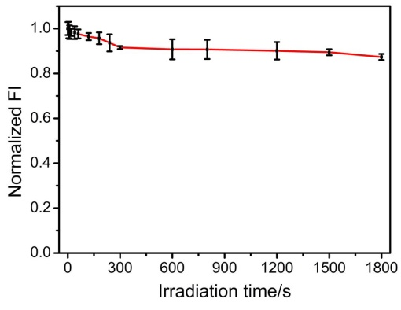

**Fig. S1** Effects of ultraviolet irradiation time on the fluorescence intensity of CDs.

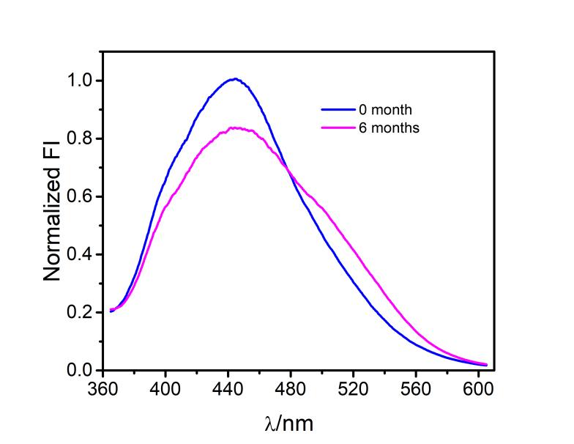

**Fig. S2** Effects of storage time on the fluorescence spectra of the CDs (blue line: 0 month, pink line: 6 months).

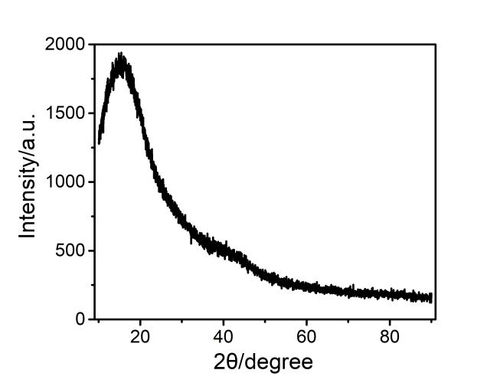

**Fig. S3** XRD spectra of the synthesized CDs.

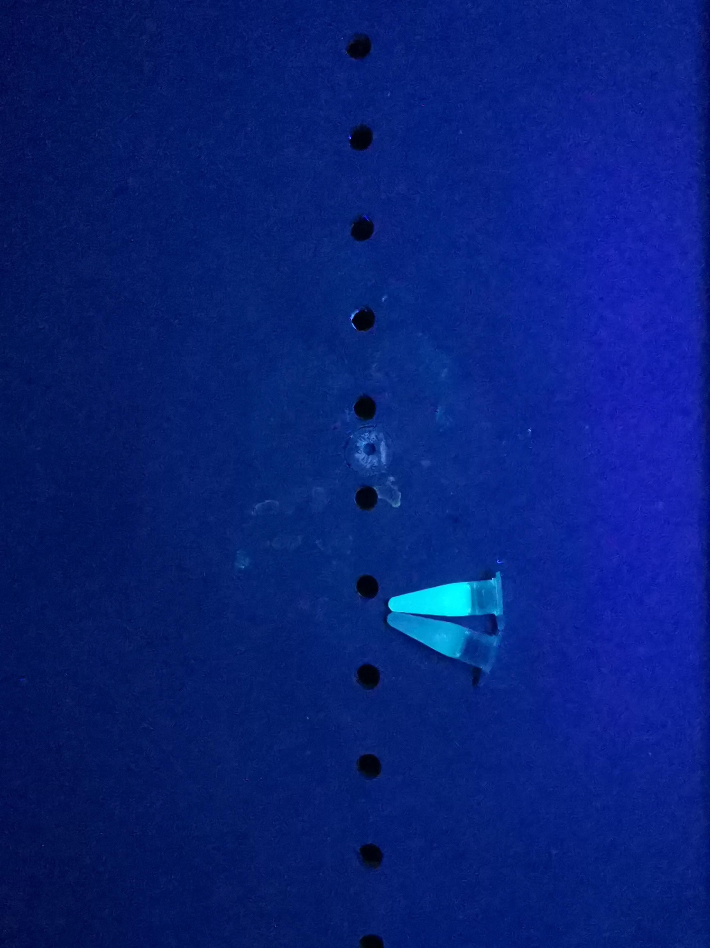

**Fig. S4** Digital photo images of the aqueous solution of the CDs (0.3 mg/mL) and in presence of Fe3+ (6 mM) under UV light (365nm).

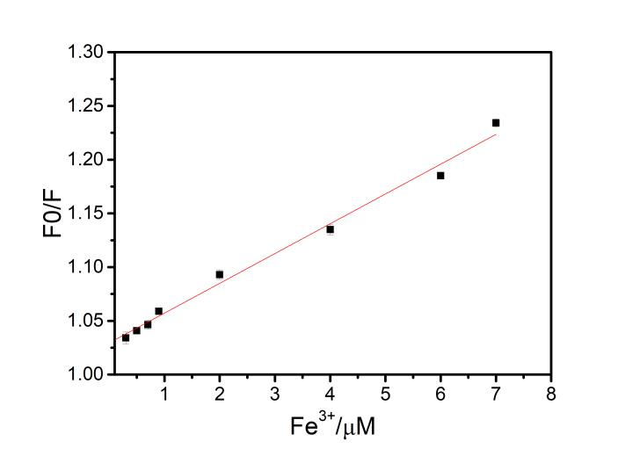

**Fig. S5**. Stern-Volmer plots describes the dependency of the fluorescence intensities on the Fe3+ concentration over the range of 0.3-7 μM.

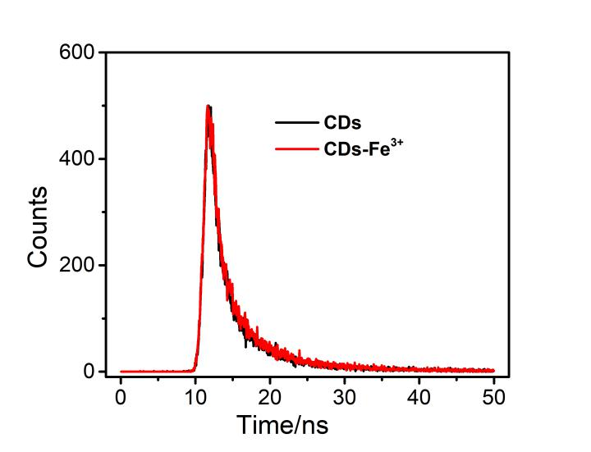

**Fig. S6** The fluorescence lifetime decay curves of the CDs and CDs-Fe3+.

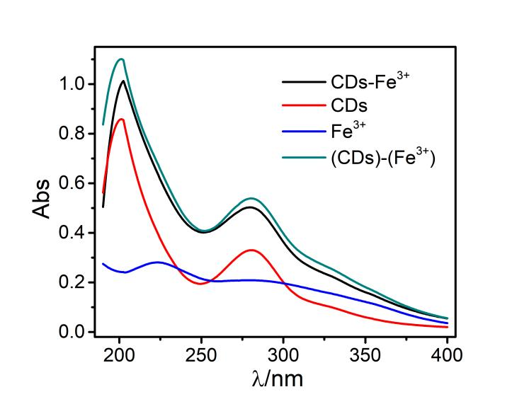

**Fig. S7** Absorption spectrum of CDs, Fe3+, CDs-Fe3+ system and sum absorption of CDs with Fe3+.

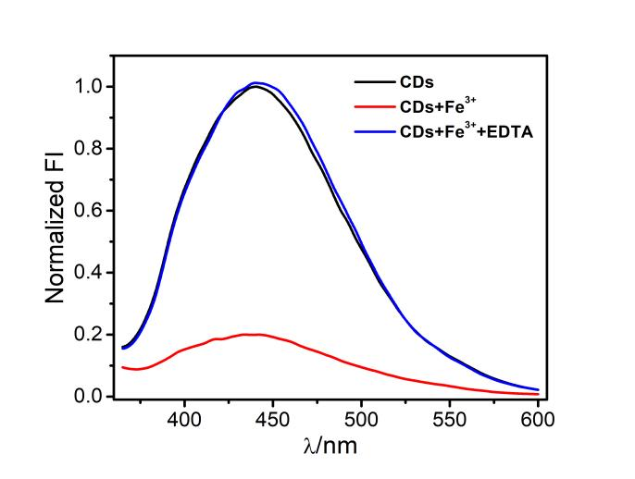

**Fig. S8** Fluorescence spectra of CDs solutions(30 μg/mL) in the absence and presence of other components: 1 mM Fe3+,1 mM Fe3++1 mM EDTA.

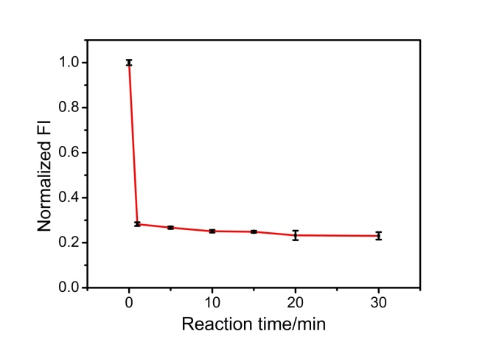

**Fig. S9**  Effects of incubation time on the fluorescence of CDs (30 μg/mL) in the presence of 1 mM Fe3+.

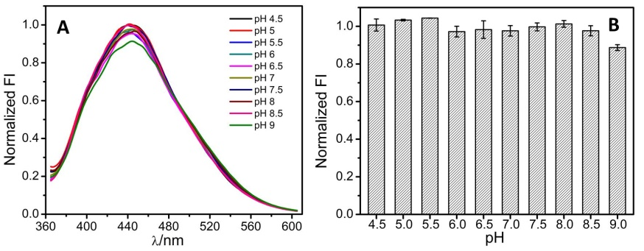

**Fig. S10** The fluorescence spectra of CDs in PB buffer of different pH levels.

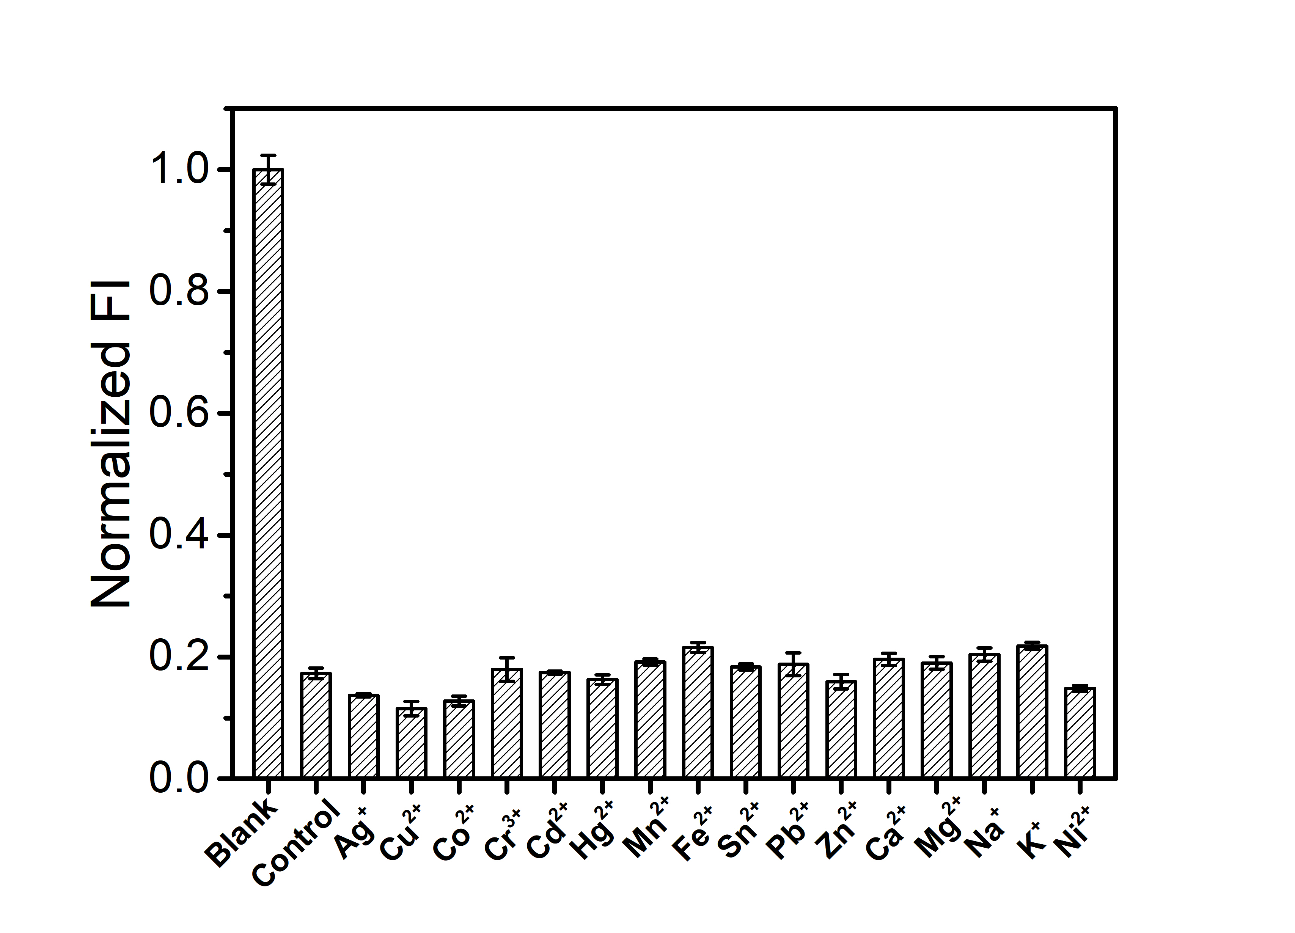

**Fig. S11** Relative fluorescence intensity of CDs co-exist with different metal ion (the concentration of Fe3+ 1 mM, the concentration of each metal ions was 10 times larger than that of Fe3+, from left to right: blank, control, Ag+, Cu2+, Co2+, Cr3+, Cd2+, Hg2+, Mn2+, Fe2+, Sn2+, Pb2+, Zn2+, Ca2+, Mg2+, Na+, K+, Ni2+.

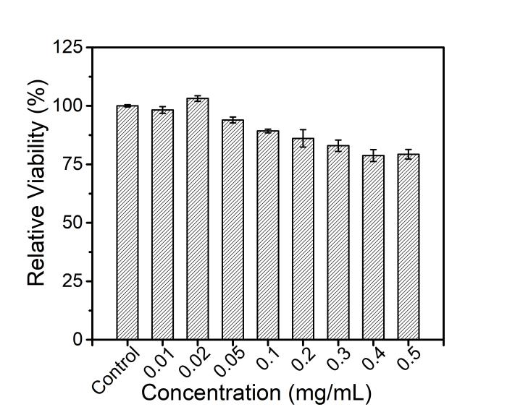

**Fig. S12** Cytotoxicity test of CDs on Hela cells viability. The values represent percentage cell viability (mean%±SD, n=3).

**Table S1.** The comparison between our assay and previous’ CD based assays.

|  |  |  |  |  |  |  |
| --- | --- | --- | --- | --- | --- | --- |
| Materials | Starting materials | Synthetic methods | Analyte | Limit of detection | Linear Range | References |
| N-CDs | Chitosan and tartaric acid | hydrothermal | Fe3+ | 0 μM- 2000 μM | 1.15 μM | (Lv et al., 2020) |
| B-CDs | Glucose and boric acid | hydrothermal | Fe3+ | 0 μM- 16 μM | 242 nM | (Wang et al., 2016) |
| CDs | 1,2,4-triaminobenzene and formamide | solvothermal | Fe3+ | 1 μM- 60 μM | 0.28 μM | (Xu et al., 2019) |
| CDs | Fish scale | hydrothermal | Fe3+ | 1 μM- 78 μM | 0.54 μM | (Zhang et al., 2019) |
| CDs | Cranberry beans | hydrothermal | Fe3+ | 30 μM- 600 μM | 9.55 μM | (Zulfajri et al., 2019) |
| N-CDs | Citric acid and allylamine  hydrochloride | hydrothermal | Fe3+ | 0.05 μM- 30 μM | 13.5 nM | (Zhou et al., 2019) |
| N-CDs | *Prunus avium* fruit extract | hydrothermal | Fe3+ | 0 μM- 100 μM | 0.96 μM | (Edison et al., 2016) |
| CDs | Goose feathers | microwave | Fe3+ | 0 μM- 10 μM | 0.196 μM | |  | | --- | | (Liu et al., 2015) | |

**References:**

Edison, T. N. J. I., Atchudan, R., Shim, J., Kalimuthu, S., Ahn, B. & Lee, Y. R. 2016. Turn-off fluorescence sensor for the detection of ferric ion in water using green synthesized N-doped carbon dots and its bio-imaging. J. Photochem. Photobiol. 158:235-42. https://doi.org/10.1016/j.jphotobiol.2016.03.010.

Liu, R., Zhang, J., Gao, M., Li, Z., Chen, J., Wu, D. & Liu, P. 2015. A facile microwave-hydrothermal approach towards highly photoluminescent carbon dots from goose feathers. RSC Adv. 5:4428-33. https://doi.org/10.1039/c4ra12077a.

Lv, X., Man, H., Dong, L., Huang, J., & Wang, X. 2020. Preparation of highly crystalline nitrogen-doped carbon dots and their application in sequential fluorescent detection of Fe3+ and ascorbic acid. Food Chem. 326:126935. https://doi.org/10.1016/j.foodchem.2020.126935.

Wang, F., Hao, Q., Zhang, Y., Xu, Y., & Lei, W. 2016. Fluorescence quenchometric method for determination of ferric ion using boron-doped carbon dots. Microchim. Acta. 183(1):273-279. https://doi.org/10.1007/s00604-015-1650-1.

Zhang, Y., Gao, Z., Yang, X., Chang, J., Liu, Z., & Jiang, K. 2019. Fish-scale-derived carbon dots as efficient fluorescent nanoprobes for detection of ferric ions. RSC Adv. 9(2):940-949. https://doi.org/10.1039/c8ra09471c.

Zhou, X., Zhao, G., Tan, X., Qian, X., Zhang, T., Gui, J., Yang, L., & Xie, X. 2019. Nitrogen-doped carbon dots with high quantum yield for colorimetric and fluorometric detection of ferric ions and in a fluorescent ink. Microchim. Acta. 186(2):67. https://doi.org/10.1007/s00604-018-3176-9.

Zulfajri, M., Gedda, G., Chang, C., Chang, Y., & Huang, G. G. 2019. Cranberry beans derived carbon dots as a potential fluorescence sensor for selective detection of Fe3+ ions in aqueous solution. ACS Omega. 4(13):15382-15392. https://doi.org/10.1021/acsomega.9b01333.