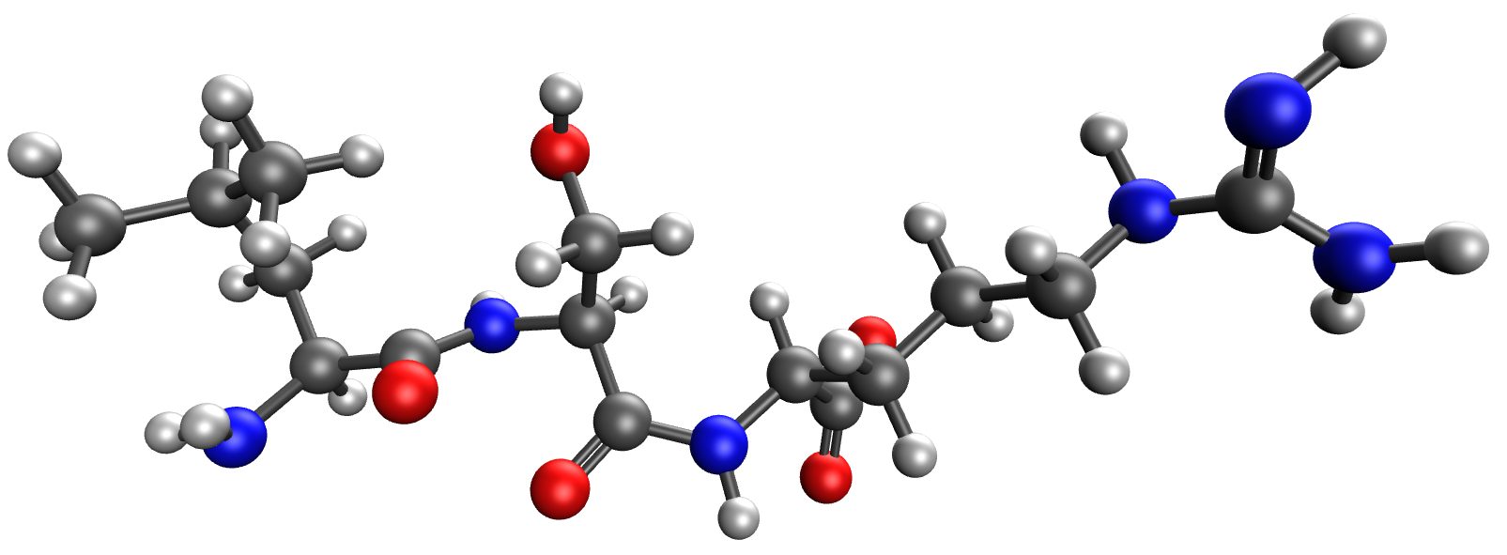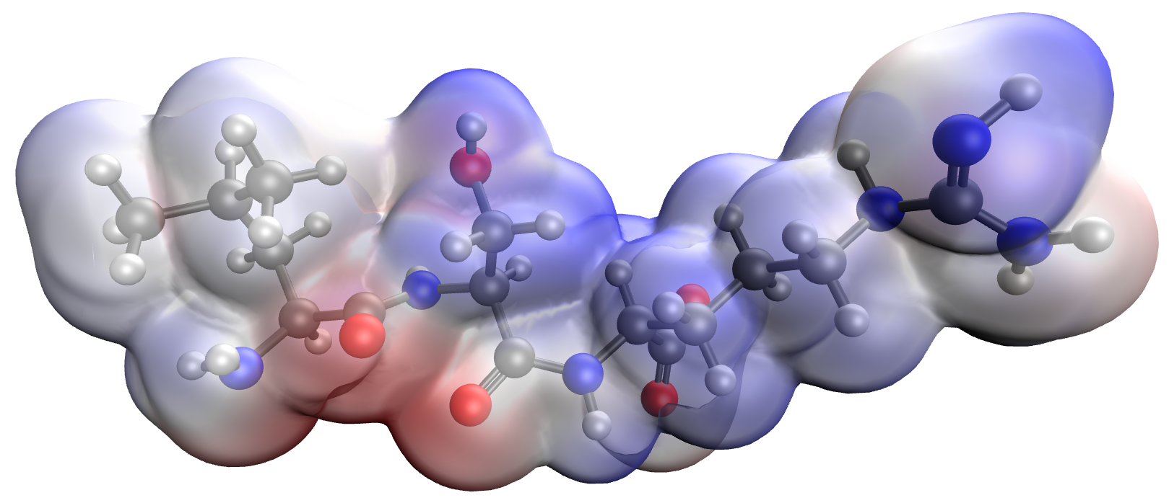
а b


c

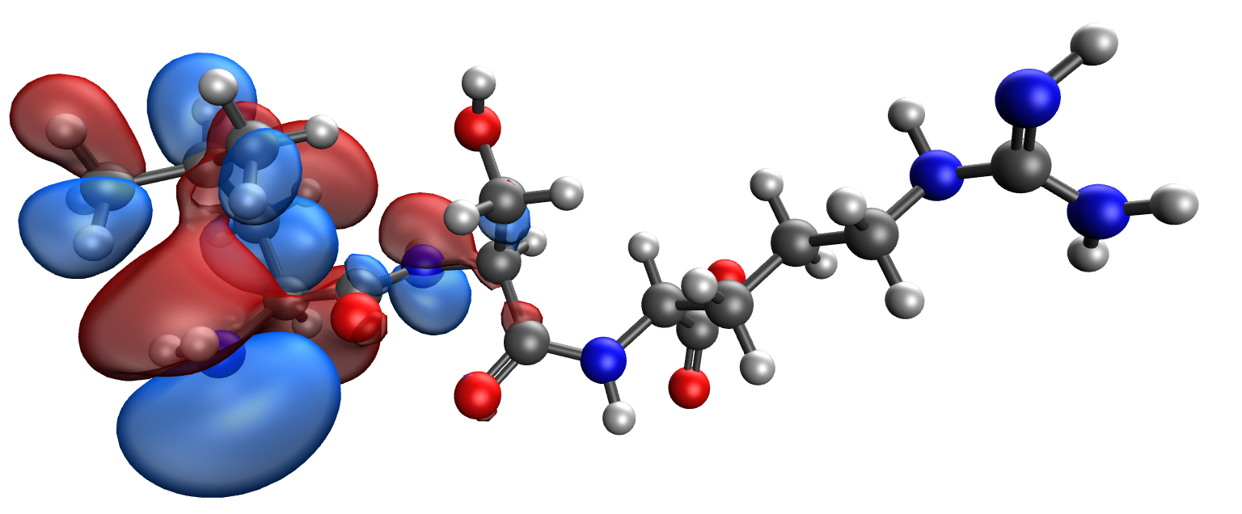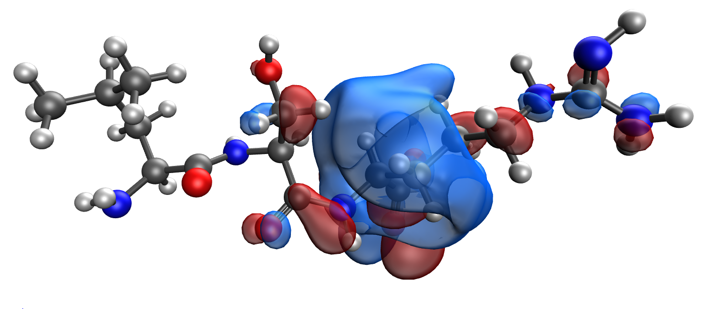
d e

Figure 1. Model of the Leu-Ser-Arg κ-casein segment containing the phosphoric acid residue: (a), electron density distribution (b), electron density distribution gradient (c) highest occupied molecular orbital HOMO (d) and lowest unoccupied molecular orbital LUMO (e)

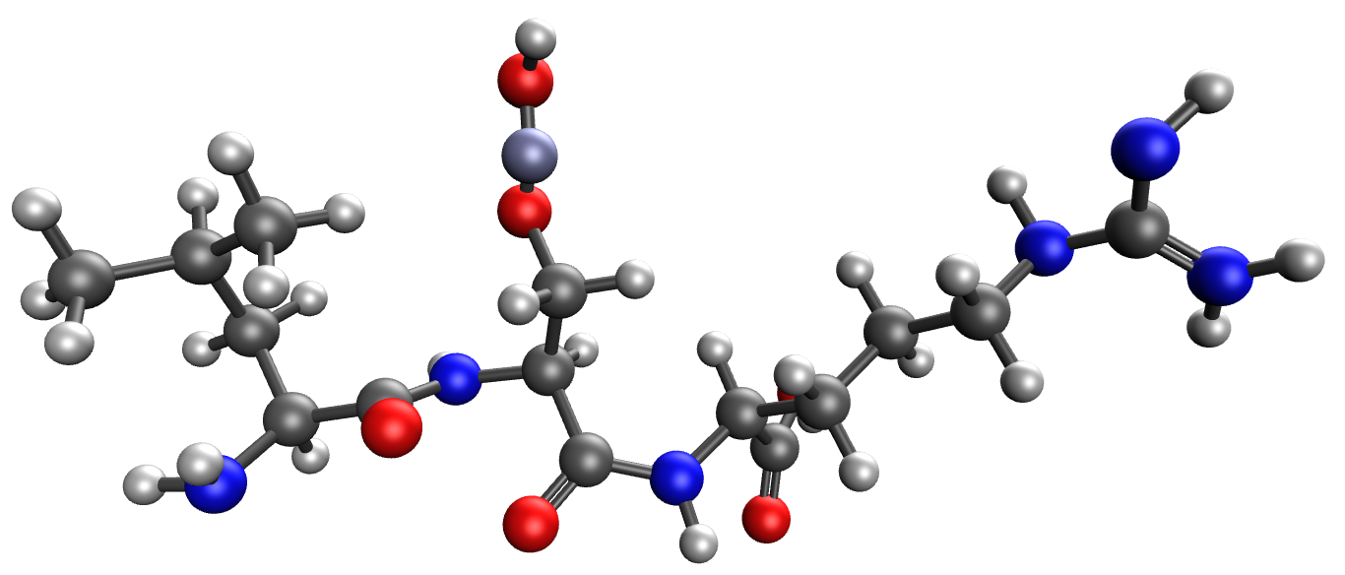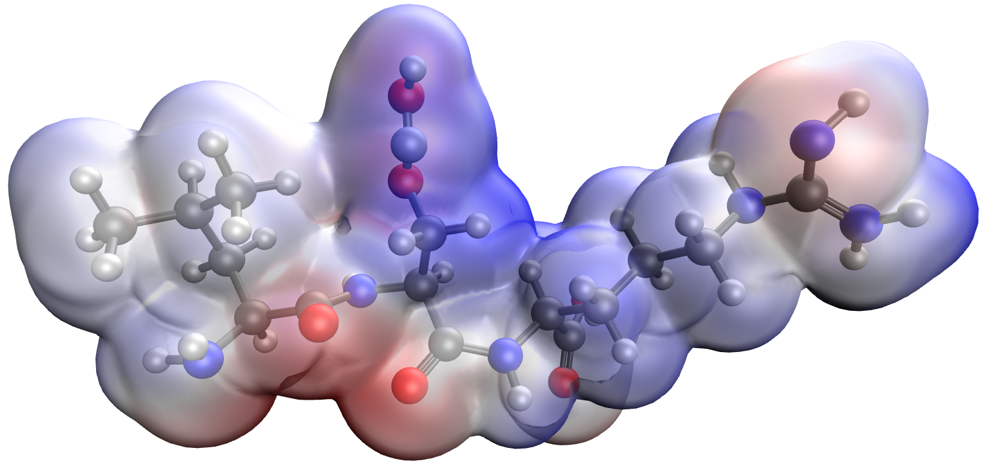
а b


c

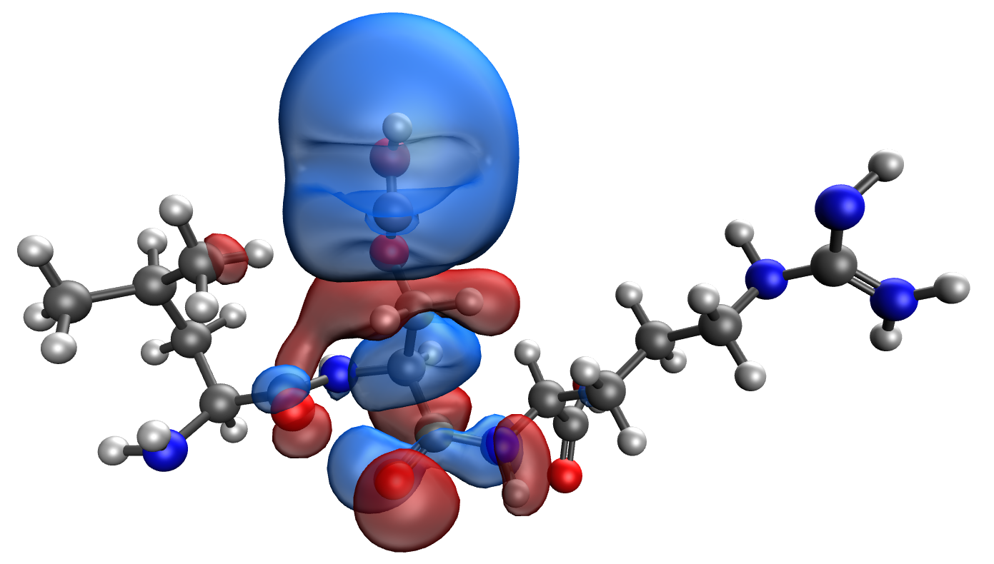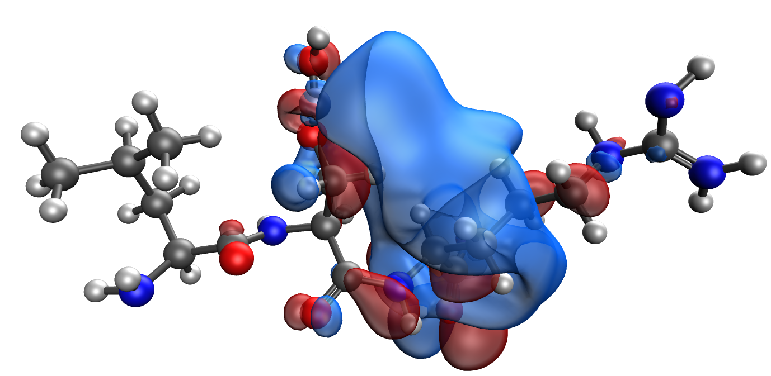

d e
Figure 2. Model of the Leu-Ser-Arg-Zn κ-casein segment containing the phosphoric acid residue: (a), electron density distribution (b), electron density distribution gradient (c) highest occupied molecular orbital HOMO (d) and lowest unoccupied molecular orbital LUMO (e)

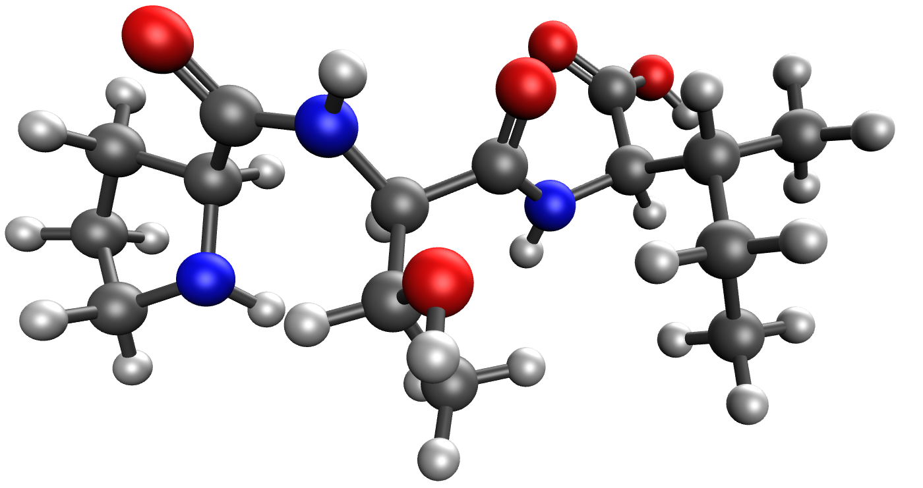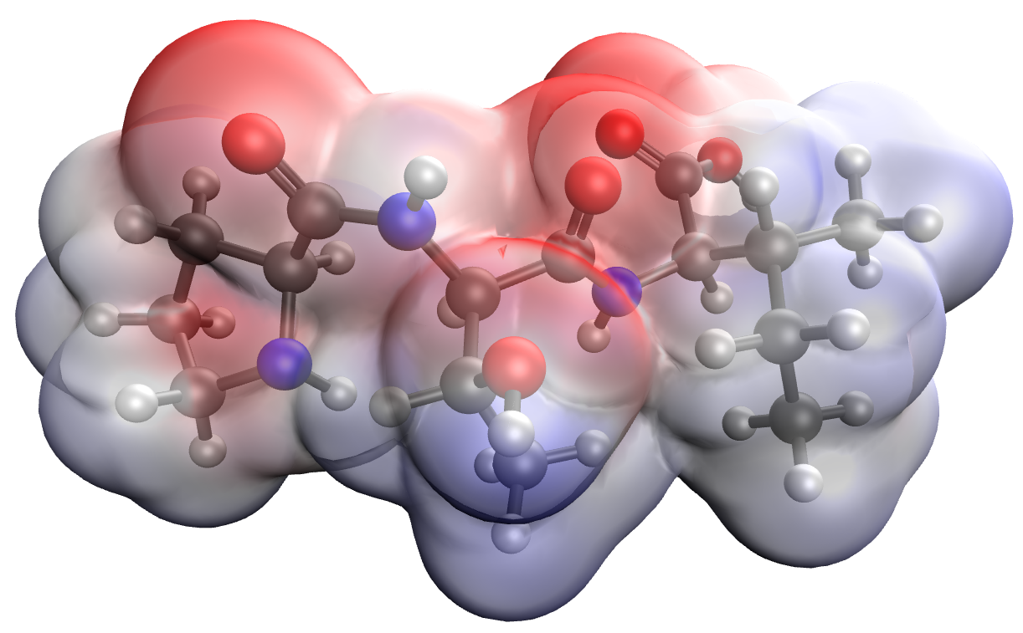
а b


c

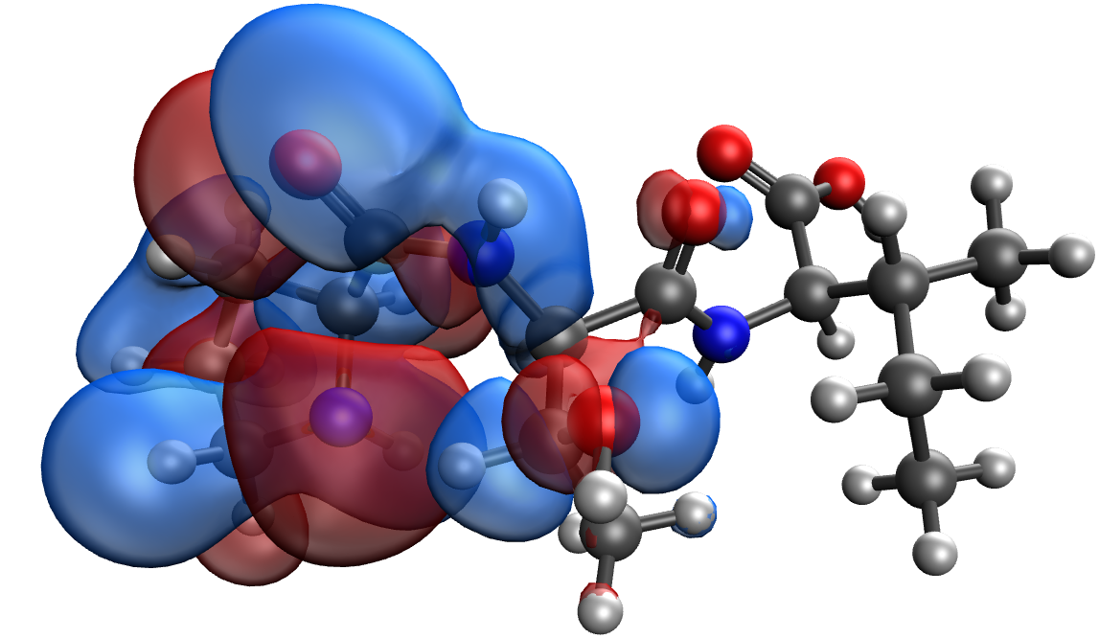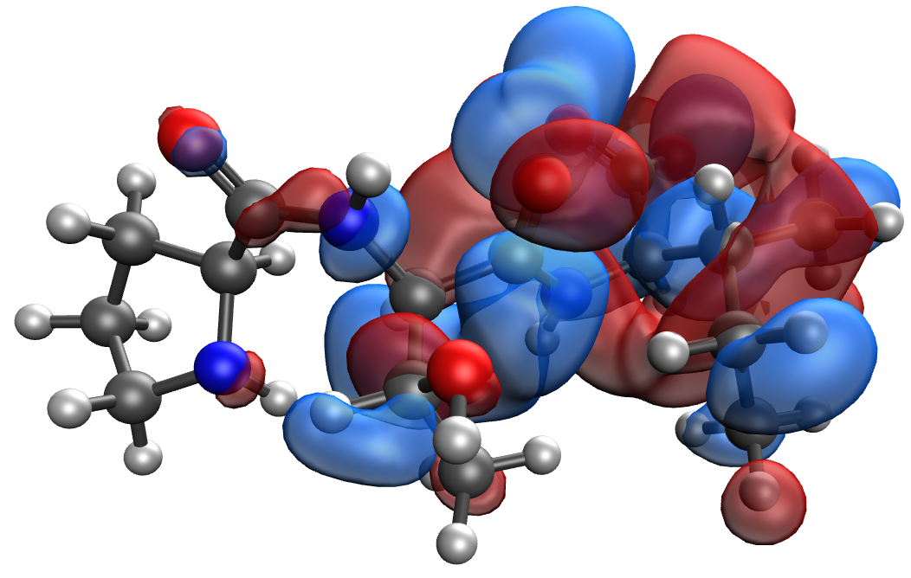
d e
Figure 3. Model of the Pro-Thr-Arg κ-casein segment containing the phosphoric acid residue: (a), electron density distribution (b), electron density distribution gradient (c) highest occupied molecular orbital HOMO (d) and lowest unoccupied molecular orbital LUMO (e)

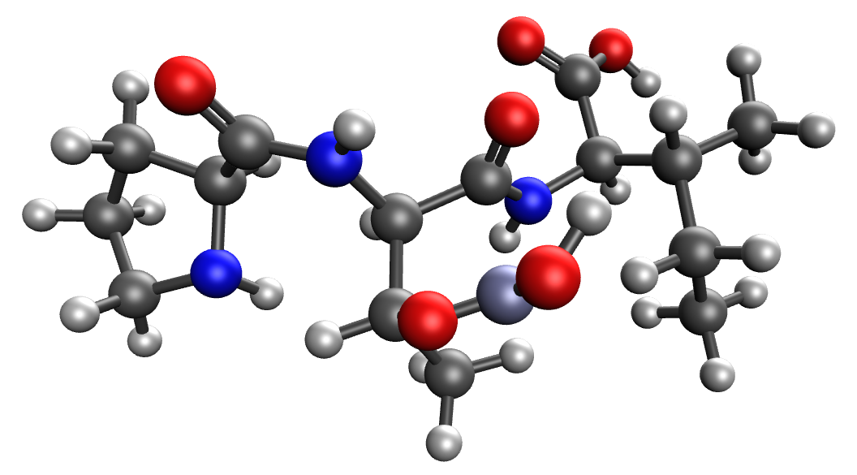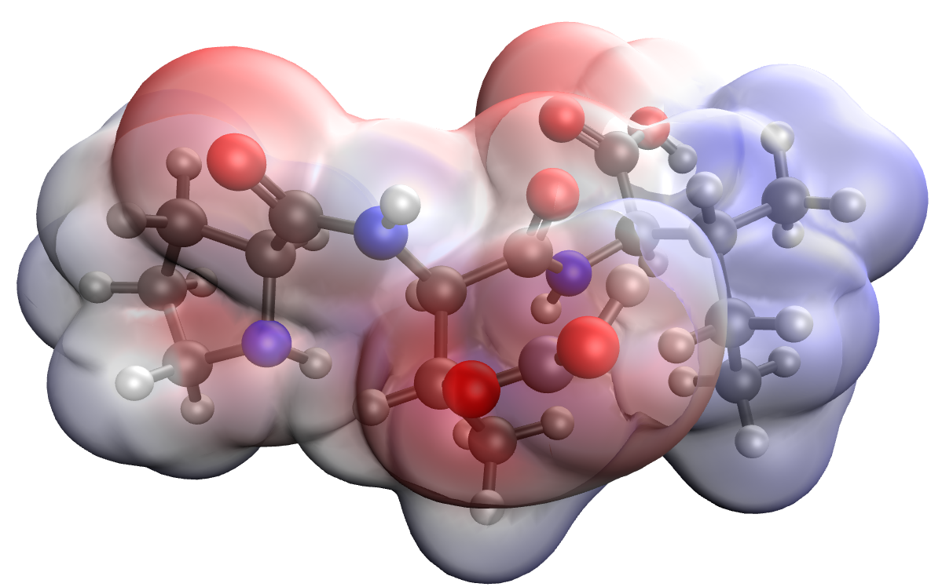
а b

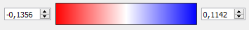
c

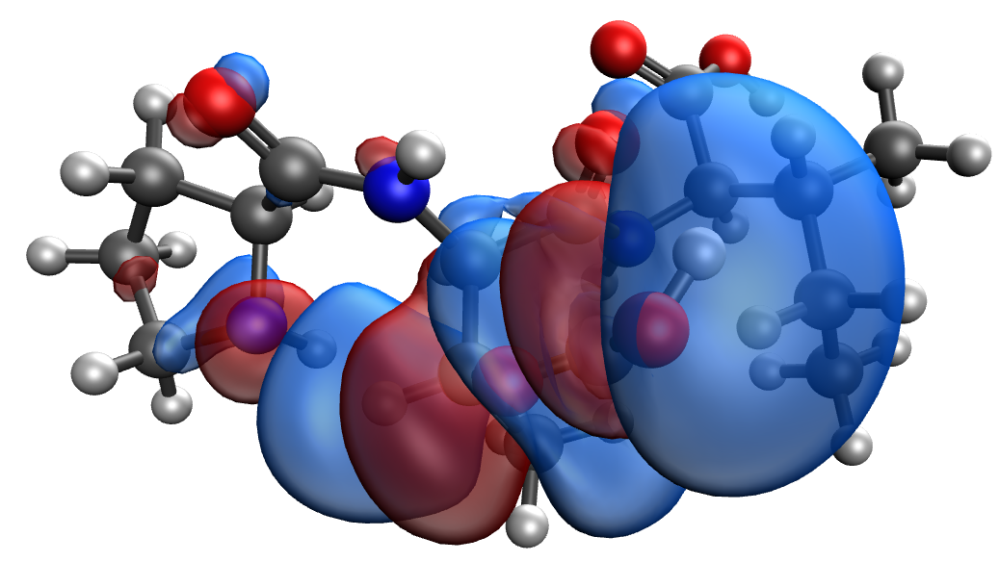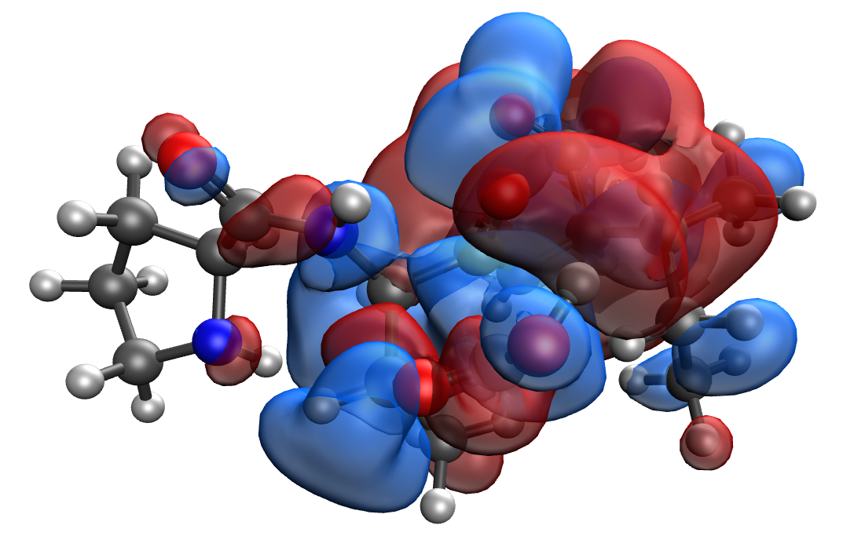
d e
Figure 4. Model of the Pro-Thr-Arg-Zn κ-casein segment containing the phosphoric acid residue: (a), electron density distribution (b), electron density distribution gradient (c) highest occupied molecular orbital HOMO (d) and lowest unoccupied molecular orbital LUMO (e)

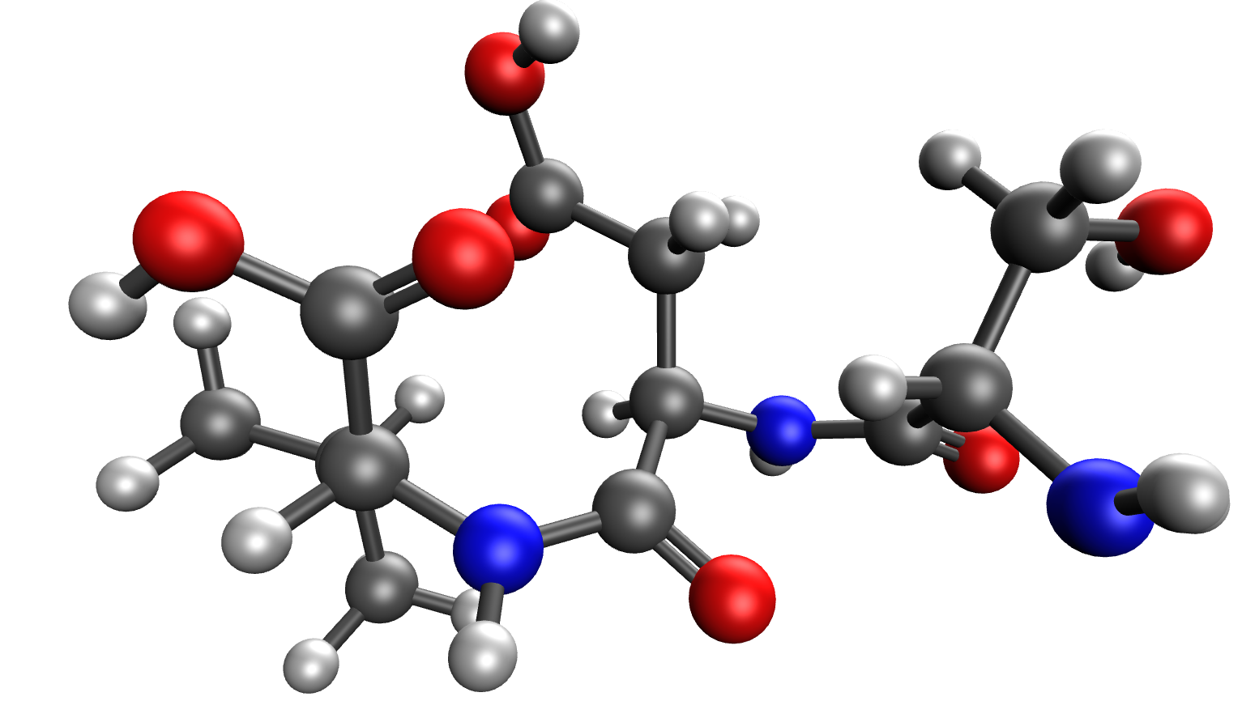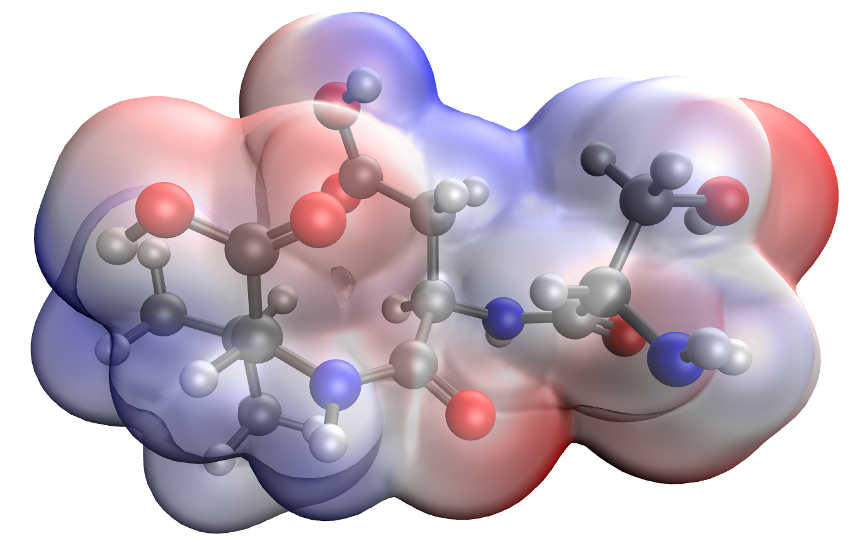
а b

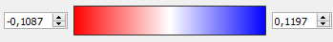
c

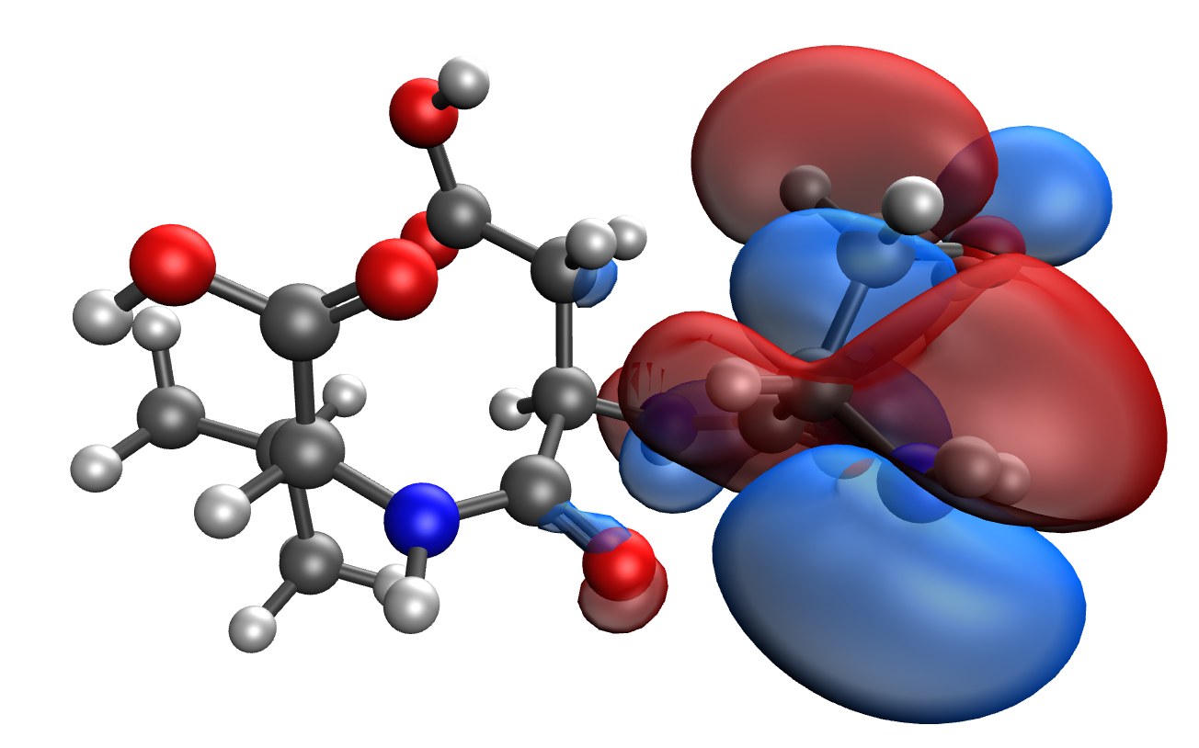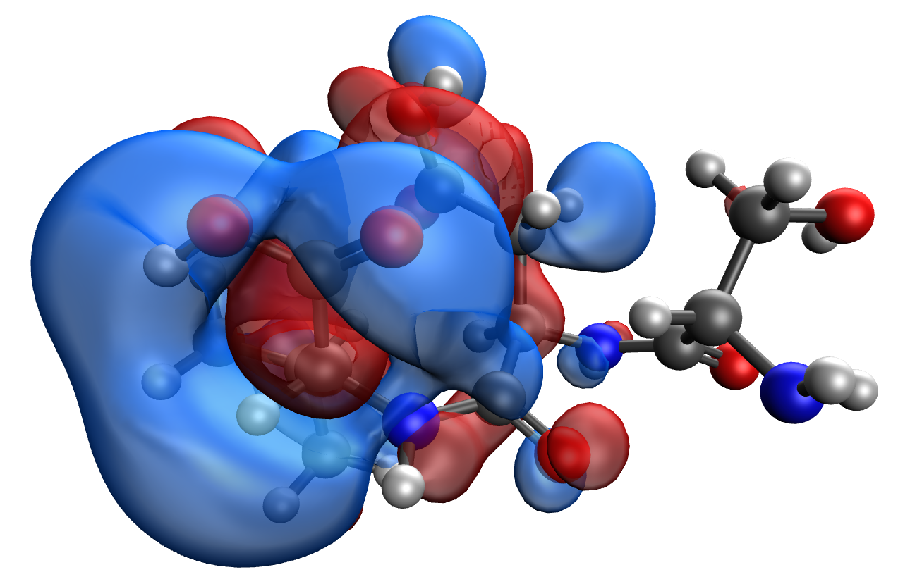
d e
Figure 5. Model of the Ser-Asp-Val κ-casein segment containing the phosphoric acid residue: (a), electron density distribution (b), electron density distribution gradient (c) highest occupied molecular orbital HOMO (d) and lowest unoccupied molecular orbital LUMO (e)

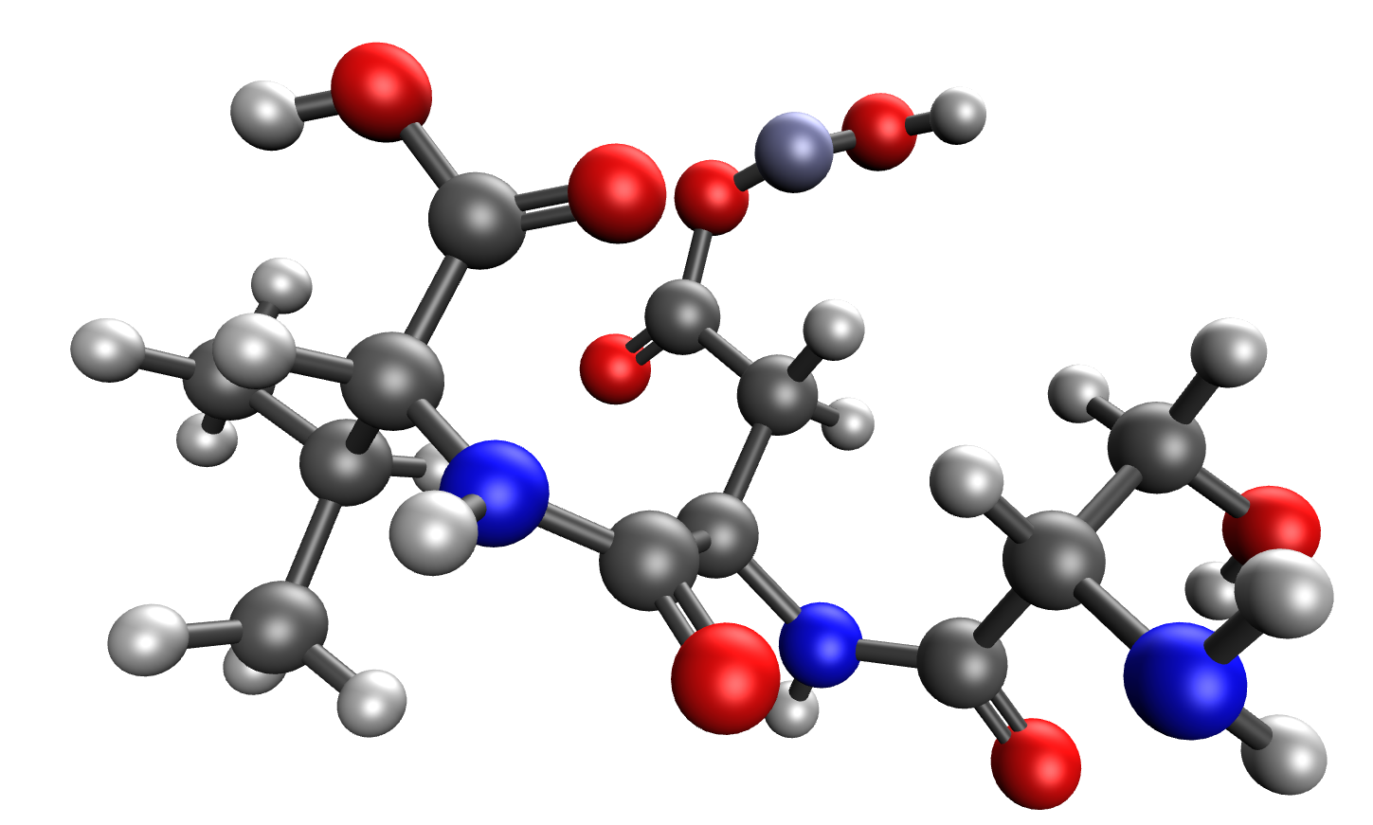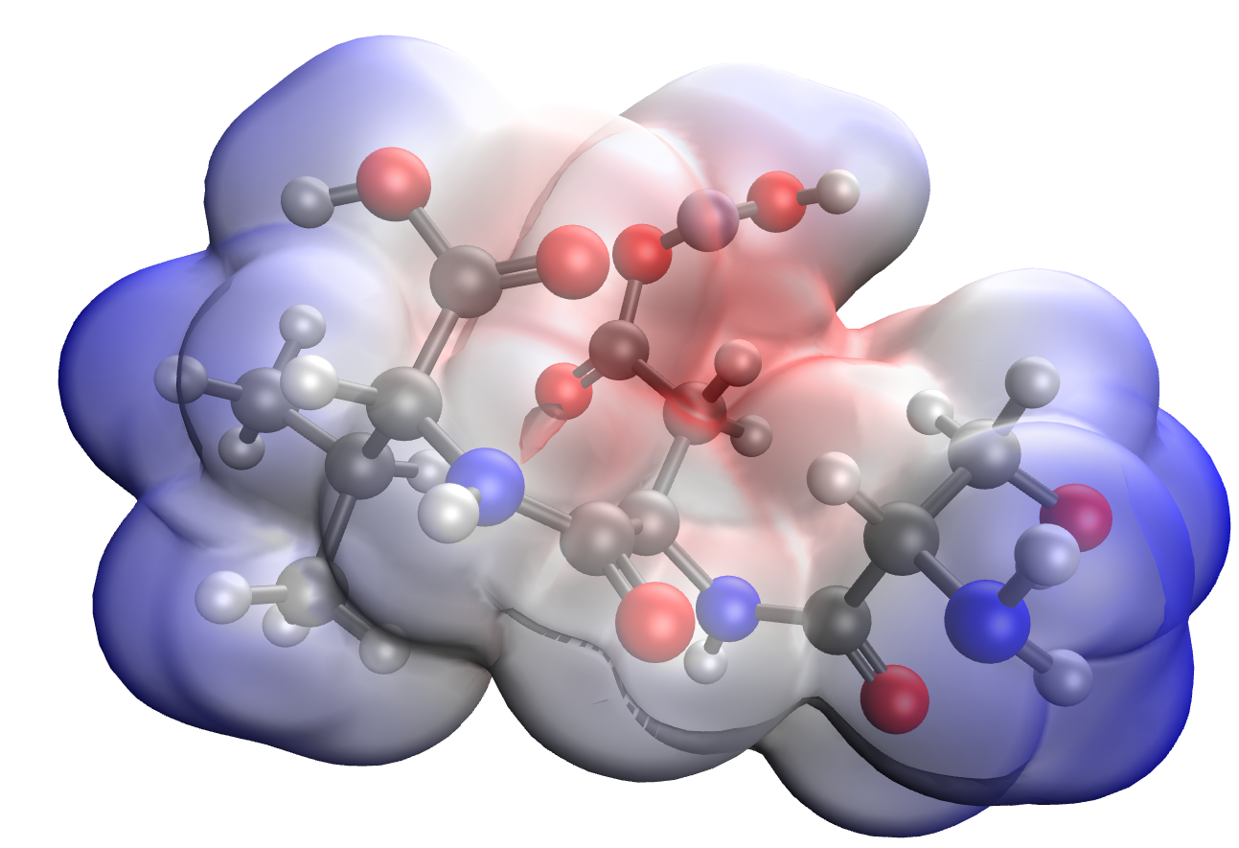
а b


c

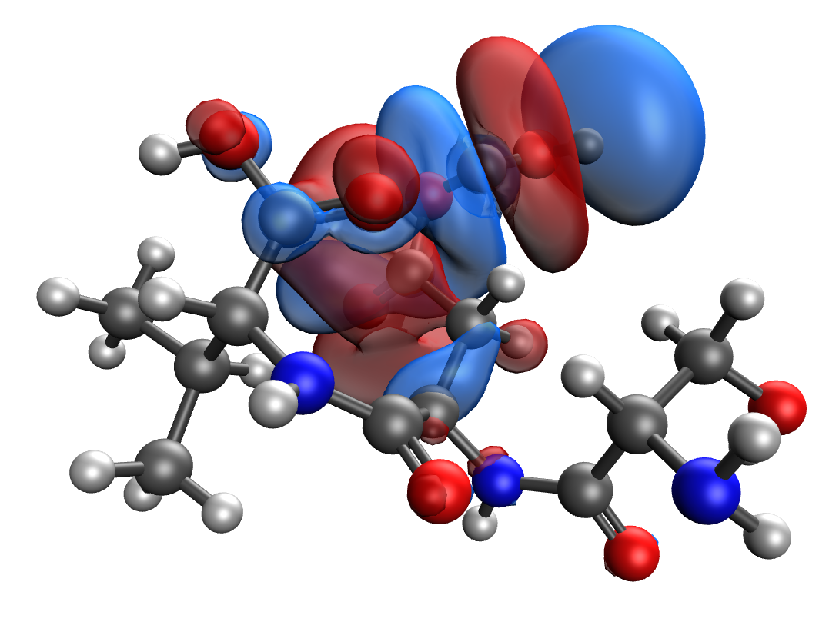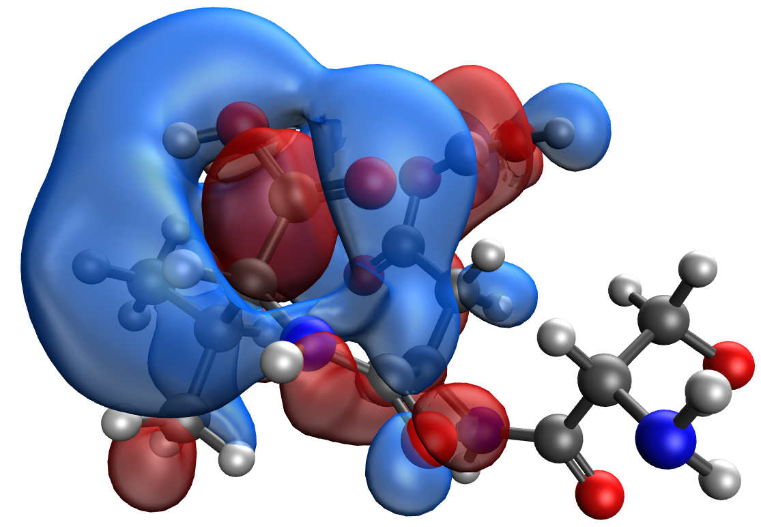
d e
Figure 6. Model of the Ser-Asp-Val-Zn κ-casein segment containing the phosphoric acid residue: (a), electron density distribution (b), electron density distribution gradient (c) highest occupied molecular orbital HOMO (d) and lowest unoccupied molecular orbital LUMO (e)

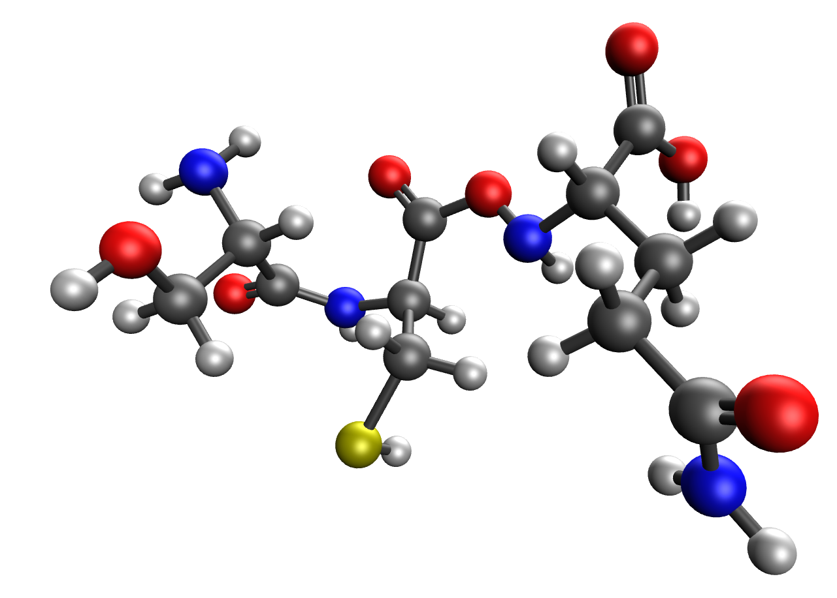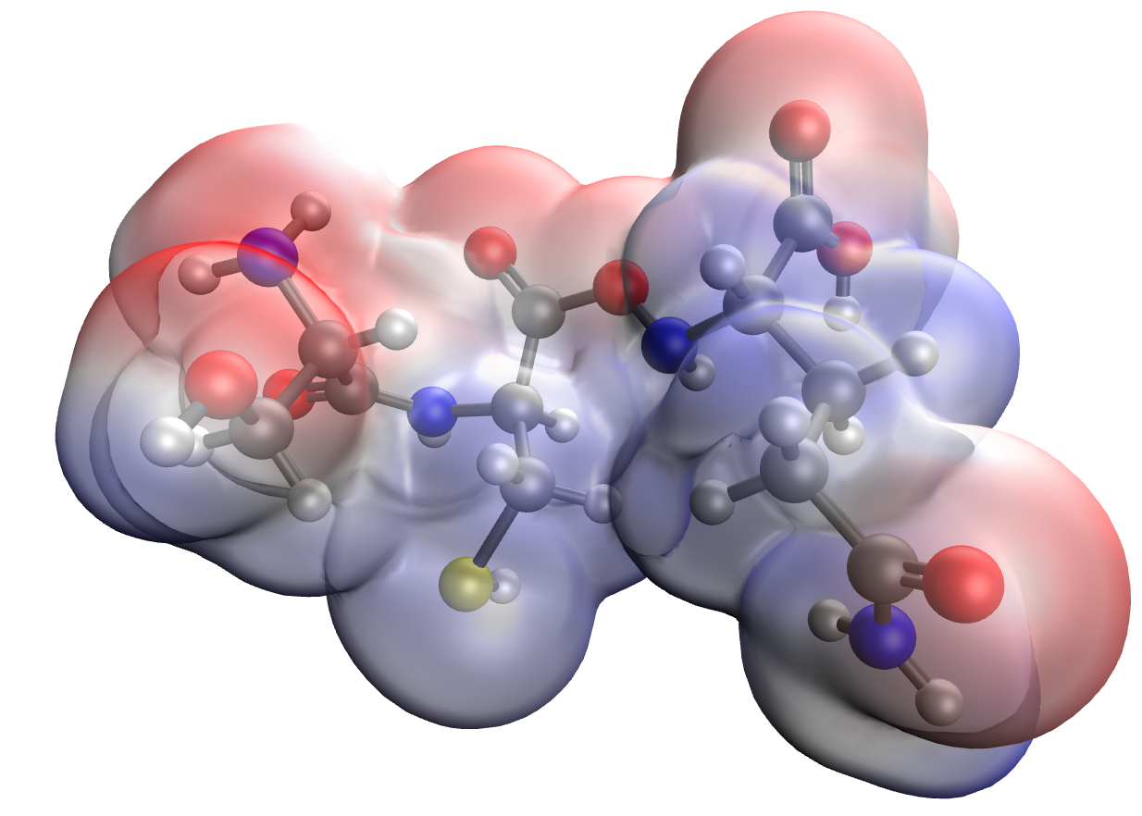
а b

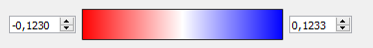
c

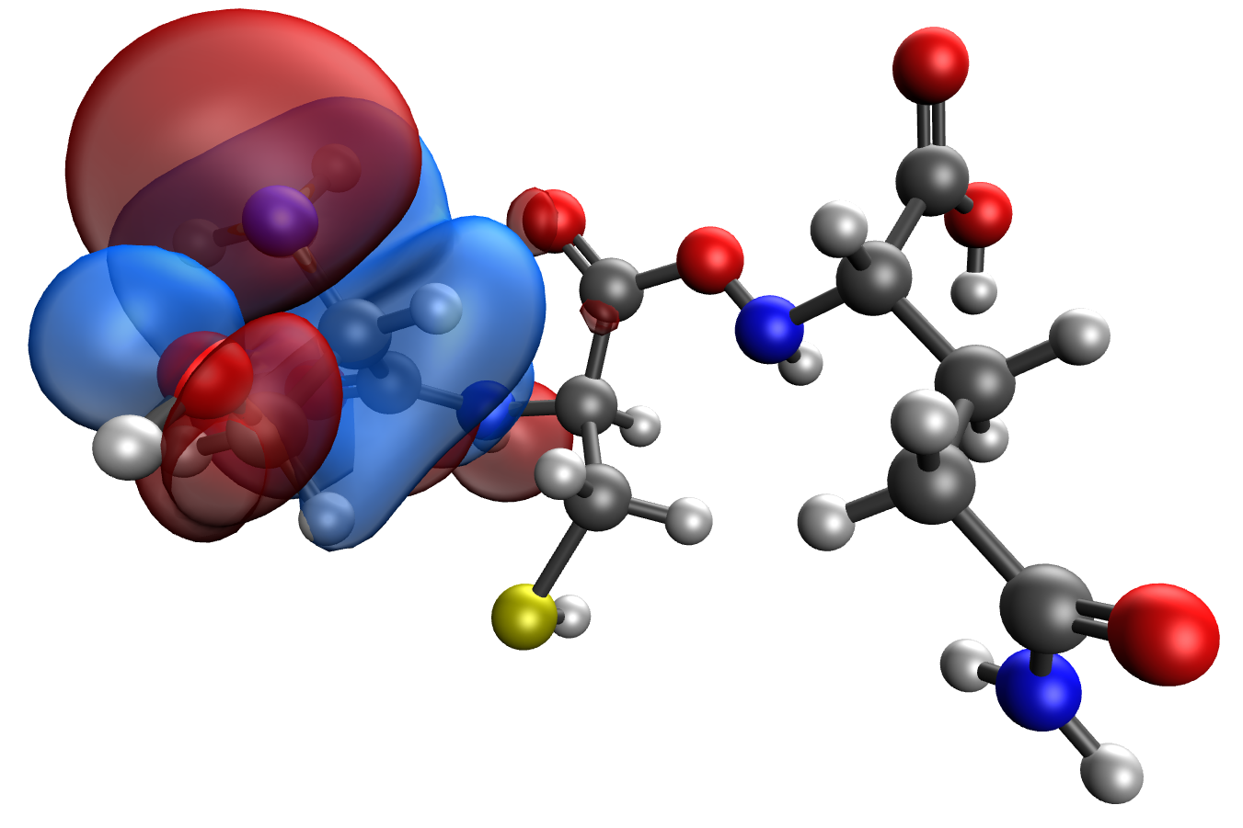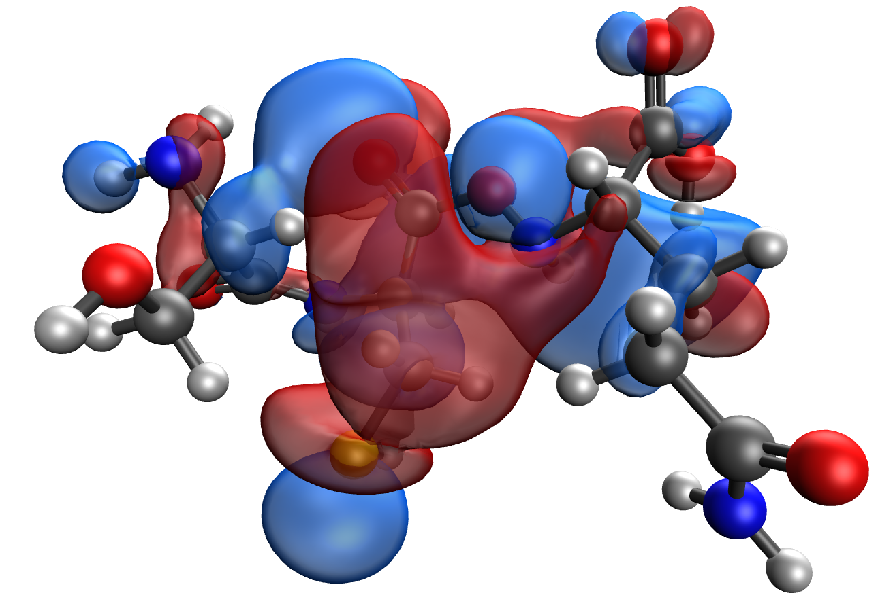
d e
Figure 7. Model of the Ser-Cys-Gln κ-casein segment containing the phosphoric acid residue: (a), electron density distribution (b), electron density distribution gradient (c) highest occupied molecular orbital HOMO (d) and lowest unoccupied molecular orbital LUMO (e)

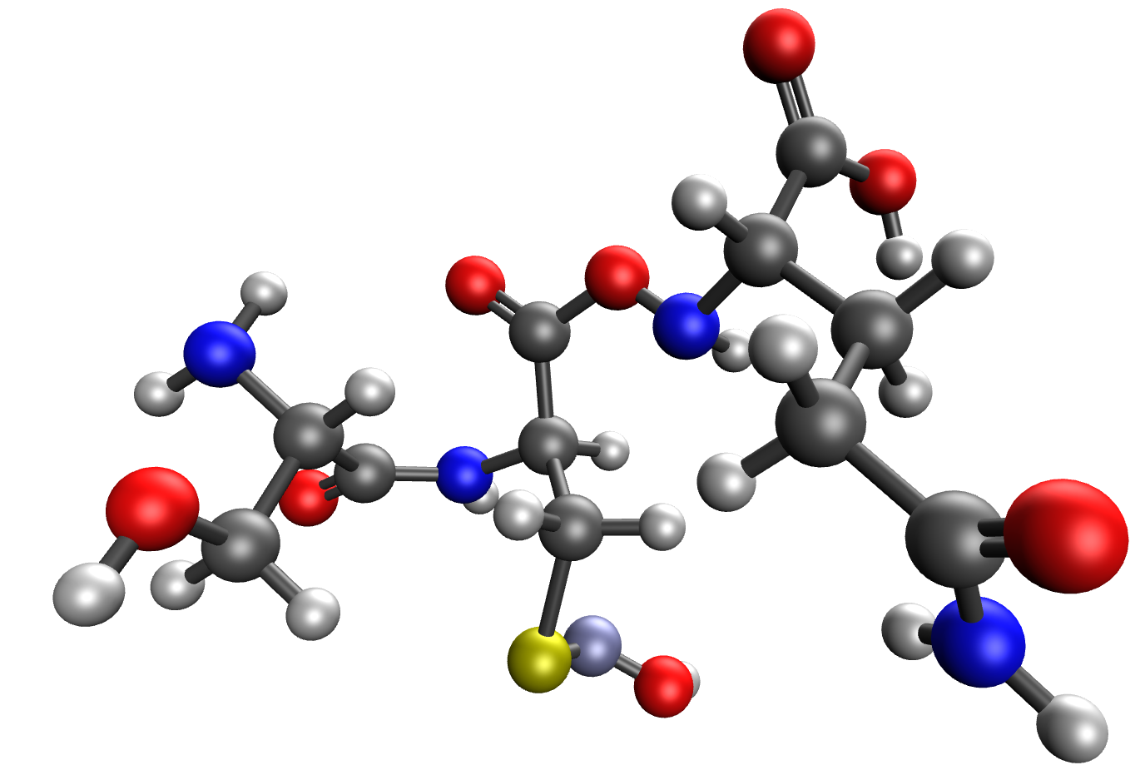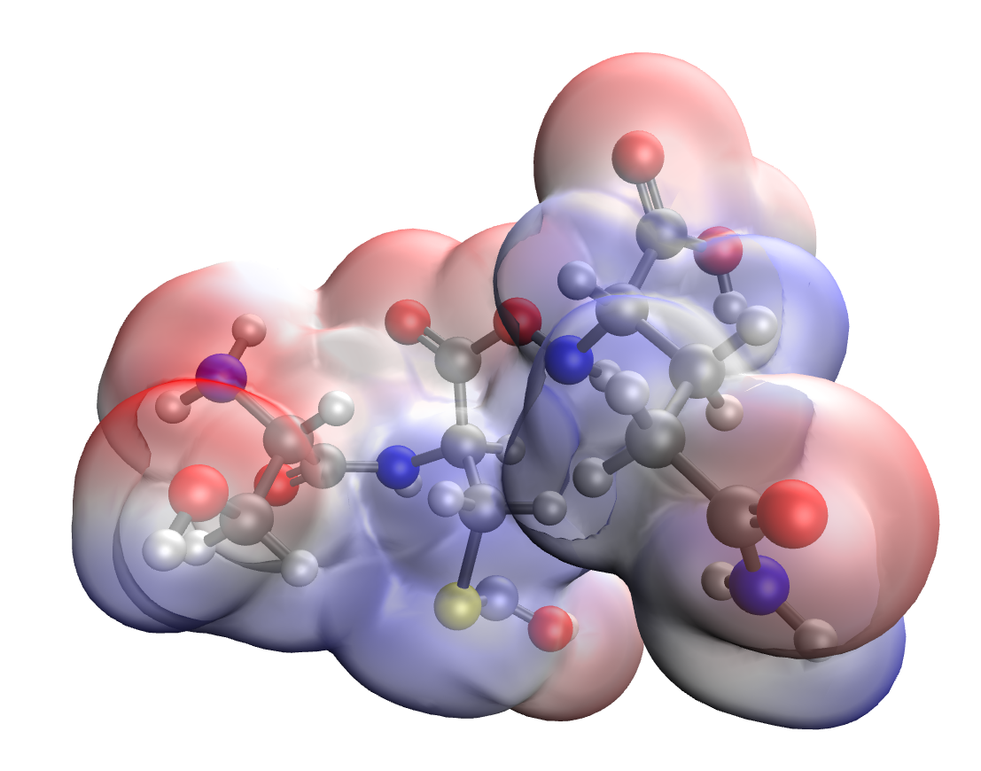
а b


c

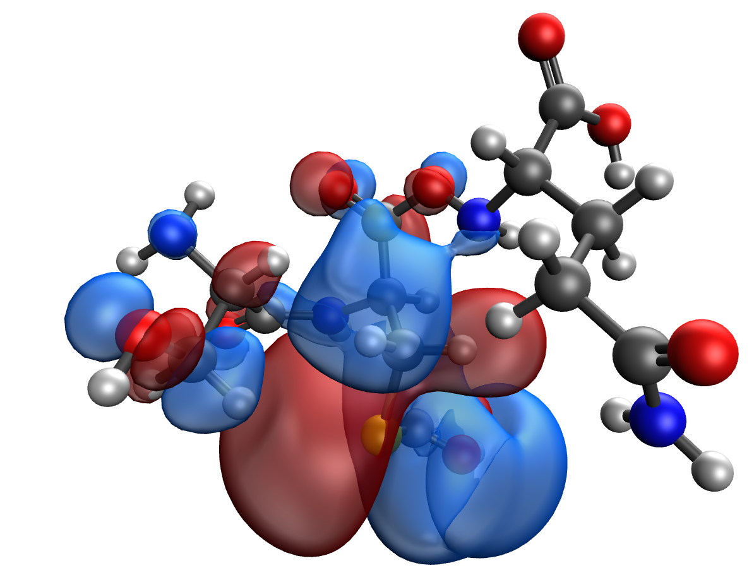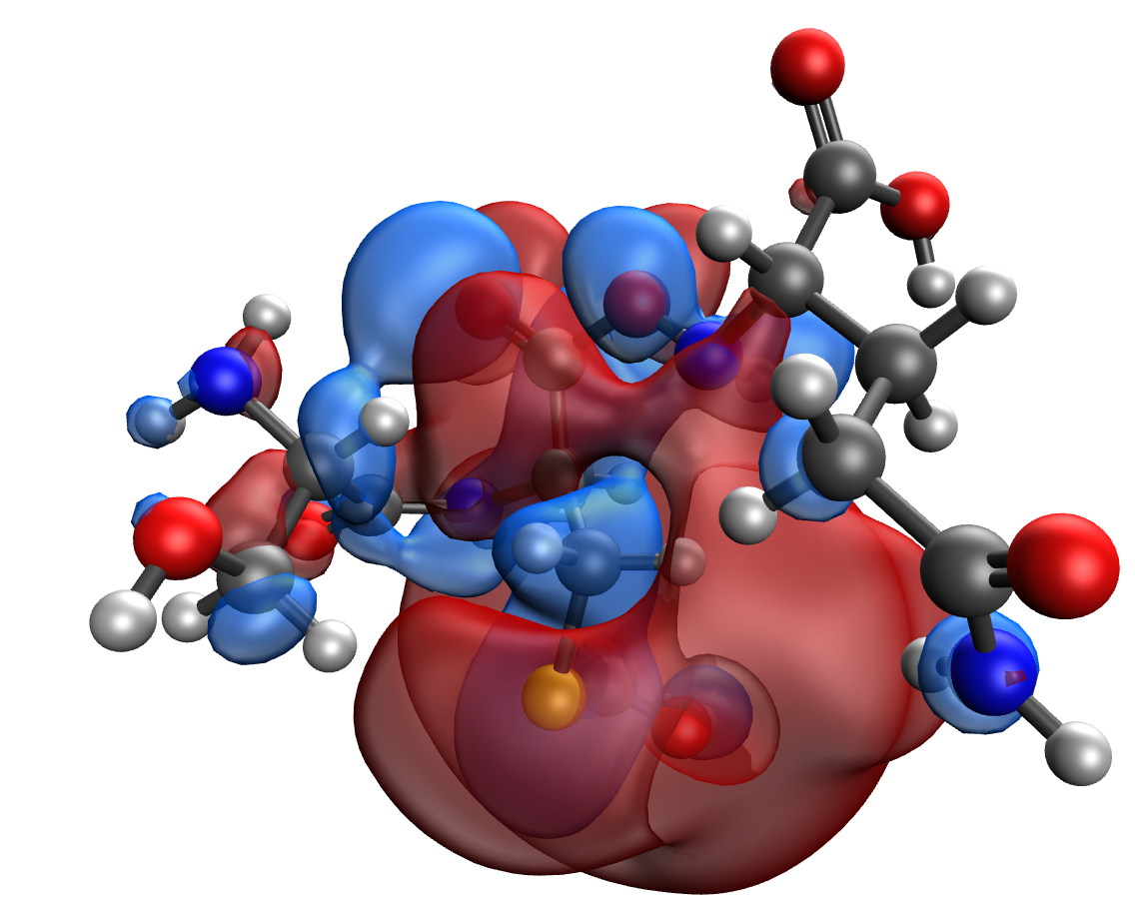
d e
Figure 8. Model of the Ser-Cys-Gln -Zn κ-casein segment containing the phosphoric acid residue: (a), electron density distribution (b), electron density distribution gradient (c) highest occupied molecular orbital HOMO (d) and lowest unoccupied molecular orbital LUMO (e)

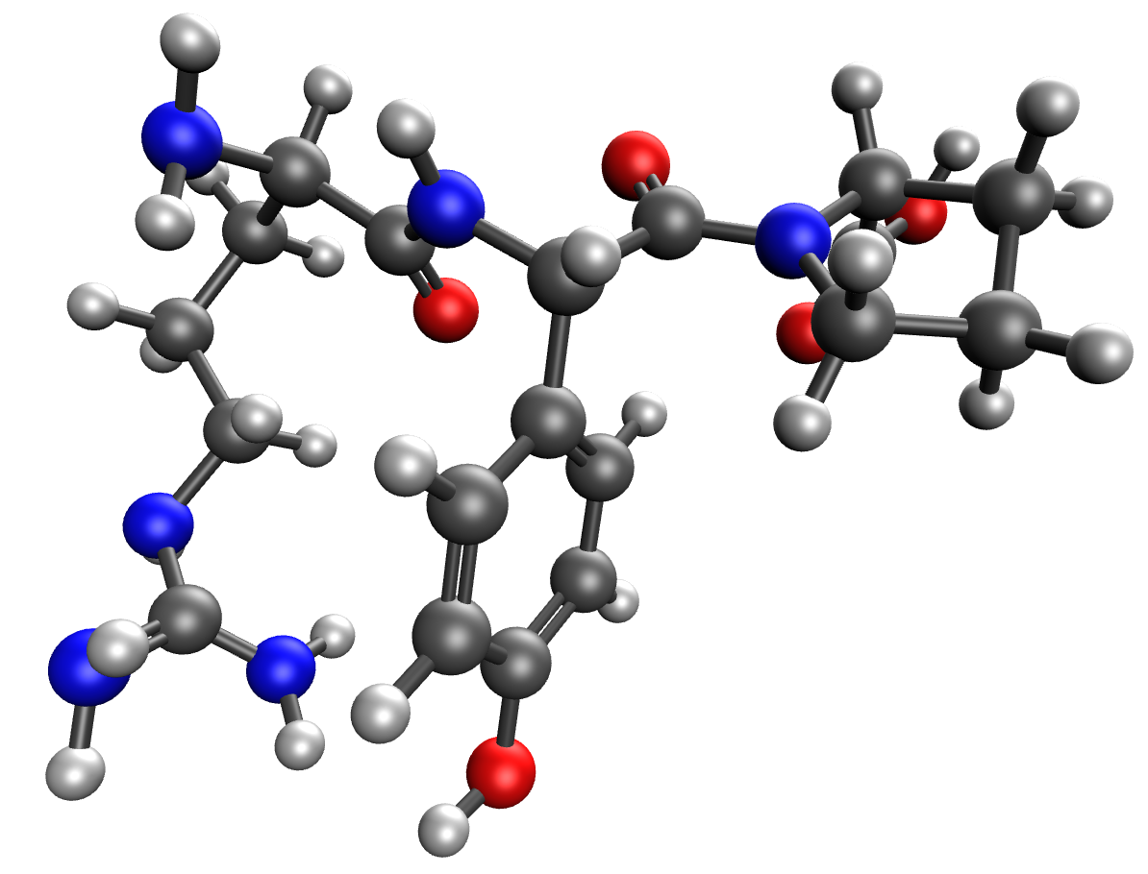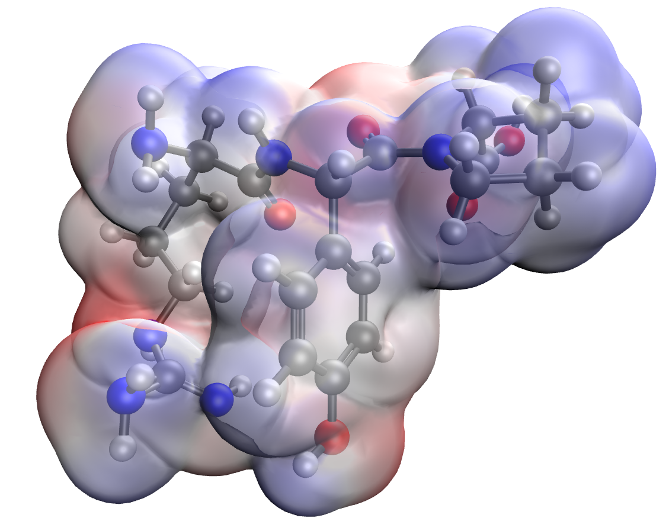
а b

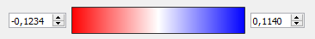
c

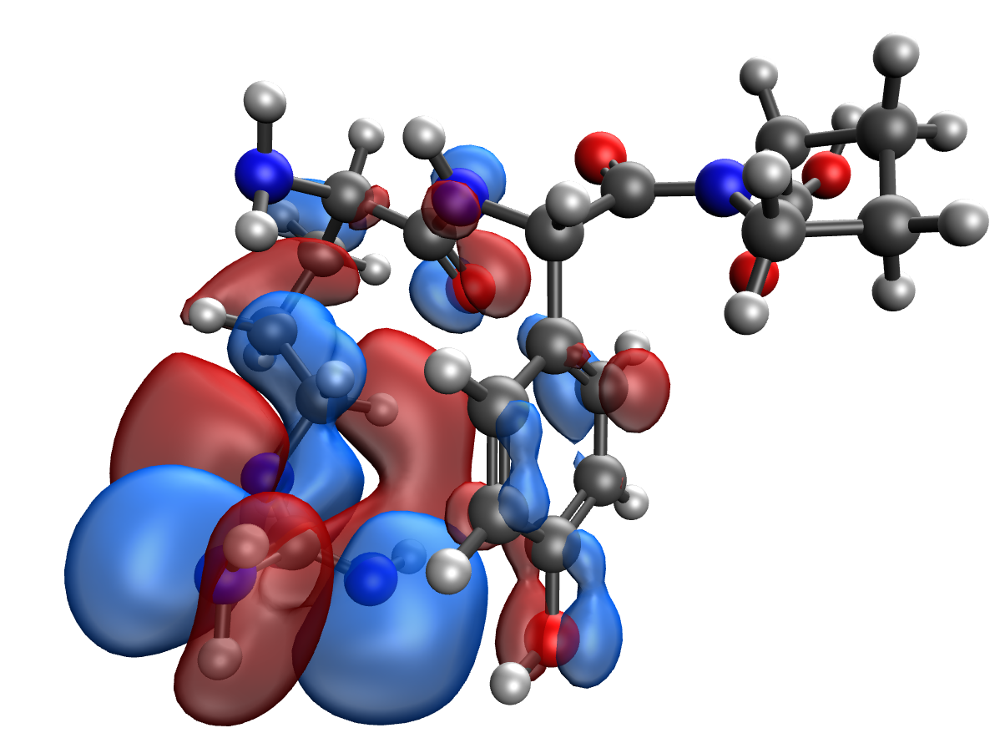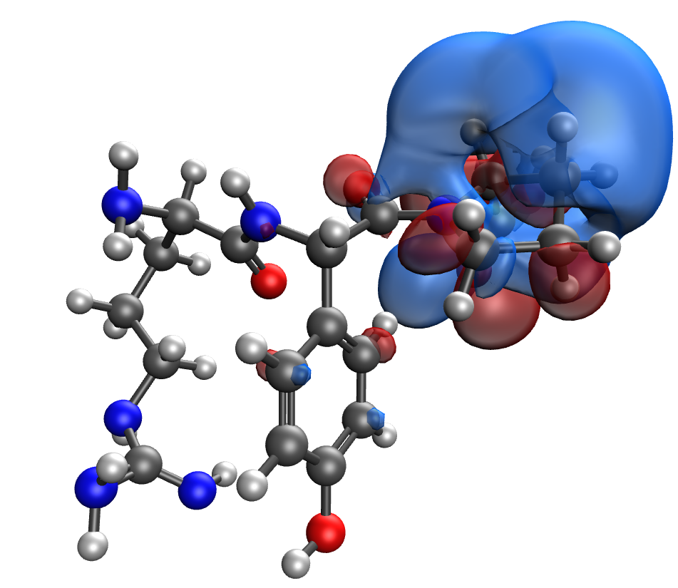
d e
Figure 9. Model of the Arg-Tyr-Pro κ-casein segment containing the phosphoric acid residue: (a), electron density distribution (b), electron density distribution gradient (c) highest occupied molecular orbital HOMO (d) and lowest unoccupied molecular orbital LUMO (e)

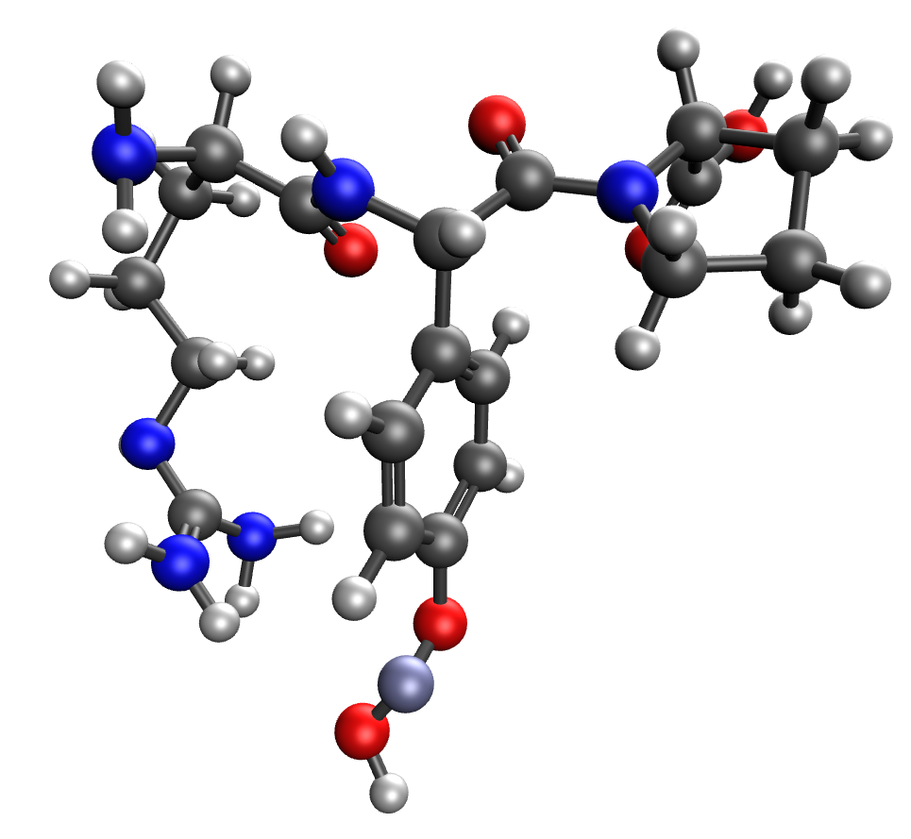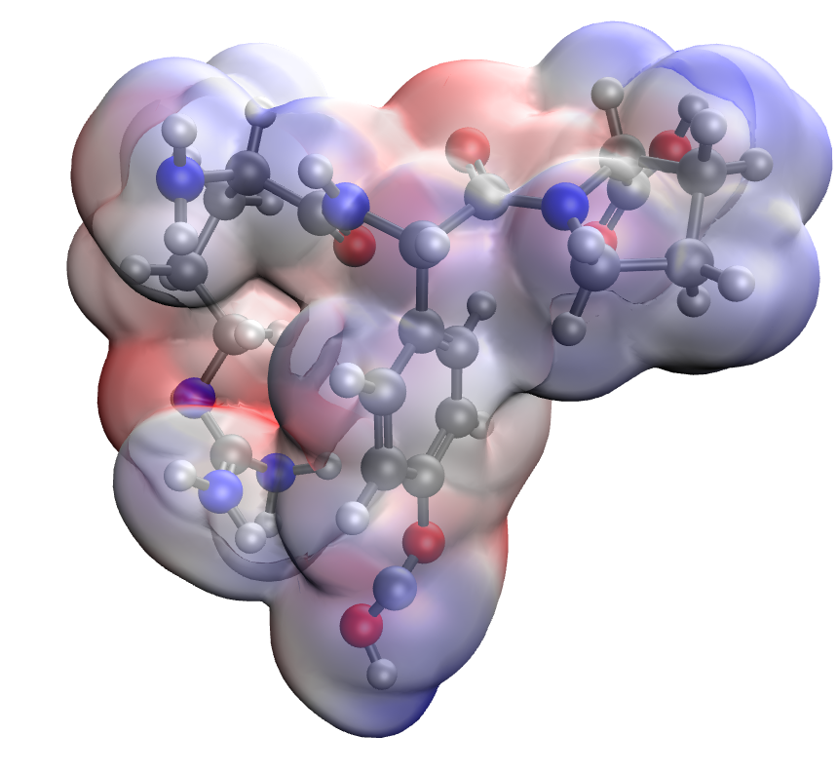
а b

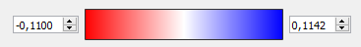
c

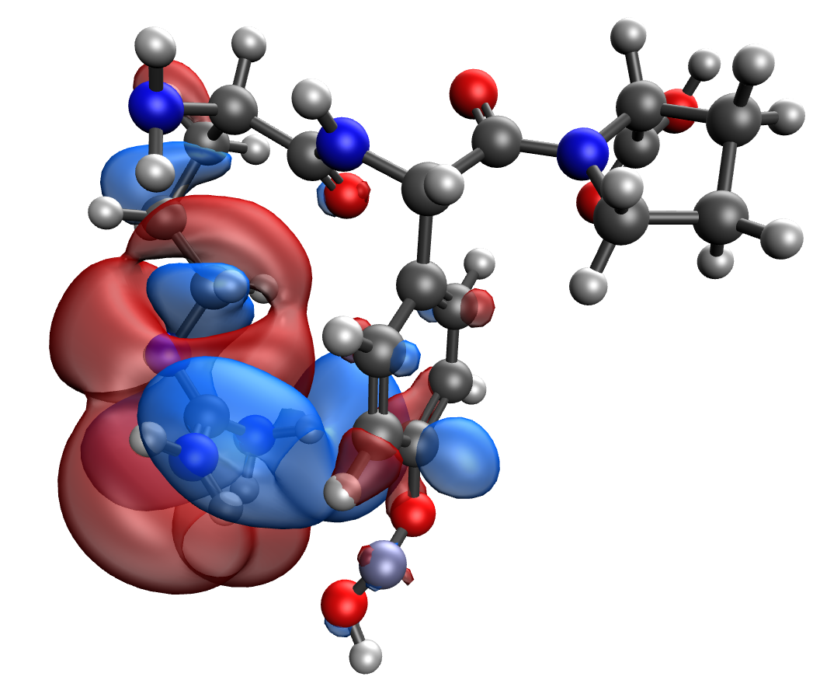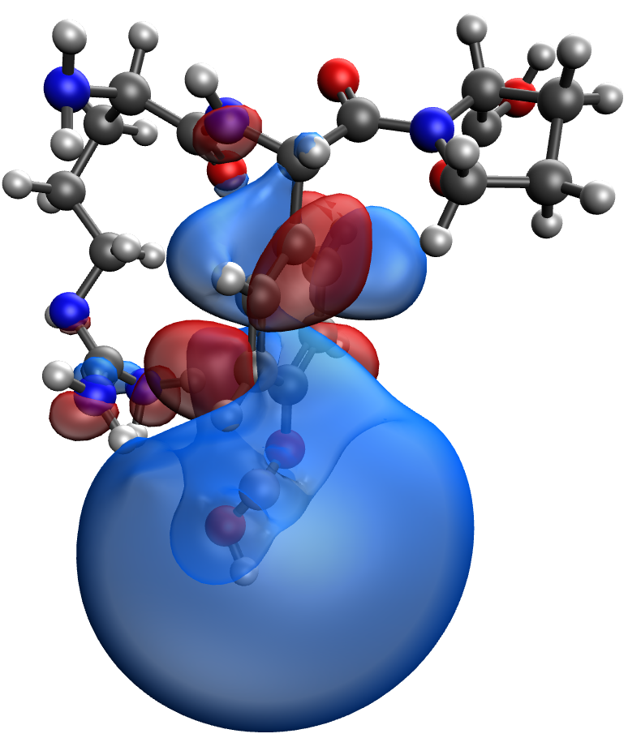
d e
Figure 10. Model of the Arg-Tyr-Pro-Zn κ-casein segment containing the phosphoric acid residue: (a), electron density distribution (b), electron density distribution gradient (c) highest occupied molecular orbital HOMO (d) and lowest unoccupied molecular orbital LUMO (e)

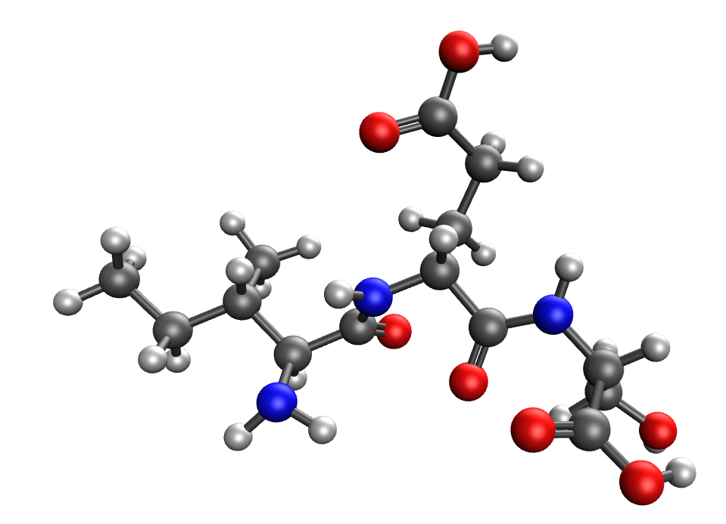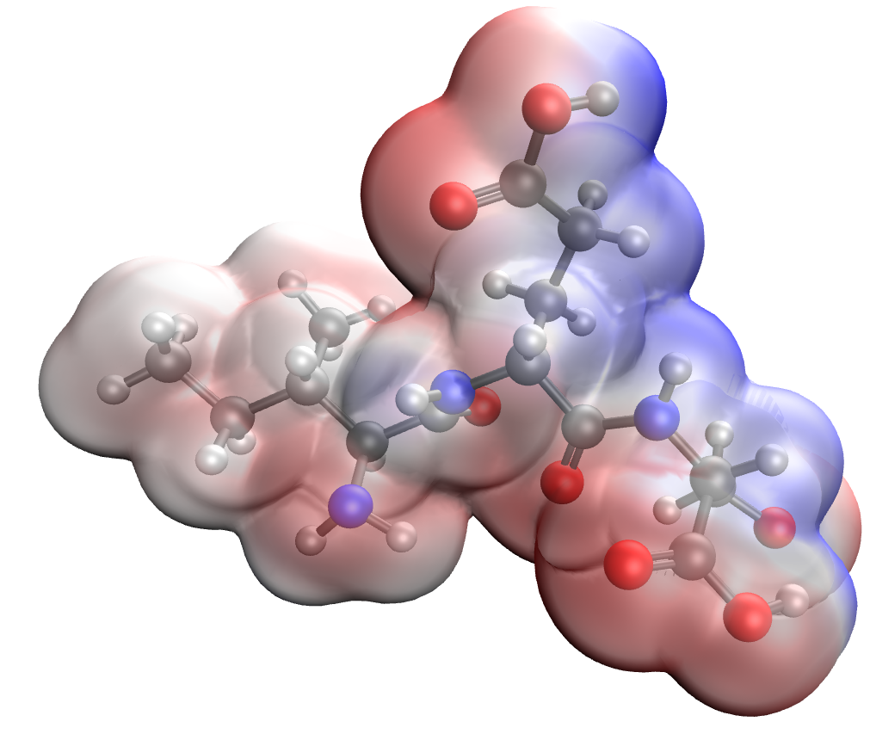
а b


c

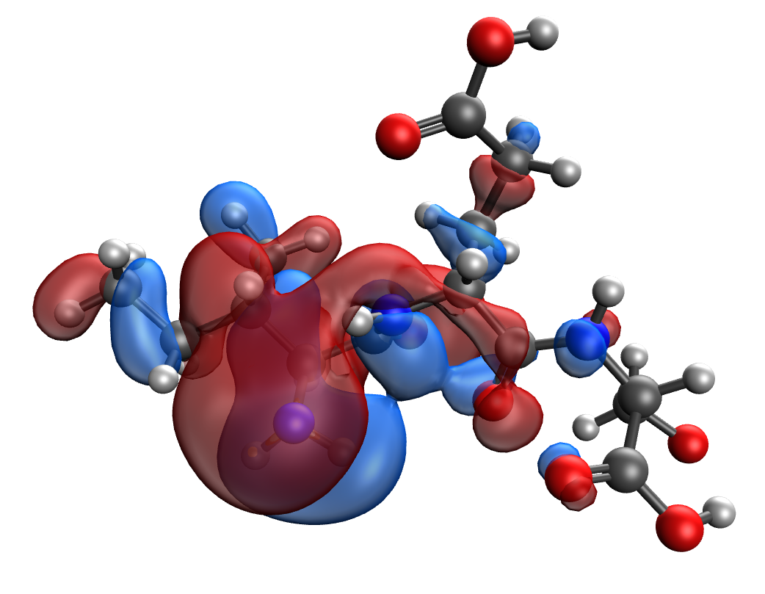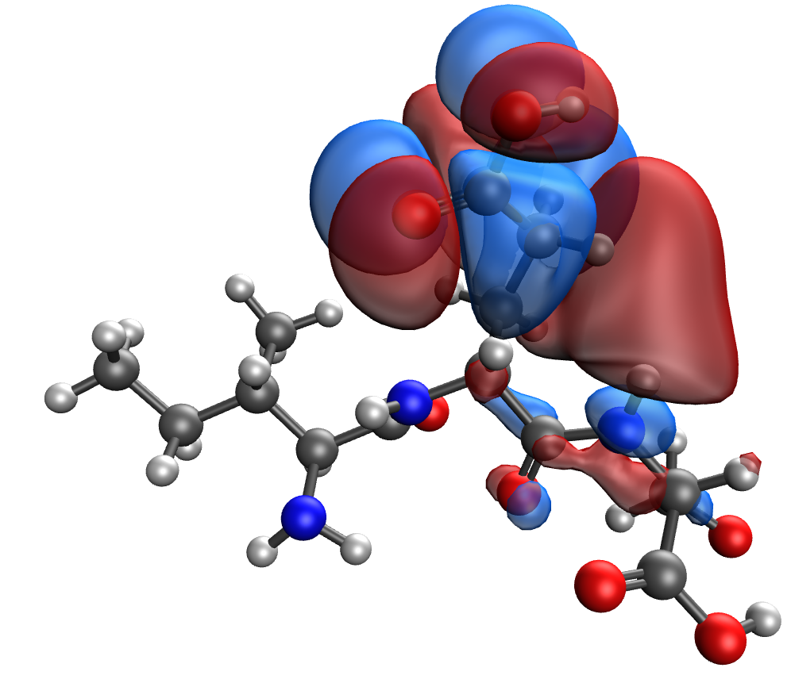
d e
Figure 11. Model of the Ile-Glu-Ser κ-casein segment containing the phosphoric acid residue: (a), electron density distribution (b), electron density distribution gradient (c) highest occupied molecular orbital HOMO (d) and lowest unoccupied molecular orbital LUMO (e)

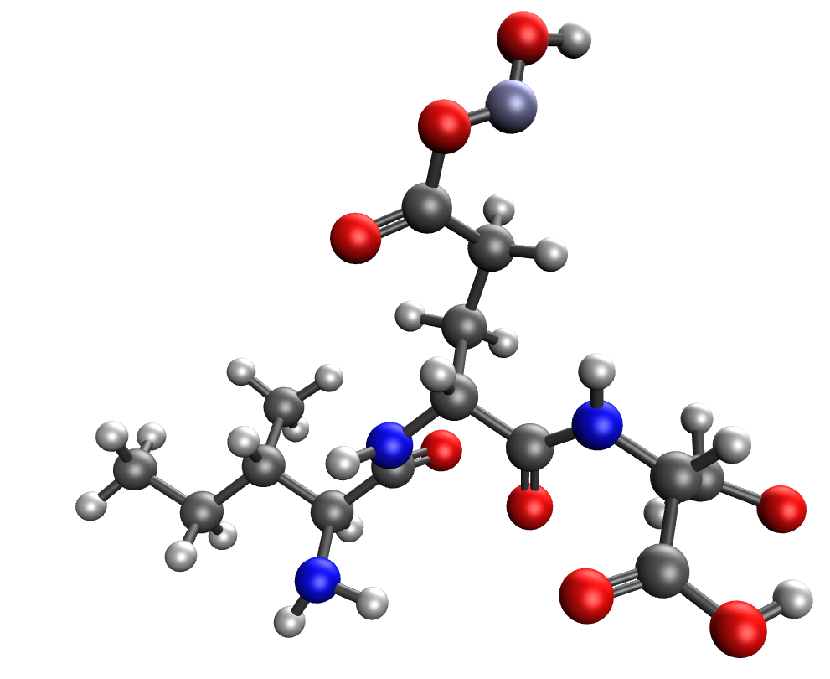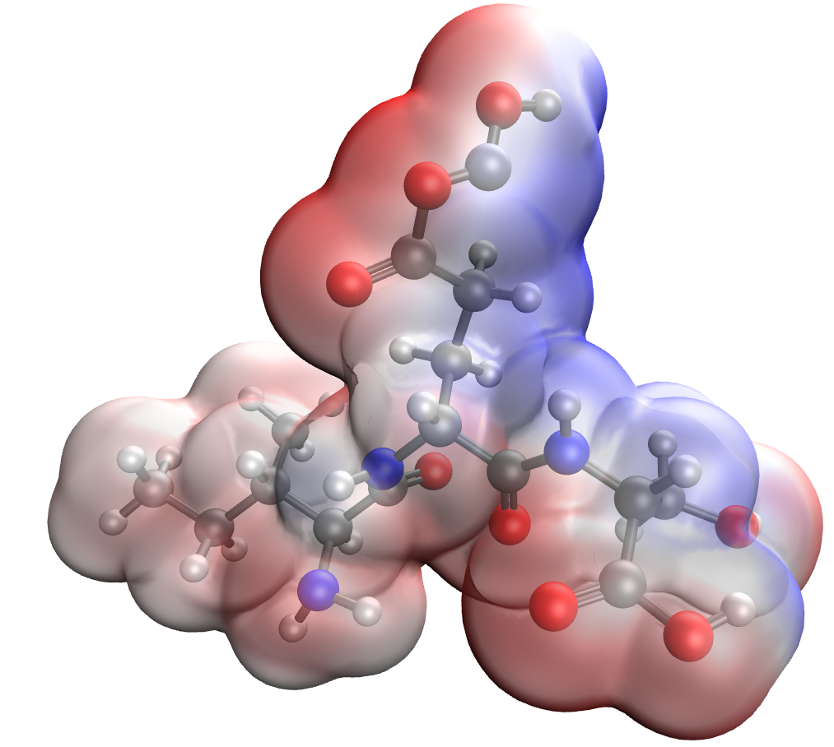
а b

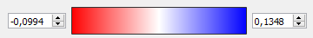
c

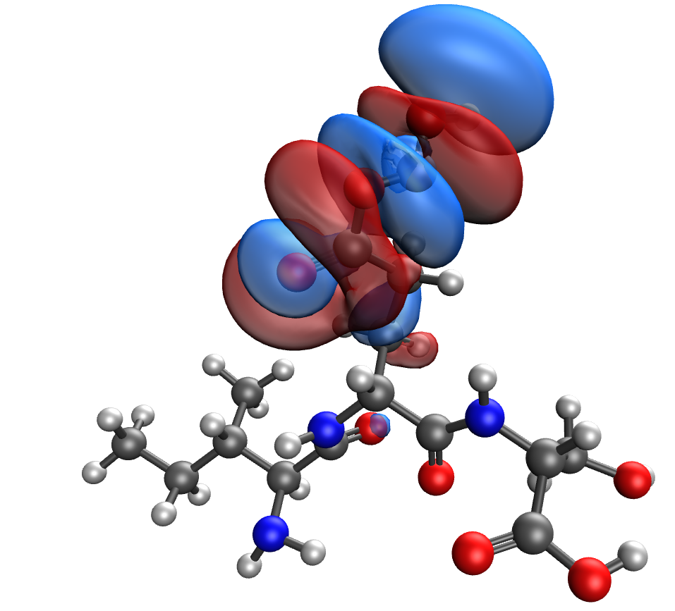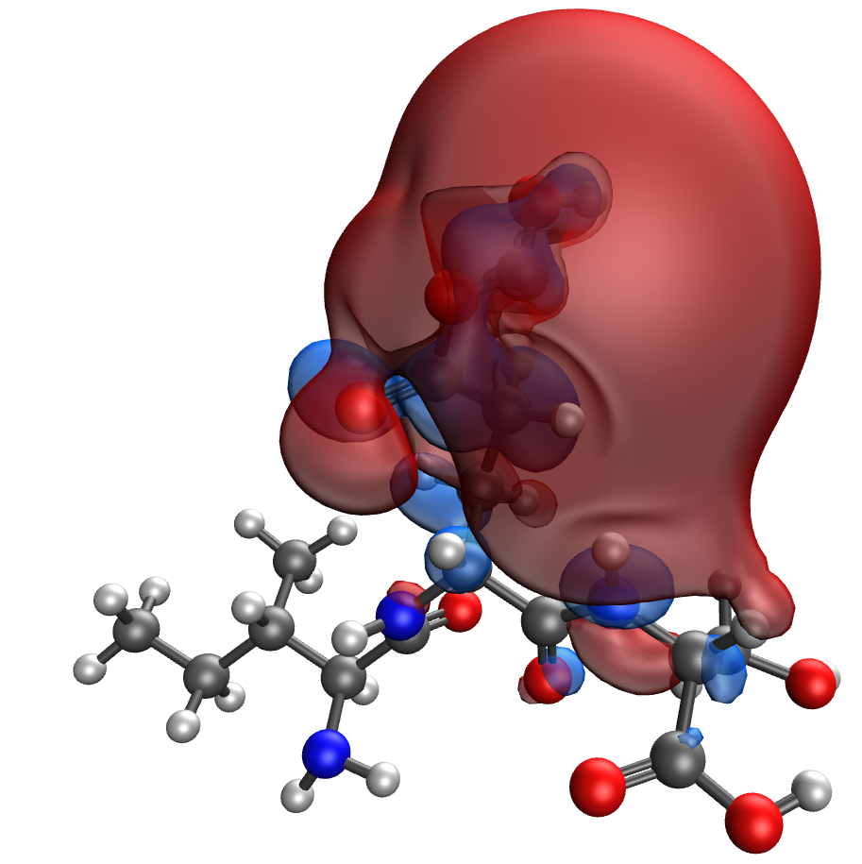
d e
Figure 12. Model of the Ile-Glu-Ser-Zn κ-casein segment containing the phosphoric acid residue: (a), electron density distribution (b), electron density distribution gradient (c) highest occupied molecular orbital HOMO (d) and lowest unoccupied molecular orbital LUMO (e)

