Appendix A. Supplementary data

Potential antidiabetic molecule involving a new chromium(III) complex of dipicolinic and metformin as a counter ion: Synthesis, structure, spectroscopy, and bioactivity in mice
Jin-long Dong^{1,2*}, Bin Wen¹, Zhen Song¹, Jie Chai³, Bin Liu², Wen-juan Tian⁴,
Gang Liang⁵, Bin-sheng Yang^{2,}*
¹ Department of Chemistry, Taiyuan Normal University, Jinzhong, China, 030619
² Institute of Molecular Science, Key Laboratory of Chemical Biology of Molecular Engineering of Education Ministry, Shanxi University, Taiyuan, China, 030006
³ College of Chemistry and Chemical Engineering, Jinzhong University, Jinzhong, China, 030619
⁴ Nanocluster Laboratory, Institute of Molecular Science, Shanxi University, Taiyuan, China, 030006
⁵ Department of Pathology, First Hospital of Shanxi Medical University, Taiyuan, China, 030001

Corresponding author (E–mail: dongjinlong20123@163.com; yangbs@sxu.edu.cn)

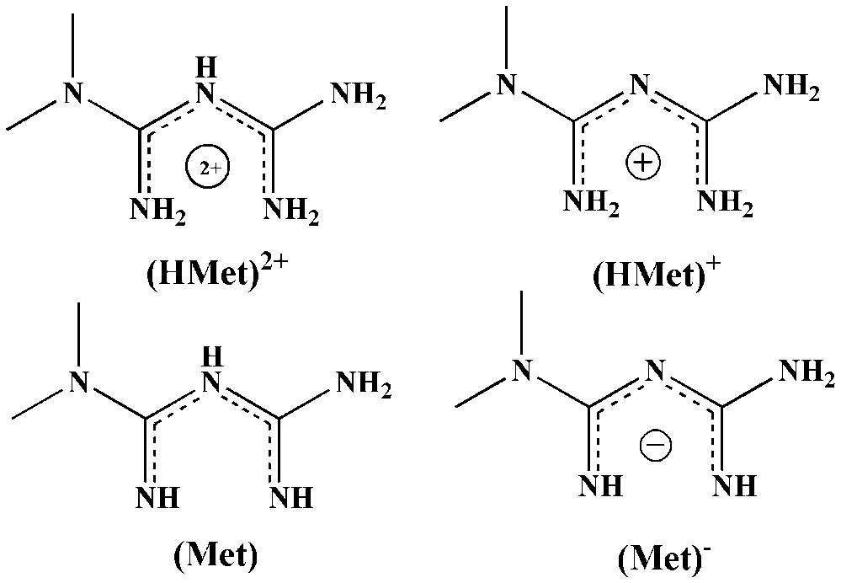
FIGURE S1 The forms of N,N-dimethylbiguanide in solution at different pH values.

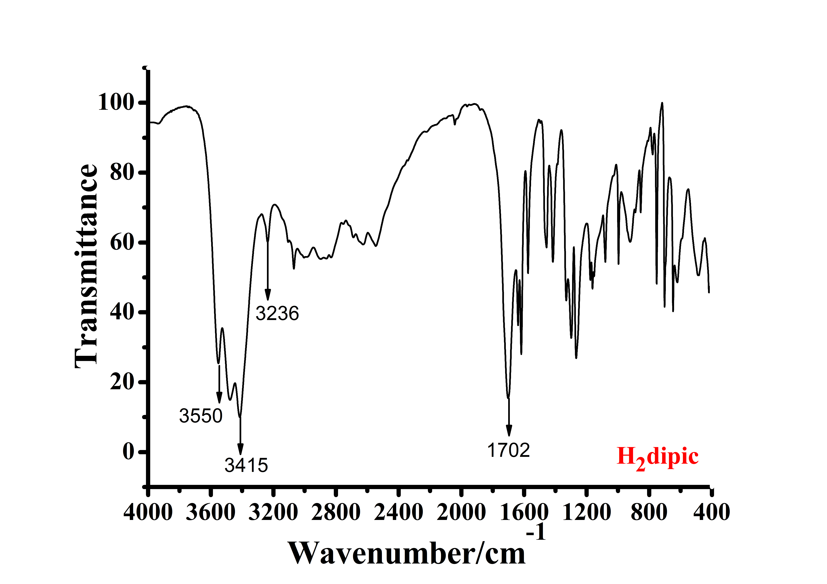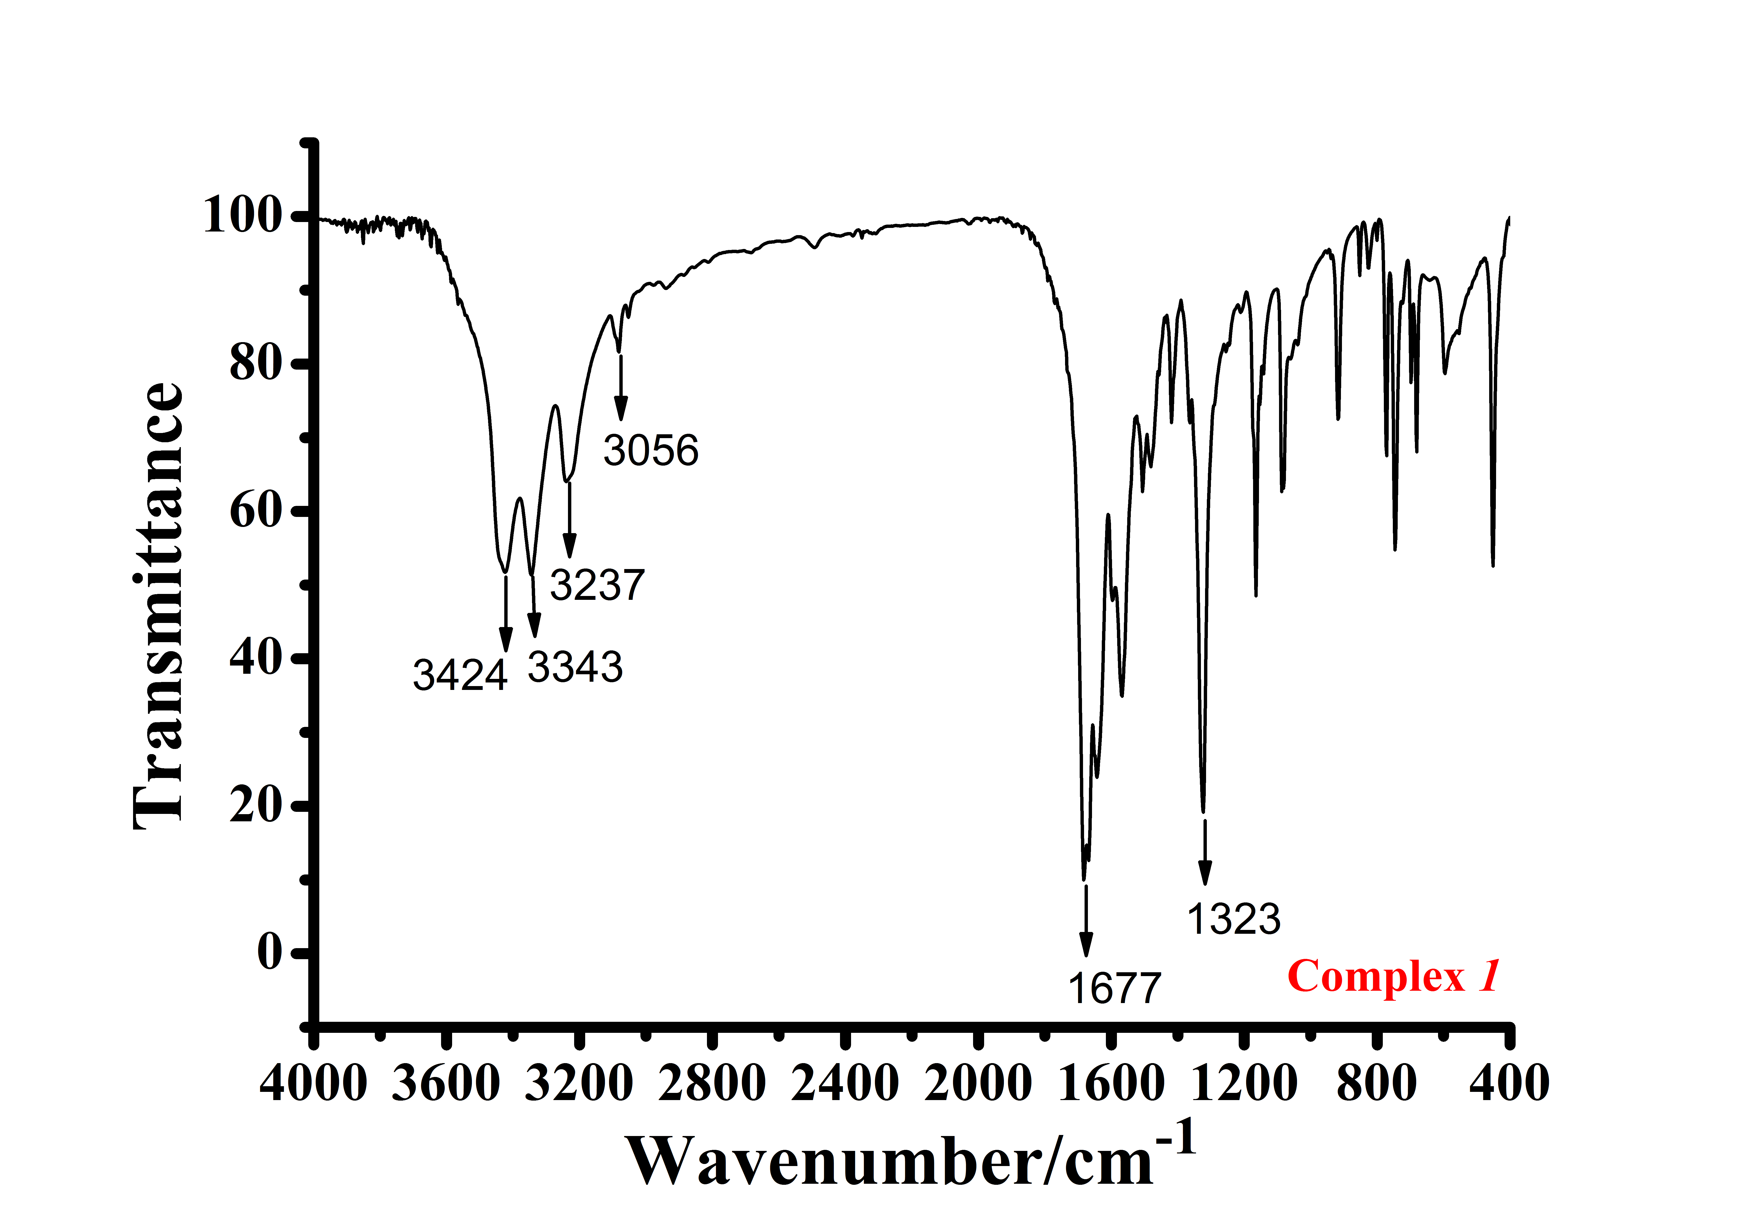

FIGURE S2 IR spectrum of H₂dipic and complex 1.

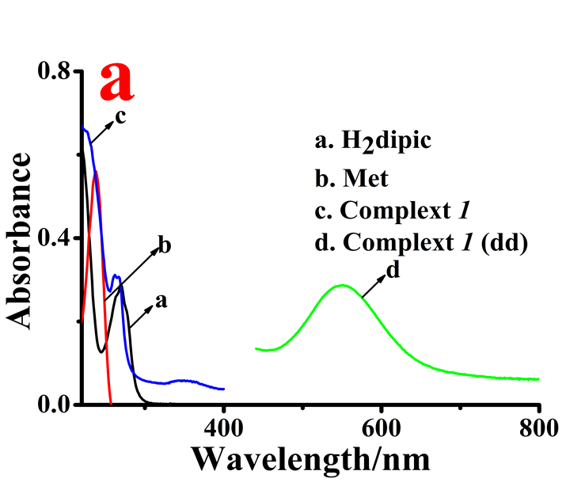 | 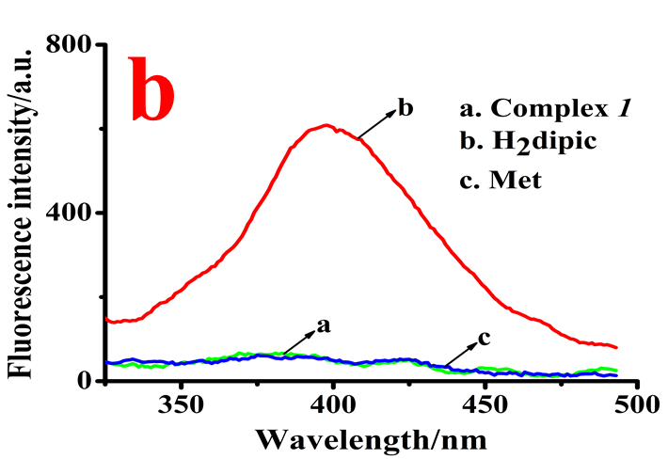
FIGURE S3 (a) Absorption spectra of H₂dipic, Met and Complex; (b) Fluorescence spectra of H₂dipic, Met and Complex 1. [H₂dipic]=7.45×10⁻⁵ M, [Met]=3.99×10⁻⁵ M, [Complex 1]=3.75×10⁻⁵ M, [Complex 1] (dd)=1.5×10⁻³ M, [CrCl₃](dd)=0.6×10⁻³ M.

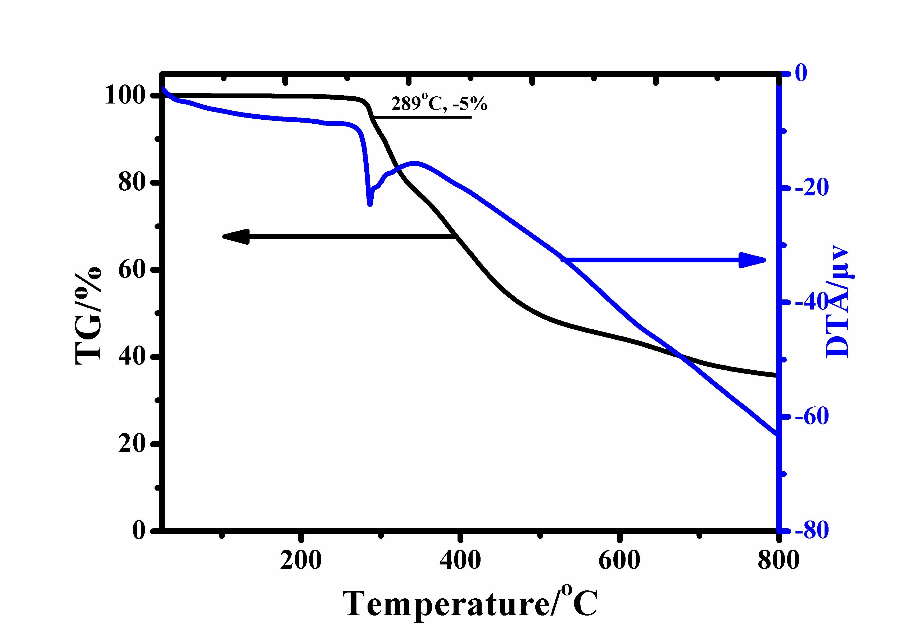

FIGURE S4 TG-DTA curves of complex 1.

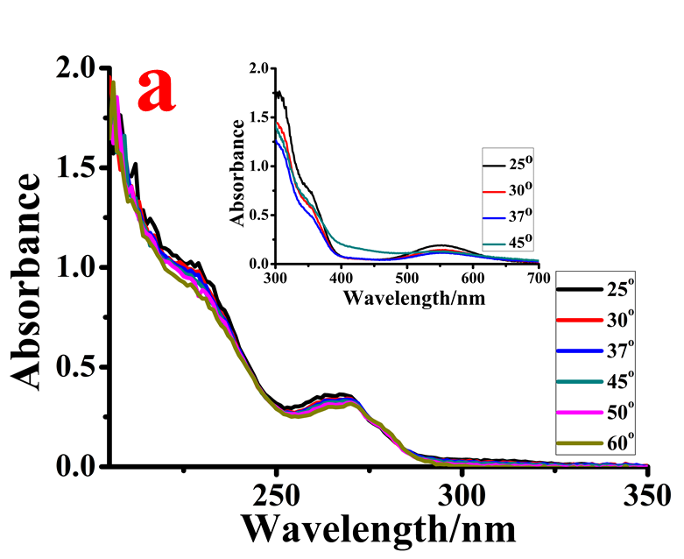 | 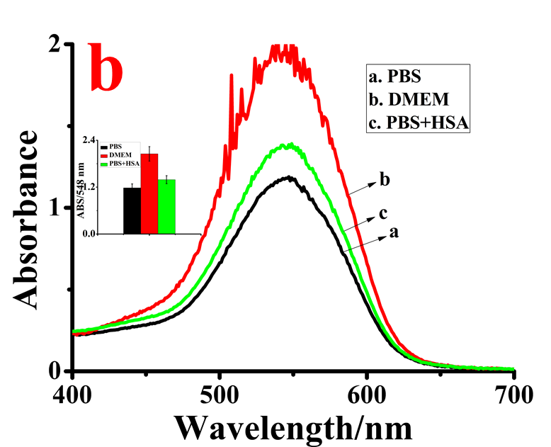
FIGURE S5. (a) Absorption spectra of the complex 1 at different temperatures. [Complex 1] = 2.25×10⁻⁴ M, [Complex 1] (dd) = 2.85×10⁻³ M (b) UV-Vis absorption spectra of complex 1, by 1 μL H₂O₂ in PBS, DMEM and HSA medium solutions at 37 °C and physiological pH 7.4. [Complex 1] = 1.05×10⁻⁴ M

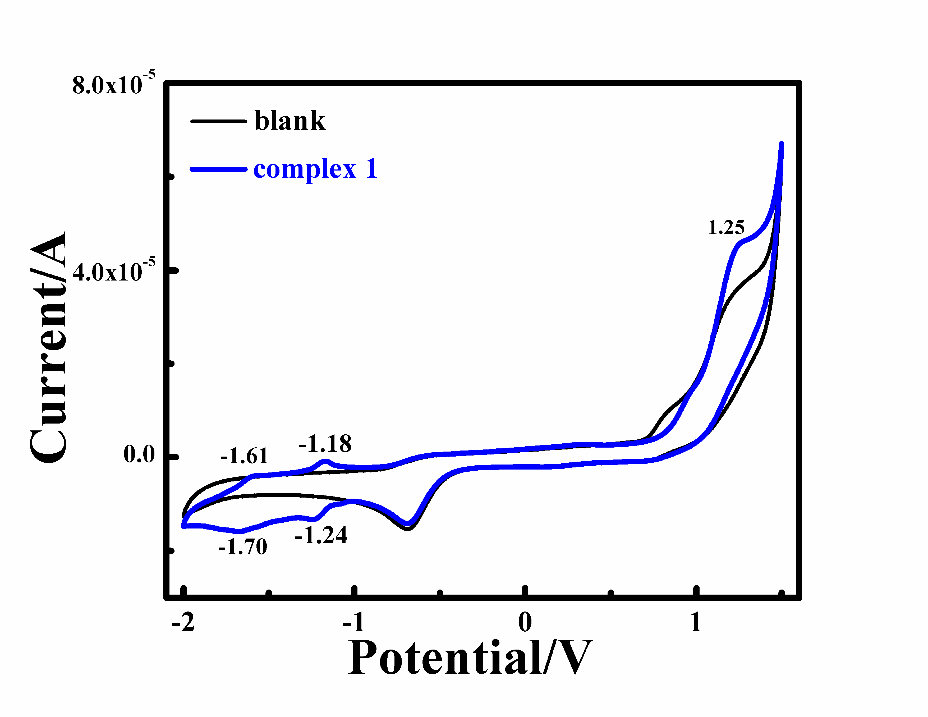
FIGURE S6 Cyclic voltammogram of complex 1 in DMSO at scan rate = 100 mV/s. (Saturated calomel electrode (SCE) as a reference electrode; Tetrabutylammonium perchlorate (0.10 M) as a supporting electrolyte)

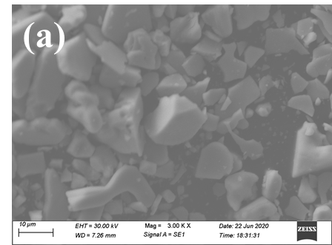 | 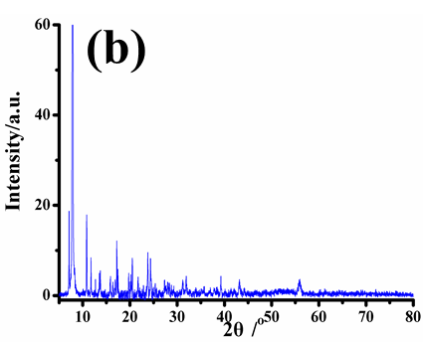
FIGURE S7 SEM photo and XRD pattern of complex 1

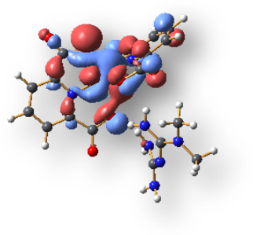 | 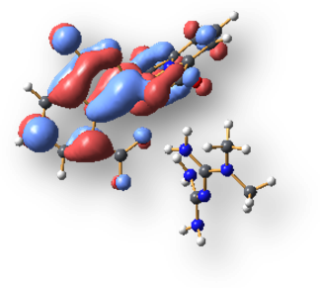
HOMO | LUMO
FIGURE S8 Selected computed (Gaussian 09) orbital plot for complex 1.

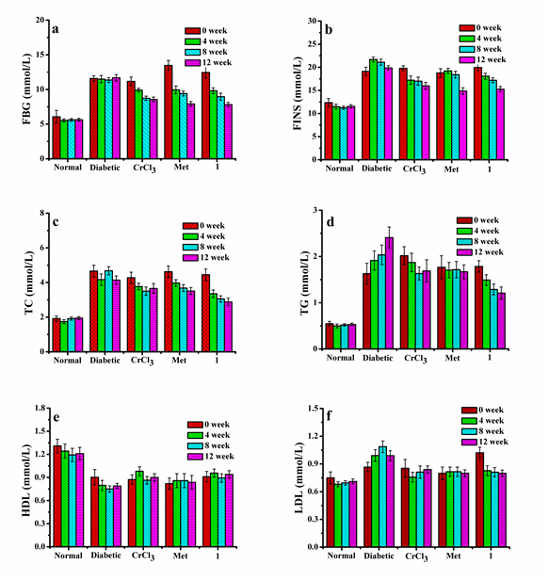

FIGURE S9 The biochemical index of normal and STZ–induced diabetic mice (n=10) during anti–hyperglycemic activity test. (a) fasting blood–glucose (FBG) level; (b) fasting insulin (FINS) level; (c) total cholesterol (TC) level; (d) triglycerides (TG) level; (e) high density lipoprotein cholesterol (HDL–c) level; (f) low density lipoprotein cholesterol (LDL–c) level. Results with different superscripts within the same day are significantly different (p < 0.05).
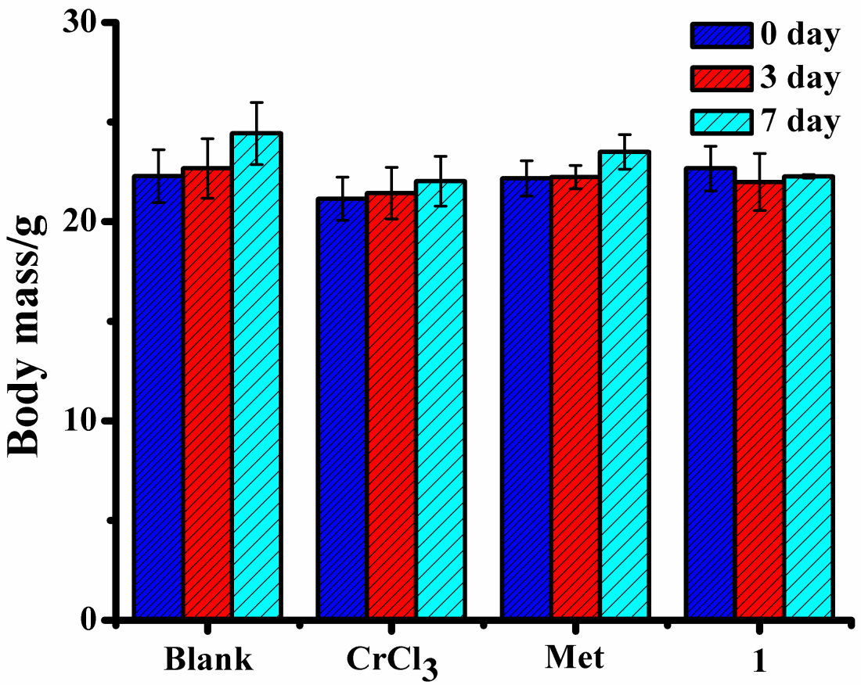
FIGURE S10 The body mass alters of mice at 0, 3rd and 7th day of treatment during acute toxicity study.

TABLE S1
Selected experimental and B3LYP/6-31+G(d,p) calculated geometry parameters of complex 1.
Bond (Å) | Complex
Bond (Å) | Calculated | Experimental
Cr(1)-N(1) | 1.982 | 1.969(4)
Cr(1)-N(2) | 1.973 | 1.961(4)
Cr(1)-O(1) | 1.967 | 1.982(4)
Cr(1)-O(3) | 1.962 | 1.977(3)
Cr(1)-O(5) | 1.958 | 1.964(3)
Cr(1)-O(7) | 1.990 | 1.991(3)
Angle (°)
N1–Cr–N2 | 176.58 | 175.85(17)
O1–Cr–O3 | 155.67 | 157.19(15)

TABLE S2
The grouping design and doses of Complex 1, CrCl₃·6H₂O, Met, and carrier (control) on normal and HF/ STZ–induced diabetic mice.
Groups | Mice | Dose | Cr(III) content
Normal control group | Normal mice | Normal saline | ——
Diabetic control group | diabetic mice | Normal saline | ——
Positive control group | diabetic mice | 16.6 mg Met/kg BW* | ——
CrCl₃–treated | diabetic mice | 5.12 mg CrCl₃/kg BW | 1000 μg/kg BW
Complex 1–treated | diabetic mice | 10.24 mg 1/kg BW | 1000 μg/kg BW

TABLE S3
The body mass alters of rats at 0, 3rd and 7th day of treatment during acute toxicity study.
Body mass/g | day | Blank-control | CrCl₃-treatedrats | Met-treated rats | 1-treated rats
Body mass/g | 0 | 22.28±1.33 | 21.95±1.08 | 22.17±0.88 | 22.67±1.12
Body mass/g | 3 | 22.67±1.50 | 21.43±1.30 | 22.23±0.59 | 21.99±1.42
Body mass/g | 7 | 24.43±1.55 | 22.03±1.25 | 22.50±0.87 | 22.27±0.088

