**Supplementary Materials**

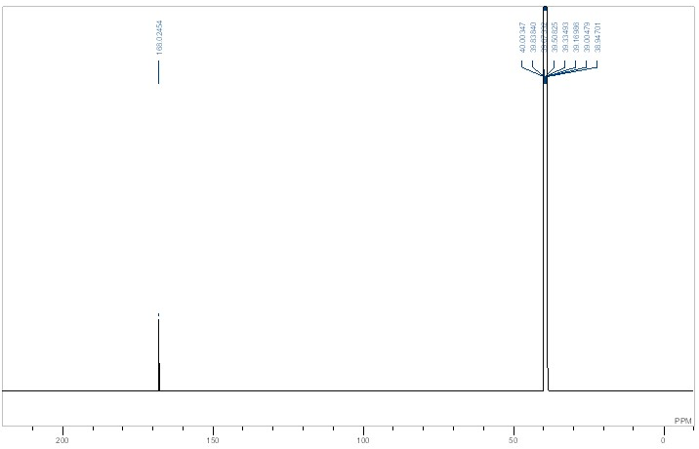

**Figure S1** 13C{1H} NMR spectrum of complex **1** in DMSO-d6.

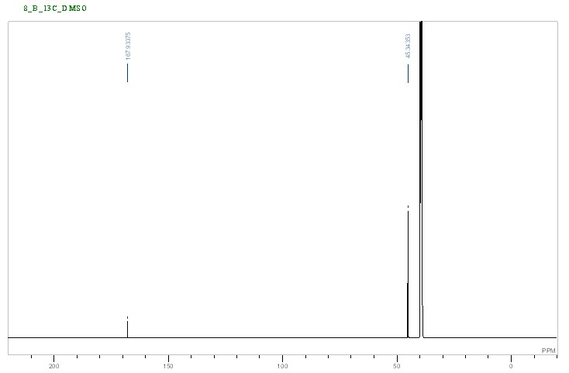

**Figure S2** 13C{1H} NMR spectrum of complex **3** in DMSO-d6.

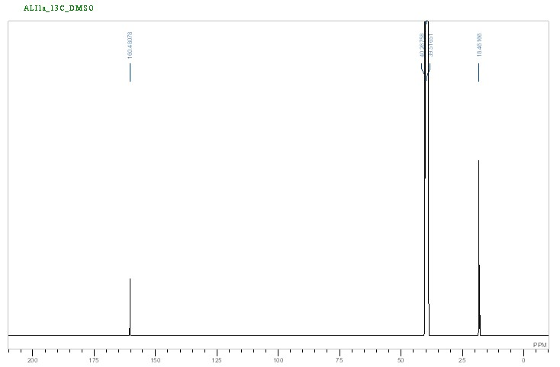

**Figure S3** 13C{1H} NMR spectrum of complex **4** in DMSO-d6.

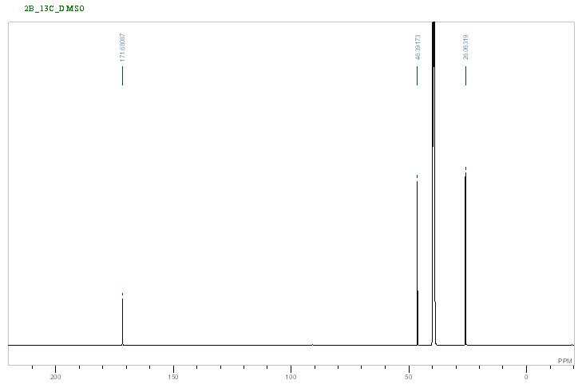**Figure S4**  13C NMR spectrum of complex **5** in DMSO-d6.

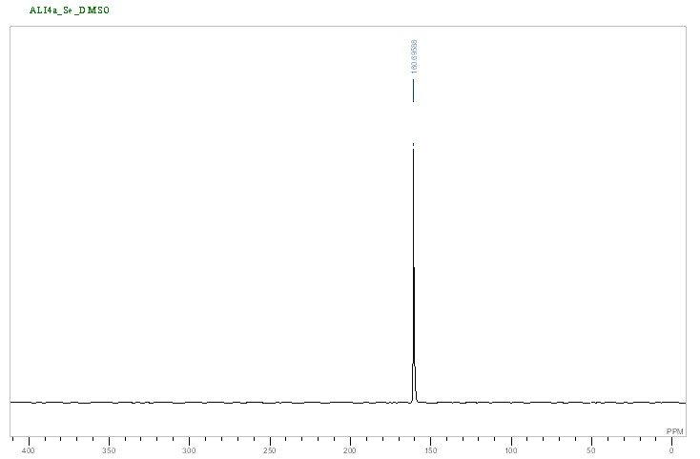

**Figure S5** 77Se NMR spectrum of complex **1** in DMSO-d6.

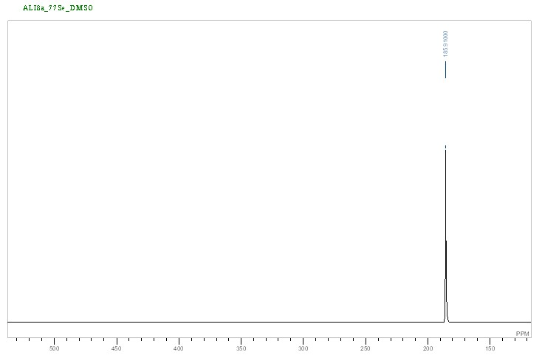

**Figure S6** 77Se NMR spectrum of complex **2** in DMSO-d6.

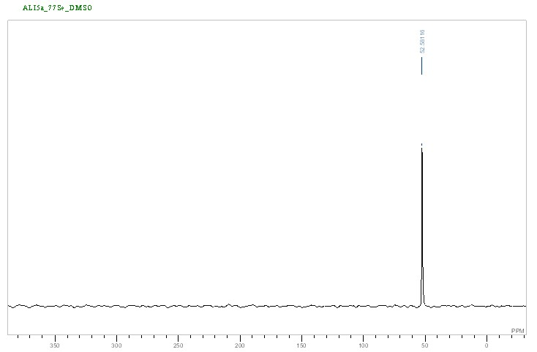

**Figure S7** 77Se NMR spectrum of complex **3** in DMSO-d6.

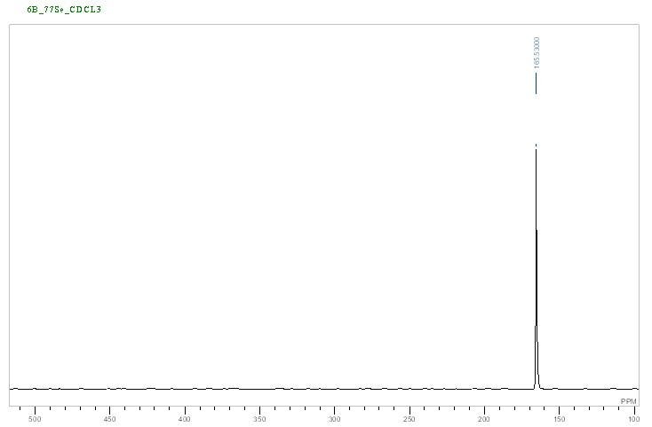

**Figure S8** 77Se NMR spectrum of complex **4** in DMSO-d6.

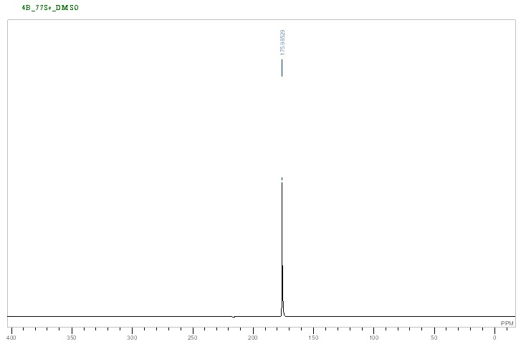**Figure S9** 77Se NMR spectrum of complex **5** in DMSO-d6.

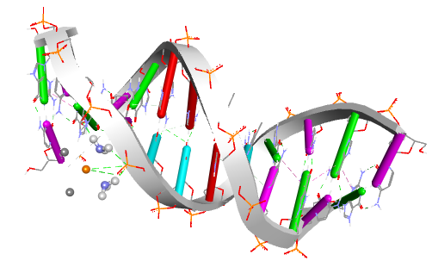a. 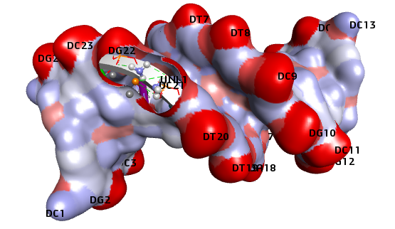b.

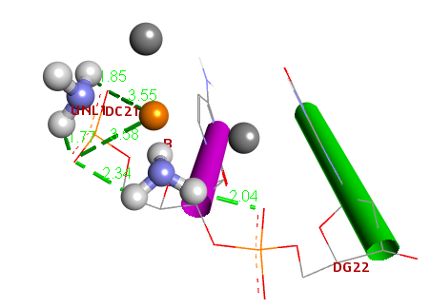c.

**Figure S10** Docking analysis of cisplatin with B-DNA (PDB ID: 1BNA).

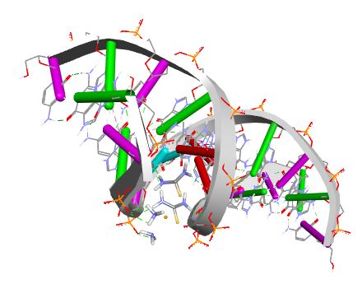 a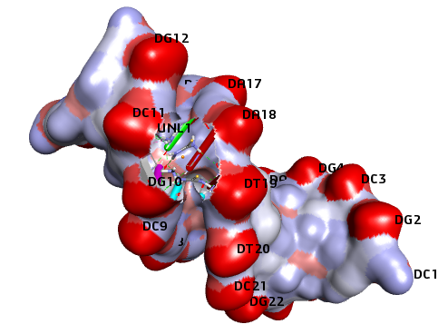b.

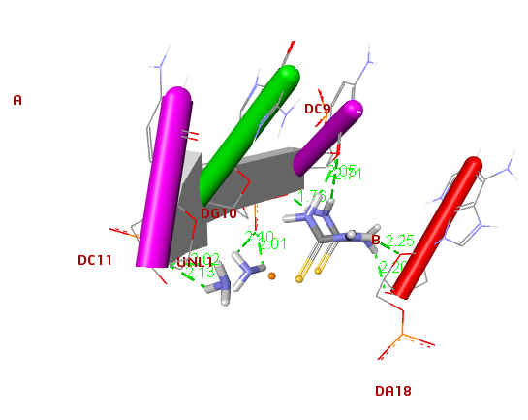c.

**Figure S11** Docking analysis of complex **1** with B-DNA (PDB ID: 1BNA).

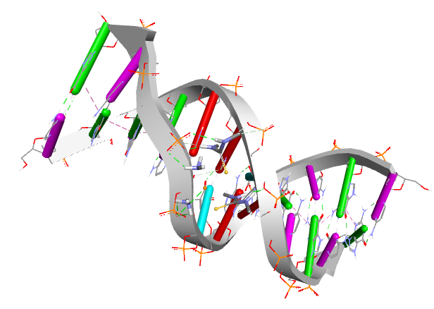a 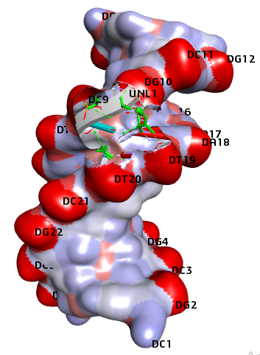b

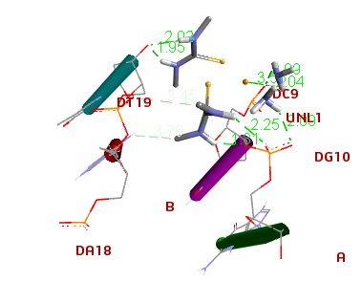c

**Figure S12** Docking analysis of complex **2** with B-DNA (PDB ID: 1BNA).

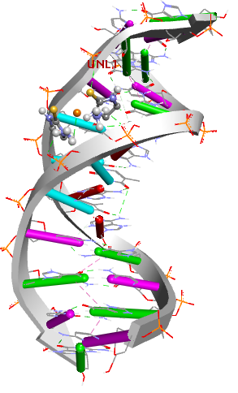a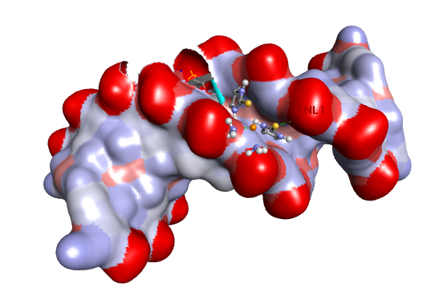b

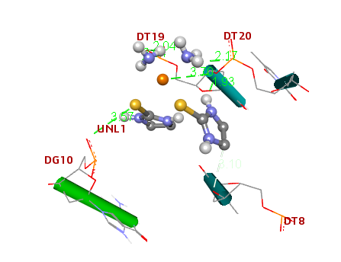c

**Figure S13** Docking analysis of complex **3** with B-DNA (PDB ID: 1BNA).

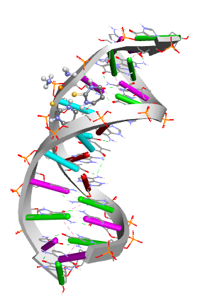a 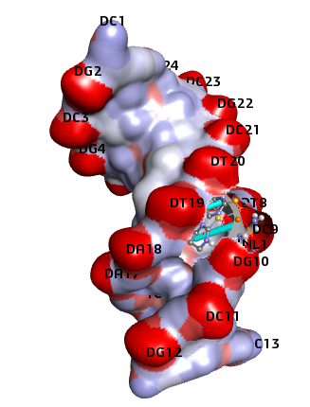b

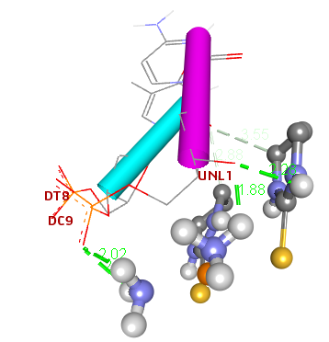c

**Figure S14** The interactions of complex **4** with B-DNA (PDB ID: 1BNA).

**Supplementary Table S1** The number of downregulated miRNA validated target genes.

|  |  |  |
| --- | --- | --- |
| # | miRNA | # of validated targets |
| 1 | hsa-miR-615-3p | 139 |
| 2 | hsa-miR-6809-3p | 88 |
| 3 | hsa-miR-939-3p | 80 |
| 4 | hsa-miR-1224-3p | 78 |
| 5 | hsa-miR-149-5p | 68 |
| 6 | hsa-miR-4695-3p | 50 |
| 7 | hsa-miR-6819-3p | 34 |
| 8 | hsa-miR-7152-5p | 28 |
| 9 | hsa-let-7b-3p | 23 |
| 10 | hsa-miR-6760-3p | 23 |
| 11 | hsa-miR-210-5p | 18 |
| 12 | hsa-miR-3148 | 18 |
| 13 | hsa-miR-6511a-3p | 15 |
| 14 | hsa-miR-6846-3p | 15 |
| 15 | hsa-miR-4731-3p | 13 |
| 16 | hsa-miR-6815-3p | 13 |
| 17 | hsa-miR-631 | 8 |
| 18 | hsa-miR-6803-3p | 5 |
| 19 | hsa-miR-7846-3p | 5 |

**Supplementary Table S2** The number of upregulated miRNA validated target genes.

|  |  |  |
| --- | --- | --- |
| # | miRNA | # of validated targets |
| 1 | hsa-miR-6894-5p | 70 |
| 2 | hsa-miR-27a-3p | 64 |
| 3 | hsa-miR-5703 | 48 |
| 4 | hsa-miR-130a-3p | 42 |
| 5 | hsa-miR-23a-3p | 37 |
| 6 | hsa-miR-320c | 32 |
| 7 | hsa-miR-4697-5p | 24 |
| 8 | hsa-miR-4259 | 17 |
| 9 | hsa-miR-6126 | 16 |
| 10 | hsa-miR-654-3p | 14 |
| 11 | hsa-miR-630 | 13 |
| 12 | hsa-miR-874-3p | 12 |
| 13 | hsa-miR-601 | 6 |

**Supplementary Table S3** Top 10 enriched pathways of downregulated miRNA target genes. *P* values based on Fisher’s exact test. FDR= False discovery rate.

|  |  |  |  |  |  |  |
| --- | --- | --- | --- | --- | --- | --- |
| # | Pathway | # Target genes | % Target genes | Fold enrichment | *P* value | FDR |
| 1 | PI3K-Akt signaling pathway | 20 | 3.08 | 1.46 | 0.089 | 0.617 |
| 2 | Ras signaling pathway | 17 | 2.62 | 1.90 | 0.017 | 0.225 |
| 3 | Purine metabolism | 16 | 2.47 | 2.29 | 0.004 | 0.136 |
| 4 | FoxO signaling pathway | 15 | 2.31 | 2.82 | 0.001 | 0.136 |
| 5 | Focal adhesion | 15 | 2.31 | 1.83 | 0.033 | 0.332 |
| 6 | Insulin signaling pathway | 14 | 2.16 | 2.56 | 0.003 | 0.136 |
| 7 | Regulation of actin cytoskeleton | 14 | 2.16 | 1.68 | 0.072 | 0.519 |
| 8 | Cell cycle | 13 | 2.00 | 2.64 | 0.004 | 0.136 |
| 9 | Protein processing in endoplasmic reticulum | 13 | 2.00 | 1.94 | 0.035 | 0.332 |
| 10 | Adrenergic signaling in cardiomyocytes | 12 | 1.85 | 2.19 | 0.020 | 0.242 |

**Supplementary Figure S15**  Survival analysis of NSCLC patients based on *PIK3CA* expression. HR= Hazard ratio.