**Supporting Information**

**Synthesis and Antitumor Activity of Novel Indole Derivatives Containing α-Aminophosphonate Moieties**

Jiaoli Maa, Jing Lib, Penghu Guo a, Xincheng Liaob, Huicheng Cheng a,*

(a College of Chemistry, Guangdong University of Petrochemical Technology, Maoming 525000, China)

(b College of Chemistry and Molecular Engineering, Zhengzhou University, Zhengzhou 450052, China)

**\***Correspondence: awchengcheng@163.com(Hui cheng Cheng)

Table of contents

1 X-ray single crystal diffraction data of compound **A2**, **B1**and **C3** 2

1.1 X-ray single crystal diffraction data of compound **A2** 2

1.2 X-ray single crystal diffraction data of compound **B1** 6

1.3 X-ray single crystal diffraction data of compound **C3** 12

2 IR Spectrum of Products 19

3 1H NMR and 13C NMR Spectra of Products 30

4 HRMS of Products 42

1 X-ray single crystal diffraction data of compound **A2, B1**and **C3**

1.1 X-ray single crystal diffraction data of compound **A2**

150 mg compound **A2** was dissolved in chloroform, and slowly volatilized at room temperature. After a few days, colorless blocky crystals are precipitated to determine the structure of the compound. The structure of compound 7A2 was further confirmed by X-ray single crystal diffraction pattern.The crystal diffraction data of compound 7A2 is as follows:

**Table 1** The crystallographic parameters of compound **A2**

|  |  |
| --- | --- |
| crystallographic parameters | data |
| Empirical formula | C24H33N2O3P |
| Formula weight | 428.49 |
| Temperature/K | 291.15 |
| Crystal system | triclinic |
| Space group | P-1 |
| a/Å | 10.1758(5) |
| b/Å | 10.4636(5) |
| c/Å | 12.5776(6) |
| α/° | 99.156(4) |
| β/° | 99.915(4) |
| γ/° | 110.328(4) |
| Volume/Å3 | 1201.79(10) |
| Z | 2 |
| ρcalcmg/mm3 | 1.184 |
| m/mm‑1 | 1.218 |
| F(000) | 460.0 |
| Crystal size/mm3 | 0.25 × 0.2 × 0.2 |
| Radiation | CuKα (λ = 1.54184) |
| 2Θ range for data collection | 7.34 to 134.14° |
| Index ranges | -11 ≤ h ≤ 12, -12 ≤ k ≤ 9, -13 ≤ l ≤ 15 |
| Reflections collected | 8723 |
| Independent reflections | 4279 [Rint = 0.0190, Rsigma = 0.0275] |
| Data/restraints/parameters | 4279/1/282 |
| Goodness-of-fit on F2 | 1.051 |
| Final R indexes [I>=2σ (I)] | R1 = 0.0425, wR2 = 0.1173 |
| Final R indexes [all data] | R1 = 0.0513, wR2 = 0.1250 |
| Largest diff. peak/hole / e Å-3 | 0.21/-0.22 |

The X-ray single crystal diffraction structure of compound **A2** is shown in Figure 1-3 and the datas are listed in Table 2-5.

p1

Figure 1 X-ray single-molecule crystal diffraction pattern of compound **A2**

p3

Figure 2 The crystal diffraction pattern of the interaction of two molecules of compound **A2** through hydrogen bonding

p4

Figure 3 Crystal diffraction multi-molecule spatial packing diagram of compound **A2**

**Table 2** Bond length (Å) data of compound **A2**

|  |  |  |  |
| --- | --- | --- | --- |
| Bond | Length/Å | Bond | Length/Å |
| P(1)-O(1) | 1.5742(13) | C(5)-C(6) | 1.398(3) |
| P(1)-O(2) | 1.5730(14) | C(6)-C(7) | 1.378(4) |
| P(1)-O(3) | 1.4622(13) | C(7)-C(8) | 1.392(4) |
| P(1)-C(1) | 1.8270(19) | C(8)-C(9) | 1.376(3) |
| O(1)-C(19) | 1.467(2) | C(8)-C(11) | 1.524(4) |
| O(2)-C(22) | 1.473(2) | C(12)-C(13) | 1.402(3) |
| N(1)-C(2) | 1.385(2) | C(12)-C(17) | 1.400(3) |
| N(1)-C(5) | 1.377(3) | C(13)-C(14) | 1.385(3) |
| N(1)-C(10) | 1.451(2) | C(13)-C(18) | 1.496(3) |
| N(2)-C(1) | 1.453(2) | C(14)-C(15) | 1.375(3) |
| N(2)-C(12) | 1.383(2) | C(15)-C(16) | 1.367(3) |
| C(1)-C(2) | 1.502(3) | C(16)-C(17) | 1.383(3) |
| C(2)-C(3) | 1.365(3) | C(19)-C(20) | 1.481(3) |
| C(3)-C(4) | 1.417(3) | C(19)-C(21) | 1.472(3) |
| C(4)-C(5) | 1.406(3) | C(22)-C(23) | 1.488(3) |
| C(4)-C(9) | 1.402(3) | C(22)-C(24) | 1.497(3) |

**Table 3** Bond angle (°) data of compound **A2**

|  |  |  |  |  |  |
| --- | --- | --- | --- | --- | --- |
| Bond | Angle/˚ | Bond | | Angle/˚ | |
| O(1)-P(1)-C(1) | 101.50(8) | C(6)-C(5)-C(4) | | 121.2(2) | |
| O(2)-P(1)-O(1) | 103.38(8) | C(7)-C(6)-C(5) | | 117.5(2) | |
| O(2)-P(1)-C(1) | 104.36(8) | C(6)-C(7)-C(8) | | 123.0(2) | |
| O(3)-P(1)-O(1) | 116.48(8) | C(7)-C(8)-C(11) | | 120.3(3) | |
| O(3)-P(1)-O(2) | 113.96(8) | C(9)-C(8)-C(7) | | 118.8(2) | |
| O(3)-P(1)-C(1) | 115.45(8) | C(9)-C(8)-C(11) | | 120.9(3) | |
| C(19)-O(1)-P(1) | 120.25(12) | C(8)-C(9)-C(4) | | 120.6(2) | |
| C(22)-O(2)-P(1) | 122.38(12) | N(2)-C(12)-C(13) | | 119.55(17) | |
| C(2)-N(1)-C(10) | 126.47(18) | N(2)-C(12)-C(17) | | 122.39(17) | |
| C(5)-N(1)-C(2) | 108.41(16) | C(17)-C(12)-C(13) | | 118.06(17) | |
| C(5)-N(1)-C(10) | 125.11(18) | C(12)-C(13)-C(18) | | 121.06(18) | |
| C(12)-N(2)-C(1) | 124.71(15) | C(14)-C(13)-C(12) | | 118.7(2) | |
| N(2)-C(1)-P(1) | 108.50(13) | C(14)-C(13)-C(18) | | 120.2(2) | |
| N(2)-C(1)-C(2) | 111.94(15) | C(15)-C(14)-C(13) | | 123.1(2) | |
| C(2)-C(1)-P(1) | 113.49(12) | C(16)-C(15)-C(14) | | 118.1(2) | |
| N(1)-C(2)-C(1) | 120.00(16) | C(15)-C(16)-C(17) | | 120.9(2) | |
| C(3)-C(2)-N(1) | 108.87(17) | C(16)-C(17)-C(12) | | 121.2(2) | |
| C(3)-C(2)-C(1) | 131.13(17) | O(1)-C(19)-C(20) | | 107.68(19) | |
| C(2)-C(3)-C(4) | 108.08(17) | O(1)-C(19)-C(21) | | 109.2(2) | |
| C(5)-C(4)-C(3) | 106.48(18) | C(21)-C(19)-C(20) | | 113.1(2) | |
| C(9)-C(4)-C(3) | 134.5(2) | O(2)-C(22)-C(23) | | 109.43(18) | |
| C(9)-C(4)-C(5) | 118.9(2) | O(2)-C(22)-C(24) | | 107.00(18) | |
| N(1)-C(5)-C(4) | 108.13(17) | C(23)-C(22)-C(24) | | 113.6(2) | |
| N(1)-C(5)-C(6) | 130.7(2) |  |  | |

**Table 4** Dihedral angle (°) data of compound **A2**

|  |  |  |  |
| --- | --- | --- | --- |
| Bond | Angle/˚ | Bond | Angle/˚ |
| P(1)-O(1)-C(19)-C(20) | 117.8(2) | C(2)-C(3)-C(4)-C(5) | 0.1(2) |
| P (1)-O(1)-C(19)-C(21) | -118.9(2) | C(2)-C(3)-C(4)-C(9) | 177.0(2) |
| P(1)-O(2)-C(22)-C(23) | -87.7(2) | C(3)-C(4)-C(5)-N(1) | -1.1(2) |
| P(1)-O(2)-C(22)-C(24) | 148.73(18) | C(3)-C(4)-C(5)-C(6) | 177.41(19) |
| P(1)-C(1)-C(2)-N(1) | 174.58(13) | C(3)-C(4)-C(9)-C(8) | -175.5(2) |
| P(1)-C(1)-C(2)-C(3) | -4.9(3) | C(4)-C(5)-C(6)-C(7) | -0.6(3) |
| O(1)-P(1)-O(2)-C(22) | 146.09(15) | C(5)-N(1)-C(2)-C(1) | 178.82(15) |
| O(1)-P(1)-C(1)-N(2) | 165.05(12) | C(5)-N(1)-C(2)-C(3) | -1.6(2) |
| O(1)-P(1)-C(1)-C(2) | -69.84(13) | C(5)-C(4)-C(9)-C(8) | 1.1(3) |
| O(2)-P(1)-O(1)-C(19) | -67.21(16) | C(5)-C(6)-C(7)-C(8) | 0.3(4) |
| O(2)-P(1)-C(1)-N(2) | 57.85(13) | C(6)-C(7)-C(8)-C(9) | 0.6(4) |
| O(2)-P(1)-C(1)- C(2) | -177.05(12) | C(6)-C(7)-C(8)-C(11) | -179.2(2) |
| O(3)-P(1)-O(1)-C(19) | 58.58(17) | C(7)-C(8)-C(9)-C(4) | -1.4(3) |
| O(3)-P(1)-O(2)-C(22) | 18.71(18) | C(9)-C(4)-C(5)-N(1) | -178.57(17) |
| O(3)-P(1)-C(1)-N(2) | -68.03(14) | C(9)-C(4)-C(5)-C(6) | 0.0(3) |
| O(3)-P(1)-C(1)-C(2) | 57.08(14) | C(10)-N(1)-C(2)-C(1) | 0.0(3) |
| N(1)-C(2)-C(3)-C(4) | 0.9(2) | C(10)-N(1)-C(2)-C(3) | 179.59(18) |
| N(1)-C(5)-C(6)-C(7) | 177.5(2) | C(10)-N(1)-C(5)-C(4) | -179.50(18) |
| N(2)-C(1)-C(2)-N(1) | -62.2(2) | C(10)-N(1)-C(5)-C(6) | 2.2(3) |
| N(2)-C(1)-C(2)-C(3) | 118.4(2) | C(11)-C(8)-C(9)-C(4) | 178.5(2) |
| N(2)-C(12)-C(13)-C(14) | -178.7(2) | C(12)-N(2)-C(1)-P(1) | -102.46(19) |
| N(2)-C(12)-C(13)-C(18) | 0.3(3) | C(12)-N(2)-C(1)-C(2) | 131.52(19) |
| N(2) -C(12)-C(17)-C916) | 178.7(2) | C(12)-C(13)-C(14)-C(15) | -0.4(4) |
| C(1)-P(1)-O(1)-C(19) | -175.18(14) | C(13)-C(12)-C(17)-C(16) | -0.9(3) |
| C(1)-P(1)-O(2)-C(22) | -108.11(15) | C(13)-C(14)-C(15)-C(16) | 0.0(4) |
| C(1)-N(2)-C(12)-C(13) | -176.44(18) | C(14)-C(15)-C(16)-C(17) | 0.1(4) |
| C(1)-N(2)-C(12)-C(17) | 4.0(3) | C(15)-C(16)-C(17)-C(12) | 0.4(4) |
| C(1)-C(2)-C(3)-C(4) | -179.59(17) | C(17)-C(12)-C(13)-C(14) | 0.9(3) |
| C(2)-N(1)-C(5)-C(4) | 1.7(2) | C(17)-C912)-C(13)-C(18) | 179.9(2) |
| C(2)-N(1)-C(5)-C(6) | -176.7(2) | C(18)-C(13)-C(14)-C(15) | -179.5(2) |

**Table 5** Hydrogen bond data of compound **A2**

|  |  |  |  |  |
| --- | --- | --- | --- | --- |
| D-H…A | d(D-H)/Å | d(H…A)/Å | d(D…A)/Å | ∠(DHA)/° |
| N(2)-H(2)-O(3A) | 0.808(15) | 2.234(15) | 3.033(2) | 169.8(18) |

1.2 X-ray single crystal diffraction data of compound **B1**

150 mg compound **B1** was dissolved in CH2Cl2, and slowly volatilized at room temperature. After a few days, colorless blocky crystals are precipitated to determine the structure of the compound. The structure of compound **B1** was further confirmed by X-ray single crystal diffraction pattern.

The crystal diffraction data of compound **B1** is as follows:

**Table 6** The crystallographic parameters of compound **B1**

|  |  |
| --- | --- |
| crystallographic parameters | data |
| Empirical formula | C43H56Cl2N4O6P2  857.76 |
| Formula weight |
| Temperature/K | 291.15 |
| Crystal system | monoclinic |
| Space group | C2/c |
| a/Å | 16.4330(6) |
| b/Å | 14.7792(6) |
| c/Å | 19.0157(8) |
| α/° | 90.00 |
| β/° | 91.808(4) |
| γ/° | 90.00 |
| Volume/Å3 | 4616.0(3) |
| Z | 4 |
| ρcalcmg/mm3 | 1.234 |
| m/mm‑1 | 2.310 |
| F(000) | 1816.0 |
| Crystal size/mm3 | 0.23 × 0.2 × 0.2 |
| Radiation | CuKα (λ = 1.54184) |
| 2Θ range for data collection | 8.04 to 134.1° |
| Index ranges | -19 ≤ h ≤ 17, -16 ≤ k ≤ 17, -22 ≤ l ≤ 22 |
| Reflections collected | 8552 |
| Independent reflections | 4124 [Rint = 0.0194, Rsigma = 0.0279] |
| Data/restraints/parameters | 4124/10/279 |
| Goodness-of-fit on F2 | 1.080 |
| Final R indexes [I>=2σ (I)] | R1 = 0.0731, wR2 = 0.2257 |
| Final R indexes [all data] | R1 = 0.0922, wR2 = 0.2515 |
| Largest diff. peak/hole / e Å-3 | 0.55/-0.62 |

The X-ray single crystal diffraction structure of compound **B1** is shown in Figure 4～6 and the datas are listed in Table 7～10.

p2

Figure 4 X-ray single-molecule crystal diffraction pattern of compound **B1**

p5

Figure 5 The crystal diffraction pattern of the interaction of two molecules of compound **B1** through hydrogen bonding

p3

Figure 6 Crystal diffraction multi-molecule spatial packing diagram of compound **B1**

**Table 7** Bond length (Å) data of compound **B1**

|  |  |  |  |
| --- | --- | --- | --- |
| Bond | Length/Å | Bond | Length/Å |
| C(l1)-C(l11) | 1.364(13) | C(1)-C(6) | 1.406(5) |
| C(l1)-C(221) | 1.691(17) | C(2)-C(3) | 1.391(7) |
| C(l1)-C(22) | 1.728(14) | C(2)-C(10) | 1.505(6) |
| C(l1A)-C(l1A1) | 1.931(15) | C(3)-C(4) | 1.381(7) |
| C(l1A)-C(22) | 1.739(14) | C(4)-C(5) | 1.388(5) |
| C(22)-C(l11) | 1.691(17) | C(5)-C(6) | 1.402(5) |
| P(1)-O(1) | 1.467(3) | C(6)-C(7) | 1.423(5) |
| P(1)-O(2) | 1.571(3) | C(7)-C(8) | 1.364(5) |
| P(1)-O(3) | 1.569(3) | C(8)-C(9) | 1.499(5) |
| P(1)-C(9) | 1.823(4) | C(12)-C(13) | 1.387(5) |
| O(2)-C(18) | 1.448(6) | C(12)-C(17) | 1.379(5) |
| O(3)-C(20) | 1.461(5) | C(13)-C(14) | 1.385(6) |
| N(1)-C(5) | 1.379(5) | C(14)-C(15) | 1.355(8) |
| C(l1)-C(l11) | 1.364(13) | C(1)-C(6) | 1.406(5) |
| C(l1)-C(221) | 1.691(17) | C(2)-C(3) | 1.391(7) |
| C(l1)-C(22) | 1.728(14) | C(2)-C(10) | 1.505(6) |
| C(l1A)-C(l1A1) | 1.931(15) | C(3)-C(4) | 1.381(7) |
| C(l1A)-C(22) | 1.739(14) | C(4)-C(5) | 1.388(5) |
| C(22)-C(l11) | 1.691(17) | C(5)-C(6) | 1.402(5) |
| P(1)-O(1) | 1.467(3) | C(6)-C(7) | 1.423(5) |
| P(1)-O(2) | 1.571(3) | C(7)-C(8) | 1.364(5) |
| P(1)-O(3) | 1.569(3) | C(8)-C(9) | 1.499(5) |
| P(1)-C(9) | 1.823(4) | C(12)-C(13) | 1.387(5) |
| O(2)-C(18) | 1.448(6) | C(12)-C(17) | 1.379(5) |
| O(3)-C(20) | 1.461(5) | C(13)-C(14) | 1.385(6) |
| N(1)-C(5) | 1.379(5) | C(14)-C(15) | 1.355(8) |

**Table 8** Bond angle (°) data of compound **B1**

|  |  |  |  |
| --- | --- | --- | --- |
| Bond | Angle/˚ | Bond | Angle/˚ |
| C(l11)-C(l1)-C(221) | 67.9(7) | N(1)-C(5)-C(4) | 130.5(4) |
| C(l11)-C(l1)-C(22) | 65.1(7) | N(1)-C(5)-C(6) | 107.9(3) |
| C(221)-C(l1)-C(22) | 100.6(10) | C(4)-C(5)-C(6) | 121.5(4) |
| C(22)-C(l1A)-C(l1A1) | 79.4(7) | C(1)-C(6)-C(7) | 134.5(4) |
| C(l11)-C(22)-C(l1) | 47.0(6) | C(5)-C(6)-C(1) | 118.7(4) |
| C(l11)-C(22)-C(l1A) | 101.2(9) | C(5)-C(6)-C(7) | 106.8(3) |
| C(l1)-C(22)-C(l1A) | 78.2(6) | C(8)-C(7)-C(6) | 107.6(3) |
| O(1)-P(1)-O(2) | 116.67(17) | N(1)-C(8)-C(9) | 120.5(3) |
| O(1)-P(1)-O(3) | 113.10(16) | C(7)-C(8)-N(1) | 109.2(3) |
| O(1)-P(1)-C(9) | 115.31(16) | C(7)-C(8)-C(9) | 130.4(3) |
| O(2)-P(1)-C(9) | 101.57(15) | N(2)-C(9)-P(1) | 110.3(3) |
| O(3)-P(1)-O(2) | 103.05(16) | N(2)-C(9)-C(8) | 111.1(3) |
| O(3)-P(1)-C(9) | 105.59(17) | C(8)-C(9)-P(1) | 112.9(2) |
| C(18)-O(2)-P(1) | 121.5(3) | N(2)-C(12)-C(13) | 123.4(4) |
| C(20)-O(3)-P(1) | 121.5(3) | N(2)-C(12)-C(17) | 118.6(3) |
| C(5)-N(1)-C(8) | 108.5(3) | C(17)-C(12)-C(13) | 118.0(4) |
| C(5)-N(1)-C(11) | 125.5(3) | C(14)-C(13)-C(12) | 120.5(5) |
| C(8)-N(1)-C(11) | 125.9(3) | C(15)-C(14)-C(13) | 120.9(5) |
| C(12)-N(2)-C(9) | 125.3(3) | C(14)-C(15)-C(16) | 119.1(5) |
| C(2)-C(1)-C(6) | 120.4(4) | C(15)-C(16)-C(17) | 120.7(5) |
| C(1)-C(2)-C(3) | 119.0(4) | C(12)-C(17)-C(16) | 120.7(4) |
| C(1)-C(2)-C(10) | 121.8(5) | C(19)-C(18)-O(2) | 110.3(5) |
| C(3)-C(2)-C(10) | 119.2(4) | C(21)-C(20)-O(3) | 112.9(5) |
| C(4)-C(3)-C(2) | 122.8(4) | C(21)-C(20)-C(21A) | 48.1(9) |
| C(3)-C(4)-C(5) | 117.5(4) | C(21A)-C(20)-O(3) | 112.3(9) |

**Table 9** Dihedral angle (°) data of compound B1

|  |  |  |  |
| --- | --- | --- | --- |
| Bond | Angle/˚ | Bond | Angle/˚ |
| C(l11)-C(l1)-C(22)-C(l1A) | 117.8(8) | C(4)-C(5)-C(6)-C(1) | -0.9(5) |
| C(l1A1)-C(l1A)-C(22)-C(l11) | -44.3(8) | C(4)-C(5)-C(6)-C(7) | -179.5(3) |
| C(l1A1)-C(l1A)-C(22)-C(l1) | -85.5(6) | C(5)-N(1)-C(8)-C(7) | 0.3(4) |
| C(221)-C(l1)-C(22)-C(l11) | -59.4(9) | C(5)-N(1)-C(8)-C(9) | -179.4(3) |
| C(221)-C(l1)-C(22)-C(l1A) | 58.3(5) | C(5)-C(6)-C(7)-C(8) | 0.2(4) |
| P(1)-O(2)-C(18)-C(19) | 160.4(4) | C(6)-C(1)-C(2)-C(3) | 0.8(6) |
| P(1)-O(3)-C(20)-C(21) | -131.8(7) | C(6)-C(1)-C(2)-C(10) | -179.2(4) |
| P(1)-O(3)-C(20)-C(21A) | 175.8(12) | C(6)-C(7)-C(8)-N(1) | -0.3(4) |
| O(1)-P(1)-O(2)-C(18) | 51.7(4) | C(6)-C(7)-C(8)-C(9) | 179.4(3) |
| O(1)-P(1)-O(3)-C(20) | 26.9(4) | C(7)-C(8)-C(9)-P(1) | -10.0(5) |
| O(1)-P(1)-C(9)-N(2) | -72.2(3) | C(7)-C(8)-C(9)-N(2) | 114.6(4) |
| O(1)-P(1)-C(9)-C(8) | 52.8(3) | C(8)-N(1)-C(5)-C(4) | 179.3(4) |
| O(2)-P(1)-O(3)-C(20) | 153.7(4) | C(8)-N(1)-C(5)-C(6) | -0.2(4) |
| O(2)-P(1)-C(9)-N(2) | 160.7(2) | C(9)-P(1)-O(2)-C(18) | 177.9(4) |
| O(2)-P(1)-C(9)-C(8) | -74.3(3) | C(9)-P(1)-O(3)-C(20) | -100.1(4) |
| O(3)-P(1)-O(2)-C(18) | -72.9(4) | C(9)-N(2)-C(12)-C(13) | -5.9(7) |
| O(3)-P(1)-C(9)-N(2) | 53.4(3) | C(9)-N(2)-C(12)-C(17) | 174.3(4) |
| O(3)-P(1)-C(9)-C(8) | 178.4(2) | C(10)-C(2)-C(3)-C(4) | 179.2(4) |
| N(1)-C(5)-C(6)-C(1) | 178.7(3) | C(11)-N(1)-C(5)-C(4) | 1.9(6) |
| N(1)-C(5)-C(6)-C(7) | 0.0(4) | C(11)-N(1)-C(5)-C(6) | -177.6(4) |
| N(1)-C(8)-C(9)-P(1) | 169.6(3) | C(11)-N(1)-C(8)-C(7) | 177.6(3) |
| N(1)-C(8)-C(9)-N(2) | -65.8(4) | C(11)-N(1)-C(8)-C(9) | -2.0(5) |
| N(2)-C(12)-C(13)-C(14) | 179.6(5) | C(12)-N(2)-C(9)-P(1) | -89.0(4) |
| N(2)-C(12)-C(17)-C(16) | -178.7(5) | C(12)-N(2)-C(9)-C(8) | 145.0(4) |
| C(1)-C(2)-C(3)-C(4) | -0.9(7) | C(12)-C(13)-C(14)-C(15) | -1.7(9) |
| C(1)-C(6)-C(7)-C(8) | -178.2(4) | C(13)-C(12)-C(17)-C(16) | 1.5(7) |
| C(2)-C(1)-C(6)-C(5) | 0.0(6) | C(13)-C(14)-C(15)-C(16) | 3.1(10) |
| C(2)-C(1)-C(6)-C(7) | 178.2(4) | C(14)-C(15)-C(16)-C(17) | -2.2(10) |
| C(2)-C(3)-C(4)-C(5) | 0.0(6) | C(15)-C(16)-C(17)-C(12) | -0.1(8) |
| C(3)-C(4)-C(5)-N(1) | -178.6(4) | C(17)-C(12)-C(13)-C(14) | -0.6(7) |
| C(3)-C(4)-C(5)-C(6) | 0.8(6) |  |  |

**Table 10** Hydrogen bond data of compound **B1**

|  |  |  |  |  |
| --- | --- | --- | --- | --- |
| D-H…A | d(D-H)/Å | d(H…A)/Å | d(D…A)/Å | ∠(DHA)/° |
| N(2)-H(2)-O(11) | 0.77(4) | 2.19(4) | 2.945(4) | 169(4) |

1.3 X-ray single crystal diffraction data of compound **C3**

150 mg compound **C3** was dissolved in chloroform, and slowly volatilized at room temperature. After a few days, colorless blocky crystals are precipitated to determine the structure of the compound. The structure of compound **C3** was further confirmed by X-ray single crystal diffraction pattern. The crystal diffraction data of compound **C3** is as follows:

**Table 11** The crystallographic parameters of compound **C3**

|  |  |
| --- | --- |
| crystallographic parameters | data |
| Empirical formula | C20H25N2O3P |
| Formula weight | 372.39 |
| Temperature/K | 291.15 |
| Crystal system | monoclinic |
| Space group | P21/c |
| a/Å | 8.62548(18) |
| b/Å | 21.2156(6) |
| c/Å | 10.8677(3) |
| α/° | 90.00 |
| β/° | 94.306(2) |
| γ/° | 90.00 |
| Volume/Å3 | 1983.12(9) |
| Z | 4 |
| ρcalcmg/mm3 | 1.247 |
| m/mm‑1 | 1.402 |
| F(000) | 792.0 |
| Crystal size/mm3 | 0.22 × 0.2 × 0.16 |
| Radiation | CuKα (λ = 1.54184) |
| 2Θ range for data collection | 8.34 to 134.16° |
| Index ranges | -5 ≤ h ≤ 10, -25 ≤ k ≤ 25, -12 ≤ l ≤ 12 |
| Reflections collected | 7329 |
| Independent reflections | 3530 [Rint = 0.0178, Rsigma = 0.0284] |
| Data/restraints/parameters | 3530/0/254 |
| Goodness-of-fit on F2 | 1.038 |
| Final R indexes [I>=2σ (I)] | R1 = 0.0455, wR2 = 0.1230 |
| Final R indexes [all data] | R1 = 0.0538, wR2 = 0.1313 |
| Largest diff. peak/hole / e Å-3 | 0.28/-0.23 |

The X-ray single crystal diffraction structure of compound **C3** is shown in Figure 7-9 and the datas are listed in Table 12-15.

p1

Figure 7 X-ray single-molecule crystal diffraction pattern of compound **C3**

p5

Figure 8 The crystal diffraction pattern of the interaction of two molecules of compound **C3** through hydrogen bonding

p4

Figure 9 Crystal diffraction multimolecule spatial packing diagram of compound **C3**

**Table 12** Bond length (Å) data of compound **C3**

|  |  |  |  |
| --- | --- | --- | --- |
| Bond | Length/Å | Bond | Length/Å |
| P(1)-O(1) | 1.4605(15) | C(3)-C(4) | 1.420(3) |
| P(1)-O(2) | 1.5737(17) | C(4)-C(5) | 1.409(3) |
| P(1)-O(3) | 1.5619(16) | C(4)-C(9) | 1.406(3) |
| P(1)-C(1) | 1.8219(19) | C(5)-C(6) | 1.393(3) |
| O(2)-C(19) | 1.407(6) | C(6)-C(7) | 1.386(4) |
| O(2)-C(19A) | 1.393(9) | C(7)-C(8) | 1.390(4) |
| O(3)-C(20) | 1.422(6) | C(8)-C(9) | 1.374(4) |
| O(3)-C(20A) | 1.35(2) | C(8)-C(11) | 1.514(3) |
| N(1)-C(2) | 1.386(3) | C(12)-C(13) | 1.394(3) |
| N(1)-C(5) | 1.379(3) | C(12)-C(17) | 1.393(3) |
| N(1)-C(10) | 1.453(3) | C(13)-C(14) | 1.382(3) |
| N(2)-C(1) | 1.444(3) | C(14)-C(15) | 1.388(3) |
| N(2)-C(12) | 1.394(2) | C(14)-C(18) | 1.506(3) |
| C(1)-C(2) | 1.504(3) | C(15)-C(16) | 1.373(3) |
| C(2)-C(3) | 1.364(3) | C(16)-C(17) | 1.387(3) |

**Table 13** Bond angle (°) data of compound **C3**

|  |  |  |  |  |  |  |
| --- | --- | --- | --- | --- | --- | --- |
| Bond | Angle/˚ | Bond | | | Angle/˚ | |
| O(1)-P(1)-O(2) | 114.54(9) | C(5)-C(4)-C(3) | | | 106.62(18) | |
| O(1)-P(1)-O(3) | 115.55(10) | C(9)-C(4)-C(3) | | | 134.3(2) | |
| O(1)-P(1)-C(1) | 114.25(9) | C(9)-C(4)-C(5) | | | 119.0(2) | |
| O(2)-P(1)-C(1) | 104.19(9) | N(1)-C(5)-C(4) | | | 108.16(18) | |
| O(3)-P(1)-O(2) | 103.46(11) | N(1)-C(5)-C(6) | | | 130.5(2) | |
| O(3)-P(1)-C(1) | 103.39(9) | C(6)-C(5)-C(4) | | | 121.4(2) | |
| C(19)-O(2)-P(1) | 122.4(3) | C(7)-C(6)-C(5) | | | 117.2(2) | |
| C(19A)-O(2)-P(1) | 125.3(4) | C(6)-C(7)-C(8) | | | 122.9(2) | |
| C(19A)-O(2)-C(19) | 38.3(4) | C(7)-C(8)-C(11) | | | 120.4(3) | |
| C(20)-O(3)-P(1) | 122.9(2) | C(9)-C(8)-C(7) | | | 119.4(2) | |
| C(20A)-O(3)-P(1) | 125.3(8) | C(9)-C(8)-C(11) | | | 120.2(3) | |
| C(20A)-O(3)-C(20) | 36.4(12) | C(8)-C(9)-C(4) | | | 120.1(2) | |
| C(2)-N(1)-C(10) | 126.75(18) | N(2)-C(12)-C(13) | | | 117.66(18) | |
| C(5)-N(1)-C(2) | 108.09(16) | C(17)-C(12)-N(2) | | | 123.97(19) | |
| C(5)-N(1)-C(10) | 125.17(19) | C(17)-C(12)-C(13) | | | 118.32(18) | |
| C(12)-N(2)-C(1) | 121.69(17) | C(14)-C(13)-C(12) | | | 121.9(2) | |
| N(2)-C(1)-P(1) | 105.30(13) | C(13)-C(14)-C(15) | | | 118.9(2) | |
| N(2)-C(1)-C(2) | 116.19(16) | C(13)-C(14)-C(18) | | | 120.0(2) | |
| C(2)-C(1)-P(1) | 109.09(13) | C(15)-C(14)-C(18) | | | 121.1(2) | |
| N(1)-C(2)-C(1) | 122.37(17) | C(16)-C(15)-C(14) | | | 119.9(2) | |
| C(3)-C(2)-N(1) | 109.43(18) | C(15)-C(16)-C(17) | | | 121.2(2) | |
| C(3)-C(2)-C(1) | 127.67(18) | C(16)-C(17)-C(12) | | | 119.7(2) | |
| C(2)-C(3)-C(4) | 107.70(18) |  |  |  | |  | |

**Table 14** Dihedral angle (°) data of compound **C3**

|  |  |  |  |
| --- | --- | --- | --- |
| Bond | Angle/˚ | Bond | Angle/˚ |
| P(1)-C(1)-C(2)-N(1) | -92.44(19) | C(2)-C(3)-C(4)-C(5) | -0.5(2) |
| P(1)-C(1)-C(2)-C(3) | 78.3(2) | C(2)-C(3)-C(4)-C(9) | 178.4(2) |
| O(1)-P(1)-O(2)-C(19) | 14.4(4) | C(3)-C(4)-C(5)-N(1) | 0.1(2) |
| O(1)-P(1)-O(2)-C(19A) | -32.0(7) | C(3)-C(4)-C(5)-C(6) | 179.9(2) |
| O(1)-P(1)-O(3)-C(20) | 44.4(6) | C(3)-C(4)-C(9)-C(8) | -179.2(2) |
| O(1)-P(1)-O(3)-C(20A) | 0.1(18) | C(4)-C(5)-C(6)-C(7) | -0.4(3) |
| O(1)-P(1)-C(1)-N(2) | 50.52(15) | C(5)-N(1)-C(2)-C(1) | 171.65(17) |
| O(1)-P(1)-C(1)-C(2) | -74.86(16) | C(5)-N(1)-C(2)-C(3) | -0.6(2) |
| O (2)-P(1)-O(3)-C(20) | -81.6(5) | C(5)-C(4)-C(9)-C(8) | -0.4(3) |
| O(2)-P(1)-O(3)-C(20A) | -125.8(18) | C(5)-C(6)-C(7)-C(8) | -0.5(3) |
| O(2)-P(1)-C(1)-N(2) | 176.23(13) | C(6)-C(7)-C(8)-C(9) | 1.0(4) |
| O(2)-P(1)-C(1)-C(2) | 50.85(15) | C(6)-C(7)-C(8)-C(11) | -177.7(2) |
| O(3)-P(1)-O(2)-C(19) | 141.0(4) | C(7)-C(8)-C(9)-C(4) | -0.5(3) |
| O(3)-P(1)-O(2)-C(19A) | 94.6(7) | C(9)-C(4)-C(5)-N(1) | -178.96(18) |
| O(3)-P(1)-C(1)-N(2) | -75.89(15) | C(9)-C(4)-C(5)-C96) | 0.9(3) |
| O(3)-P(1)-C(1)-C(2) | 158.73(14) | C(10)-N(1)-C(2)-C(1) | -8.6(3) |
| N(1)-C(2)-C(3)-C(4) | 0.7(2) | C(10)-N(1)-C(2)-C(3) | 179.13(19) |
| N(1)-C(5)-C(6)-C(7) | 179.4(2) | C(10)-N(1)-C(5)-C(4) | -179.45(18) |
| N(2)-C(1)-C(2)-N(1) | 148.78(17) | C(10)-N(1)-C(5)-C(6) | 0.8(3) |
| N(2)-C(1)-C(2)-C(3) | -40.4(3) | C(11)-C(8)-C(9)-C(4) | 178.2(2) |
| N(2)-C(12)-C(13)-C(14) | 178.21(19) | C(12)-N(2)-C(1)-P(1) | 157.68(15) |
| N(2)-C(12)-C(17)-C(16) | -177.5(2) | C(12)-N(2)-C(1)-C(2) | -81.5(2) |
| C(1)-P(1)-O(2)-C(19) | -111.1(4) | C(12)-C(13)-C(14)-C(15) | -0.6(3) |
| C(1)-P(1)-O(2)-C(19A) | -157.5(7) | C(12)-C(13)-C(14)-C(18) | 179.5(2) |
| C(1)-P(1)-O(3)-C(20) | 170.0(5) | C(13)-C(12)-C(17)-C(16) | 0.1(3) |
| C(1)-P(1)-O(3)-C(20A) | 125.7(18) | C(13)-C(14)-C(15)-C(16) | 0.2(3) |
| C(1)-N(2)-C(12)-C(13) | -177.69(17) | C(14)-C(15)-C(16)-C(17) | 0.3(4) |
| C(1)-N(2)-C(12)-C(17) | -0.1(3) | C(15)-C(16)-C(17)-C(12) | -0.5(4) |
| C(1)-C(2)-C(3)-C(4) | -171.06(18) | C(17)-C(12)-C(13)-C(14) | 0.5(3) |
| C(2)-N(1)-C95)-C(4) | 0.3(2) | C(18)-C(14)-C(15)-C(16) | -179.9(2) |
| C(2)-N(1)-C(5)-C(6) | -179.5(2) |  |  |  |

**Table 15** Hydrogen bond data of compound **C3**

|  |  |  |  |  |
| --- | --- | --- | --- | --- |
| D-H…A | d(D-H)/Å | d(H…A)/Å | d(D…A)/Å | ∠(DHA)/° |
| N(2)-H(2)-O(11) | 0.81(2) | 2.22(3) | 2.984(2) | 158(2) |

2 IR Spectrum of Products



IR of Compound **A1**



IR of Compound **A2**



IR of Compound **A3**



IR of Compound **A4**



IR of Compound **A5**



IR of Compound **A6**



IR of Compound **A7**



IR of Compound **A8**



IR of Compound **B1**



IR of Compound **B2**



IR of Compound **B3**



IR of Compound **B4**



IR of Compound **B5**



IR of Compound **B6**



IR of Compound **B7**



IR of Compound **B8**



IR of Compound **C1**



IR of Compound **C2**



IR of Compound **C3**



IR of Compound **C4**



IR of Compound **C5**



IR of Compound **C6**

3 1H NMR and 13C NMR Spectra of Products

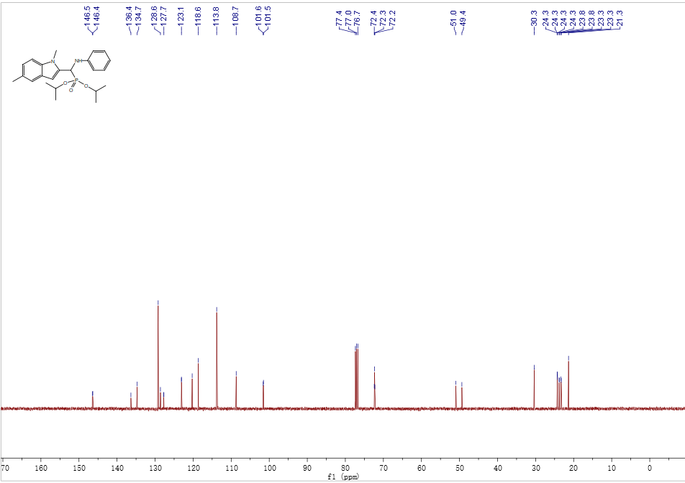

13C NMR Spectrum of Compound **A1**

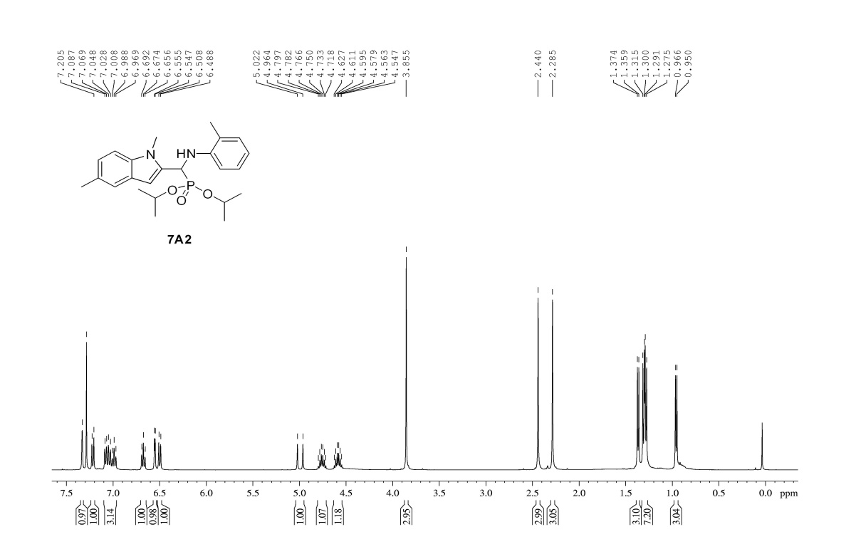

1H NMR Spectrum of Compound **A2**

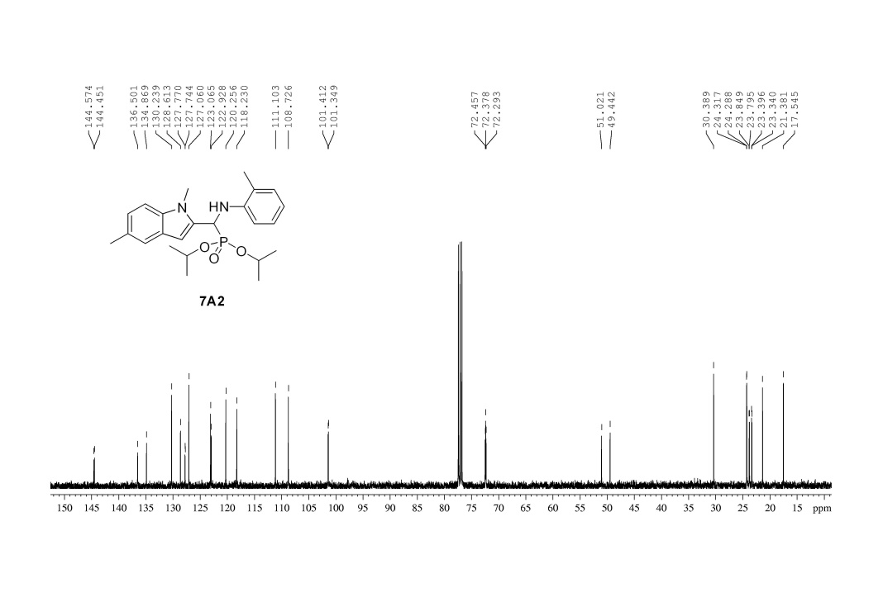

13C NMR Spectrum of Compound **A2**

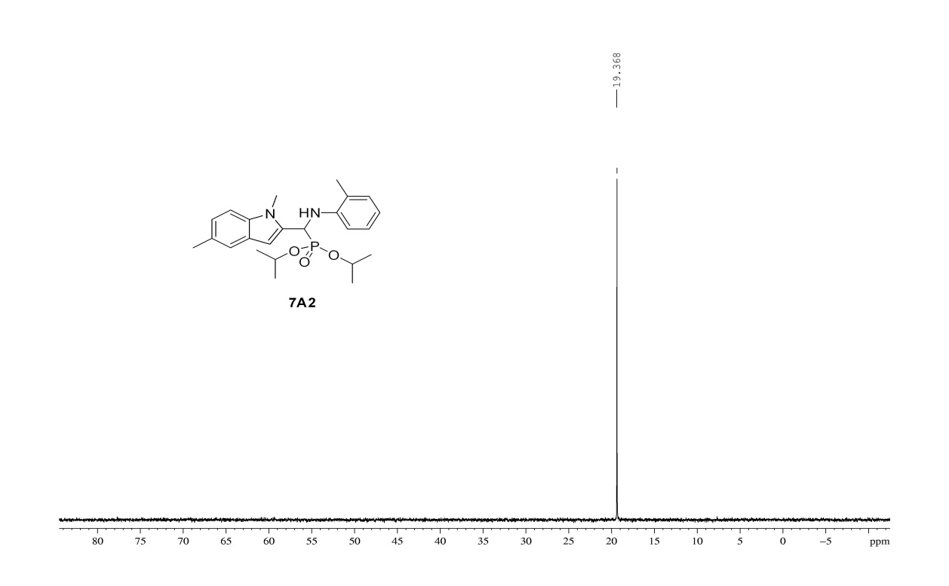

31P NMR Spectrum of Compound **A2**

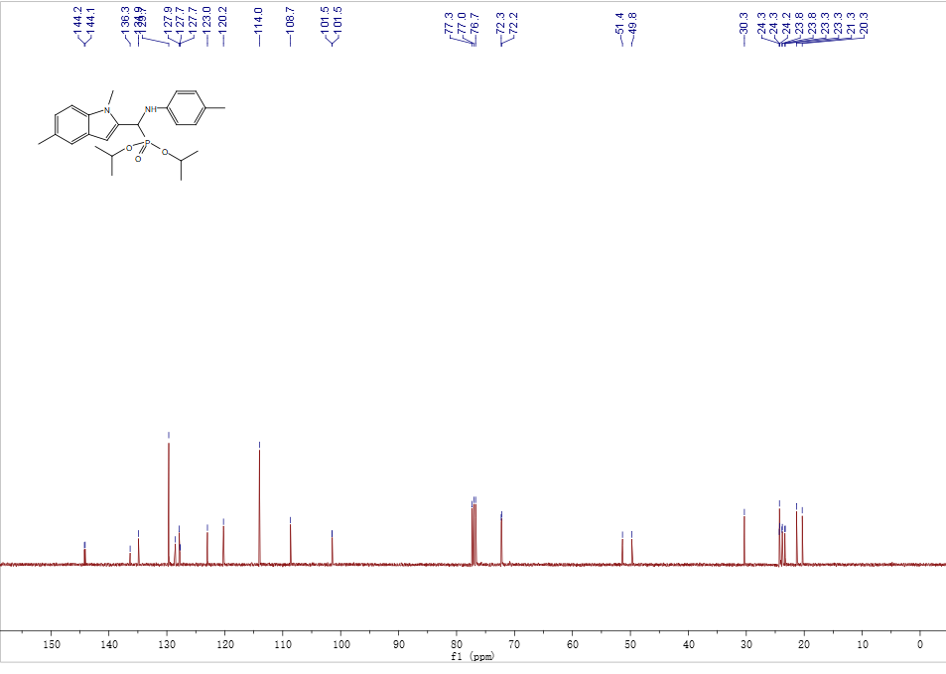

13C NMR Spectrum of Compound **A4**

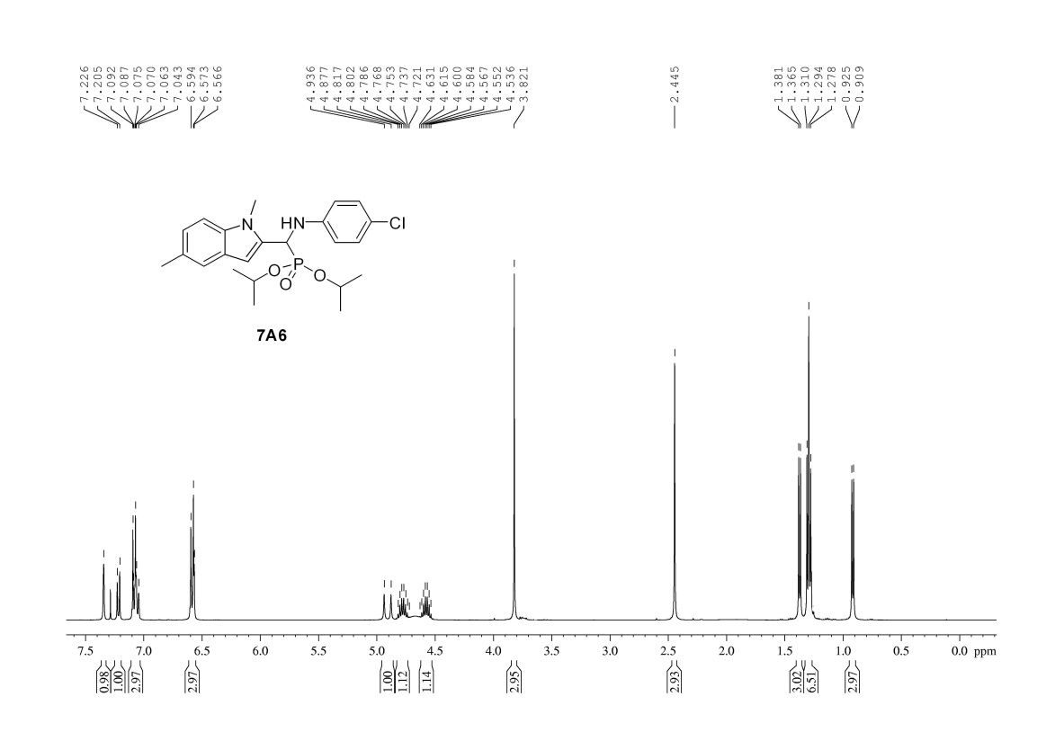

1H NMR Spectrum of Compound **A6**

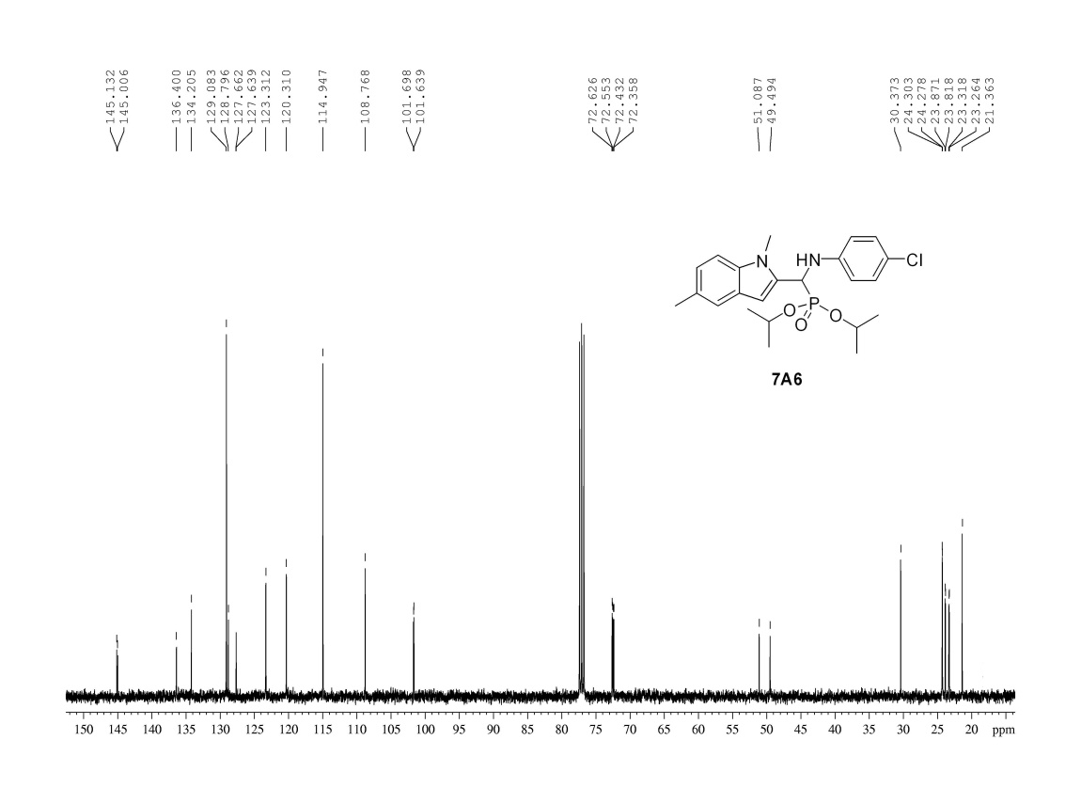

13C NMR Spectrum of Compound **A6**

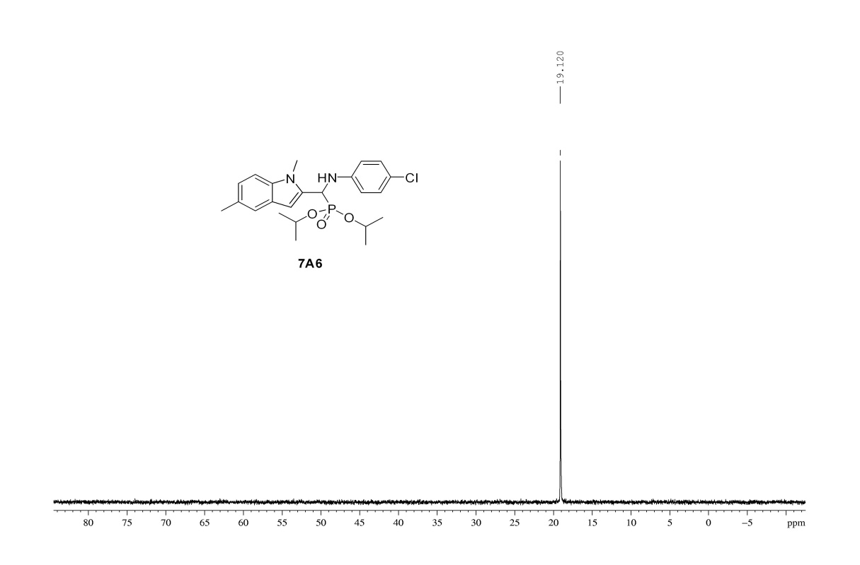

31P NMRSpectrum of Compound **A6**

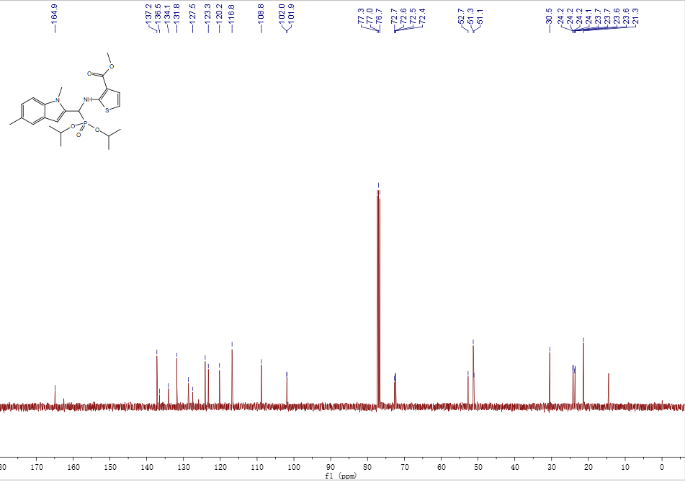

13C NMR Spectrum of Compound **A7**

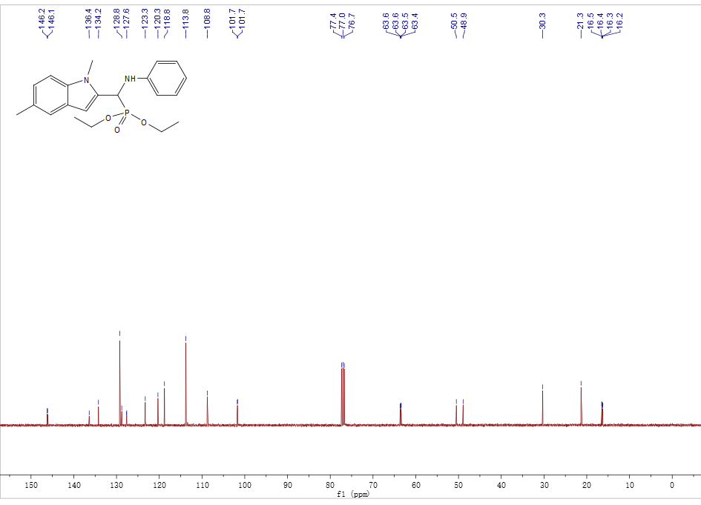

13C NMR Spectrum of Compound **B1**

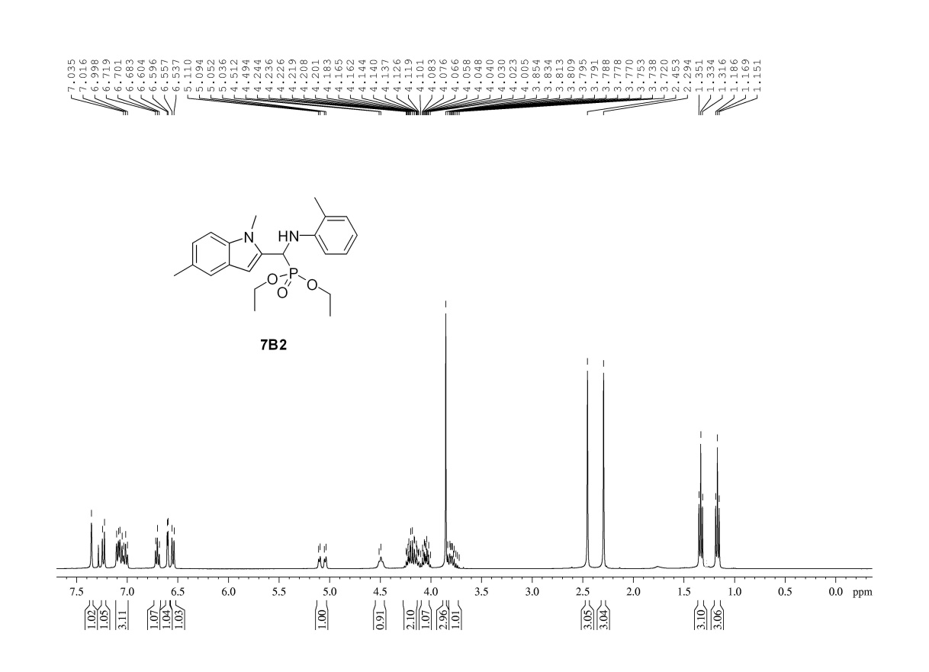

1H NMR Spectrum of Compound **B2**

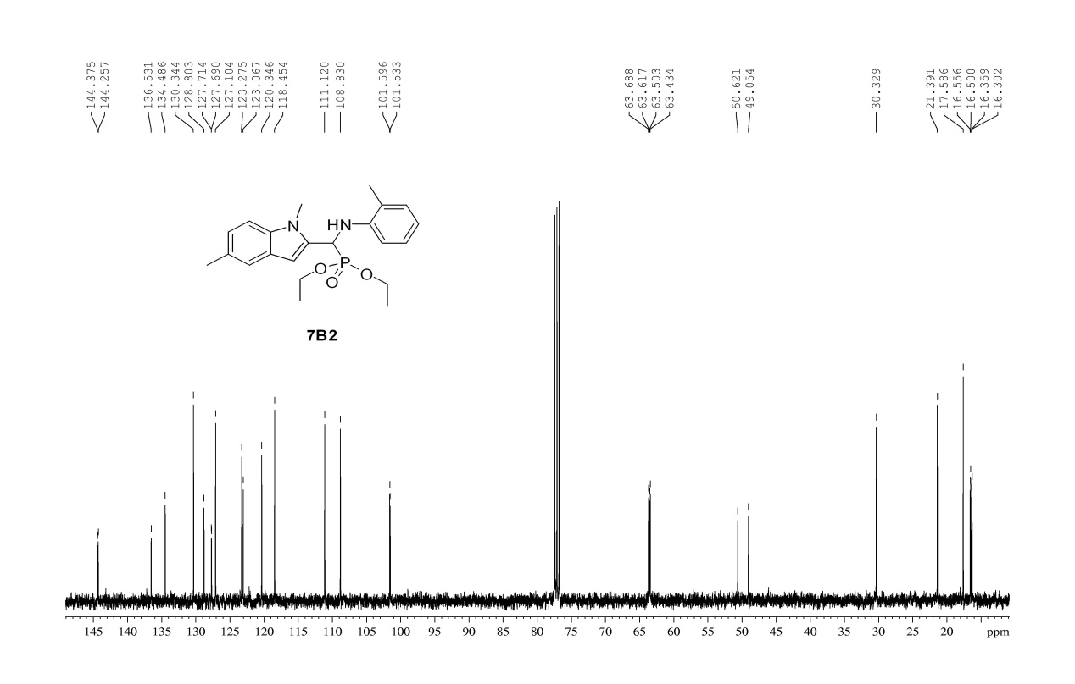

13C NMR Spectrum of Compound **B2**

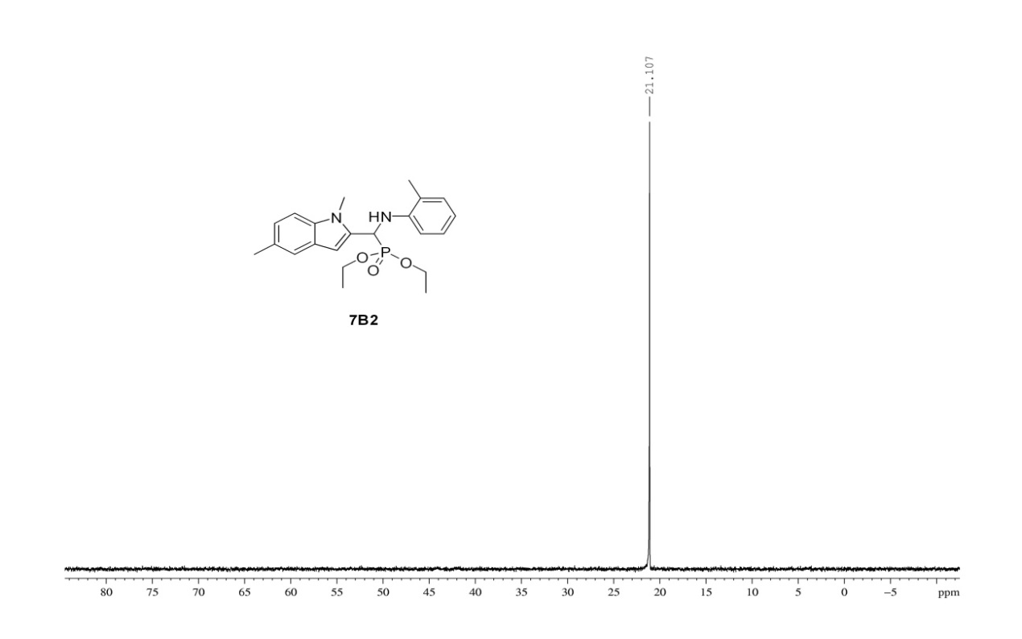

31P NMR Spectrum of Compound **B2**

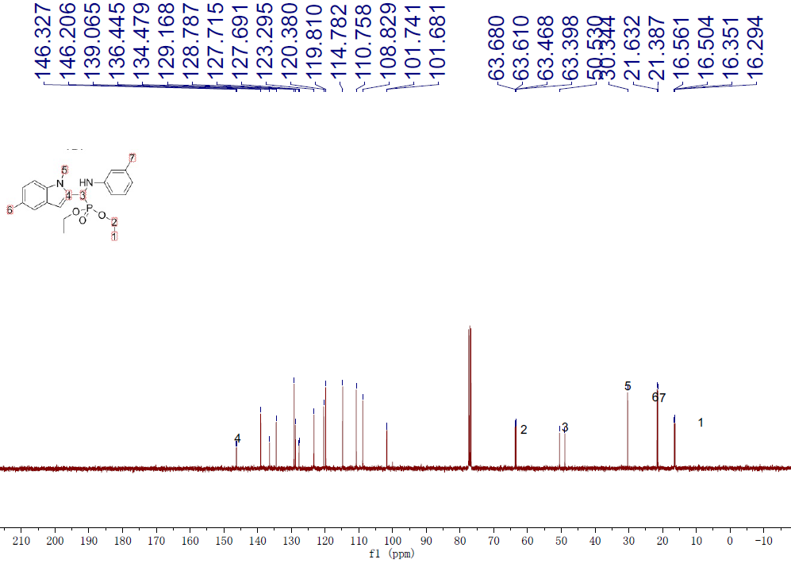

13C NMR Spectrum of Compound **B3**

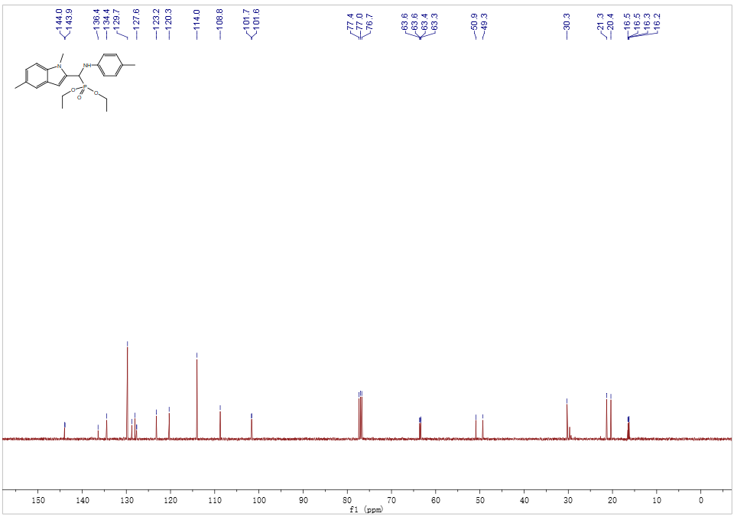

13C NMR Spectrum of Compound **B4**

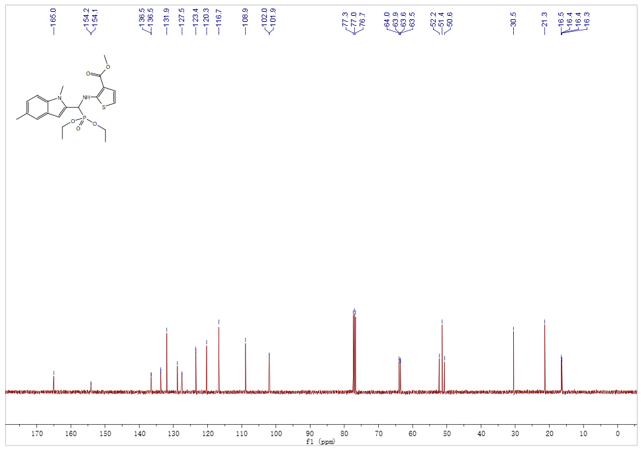

13C NMR Spectrum of Compound **B7**

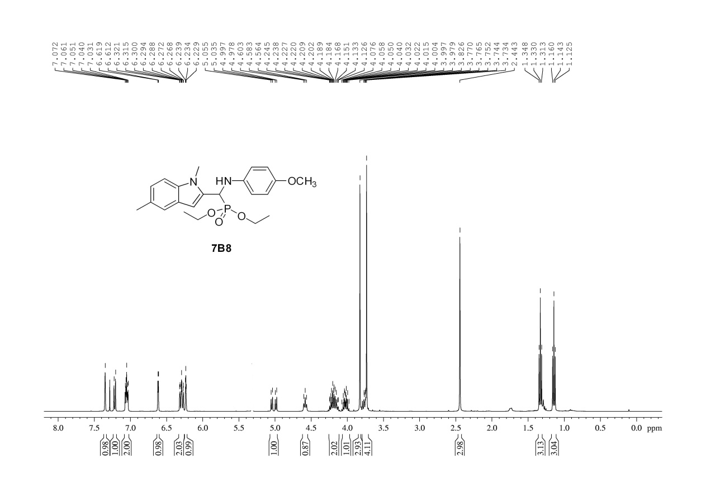

1H NMR Spectrum of Compound **B8**

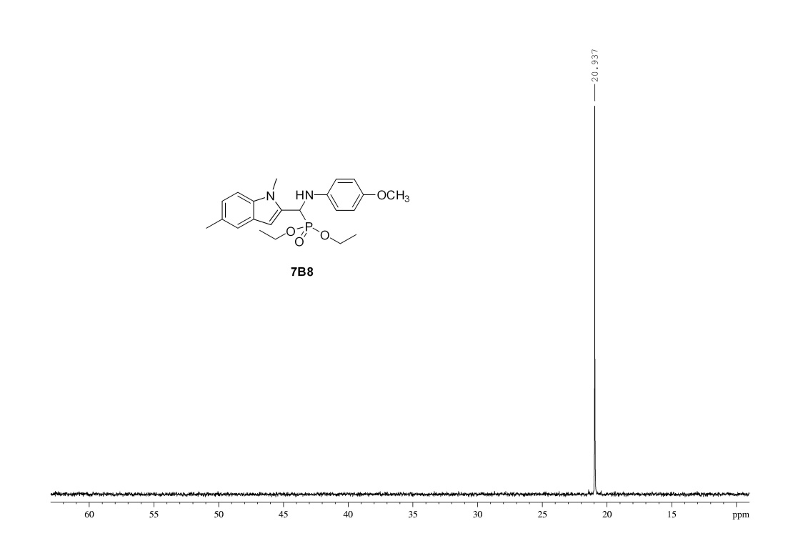

31P NMR Spectrum of Compound **B8**

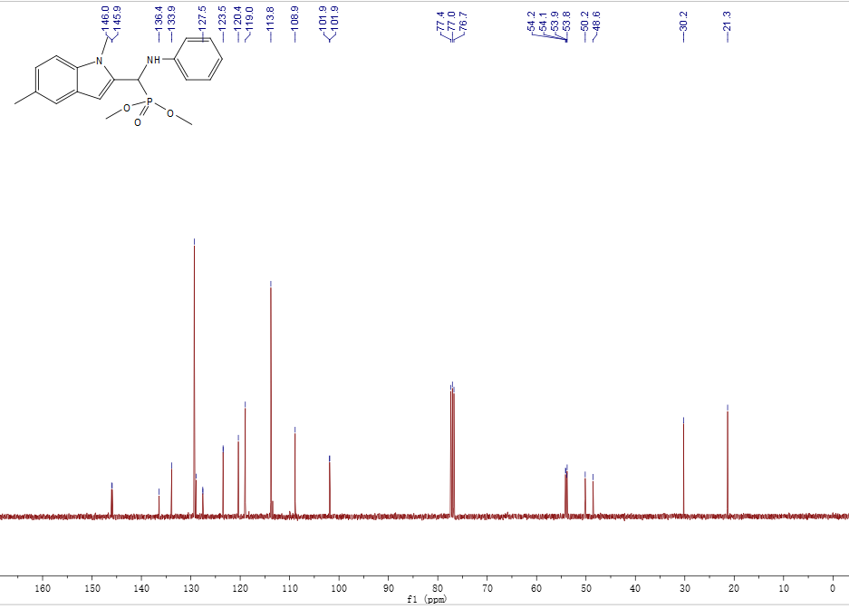

13C NMR Spectrum of Compound **C1**

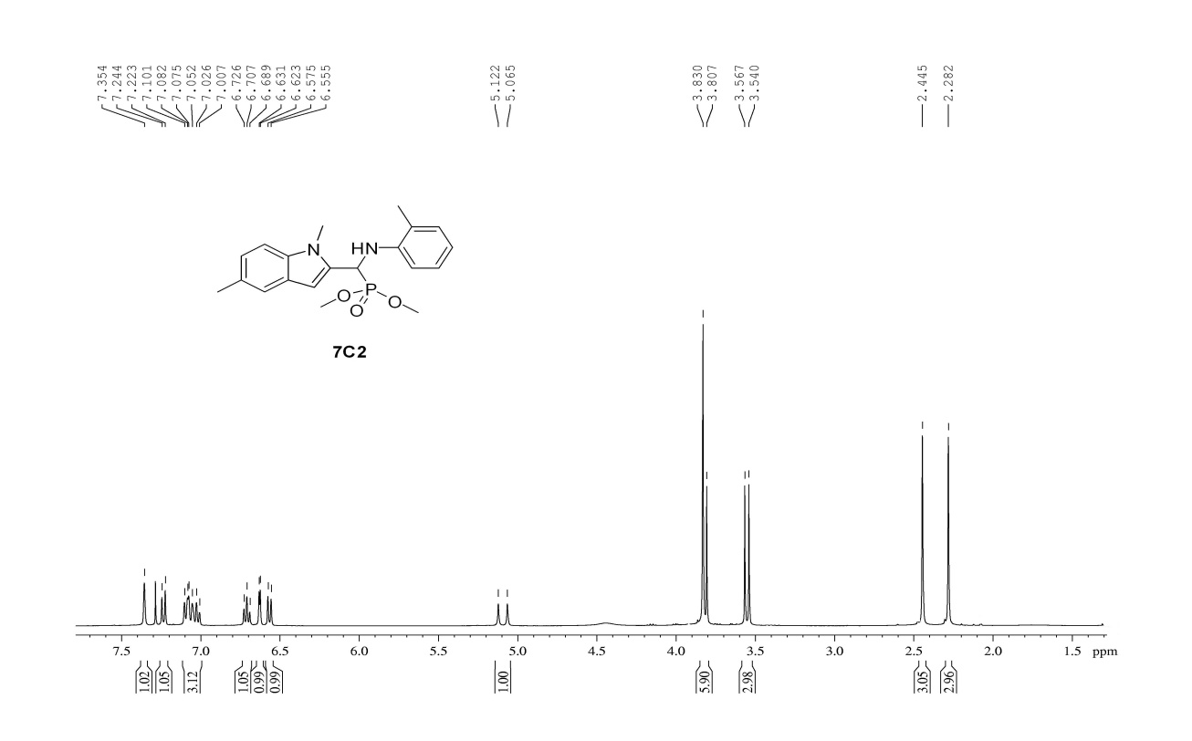

1H NMR Spectrum of Compound **C2**

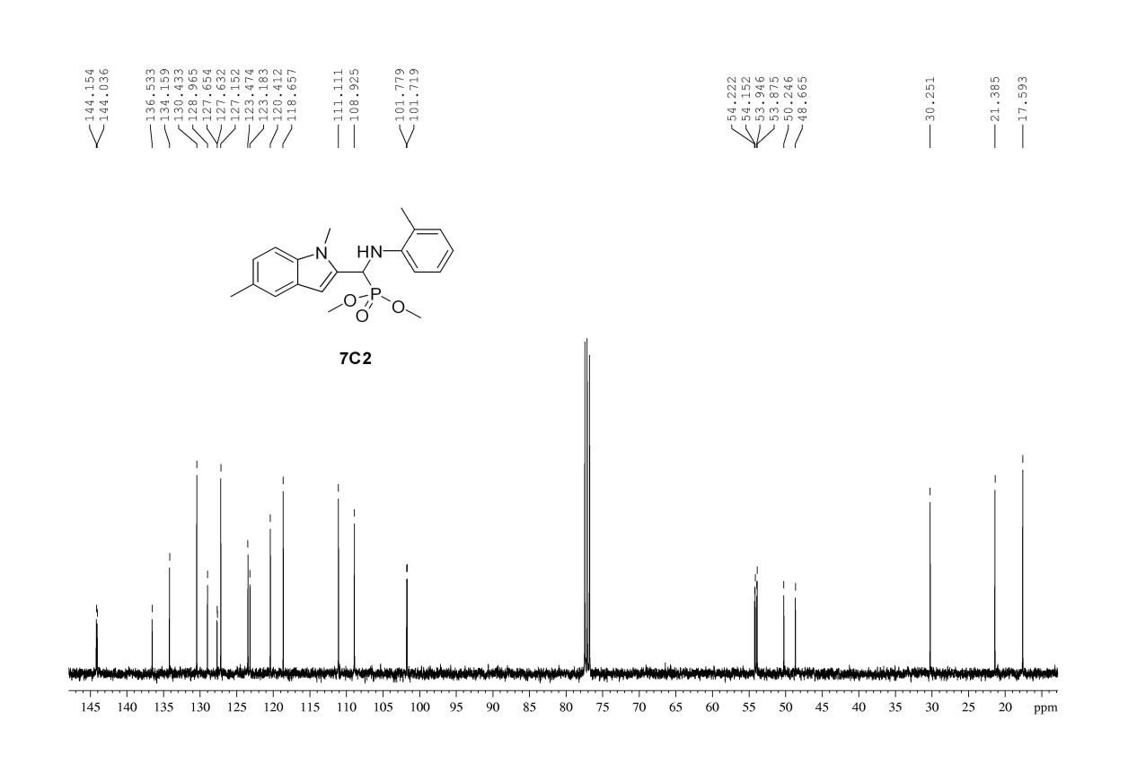

13C NMR Spectrum of Compound **C2**

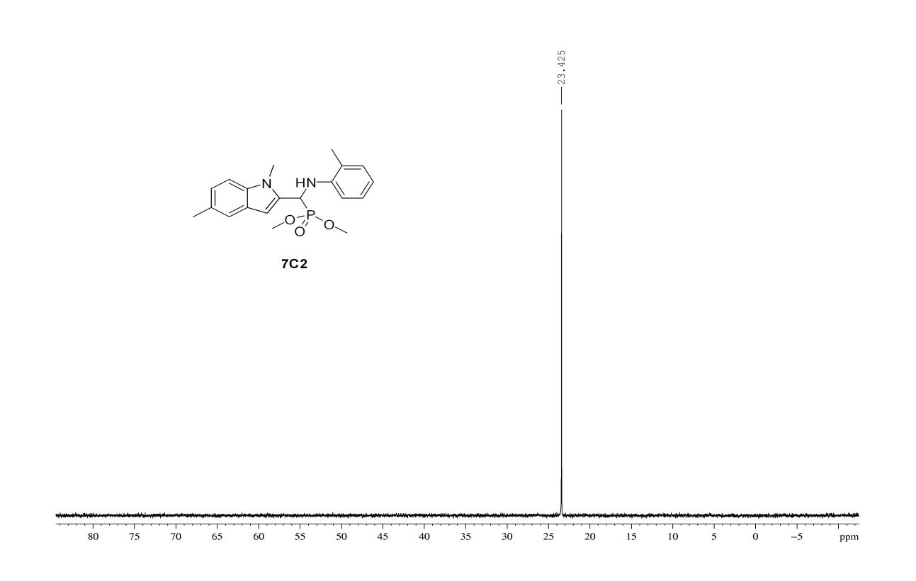

31P NMR Spectrum of Compound **C2**

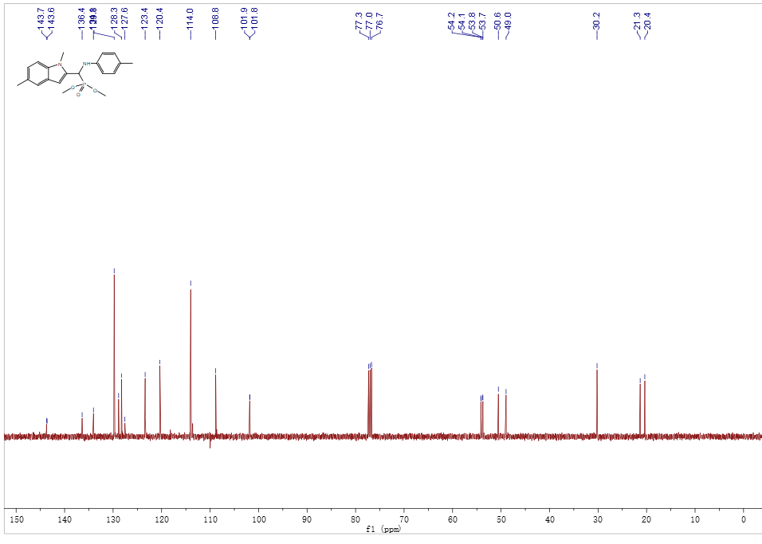

13C NMR Spectrum of Compound **C4**

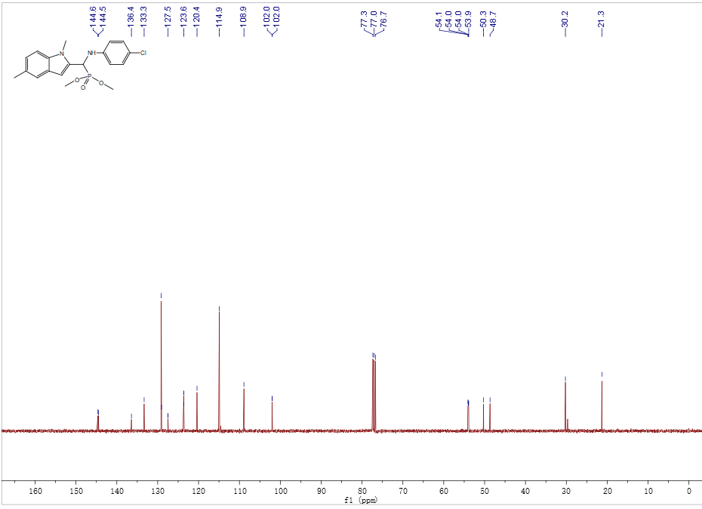

13C NMR Spectrum of Compound **C5**

4 HRMS of Products

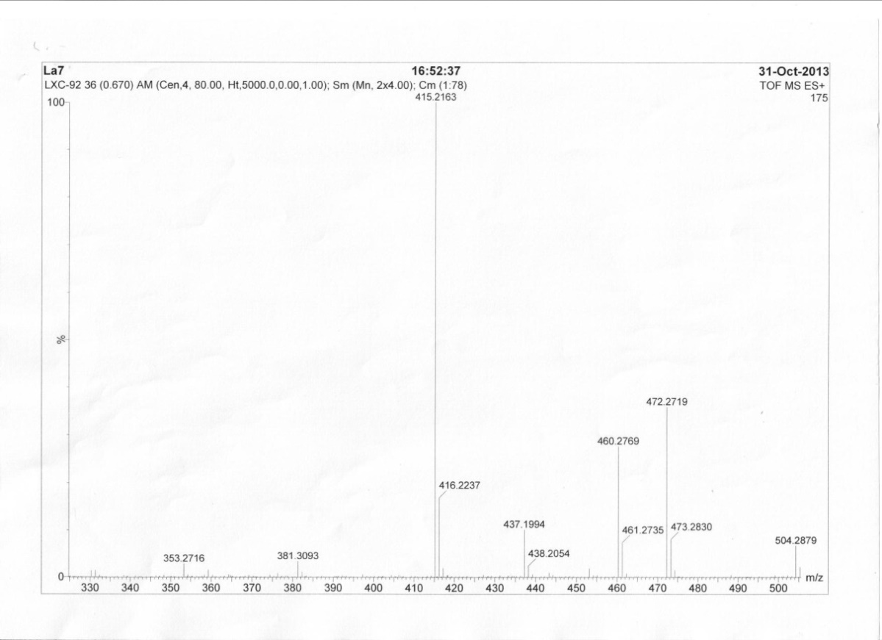

HRMS of Compound **A1**

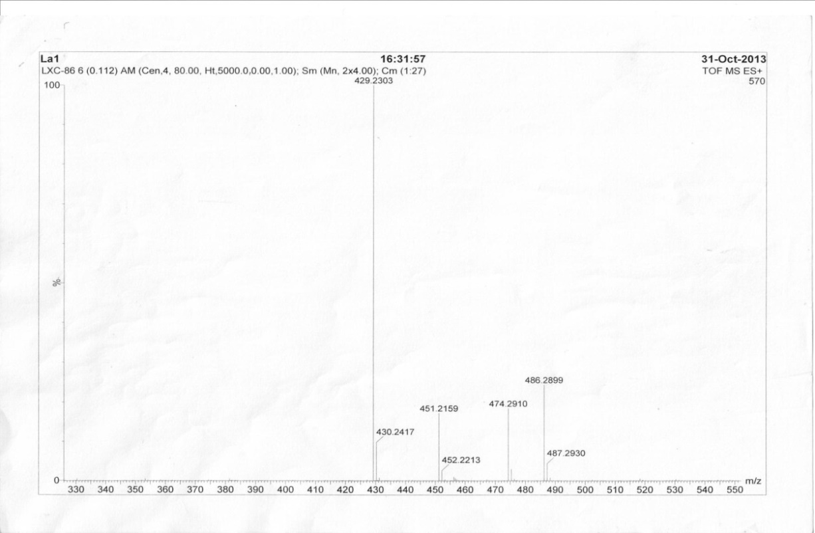

HRMS of Compound **A2**

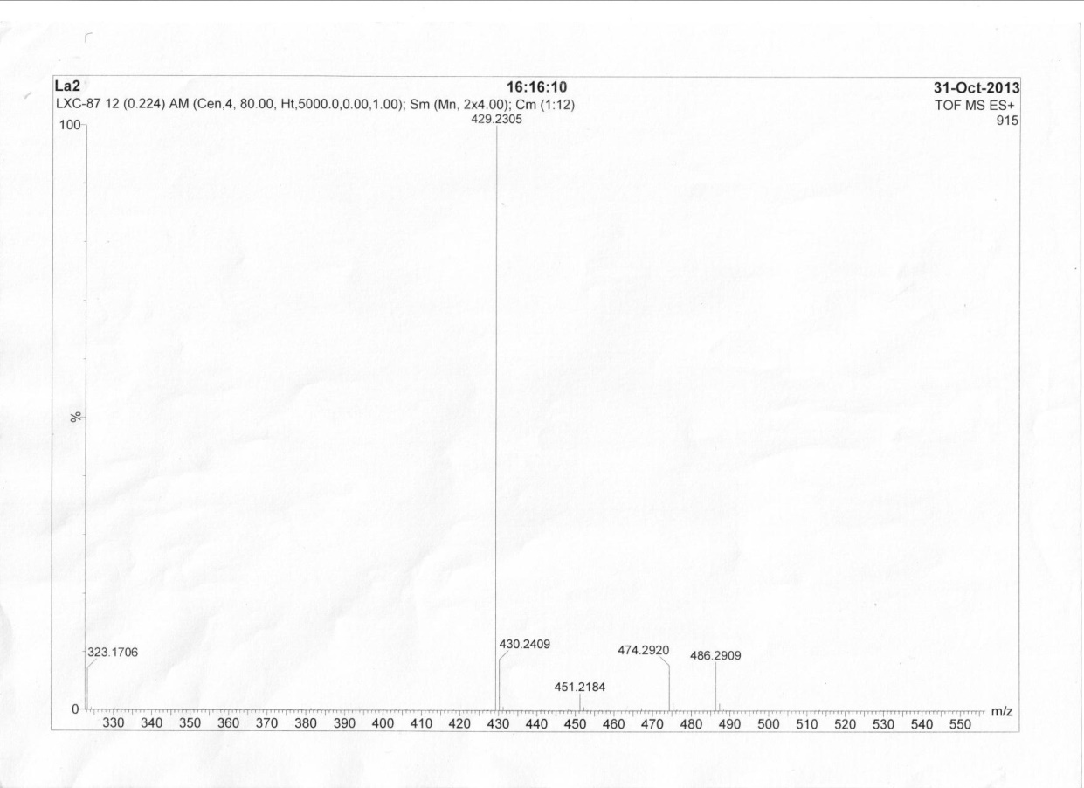

HRMS of Compound **A3**

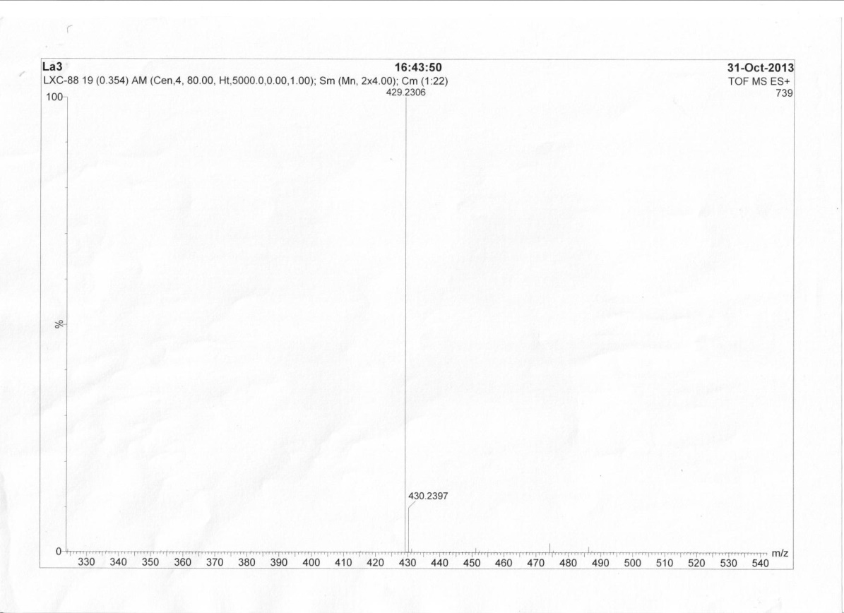

HRMS of Compound **A4**

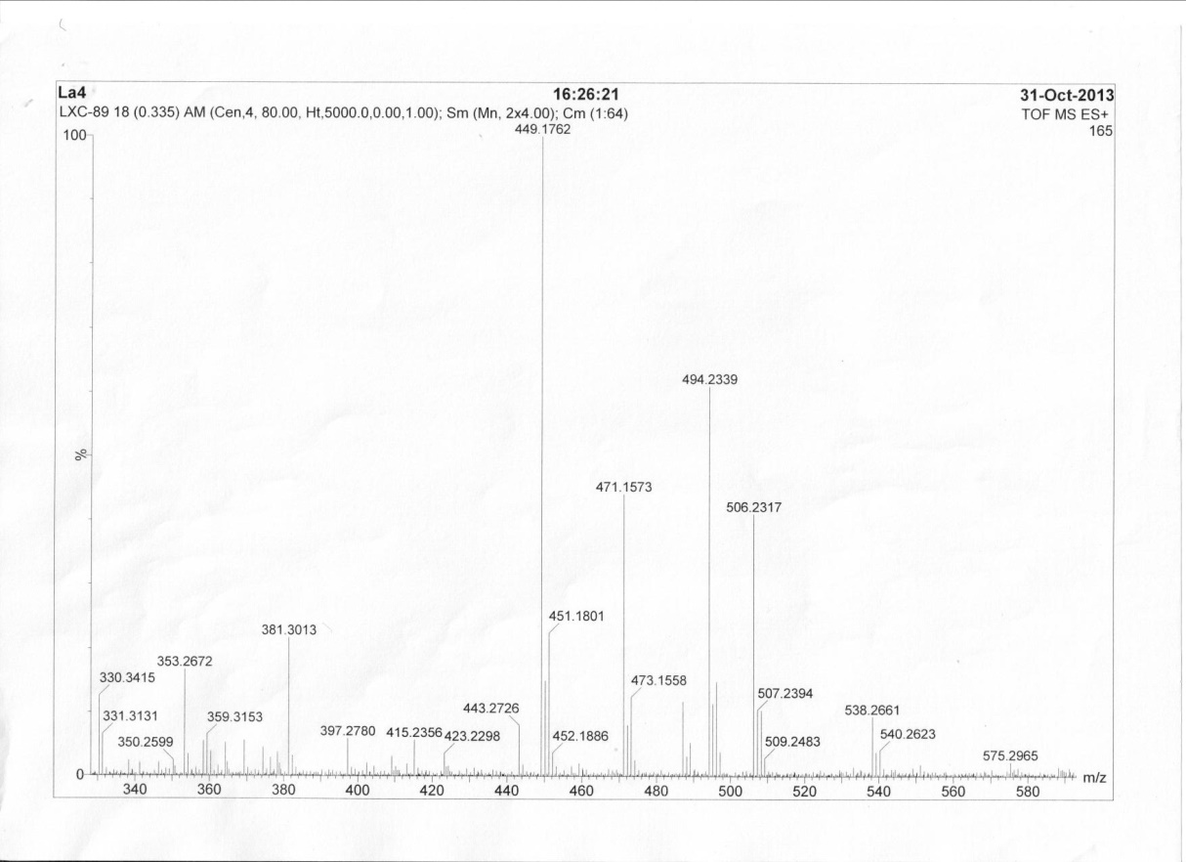

HRMS of Compound **A5**

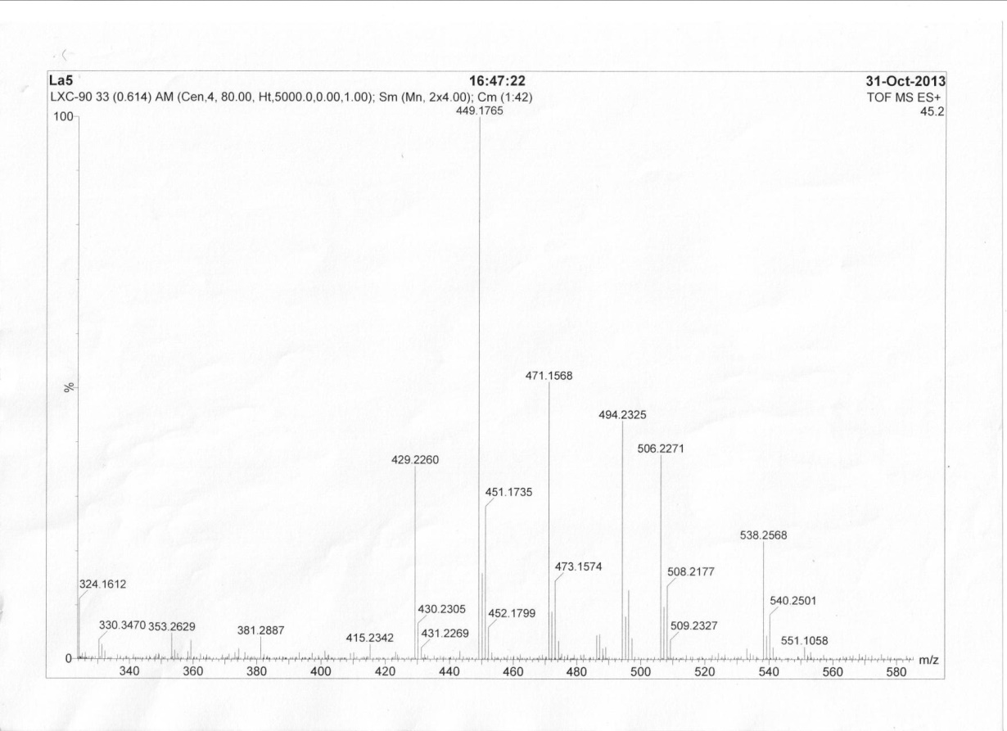

HRMS of Compound **A6**

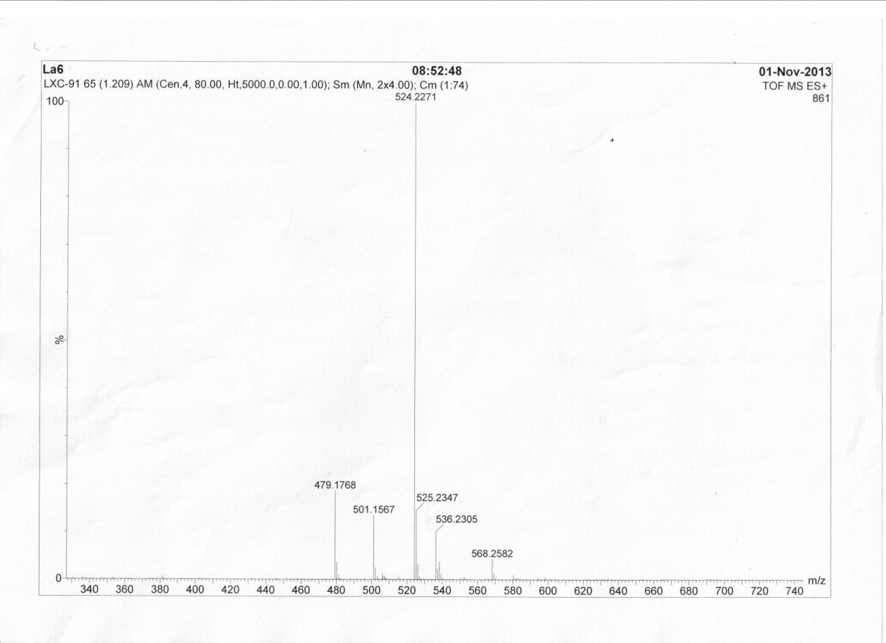

HRMS of Compound **A7**

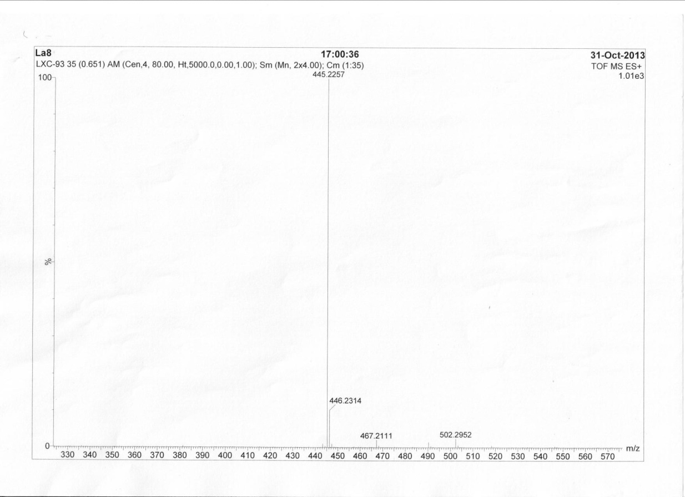

HRMS of Compound **A8**

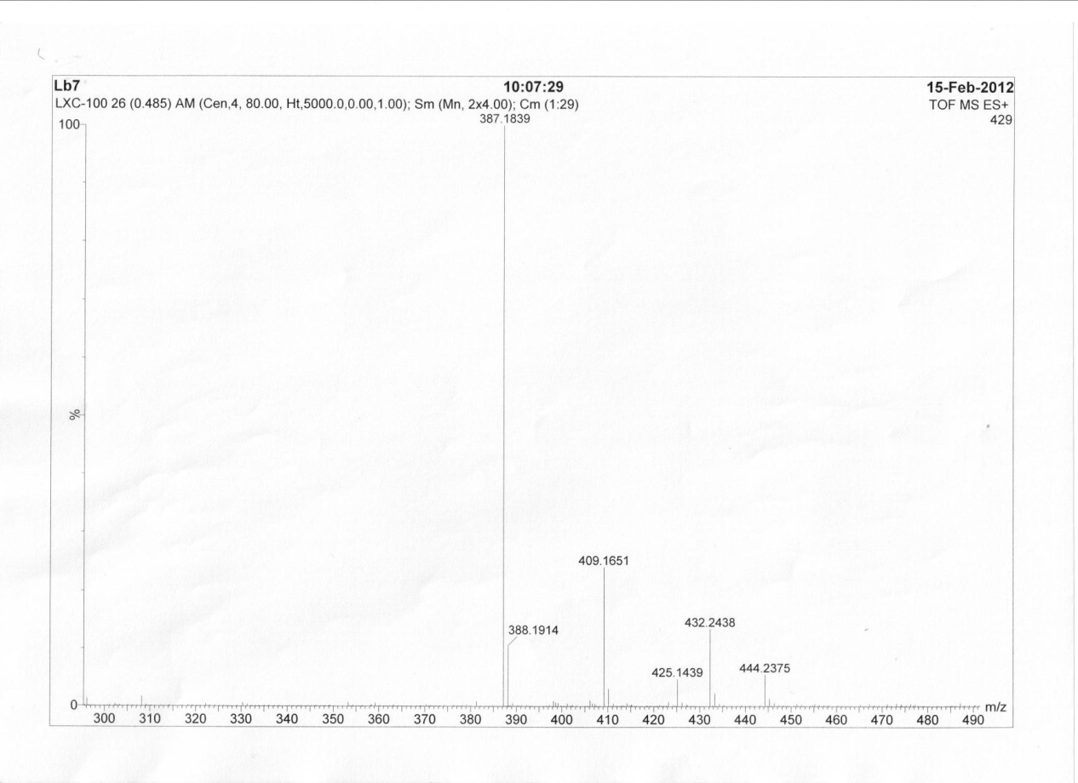

HRMS of Compound **B1**

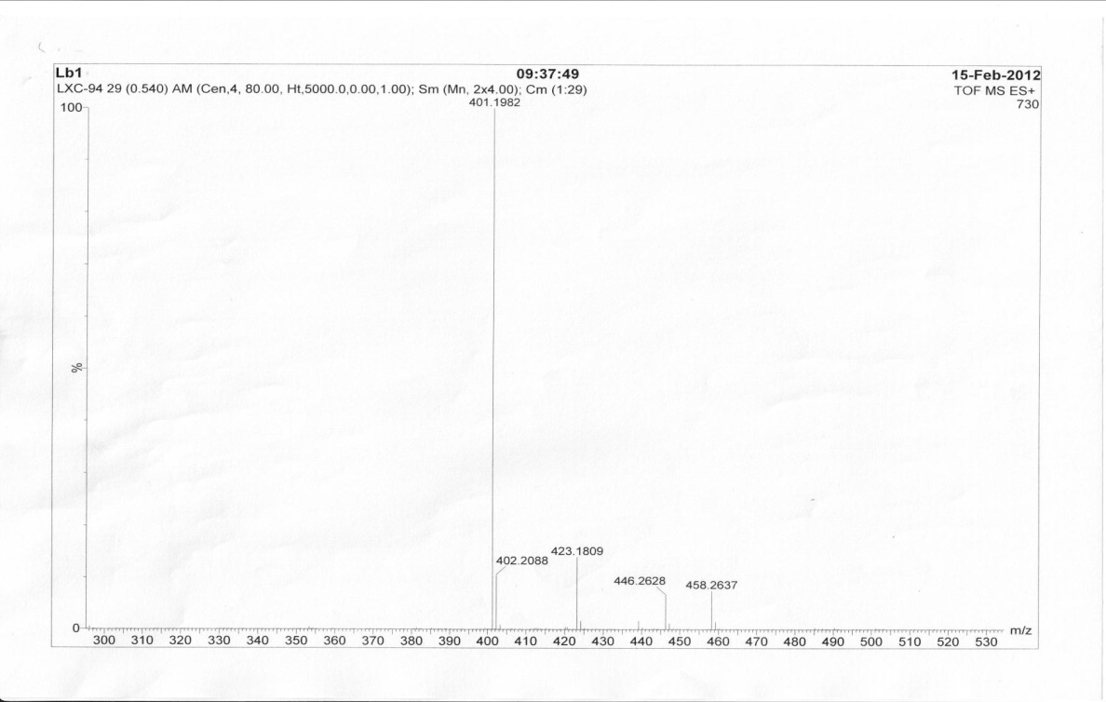

HRMS of Compound **B2**

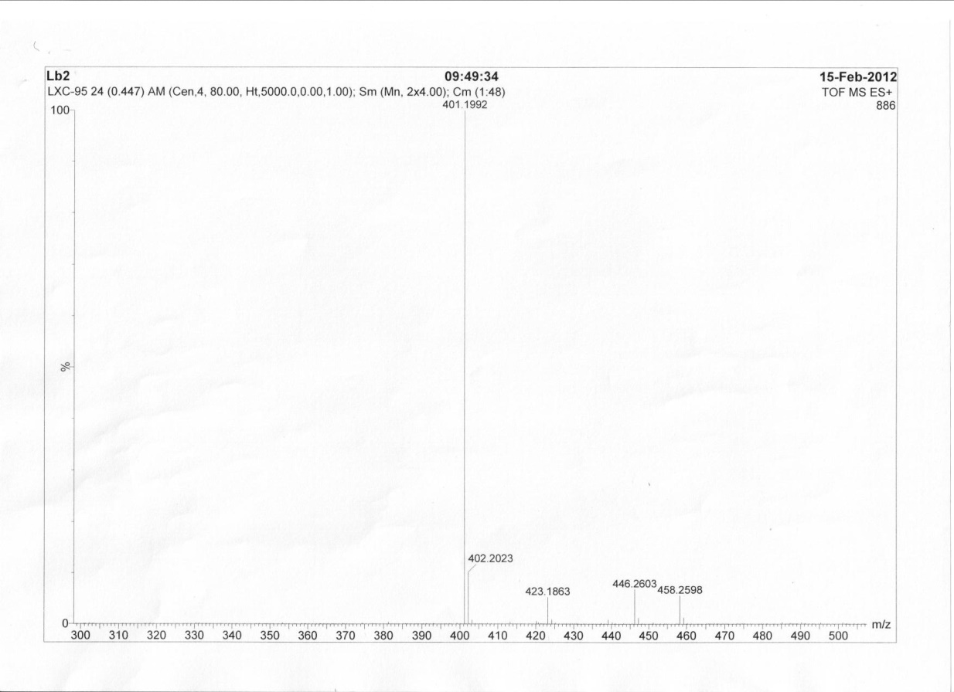

HRMS of Compound **B3**

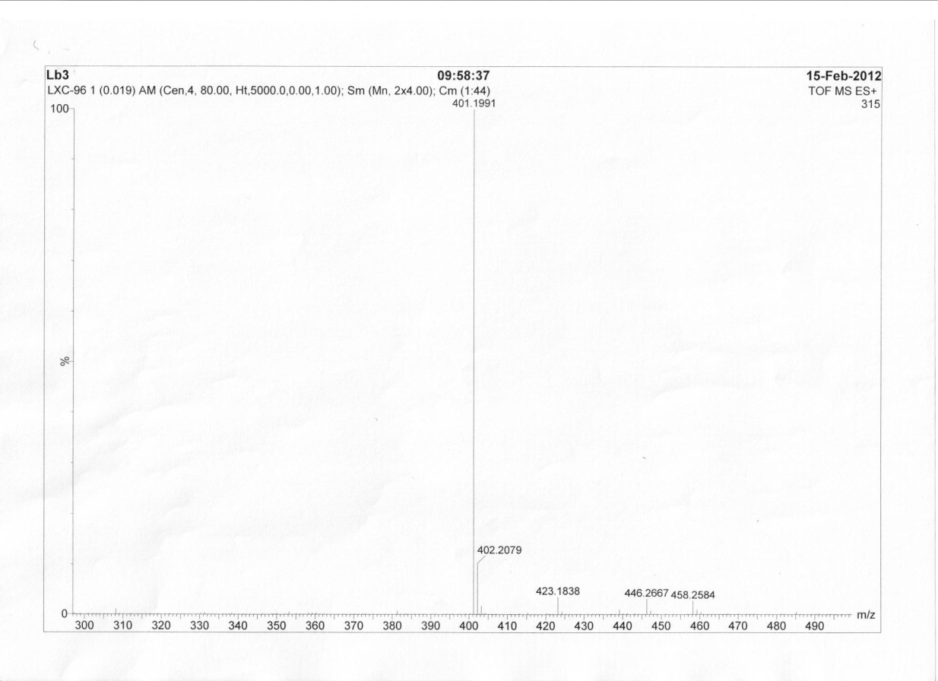

HRMS of Compound **B4**

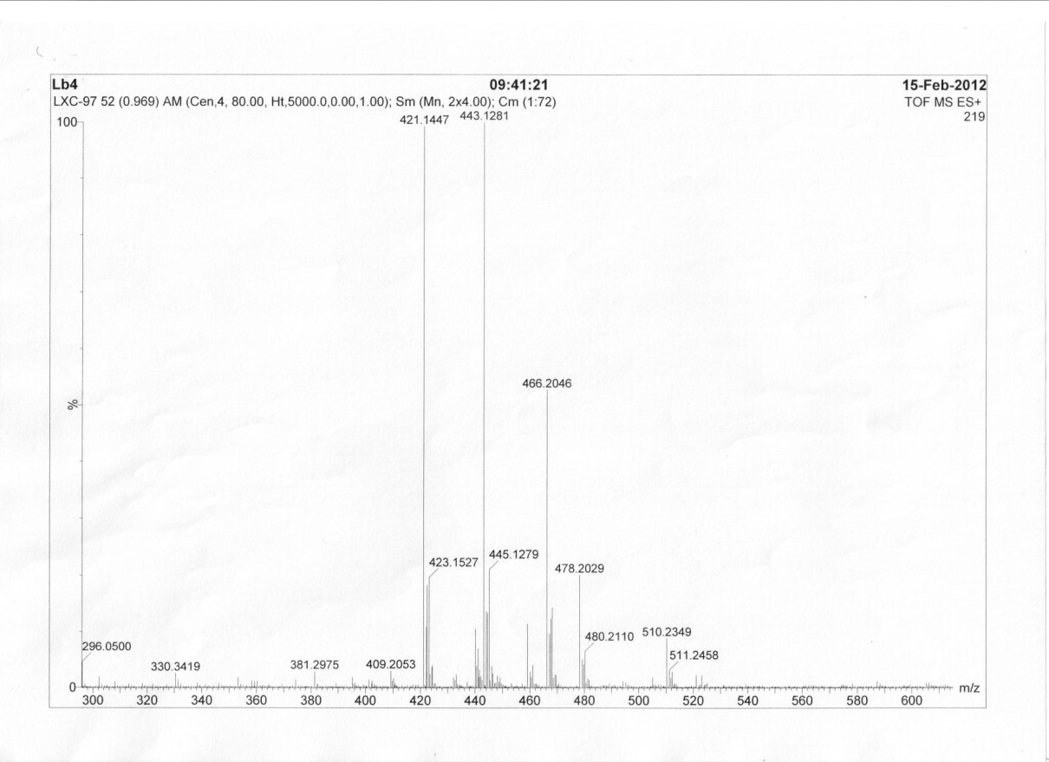

HRMS of Compound **B5**

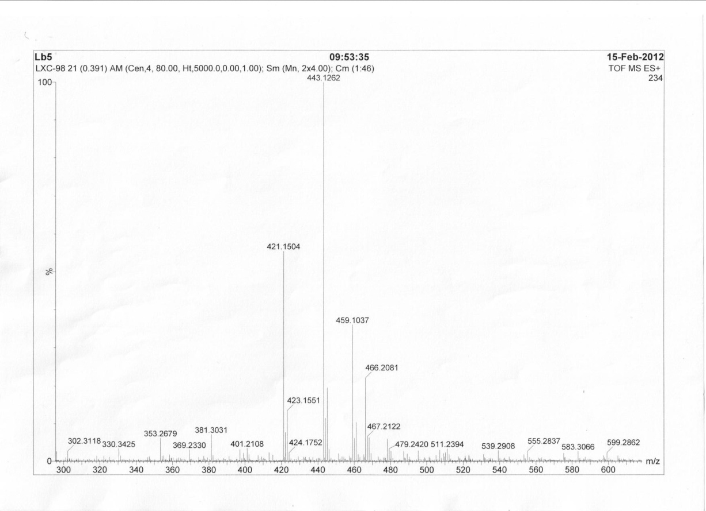

HRMS of Compound **B6**

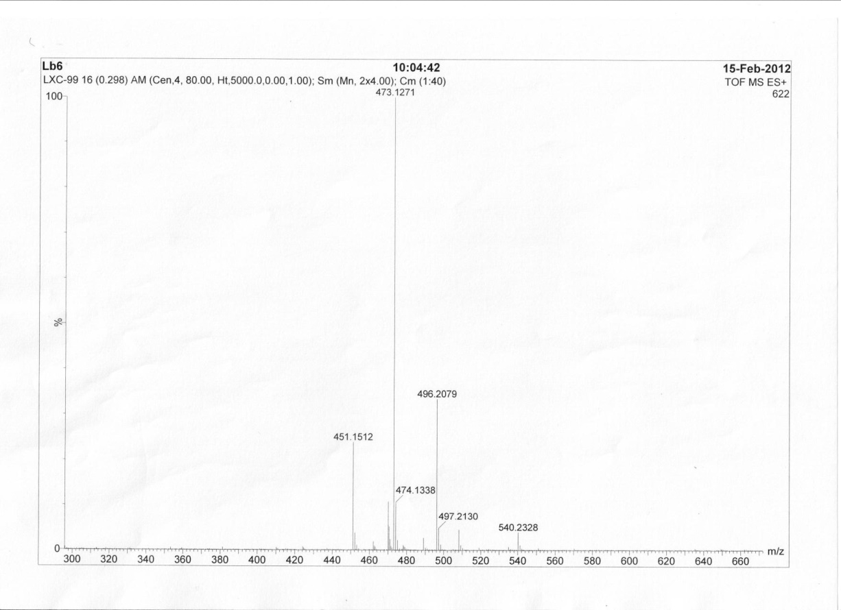

HRMS of Compound **B7**

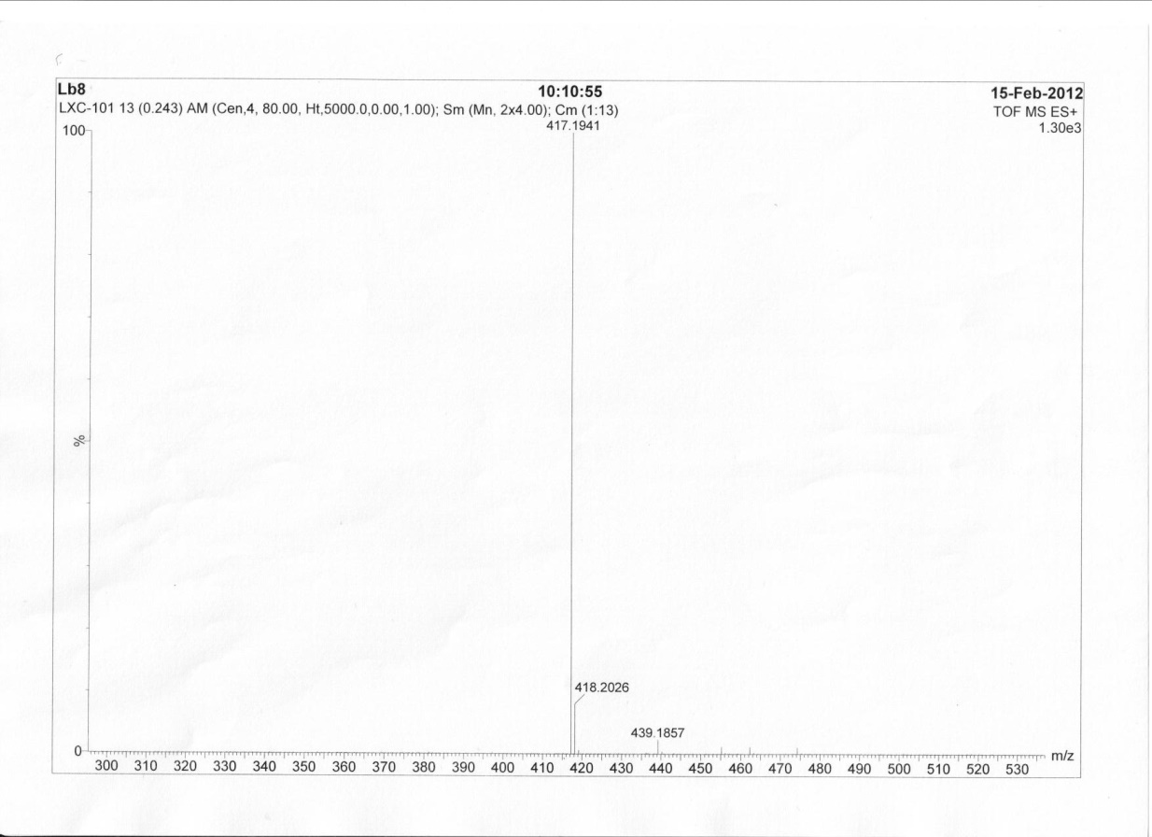

HRMS of Compound **B8**

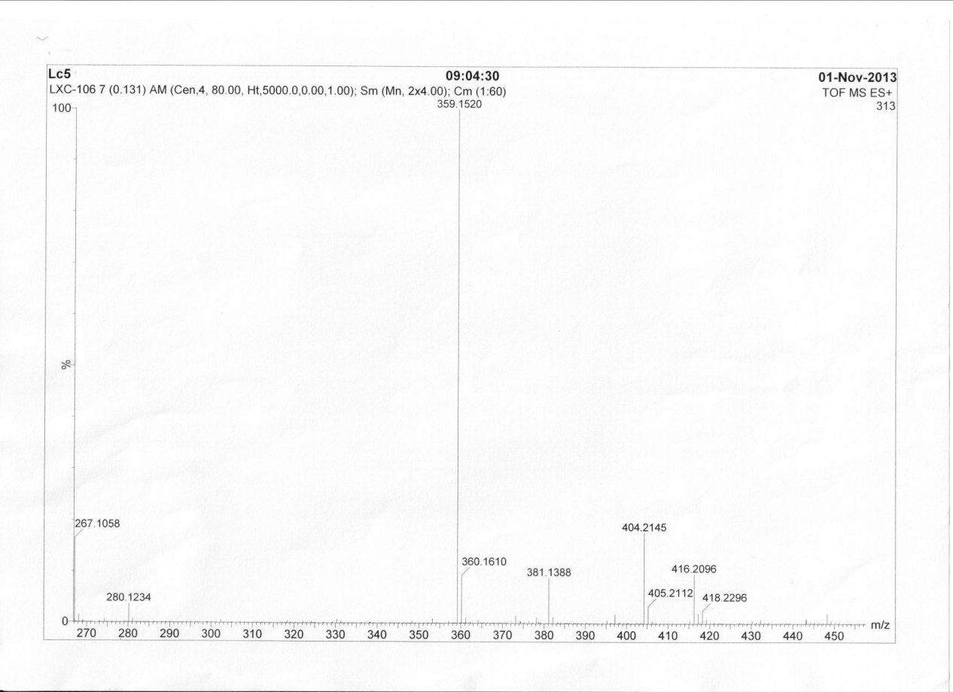

HRMS of Compound **C1**

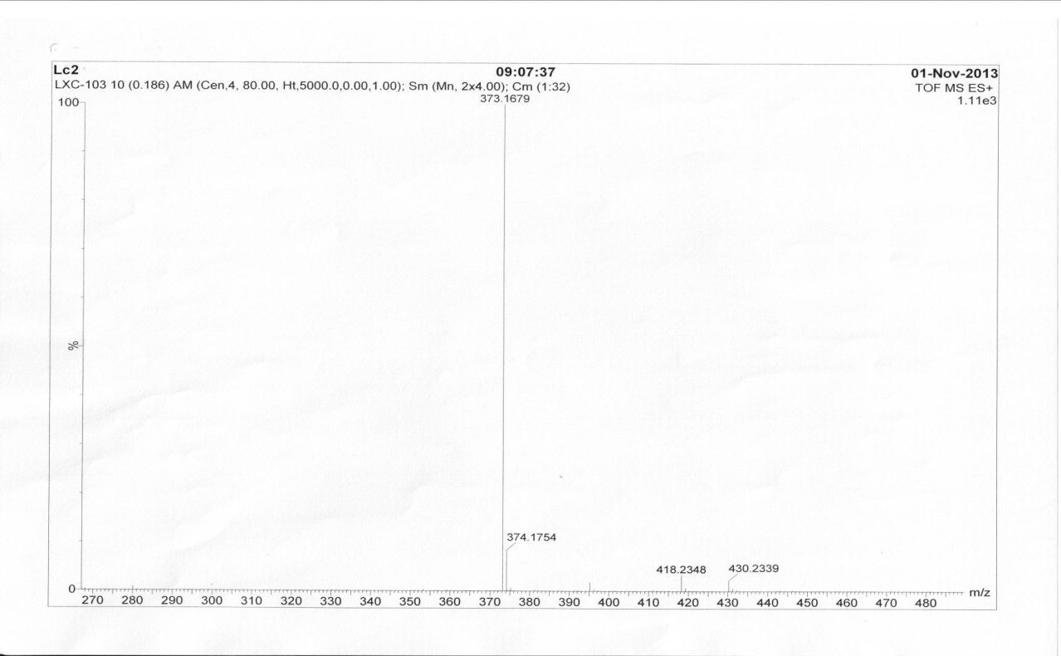

HRMS of Compound **C2**

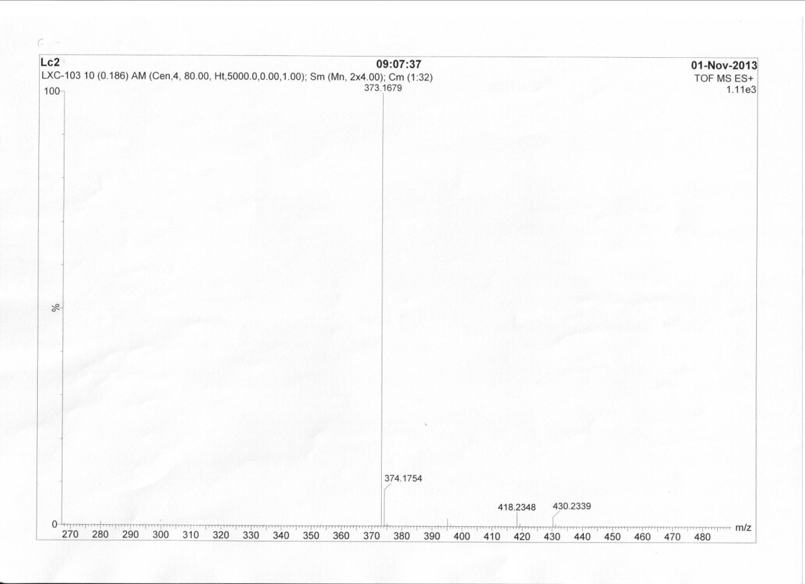

HRMS of Compound **C3**

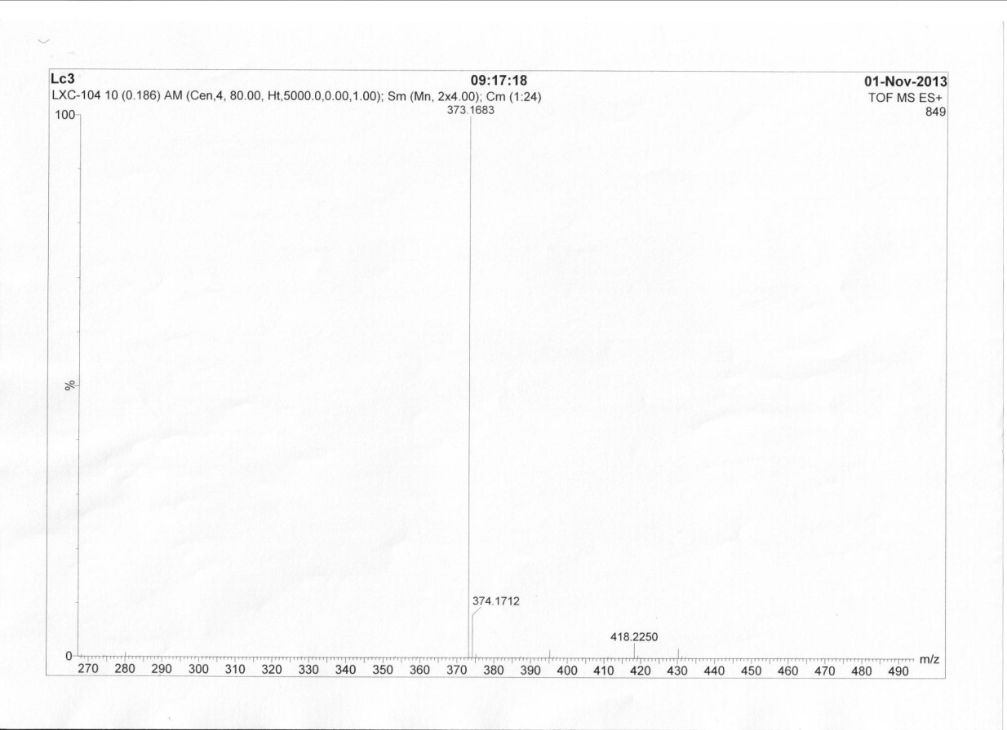

HRMS of Compound **C4**

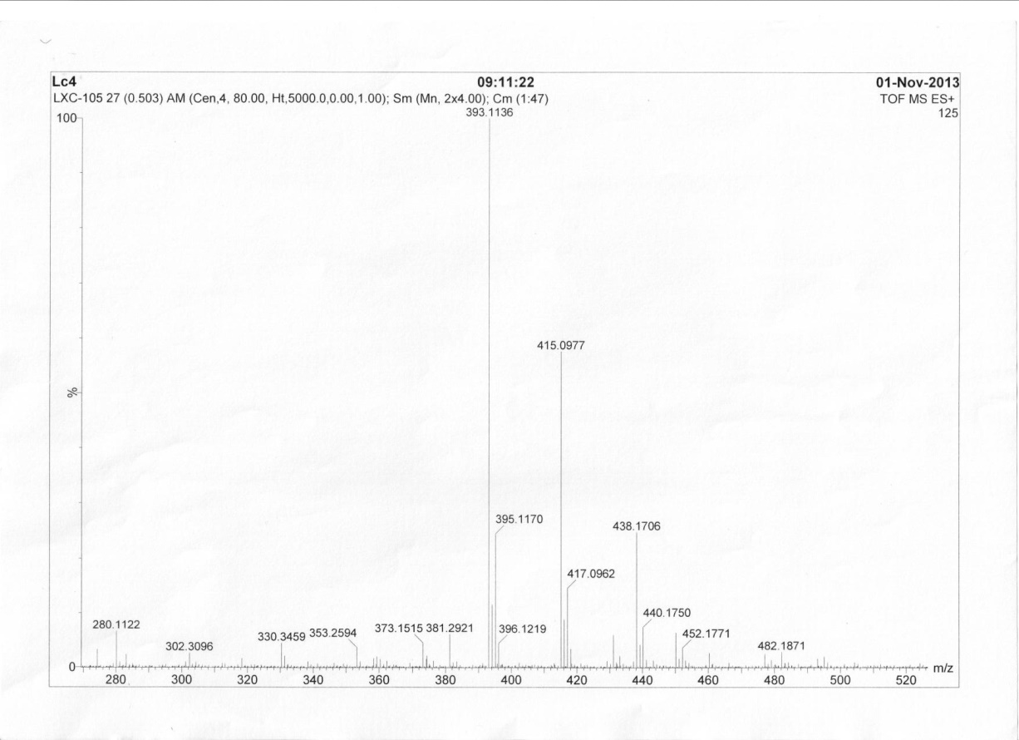

HRMS of Compound **C5**

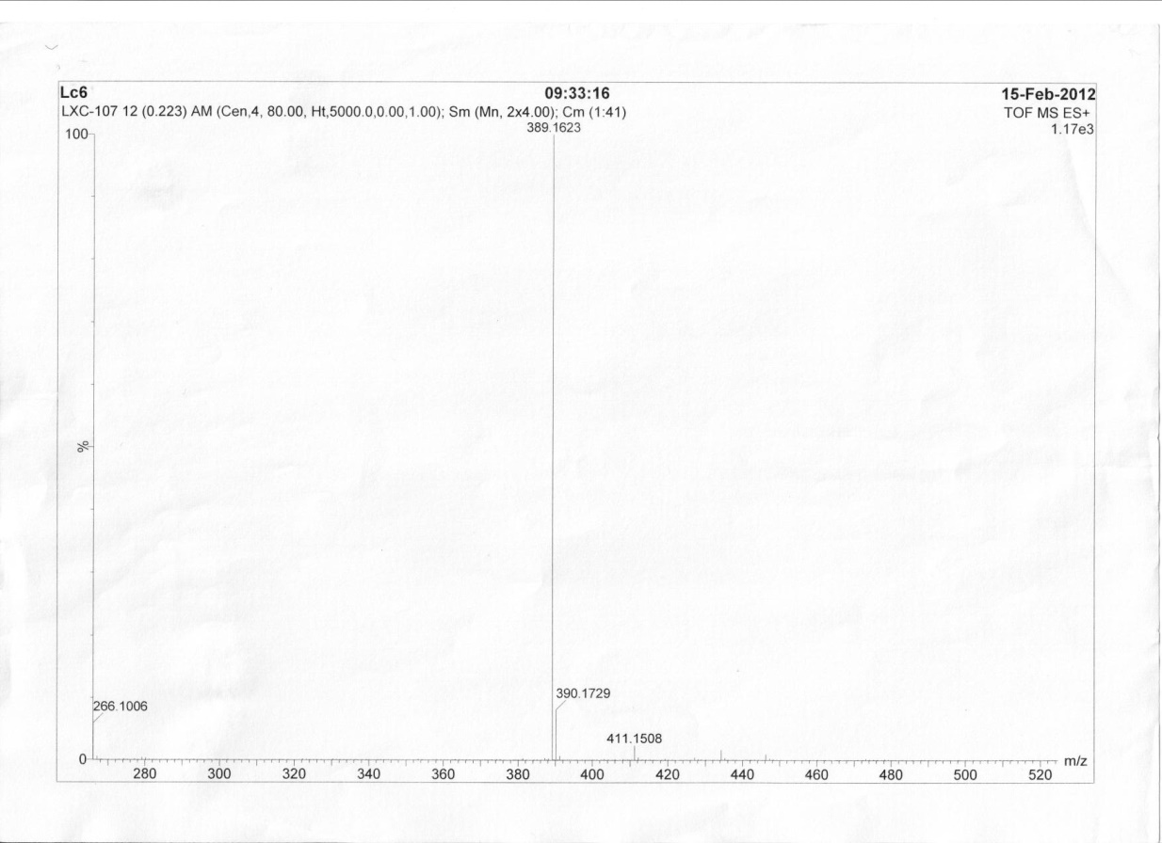

HRMS of Compound **C6**