NLO Potential Exploration for D−π−A Heterocyclic Organic Compounds by Incorporation of Various π-Linkers and Acceptor Units

Muhammad Khalid,*¹ Muhammad Usman Khan,² Iqra Shafiq,¹ Riaz Hussain,² Khalid Mahmood,³ Ajaz Hussain,*³ Rifat Jawaria,¹ Amjad Hussain,² Muhammad Imran,⁴ Mohammed A. Assiri^{4, 5,} Akbar Ali,⁶ Muhammad Fayyaz ur Rehman⁶, Ke Yu Sun⁷, Yu Zhen Li*⁷
¹Department of Chemistry, Khwaja Fareed University of Engineering & Information Technology, Rahim Yar Khan, 64200, Pakistan
²Department of Chemistry, University of Okara, Okara-56300, Pakistan
³Institute of chemical sciences Bahauddin Zakariya University, Multan 60800, Pakistan
⁴Department of Chemistry, Faculty of Science, King Khalid University, P.O. Box 9004, Abha 61413, Saudi Arabia.
⁵Research Center for Advanced Materials Science (RCAMS), King Khalid University, P.O. Box 9004, Abha 61413, Saudi Arabia.
⁶Institute of Chemistry, University of Sargodha, 40100, Pakistan.
⁷Department of Emergency, Minhang hospital, Fudan University, No.170, Xinsong Road, Minhang District, Shanghai, China
*Corresponding authors E-mail addresses:
Dr. Muhammad Khalid (muhammad.khalid@kfueit.edu.pk; Khalid@iq.usp.br)
Dr. Ajaz Hussain (ajaz_hussain01@yahoo.com)
Dr. Yu Zhen Li (liyuzhenmhh@126.com)
Dr M Fayyaz ur Rehman (fayyaz9@gmail.com)

Table S1: Cartesian coordinates of DTA1
 | X-axis | Y-axis | Z-axis
C | -1.9853 | -0.0771 | 0.1035
C | -2.7817 | -0.9770 | 0.8383
C | -2.6519 | 0.8700 | -0.6994
C | -4.1667 | -0.9370 | 0.7730
H | -2.3095 | -1.7108 | 1.4791
C | -4.0360 | 0.9182 | -0.7659
H | -2.0787 | 1.5804 | -1.2825
C | -4.8249 | 0.0123 | -0.0313
H | -4.7506 | -1.6423 | 1.3532
H | -4.5167 | 1.6587 | -1.3949
N | -6.2307 | 0.0561 | -0.0993
C | -6.9998 | -1.1399 | 0.0070
C | -8.1362 | -1.1725 | 0.8334
C | -6.6363 | -2.2849 | -0.7256
C | -8.9118 | -2.3256 | 0.9331
H | -8.4048 | -0.2844 | 1.3952
C | -7.4003 | -3.4369 | -0.6111
H | -5.7640 | -2.2496 | -1.3711
C | -8.5429 | -3.4641 | 0.2135
C | -6.9088 | 1.2982 | -0.2779
C | -7.9471 | 1.4024 | -1.2190
C | -6.5535 | 2.4174 | 0.4972
C | -8.6349 | 2.6019 | -1.3911
H | -8.2092 | 0.5329 | -1.8122
C | -7.2279 | 3.6152 | 0.3114
H | -5.7584 | 2.3261 | 1.2308
C | -8.2737 | 3.7145 | -0.6283
H | -9.4348 | 2.6630 | -2.1235
S | 0.8880 | -1.0180 | 3.5986
C | 6.3676 | -0.1273 | -0.4103
C | 6.1347 | -0.4557 | 0.9270
C | 0.2267 | -0.4543 | 1.3590
C | 1.6871 | -0.4911 | 1.3927
S | 4.8730 | 0.1094 | -1.2679
C | 0.2962 | 0.1405 | -0.9192
C | 1.7166 | 0.1041 | -0.8896
S | 7.6228 | -0.7327 | 1.7801
C | 8.5573 | -0.3744 | 0.3136
C | 10.0150 | -0.3881 | 0.2409
C | 10.7076 | 0.5650 | -0.4403
O | 12.4500 | -1.1965 | -1.5039
H | 12.9166 | -1.6365 | -0.7727
C | 7.7299 | -0.0773 | -0.7593
H | 8.1135 | 0.1515 | -1.7442
C | -9.1520 | -4.7953 | 0.1250
C | -7.1967 | -4.7844 | -1.3047
C | -8.3821 | -5.5802 | -0.7572
H | -9.7866 | -2.3315 | 1.5771
C | -5.8510 | -5.4255 | -0.8980
H | -5.7436 | -6.4176 | -1.3488
H | -5.0108 | -4.8100 | -1.2364
H | -5.7795 | -5.5352 | 0.1877
C | -7.2721 | -4.6453 | -2.8415
H | -6.4519 | -4.0237 | -3.2158
H | -7.1953 | -5.6262 | -3.3220
H | -8.2166 | -4.18801 | -3.1493
C | -10.2868 | -5.3261 | 0.7425
H | -10.8840 | -4.7247 | 1.4223
C | -8.7456 | -6.8953 | -1.0231
H | -8.1595 | -7.5092 | -1.7022
C | -9.8824 | -7.4279 | -0.4034
H | -10.1744 | -8.4545 | -0.6040
C | -10.6453 | -6.6482 | 0.4717
H | -11.5249 | -7.0750 | 0.9449
C | -8.0847 | 5.8154 | 0.3699
C | -7.0156 | 4.9464 | 1.0330
C | -7.2617 | 4.8094 | 2.5520
H | -6.5267 | 4.1355 | 3.0046
H | -7.1740 | 5.7823 | 3.0468
H | -8.2604 | 4.4127 | 2.7547
C | -5.5972 | 5.5031 | 0.7762
H | -4.8372 | 4.8363 | 1.1969
H | -5.4041 | 5.6100 | -0.2948
H | -5.4775 | 6.4860 | 1.2439
C | -8.8049 | 5.0812 | -0.5943
C | -8.3907 | 7.1506 | 0.6061
H | -7.8416 | 7.7255 | 1.3474
C | -9.4199 | 7.7546 | -0.1256
H | -9.6662 | 8.7976 | 0.0506
C | -10.1336 | 7.0255 | -1.0822
H | -10.9296 | 7.5075 | -1.6423
C | -9.8324 | 5.6835 | -1.3237
H | -10.3910 | 5.1221 | -2.0674
N | 2.1726 | -0.7995 | 2.5959
N | -0.3304 | -0.7283 | 2.5400
C | 4.7704 | -0.5194 | 1.2828
H | 4.3873 | -0.7561 | 2.2639
C | 3.9395 | -0.2353 | 0.2103
C | 2.4831 | -0.2044 | 0.2182
C | -0.5138 | -0.1261 | 0.1634
F | -0.2265 | 0.4421 | -2.1206
F | 2.3063 | 0.3858 | -2.0646
S | 12.3766 | 0.3980 | -1.1635
O | 12.2905 | 1.0520 | -2.4562
O | 13.4144 | 0.7180 | -0.1929
C | 10.1409 | 1.9529 | -0.7310
C | 10.6875 | -1.5876 | 0.9067
F | 9.2266 | 2.3222 | 0.1835
F | 11.1335 | 2.8619 | -0.6725
F | 9.5680 | 2.0517 | -1.9474
F | 12.0175 | -1.4221 | 1.0994
F | 10.5136 | -2.7152 | 0.1999
F | 10.1640 | -1.7861 | 2.1338

Table S2: Cartesian coordinates of DTA2
 | X-axis | Y-axis | Z-axis
C | 3.5500 | -0.7530 | -0.2031
C | 4.5053 | -1.4285 | -0.9878
C | 4.0178 | 0.2674 | 0.6460
C | 5.8533 | -1.1078 | -0.924
H | 4.1799 | -2.1919 | -1.6877
C | 5.3649 | 0.5927 | 0.7174
H | 3.3195 | 0.7929 | 1.2912
C | 6.3125 | -0.0892 | -0.0680
H | 6.5610 | -1.6329 | -1.5565
H | 5.6946 | 1.3715 | 1.3957
N | 7.6818 | 0.2428 | -0.0031
C | 8.6792 | -0.7632 | -0.1540
C | 9.8012 | -0.5231 | -0.9664
C | 8.5551 | -1.9943 | 0.5168
C | 10.7961 | -1.4873 | -1.1116
H | 9.8849 | 0.4279 | -1.4812
C | 9.5384 | -2.9594 | 0.3561
H | 7.6919 | -2.1698 | 1.1517
C | 10.6650 | -2.7123 | -0.4540
C | 8.0854 | 1.5939 | 0.2068
C | 9.0957 | 1.8883 | 1.1387
C | 7.4859 | 2.6358 | -0.5248
C | 9.5174 | 3.2005 | 1.3421
H | 9.5471 | 1.0770 | 1.6998
C | 7.8951 | 3.9432 | -0.3075
H | 6.7132 | 2.4006 | -1.2505
C | 8.9145 | 4.2335 | 0.6213
H | 10.3002 | 3.4082 | 2.0662
C | -7.9997 | -0.9404 | -0.1658
C | 2.1350 | -1.1105 | -0.2771
S | -9.6545 | -1.2522 | -0.5792
C | -10.2065 | 0.0308 | 0.5190
C | -11.6394 | 0.2731 | 0.6851
C | -12.5068 | 0.4055 | -0.3534
O | -14.6753 | -0.4093 | -1.6469
H | -14.8014 | 0.3234 | -2.2747
C | -9.1423 | 0.6393 | 1.1637
H | -9.2635 | 1.4483 | 1.8690
C | 11.5306 | -3.8957 | -0.4260
C | 9.6112 | -4.3545 | 0.9782
C | 10.9332 | -4.8657 | 0.4043
H | 11.6553 | -1.2825 | -1.7440
C | 8.4226 | -5.2320 | 0.5264
H | 8.5183 | -6.2472 | 0.9253
H | 7.4756 | -4.8170 | 0.8876
H | 8.3743 | -5.2975 | -0.5642
C | 9.6577 | -4.2832 | 2.5209
H | 8.7298 | -3.8581 | 2.9179
H | 9.7789 | -5.2832 | 2.9501
H | 10.4917 | -3.6630 | 2.8612
C | 12.7502 | -4.1533 | -1.0558
H | 13.2149 | -3.4083 | -1.6957
C | 11.5536 | -6.0932 | 0.6055
H | 11.1019 | -6.8483 | 1.2438
C | 12.7757 | -6.3521 | -0.0266
H | 13.2680 | -7.3085 | 0.1233
C | 13.3674 | -5.3889 | -0.8499
H | 14.3160 | -5.6040 | -1.3334
C | 8.2670 | 6.2760 | -0.3033
C | 7.3919 | 5.2207 | -0.9807
C | 7.6297 | 5.1861 | -2.5069
H | 7.0465 | 4.3845 | -2.9723
H | 7.3246 | 6.1322 | -2.9660
H | 8.6857 | 5.0197 | -2.7371
C | 5.8935 | 5.4567 | -0.6863
H | 5.2832 | 4.6567 | -1.1183
H | 5.7042 | 5.4891 | 0.3903
H | 5.5596 | 6.4050 | -1.1201
C | 9.1448 | 5.6818 | 0.6260
C | 8.2818 | 7.6521 | -0.4988
H | 7.6099 | 8.1213 | -1.2130
C | 9.1768 | 8.4367 | 0.2383
H | 9.1955 | 9.51294 | 0.0933
C | 10.0471 | 7.8460 | 1.1600
H | 10.7361 | 8.4677 | 1.7242
C | 10.0382 | 6.4642 | 1.3609
H | 10.7168 | 6.0100 | 2.0777
C | 0.1611 | -2.2916 | -0.6085
S | 0.8861 | 0.0818 | 0.1298
S | -1.0811 | -3.4925 | -0.9455
C | -7.9049 | 0.0991 | 0.7645
C | -5.6963 | -0.8683 | 0.0779
C | -6.7557 | -1.4870 | -0.5598
H | -6.6251 | -2.2654 | -1.3004
S | -6.2394 | 0.40243 | 1.1883
C | -0.3754 | -1.0714 | -0.1963
C | -1.7900 | -1.0883 | -0.1497
C | -2.3277 | -2.3217 | -0.5275
C | -4.2930 | -1.1748 | -0.0707
S | -3.0460 | 0.0439 | 0.2544
C | -3.7386 | -2.3744 | -0.4771
H | -4.3332 | -3.2531 | -0.6945
C | 1.5769 | -2.3152 | -0.6521
H | 2.1692 | -3.1835 | -0.9121
S | -14.3187 | 0.2282 | -0.1854
O | -14.5852 | -0.8427 | 0.7540
O | -14.9420 | 1.5420 | -0.0974
C | -12.0564 | 0.7426 | -1.7660
C | -12.1269 | 0.2729 | 2.1441
F | -11.2081 | 0.8510 | 2.9502
F | -13.2586 | 0.9751 | 2.3059
F | -11.9156 | -0.3399 | -2.5541
F | -10.9021 | 1.4237 | -1.7874
F | -12.9812 | 1.5450 | -2.3644
F | -12.3171 | -0.9765 | 2.5856

Table S3: Cartesian coordinates of DTA3
 | X-axis | Y-axis | Z-axis
C | -3.6901 | -0.2812 | 0.1071
C | -4.7156 | -0.9399 | 0.8146
C | -4.0583 | 0.8330 | -0.6709
C | -6.0340 | -0.5137 | 0.7464
H | -4.4685 | -1.7786 | 1.4579
C | -5.3753 | 1.2642 | -0.7467
H | -3.3051 | 1.3522 | -1.2567
C | -6.3914 | 0.5986 | -0.0380
H | -6.7977 | -1.0313 | 1.3164
H | -5.6283 | 2.1152 | -1.3692
N | -7.7329 | 1.0360 | -0.1084
C | -8.7977 | 0.0908 | -0.1139
C | -9.9450 | 0.3179 | 0.6668
C | -8.7149 | -1.0682 | -0.9084
C | -11.0049 | -0.5860 | 0.6575
H | -9.9969 | 1.2117 | 1.2791
C | -9.7642 | -1.9750 | -0.9018
H | -7.8318 | -1.2337 | -1.5177
C | -10.9163 | -1.7393 | -0.1252
C | -8.0309 | 2.4266 | -0.1880
C | -8.9953 | 2.8898 | -1.1003
C | -7.3684 | 3.3431 | 0.6499
C | -9.3098 | 4.2446 | -1.1797
H | -9.4957 | 2.1759 | -1.7457
C | -7.6703 | 4.6934 | 0.5555
H | -6.6313 | 2.9791 | 1.3591
C | -8.6442 | 5.1529 | -0.3537
H | -10.0581 | 4.5819 | -1.8915
C | 7.7931 | -0.2323 | -0.0757
C | -2.3091 | -0.7516 | 0.1872
S | 9.4824 | -0.4359 | 0.2569
C | 9.8887 | 0.9569 | -0.7699
C | 11.2893 | 1.3205 | -0.9735
C | 12.1929 | 1.4404 | 0.0366
O | 14.4705 | 0.6965 | 1.1761
H | 14.5802 | 1.3930 | 1.8466
C | 8.7532 | 1.5196 | -1.3314
H | 8.7824 | 2.3802 | -1.9835
C | -11.8545 | -2.8473 | -0.3316
C | -9.8907 | -3.2848 | -1.6805
C | -11.2759 | -3.7588 | -1.2386
H | -11.8827 | -0.3916 | 1.2673
C | -8.7931 | -4.2907 | -1.2666
H | -8.9306 | -5.2463 | -1.7834
H | -7.7999 | -3.9088 | -1.5253
H | -8.8180 | -4.4790 | -0.1896
C | -9.8355 | -3.0431 | -3.2054
H | -8.8603 | -2.6403 | -3.4986
H | -9.9885 | -3.9803 | -3.7506
H | -10.6070 | -2.3350 | -3.5202
C | -13.1230 | -3.0850 | 0.2020
H | -13.5734 | -2.3850 | 0.9004
C | -11.9649 | -4.9063 | -1.6133
H | -11.5286 | -5.6147 | -2.3130
C | -13.2364 | -5.1449 | -1.0779
H | -13.7825 | -6.0390 | -1.3640
C | -13.8087 | -4.2407 | -0.1775
H | -14.7961 | -4.4389 | 0.2293
C | -7.8553 | 7.0385 | 0.7724
C | -7.0807 | 5.8560 | 1.3551
C | -7.3498 | 5.6958 | 2.8680
H | -6.8404 | 4.8094 | 3.2606
H | -6.9801 | 6.5666 | 3.4193
H | -8.4198 | 5.5934 | 3.0690
C | -5.5628 | 5.9965 | 1.1024
H | -5.0266 | 5.1136 | 1.4658
H | -5.3502 | 6.1118 | 0.0359
H | -5.1638 | 6.8713 | 1.6265
C | -8.7589 | 6.6089 | -0.2208
C | -7.7633 | 8.3861 | 1.1003
H | -7.0703 | 8.7276 | 1.8650
C | -8.5769 | 9.3086 | 0.4317
H | -8.5118 | 10.3639 | 0.6800
C | -9.4728 | 8.8815 | -0.5534
H | -10.0980 | 9.6085 | -1.0637
C | -9.5714 | 7.5290 | -0.8870
H | -10.2702 | 7.2034 | -1.6526
C | -0.4309 | -2.1362 | 0.5039
S | -0.9568 | 0.3329 | -0.1431
C | 7.5798 | 0.8571 | -0.9268
C | 5.4825 | -0.3348 | -0.2356
C | 6.6141 | -0.9058 | 0.3194
H | 6.5759 | -1.7430 | 1.0042
S | 5.8785 | 1.0516 | -1.2681
C | 0.1871 | -0.9382 | 0.1554
C | 1.6321 | -0.9457 | 0.0950
C | 2.2694 | -2.1508 | 0.3910
C | 4.1183 | -0.7715 | -0.0638
S | 2.7518 | 0.3238 | -0.2851
C | 3.6743 | -2.0367 | 0.2932
H | 4.3642 | -2.8586 | 0.4502
C | -1.8424 | -2.0133 | 0.5153
H | -2.5175 | -2.8351 | 0.7260
S | 14.0016 | 1.4065 | -0.2192
O | 14.2970 | 0.4258 | -1.2451
O | 14.5310 | 2.7639 | -0.23674
S | 0.9251 | -3.4259 | 0.7853
C | 0.9227 | -4.8544 | -0.4400
C | 0.2115 | -6.0392 | -0.1712
C | 1.5909 | -4.7528 | -1.6742
C | 0.1661 | -7.0795 | -1.0998
H | -0.3050 | -6.1572 | 0.7778
C | 1.5486 | -5.7917 | -2.6046
H | 2.1534 | -3.8535 | -1.9096
C | 0.8351 | -6.9568 | -2.3188
H | -0.3876 | -7.9856 | -0.8712
H | 2.0741 | -5.6930 | -3.5501
H | 0.8030 | -7.7670 | -3.0417
C | 0.9511 | -4.0597 | 2.5573
C | 1.7069 | -5.1940 | 2.9098
C | 0.2536 | -3.3893 | 3.5790
C | 1.7682 | -5.6378 | 4.2310
H | 2.2456 | -5.7452 | 2.1431
C | 0.3115 | -3.8314 | 4.9012
H | -0.3443 | -2.5148 | 3.3376
C | 1.0702 | -4.9560 | 5.2293
H | 2.3569 | -6.5160 | 4.4806
H | -0.2366 | -3.3000 | 5.6740
H | 1.1150 | -5.3017 | 6.2582
C | 11.7856 | 1.6446 | 1.4866
C | 11.7087 | 1.4667 | -2.4461
F | 10.7167 | 2.0358 | -3.1677
F | 12.7808 | 2.2595 | -2.5978
F | 11.7545 | 0.5031 | 2.2004
F | 12.6798 | 2.4672 | 2.1044
F | 11.9654 | 0.2715 | -2.9925
F | 10.5899 | 2.2391 | 1.6040

Table S4: Cartesian coordinates of DTA4
 | X-axis | Y-axis | Z-axis
C | 3.56279 | -0.4746 | -0.2245
C | 4.4679 | -1.2557 | -0.9708
C | 4.1045 | 0.5419 | 0.5852
C | 5.8360 | -1.0399 | -0.9067
H | 4.0889 | -2.0213 | -1.6405
C | 5.4722 | 0.7634 | 0.6566
H | 3.4464 | 1.1476 | 1.2019
C | 6.3690 | -0.0259 | -0.0874
H | 6.5045 | -1.6465 | -1.5072
H | 5.8574 | 1.5414 | 1.3058
N | 7.7602 | 0.1899 | -0.0161
C | 8.6656 | -0.9075 | -0.1072
C | 9.8079 | -0.8101 | -0.9203
C | 8.4288 | -2.0858 | 0.6248
C | 10.7141 | -1.8649 | -1.0062
H | 9.9777 | 0.1019 | -1.4825
C | 9.3231 | -3.1412 | 0.5234
H | 7.5513 | -2.1505 | 1.2607
C | 10.4715 | -3.0371 | -0.2869
C | 8.2804 | 1.5040 | 0.1688
C | 9.3073 | 1.7281 | 1.1021
C | 7.7786 | 2.5793 | -0.5880
C | 9.8404 | 3.0024 | 1.2832
H | 9.6833 | 0.8925 | 1.6826
C | 8.2979 | 3.8505 | -0.3918
H | 6.9931 | 2.3976 | -1.3152
C | 9.3328 | 4.0697 | 0.5394
H | 10.6341 | 3.1556 | 2.0089
C | -7.9947 | -0.6442 | 0.1437
C | 2.1275 | -0.7301 | -0.2954
S | -9.6186 | -1.2111 | 0.3618
C | -10.2432 | 0.4507 | 0.3012
C | -11.6749 | 0.6920 | 0.4845
C | -12.6444 | 0.0124 | -0.1831
O | -14.7887 | -1.5497 | -0.1464
H | -15.0752 | -1.4925 | -1.0746
C | -9.2219 | 1.3714 | 0.1356
H | -9.3914 | 2.4364 | 0.0728
C | 11.2299 | -4.2883 | -0.1863
C | 9.2694 | -4.5014 | 1.2203
C | 10.5459 | -5.1552 | 0.6900
H | 11.5914 | -1.7702 | -1.6398
C | 8.0131 | -5.2973 | 0.8010
H | 8.0191 | -6.2940 | 1.2541
H | 7.1022 | -4.7851 | 1.1285
H | 7.9675 | -5.4171 | -0.2850
C | 9.3088 | -4.3492 | 2.7570
H | 8.4187 | -3.8228 | 3.1173
H | 9.3367 | -5.3306 | 3.2419
H | 10.1914 | -3.7868 | 3.0745
C | 12.4252 | -4.6859 | -0.7896
H | 12.9562 | -4.0213 | -1.4655
C | 11.0560 | -6.4188 | 0.9644
H | 10.5375 | -7.0952 | 1.6392
C | 12.2536 | -6.8179 | 0.3589
H | 12.6598 | -7.8036 | 0.5662
C | 12.9310 | -5.9572 | -0.5106
H | 13.8591 | -6.2805 | -0.9729
C | 8.8656 | 6.1433 | -0.4236
C | 7.9081 | 5.1544 | -1.0896
C | 8.1494 | 5.0743 | -2.6134
H | 7.5023 | 4.3176 | -3.0695
H | 7.9286 | 6.0350 | -3.0899
H | 9.1885 | 4.8146 | -2.8341
C | 6.4340 | 5.5214 | -0.8076
H | 5.7594 | 4.7711 | -1.2332
H | 6.2430 | 5.5840 | 0.2673
H | 6.1854 | 6.4892 | -1.2553
C | 9.6848 | 5.4932 | 0.5215
C | 8.9968 | 7.5100 | -0.6412
H | 8.3710 | 8.0215 | -1.3681
C | 9.9494 | 8.2295 | 0.0902
H | 10.0589 | 9.2978 | -0.0718
C | 10.7609 | 7.5834 | 1.0281
H | 11.4957 | 8.1547 | 1.5880
C | 10.6356 | 6.2106 | 1.2508
H | 11.2696 | 5.7140 | 1.9802
C | 0.0749 | -1.7715 | -0.6057
S | 0.9598 | 0.5487 | 0.0828
C | -7.9635 | 0.7490 | 0.0299
C | -5.7071 | -0.3418 | -0.0766
C | -6.7237 | -1.2635 | 0.0986
H | -6.5451 | -2.3246 | 0.2152
S | -6.3263 | 1.3163 | -0.1843
C | -0.3602 | -0.5169 | -0.2224
C | -1.8072 | -0.4998 | -0.1843
C | -2.2978 | -1.7433 | -0.5456
C | -4.2966 | -0.6212 | -0.1939
S | -3.0743 | 0.6101 | 0.1705
C | -3.6989 | -1.8211 | -0.5602
H | -4.2682 | -2.6966 | -0.8474
C | 1.4750 | -1.9025 | -0.6479
H | 2.0009 | -2.8168 | -0.8930
S | -14.3908 | -0.0469 | 0.3558
O | -14.4174 | -0.1261 | 1.8027
O | -15.1791 | 0.9120 | -0.4065
C | -1.1289 | -2.6702 | -0.8479
F | -1.1217 | -3.7725 | -0.0347
F | -1.1692 | -3.1480 | -2.1310
C | -12.3768 | -0.7491 | -1.4720
C | -12.0197 | 1.7191 | 1.5764
F | -12.1508 | -2.0620 | -1.2781
F | -13.2143 | 2.2965 | 1.3767
F | -11.1142 | 2.7230 | 1.5844
F | -13.4578 | -0.6548 | -2.2962
F | -11.3404 | -0.2467 | -2.1578
F | -12.0009 | 1.1536 | 2.7895

Table S5: Cartesian coordinates of DTA5
 | X-axis | Y-axis | Z-axis
C | 1.9620 | -0.1212 | -0.2941
C | 2.5944 | 0.8362 | 0.5223
C | 2.7897 | -1.0153 | -1.0022
C | 3.9762 | 0.8983 | 0.6276
H | 1.9948 | 1.5333 | 1.0935
C | 4.1717 | -0.9602 | -0.8997
H | 2.3453 | -1.7657 | -1.6446
C | 4.7958 | 0.0001 | -0.0810
H | 4.4309 | 1.6446 | 1.2690
H | 4.7791 | -1.6625 | -1.4590
N | 6.1993 | 0.0594 | 0.0263
C | 6.8585 | 1.3089 | 0.2204
C | 7.8690 | 1.4263 | 1.1901
C | 6.5133 | 2.4230 | -0.5665
C | 8.5395 | 2.6331 | 1.3783
H | 8.1231 | 0.5609 | 1.7927
C | 7.1698 | 3.6281 | -0.3646
H | 5.7398 | 2.3221 | -1.3217
C | 8.1883 | 3.7403 | 0.6031
C | 6.9839 | -1.1282 | -0.0543
C | 8.1435 | -1.1505 | -0.8482
C | 6.6119 | -2.2759 | 0.6701
C | 8.9340 | -2.2952 | -0.9233
H | 8.4183 | -0.2607 | -1.4045
C | 7.3910 | -3.4199 | 0.5794
H | 5.7214 | -2.2485 | 1.2906
C | 8.5570 | -3.4363 | -0.2120
H | 9.8267 | -2.2929 | -1.5423
S | -1.3630 | 0.5967 | 2.8323
C | -6.2581 | -0.6533 | -1.7888
C | -6.2082 | -0.3289 | -0.4288
C | -0.4038 | 0.0868 | 0.6895
C | -1.8569 | 0.0151 | 0.5520
S | -4.6598 | -0.7900 | -2.4653
C | -0.1620 | -0.5105 | -1.5757
C | -1.5748 | -0.5804 | -1.7129
S | -7.7974 | -0.1912 | 0.2677
C | -8.5349 | -0.5759 | -1.3031
C | -9.9250 | -0.6738 | -1.6235
C | -7.5628 | -0.7922 | -2.2829
H | -7.8205 | -1.0391 | -3.3063
C | 8.7062 | 5.1123 | 0.5803
C | 6.9635 | 4.9556 | -1.0948
C | 8.0051 | 5.8371 | -0.4048
H | 9.3179 | 2.7039 | 2.1327
C | 5.5331 | 5.4984 | -0.8777
H | 5.4163 | 6.4791 | -1.3505
H | 4.7914 | 4.8232 | -1.3174
H | 5.3101 | 5.6051 | 0.1875
C | 7.2521 | 4.8182 | -2.6062
H | 6.5383 | 4.1337 | -3.0765
H | 7.1653 | 5.7886 | -3.1060
H | 8.2609 | 4.4339 | -2.7809
C | 9.7073 | 5.7267 | 1.3359
H | 10.2511 | 5.1726 | 2.0960
C | 8.3037 | 7.1748 | -0.6357
H | 7.7693 | 7.7424 | -1.3932
C | 9.3065 | 7.7911 | 0.1223
H | 9.5467 | 8.8361 | -0.0496
C | 10.0013 | 7.0712 | 1.0995
H | 10.7768 | 7.5625 | 1.6799
C | 8.3909 | -5.5526 | 0.7573
C | 7.18158 | -4.7688 | 1.2687
C | 7.2100 | -4.6275 | 2.8068
H | 6.3733 | -4.0130 | 3.1556
H | 7.1278 | -5.6085 | 3.2861
H | 8.1406 | -4.1611 | 3.1419
C | 5.8553 | -5.4246 | 0.8230
H | 4.9988 | -4.8183 | 1.1360
H | 5.8173 | -5.5354 | -0.2642
H | 5.7456 | -6.4177 | 1.2710
C | 9.1775 | -4.7607 | -0.1037
C | 8.7608 | -6.8631 | 1.0363
H | 8.1620 | -7.4822 | 1.6994
C | 9.9210 | -7.3842 | 0.4510
H | 10.2181 | -8.4073 | 0.6621
C | 10.7003 | -6.5978 | -0.4032
H | 11.5979 | -7.0157 | -0.8497
C | 10.3353 | -5.2802 | -0.6870
H | 10.9452 | -4.6734 | -1.3506
N | -2.5011 | 0.2846 | 1.6879
N | -0.0105 | 0.3999 | 1.9257
C | -4.9009 | -0.1857 | 0.0825
H | -4.6524 | 0.0629 | 1.1033
C | -3.9303 | -0.4005 | -0.8838
C | -2.4876 | -0.3275 | -0.7058
C | 0.4938 | -0.1838 | -0.4085
F | 0.5198 | -0.7736 | -2.7048
F | -1.9997 | -0.9063 | -2.9467
C | -11.0782 | -0.5285 | -0.9074
H | -10.0707 | -0.9196 | -2.6751
C | -11.2316 | -0.2080 | 0.5129
C | -13.5224 | -0.4036 | -0.1332
S | -15.1638 | -0.3950 | 0.0216
S | -12.6798 | -0.7291 | -1.6524
O | -10.3468 | -0.0043 | 1.3317
N | -12.5990 | -0.1700 | 0.8600
C | -12.9831 | 0.1624 | 2.2210
H | -12.1150 | -0.0371 | 2.8546
H | -13.8173 | -0.4661 | 2.5342
C | -13.3893 | 1.6146 | 2.4411
O | -13.9150 | 1.9978 | 3.4584
O | -13.0605 | 2.4173 | 1.4100
H | -13.3520 | 3.3116 | 1.6562

Table S6: Cartesian coordinates of DTA6
 | X-axis | Y-axis | Z-axis
C | 3.4501 | -0.5926 | -0.2241
C | 4.3516 | -1.3438 | -1.0039
C | 3.9919 | 0.4109 | 0.6007
C | 5.7183 | -1.1132 | -0.9560
H | 3.9700 | -2.0963 | -1.6870
C | 5.3586 | 0.6463 | 0.6569
H | 3.3355 | 0.9942 | 1.2402
C | 6.2516 | -0.1137 | -0.1200
H | 6.3849 | -1.6960 | -1.5818
H | 5.7455 | 1.4137 | 1.3177
N | 7.6427 | 0.1185 | -0.0663
C | 8.5581 | -0.9677 | -0.1744
C | 9.6978 | -0.8491 | -0.9891
C | 8.3338 | -2.1592 | 0.5404
C | 10.6129 | -1.8945 | -1.0924
H | 9.8584 | 0.0720 | -1.5388
C | 9.2371 | -3.2050 | 0.4213
H | 7.4583 | -2.2411 | 1.1769
C | 10.3826 | -3.0794 | -0.3899
C | 8.1469 | 1.4389 | 0.1137
C | 9.1891 | 1.6758 | 1.0270
C | 7.6129 | 2.5097 | -0.6275
C | 9.7056 | 2.9576 | 1.2029
H | 9.5900 | 0.8440 | 1.5962
C | 8.1162 | 3.7880 | -0.4365
H | 6.8153 | 2.3187 | -1.3390
C | 9.1664 | 4.0199 | 0.4742
H | 10.5114 | 3.1202 | 1.9131
C | -8.0968 | -0.1210 | 0.0065
C | 2.0147 | -0.8617 | -0.2769
S | -9.7736 | -0.3723 | -0.3841
C | -10.2424 | 0.9727 | 0.6812
C | -11.5566 | 1.4650 | 0.9495
C | -9.1248 | 1.5552 | 1.2843
H | -9.2089 | 2.3917 | 1.9682
C | 11.1514 | -4.3256 | -0.3103
C | 9.1963 | -4.5760 | 1.0976
C | 10.4767 | -5.2115 | 0.5543
H | 11.4875 | -1.7829 | -1.7271
C | 7.9453 | -5.3753 | 0.6694
H | 7.9595 | -6.3784 | 1.1082
H | 7.0314 | -4.8744 | 1.0058
H | 7.8986 | -5.4798 | -0.4181
C | 9.2386 | -4.4468 | 2.6364
H | 8.3454 | -3.9325 | 3.0066
H | 9.2752 | -5.4350 | 3.1066
H | 10.1175 | -3.8824 | 2.9601
C | 12.3480 | -4.7045 | -0.9228
H | 12.8719 | -4.0253 | -1.5896
C | 10.9975 | -6.4752 | 0.8076
H | 10.4861 | -7.1661 | 1.4731
C | 12.1964 | -6.8555 | 0.1927
H | 12.6108 | -7.8411 | 0.3835
C | 12.8645 | -5.9761 | -0.6650
H | 13.7939 | -6.2848 | -1.1348
C | 8.6481 | 6.0894 | -0.4712
C | 7.6929 | 5.0881 | -1.1217
C | 7.9059 | 5.0165 | -2.6503
H | 7.2621 | 4.2510 | -3.0961
H | 7.6604 | 5.9751 | -3.1190
H | 8.9445 | 4.7742 | -2.8920
C | 6.2190 | 5.4318 | -0.8105
H | 5.5479 | 4.6724 | -1.2254
H | 6.0476 | 5.4885 | 0.2680
H | 5.9471 | 6.3968 | -1.2506
C | 9.4960 | 5.4486 | 0.4549
C | 8.7539 | 7.4587 | -0.6862
H | 8.1057 | 7.9630 | -1.3984
C | 9.7098 | 8.1903 | 0.0288
H | 9.7995 | 9.2607 | -0.1313
C | 10.5499 | 7.5535 | 0.9477
H | 11.2869 | 8.1341 | 1.4949
C | 10.4502 | 6.1782 | 1.1677
H | 11.1059 | 5.6887 | 1.8824
C | -0.0315 | -1.9246 | -0.5687
S | 0.8453 | 0.4062 | 0.1388
S | -1.3481 | -3.0517 | -0.8771
C | -7.9253 | 0.9393 | 0.9052
C | -5.7839 | -0.1561 | 0.1995
C | -6.8895 | -0.7337 | -0.3992
H | -6.8141 | -1.5383 | -1.1197
S | -6.2363 | 1.1697 | 1.2878
C | -0.4881 | -0.6717 | -0.1585
C | -1.9005 | -0.6039 | -0.0898
C | -2.5161 | -1.8058 | -0.4493
C | -4.4039 | -0.5434 | 0.0311
S | -3.0819 | 0.6022 | 0.3270
C | -3.9265 | -1.7760 | -0.3757
H | -4.5746 | -2.6198 | -0.5773
C | 1.3793 | -2.0333 | -0.6332
H | 1.9137 | -2.9379 | -0.8947
H | -11.5293 | 2.3009 | 1.6480
C | -12.8067 | 1.1167 | 0.5247
S | -14.2621 | 1.9738 | 1.0791
N | -14.5849 | 0.0360 | -0.5822
C | -13.1866 | 0.0483 | -0.3996
C | -15.3362 | 0.9502 | 0.1206
O | -12.4509 | -0.7405 | -0.9762
S | -16.9771 | 1.1172 | 0.0947
C | -15.1808 | -0.9951 | -1.4064
H | -14.4493 | -1.2842 | -2.1648
H | -16.0781 | -0.6047 | -1.8895
C | -15.5394 | -2.2249 | -0.5809
O | -15.2818 | -2.3904 | 0.5856
O | -16.1794 | -3.1281 | -1.3535
H | -16.3736 | -3.8915 | -0.7837

Table S7: Cartesian coordinates of DTA7
 | X-axis | Y-axis | Z-axis
C | -3.6600 | -0.2021 | 0.0653
C | -4.6386 | -0.9103 | 0.7913
C | -4.0988 | 0.8839 | -0.7157
C | -5.9791 | -0.5577 | 0.7376
H | -4.3372 | -1.7287 | 1.4375
C | -5.4386 | 1.2414 | -0.7773
H | -3.3828 | 1.4391 | -1.3151
C | -6.4073 | 0.5269 | -0.0500
H | -6.7055 | -1.1114 | 1.3222
H | -5.7459 | 2.0724 | -1.4023
N | -7.7719 | 0.8896 | -0.1051
C | -8.7821 | -0.1137 | -0.0907
C | -9.9273 | 0.0505 | 0.7085
C | -8.6463 | -1.2693 | -0.8829
C | -10.9338 | -0.9126 | 0.7200
H | -10.0199 | 0.9421 | 1.3192
C | -9.6418 | -2.2347 | -0.8556
H | -7.7652 | -1.3870 | -1.5062
C | -10.7922 | -2.0623 | -0.0600
C | -8.1476 | 2.2611 | -0.1812
C | -9.1574 | 2.6672 | -1.0716
C | -7.5173 | 3.2164 | 0.6382
C | -9.5484 | 4.0022 | -1.1465
H | -9.6326 | 1.9245 | -1.7033
C | -7.8959 | 4.5476 | 0.5478
H | -6.7443 | 2.8973 | 1.3306
C | -8.9151 | 4.9491 | -0.3387
H | -10.3312 | 4.2946 | -1.8409
C | 7.8093 | 0.4548 | -0.2047
C | -2.2545 | -0.5962 | 0.1310
S | 9.5137 | 0.3050 | 0.1128
C | 9.8357 | 1.7927 | -0.8092
C | 11.0936 | 2.42093 | -1.0529
C | 8.6527 | 2.3401 | -1.3154
H | 8.6449 | 3.2502 | -1.9039
C | -11.6676 | -3.2241 | -0.2452
C | -9.7057 | -3.5533 | -1.6272
C | -11.0528 | -4.1049 | -1.1586
H | -11.8108 | -0.7663 | 1.3442
C | -8.5436 | -4.4910 | -1.2300
H | -8.6345 | -5.4558 | -1.7398
H | -7.5797 | -4.0527 | -1.5094
H | -8.5371 | -4.6742 | -0.1518
C | -9.6924 | -3.3160 | -3.1537
H | -8.7472 | -2.8598 | -3.4666
H | -9.8018 | -4.2631 | -3.6923
H | -10.5086 | -2.6544 | -3.4567
C | -12.9101 | -3.5332 | 0.3124
H | -13.3883 | -2.8576 | 1.0162
C | -11.6797 | -5.2928 | -1.5159
H | -11.2150 | -5.9781 | -2.2204
C | -12.9251 | -5.6031 | -0.9565
H | -13.4226 | -6.5293 | -1.2288
C | -13.5334 | -4.7293 | -0.0496
H | -14.4998 | -4.9831 | 0.3762
C | -8.2061 | 6.8795 | 0.7646
C | -7.3527 | 5.7438 | 1.3304
C | -7.5756 | 5.5742 | 2.8497
H | -7.0108 | 4.7169 | 3.2310
H | -7.2387 | 6.4648 | 3.3903
H | -8.6335 | 5.4162 | 3.0772
C | -5.8517 | 5.9679 | 1.0398
H | -5.2581 | 5.1166 | 1.3892
H | -5.6729 | 6.0935 | -0.0316
H | -5.4888 | 6.8641 | 1.5538
C | -9.1080 | 6.3968 | -0.2056
C | -8.1824 | 8.2310 | 1.0879
H | -7.4915 | 8.6136 | 1.8349
C | -9.0631 | 9.1041 | 0.4381
H | -9.0519 | 10.1621 | 0.6832
C | -9.9574 | 8.6243 | -0.5240
H | -10.6351 | 9.3134 | -1.0197
C | -9.9872 | 7.2675 | -0.8532
H | -10.6849 | 6.9003 | -1.6009
C | -0.30127 | -1.8767 | 0.4305
S | -0.96618 | 0.5597 | -0.2132
C | 7.5219 | 1.5890 | -0.9759
C | 5.4997 | 0.2487 | -0.3349
C | 6.6715 | -0.2968 | 0.1631
H | 6.6884 | -1.1794 | 0.7896
S | 5.8060 | 1.7192 | -1.2803
C | 0.2479 | -0.6473 | 0.0758
C | 1.6903 | -0.5760 | 0.0038
C | 2.3947 | -1.7454 | 0.2920
C | 4.1638 | -0.2646 | -0.1650
S | 2.7371 | 0.7539 | -0.3768
C | 3.7902 | -1.5543 | 0.1889
H | 4.5241 | -2.3375 | 0.3438
C | -1.7172 | -1.8303 | 0.4552
H | -2.3454 | -2.6868 | 0.6728
S | 1.1252 | -3.0910 | 0.6992
C | 1.182943 | -4.51956 | -0.5246
C | 0.5229 | -5.7330 | -0.2533
C | 1.8441 | -4.3913 | -1.7601
C | 0.5197 | -6.7753 | -1.1806
H | 0.0135 | -5.8717 | 0.6969
C | 1.8442 | -5.4322 | -2.6892
H | 2.3673 | -3.4691 | -1.9973
C | 1.1809 | -6.6259 | -2.4010
H | 0.0050 | -7.7038 | -0.9501
H | 2.3635 | -5.3126 | -3.6358
H | 1.1816 | -7.4376 | -3.1230
C | 1.2036 | -3.7196 | 2.4714
C | 2.0125 | -4.8192 | 2.8155
C | 0.4939 | -3.0759 | 3.5019
C | 2.1133 | -5.2550 | 4.1370
H | 2.5628 | -5.3496 | 2.0424
C | 0.5912 | -3.5101 | 4.8243
H | -0.1442 | -2.2283 | 3.2675
C | 1.4024 | -4.600 | 5.1441
H | 2.7430 | -6.1062 | 4.3801
H | 0.0330 | -2.9996 | 5.6040
H | 1.4781 | -4.9395 | 6.1732
H | 10.9746 | 3.3202 | -1.6567
C | 12.3828 | 2.1408 | -0.6955
C | 12.8796 | 1.0247 | 0.1066
C | 14.9258 | 2.1700 | -0.3500
S | 13.7406 | 3.1788 | -1.1860
S | 16.5457 | 2.4820 | -0.3279
O | 12.2306 | 0.1182 | 0.6109
N | 14.2807 | 1.1184 | 0.2589
C | 14.9906 | 0.0913 | 1.0009
H | 14.2532 | -0.4085 | 1.6345
H | 15.7600 | 0.5483 | 1.6241
C | 15.6618 | -0.9765 | 0.1461
O | 16.4534 | -1.7703 | 0.5956
O | 15.2443 | -0.9678 | -1.1348
H | 15.7224 | -1.6862 | -1.5827

Table S8: Cartesian coordinates of DTA8
 | X-axis | Y-axis | Z-axis
C | -3.4551 | -0.3877 | 0.1527
C | -4.3055 | -1.1946 | 0.9352
C | -4.0614 | 0.5931 | -0.6552
C | -5.6828 | -1.0361 | 0.9080
H | -3.8762 | -1.9338 | 1.6041
C | -5.4387 | 0.7575 | -0.6894
H | -3.4467 | 1.2159 | -1.2991
C | -6.2799 | -0.0563 | 0.0918
H | -6.3088 | -1.6608 | 1.5351
H | -5.8748 | 1.5093 | -1.3374
N | -7.6809 | 0.1031 | 0.0600
C | -8.5366 | -1.0305 | 0.1788
C | -9.6577 | -0.9796 | 1.0253
C | -8.2719 | -2.1997 | -0.5583
C | -10.5161 | -2.0711 | 1.1382
H | -9.8491 | -0.0744 | 1.5917
C | -9.1183 | -3.2911 | -0.4306
H | -7.4110 | -2.2293 | -1.2191
C | -10.2462 | -3.2333 | 0.4125
C | -8.2581 | 1.3949 | -0.1082
C | -9.3280 | 1.5762 | -1.0020
C | -7.7702 | 2.4919 | 0.6265
C | -9.9157 | 2.8286 | -1.1660
H | -9.6939 | 0.7246 | -1.5654
C | -8.3451 | 3.7413 | 0.4472
H | -6.9517 | 2.3434 | 1.3242
C | -9.4216 | 3.9177 | -0.4450
H | -10.7418 | 2.9482 | -1.8614
C | 8.1041 | 0.0758 | -0.0486
C | -2.0087 | -0.5812 | 0.1882
S | 9.7660 | -0.2442 | 0.3548
C | 10.2958 | 1.1022 | -0.6795
C | 11.6300 | 1.5498 | -0.9261
C | 9.2070 | 1.7371 | -1.2831
H | 9.3295 | 2.5822 | -1.9503
C | -10.9557 | -4.5143 | 0.3332
C | -9.0286 | -4.6490 | -1.1283
C | -10.2621 | -5.3537 | -0.5622
H | -11.3777 | -2.0120 | 1.7971
C | -7.7297 | -5.3926 | -0.7443
H | -7.7085 | -6.3899 | -1.1958
H | -6.8498 | -4.8451 | -1.0982
H | -7.6483 | -5.5079 | 0.3401
C | -9.1176 | -4.5009 | -2.6634
H | -8.2602 | -3.9391 | -3.0490
H | -9.1190 | -5.4833 | -3.1469
H | -10.0311 | -3.9756 | -2.9559
C | -12.1172 | -4.9589 | 0.9687
H | -12.6557 | -4.3155 | 1.6591
C | -10.7288 | -6.6368 | -0.8232
H | -10.2026 | -7.2922 | -1.5126
C | -11.8925 | -7.0829 | -0.1853
H | -12.2648 | -8.0840 | -0.3821
C | -12.5796 | -6.2494 | 0.7028
H | -13.4812 | -6.6091 | 1.1901
C | -8.9979 | 6.0111 | 0.4953
C | -7.9805 | 5.0611 | 1.1284
C | -8.1657 | 4.9759 | 2.6599
H | -7.4747 | 4.2455 | 3.0940
H | -7.9654 | 5.9456 | 3.1273
H | -9.1858 | 4.6773 | 2.9169
C | -6.5321 | 5.4827 | 0.7951
H | -5.8152 | 4.7594 | 1.1979
H | -6.3807 | 5.5497 | -0.2858
H | -6.3048 | 6.4604 | 1.2327
C | -9.8261 | 5.3270 | -0.4178
C | -9.1720 | 7.3726 | 0.7143
H | -8.5397 | 7.9097 | 1.4168
C | -10.1764 | 8.0536 | 0.0160
H | -10.3196 | 9.1177 | 0.1793
C | -10.9966 | 7.3742 | -0.8902
H | -11.7718 | 7.9157 | -1.4247
C | -10.8286 | 6.0061 | -1.1138
H | -11.4696 | 5.4835 | -1.8184
C | 0.0943 | -1.5286 | 0.4605
S | -0.9071 | 0.7381 | -0.2457
C | 7.9820 | 1.15892 | -0.9283
C | 5.7931 | 0.1301 | -0.2657
C | 6.8710 | -0.4999 | 0.3321
H | 6.7591 | -1.3165 | 1.0341
S | 6.3068 | 1.4591 | -1.3235
C | 0.4651 | -0.2644 | 0.0423
C | 1.9086 | -0.1831 | -0.0271
C | 2.4618 | -1.3955 | 0.3492
C | 4.4003 | -0.2095 | -0.1157
S | 3.1175 | 0.9717 | -0.4387
C | 3.8638 | -1.4235 | 0.2980
H | 4.4753 | -2.2891 | 0.5212
C | -1.2972 | -1.7175 | 0.5442
H | -1.7763 | -2.6485 | 0.8204
C | 1.3422 | -2.3681 | 0.6917
F | 1.3691 | -3.4847 | -0.1013
F | 1.4289 | -2.8199 | 1.9823
H | 11.6412 | 2.3973 | -1.6109
C | 12.8617 | 1.1483 | -0.4946
C | 15.3787 | 0.8806 | -0.0685
C | 13.1917 | 0.0525 | 0.4170
N | 14.5865 | -0.0148 | 0.6133
O | 12.4207 | -0.7162 | 0.9741
S | 14.3537 | 1.9581 | -1.0216
S | 17.0243 | 0.9858 | -0.0245
C | 15.1348 | -1.0803 | 1.4269
H | 14.3885 | -1.3488 | 2.1784
H | 16.0450 | -0.7330 | 1.9187
C | 15.4468 | -2.3128 | 0.5868
O | 15.1933 | -2.4500 | -0.5843
O | 16.0395 | -3.2541 | 1.3516
H | 16.2054 | -4.0172 | 0.7725

Table S9: Cartesian coordinates of DTA9
 | X-axis | Y-axis | Z-axis
C | 1.6687 | -0.0401 | -0.2024
C | 2.3537 | 0.8827 | 0.6120
C | 2.4489 | -0.9450 | -0.9504
C | 3.7390 | 0.9022 | 0.6772
H | 1.7929 | 1.5869 | 1.2130
C | 3.8340 | -0.9331 | -0.8874
H | 1.9650 | -1.6709 | -1.5920
C | 4.5108 | -0.0069 | -0.0707
H | 4.2339 | 1.6228 | 1.3181
H | 4.4029 | -1.6432 | -1.4764
N | 5.9171 | 0.0082 | -0.0035
C | 6.6199 | 1.2324 | 0.2019
C | 7.6600 | 1.2947 | 1.1446
C | 6.2880 | 2.3752 | -0.5487
C | 8.3723 | 2.4757 | 1.3428
H | 7.9039 | 0.4071 | 1.7185
C | 6.9868 | 3.5544 | -0.3370
H | 5.4909 | 2.3166 | -1.2836
C | 8.0342 | 3.6118 | 0.6044
C | 6.6632 | -1.1997 | -0.1383
C | 7.7971 | -1.2353 | -0.9679
C | 6.2786 | -2.3540 | 0.5685
C | 8.5492 | -2.4010 | -1.0967
H | 8.0822 | -0.3398 | -1.5094
C | 7.0185 | -3.5183 | 0.4241
H | 5.4085 | -2.3164 | 1.2169
C | 8.1585 | -3.5489 | -0.4040
H | 9.4223 | -2.4092 | -1.7430
S | -1.5440 | 0.7542 | 3.0229
C | -6.6007 | -0.3645 | -1.4550
C | -6.5035 | -0.0283 | -0.0995
C | -0.6613 | 0.2307 | 0.8505
C | -2.1191 | 0.1998 | 0.7550
S | -5.0266 | -0.5427 | -2.1769
C | -0.5014 | -0.3593 | -1.4245
C | -1.9185 | -0.3905 | -1.5201
S | -8.0671 | 0.1530 | 0.6420
C | -8.8587 | -0.2306 | -0.9025
C | -10.2579 | -0.3011 | -1.1797
C | -7.9211 | -0.4787 | -1.9090
H | -8.2143 | -0.7300 | -2.9218
C | 8.5931 | 4.9679 | 0.6001
C | 6.8015 | 4.9053 | -1.0289
C | 7.8879 | 5.7377 | -0.3472
H | 9.1732 | 2.5043 | 2.0761
C | 5.3946 | 5.4847 | -0.7594
H | 5.2949 | 6.4798 | -1.2052
H | 4.6214 | 4.8428 | -1.1945
H | 5.2036 | 5.5717 | 0.3138
C | 7.0448 | 4.7969 | -2.5507
H | 6.2969 | 4.1473 | -3.0174
H | 6.9759 | 5.7818 | -3.0242
H | 8.0357 | 4.3855 | -2.7626
C | 9.6332 | 5.5324 | 1.3418
H | 10.1803 | 4.9429 | 2.0723
C | 8.2211 | 7.0711 | -0.5539
H | 7.6840 | 7.6736 | -1.2820
C | 9.2629 | 7.6375 | 0.1902
H | 9.5305 | 8.6788 | 0.0368
C | 9.9619 | 6.8729 | 1.1298
H | 10.7679 | 7.3260 | 1.6996
C | 7.9543 | -5.6853 | 0.5126
C | 6.7876 | -4.8785 | 1.0836
C | 6.8691 | -4.7805 | 2.6233
H | 6.0638 | -4.1505 | 3.0154
H | 6.7710 | -5.7714 | 3.0787
H | 7.82420 | -4.3524 | 2.9404
C | 5.4275 | -5.4797 | 0.6642
H | 4.6016 | -4.8548 | 1.0202
H | 5.3515 | -5.5605 | -0.4236
H | 5.2994 | -6.4802 | 1.0904
C | 8.7393 | -4.8945 | -0.3510
C | 8.2895 | -7.0144 | 0.7431
H | 7.6915 | -7.6331 | 1.4074
C | 9.4130 | -7.5553 | 0.1065
H | 9.6827 | -8.5930 | 0.2792
C | 10.1909 | -6.7698 | -0.7501
H | 11.0598 | -7.2033 | -1.2368
C | 9.8608 | -5.4336 | -0.9852
H | 10.4695 | -4.8278 | -1.6508
N | -2.7228 | 0.4803 | 1.9103
N | -0.2246 | 0.5254 | 2.0765
C | -5.1791 | 0.0891 | 0.3720
H | -4.8941 | 0.3395 | 1.3828
C | -4.2431 | -0.1568 | -0.6211
C | -2.7945 | -0.1198 | -0.4851
C | 0.1973 | -0.0584 | -0.2746
F | 0.1385 | -0.6328 | -2.5753
F | -2.3884 | -0.6983 | -2.7419
C | -11.3814 | -0.1179 | -0.4265
H | -10.4423 | -0.5581 | -2.2224
C | -11.4881 | 0.2309 | 0.9950
C | -13.7781 | 0.0748 | 0.3825
S | -13.0083 | -0.2987 | -1.1478
O | -10.5899 | 0.4296 | 1.7951
N | -12.8453 | 0.3137 | 1.3463
H | -13.1081 | 0.5463 | 2.2979
C | -15.1445 | 0.1207 | 0.5827
C | -16.0426 | -0.1440 | -0.4874
N | -16.7546 | -0.3655 | -1.3827
C | -15.6395 | 0.4376 | 1.8788
N | -15.9698 | 0.7033 | 2.9648

Table S10: Cartesian coordinates of DTA10
 | X-axis | Y-axis | Z-axis
C | 3.1217 | -0.6488 | -0.2646
C | 4.0605 | -1.3662 | -1.0324
C | 3.6167 | 0.3685 | 0.5730
C | 5.4177 | -1.0906 | -0.9613
H | 3.7162 | -2.1284 | -1.7246
C | 4.9733 | 0.6496 | 0.6516
H | 2.9316 | 0.9270 | 1.2045
C | 5.9039 | -0.0769 | -0.1135
H | 6.1131 | -1.6485 | -1.5783
H | 5.3235 | 1.4271 | 1.3212
N | 7.2844 | 0.2031 | -0.0368
C | 8.2402 | -0.8488 | -0.1352
C | 9.3909 | -0.6820 | -0.9255
C | 8.0455 | -2.0532 | 0.5665
C | 10.3455 | -1.6925 | -1.0177
H | 9.5288 | 0.2487 | -1.4651
C | 8.9887 | -3.0643 | 0.4583
H | 7.1607 | -2.1723 | 1.1843
C | 10.1448 | -2.8906 | -0.3288
C | 7.7379 | 1.5409 | 0.1527
C | 8.7506 | 1.8147 | 1.0884
C | 7.1832 | 2.5912 | -0.6023
C | 9.2187 | 3.1140 | 1.2724
H | 9.1672 | 0.9980 | 1.6680
C | 7.6381 | 3.8864 | -0.4038
H | 6.4085 | 2.3716 | -1.3306
C | 8.6599 | 4.1556 | 0.5287
H | 10.0026 | 3.3056 | 1.9996
C | -8.4340 | -0.5816 | -0.1305
C | 1.6973 | -0.9642 | -0.3416
S | -10.0987 | -0.8905 | -0.5287
C | -10.6191 | 0.4218 | 0.5539
C | -11.9493 | 0.8576 | 0.8281
C | -9.5241 | 1.0393 | 1.1666
H | -9.6404 | 1.8632 | 1.8611
C | 10.9563 | -4.1091 | -0.2434
C | 8.9841 | -4.4415 | 1.1230
C | 10.2968 | -5.0262 | 0.6002
H | 11.2279 | -1.5441 | -1.6338
C | 7.7707 | -5.2805 | 0.6644
H | 7.8104 | -6.2855 | 1.0971
H | 6.8336 | -4.8133 | 0.9851
H | 7.7495 | -5.3789 | -0.4245
C | 8.9921 | -4.3238 | 2.6635
H | 8.0740 | -3.8451 | 3.0202
H | 9.0555 | -5.3140 | 3.1265
H | 9.8437 | -3.7309 | 3.0086
C | 12.1775 | -4.4394 | -0.8350
H | 12.6898 | -3.7357 | -1.4854
C | 10.8573 | -6.2729 | 0.8530
H | 10.3578 | -6.9877 | 1.5020
C | 12.0809 | -6.6045 | 0.2589
H | 12.5264 | -7.5765 | 0.4495
C | 12.7340 | -5.6940 | -0.5777
H | 13.6829 | -5.9653 | -1.0314
C | 8.0940 | 6.2040 | -0.4352
C | 7.1861 | 5.1699 | -1.1019
C | 7.4325 | 5.1014 | -2.6255
H | 6.8239 | 4.3137 | -3.0819
H | 7.1645 | 6.0501 | -3.1021
H | 8.4833 | 4.8935 | -2.8454
C | 5.6955 | 5.4649 | -0.8217
H | 5.0589 | 4.6815 | -1.2462
H | 5.5006 | 5.5205 | 0.2529
H | 5.3999 | 6.4183 | -1.2720
C | 8.9426 | 5.5944 | 0.5111
C | 8.1601 | 7.5753 | -0.6534
H | 7.5112 | 8.0561 | -1.3810
C | 9.0771 | 8.3396 | 0.0781
H | 9.1358 | 9.4117 | -0.0847
C | 9.9181 | 7.7335 | 1.0168
H | 10.6246 | 8.3395 | 1.5765
C | 9.8578 | 6.3565 | 1.2405
H | 10.5141 | 5.8906 | 1.9704
C | -0.3085 | -2.0879 | -0.6817
S | 0.4817 | 0.2551 | 0.0867
S | -1.5825 | -3.25136 | -1.0306
C | -8.3033 | 0.4743 | 0.7822
C | -6.1223 | -0.5333 | 0.0687
C | -7.2052 | -1.1446 | -0.5404
H | -7.0990 | -1.9371 | -1.2702
S | -6.6248 | 0.76220 | 1.1712
C | -0.8114 | -0.8599 | -0.2495
C | -2.2251 | -0.8414 | -0.1947
C | -2.7964 | -2.0553 | -0.5885
C | -4.7295 | -0.8674 | -0.0991
S | -3.4498 | 0.3143 | 0.2378
C | -4.2067 | -2.0738 | -0.5304
H | -4.8238 | -2.9338 | -0.7592
C | 1.1054 | -2.1486 | -0.7309
H | 1.67256 | -3.0290 | -1.0053
H | -11.9567 | 1.6839 | 1.5385
C | -13.1827 | 0.4616 | 0.3949
S | -14.6651 | 1.2723 | 0.9824
N | -14.9197 | -0.6590 | -0.6981
C | -13.5239 | -0.6063 | -0.5495
C | -15.6783 | 0.2255 | 0.0074
O | -12.7721 | -1.3611 | -1.1437
H | -15.3368 | -1.3436 | -1.3194
C | -17.0581 | 0.2896 | -0.0386
C | -17.7613 | -0.6221 | -0.8747
N | -18.2673 | -1.3997 | -1.5808
C | -17.7648 | 1.2499 | 0.7361
N | -18.3171 | 2.04707 | 1.3820

Table S11: Cartesian coordinates of DTA11
 | X-axis | Y-axis | Z-axis
C | -3.3472 | -0.2180 | 0.0616
C | -4.3500 | -0.9083 | 0.7716
C | -3.7492 | 0.8944 | -0.7021
C | -5.6786 | -0.5134 | 0.7200
H | -4.0765 | -1.7467 | 1.4045
C | -5.0768 | 1.2943 | -0.7618
H | -3.0141 | 1.4370 | -1.2897
C | -6.0703 | 0.5979 | -0.0499
H | -6.4237 | -1.0545 | 1.2926
H | -5.3557 | 2.1446 | -1.3739
N | -7.4216 | 1.0040 | -0.1028
C | -8.4655 | 0.0352 | -0.0896
C | -9.6015 | 0.2357 | 0.7143
C | -8.3735 | -1.1195 | -0.8891
C | -10.6416 | -0.6909 | 0.7237
H | -9.6603 | 1.1268 | 1.3300
C | -9.4027 | -2.0489 | -0.8642
H | -7.4992 | -1.2644 | -1.5162
C | -10.5437 | -1.8400 | -0.0639
C | -7.7541 | 2.3873 | -0.1784
C | -8.7409 | 2.8262 | -1.0785
C | -7.1048 | 3.3198 | 0.6521
C | -9.0902 | 4.1728 | -1.1534
H | -9.2311 | 2.1000 | -1.7179
C | -7.4417 | 4.6622 | 0.5622
H | -6.3502 | 2.9746 | 1.3522
C | -8.4377 | 5.0973 | -0.3350
H | -9.8555 | 4.4912 | -1.8557
C | 8.1380 | 0.0829 | -0.1503
C | -1.9548 | -0.6554 | 0.1260
S | 9.8378 | -0.1480 | 0.1393
C | 10.2058 | 1.3820 | -0.6922
C | 11.4821 | 1.9766 | -0.9094
C | 9.0385 | 2.0029 | -1.1512
H | 9.0591 | 2.9477 | -1.6821
C | -11.4614 | -2.9680 | -0.2539
C | -9.5165 | -3.3595 | -1.6436
C | -10.8817 | -3.8646 | -1.1747
H | -11.5111 | -0.5170 | 1.3515
C | -8.3887 | -4.3418 | -1.2550
H | -8.5164 | -5.2995 | -1.7703
H | -7.4099 | -3.9379 | -1.5343
H | -8.3864 | -4.5318 | -0.1780
C | -9.4978 | -3.1134 | -3.1687
H | -8.5377 | -2.6891 | -3.4808
H | -9.6420 | -4.0525 | -3.7130
H | -10.2906 | -2.4213 | -3.4659
C | -12.7131 | -3.2345 | 0.3050
H | -13.1643 | -2.5462 | 1.0144
C | -11.5528 | -5.0262 | -1.5382
H | -11.1156 | -5.7234 | -2.2484
C | -12.8075 | -5.2938 | -0.9774
H | -13.3396 | -6.1992 | -1.2545
C | -13.3810 | -4.4043 | -0.0632
H | -14.3551 | -4.6251 | 0.3634
C | -7.6834 | 7.0017 | 0.7830
C | -6.8722 | 5.8389 | 1.3555
C | -7.1193 | 5.6714 | 2.8713
H | -6.5844 | 4.7971 | 3.2570
H | -6.7637 | 6.5504 | 3.4190
H | -8.1841 | 5.5436 | 3.0850
C | -5.3615 | 6.0178 | 1.0849
H | -4.7988 | 5.1482 | 1.4404
H | -5.1647 | 6.1398 | 0.0161
H | -4.9783 | 6.9017 | 1.6055
C | -8.5877 | 6.5498 | -0.1996
C | -7.6219 | 8.3510 | 1.1109
H | -6.9288 | 8.7099 | 1.8675
C | -8.4669 | 9.2527 | 0.4530
H | -8.4260 | 10.3092 | 0.7014
C | -9.3636 | 8.8034 | -0.5216
H | -10.0134 | 9.5145 | -1.0235
C | -9.4315 | 7.4491 | -0.8552
H | -10.1310 | 7.1060 | -1.6125
C | -0.0426 | -1.9997 | 0.4096
S | -0.6310 | 0.4687 | -0.1862
C | 7.8856 | 1.2737 | -0.8474
C | 5.8220 | -0.0331 | -0.2726
C | 6.9784 | -0.6498 | 0.1799
H | 6.9695 | -1.5711 | 0.7481
S | 6.1730 | 1.4824 | -1.1265
C | 0.5450 | -0.7796 | 0.0841
C | 1.9885 | -0.7500 | 0.0230
C | 2.6563 | -1.9462 | 0.2917
C | 4.4711 | -0.5080 | -0.1210
S | 3.0764 | 0.5559 | -0.3225
C | 4.0564 | -1.7940 | 0.2031
H | 4.7650 | -2.6019 | 0.3491
C | -1.4563 | -1.9119 | 0.4275
H | -2.1109 | -2.7536 | 0.6236
S | 1.3446 | -3.2619 | 0.6639
C | 1.3722 | -4.6673 | -0.5871
C | 0.6826 | -5.8697 | -0.3413
C | 2.0414 | -4.5314 | -1.8174
C | 0.6591 | -6.8940 | -1.2882
H | 0.1660 | -6.0143 | 0.6041
C | 2.0210 | -5.5542 | -2.7661
H | 2.5875 | -3.6175 | -2.0351
C | 1.3287 | -6.7373 | -2.5030
H | 0.1218 | -7.8143 | -1.0772
H | 2.5469 | -5.4291 | -3.7083
H | 1.3136 | -7.5350 | -3.2401
C | 1.3912 | -3.9255 | 2.4242
C | 2.1641 | -5.0556 | 2.7521
C | 0.6935 | -3.2806 | 3.4621
C | 2.2415 | -5.5200 | 4.0654
H | 2.7036 | -5.5875 | 1.9725
C | 0.7677 | -3.7433 | 4.7763
H | 0.0824 | -2.4101 | 3.2398
C | 1.5431 | -4.8633 | 5.0802
H | 2.84327 | -6.3945 | 4.2961
H | 0.21916 | -3.2315 | 5.5620
H | 1.60068 | -5.2249 | 6.1029
H | 11.3936 | 2.9173 | -1.4525
C | 12.7609 | 1.6196 | -0.5841
C | 13.2268 | 0.4319 | 0.1351
C | 15.2803 | 1.5464 | -0.2978
S | 14.1455 | 2.6571 | -1.0394
O | 12.5667 | -0.4869 | 0.5920
N | 14.6274 | 0.4811 | 0.2437
H | 15.1245 | -0.2659 | 0.7162
C | 16.6508 | 1.7272 | -0.2673
C | 17.2438 | 2.8743 | -0.8621
N | 17.7024 | 3.8240 | -1.3578
C | 17.4596 | 0.7449 | 0.3693
N | 18.0563 | -0.0999 | 0.9073

Table S12: Cartesian coordinates of DTA12
 | X-axis | Y-axis | Z-axis
C | -3.1260 | -0.4307 | 0.1831
C | -4.0098 | -1.2216 | 0.9448
C | -3.6928 | 0.5788 | -0.6182
C | -5.3810 | -1.0217 | 0.9031
H | -3.6113 | -1.9820 | 1.6090
C | -5.0639 | 0.7847 | -0.6672
H | -3.0521 | 1.1916 | -1.2462
C | -5.9394 | -0.0144 | 0.0921
H | -6.0325 | -1.6354 | 1.5149
H | -5.4687 | 1.5575 | -1.3106
N | -7.3334 | 0.1848 | 0.0437
C | -8.2244 | -0.9225 | 0.1590
C | -9.3479 | -0.8353 | 0.9988
C | -7.9916 | -2.1000 | -0.5755z
C | -10.2399 | -1.9000 | 1.1089
H | -9.5146 | 0.0763 | 1.5625
C | -8.8713 | -3.1651 | -0.4503
H | -7.1287 | -2.1564 | -1.2318
C | -10.0012 | -3.0714 | 0.3870
C | -7.8732 | 1.4913 | -0.1390
C | -8.9190 | 1.6971 | -1.0554
C | -7.3730 | 2.5768 | 0.6041
C | -9.4716 | 2.9635 | -1.2338
H | -9.2942 | 0.8535 | -1.6248
C | -7.9123 | 3.8401 | 0.4108
H | -6.5733 | 2.4089 | 1.3191
C | -8.9653 | 4.0412 | -0.5041
H | -10.2797 | 3.1025 | -1.9464
C | 8.4416 | -0.3704 | 0.0617
C | -1.6873 | -0.6699 | 0.2314
S | 10.0884 | -0.7732 | 0.4503
C | 10.6720 | 0.5910 | -0.5312
C | 12.0212 | 0.9918 | -0.7622
C | 9.6087 | 1.2938 | -1.1075
H | 9.7649 | 2.1597 | -1.7404
C | -10.7480 | -4.3311 | 0.3076
C | -8.8192 | -4.5266 | -1.1447
C | -10.0754 | -5.1930 | -0.5824
H | -11.1030 | -1.8135 | 1.7629
C | -7.5445 | -5.3075 | -0.7537
H | -7.5505 | -6.3055 | -1.2040
H | -6.6474 | -4.7865 | -1.1043
H | -7.4716 | -5.4238 | 0.3312
C | -8.8973 | -4.3790 | -2.6805
H | -8.0224 | -3.8430 | -3.0633
H | -8.9250 | -5.3619 | -3.1622
H | -9.7939 | -3.8281 | -2.9779
C | -11.9244 | -4.7397 | 0.9398
H | -12.4465 | -4.0788 | 1.6262
C | -10.5781 | -6.4628 | -0.8414
H | -10.0684 | -7.1355 | -1.5265
C | -11.7568 | -6.8729 | -0.2069
H | -12.1571 | -7.8634 | -0.4020
C | -12.4229 | -6.0171 | 0.6760
H | -13.3364 | -6.3490 | 1.1608
C | -8.5094 | 6.1254 | 0.4411
C | -7.5289 | 5.1522 | 1.0966
C | -7.7464 | 5.0756 | 2.6243
H | -7.0827 | 4.3294 | 3.0737
H | -7.5309 | 6.0413 | 3.0933
H | -8.7786 | 4.8036 | 2.8617
C | -6.0641 | 5.5370 | 0.7911
H | -5.3735 | 4.7977 | 1.2102
H | -5.8898 | 5.5970 | -0.2868
H | -5.8217 | 6.5102 | 1.2307
C | -9.3353 | 5.4601 | -0.4875
C | -8.6544 | 7.4914 | 0.6542
H | -8.0238 | 8.0144 | 1.3686
C | -9.6275 | 8.1951 | -0.0655
H | -9.7479 | 9.2628 | 0.0930
C | -10.4456 | 7.5341 | -0.9872
H | -11.1962 | 8.0932 | -1.5382
C | -10.3065 | 6.1618 | -1.2051
H | -10.9456 | 5.6536 | -1.9219
C | 0.3806 | -1.6886 | 0.5124
S | -0.5398 | 0.6182 | -0.1760
C | 8.3630 | 0.7521 | -0.7743
C | 6.1353 | -0.2160 | -0.1513
C | 7.1880 | -0.9122 | 0.4201
H | 7.0445 | -1.7520 | 1.0880
S | 6.7009 | 1.1338 | -1.1546
C | 0.7966 | -0.4320 | 0.1127
C | 2.2417 | -0.3990 | 0.0547
C | 2.7516 | -1.6344 | 0.4208
C | 4.7316 | -0.5071 | -0.0137
S | 3.4912 | 0.7196 | -0.3334
C | 4.1510 | -1.7080 | 0.3814
H | 4.7309 | -2.5961 | 0.6006
C | -1.0165 | -1.8333 | 0.5807
H | -1.5283 | -2.7514 | 0.8406
C | 1.5973 | -2.5730 | 0.7425
F | 1.5928 | -3.6788 | -0.0656
F | 1.6585 | -3.0439 | 2.0272
H | 12.0692 | 1.8652 | -1.4120
C | 13.2329 | 0.5175 | -0.3470
C | 15.7125 | 0.1545 | 0.0457
C | 13.5205 | -0.6273 | 0.5223
N | 14.9111 | -0.7465 | 0.6795
O | 12.7323 | -1.3913 | 1.0543
S | 14.7530 | 1.3073 | -0.8620
H | 15.2935 | -1.4900 | 1.2537
C | 17.0931 | 0.1599 | 0.1093
C | 17.8463 | 1.1435 | -0.5884
N | 18.4374 | 1.9616 | -1.1708
C | 17.7494 | -0.8359 | 0.8853
N | 18.2155 | -1.6810 | 1.5394

Table S13 (a): The EHOMO, ELUMO and Eg energy gap (in eV) of DTA1-DTA12 obtained by DFT method using B3LYP/6-31G(d,p) level and compared with that of the reference JK-201

Dye | EHOMO | ELUMO | Eg
JK-201 | -4.87 | -2.74 | 2.13
DTA1 | -5.03 | -3.14 | 1.88
DTA2 | -4.89 | -2.89 | 2.00
DTA3 | -4.80 | -2.83 | 1.97
DTA4 | -4.91 | -2.93 | 1.98
DTA5 | -4.97 | -3.04 | 1.93
DTA6 | -4.84 | -2.77 | 2.07
DTA7 | -4.76 | -2.76 | 1.99
DTA8 | -4.86 | -2.83 | 2.02
DTA9 | -5.04 | -3.19 | 1.84
DTA10 | -4.91 | -3.02 | 1.89
DTA11 | -4.83 | -2.95 | 1.88
DTA12 | -4.94 | -3.07 | 1.87
Energy gap (∆E)= E_{LUMO}-E_{HOMO}; Units in eV.

Table S13 (b): The E_{HOMO}, E_{LUMO} and energy gap (E_{LUMO+1}-E_{HOMO-1}) and (E_{LUMO+2}-E_{HOMO-2}) of studied Dyes (DTA1 – DTA12) in eV.
Dyes | E_{HOMO-1} | E_{LUMO+1} | ΔE | E_{HOMO-2} | E_{LUMO+2} | ΔE
DTA1 | -5.962 | -2.660 | 3.302 | -6.077 | -1.476 | 4.601
DTA2 | -5.529 | -1.974 | 3.555 | -6.049 | -1.244 | 4.805
DTA3 | -5.372 | -2.050 | 3.322 | -6.005 | -1.198 | 4.807
DTA4 | -5.532 | -2.271 | 3.261 | -6.070 | -1.349 | 4.721
DTA5 | -5.604 | -2.529 | 3.075 | -6.049 | -1.448 | 4.601
DTA6 | -5.329 | -1.837 | 3.492 | -5.954 | -1.233 | 4.721
DTA7 | -5.230 | -1.964 | 3.266 | -5.885 | -1.233 | 4.652
DTA8 | -5.341 | -2.113 | 3.228 | -5.972 | -1.300 | 4.672
DTA9 | -5.777 | -2.676 | 3.101 | -6.092 | -1.662 | 4.43
DTA10 | -5.486 | -2.015 | 3.471 | -6.067 | -1.488 | 4.579
DTA11 | -5.335 | -2.083 | 3.252 | -6.027 | -1.458 | 4.569
DTA12 | -5.491 | -2.273 | 3.218 | -6.097 | -1.569 | 4.528

Table S14: The computed second-order polarizabilities (β_{tot}) and major contributing tensors (a.u) of the studied dyes (DTA1-DTA12)
Dye | β_{xxx} | β_{xxy} | β_{xyy} | β_{yyy} | β_{xxz} | β_{yyz} | β_{xzz} | β_{yzz} | β_{zzz} | β_{tot}
DTA1 | 157557.27 | -2615.54 | -2744.42 | 164.89 | 5019.75 | -91.86 | 272.92 | -59.19 | 252.30 | 155192.55
DTA2 | -155031.06 | -62.73 | 2466.67 | 2130.33 | 1874.90 | 194.59 | 128.13 | 38.10 | -22.60 | 152464.53
DTA3 | 162700.28 | 4431.16 | 1077.40 | 3255.21 | -4157.07 | -44.61 | 83.41 | 78.05 | -33.81 | 164099.62
DTA4 | -177909.55 | 377.72 | 3563.99 | 1361.43 | 1188.61 | 172.78 | 79.54 | 23.27 | -9.15 | 174280.17
DTA5 | -151130.70 | -3591.37 | 3187.41 | 414.67 | -2054.58 | 183.24 | -393.49 | 17.03 | 265.51 | 148379.11
DTA6 | -162572.56 | 4106.17 | 3251.79 | 1509.22 | 2914.09 | 202.53 | -202.19 | 36.80 | -27.28 | 159652.95
DTA7 | 184246.20 | 9512.60 | 162.76 | 3111.13 | -4652.32 | -182.40 | 333.78 | 95.01 | -71.14 | 185245.02
DTA8 | -191584.64 | 5294.98 | 3569.12 | 959.60 | 3077.43 | 111.21 | -170.07 | 35.24 | -15.10 | 188317.42
DTA9 | -197549.43 | 192.64 | 2860.97 | 81.74 | 712.00 | 103.98 | -523.00 | 97.69 | 383.37 | 195215.50
DTA10 | -231819.92 | 174.48 | 2832.94 | 1804.46 | 3342.65 | 213.73 | -296.85 | 3.80 | 3.80 | 229320.19
DTA11 | 241662.15 | 7279.43 | 1062.36 | 3131.73 | -5359.33 | -120.51 | 311.63 | 120.36 | -86.09 | 243327.90
DTA123 | 271497.87 | 852.28 | -3221.14 | 1229.69 | -3161.66 | -110.33 | 189.63 | 17.22 | -15.60 | 268494.70

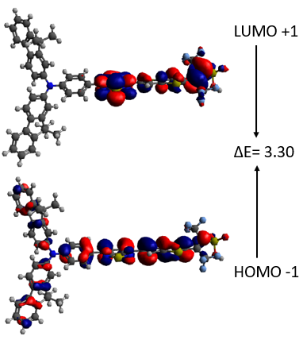 | 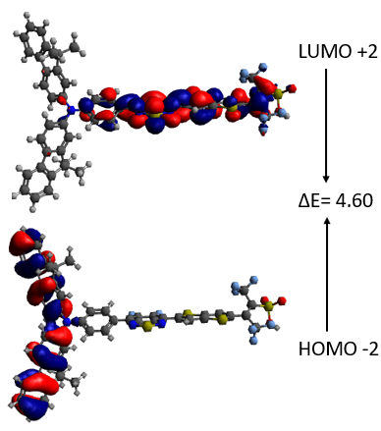
DTA1
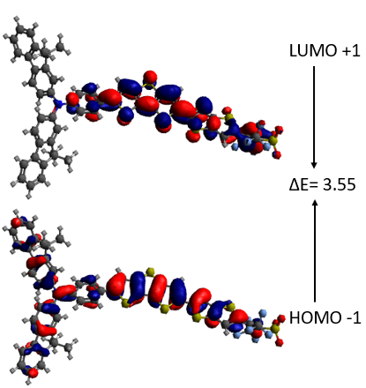 | 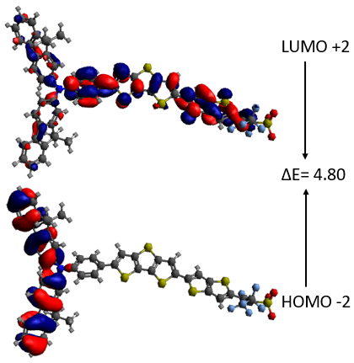
DTA2
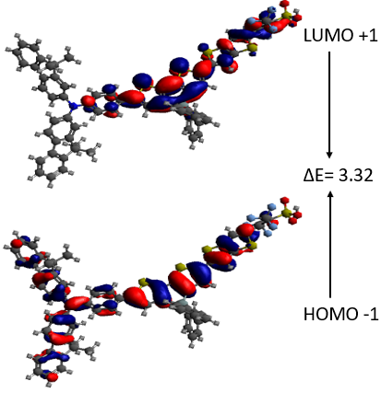 | 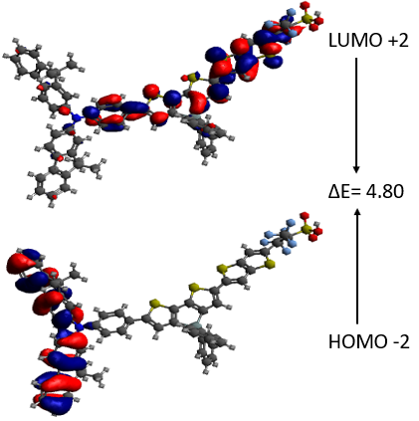
DTA3
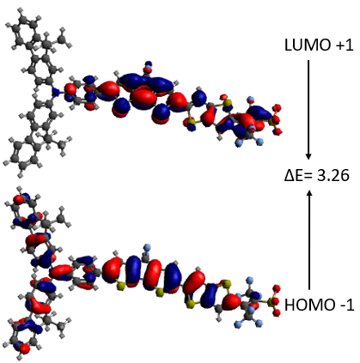 | 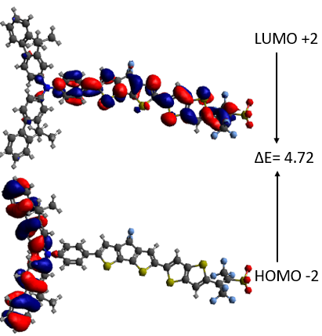
DTA4
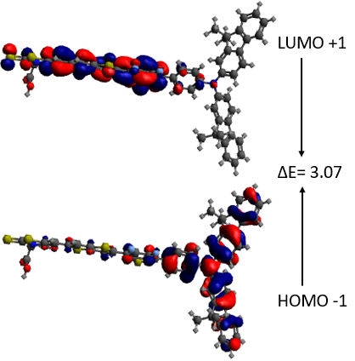 | 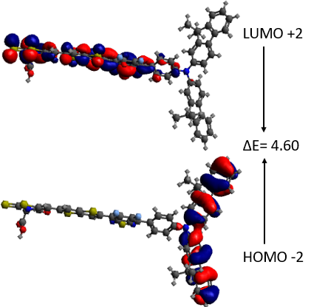
DTA5
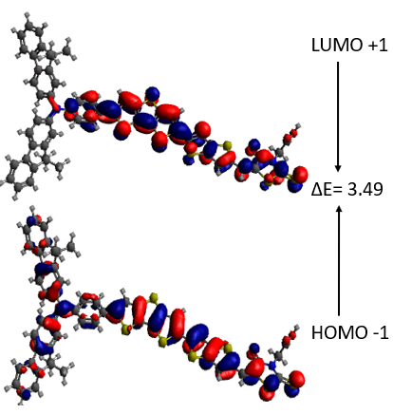 | 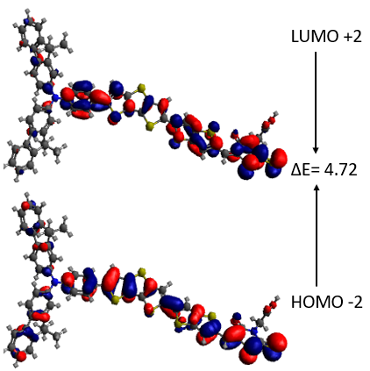
DTA6
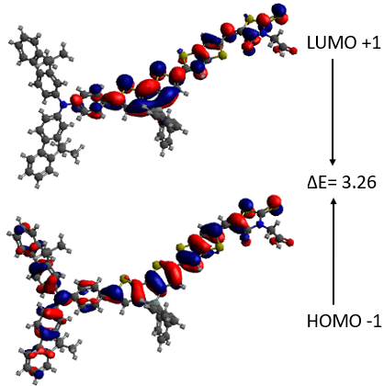 | 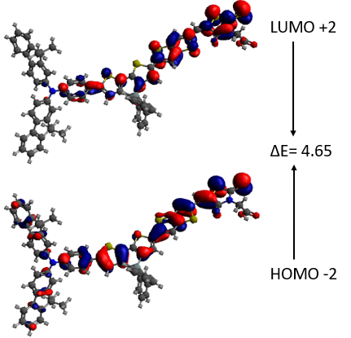
DTA7
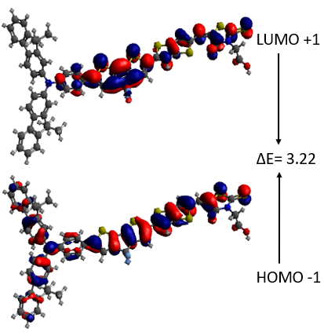 | 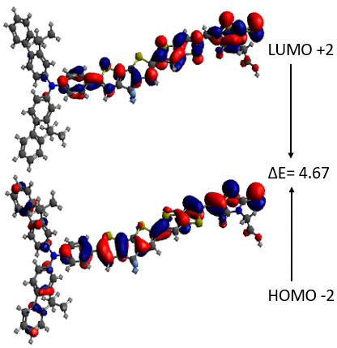
DTA8
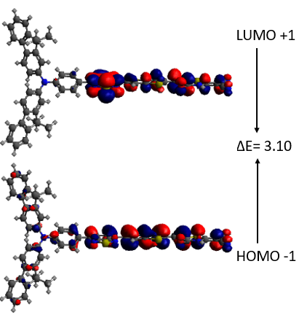 | 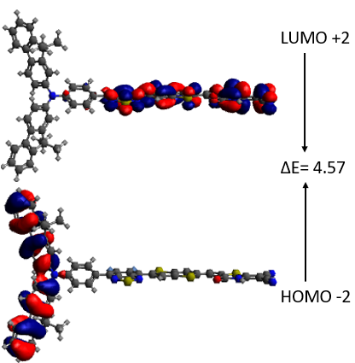
DTA9
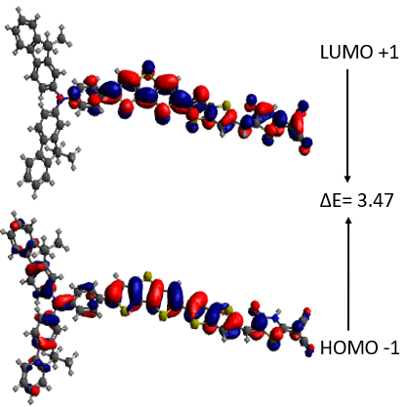 | 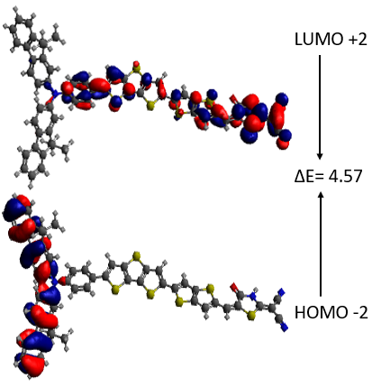
DTA10
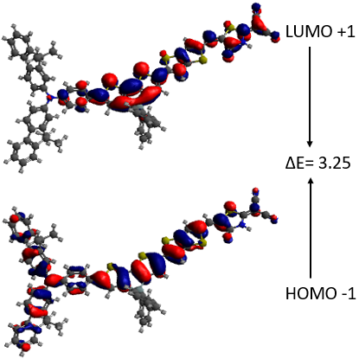 | 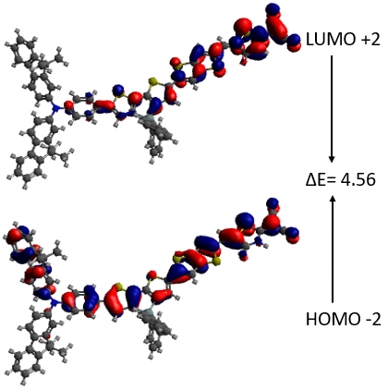
DTA-11
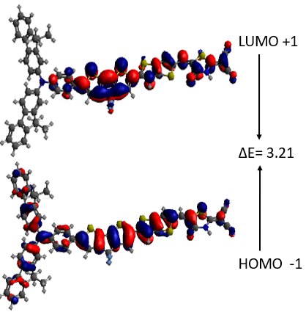 | 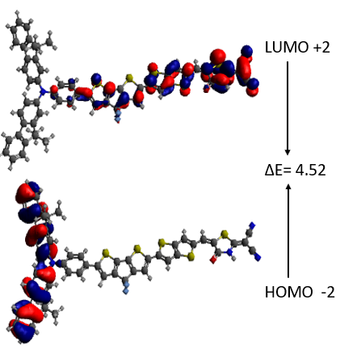
DTA12

Fig. S1. E_{LUMO+1} −E_{HOMO-1} and E_{LUMO+2} −E_{HOMO-2} of the studied dyes (DTA1 – DTA12)

