**Effect of Advanced Oxidation and Amino Acid Addition on antioxidant capability, iron chelating property and anti-cancer activity of Tannic Acid**

Watchareeporn Chariyarangsitham, Saowalak Krungchanuchat, Piyachat Khuemjun, Jannarong Intakhad, and Chalermchai Pilapong*

Center of Excellence for Molecular Imaging (CEMI), Department of Radiologic Technology, Faculty of Associated Medical Sciences, Chiang Mai University, Chiang Mai 50200, Thailand

*To whom correspondence should be addressed: tel. +66-53 94 9305, fax. +66-53 21 3218, e-mail: [chalermchai.pilapong@cmu.ac.th](mailto:chalermchai.pilapong@cmu.ac.th)

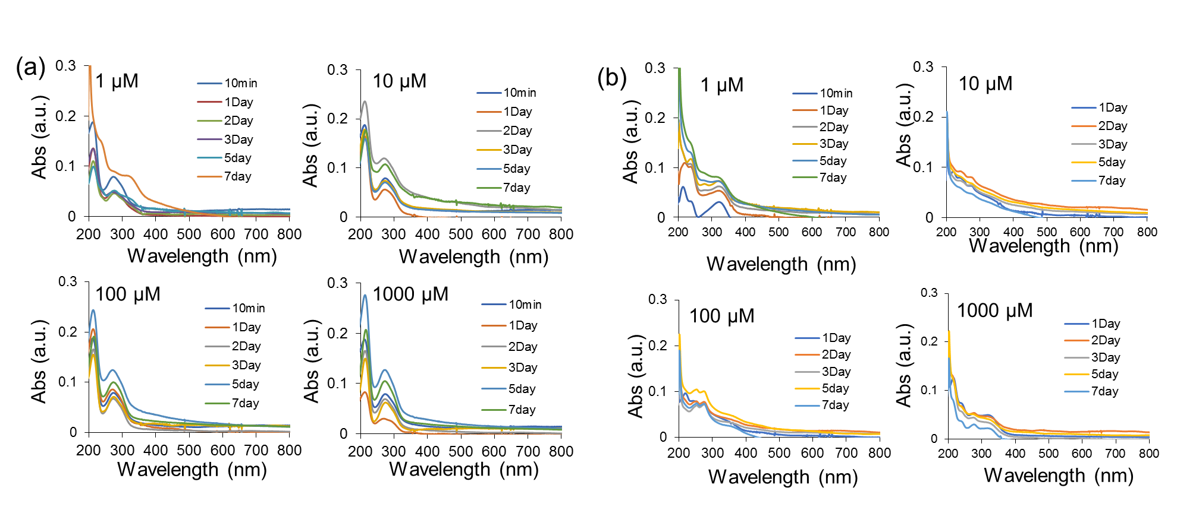

Figure S1Change in spectrum shape of TA incubated in different media; (a) UV-Vis spectra of TA solutions being incubated in DI water for different lengths of incubation, (b) UV-Vis spectra of TA solutions being incubated in PBS for different lengths of incubation. It should be noted that the final concentration of TA at incubation step were 1, 10, 100 and 1000 μM (as shown in each spectra) but the concentration for measuring the spectra was 1 μM (dilution was made for concentration higher than 1 μM).



**N-H**

**bending (1375 cm-1)**

**N-H**

**Stretching (3400-3500 cm-1)**

**C-N**

**Stretching (1062 cm-1)**

**C=O**

**Stretching (1625 cm-1)**

Figure S2 (a) FTIR spectra of different TA samples including un-modified TA and amino acid modified TA

TA

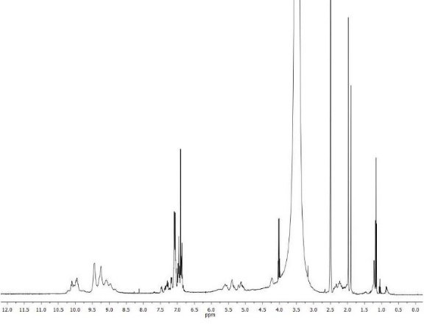

Hydroxyl protons

Aromatic protons

Methoxyl protons

Aliphatic protons



Figure S3 1H-NMR spectra of pure TA

รูปภาพประกอบด้วย วัตถุ

คำอธิบายที่สร้างขึ้นโดยอัตโนมัติ

TA-Cys



**1**

**2,3**

**1**

**2,3**

Figure S4 1H-NMR spectra of cysteine modified TA (TA-Cys)

รูปภาพประกอบด้วย วัตถุ

คำอธิบายที่สร้างขึ้นโดยอัตโนมัติ

TA-Lys



**2**

**4**

**1**

**5**

**3**

**5**

**2**

**4**

**3**

**1**

Figure S5 1H-NMR spectra of lysine modified TA (TA-Lys)

รูปภาพประกอบด้วย วัตถุ, นั่ง

คำอธิบายที่สร้างขึ้นโดยอัตโนมัติ

TA-Phe



**2,3**

**1**

**H-aromatic**

**1**

**2,3**

Figure S6 1H-NMR spectra of phenylalanine modified TA (TA-Phe)



**TA**

**TAox**

**TA+Lys**

**TA+Cys**

**TA+Phe**

**(a)**

**(b)**

**(c)**

**(d)**

**(e)**

Figure S7 Number of K562/ADR cells after treatment with different concentration of samples for different lengths of incubation time

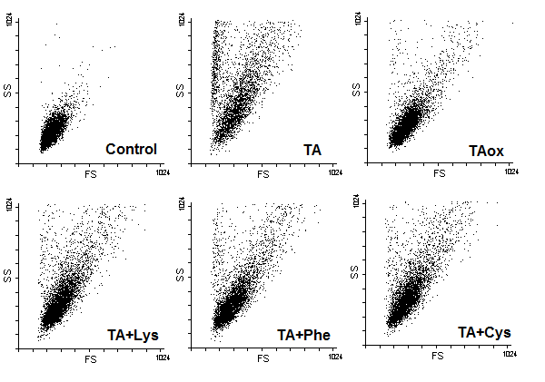

Figure S8. SSC/FSC graphs of untreated K562/ADR cells and the cells treated with un-modified TA and amino acid modified TA for 48 hrs. The final concentrations of TA, TA+Lys, TA+Phe and TA+Cys were 10 μM (TA eqivalent), while that of TAox was 20 μM.

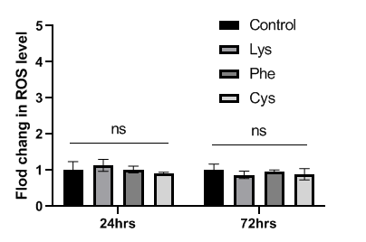

Figure S9. Flow cytometric analysis of intracellular ROS of K562/ADR cell after treatment with different amino acid (30 μM) for 24 hrs and 72 hrs (n=3), (ns: not significant by one-way ANOVA).