**Impact of ethynylene linkers on the optical and electrochemical properties of benzothiadiazole based alternate conjugated polymers.**

**Ahmed G. S Al-Azzawi1,2, Shujahadeen B. Aziz3,4, Ahmed Iraqi1, Ary R. Murad5** , **Rebar T. Abdulwahid**3,6, **Saad M. Alshehrid7, Tansir Ahamadd7**

1Department of Chemistry, University of Sheffield, Sheffield S3 7HF, UK.

2 Department of Chemistry, College of Education for Pure Science, University of Mosul, Iraq.

3Hameed Majid Advanced Polymeric Materials Research Lab., Department of Physics, College of Science, University of Sulaimani, Qlyasan Street, Sulaimani 46001, Iraq

4Department of Civil engineering, College of Engineering, Komar University of Science and Technology, Sulaimani 46001, Iraq

5Department of Pharmaceutical Chemistry, College of Medical and Applied Sciences, Charmo University, Chamchamal, Sulaimani 46023, Iraq

6Department of Physics, College of Education, University of Sulaimani, Old Campus, Sulaimani 46001, Iraq.

7Department of Chemistry, King Saud University, P.O. Box 2455, Riyadh 11451, Saudi Arabia.

Correspondence: [amsss82@uomosul.edu.iq](mailto:amsss82@uomosul.edu.iq)*,* [shujahadeenaziz@gmail.com](mailto:shujahadeenaziz@gmail.com)

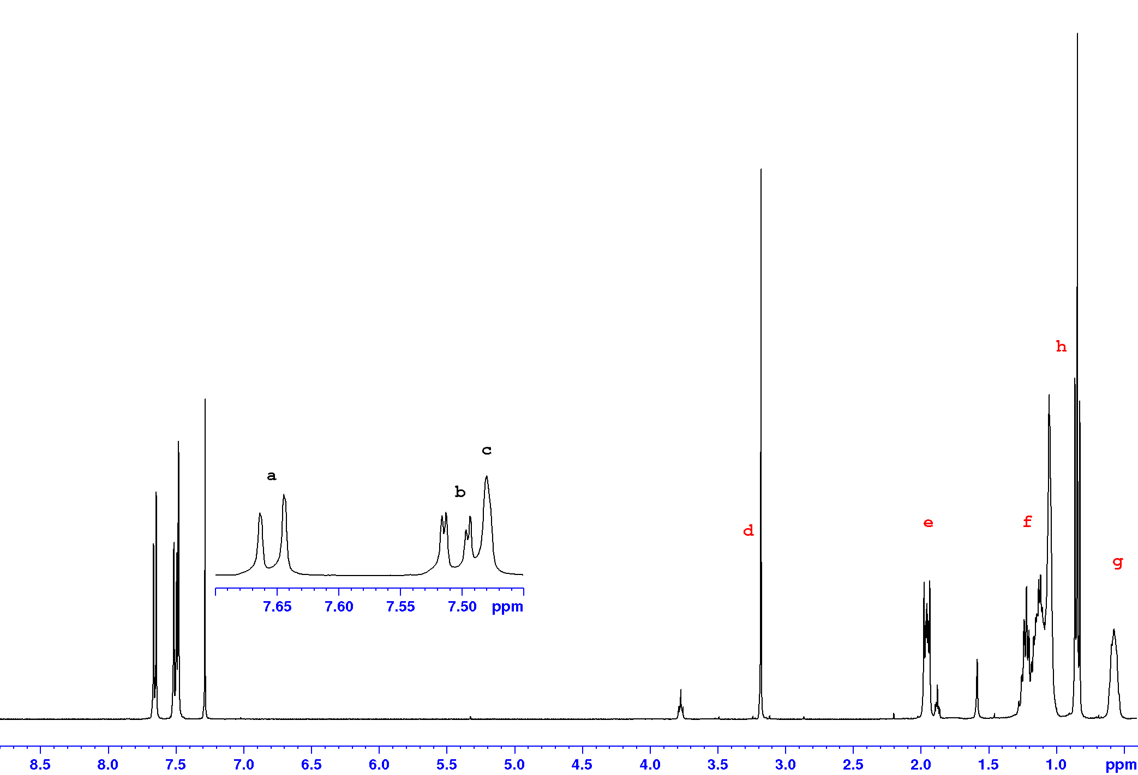



Figure 1: 1H NMR spectra of 9,9-dioctyl -2,7-diethynylfluorene (2).

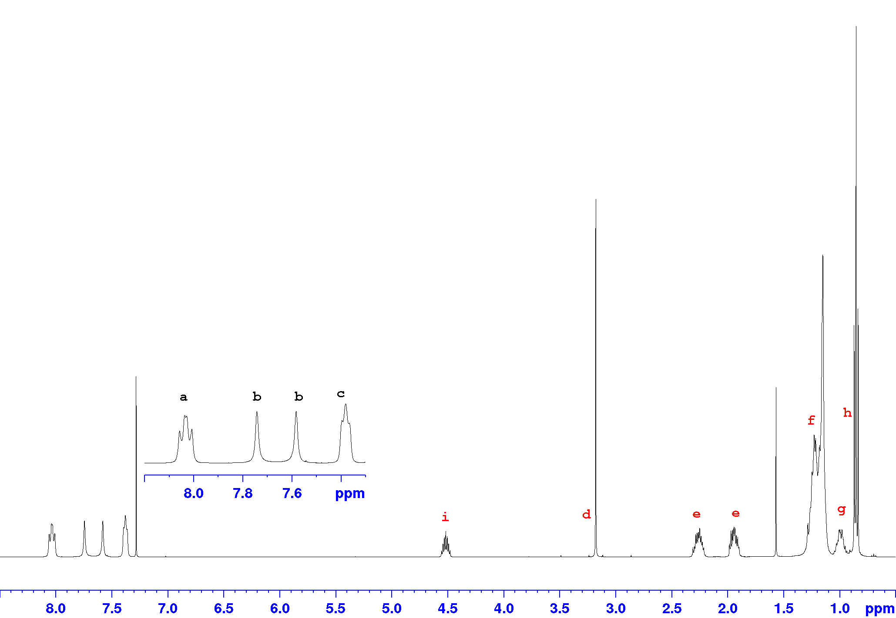



Figure 2:1H NMR spectra of 2,7-diethynyl-9-(heptadecan-9-yl)-9H-carbazole (3)

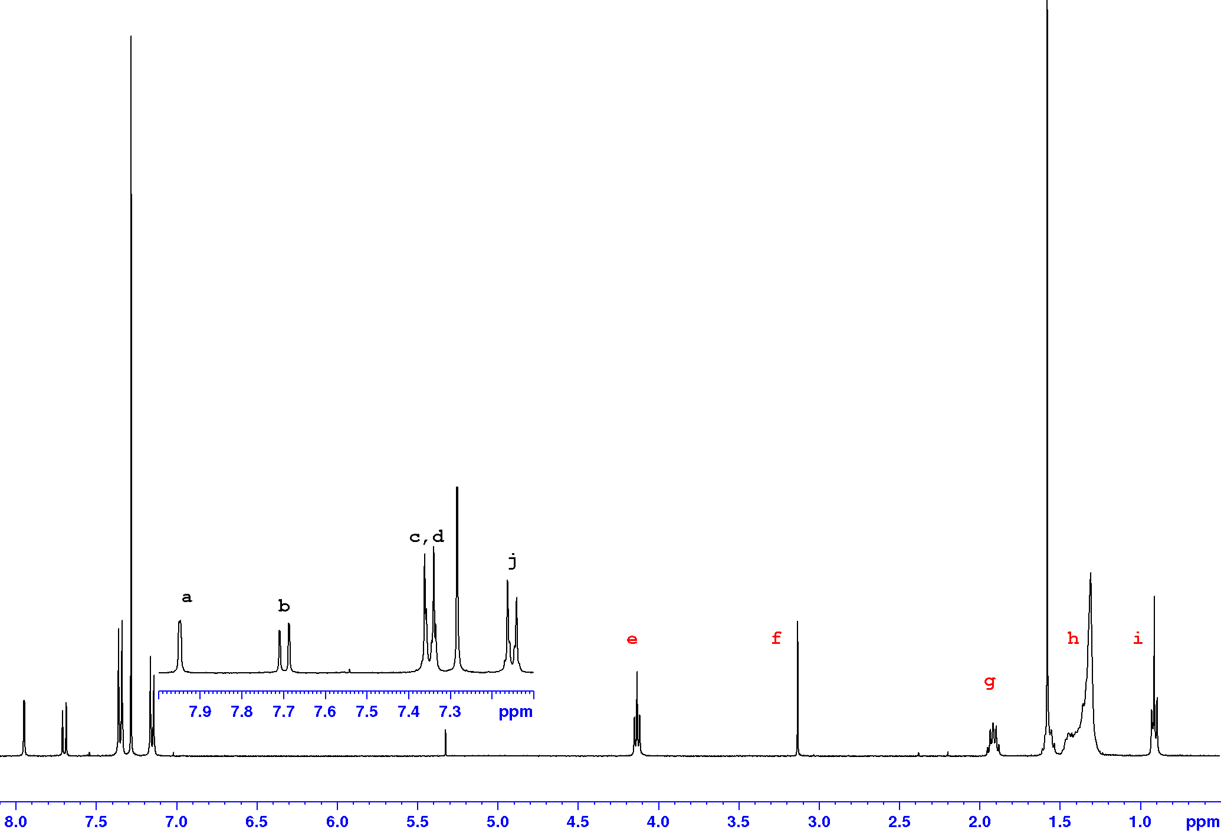



Figure 3: 1H NMR spectra of 2,6-Diethynyl-9,10-bis(4-(dodecyloxy)phenyl)-anthracene (4)

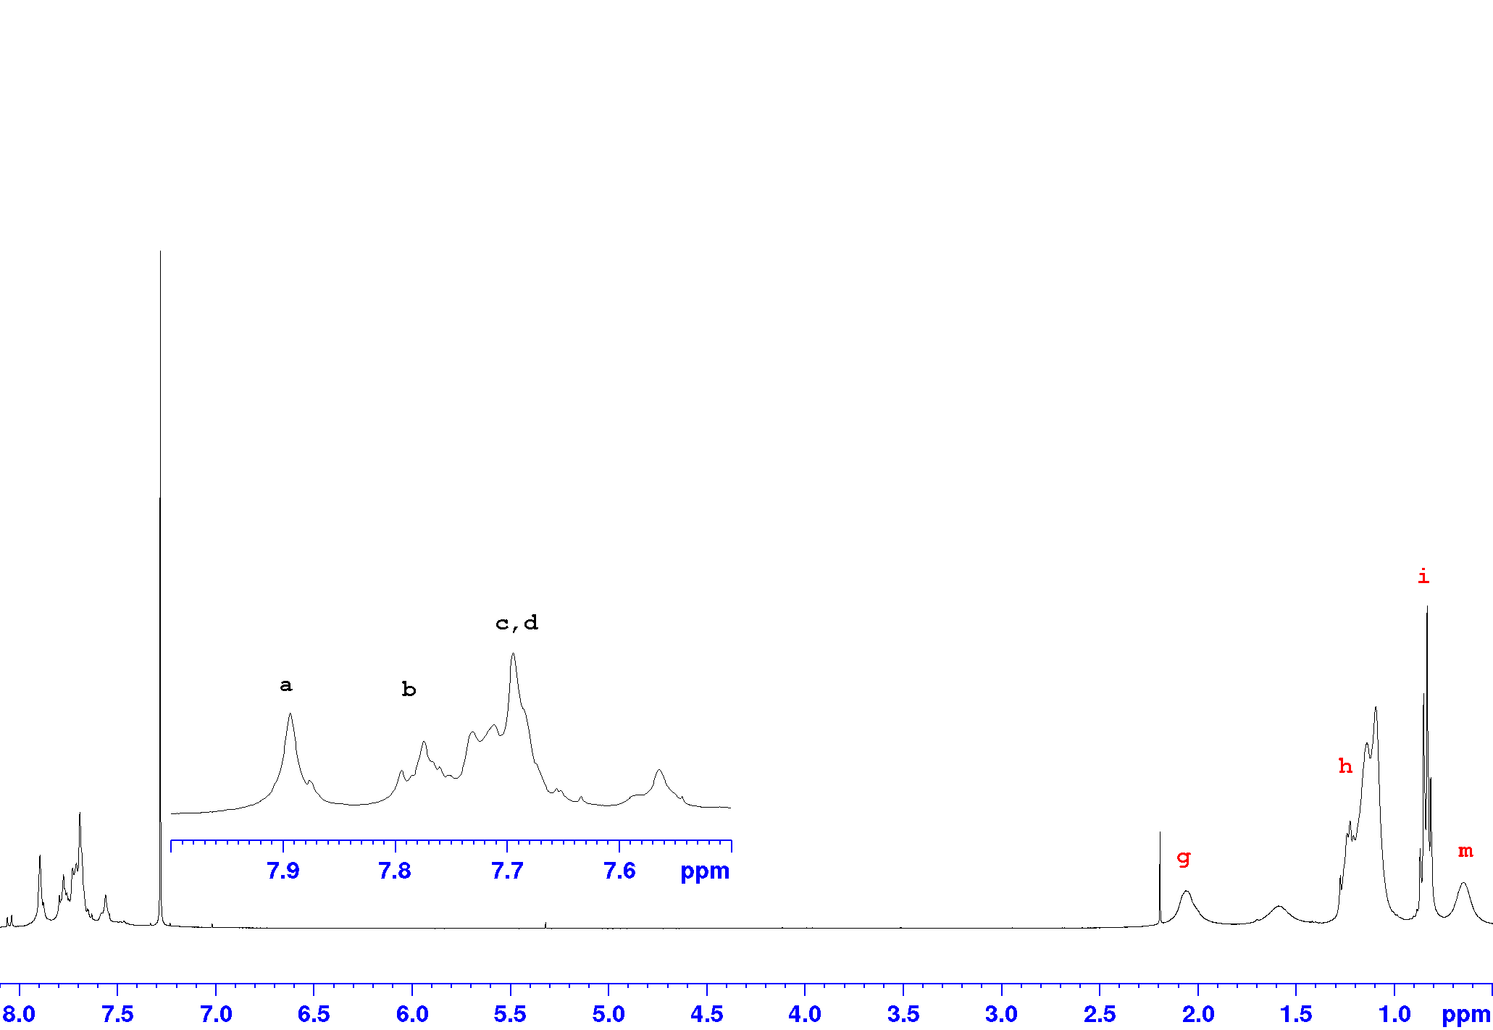



Figure 4: 1H NMR spectra of **PFDEBT** in CDCl3 at room temperature.

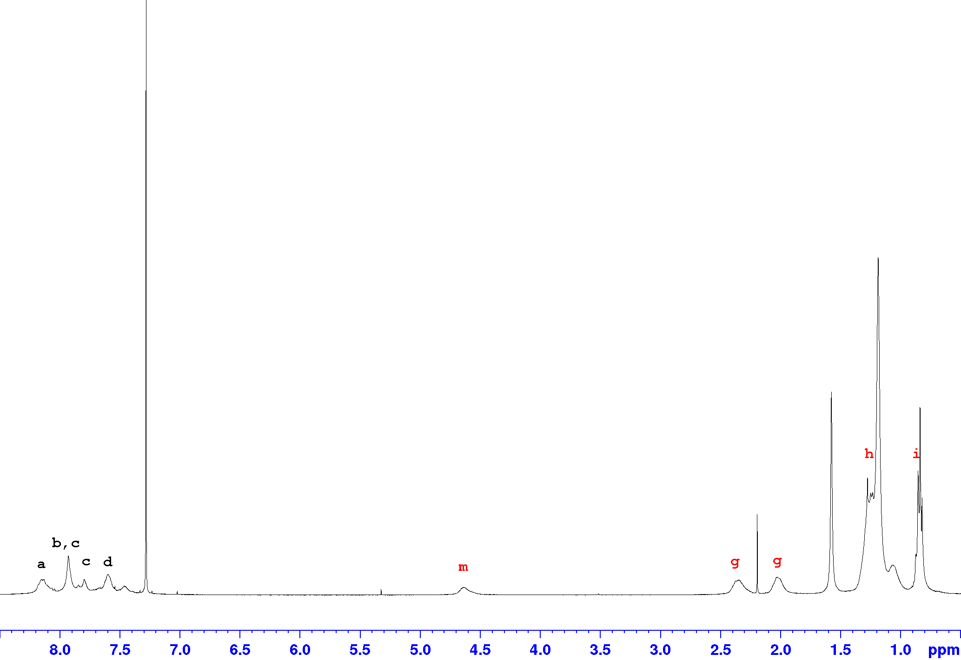



Figure 5: 1H NMR spectra of **PCDEBT** in CDCl3 at room temperature.

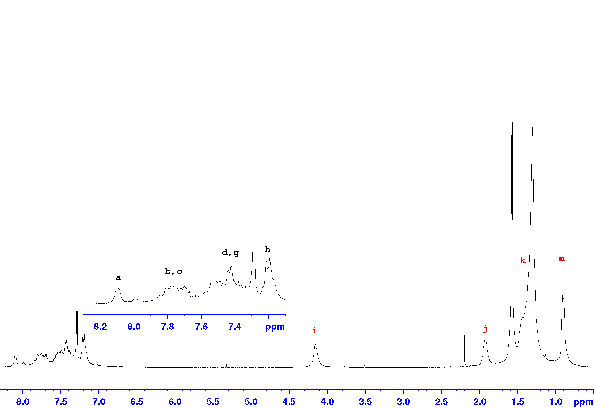



Figure 6: 1H NMR spectra of **PPADEBT** in CDCl3 at room temperature.