**Synthesis, X-ray crystal structures and anticancer studies of four Pd(II) dithiocarbamate complexes**

Athandwe M. Pacaa, Peter A. Ajibadea*, Fartisincha P. Andrewa, Nirasha Nundkumarb, Moganavelli Singhb

**a***School of Chemistry and Physics, University of KwaZulu-Natal, Pietermaritzburg campus, Private Bag X01, Scottsville 3209, South Africa*

**b***School of Life Sciences, University of KwaZulu-Natal, Westville campus, Private Bag X54001, Durban, 4000, South Africa*

**Supplementary material**

**Figure S1:** FTIR spectra of Pipdtc-Na and [Pd(Pipdtc)2]

**Figure S2:** FTIR spectra of 1-PhPzdtc-Na and [Pd(1-PhPzdtc)2]

**Figure S3:** FTIR spectrum of Phdtc-NH4 and [Pd(Phdtc)2].

**Figure S4:** FTIR spectra of 4-BenzPipdtc and [Pd(4-BenzPipdtc)2].

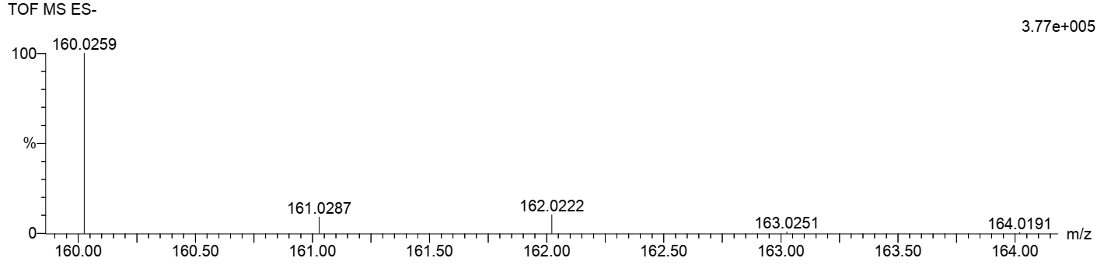

**Figure S5:** MS spectrum of Pipdtc-Na

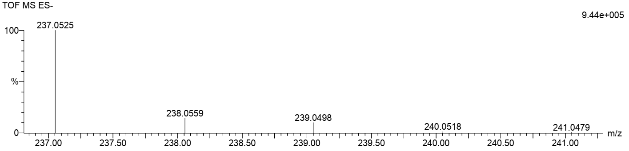

**Figure S6:** MS spectrum of 1-PhPzdtc-Na

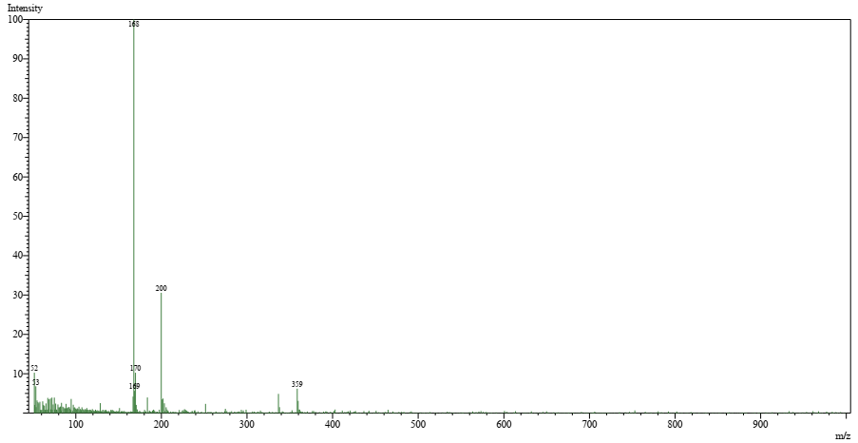

**Figure S7:** MS spectrum of Phdtc-NH4

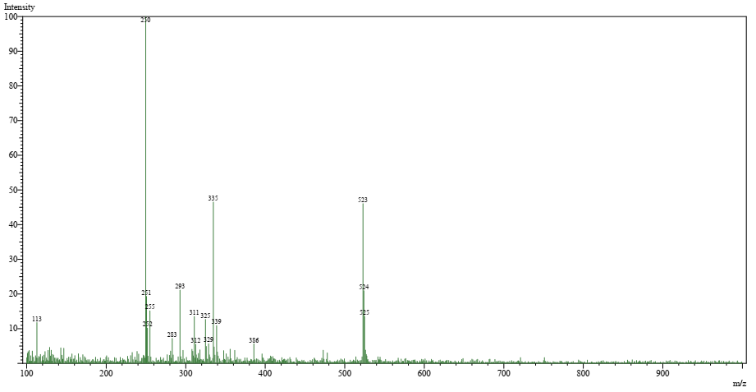

**Figure S8:** MS spectrum of 4-BenzPipdtc-Na.

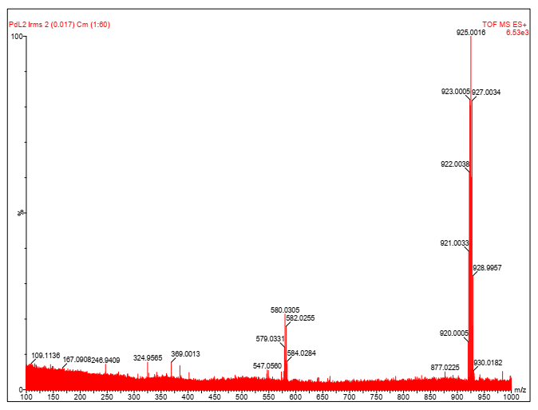

**Figure S9:** MS spectrum of [Pd(1-PhPzdtc)2].

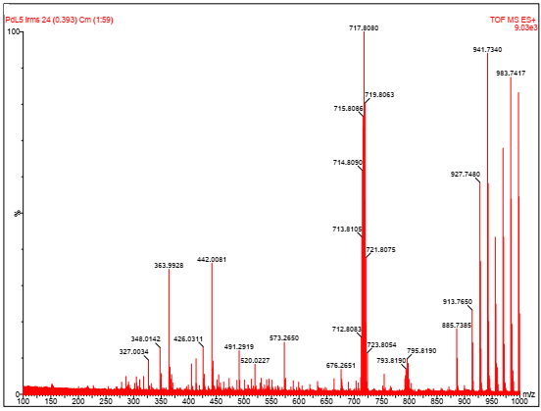

**Figure S10:** MS spectrum of [Pd(Phdtc)2].

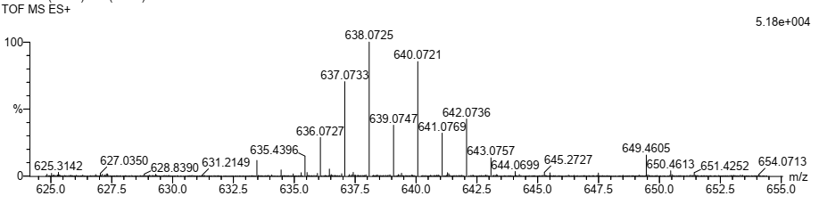

**Figure S11:** MS spectrum of [Pd(4-BenzPzdtc)2].