Figure SI-1a shows the UV-visible spectra of o-NP aqueous solution before and after addition of NaBH₄. The spectrum of o-NP solution without NaBH₄ has two peaks at 280 and 350nm, which rearranged to the new positions of 283 and 415nm, respectively. Similarly, the spectrum of p-NP solution without NaBH₄ has a peak at 317nm. This peak completely vanished and a single broad peak was there at 400 nm in the UV-vis spectrum recorded from p-NP solution with NaBH₄. Next, the o-NP and p-NP mixed with NaBH₄ solutions were monitored constantly by spectrophotometer in the presence of pure CC. Figure SI-1c and d show the UV-vis spectra of the two solutions. Merely, a slight change could be observed in the peaks. This evidently suggests that the pure CC has no catalytic activity for reduction of both the nitrophenols.
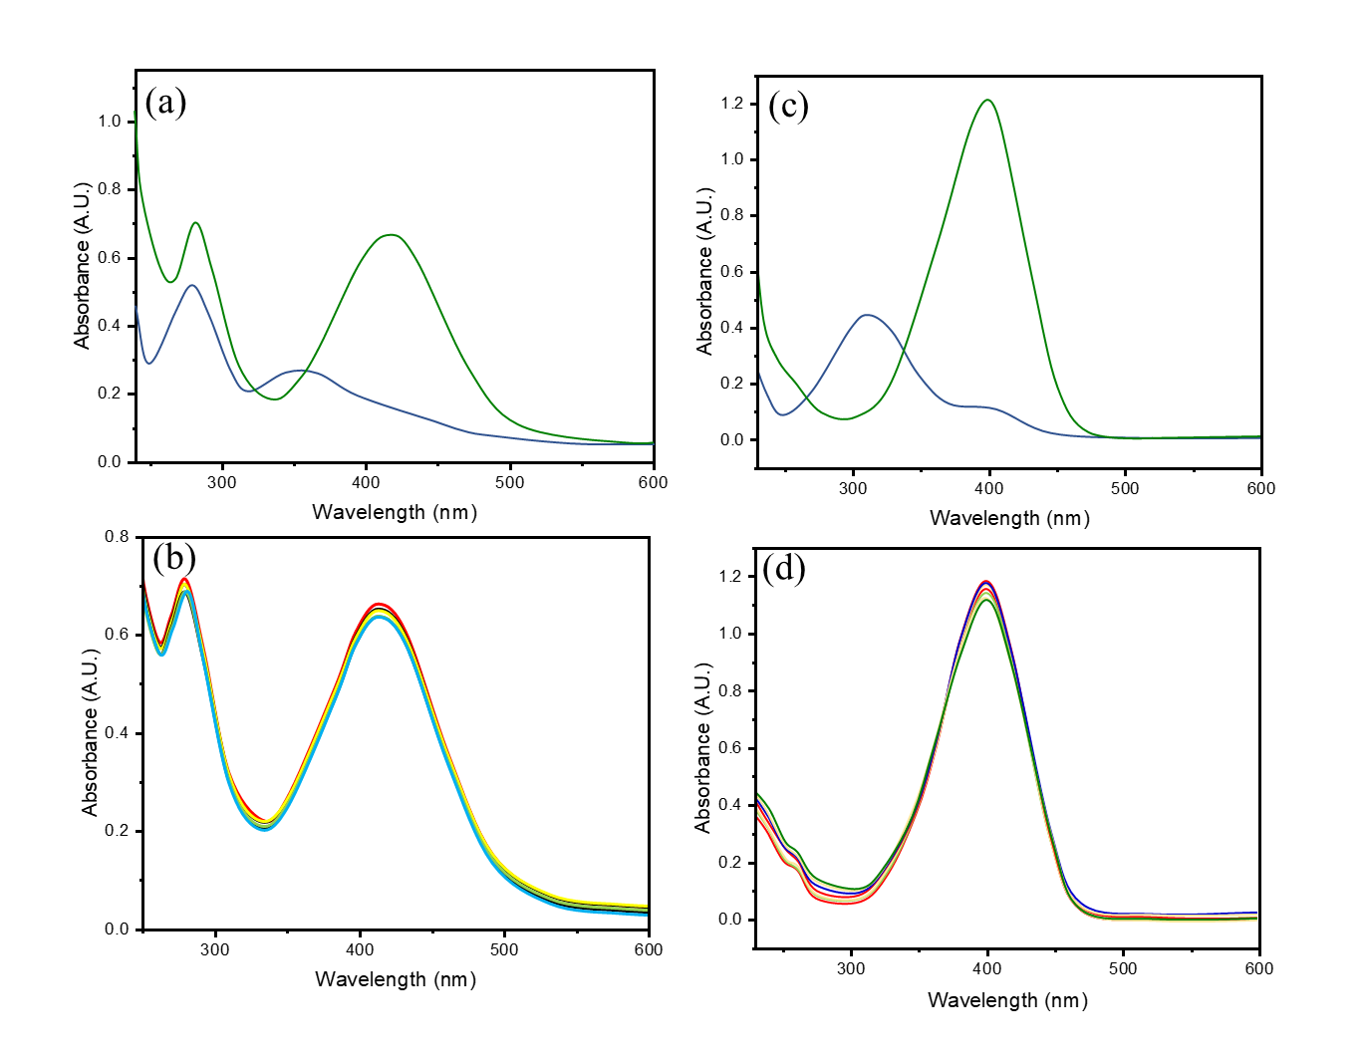
Figure SI-1. Effect of addition of NaBH₄ to the (a,b) nitrophenols on their UV-visible spectra and (c,d) progress of reactions in the presence of a bare-CC catalyst.

