**Supplementary Information**

**Nuclear targeted multimodal 3D-bimetallic Au@Pd nanodendrites promote doxorubicin efficiency in breast cancer therapy**

Adewale O. Oladipo a*, Jeremiah O. Unuofin b,Solange I.I. Iku b, Thabo T.I. Nkambule a, Bhekie B. Mamba a, Titus A.M. Msagati a**

aInstitute for Nanotechnology and Water Sustainability (iNanoWS), College of Science, Engineering and Technology, University of South Africa, Science Park Florida, Johannesburg 1710, South Africa

bDepartment of Life Sciences, College of Agriculture and Environmental Sciences, University of South Africa, Science Park Florida, Johannesburg 1710, South Africa

Author for correspondence: walexy20002001@gmail.com, [msagatam@unisa.ac.za](mailto:msagatam@unisa.ac.za)

**Cellular uptake studies**

CytoViva imaging microscopy was used to study the cellular uptake of the PS.Au@PdNDs.DOX nanocomplex. MCF-7 cells were routinely cultured in DMEM media with 2 mM Glutamine, 1% Non-Essential Amino Acids (NEAA), 10% FBS, and 1% Penicillin/Streptomycin, in a humidified environment at 37°C and 5% CO2. For experiments, cells were seeded at 2 x 104 cells per well in an 8-well Millicell EZ slide (growing area 0.7 cm2 per well) and allowed to recover in the incubator overnight.

The DOX-loaded PS-modified bimetallic nanodendrites (PS.Au@PdNDs.DOX) were suspended in DMEM media (5 µg/mL) without FBS or Pen/Strep supplement and sonicated before treatment. Media in the EZ-slide were removed and nanoparticle suspension was added to relevant wells, with fresh media was added to untreated control wells. Slides were then returned to the incubator for 2 h depending on the experiment.

**Darkfield and hyperspectral imaging (HSI)**

Following incubation, media containing nanoparticles not uptake by cells were removed. Cells were rinsed three times with media followed by three times with HBSS (Hanks Balanced Salt Solution). Thereafter, the cells were fixed with 4% formaldehyde for 15 min at 4°C. The cells were rinsed with PBS (phosphate-buffered saline) and allowed to air dry. Kaiser’s gelatin was used to mount the coverslip and allowed to dry overnight.

**3D imaging**

Following incubation, media with nanoparticles was removed. Cells were rinsed three times with media followed by three times with HBSS (Hanks Balanced Salt Solution). Cells were fixed with 4% formaldehyde for 15 mins at 4°C. Cells were incubated with a solution of 5 µg/mL Wheat Germ Agglutinin conjugated to Alexa Fluor 488, to stain the plasma membrane, for 10 min at room temperature. Cells are washed twice with PBS and then incubated with 300 nM DAPI (4’,6-diamidino-2-phenylindole, dihydrochloride) for 15 min at room temperature to stain the nucleus. Cells were rinsed four times in PBS and allowed to air dry. Kaiser’s gelatin was used to mount the coverslip and allowed to dry overnight.

**CytoViva analysis**

For darkfield analysis, images were acquired at 60 X magnifications using the Q Imaging Exi Blue Monochrome camera. General observations were noted.

For hyperspectral imaging (HSI) and subsequent spectral angle mapping (SAM), scans were acquired at 60 X magnification using ENVI software. Spectral libraries were obtained as described.4 To create the spectral libraries, we made use of the software to automatically detect nanoparticles and then subtract the background, therefore the number of spectra in each library differs. But the approach to creating the spectral libraries is consistent and removes operator bias. SAM was performed at maximum radians 1.2, to map the spectral profiles of known particles onto the scans of the cells incubated with nanoparticles. The spectral libraries used for SAM were derived from positive controls that had the background subtracted by the software.

For 3D analysis, images were acquired at 60 X magnification, using the Q Imaging Exi Blue Monochrome camera and corresponding CytoViva 3D Imaging acquisition software. Image processing is done in ImageJ using the CytoViva plugins for 3D analysis. Fluorescent characteristics of the dyes: DAPI bound to dsDNA: Ex 358 nm, Em 461 nm Alexa Fluor 488: Ex 495, Em 519 nm

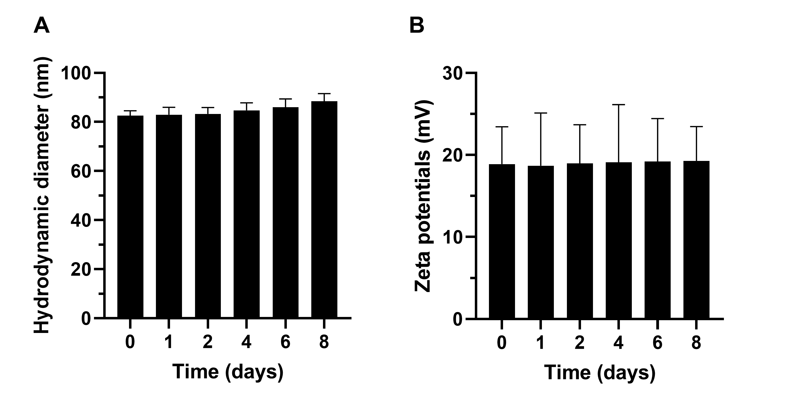

**Fig. S1**. Stability studies of PS.Au@PdNDs.DOX nanocarrier in aqueous solution (A) hydrodynamic diameter and (B) zeta potential measurements over 8 days period.

Table S1. Mixing ratios for optimization of the loading efficiency of PS.Au@PdNDs

|  |  |  |  |  |
| --- | --- | --- | --- | --- |
| **Samples** | **Volume of NDs**  **(µL)** | **Volume of DOX**  **(µL)** | **Loading content**  **(%)** | **Loading efficiency (%)** |
| PS.Au@PdNDs | 100 | 200 | 26.24±1.91 | 34.81±3.21 |
| PS.Au@PdNDs | 100 | 100 | 31.57±0.96 | 52.61±2.17 |
| PS.Au@PdNDs | 200 | 100 | 34.11±1.25 | 67.98±2.26 |
| PS.Au@PdNDs | 300 | 100 | 38.42±2.17 | 75.52±1.32 |
| PS.Au@PdNDs | 400 | 100 | 50.21±1.65 | 79.41±2.06 |

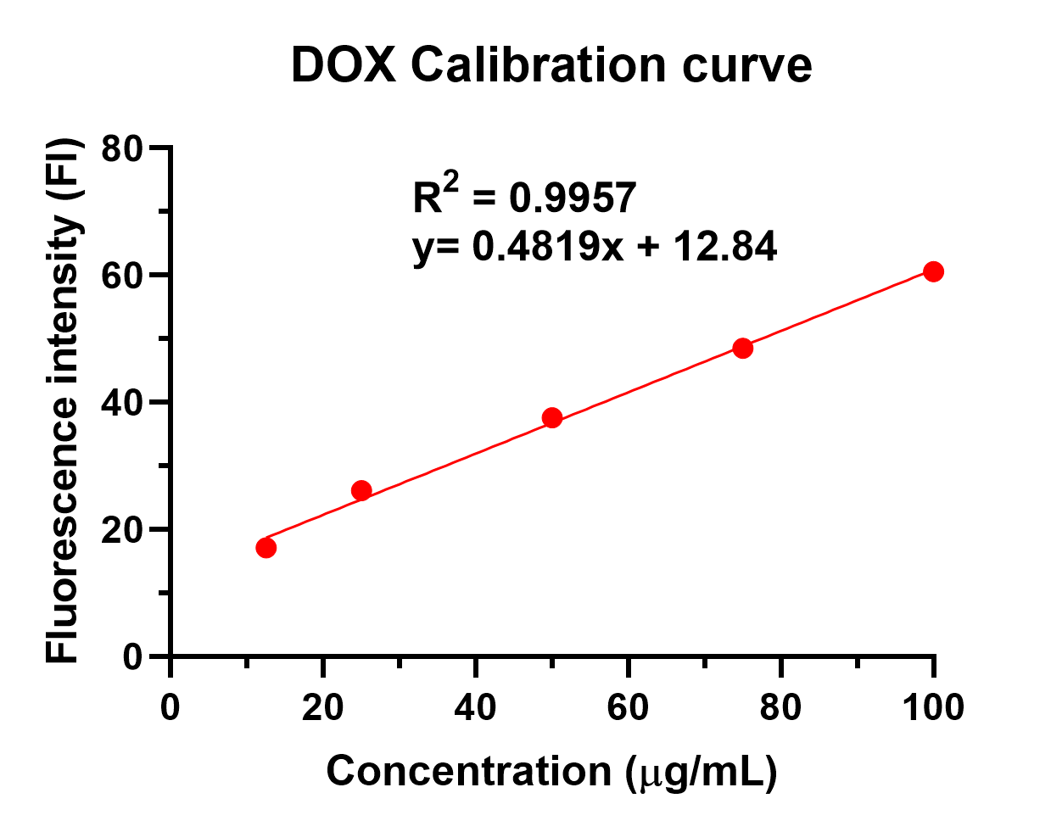

**Fig. S2**. DOX fluorescence calibration curve used to quantify the amount of DOX loaded onto the PS.Au@PdNDs nanocarrier.

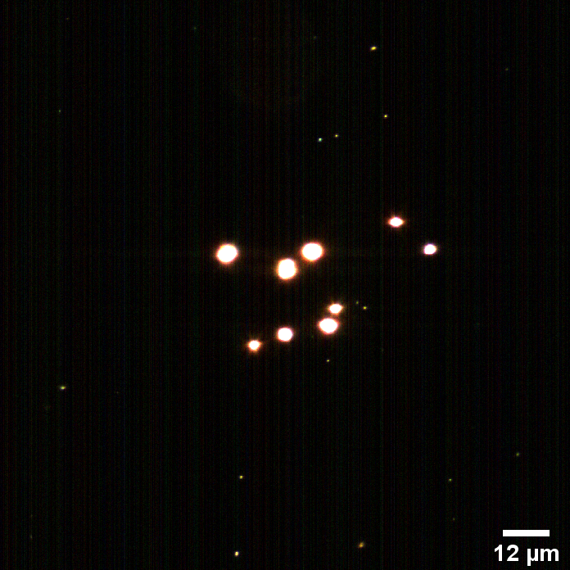

**Fig. S3.** Hyperspectral scanning image of a solution of PS.Au@PdNDs.DOX. The PS-modified DOX-loaded bimetallic nanodendrites were suspended in Kaiser’s gelatin and image was acquired at 60 X magnification.

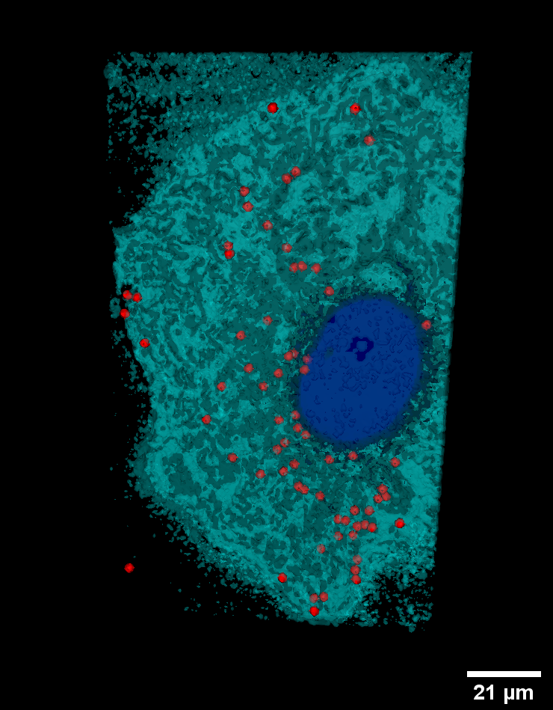

**Fig. S4.** 3D-CytoViva fluorescent images of MCF-7 cells treated with Au@PdNDs.PEG/DOX for 2 h. Images were acquired at 60 X magnification, scale bar = 21 µm).

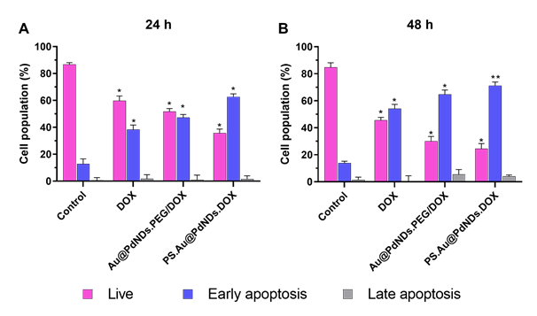

**Fig. S5** Histogram plots showing the effect of DOX, Au@PdNDs.PEG/DOX and PS.Au@PdNDs.DOX treatment on apoptotic cell distribution in MCF-7 for (A) 24 h and (B) 48 h. Data are presented as mean ± SD (n = 3). \**P* < 0.05 and \*\**P* < 0.01.

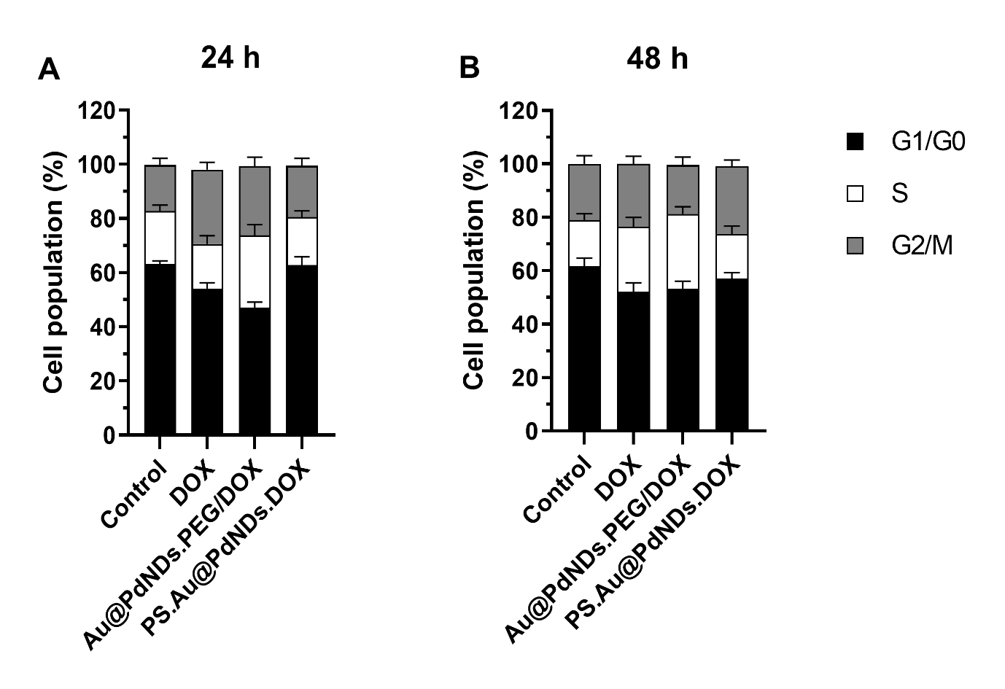**Fig. S6** Analysis of cell population showing the effect of DOX, Au@PdNDs.PEG/DOX, and PS.Au@PdNDs.DOX treatment on the cell cycle phase distribution in MCF-7 cells at (A) 24 h, and (B) 48 h. All data points are presented as mean ± SD (n = 3).