**Synergy Effect of Nitrogen and Molybdenum on Activated Carbon Matrix for Selective Adsorptive Desulfurization: Insights into Surface Chemistry Modification**

Musa O. Azeez, Abdulkadir Tanimu, Khalid Alhooshani, Saheed A. Ganiyu**\*.**

Department of Chemistry, King Fahd University of Petroleum & Minerals, 31261, Dhahran, Saudi Arabia.

**Supplementary Information**

**EDX analysis of adsorbents**

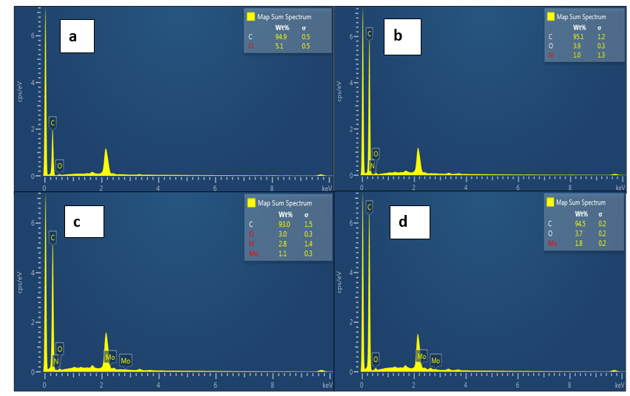

**Fig. SI-1: EDS images of (a) AC (b) AC-N (c) AC-N-Mo and (d) AC-Mo**

**Table SI-1: Surface atomic percent of elements present in modified carbon.**

|  |  |  |  |  |  |  |  |  |  |  |  |  |
| --- | --- | --- | --- | --- | --- | --- | --- | --- | --- | --- | --- | --- |
| **States** | **C1s** | **C1s** | **N1s** | **N1s** | **N1s** | **O1s** | **O1s** | **O1s** | **O1s** | **Mod3** | **Mod3** | **Mod3** |
| **BE (eV)** | **284.5** | **283** | **396** | **398** | **401.6** | **530.2** | **530.8** | **530.9** | **531** | **227.8** | **230.8** | **233** |
| **AC-N** | 23.7 | 33.66 | 3.33 | - | - | - | 39.31 | - | - | - | - | - |
| **AC-N-Mo** | 16.89 | 32.83 | 1.97 | 0.93 | 0.28 | - | - | 46.8 | - | 0.18 | 0.09 | 0.03 |

**NH3-TPD analysis of sorbents**

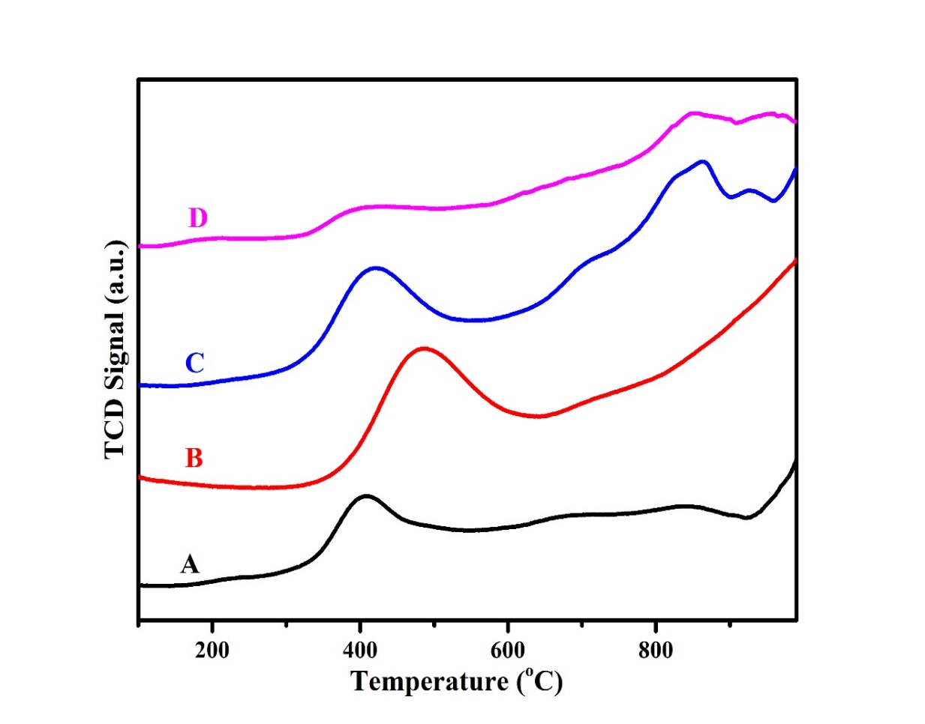

**Fig. SI-2: Surface acidity by ammonia-temperature-programmed desorption (NH3-TPD) of adsorbents (A) AC (B) AC-N (C) AC-N-Mo and (D) AC-Mo**

**Table SI-2: NH3-TPD of the adsorbents**

|  |  |  |
| --- | --- | --- |
| **Adsorbents** | **Temp. (s) (oC)** | **Quantity (mmol/g at STP)** |
| AC | 410, 844 | 4.67, 0.31 |
| AC-N | 485 | 8.03 |
| AC-N-Mo | 421, 856, 935 | 6.23, 1.84 |
| AC-Mo | 214, 400, 847 | 0.22, 2.59, 0.60 |

**Adsorption kinetics**

The Pseudo-first order equation as given by Lagergren 1988 is as shown in equation 3 below.

$$\ln{(q_{e }- q_{t}})=lnq_{e }- k_{1}t……………3$$

Where $q_{e }$ (mg/g) and $q_{t}$ (mg/g) denote the quantity of sulfur adsorbed at equilibrium and time t (min) respectively, (min-1)represents rate constant for pseudo- first order kinetics.

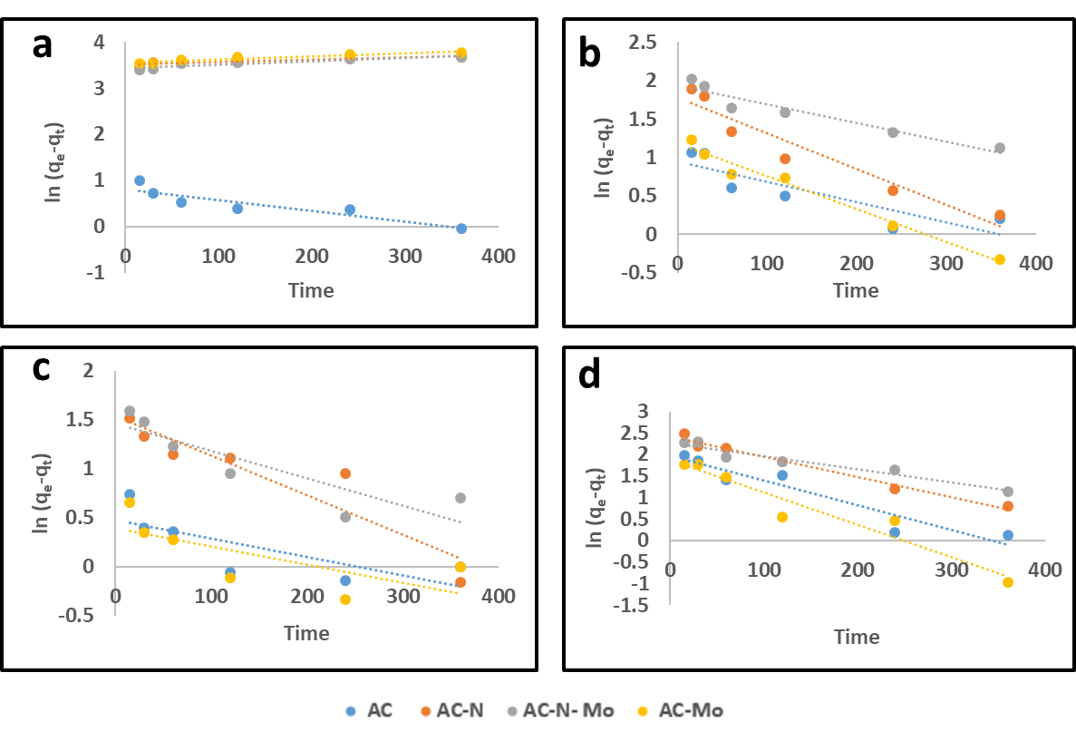

**Fig. SI-3: Pseudo first order kinetics at the concentration of (a) 50 mg-S/L, (a) 100 mg-S/L, (a) 150 mg-S/L, (a) 200 mg-S/L**

Pseudo-second order equation and the interpretation of the terms are expressed in equation 4 below:

$$\frac{t}{q_{t}}= \frac{1}{k_{2}q_{e}^{2}}+ \frac{t}{q_{e}}……………4$$

Where $q_{e}$ (mg/g) and $q_{t}$ (mg/g) denote the quantity of sulfur adsorbed at equilibrium and time t (min) respectively, $k_{2}$ (g/(mg-S.min))represents rate constant for pseudo second order kinetics model. The value of $\frac{1}{q_{e}}$ and $\frac{1}{k_{2}q_{e}^{2}}$ are both obtained from the slope and intercept of the plot of $\frac{t}{q_{t}}$ versus t.

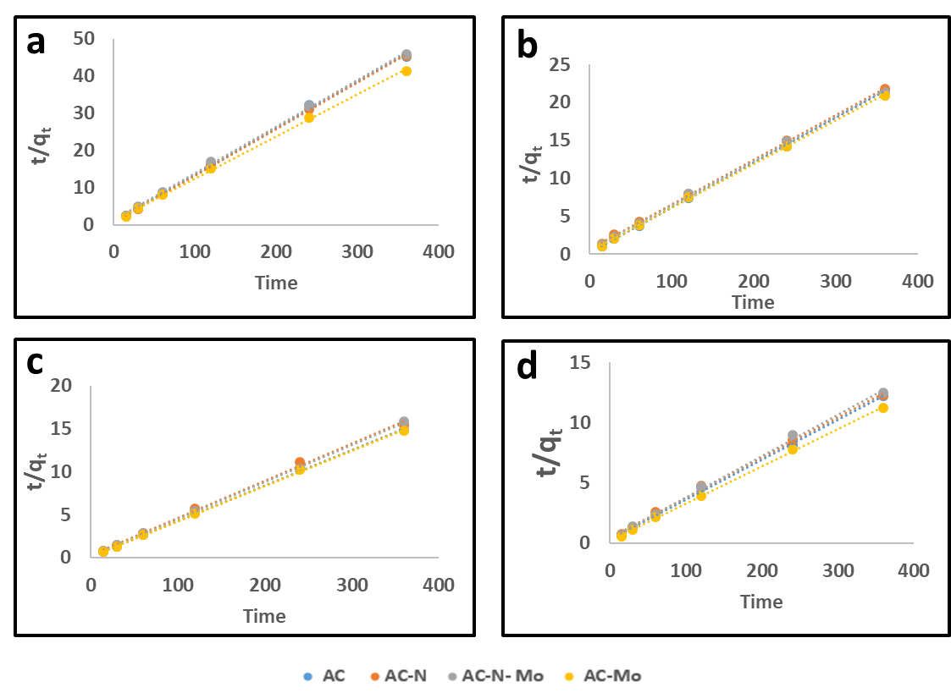

**Fig. SI-4: Pseudo second order kinetics at the concentration of (a) 50 mg-S/L, (a) 100 mg-S/L, (a) 150 mg-S/L, (a) 200 mg-S/L**

Intraparticle-diffusion equation as given by Weber and Morris and the interpretation of the terms are given in equation 5 below:

$$q_{t}=K_{i.d}t^{1/2}+C……….. 5$$

Where $q_{t}$ (mg/g), ${ t}^{1/2}$ (min1/2), (mg/g.min), and $C(mg/g)$ represent the quantity of sulfur adsorbed at equilibrium, the square root of the contact time, the intraparticle diffusion rate constant, and boundary layer thickness respectively.

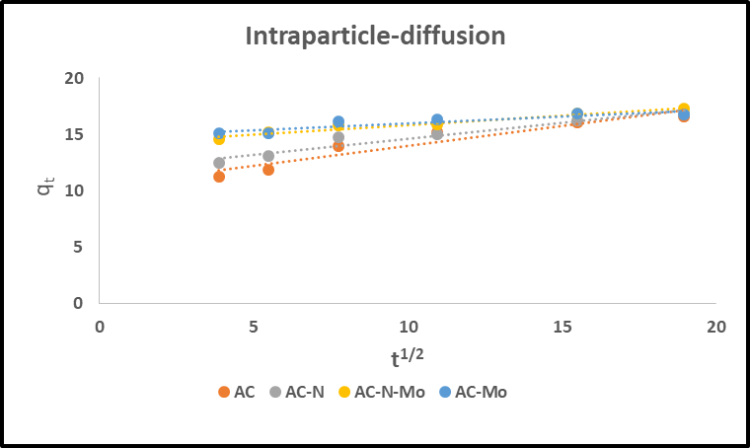

**Fig. SI-5: Intraparticle diffusion at the concentration of 100 mg-S/L**

**Table SI-3: Kinetic parameter of 100 mg-S/L on the investigated adsorbent materials**

|  |  |  |  |  |  |  |  |  |  |  |
| --- | --- | --- | --- | --- | --- | --- | --- | --- | --- | --- |
| **100 mg-S/L** | **Pseudo-first order** | | | | **Pseudo-second order** | | | **Intraparticle diffusion** | | |
| **Adsorbent** | **qe(exp)a** | **qe(cal)a** | **k1(103)b** | **R2** | **qe(cal)a** | **k2(103)c** | **R2** |  | **C** | **R2** |
| **AC** | 17.96 | 2.57 | 2.7 | 0.7573 | 16.92 | 20.6 | 0.9999 | 0.1221 | 14.768 | 0.8270 |
| **AC-N** | 17.84 | 5.89 | 4.6 | 0.9213 | 17.01 | 4.9 | 0.9996 | 0.3579 | 10.404 | 0.9061 |
| **AC-N-Mo** | 19.94 | 6.92 | 2.4 | 0.9221 | 17.15 | 5.7 | 0.9989 | 0.2829 | 11.786 | 0.9340 |
| **AC-Mo** | 17.98 | 3.27 | 4.3 | 0.9760 | 17.42 | 9.5 | 0.9994 | 0.1659 | 14.151 | 0.9581 |

a: (mgS/g), b: (min-1), c: g/(mg-S.min)

**Adsorption Isotherms**

The Langmuir linear equation expressed in equation 6 governs the quantity of DBT adsorbed.

$$\frac{C_{e}}{q_{e}}=\frac{1}{k_{L}q_{m}}+\frac{C_{e}}{q_{m}}……….. 6$$

Where $C_{e}$ (mg/L), $q_{e}$ (mg/g), $q_{m}$ (mg/g) and $k_{L}$ represent equilibrium concentration, sorption capacity, and maximum adsorption capacity, Langmuir constant related to adsorption energy respectively. The expression $\frac{1}{q_{m}}$ and $\frac{1}{k_{L}q_{m}}$ are obtained from the slope and intercept of the plot of $\frac{C_{e}}{q_{e} }$ versus $C_{e}$.

The Freundlich isotherm is represented in equation 7 below;

$$\ln{q_{e}}{=}\ln{K_{F}+\frac{1}{n}\ln{C_{e}…………7}}$$

Where KF (mg g-1) and n represents Freundlich constant related to adsorption capacity, and intensity respectively.

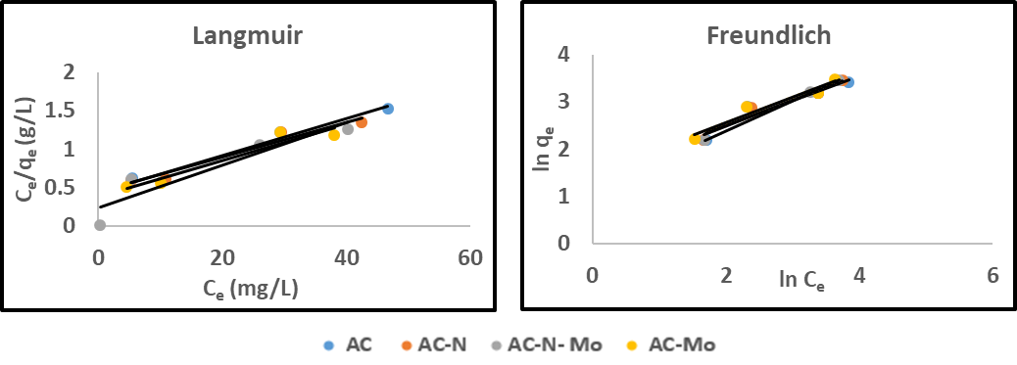

**Fig. SI-6: Adsorption isotherm of adsorbents by Langmuir and Freundlich. (Initial conc. = 50-250 mg-S/L contact time = 24 h, adsorbent dosage = 100 mg, and 20 mL solution of isooctane containing DBT)**

**Table SI-4: Isotherm parameters for adsorption of 50-200 ppmw-S DBT on adsorbent materials**

|  |  |  |  |  |  |  |  |  |
| --- | --- | --- | --- | --- | --- | --- | --- | --- |
| **Langmuir** | | | | | **Freundlich** | | | |
| **Adsorbent** | **aqmax** | **bKL** | **R2** |  | **CKF** | **1/n** | **n** | **R2** |
| **AC** | 41.7 | 0.056 | 0.9713 |  | 4.20 | 0.5246 | 1.88 | 0.9131 |
| **AC-N** | 44.2 | 0.051 | 0.9486 |  | 3.90 | 0.5546 | 1.79 | 0.9384 |
| **AC-N-Mo** | 48.8 | 0.054 | 0.9580 |  | 4.57 | 0.6383 | 1.81 | 0.8878 |
| **AC-Mo** | 46.1 | 0.047 | 0.9223 |  | 3.22 | 0.5397 | 1.61 | 0.9044 |

a: (mgS/g), b: (L/mg), c: (𝑚𝑔(1− 1 /𝑛 ) 𝑆 × 𝐿 1⁄𝑛 × 𝑔 −1)