***Electronic Supplementary Information (ESI)***

***for***

**Colorimetric determination of radical scavenging activity of antioxidants using Fe3O4 magnetic nanoparticles**

Pacharaporn Thongsuk*a*, Yupaporn Sameenoi*a,b*\*

*a*Department of Chemistry and Center of Excellence for Innovation in Chemistry, Faculty of Science, Burapha University, Chon Buri, 20131, Thailand

*b*Sensor Innovation Research Unit (SIRU), Burapha University, Chon Buri, 20131, Thailand

*Corresponding author:

Dr. Yupaporn Sameenoi, Department of Chemistry and Center of Excellence for Innovation in Chemistry, Faculty of Science, Burapha University, Chon Buri, 20131, Thailand; E-mail: yupaporn@buu.ac.th Fax: 66-38-393-494; Tel: 66-38-103-111

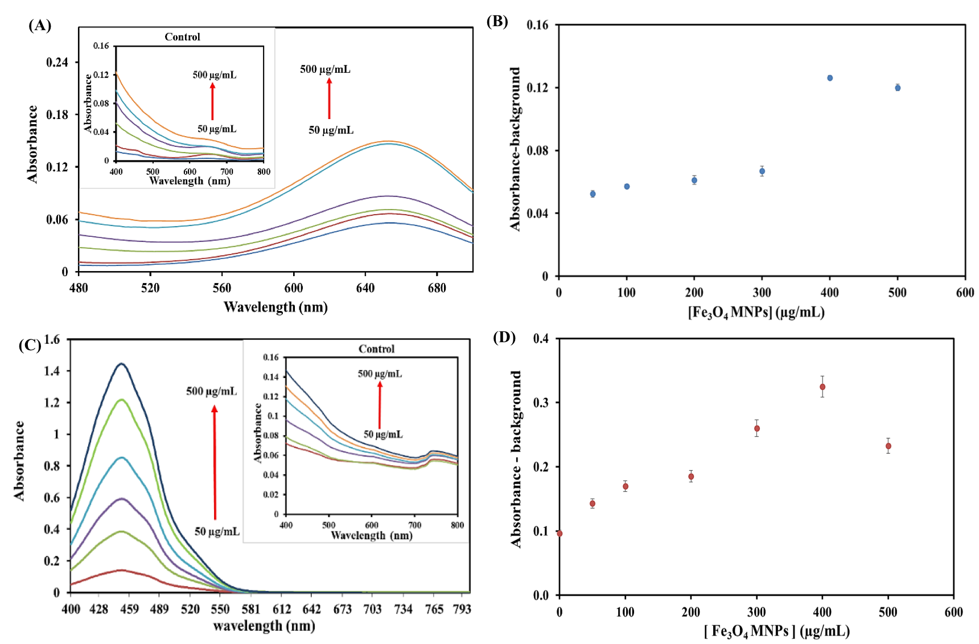

**Figure S1**. Optimization of Fe3O4 MNP concentration using TMB and OPD as peroxidase substrates. Absorbance spectra of the assay containing Fe3O4 MNP in the concentration range of 50-500 μg/mL using(A) TMB as substrate and (C) OPD as a substrate. Inset: Absorbance spectra of the control containing only Fe3O4 MNPs at the investigated concentration. Plot of absorbance after background subtraction as a function of Fe3O4 MNPs concentration (B) absorbance at 654 nm when TMB was used as a substrate, (D) absorbance at 450 nm when OPD was used as a substrate. Experimental condition: Mixture of 20 µL of Fe3O4 MNPs at each concentration, 20 µL of 100 mM TMB or OPD, 1170 µL of 200 mM acetate buffer pH 3.7 and 20 µL of 10 mM H2O2, reaction time of 30 min in the dark.

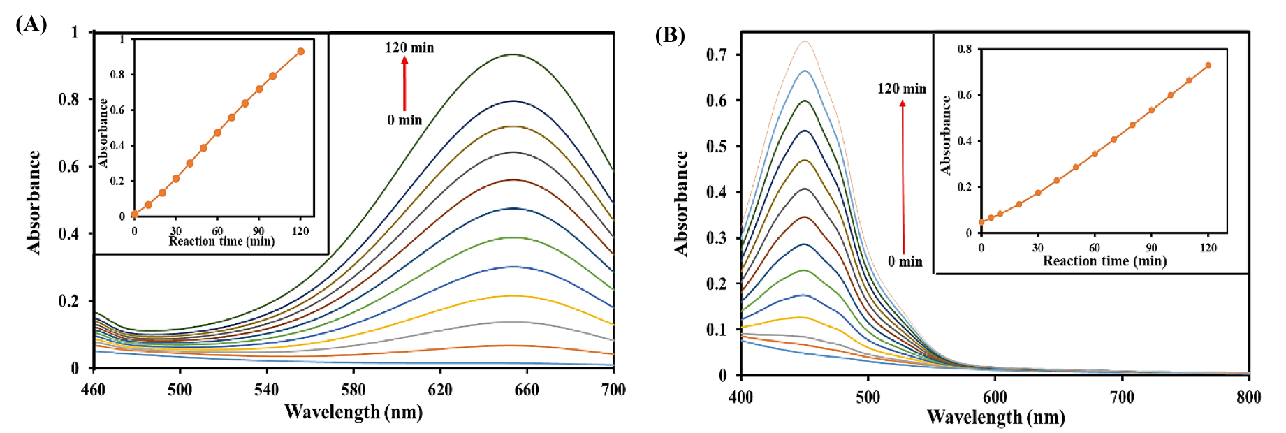

**Figure S2.** (A) Absorbance spectra from the reaction time studied in the range of 0-120 min using TMB as a peroxidase substrate. Inset: Plot of absorbance at 650 nm as a function of reaction time. (B) Absorbance spectra from the reaction time studied in the range of 0-120 min using OPD as a peroxidase substrate. Inset: Plot of absorbance at 450 nm as a function of reaction time. Experimental conditions: Mixture of Fe3O4 MNPs (400 µg/mL, 20 µL), TMB or OPD (20 mM, 20 µL), acetate buffer pH 3.7 (200 mM, 1170 µL).and H2O2 (10 mM, 20 µL), reaction time of 0-120 min.

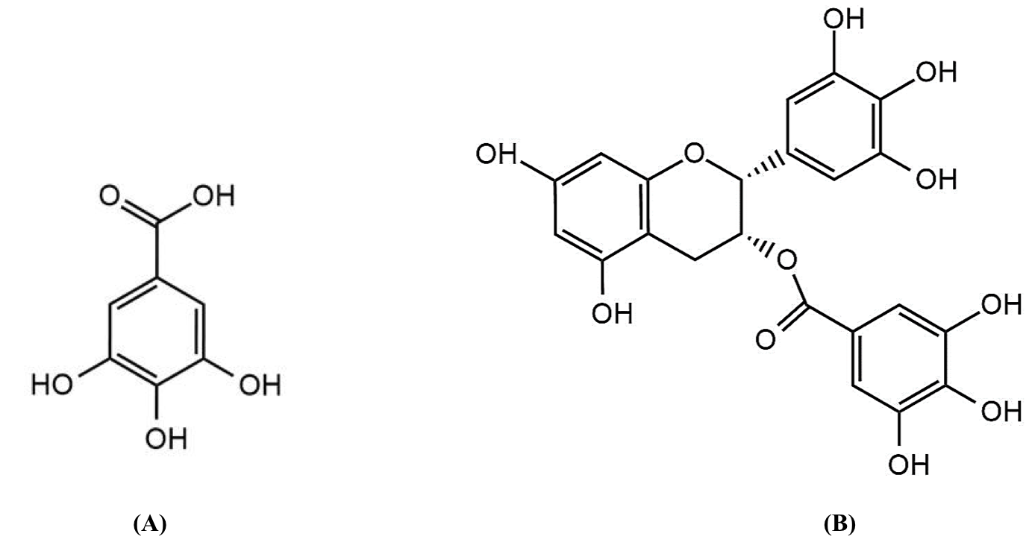

**Figure S3.** Chemical structure of the antioxidant standards (A) gallic acid (B) epigallochatechin gallate

Table S1. Tolerance limits of the potential interferences normally found in tea samples.

|  |  |
| --- | --- |
| Interferences | Tolerance limits (mM) |
| Tartrate, tartraric acid | 0.8 |
| Alanine | 100 |
| Glycine, | 500 |
| Galactose | 1000 |
| Glucose, sucrose | 3000 |