**Comparative analysis of phytochemical profile, antioxidant and anti-inflammatory activity from *Hibiscus manihot* L. flower**

Ju-Zhao Liua,1, Wei-Hua Konga,1, Chun-Chun Zhanga, Yu-Jie Fub,c, Qi Cuia,*

a School of Pharmaceutical Science, Zhejiang Chinese Medical University, Hangzhou 311402, PR China

b Key Laboratory of Forest Plant Ecology, Ministry of Education, Northeast Forestry University, Harbin 150040, PR China

c College of Chemistry, Chemical Engineering and Resource Utilization, Northeast Forestry University, Harbin 150040, PR China

* Corresponding author: E-mail address: [zcmucq@163.com](mailto:zcmucq@163.com)

1 These authors contributed equally to this work.

**Table S1** The correlation coefficient of the variables.

|  |  |  |  |  |  |  |  |  |  |  |  |  |  |  |  |  |  |
| --- | --- | --- | --- | --- | --- | --- | --- | --- | --- | --- | --- | --- | --- | --- | --- | --- | --- |
|  | TFC | TPC | DPPH | ABTS | RP | FRAP | AIFT | NA | CHA | CAA | RU | HY | ISQ | HI | MY | QOG | QU |
| TFC | 1.000 | .451 | –.581 | .621 | –.662 | .563 | –.510 | .503 | .194 | .212 | .089 | .488 | .141 | .072 | .194 | .124 | .112 |
| TPC | .451 | 1.000 | –.923 | .891 | –.875 | .861 | –.900 | .692 | .331 | .787 | .786 | .803 | .920 | .656 | .632 | .876 | .340 |
| DPPH | –.581 | –.923 | 1.000 | –.962 | .966 | –.924 | .909 | –.568 | –.207 | –.656 | –.590 | –.806 | –.768 | –.646 | –.575 | –.843 | –.288 |
| ABTS | .621 | .891 | –.962 | 1.000 | –.985 | .958 | –.933 | .564 | .335 | .553 | .575 | .722 | .715 | .488 | .552 | .759 | .335 |
| RP | –.662 | –.875 | .966 | –.985 | 1.000 | –.920 | .921 | –.553 | –.364 | –.513 | –.492 | –.691 | –.658 | –.455 | –.501 | –.734 | –.252 |
| FRAP | .563 | .861 | –.924 | .958 | –.920 | 1.000 | –.914 | .596 | .312 | .570 | .616 | .717 | .724 | .486 | .551 | .732 | .371 |
| AIFT | –.510 | –.900 | .909 | –.933 | .921 | –.914 | 1.000 | –.513 | –.466 | –.483 | –.572 | –.603 | –.750 | –.407 | –.443 | –.807 | –.114 |
| NA | .503 | .692 | –.568 | .564 | –.553 | .596 | –.513 | 1.000 | .259 | .707 | .693 | .672 | .626 | .318 | .334 | .332 | .394 |
| CHA | .194 | .331 | –.207 | .335 | –.364 | .312 | –.466 | .259 | 1.000 | –.101 | .120 | –.205 | .194 | –.418 | –.186 | .148 | –.301 |
| CAA | .212 | .787 | –.656 | .553 | –.513 | .570 | –.483 | .707 | –.101 | 1.000 | .903 | .822 | .877 | .845 | .730 | .708 | .584 |
| RU | .089 | .786 | –.590 | .575 | –.492 | .616 | –.572 | .693 | .120 | .903 | 1.000 | .658 | .924 | .660 | .674 | .703 | .562 |
| HY | .488 | .803 | –.806 | .722 | –.691 | .717 | –.603 | .672 | –.205 | .822 | .658 | 1.000 | .745 | .823 | .691 | .670 | .579 |
| ISQ | .141 | .920 | –.768 | .715 | –.658 | .724 | –.750 | .626 | .194 | .877 | .924 | .745 | 1.000 | .746 | .636 | .899 | .384 |
| HI | .072 | .656 | –.646 | .488 | –.455 | .486 | –.407 | .318 | –.418 | .845 | .660 | .823 | .746 | 1.000 | .770 | .777 | .531 |
| MY | .194 | .632 | –.575 | .552 | –.501 | .551 | –.443 | .334 | –.186 | .730 | .674 | .691 | .636 | .770 | 1.000 | .603 | .826 |
| QOG | .124 | .876 | –.843 | .759 | –.734 | .732 | –.807 | .332 | .148 | .708 | .703 | .670 | .899 | .777 | .603 | 1.000 | .206 |
| QU | .112 | .340 | –.288 | .335 | –.252 | .371 | –.114 | .394 | –.301 | .584 | .562 | .579 | .384 | .531 | .826 | .206 | 1.000 |

**Fig. S1** HPLC chromatograms of standards mixture (A) and the samples from *Hibiscus manihot* L. flower (B). (1) neochlorogenic acid, (2) chlorogenic acid, (3) caffeic acid, (4) rutin, (5) hyperin, (6) isoquercetin, (7) hibifolin, (8) myricetin, (9) quercetin–3'–O–glucoside, (10) quercetin.

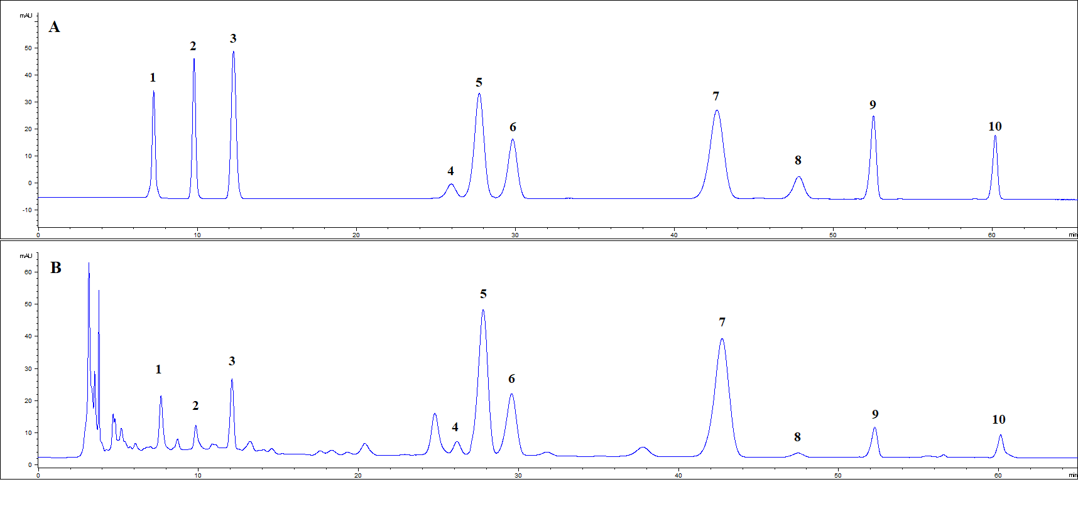

**Fig. S2** Structures of ten target bioactive compounds in *Hibiscus manihot* L. flower.



**Fig. S3** The monthly average temperature and monthly average precipitation of May to September in Harbin.

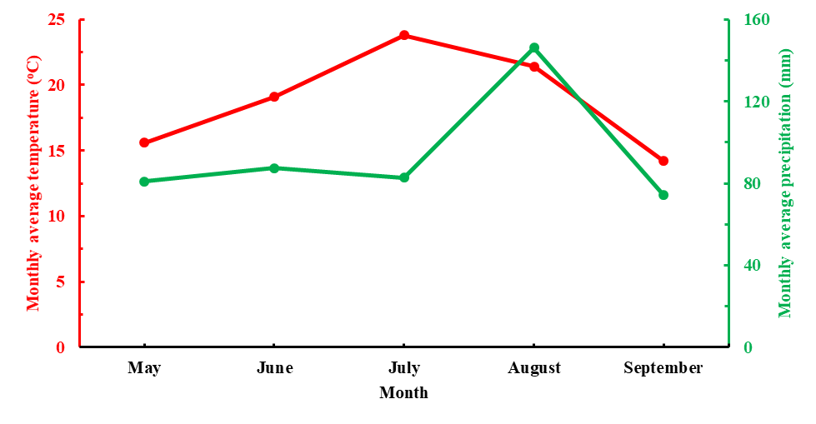

**Fig. S4** Heat-map of active compounds in HMLFsamples from different harvest time. RP, reducing power; TFC, total flavonoids content; TPC, total phenolics content; NA, neochlorogenic acid; CHA, chlorogenic acid; CAA, caffeic acid; RU, rutin; HY, hyperin; ISQ, isoquercetin; HI, hibifolin; MY, myricetin; QOG, quercetin–3'–O–glucoside; QU, quercetin.

