**Supporting Data**

High Resolution Electrospray Ionization-Mass Spectrometry (HRESI-MS) of A

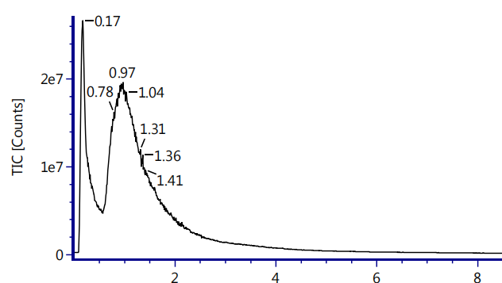

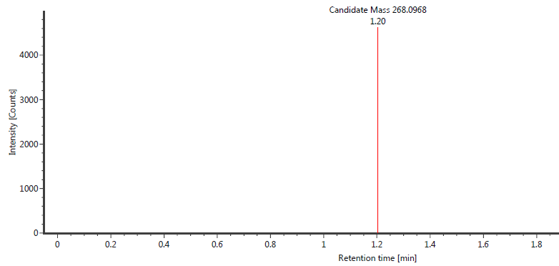



[M+H]+

**Appendix A2**

High Resolution Electrospray Ionization-Mass Spectrometry (HRESI-MS)of B

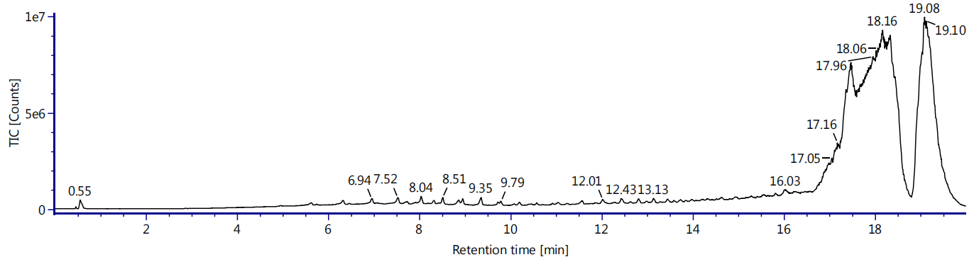



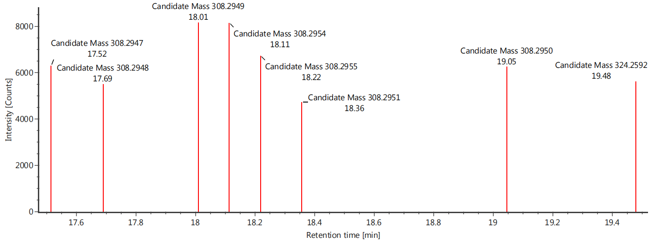

[M+Na]+

[M+Na]+

[M+K]+

[M+Na]+

**Appendix A3**

High Resolution Electrospray Ionization-Mass Spectrometry (HRESI-MS) of C

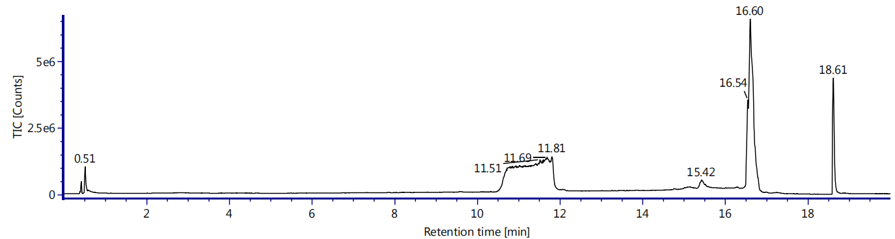

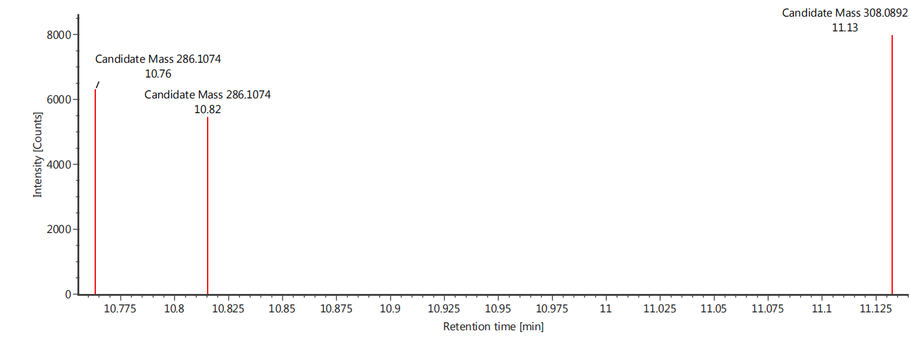

[M+Na]+

[M+H]+

[M+H]+



**Appendix A4**

High Resolution Electrospray Ionization-Mass Spectrometry (HRESI-MS) of D

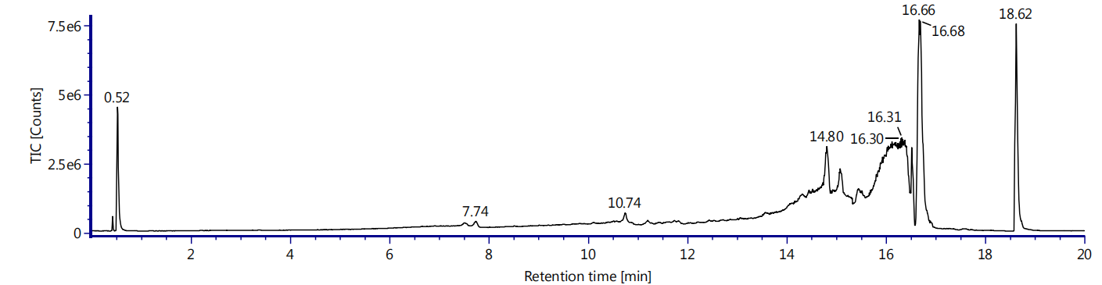

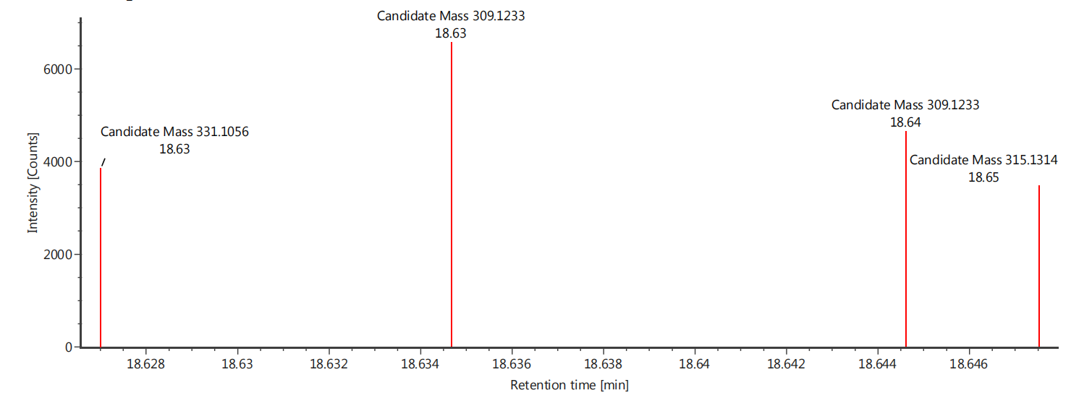

[M+Na]+

[M+H]+

[M+H]+

[M+Li]+



[M+Li]+

**Appendix A5**

High Resolution Electrospray Ionization-Mass Spectrometry (HRESI-MS) of E

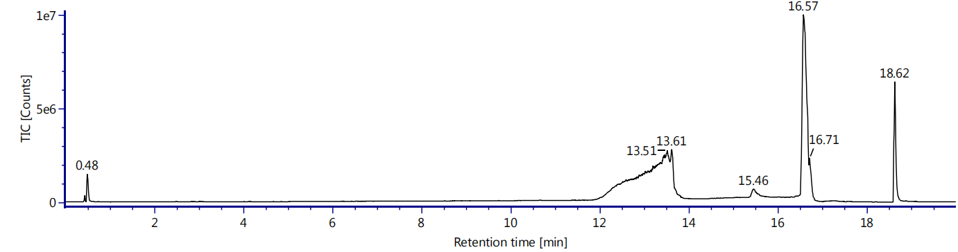

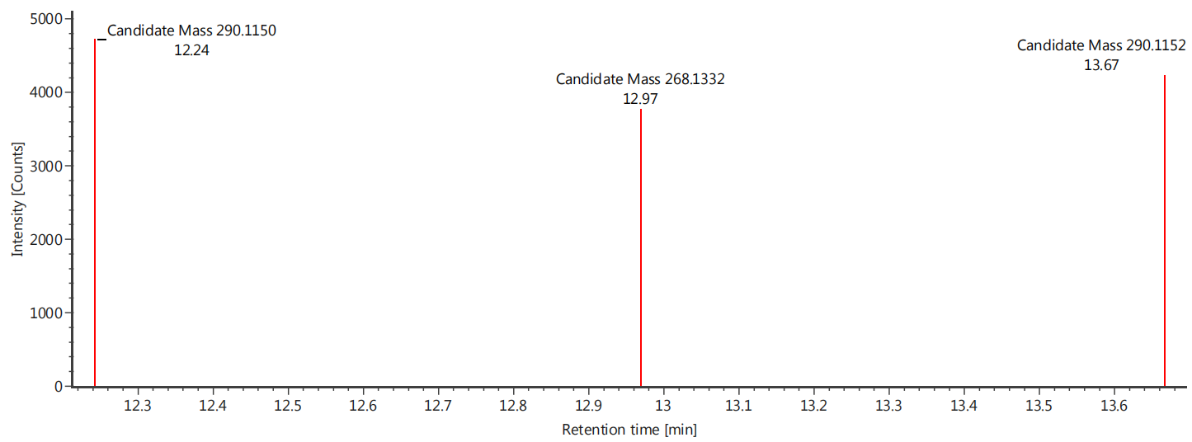



[M+Na]+

[M+H]+

[M+Na]+

**Appendix A6**

High Resolution Electrospray Ionization-Mass Spectrometry (HRESI-MS) of F

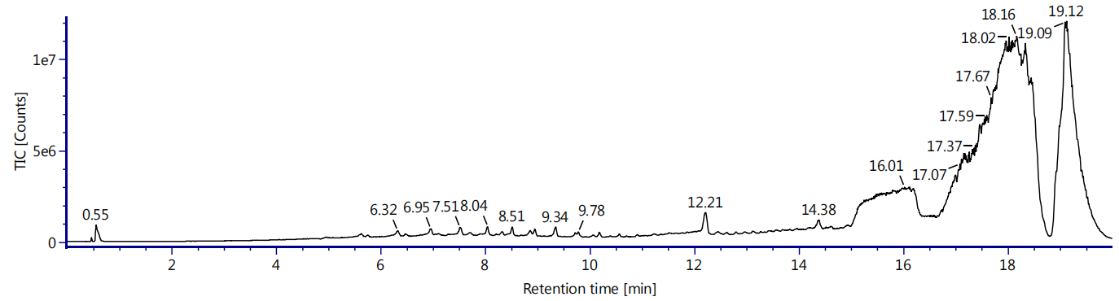

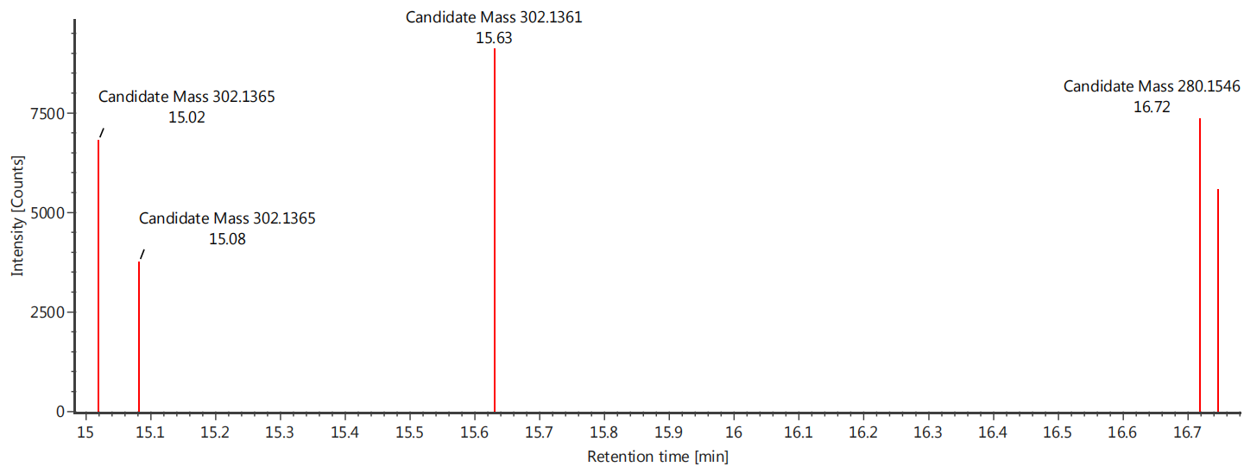



[M+Na]+

[M+Na]+

[M+H]+

[M+Na]+

**Appendix A7**

High Resolution Electrospray Ionization-Mass Spectrometry (HRESI-MS) of G

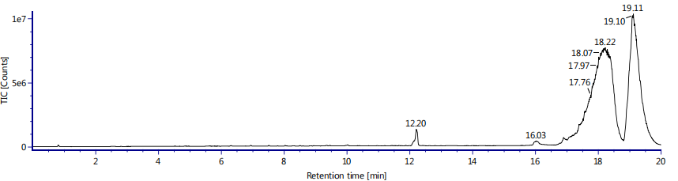

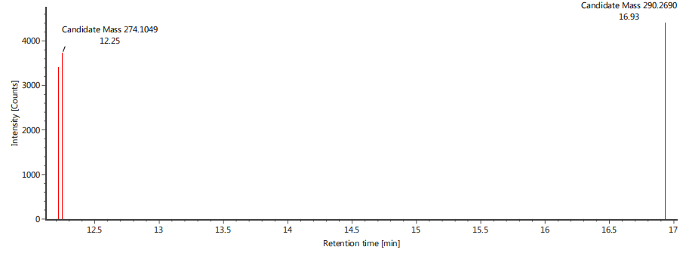



[M+Na]+

[M+K]+

**Appendix A8**

High Resolution Electrospray Ionization-Mass Spectrometry (HRESI-MS) of H

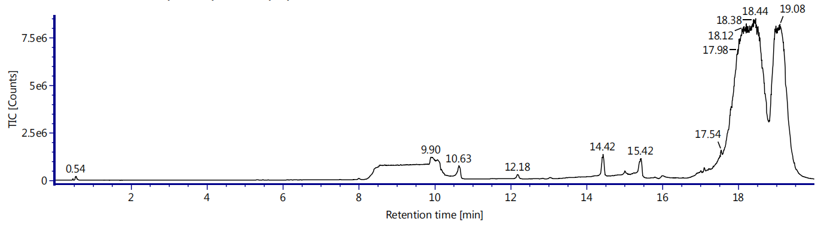

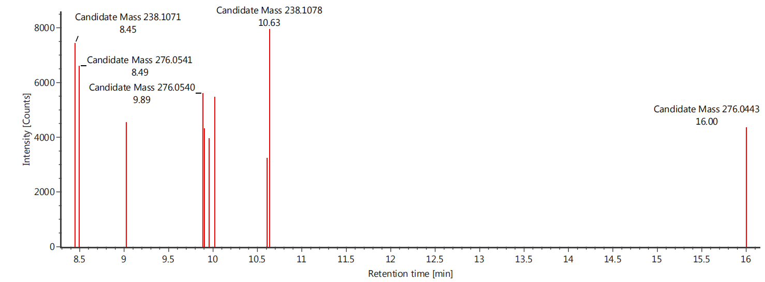

[M+K]+



[M+H]+

**Appendix A9**

High Resolution Electrospray Ionization-Mass Spectrometry (HRESI-MS) of I

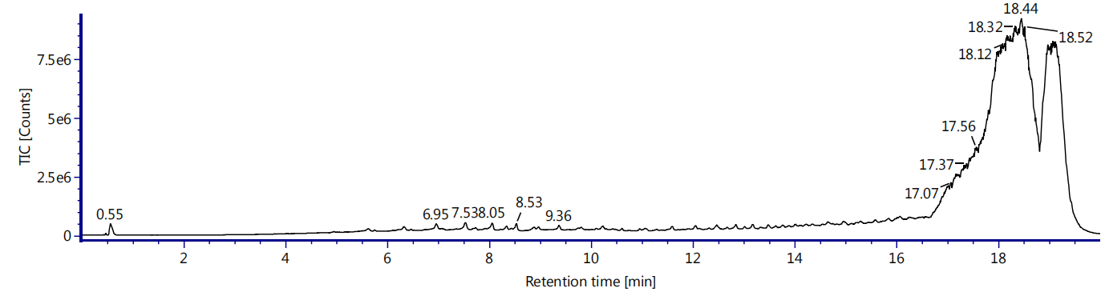

[M+Li]+

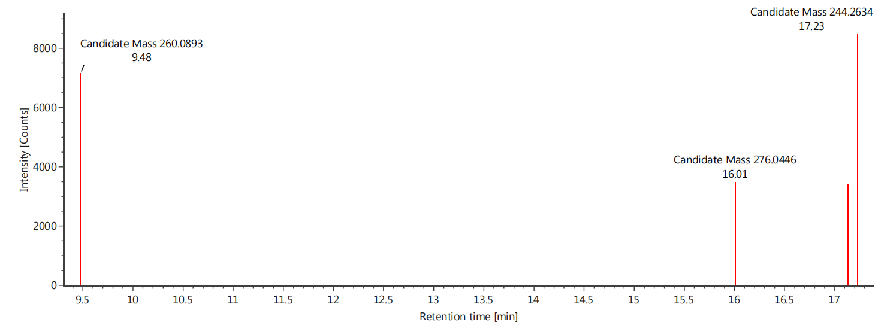



[M+Na]+

[M+K]+

**Appendix A10**

High Resolution Electrospray Ionization-Mass Spectrometry (HRESI-MS) of J

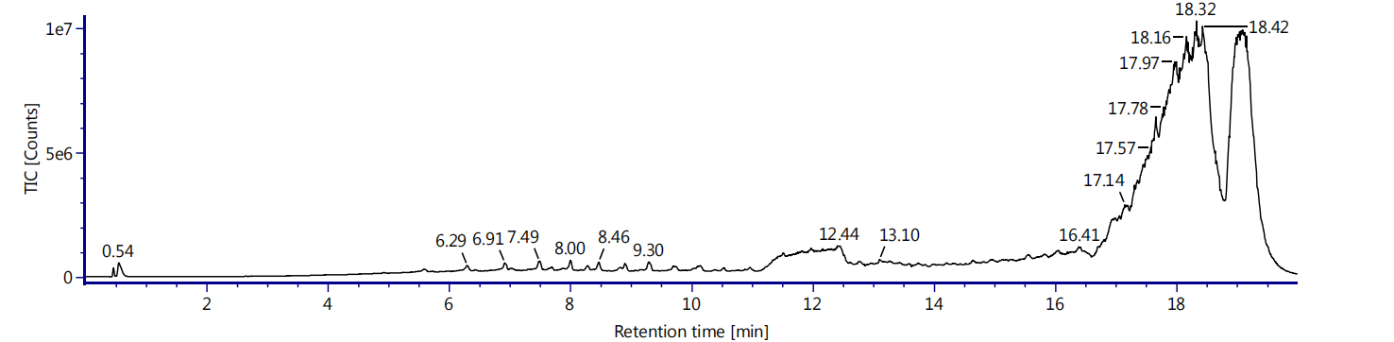

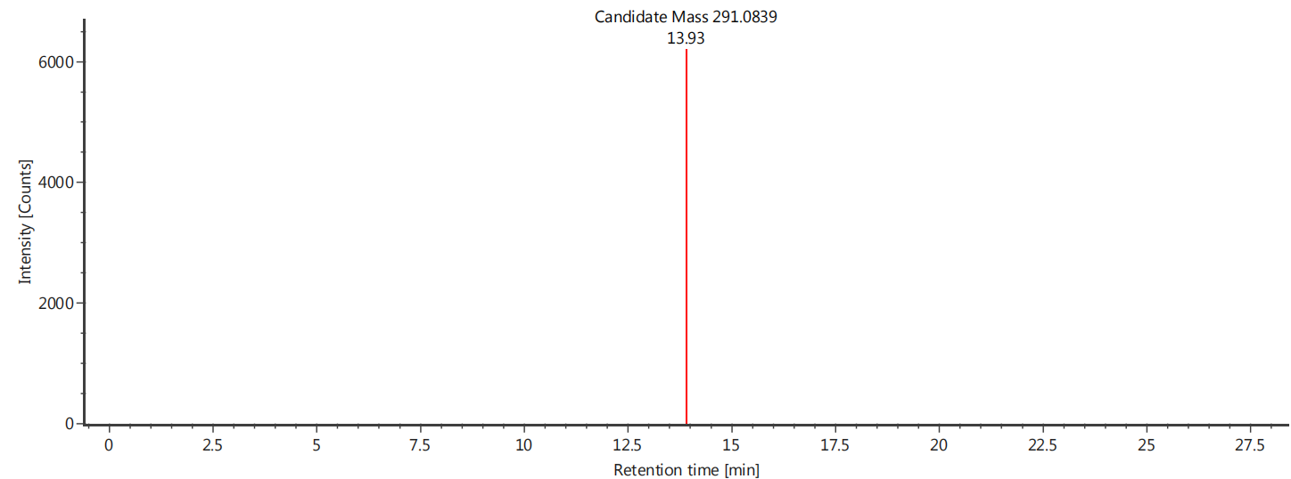



[M+K]+

**Appendix A11**

High Resolution Electrospray Ionization-Mass Spectrometry (HRESI-MS) of K

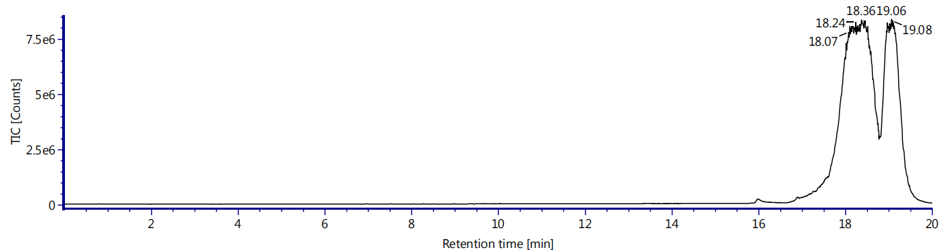

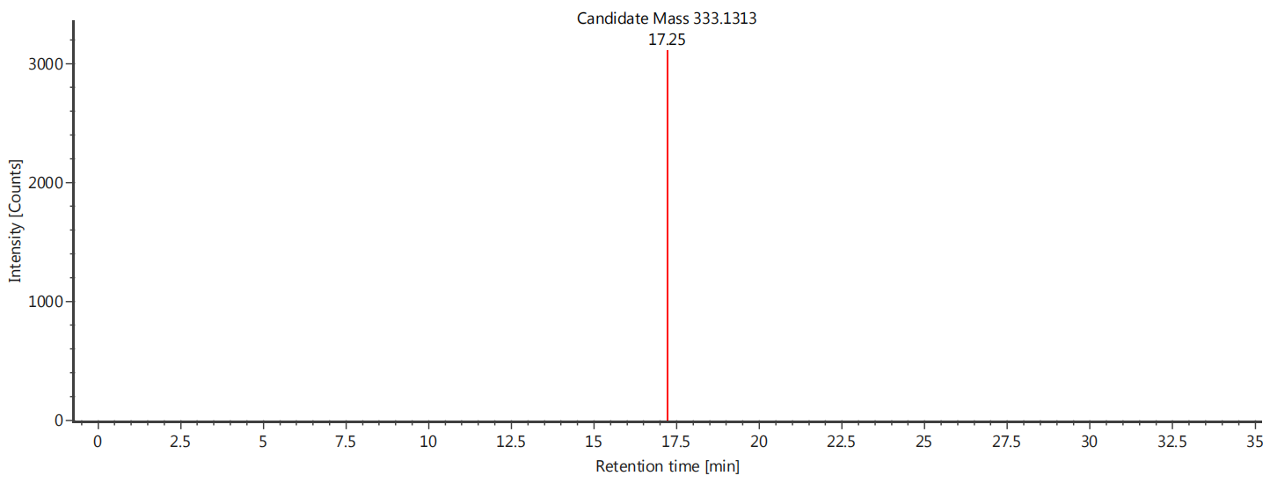



[M+K]+

**Appendix B1-1**

ATR-IR spectrum of A

$v$ (C-N)



$v$ (C-O)

$v$ (C=C)

$v$ (C=O)

$v$ (N-H)

$v$ (O-H)



\

**Appendix B1-2**

1H NMR and 13C NMR spectral of A

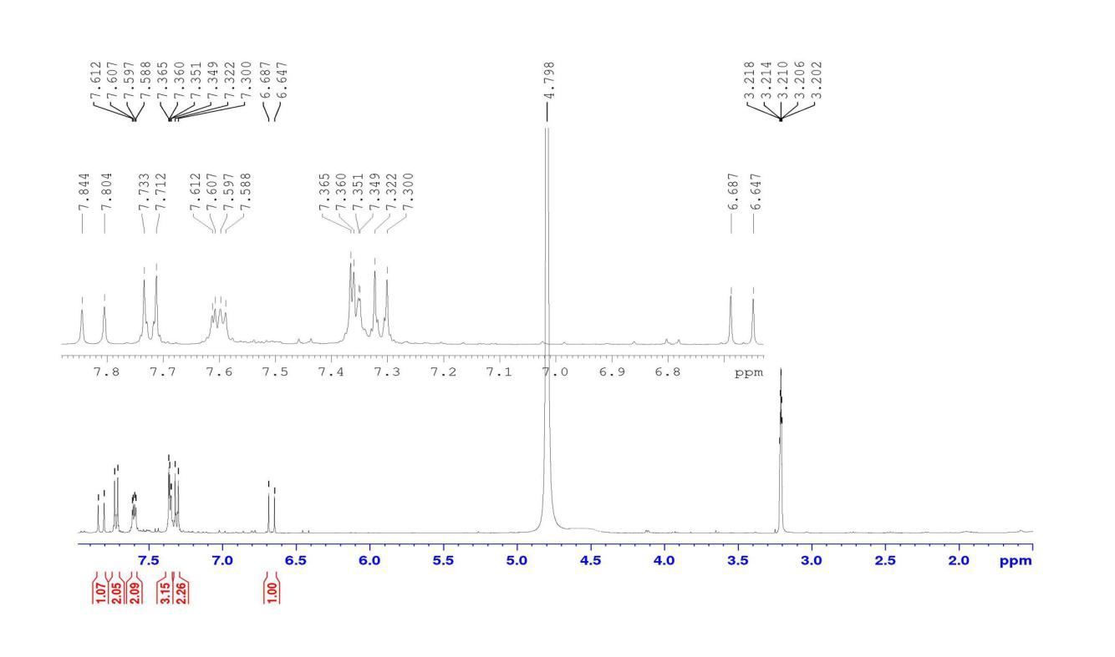

H-6

H-1, H-13

H-9,H-10,H-11

H-5

H-2,H-14

H-8, H-12



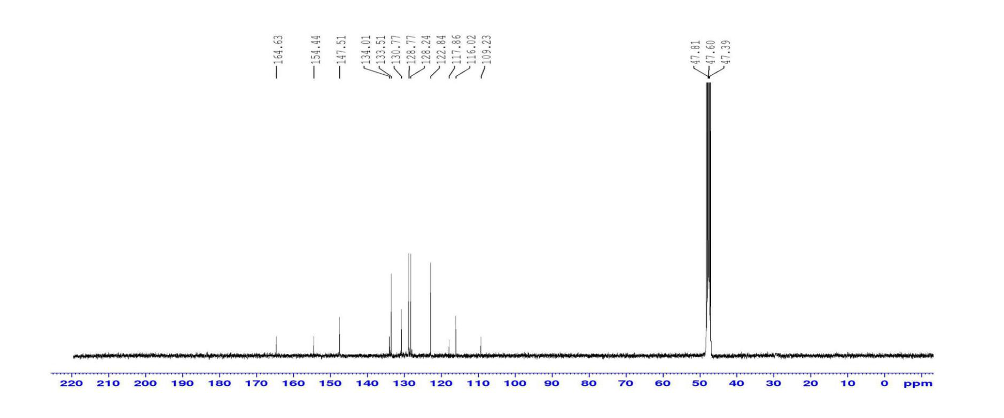



C-1,C-13,C-10,C-9,C-11,C-8,C-12, C-2,C-14,C-10,C-3

C-6

C-15

C-4,C-4*

**Appendix B2-1**

ATR-IR spectrum of B



$v$ (C-N)

$v$ (C-O)

$v$ (C=C)

$v$ (C=O)

$v$ (N-H)



$v$ (O-H)

**Appendix B2-2**



1H NMR and 13C NMR spectral of B

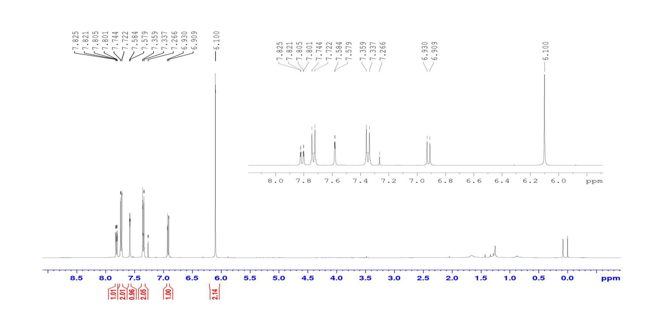

H-7

H-2,H-13

H-12

H-1,H-14 CDCl3

H-11

H-9

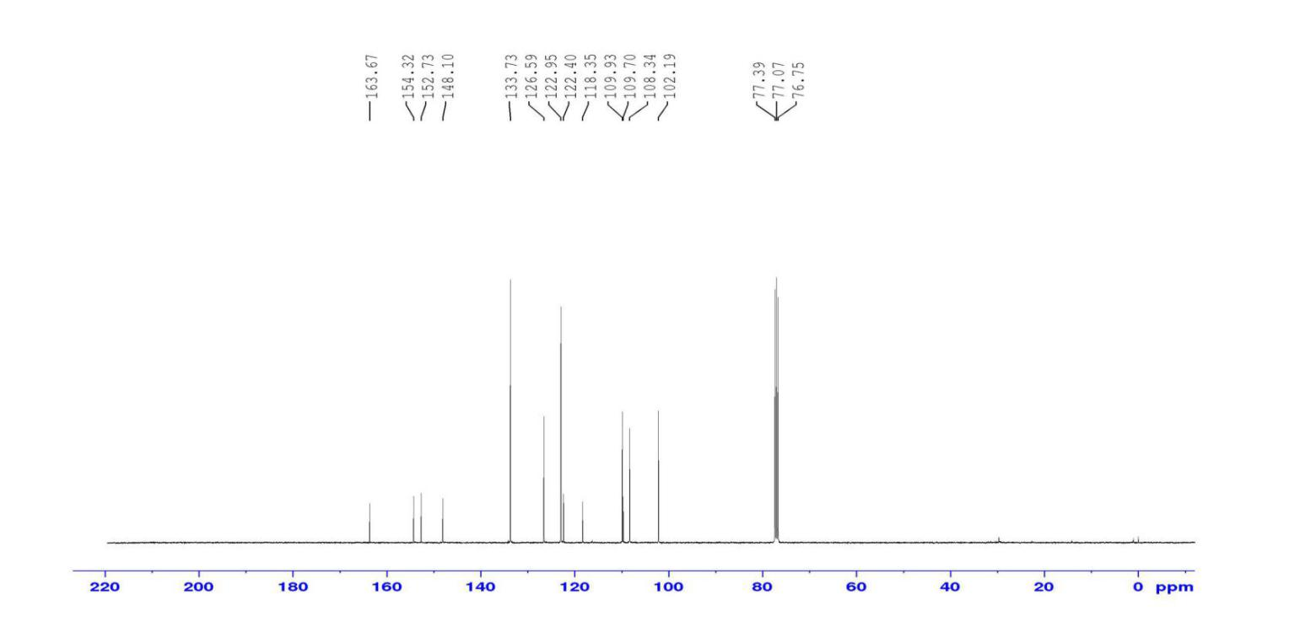



C-3,C-6,C-7, C-11

C-12,C-1,C-14

C-10,C-8

C-2,C-13

C-9

C-4, C-5

C-15

**Appendix B3-1**

ATR-IR spectrum of C

$v$****

(C-O $)$

$v$ (C-N $)$

$v$ (C=C)

$v$ (C=O)

$v$ (N-H $)$

$v$ (O-H)



**Appendix B3-2**

1H NMR and 13C NMR spectral of C

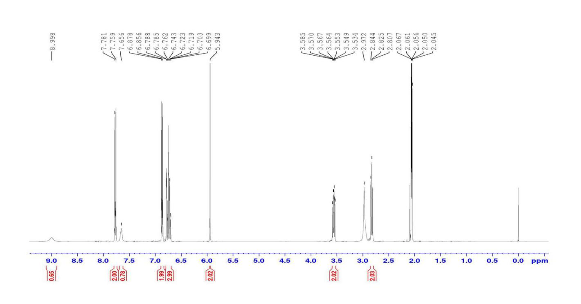

H-18

H-9

H-8

H-1

H-14,H-15, H-4,H-5,H-7

H-12, H-13

H-17

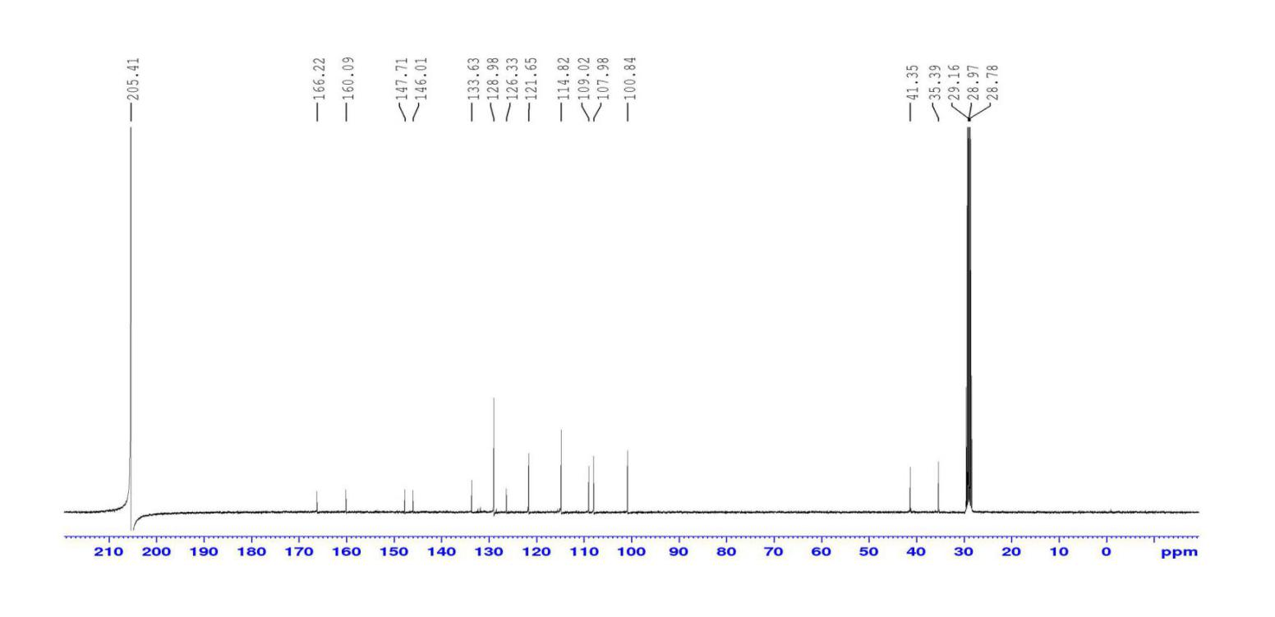



C-11,C-5,C-14,C-15, C-7,C-4

C-6, C-12,C-13

C-3,C-2

C-1

C-9 ,C-8

C-16

C-10



**Appendix B4-1**

ATR-IR spectrum of D

$v$ (C-N)



$v$ (C-O)

$v$ (C=O)

$v$ (C=C)

$v$ (N-H)

$v$ (N-H)



**Appendix B4-2**

1H NMR spectral of D

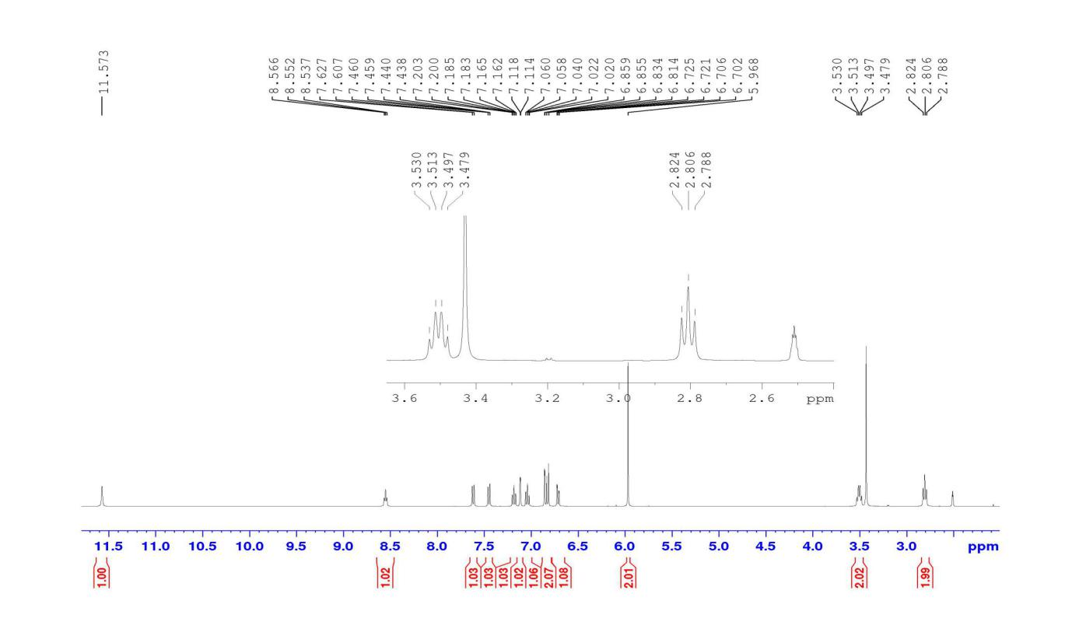

DMSO-d6

H-8

H-9



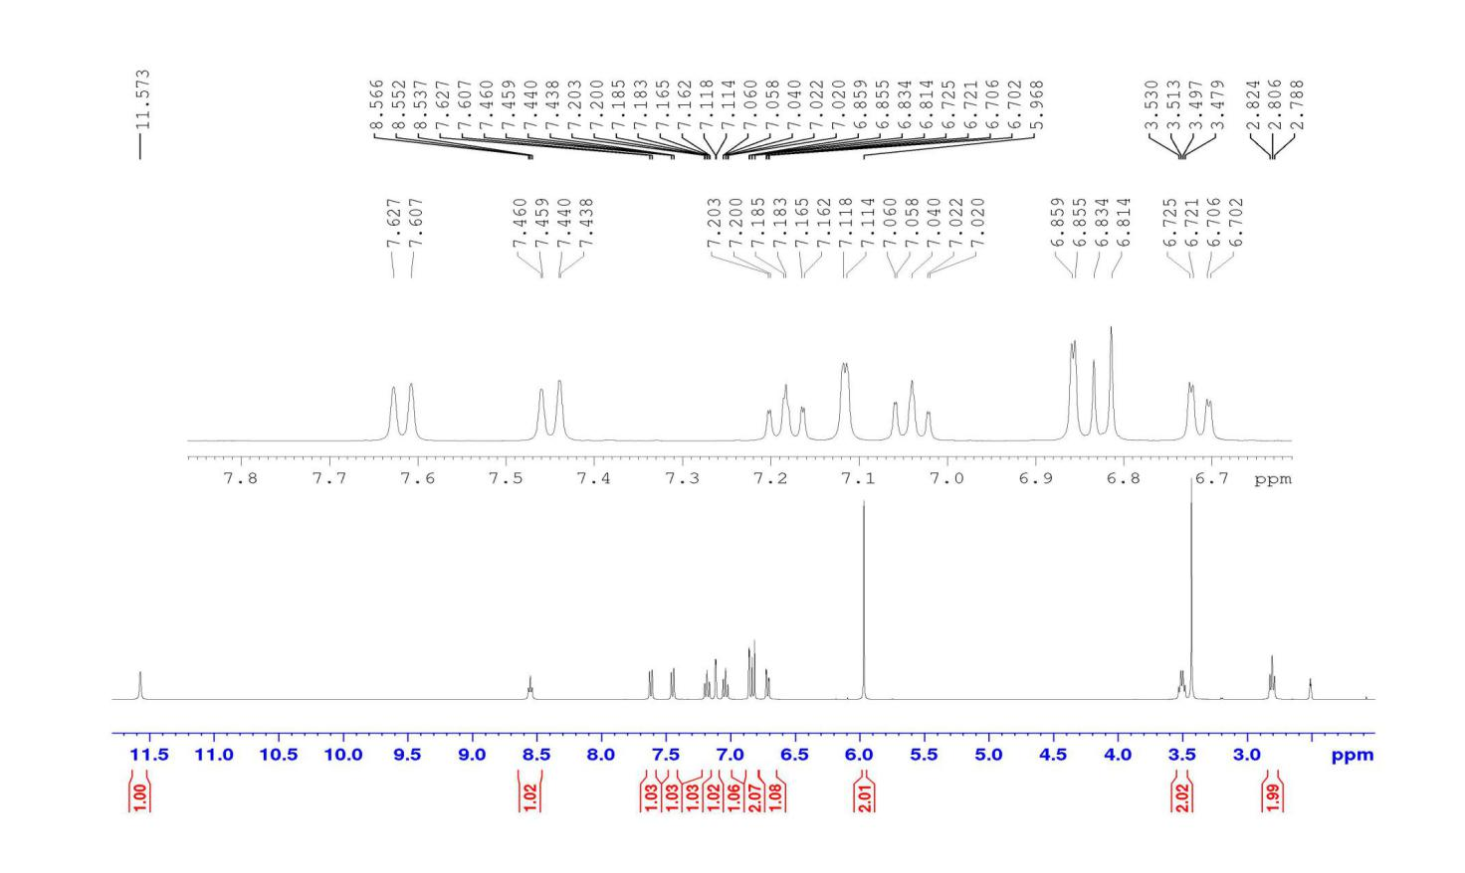

H-7, H-4

H-5

H-17, H-12, H-18

H-16

H-15

H-1

H-19

H-20

**Appendix B4-3**

13C NMR spectral of D

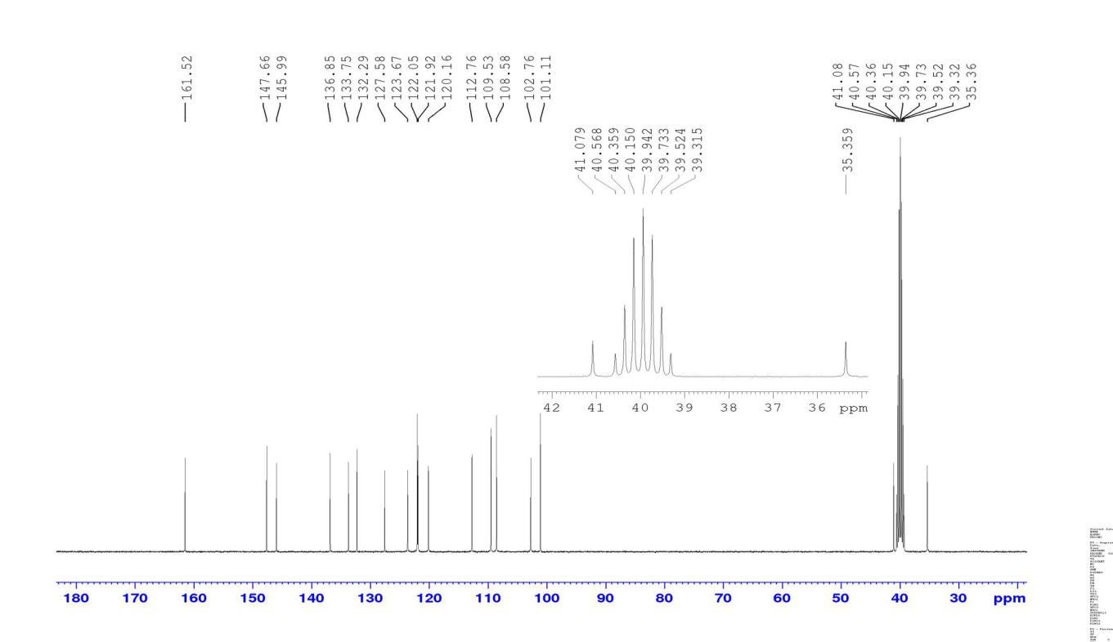

C-1

C-8

C-2,C-3

C-9

C-10



**Appendix B5-1**

ATR-IR spectrum of E

$v$****

(C-H)Sp3

$v$ (N-H)

$v$ (C-O)

$v$ (C=O)

$v$ (C=C)



**Appendix B5-2**

1H NMR and 13C spectral of E

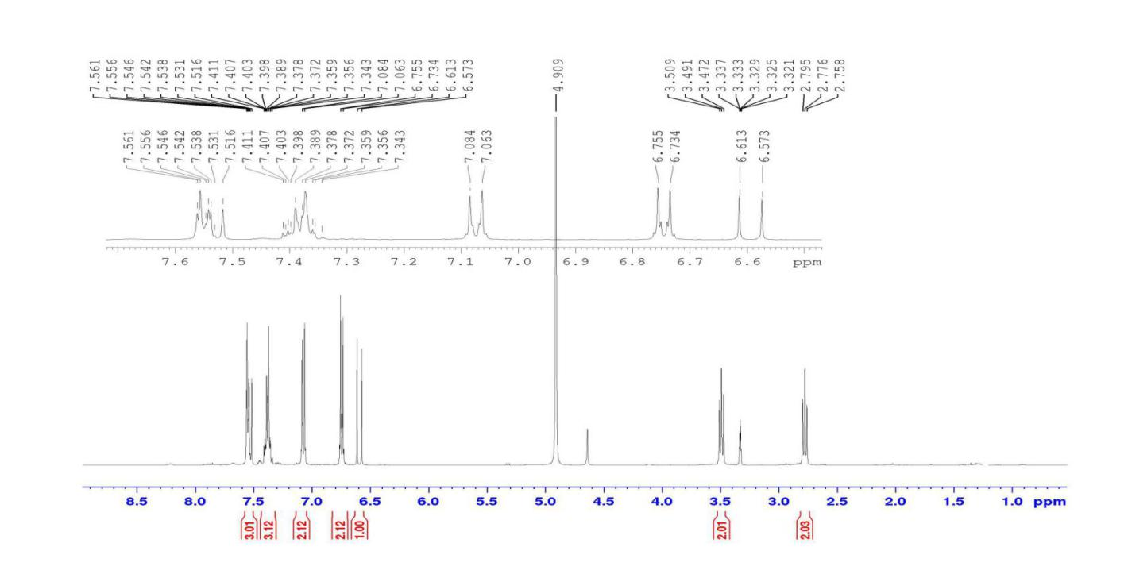

H-2, H-3,H-4,H-5, H-6,H-7



H-13, H-14

H2O

H-15, H-16

H-8

H-10

H-11

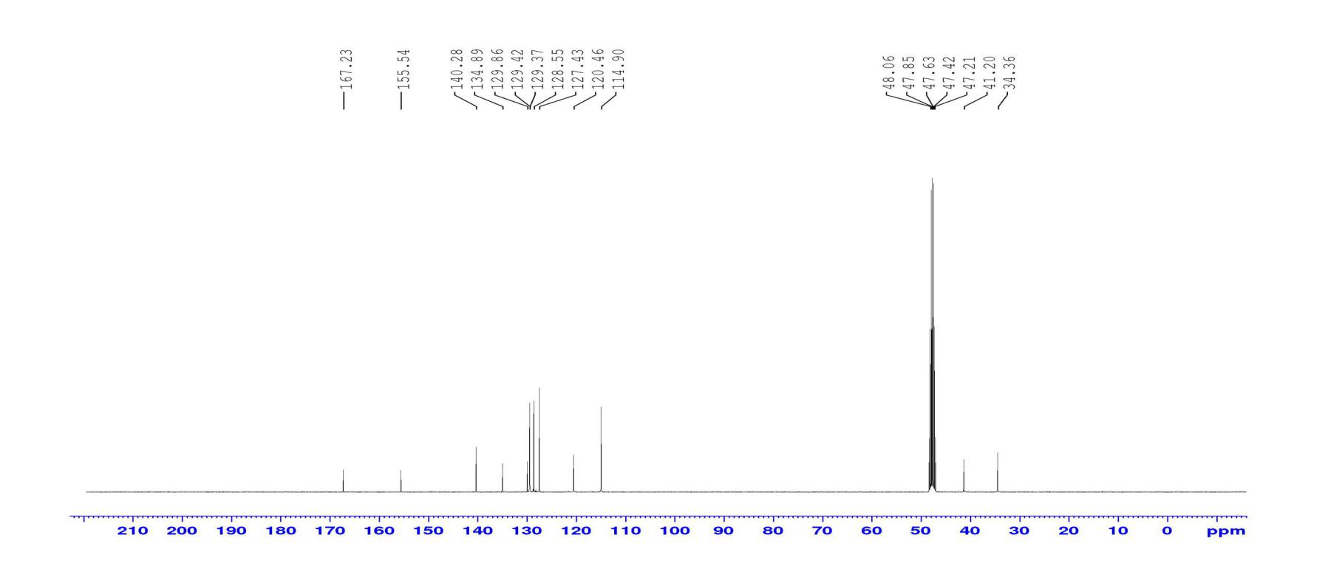

C-15, C-16

C-17

C-7, C-1, C-12,C-13,C-14,C-2,C-6,C-3,C-5,C-4

C-8

MeOD

C-10,C-11

C-9



**Appendix B6-1**

ATR-IR spectrum of F

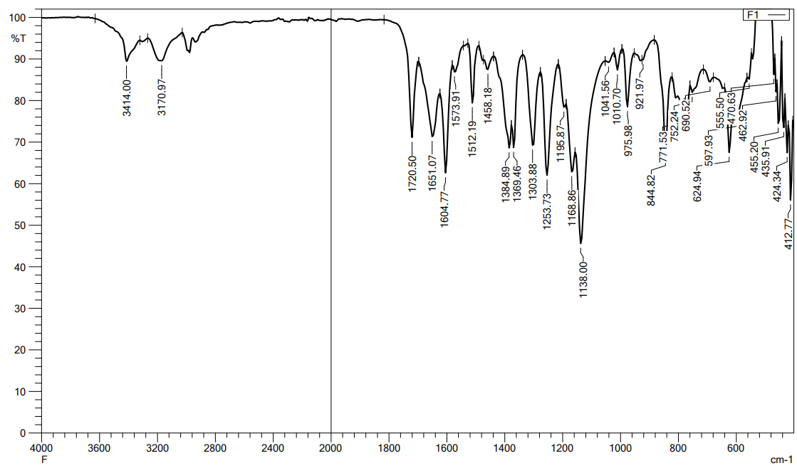

$v$ (C-O)

$v$ (C-N)

$v$ (C=C)

$v$ (C=O)



$v$ (N-H)

**Appendix B6-2**

1H NMR and 13C spectral of F

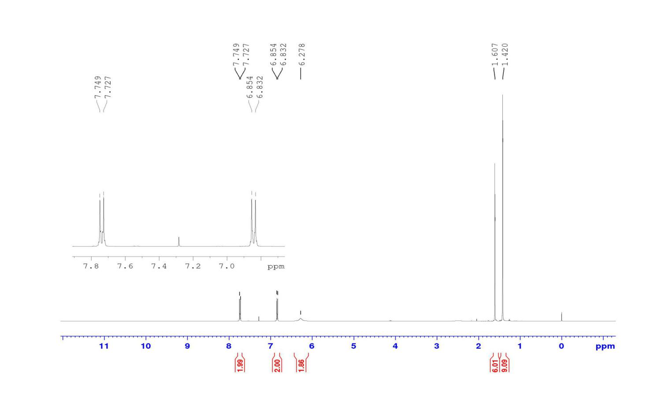

NH2

CDCl3

H-3, H-4

H-5,H-6

H-8,H-8*

H-11,H-11*,H-11**



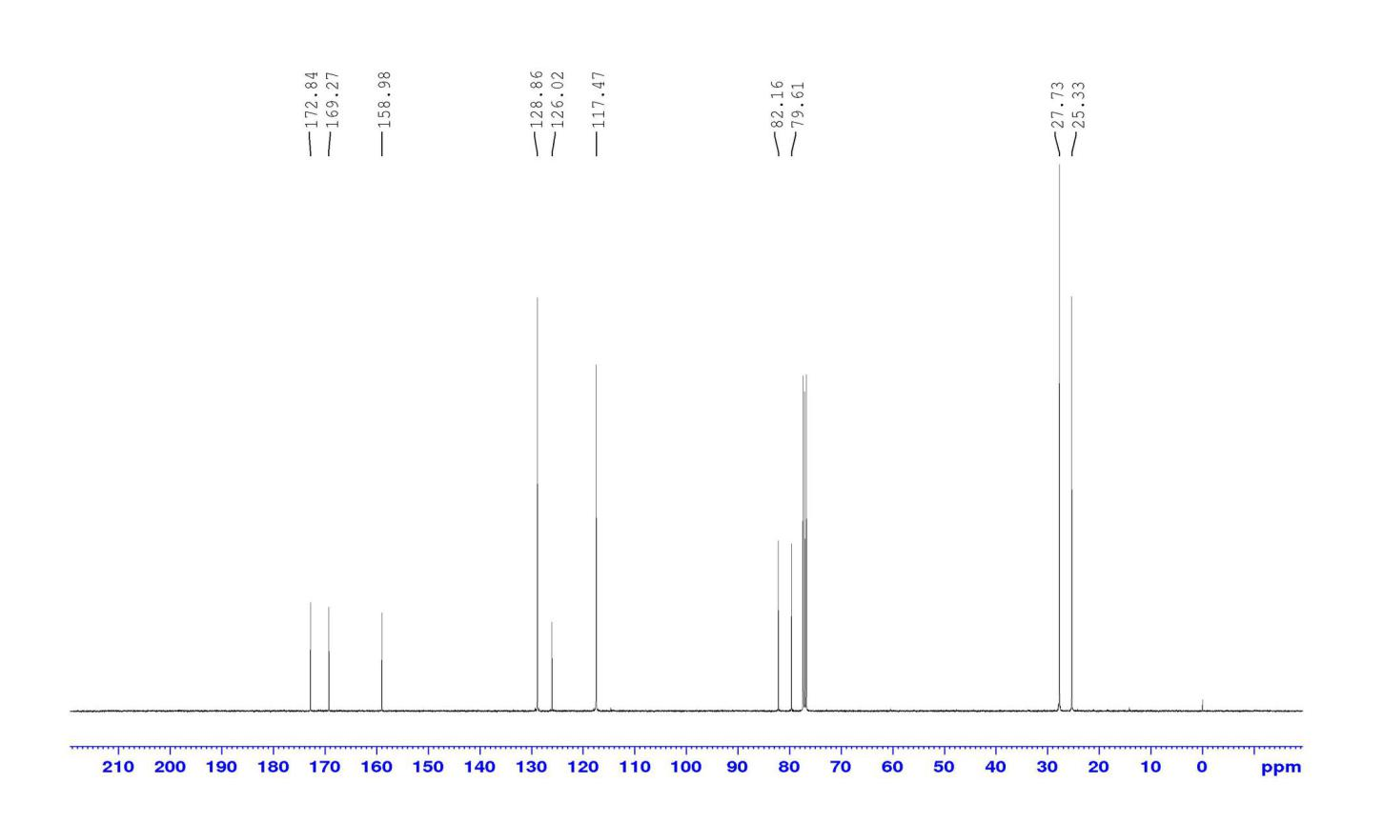

C-9, C-12

C-2

C-3,C-4

C-5,C-6

C-10, C-1, C-7

C-11, C-11*,C-11***

C-8, C-8*



**Appendix B7-1**

ATR-IR spectrum of G

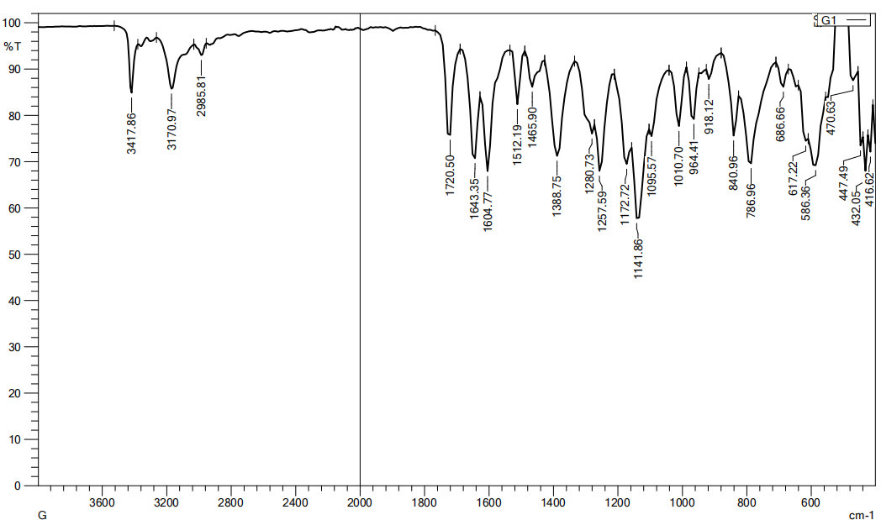

$v$ (C-N)

$v$ (C=C)

$v$ (C-O)

$v$ (C=O)



$v$ (N-H)



**Appendix B6-2**

1H NMR and 13C spectral of G

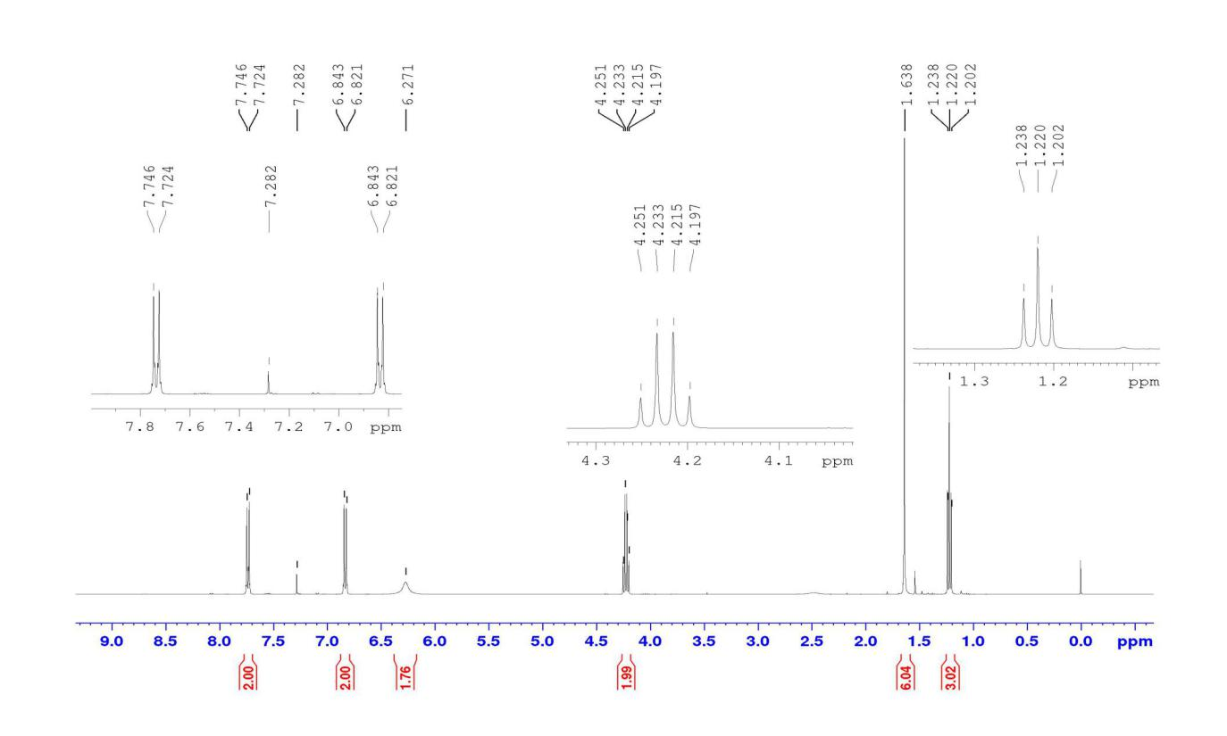

H-12

H-11

NH2

H-5, H-6

H-3,H-4



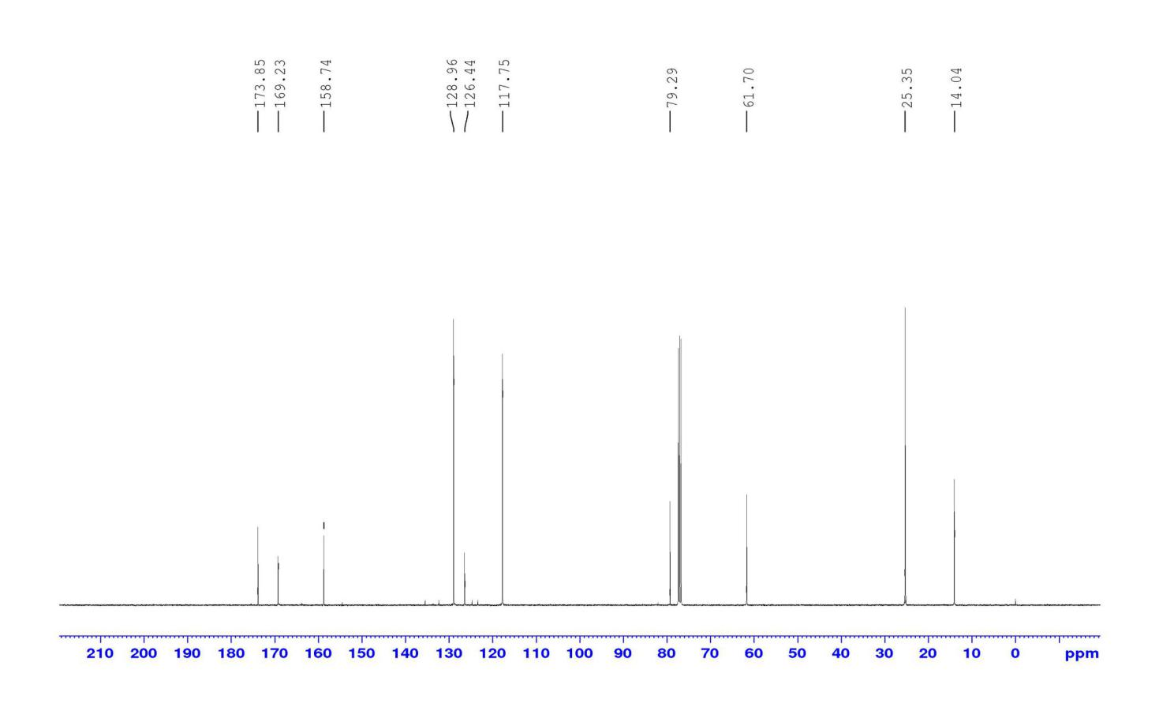

C-12

C-10, C-1, C-7

C-3, C-4, C-2

C-5,C-6

C-9

C-11

C-8, C-8*



**Appendix B7-3**

DEPT 135 spectral of G

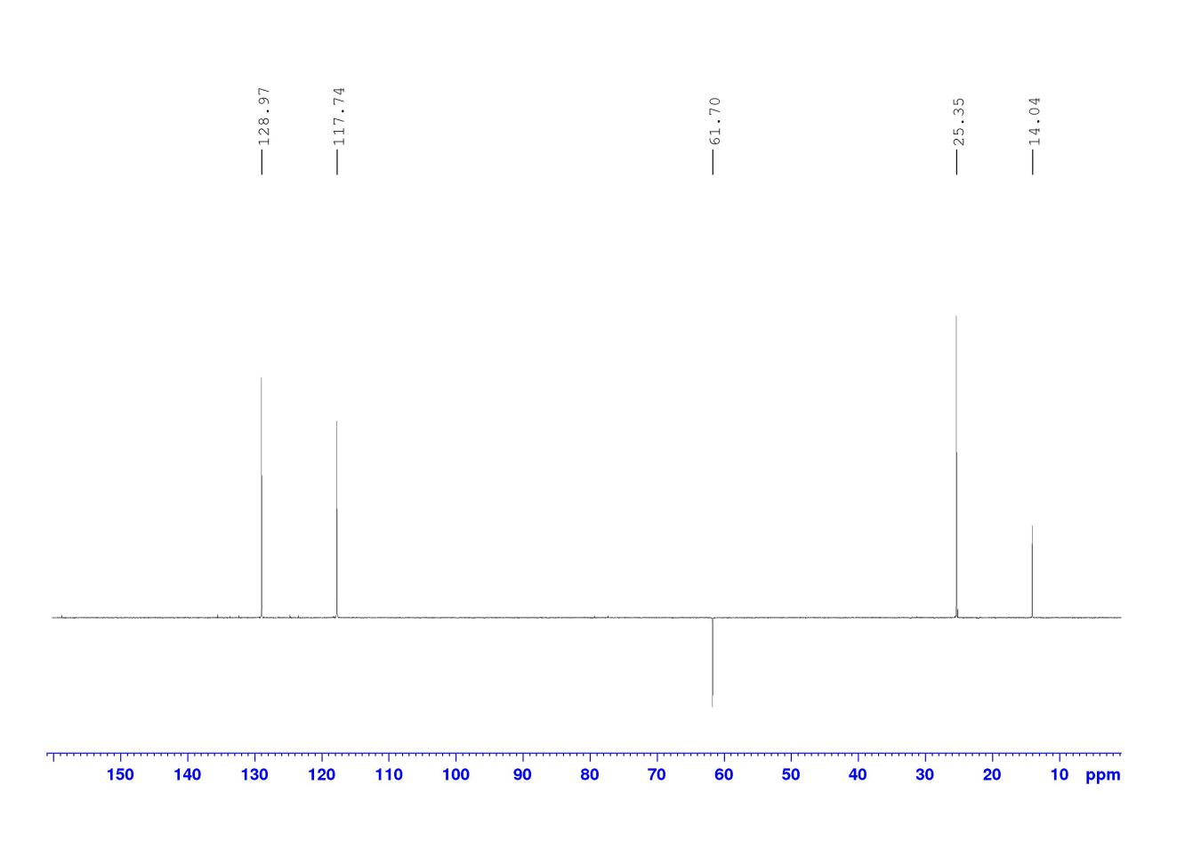

CH,C-3,C-4

CH2, C-11

CH,C-5,C-6

CH3, C-8, C-8*

CH3,C-12



**Appendix B8-2**

ATR-IR spectrum of H

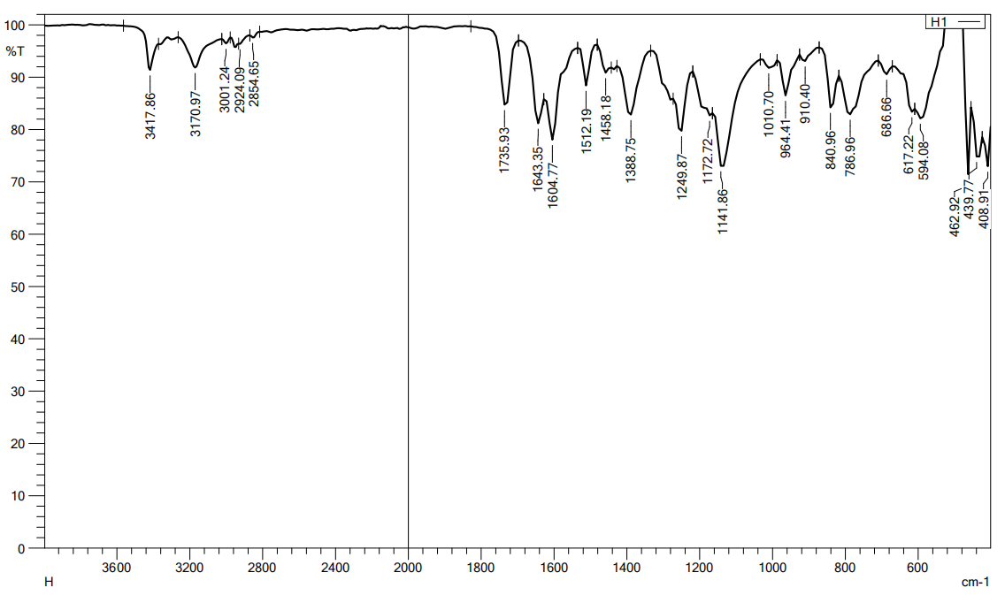

$v$ (C-O)

$v$ (C=C)

$v$ (C=O)

$v$ (C-N)

$v$ (CHsp3)

(N-H)



**Appendix B8-1**

1H NMR and 13C spectral of H

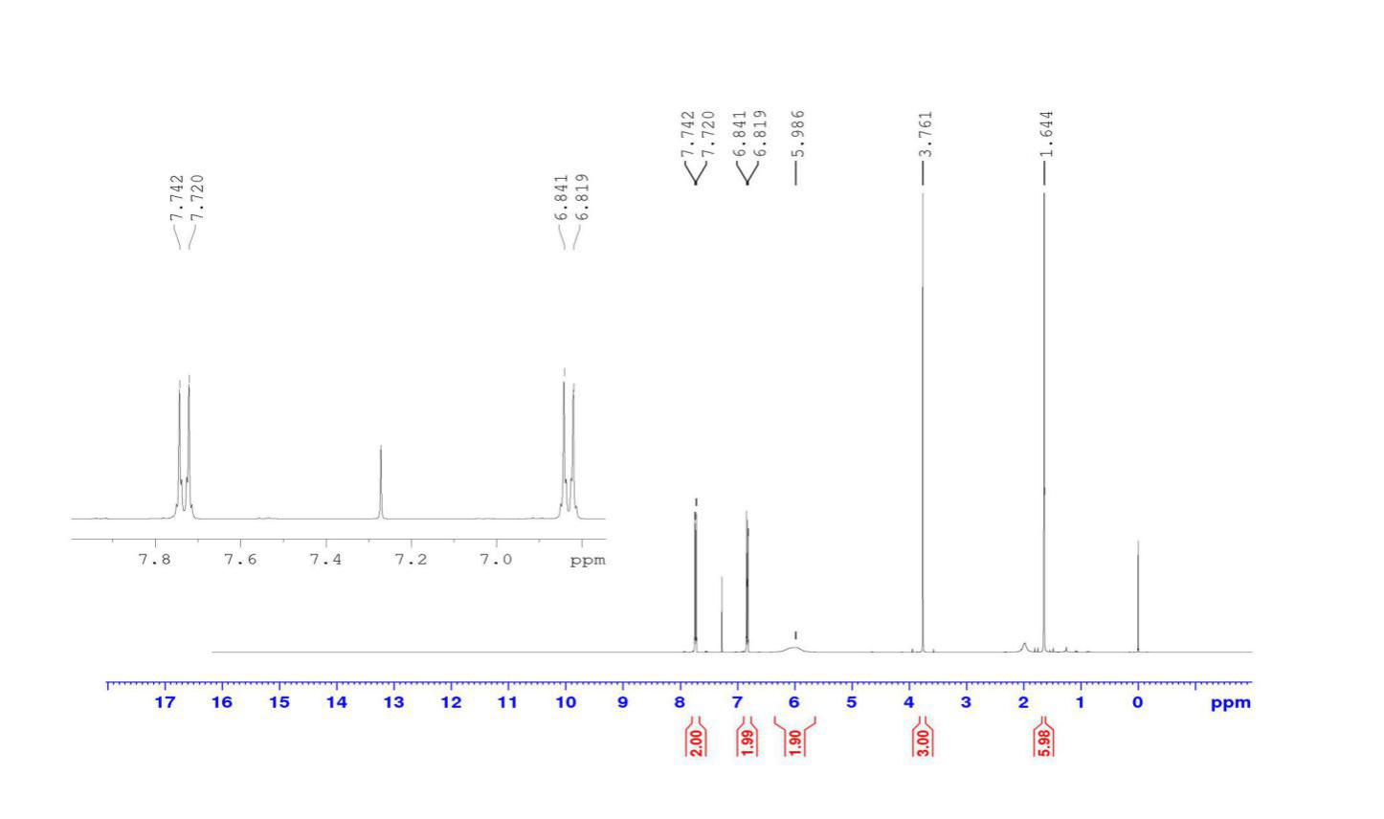

H-3,H-4

H-5, H-6

NH2

H-11

H-8, H-8*



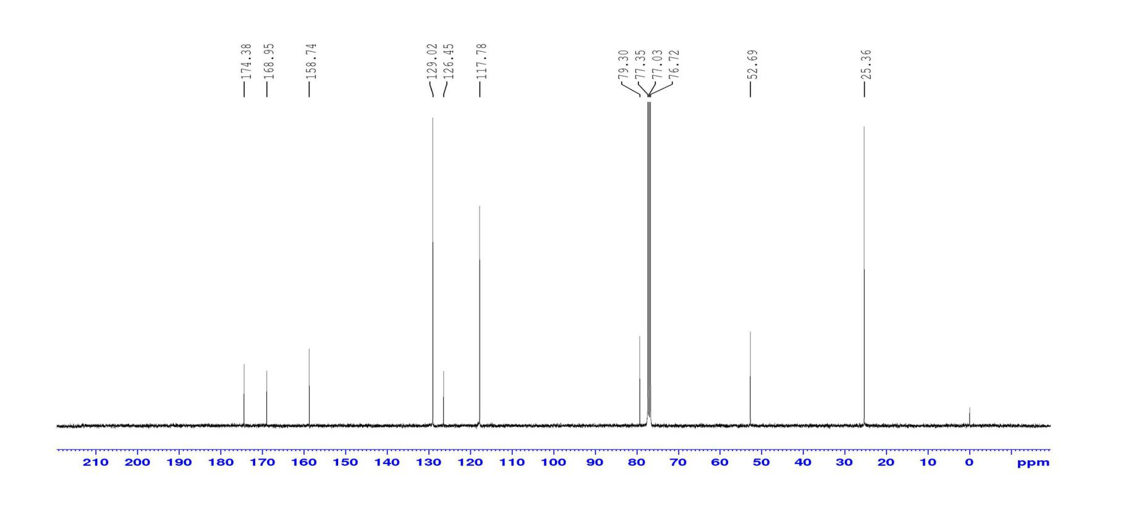

C-10, C-1

C-7

C-3,C-4

C-2,C-5,C-6

C-9

C-11

C-8,C-8*



**Appendix B11-1**

ATR-IR spectrum of K





$v$ (C=O)

$v$ (C=C)

$v$ (CHsp3 )

(N-H)

**Appendix B11-2**

1H NMR and 13C spectral of K

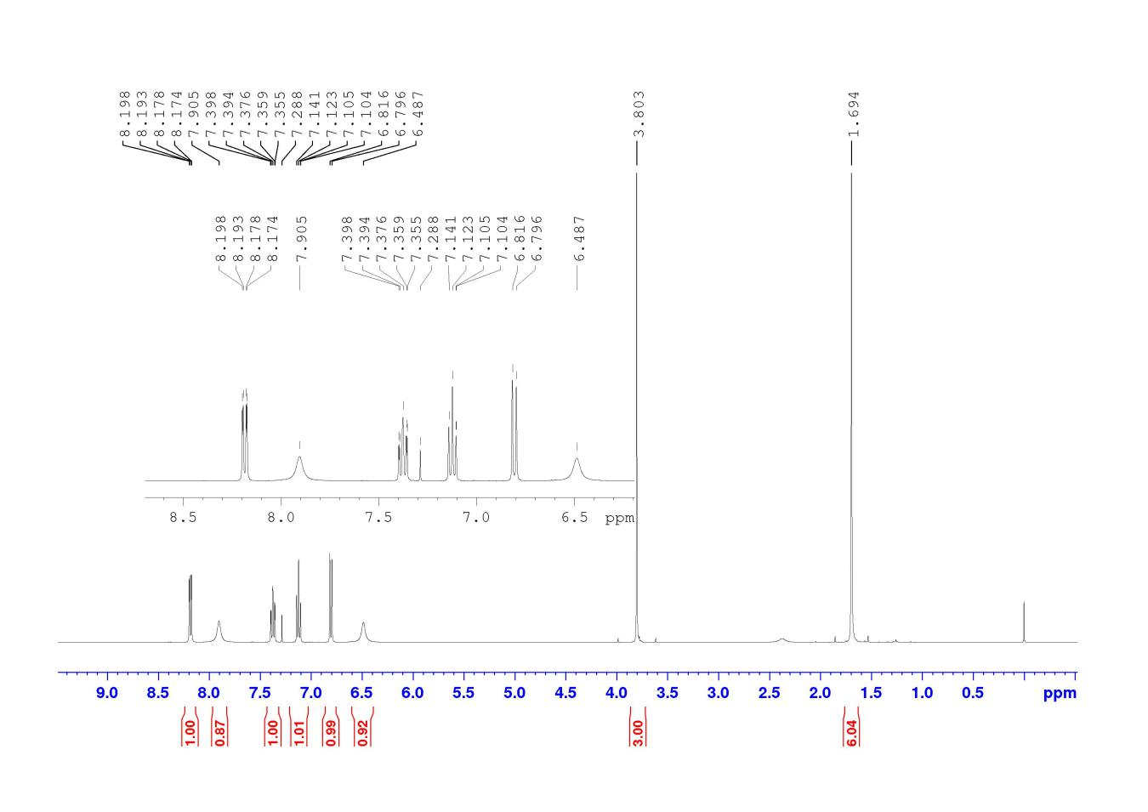

H-7,H-6

H-4



H-5

N-H

N-H

H-10

H-8,H-8*

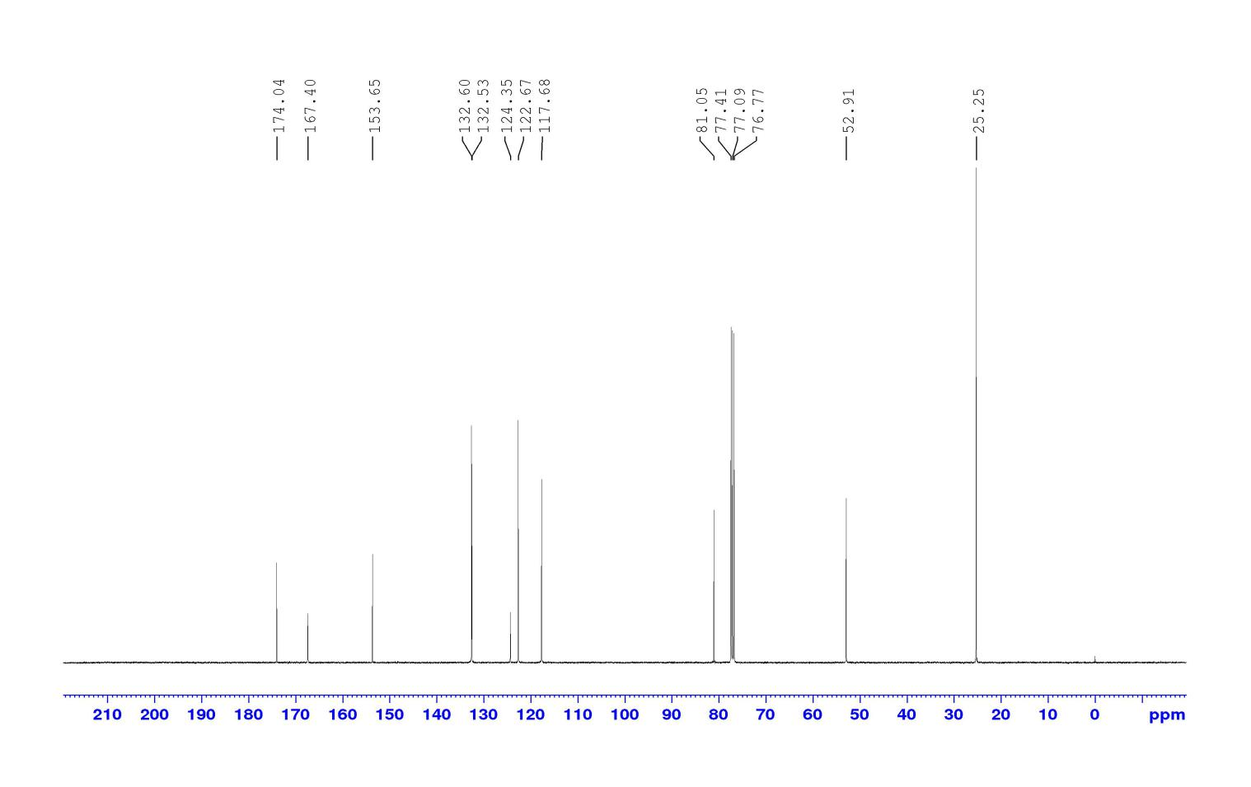

C-3

C-7,C-4,C-2,C-6

C-5

C-9,C-1

C-11

C-10

C-8,C-8*



**Appendix B12-1**

ATR-IR spectrum of L

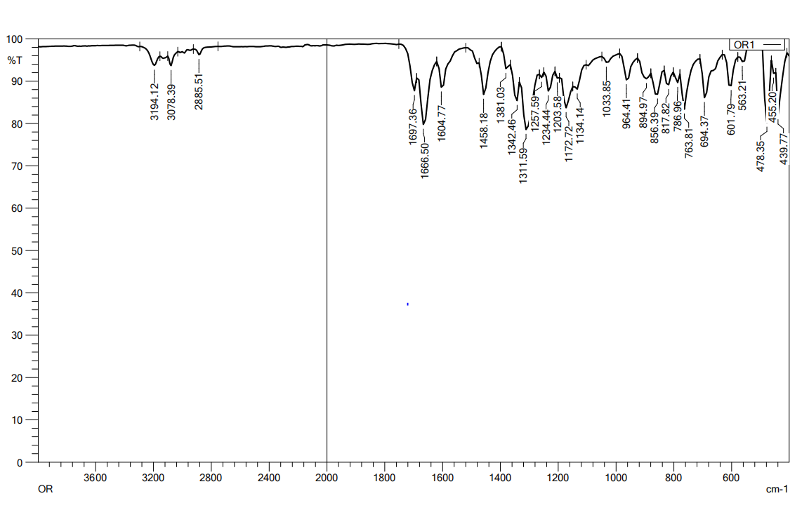

$v$ (C-O)

$v$ (C=C)

$v$ (C=O)

$v$ (CH)sp3



**Appendix B12-2**

1H NMR and 13C spectral of L

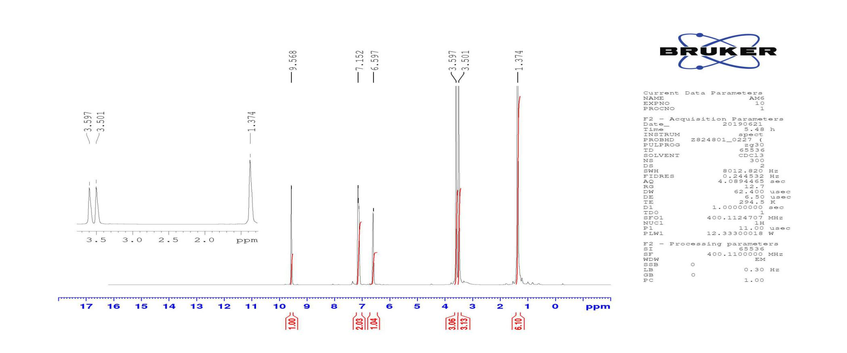

H-10, H-10*

H-12

H-3

H-6, H-7

H-C=O

H-8



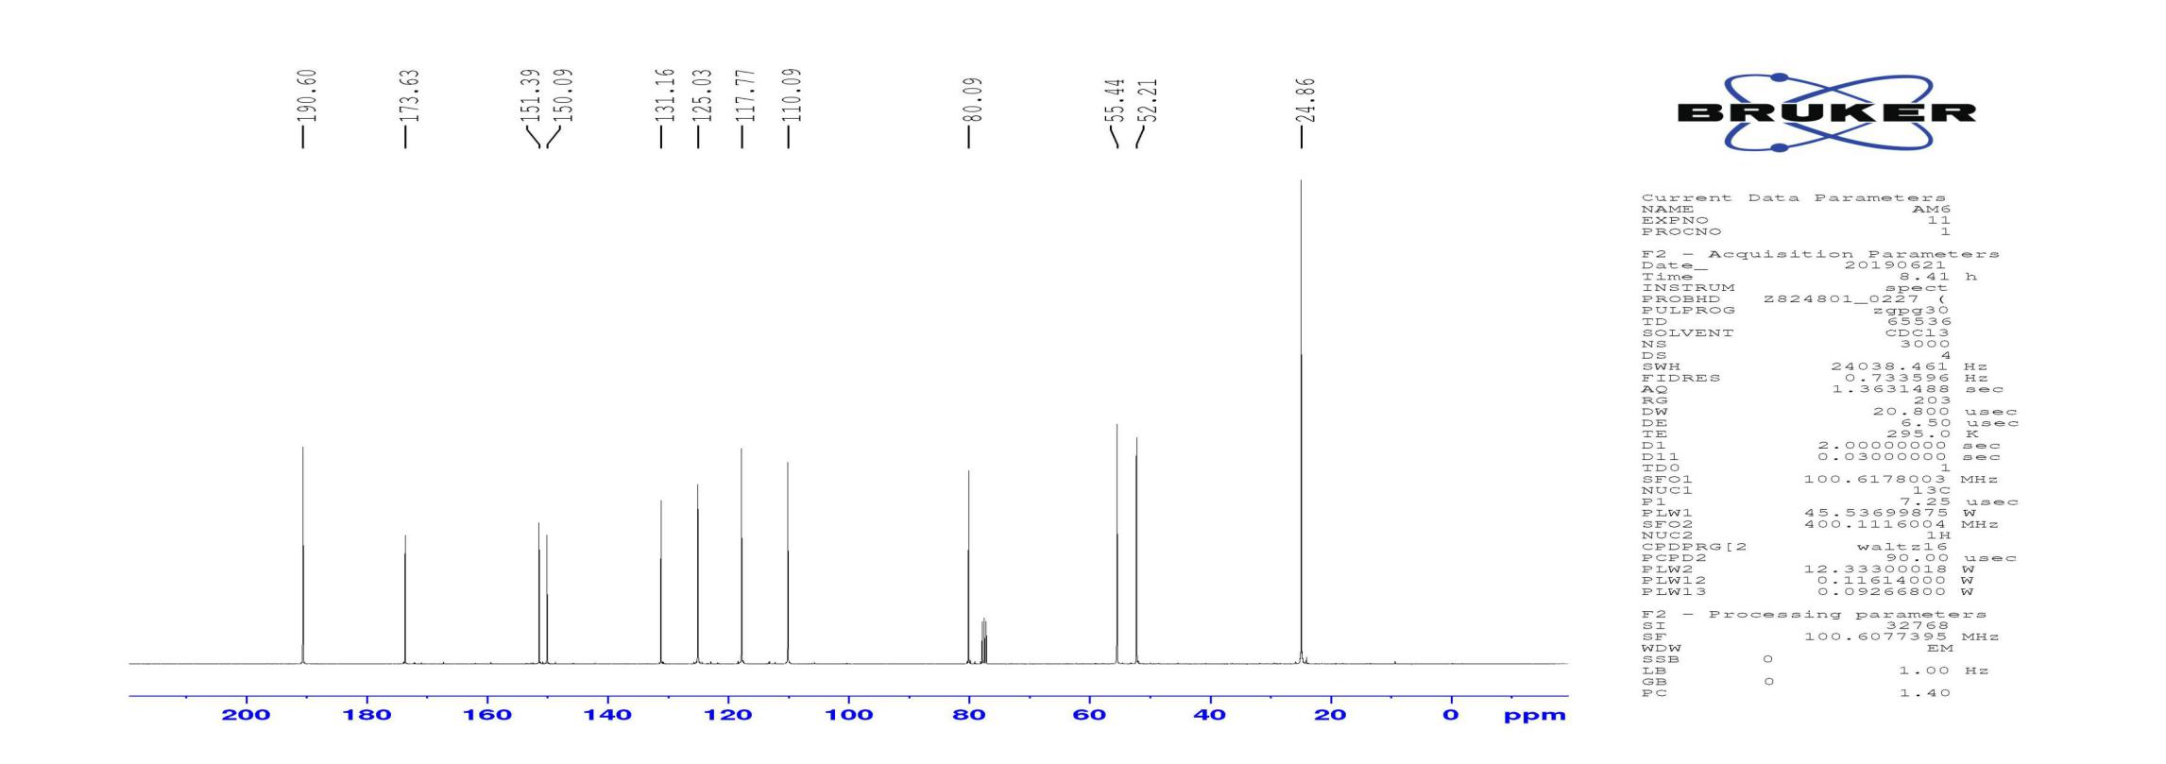

C-11

C-5, C-4

C-9

C-8, C-12

C-10, C-10*

C-2, C-7, C-6, C-3



C-1

**Appendix B12-3**

DEPT 135 spectral of L

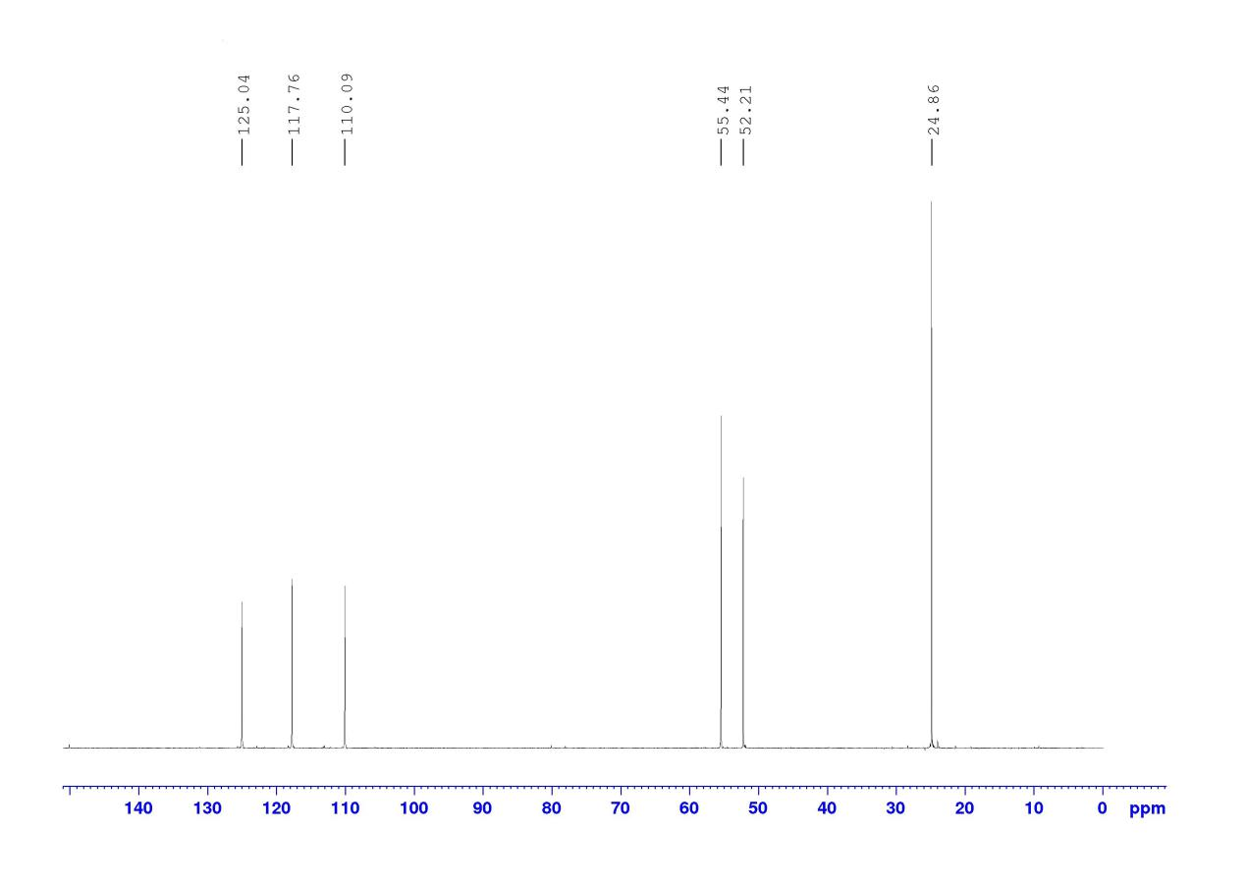

CH3, C-8, C-12

CH3, C-10, C-10*

CH, C-7, C-6, C-3



**Appendix B13-1**

ATR-IR spectrum of M

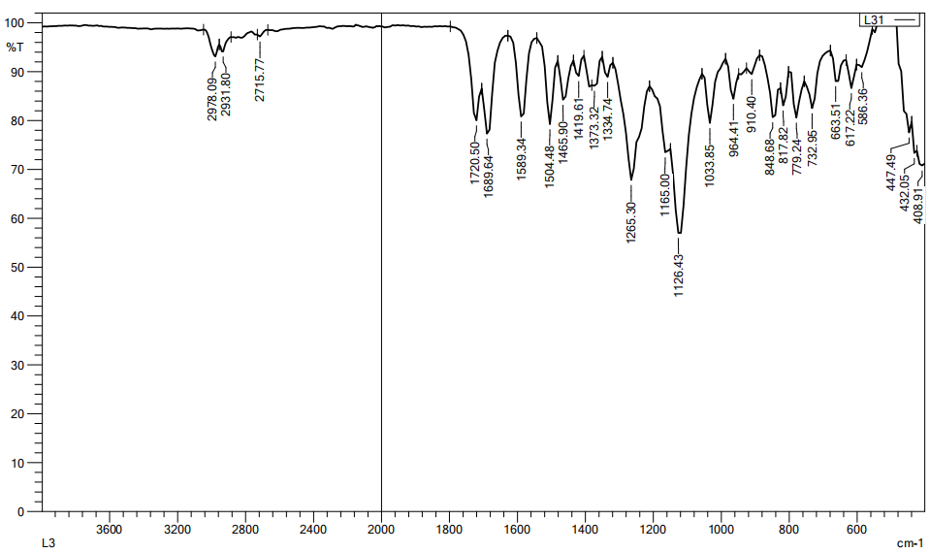

$v$ (C-O)

$v$ (C=C)

$v$ (C=O)



$v$ (CH)sp3

**Appendix B13-2**

1H NMR and 13C spectral of M

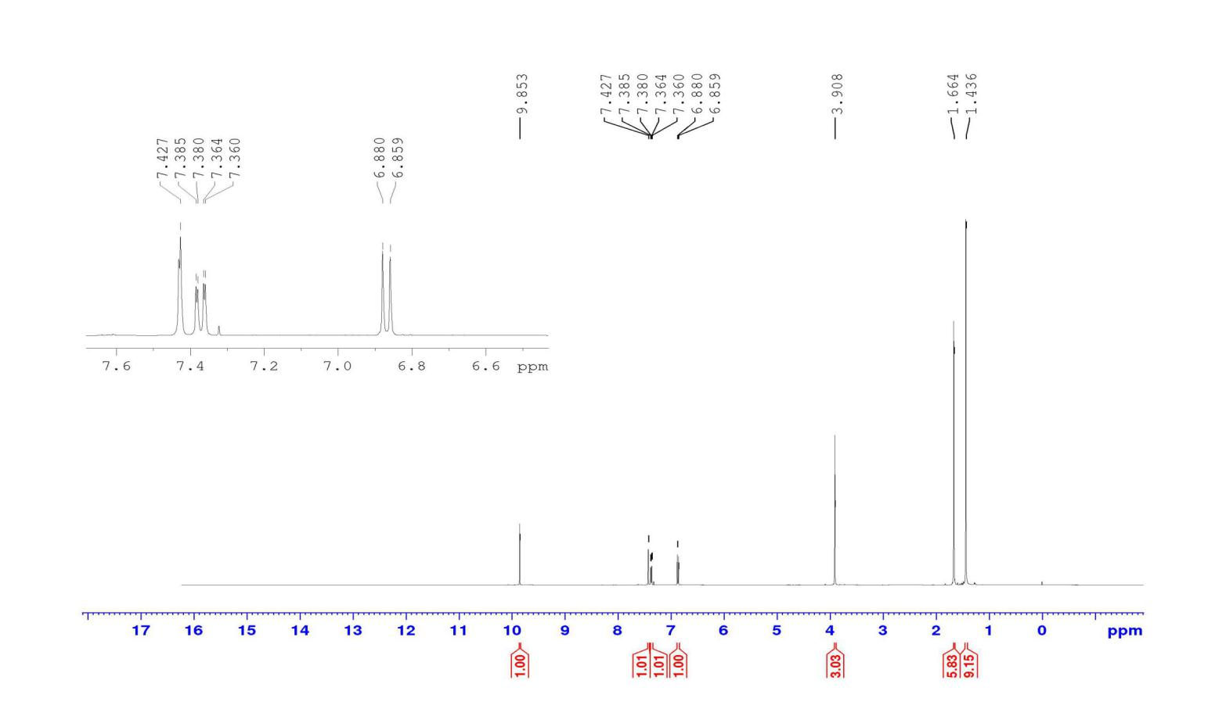

H-11,H-11*

H-4

H-5

H-6

H-2

H-8

H-13,H-13*,H-13**



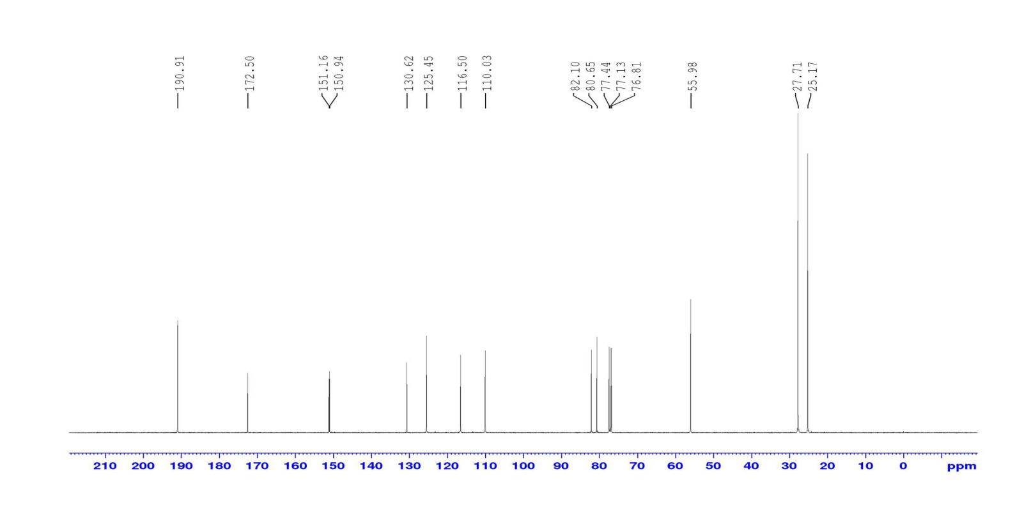

C-13,C-13*,C-13**

C-3, C-4,C-6,C-5



C-10,C-14

C-9,C-7

C-12

C-1

C-8

C-11, C-11*

**Appendix C1**





π→π*

283.5nm n→π*

n→π*

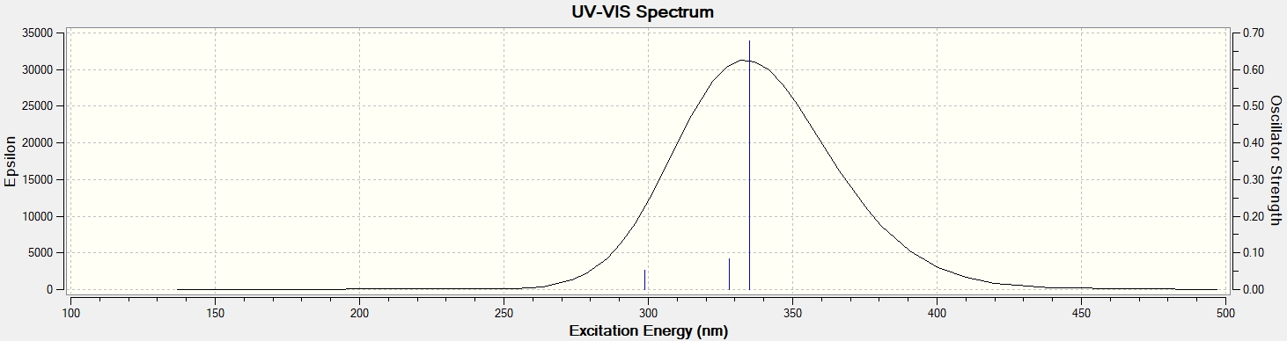



298.73nm n→π*

The UV-VIS spectrum calculate by TD-SCF/TD/B3YLP 6-31+G(d,p) basic set

**Appendix C2**





226.50nm π→π*

269nm, 303.00 nm n→π*

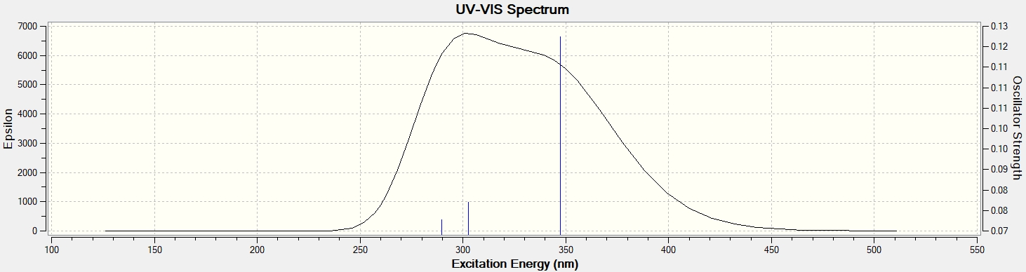



289.00nm, 302.00 nm n→π*

The UV-VIS spectrum calculate by TD-SCF/TD/B3YLP 6-31+G(d,p) basic set

**Appendix C3**



252.5nm, n→π*



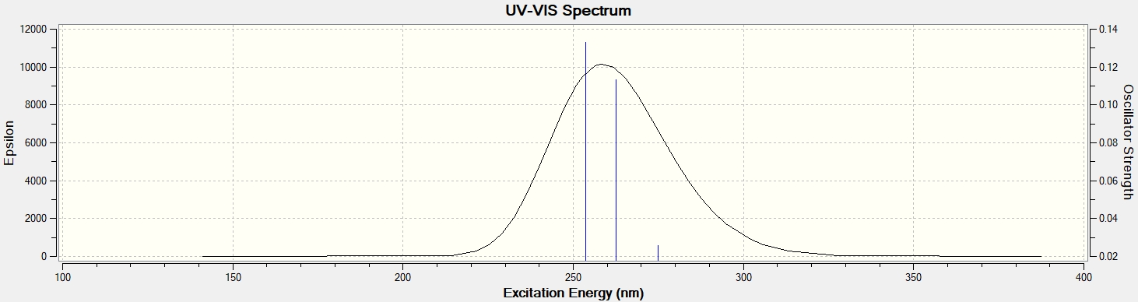

253.6nm, 262.48m n→π*



The UV-VIS spectrum calculate by TD-SCF/TD/B3YLP 6-31+G(d,p) basic set

**Appendix C4**





215.0nm π→π*

292.5nm n→π*

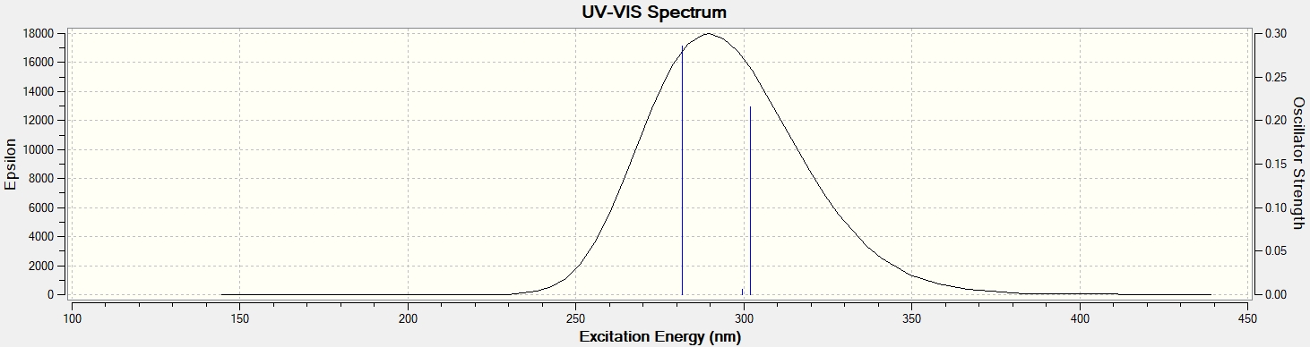

299.50nm n→π*

The UV-VIS spectrum calculate by TD-SCF/TD/B3YLP 6-31+G(d,p) basic set

**Appendix C5**



280.50nm n→π*



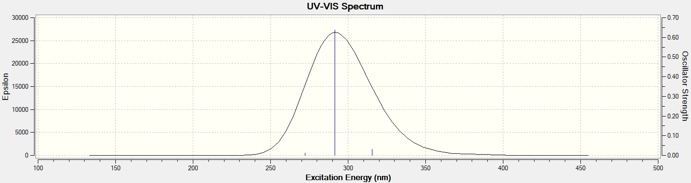



272.32nm, 291.51nm n→π*

The UV-VIS spectrum calculate by TD-SCF/TD/B3YLP 6-31+G(d,p) basic set

**Appendix C6**





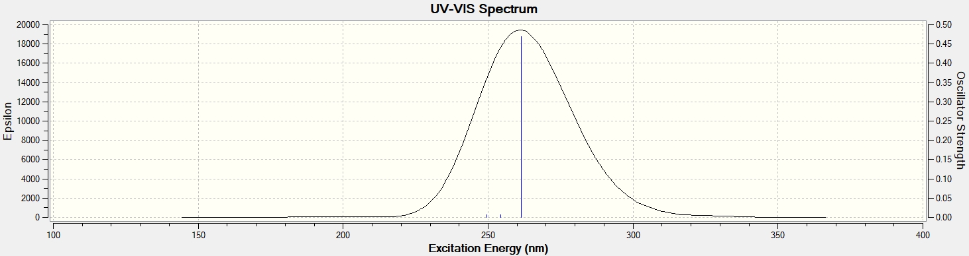

254.3nm, 261.32nm n→π*



251.00nm n→π*

The UV-VIS spectrum calculate by TD-SCF/TD/B3YLP 6-31+G(d,p) basic set

**Appendix C7**



278.50nm n→π*

243.50nm n→π*



**Appendix C8**



251.50nm n→π*



**Appendix C9**



276.00nm n→π*

232.00nm π→π*



**Appendix C10**



227nm π→π*

272nm n→π*

308 nm n→π*



**Appendix C11**



308nm π→π*

272.50nm n→π*

227.50nm π→π*



**Appendix D1**

Dose response studied

|  |  |  |  |  |
| --- | --- | --- | --- | --- |
|  | | Percentage of cell viability % | | |
| Ligand | Concentration (µg⁄mL) | MCF7 | MDM-MD-231 | 3T3 |
| A | 100 | 42.39±3.49 | 33.26±2.01 | **19.26**±4.65 |
|  | 50 | 41.89±3.59 | 42.16±3.19 | 35.70±8.31 |
|  | 25 | 62.98±9.28 | 56.69±4.59 | 62.09±7.78 |
|  | 12.5 | 69.35±2.21 | 61.13±10.16 | 75.06±4.25 |
|  | 6.25 | 75.03±1.68 | 65.52±3.70 | 78.85±11.91 |
|  | 3.125 | 82.03±4.83 | 69.69±3.94 | 84.05±11.17 |
|  |  |  |  |  |
| B | 100 | 51.86±2.74 | 39.93±0.54 | 66.37±4.51 |
|  | 50 | 51.86±6.52 | 43.63±2.07 | 96.67±11.86 |
|  | 25 | 58.26±6.03 | 54.65±5.29 | 102.19±5.14 |
|  | 12.5 | 71.77±5.86 | 62.05±2.75 | 111.55±3.02 |
|  | 6.25 | 84.59±11.79 | 73.35±5.24 | 119.42±19.87 |
|  | 3.125 | 87.93±5.07 | 79.98±5.01 | 124.86±3.02 |
|  | 1.562 | 88.92±11.79 | 87.96±6.63 | 177.25±4.51 |
|  |  |  |  |  |
| C | 100 | 24.92±0.15 | 36.25±4.85 | 63.74±7.51 |
|  | 50 | 45.55±4.58 | 41.38±2.40 | 83.29±4.92 |
|  | 25 | 69.35±3.64 | 81.85±7.77 | 93.50±5.43 |
|  | 12.5 | 73.69±4.97 | 88.22±6.09 | 94.26±3.78 |
|  | 6.25 | 75.73±1.52 | 92.79±5.09 | 96.27±1.43 |
|  | 3.125 | 77.17±2.16 | 99.92±4.85 | 97.43±0.87 |
|  | 1.562 | 78.35±3.65 | 100±2.40 | 100.80±0.24 |
|  |  |  |  |  |
|  |  |  |  |  |
| D | 100 | 49.51±2.63 | 54.73±1.43 | 67.68±5.30 |
|  | 50 | 45.93±2.63 | 64.66±4.97 | 83.53±7.12 |
|  | 25 | 46.57±5.79 | 65.63±5.11 | 88.25±6.94 |
|  | 12.5 | 77.56±4.95 | 74.62±2.10 | 97.12±9.42 |
|  | 6.25 | 80.96±4.38 | 78.74±2.45 | 101.35±9.20 |
|  | 3.125 | 88.27±5.79 | 83.18±4.97 | 105.06±5.30 |
|  | 1.562 | 90.80±6.04 | 90.016±2.45 | 109.65±6.94 |
|  |  |  |  |  |
| E | 100 | 39.08±2.67 | 34.62±7.08 | 72.08±6.06 |
|  | 50 | 41.49±2.23 | 40.45±4.98 | 75.10±4.52 |
|  | 25 | 43.73±1.89 | 43.72±2.53 | 75.99±3.68 |
|  | 12.5 | 44.16±2.54 | 45.23±1.66 | 85.63±2.60 |
|  | 6.25 | 47.78±2.70 | 47.42±3.99 | 90.42±2.92 |
|  | 3.125 | 54.24±1.75 | 60.33±1.66 | 94.70±0.42 |
|  | 1.562 | 58.03±0.61 | 69.89±4.58 | 100±0.68 |
|  |  |  |  |  |
| F | 100 | 49.08±2.00 | 39.33±0.80 | 73.43±6.26 |
|  | 50 | 59.24±2.00 | 49.62±11.0 | 74.256±11.39 |
|  | 25 | 78.40±1.80 | 61.79±4.61 | 81.67±15.92 |
|  | 12.5 | 85.64±2.21 | 76.27±3.84 | 93.77±16.39 |
|  | 6.25 | 85.87±1.68 | 83.08±0.38 | 99.98±6.20 |
|  | 3.125 | 90.21±4.82 | 85.46±2.81 | 104.63±11.38 |
|  | 1.562 | 95.81±4.40 | 88.12±5.05 | 166.83±6.20 |
|  |  |  |  |  |
| G | 100 | 64.19±9.20 | 58.53±2.99 | 80.30±6.53 |
|  | 50 | 72.06±11.07 | 65.33±5.90 | 80.77±8.93 |
|  | 25 | 73.48±6.54 | 68.31±6.58 | 82.73±14.20 |
|  | 12.5 | 76.64±8.96 | 70.12±9.68 | 95.09±12.40 |
|  | 6.25 | 77.38±3.01 | 76.32±3.83 | 99.85±11.57 |
|  | 3.125 | 83.23±10.68 | 78.49±7.00 | 108.12±4.02 |
|  | 1.562 | 89.04±12.19 | 88.01±1.76 | 129.76±8.93 |
|  |  |  |  |  |
| H | 100 | 78.52±.9.91 | 60.74±4.32 | 74.97±6.90 |
|  | 50 | 80.52±10.31 | 64.42±1.75 | 79.39±6.82 |
|  | 25 | 82.49±11.07 | 69.01±1.71 | 79.58±4.36 |
|  | 12.5 | 83.43±8.16 | 78.68±3.43 | 89.41±9.61 |
|  | 6.25 | 86.14±1.35 | 80.85±3.38 | 93.39±6.18 |
|  | 3.125 | 87.23±6.81 | 83.08±2.92 | 95.59±8.94 |
|  | 1.562 | 89.12±3.27 | 90.45±6.75 | 99.47±4.36 |
|  |  |  |  |  |
| I | 100 | 67.92±2.07 | 62.79±1.64 | 64.54±4.20 |
|  | 50 | 70.26±1.43 | 80.93±5.09 | 70.38±9.00 |
|  | 25 | 73.45±3.32 | 81.79±2.14 | 86.28±7.26 |
|  | 12.5 | 76.81±9,60 | 83.10±5.26 | 96.01±16.20 |
|  | 6.25 | 77.24±1.39 | 85.18±5.60 | 114.33±14.78 |
|  | 3.125 | 84.01±2.18 | 88.39±5.57 | 115.30±13.05 |
|  | 1.562 | 86.40±3.55 | 89.99±2.44 | 118.97±12.93 |
|  |  |  |  |  |
| J | 100 | 47.84±10.80 | 47.36±2.65 | 72.41±6.30 |
|  | 50 | 66.41±4.48 | 58.85±13.17 | 75.24±5.24 |
|  | 25 | 67.85±10.80 | 60.81±4.40 | 79.84±8.18 |
|  | 12.5 | 69.84±4.91 | 71.25±6.02 | 88.10±7.62 |
|  | 6.25 | 77.53±3.72 | 80.10±4.11 | 104.37±1.65 |
|  | 3.125 | 82.33±3.85 | 84.80±8.16 | 121.54±9.9 |
|  | 1.562 | 87.33±4.46 | 93.16±1.15 | 129.08±3.84 |
|  |  |  |  |  |
|  |  |  |  |  |
| Doxorubucin | 100 | 1.80±0.23 | 2.68±1.35 | 18.78±0.59 |
|  | 50 | 2.03±0.48 | 3.62±0.811 | 20.50±3.98 |
|  | 25 | 2.37±0.17 | 3.71±1.32 | 25.78±2.71 |
|  | 12.5 | 3.02±0.63 | 5.98±0.42 | 32.08±5.76 |
|  | 6.25 | 3.98±0.1 | 10.41±0.64 | 41.45±2.81 |
|  | 3.125 | 4.71±1.0 | 13.06±0.60 | 52.30±1.86 |
|  | 1.562 | 5.11±0.14 | 17.51±0.84 | 89.82±7.16 |

**Appendix D-2**

Concentration (µg⁄mL)

Figure 4.54: percentage of cell viability of MCF-7against concentration of selected compounds

**Appendix D-3**

Figure 4.55: Percentage of cell viability of MDA-MD-231 against concentration of selected compounds

**Appendix D-4**

Figure 4.55: Percentage of cell viability of NIH/3T3 against concentration of selected compounds

**Appendix D-5**

**Geometry structure and geometry parameters of molecules**

|  |  |
| --- | --- |
| chalcone imide smd  ***N*-(4-hydroxyl)-Cinnamoyl imide (A**) | 4oh smd  ***N*-(4-hydroxylbenzoyl)-1,3-benzodioxole imide (B**) |
| 4hbenzoic amide smd  ***N*-4-hydroxyl-1,3-benzodioxo amide (C**) | D STRUCTURE  ***N-*(2-(1,3-benzodioxol-5-yl)ethyl)-1H-indole-2-carboxamide (D)** |
| chalcone amide smd  **4-hydroxylbenzoyl-Cinnamoyl amide (E)** | smde5new    **Tert-butyl-2-methylpropanoate 4-oxyl-benzamide (F**) |

Selected geometric structure of A,B,C,D,E, and F molecules in water phase.and calculated in DFT (B3LYP) 6–31+G (d,p) basic set using solvation density model (SMD)

**Appendix D-6**

Selected bond length and bond angles, dihedral angles for compound A, B,C,D,E and F theoretical data. Calculated in DFT (B3LYP) 6–31+G (d,p)/SMD basic set in water phase.

|  |  |  |  |  |  |  |  |  |
| --- | --- | --- | --- | --- | --- | --- | --- | --- |
| Ligand | Dipole moment | Energy (a.u) | atoms | Bond distance Å | atoms | Angles | atoms | Dihedral angle |
| A | 6.3256 | -898.05087 | 18H-17O | 0.97073 | 18H-17O-6C | 110.182 | 18H-17O-6C-5C | 1.181 |
|  |  |  | 13N-14H | 1.01515 | 13N-14H-11C | 115.936 | 14H-13N-11C-12O | -170.529 |
|  |  |  | 16O-15C | 1.24214 | 16O-15C-13N | 116.752 | 16O-15C-13N-14H | 14.426 |
|  |  |  |  |  |  |  |  |  |
| B | 8.1163 | -1009.1759 | 18H-17O | 0.97065 | 18H-17O-5C | 110.496 | 18H-17O-5C-4C | -0.694 |
|  |  |  | 13N-14H | 1.01818 | 13N-14H-11C | 113.543 | 14H-13N-11C-12O | 24.179 |
|  |  |  | 12O-11C | 1.23814 | 12O-11C-13N | 117.789 | 12O-11C-13N-15C | -156.133 |
|  |  |  |  |  |  |  |  |  |
| C | 7.5341 | -974.4651 | 14H-13O | 0.97022 | 14H-13O-6C | 109.902 | 14H-13O-6C-1C | -0.646 |
|  |  |  | 15N-16H | 1.01577 | 15N-16H-17C | 115.513 | 16H-15N-17C-20C | 71.880 |
|  |  |  | 12O-11C | 1.25742 | 12O-11C-15N | 119.854 | 16H-15N-17C-19H | -164.901 |
|  |  |  |  |  |  |  |  |  |
| D | 7.2612 | -1030.81 | 38N-25C | 1.38829 | 38N-25C-23C | 125.19 | 38N-25C-23C-24O | -145.303 |
|  |  |  | 39H-38N | 1.0111 | 39H-38N-25C | 125.86 | 39H-38N-25C-23C | 3.394 |
|  |  |  | 22H-21N | 1.01556 | 22H-21N-23C | 113.093 | 22H-21N-23C-24O | 1.618 |
|  |  |  |  |  |  |  |  |  |
| E | 7.2218 | -863.3359 | 37H-16O | 0.97017 | 37H-16O-33C | 109.476 | 37H-36O-33C-31C | -179.052 |
|  |  |  | 18N-19H | 1.01570 | 18N-19H-16C | 113.762 | 19H-18N-16C-17O | -2.502 |
|  |  |  | 17O-16C | 1.26149 | 17O-16C-18N | 120.028 | 17O-16C-18N-20C | 169.935 |
|  |  |  |  |  |  |  |  |  |
| F | 7.0431 | -940.01854 | 11C-12O | 1.25258 | 12O-11C-13N | 120.445 | 12O-11C-13N-14H | -177.276 |
|  |  |  | 13N-15H | 1.01163 | 15H-13N-14H | 118.336 | 15H-13N-11C-12O | -0.355 |
|  |  |  | 13N-14H | 1.00918 | 14H-13N-11C | 123.128 | 14H-13N-11C-3C | 2.705 |