Facile synthesis of Z-scheme NiO/α-MoO₃ p-n heterojunction for improved photocatalytic activity towards degradation of methylene blue
Jintao Li ^{a,b}, Hongjie Liu^{c}, Zhuo Liu ª, Daiqiong Yang ^{b}, Mengzhao Zhang ^{b}, Luning Gao ^{b}, Yahong Zhou ^{b}, Changyu Lu ^{a,b,}*
ªExperimental Practising & Teaching center, Hebei GEO University, Shijiazhuang, 050031, PR China
^{b}Hebei Province Key Laboratory of Sustained Utilization & Development of Water Recourse, Hebei Center for Ecological and Environmental Geology Research, School of Water Resource and Environment, Hebei Geo University, Shijiazhuang, 050031, PR China;
^{c}School of Chemistry and Chemical Engineering, Guangxi University, Nanning, 530004, PR China;
*Corresponding author Tel.: +86-189-4265-7416
E-mail address: pzpzlxl@163.com (C.Y. Lu)

1. Experimental section
1.1. Characterization
The X-ray difraction (XRD) of the samples were determined by Rigaku Ultima IV, Cu Kα radiation (λ = 1.5418 Å) through a 2θ range from 10º to 80º. The morphology was evaluated via scanning electron microscopy (SEM) images by the Hitachi SU5000. Transmission electron microscopy (TEM) and high-resolution transmission electron microscopy (HRTEM) images with energy dispersive X-ray spectroscopy (EDX) were acquired using a JEOL 2100F instrument to observe the morphology and composition of the materials. UV-Vis absorption spectra were obtained using a Shimadzu UV 3600 spectrophotometer, and a pure BaSO₄ pellet was employed as a reference. X-ray photoelectron spectroscopy (XPS) was conducted on a Thermo ScientificTM K-Alpha^{TM+} spectrometer equipped with a monochromatic Al Kα excitation source (1486.6 eV) operating at 100 W. Samples were analyzed under vacuum (P < 10⁻⁸ mbar) with a pass energy of 150 eV (survey scans) or 50 eV (high-resolution scans). All peaks would be calibrated with C1s peak binding energy at 284.8 eV for adventitious carbon. The photoluminescence (PL) was characterized via Fluorolog-TCSPC luminescence spectrometer with a maximum excitation wavelength of 330 nm. The photocurrents and the electrochemical impedance spectra (EIS) were measured on a CHI660D e electrochemical workstation. In addition, the electron spin resonance (ESR) technique was applied to detect the presence of •OH and •O²⁻ in the photocatalytic reaction system. The generated •OH and •O²⁻ were trapped by 5,5-Dimethyl-1-pyrroline N-oxide (DMPO) to form corresponding adducts, which could be detected using ESR spectrometer (A300-10/12, Bruker). The active species trapping tests are similar with the photocatalytic tests. The sacrificial agents, such as isopropanol (IPA), ethylenediamine tetraacetic acid (EDTA) and p-benzoquinone (BQ), were separately added in the TC solution to capture the hydroxyl radicals (•OH), electron holes (h⁺) and superoxide radicals (•O₂⁻), respectively. All scavengers are added with a concentration of 0.1 mmol/L.

Table S1 Comparison of 3% NiO/α-MoO₃ with other MoO₃ based photocatalysts for MB degradation
Samples | C_{catalyst} (g L⁻¹) | C_{MB} (mg L ⁻¹) | Light source | DR % | Rate constant (min⁻¹) | Reference
3% NiO/α-MoO₃ | 0.1 | 15 | solar light irradiation (500 W Xe lamp) | 96.5% (120 min) | 0.02685 | This work
0.5 mol% Ag doped h-MoO₃ | 1 | 10 | Diffused sunlight with ultrasound | 98.2% (90min) | - | [1]
3 mol% Gd-doped MoO₃ | 0.2 | 10 | visible-light | 99% (60 min) | 0.075 | [2]
MoO₃-C₃N₄ | 1 | 20 | visible-light (300 W Xe lamp) | 41% (2.5h) | 0.01862 | [3]
7% g-C₃N₄/MoO₃ | 1 | 10 | visible-light (300 W Xe lamp) | 93% (3h) | 0.01473 | [4]
Cu₂S-MoO₃ | 0.5 | 15 | visible-light (200 W metal-halide lamp) | 98% (2h) | 0.0218 | [5]
0.25 % MoO₃/P25 | 0.1 | 15 | visible-light (110 W high-pressure sodium lamp) | 38% (150 min) | - | [6]
SnO₂/MoO₃ | - | 14 | UV irradiation (16 W OSRAM germicidal lamp) | 93% (120 min) | - | [7]

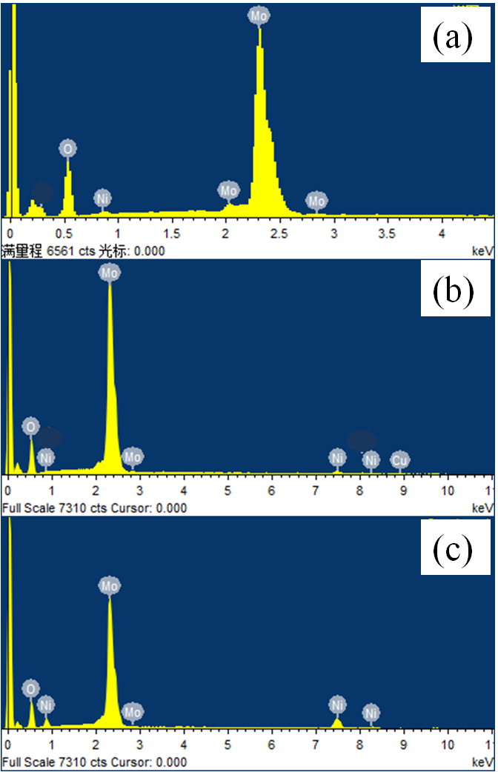
Fig. S1 EDS patterns of the obtained heterojunctions: (a) 1% NiO/α-MoO3 (b) 3% NiO/α-MoO3 and (c) 5% NiO/α-MoO3.
Fig. S1 shows EDS patterns of the NiO/α-MoO3 heterojunctions obtained by adding different amount of Ni(NO3)2·6H2O into the reaction solution. It indicates that the content of NiO in the nanocomposites is increased with increasing Ni(NO3)2·6H2O amount. The mass ratios of NiO to α-MoO3 for 1% NiO/α-MoO3, 3% NiO/α-MoO3 and 5% NiO/α-MoO3 are 0.78%, 2.60% and 4.41%, respectively, which is close to the theoretical mass ratios.
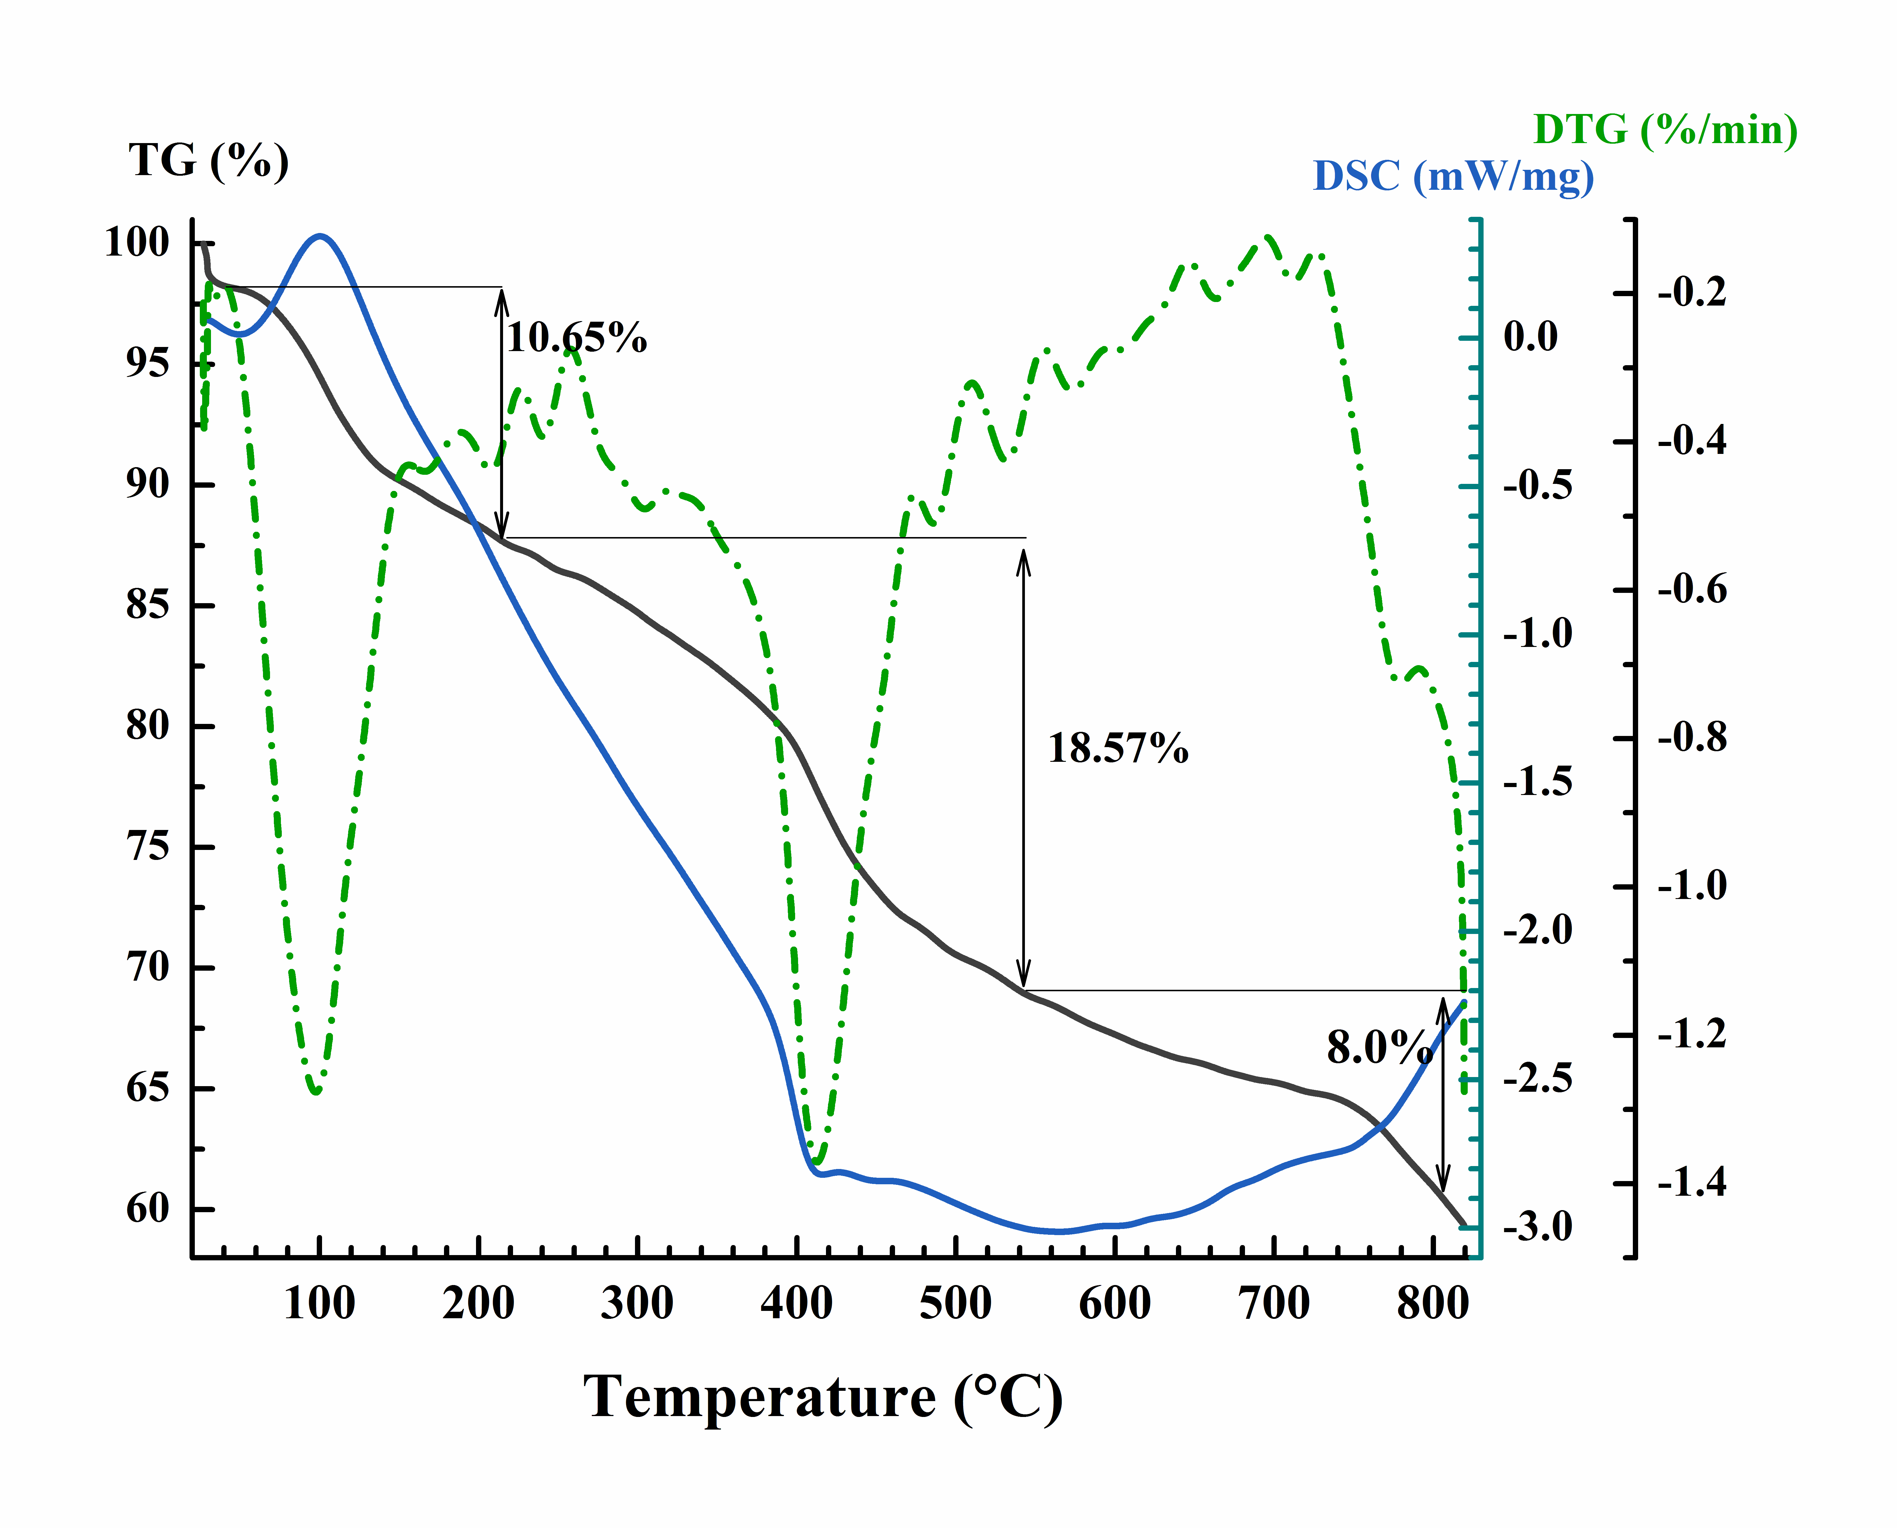
Fig. S2 TGA and DSC analyses of the precursor of 3% NiO/α-MoO₃ with a heating rate of 10 °C min⁻¹ under nitrogen at a flow rate of 30 ml/min
TGA and DSC analyses are performed to investigate the thermal decomposition behavior of the precursor of 3% NiO/α-MoO₃ and the results can be seen in Fig. S2. From the TG curve, it can be seen that there are three obvious stages of mass-loss. In the first stage, the mass-loss of 10.65% occurred up to 220 ºC is assigned to the removal of absorbed water and structural water. The second mass loss of 18.57% between 220 ºC and 540 ºC can be attributed to the thermal decomposition of the carbon coating formed by the dehydrated glucose. In the third stage, an apparent mass-loss is expected after 540 ºC, which can be ascribed to the melting and the sublimation behavior of α-MoO₃, since the vapor pressure of α-MoO₃ is appreciable at these temperatures [8, 9].

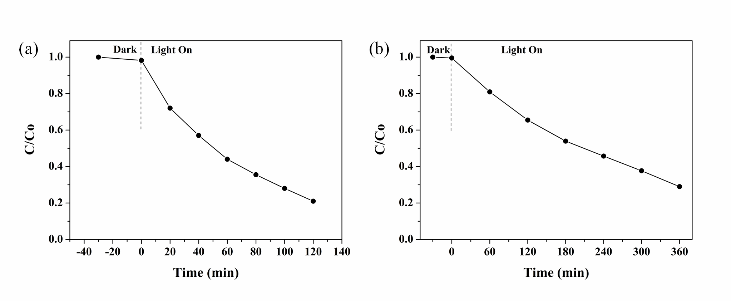
Fig. S3 Photodegradation efficiency of (a) RhB and (b) phenol over 3% NiO/α-MoO₃;

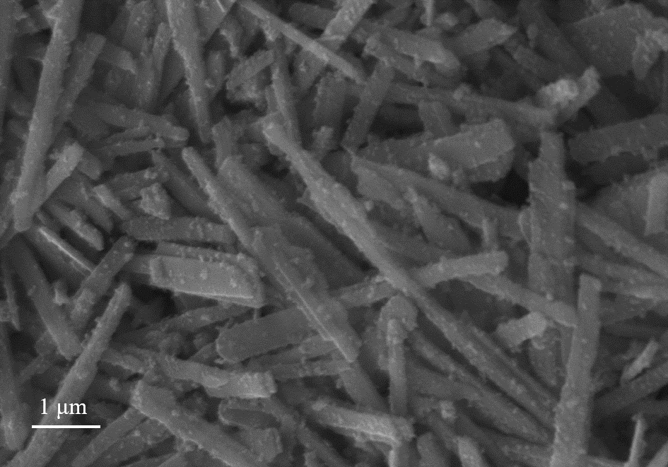
Fig. S4 SEM image of 3% NiO/α-MoO₃ after cyclicing experiments

References:
[1] Paul M., Dhanasekar M., Bhat S. V., Silver doped h-MoO₃ nanorods for sonophotocatalytic degradation of organic pollutants in ambient sunlight[J]. Applied Surface Science, 2016, 418:113-118.
[2] Phuruangrat A., Im U. C., Thongtem T., Thongtem S., Influence of Gd dopant on photocatalytic properties of MoO₃ nanobelts[J]. Materials Letters, 2016, 173:158-161.
[3] Li Y.P., Huang L.Y., Xu J.B., Xu H., Xu Y.G., Xia J.X., Li H.M., Visible-light-induced blue MoO₃-C₃N₄ composite with enhanced photocatalytic activity[J]. Materials Research Bulletin, 2015, 70:500-505.
[4] Huang L.Y., Xu H., Zhang R.X., Cheng X.N., Xia J.X., Xu Y.G., Li H.M., Synthesis and characterization of g-C₃N₄/MoO₃ photocatalyst with improved visible-light photoactivity[J]. Applied Surface Science, 2013, 283:25-32.
[5] Shivaraj B. Patil, Brij Kishore, K. Manjunath, Viswanath Reddy, G. Nagaraju, One step hydrothermal synthesis of novel Cu₂S-MoO₃ nanocomposite for lithium ion battery and photocatalytic applications[J]. International Journal of Hydrogen Energy, 2018, 43:4003-4014.
[6] Yang H.B., Li X., Wang A.J., Wang Y., Chen Y.Y., Photocatalytic degradation of methylene blue by MoO₃ modified TiO₂ under visible light[J]. Chinese Journal of Catalysis, 2014, 35:140-147.
[7] Arfaoui A., Mhamdi A., Besrour N., Touihri S., Ouzari H.I., Alrowaili Z.A., Amlouk M., Investigations into the physical properties of SnO₂/MoO₃ and SnO₂/WO₃ bilayered structures along with photocatalytic and antibacterial applications[J]. Thin Solid Films, 2018, 648:12-20.
[8] Bai S.L., Chen S., Chen L.Y., Zhang K.W., Luo R.X., Li D.Q., Liu C.C., Ultrasonic synthesis of MoO₃ nanorods and their gas sensing properties[J]. Sensors & Actuators B Chemical, 2012, 174:51-58.
[9] Sui L.L., Xu Y.M., Zhang X.F., Cheng X.L., Gao S., Zhao H., Cai Z., Huo L.H., Construction of three-dimensional flower-like α-MoO₃ with hierarchical structure for highly selective triethylamine sensor[J]. Sensors & Actuators B Chemical, 2015, 208:406-414.

