Design, synthesis, antimycobacterial, and anticancer activity of novel cinnamic acid hydrazides

Mohamed H. Assaleh^{a,b}, Snezana K. Bjelogrlic^{c,d}, Nevena Prlainovicª, Ilija Cvijetic^{e}, Aleksandra Bozic^{f}, Irena Arandjelovic^{g}, Dragana Vukovic^{g}, Aleksandar Marinkovic^{a,*}

ªFaculty of Technology and Metallurgy, University of Belgrade, Karnegijeva 4, 11000 Belgrade, Serbia
^{b}CID Forensics Laboratory, Toxicology Unit Lab, Tripoli, Libya
^{c}National Cancer Research Center, Pasterova 14, Belgrade, Serbia
^{d}Institut Pluridisciplinaire Hubert Curien, UMR 7178 CNRS Université de Strasbourg, Illkirch, 67401, France
^{e}Faculty of Chemistry, University of Belgrade, Studentski trg 12-16, 11000 Belgrade, Serbia
^{f}Academy of Applied Technical Studies, Katarine Ambrozic 3, Belgrade, Serbia
^{g}Institute of Microbiology and Immunology, Faculty of Medicine, University of Belgrade, Dr. Subotica 1, Serbia

*Corresponding author
Phone number: +381694121970
Fax:+381113370387
E-mail address: marinko@tmf.bg.ac.rs

Electronic Supplementary Information

Contents
3. Results and discussion
3.1. Chemistry, design
3.1.1. NMR spectra of novel cinnamic acid hydrazides

Figure S1. ¹H NMR spectrum of compound 1 in DMSO-d6. - 5 -
Figure S2. ¹³C NMR spectrum of compound 1 in DMSO-d6. - 6 -
Figure S3. COSY NMR spectrum of compound 1 in DMSO-d6. - 7 -
Figure S4. HSQC NMR spectrum of compound 1 in DMSO-d6. - 8 -
Figure S5. HMBC NMR spectrum of compound 1 in DMSO-d6. - 9 -
Figure S6. ¹H NMR spectra of compound 2 in DMSO-d6. - 10 -
Figure S7. ¹³C NMR spectra of compound 2 in DMSO-d6. - 11 -
Figure S8. ¹H NMR spectra of compound 3 in DMSO-d6. - 12 -
Figure S9. ¹³C NMR spectra of compound 3 in DMSO-d6. - 13 -
Figure S10. HSQC NMR spectra of compound 3 in DMSO-d6. - 14 -
Figure S11. HMBC NMR spectra of compound 3 in DMSO-d6. - 15 -
Figure S12. ¹H NMR spectra of compound 4 in DMSO-d6. - 16 -
Figure S13. ¹³C NMR spectra of compound 4 in DMSO-d6. - 17 -
Figure S14. COSY NMR spectra of compound 4 in DMSO-d6. - 18 -
Figure S15. HSQC NMR spectra of compound 4 in DMSO-d6. - 19 -
Figure S16. ¹H NMR spectra of compound 1a in DMSO-d6. - 20 -
Figure S17. ¹³C NMR spectra of compound 1a in DMSO-d6. - 21 -
Figure S18. ¹H NMR spectra of compound 2a in DMSO-d6. - 22 -
Figure S19. ¹³C NMR spectra of compound 2a in DMSO-d6. - 23 -
Figure S20. COSY NMR spectra of compound 2a in DMSO-d6. - 24 -
Figure S21. HSQC NMR spectra of compound 1a in DMSO-d6. - 25 -
Figure S22. NMBC NMR spectra of compound 1a in DMSO-d6. - 26 -
Figure S23. ¹H NMR spectra of compound 3a in DMSO-d6. - 27 -
Figure S24. ¹³C NMR spectra of compound 3a in DMSO-d6. - 28 -
Figure S25. ¹H NMR spectra of compound 4a in DMSO-d6. - 29 -
Figure S26. ¹³C NMR spectra of compound 4a in DMSO-d6. - 30 -
Figure S27. ¹H NMR spectra of compound 1b in DMSO-d6. - 31 -
Figure S28. ¹³C NMR spectra of compound 1b in DMSO-d6. - 32 -
Figure S29. ¹H NMR spectra of compound 2b in DMSO-d6. - 33 -
Figure S30. ¹³C NMR spectra of compound 2b in DMSO-d6. - 34 -
Figure S31. ¹H NMR spectra of compound 3b in DMSO-d6. - 35 -
Figure S32. ¹³C NMR spectra of compound 3b in DMSO-d6. - 36 -
Figure S33. ¹H NMR spectra of compound 4b in DMSO-d6. - 37 -
Figure S34. ¹³C NMR spectra of compound 4b in DMSO-d6. - 38 -
Figure S35. The NOESY spectra of 1 (a), 2a (b), 3 (c), and 4 (d), with the most important cross-peaks zoomed-in and labeled on 3D structures of compounds - 39 -

3.3 Investigation of anti-Mtb activity

Figure S36. Profiles of Mtb strains obtained by the GenoType MTBDRplus assy (A) Mtb-Rif-R, (B) Mtb-Inh-R, and (C) Mtb-InhRif-S. CC – Conjugate Control; AC – Amplifiation Control; TUB – Mycobacterium tuberculosis complex; rpoB, katG, inhA – locus control zones; rpoB WT1-8 – rpoB wild type probes 1-8 (codons 505-533); rpoB MUT1-3 – rpoB mutation probes (MUT1 - D516V; MUT2A - H526Y; MUT2B - H526D; MUT3 - S531L); katG WT – katG wild type probe (codon 315); katG MUT1-2 – katG mutation probes (MUT1 - S315T1); inhA WT1-2 – inhA wild type probes (nucleic acid positions -15, -16, -8); inhA MUT1-3 – inhA mutation probes (MUT1 - C15T; MUT2 - A16G; MUT3A - T8C; MUT3B - T8A); RMP – rifampicin; INH – isoniazid; R – resistant; S – sensitive. - 40 -
Figure S37. Concentration-response curves for activity of INH, REF and investigated compounds on Mtb-Inh-R plotted by the asymmetric five-parameter sigmoidal equation in GraphPad Prism 8 software, according to data acquired by means of MTT assay. Results for each tested concentration are expressed as the mean ± SD of two replicates from independent experiments. Instead of Log₁₀ values on X axes, the exact concentrations are specified to assure compliance with concentrations indicated in corresponding text. - 41 -
Figure S38. Concentration-response curves for activity of INH, REF and investigated compounds on Mtb-Rif-R plotted by the asymmetric five-parameter sigmoidal equation in GraphPad Prism 8 software, according to data acquired by means of MTT assay. Results for each tested concentration are expressed as the mean ± SD of two replicates from independent experiments. Instead of Log₁₀ values on X axes, the exact concentrations are specified to assure compliance with concentrations indicated in corresponding text. - 42 -
Figure S39. Concentration-response curves for activity of INH, REF and investigated compounds on Mtb-InhRif-S plotted by the asymmetric five-parameter sigmoidal equation in GraphPad Prism 8 software, according to data acquired by means of MTT assay. Results for each tested concentration are expressed as the mean ± SD of two replicates from independent experiments. Instead of Log₁₀ values on X axes, the exact concentrations are specified to assure compliance with concentrations indicated in corresponding text. - 43 -

3.3.1. Plausible mechanism of anti-Mtb action

Figure S40. a) UV-Vis spectra, and b) the corresponding plots representing difference in absorbance versus metal/compound ratio for compound 3 and complexes formed with Fe²⁺ ions - 44 -

3.3.2. Hepatotoxicity

Figure S41. Representative fluorescent microscopic images of HepG2 cells stained with Calcein AM and propidium iodide (PI) after 24 h incubation with compound 3. - 45 -
Figure S42. Representative fluorescent microscopic images of HepG2 cells stained with Calcein AM and propidium iodide (PI) after 24 h incubation with compound 4. - 46 -
Figure S43. Representative fluorescent microscopic images of HepG2 cells stained with Calcein AM and propidium iodide PI after 24 h incubation with compound 4a. - 47 -
Figure S44. Representative fluorescent microscopic images of HepG2 cells stained with Calcein AM and propidium iodide (PI) after 24 h incubation with compound 1b. - 48 -

3.4 Investigation of anticancer activity

Table S1. Effects of investigated compounds on cell survival after 24 h incubation, expressed as percentage of viable treated cells in respect to corresponding non-treated controls. Results are expressed as the mean ± SD of three replicates from independent experiments. Shaded areas mark outcomes with ≤ 50 % of cell survival that is considered as favorable activity. - 49 -
Figure S45. Representative fluorescent microscopic images of HaCaT cells stained with Calcein AM and propidium iodide (PI) after 24 h incubation with compound 2a. - 50 -
Figure S46. Representative fluorescent microscopic images of HaCaT cells stained with Calcein AM and PI after 24 h incubation with compound 3b. - 51 -
Figure S47. Concentration-response curves plotted by the asymmetric five-parameter sigmoidal equation in GraphPad Prism 8 software, according to data acquired by means of Calcein AM/propidium iodide staining from two independent experiments (circles and rhomboids). Data for A549 cells in both graphs correspond to those presented in Table S1. Instead of Log₁₀ values on X axes, the exact concentrations are specified to assure compliance with concentrations indicated in corresponding text. - 52 -
Figure S48. Representative fluorescent microscopic images of HepG2 cells stained with Calcein AM and propidium iodide (PI) after 24 h incubation with compound 2a. - 53 -
Figure S49. Representative fluorescent microscopic images of HepG2 cells stained with Calcein AM and propidium iodide (PI) after 24 h incubation with compound 3b. - 54 -

3.4.1 Plausible anticancer targets suggested by pharmacophoric similarity search

Figure S50. Pharmacophore matching between 2a and several targets: a) Collagenase-2; b) Abl-1 kinase; c) Pim-1 kinase; d) Caspase-3; e) Complement C1r subcomponent. - 55 -
Figure S51. Pharmacophore matching between 3b and several targets: a) Dipeptidyl peptidase 4 (DPPH4); b) Baculoviral IAP repeat-containing protein 4; c) Collagenase-2; d) Tyrosine-protein phosphatase non-receptor type 1 (PTP1B). - 55 -

3. Results and discussion
3.1. Chemistry, design
3.1.1. NMR spectra of novel cinnamic acid hydrazides

Figure S1. ¹H NMR spectrum of compound 1 in DMSO-d6.
Figure S2. ¹³C NMR spectrum of compound 1 in DMSO-d6.

Figure S3. COSY NMR spectrum of compound 1 in DMSO-d6.
Figure S4. HSQC NMR spectrum of compound 1 in DMSO-d6.
Figure S5. HMBC NMR spectrum of compound 1 in DMSO-d6.

Figure S6. ¹H NMR spectra of compound 2 in DMSO-d6.

Figure S7. ¹³C NMR spectra of compound 2 in DMSO-d6.

Figure S8. ¹H NMR spectra of compound 3 in DMSO-d6.

Figure S9. ¹³C NMR spectra of compound 3 in DMSO-d6.
Figure S10. HSQC NMR spectra of compound 3 in DMSO-d6.

Figure S11. HMBC NMR spectra of compound 3 in DMSO-d6.
Figure S12. ¹H NMR spectra of compound 4 in DMSO-d6.

Figure S13. ¹³C NMR spectra of compound 4 in DMSO-d6.

Figure S14. COSY NMR spectra of compound 4 in DMSO-d6.
Figure S15. HSQC NMR spectra of compound 4 in DMSO-d6.

Figure S16. ¹H NMR spectra of compound 1a in DMSO-d6.

Figure S17. ¹³C NMR spectra of compound 1a in DMSO-d6.

Figure S18. ¹H NMR spectra of compound 2a in DMSO-d6.

Figure S19. ¹³C NMR spectra of compound 2a in DMSO-d6.

Figure S20. COSY NMR spectra of compound 2a in DMSO-d6.

Figure S21. HSQC NMR spectra of compound 1a in DMSO-d6.

Figure S22. NMBC NMR spectra of compound 1a in DMSO-d6.
Figure S23. ¹H NMR spectra of compound 3a in DMSO-d6.

Figure S24. ¹³C NMR spectra of compound 3a in DMSO-d6.

Figure S25. ¹H NMR spectra of compound 4a in DMSO-d6.

Figure S26. ¹³C NMR spectra of compound 4a in DMSO-d6.

Figure S27. ¹H NMR spectra of compound 1b in DMSO-d6.
Figure S28. ¹³C NMR spectra of compound 1b in DMSO-d6.

Figure S29. ¹H NMR spectra of compound 2b in DMSO-d6.

Figure S30. ¹³C NMR spectra of compound 2b in DMSO-d6.

Figure S31. ¹H NMR spectra of compound 3b in DMSO-d6.

Figure S32. ¹³C NMR spectra of compound 3b in DMSO-d6.

Figure S33. ¹H NMR spectra of compound 4b in DMSO-d6.

Figure S34. ¹³C NMR spectra of compound 4b in DMSO-d6.

Fig. S35 The NOESY spectra of 1 (a), 2a (b), 3 (c), and 4 (d), with the most important cross-peaks zoomed-in and labeled on 3D structures of compounds.

3.3 Investigation of anti-Mtb activity
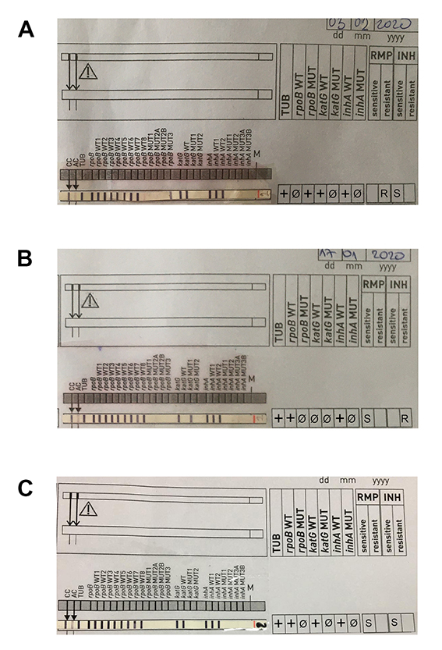
Figure S36. Profiles of Mtb strains obtained by the GenoType MTBDRplus assy (A) Mtb-Rif-R, (B) Mtb-Inh-R, and (C) Mtb-InhRif-S. CC – Conjugate Control; AC – Amplifiation Control; TUB – Mycobacterium tuberculosis complex; rpoB, katG, inhA – locus control zones; rpoB WT1-8 – rpoB wild type probes 1-8 (codons 505-533); rpoB MUT1-3 – rpoB mutation probes (MUT1 - D516V; MUT2A - H526Y; MUT2B - H526D; MUT3 - S531L); katG WT – katG wild type probe (codon 315); katG MUT1-2 – katG mutation probes (MUT1 - S315T1); inhA WT1-2 – inhA wild type probes (nucleic acid positions -15, -16, -8); inhA MUT1-3 – inhA mutation probes (MUT1 - C15T; MUT2 - A16G; MUT3A - T8C; MUT3B - T8A); RMP – rifampicin; INH – isoniazid; R – resistant; S – sensitive.
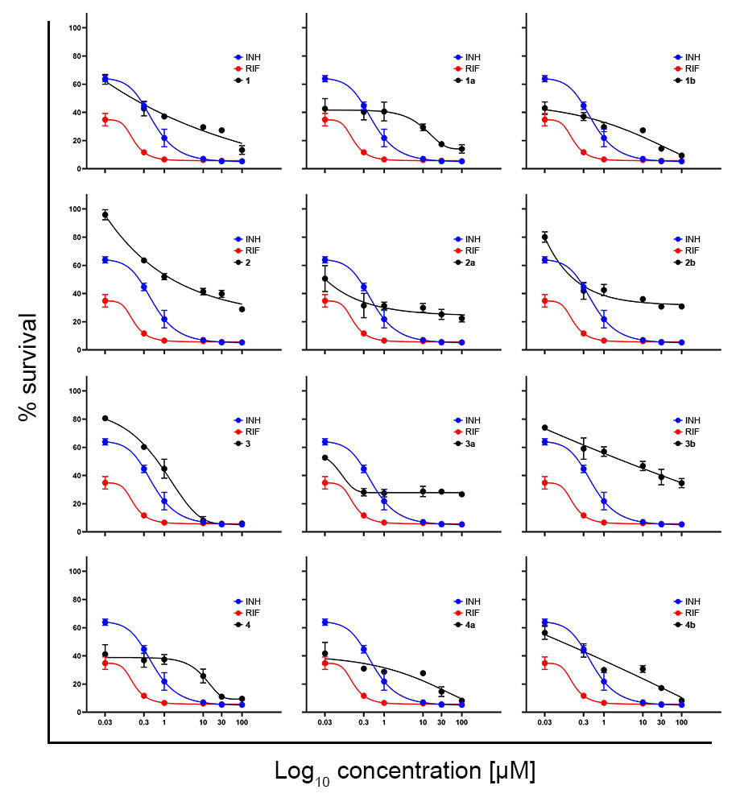
Figure S37. Concentration-response curves for activity of INH, REF and investigated compounds on Mtb-Inh-R plotted by the asymmetric five-parameter sigmoidal equation in GraphPad Prism 8 software, according to data acquired by means of MTT assay. Results for each tested concentration are expressed as the mean ± SD of two replicates from independent experiments. Instead of Log₁₀ values on X axes, the exact concentrations are specified to assure compliance with concentrations indicated in corresponding text.
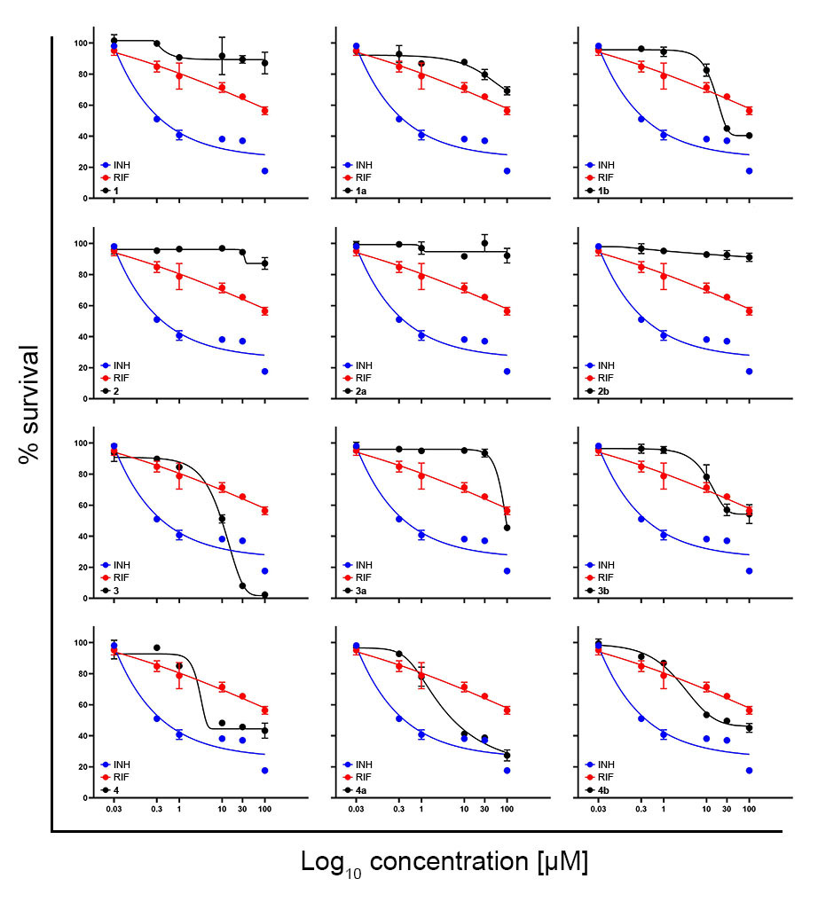
Figure S38. Concentration-response curves for activity of INH, REF and investigated compounds on Mtb-Rif-R plotted by the asymmetric five-parameter sigmoidal equation in GraphPad Prism 8 software, according to data acquired by means of MTT assay. Results for each tested concentration are expressed as the mean ± SD of two replicates from independent experiments. Instead of Log₁₀ values on X axes, the exact concentrations are specified to assure compliance with concentrations indicated in corresponding text.

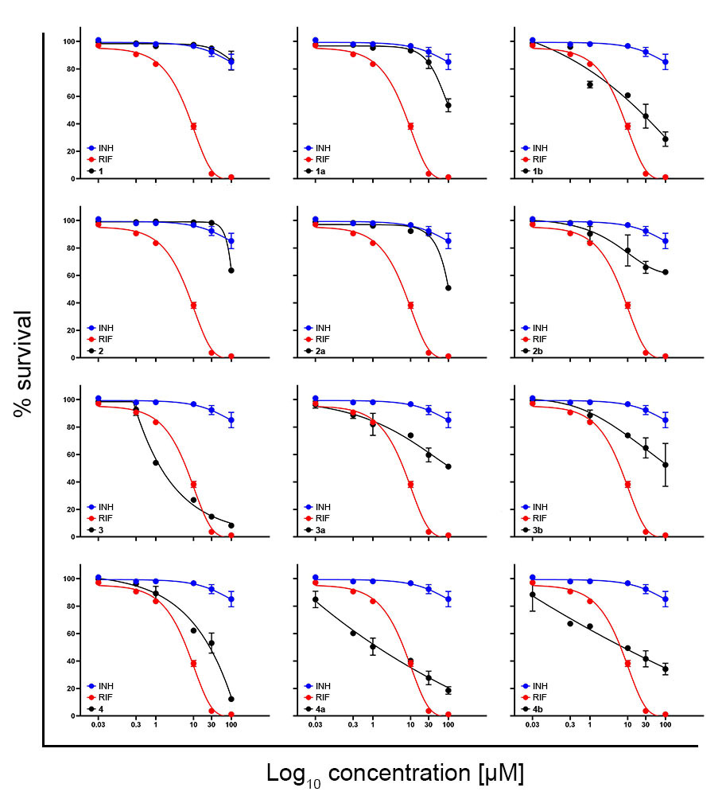

Figure S39. Concentration-response curves for activity of INH, REF and investigated compounds on Mtb-InhRif-S plotted by the asymmetric five-parameter sigmoidal equation in GraphPad Prism 8 software, according to data acquired by means of MTT assay. Results for each tested concentration are expressed as the mean ± SD of two replicates from independent experiments. Instead of Log₁₀ values on X axes, the exact concentrations are specified to assure compliance with concentrations indicated in corresponding text.

3.3.1. Plausible mechanism of anti-Mtb action

Figure S40. a) UV-Vis spectra, and b) the corresponding plots representing difference in absorbance versus metal/compound ratio for compound 3 and complexes formed with Fe²⁺ ions

3.3.2. Hepatotoxicity

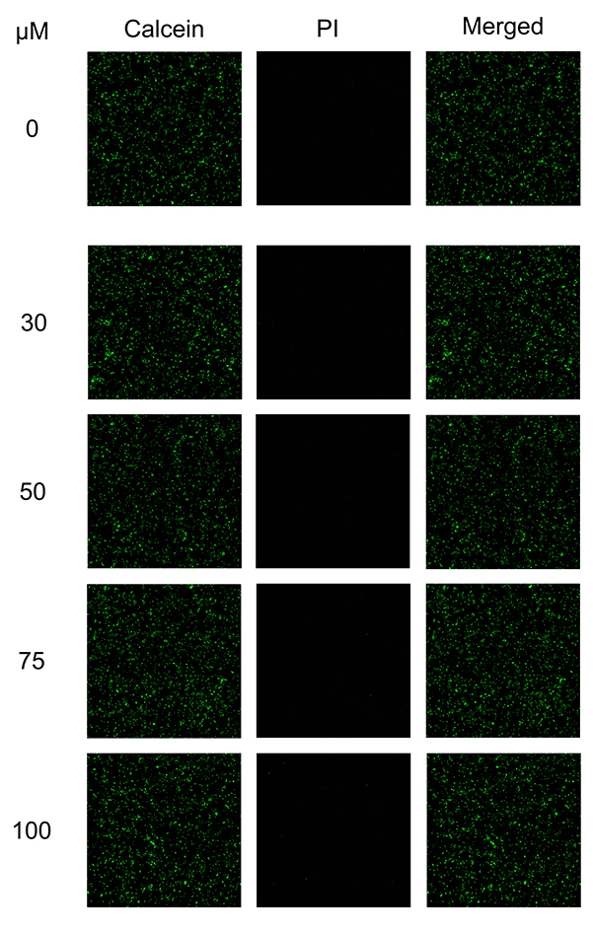
Figure S41. Representative fluorescent microscopic images of HepG2 cells stained with Calcein AM and propidium iodide (PI) after 24 h incubation with compound 3.

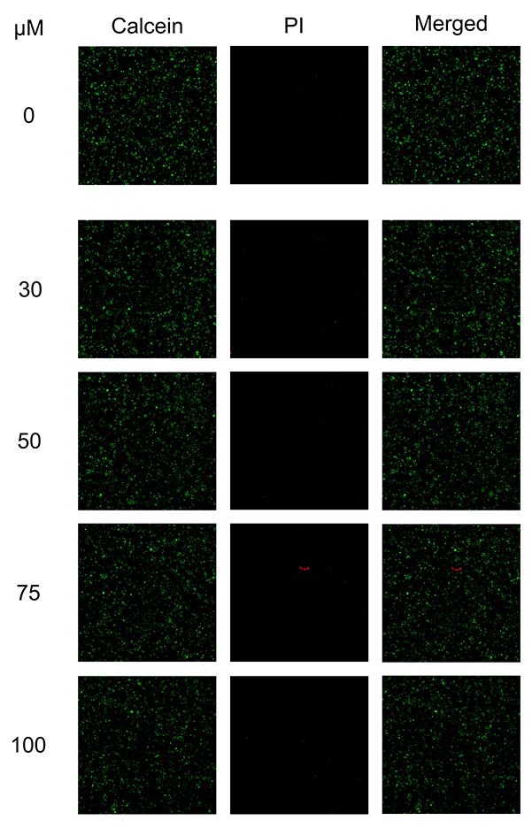
Figure S42. Representative fluorescent microscopic images of HepG2 cells stained with Calcein AM and propidium iodide (PI) after 24 h incubation with compound 4.

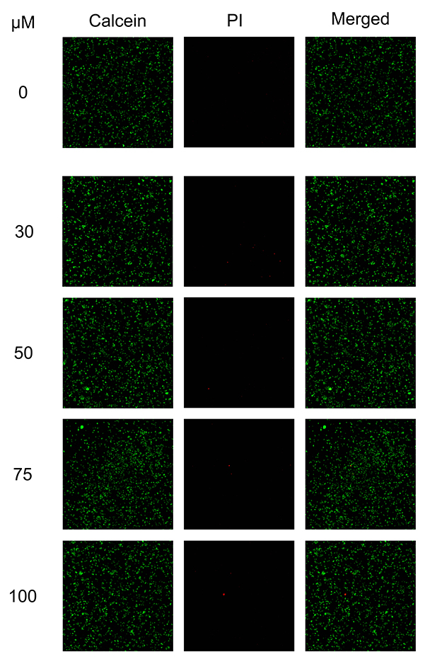
Figure S43. Representative fluorescent microscopic images of HepG2 cells stained with Calcein AM and propidium iodide PI after 24 h incubation with compound 4a.

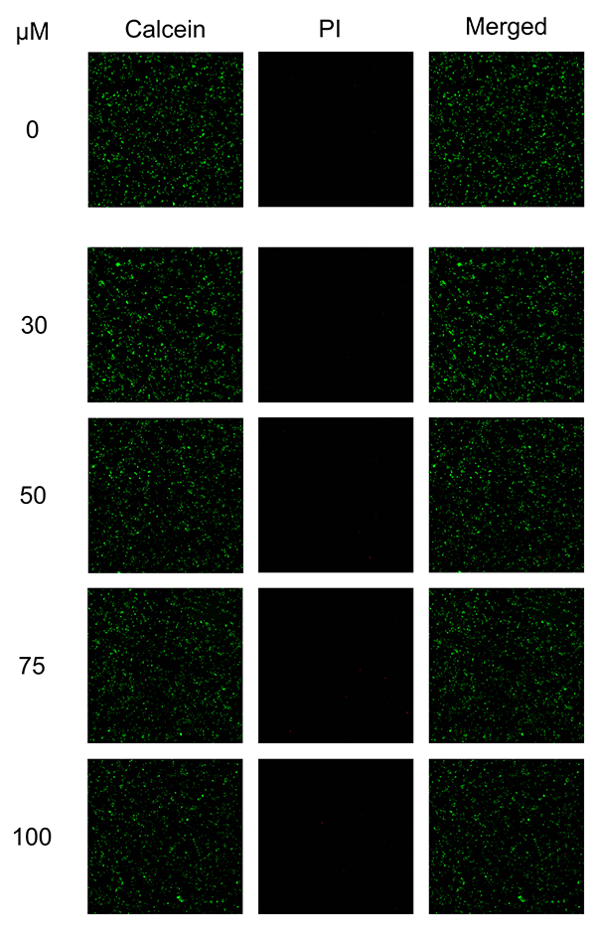
Figure S44. Representative fluorescent microscopic images of HepG2 cells stained with Calcein AM and propidium iodide (PI) after 24 h incubation with compound 1b.

3.4 Investigation of anticancer activity
Table S1. Effects of investigated compounds on cell survival after 24 h incubation, expressed as percentage of viable treated cells in respect to corresponding non-treated controls, determined by means of CAM/PI dual staining. Results are expressed as the mean ± SD of three replicates from independent experiments. Shaded areas mark outcomes with ≤ 50 % of cell survival that is considered as favorable activity.
Compound | Concentration  [µM] | LoVo cells | SkOV-3 cells | A549 cells | MCF-7 cells | AsPC1 cells
1 | 100 | _* | _ | 49±7 | _ | _
 | 75 | _ | _ | 58±6 | _ | _
 | 50 | _ | _ | 64±3 | _ | _
 | 30 | _ | _ | 67±1 | _ | _
2 | 100 | 75±5 | 67±9 | 48±4 | _ | _
 | 75 | 81±2 | 71±2 | 56±1 | _ | _
 | 50 | 82±2 | 73±1 | 63±2 | _ | _
 | 30 | 83±1 | 79±8 | 84±3 | _ | _
3 | 100 | _ | 65±5 | 48±4 | _ | _
 | 75 | _ | 75±1 | 56±4 | _ | _
 | 50 | _ | 79±4 | 60±3 | _ | _
 | 30 | _ | 84±3 | 70±6 | _ | _
4 | 100 | _ | _ | _ | _ | _
 | 75 | _ | _ | _ | _ | _
 | 50 | _ | _ | _ | _ | _
 | 30 | _ | _ | _ | _ | _
1a | 100 | _ | _ | _ | _ | _
 | 75 | _ | _ | _ | _ | _
 | 50 | _ | _ | _ | _ | _
 | 30 | _ | _ | _ | _ | _
2a | 100 | 64±3 | 21±8 | 39±3 | 48±3 | _
 | 75 | 69±3 | 79±9 | 46±4 | 71±8 | _
 | 50 | 79±8 | 78±9 | 53±1 | 75±1 | _
 | 30 | 91±2 | 90±9 | 65±3 | 86±3 | _
3a | 100 | _ | _ | _ | _ | _
 | 75 | _ | _ | _ | _ | _
 | 50 | _ | _ | _ | _ | _
 | 30 | _ | _ | _ | _ | _
4a | 100 | _ | _ | 48±2 | _ | _
 | 75 | _ | _ | 70±2 | _ | _
 | 50 | _ | _ | 73±9 | _ | _
 | 30 | _ | _ | 85±3 | _ | _
1b | 100 | _ | _ | 50±5 | _ | _
 | 75 | _ | _ | 65±1 | _ | _
 | 50 | _ | _ | 76±5 | _ | _
 | 30 | _ | _ | 80±6 | _ | _
2b | 100 | 57±2 | 72±5 | 58±6 | _ | _
 | 75 | 62±1 | 72±6 | 69±1 | _ | _
 | 50 | 67±4 | 77±2 | 63±5 | _ | _
 | 30 | 72±1 | 77±5 | 80±4 | _ | _
3b | 100 | 43±5 | 43±3 | 38±2 | 35±3 | _
 | 75 | 70±2 | 95±6 | 46±3 | 84±6 | _
 | 50 | 76±4 | 91±2 | 50±1 | 82±8 | _
 | 30 | 83±2 | 90±4 | 53±1 | 85±2 | _
4b | 100 | _ | _ | 57±2 | _ | _
 | 75 | _ | _ | 60±4 | _ | _
 | 50 | _ | _ | 73±6 | _ | _
 | 30 | _ | _ | 75±1 | _ | _
* ≥ 90 % of cell survival.
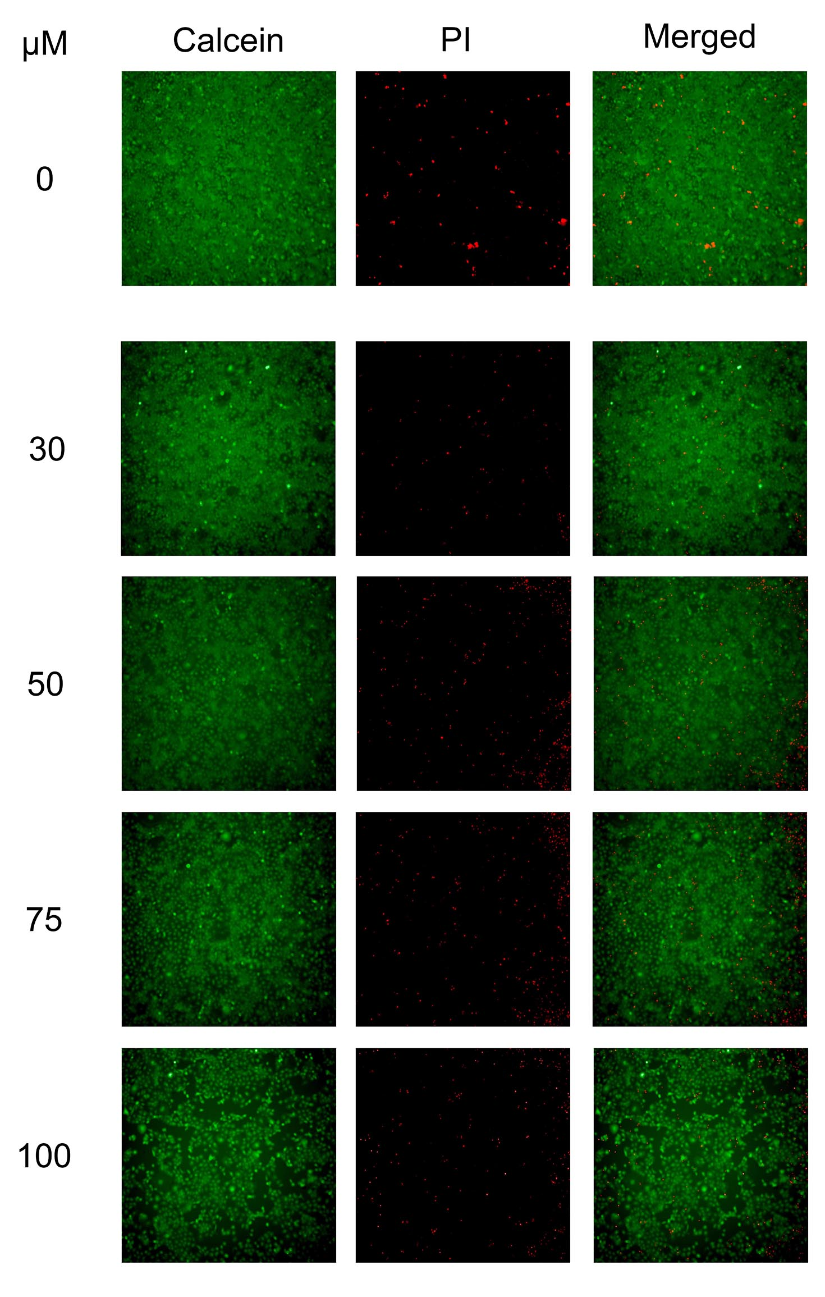
Figure S45. Representative fluorescent microscopic images of HaCaT cells stained with Calcein AM and propidium iodide (PI) after 24 h incubation with compound 2a.

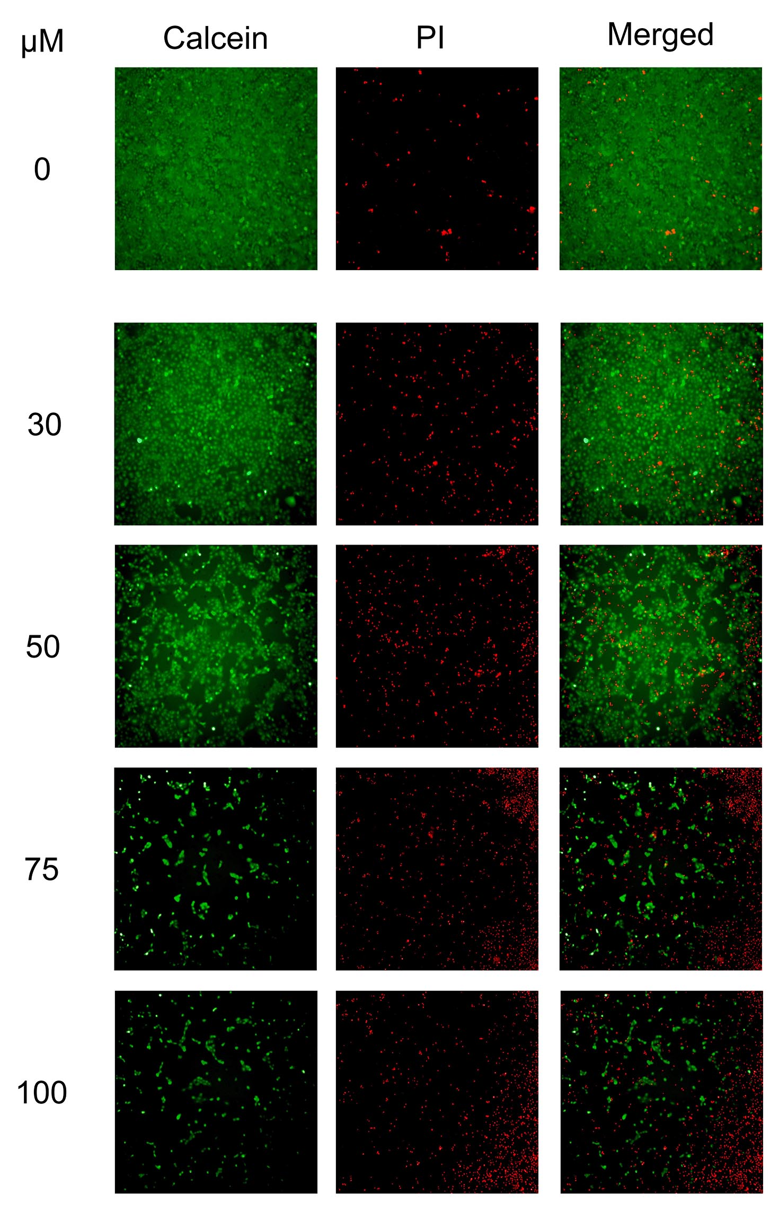
Figure S46. Representative fluorescent microscopic images of HaCaT cells stained with Calcein AM and PI after 24 h incubation with compound 3b.

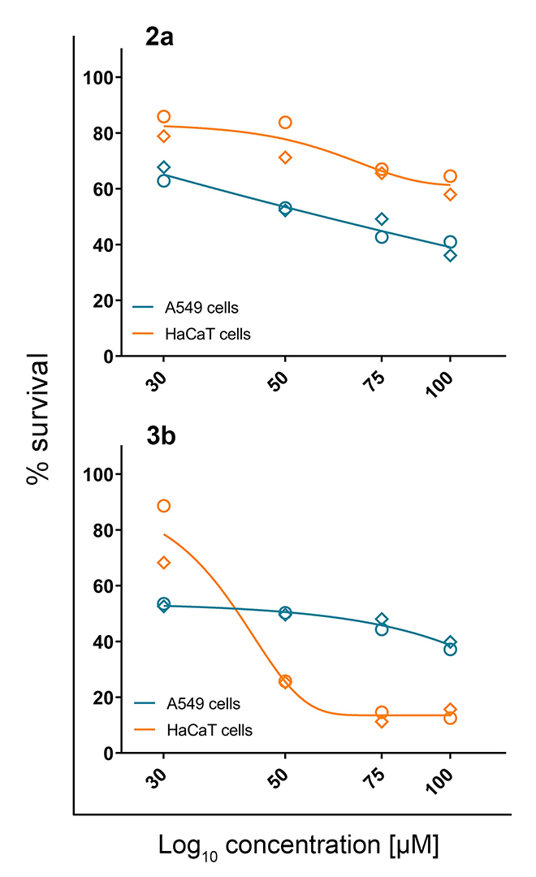
Figure S47. Concentration-response curves plotted by the asymmetric five-parameter sigmoidal equation in GraphPad Prism 8 software, according to data acquired by means of Calcein AM/propidium iodide staining from two independent experiments (circles and rhomboids). Data for A549 cells in both graphs correspond to those presented in Table S1. Instead of Log₁₀ values on X axes, the exact concentrations are specified to assure compliance with concentrations indicated in corresponding text.

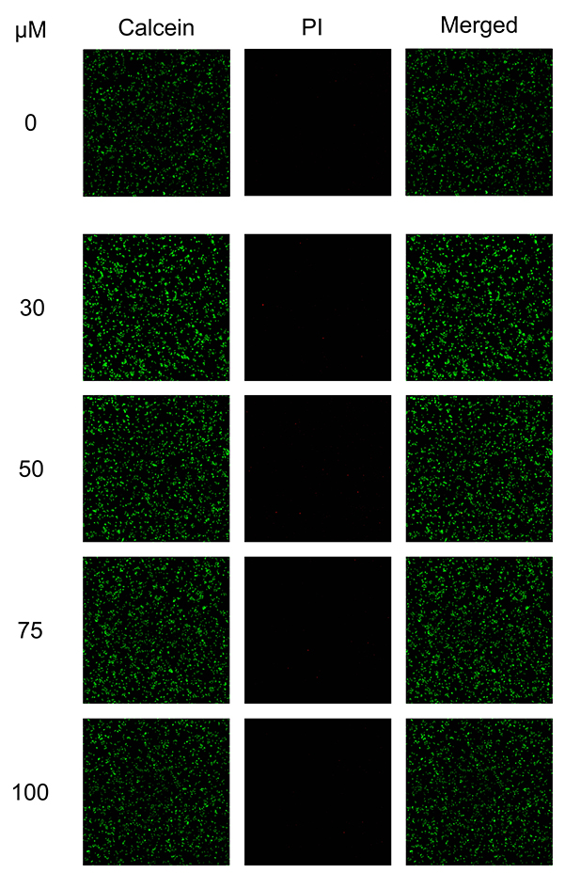
Figure S48. Representative fluorescent microscopic images of HepG2 cells stained with Calcein AM and propidium iodide (PI) after 24 h incubation with compound 2a.

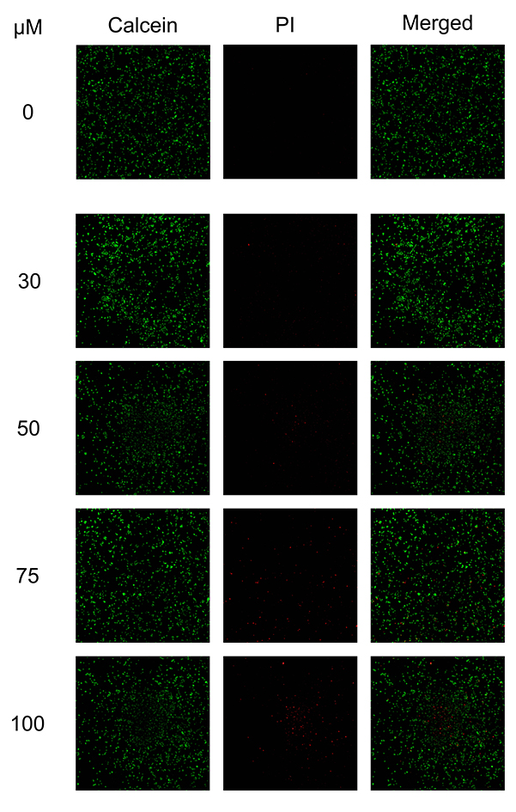
Figure S49. Representative fluorescent microscopic images of HepG2 cells stained with Calcein AM and propidium iodide (PI) after 24 h incubation with compound 3b.

3.4.1 Plausible anticancer targets suggested by pharmacophoric similarity search

Figure S50. Pharmacophore matching between 2a and several targets: a) Collagenase-2; b) Abl-1 kinase; c) Pim-1 kinase; d) Caspase-3; e) Complement C1r subcomponent.

Figure S51. Pharmacophore matching between 3b and several targets: a) Dipeptidyl peptidase 4 (DPPH4); b) Baculoviral IAP repeat-containing protein 4; c) Collagenase-2; d) Tyrosine-protein phosphatase non-receptor type 1 (PTP1B).

