**Design, modification, and bio-evaluation of salazinic acid derivatives**

**Nguyen-Kim-Tuyen Phama, Nguyen-Minh-An Tranb, Huy Truong Nguyenc, Duc-Dung Phamd, Thi-Quynh-Trang Nguyena, Thi-Hong-Anh Nguyene, Huu-Tri Nguyena, Thanh-Hung Dof, Ngoc-Hong Nguyeng*, Thuc-Huy Duongd*.**

*aFaculty of Environmental Science, Sai Gon University, Ho Chi Minh City, Vietnam*

*bIndustrial University of Ho Chi Minh City, Ho Chi Minh City, Vietnam*

*cFaculty of Pharmacy, Ton Duc Thang University, Ho Chi Minh city, Vietnam*

*dDepartment of Chemistry, Ho Chi Minh City University of Education, 280 An Duong Vuong Street, District 5, 748342 Ho Chi Minh City, Vietnam*

*eHo Chi Minh City University of Food Industry, 140 Le Trong Tan Street, Tay Thanh Ward, Tan Phu District, HCMC, Vietnam*

*fNTT Hi-Tech Institute, Nguyen Tat Thanh University, Ho Chi Minh City 700000, Vietnam*

*gHo Chi Minh City University of Technology (HUTECH), Ho Chi Minh City, Vietnam*

*nn.hong@hutech.edu.vn*

*huydt@hcmue.edu.vn*

**Abstract**

Data on synthesized derivatives of salazinic acid are scarce, with existing reports addressing only derivative hexaacetyl salazinic acid. This study investigated a set of novel potential antidiabetic agents. Analogs of salazinic acid were designed and synthesized using bromination, nucleophilic addition, Friedel-Crafts alkylation, and esterification. Ten synthetic compounds were prepared and structurally elucidated, including eight new compounds (**1a**-**1c**, **2a**, **3a**, **3b**, **4a**, **4b**) and two known analogs. Under bromination, salazinic acid (**1**) enabled the following reaction chain: oxidation, decarboxylation, and substitution. This yielded products **1a**-**1c**, which were found to have unprecedented scaffolds. Parmosidone F (**5**) was prepared from **1** with orsellinic acid via Friedel-Crafts alkylation, confirming a previously reported biosynthesis route. These analogs were evaluated for enzyme inhibition of α-glucosidase, and all showed more potent activity than that of acarbose, a positive control (IC50 332 μM), with IC50 values in the range 9.32-39.96 μM. An in silico molecular docking model confirmed that, in terms of enzyme inhibition, the compounds ranked as follows: **3b> 4b > 4a > 1c > 2a > 1b > 1a > 3a**. The kinetics of enzyme inhibition showed **4a** and **5** to be a non-competitive-type and mixed-type inhibitors, respectively.

**Keywords** lichen, bromination, nucleophilic addition, *α*-glucosidase inhibition, molecular docking, kinetic

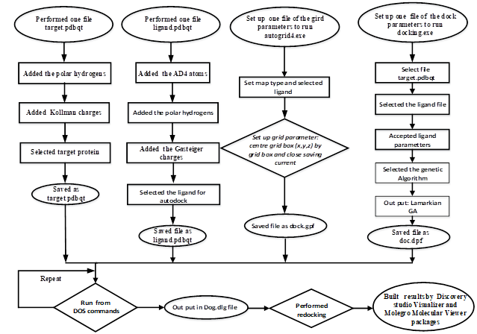

**Scheme S1.** General procedure described for molecular docking model of one ligand to one receptor based on autodock package.

**The results of docking poses: ligands 1, 2b, 4a-4b, and acarbose were presented in Figure S1-S5**

**Figure S1**. The significant interactions between a ranked **pose 15**, **ligand 4b** and amino acid of protein chains in crystal structure of enzyme, code 5KEZ: PDB

**Figure S2**. The important interactions between **pose 146** of ligand **4a** to active sites in enzyme, 5KEZ performed in a 2D diagram

**Figure S3**. The significant interactions formed between ranked docking **pose 196** of ligand **2b and receptor, 5KEZ.**

**Figure S13.** The significant interactions between **pose 90 of ligand 1** and active sites of enzyme, 5KEZ presented on 2D diagram.

**Figure S4.** The significant interactions between docking **pose 164** of ligand Acarbose and active sites on receptor, a crystal structure of enzyme α-glucosidase performed on 2D diagram.

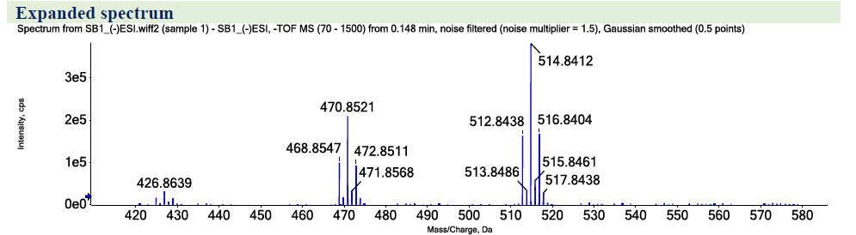



**Figure S1.** HRESIMS spectrum of **1a**.

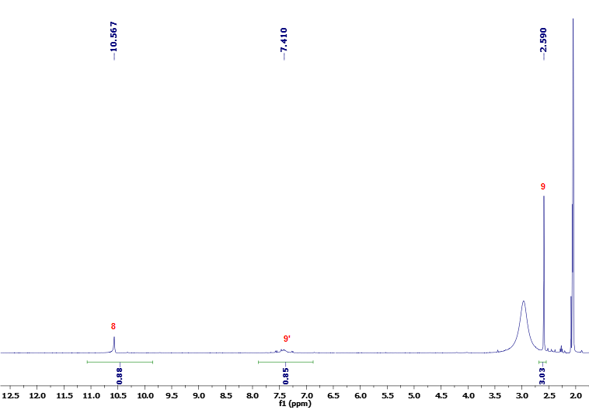



**Figure S2.** 1H-NMR (400 MHz) spectrum of **1a** in Acetone-*d6*.

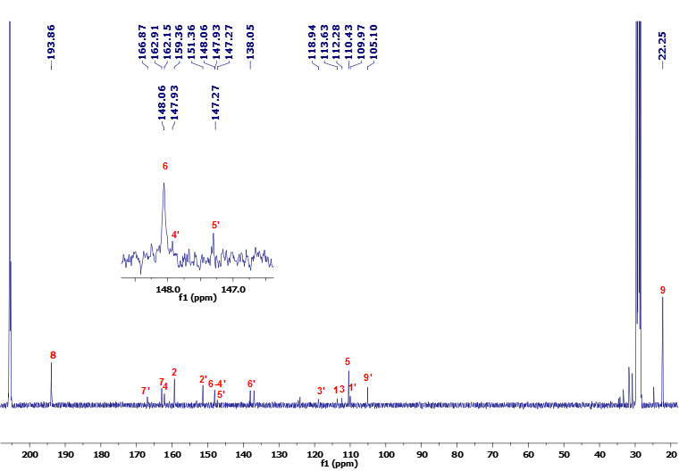



**Figure S3.** 13C-NMR (100 MHz) spectrum of **1a** in Acetone-*d6*.

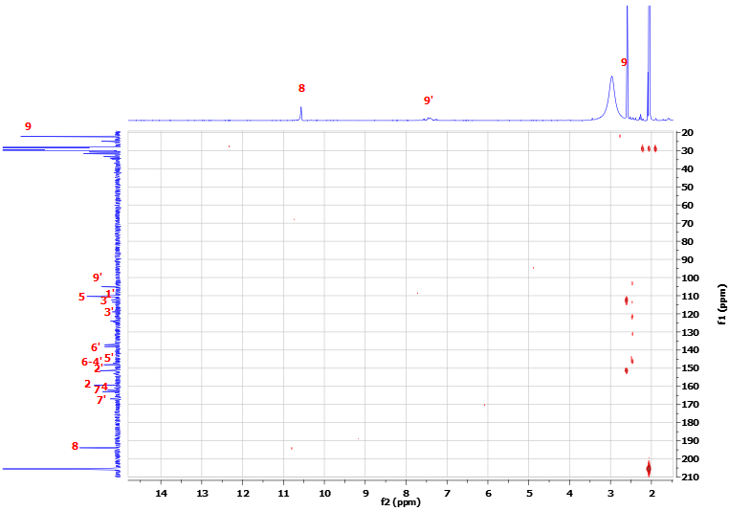



**Figure S4.** HMBC spectrum of **1a** in Acetone-*d6*.

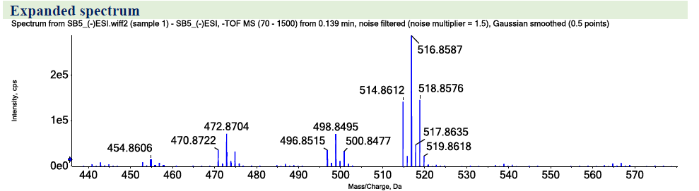



**Figure S5.** HRESIMS spectrum of **1b**.

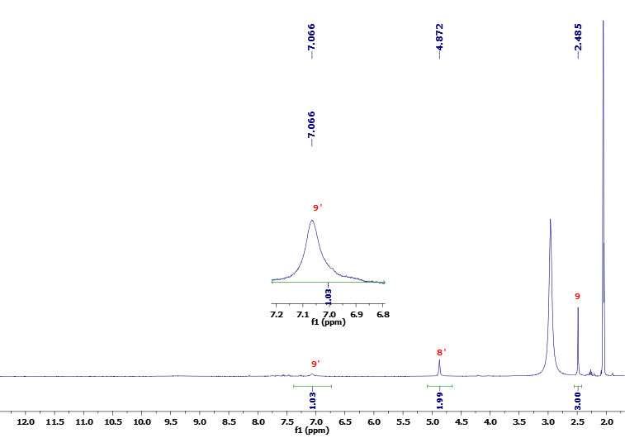



**Figure S6.** 1H-NMR (400 MHz) spectrum of **1b** in Acetone-*d6*.

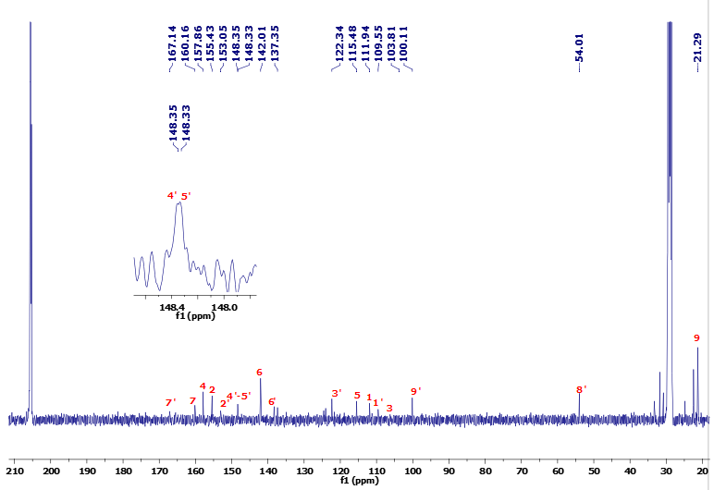



**Figure S7.** 13C-NMR (100 MHz) spectrum of **1b** in Acetone-*d6*.

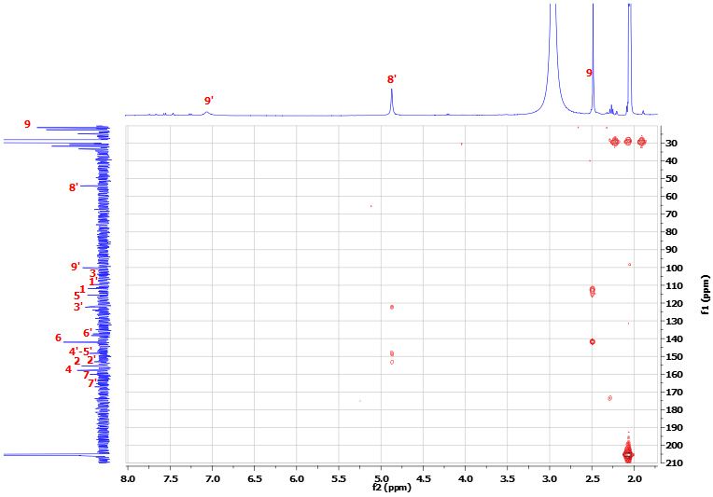



**Figure S8.** HMBC spectrum of **1b** in Acetone-*d6*.

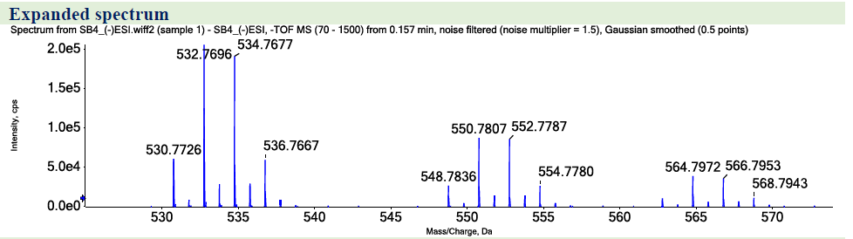



**Figure S9.** HRESIMS spectrum of **1c**.

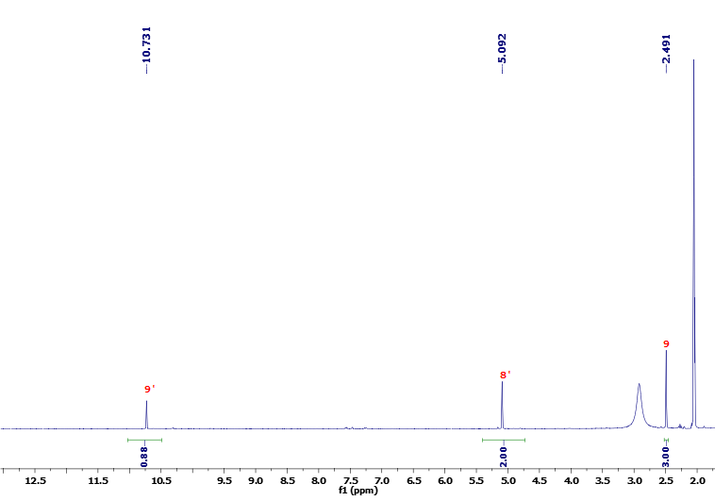



**Figure S10.** 1H-NMR (400 MHz) spectrum of **1c** in Acetone-*d6*.

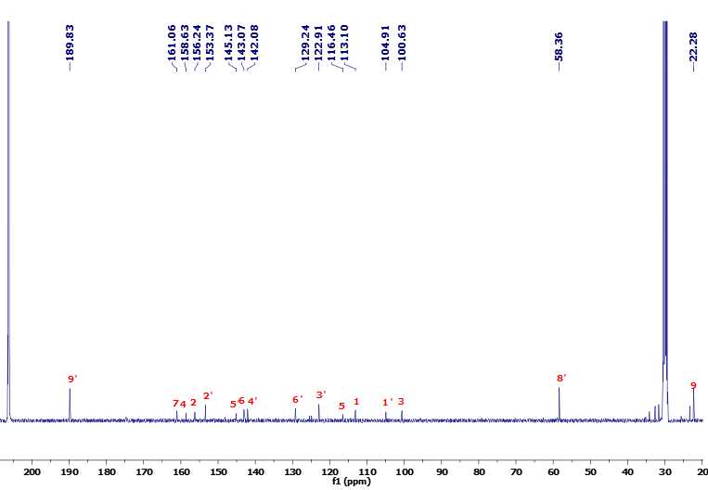



**Figure S11.** 13C-NMR (100 MHz) spectrum of **1c** in Acetone-*d6*.

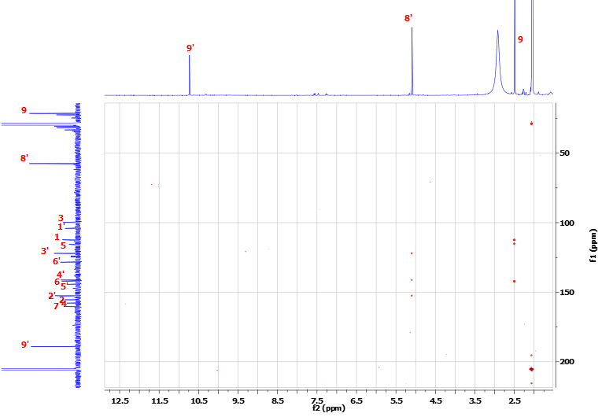  
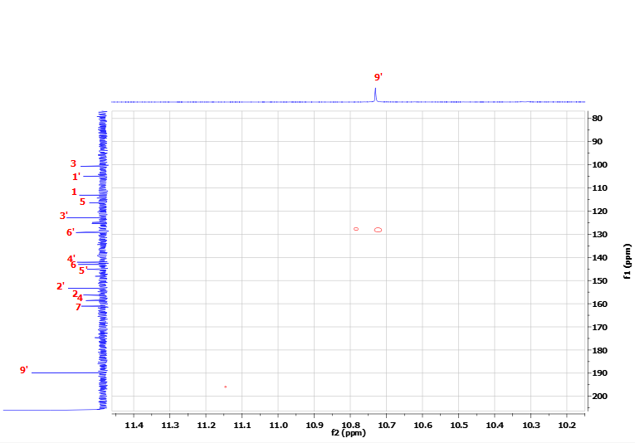



**Figure S12.** HMBC spectrum of **1c** in Acetone-*d6*.

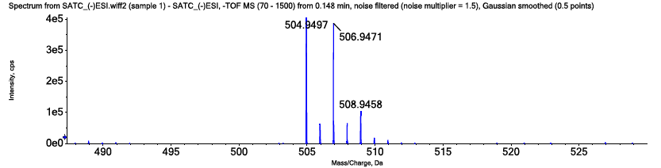

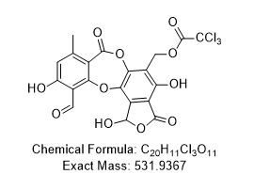

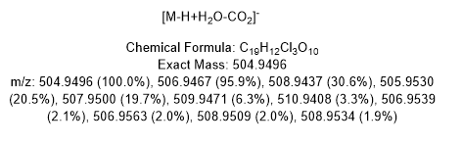

**Figure S13.** The HRESIMS spectrum of **2a**.

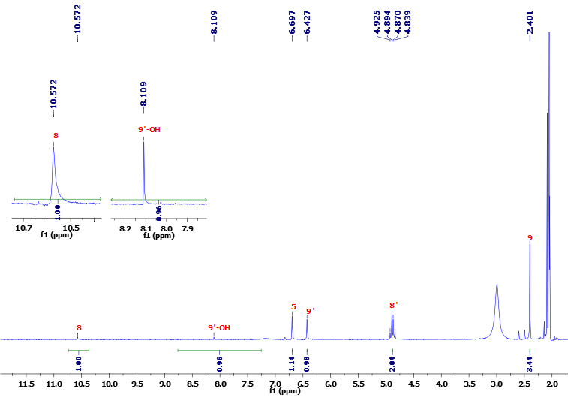



**Figure S14.** 1H-NMR (400 MHz) spectrum of **2a** in Acetone-*d6*.

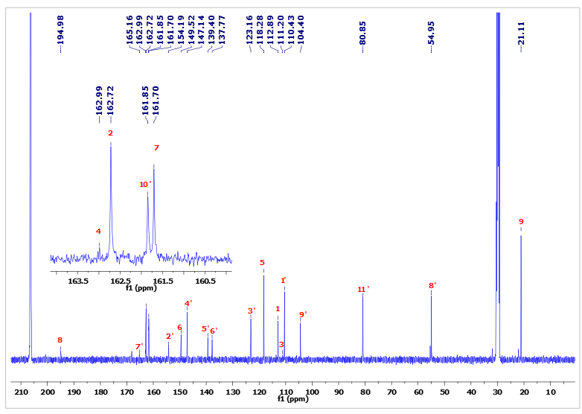



**Figure S15.** 13C-NMR (100 MHz) spectrum of **2a** in Acetone-*d6*.

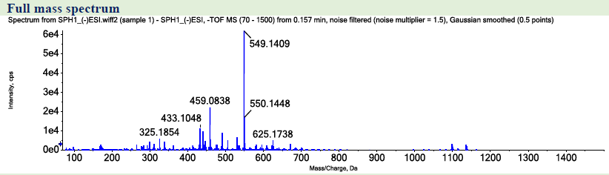

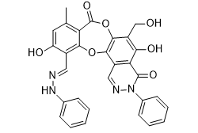

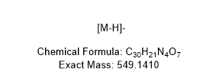

**Figure S16.** HRESIMS spectrum of **3a**.

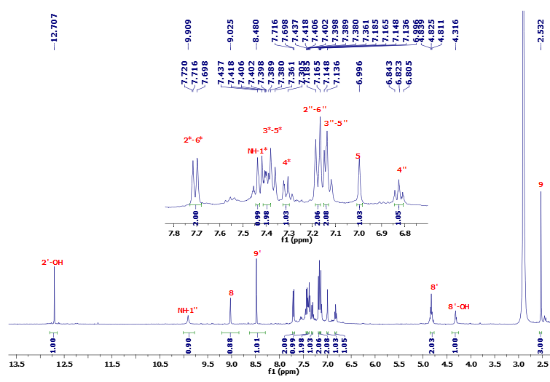



**Figure S17.** 1H-NMR (400 MHz) spectrum of **3a** in Acetone-*d6*.

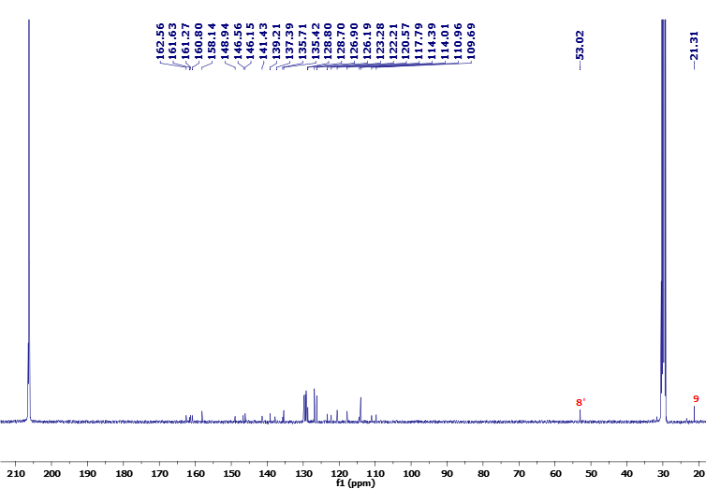

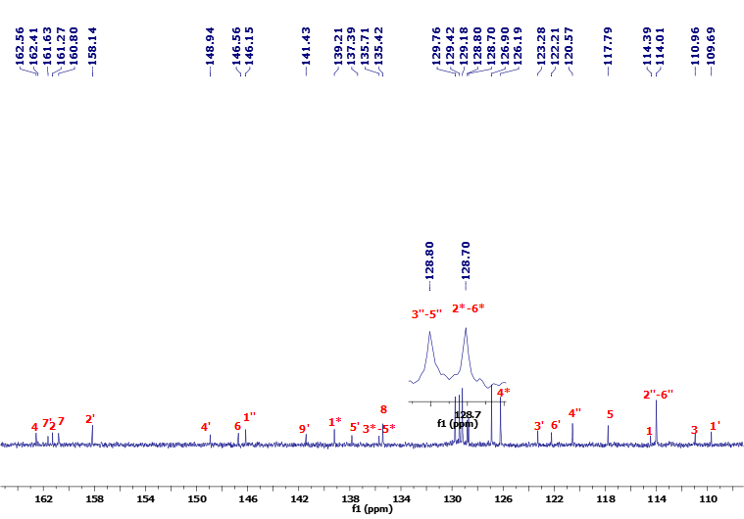l



**Figure S18.** 13C-NMR (100 MHz) spectrum of **3a** in Acetone-*d6*.

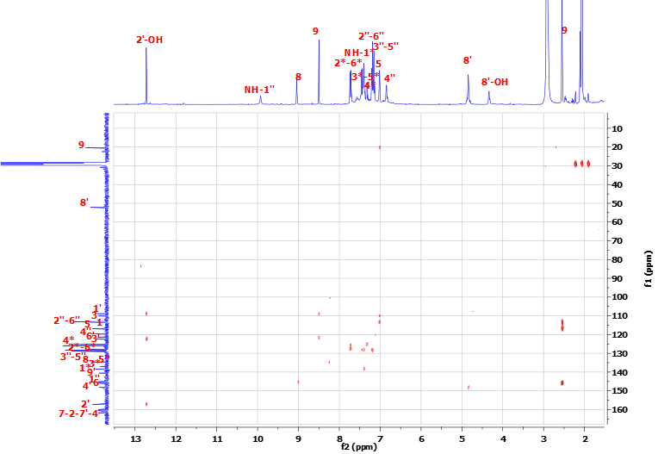



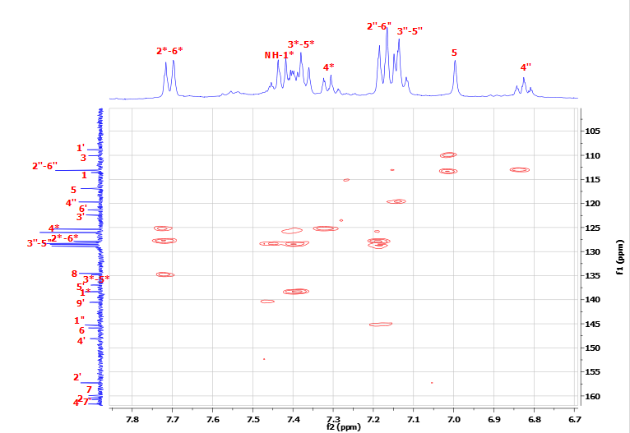

**Figure S19.** HMBC spectrum of **3a** in Acetone-*d6*.

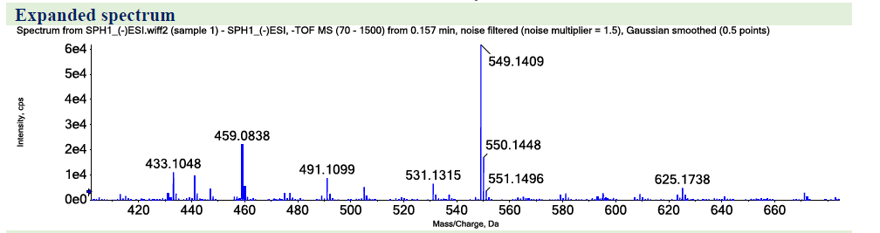



**Figure S20.** HRESIMS spectrum of **3b**.

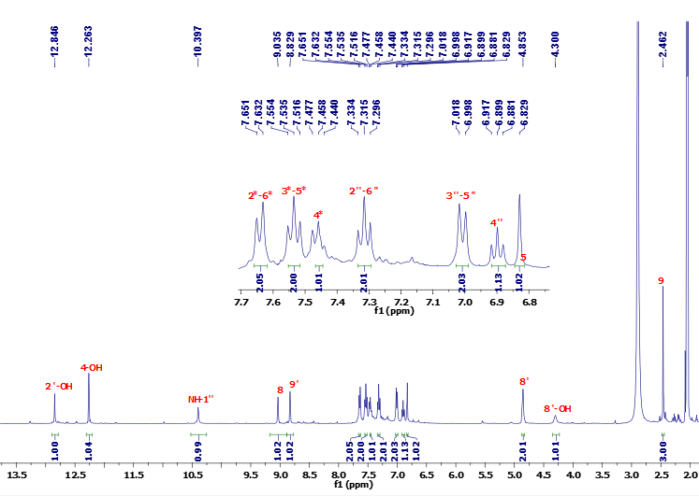



**Figure S21.** 1H-NMR (400 MHz) spectrum of **3b** in Acetone-*d6*.

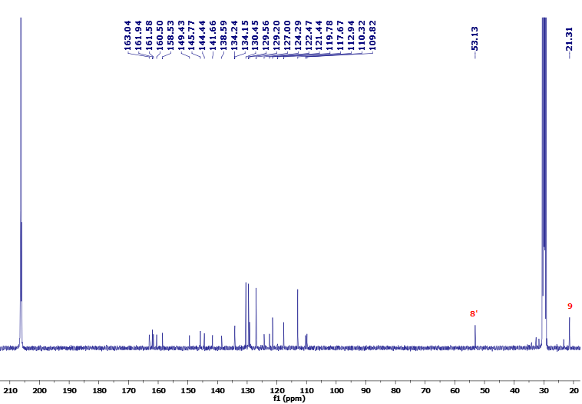

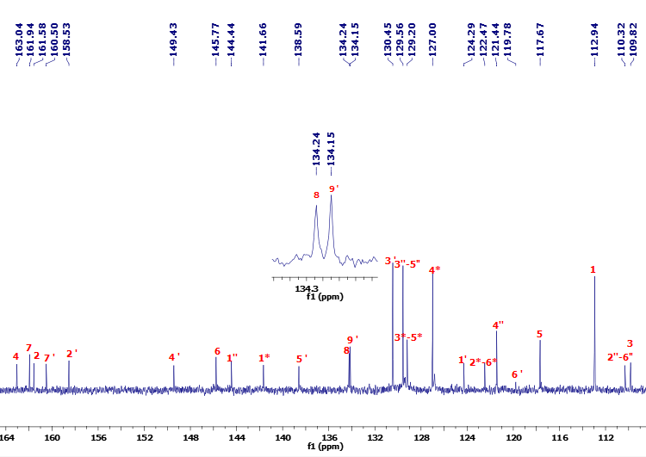



**Figure S22.** 13C-NMR (100 MHz) spectrum of **3b** in Acetone-*d6*.

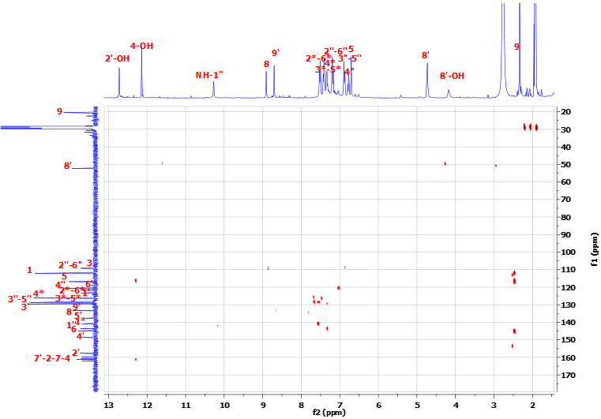



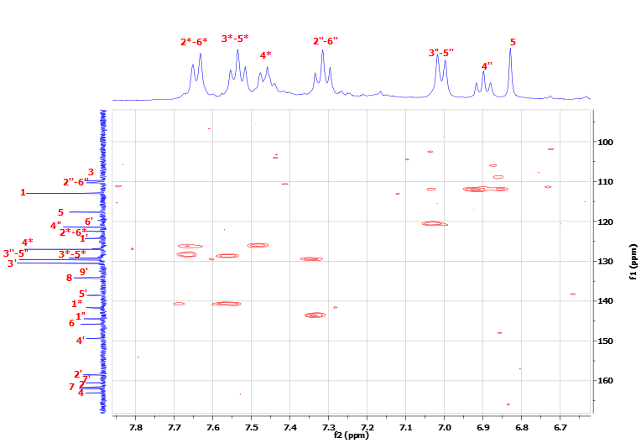

**Figure S23.** HMBC spectrum of **3b** in Acetone-*d6*.

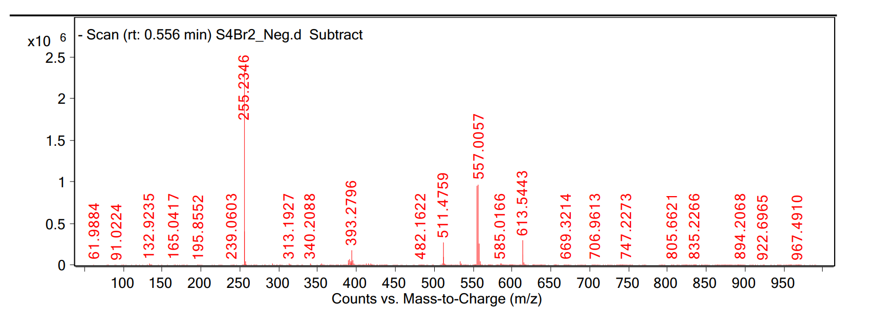

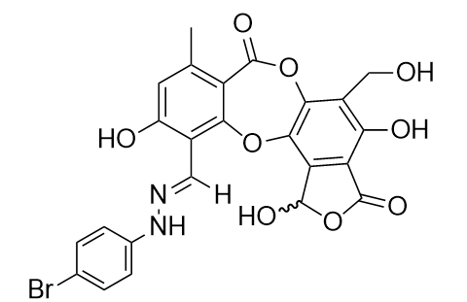

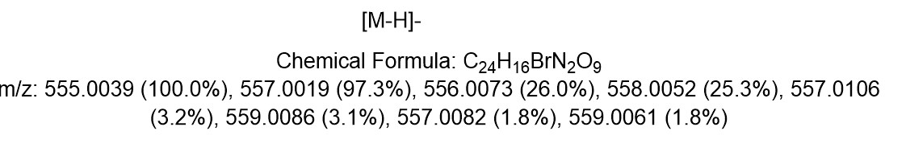

**Figure S24.** HRESIMS spectrum of **4a**.

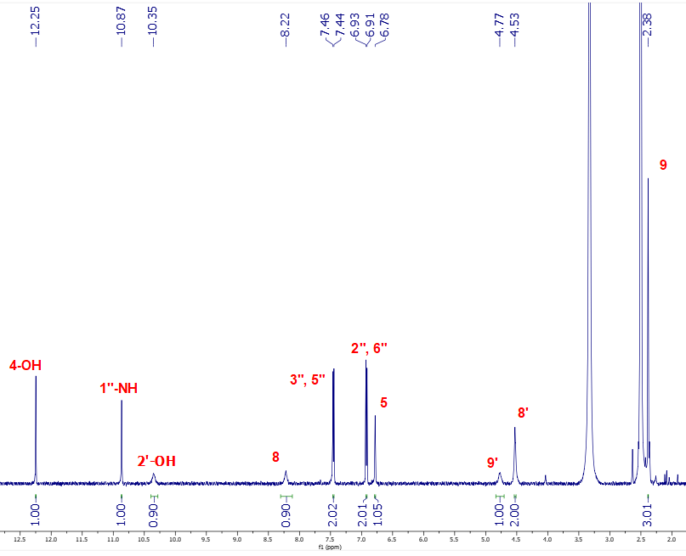

**Figure S25.** 1H NMR (500 MHz) spectrum of **4a** in DMSO-*d6*.

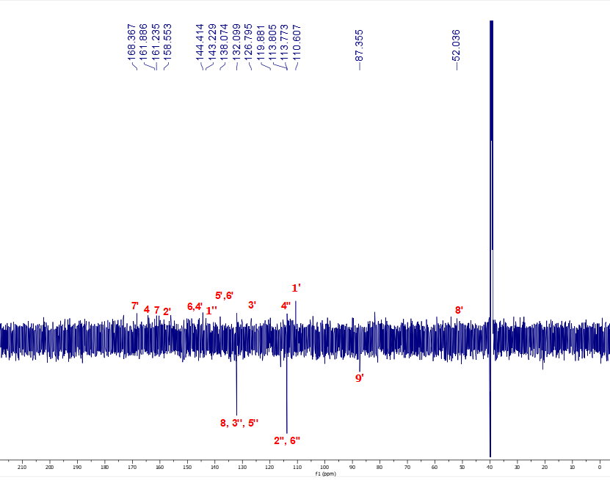



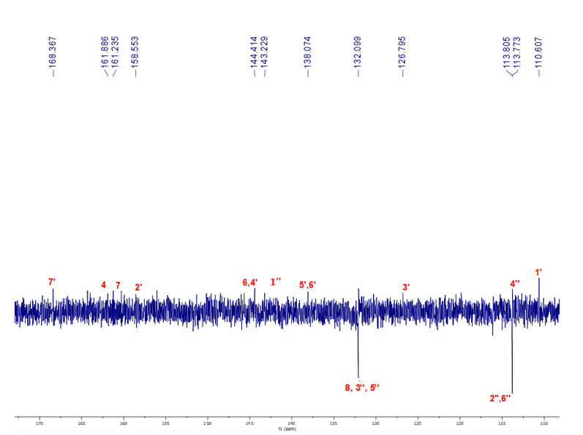

**Figure S26.** 13C NMR (125 MHz) spectrum of **4a** in DMSO-*d6*.

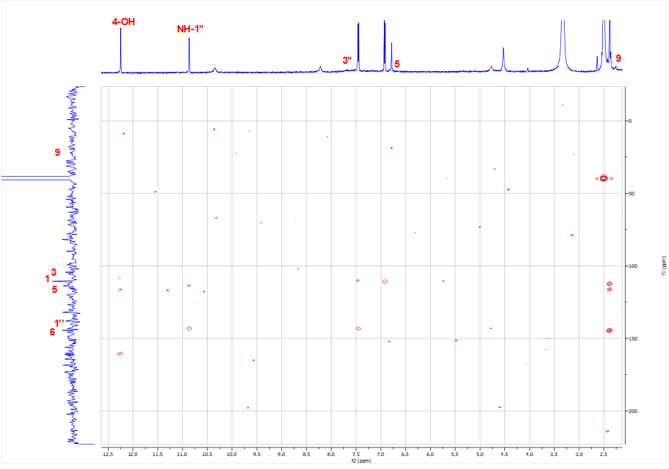

**Figure S27.** HMBC spectrum of **4a** in DMSO-*d6*.

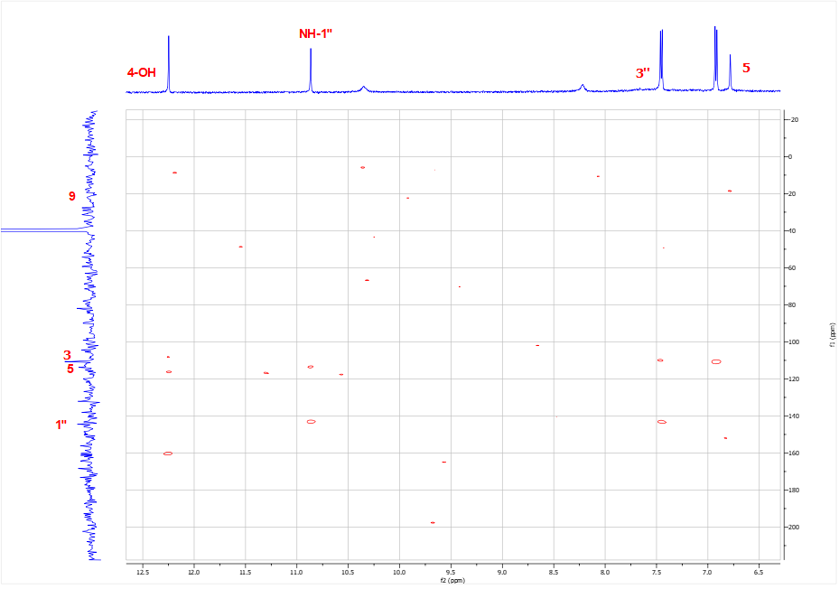

**Figure S28.** HMBC spectrum of **4a** in DMSO-*d6*.

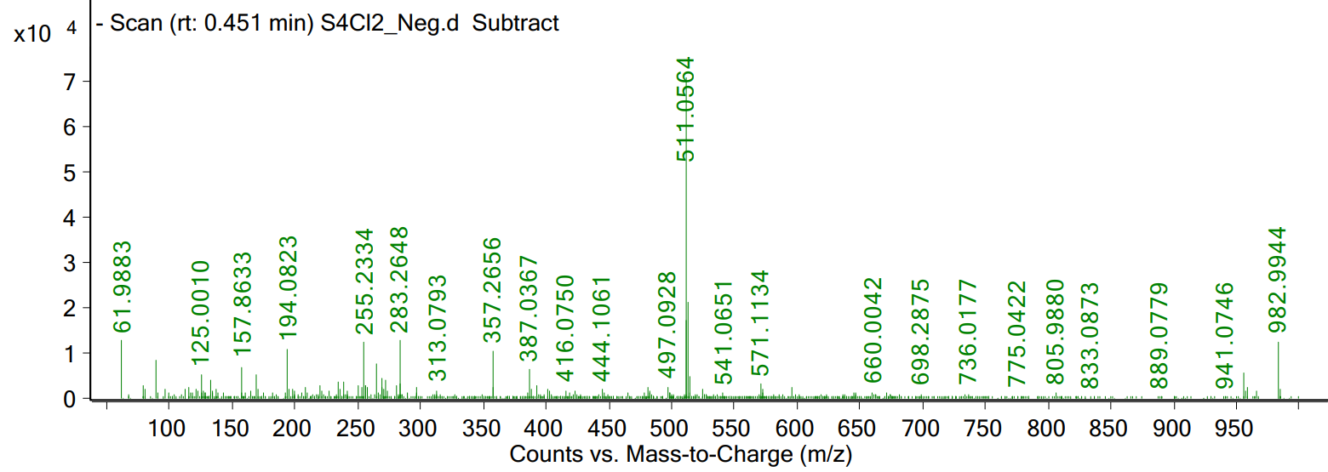



**Figure S29.** HRESIMS spectrum of **4b**.

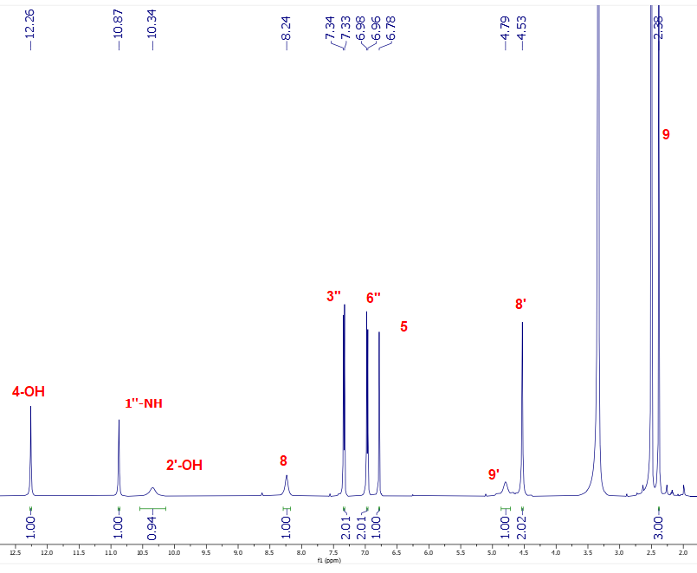

**Figure S30.** 1H-NMR (500 MHz) spectrum of **4b** in DMSO-*d6*.

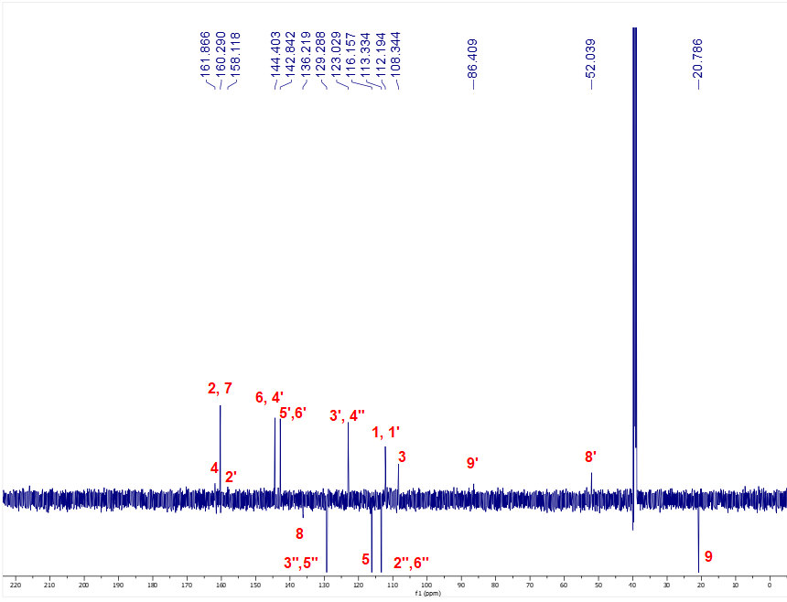

**Figure S31.** 13C-NMR (125 MHz) spectrum of **4b** in DMSO-*d6*.

**Figure S32.** HMBC correlations of **1a-1c, 3a** and **3b**

**Figure S33.** HPLC chromatogram of **4a**

**Figure S34.** HPLC chromatogram of **5**

| **Table S1.** The calculated results in silico molecular docking of structures with receptor, 5KEZ (PDB: 10.2210/pdb5KEZ/pdb) briefly performed by ATD and DSC packages like free energy of binding ($∆G$), inhibition constant, Ki, the number of hydrogen bonds, the property and bond length of hydrogen. | | | | |
| --- | --- | --- | --- | --- |
| Entry | Free Energy of Binding[g] | Ki[h] | The number of hydrogen bonds[i] | The property and bond length[j] |
| Slazinic acid | -7.08 | 6.42 | 4 | A:Ala307:N – **Slazinic**: O (2.86)  A:ALA307:N - **Slazinic**:O (2.68)  **Slazinic**: H - A:Glu233:O (1.89)  **Slazinic**: H - A:His201:N (2.09) |
| **1a** | -6.97 | 7.82 | 4 | A:Thr6:O – **SB1**:Br (3.52)  A:Arg252:N– **SB1**:O (3.09)  A:Arg421:N–**SB1**:Br (3.13)  **SB1**:H - A:Pro332:O (1.84) |
| **1b** | -7.81 | 1.90 | 5 | A:His305:ND1 - **SB5**:O (3.0)  B:PRO2:N - **SB5**:O (3.11)  **SB5**:H - A:His201:N (2.11)  **SB5**:H - A:His305:O (1.98)  **SB5**:H - A:His305:O (2.43) |
| **1c** | -8.03 | 1.30 | 5 | A:Lys200:N - **SB4**:O (3.05)  A:ALA307:N - **SB4**:O (2.85)  **SB4**:H - A:Glu233:O (2.19)  **SB4**:H - A:Glu240:O (2.11)  **SB4**:H - A:Glu240:O (1.95) |
| **2a** | **-7.35** | **4.12** | 5 | A:Asn364:N - **SATC**:O (2.99)  A:Lys368:NZ - **SATC**:O (2.77)  **SATC**:H - A:Asp381: O (2.15)  **SATC**:H - A:Asn362:O (1.80)  **SATC**:H - A:Asn362:O (2.31 ) |
| **2b** | -7.17 | 5.57 | 5 | A:Asn362:N- **SAC1**:O (2.82)  A:Asn364:N - **SAC1**:O (2.73)  A:Lys368:N - **SAC1**:O (2.65)  **SAC1**:H - A:Asp381:O (2.23)  **SAC1**:H - A:Asn362:O (2.20) |
| **3a** | -6.80 | 0.10 | 2 | A:Arg252:N- **SPH2**:O (3.04)  **SPH2**:H - A:Arg10:O (1.94) |
| **3b** | -9.79 | 0.067 | 3 | A: Ala307:N-**SPH1**:N (3.17)  **SPH1**:H - A: Asp300:O (1.93)  **SPH1**:H - A:His201:N (2.14) |
| Acarbobose-Drug | -4.10 | 989 | 11 | A:Ser3:O–**Drug**: O (2.59)  A:Thr6:O– **Drug**: O (3.16)  A:SER226:O–**Drug**::O (3.12)  **Drug**: H–A:Asp402:O (1.75)  **Drug**: H–A:Asp402:O (2.07)  **Drug**: H–A:Asp402:O (1.85)  **Drug**: H–A:Asp402:O (2.33)  **Drug**: H–A: Asn5:O (2.08)  **Drug**: H–A:Asn5:O (2.04)  **Drug**: H–A:Ser3:O (2.25)  **Drug**: H–A:Arg10:O (2.27) |