**Supplementary data**

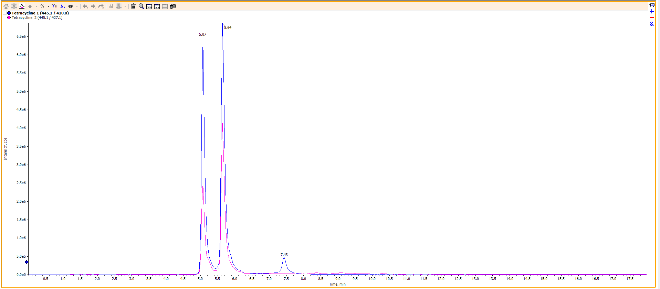

Figure S1: Total ion flow chromatogram for tetracycline

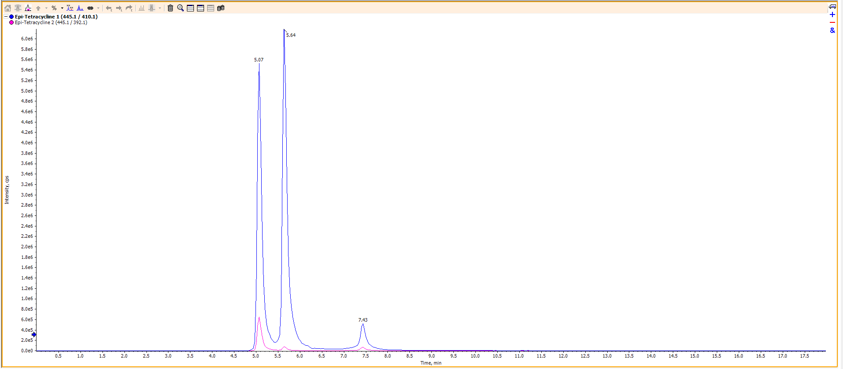

Figure S2: Total ion flow chromatogram for epi-tetracycline

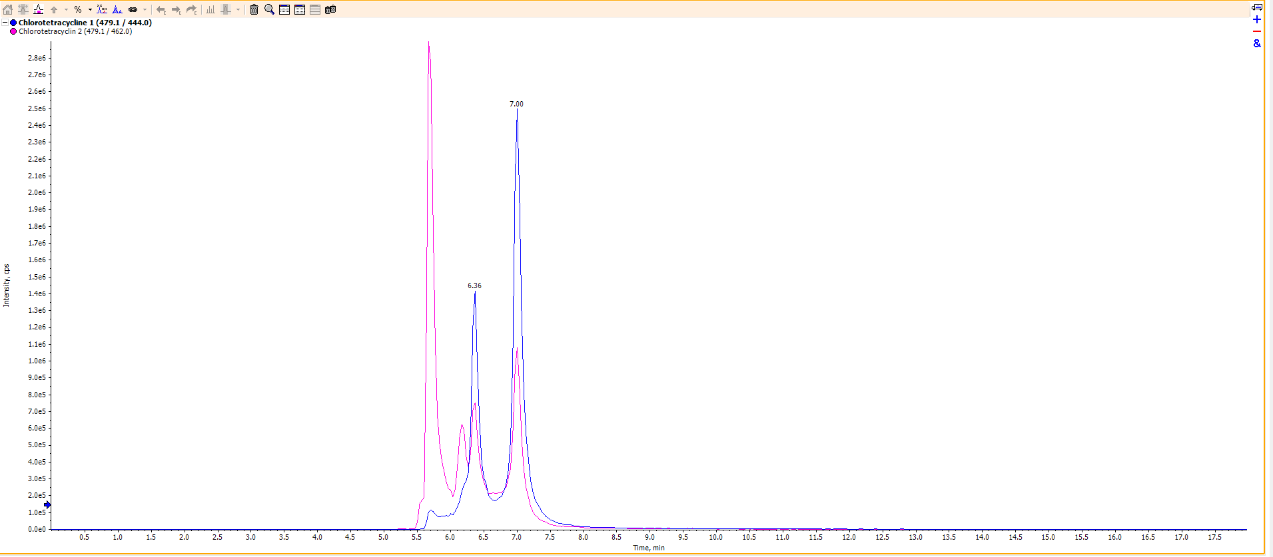

Figure S3: Total ion flow chromatogram for chlortetracycline

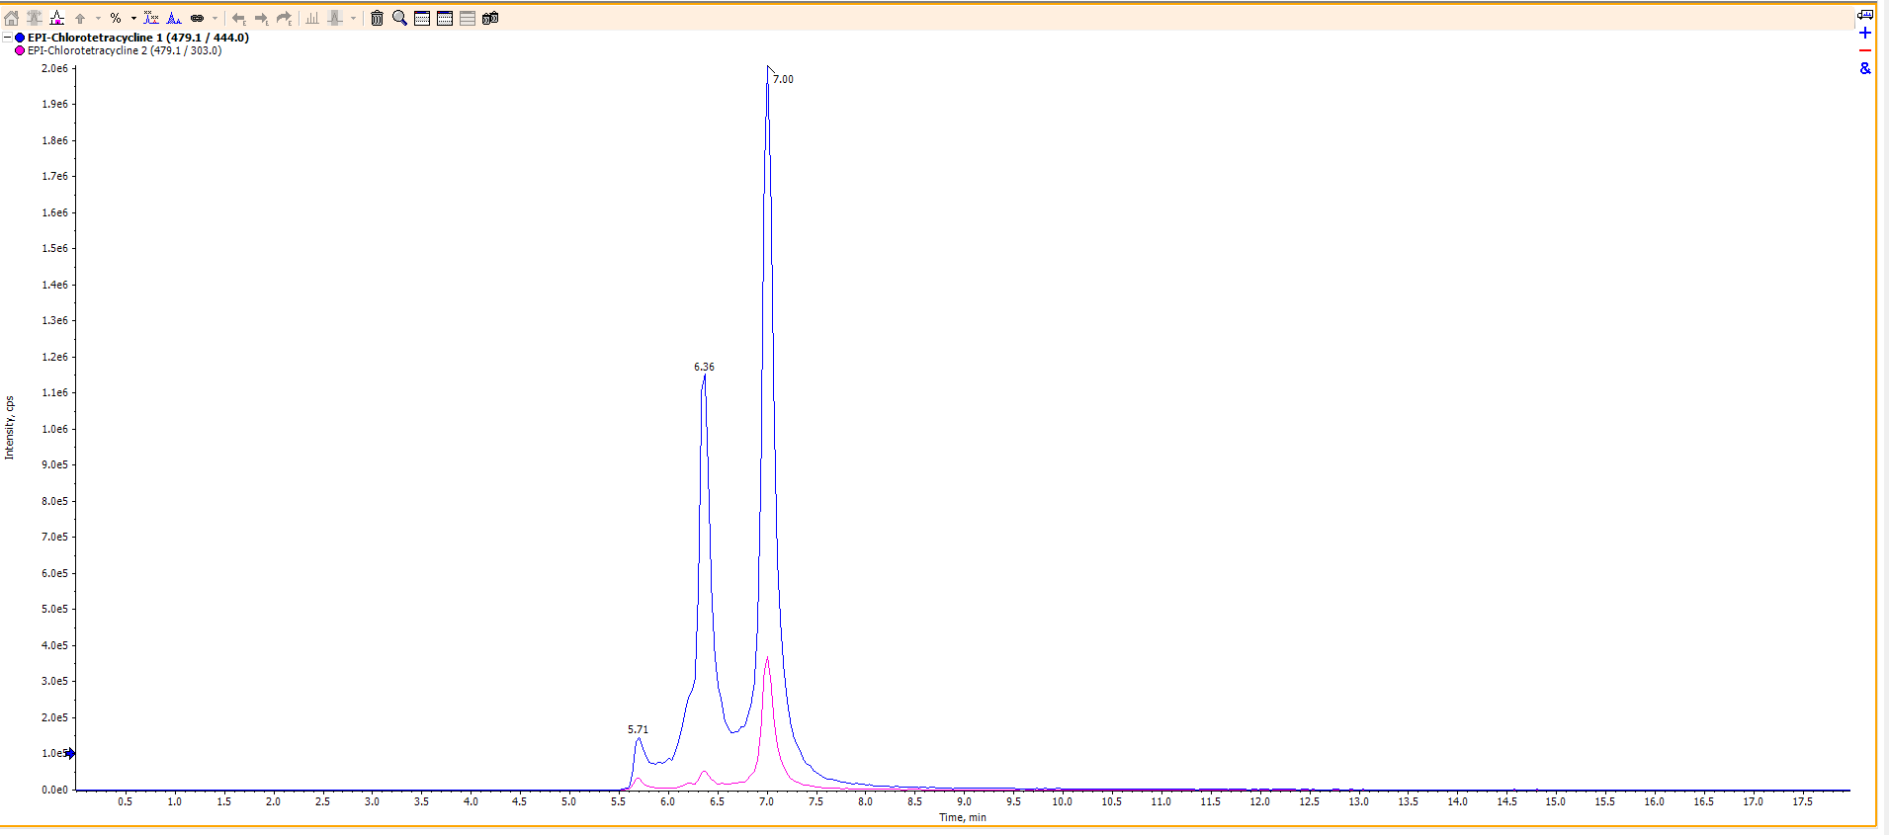

Figure S4: Total ion flow chromatogram for epi-chlortetracycline

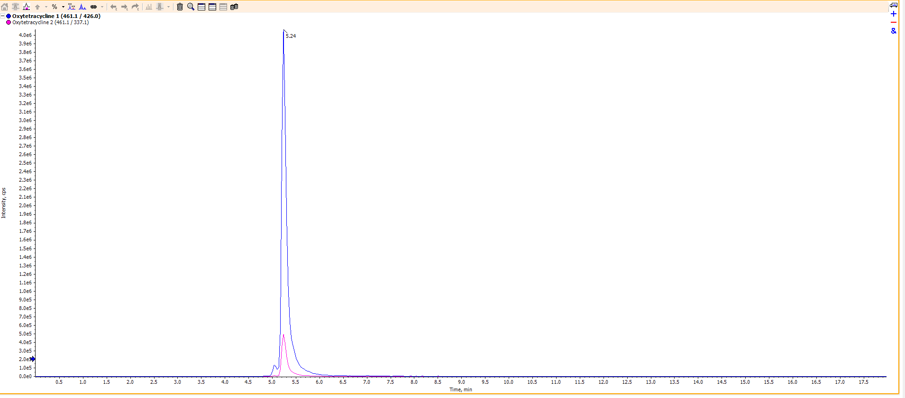

Figure S5: Total ion flow chromatogram for oxytetracycline

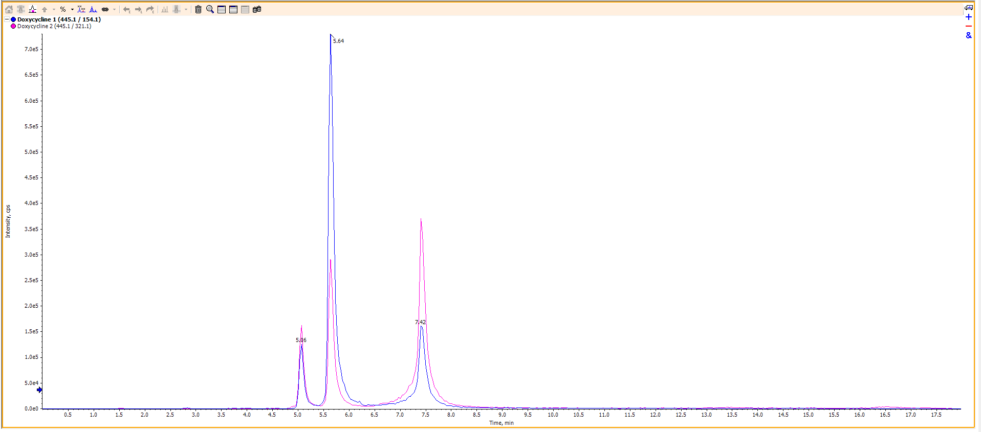

Figure S6: Total ion flow chromatogram for doxycyclin

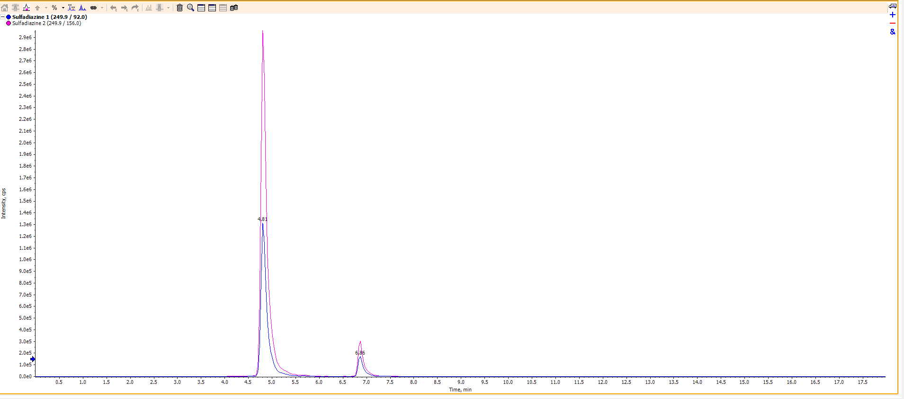

Figure S7: Total ion flow chromatogram for sulfadiazine

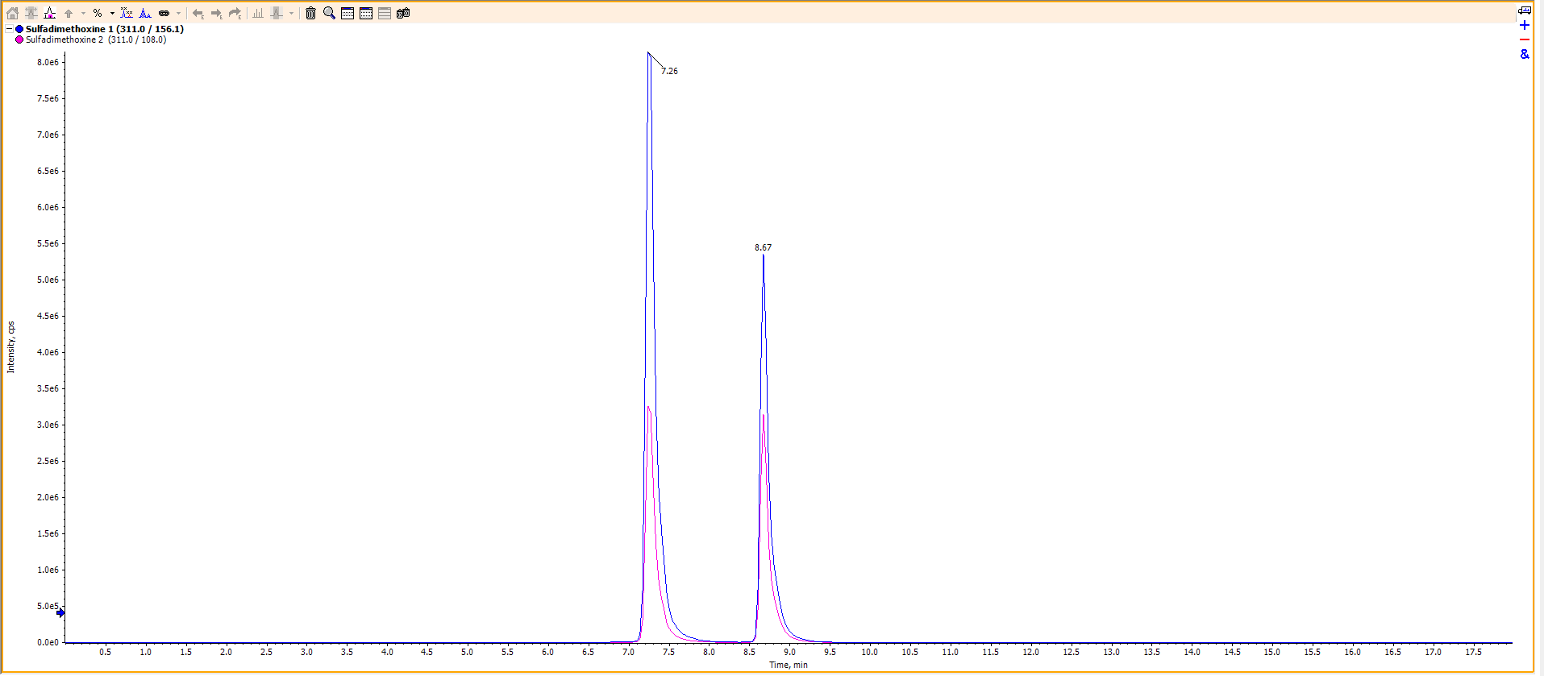

Figure S8: Total ion flow chromatogram for sulfadimethoxine

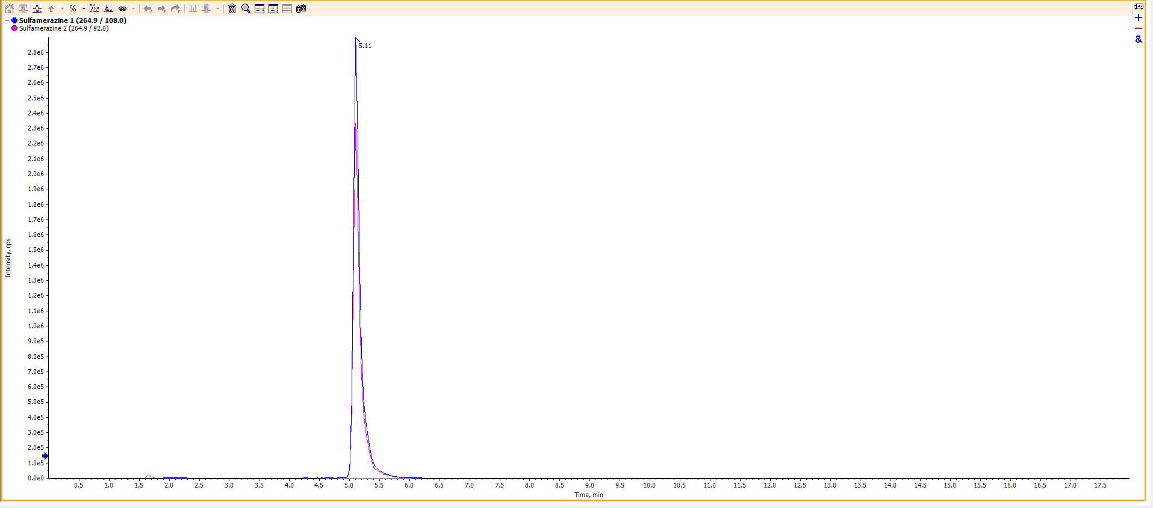

Figure S9: Total ion flow chromatogram for sulfamerazine

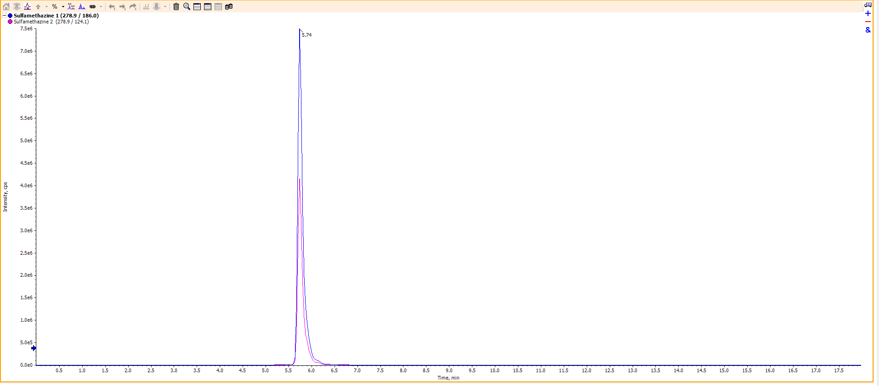

Figure S10: Total ion flow chromatogram for sulfamethazine

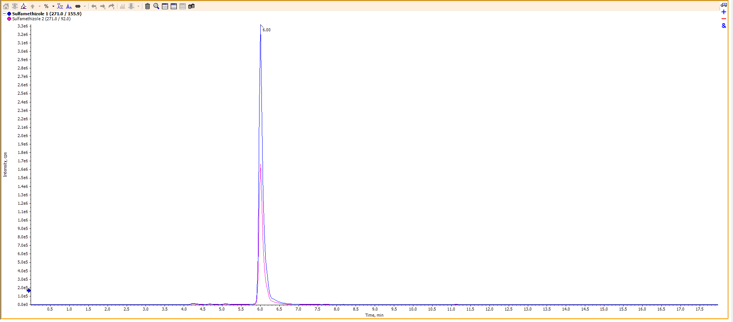

Figure S11: Total ion flow chromatogram for sulfamethizole

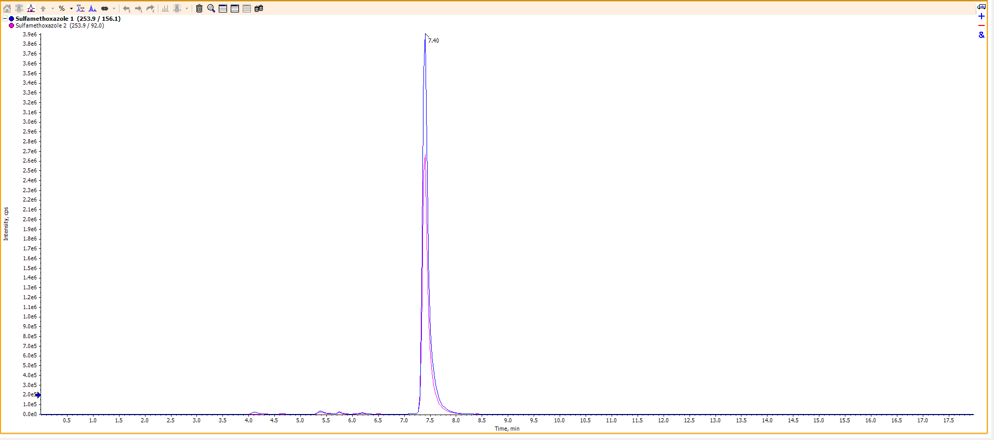

Figure S12: Total ion flow chromatogram for sulfamethoxazole

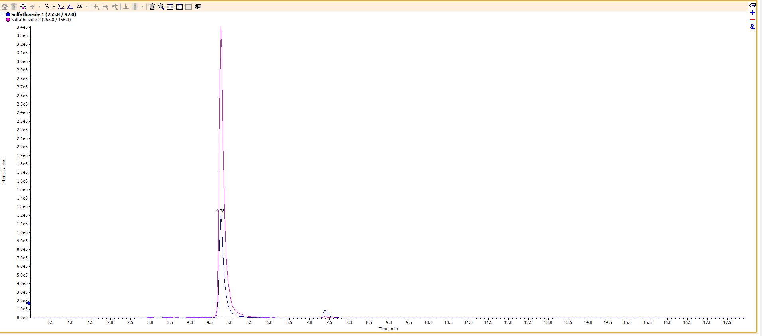

Figure S13: Total ion flow chromatogram for sulfathiazole

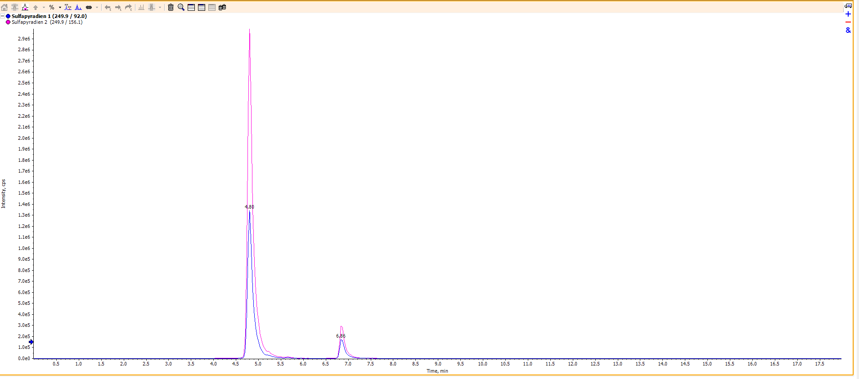

Figure S14: Total ion flow chromatogram for sulfapyridine

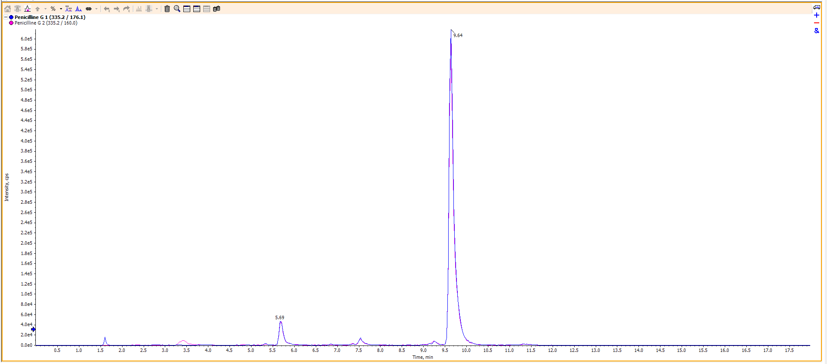

Figure S15: Total ion flow chromatogram for benzylpenicillin

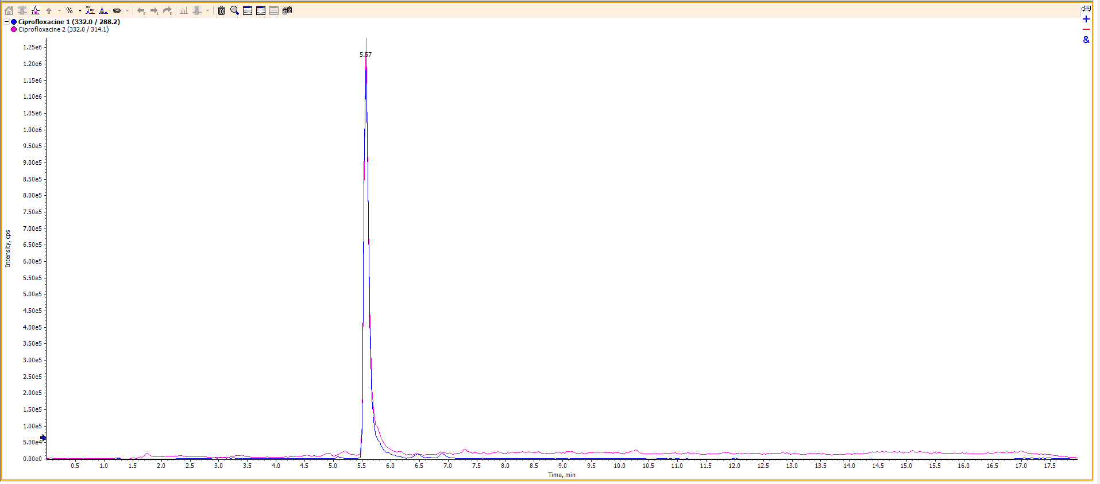

Figure S16: Total ion flow chromatogram for ciprofloxacin

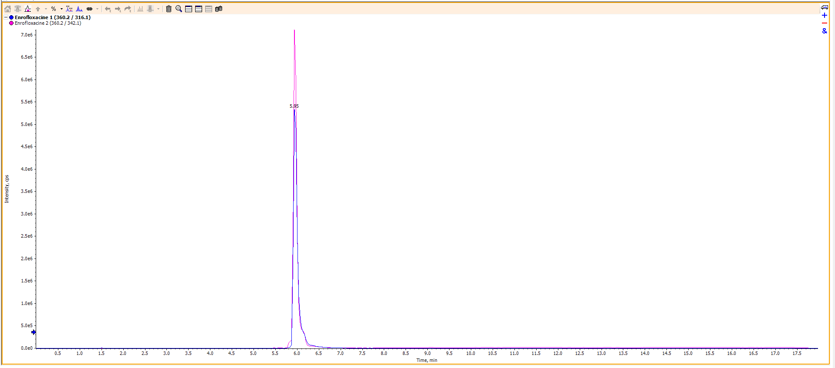

Figure S17: Total ion flow chromatogram for enrofloxacin

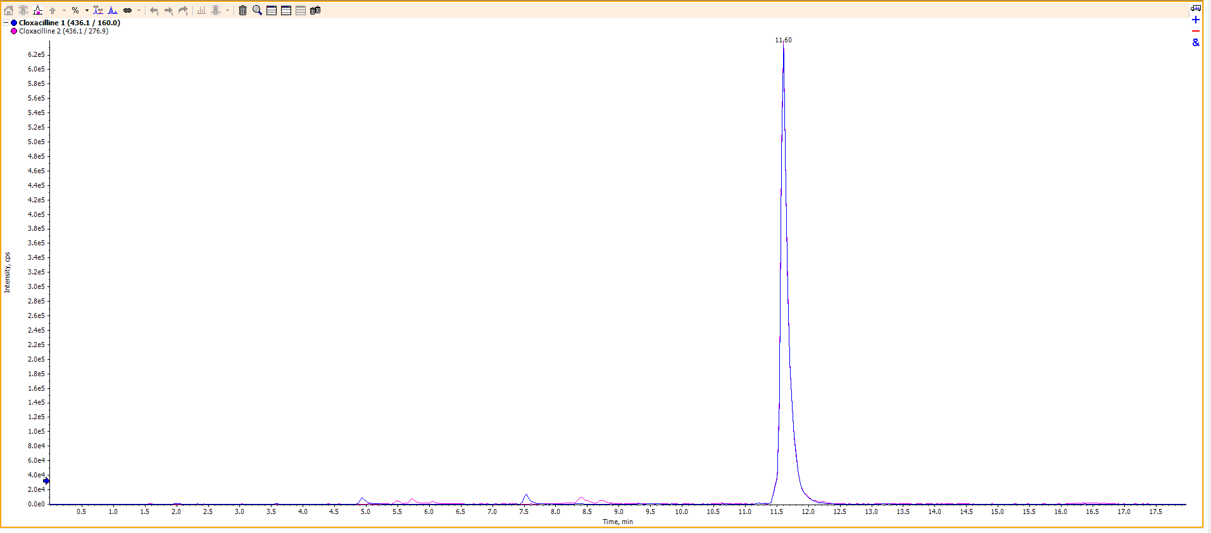

Figure S18: Total ion flow chromatogram for cloxacillin

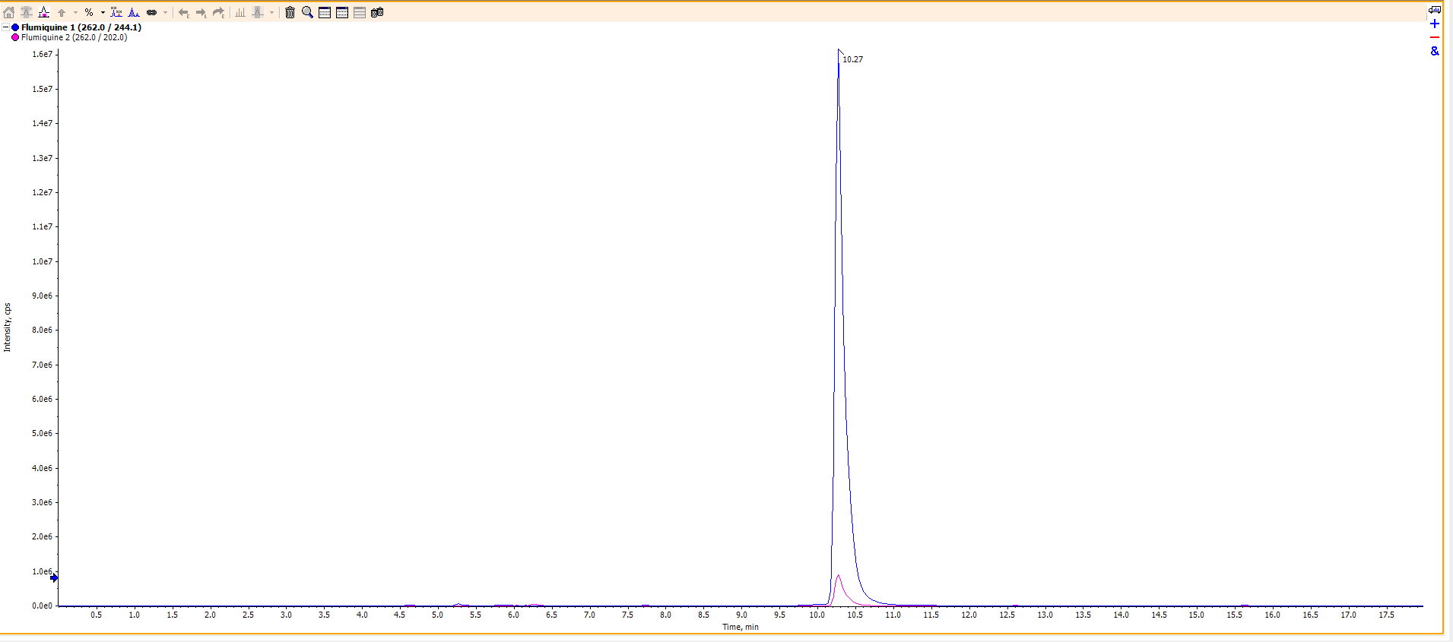

Figure S19: Total ion flow chromatogram for flumequine

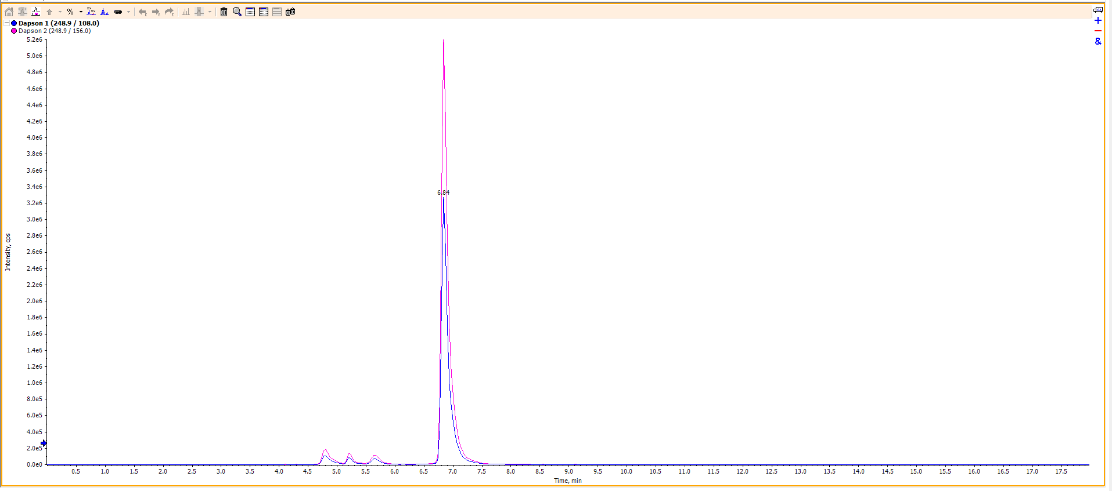

Figure S20: Total ion flow chromatogram for dapsone

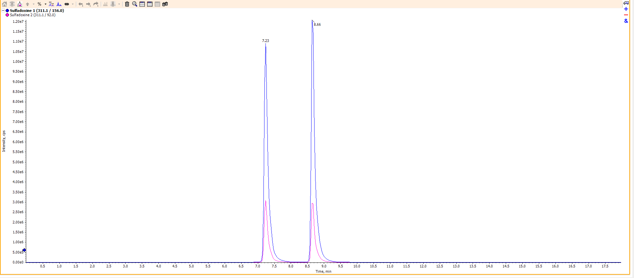

Figure S21: Total ion flow chromatogram for sulfadoxine

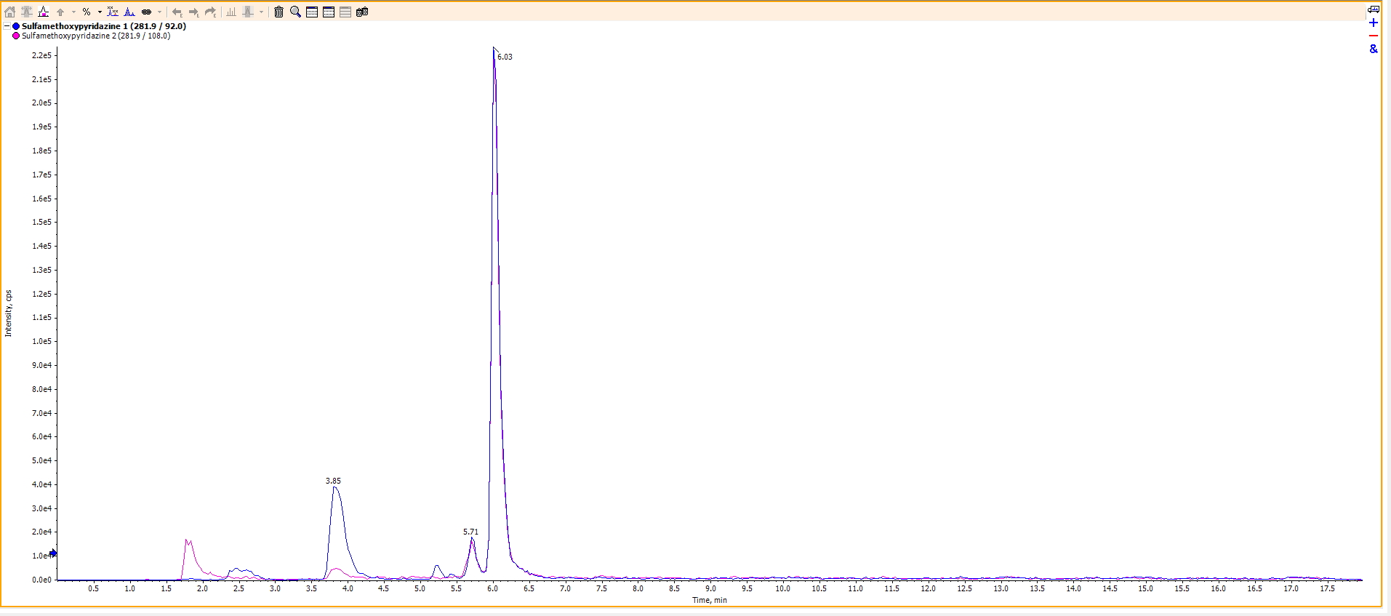

Figure S22: Total ion flow chromatogram for sulfamethoxypyridazine

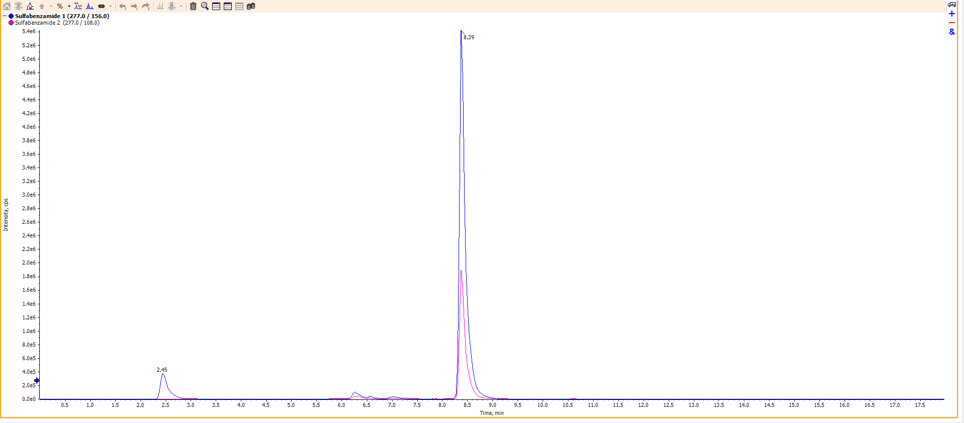

Figure S23: Total ion flow chromatogram for sulfabenzamide

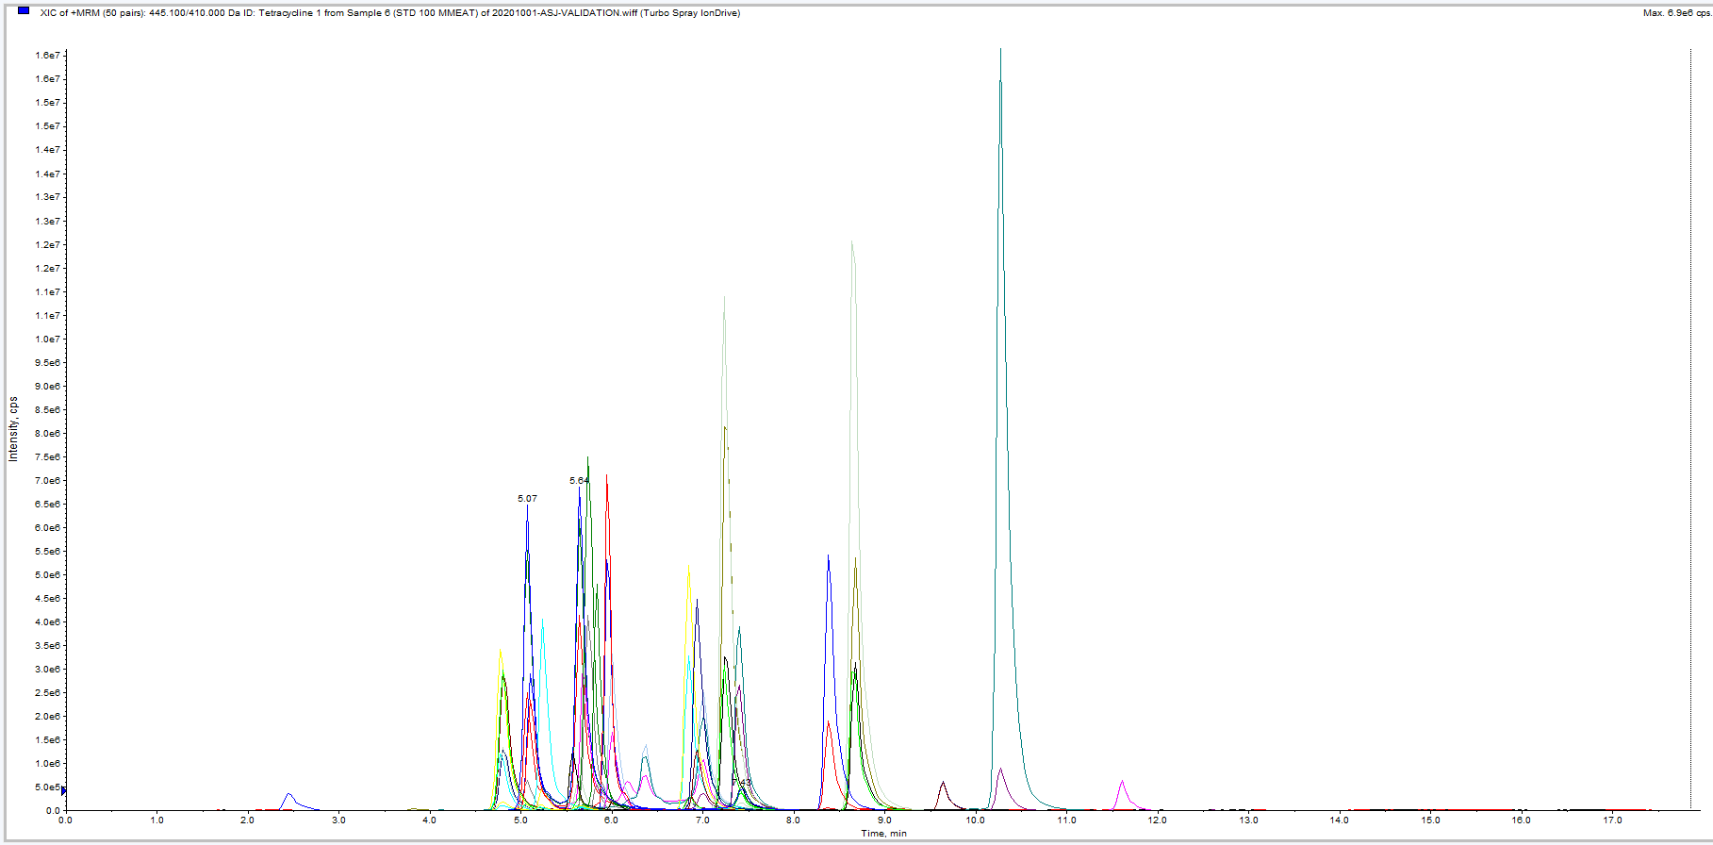

Figure S24: Total ion flow chromatogram of mixed standards

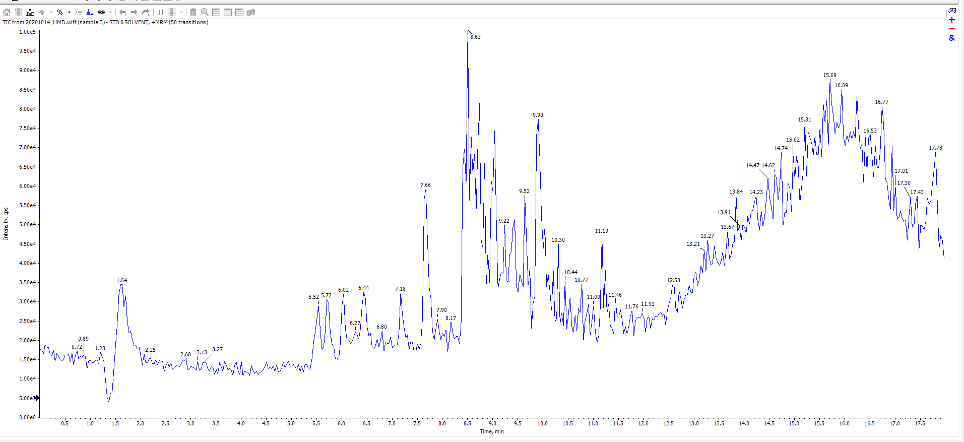

Figure S25: Total ion flow chromatogram of a blank sample

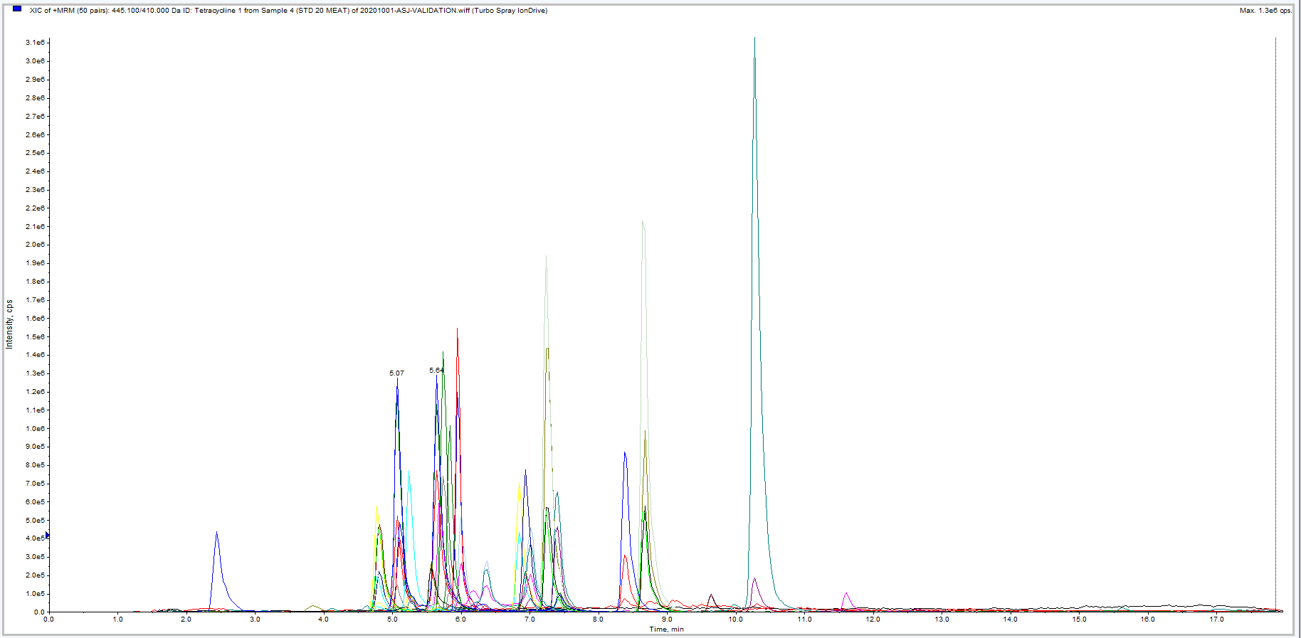

Figure S26: Total ion flow chromatogram for the minimum added concentration (20 μg/kg) of the 23 veterinary drug

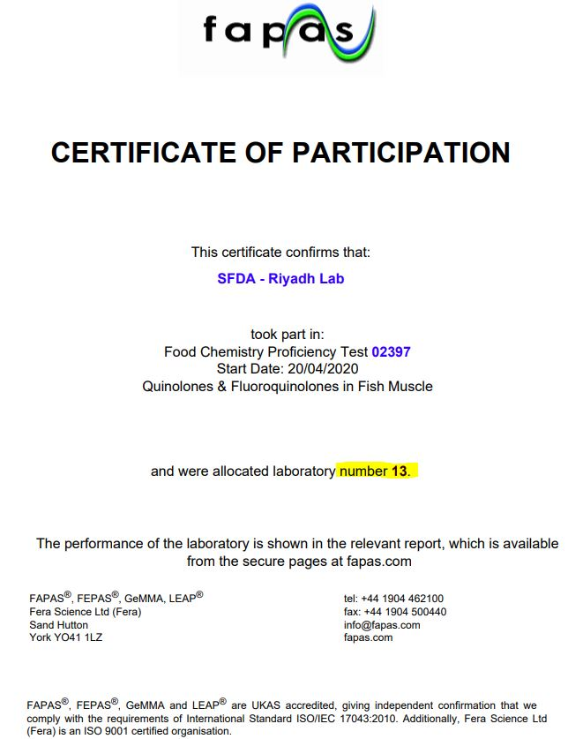

Figure S27: Certificate of participation in a proficiency test provided by fapas

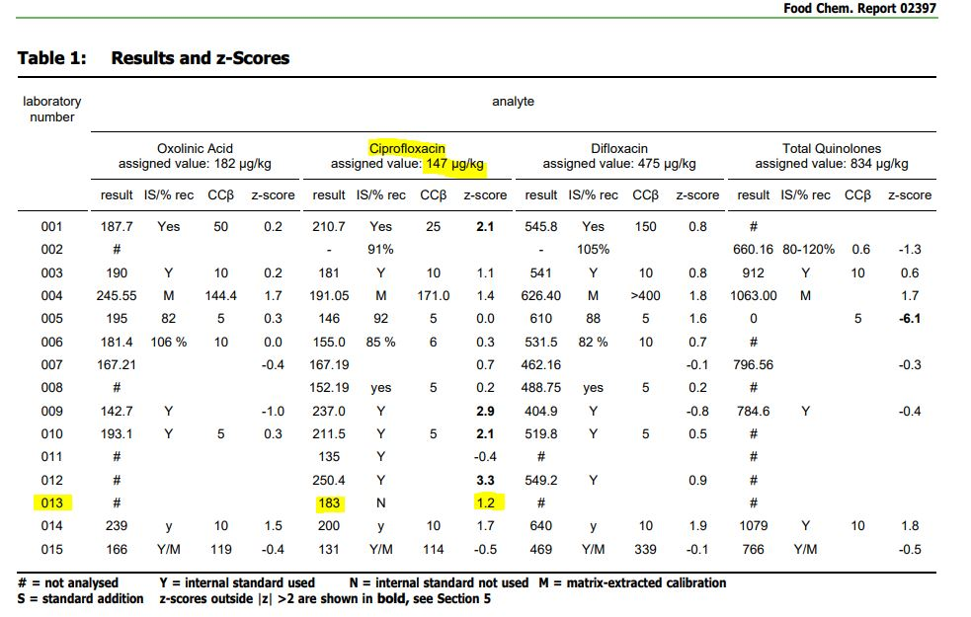

Figure S28: Laboratory performance in the proficiency test