**Selective removal of Cd(II), As(III), Pb(II) and Cr(III) ions from water resources using novel 2-anthracene ammonium-based magnetic ionic liquids**

Ahmed Abdi Hassana, Abdulkadir Tanimub,Saheed A. Ganiyua,b, Ibrahim Y. Yaagooba, Khalid Alhooshania,b*

aDepartment of Chemistry, King Fahd University of Petroleum and Minerals, Dhahran 31261, Saudi Arabia.

bCenter for Refining and Advanced Chemicals, Research Institute, King Fahd University of Petroleum and Minerals, Dhahran 31261, Saudi Arabia.

*Corresponding author

Email: hooshani@kfupm.edu.sa

Phone: +966 13 860 3065

Fax: +966 13 860 4277

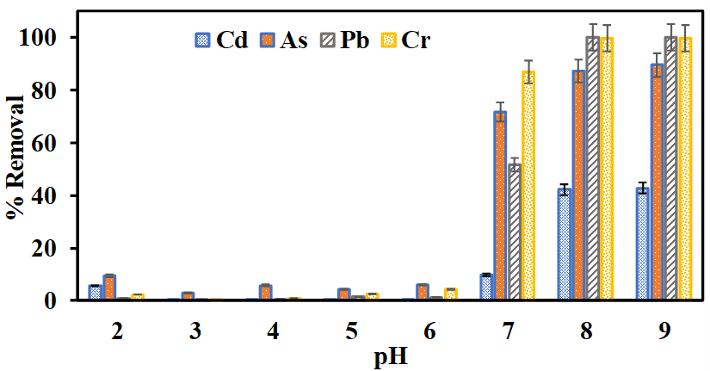

**Fig. SI-1** Effects of solution pH on the adsorption of the metal ions by [2-AA]CoCl3 MIL

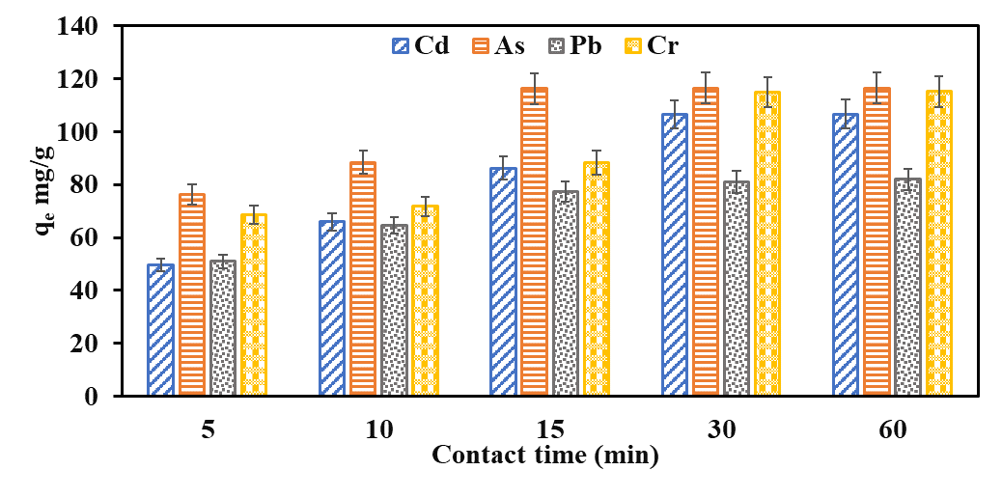

**Fig. SI-2** Effects of contact time on the adsorption of the heavy metal ions by [2-AA]CoCl3 MIL

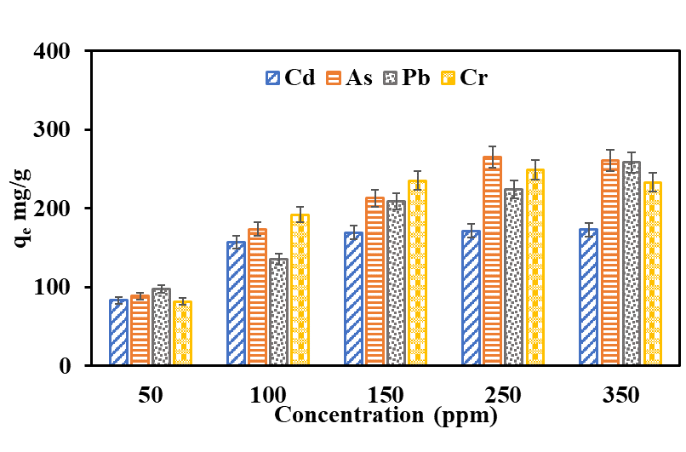

**Fig. SI-3** Effects of different initial concentrations of each of the targeted metal ions on their adsorption by [2-AA]CoCl3 MIL

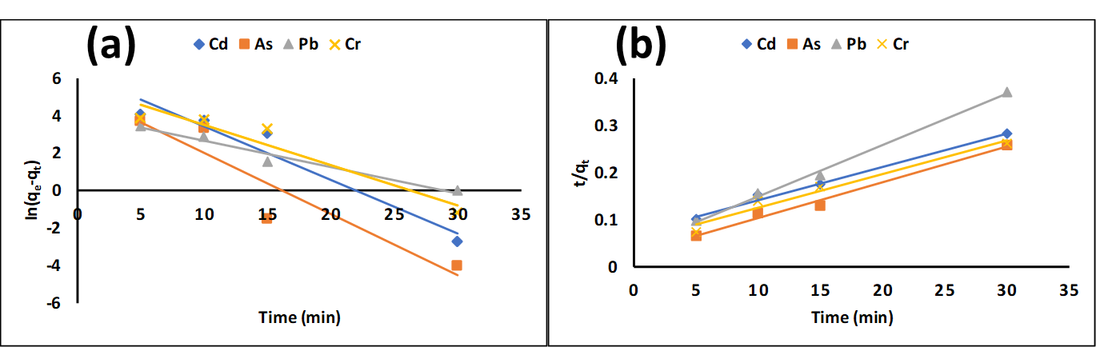**Fig. SI-4** (a) Pseudo-first order and (b) Pseudo-second order plots for the targeted metal ions adsorption on [2-AA]CoCl3 MIL

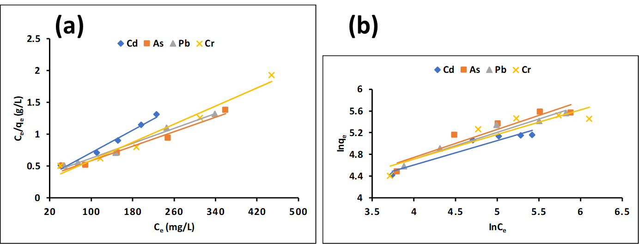

**Fig. SI-5** (a) Langmuir and (b) Freudlinch isotherms for the targeted metal ions adsorption on [2-AA]CoCl3 MIL

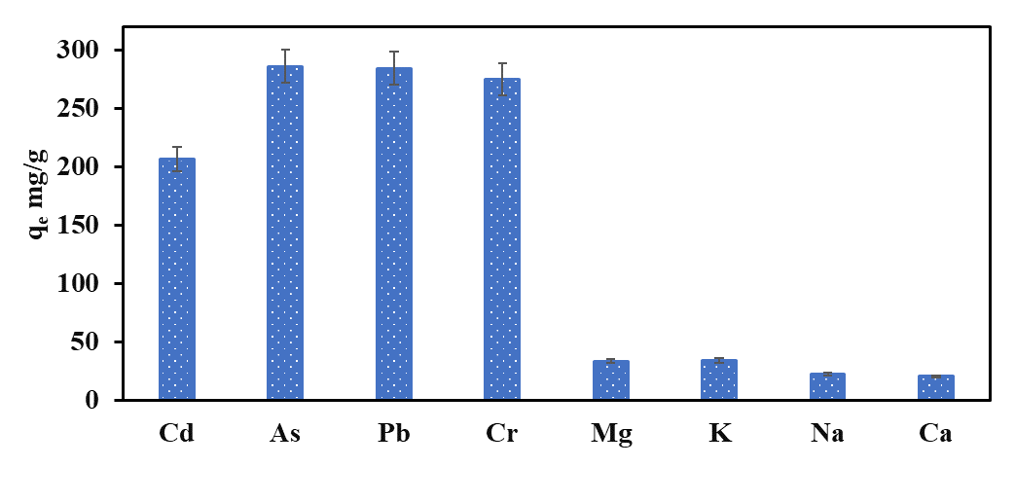

**Fig. SI-6** Selective adsorption of targeted metal ions by [2-AA]CoCl3 in a mixed component solution.



**Fig. SI-7** FTIR spectrum of the MIL before and after adsorption. .