***Supplementary Information***

**Enhanced Alcohol and H2O Adsorption and Separation Performances by Introducing pyridyl ligand in a MOF**

Chenxu Zhanga,1, Mingming Zhaia,1, Kangning Xiea,1, Yingchao Wanga, Xiuyuan Lib, Juan Liua, Yuanzhe Lia, Yanfei Huc, Erping Luoa,*and Chi Tanga,d*

aShaanxi Provincial Key Laboratory of Bioelectromagnetic Detection and Intelligent Perception, School of Biomedical Engineering, Air Force Medical University, Xi'an, 710032, P. R. China

bShaanxi Key Laboratory of Optoelectronic Functional Materials and Devices, School of Materials Science and Chemical Engineering, Xi'an Technological University, Xi'an, 710021, P. R. China

cDepartment Wide Bandgap Semiconductor Technology Disciplines State Key Laboratory, Institution School of Microelectronics, Xidian University, Xi’an, 710071, P. R. China

dShaanxi Provincial Key Laboratory of Bioelectromagnetic Detection and Intelligent Perception, Xi'an, 710032, P. R. China

*Corresponding authors:

E-mail: tangchi@fmmu.edu.cn; luoerping@fmmu.edu.cn.

1These authors contributed to the work equally and should be regarded as co-first authors

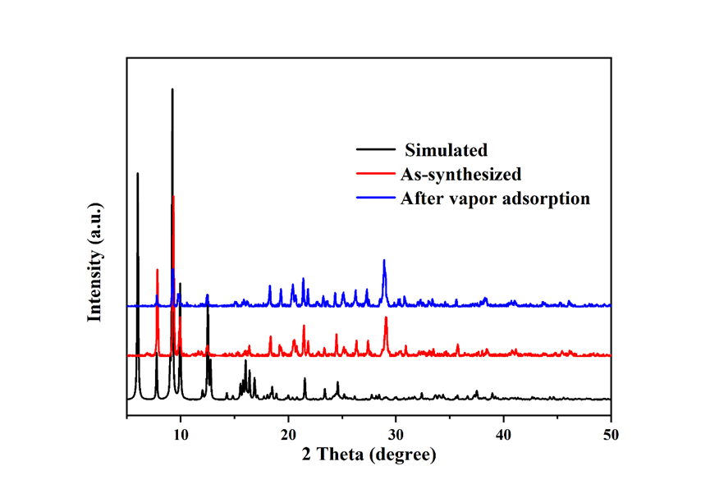

(a)

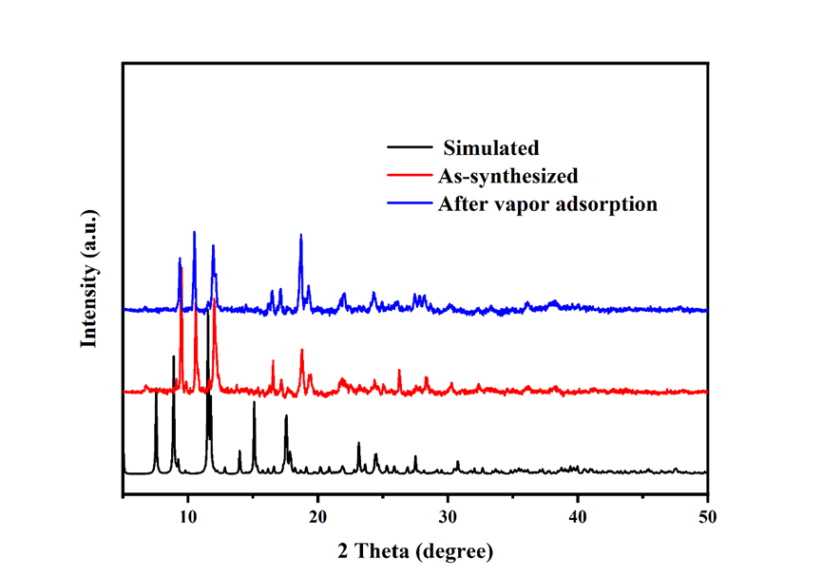

(b)

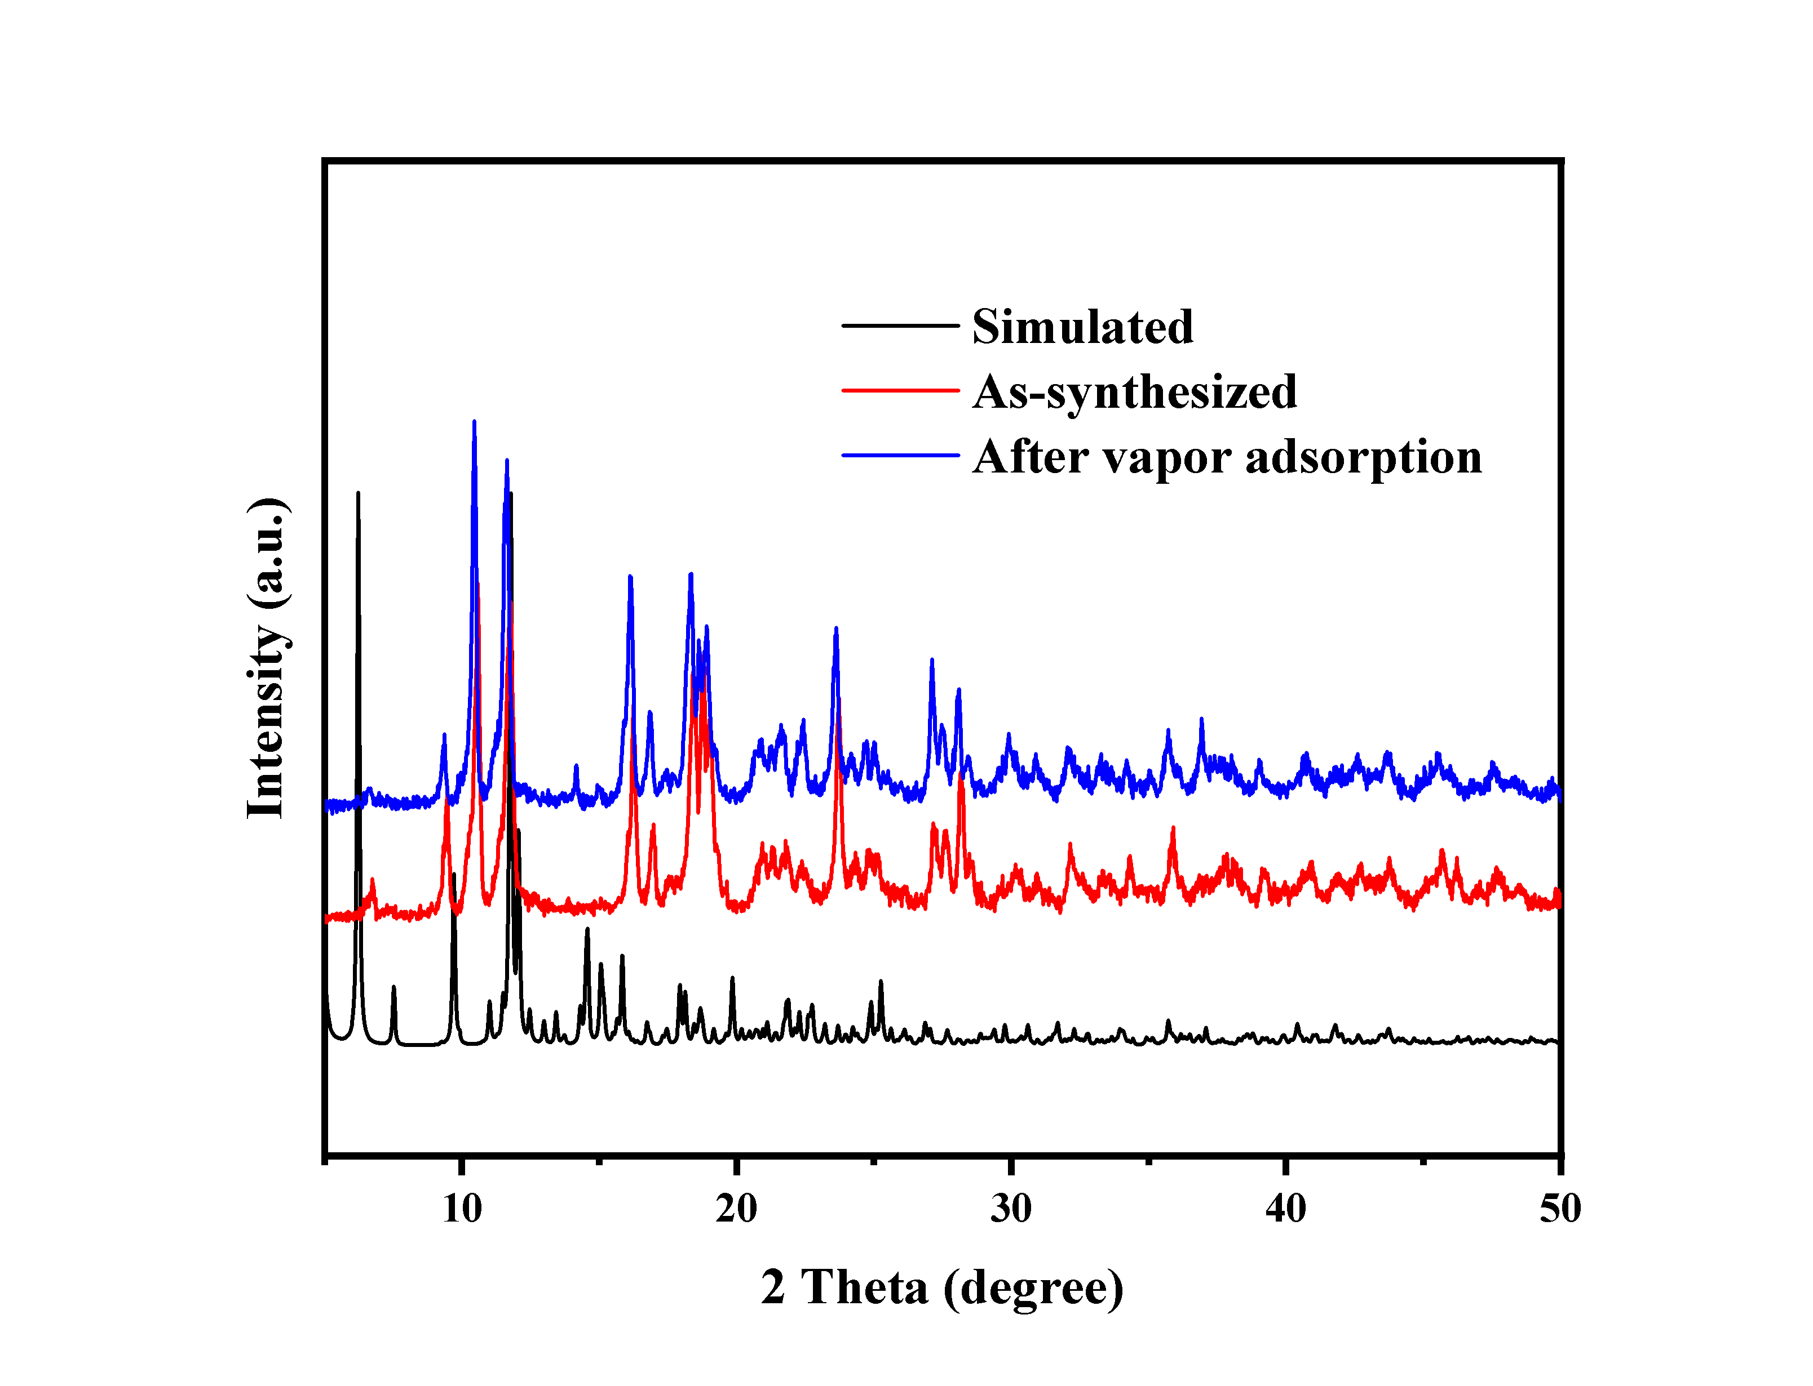

(c)

**Fig. S1** PXRD spectra of complex (a)**1,** (b)**2** and (c)**3**

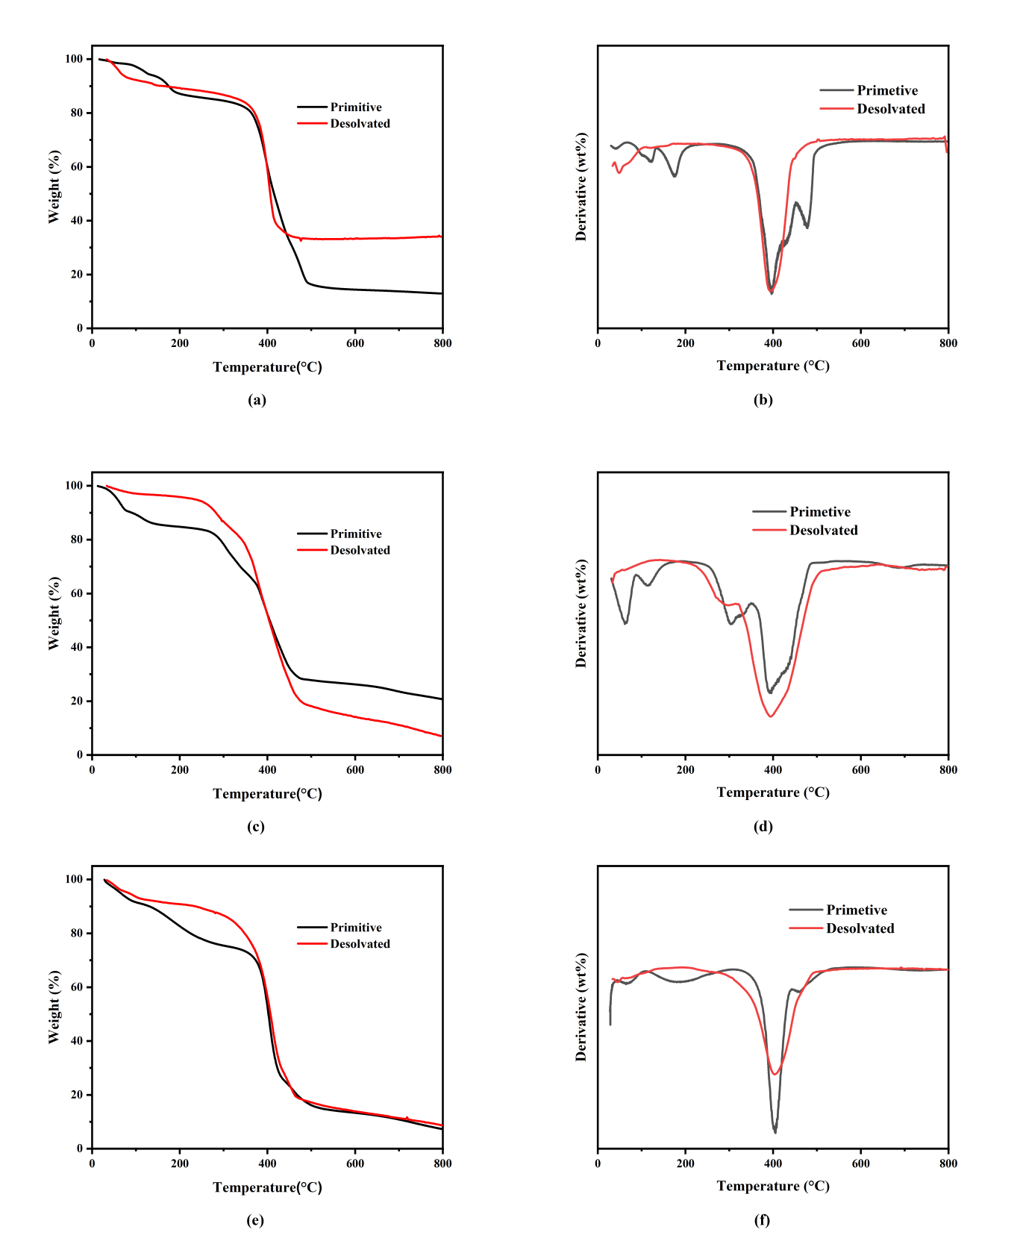

**Fig. S2** TG and DTG curves of (a,b)**1**, (c,d)**2** and (e,f)**3**

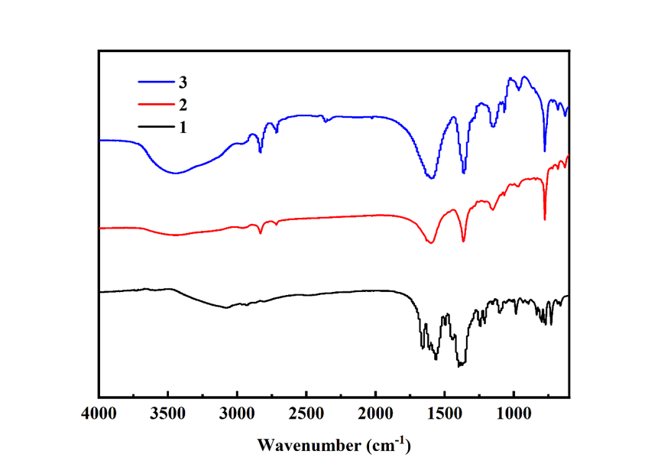

**Fig. S3** FT-IR spectrum of complex **1**, **2** and **3**

**Calculation of IAST using Langmuir-Freundlich (L-F) model**

Derived by Myers and Prausnitz[1], the Ideal Adsorption Solution Theory (IAST) is a method for predicting the adsorption equilibria for components in a mixture, using only single-component adsorption data at the same temperature and on the same adsorbent. IAST is based upon three assumptions: (i) that the same surface area is available to all adsorbates, (ii) that the adsorbent is inert, and (iii) that the multicomponent mixture behaves as an ideal solution (such that the mean strength of interaction is equal between all molecules of the solution) at constant spreading pressure and temperature.

Using a mathematical fitting of the single-component isotherms the mole fraction of each species in the adsorbed phase can be calculated by solving the expression

$$\int_{0}^{P∙y_{i}/x_{i}}{\frac{Isotherm fit for component i(P)}{P}}dp=\int_{0}^{P∙y_{j}/x_{j}}{\frac{Isotherm fit for component j(P)}{P}dp}$$

where *x*i and *y*i are the adsorbed and bulk phase mole fractions of component *i*, respectively, and *p* is the total pressure. To determine the amount adsorbed in the mixture, as opposed to the mole fraction, the following equation can be used:

$$\frac{1}{n_{total}}=\frac{x_{i}}{n_{i}^{0}}+\frac{x_{j}}{n_{j}^{0}}$$

where, at a given pressure, *n*total is the total number of moles adsorbed in the mixture and $n_{i}^{0}$ is the amount of pure component *i* adsorbed per gram of adsorbent.

The experimental isotherm data for pure H2O, MeOH and EtOH were fitted using a Single Site Langmuir-Freundlich (SSLF) or Double Site Langmuir-Freundlich (DSLF) model:

$$N=A\frac{B×pC}{1+B×pC}$$

Or:

$$N=A_{1}\frac{B_{1}×pC_{1}}{1+B_{1}×pC_{1}}+A_{2}\frac{B_{2}×pC_{2}}{1+B_{2}×PC_{2}}$$

Where, N is the adsorption amounts (mmol/g), p is the pressure (kPa), A is the saturation adsorption amount (mmol/g), B is the affinity coefficient (kPa-1 or kPa-C), and C is the Langmuir-Freundlich index (dimensionless). The corresponding parameters A, B and C can be obtained by the least square method, and the experimental adsorption isotherm data can be functionalized.

The adsorption selectivities for binary mixtures defined by:

$$S_{ads}=\frac{x_{A}∕x_{B}}{y_{A}∕y_{B}}$$

were respectively calculated using IAST. Where $x_{i}$ is the mole fraction of component *i* in the adsorbed phase and $y_{i}$ is the mole fraction of component *i* in the bulk.

**Table S1** Parameters obtained from DSLF model fitting of **1** adsorption isotherms at 293K

|  |  |  |  |
| --- | --- | --- | --- |
| **293 K** | **H2O** | **MeOH** | **EtOH** |
| **A1** | 9.0003e+02 | 4.0003e+02 | 2.9999e+02 |
| **A2** | 3.4823e+00 | 1.4798e+00 | 4.3059e-01 |
| **B1** | 8.3636e-06 | 5.1496e-08 | 9.0896e-04 |
| **B2** | 1.3494e+00 | 9.9746e-01 | 9.7088e-01 |
| **C1** | 7.1093e+00 | 4.7463e+00 | 6.4154e-01 |
| **C2** | 1.2011e+00 | 1.1552e+00 | 5.2288e-01 |
| **Chi^2** | 0.03449 | 3.1290 | 0.001310 |
| **R^2** | 0.9989 | 0.8526 | 0.9995 |

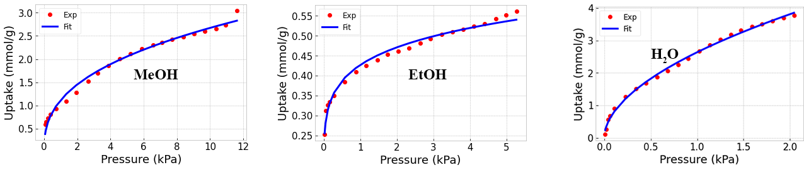

**Fig. S4.** Adsorption isotherms of **1** fitting by L-F model.

**Table S2** Parameters obtained from SSLF model fitting of **2** adsorption isotherms at 293K

|  |  |  |  |
| --- | --- | --- | --- |
| **293 K** | **H2O** | **MeOH** | **EtOH** |
| **A1** | 6.468815e+02 | 7.2215e+02 | 2.4753e+02 |
| **B1** | 4.088192e-03 | 1.5538e-03 | 1.7274e-03 |
| **C1** | 5.338894e-01 | 3.7844e-01 | 1.4230e-01 |
| **Chi^2** | 0.09902 | 0.2099 | 0.002982 |
| **R^2** | 0.9967 | 0.9833 | 0.9815 |

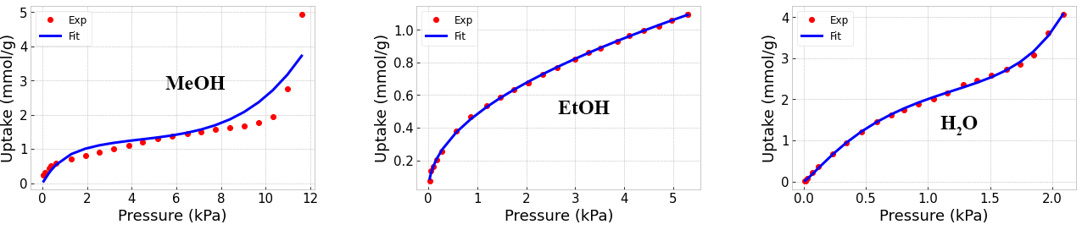

**Fig. S5.** Adsorption isotherms of **2** fitting by L-F model.

**Table S3** Parameters obtained from DSLF model fitting of **3** adsorption isotherms at 293K

|  |  |  |  |
| --- | --- | --- | --- |
| **293 K** | **H2O** | **MeOH** | **EtOH** |
| **A1** | 7.5000e+02 | 3.9942e+00 | 1.6938e+00 |
| **A2** | 9.2657e+00 | 1.7646e+02 | 8.8306e+00 |
| **B1** | 5.3969e-03 | 1.4133e-05 | 1.7639e+03 |
| **B2** | 1.4982e-07 | 7.1871e-03 | 3.6726e-01 |
| **C1** | 4.9362e-01 | 9.5176e+00 | 1.9260e+00 |
| **C2** | 2.3421e+01 | 2.7729e-01 | 1.6208e-01 |
| **Chi^2** | 365.2223 | 0.3796 | 0.0005828 |
| **R^2** | 0.9691 | 0.9970 | 0.9999 |



**Fig. S6.** Adsorption isotherms of **3** fitting by L-F model.

**Selectivity at different humidity**

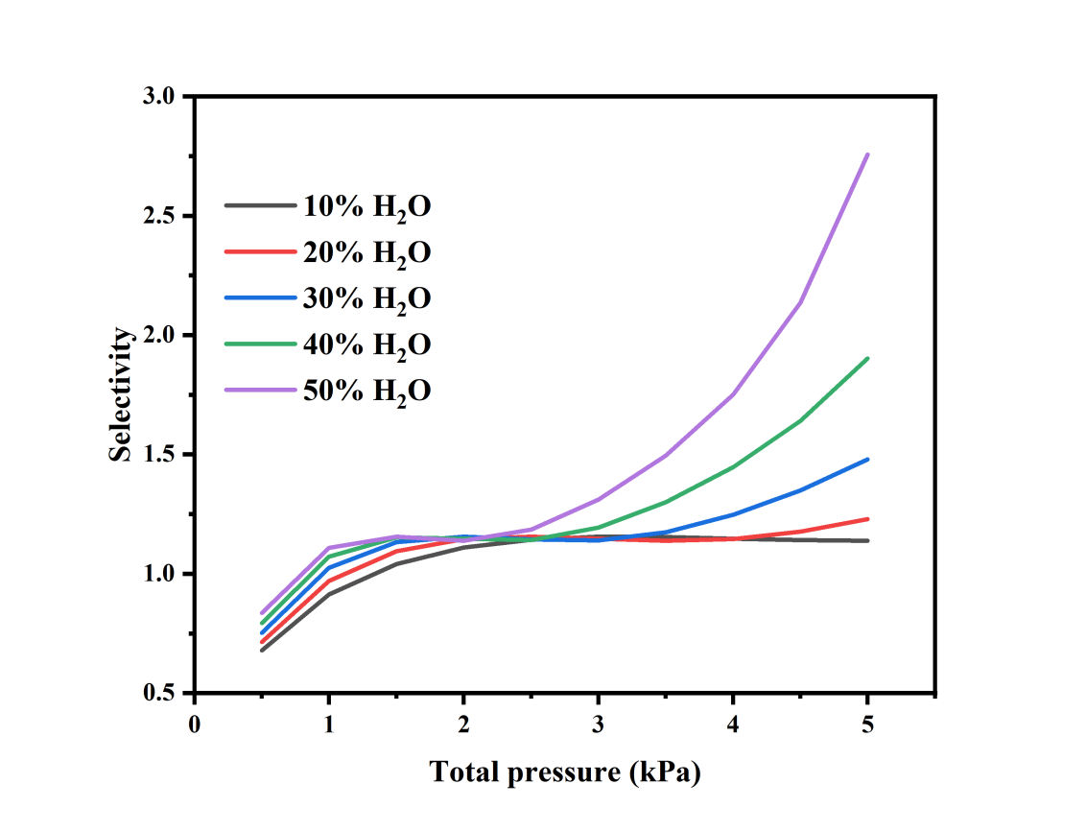

**(a)**

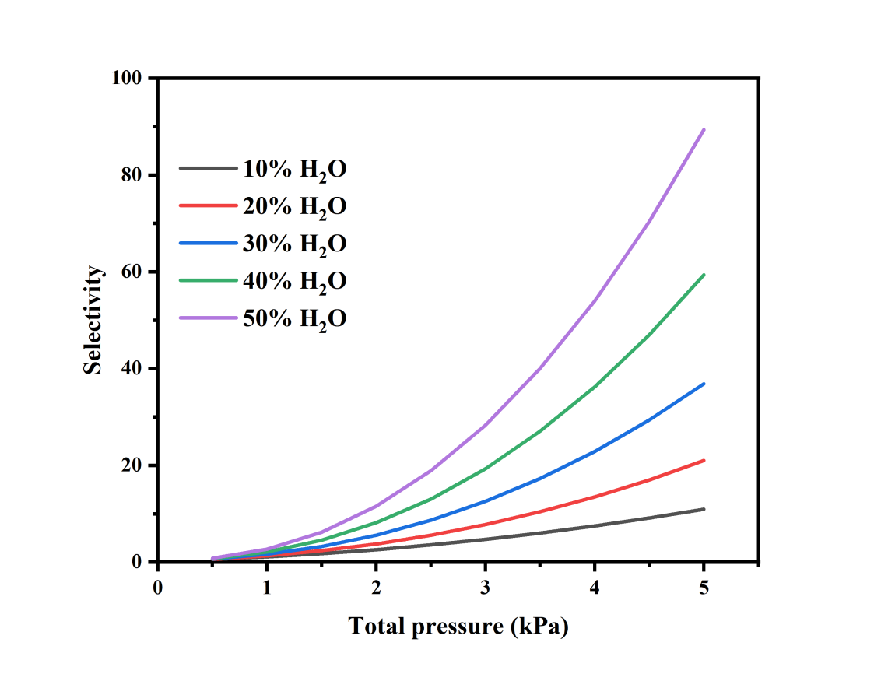

**(b)**

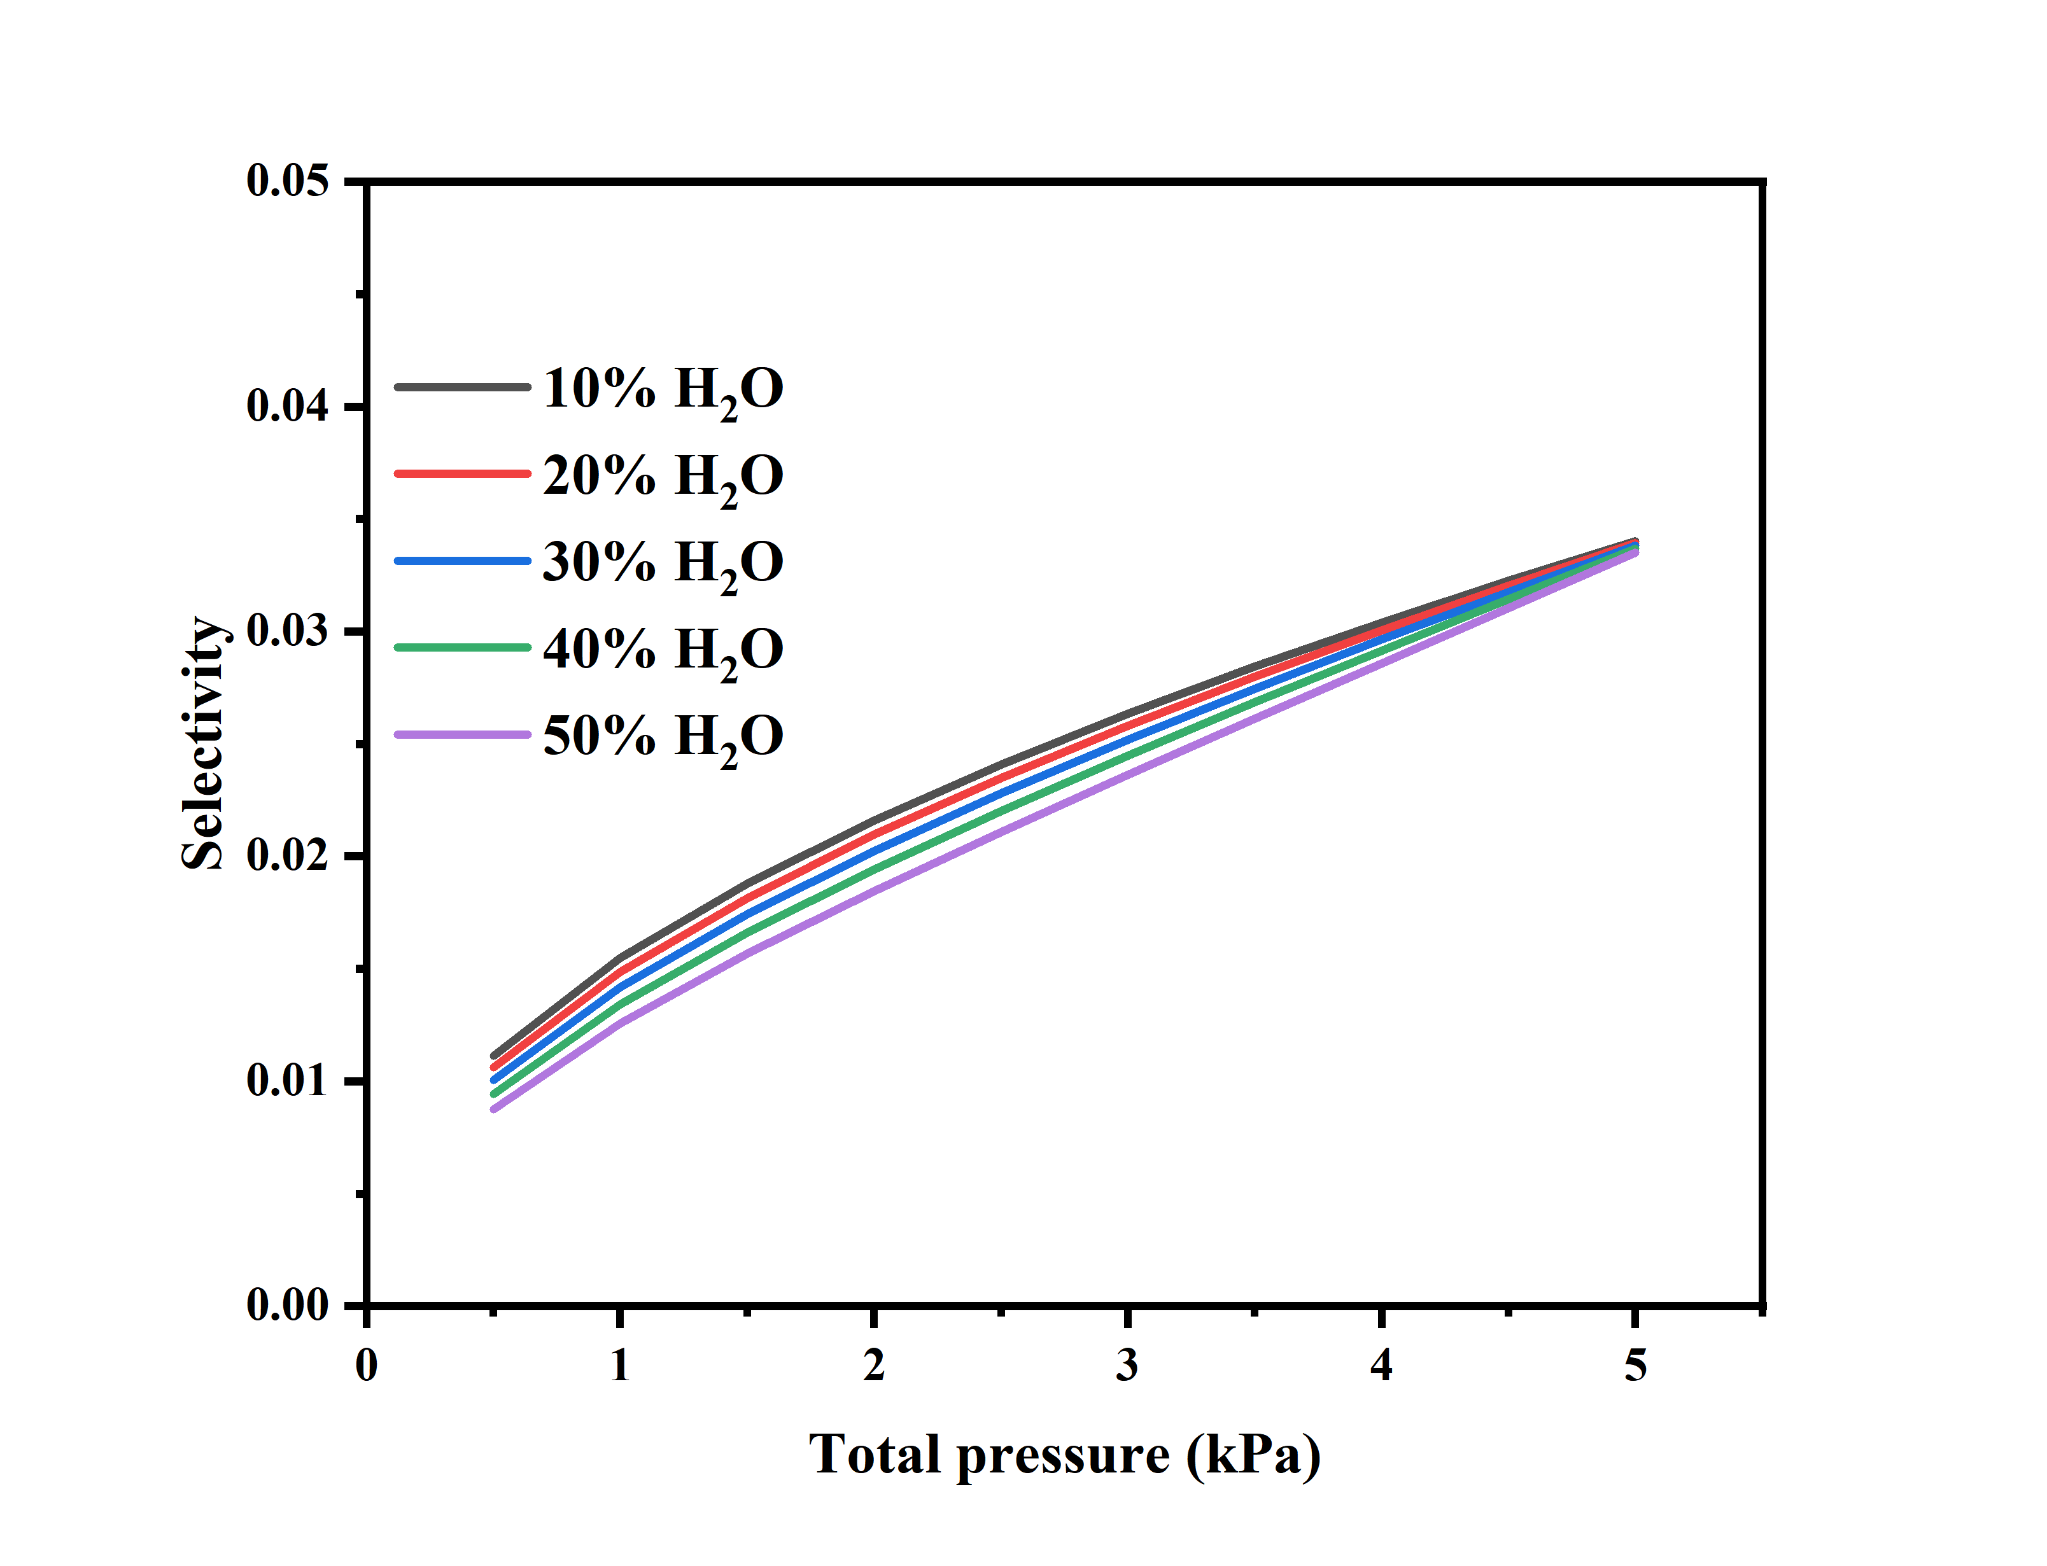

**(c)**

**Fig.S7** Selectivity at different humidity of (a)**1,** (b)**2** and (c)**3**

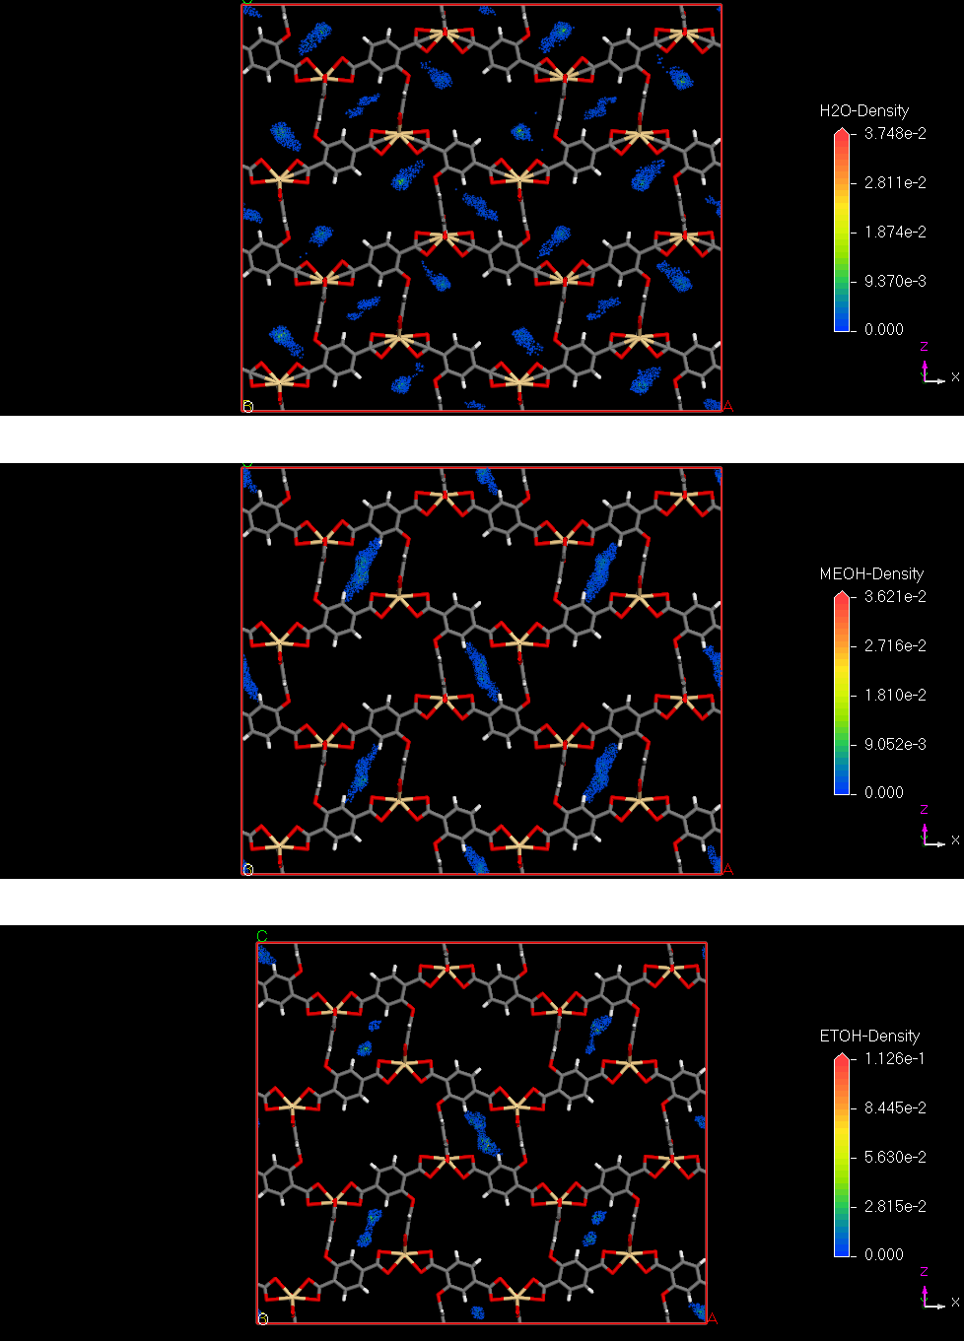

(a)

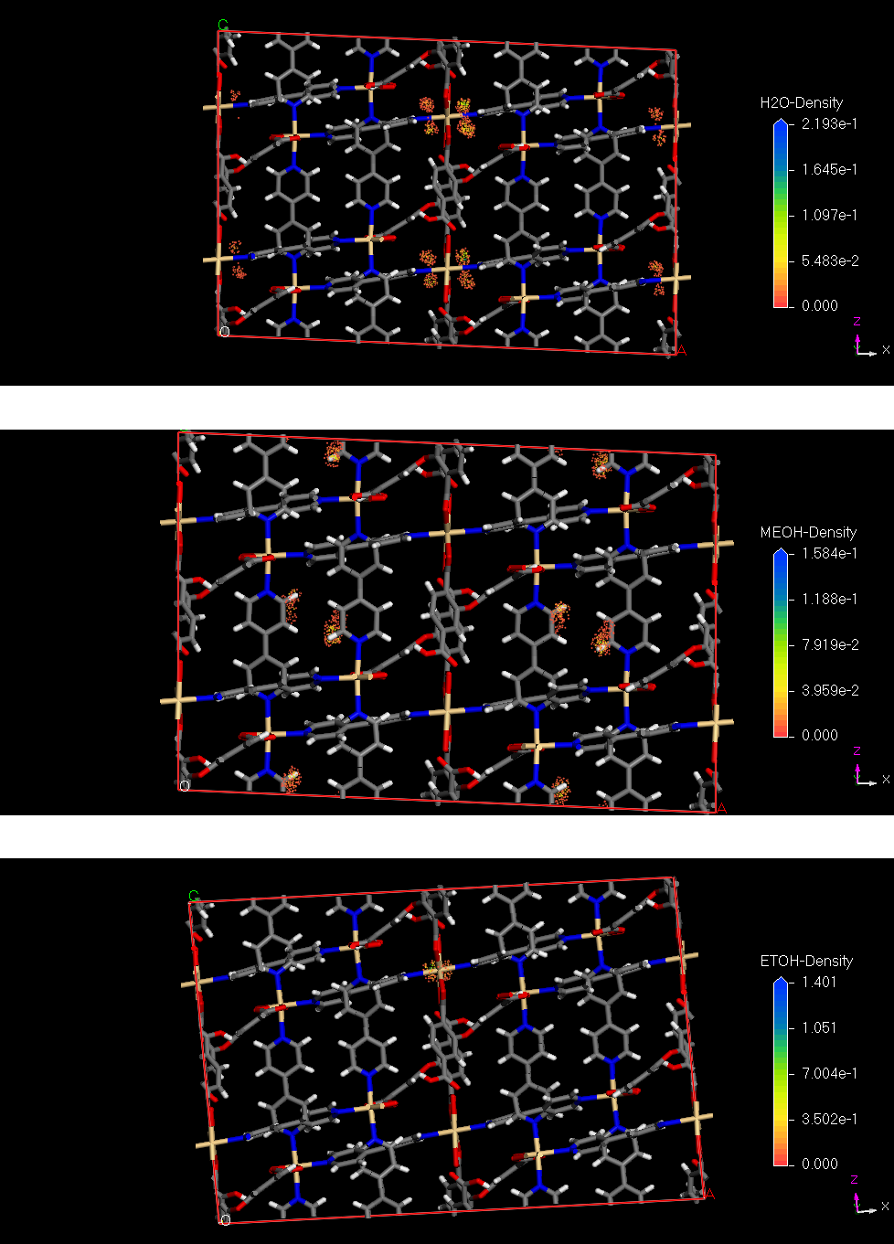

(b)

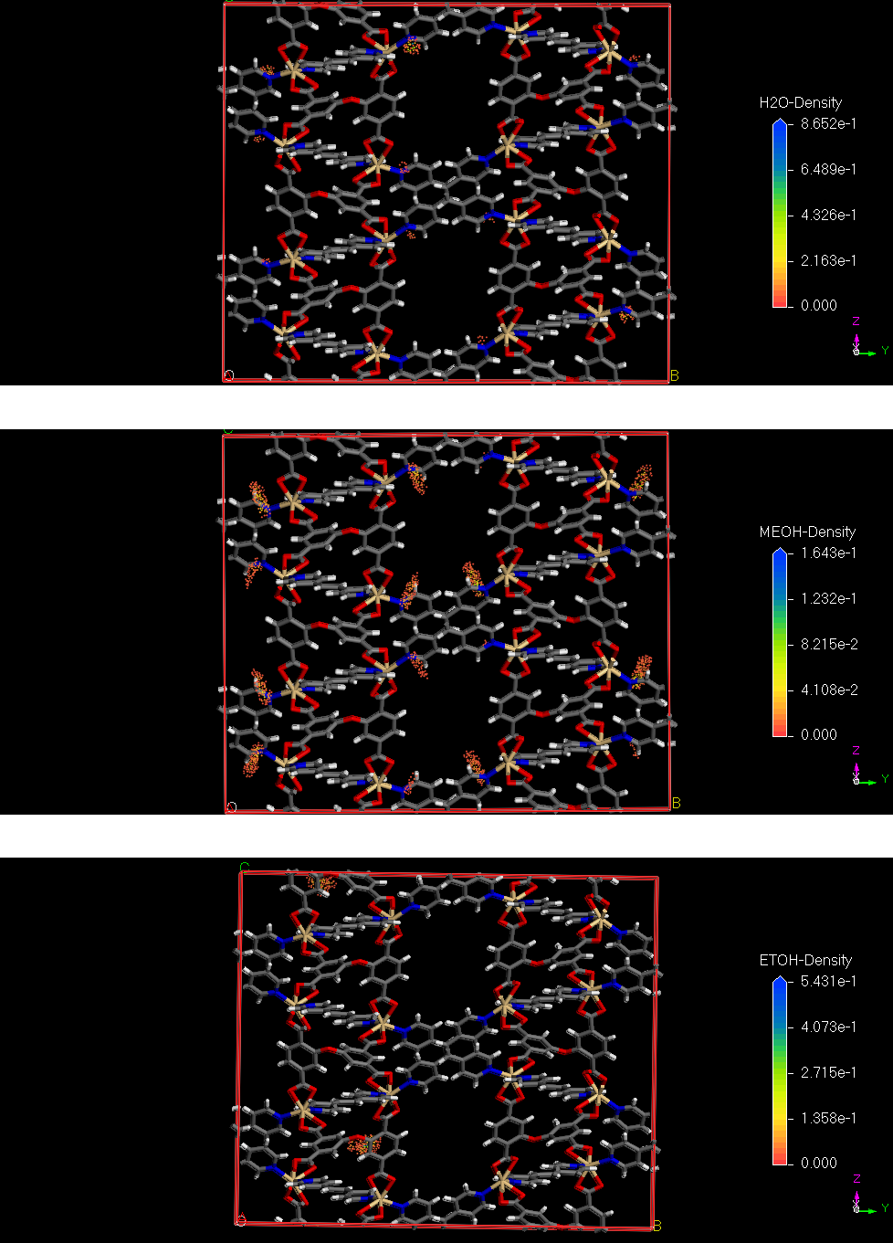

(c)

**Fig. S8** Adsorption density contours of H2O, MeOH and EtOH in channel of (a)**1**, (b)**2** and (c)**3** at 293 K

**GCMC Simulation Methodology**

Grand Canonical Monte Carlo (GCMC) simulations were performed to assess adsorption performance. The 2×2×2 supercell was used for the simulations. The partial charges for atoms of the framework were derived from QEq method [2]. All the parameters for atoms of **1**, **2** and **3** were modeled with the Universal forcefield [3,4]. A cutoff distance of 10Å was used for L-J interactions, and the Coulombic interactions were calculated by using Ewald summation. For each run, the 5 × 107 equilibration steps, 5×107 production steps were employed.

**Reference**

[1] A.L. Myers, J.M. Prausnitz, Thermodynamics of mixed-gas adsorption, AIChE Journal. 11 (1965) 121–127. https://doi.org/10.1002/AIC.690110125.

[2] A.K. Rappé, W.A. Goddard, Charge equilibration for molecular dynamics simulations, Journal of Physical Chemistry. 95 (2002) 3358–3363. https://doi.org/10.1021/J100161A070.

[3] C.J. Casewit, K.S. Colwell, A.K. Rappé, Application of a Universal Force Field to Main Group Compounds, Journal of the American Chemical Society. 114 (1992) 10046–10053. https://doi.org/10.1021/JA00051A042.

[4] M.A. Addicoat, N. Vankova, I.F. Akter, T. Heine, Extension of the universal force field to metal-organic frameworks, Journal of Chemical Theory and Computation. 10 (2014) 880–891. https://doi.org/10.1021/CT400952T/SUPPL_FILE/CT400952T_SI_001.PDF.