Supporting Information

**Synthesis of solar light driven nanorod-zinc oxide for degradation of rhodamine B, industrial effluent and contaminated river water**

Md. Shahidullah Mahmud1, Md. Jahir Raihan1, Md. Nazrul Islam1, Deepro Sanjid Qais1, Nilofar Asim2, Wan Azelee Wan Abu Bakar3, Md. Emran Quayum1, Md. Anwarul Islam1, Iqbal Mohammad Ibrahim Ismail4 and Ahsan Habib1*

1Department of Chemistry, University of Dhaka, Dhaka 1000, Bangladesh

2Solar Energy Research Institute, National University of Malaysia, 43600 Bangi, Selangor Darul Ehsan, Malaysia

3Department of Chemistry, Faculty of Science, Universiti Teknologi Malaysia, 81310 UTM, Johor Bahru, Johor, Malaysia

4The Center of Excellence in Environmental Studies and Department of Chemistry, King Abdulaziz University, Jeddah 21589, Saudi Arabia

-------------------------------------------------------------------

Corresponding author’s email: habibchem@du.ac.bd

Ahsan Habib, Department of Chemistry, University of Dhaka, Dhaka 1000, Bangladesh.

Email: habibchem@du.ac.bd; Tel.: +880-1779227863; Fax: +880-2-9661900



**Supplementary Figure S1**. Molecular structure (a) and UV-Vis absorption spectrum (b) of Rhodamine B (RB), 9-(2-Carboxyphenyl)-6-(diethylamino)-N,N-diethyl-3H-xanthen-3-iminium chloride (C28H31ClN2O3; M.Mass: 479.02).



Supplementary Figure S2. UV visible reflectance spectrum of (a) nanorod-ZnO and (b) commercial TiO2 (anatase) in determining band gap energy (*E*g).

Supplementary Figure S3. Analytical calibration curve for absorbance vs concentration of RB for determination of molar absorptivity.

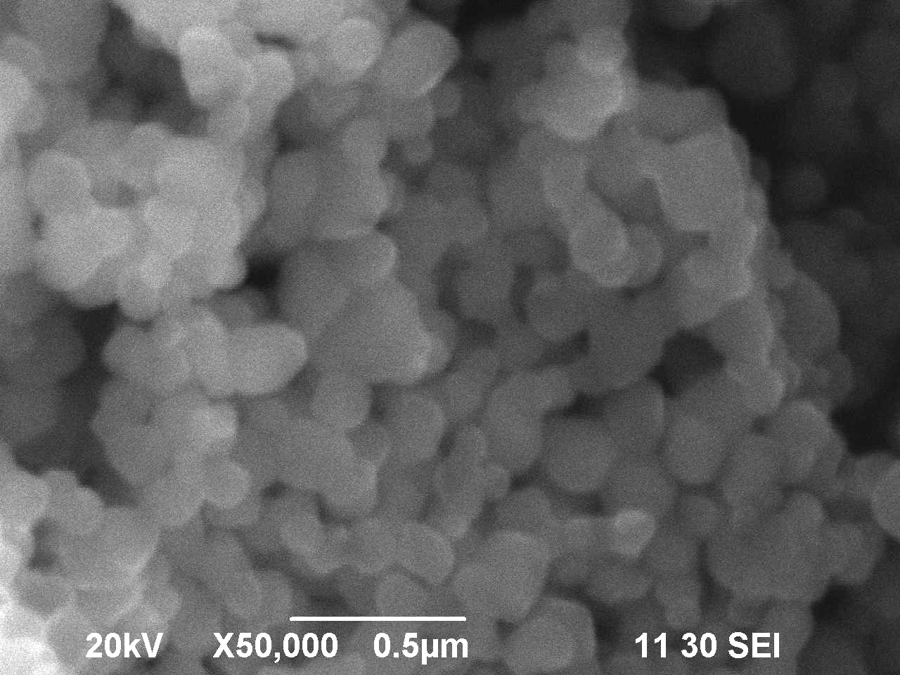

Supplementary Figure S4. SEM image of commercial TiO2 (anatase).



Supplementary Figure S5. EDS spectra of (a) nanorod-ZnO and (b) commercial TiO2 (anatase).



Supplementary Figure S6. A spectral pattern is generated when RB is degraded in the presence of (a) nanorod-ZnO (0.01g/50 mL) and (b) commercial TiO*2* (0.01g/50 mL) under solar light irradiation. [RB] = 2.00 × 10-5 M; Solution pH = 7.8.



Supplementary Figure S7. Photodegradation (%) of RB in the presence of 0.01g/50 mL of nanorod-ZnO and commercial TiO2 under solar light irradiation. [RB] = 2.00 × 10-5 M; Solution pH = 7.82.



Supplementary Figure S8. Overlay spectra of RB in presence of nanorod-ZnO at different time intervals in dark condition. [RB] = 2.00 × 10-5 M; Solution pH: 7.8.



Supplementary Figure S9. Overlay spectra of RB at different time intervals (0 min, 05 min, 10 min, 20 min, 30 min, 45 min, and 60 min) during photodegradation in presence of nanorod-ZnO under (a) UV light, (b) fluorescent light and (c) tungsten filament light.



Supplementary Figure S10. Degradation pattern of (a) untreated industrial effluent and (b) contaminated river water in the presence of nanorod-ZnO (0.2g/50 mL) under solar light irradiation.



Supplementary Figure S11. Photodegradation (%) of RB in the presence of sodium chloride under solar light irradiation. Nanorod-ZnO = 0.01g/50 mL; [RB] = 2.00 × 10-5 M; Solution pH = 7.82.

|  |  |  |  |
| --- | --- | --- | --- |
| Supplementary Table S1. Values of COD, DO, pH, absorbance and conductivity of untreated effluent and contaminated river water before and after photodegradation | | | |
|  | |  |  |
| Parameters | | Industrial effluent (Gazipur) | Contaminated river water  (Turag, Dhaka-Gazipur) |
| COD (mg/L) | Initial | 215.71 | 168.45 |
| Final | 144.13 | 65.55 |
| DO (mg/L) | Initial | 7.65 | 7.70 |
| Final | 7.55 | 7.59 |
| pH | Initial | 8.83 | 8.85 |
| Final | 7.77 | 7.86 |
| Absorbance | Initial | 0.314 | 0.153 |
| Final | 0.007 | 0.019 |
| Conductivity  (mS/cm) | Initial | 1.0 | 1.4 |
| Final | 1.1 | 1.6 |

|  |  |  |
| --- | --- | --- |
| Supplementary Table S2. Comparison of different types of surface area of nanorod-ZnO and commercial TiO2 (anatase) | | |
|  |  |  |
| Types of surface area | **Nanorod-ZnO** | **TiO2** |
| Single point surface area at P/Po, m²/g | 0.299/ 3.643 | 0.299/8.756 |
| BET Surface Area, m²/g | 3.7182 | 8.908 |
| Langmuir Surface Area | 5.424 | 12.963 |
| t-Plot Micropore Area, m²/g | 0.173 | 0.496 |
| t-Plot External Surface Area, m²/g | 3.544 | 8.412 |
| BJH Adsorption cumulative surface area of pores between 17.000 Å and 3000.000 Å width, m²/g | 3.815 | 9.138 |
| BJH Desorption cumulative surface area of pores between 17.000 Å and 3000.000 Å width, m²/g | 2.833 | 7.7033 |