**7.0 Supplementary Figures**

Supplementary figure 01: Process Flow Diagram of Black tea manufacturing

Green leaves plucking

Receiving of green leaves

Withering

Rolling

Dhool Extraction

Fermentation

Drying

Shifting

Black tea main grades

BMF

**Updated Figures**

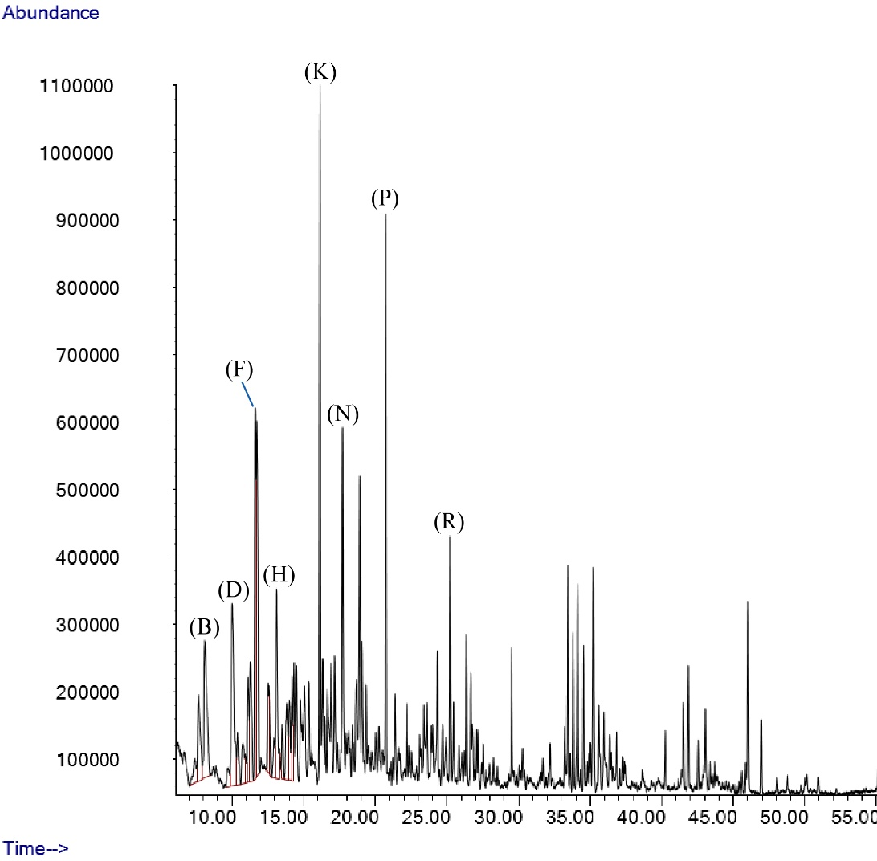

**Figure 1a**

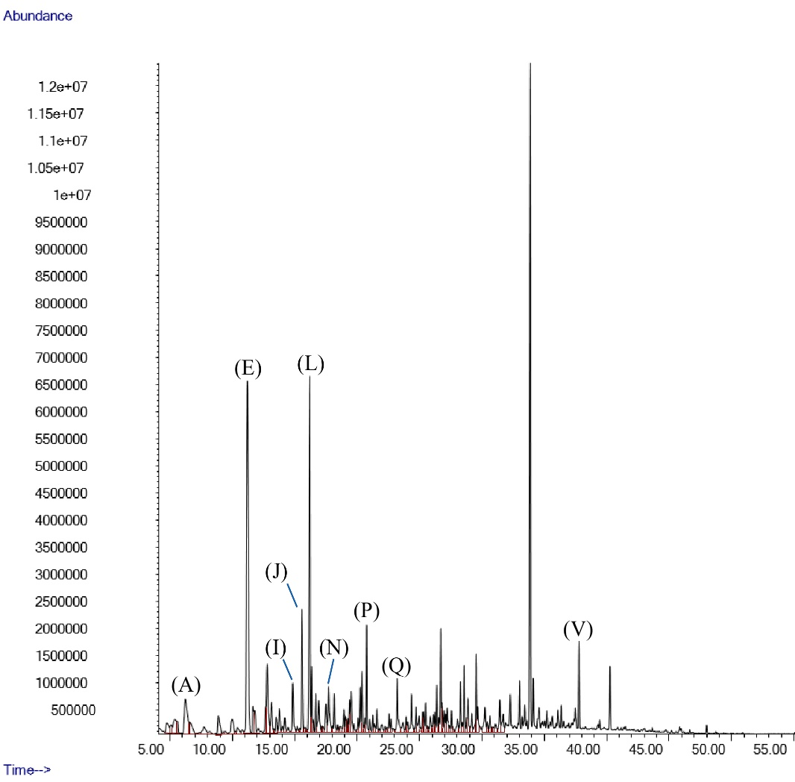

**Figure 1b**

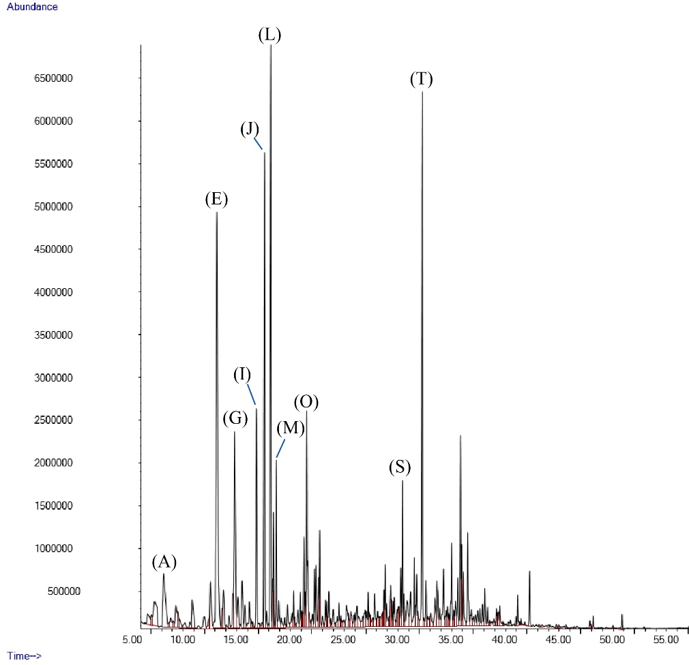

**Figure 1c**

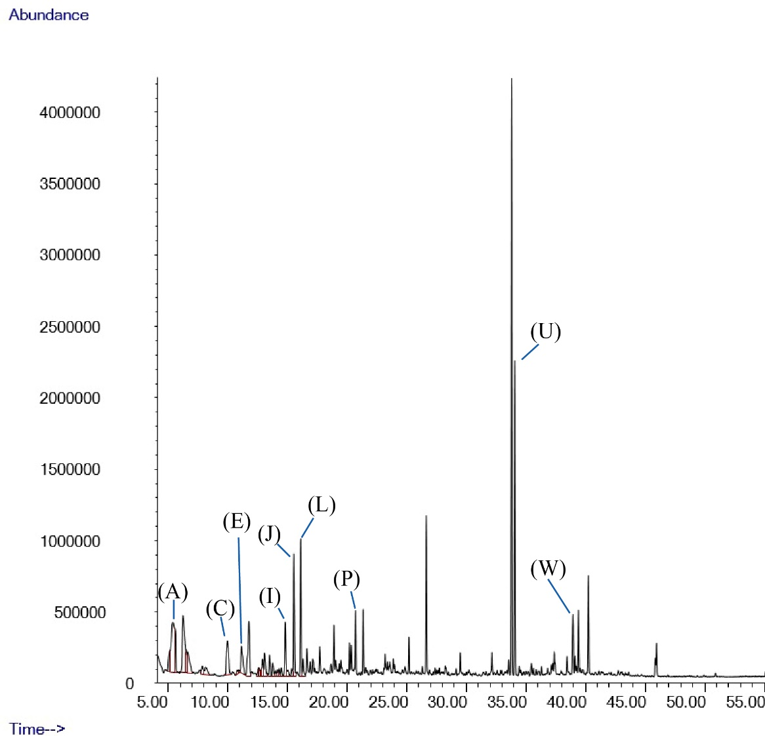

**Figure 1d**