**Supporting Information for**

**Arylnaphthalide Lignans from *Saussurea medusa* and their anti-inflammatory activities**

Jing-Ya Caoa,b, Qi Donga, Zhi-Yao Wangc, Ye Zhaod, Yu Rend, Chang Liud, Jun Danga, Rui-Tao Yua,*, and Yan-Duo Tao a,*

aQinghai Provincial Key Laboratory of Tibetan Medicine Research; Key Laboratory of Tibetan Medicine Research, Northwest Institute of Plateau Biology, Chinese Academy of Sciences, Xining 810008, PR China

bUniversity of Chinese Academy of Sciences, No. 19A Yuquan Road, Beijing 100049, PR China

cHenan Academy of Science, Zhengzhou 450002, PR China

dState Key Laboratory of Drug Research, Shanghai Institute of Materia Medica, Chinese Academy of Sciences, 555 Zuchongzhi Road, Shanghai 201203, PR China

**Contents**

Table S1. Re-optimized conformers, energies and proportions for 7*R*,8*S*,8'*S*-1 36

Table S2. Re-optimized conformers, energies and proportions for 7*S*,8*S*,8'*S*-2 38

Table S3. Re-optimized conformers, energies and proportions for 7*R*,8*R*,7'*R*,8'*R*-4 41

Figure S1. 1H NMR spectrum of compound 1 in CD3OD 44

Figure S2. 13C NMR spectrum of compound 1 in CD3OD 45

Figure S3. HSQC spectrum of compound 1 in CD3OD 46

Figure S4. HMBC spectrum of compound 1 in CD3OD 47

Figure S5. 1H–1H COSY spectrum of compound 1 in CD3OD 48

Figure S6. ROESY spectrum of compound 1 in CD3OD 49

Figure S7. (+)-ESIMS spectrum of compound 1 50

Figure S8. (-)-ESIMS spectrum of compound 1 51

Figure S9. (+)-HRESIMS spectrum of compound 1 52

Figure S10. IR spectrum of compound 1 53

Figure S11. UV spectrum of compound 1 54

Figure S12. 1H NMR spectrum of compound 2 in CD3OD 55

Figure S13. 13C NMR spectrum of compound 2 in CD3OD 56

Figure S14. HSQC spectrum of compound 2 in CD3OD 57

Figure S15. HMBC spectrum of compound 2 in CD3OD 58

Figure S16. 1H–1H COSY spectrum of compound 2 in CD3OD 59

Figure S17. ROESY spectrum of compound 2 in CD3OD 60

Figure S18. (-)-ESIMS spectrum of compound 2 61

Figure S19. (+)-HRESIMS spectrum of compound 2 62

Figure S20. IR spectrum of compound 2 63

Figure S21. UV spectrum of compound 2 64

Figure S22. 1H NMR spectrum of compound 3 in CD3OD 65

Figure S23. 13C NMR spectrum of compound 3 in CD3OD 66

Figure S24. HSQC spectrum of compound 3 in CD3OD 67

Figure S25. HMBC spectrum of compound 3 in CD3OD 68

Figure S26. 1H–1H COSY spectrum of compound 3 in CD3OD 69

Figure S27. (+)-ESIMS spectrum of compound 3 70

Figure S28. (-)-ESIMS spectrum of compound 3 71

Figure S29. (+)-HRESIMS spectrum of compound 3 72

Figure S30. IR spectrum of compound 3 73

Figure S31. UV spectrum of compound 3 74

Figure S32. 1H NMR spectrum of compound 4(4a/4b) in CDCl3 75

Figure S33. 13C NMR spectrum of compound 4(4a/4b) in CDCl3 76

Figure S34. HSQC spectrum of compound 4(4a/4b) in CDCl3 77

Figure S35. HMBC spectrum of compound 4(4a/4b) in CDCl3 78

Figure S36. 1H–1H COSY spectrum of compound 4(4a/4b) in CDCl3 79

Figure S37. ROESY spectrum of compound 4 (4a/4b) in CDCl3 80

Figure S38. (-)-ESIMS spectrum of compound 4 (4a/4b) 81

Figure S39. (+)-HRESIMS spectrum of compound 4 (4a/4b) 82

Figure S40. IR spectrum of compound 4 (4a/4b) 83

Figure S41. UV spectrum of compound 4 (4a/4b) 84

Experimental Section 85

Supplementary References 86

**Table S1. Re-optimized conformers, energies and proportions for 7*R*,8*S*,8'*S*-1**

|  |  |  |  |  |
| --- | --- | --- | --- | --- |
| Number | Conformer | Energy (hartree) | Energy (Kcal/mol) | Proportion (%) |
| 1 |  | -1302.863047 | -817558.7972 | 33.49 |
| 2 |  | -1302.86278 | -817558.6296 | 25.23 |
| 3 |  | -1302.862316 | -817558.3385 | 15.43 |
| 4 |  | -1302.862312 | -817558.336 | 15.36 |
| 5 |  | -1302.861726 | -817557.9682 | 8.25 |
| 6 |  | -1302.859687 | -817556.6887 | 0.95 |
| 7 |  | -1302.858852 | -817556.1648 | 0.39 |
| 8 |  | -1302.858445 | -817555.9094 | 0.25 |
| 9 |  | -1302.858374 | -817555.8648 | 0.24 |
| 10 |  | -1302.857857 | -817555.5404 | 0.14 |
| 11 |  | -1302.85759 | -817555.3729 | 0.10 |
| 12 |  | -1302.857097 | -817555.0635 | 0.06 |
| 13 |  | -1302.856748 | -817554.8445 | 0.04 |
| 14 |  | -1302.856616 | -817554.7617 | 0.04 |
| 15 |  | -1302.856435 | -817554.6481 | 0.03 |

**Table S2. Re-optimized conformers, energies and proportions for 7*S*,8*S*,8'*S*-2**

|  |  |  |  |  |
| --- | --- | --- | --- | --- |
| Number | Conformer | Energy (hartree) | Energy (Kcal/mol) | Proportion (%) |
| 1 |  | -1302.862978 | -817558.7539 | 57.23 |
| 2 |  | -1302.861331 | -817557.7204 | 9.98 |
| 3 |  | -1302.861278 | -817557.6871 | 9.44 |
| 4 |  | -1302.86092 | -817557.4625 | 6.46 |
| 5 |  | -1302.860791 | -817557.3815 | 5.63 |
| 6 |  | -1302.860682 | -817557.3131 | 5.02 |
| 7 |  | -1302.859835 | -817556.7816 | 2.04 |
| 8 |  | -1302.859802 | -817556.7609 | 1.97 |
| 9 |  | -1302.859625 | -817556.6498 | 1.64 |
| 10 |  | -1302.857686 | -817555.4331 | 0.21 |
| 11 |  | -1302.857279 | -817555.1777 | 0.14 |
| 12 |  | -1302.857228 | -817555.1457 | 0.13 |
| 13 |  | -1302.856288 | -817554.5558 | 0.05 |
| 14 |  | -1302.855855 | -817554.2841 | 0.03 |
| 15 |  | -1302.855854 | -817554.2835 | 0.03 |
| 16 |  | -1302.855047 | -817553.7771 | 0.01 |

**Table S3. Re-optimized conformers, energies and proportions for 7*R*,8*R*,7'*R*,8'*R*-4**

|  |  |  |  |  |
| --- | --- | --- | --- | --- |
| Number | Conformer | Energy (hartree) | Energy (Kcal/mol) | Proportion (%) |
| 1 |  | -1379.095304 | -865395.2543 | 19.60 |
| 2 |  | -1379.095047 | -865395.0931 | 14.92 |
| 3 |  | -1379.094947 | -865395.0303 | 13.42 |
| 4 |  | -1379.09477 | -865394.9193 | 11.13 |
| 5 |  | -1379.094763 | -865394.9149 | 11.04 |
| 6 |  | -1379.09439 | -865394.6808 | 7.44 |
| 7 |  | -1379.093852 | -865394.3432 | 4.20 |
| 8 |  | -1379.093782 | -865394.2993 | 3.90 |
| 9 |  | -1379.093668 | -865394.2277 | 3.46 |
| 10 |  | -1379.093661 | -865394.2233 | 3.43 |
| 11 |  | -1379.09366 | -865394.2227 | 3.43 |
| 12 |  | -1379.093431 | -865394.079 | 2.69 |
| 13 |  | -1379.091814 | -865393.0643 | 0.48 |
| 14 |  | -1379.091526 | -865392.8836 | 0.36 |
| 15 |  | -1379.091176 | -865392.664 | 0.25 |
| 16 |  | -1379.091158 | -865392.6527 | 0.24 |

**Figure S1. 1H NMR spectrum of compound 1 in CD3OD**

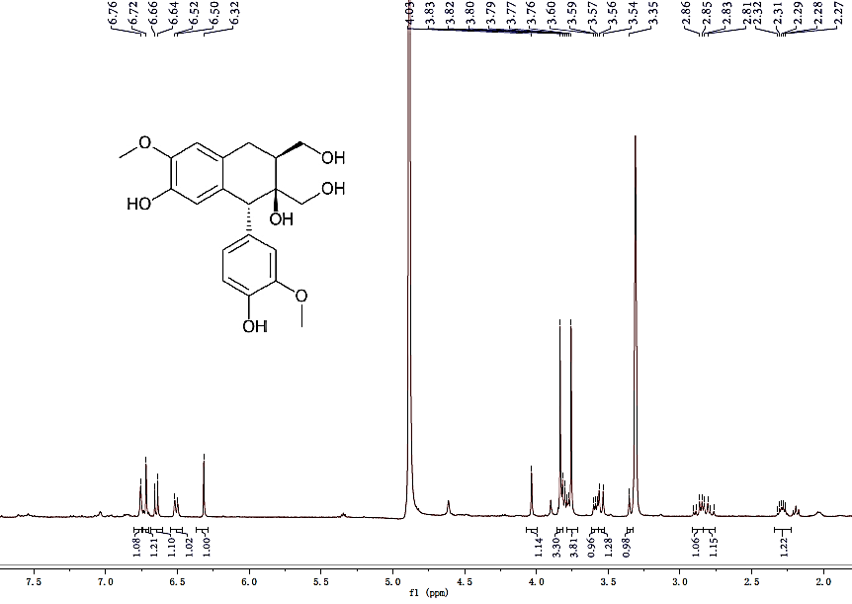

**Figure S2. 13C NMR spectrum of compound 1 in CD3OD**

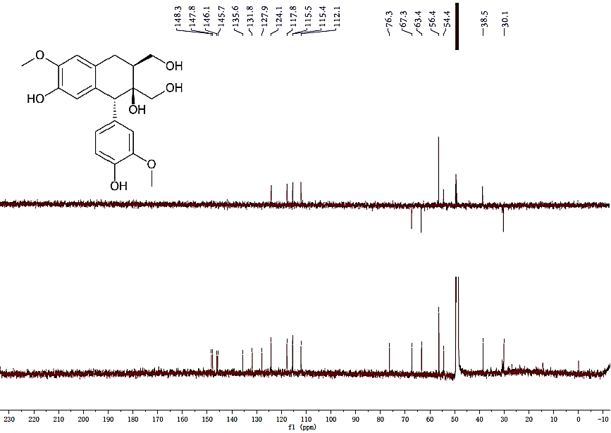

**Figure S3. HSQC spectrum of compound 1 in CD3OD**

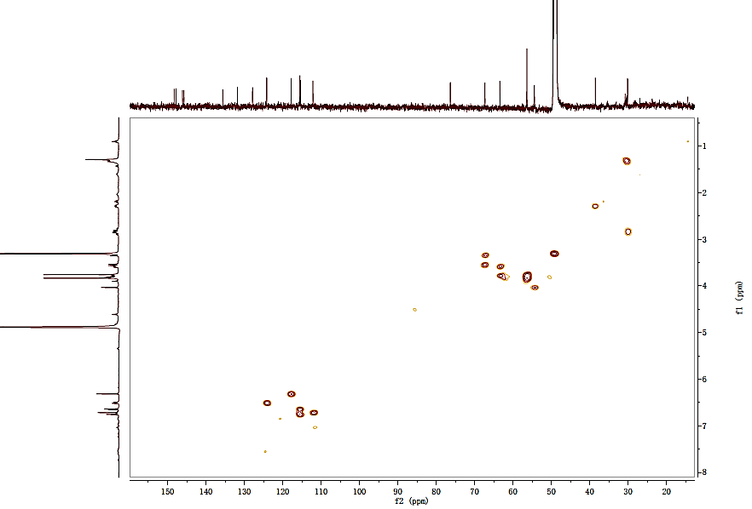

**Figure S4. HMBC spectrum of compound 1 in CD3OD**

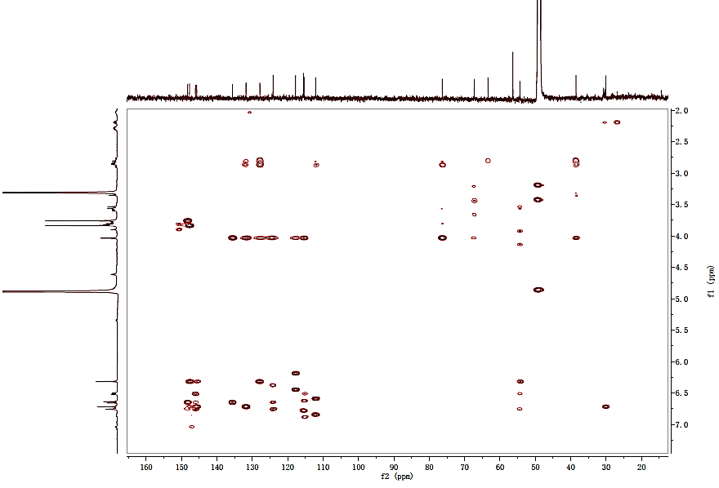

**Figure S5. 1H–1H COSY spectrum of compound 1 in CD3OD**

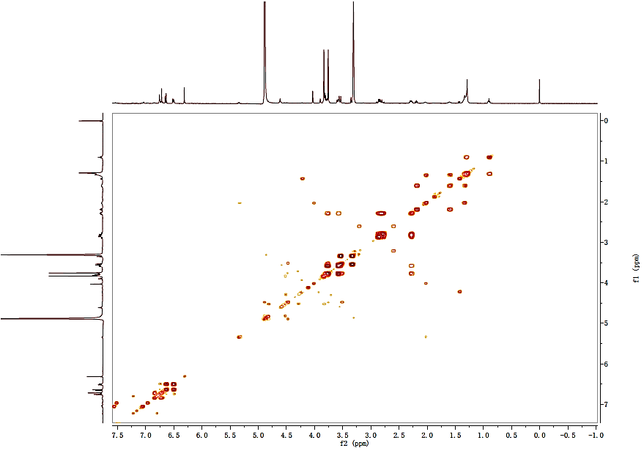

**Figure S6. ROESY spectrum of compound 1 in CD3OD**

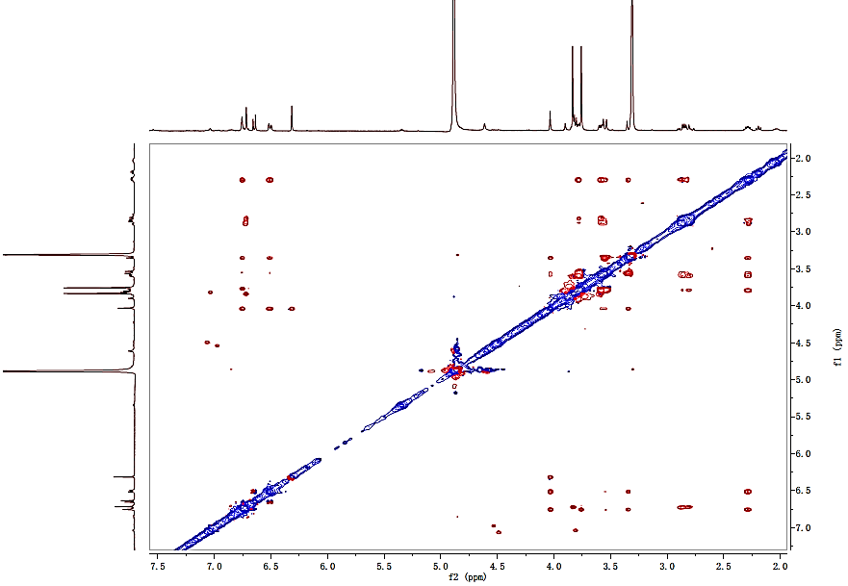

**Figure S7. (+)-ESIMS spectrum of compound 1**

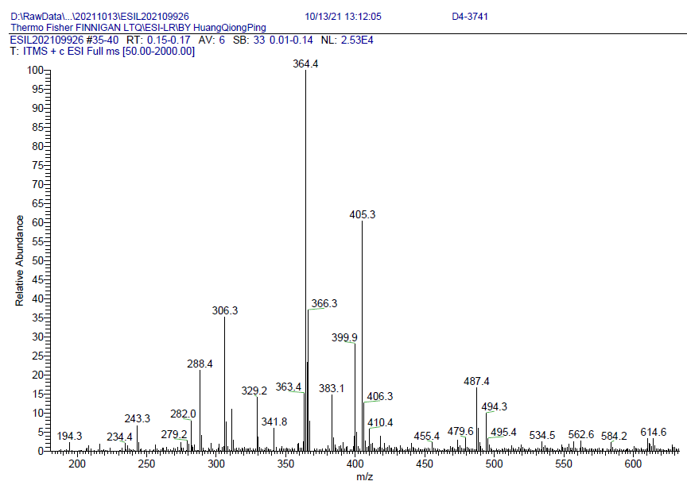

**Figure S8. (-)-ESIMS spectrum of compound 1**

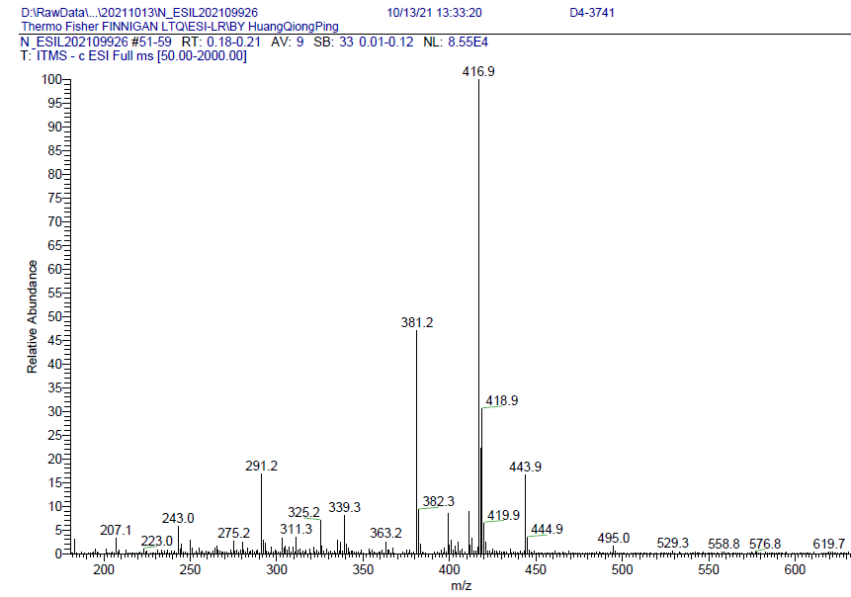

**Figure S9. (+)-HRESIMS spectrum of compound 1**

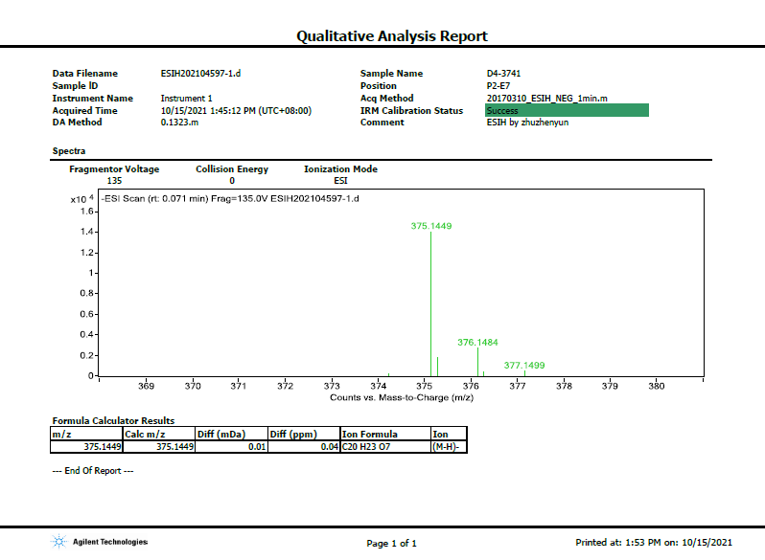

**Figure S10. IR spectrum of compound 1**

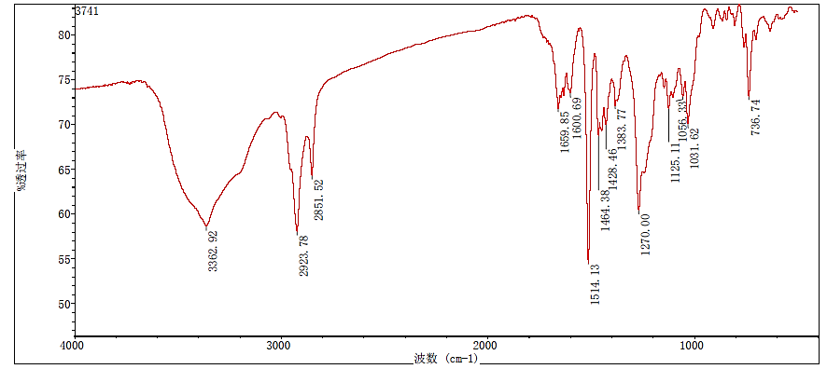

**Figure S11. UV spectrum of compound 1**



**Figure S12. 1H NMR spectrum of compound 2 in CD3OD**

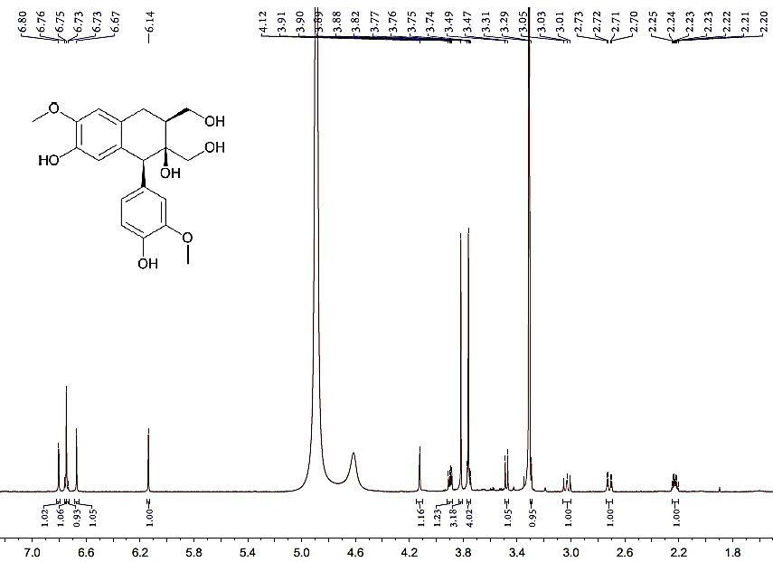

**Figure S13. 13C NMR spectrum of compound 2 in CD3OD**

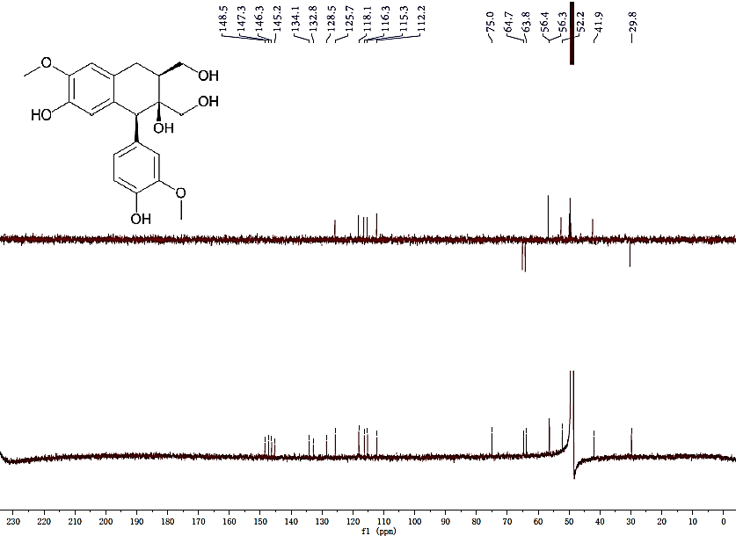

**Figure S14. HSQC spectrum of compound 2 in CD3OD**

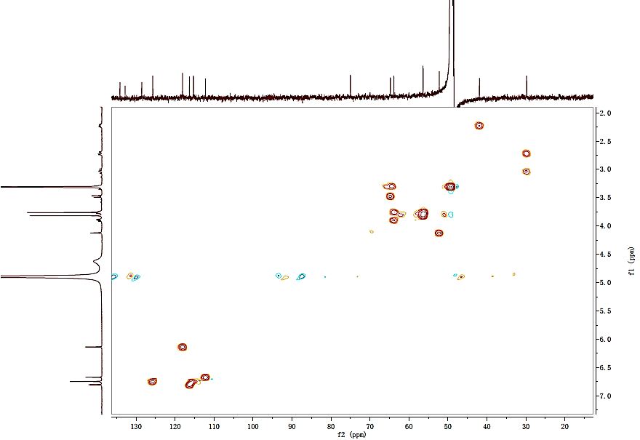

**Figure S15. HMBC spectrum of compound 2 in CD3OD**

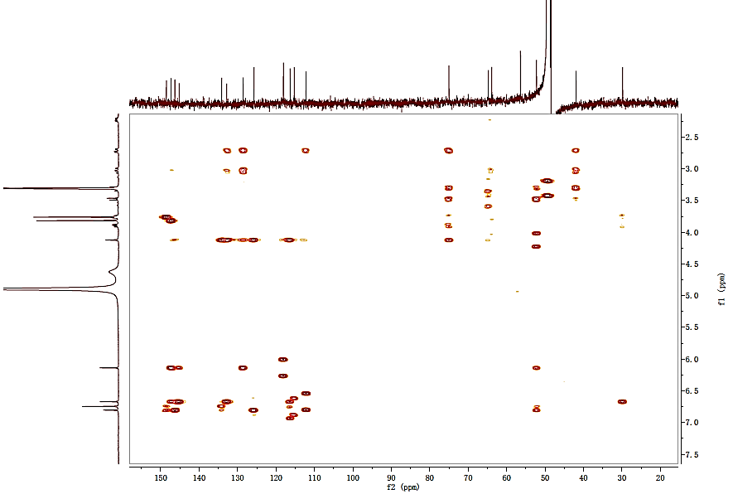

**Figure S16. 1H–1H COSY spectrum of compound 2 in CD3OD**

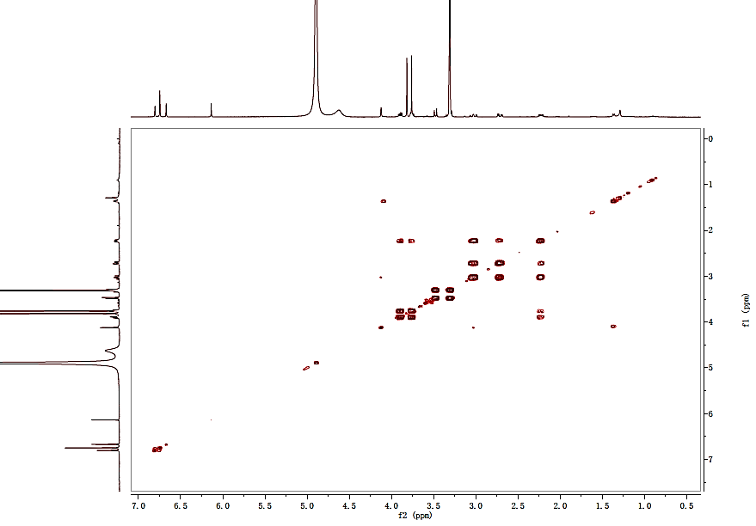

**Figure S17. ROESY spectrum of compound 2 in CD3OD**

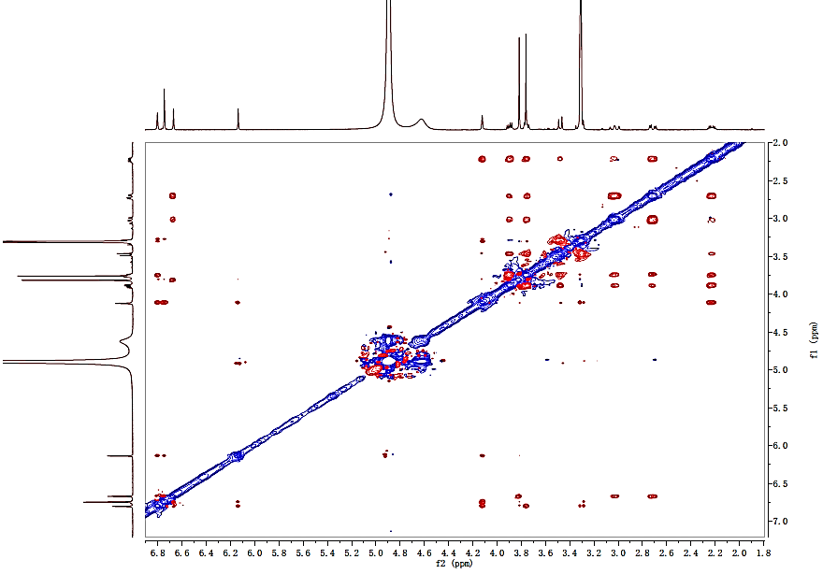

**Figure S18. (-)-ESIMS spectrum of compound 2**

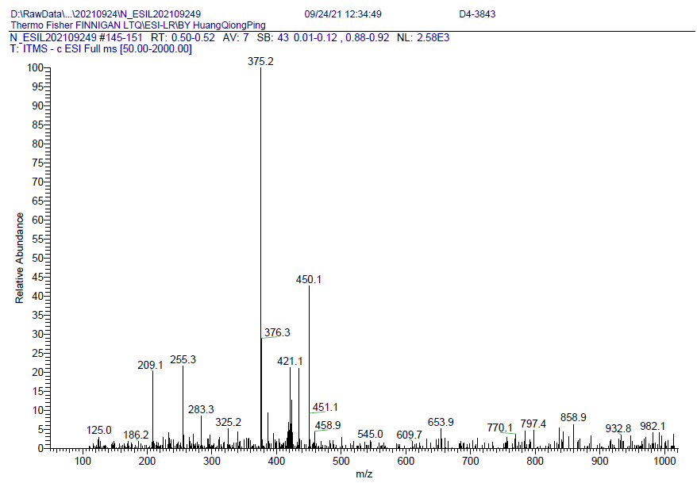

**Figure S19. (+)-HRESIMS spectrum of compound 2**

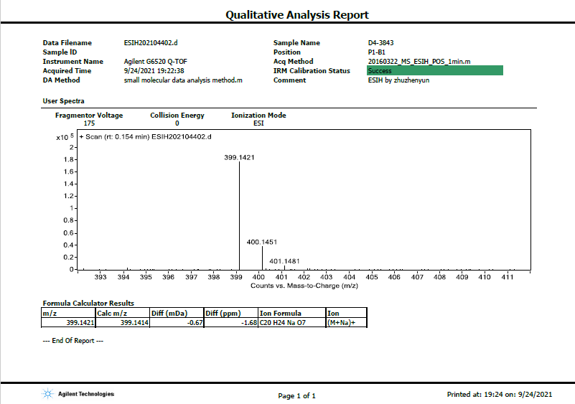

**Figure S20. IR spectrum of compound 2**

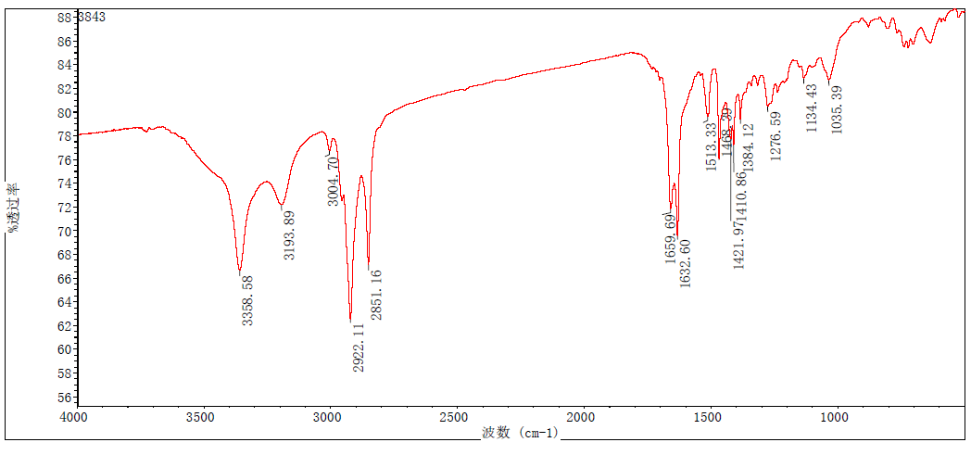

**Figure S21. UV spectrum of compound 2**



**Figure S22. 1H NMR spectrum of compound 3 in CD3OD**

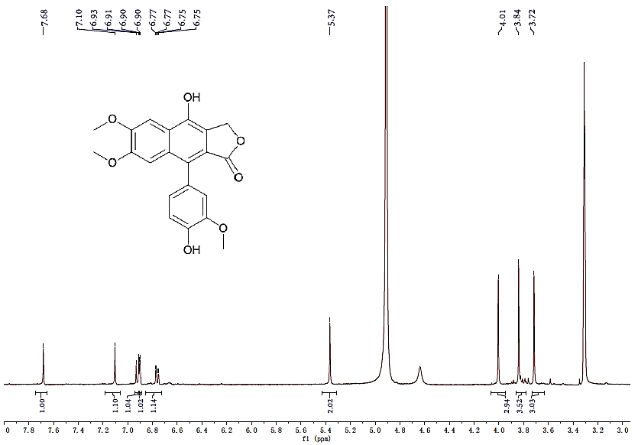

**Figure S23. 13C NMR spectrum of compound 3 in CD3OD**

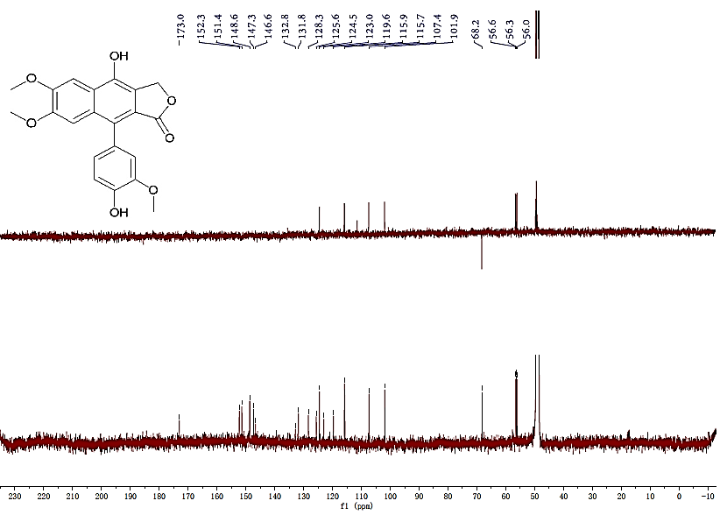

**Figure S24. HSQC spectrum of compound 3 in CD3OD**

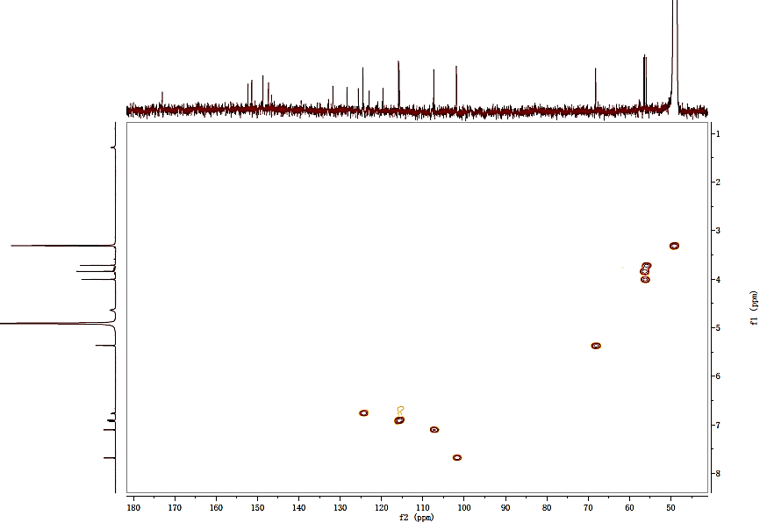

**Figure S25. HMBC spectrum of compound 3 in CD3OD**

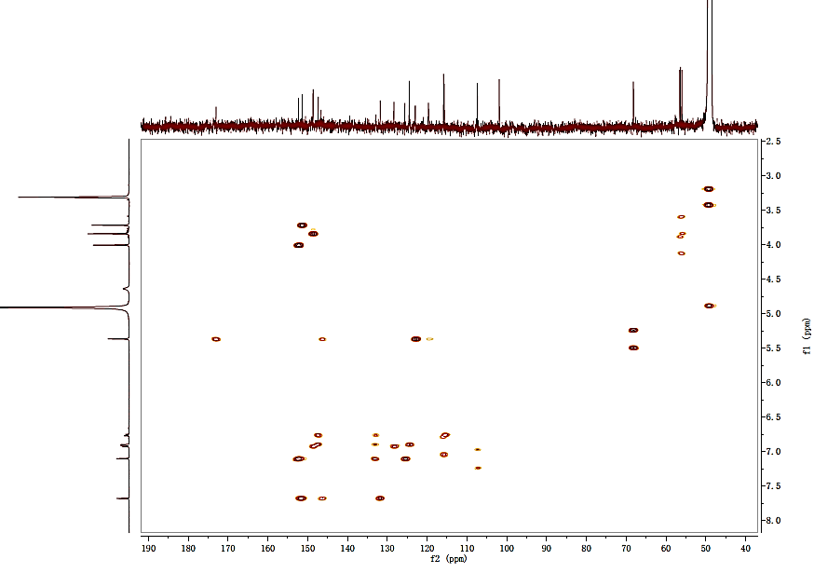

**Figure S26. 1H–1H COSY spectrum of compound 3 in CD3OD**

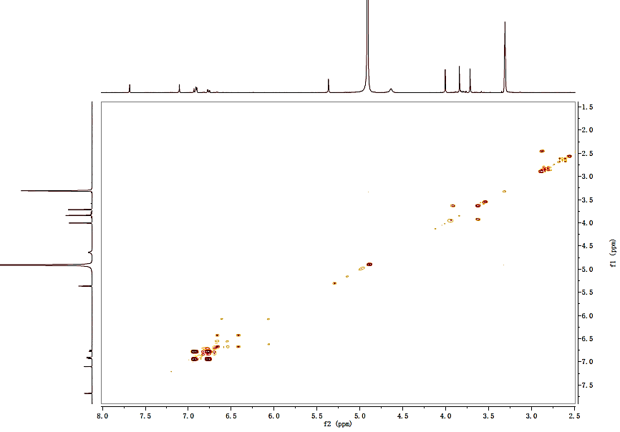

**Figure S27. (+)-ESIMS spectrum of compound 3**

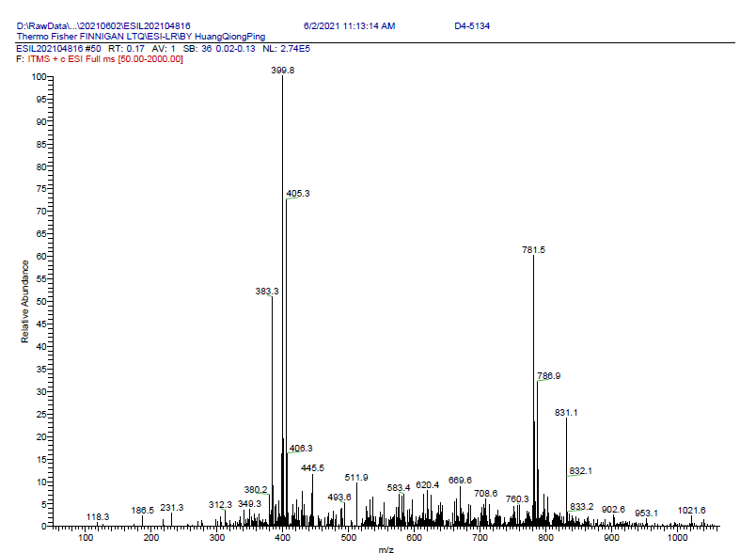

**Figure S28. (-)-ESIMS spectrum of compound 3**

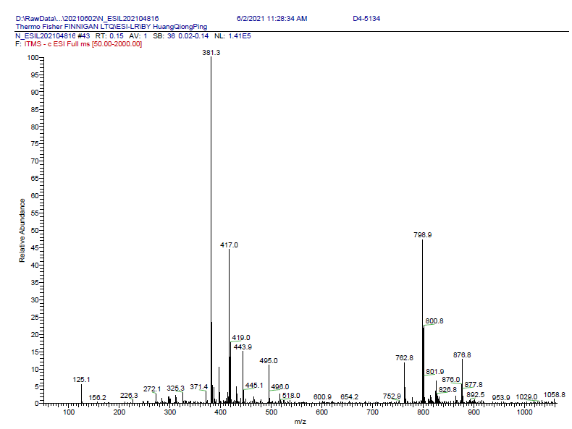

**Figure S29. (+)-HRESIMS spectrum of compound 3**

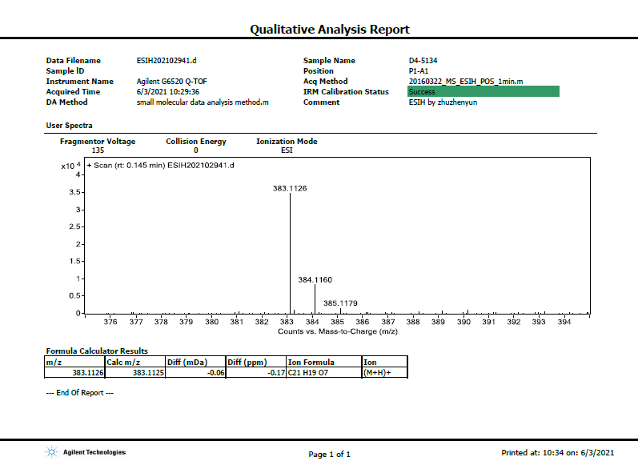

**Figure S30. IR spectrum of compound 3**

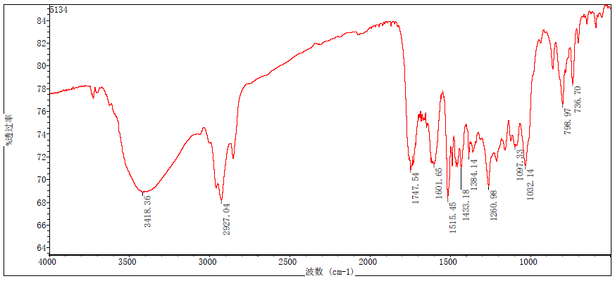

**Figure S31. UV spectrum of compound 3**



**Figure S32. 1H NMR spectrum of compound 4(4a/4b) in CDCl3**

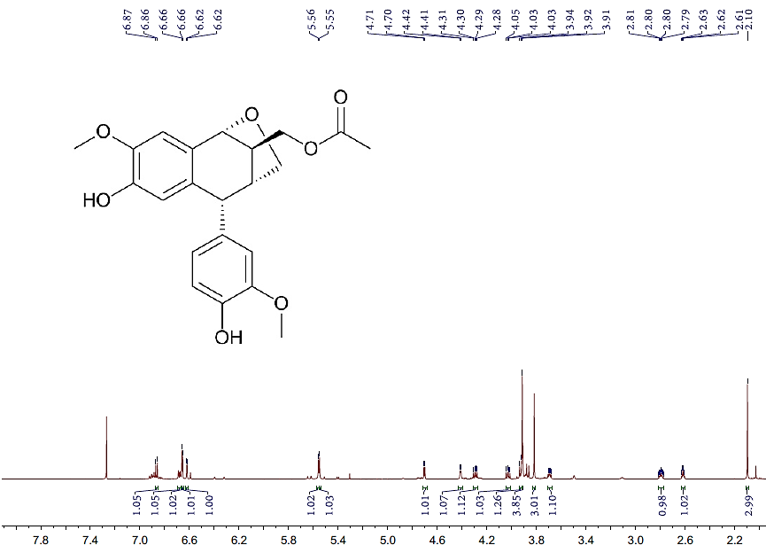

**Figure S33. 13C NMR spectrum of compound 4(4a/4b) in CDCl3**

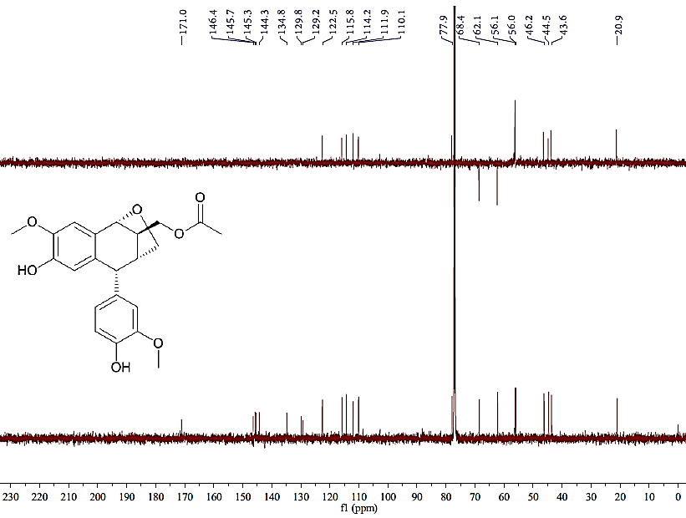

**Figure S34. HSQC spectrum of compound 4(4a/4b) in CDCl3**

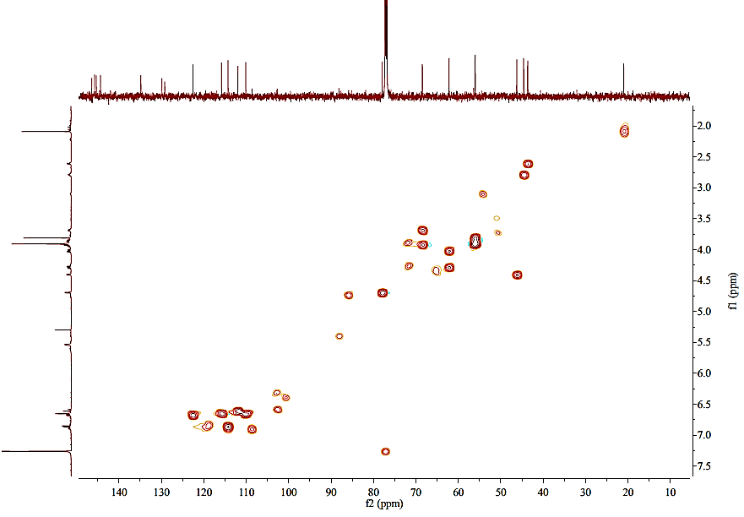

**Figure S35. HMBC spectrum of compound 4(4a/4b) in CDCl3**

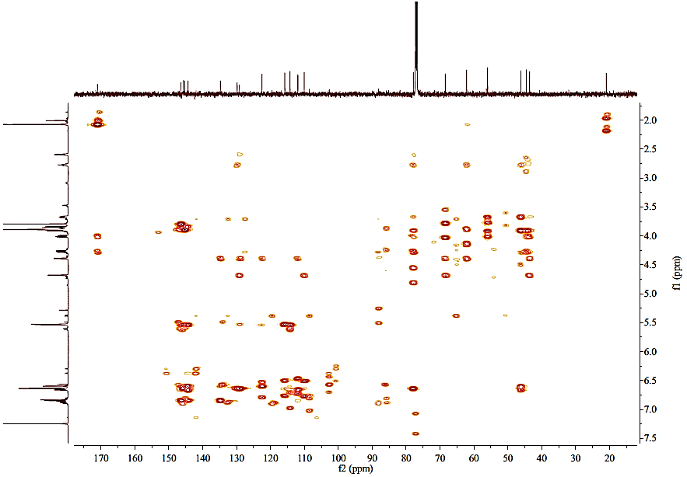

**Figure S36. 1H–1H COSY spectrum of compound 4(4a/4b) in CDCl3**

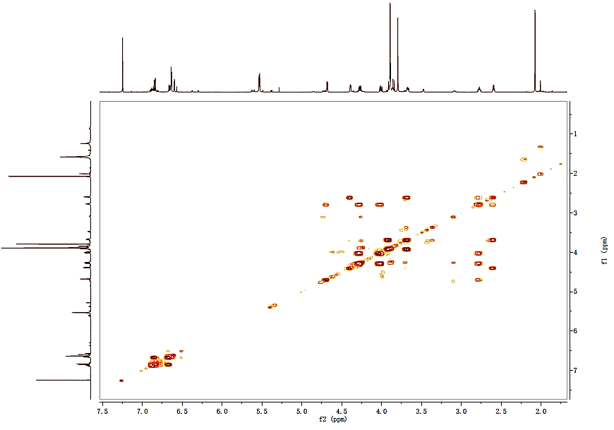

**Figure S37. ROESY spectrum of compound 4 (4a/4b) in CDCl3**

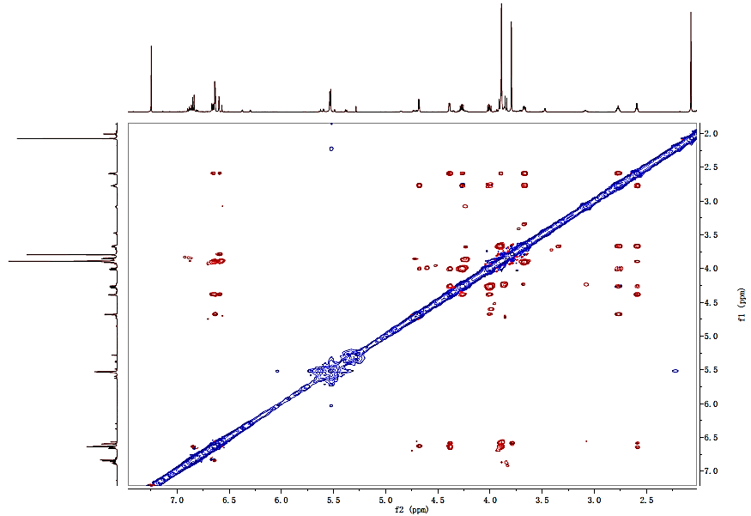

**Figure S38. (-)-ESIMS spectrum of compound 4 (4a/4b)**

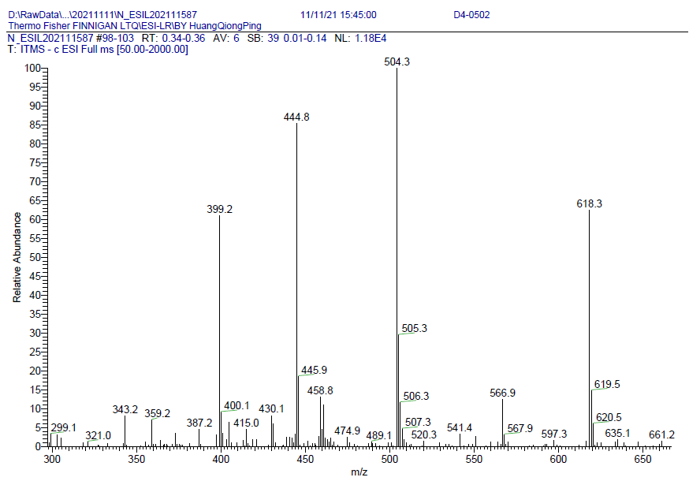

**Figure S39. (+)-HRESIMS spectrum of compound 4 (4a/4b)**

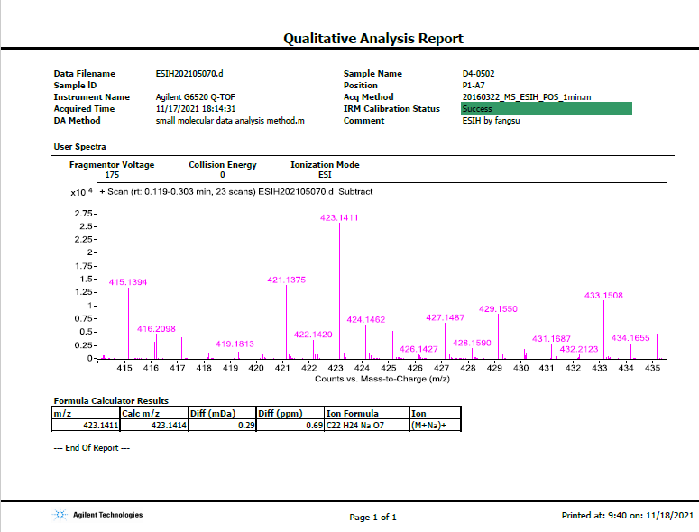

**Figure S40. IR spectrum of compound 4 (4a/4b)**

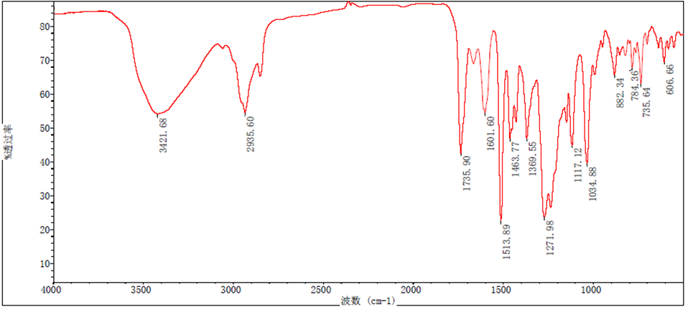

**Figure S41. UV spectrum of compound 4 (4a/4b)**



**Experimental Section**

*Effect of the selected active compounds on iNOS protein expression*

The large amount of NO production is mainly catalyzed by the upstream protein iNOs in the inflammatory signaling pathway (Lee et al., 2016; Lee et al., 2018). Inhibition the overproduction of NO means reducing the enzyme activity of iNOS. Given that compounds **2** and **5** had relatively strong activities and enough contents, these two active compounds were selected to detect the iNOS protein expression by western blot to explore primary anti-inflammation mechanism. The experimental methods were referred to the previous literature (Sheeba and Asha, 2009). As demonstrated in Figure S42, the iNOS enzymatic activation stimulated with LPS was significantly increased, and both compounds **2** and **5** showed a certain dose dependent reduction in the expression of iNOS in LPS treated RAW264.7 cells. The results revealed that compounds **2** and **5** inhibited the productionof NO by reducing the iNOS enzymatic activation.

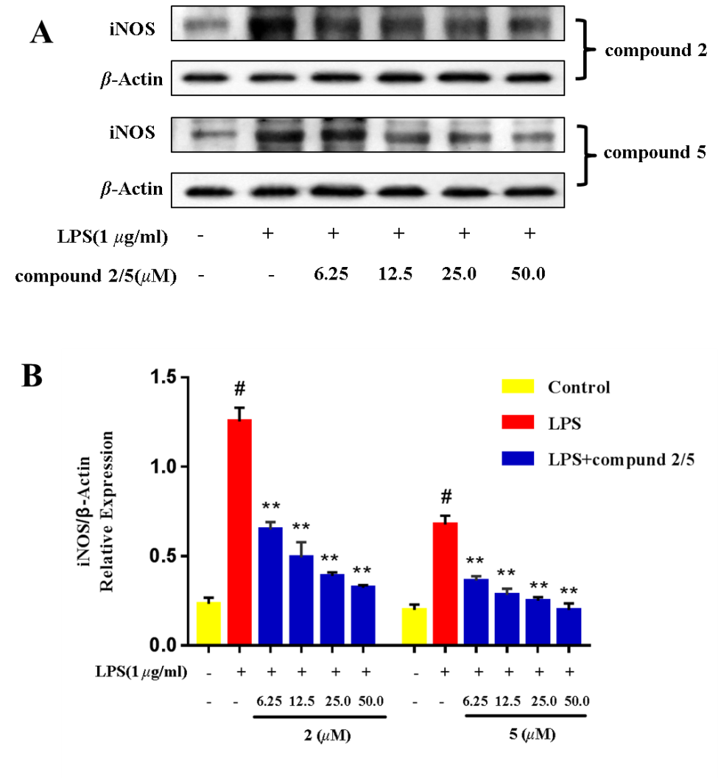

**Figure S42. Concentration dependency of the inhibitory effects of compounds 2 and 5. (A) Typical blotting of iNOS and *β*-actin. (B) The bar chart shows the quantitative evaluation of iNOS bands by densitometry. Data represents the mean ± SD (n=3). \*\**p*≤0.01 compared with LPS treated control.**

**Supplementary References**

Lee, S.R., Lee, S., Moon, E., Park, H.J., Park, H.B., Kim, K.H., 2016. Bioactivity-guided isolation of anti-inflammatory triterpenoids from the sclerotia of *Poria cocos* using LPS-stimulated Raw 264.7 cells. Bioorg. Chem. 70, 94‒99.

http://dx.doi.org/10.1016/j.bioorg.2016.11.012

Lee, T.K., Trinh, T.A., Lee, S.R., Kim, S., So, H.M., Moon, E., Hwang, G.S., Kang, K. S., Kim, J.H., Yamabe, N., Kim, K.H., 2018. Bioactivity-based analysis and chemical characterization of anti-inflammatory compounds from *Curcuma zedoaria* rhizomes using LPS-simulated RAW264.7 cells. Bioorg. Chem. 82, 26‒32.

https://doi.org/10.1016/j.bioorg.2018.09.027

Sheeba, M.S., Asha, V.V., 2009. *Cardiospermum halicacabum* ethanol extract inhibits LPS induced COX-2, TNF-α and iNOS expression, which is mediated by NF-κB regulation, in RAW264.7 cells. J. Ethnopharmacol. 124, 39–44.

doi:10.1016/j.jep.2009.04.020