SI Using Hummer method to treat the preparation process of graphene ( GR )

After stirring 1 g GR, 1 g NaNO3 and 50 ml concentrated sulfuric acid in ice bath (≤ 5 °C ) for 1h, 6 g KMnO4 was added slowly and repeatedly. After the potassium permanganate was uniformly dispersed, the three flasks were moved to a water bath at 35 °C for 2 h, and then slowly poured into 80 ml deionized water, and heated to 90 °C for 1 h. Then, 5 ml of H2O2 with mass fraction of 30 % was added. After 1 h, the reaction solution was filtered, centrifuged and washed, and finally dried at 65 °C for 24 h to obtain graphene oxide (GO). The preparation process is shown in Figure 1.

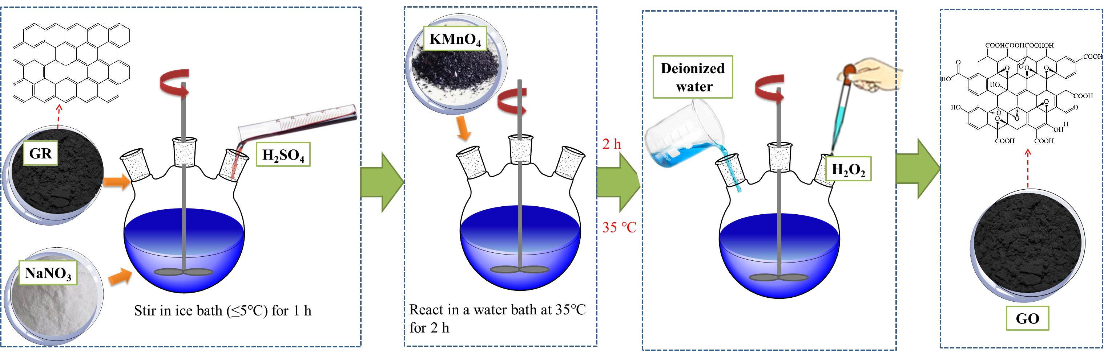

**Figure 1 Preparation of graphene oxide**

S2 Preparation of carbon nanospheres by hydrolysis of glucose

First, quantitative glucose and quantitative deionized water (mass ratio of glucose to deionized water was 1:10) were put into the beaker, and stirred with a glass rod until glucose was completely dissolved and mixed evenly, and then poured into a reactor. Then the sealed reactor was placed in a muffle furnace at 180 °C for 12 h. The brown-black paste solution was obtained at the end of the reaction. It was repeatedly washed with deionized water and anhydrous ethanol for 3-5 times, respectively. When deionized water and anhydrous ethanol reached colorlessness, the solid below was poured out and dried in an electrothermal constant temperature drying oven at 80 °C for 12 h to obtain brown-black carbon nanospheres. The preparation process is shown in Figure 2.

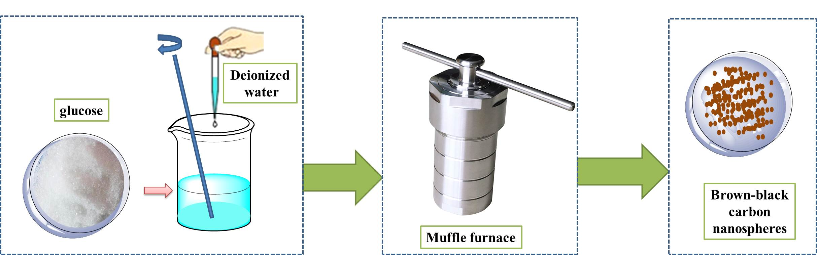

**Figure 2 Preparation of carbon nanospheres**

S3 Oxidation process of carbon nanotubes

The mixture of 0.32g CNTs and400ml deionized water was ultrasonically dispersed for30min at room temperature. Then 3.6 g potassium persulfate was added to the mixture and stirred until potassium persulfate was completely dissolved. After the PH value of the mixture was adjusted to 13 with KOH concentrated solution, it was poured into three round-bottom flasks and stirred for 6 h under the conditions of water bath temperature of 85 °C and rotation speed of 550 r / min. In order to ensure the safety of the experiment, the reflux condenser is placed on three bottles. After the reaction, the mixture was cooled to room temperature and poured into the centrifuge tube. The mixture was centrifuged at a speed of 3000 rpm for 6 min with a table-type low-speed centrifuge, and the precipitate was collected. The precipitate was repeatedly washed and precipitated with deionized water and anhydrous ethanol for 3-5 times, respectively. When deionized water and anhydrous ethanol reached colorlessness, the precipitate was poured out and dried in an electrothermal constant temperature drying oven at 80 °C for 12 h to obtain black oxidized carbon nanotubes ( O-CNTs ). The preparation process is shown in Figure 3.

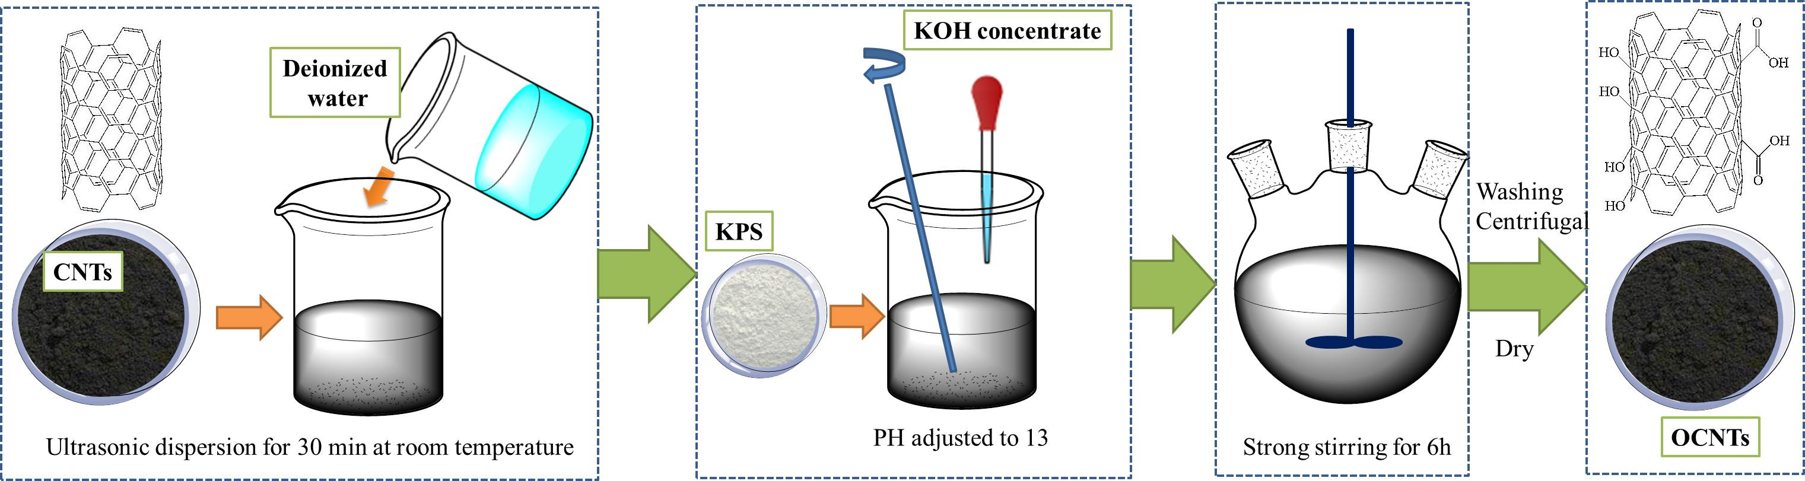

**Figure 3 Preparation of carbon oxide nanotubes**