Fabrication of ternary dual Z-Scheme AgI/ZnIn₂S₄/BiVO₄ heterojunction photocatalyst with enhanced photocatalytic degradation of tetracycline under visible light
Shuhang Wang^{1,§}, Li Zhao^{1,§}, Luning Gao², Daiqiong Yang², Sijie Wen², Wei Huang^{1,3}, Zexin Sun⁴, Jifeng Guo⁴, Xia Jiang¹, Changyu Lu^{2,4}*
¹ National Engineering Laboratory for Lake Pollution Control and Ecological Restoration, Chinese Research Academy of Environmental Sciences, Beijing, 100012, P.R. China
² Hebei Province Key Laboratory of Sustained Utilization & Development of Water Recourse, Hebei Province Collaborative Innovation Center for Sustainable Utilization of Water Resources and Optimization of Industrial Structure, Department of Water Resource and Environment, Hebei Geo University, No. 136 Huai’an Road, Shijiazhuang 050031, Hebei PR China;
³ State Environmental Protection Engineering Center for Pollution Treatment and Control in Textile Industry, College of Environmental Science and Engineering, Donghua University, Shanghai 201620, P.R. China
⁴ School of Water and Environment, Key Laboratory of Subsurface Hydrology and Ecology in Arid Areas, Ministry of Education, Chang'an University, No. 126 Yanta Road, Xi'an 710054, Shaanxi, PR China;
*Corresponding author Tel.: +86-183-9211-3365
E-mail address: pzpzlxl@163.com (C.Y. Lu)
§: These authors contribute equally to this work.
1. Experimental section
1.1. Characterization
The crystal structure and crystallinity of the prepared powder samples were characterized by a Rigaku SmartLab 9KW X-ray diffraction (XRD), where λ = 0.154178 nm for Cu-Kα radiation. The FEI-quanta 200 can be used to obtain the cold field emission scanning electron microscope (SEM) image of the sample. The transmission electron microscope (TEM) and high resolution transmission electron microscope (HR-TEM) images were observed by a Tecnai 12 high-resolution TEM instrument (Philips, Netherlands). X-ray photoelectron spectroscopy (XPS) were operated on K-Alpha XPS system (Thermo Fisher) and the C 1s binding energy of 284.6 eV as the internal standard. The Ultraviolet–visible spectroscopy (UV-Vis) of the samples were carried out on the Lambda 750 (Perkin-Elmer) UV-Vis spectrometer, and barium sulfate (BaSO₄) was used as a background control to scan in the range of 200-800 nm. The transient photocurrent responses and electrochemical impedance spectroscopy (EIS) were conducted on the electrochemical workstation (CHI660D, Shanghai Chenhua). Chemical oxygen demand (COD) removal efficiency was measured on TR-108 COD. Total organic carbon (TOC) analysis was measured on a multi N/C2100 (Analytik Jena AG, Germany) TOC analyzer.
1.2 Cycling tests of photocatalyst
During the photocatalytic experiment, AgI/ZnIn₂S₄/BiVO₄ photocatalysts used were collected and retained for repeated experiment. The photocatalyst was washed and centrifuged with deionized water and ethanol several times, and then dried. The photocatalytic experiment was carried out again with the dried photocatalyst, and the above process was repeated 9 times to test the performance of the photocatalyst after ten cycles.
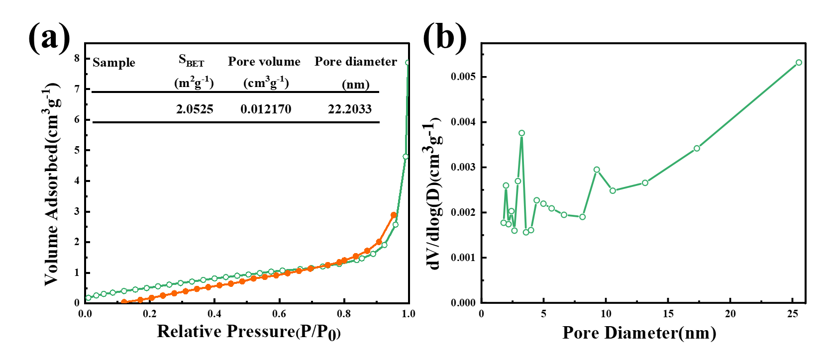
Fig. S1. (a) N₂ adsorption–desorption isotherms and (b) the corresponding pore size distribution of as-prepared AZB1 sample.

