### Supplementary Information

### Ultra-fast sustainable synthesis, optimization and characterization of guava phenolic extract functionalized nanosilver with enhanced biomimetic attributes

Fredrick Nwude Eze,1,2* Chitchamai Ovatlarnporn,1,2,3* Sirinporn Nalinbenjapun,1,2,3 Sasikarn Sripetthong1,2,3

1Drug Delivery System Excellence Center, Prince of Songkla University, Hat Yai, Songkhla 90112, Thailand.

2Faculty of Pharmaceutical Sciences, Prince of Songkla University, Hat Yai, Songkla 90112, Thailand.

3Department of Pharmaceutical Chemistry, Faculty of Pharmaceutical Sciences, Prince of Songkla University, Hat Yai, Songkla 90112, Thailand

* Authors to whom correspondence should be addressed

**Supplementary figure and table captions**

**Supplementary Figure S1**. Effect of pH in guava mediated synthesis of biogenic nanosilver at room temperature. pH of the extract was quickly adjusted prior to adding to the aqueous silver nitrate solution while stirring. UV-visible spectra and corresponding photographic images were collected for the as-prepared GVE-SNP solution synthesized at various pH conditions.

**Supplementary Figure S2**. High resolution TEM image of GVE-SNP

**Supplementary Figure S3**. Matching of the main XRD peaks (*2θ*) of GVE-SNP (above) with those of silver and silver chloride (below).

**Supplementary Figure S4**. Antimicrobial inhibition zones of GVE against *S. aureus* (A) and *S. epidermidis* (B). The control contains only the solvent.

**Supplementary Table S1:** Thermogravimetric (TGA) data of GVE-SNP

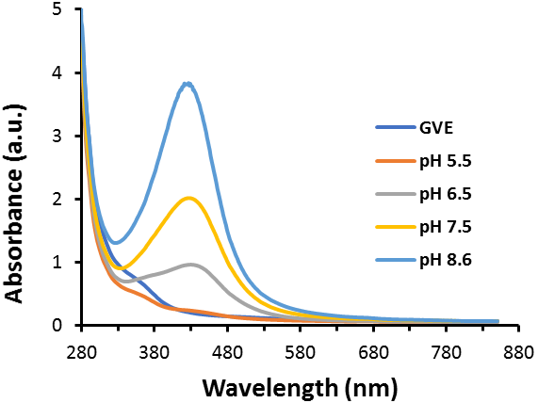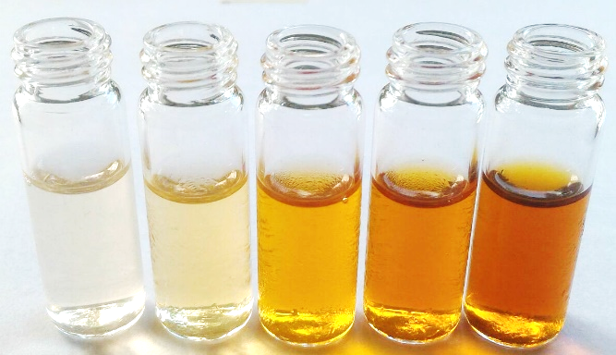

8.6

7.5

6.5

5.5

GVE

**Supplementary Figure S1**

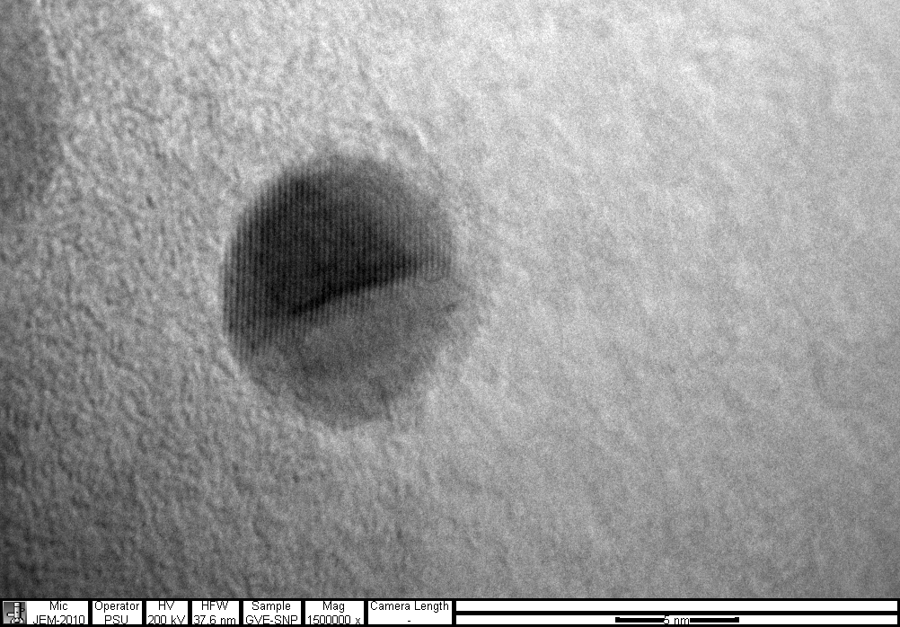

**5 nm**

**Supplementary Figure S2**

**Supplementary Figure S3**

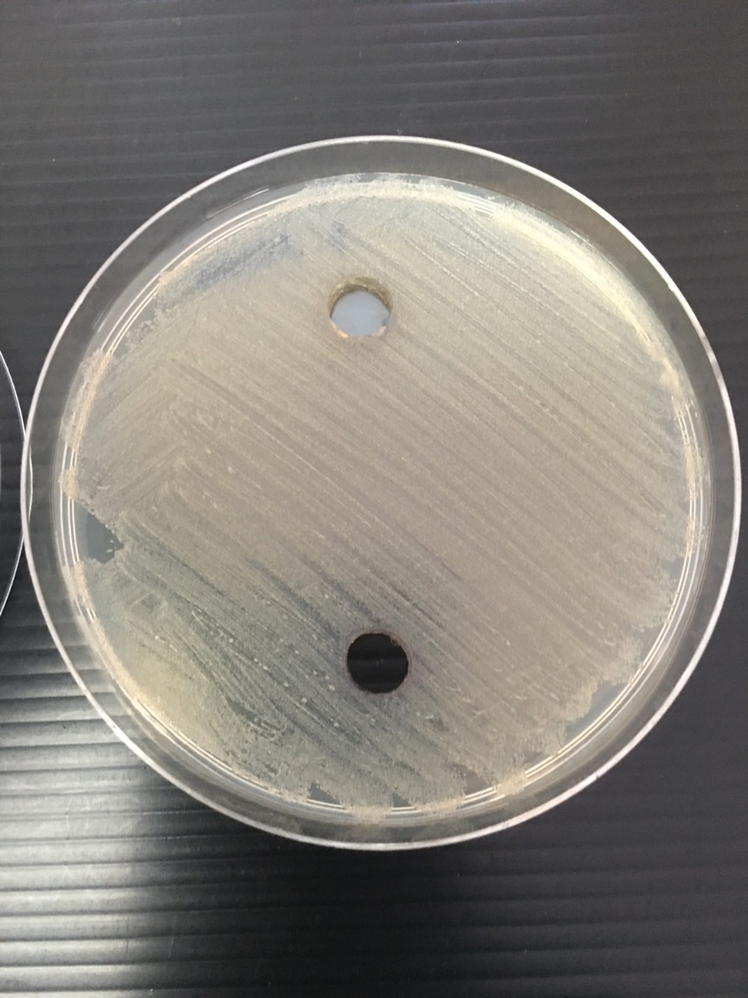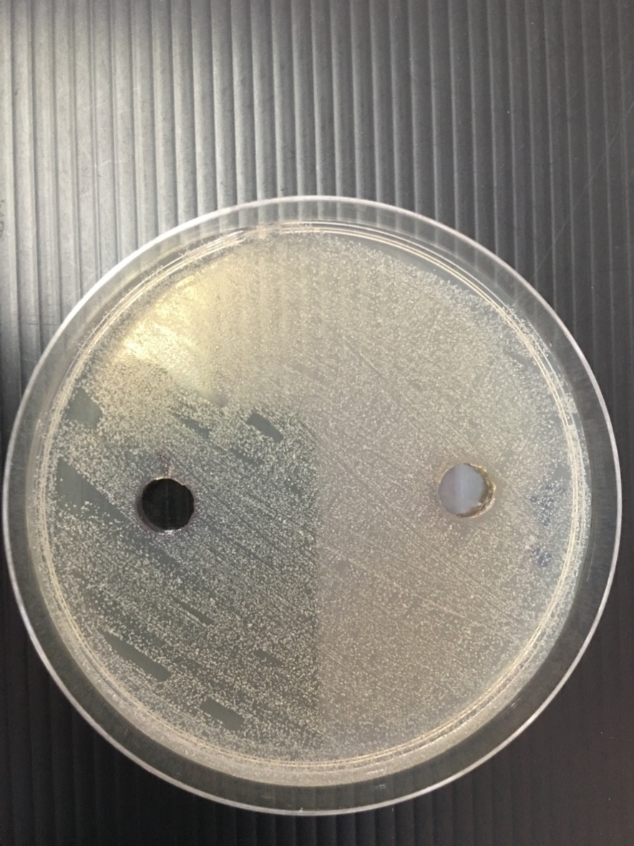

**GVE**

**GVE**

**Control**

**Control**

**A**

**B**

**Supplementary Figure S4**

**Supplementary Table S1:** TGA data of GVE-SNP

|  |  |  |  |  |  |  |  |
| --- | --- | --- | --- | --- | --- | --- | --- |
| **Sample** | **Stages** | **Onset Temperature (°C)** | **Temperature ranges (°C)** | **IDT (°C)** | **IPDT (°C)** | **Mass loss (%)** | **Ash (%)** |
| GVE-SNP | I | **31.75** | 24.96-172.18 | 51.44 | 799.61 | Y = 7.455 | **65.938** |
|  | II | **228.4** | 172.18-518.46 |  |  | Y = 20 |  |
|  | III | **540.13** | 518.46-799.61 |  |  | Y = 4.72 +1.189 |  |
|  |  |  |  |  |  | **Total = 34.062** |  |

**IDT: Initial decomposition temperature; IPDT: Integral procedural decomposition temperature.**