**Supplementary information**

Adsorption of Cu2+ by Modified Chitosan Microspheres and Its Application in homocoupling of Arylboronic Acid

Kewang Zhenga,b, Qiao Lin Renc, Jingxian Lia, Xiaofeng Dengc, Baiyang Sunc, Wei Wanga,*, Zufeng Xiao a,*, Caiqin Qina

a College of Chemistry and Materials Science, Hubei Engineering University, Xiaogan 432000, China

b Hubei Key Laboratory of Biological Resources and Environmental Biotechnology, Wuhan University, Wuhan 430079, China

c State Grid Hubei Electric Power Company, Hubei Xiaogan Electric Power Supply Company, Xiaogan 432000, China

*Correspondence to:

Wei Wang (E-mail: [weiwang@hbeu.edu.cn](mailto:weiwang@hbeu.edu.cn)) and Zufeng Xiao (E-mail: chemhbeu@163.com)

**Table of Contents**

|  |  |
| --- | --- |
| 1. Fig. S1 The pseudo-first-order kinetic model fitting results | S1 |
| 1. Characterization data for products | S2 |
| 1. Fig. S2-S25 1H NMR and 13C NMR spectra of products **2a-2x** | S8 |
| 1. Fig. S26-S28 1H NMR spectra of **3k**, **3l** and **3s** | S33 |

**1.**

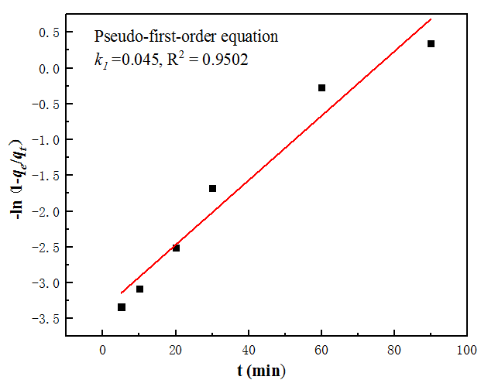

**Figure. S1** The pseudo-first-order kinetic model fitting results .

2. **Characterization data for products**

Most of adducts are literature-known [31-39] and obtained characterization data for these compounds is in full agreement with reported data.

4,4'-dimethoxy-1,1'-biphenyl (**2a**)

。

1H NMR (400 MHz, CDCl3, ppm) δ = 7.50-7.46 (m, 4H), 6.98-6.94 (m, 4H), 3.84(s, 6H）

13C NMR (100 MHz, CDCl3, ppm) δ=158.64, 133.45, 127.71, 114.13, 55.34.

3,3'-dimethoxy-1,1'-biphenyl (**2b**)



1H NMR (400 MHz, CDCl3, ppm) δ = 7.38-7.34(t, *J*= 8.0 Hz, 2H), 7.19-7.17(d, *J*= 7.8Hz, 2H), 7.13(s, 2H), 6.92-6.89 (dd, *J*= 8.4 Hz, *J*=2.6 Hz ,2H), 3.87(s, 6H）

13C NMR (100 MHz, CDCl3，ppm) δ= 159.86, 142.61, 129.70, 119.69, 112.93, 112.79,55.30.

2,2'-dimethoxy-1,1'-biphenyl (**2c**)



1H NMR (400 MHz, CDCl3, ppm) δ = 7.35-7.31(td, *J*= 8.2 Hz,1.8Hz, 4H), 7.26-7.24(d, *J*= 6.2 Hz, 4H), 7.03- 6.97(m, 4H), 3.78 (s, 6H).

13C NMR (100 MHz, CDCl3, ppm) δ =156.94, 131.42, 128.59, 127.69, 120.30, 110.99, 55.66.

2,2'-diethoxy-1,1'-biphenyl (**2d**)



1H NMR (400 MHz, CDCl3, ppm) δ = 7.32-7.26(m, 4H), 7.01-6.97(td, *J*= 7.4 Hz, *J*= 1.2Hz, 2H), 6.96-6.94(d, *J*= 8.2 Hz, 2H), 4.04- 3.99(q, *J*= 7.0Hz, 4H), 1.27(s, 6H).

13C NMR (100 MHz, CDCl3, ppm) δ = 156.40, 131.51, 128.30, 128.26, 120.12, 112.10, 63.80, 14.78.

4,4'-dimethyl-1,1'-biphenyl (**2e**)



1H NMR (400 MHz, CDCl3, ppm) δ = 7.52-.49(dt, *J*= 8.2Hz, 2.0Hz, 4H), 7.27-7.25(d, *J*= 7.6 Hz, 4H), 2.41(s, 6H).

13C NMR (100 MHz, CDCl3, ppm) δ = 138.23, 136.67, 129.40, 126.78, 21.07.

2,2'-diisopropyl-1,1'-biphenyl (**2f**)



1H NMR (400 MHz, CDCl3, ppm) δ = 7.40-7.34(m, 4H), 7.22-7.18 (td, *J*=7.6 Hz, 1.8 Hz, 2H), 7.10-7.07(m, 2H), 2.76- 2.66(hept, *J*= 6.8 Hz, 2H), 1.16-1.14 (d, *J*= 6.8 Hz, 6H), 1.09-1.08 (d, *J*= 6.8 Hz, 6H).

13C NMR (100 MHz, CDCl3, ppm) δ = 146.73, 140.10, 129.69, 127.49, 125.19, 125.00, 29.77, 24.80, 23.05.

4,4'-di-tert-butyl-1,1'-biphenyl (**2g**)



1H NMR (400 MHz, CDCl3, ppm) δ = 7.55-7.53(d, *J*= 8.0 Hz, 4H), 7.47-7.45(d, *J*= 8.0 Hz, 4H), 1.37(s, 18H)

13C NMR (100 MHz, CDCl3, ppm) δ = 149.88, 138.17, 126.64, 125.61, 34.49, 31.38.

biphenyl (**2h**)



1H NMR (400 MHz, CDCl3, ppm) δ = 7.62-7.59(m, 4H), 7.47-7.43(t, *J*= 7.4Hz, 4H), 7.38-7.33(m, 2H).

13C NMR (100 MHz, CDCl3, ppm) δ = 141.18, 128.73, 127.22, 127.14.

[1,1'-biphenyl]-4,4'-dicarbonitrile (**2i**)



1H NMR (400 MHz, CDCl3, ppm) δ = 7.79-7.77 (d, *J*= 8.4 Hz, 4H), 7.71-7.69 (d, *J*= 8.4Hz, 4H),

13C NMR (100 MHz, CDCl3, ppm) δ= 143.41, 132.80, 127.87, 118.37, 112.27.

[1,1'-biphenyl]-3.3'-dicarbonitrile (**2j**)



1H NMR (400 MHz, CDCl3, ppm) δ = 7.85-7.84(t, *J*= 1.4 Hz, 2H), 7.81-7.78(ddd, *J*= 7.8 Hz, 2.0Hz, 2.0Hz, 2H), 7.73-7.70(dt, *J*= 7.8 Hz, 1.4 Hz, 2H), 7.63-7.59(td, *J*= 7.8 Hz, 0.6 Hz, 2H)

13C NMR (100 MHz, CDCl3, ppm) δ= 140.11, 131.78, 131.40, 130.62, 130.02, 118.31, 113.43.

[1,1'-biphenyl]-4,4'-dicarbaldehyde (**2k**)



1H NMR (400 MHz, CDCl3, ppm) δ = 10.09 (s, 1H), 8.02-7.99(dt, *J*= 8.4 Hz, 2.0 Hz, 4H), 7.82-7.80(dt, *J*= 8.4 Hz, 2.0 Hz, 4H).

13C NMR (100 MHz, CDCl3, ppm) δ= 191.75, 145.53, 135.92, 130.36, 128.02.

1,1'-([1,1'-biphenyl]-3,3'-diyl)diethanone (**2l**)



1H NMR (400 MHz, CDCl3, ppm) δ = 8.20-8.19(t, *J*= 2.0 Hz,2H). 7.98-7.95(dt, *J*= 7.8 Hz,1.4 Hz, 2H), 7.83-7.80(m, 2H), 7.59-7.55(t, *J*= 7.8 Hz,2H). 2.67(s, 6H).

13C NMR (100 MHz, CDCl3, ppm) δ= 197.89, 140.67, 137.68, 131.74, 129.19, 127.72, 126.83, 26.77.

3,3'-dinitro-1,1'-biphenyl (**2m**)



1H NMR (400 MHz, CDCl3, ppm) δ = 8.51-8.50(t, *J*= 2.0 Hz, 2H), 8.32-8.29(ddd, *J*= 8.2 Hz, 2.4Hz, 1.0 Hz, 2H), 7.99-7.96(ddd, *J*= 8.2 Hz, 2.4Hz, 1.0 Hz, 2H), 7.73-7.69(t, *J*= 8.0 Hz, 2H).

13C NMR (100 MHz, CDCl3, ppm) δ = 148.84, 140.30, 133.05, 130.28, 123.29, 122.10.

4,4'-bis(trifluoromethyl)-1,1'-biphenyl (**2n**)



1H NMR (400 MHz, CDCl3) δ = 7.75-7.69(dd, *J*= 15.2 Hz, *J*= 8.4Hz, 8H).

13C NMR (100 MHz, ppm) δ = 143.22, 130.75- 129.77(q, *J*= 32.4 Hz), 127.62, 125.99-125.88(q, *J*= 32.4 Hz), 128.15-120.03(q, *J*= 270.3 Hz).

5,5'-difluoro-2,2'-dimethyl-1,1'-biphenyl (**2o**)



1H NMR (400 MHz, CDCl3, ppm) δ = 7.23-7.20(dd, *J*= 8.8 Hz, 1.8Hz, 2H), 7.00-6.95(td, *J*= 8.4Hz,2.8Hz, 2H), 6.83-6.80(dd, *J*= 9.2 Hz,2.8Hz, 2H), 2.01(s, 6H).

13C NMR (100 MHz, ppm) δ = 162.00, 159.57, 142.07-141.98(dd, *J*= 7.2 Hz, *J*= 1.8Hz), 131.24-131.16(m), 115.83-115.62(d, *J*=21.0 Hz), 114.31-114.11(d, *J*=21.0 Hz), 18.88.

2,2'-dichloro-4,4'-dimethyl-1,1'-biphenyl (**2p**)



1H NMR (400 MHz, CDCl3, ppm) δ = 7.31(t, *J*= 1.0 Hz, 2H), 7.16-7.11(m.4H), 2.39(s, 6H).

13C NMR (100 MHz, ppm) δ = 139.30, 135.28, 133.22, 131.04, 129.82, 127.28, 20.98.

5,5'-dichloro-2,2'-dimethoxy-1,1'-biphenyl (**2q**)



1H NMR (400 MHz, CDCl3, ppm) δ = 7.30-7.27(dd, *J*= 8.8 Hz, 2.6 Hz, 2H), 7.20-7.19(d, *J*= 2.6 Hz, 2H), 6.90-6.88(d *J*= 8.8 Hz, 2H), 3.76(s, 6H).

13C NMR (100 MHz, ppm) δ = 155.52, 130.99, 128.61, 127.89, 125.15, 112.19, 55.96.

2,2'-dichloro-1,1'-biphenyl (**2r**)



1H NMR (400 MHz, CDCl3, ppm) δ = 7.52-7.48(m, 2H), 7.38-7.32(m, 4H), 7.31-7.27(m, 2H).

13C NMR (100 MHz, ppm) δ = 138.30, 133.46, 131.14, 129.40, 129.21, 126.48.

1,1'-binaphthalene (**2s**)



1H NMR (400 MHz, CDCl3, ppm) δ = 7.97-7.94(dd, *J*= 8.2 Hz, 3.6 Hz, 4H), 7.62-7.58 (dd, *J*= 8.2 Hz, 7 Hz, 2H), 7.51-7.46 (m, 4H), 7.41-7.39(d, *J*= 8.0 Hz, 2H), 7.32-7.27 (m, 2H),

13C NMR (100 MHz, ppm) δ = 138.40, 133.46, 132.79, 128.11, 127.85, 127.79, 126.52, 125.94, 125.77, 125.35.

2',3-difluoro-2,3'-bipyridine **(2t**)



1H NMR (400 MHz, CDCl3, ppm) δ = 8.19- 8.17 (dd, *J*= 5.2 Hz, *J*=2.0 Hz, 2H), 7.60-7.58 (dd, *J*= 7.3Hz, *J*=2.0 Hz , 2H), 6.97-6.94 (dd, *J*= 5.0Hz, *J*=2.2 Hz ,2H), 3.92 (s, 6H).

13C NMR (100MHz, CDCl3，ppm) δ =161.44, 159.04 (d, *J*= 242Hz）, 148.01-147.86 (t, *J*= 7.6Hz), 141.89-141.83 (t, *J*= 3.4Hz), 121.63-121.59(t, *J*= 2.4Hz), 116.64, 116.39(d, *J*= 25.2Hz).

2,2'-dichloro-3,3'-bipyridine **(2u**)



1H NMR (400 MHz, CDCl3, ppm) δ = 8.48-8.47(dd, *J*= 4.8 Hz, *J*=2.0 Hz, 2H), 7.67-7.64 (dd, *J*= 7.6 Hz, *J*=2.0 Hz, 2H), 7.38-7.354 (dd, *J*= 7.6 Hz, *J*=4.8 Hz, 2H).

13C NMR (100MHz, CDCl3，ppm) δ = 150.16, 149.76, 139.77, 132.73, 122.33

2',3-dimethoxy-2,3'-bipyridine **(2v**)



1H NMR (400 MHz, CDCl3, ppm) δ = 8.19- 8.17 (dd, *J*= 5.2 Hz, *J*= 2.0 Hz, 2H), 7.60-7.58 (dd, *J*= 7.4Hz, 2 *J*=2.0 Hz, 2H), 6.97-6.94 (dd, *J*= 5.0Hz, 2.2 Hz ,2H), 3.92 (s, 6H),

13C NMR (100 MHz, CDCl3, ppm) δ = 161.13, 146.22, 139.58, 119.82, 116.50, 53.56.

2,2'-dimethoxy-4,4'-bipyridine **(2w**)



1H NMR (400 MHz, CDCl3, ppm) δ = 8.26- 8.24 (dd, *J*= 5.4 Hz, *J*= 0.8 Hz, 2H), 7.09-7.07(dd, *J*= 5.4 Hz, *J*= 0.8 Hz, 2H), 6.95-6.95(dd, *J*= 1.6 Hz, *J*= 0.8 Hz, 2H),, 3.98 (s, 6H).

13C NMR (100 MHz, CDCl3, ppm) δ = 164.90, 148.42, 147.65, 114.87, 108.67, 53.66.

**3,3'-bithiophene (2x**)



1H NMR (400 MHz, CDCl3, ppm) δ = 7.39-7.38 (q, *J*= 1.4 Hz, 2H), 7.37-7.33(m, 6H).

1H NMR (400 MHz, CDCl3, ppm) δ = 137.17, 126.31, 126.06, 119.74.

**3**

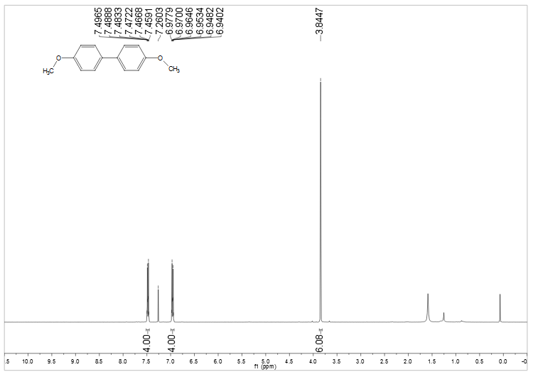

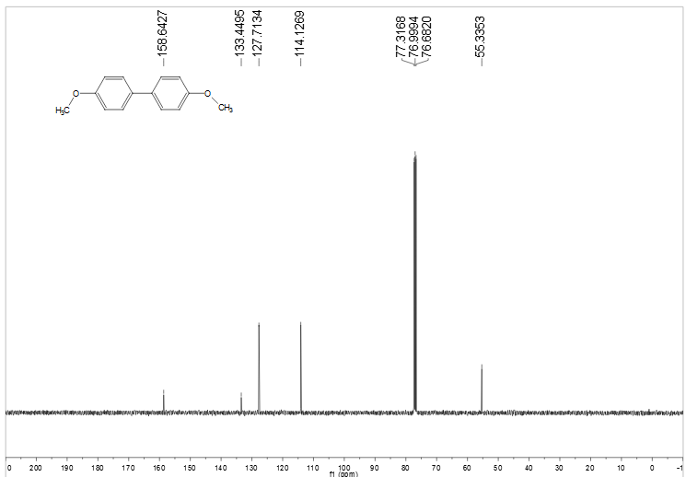

**Figure S2** 1H NMR and 13 C NMR spectra of **2a**

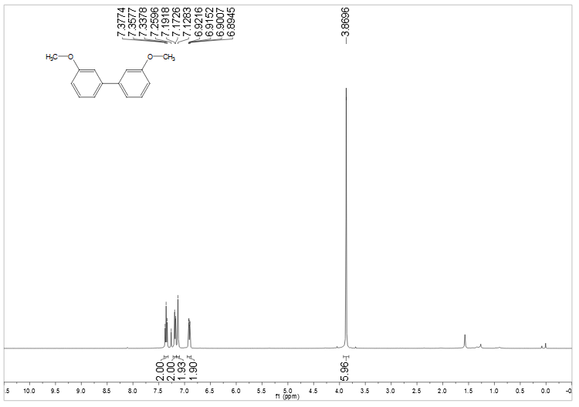

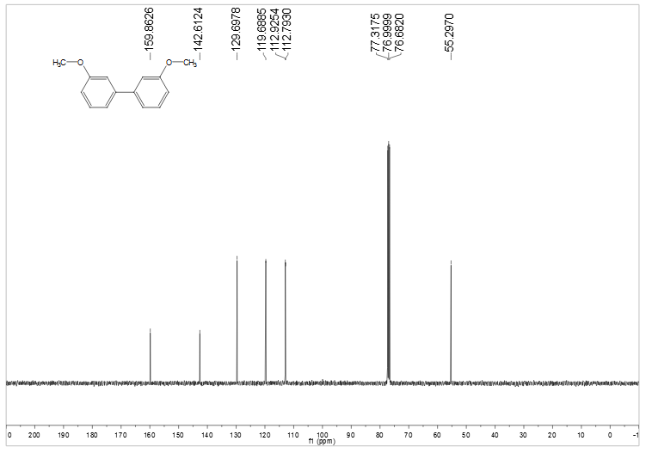

**Figure S3** 1H NMR and 13 C NMR spectra of **2b**

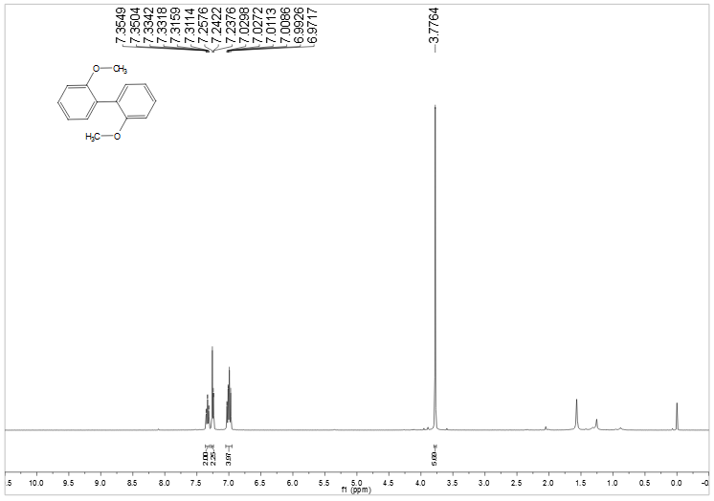

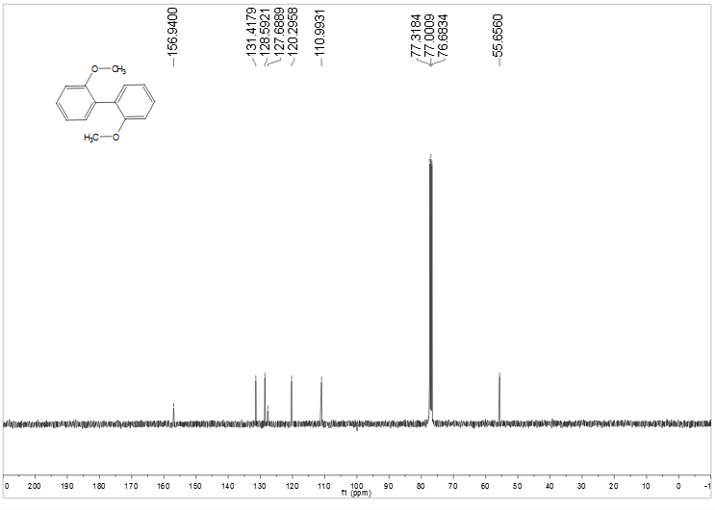

**Figure S4** 1H NMR and 13 C NMR spectra of **2c**

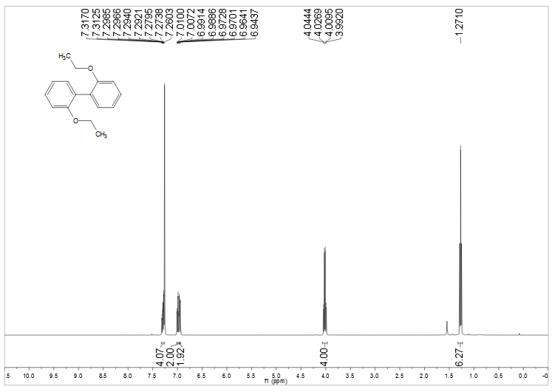

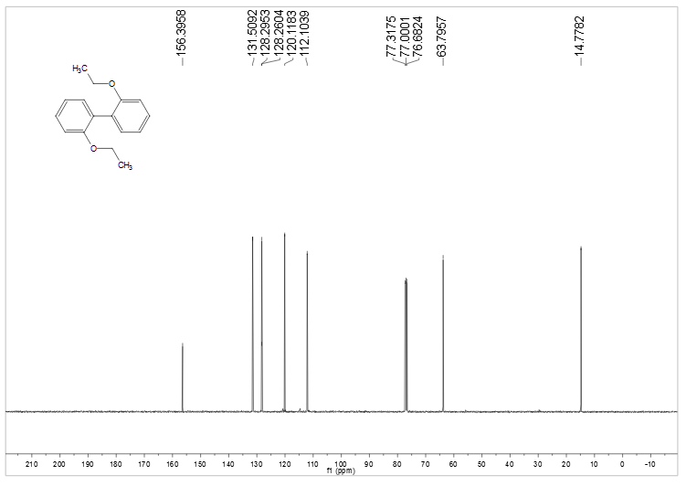

**Figure S5** 1H NMR and 13 C NMR spectra of **2d**

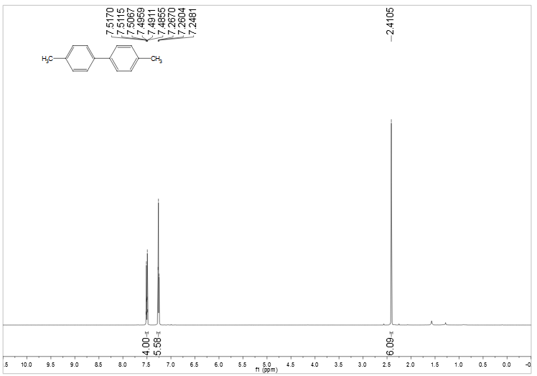

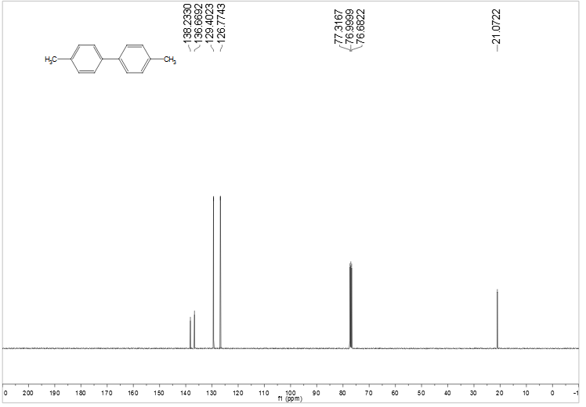

**Figure S6** 1H NMR and 13 C NMR spectra of **2e**

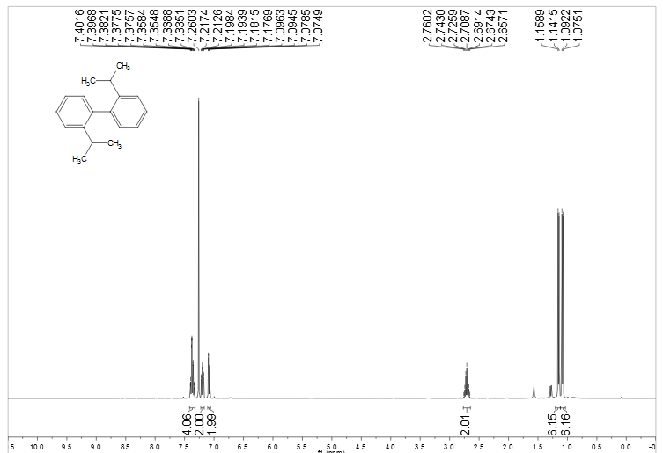

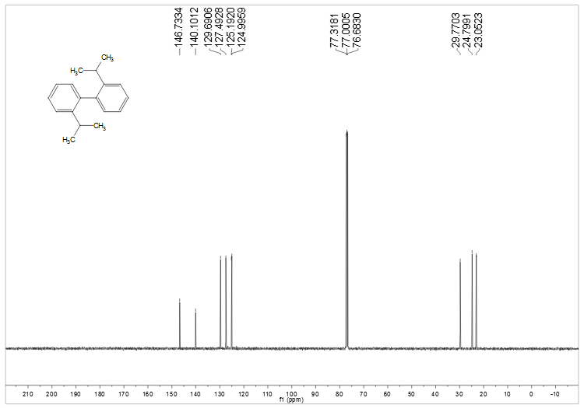

**Figure S7** 1H NMR and 13 C NMR spectra of **2f**

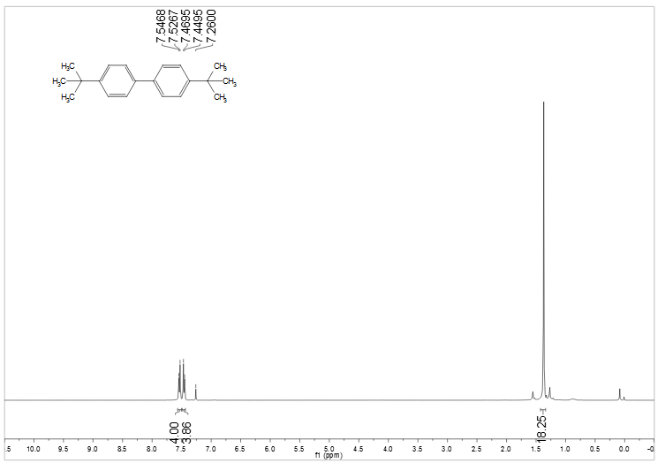

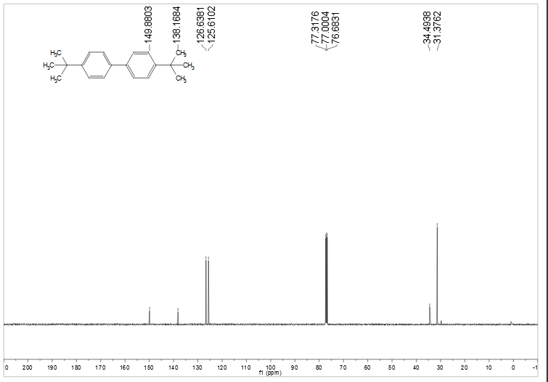

**Figure S8** 1H NMR and 13 C NMR spectra of **2g**

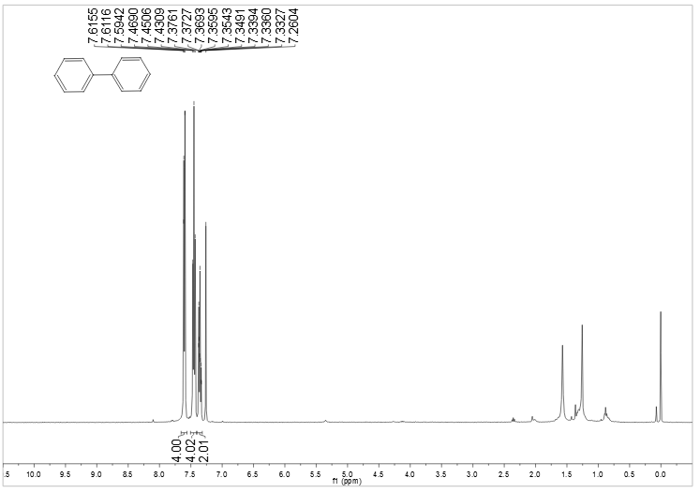

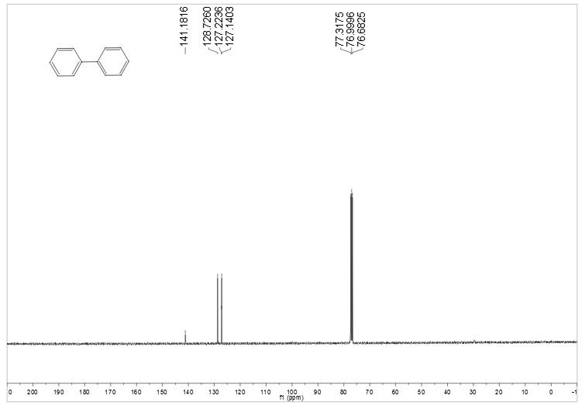

**Figure S9** 1H NMR and 13 C NMR spectra of **2h**

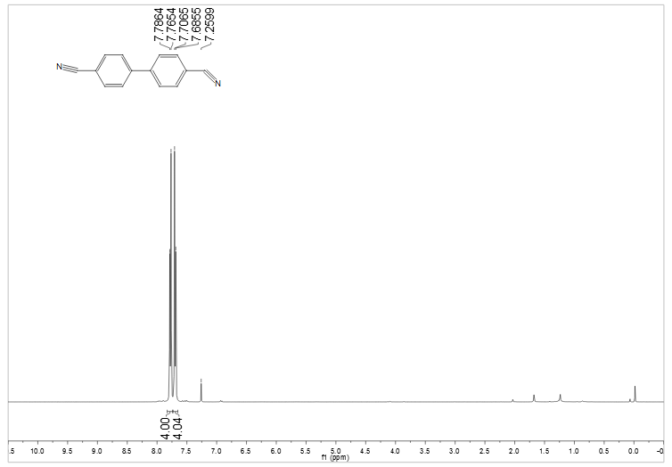

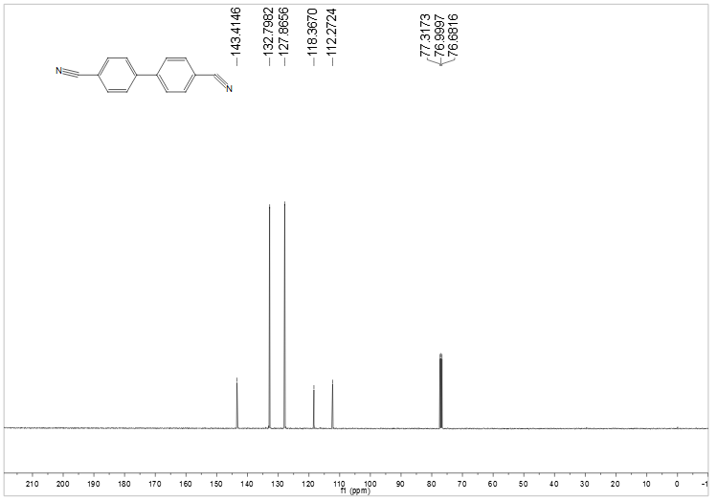

**Figure S10** 1H NMR and 13 C NMR spectra of **2i**

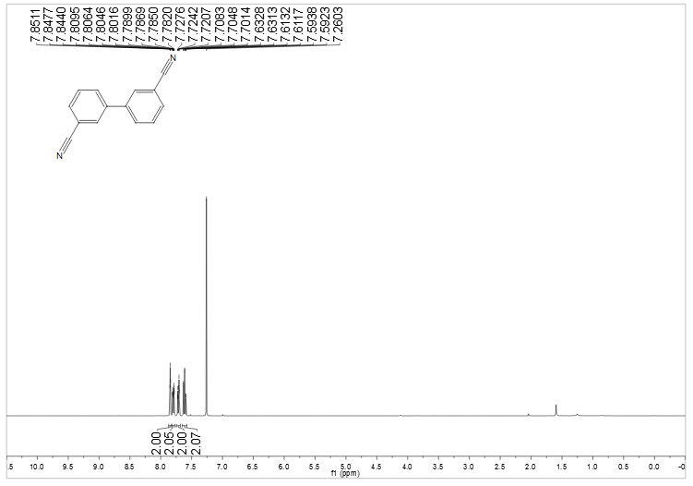

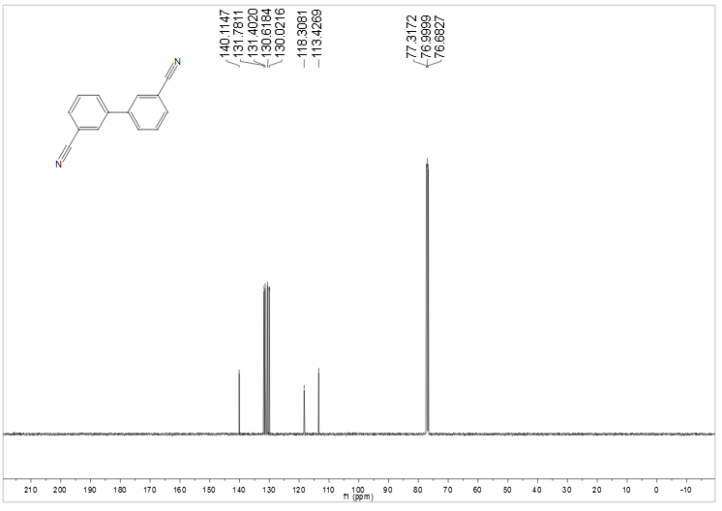

**Figure S11** 1H NMR and 13 C NMR spectra of **2j**

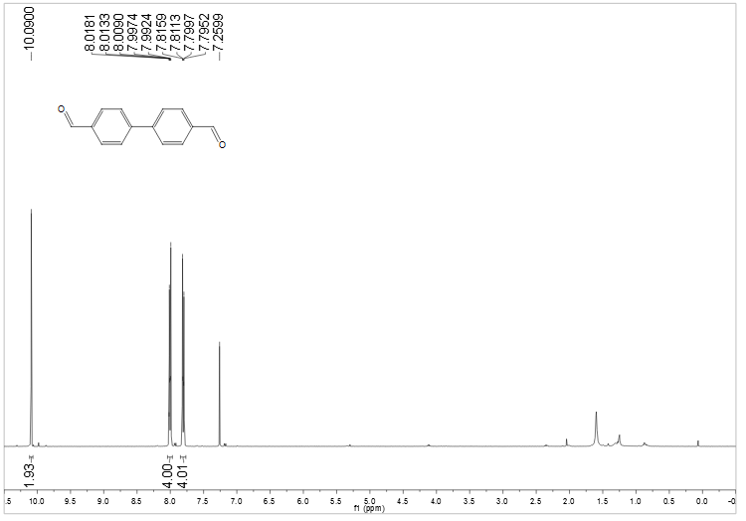

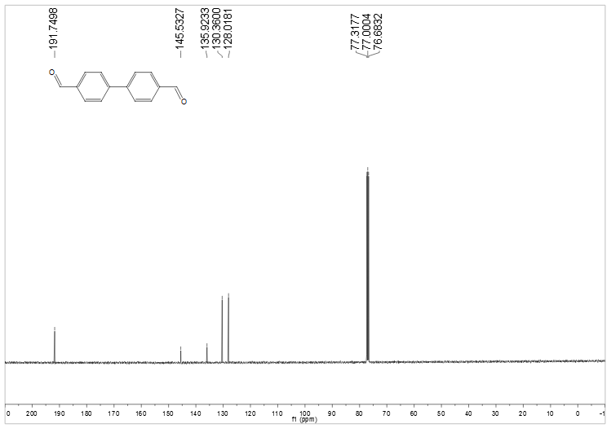

**Figure S12** 1H NMR and 13 C NMR spectra of **2k**

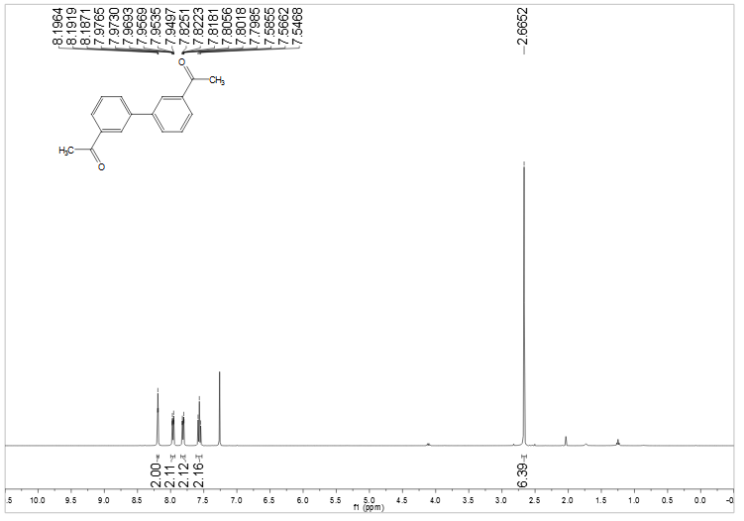

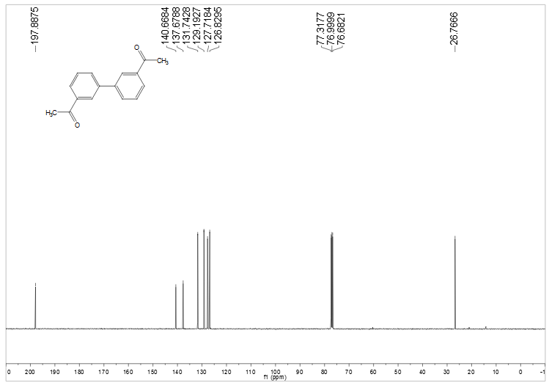

**Figure S13** 1H NMR and 13 C NMR spectra of **2l**

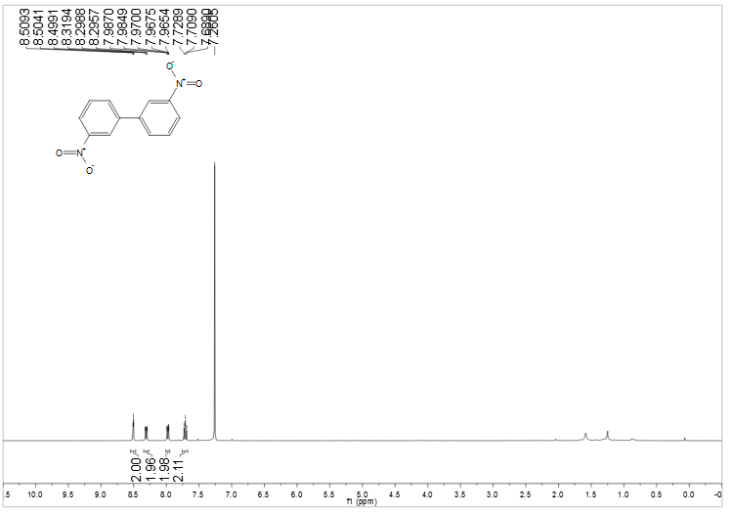

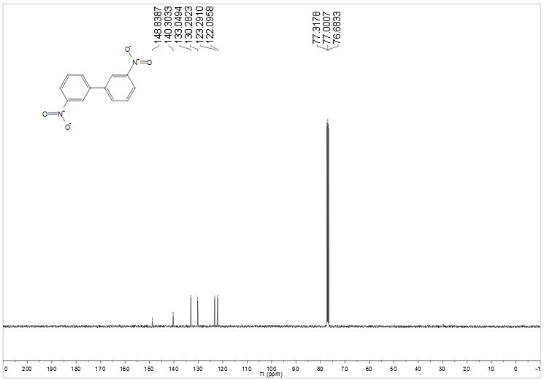

**Figure S14** 1H NMR and 13 C NMR spectra of **2m**

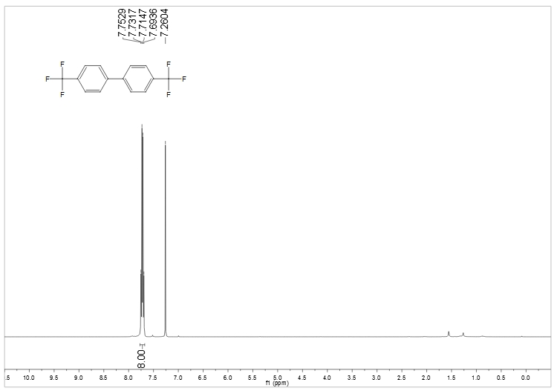

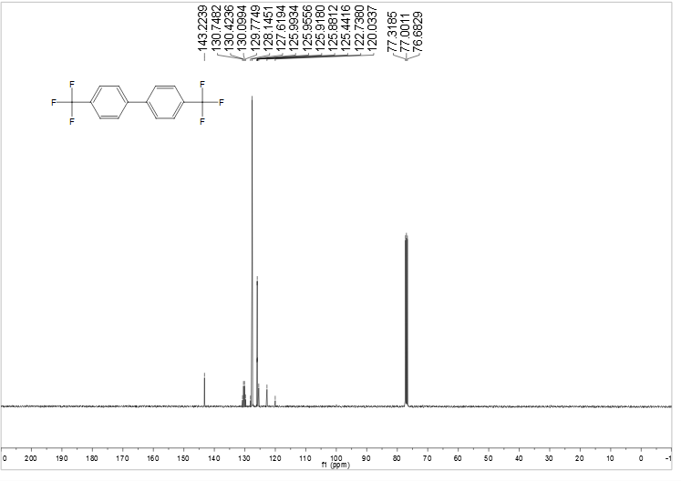

**Figure S15** 1H NMR and 13 C NMR spectra of **2n**

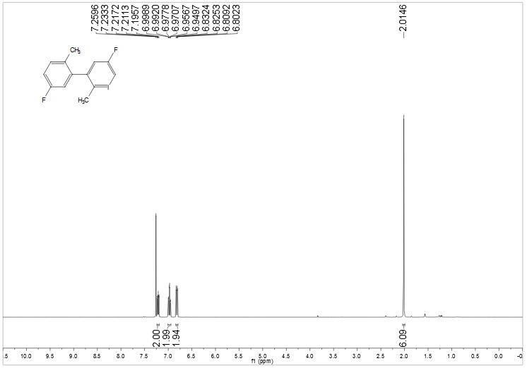

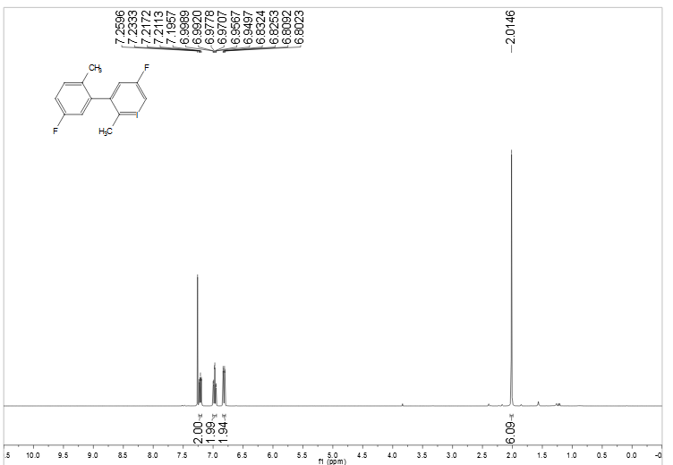

**Figure S16** 1H NMR and 13 C NMR spectra of **2o**

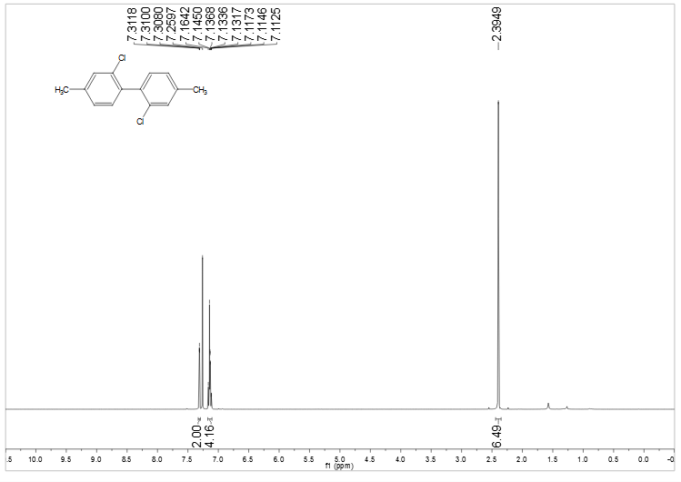

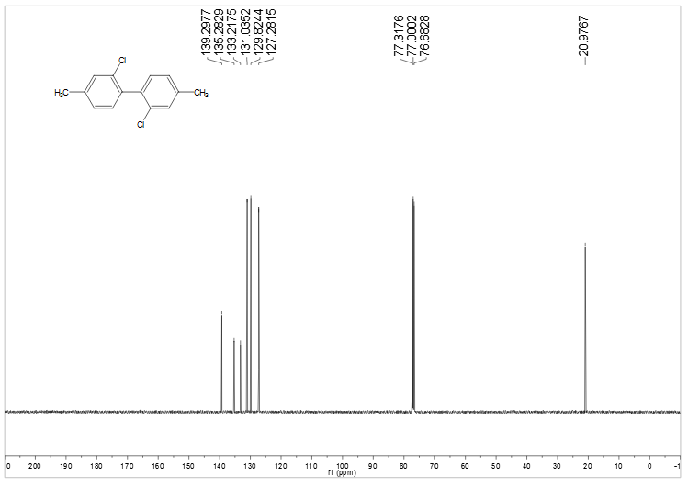

**Figure S17** 1H NMR and 13 C NMR spectra of **2p**

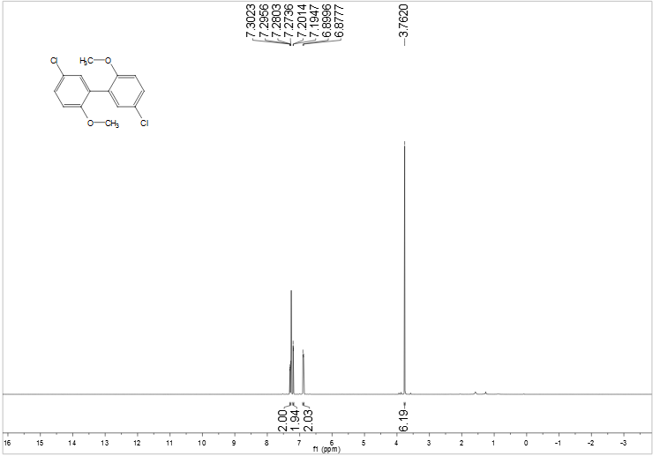

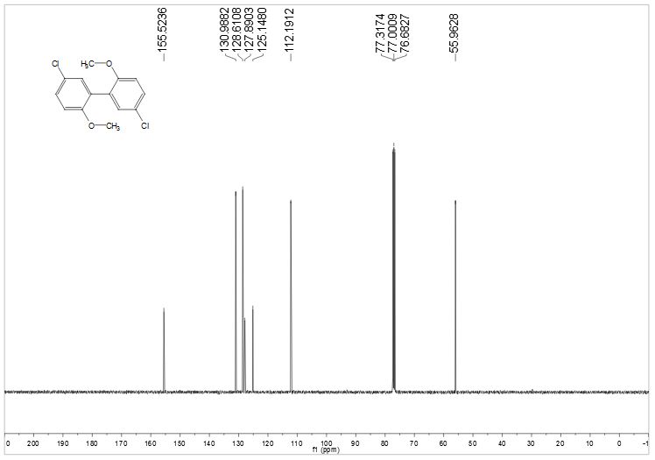

**Figure S18** 1H NMR and 13 C NMR spectra of **2q**

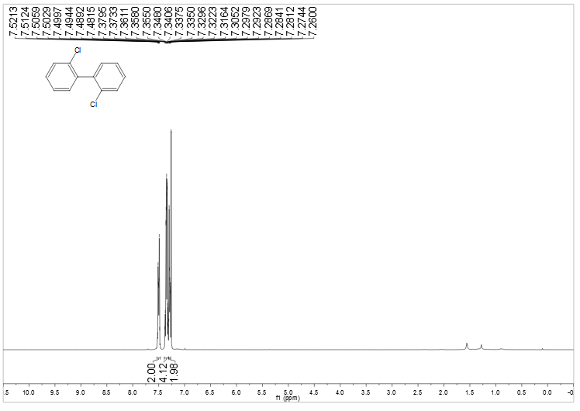

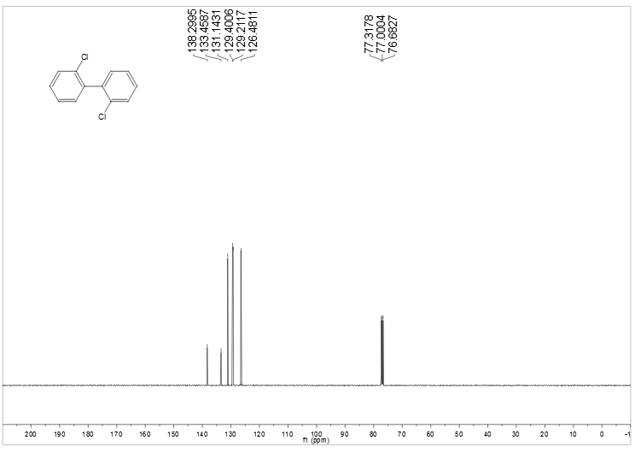

**Figure S19** 1H NMR and 13 C NMR spectra of **2r**

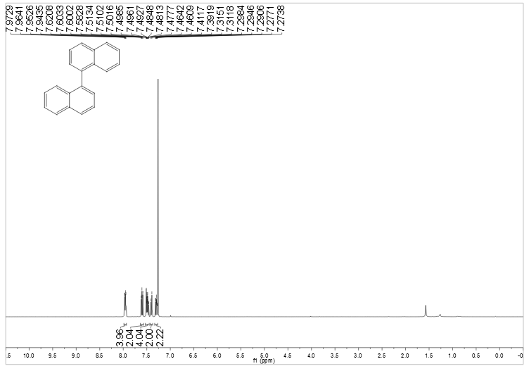

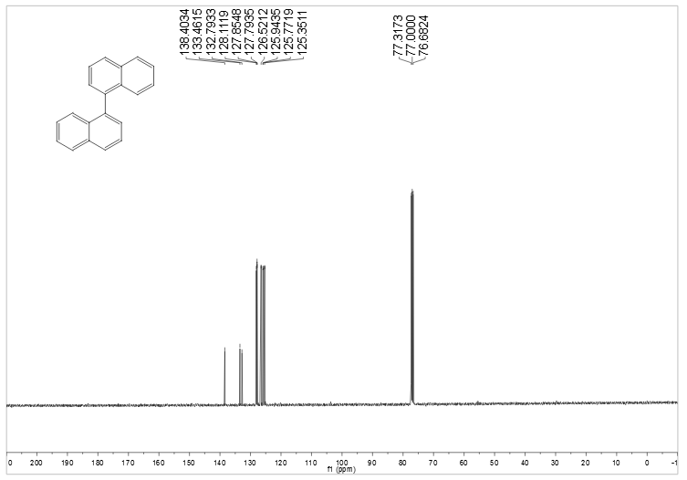

**Figure S20** 1H NMR and 13 C NMR spectra of **2s**

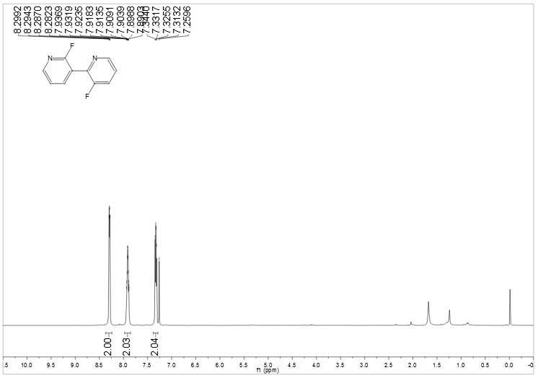

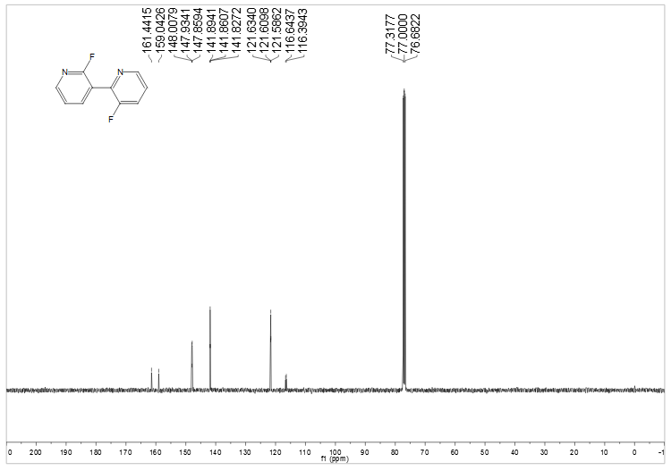

**Figure S21** 1H NMR and 13 C NMR spectra of **2t**

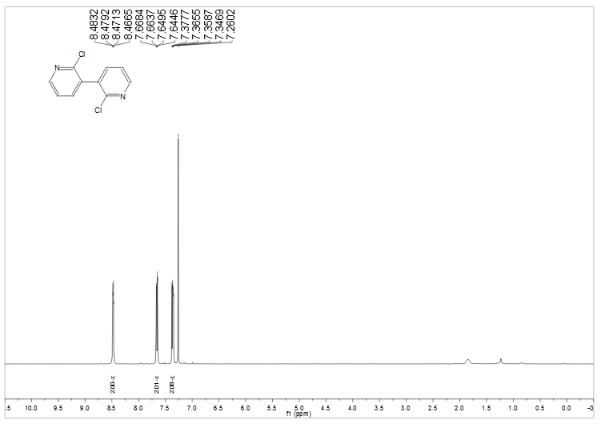

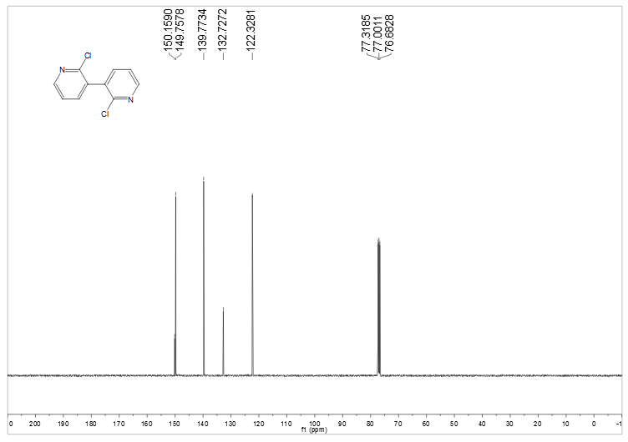

**Figure S22** 1H NMR and 13 C NMR spectra of **2u**

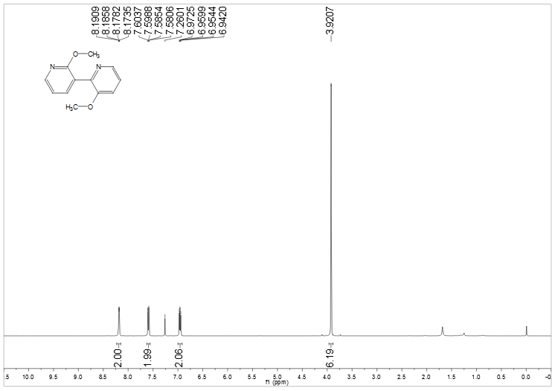

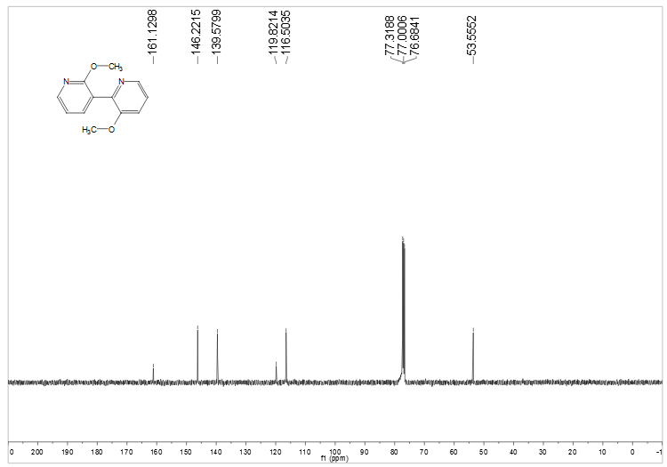

**Figure S23** 1H NMR and 13 C NMR spectra of **2v**

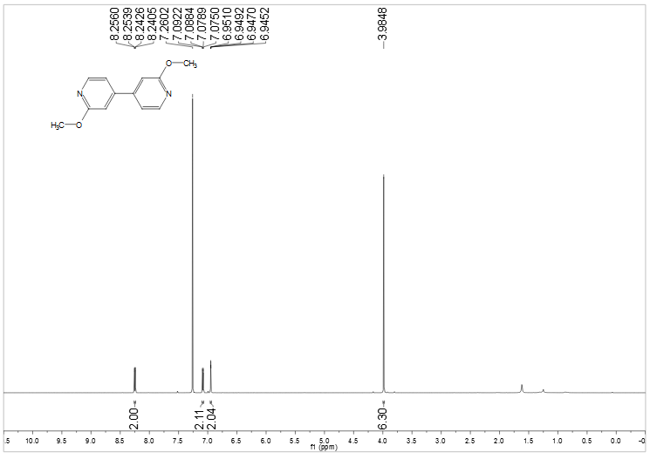

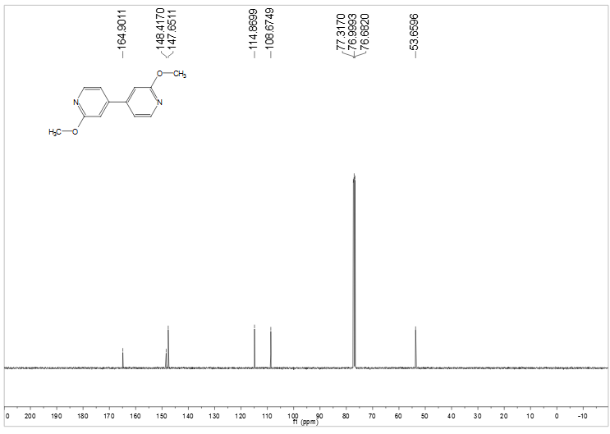

**Figure S24** 1H NMR and 13 C NMR spectra of **2w**

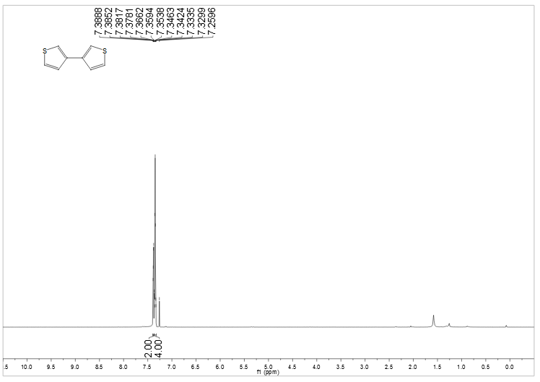

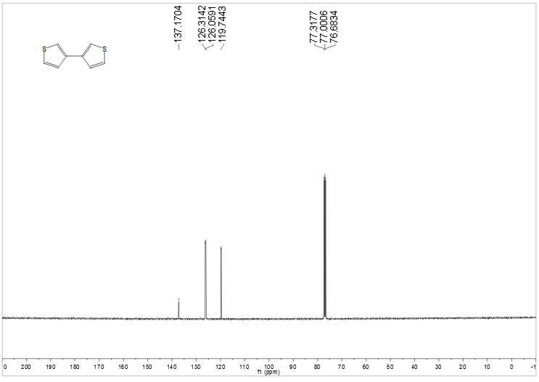

**Figure S25** 1H NMR and 13 C NMR spectra of **2x**

**3k** 1H NMR (400 MHz, CDCl3, ppm) δ = 9.88 (s, 1H), 7.86-7.82(m, 2H), 7.02-6.98(m, 2H), 3.89 (s, 3H).

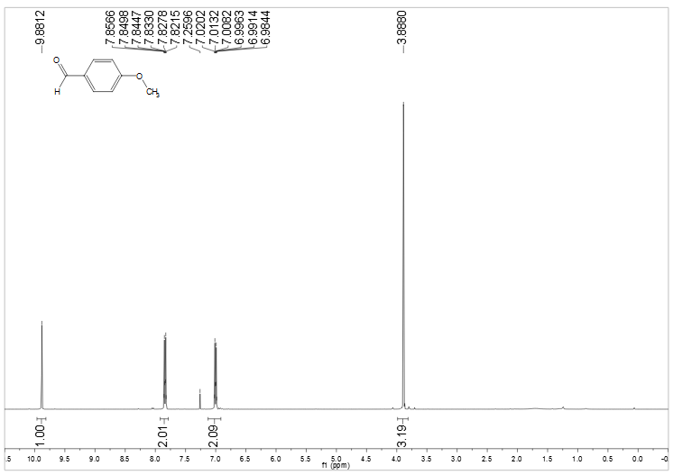**Figure S26** 1H NMR spectra of **3k**

**3l** 1H NMR (400 MHz, CDCl3, ppm) δ = 7.55-7.53(ddd, *J*= 7.6 Hz, 1.6 Hz, 1.0 Hz,1H), 7.49-7.48 (dd, *J*= 2.6 Hz, 1.6 Hz, 1H), 7.39-7.35(t, *J*= 8.0 Hz,2H), 7.13-7.10(ddd, *J*= 8.2 Hz, 2.8Hz, 1.0 Hz,1H), 3.86(s, 3H), 2.60(s, 3H).

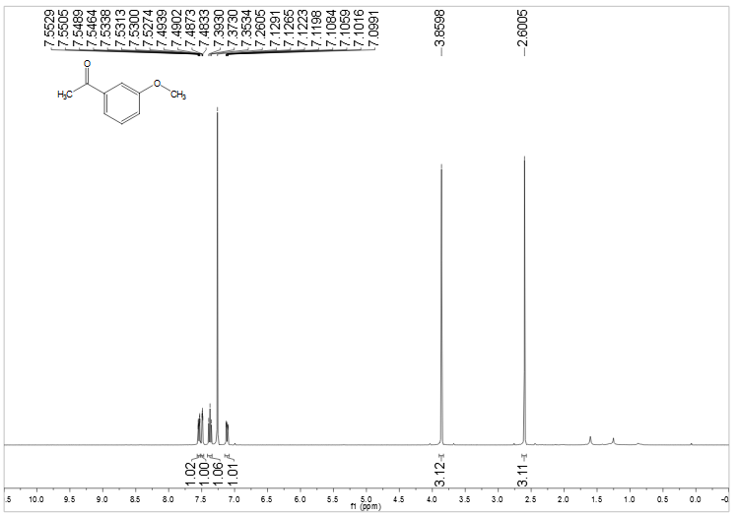

**Figure S27** 1H NMR spectra of **3l**

**3s** 1H NMR (400 MHz, CDCl3, ppm) δ = 7.87-7.84(dd, *J*= 6.2 Hz,3.2Hz, 4H), 7.50-7.48(dd, *J*= 6.2 Hz,3.2Hz, 4H).

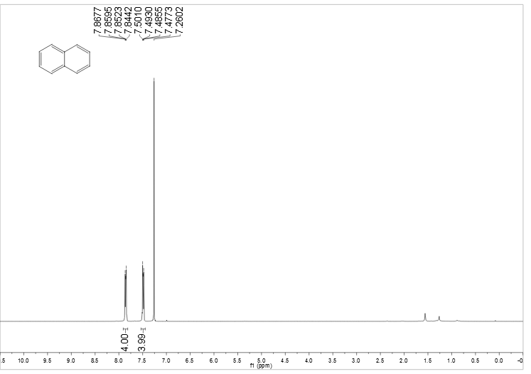

**Figure S28** 1H NMR spectra of **3s**