**SUPPORTING INFORMATION**

**Metabolomic Profile and *In vitro* Evaluation of the Cytotoxic Activity of *Asphodelus microcarpus* against Human Malignant Melanoma Cells A375**

Dalia A. Abosedera1, Emara, S. A.2, Omar A. S. Tamam1, Osama M. Badr3, Shaden A. M. Khalifa4, Hesham R. El-Seedi5,6,7,* and Mohamed S. Refaey8,*

*1 Department of Natural Resources, Environmental Studies and Research Institute, University of Sadat City, Sadat City, Egypt.*

*2 Department of Cytology & Histology, Faculty of Veterinary Medicine, University of Sadat City, Sadat City, Egypt.*

*3 Animal Biotechnology Department Genetic Engineering and Biotechnology Institute (GEBRI), University of Sadat city, Sadat City, Egypt.*

*4 Department of Molecular Biosciences, The Wenner-Gren Institute, Stockholm University, 10691, Stockholm, Sweden.*

*5 Pharmacognosy Group, Department of Pharmaceutical Biosciences, BMC, Uppsala University, Uppsala, Box 591, SE 751 24 Uppsala, Sweden.*

*6 International Research Center for Food Nutrition and Safety, Jiangsu University, Zhenjiang, 212013, China.*

*7 International Joint Research Laboratory of Intelligent Agriculture and Agri-products Processing, Jiangsu Education Department, Jiangsu University China.*

*8 Department of Pharmacognosy, Faculty of Pharmacy, University of Sadat City, Menoufia 32897, Egypt.*

\***Corresponding author**: Mohamed S. Refaey

Department of Pharmacognosy, Faculty of Pharmacy, University of Sadat City, Egypt

**E-mail address**: [Mohamed.said@fop.usc.edu.eg](mailto:Mohamed.said@fop.usc.edu.eg)

**ORCID**:0000-0003-3879-104X

\***Corresponding author**: Hesham R. El-Seedi

**E-mail address**: [hesham.el-seedi@fkog.uu.se](mailto:hesham.el-seedi@fkog.uu.se)

**Contents of Supporting Information**

|  |  |  |
| --- | --- | --- |
| **No.** | **Contents** | **Page** |
| **Fig. S1** | |  | | --- | | Photograph of *A. microcarpus;* a) at the collection site; b) tubers of the plant; c) after cultivation of the plant at the garden of Environmental Studies and Research Institute. | | S3 |
| **Fig. S2** | Flow cytometry DNA content distribution in a cell cycle analysis assay for *A. microcapus* using FL2 (λex/em 535/617 nm) signal detector (ACEA Novocyte™ flow cytometer G0/G1-phase, S-phase, G2/M-phase (a): control, (b): EtOAc fraction (100 µg/mL), (c): EtOAc fraction (83 µg/mL), (d): PPT fraction (100 µg/mL), (e):PPT fraction (65 µg/mL). | S4 |
| **Fig. S3** | Apoptotic analysis of*A. microcarpus* EtOAc fraction treated with melanoma A375 cells after 72 h. | S5 |
| **Fig. S4** | Effect of *A. micrpcarpus* EtOAc fraction and PPT on the induction of apoptosis in melanoma A375 cell. Melanoma A375 cells were cultured in the presence of various concentrations of the EtOAc fraction and PPT for 24 h. The cells were then stained with Annexin V and PI and analyzed by flow cytometry. (a): control; (b) EtOAC (85 µg/mL); (c) EtOAC (100 µg/mL); (d) PPT (65 µg/mL) and (e) PPT (100 µg/mL). | S6 |
| **Table S1** | Cell cycle phase according to two fractions EtoAc with two concentrate and PPT fraction with two concentrate and control. | S7 |
| **Table S2** | Apoptosis assay according to two fractions EtOAc fraction & PPT with two concentrate and control. | S7 |

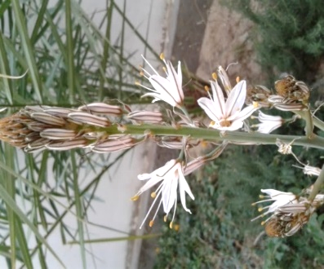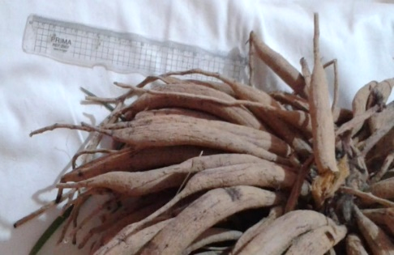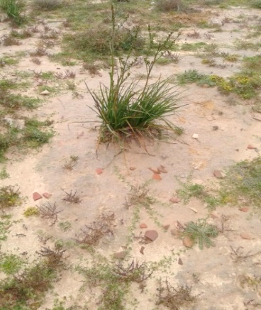

a b c

**Fig. S1**: Photograph of *A. microcarpus;* a) at the collection site; b) tubers of the plant; c) after cultivation of the plant at the garden of Environmental Studies and Research Institute.

**Fig. S2:** Flow cytometry DNA content distribution in a cell cycle analysis assay for *A. microcapus* using FL2 (λex/em 535/617 nm) signal detector (ACEA Novocyte™ flow cytometer G0/G1-phase, S-phase, G2/M-phase (a): control, (b): EtOAc fraction (100 µg/mL), (c): EtOAc fraction (83 µg/mL), (d): PPT fraction (100 µg/mL), (e):PPT fraction (65 µg/mL).

**(a)**

**(b)**

**(c)**

**Fig. S3:** Apoptotic analysis of*A. microcarpus* EtOAc fraction treated with melanoma A375 cells after 72 h.

**Fig.** **S4**: Effect of *A. micrpcarpus* EtOAc fraction and PPT on the induction of apoptosis in melanoma A375 cell. Melanoma A375 cells were cultured in the presence of various concentrations of the EtOAc fraction and PPT for 24 h. The cells were then stained with Annexin V and PI and analyzed by flow cytometry. (a): control; (b) EtOAC (85 µg/mL); (c) EtOAC (100 µg/mL); (d) PPT (65 µg/mL) and (e) PPT (100 µg/mL).

**Table S1:** Cell cycle phase according to two fractions EtoAc with two concentrate and PPT fraction with two concentrate and control.

|  |  |  |  |  |
| --- | --- | --- | --- | --- |
| **Fractions** | **Conc.** | **G1 phase** | **S phase** | **G2 phase** |
| **EtoAC** | 100µg/mL | 60.45 | 27.22 | 9.5 |
|  | 83µg/mL | 58 | 25.79 | 11.67 |
| **PPT** | 100µg/mL | 62.67 | 22.6 | 11.17 |
|  | 65µg/mL | 60.04 | 24.52 | 11.8 |
| **Control**  **paclitaxel** | 1µmL | 62.09 | 19.02 | 15.99 |

**Table S2:** Apoptosis assay according to two fractions EtOAc fraction & PPT with two concentrate and control.

|  |  |  |  |  |  |
| --- | --- | --- | --- | --- | --- |
| **Fractions** | **Conc.** | **Early apoptosis** | **Late apoptosis** | **Live cells** | **Necrosis** |
| **EtOAc** | 100µg/mL | 93 | 3892 | 469 | 4086 |
|  | 83µg/mL | 63 | 1952 | 797 | 4236 |
| **PPT** | 100µg/mL | 1491 | 1941 | 4310 | 897 |
|  | 65µg/mL | 707.3 | 1137 | 5580 | 645.3 |
| **Control**  **doxorubicin** | 10 µ/mL | 43 | 147.6 | 81 | 14 |