**Supplementary Material**

**Application of *Forsskaolea tenacissima* mediated gold nanoparticles in dyes discolouration, antibiotics removal, and metal ions detection**

Wajheeba Khana, Nargis Jamilaa, *, Naeem Khanb, **, Rehana Masoodc, Tan Wen Need, Naheed Bibia, Joon Ho Honge, Amir Atlasf

aDepartment of Chemistry, Shaheed Benazir Bhutto Women University, Peshawar 25000, Khyber Pakhtunkhwa, Pakistan

bDepartment of Chemistry, Kohat University of Science and Technology, Kohat 26000, Khyber Pakhtunkhwa, Pakistan

cDepartment of Biochemistry, Shaheed Benazir Bhutto Women University, Peshawar 25000, Khyber Pakhtunkhwa, Pakistan

dChemistry Section,School of Distance Education, Universiti Sains Malaysia, 11800 Penang, Malaysia

eNanobio Research Center, Jeonnam Bioindustry Foundation (JBF), Jangsung-gun, Jeollanam-do 57248, South Korea

fInstitute of Basic Medical Sciences, Khyber Medical University, Peshawar 25000, Khyber Pakhtunkhwa, Pakistan

**To whom the correspondence should be addressed:**

**Corresponding Author\***

*Dr. Nargis Jamila

Department of Chemistry, Shaheed Benazir Bhutto Women University

Peshawar 25000, Khyber Pakhtunkhwa, Pakistan

Email: [njk985@gmail.com](mailto:njk985@gmail.com), [nargisjamila@sbbwu.edu.pk](mailto:nargisjamila@sbbwu.edu.pk)

**Dr. Naeem Khan

Department of Chemistry, Kohat University of Science and Technology,

Kohat 26000, Khyber Pakhtunkhwa, Pakistan

Email: [nkhan812@gmail.com](mailto:nkhan812@gmail.com), [naeem@kust.edu.pk](mailto:naeem@kust.edu.pk)

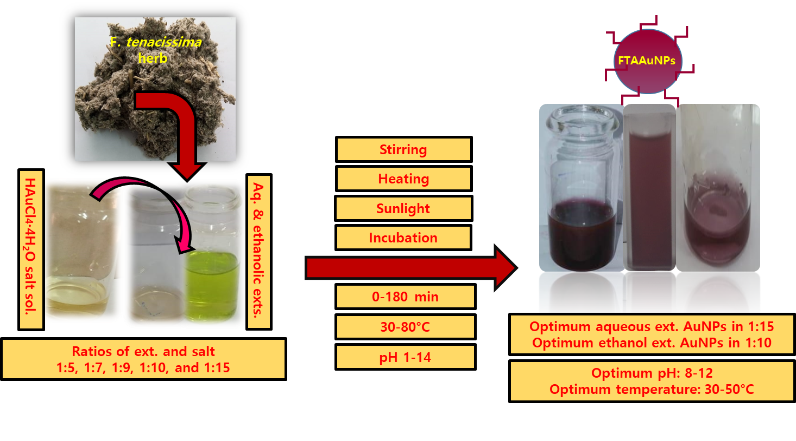

**Figure S1**. FTAAuNPs formation from aqueous and natural ethanolic extracts of *F. tenacissima* aerial part and Au salt (1:15 and 1:10, respectively) in sunlight

|  |  |
| --- | --- |
| **a** | **b** |
| **c** | **d** |

**Figure S2.** Successive UV–Vis absorption spectra for FTAAuNPs formation in (a) 1:5, (b) 1:7, (c) 1:9, and (d) 1:10 under sunlight, stirring, heating, and incubation from aqueous extract of *F. tenacissima* aerial part

|  |  |
| --- | --- |
| **a** | **b** |
| **c** | **d** |

**Figure S3.** Successive UV–Vis absorption spectra for FTAAuNPs formation in (a) 1:5, (b) 1:7, (c) 1:9 under sunlight, stirring, heating, and incubation, and (d) 1:10 at incubation from ethanolic extract of *F. tenacissima* aerial part

|  |
| --- |
| **a** |
| **b** |

**Figure S4.** UV-Vis spectra of FTAAuNPs at different (a) pH (1-14), and (b) temperature (30-80°C)

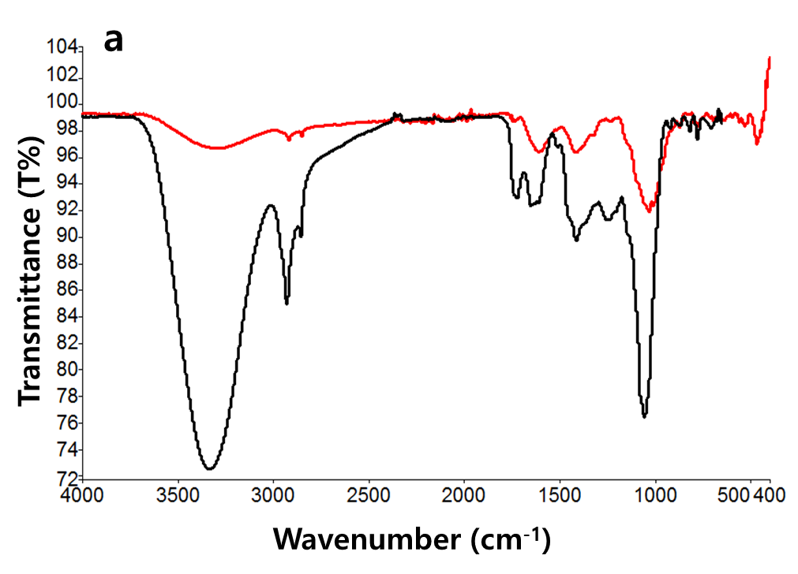

**__ FTAE**

**__ FTAAuNPs**

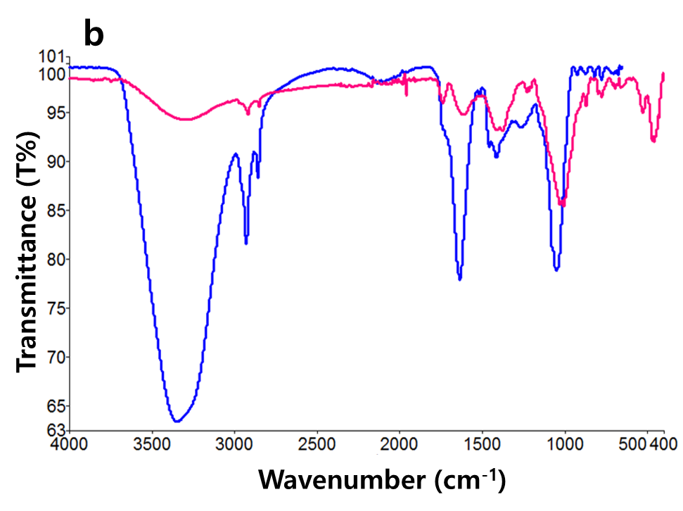

**__ FTAE**

**__ FTAAuNPs**

**Figure S5**. FT-IR spectra of (a) aqueous extract and aqueous extract mediated FTAAuNPs (b) ethanol extract and ethanol extract mediated FTAAuNPs

**Table S1**. %removal, Linear relationship (equation, *R*2, and rate constant) based on pseudo-first-order kinetics of dyes/nitrophenols (MB, CR, RdB, MO, PNP, and ONP) at intervals of 0 to 80 min, and antibiotics (AMX, DXC, LFX, and ORX) at 0-180 min

|  |  |  |  |  |
| --- | --- | --- | --- | --- |
| **Sample** | **% reduction/removal** | **Linear equation** | ***R*2** | **Rate constant (k)** |
| **Dyes/nitrophenols** | | | | |
| **MB** | 70 | y = -0.0076x+0.0433 | 0.9931 | 1.45 x10-1 |
| **CR** | 85 | y = -0.0206x+0.1228 | 0.9919 | 1.72 x 10-1 |
| **RdB** | 50 | y = -0.0014x-0.0083 | 0.9428 | 0.72 x 10-1 |
| **MO** | 90 | y = 0.0126x+0.1087 | 0.9684 | 1.03 x 10-1 |
| **PNP** | 85 | y = -0.012x+0.08 | 0.9927 | 0.97 x 10-1 |
| **ONP** | 85 | y = -0.0199x+0.296 | 0.9957 | 1.80 x 10-1 |
| **Antibiotics** | | | | |
| **AMX** | 95 | y = -0.0029x+0.9031 | 0.9173 | 1.02 x 10-1 |
| **DXC** | 95 | y = -0.003x+1.009 | 0.9928 | 1.31 x 10-1 |
| **LFX** | 95 | y = -0.003x+1.0024 | 0.9974 | 0.975 x 10-1 |
| **ORX** | 80 | y = -0.004x+0.9777 | 0.9746 | 0.815 x 10-1 |

|  |
| --- |
| **a** |
| **b** |

**Figure S6.** Successive UV–Vis absorption for effect of pH on the removal of (a) LFX and DXC, and (b) AMX and ORX by FTAAuNPs

|  |  |
| --- | --- |
|  | **b** |
| **c** | **d** |
| **e** | **f** |

**Figure S7**. Successive UV–Vis absorption spectra for metal ion solutions (a) Fe+++, (b) Pd++, (c) Sn++, (d) K+,(e) Na+,and (f) Mg++ detection by FTAAuNPs