**The adsorption capacity/ removal rate time curve**

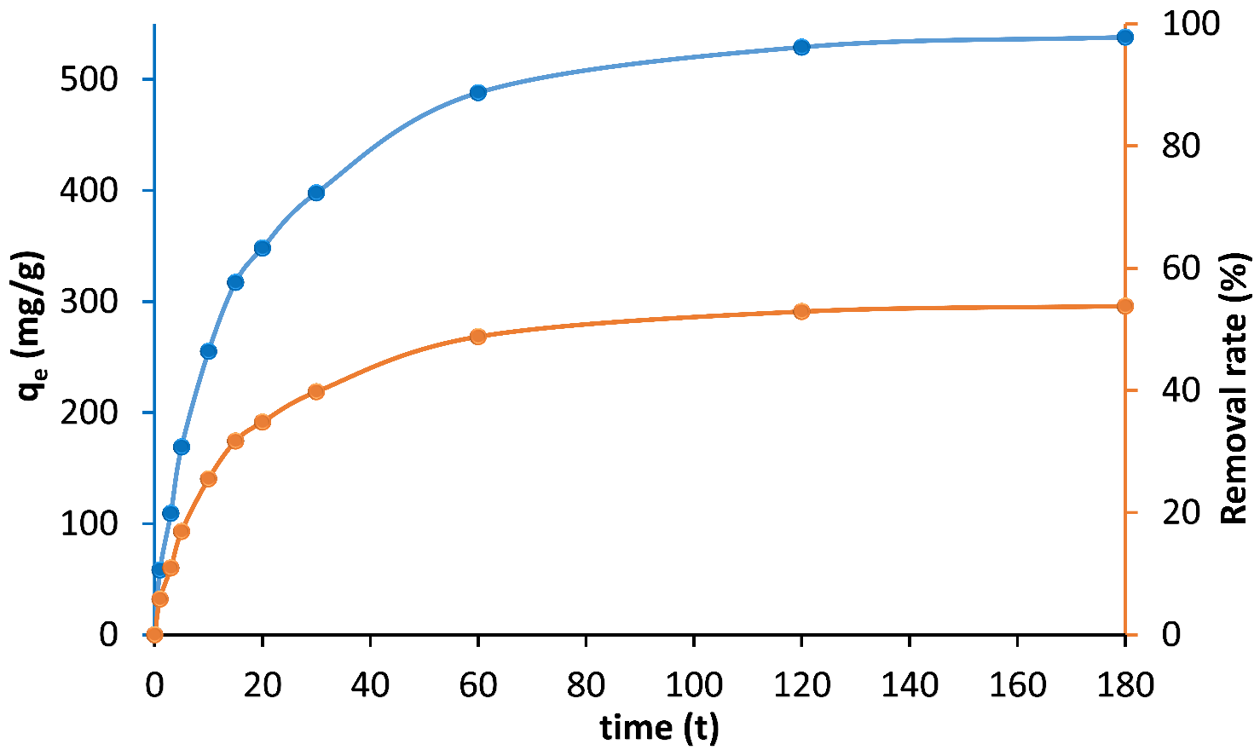

Effect of time on the adsorption capacity and removal rate efficiency of CR by MgAl–LDH (Co=500 mg/L, m=0.05g).