Reviewers' comments answering:

**Reviewer #1:** the introduced work provides the synthesis of nanosorbent MgAl-layered double hydroxides for adsorption of Cogno red from wastewater, the experimental is clear and organized, discussion is comprehensive.

**Answering**: Dear Reviewer #1, Thank you for your acceptance.

**Reviewer #3:** What is the innovation of this paper? The points listed below are raised from the reviewer as queries and concerns.

**Dear Reviewer #3**, Thank you for your valuable comments.

The innovation of this paper is the successful preparation of a homogenous nanosorbent of MgAl-LDH with a higher adsorption capacity equal to 769.23mg/g compared with other LDH sorbents.

1. The abstract can be rephrased to be more concise.

**Answering:** the abstract was rephrased to be more expressive.

2. Introduction section should be written by more up-to-date references addressed. Research progress should be delivered on more clear way with directed necessity for the conducted research work.

**Answering:** the introduction section has been modified with updated references to be clearer**.**

3. Please supplement the standard curve of Congo red dye.

**Answering:** the standard curve of Congo red dye was added as a supplement file.

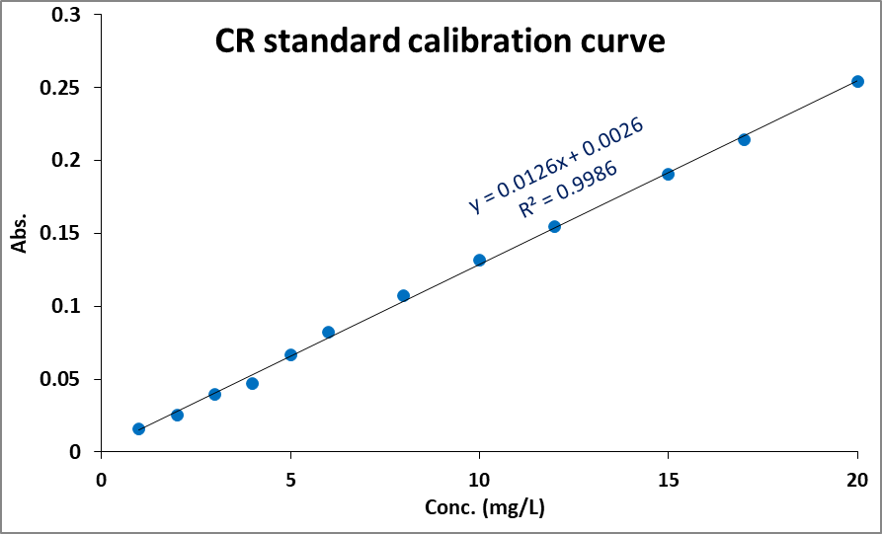

4. Equation 2, "R%= *100" should be "R%= *100%"

**Answering:** Equation 2 has been modified and % has been added to the equation.

5. The Elovich model equation, Equation 6, "qe= “should be "qt= “.

**Answering:** the qe has been replaced by qt in Equation 6

6. The XRD，FT-IR and HRTEM were not enough to prove that Congo red was adsorbed to LDH. Are these small peaks of XRD baseline disturbance or Congo red peak? It is suggested to supplement XPS and EDS to prove that Congo red was adsorbed to LDH by analyzing S in Congo red.

**Answering:** the small peaks in the red line of the XRD pattern, Fig. (2), represent the adsorbed CR into the LDH, the 2Ɵ position of these small peaks corresponds to the CR reference card (00-036-1788). The weak intensity of these CR peaks is due to the low concentration of CR in ppm unit. Regarding the EDS analysis. It was clear that the EDS of LDH before the adsorption process contains the peaks related to the elements of MgAl-LDH that contain the elements of (O, Al, Mg) and a small peak for carbon from the grid. On the other side, the EDS of LDH after the adsorption of CR dye indicates the presence of peaks related to the elements of Nitrogen and Sulfur in addition to high intense peaks of carbon and oxygen related to the structure of CR dye. The change of EDS before and after the adsorption of CR dye prove the successful adsorption process of CR to the LDH sorbent.

The EDS analysis of LDH before and after adsorption of CR has been added as a supplement file.

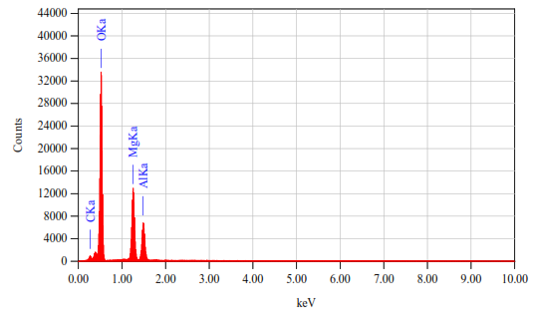

**Mg/Al-LDH before adsorption**

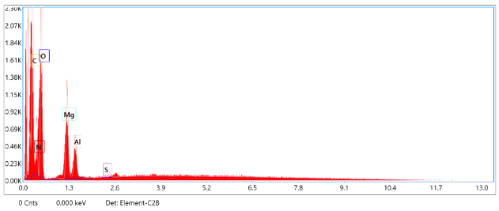

**Mg/Al-LDH-CR after CR adsorption to LDH**

Regarding the XPS analysis, we have only one instrument in Egypt and have long waiting list more than four months.

**Dear Reviewer #5**, Thank you for your valuable comments

1. The methodology used for the preparation of HDL is the conventional one, not presenting any novelty.

**Answering:** Despite using conventional method in synthesis of LDH nanosheets, but the effective absorbability of Congo red dye as pollutant could make the work interested, especially it was showed higher adsorption capacity equal to 769.23 mg/g compared with other LDH sorbents.

1. In the introduction of the work, the authors failed to present the originality of the studies

**Answering:** The introduction was revised, trying to present some type of our study originality

1. Lines 135 and 136. Replace M with m (lowercase), as it represents mass.

**Answering:** M has been replaced with m in lines 133 and 134.

1. Line 161: equation (5) h = k qe is incorrect the correct one is h = K Qe2. Check that the dates were calculated correctly and, if necessary, correct the table data. Another observation: the calculations were made, and the data is presented in Table 1, however, the value obtained was not discussed in the text.

**Answering:** Thank you for this important comment, the equation (5) in the line 158 has been corrected from (h = k qe) to h = k2 qe2. Unfortunately, this is a written mistake in the equation only, but the equations and table’s data were calculated according to the equation h = k2 qe2. On the other hand, the data presented in table 1, was discussed in section (3.2.1.) from lines 277-285. **[1,2].**

**[1]** Spies, A.R.L. and F. Wewers, *Equilibrium, kinetics and thermodynamics studies of Cd sorption onto a dithizone-impregnated Amberchrom CG-300m polymer resin.* Arabian Journal of Chemistry, 2020. **13**(4): p. 5050-5059.

**[2]** Ho, Y.S., J.C.Y. Ng, and G. McKay, *REMOVAL OF LEAD(II) FROM EFFLUENTS BY SORPTION ON PEAT USING SECOND-ORDER KINETICS.* Separation Science and Technology, 2001. **36**(2): p. 241-261.

1. Lines 180 and 183. Replace qm with qmax, according to equation 7.

**Answering:** qm has been replaced by qmax in lines 177 to 180.

1. Line 193: Kf (mg/g) (mg/L) check this information

**Answering:** The unit of the term kf has been replaced from (mg/g) (mg/L) to (L·mg−1) in the line 188 **[1].**

*[****1]*** *Spies, A.R.L. and F. Wewers, Equilibrium, kinetics and thermodynamics studies of Cd sorption onto a dithizone-impregnated Amberchrom CG-300m polymer resin. Arabian Journal of Chemistry, 2020. 13(4): p. 5050-5059.*

1. Lines 254-256: "with slight decrease in the particle size of LDH due to high absorptivity of LDH for the congo red molecules on its surface and ion exchange of CR with the presented water molecules between the LDH layers spacing". I believe that this observation needs to be more substantiated and I suggest that the microscopy of figures 4A and 4B be presented in the same magnitude in order to be able to better compare.

**Answering:** Lines 254-256 were corrected in the modified manuscript in the lines 246-249

The use of "with slight decrease "this expression was lacks the meaning.

The desired meaning was supposed to be" In addition, the presence of the small bulky aggregations in MgAl-LDH-CR represented in Fig.4B related to the accumulation of Congo red dye. So the part "with slight decrease in the particle size of LDH due to high absorptivity of LDH for the Congo red molecules on its surface" was removed and corrected in the original manuscript ".

According to TEM measurement, the size, width and thickness of LDH before and after loading with Congo red do not changed and the size was around 100nm.

1. Line 257: range between (3-11), the correct is range between (3-13).

**Answering:** Good observation, the pH range has been modified from (3-11) to (3-13) in line 251.

1. Lines 291-292: "adsorption process was controlled by chemisorption" On what data did the authors base the rationale for chemisorption?

**Answering:** According to the values of R2, it was indicated that the adsorption of CR dye on LDH follows the pseudo-second order kinetic model rather than pseudo-first order kinetic model and Elovich kinetic models as shown in table (1). The pseudo-second order kinetic model is assumes that [chemisorption](https://08101mgll-1105-y-https-www-sciencedirect-com.mplbci.ekb.eg/topics/earth-and-planetary-sciences/chemisorption) is the rate determining step, which indicated that chemisorption was the rate controlling mechanism for CR dye adsorption **[3,4,5].**

**[3]** Zhang, X., et al., *Efficient adsorptive elimination of organic pollutants from aqueous solutions on ZIF-8/MWCNTs-COOH nanoadsorbents: Adsorption kinetics, isotherms, and thermodynamic study.* Journal of Industrial and Engineering Chemistry, 2022. **111**: p. 155-167.

**[4]** Lung, I., et al., *Evaluation of CNT-COOH/MnO2/Fe3O4 nanocomposite for ibuprofen and paracetamol removal from aqueous solutions.* Journal of Hazardous Materials, 2021. **403**: p. 123528.

**[5]** Ho, Y.S. and G. McKay, *The kinetics of sorption of basic dyes from aqueous solution by sphagnum moss peat.* The Canadian Journal of Chemical Engineering, 1998. **76**(4): p. 822-827.

1. Lines 304,351 and 401: Figures 7, 9 and 13 are not very representative and can be taken from the article.

**Answering:** Figures 7and 9 have been removed from the article, but figure 13 remain and modified to have number figure 11 to indicates the nature of the adsorbent at low pH, as the pH decrease the sorbent became more positive and has the high ability to attract anions of CR dye than at higher pH values which can be seen in figure 5 of the zeta potential of LDH sorbent.

1. In item 3.2.4. Adsorption mechanism, or authors make two considerations: " In the first approach, the adsorption of CR occurs on the outer surface of sorbent through electrostatic attraction and H-bonding", and "The second approach, the ion exchange process, takes place by inserting CR molecules and replacing the anions existing in the interlayer spacing of CO32− or HCO3- or OH− with CR anions". Based on what results did the authors make these observations? It needs to be better justified.

**Answering:** Many previous studies confirm the reaction or adsorption mechanism between the CR and LDH occurs through two approaches, first one, the positively charged surface of the LDH which can cause a very strong electrostatic force to attract CR anionic dyes. The second approach is the ion exchange between the CR anions and negatively charged anions of CO32-, HCO33- and OH- existing in the interlayer spacing of LDH. **[6,7,8,9]**

**[6]** Miao, J., et al., *Preparation of hollow hierarchical porous CoMgAl-borate LDH ball-flower and its calcinated product with extraordinary adsorption capacity for Congo red and methyl orange.* Applied Clay Science, 2021. **207**: p. 106093.

**[7]** Hu, H., et al., *Hierarchical porous Ni/Co-LDH hollow dodecahedron with excellent adsorption property for Congo red and Cr(VI) ions.* Applied Surface Science, 2019. **478**: p. 981-990.

**[8]** Guan, T., et al., *A facile approach to synthesize 3D flower-like hierarchical NiCo layered double hydroxide microspheres and their enhanced adsorption capability.* Colloids and Surfaces A: Physicochemical and Engineering Aspects, 2017. **529**: p. 907-915.

**[9]** Miao, J., et al., *Feasible synthesis of hierarchical porous MgAl-borate LDHs functionalized Fe3O4@SiO2 magnetic microspheres with excellent adsorption performance toward congo red and Cr(VI) pollutants.* Journal of Alloys and Compounds, 2021. **861**: p. 157974.

1. The numbers of the final figures do not coincide with those inserted in the text.

**Answering:** The numbers of the figures have been modified to coincide with those inserted in the text.

**Dear Reviewer #6,** Thank you for your valuable comments.

1. In equation (6), "qe" should be "qt".

**Answering:** Equation (6) has been corrected and "qe" replaced with "qt".

1. What's the meaning of "The FT-IR is inconsistent with PXRD (Fig.3)" in page 11, line 238?  In Fig.3, the main bands (wavenumber) should be labeled in FT-IR spectra.

**Answering:** written mistake, the correct sentence is "The FT-IR is consistent with PXRD (Fig.3)"

1. Page 12, line 254, what is the accurate size of LDH before and after CR adsorption (in Fig. 5)? Width? Thickness? Why did the size of hexagonal LDH nanoflakes decrease after CR adsorption?

**Answering:** Lines 246-249 were corrected in the modified manuscript:

The use of "with slight decrease "this expression was lacks the meaning

The desired meaning was supposed to be" In addition, the presence of the small bulky aggregations in MgAl-LDH-CR represented in Fig.4B related to the accumulation of Congo red dye. So the part "with slight decrease in the particle size of LDH due to high absorptivity of LDH for the Congo red molecules on its surface" was removed and corrected in the original manuscript ".

According to TEM measurement, the size, width and thickness of LDH before and after loading with CR do not changed and the size was around 100nm.

1. Adsorption conditions (adsorbent dosage? dye concentration? etc.) should be indicated in each figure caption.

**Answering**: Adsorption conditions have been inserted in each figure caption.

1. For the CR adsorption measurement, the removal rate need be considered, based on Fig.7,9,13, the final CR concentration is still high, how about the removal rate? Based on Fig. 10, it is also obvious that higher dye concentration (or adsorbate/adsorbent ratio) will lead higher adsorption capacity but lower removal efficiency, for some typical and important adsorption measurement, the author should provide corresponding removal rate-time curves to display the adsorption efficiency.

**Answering:** because the adsorption capacity, q (mg/g) is more significant and reliable than the removal rate (%) for the adsorbent efficiency, which means how many mg of adsorbate is removed by one g of adsorbent, we can use a large adsorbent dose on low adsorbate concentration solution to achieve a high removal rate but the q will be very low, which is not expressive about the efficiency of the adsorbent.

The adsorption capacity/ removal rate time curve has been attached as a supplement file.

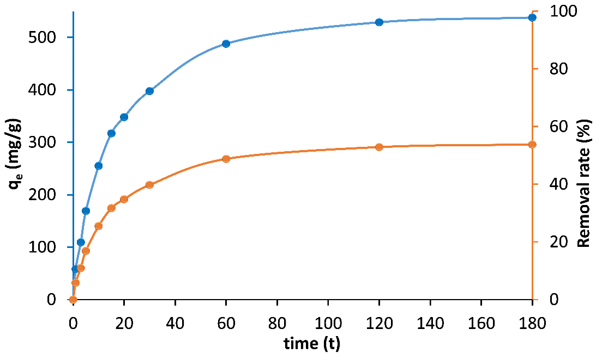

Effect of time on the adsorption capacity and removal rate efficiency of CR by MgAl–LDH (Co=500 mg/L, m=0.05g).

1. In Table 3, the author should also compare the CR removal rate.

**Answering:** As mentioned in the previous point (5), the removal rate is not expressive about the efficiency of the adsorbent and q is the more considerable term in the adsorption process, in addition most of the previous work compare the adsorption capacity.

1. The English should be smoothed carefully.

**Answering:** the language editing has been revised by the Enago through the Egyptian Knowledge Bank (EKB). The certificate of the language editing has been attached as a supplement file.

**References:**

1. Spies, A.R.L. and F. Wewers, *Equilibrium, kinetics and thermodynamics studies of Cd sorption onto a dithizone-impregnated Amberchrom CG-300m polymer resin.* Arabian Journal of Chemistry, 2020. **13**(4): p. 5050-5059.

2. Ho, Y.S., J.C.Y. Ng, and G. McKay, *REMOVAL OF LEAD(II) FROM EFFLUENTS BY SORPTION ON PEAT USING SECOND-ORDER KINETICS.* Separation Science and Technology, 2001. **36**(2): p. 241-261.

3. Zhang, X., et al., *Efficient adsorptive elimination of organic pollutants from aqueous solutions on ZIF-8/MWCNTs-COOH nanoadsorbents: Adsorption kinetics, isotherms, and thermodynamic study.* Journal of Industrial and Engineering Chemistry, 2022. **111**: p. 155-167.

4. Lung, I., et al., *Evaluation of CNT-COOH/MnO2/Fe3O4 nanocomposite for ibuprofen and paracetamol removal from aqueous solutions.* Journal of Hazardous Materials, 2021. **403**: p. 123528.

5. Ho, Y.S. and G. McKay, *The kinetics of sorption of basic dyes from aqueous solution by sphagnum moss peat.* The Canadian Journal of Chemical Engineering, 1998. **76**(4): p. 822-827.

6. Miao, J., et al., *Preparation of hollow hierarchical porous CoMgAl-borate LDH ball-flower and its calcinated product with extraordinary adsorption capacity for Congo red and methyl orange.* Applied Clay Science, 2021. **207**: p. 106093.

7. Hu, H., et al., *Hierarchical porous Ni/Co-LDH hollow dodecahedron with excellent adsorption property for Congo red and Cr(VI) ions.* Applied Surface Science, 2019. **478**: p. 981-990.

8. Guan, T., et al., *A facile approach to synthesize 3D flower-like hierarchical NiCo layered double hydroxide microspheres and their enhanced adsorption capability.* Colloids and Surfaces A: Physicochemical and Engineering Aspects, 2017. **529**: p. 907-915.

9. Miao, J., et al., *Feasible synthesis of hierarchical porous MgAl-borate LDHs functionalized Fe3O4@SiO2 magnetic microspheres with excellent adsorption performance toward congo red and Cr(VI) pollutants.* Journal of Alloys and Compounds, 2021. **861**: p. 157974.