A Novel Colorimetric and “turn-on”Fluorescent sensor for Selective detection of Cu²⁺
Jiaxin Li ª，Chen Zhou ^{a, b, *}，Huan Zhang ª, Yue Hou ^{c}，Qingqing Pan，Jing Sun ^{a, b}，Xiao Li ^{a, b}
ª School of Chemistry & Enviromental Engineering, Changchun University of Science and Technology, Changchun, 130022, PR China
^{b} Jilin Provincial International Joint Research Center of Photo-functional Materials and Chemistry, Changchun, 130022, PR China
^{c} School of Life Science and Technology, Changchun University of Science and Technology, Changchun, 130022, PR China

Corresponding author: Chen Zhou
E-mail address: zhouchen@cust.edu.cn
Contents:
1. ¹H NMR anf ¹³C NMR of Sensor 1

Fig.S1 ¹H NMR spectrum of sensor 1
Fig.S2 ¹³C NMR spectrum of sensor 1

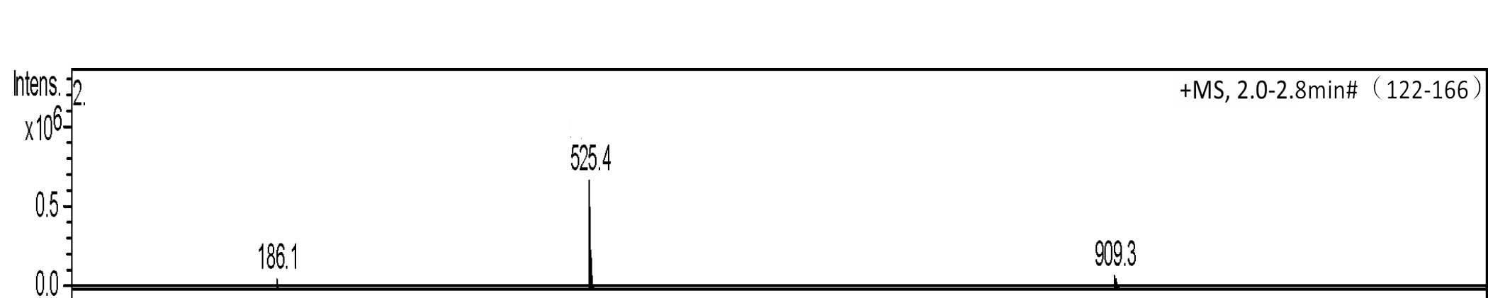
Fig.S3 Mass spectra of sensor 1

