Supporting information for

**Fate and Behavior of Glufosinate-enantiomers and Their Metabolites in Soil and Weeds Under Open Field Condition**

**Yunfang Li1, Fei Wang1, Qiao Lin, Pengyu Deng, Yuping Zhang*, Deyu Hu\***

aState Key Laboratory Breeding Base of Green Pesticide and Agricultural Bioengineering, Key Laboratory of Green Pesticide and Agricultural Bioengineering, Ministry of Education, Guizhou University, Guiyang 550025, P. R. China.

1 These authors contributed equally to this work.

* Correspondence: e-mail: zhangyupinggz@163.com (Yuping Zhang); [gzu_dyhu@126.com](mailto:gzu_dyhu@126.com) (Deyu Hu).

Tel.: (+86) 851 8829 2090; Fax: (+86)851 8829 2090.

Table S1 Instrumental parameters of glufosinate on HPLC-HRMS

|  |  |  |  |
| --- | --- | --- | --- |
| HPLC conditions | | HRMS conditions | |
| column | CROWNPAK CR (+) (150 mm × 4.6 mm, 5 μm; Daicel, Japan) | Ion source | ESI |
| column  temperature | 5.5 ℃ | Scanning mode | Target-SIM |
| Resolution | 70000 |
| Sample plate temperature | 20 °C | Sheath gas, nitrogen (99.999 %) | 50 mL/min |
| Mobile phase | 2 % formic acid aqueous solution (V/V) | Auxiliary gas: Nitrogen (99.999 %), | 10 mL/min |
| Flow rate | 0.3 mL/min | Spraying voltage | 3.5 kV |
| Injection volume | 5 μL | Capillary temperature | 320 °C |
| Acquisition time | 12.00 min | auxiliary gas heater temperature | 480 °C |

Table S2. Calibration equations, correlation coefficients, and the MEs of D-glufosinate, L-glufosinate, MPP, NAG, and MPA in different matrices

|  |  |  |  |  |  |  |  |  |  |  |  |  |  |  |  |  |  |  |  |  |  |  |  |  |  |  |  |  |  |  |  |  |  |  |  |  |  |  |  |  |  |  |  |  |  |  |  |  |  |  |  |  |  |  |  |  |  |  |  |  |  |  |  |  |  |  |  |  |  |  |  |  |  |  |  |  |  |  |  |  |  |  |  |  |  |  |  |  |  |  |  |  |  |  |  |  |  |  |  |  |  |  |  |  |  |  |  |  |  |  |  |  |  |  |  |  |  |  |  |  |  |  |  |  |  |  |  |  |  |  |  |  |  |  |  |  |  |  |  |  |  |  |  |  |  |  |  |  |  |  |  |  |  |  |  |  |  |  |  |  |  |  |  |  |  |  |  |  |  |  |  |  |  |  |  |  |  |  |  |  |  |  |  |  |  |  |  |  |  |  |  |  |  |  |  |  |  |  |  |  |  |  |  |  |  |  |  |  |  |  |  |  |  |  |  |  |  |  |  |  |  |  |  |  |
| --- | --- | --- | --- | --- | --- | --- | --- | --- | --- | --- | --- | --- | --- | --- | --- | --- | --- | --- | --- | --- | --- | --- | --- | --- | --- | --- | --- | --- | --- | --- | --- | --- | --- | --- | --- | --- | --- | --- | --- | --- | --- | --- | --- | --- | --- | --- | --- | --- | --- | --- | --- | --- | --- | --- | --- | --- | --- | --- | --- | --- | --- | --- | --- | --- | --- | --- | --- | --- | --- | --- | --- | --- | --- | --- | --- | --- | --- | --- | --- | --- | --- | --- | --- | --- | --- | --- | --- | --- | --- | --- | --- | --- | --- | --- | --- | --- | --- | --- | --- | --- | --- | --- | --- | --- | --- | --- | --- | --- | --- | --- | --- | --- | --- | --- | --- | --- | --- | --- | --- | --- | --- | --- | --- | --- | --- | --- | --- | --- | --- | --- | --- | --- | --- | --- | --- | --- | --- | --- | --- | --- | --- | --- | --- | --- | --- | --- | --- | --- | --- | --- | --- | --- | --- | --- | --- | --- | --- | --- | --- | --- | --- | --- | --- | --- | --- | --- | --- | --- | --- | --- | --- | --- | --- | --- | --- | --- | --- | --- | --- | --- | --- | --- | --- | --- | --- | --- | --- | --- | --- | --- | --- | --- | --- | --- | --- | --- | --- | --- | --- | --- | --- | --- | --- | --- | --- | --- | --- | --- | --- | --- | --- | --- | --- | --- | --- | --- | --- | --- | --- | --- | --- | --- | --- | --- |
| |  |  |  |  |  |  |  | | --- | --- | --- | --- | --- | --- | --- | | Matrix | Analyte | Regression equation | R2 | Matrix effect | LOQ  mg/kg | LOD  mg/kg | | Solvent | D-glu | y = 146094304 x + 991037 | 1.0000 | / | / | / | | L-glu | y= 150805380 x + 2495177 | 0.9999 | / | / | / | | MPP | y = 27304569 x + 72390 | 1.0000 | / | / | / | | NAG | y = 41103639 x + 696294 | 0.9999 | / | / | / | | MPA | y = 22649427 x + 719416 | 0.9994 | / | / | / | | Guizhou soil | D-glu | y = 151122507 x - 101307.47 | 1.0000 | 1.03 | 0.04 | 0.004 | | L-glu | y = 106849833 x + 2854258 | 0.9998 | 0.71 | 0.04 | 0.004 | | MPP | y = 20890610 x + 963364 | 0.9992 | 0.77 | 0.08 | 0.02 | | NAG | y = 34846928 x + 594097 | 0.9999 | 0.85 | 0.08 | 0.02 | | MPA | y = 29610725 x + 890761 | 0.9997 | 1.31 | 0.08 | 0.02 | | Hunan soil | D-glu | y = 123126678 x - 302248 | 0.9999 | 0.84 | 0.04 | 0.004 | | L-glu | y = 114522921 x + 6753226 | 1.0000 | 0.76 | 0.04 | 0.004 | | MPP | y = 1832652 x + 563247 | 0.9997 | 0.67 | 0.08 | 0.02 | | NAG | y = 29678929 x + 475067 | 0.9998 | 0.72 | 0.08 | 0.02 | | MPA | y = 18321721 x + 704753 | 0.9999 | 0.81 | 0.08 | 0.02 | | Hainan soil | D-glu | y=73184250x + 940424 | 0.9999 | 0.50 | 0.04 | 0.004 | | L-glu | y=109411210 x+1262386 | 0.9998 | 0.73 | 0.04 | 0.004 | | MPP | y = 16000865 x - 784398 | 0.9905 | 0.59 | 0.08 | 0.02 | | NAG | y =11742277x +1032175 | 0.9967 | 0.29 | 0.08 | 0.02 | | MPA | y = 4194226 x + 71373 | 0.9932 | 0.19 | 0.08 | 0.02 | | Guizhou weed | D-glu | y = 41744901 x + 2322492 | 0.9992 | 0.29 | 0.4 | 0.004 | | L-glu | y = 61321499 x + 896399 | 0.9999 | 0.41 | 0.4 | 0.004 | | MPP | y = 31905269 x + 514141 | 0.9996 | 1.17 | 0.08 | 0.02 | | NAG | y = 64551252 x - 73330 | 0.9998 | 1.57 | 0.08 | 0.02 | | MPA | y = 18069504 x + 718308 | 0.9991 | 0.80 | 0.08 | 0.02 | | Hunan weed | D-glu | y = 90965677 x + 2113447 | 0.9999 | 0.62 | 0.4 | 0.004 | | L-glu | y = 89657332 x + 1375309 | 1.0000 | 0.59 | 0.4 | 0.004 | | MPP | y = 34063381 x + 662020 | 1.0000 | 1.25 | 0.08 | 0.02 | | NAG | y = 76334347 x - 1354986 | 0.9998 | 1.86 | 0.08 | 0.02 | | MPA | y = 40616441 x + 647803 | 0.9999 | 1.79 | 0.08 | 0.02 | | Hainan weed | D-glu | y = 127906926 x 876295 | 0.9997 | 0.88 | 0.04 | 0.004 | | L-glu | y=199522833 x-3768202 | 0.9980 | 1.32 | 0.04 | 0.004 | | MPP | y = 22588776x - 926969 | 0.9983 | 0.83 | 0.08 | 0.02 | | NAG | y = 31500152 x - 930049 | 0.9990 | 0.77 | 0.08 | 0.02 | | MPA | y=26331496 x - 294,418 | 0.9997 | 1.16 | 0.08 | 0.02 | |

Table S3 The mean recoveries and RSDs for glufosinate enantiomers and their metabolites in weed and soil (n=5)

|  |  |  |  |  |  |
| --- | --- | --- | --- | --- | --- |
| Analyte | Spiked level  (mg/kg) | Weed (n = 5) | | Soil (n = 5) | |
| Mean recovery (%) | RSD  (%) | Mean recovery (%) | RSD  (%) |
| D-glufosinate | 0.04 | 94.3 | 6.8 | 92.2 | 8.3 |
| 0.4 | 79.7 | 6.3 | 92.4 | 4.4 |
| 4 | 84.3 | 7.4 | 89.5 | 5.7 |
| 40 | 84.3 | 7.4 | 89.5 | 5.7 |
| L-glufosinate | 0.04 | 93.5 | 8.5 | 87.2 | 6.6 |
| 0.4 | 79.6 | 7.8 | 88.3 | 6.4 |
| 4 | 82.3 | 5.6 | 88.0 | 6.7 |
| 40 | 82.3 | 5.6 | 88.0 | 6.7 |
| MPP | 0.08 | 83.2 | 6.7 | 84.0 | 8.2 |
| 0.8 | 82.4 | 5.6 | 82.4 | 7.9 |
| 8 | 81.4 | 7.8 | 83.4 | 8.8 |
| NAG | 0.08 | 85.8 | 8.4 | 84.8 | 6.5 |
| 0.8 | 83.5 | 7.2 | 85.8 | 9.1 |
| 8 | 81.9 | 5.8 | 84.5 | 9.8 |
| MPA | 0.08 | 78.6 | 7.4 | 83.4 | 8.0 |
| 0.8 | 81.7 | 7.9 | 80.4 | 6.8 |
| 8 | 82.1 | 3.0 | 86.0 | 7.2 |

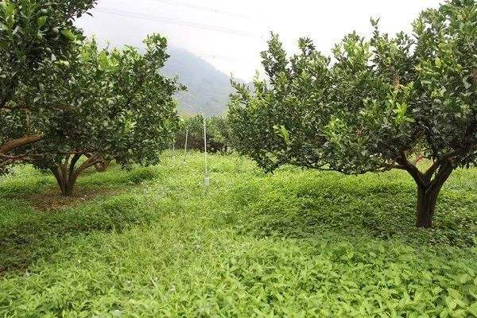

Figure S1Guizhou weeds in citrus orchard

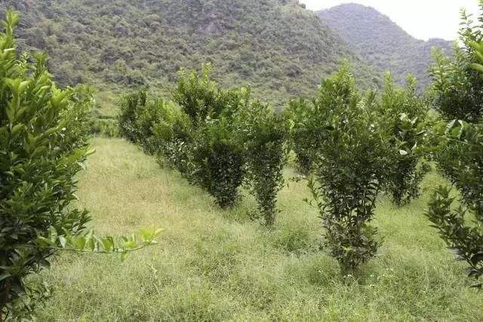

Figure S2 Hunan weeds in citrus orchard



Figure S3 Hainan weeds in banana orchard

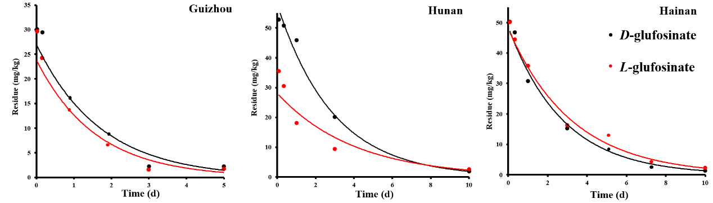

Figure S4. The degradation of glufosinate in weed under field conditions

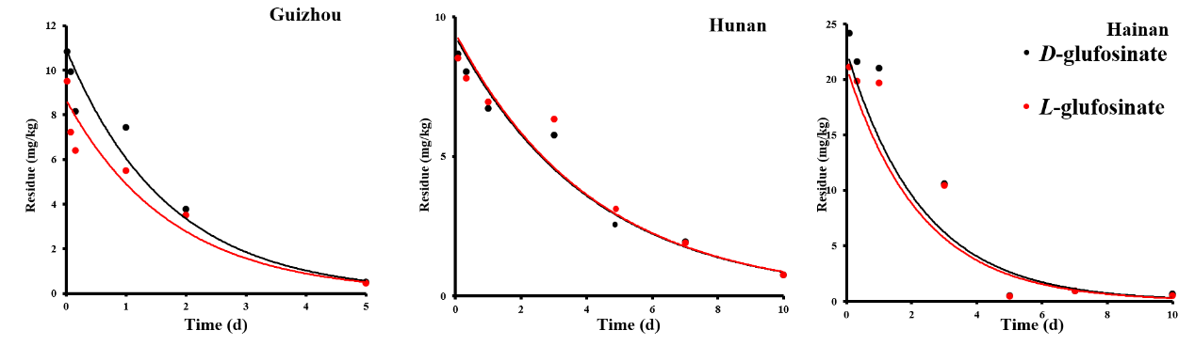

Figure S5. The degradation of glufosinate in soil under field conditions