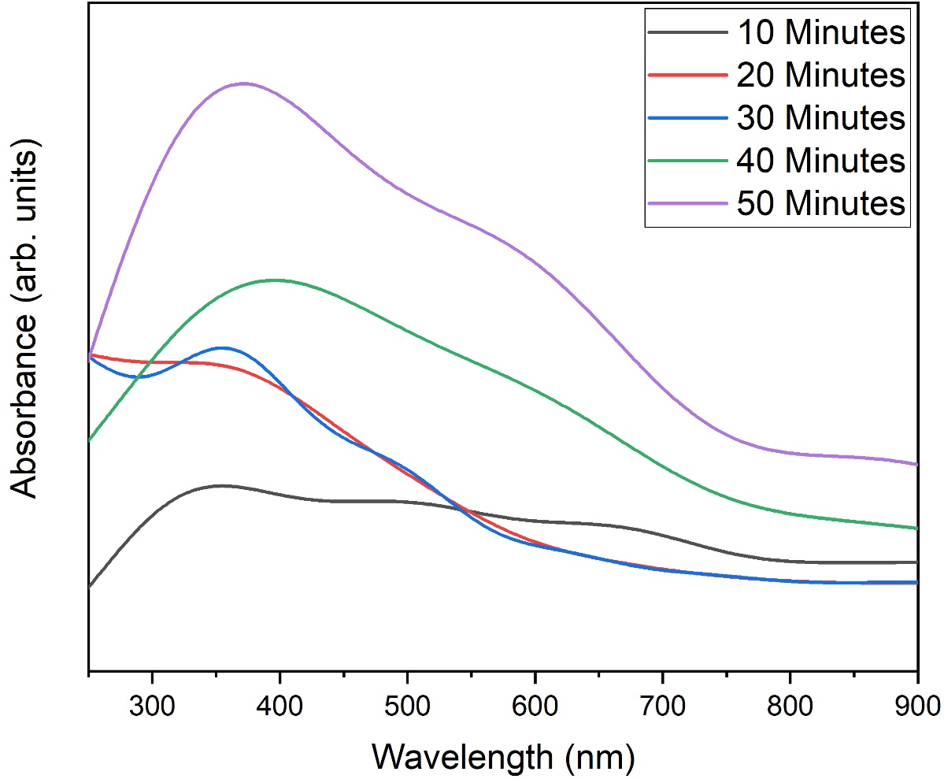

Figure S1. UV-Vis analysis of ZnO nanoflakes prepared at different ultrasonic treatments