Table S1. Identifying reference proteins for the homology modeling of the OppA models from B. longum KACC91563.
Template  (PDB ID) | Crystal structure  (Resolution Å) | Protein sequence identity  (Protein sequence similarity) | Coverage  (Model-Template range) | Description /  Peptide ligand
OppA of L. lactis  (3FTO) | X-ray  (2.4 Å) | 16.97%  (29.0%) | 89%  (37-547) | Oligopeptide-binding protein OppA  Non-binding of peptide ligand
OppA of L. lactis  (3DRG) | X-ray  (2.5 Å) | 16.97%  (29.0%) | 89%  (37-547) | Oligopeptide-binding protein OppA  Arg-Pro-Pro-Gly-Phe-Ser-Pro-Phe-Ala
AppA of B. substilis  (1XOC) | X-ray  (1.6Å) | 22.38%  (31.0%) | 87%  (37-547) | Oligopeptide-binding protein AppA  Val-Asp-Ser-Lys-Asn-Thr-Ser-Ser-Trp
AppA of B. anthracis str. Ames  (5U4O) | X-ray  (2.0 Å) | 22.67%  (32.0%) | 94%  (37-546) | Family 5 extracellular solute binding protein  Non-binding of peptide ligand
PreZ of E. faecalis  (4FAJ) | X-ray  (1.9 Å) | 19.11%  (32%) | 95%  (37-547) | PregZ, Pheromone binding protein  Leu-Val-Thr-Leu-Val-Phe-Val

Table S2. Assessment scores for the OppA models from B. longum KACC91563 compared to the templates
Protein structure | ERRAT2  (Hand, 2014) | Z-score of ProSA  (Sippl, 2007) | Verify3D  (Bowie, 1997)
OppA model  (on the opened-unliganded structural state) | 82.76% | -8.64 | 93.35% (pass)
OppA model  (on the closed-liganded structural state) | 84.31% | -9.27 | 96.09% (pass)
3FTO | 94.96% | -9.71 | 100.00% (pass)
3DRG | 94.89% | -10.22 | -
1XOC | 92.15% | -9.02 | -
5U4O | 96.82% | -9.87 | 97.42% (pass)
4FAJ | 99.19% | -8.82 | -

Table S3. In both complex structures, interacting counterpart residues at each defined position of peptide ligands in 3.5Å
Side chain pocket | AppA from B. substilis  (template) | OppA from L. lactis  (template) | PreZ from E. faecalis  (template) | OppA from B. longum KACC91563 (query)
PDB ID | 1XOC | 3DRG | 4FAJ | Model structure
Peptide ligand | Val-Asp-Ser-Lys-Asn-Thr-Ser-Ser-Trp | Arg-Pro-Pro-Gly-Phe-Ser-Pro-Phe-Ala (bradykinin like peptide) | Leu-Val-Thr-Leu-Val-Phe-Val | Arg-Pro-Pro-Gly-Phe-Ser-Pro-Phe-Ala (bradykinin like peptide)
at position 1 | Asn150, Asn151, Asp154, Ser422, Thr423 | Ser51, Gly186, Glu192, Thr193, Ala476, Ser477 | Gln81, Ile84, Trp469, Gln470, Asp472 | Tyr76, Val184, Lys185, Ser186, Gly187, Ser188, His189, Ala190, Tyr191, Met192, Gly535, Gly536
at position 2 | Arg119, Thr122, Ser155, Lys507 | Not contact residues | Val79, Asp80, Met454, Met489, His491 | Ser188, His189, Ala190, Asp446
at position 3 | Arg119, Trp419, Ser420, Ser422, Gln427, Leu440 | Arg135, Ser474 | Asn318, Met320, Gly468, Gln470 | Thr58, Phe139, His189, Trp443, Asp446, Tyr,447, Asn452
at position 4 | Thr41, Asp43, Thr46, Arg119, Trp419, Ser420, Lys507, Arg508 | Trp473, Ser474 | Phe453, Met454, Leu457, Ser467 | Thr58, Glu59, Ala60, Gly444
at position 5 | Thr41, Asp42, Asp43, Tyr268, Trp398, Leu401, Met405, Met407, Trp419, Tyr442 | Asn55, Asp56, Ala57, Phe450, Val454, Trp473, Tyr491, Phe493 | Gly67, Thr68, Ser418, Glu423 | Glu47, Thr58, Glu59, Ala60, Gly61, Leu427, Val430
at position 6 | Arg373, Trp398, Gly418 | Arg416, Phe450, Ser472 | Met320, Leu356, Phe422, Glu423, Ala426, Phe531 | Ala60, Asn294
at position 7 | Ile29, Asn367, Asn370, Arg373, Trp398 | Arg416 | Ile280, Pro296, Ala298, Phe422, Glu423 | Ser46, His269, Asn391
at position 8 | Asn241, Arg373, Asp509 | Arg416 |  | Leu296, Phe334, Ala396, Trp399, Arg440, Trp515, Gln517
at position 9 | Asn241, Ser265, Asn370, Arg373, Tyr487, Pro489, Asn491 | Not contact residues |  | Gln517

Table S4. Effect of mTOR (mechanistic target of rapamycin complex) signaling on different immune cells
Cell Type |  | mTOR effect (Horton, 2012)
CD4⁺ T-cell |  | ㆍ CD4⁺ T-cell activation, differentiation, tolerance, and migration  T-cell receptor engagement, CD28 costimulation, cytokine IL-1, IL-2, IL-4, IL-12, IFN-γ, growth factors, and  nutrients (e.g. amino acids)  ㆍRegulates CD4⁺ T effector cell differentiation into T_{H}1, T_{H}7 or T_{H}2 effector cell  ㆍNot required for CD4⁺ T-cell proliferation  mTOR-deficient T-cell proliferated more slowly than wild-type cells  ㆍPromotes CD4⁺Fox3⁺ regulatory T-cells by mTOR inhibition  IL-2 stimulation decreases mTOR activation  ㆍSelectively regulates CD4⁺ T effector cell development  T_{H}1 and T_{H}7 by mTORC1, T_{H}2 by mTORC2, Tregs in the absence of mTORC1 and mTORC2
CD8⁺ T-cell |  | ㆍ CD8⁺ T-cell activation, differentiation, memory formation, and migration  T-cell receptor engagement, CD28 costimulation, cytokine IL-1, IL-2, IL-4, IL-12, IFN-γ, growth factors,  nutrients (e.g. amino acids) as do CD4⁺ T-cell  ㆍIL-7 and IL-15 promote generation of memory cell by expressing IL-7 receptor (CD127) and IL-2 receptor-β (CD122)  ㆍAssociates with expression of CD62L and upregulation of the chemokine receptor CCR7(CD197)  ㆍIL-7 induced mTOR activation leads to the upregulation of CD122  ㆍmTOR inhibitors (as rapamycin and metformin) promote CD8⁺ memory T-cell formation
B-cell |  | ㆍB-cell activation, maturation, differentiation, antibody production, survival B-cell receptor signaling, CD40 ligation,  T-cell receptor signaling, Fc receptor binding, B lymphocyte stimulator (BLyS)  ㆍEnhances mTOR activation by B-cell receptor signaling  ㆍSuppresses mTOR activation by Fc receptor signaling
Dendritic cell |  | ㆍRegulates dendritic cell maturation  ㆍInhibits proinflammatory cytokine IL-12 in mature dendritic cell and monocytes  ㆍEnhances anti-inflammatory cytokine IL-10 in mature dendritic cell and monocytes  ㆍAntiviral immune response by type I interferons mediating TLR7 and TLR9 in plasmacytoid dendritic cell

Table S5. Mutation energy effects of single Alanine mutants on its binding affinity and structural stability whin OppA/9-mer RPPGFSPFA complex from B. longum KACC91563.
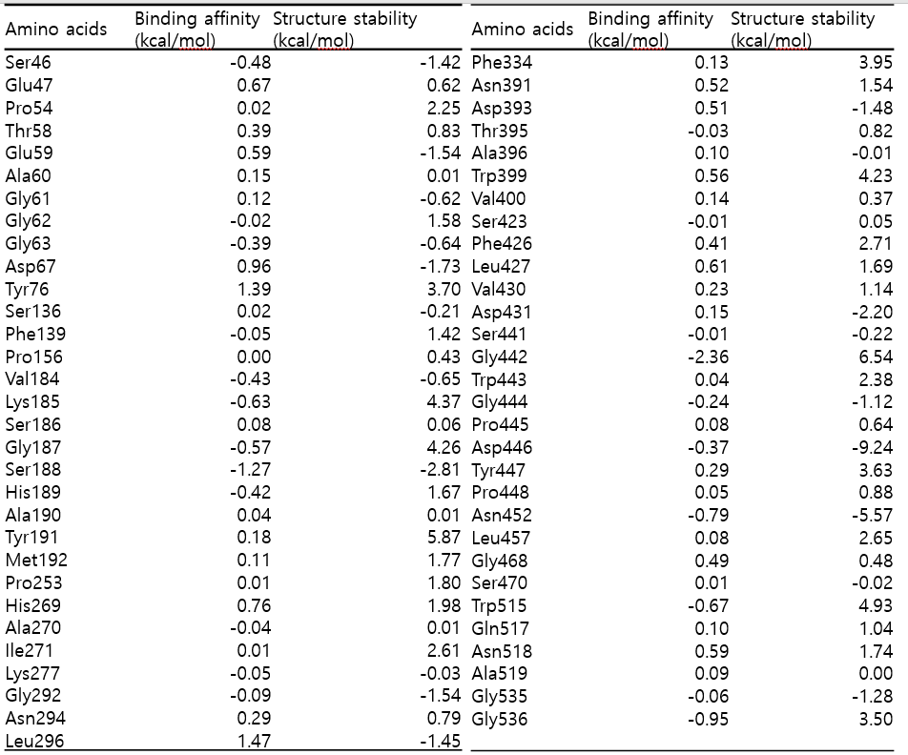

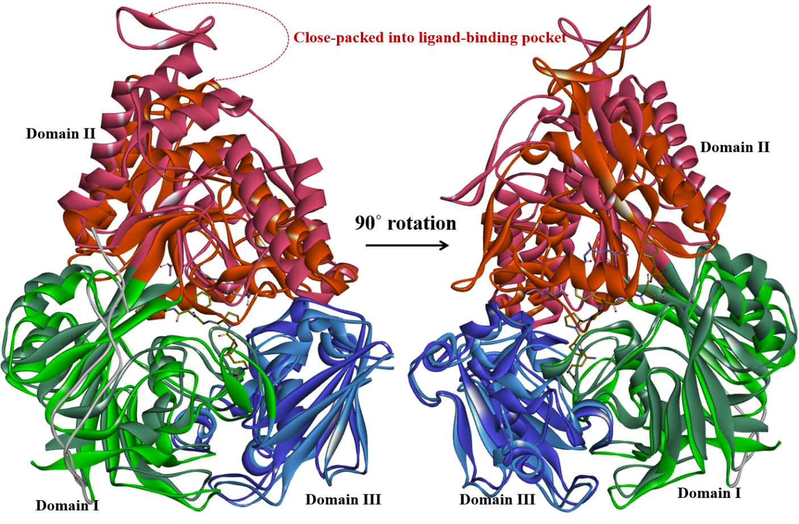
Fig. S1 The majority of structural differences of the L. lactis OppA in the relative orientations of the second α/β domain (residues 301-542 in domain II, orange) between the open (PDB ID: 3DRH colored in dark) and the closed (PDB ID: 3DRG colored in light) conformers on peptide-liganded. The L. lactis OppA is made up of the two α/β domains (residues 32-82, 220-300 and 543-570 in domain I and residues 301-542 in domain II) and an extra domain (residues 83-219 in domain III) displayed in green, orange and blue, respectively. The hinge region corresponds to the connecting two strands between domain I and domain II (changed green to orange colored two β-strands).
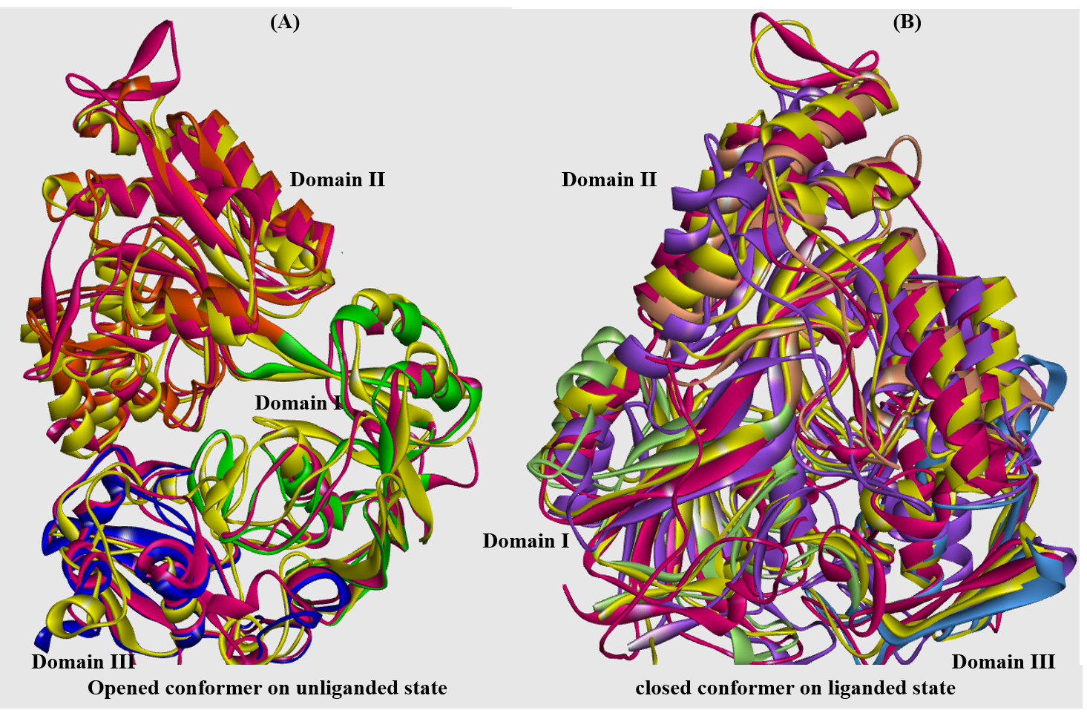
Fig. S2 Superimposing protein structures between template OppAs and query of OppA from B. longum KACC 91563 (A, B). When aligning the query OppA model with the template structures, there is high conservation in both open-unliganded (A) and closed-liganded (B) OppAs conformers.
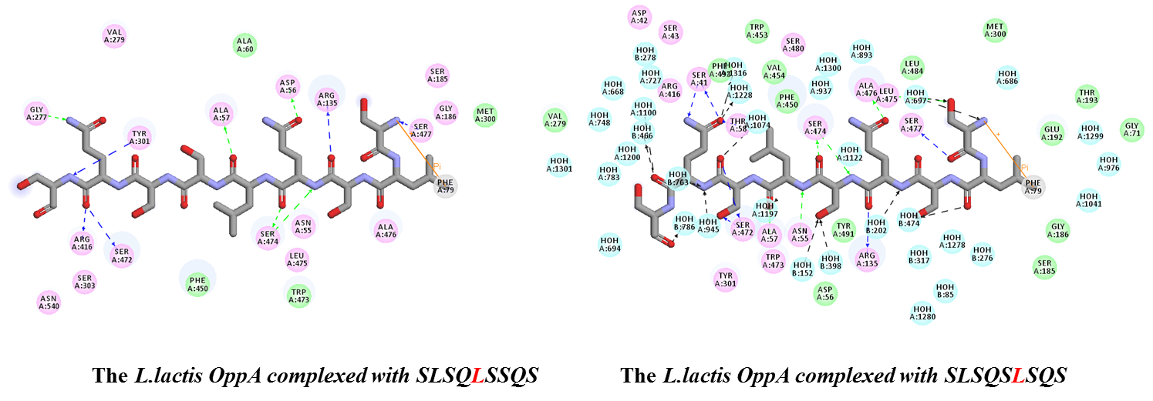
Fig. S3 Both interaction residues of the L. lactis OppA complex with the 9-mer peptides of SLSQLSSQS (PDB ID: 3RYA) and SLSQSLSQS (PDB ID: 3RYB) in the closed conformation (Slotboom, 2011). In both complexes, both the central leucine residue of the casein-derived 9-mer peptides were occupied at 5 and 6 positions. In the determined bradykinin like 9-mer peptide (RPPGFSPFA) bound L. lactis OppA, the phenylalanine was located at 5 position (PDB ID: 3DRG).

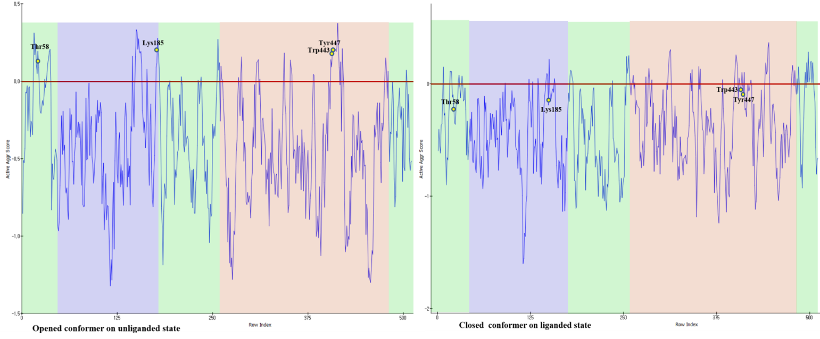
Fig. S4 Plot of spatial aggregation propensity (SAP) (Trout, 2010) scores for the OppA receptor from B. longum KACC91563 both open-unliganded and closed-liganded structure states. The scores define SAP based atoms within a radius of 10Å from a given residue for the three domains of the OppA conformers where the color scheme of domains is the same as in Fig. 1.

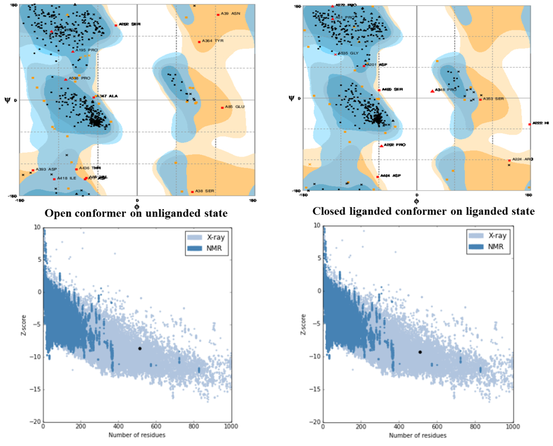
Fig. S5 Ramachandran plots and Z-scores of ProSA (Sippl, 2007) for both the open-unliganded and the closed-liganded OppA model structures from B. longum KACC 91563. Both models represent good protein structures for which more than 90% of their residues were occupied in the favored region based on the probability of finding a residue derived from well-refined high-resolution structures. The Z-scores for both models were likely to depict experimental protein structures in the middle region of the scatterplot of scores.

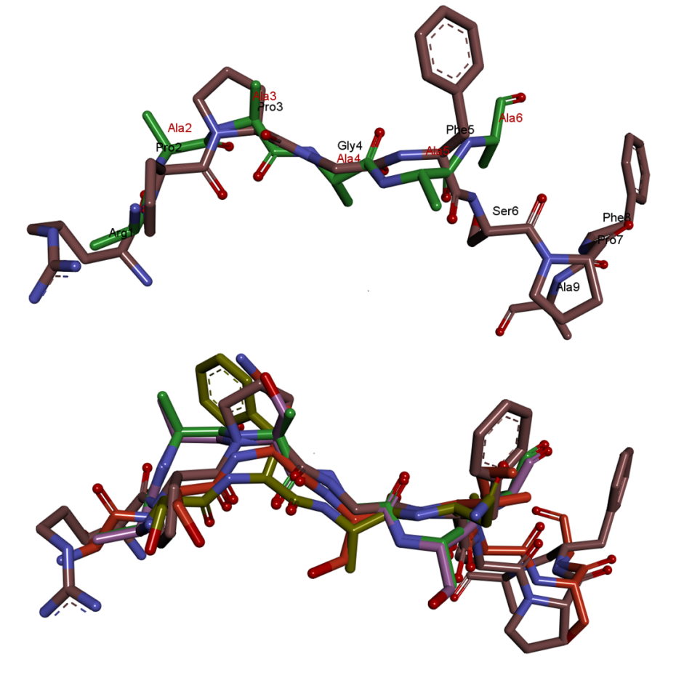
Fig. S6 The conformer overlaps of peptide ligands with different lengths (from 6-mer to 9-mer peptides) and with variant binding affinities in the peptide-bounded open and closed states of L. lactis OppA. Peptide ligands were co-crystallized with the L. lactis OppA; 5-mer neuropeptide S as SFANG (PDB code3DRK), 6-mer polyalanine (PDB code of 3DRH) and AASASA (PDB code of 3DRI), 8-mer endogenous peptide of ASNSIASG (PDB code of 3DRF) and 9-mer bradkinin like peptide of RPPGFSPFA (PDB code of 3DRG). These backbone conformers of peptide ligands were very well superimposed within an RMSD of 0.4Å.

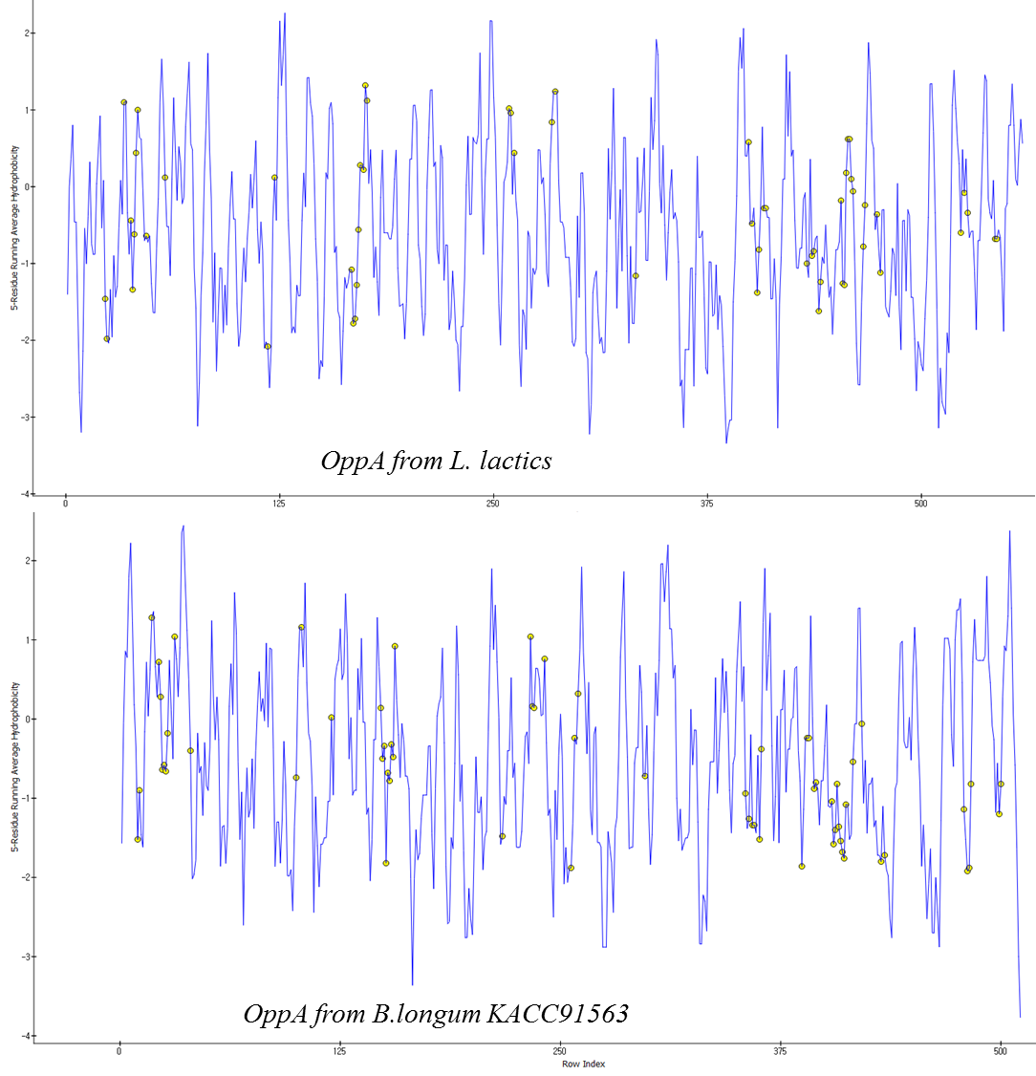
Fig. S7 Hydrophobicity plot of open-unliganded OppAs of L. lactis and B. longum KACC91563 by averaging the hydrophobicity value of each residue with neighboring four residues, where the hydrophobicity scale is taken from Kyte and Doolitle (Doolittle, 1982). The residues in the binding pocket (listed in Table 1.) are illustrated by yellow points.

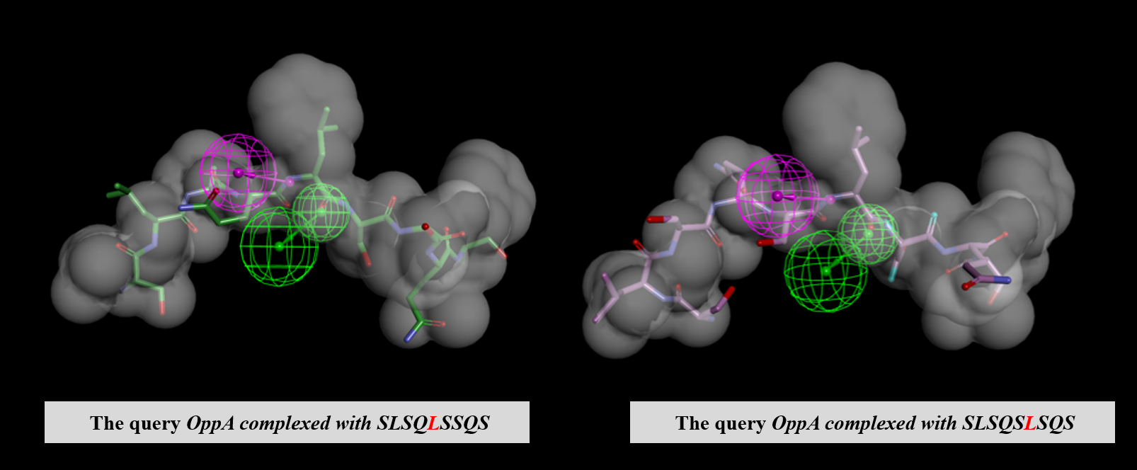
Fig. S8 Both the OppA from B. longum KACC91563 complexed with the 9-mer peptides of SLSQLSSQS and SLSQSLSQS were mapped on the H-bonding features (HBA and HBD) and its hydrophobic shape constant at positions 5 and 6, respectively.

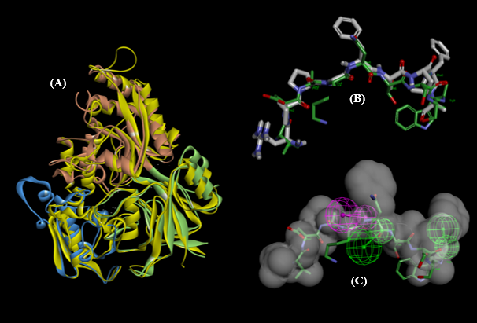
Fig. S9 In B. subtilis, superposition of (A) the structures of the query of OppA and the template AppA (PDB code of lXOC, colored yellow) with their bound nonapeptide (RMSD = 1.4Å). (B) Stereo stick representation of the peptide ligands RPPGFSPFA (in dark gray) in the OppA and VDSKNTSSW (in green) in AppA. (C) Two HBD and one HBA features are fitted into Asn(P5) and Trp(P9) on the VDSKNTSSW peptide with a surrounding hydrophobic shape constant when the resulting jostle Trp(P9) of competing Ser(P8) lead marks on the exposed side chains of Ser(P8) and half of Trp(P9) from the shape constant.

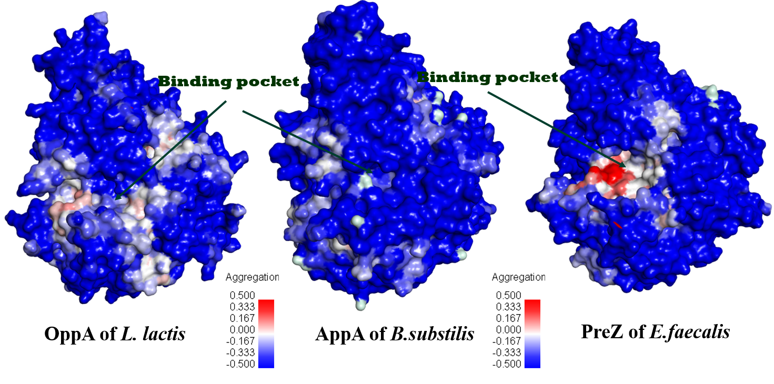
Fig. S10 Map of spatial aggregation propensity (SAP) for closed-liganded conformers. The aggregation propensity scores for OppA of L. lactis (PDB ID 3DRG), AppA of B. substilis (PDB ID: 1XOC) and Prez of E. faecalis (PDB ID: 4FAJ) are an approximate indication of their overall tendency to aggregate. For a given spherical regions of radius R (R=5) and size of molecule, the molecular aggregation score is calculated as the sum of all atomic scores, which score R=5 is -342.18, -393.43, and -371.40 respectively compared to -301.62 from OppA of B. longum KACC91563(closed-liganded conformer in Fig.4). High aggregation scores indicate highly exposed hydrophobic regions to be deep red.

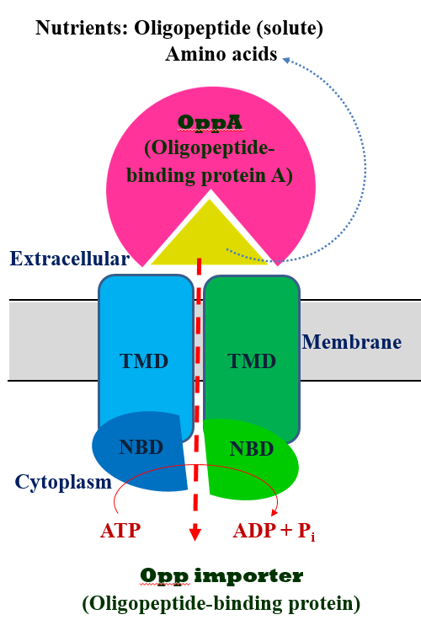
Fig. S11 Schematic ATP-binding cassette (ABC) transporter. ABC transports can be divided into different types of importers and exporters on the basis of the transport direction. The Opp importer from B. longum KACC91563 requires a solute-binding protein (SBP) of OppA where the Opp importer system (as an OppBCDF) is separated into two TMDs (OppB and OppC) and two NBDs (OppD and OppF). The Opp importer converts ATP chemical energy into conformational energy for substrate peptides’ translocation. Then the energy was gained from ATP hydrolysis into TMDs movement of substrate peptides entering into the cytoplasm (importer).
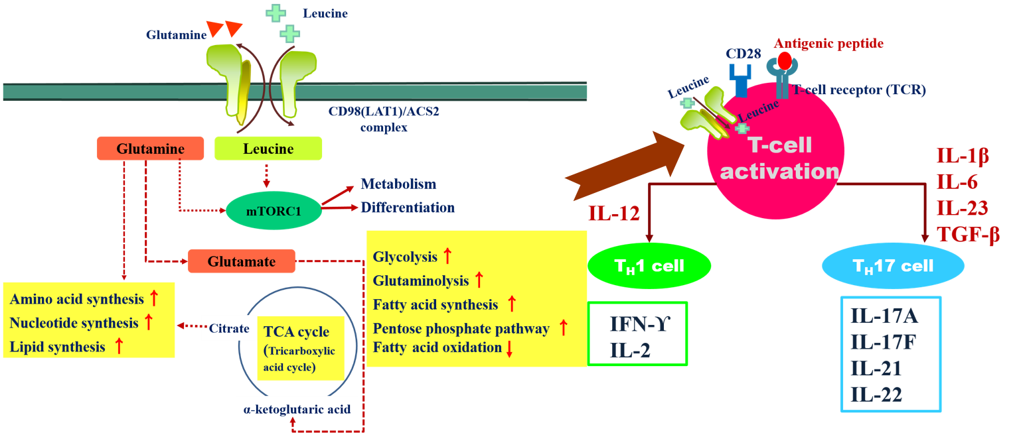
Fig. S12 Dominant metabolic pathway in T-cell receptor mediated native T-cell activation. On differentiating the activated CD4⁺ T-cell or CD8⁺ T-cell, T_{H}1 cell requires the cytokine IL-12. In addition, the T_{H}17 cell needs to stimulate IL-1β, IL-6, IL-23, and TGF-β (transforming growth factor-β).

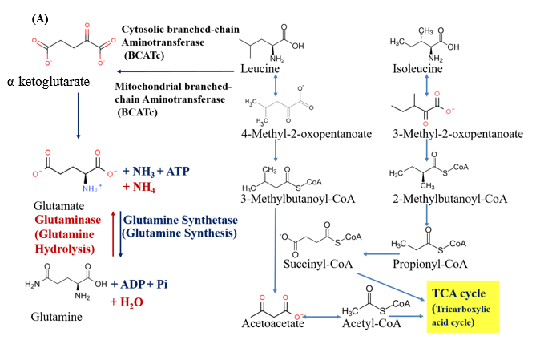
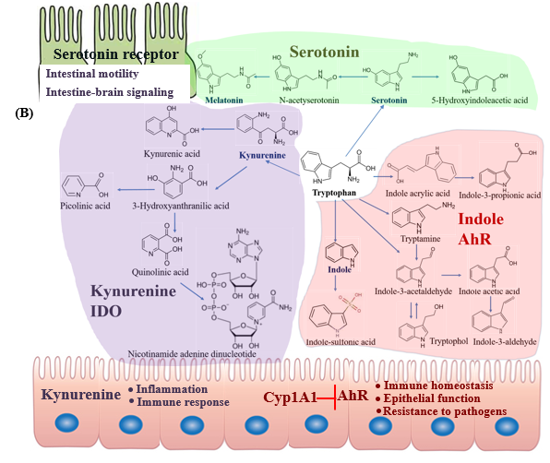
Fig. S13 Overview of proteinogenic amino acid metabolites in the host intestinal absorption (A) the main steps of leucine and isoleucine catabolism including glutamine as leucine metabolites (Ma, 2018) and (B) intestinal tryptophan metabolism in host physiology (Sokolo, 2018).
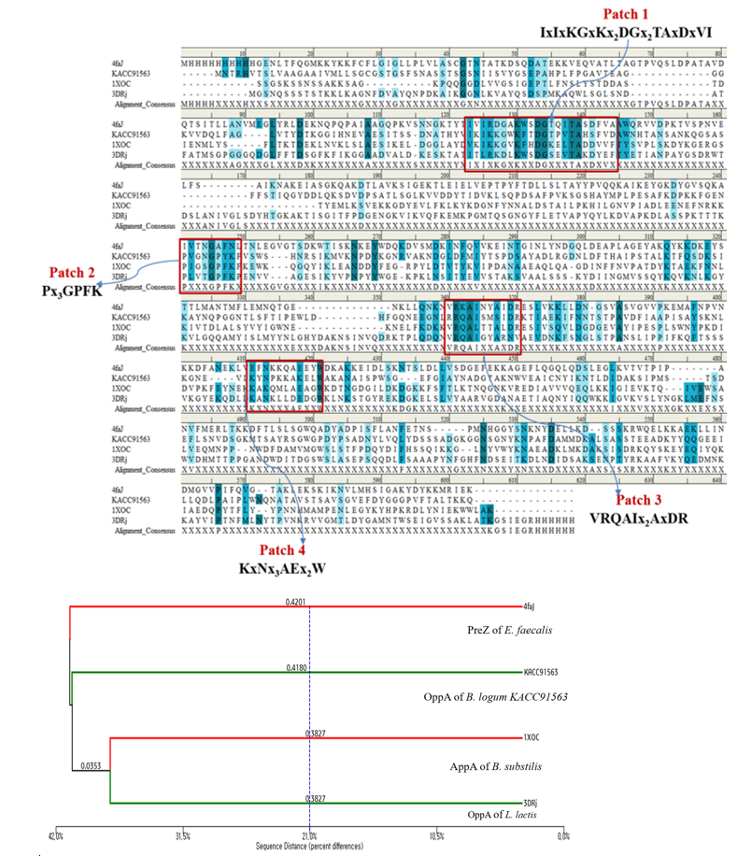
Fig. S14 Conserved sequence alignment by trace residues between the template and the query of OppAs at the specified distance cut off of 21.0%, as shown in Fig. 3. For the three template sequences of PreZ from E. faecalis (PDB code 4FAJ), the AppA from B. substilis (PDB code 1XOC), OppA of L. lactis (PDB code 3DRJ), and the query OppA from B. logum KACC91563, where the structure-based sequence alignments are available, were compared. The conservation patterns of the patches are highlighted in the red box between them.
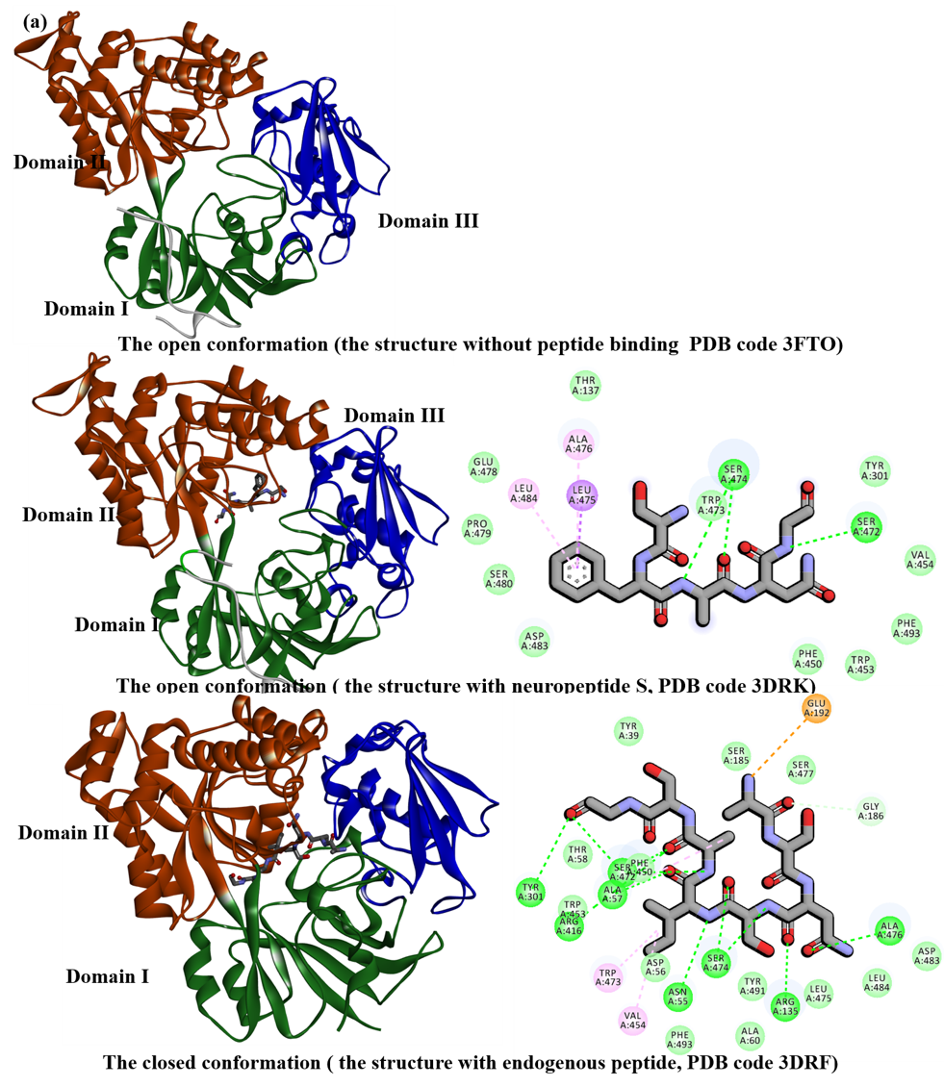
Fig. S15 The experimentally determined 3D-structures of the OppA importer conformations with the open-unliganded (PDB code 3FTO), the open-liganded (neuropeptide S of SFANG, PDB code 3DRK), and the closed-liganded (an octapeptide ASNSIASG, PDB code 3DRF) from Lactococcus lactis. In the OppA importer conformations, the open and closed OppAs are in an equilibrium both with and without the ligand, but the binding of the ligand depended on the peptide binding affinity shifts in the equilibrium to the closed conformation (i.e., the open conformation favored with the low-affinity ligand). There is a case where the backbone of the neuropeptide S peptide (PDB code 3DRK) in the open conformation is H-bonding with the Ser472 and Ser 474 residues of the OppA domain II compared to the H-bondings of the octapeptide (PDB code 3DRF) with the Ser472, Ser 474, Tyr301, Arg135, Asn55, Ala57, and Ala476 stabilized in the closed conformation.

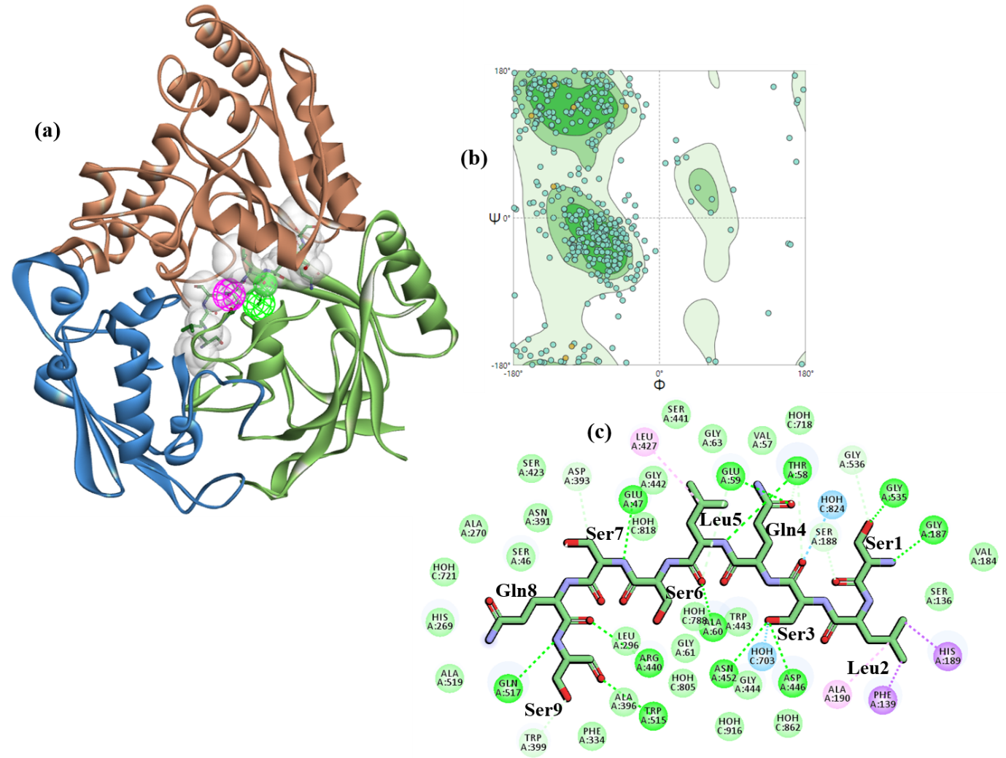
Fig. S16 The OppA/SLSQLSSQS complex structure from B. longum KACC91563 are produced by a CHARMm forcefield based docking for the center of the 9-mer peptide ligand to a specified location as (a) the pharmacophore features based on (c) the OppA-SLSQLSSQS interaction within the OppA active site, and perfoming a series of random rotations. For the best docked pose, the CDOCKER binding energy is -153.64 kcal/mol, which is this is in (b) Ramachandran plot of the closed-liganded OppA model structure.

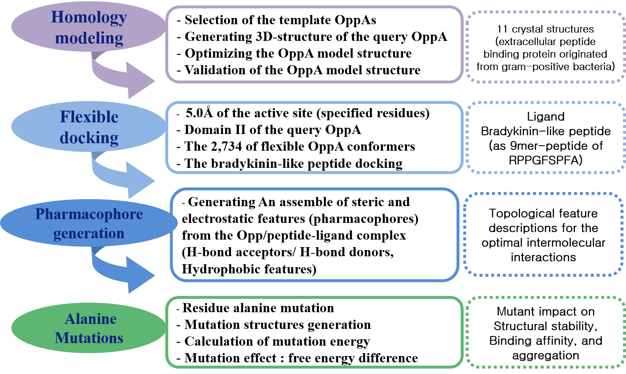
Fig. S17 The steps of the research process used for the structure-based modeling of the OppA from B. longum KACC91563 in the Discovery Studio, version 2017 R2, from BIOVIA.

