### Annexure-I

### Supporting Information

**Ms. Ref. No.:  ARABJC-D-22-00220**

***In vitro*, *in silico* antidiabetic and antioxidant potential of bioactivity based isolated “Pakistanine” from *Berberis baluchistanica***

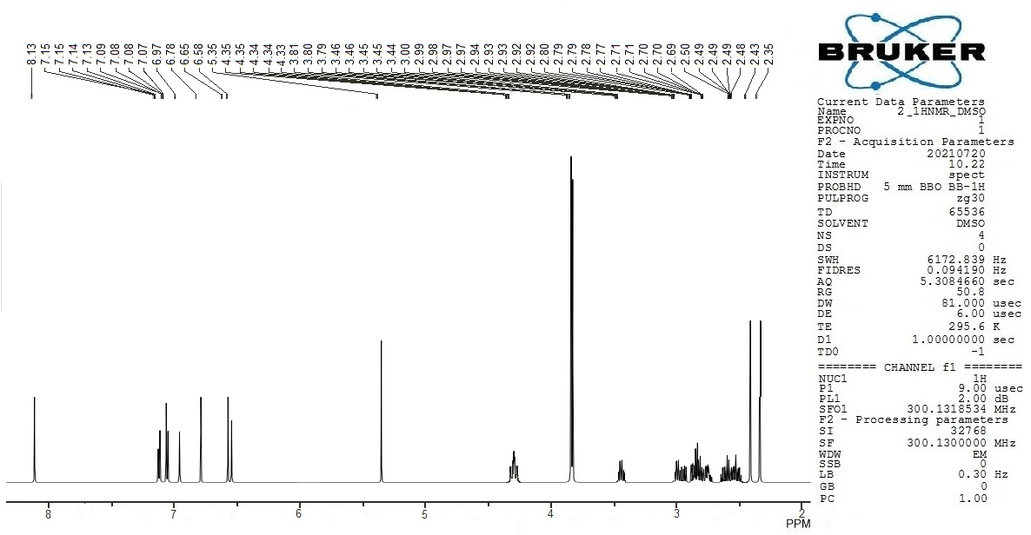

Figure S8: 1H-NMR spectrum of Compound 2 (Pakistanine)

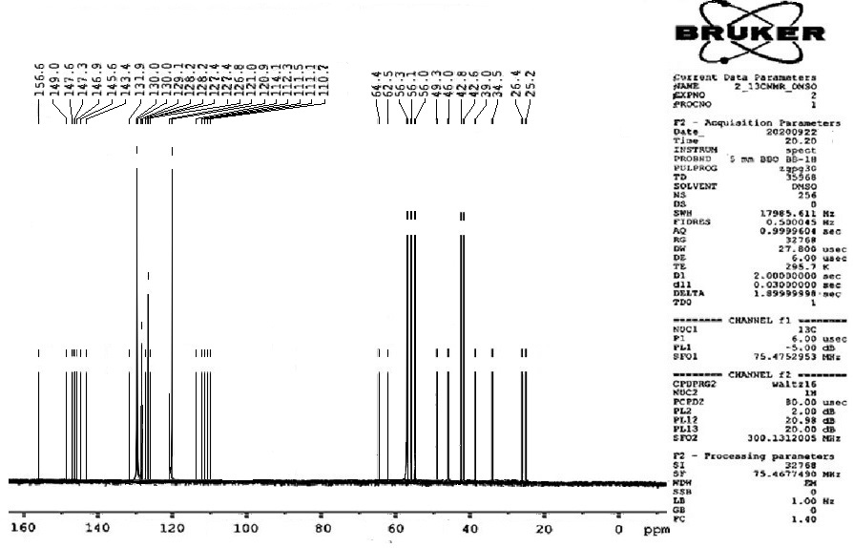

Figure S9: 13C-NMR spectrum of Compound 2 (Pakistanin)