**Supporting Information**

**Validation of Sennae Folium Specification Grade Classification Based on UPLC-Q-TOF/MS Spectrum-effect Relationship**

Qi An1, 5†, Lei Wang1, 4 †, Xiao-ying Ding1, Ya-jun Shen1, Sheng-hui Hao1, Wen-jie Li1, Heng-yang Li1, Tao Wang1, Zhi-lai Zhan2, Yu-guang Zheng1, 3, *, Long Guo1, 4, *, Dan Zhang1, 4, *

1 *Traditional Chinese Medicine Processing Technology Innovation Center of Hebei Province, College of Pharmacy, Hebei University of Chinese Medicine, Shijiazhuang 050200, China*

2 *National Resource Centre for Chinese Materia Medica, China Academy of Chinese Medical Sciences, Beijing 100700, China*

3 *Department of Pharmaceutical Engineering, Hebei Chemical and Pharmaceutical College, Shijiazhuang 050026, China*

4 *International Joint Research Center on Resource Utilization and Quality Evaluation of Traditional Chinese Medicine of Hebei Province, Shijiazhuang, 050200, China*

5 *Department of Traditional Chinese Medicine, Hebei Institute for Drug and Medical Device Control, Shijiazhuang, 050200, China*

† *These authors contributed equally to this work.*

* *Corresponding authors.* Tel.: +86 311-89926466, Fax: +86 311-89926000. *E-mail address:* zhangdan@hebcm.edu.cn (D. Zhang*), guo_long11@163.com (L. Guo*), zyg314@163.com (Y. G. Zheng*)

Fig. S1. Effect of different methanol concentration on total yield of Sennoside A and B (a); effects of different ultrasonic time on total yield of Sennoside A and B (b); effects of different liquid/solid ratio on total yield of Sennoside A and B (c).

Fig. S2. Interaction of various factors two-dimensional contour map and three-dimensional response surface map.

Fig. S3. MS/MS molecular networking of the MeOH extracts of Sennae folium.

Fig. S4. Total ion chromatograms of UPLC-Q-TOF MS for the extraction of *Cassia angustifolia* leaves (a) and standard solution (b).

Fig. S5. MS/MS spectra of peak 41, quercetin 3-*O*-sophoroside (a); peak 46, leucoside conjunct with a ferulic acid (b); peak 44 (c) and 45 (d), the analogues of isorhamnetin–3-*O*-gentiobioside; peak 3 (e), 4 (f), 13 (g), 15 (h), 16 (i), and 21 (j), the analogues of cassiaphenone B-2'-glucoside.

Fig. S6. The structure of differential compounds.

Fig. S7. 200 iterations of permutation tests of OPLS model.

Fig. S8. The OPLS linear regression, regression coefficient between the 22 common peaks and the lipase inhibitory activity.

Table S1. The information of three grades of Sennae folium.

Table S2. Response surface experimental design factor and level code of SF.

Table S3. Analysis of variance of regression mode

Table S4. Information on 60 compounds in SF identified by UPLC-Q-TOF/MS.

Table S5. Inhibition rates of different grades for IC50 calculation of pancreatic lipase inhibitory activity (n=3)

**Fig. S1.** Effect of different methanol concentration on total yield of Sennoside A and B (a); effects of different ultrasonic time on total yield of Sennoside A and B (b); effects of different liquid/solid ratio on total yield of Sennoside A and B (c).

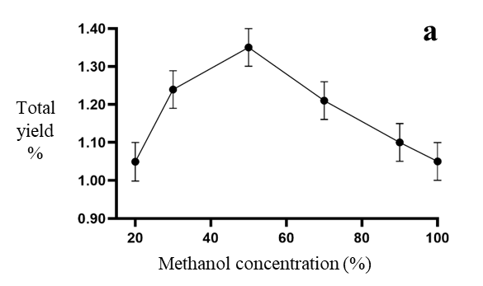

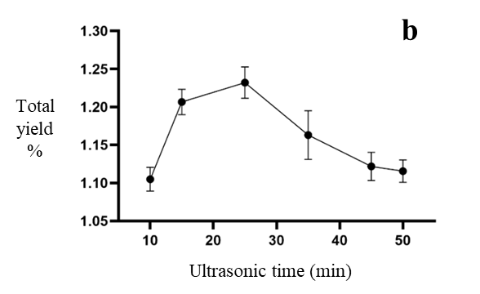

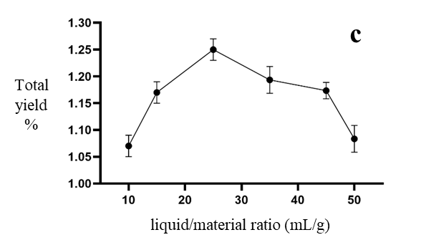

**Fig. S2.** Interaction of various factors two-dimensional contour map and three-dimensional response surface map

**Fig. S3.** MS/MS molecular networking of the MeOH extracts of Sennae folium.

**Fig. S4.** Total ion chromatograms of UPLC-Q-TOF MS for the extraction of *Cassia angustifolia* leaves (a) and standard solution (b).

1. Sennoside B; 2. Sennoside C; 3. Sennoside A.

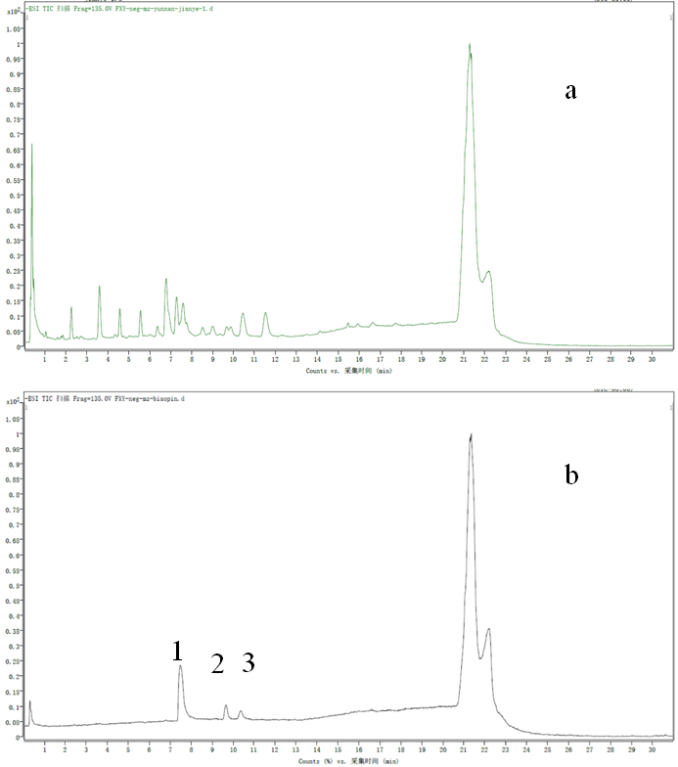

**Fig. S5.** MS/MS spectra of peak **41**, quercetin 3-O-(6"'-(E)-feruloylglucosyl)-(1→6)- glucoside (a); peak **46**, leucoside conjunct with a ferulic acid (b); peak **44** (c) and **45** (d), the analogues of isorhamnetin 3–*O*–gentiobioside; peak **3** (e), **4** (f), **13** (g), **15** (h), **16** (i), and **21** (j), the analogues of cassiaphenone B–2–glucoside.

图表

图示

**Fig. S6.** The structure of differential compounds.













**Fig. S7.** 200 iterations of permutation tests of OPLS model.

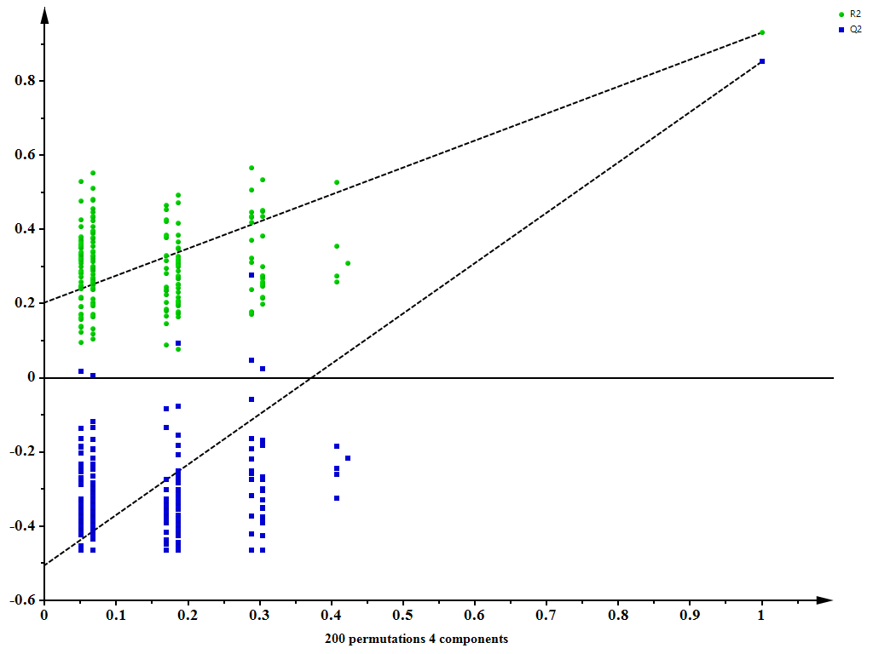

**Fig. S8.** The OPLS linear regression, regression coefficient between the 22 common peaks and the lipase inhibitory activity.



**Table S1.** The information of three grades of Sennae folium.

|  |  |  |
| --- | --- | --- |
| Label | Grades | Source |
| L1 | Green-colored | Anguo herbal medicine market, Hebei, China |
| L2 | Green-colored | Anguo herbal medicine market, Hebei, China |
| L3 | Green-colored | Anguo herbal medicine market, Hebei, China |
| L4 | Green-colored | Bozhou herbal medicine market, Anhui, China |
| L5 | Green-colored | Bozhou herbal medicine market, Anhui, China |
| L6 | Green-colored | Bozhou herbal medicine market, Anhui, China |
| L7 | Green-colored | Hehuachi herbal medicine market, Sichuan, China |
| L8 | Green-colored | Hehuachi herbal medicine market, Sichuan, China |
| L9 | Green-colored | Hehuachi herbal medicine market, Sichuan, China |
| L10 | Green-colored | Yulin herbal medicine market, Guangxi, China |
| L11 | Green-colored | Yulin herbal medicine market, Guangxi, China |
| L12 | Green-colored | Yulin herbal medicine market, Guangxi, China |
| L13 | Green-colored | Qingping herbal medicine market, Guangdong, China |
| H1 | Yellow-colored | Anguo herbal medicine market, Hebei, China |
| H2 | Yellow-colored | Anguo herbal medicine market, Hebei, China |
| H3 | Yellow-colored | Anguo herbal medicine market, Hebei, China |
| H4 | Yellow-colored | Bozhou herbal medicine market, Anhui, China |
| H5 | Yellow-colored | Bozhou herbal medicine market, Anhui, China |
| H6 | Yellow-colored | Bozhou herbal medicine market, Anhui, China |
| H7 | Yellow-colored | Hehuachi herbal medicine market, Sichuan, China |
| H8 | Yellow-colored | Hehuachi herbal medicine market, Sichuan, China |
| H9 | Yellow-colored | Hehuachi herbal medicine market, Sichuan, China |
| H10 | Yellow-colored | Yulin herbal medicine market, Guangxi, China |
| H11 | Yellow-colored | Yulin herbal medicine market, Guangxi, China |
| H12 | Yellow-colored | Yulin herbal medicine market, Guangxi, China |
| H13 | Yellow-colored | Qingping herbal medicine market, Guangdong, China |
| D1 | Diseased | Anguo herbal medicine market, Hebei, China |
| D2 | Diseased | Anguo herbal medicine market, Hebei, China |
| D3 | Diseased | Anguo herbal medicine market, Hebei, China |
| D4 | Diseased | Bozhou herbal medicine market, Anhui, China |
| D5 | Diseased | Bozhou herbal medicine market, Anhui, China |
| D6 | Diseased | Bozhou herbal medicine market, Anhui, China |
| D7 | Diseased | Hehuachi herbal medicine market, Sichuan, China |
| D8 | Diseased | Hehuachi herbal medicine market, Sichuan, China |
| D9 | Diseased | Yulin herbal medicine market, Guangxi, China |
| D10 | Diseased | Yulin herbal medicine market, Guangxi, China |
| D11 | Diseased | Qingping herbal medicine market, Guangdong, China |

**Table S2.** Response surface experimental design factor and level code of SF

|  |  |  |  |  |
| --- | --- | --- | --- | --- |
| Levels | Methanol concentration (%) | Ultrasonic extraction time (min) | | Liquid to material ratio (mL/g) |
| -1 | 40 | | 12 | 20:1 |
| 0 | 50 | | 15 | 25:1 |
| 1 | 60 | | 18 | 30:1 |

**Table S3.** Analysis of variance of regression mode

|  |  |  |  |  |  |
| --- | --- | --- | --- | --- | --- |
| Source | Sum of Squares | df | Mean Square | *F*-value | *p*-value |
| **Model** | 0.2529 | 9 | 0.0281 | 3.70 | 0.0491* |
| A-Methanol concentration | 0.0338 | 1 | 0.0338 | 4.46 | 0.0427* |
| B-Ultrasonic time | 0.0253 | 1 | 0.0253 | 3.34 | 0.1105 |
| C- liquid / material ratio ratio | 0.0021 | 1 | 0.0021 | 0.2785 | 0.6140 |
| AB | 0.0004 | 1 | 0.0004 | 0.0527 | 0.8250 |
| AC | 0.0009 | 1 | 0.0009 | 0.1186 | 0.7406 |
| BC | 0.0006 | 1 | 0.0006 | 0.0824 | 0.7824 |
| A² | 0.0382 | 1 | 0.0382 | 5.04 | 0.0497* |
| B² | 0.1048 | 1 | 0.1048 | 13.81 | 0.0075** |
| C² | 0.0288 | 1 | 0.0288 | 3.80 | 0.0922 |
| **Resdual** | 0.0531 | 7 | 0.0076 |  |  |
| Lack of Fit | 0.0344 | 3 | 0.0115 | 2.46 | 0.2027 |
| Pure Error | 0.0187 | 4 | 0.0047 |  |  |
| **Cor Total** | 0.3060 | 16 |  |  |  |

Note: \*\**p*<0.01, indicates a highly significant difference; \**P*<0.05, indicates a significant difference.

**Table S4.** Information on 60 compounds in SF identified by UPLC-Q-TOF/MS.

|  |  |  |  |  |  |  |  |
| --- | --- | --- | --- | --- | --- | --- | --- |
| No. | *tR* (min) | Molecular  formula | [M-H]− | MS/MS | Error (ppm) | Identification | Reference |
| 1 | 1.284 | C13H16O9 | 315.0721 | 153.015;152.011;109.0284;108.021 | -0.36 | Bezoic acid+2O, O-Hex | Massbank |
| 2* | 2.814 | C21H22O12 | 465.1042 | 285.0397;241.0495;203.0923;59.0140 | 0.65 | Cassiaphenone A-2'-glucoside | [1] |
| 3* | 3.197 | C27H30O18 | 641.1311 | 299.0186;255.0285 | 0.39 | Deduced new compounds by MN |  |
| 4 | 3.736 | C18H28O9 | 387.1652 | 225.8625;163.1122 | -0.62 | Deduced new compounds by MN |  |
| 5* | 4.444 | C21H20O13 | 479.0840 | 299.0196;255.0297;211.0392;59.0138 | 1.52 | Cassiaphenone B-2'-glucoside | [1] |
| 6 | 4.677 | C27H30O16 | 609.1466 | 519.1108;489.1025;399.0710;369.0608 | 0.6 | Luteolin-6,8-C-diglucoside | [2] |
| 7* | 5.392 | C27H30O15 | 593.1526 | 473.1086;383.0772;353.0664;354.0694 | 1.9 | Vicenin-2 | [1] |
| 8 | 5.368 | C27H30O18 | 641.1363 | 316.0209;299.0196 | 0.4 | Deduced new compounds by MN |  |
| 9* | 6.473 | C27H28O16 | 607.1308 | 283.0242;239.0338;284.0273;325.0332 | 0.34 | Physcion-di-O-glucoside | [3] |
| 10* | 6.706 | C27H30O17 | 625.1427 | 301.0341;271.0241;178.9978;151.0023 | 2.19 | Quercetin-O-sophoroside | [1] |
| 11* | 7.122 | C32H37O20 | 741.1889 | 301.0132;300.0265 | 0.82 | Quercetin-3-O-pentosyl-rhamnosyl-hexoside | [1] |
| 12 | 7.238 | C26H28O16 | 595.1309 | 301.0337;300.0271;271.0243; | 0.79 | Quercetin-3-O-vicianoside | [1] |
| 13 | 7.427 | C19H30O9 | 401.1812 | 221.1174;177.1277 | 0.14 | Deduced new compounds by MN |  |
| 14 | 7.571 | C21H20O10 | 431.0976 | 240.0426;283.0606;269.0454;203.0329 | 0.42 | Aloe-emodin glucoside | [4] |
| 15 | 7.855 | C19H28O9 | 399.1635 | 219.1018;175,1125; | 7.86 | Deduced new compounds by MN |  |
| 16 | 7.866 | C18H28O10 | 403.1614 | 223.0964;179.1067; | 0.47 | Deduced new compounds by MN |  |
| 17 | 7.941 | C21H20O10 | 431.0983 | 269.0450;241.0989;225.0543;183.0432 | 0.39 | Emodin-8-O-glucoside | [1] |
| 18* | 8.097 | C27H30O16 | 609.1476 | 301.0397 | 2.09 | Rutin | [5] |
| 19 | 8.281 | C21H18O11 | 445.0781 | 283.0243.239.0343;211.0391 | 0.04 | Rhein-8-O-glucopyranoside | [6] |
| 20 | 8.569 | C21H20O12 | 463.0886 | 301.0321;300.0268;271.0244;255.0268 | 0.80 | Quercetrin-3-O-glucoside | [5] |
| 21 | 8.635 | C20H34O11 | 449.1994 | 269.1388;209.1182 | -2.36 | Deduced new compounds by MN |  |
| 22 | 8.809 | C26H28O15 | 579.1348 | 285.0392;255.0288;227.0336 | -0.65 | Leucoside | [1] |
| 23* | 8.985 | C28H32O17 | 639.1573 | 315.0506;300.0269;243.0289;271.0242 | 0.82 | Isorhamnetin-3-O-β-gentiobioside | [7] |
| 24 | 9.234 | C42H40O19 | 847.2092 | 803.2182;685.1549;523.1029;386.1006 | 0.08 | Sennoside D type | [8] |
| 25* | 9.334 | C42H38O20 | 861.1892 | 817.1967;699.1342;537.0811;386.0996 | 0.83 | Sennoside B | [8] |
| 26 | 9.492 | C27H36O16 | 609.1455 | 315.0501;300.0261;271.0237 | 0.79 | Isorhamnetin-O-di-glucoside | [3, 10] |
| 27 | 10.049 | C27H30O15 | 593.1517 | 286.0428;285.0389;284.0507;255.0292 | 0.53 | Kaempferol-3-rutincoside | [10] |
| 28 | 10.481 | C27H30O15 | 593.1526 | 431.0988;269.0444;241.05;225.0507 | 1.90 | Emodin-O-di-glucoside | [3] |
| 29* | 10.748 | C42H40O19 | 847.2099 | 803.2182;685.1549;523.1018;386.1006 | 0.77 | Sennoside D | [8] |
| 30* | 10.802 | C21H20O17 | 447.0934 | 285.0400;284.0312;269.1372;225.1476 | 0.05 | Kaempferol glucoside | [11] |
| 31 | 11.330 | C28H32O16 | 623.1626 | 315.0499;314.0424;300.0263;299.0183 | 1.07 | Isorhamnetin-3-rutincoside | [12] |
| 32 | 11.563 | C21H20O10 | 431.0980 | 269.0448;240.0424 | -0.9 | Aloe emodin-O-glucoside | [8] |
| 33 | 11.795 | C22H22O12 | 477.1039 | 315.047;314.0427;300.0259;243.0290 | 0.11 | Isorhamnetin-3-O-glucoside | [9] |
| 34 | 11.978 | C19H22O9 | 393.1190 | 231.0657;187.0757;145.0653;117.0705 | -0.26 | 6-hydroxymusizin-glucoside | [13] |
| 35* | 12.045 | C42H40O19 | 847.2095 | 803.2182;685.1549;523.0283;386.1006 | 0.32 | Sennoside C | [8] |
| 36* | 12.244 | C42H38O20 | 861.1890 | 817.1967;699.1342;537.0811;386.0996 | 0.57 | Sennoside A/B type | [8] |
| 37 | 12.560 | C22H22O11 | 461.1091 | 446.0830;299.0548;298.0426;283.0244 | 0.10 | Diosmetin-O-glucoside | [1] |
| 38* | 13.342 | C42H38O20 | 861.1894 | 817.1967;699.1342;537.0811;386.0996 | 1.06 | Sennoside A | [8] |
| 39 | 13.592 | C20H30O10 | 429.1768 | 250.1152;249.1333;205.1222;179.0534 | 0.17 | Trihydroxyxanthone-methylethylether glucoside | [1] |
| 40* | 13.908 | C27H30O15 | 593.1517 | 503.1182;473.1083;431.0998;269.0449 | 0.91 | Apigenin 6,8-digalactoside | [2] |
| 41 | 13.996 | C38H40O21 | 831.1980 | 625.1385;301.0348 | -1.35 | Deduced new compounds by MN |  |
| 42* | 14.140 | C42H40O19 | 847.2099 | 685.1545;523.1016;641.1705;386.0994 | 0.57 | Sennoside C/D type | [8] |
| 43 | 14.506 | C42H40O19 | 847.2091 | 685.1543;523.1042;641.673;386.1003 | -0.29 | Sennoside C/D type | [8] |
| 44 | 14.724 | C39H42O21 | 845.2139 | 639.1553;315.0503 | -0.05 | Morindaparvin U | [14] |
| 45 | 14.880 | C38H40O20 | 815.2026 | 639.1555;315.0499 | 0.37 | Morindaparvin V | [15] |
| 46 | 15.238 | C37H38O19 | 785.1934 | 609.1455;285.0396; | 0.03 | Kaempferol 3-(6"-(E)-Feruloylglucosyl)-(1→2)-galactoside | [16] |
| 47* | 15.637 | C42H40O19 | 847.2094 | 685.1498;641.1653;523.088;386.1002 | 0.45 | Sennoside D/C type | [8] |
| 48* | 15.737 | C15H10O7 | 301.0354 | 271.0225;178.9979;151.0033;121.0287 | -0.1 | Quercetin | [1] |
| 49 | 15.770 | C15H10O6 | 285.0405 | 285.0393;239.0345;217.0503;211.0378 | -0.05 | Luteolin | [1] |
| 50 | 16.020 | C14H14O4 | 245.0283 | 231.0612;230.0578;215.0345;203.0656 | 1.2 | Torachrysone/Isotorachrysone | [1] |
| 51* | 16.153 | C21H20O10 | 431.0989 | 270.0431; 268.0371 | 0.99 | Apigenin-7-O-glucoside | [2] |
| 52 | 16.435 | C21H20O10 | 431.0988 | 270.0433;269.0407;268.0372 | 0.99 | Rhein anthrone glucoside | [1] |
| 53 | 16.652 | C36H30O14 | 685.1565 | 641.1592;523.1034;479.1138;268.0378 | 0.3 | Sennidin glucoside C/D | [1] |
| 54 | 17.234 | C36H30O14 | 685.1571 | 641.1641;523.1018;479.1107;268.0378 | 0.47 | Sennidin glucoside C/D | [1] |
| 55 | 17.367 | C36H28O15 | 699.1369 | 655.1439;537.0811;493.0936;386.1000 | 1.57 | Sennidin glucoside A/B | [1] |
| 56* | 17.666 | C15H10O5 | 269.0458 | 149.0234;151.0033117.0351;65.0039 | 0.59 | Apigenin | [1] |
| 57 | 17.966 | C36H28O15 | 699.1360 | 655.1449;537.0834;493.0904;386.1001 | 0.57 | Sennidin glucoside A/B | [1] |
| 58* | 18.132 | C15H10O6 | 285.0406 | 257.0444;229.05;213.055 | 0.56 | Kaempferol | [1] |
| 59 | 18.193 | C16H12O6 | 299.0536 | 256.0379;241.0057 | -4.49 | Emodic acid | [1] |
| 60 | 18.697 | C16H12O7 | 315.0511 | 301.0303;153.0002;136.0182 | -0.06 | Isorhamnetin | [1] |

Note: * On behalf of the twenty-two characteristic metabolites identified of different grade samples

**Table S5.** Inhibition rates of different grades for IC50 calculation of pancreatic lipase inhibitory activity.

|  |  |  |  |  |  |
| --- | --- | --- | --- | --- | --- |
|  | 20 mg/mL | 16 mg/mL | 12 mg/mL | 8 mg/mL | 4 mg/mL |
| GL | 75.38±1.37 | 72.39±0.67 | 62.10±0.85 | 49.96±1.08 | 39.60±1.15 |
| YL | 72.32±0.76 | 60.88±0.76 | 41.52±1.32 | 19.31±0.59 | 14.11±1.14 |
| DL | 69.68±0.66 | 59.68±0.74 | 31.38±1.33 | 18.44±0.87 | 13.31±0.53 |

**Reference**

[1] Farag M A, Porzel A, Mahrous E A, et al. Integrated comparative metabolite profiling via MS and NMR techniques for Senna drug quality control analysis[J]. Anal Bioanal Chem, 2015, 407(7): 1937-49.

[2] Yadav J P, Arya V, Yadav S, et al. *Cassia occidentalis* L.: A review on its ethnobotany, phytochemical and pharmacological profile[J]. Fitoterapia, 2010, 81(4): 223-230.

[3] Meier N, Meier B, Peter S, et al. In-Silico UHPLC Method Optimization for Aglycones in the Herbal Laxatives *Aloe barbadensis* Mill., *Cassia angustifolia* Vahl Pods, *Rhamnus frangula* L. Bark, *Rhamnus purshianus* DC. Bark, and *Rheum palmatum* L. Roots[J]. Molecules, 2017, 22(11).

[4] Farag M A, El Senousy A S, El-Ahmady S H, et al. Comparative metabolome-based classification of Senna drugs: a prospect for phyto-equivalency of its different commercial products[J]. Metabolomics, 2019, 15(5): 80.

[5] Tan J, Zheng M, Duan S, et al. Chemical Profiling and Screening of the Marker Components in the Fruit of *Cassia fistula* by HPLC and UHPLC/LTQ-Orbitrap MS(n) with Chemometrics[J]. Molecules, 2018, 23(7).

[6] Goppel M, Franz G. Stability control of senna leaves and senna extracts[J]. Planta Med, 2004, 70(5): 432-6.

[7] Wu Q P, Wang Z J, Tang L Y, et al. Determination of five primary chemical constituents in *Cassia angustifolia* by HPLC [J]. China J Chin Materia Med, 2008, 33(04): 363-365.

[8] Ye M, Han J, Chen H, et al. Analysis of phenolic compounds in rhubarbs using liquid chromatography coupled with electrospray ionization mass spectrometry[J]. J Am Soc Mass Spectrom, 2007, 18(1): 82-91.

[9] Sabatino L, Scordino M, Gargano M, et al. HPLC/PDA/ESI-MS evaluation of saffron (*Crocus sativus* L.) adulteration[J]. Nat Prod Commun, 2011, 6(12): 1873-6.

[10] Afzan A, Abdullah N R, Halim S Z, et al. Repeated dose 28-days oral toxicity study of *Carica papaya* L. leaf extract in Sprague Dawley rats[J]. Molecules, 2012, 17(4): 4326-42.

[11] Li C Y, Lee E J, Wu T S. Antityrosinase principles and constituents of the petals of *Crocus sativus*[J]. J Nat Prod, 2004, 67(3): 437-40.

[12] Shi P, He Q, Song Y, et al. Characterization and identification of isomeric flavonoid O-diglycosides from genus *Citrus* in negative electrospray ionization by ion trap mass spectrometry and time-of-flight mass spectrometry[J]. Anal Chim Acta, 2007, 598(1): 110-8.

[13] Lemli J, Toppet S, Cuveele J, et al. Naphthalene glycosides in *Cassia senna* and *Cassia angustifolia*[J]. Planta Med, 1981, 43(1): 11-7.

[14] Su X, Li L, Sun H, et al. Eight new glycosides with hepatoprotective activity isolated from the aerial parts of *Morinda parvifolia*[J]. Bioorg Chem, 2019, 87: 867-875.

[15] Pascale R, Acquavia M A, Cataldi T R I, et al. Profiling of quercetin glycosides and acyl glycosides in sun-dried peperoni di Senise peppers (*Capsicum annuum* L.) by a combination of LC-ESI(-)-MS/MS and polarity prediction in reversed-phase separations[J]. Anal Bioanal Chem, 2020, 412(12): 3005-3015.

[16] Veitch N C, Regos I, Kite G C, et al. Acylated flavonol glycosides from the forage legume, Onobrychis viciifolia (sainfoin)[J]. Phytochemistry, 2011, 72(4-5): 423-9.