**Supporting Information**

**Removal of Pb(II) from Water Samples using Surface Modified Core/Shell CdZnS/ZnS QDs as Adsorbents: Characterization, Adsorption, Kinetic and Thermodynamic Studies**

Kousar Yasmeena, Sadia Nawaza, Azhar Iqbala, Asma Siddiquia, Abdul Rehman Umarb, Haji Muhammada,*,Maryam Shafiquec, Faheem Shahd,*, Sobia Tahira , Abdul Majeed Khan a, Muhammad Masabe and Muddasir Hanif f,*

*a Department of Chemistry, Federal Urdu University of Arts, Sciences and Technology, Gulshan-e-Iqbal Campus, Karachi-75300, Pakistan*

b *Institute of Supramolecular Science and Engineering (ISIS) - UMR 7006 University of Strasbourg CNRS, 8 All ́ee Gaspard Monge, Strasbourg F-67000, France*

c *Department of Microbiology, Federal Urdu University of Arts, Sciences and Technology, Gulshan-e-Iqbal Campus, Karachi-75300, Pakistan*

d *Department of Chemistry, COMSATS University Islamabad, Abbottabad Campus, 22060-Abbottabad, Pakistan*

e *Department of Chemistry, Government Degree College Hangu, Hangu District, KPK, Pakistan*

f *Department of Chemistry and Chemical Engineering, Jiangxi Normal University, Nanchang, Jiangxi 330022, P.R. China*

***Corresponding Author Emails:*** [*haji.muhammad@fuuast.edu.pk*](mailto:haji.muhammad@fuuast.edu.pk), [shah_ceac@yahoo.com](mailto:shah_ceac@yahoo.com)*, muddasirhanif@yahoo.com*

**Optical Characterization of Surface Modified CdZnS/ZnS QDs**

**UV–Visible spectroscopy**

UV–Visible spectroscopy is a technique which gives information of optical properties of QDs (optical band gaps and absorption spectra). For this intent, powder sample of CdZnS/ZnS QDs of different composition were taken with deionized water and were sonicated for 15 minutes. The dispersed QDs in water were then taken in quartz cuvette for spectral analyses as showed in **S1** **(**a, b) & (c, d). For all samples single phase peaks were appeared in the 400-450 nm range.

**C:\Users\dt\Documents\Origin User Files\znno3.3maa 2.tif**

**a**

**b**

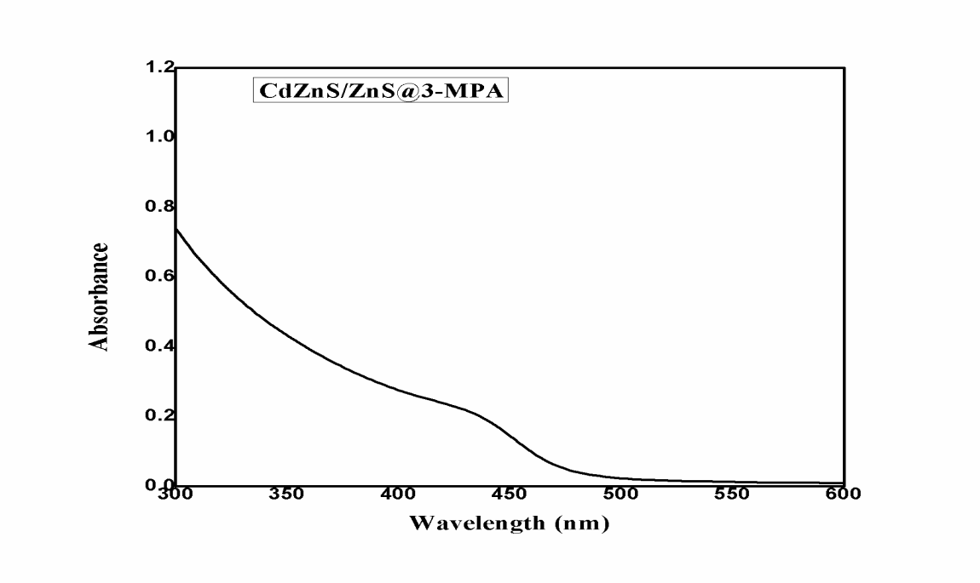

**c**

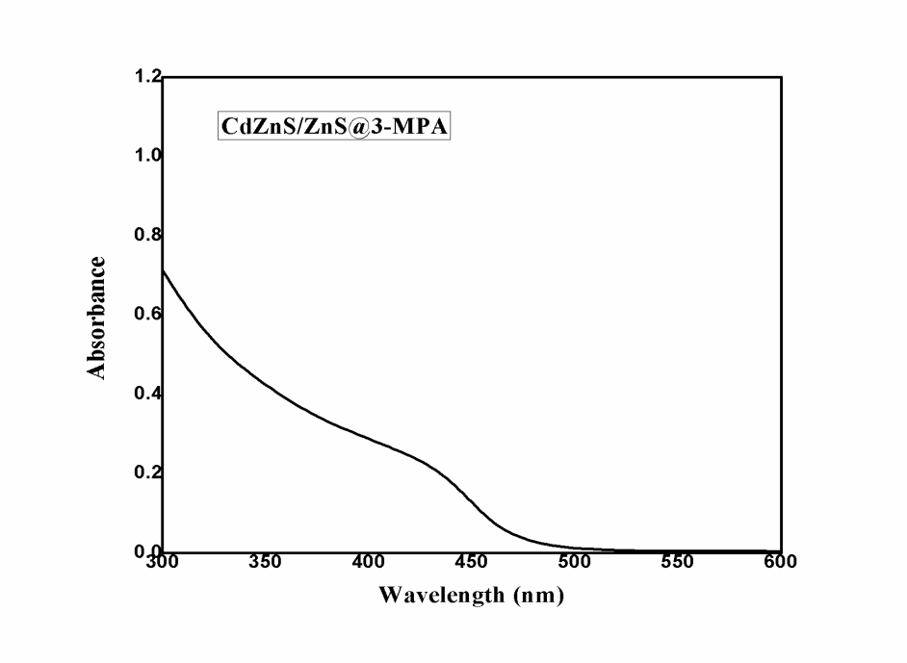

**d**

**S1** UV–Visible absorption spectra of (a) CdZnS/ZnS@ 2-MAA QDs (using ZnCl2 as salt) (b) CdZnS/ZnS@ 2-MAA QDs (ZnNO3. 6H2O as salt) (c) CdZnS/ZnS@ 3-MPA QDs (ZnCl2 salt) (d) CdZnS/ZnS@ 3- MPA QDs (ZnNO3. 6H2O salt)

**FTIR spectroscopy**

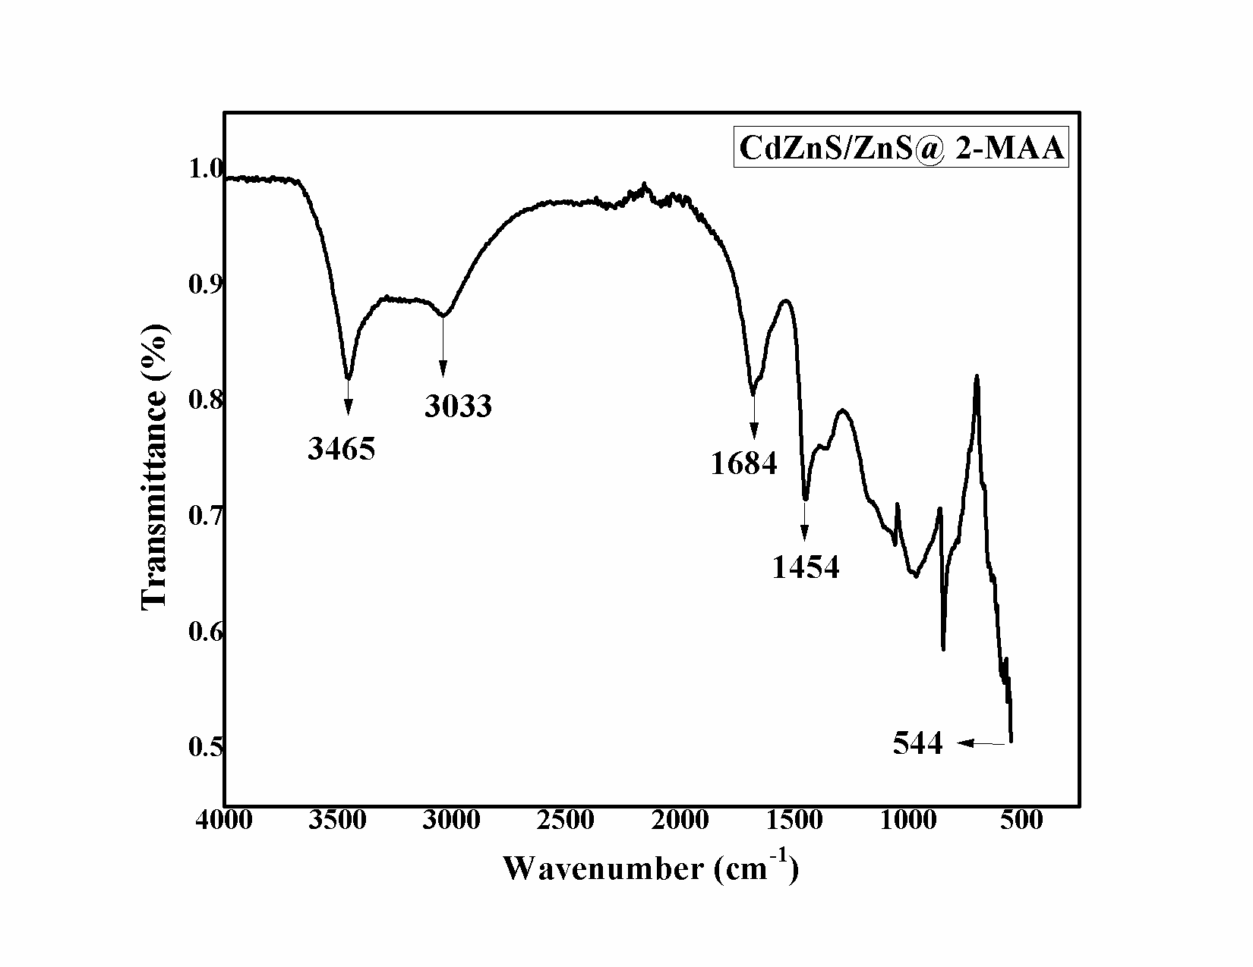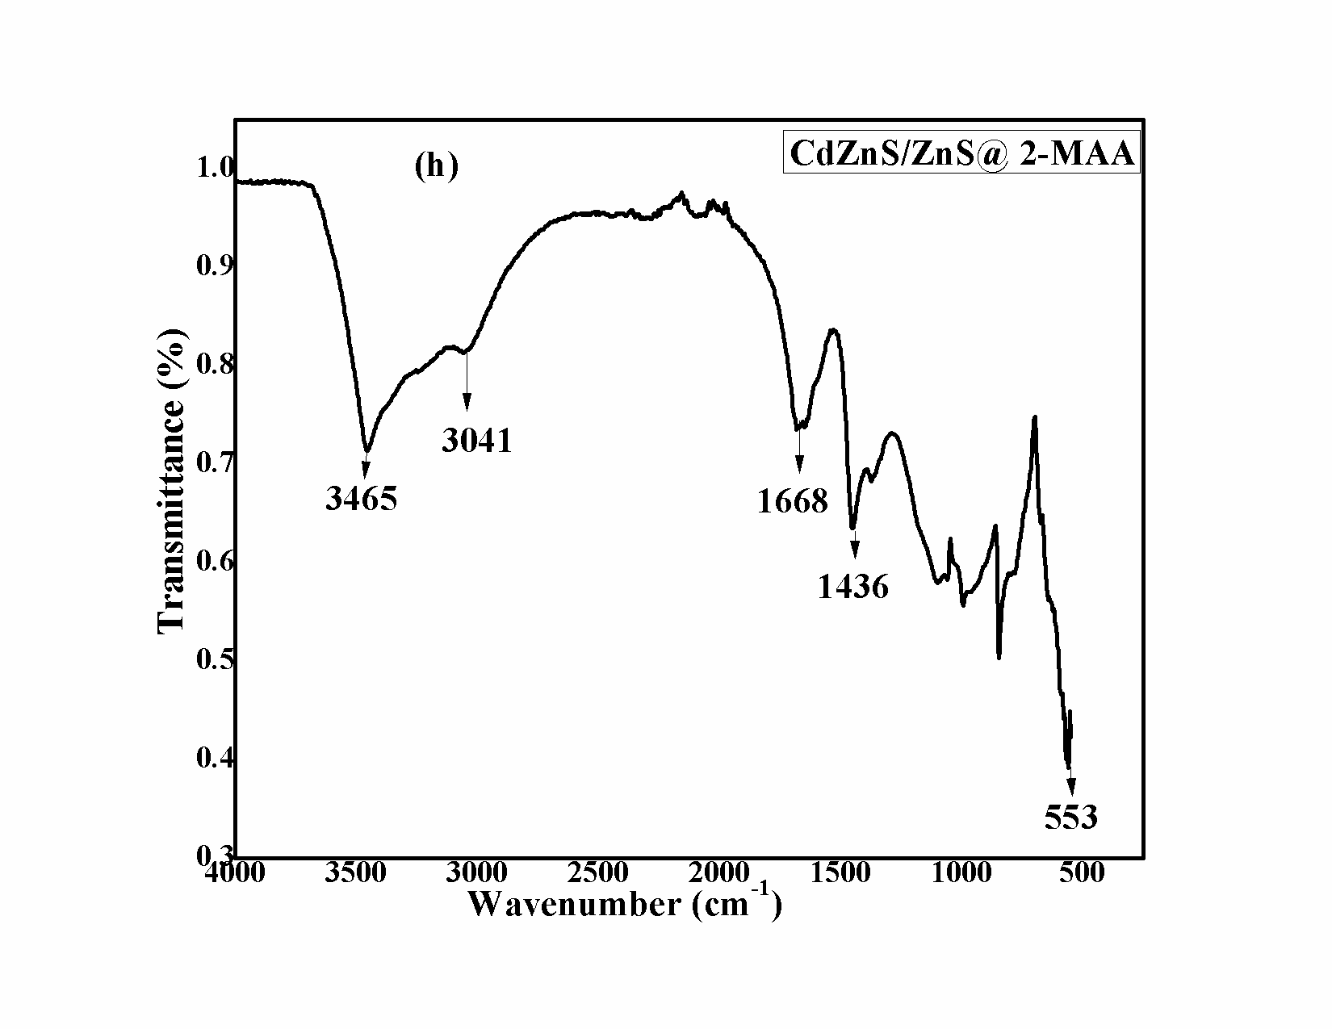

**b**

**a**

**S2a** FTIR of (a) CdZnS/ZnS@2-MAA QDs (synthesized from ZnCl2 as salt) (b) CdZnS/ZnS@2- MAA QDs (synthesized from ZnNO3. 6H2O as salt).

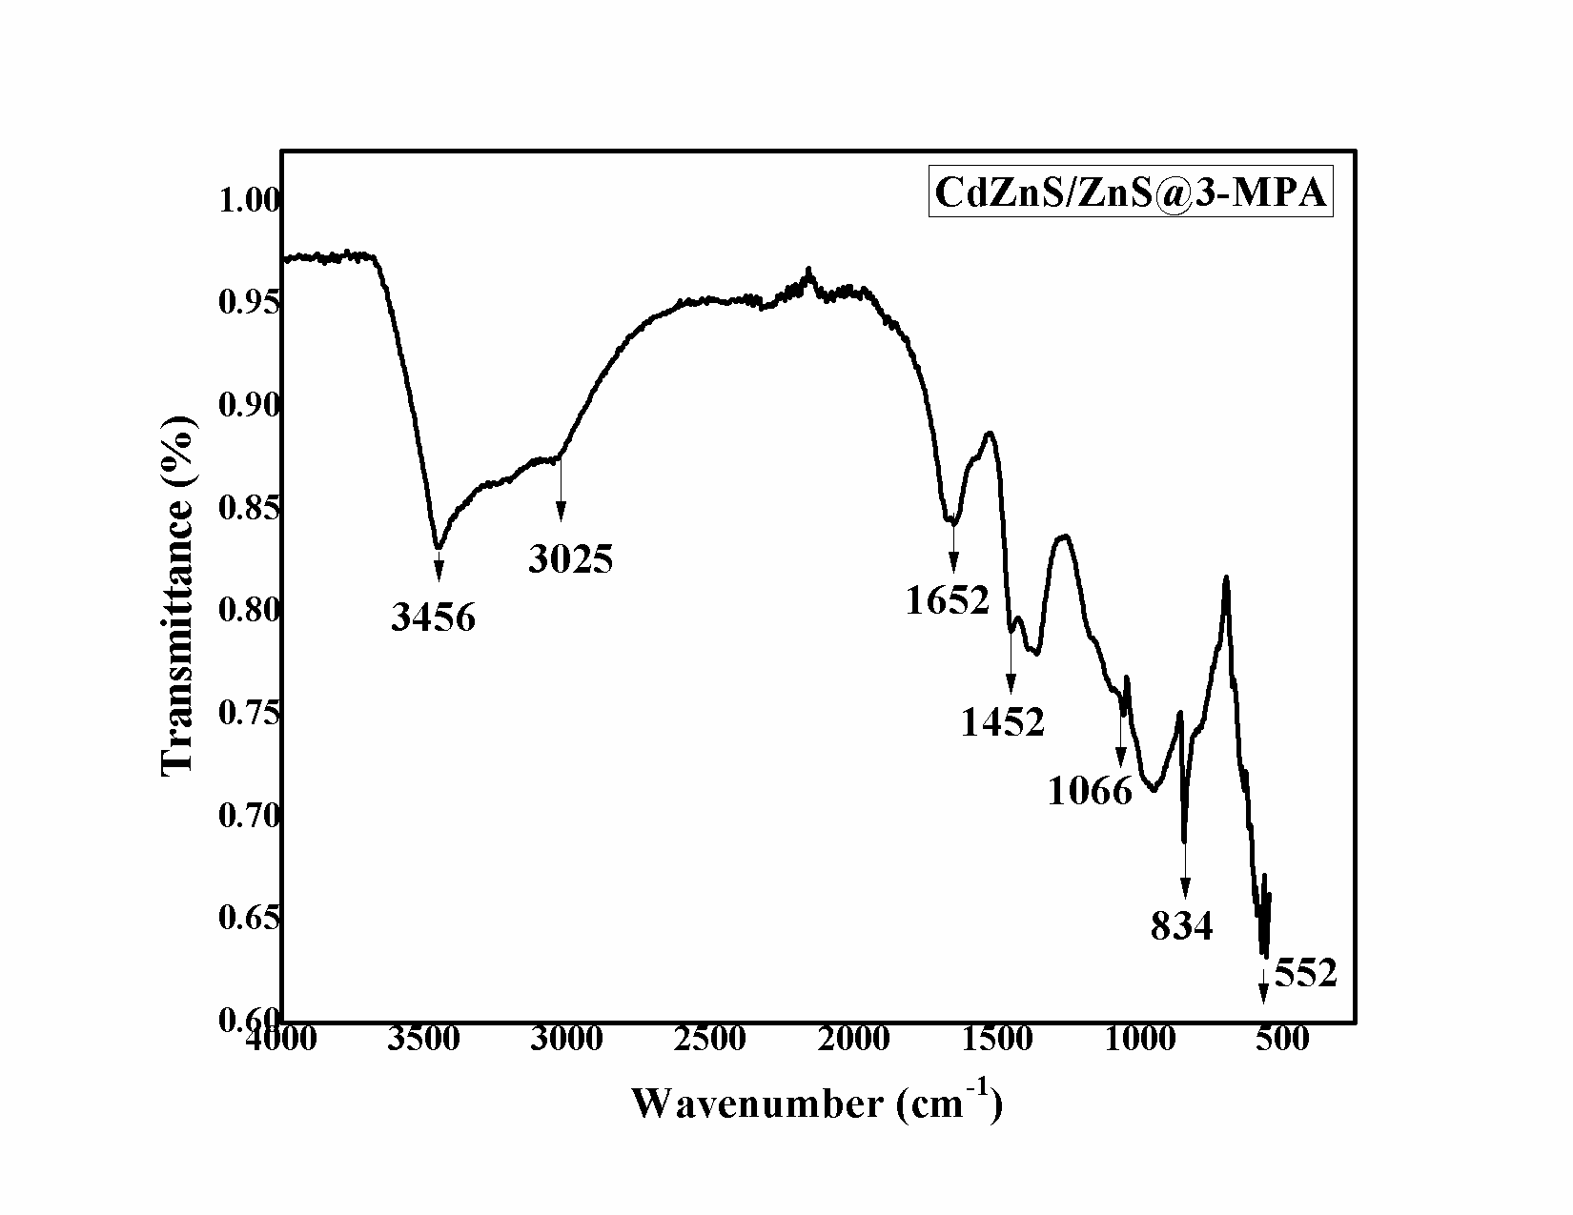

**a**

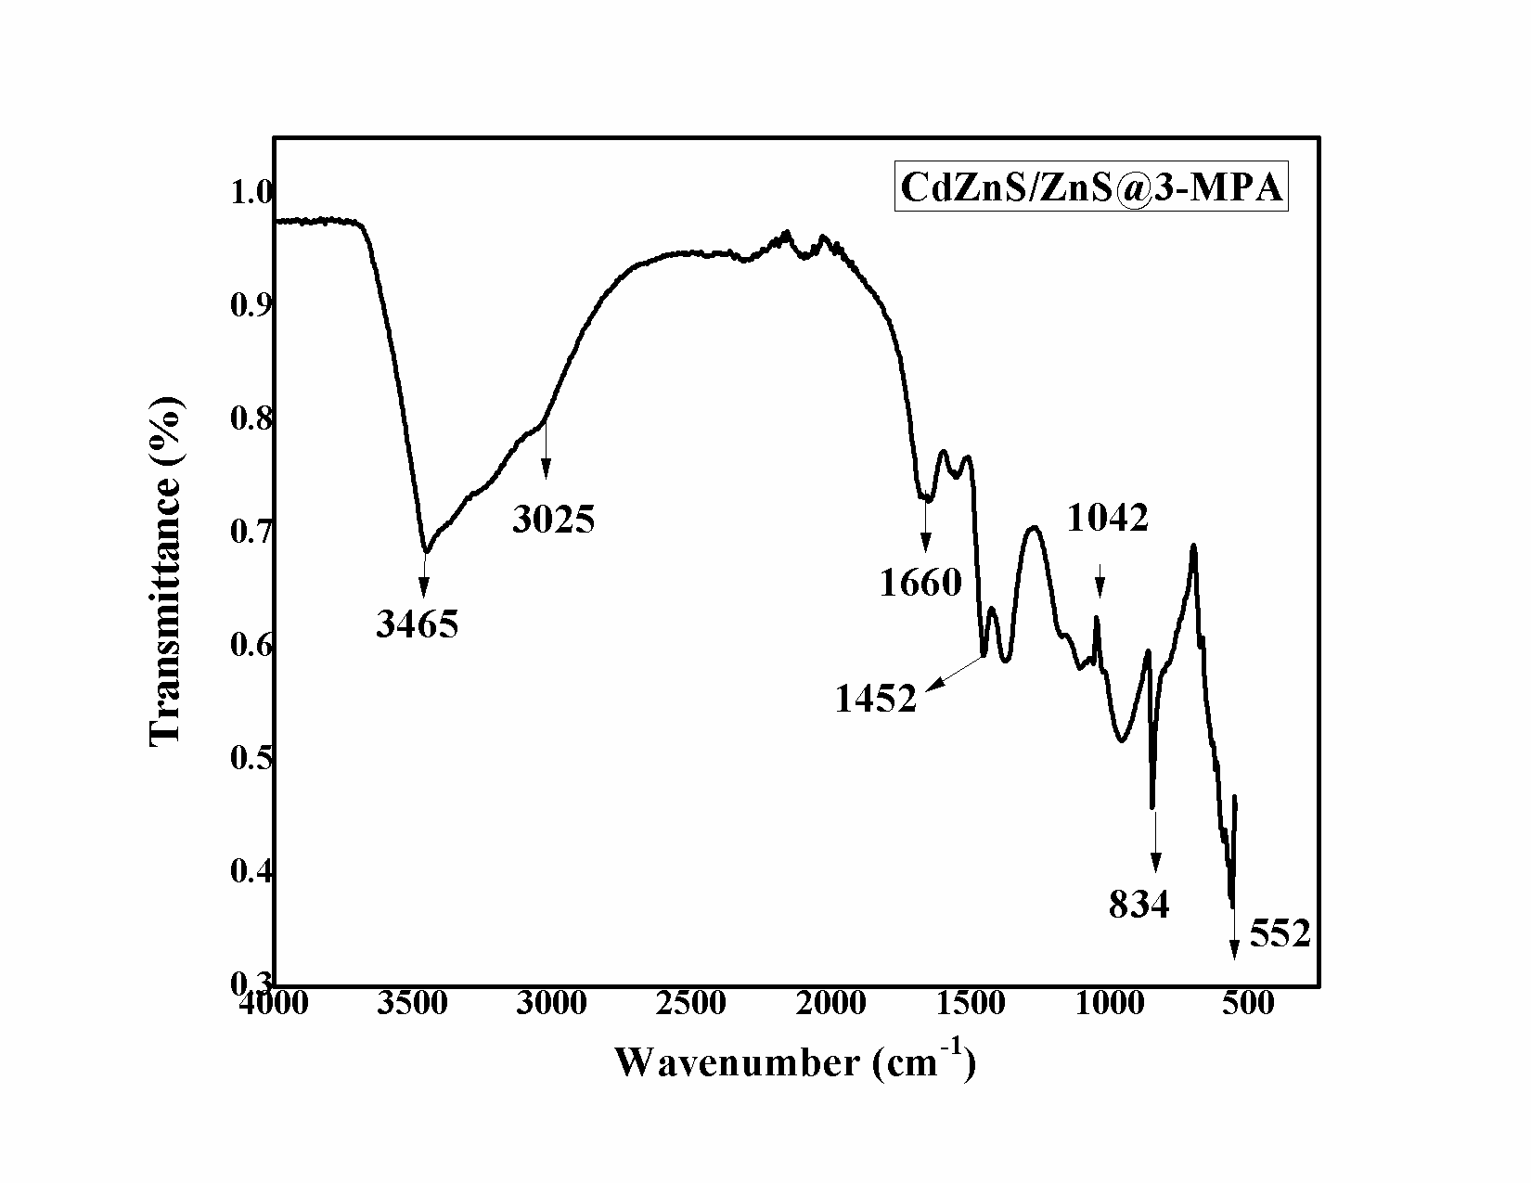

**b**

**S2b** FTIR of (a) CdZnS/ZnS@3-MPA QDs (ZnCl2 salt) (b) CdZnS/ZnS@3-MPA QDs (ZnNO3. 6H2O salt).

IR spectrum of the CdZnS/ZnS QDs with 2-MAA and 3-MPA were given in **S2 a-d** and **Table 1a-b** has displayed the several characteristics peaks (Jimenez Hernandez et al., 2016).

**S2.Table 1a** FTIR data of (a) CdZnS/ZnS@2-MAA QDs (synthesized from ZnCl2 salt) (b) CdZnS/ZnS@ 2-MAA QDs (synthesized from ZnNO3. 6H2O salt)

|  |  |
| --- | --- |
| **Peaks Wave Number (cm-1)** | **Mode Assignment** |
| 3465 | O-H stretching vibrations |
| 3033 | CH2 stretching |
| 2568 | Absent due to ligation of 2-MAA with metal of QDs. |
| 1684 and1454, 1668 and 1436 | stretching of Carboxylate anions |
| 1050,1066 | Zn-S, Cd-S minor intensified peaks |
| 544, 553 | Zn-O stretching |

**S2.Table 1b** FTIR data of (a) CdZnS/ZnS@3-MPA QDs (synthesized from ZnCl2 salt) (b) CdZnS/ZnS@3 MPA QDs (synthesized from ZnNO3. 6H2Osalt)

|  |  |
| --- | --- |
| **Peaks Wave Number (cm-1)** | **Mode Assignment** |
| 3456, 3465 | O-H elongation |
| 3025 | CH2 strain |
| 2568 | Missing because of the association of 3-MPA with metal of QDs |
| 1652and 1452, 1660 and 1452 | anionic group of carboxylate |
| 1066 and 1042, 834 | Zn-S, Cd-S peaks |
| 552 | Zn-O stretching |

**S3**. ANOVA results of the quadratic model for Pb(II) removal by Surface Modified Core/Shell CdZnS/ZnS.

