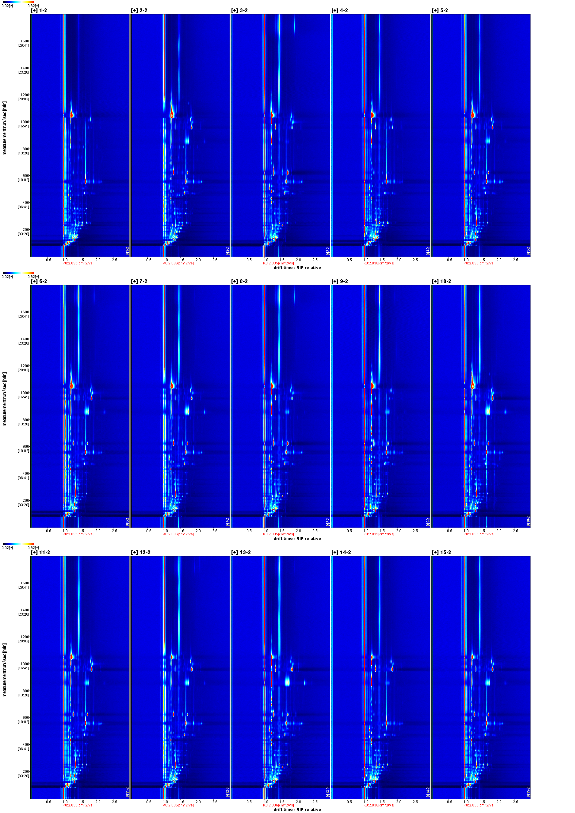
Fig. S1 Topographic plot of 15 batches of ATR.
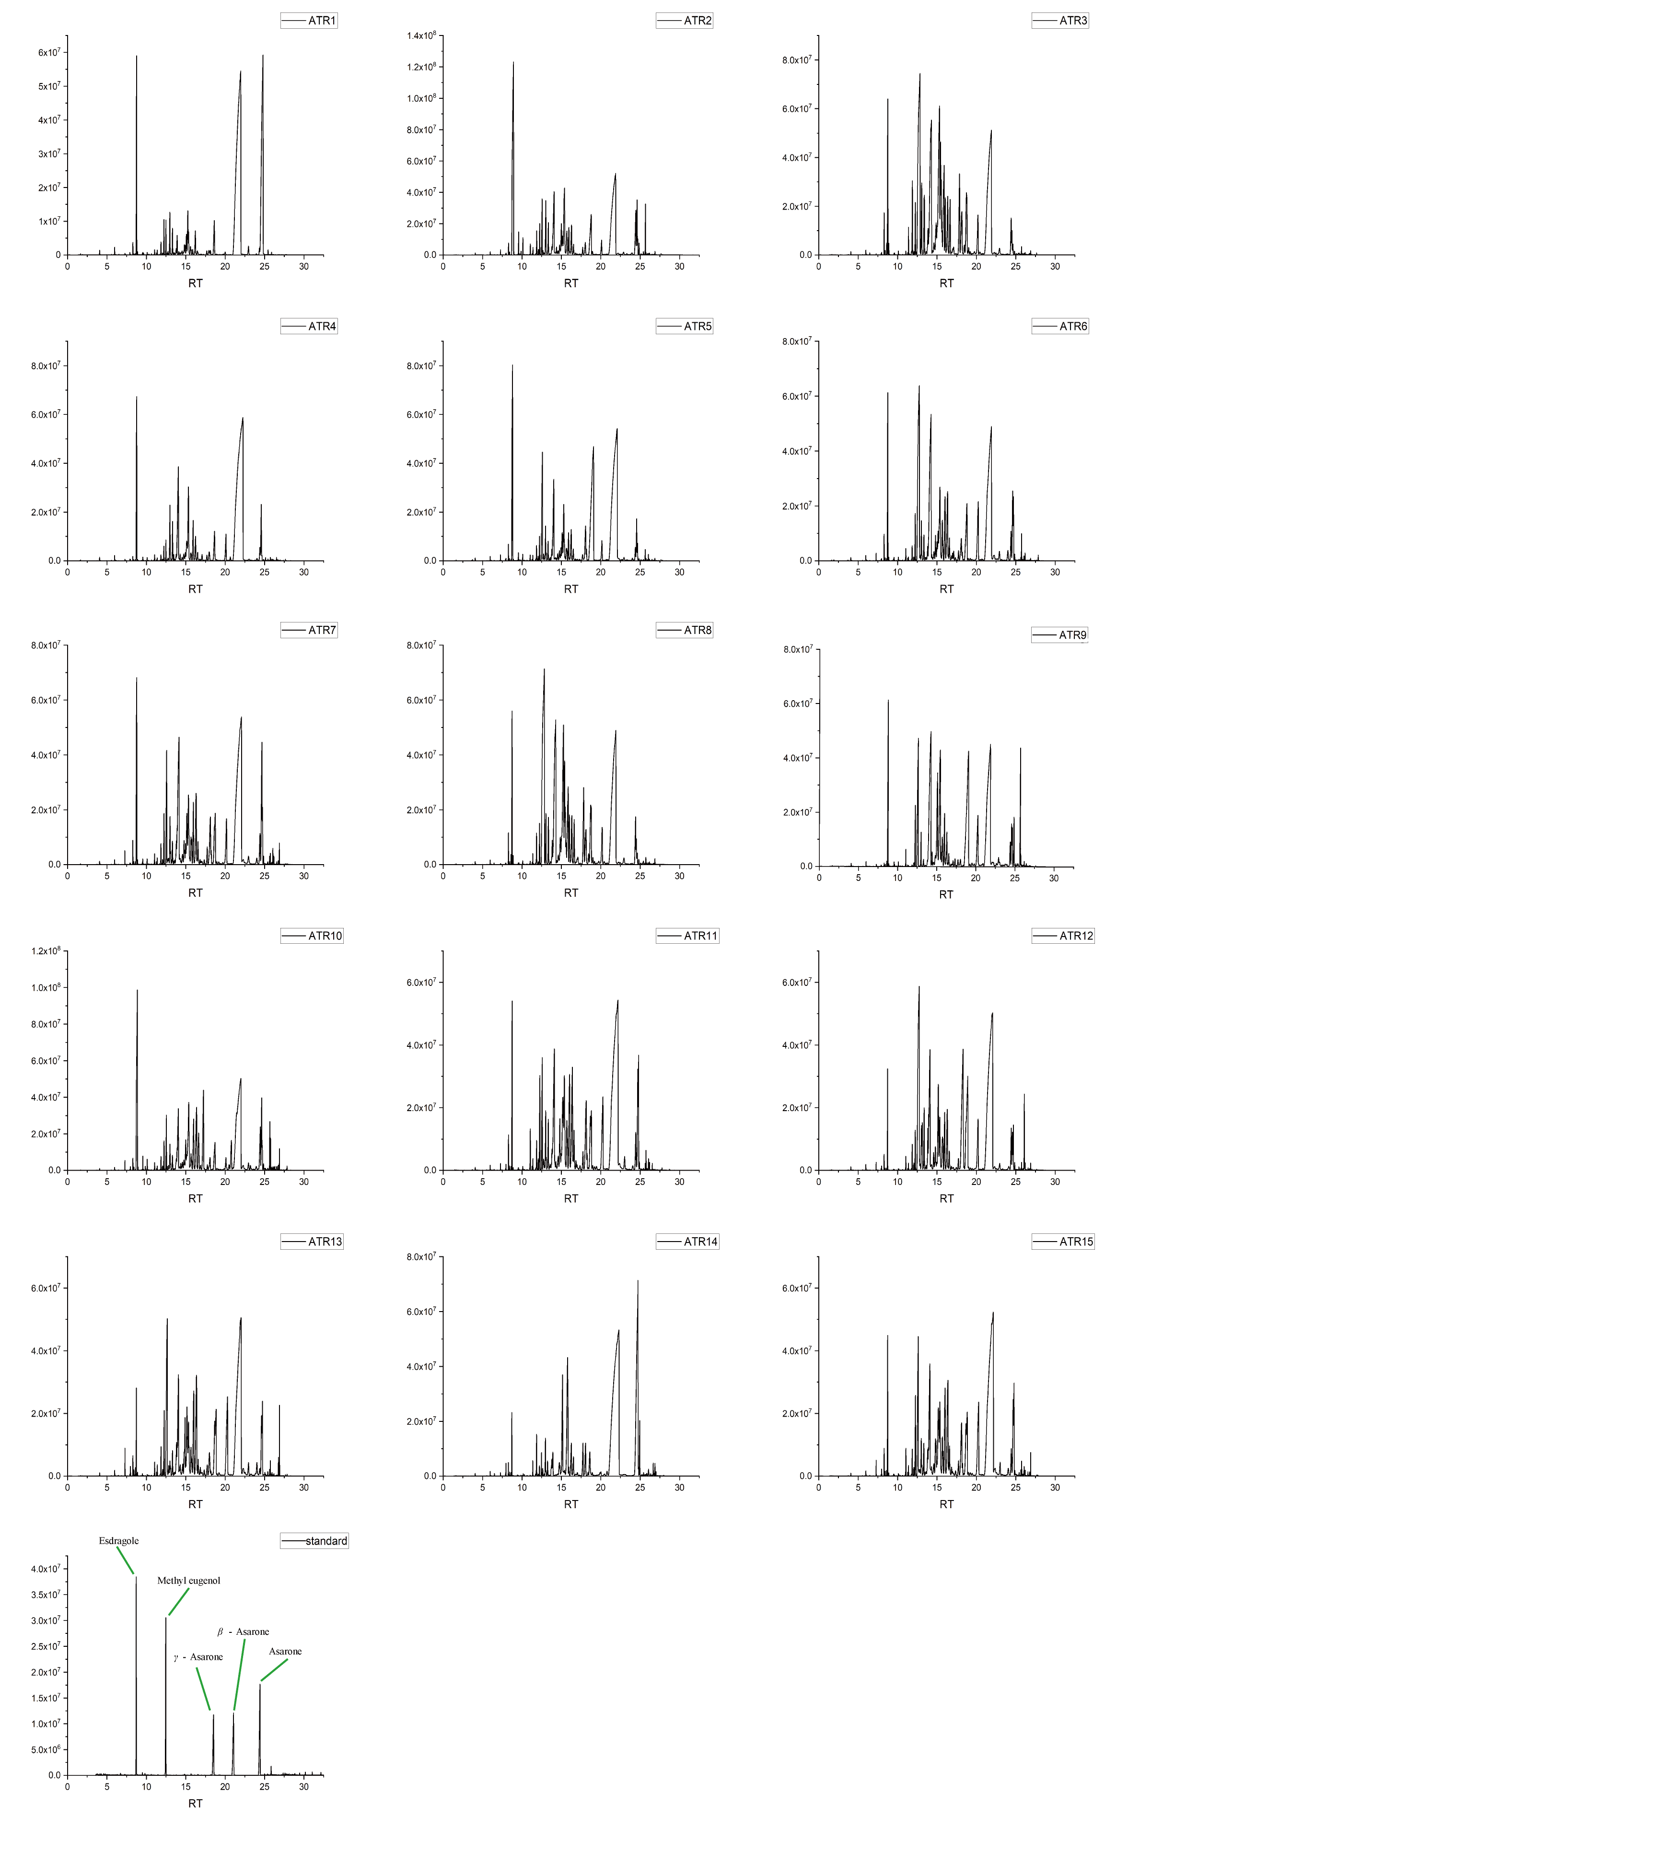
Fig. S2 Total ion chromatograms (TIC) of 15 batches of ATR and standard compounds.
Table S1 Detailed information of all the samples.
 | Origin | Batch number | Place of purchase
ATR1 | Anqing, Anhui | 20210930001 | Bozhou Chinese herbal market
ATR2 | Qianshan, Anhui | 20210930002 | Bozhou Chinese herbal market
ATR3 | Huangshan, Anhui | 20210930003 | Bozhou Chinese herbal market
ATR4 | Anqing, Anhui | 20210930004 | Bozhou Chinese herbal market
ATR5 | Dabieshan, Anhui | 20210930005 | Bozhou Chinese herbal market
ATR6 | Jiujiang, Jiangxi | 20210930006 | Bozhou Chinese herbal market
ATR7 | Nanchang, Jiangxi | 20210930007 | Bozhou Chinese herbal market
ATR8 | Shangrao, Jiangxi | 20210930008 | Bozhou Chinese herbal market
ATR9 | Jingdezhen, Jiangxi | 20210930009 | Bozhou Chinese herbal market
ATR10 | Guixi, Jiangxi | 20210930010 | Bozhou Chinese herbal market
ATR11 | Guangyuan, Sichuan | 20210930011 | Bozhou Chinese herbal market
ATR12 | Kaijiang, Sichuan | 20210930012 | Bozhou Chinese herbal market
ATR13 | Yaan, Sichuan | 20210930013 | Bozhou Chinese herbal market
ATR14 | Nanchong, Sichuan | 20210930014 | Bozhou Chinese herbal market
ATR15 | Chongqing | 20210930015 | Bozhou Chinese herbal market

Table S2 Composition detected by HS-SPME-GC-MS.
NO. | Compound | CAS | Formula | Rt | RI
1 | Acetic acid | 64-19-7 | C₂H₄O₂ | 1.88
2 | (R,R)-2,3-Butanediol | 24347-58-8 | C₄H₁₀O₂ | 3.65
3 | (2S,3S)-(+)-2,3-Butanediol | 19132-06-0 | C₄H₁₀O₂ | 3.76
4 | Hexanoic acid | 142-62-1 | C₆H₁₂O₂ | 5.90 | 985.83
5 | p-Cymene | 99-87-6 | C₁₀H₁₄ | 6.38 | 1028.22
6 | 1,8-Cineole | 470-82-6 | C₁₀H₁₈O | 6.47 | 1036.48
7 | Benzyl alcohol | 100-51-6 | C₇H₈O | 6.52 | 1040.78
8 | Linalool | 78-70-6 | C₁₀H₁₈O | 7.28 | 1102.71
9 | D-Camphor | 464-49-3 | C₁₀H₁₆O | 7.98 | 1155.83
10 | Borneol | 507-70-0 | C₁₀H₁₈O | 8.29 | 1177.57
11 | L-4-terpineol | 20126-76-5 | C₁₀H₁₈O | 8.42 | 1186.93
12 | α-Terpineol | 98-55-5 | C₁₀H₁₈O | 8.61 | 1199.87
13 | Estragole | 140-67-0 | C₁₀H₁₂O | 8.73 | 1207.78
14 | Linalyl acetate | 115-95-7 | C₁₂H₂₀O₂ | 9.50 | 1258.64
15 | cis-Anethole | 25679-28-1 | C₁₀H₁₂O | 9.55 | 1261.80
16 | 1.2,6,11-Trimethyldodecane | 31295-56-4 | C₁₅H₃₂ | 9.83 | 1279.52
17 | Cinnamal | 104-55-2 | C₉H₈O | 9.88 | 1282.58
18 | Anethole | 104-46-1 | C₁₀H₁₂O | 10.10 | 1295.48
19 | Thymol | 89-83-8 | C₁₀H₁₄O | 10.17 | 1299.64
20 | δ-EIemene | 20307-84-0 | C₁₅H₂₄ | 11.05 | 1346.12
21 | Copaene | 3856-25-5 | C₁₅H₂₄ | 11.30 | 1358.27
22 | α-Longipinene | 5989-08-2 | C₁₅H₂₄ | 11.38 | 1362.42
23 | Cyclosativene | 22469-52-9 | C₁₅H₂₄ | 11.74 | 1379.39
24 | Longicyclene | 1137-12-8 | C₁₅H₂₄ | 11.85 | 1384.79
25 | β-Patchoulene | 514-51-2 | C₁₅H₂₄ | 12.08 | 1395.20
26 | β-Elemen | 515-13-9 | C₁₅H₂₄ | 12.26 | 1402.89
27 | (+)-Sativene | 3650-28-0 | C₁₅H₂₄ | 12.34 | 1405.99
28 | Methyleugenol | 93-15-2 | C₁₁H₁₄O₂ | 12.56 | 1414.62
29 | Longifolene | 475-20-7 | C₁₅H₂₄ | 12.65 | 1418.03
30 | β-Maaliene | 489-29-2 | C₁₅H₂₄ | 12.75 | 1421.67
31 | β-Funebrene | 79120-98-2 | C₁₅H₂₄ | 12.85 | 1425.33
32 | β-Caryophyllen | 87-44-5 | C₁₅H₂₄ | 12.99 | 1430.65
33 | (-)-Aristolene | 6831-16-9 | C₁₅H₂₄ | 13.06 | 1433.03
34 | γ-Maaliene | 20071-49-2 | C₁₅H₂₄ | 13.21 | 1438.66
35 | γ-Elemene | 29873-99-2 | C₁₅H₂₄ | 13.26 | 1440.43
36 | Aromandendrene | 489-39-4 | C₁₅H₂₄ | 13.32 | 1442.44
37 | α-Guaiene | 3691-12-1 | C₁₅H₂₄ | 13.63 | 1453.56
38 | Prezizaene | 3853-83-6 | C₁₅H₂₄ | 13.84 | 1460.86
39 | Preziza-7(15)-ene | 31145-21-8 | C₁₅H₂₄ | 13.92 | 1463.44
40 | cis-Methyl isoeugenol | 6380-24-1 | C₁₁H₁₄O₂ | 14.08 | 1468.89
41 | epi-β-Caryophyllene | 68832-35-9 | C₁₅H₂₄ | 14.15 | 1471.26
42 | γ-Gurjunene | 22567-17-5 | C₁₅H₂₄ | 14.26 | 1474.96
43 | 4-epi-α-Acoradiene | 729602-94-2 | C₁₅H₂₄ | 14.31 | 1476.63
44 | 4,5-Di-epi-Aristolochene | 54868-40-5 | C₁₅H₂₄ | 14.39 | 1479.29
45 | γ-Muurolene | 30021-74-0 | C₁₅H₂₄ | 14.62 | 1486.99
46 | β-Chamigrene | 18431-82-8 | C₁₅H₂₄ | 14.79 | 1492.67
47 | γ-himachalene | 53111-25-4 | C₁₅H₂₄ | 14.91 | 1496.36
48 | β-Selinene | 17066-67-0 | C₁₅H₂₄ | 14.99 | 1499.08
49 | Viridiflorene | 21747-46-6 | C₁₅H₂₄ | 15.16 | 1503.46
50 | Eremophilene | 10219-75-7 | C₁₅H₂₄ | 15.35 | 1508.40
51 | α-Muurolene | 10208-80-7 | C₁₅H₂₄ | 15.42 | 1510.04
52 | Bicyclogermacren | 24703-35-3 | C₁₅H₂₄ | 15.62 | 1515.02
53 | δ-Guaiene | 3691-11-0 | C₁₅H₂₄ | 15.66 | 1516.13
54 | Shyobunone | 21698-44-2 | C₁₅H₂₄O | 16.02 | 1524.77
55 | β-Cadinene | 523-47-7 | C₁₅H₂₄ | 16.36 | 1532.89
56 | (-)-α-Panasinsen | 56633-28-4 | C₁₅H₂₄ | 16.46 | 1535.23
57 | 3,7(11)-Selinadiene | 6813-21-4 | C₁₅H₂₄ | 16.54 | 1537.22
58 | Isoshyobunone | 21698-46-4 | C₁₅H₂₄O | 16.58 | 1538.15
59 | α-Cadinene | 24406-05-1 | C₁₅H₂₄ | 16.86 | 1544.51
60 | (E)-α-Bisabolene | 25532-79-0 | C₁₅H₂₄ | 16.97 | 1547.03
61 | α-Calacorene | 21391-99-1 | C₁₅H₂₀ | 17.09 | 1549.75
62 | Isolongifolene epoxide | 67999-56-8 | C₁₅H₂₄O | 17.47 | 1558.24
63 | Elemol | 639-99-6 | C₁₅H₂₆O | 17.50 | 1558.90
64 | Elemicin | 487-11-6 | C₁₂H₁₆O₃ | 17.73 | 1563.95
65 | Eremophila ketone | 158930-41-7 | C₁₅H₂₄O | 18.19 | 1573.94
66 | Spathulenol | 6750-60-3 | C₁₅H₂₄O | 18.48 | 1580.06
67 | γ-Asarone | 5353-15-1 | C₁₂H₁₆O₃ | 18.85 | 1587.70
68 | (-)-Spathulenol | 77171-55-2 | C₁₅H₂₄O | 18.97 | 1590.26
69 | Viridiflorol | 552-02-3 | C₁₅H₂₆O | 19.47 | 1600.21
70 | Guaiol | 489-86-1 | C₁₅H₂₆O | 19.71 | 1605.38
71 | Allyltetramethoxybenzene | 15361-99-6 | C₁₃H₁₈O₄ | 19.77 | 1606.63
72 | β-Oplopenone | 28305-60-4 | C₁₅H₂₄O | 20.31 | 1617.63
73 | Longiborneol | 465-24-7 | C₁₅H₂₆O | 20.47 | 1620.98
74 | β-Asarone | 5273-86-9 | C₁₂H₁₆O₃ | 21.92 | 1649.29
75 | Cadinol T | 5937-11-1 | C₁₅H₂₆O | 22.34 | 1657.11
76 | δ-Cadinol | 19435-97-3 | C₁₅H₂₆O | 22.52 | 1660.42
77 | α-Eudesmol | 473-16-5 | C₁₅H₂₆O | 22.68 | 1663.34
78 | T-Muurolol | 19912-62-0 | C₁₅H₂₆O | 22.97 | 1668.57
79 | epi-γ-Eudesmol | 117066-77-0 | C₁₅H₂₆O | 23.03 | 1669.65
80 | Bulnesol | 22451-73-6 | C₁₅H₂₆O | 23.60 | 1679.63
81 | Acorenone B | 21653-33-8 | C₁₅H₂₄O | 24.03 | 1687.09
82 | Cyperenone | 3466-15-7 | C₁₅H₂₂O | 24.40 | 1693.38
83 | Asarone | 2883-98-9 | C₁₂H₁₆O₃ | 24.61 | 1697.01
84 | Shyobunol | 35727-45-8 | C₁₅H₂₆O | 24.74 | 1699.10
85 | zierone | 6754-66-1 | C₁₅H₂₂O | 24.86 | 1704.61
86 | Acetosyringone | 4460-86-0 | C₁₀H₁₂O₄ | 25.44 | 1742.00
87 | Eremophilone | 562-23-2 | C₁₅H₂₂O | 25.65 | 1754.86
88 | Cadin-4(14)-ene-6,10-diol | 25330-21-6 | C₁₅H₂₆O₂ | 25.73 | 1760.19
89 | Aristolone | 6831-17-0 | C₁₅H₂₂O | 25.83 | 1766.13
90 | Acoramone | 2020-90-8 | C₁₂H₁₆O₄ | 25.88 | 1769.24
91 | Guaiol acetate | 134-28-1 | C₁₇H₂₈O₂ | 26.18 | 1788.11
92 | Nootkatone | 4674-50-4 | C₁₅H₂₂O | 26.45 | 1809.23
93 | Dehydrofukinone | 19598-45-9 | C₁₅H₂₂O | 26.67 | 1835.55
94 | Dibutyl phthalate | 84-74-2 | C₁₆H₂₂O₄ | 27.65 | 1975.12
95 | Ethyl hexadecanoate | 628-97-7 | C₁₈H₃₆O₂ | 27.78 | 1997.50
RI is retention index, Rt is retention time, MW is molecular mass.

Table S3 Quantitative methodological examination.
5 kinds of component precision experimental data table (ng).
Compound | 1 | 2 | 3 | 4 | 5 | 6 | RSD（%）
Esdragole | 1160.00 | 1146.08 | 1186.56 | 1194.64 | 1154.43 | 1160.69 | 1.64%
Methyl eugenol | 934.25 | 932.18 | 964.33 | 967.96 | 931.13 | 937.22 | 1.79%
γ-Asarone | 7476.57 | 7442.39 | 7679.43 | 7649.09 | 7425.71 | 7447.11 | 1.51%
β-Asarone | 5101.42 | 5060.59 | 5243.58 | 5206.05 | 5066.93 | 5028.48 | 1.70%
Asarone | 5413.31 | 5489.83 | 5507.72 | 5702.13 | 5451.79 | 5454.60 | 1.87%

Stability of 5 compounds at room temperature for 24 hours (ng).
Compound | 0h | 2h | 4h | 6h | 12h | 24h | RSD（%）
Esdragole | 1629.18 | 1602.10 | 1647.10 | 1620.83 | 1695.36 | 1635.24 | 1.93%
Methyl eugenol | 2537.08 | 2469.58 | 2535.12 | 2497.42 | 2598.74 | 2495.26 | 1.80%
γ-Asarone | 5070.46 | 5103.51 | 5262.21 | 5262.79 | 5285.39 | 5344.00 | 2.09%
β-Asarone | 6649.08 | 6913.01 | 6842.88 | 6758.84 | 6720.62 | 6995.87 | 1.89%
Asarone | 1993.30 | 1932.27 | 1998.71 | 1952.44 | 2052.13 | 1965.13 | 2.14%

5 kinds of composition repeatability experiment data table (ng).
Compound | 1 | 2 | 3 | 4 | 5 | 6 | RSD（%）
Esdragole | 1609.34 | 1643.65 | 1625.61 | 1666.96 | 1677.80 | 1569.00 | 2.45%
Methyl eugenol | 2622.13 | 2499.97 | 2490.41 | 2485.96 | 2481.89 | 2501.00 | 2.14%
γ-Asarone | 5451.40 | 5518.98 | 5240.88 | 5576.30 | 5337.65 | 5426.26 | 2.24%
β-Asarone | 6811.13 | 6696.63 | 6712.94 | 7011.28 | 6721.19 | 6823.00 | 1.74%
Asarone | 2066.41 | 1978.83 | 1973.92 | 2072.98 | 2033.13 | 2012.00 | 2.09%

Test data table of recovery rate of esdragole (μg).
Initial value | Addition | Estimated value | Recovery rate | Average recovery rate | RSD (%)
1.64 | 0.81 | 2.40 | 93.83% | 97.15% | 3.00%
1.66 | 0.80 | 2.44 | 97.13%
1.62 | 0.82 | 2.39 | 94.24%
1.66 | 1.58 | 3.28 | 102.91%
1.63 | 1.64 | 3.26 | 99.45%
1.65 | 1.61 | 3.24 | 98.33%
1.65 | 2.49 | 4.08 | 97.67%
1.59 | 2.40 | 3.91 | 96.46%
1.62 | 2.48 | 3.96 | 94.35%

Test data table of recovery rate of methyl eugenol (μg).
Initial value | Addition | Estimated value | Recovery rate | Average recovery rate | RSD (%)
2.55 | 1.29 | 3.78 | 95.80% | 98.50% | 3.36%
2.61 | 1.25 | 3.78 | 93.67%
2.57 | 1.26 | 3.84 | 100.72%
2.54 | 2.52 | 5.00 | 97.77%
2.60 | 2.51 | 5.08 | 98.80%
2.61 | 2.51 | 5.00 | 95.30%
2.61 | 3.86 | 6.44 | 99.09%
2.49 | 3.82 | 6.48 | 104.48%
2.55 | 3.80 | 6.38 | 100.82%

Test data table of recovery rate of γ-asarone (μg).
Initial value | Addition | Estimated value | Recovery rate | Average recovery rate | RSD (%)
5.28 | 2.63 | 7.95 | 101.48% | 98.75% | 2.90%
5.44 | 2.71 | 7.97 | 93.32%
5.37 | 2.70 | 8.06 | 99.78%
5.39 | 5.28 | 10.53 | 97.37%
5.40 | 5.36 | 10.59 | 96.90%
5.26 | 5.42 | 10.57 | 98.12%
5.40 | 7.88 | 13.32 | 100.56%
5.32 | 8.04 | 13.22 | 98.23%
5.29 | 7.94 | 13.47 | 103.01%

Test data table of recovery rate of β-asarone (μg).
Initial value | Addition | Estimated value | Recovery rate | Average recovery rate | RSD (%)
6.85 | 3.41 | 10.49 | 106.93% | 101.26% | 2.81%
6.86 | 3.43 | 10.25 | 98.75%
6.90 | 3.46 | 10.48 | 103.44%
6.86 | 6.81 | 13.83 | 102.31%
6.84 | 6.86 | 13.79 | 101.27%
6.82 | 6.80 | 13.75 | 101.82%
6.92 | 10.31 | 17.03 | 98.15%
6.83 | 10.39 | 17.29 | 100.64%
6.82 | 10.39 | 17.01 | 98.06%

Test data table of recovery rate of asarone (μg).
Initial value | Addition | Estimated value | Recovery rate | Average recovery rate | RSD (%)
2.00 | 1.01 | 2.99 | 97.72% | 101.51% | 2.70%
2.06 | 1.01 | 3.09 | 101.99%
2.04 | 1.00 | 3.04 | 100.00%
1.98 | 1.97 | 4.07 | 105.68%
2.02 | 2.01 | 4.06 | 101.55%
1.99 | 2.03 | 3.98 | 97.64%
2.03 | 2.99 | 5.07 | 101.94%
2.02 | 2.98 | 5.14 | 104.59%
2.05 | 2.99 | 5.11 | 102.48%

Table S4 The contents of the five components
The content of 5 components in 15 batches of ATR volatile oil.
 | Estragole | Methyleugenol | γ-Asarone | β-Asarone | Asarone
ATR1 | 4.61 | 3.38 | 20.41 | 587.27 | 387.25
ATR2 | 740.72 | 8.37 | 23.27 | 172.10 | 28.33
ATR3 | 48.10 | 165.02 | 32.71 | 375.03 | 13.24
ATR4 | 39.35 | 4.36 | 15.96 | 888.97 | 32.76
ATR5 | 173.04 | 33.79 | 216.16 | 435.04 | 14.50
ATR6 | 19.67 | 144.81 | 39.56 | 418.24 | 21.37
ATR7 | 89.23 | 19.70 | 25.09 | 560.48 | 52.88
ATR8 | 52.62 | 239.19 | 35.51 | 406.38 | 12.84
ATR9 | 139.37 | 37.47 | 130.61 | 260.51 | 12.91
ATR10 | 457.33 | 9.74 | 16.46 | 268.26 | 22.82
ATR11 | 19.93 | 10.33 | 27.88 | 599.75 | 26.08
ATR12 | 21.53 | 124.55 | 88.73 | 492.39 | 14.73
ATR13 | 11.89 | 39.02 | 38.61 | 416.97 | 14.65
ATR14 | 4.17 | 3.76 | 15.02 | 918.80 | 14.96
ATR15 | 19.16 | 30.51 | 43.30 | 743.49 | 25.95
Unit. mg/ml

The content of 5 components in 15 batches of ATR powder.
 | Estragole | Methyleugenol | γ-Asarone | β-Asarone | Asarone
ATR1 | 0.05 | 0.04 | 0.24 | 6.91 | 4.55
ATR2 | 21.78 | 0.25 | 0.68 | 5.06 | 0.83
ATR3 | 0.67 | 2.31 | 0.46 | 5.25 | 0.19
ATR4 | 0.54 | 0.06 | 0.22 | 12.09 | 0.45
ATR5 | 2.37 | 0.46 | 2.97 | 5.97 | 0.20
ATR6 | 0.35 | 2.55 | 0.70 | 7.38 | 0.38
ATR7 | 1.53 | 0.34 | 0.43 | 9.64 | 0.91
ATR8 | 1.13 | 5.16 | 0.77 | 8.76 | 0.28
ATR9 | 1.64 | 0.44 | 1.54 | 3.06 | 0.15
ATR10 | 9.41 | 0.20 | 0.34 | 5.52 | 0.47
ATR11 | 0.55 | 0.28 | 0.77 | 16.46 | 0.72
ATR12 | 0.37 | 2.17 | 1.54 | 8.57 | 0.26
ATR13 | 0.16 | 0.54 | 0.53 | 5.72 | 0.20
ATR14 | 0.10 | 0.09 | 0.35 | 21.61 | 0.35
ATR15 | 0.38 | 0.60 | 0.85 | 14.57 | 0.51
Unit. mg/g

