**Supplementary Information**

Mechanistic and kinetic insights into size-dependent activity in ultra-small Pt/CNTs nanozymes during antibacterial

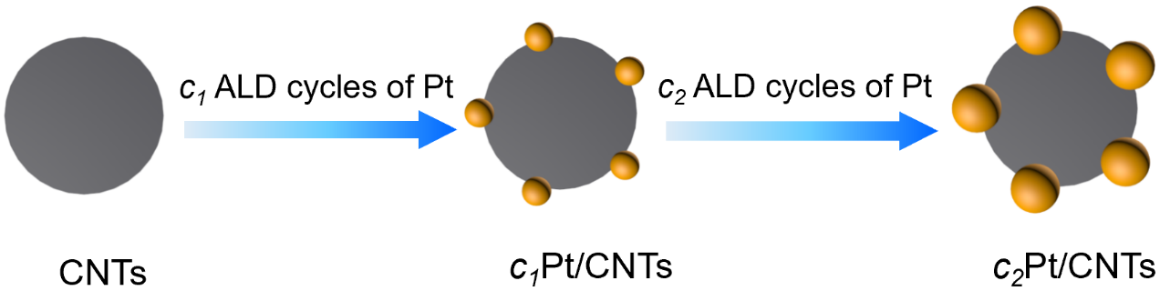

Figure S1.Section diagram of the preparation process for Pt/CNTs nanozymes.

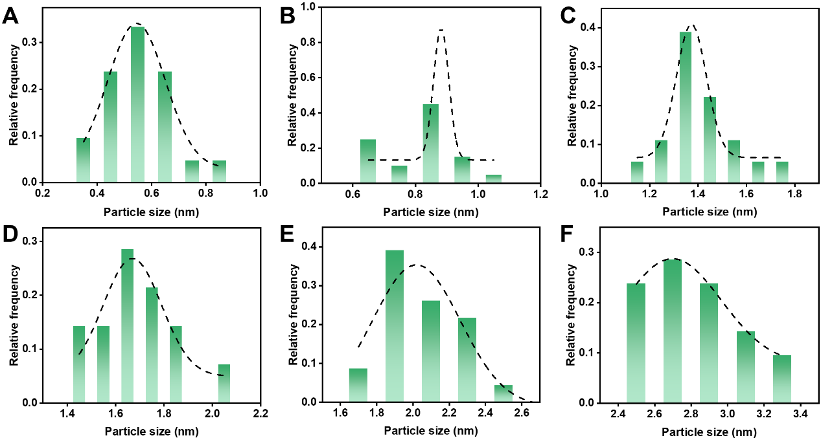

Figure S2. Particle size distribution of 5Pt/CNTs, 10Pt/CNTs, 20Pt/CNTs, 30Pt/CNTs, 50Pt/CNTs and 70Pt/CNTs, respectively.

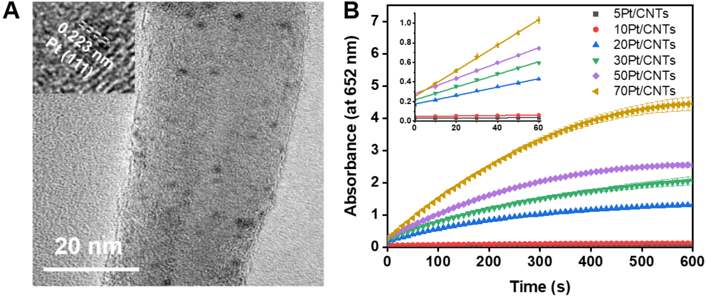

Figure S3. (A) TEM and HRTEM (inset) images of 30Pt/CNTs nanozyme. (B) Reaction-time curves of TMB colorimetric reaction catalyzed by cPt/CNTs nanozymes (the same mass of nanozyme). Inserted images represent the magnified initial linear portion of the nanozyme reaction-time curves. A length of 60 s was chosen for the initial rate period because the R2 coefficients were close to 1 during this period after a linear regression analysis. Absorbance is measured in arbitrary units. Error bars shown represent standard errors derived from three independent experiments.

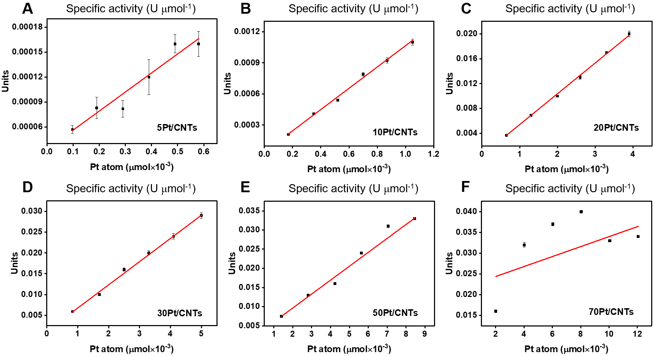

Figure S4. The specific activities of *c*Pt/CNTs nanozymes at 652 nm. Error bars shown represent standard error derived from three independent experiments.



Figure S5 Zeta potential of CNTs, 5Pt/CNTs, 10Pt/CNTs, 20Pt/CNTs, 30Pt/CNTs, 50Pt/CNTs and 70Pt/CNTs, respectively.



Figure S6. High-resolution Pt 4f XPS of *c*Pt/CNTs (*c*=5, 10, 20, 30, 50 and 70) nanozymes.

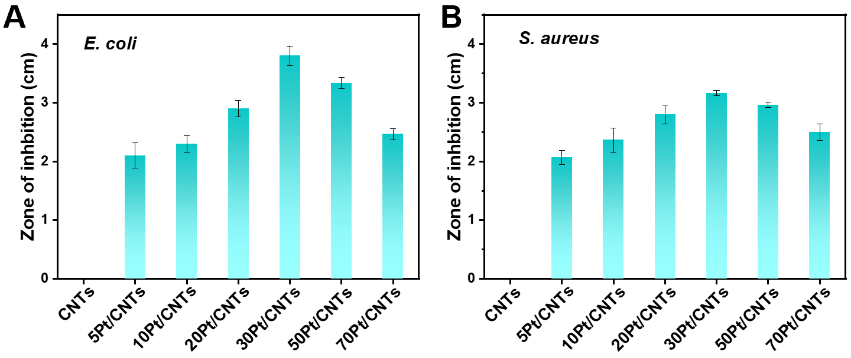

Figure S7. Antibacterial properties of the *c*Pt/CNTs nanozymes. The inhibition zone experiment determines the corresponding bacterial viabilities of (A) E. coli and (B) S. aureus after treatment with *c*Pt/CNTs nanozymes in different groups. Error bars shown represent standard errors derived from three independent experiments.

Table S1. The Pt loading of *c*Pt/CNTs (*c*=5, 10, 20, 30, 50 and 70) nanozymes.

|  |  |
| --- | --- |
| Nanozyme | Pt loadinga (wt%) |
| 5Pt/CNTs | 0.19 |
| 10Pt/CNTs | 0.34 |
| 20Pt/CNTs | 1.27 |
| 30Pt/CNTs | 1.61 |
| 50Pt/CNTs | 2.75 |
| 70Pt/CNTs | 3.92 |

aMeasured by ICP-AES.

Table S2. The specific activity of *c*Pt/CNTs (*c*=5, 10, 20, 30, 50 and 70) nanozymes.

|  |  |
| --- | --- |
| Nanozyme | Specific activitya (U μmol-1) |
| 5Pt/CNTs | 0.23 |
| 10Pt/CNTs | 1.03 |
| 20Pt/CNTs | 4.95 |
| 30Pt/CNTs | 5.58 |
| 50Pt/CNTs | 3.64 |
| 70Pt/CNTs | 1.20 |

a Calculated by the nanozyme activity standardization method.[1]

Table S3. Comparison of TMB kinetics assay of the Pt active sites engineered in *c*Pt/CNTs (*c*=5, 10, 20, 30, 50, 70) nanozymes.

|  |  |  |  |  |  |
| --- | --- | --- | --- | --- | --- |
| Nanozymes | **[E/Pt]**  **(M)** | **Km**  **(mM)** | **vmax**  **(M s-1)** | **kcat**  **(s-1)** | **References** |
| 5Pt/CNTs | 1.95×10-7 | 0.035 | 0.21×10-7 | 0.11 | This work |
| 10Pt/CNTs | 3.49×10-7 | 0.11 | 0.71×10-7 | 0.20 | This work |
| 20Pt/CNTs | 1.30×10-6 | 1.43 | 1.48×10-6 | 1.14 | This work |
| 30Pt/CNTs | 1.65×10-6 | 1.15 | 1.89×10-6 | 1.15 | This work |
| 50Pt/CNTs | 2.82×10-6 | 1.56 | 1.53×10-6 | 0.54 | This work |
| 70Pt/CNTs | 4.02×10-6 | 1.71 | 1.20×10-6 | 0.30 | This work |
| Pt-NPs nanozyme | 2.04×10-8 | 0.870 | 1.77×10-7 | 8.67 | [2] |
| Pt hollow nanodendrites | 7×10-6 | 0.81 | 1.2×10-7 | 0.017 | [3] |
| Pt20 | 0.2×10-6 | 1.3 | 1.4×10-7 | 0.7 | [4] |
| RET2-Pt2.9 | 9×10-7 | 0.056 | 5.82×10-7 | 0.65 | [5] |

[E] is the molar concentration of Pt active sites in *c*Pt/CNTs nanozymes. The molar concentration of Pt was chosen to obtain the well-fitted Michaelis-Menten plots while varying the substrate concentrations. Km is the Michaelis constant, Vmax is the maximal reaction velocity and kcat is the catalytic constant, where kcat=Vmax/[E/Pt] value indicates the catalytic efficiency of the nanozymes.

Table S4. Comparison of H2O2 kinetics assay of the Pt active sites engineered in *c*Pt/CNTs (*c*=5, 10, 20, 30, 50, 70) nanozymes.

|  |  |  |  |  |  |
| --- | --- | --- | --- | --- | --- |
| Nanozymes | **[E/Pt]**  **(M)** | **Km**  **(mM)** | **vmax**  **(M s-1)** | **kcat**  **(s-1)** | **References** |
| 5Pt/CNTs | 2.44×10-7 | 25.94 | 1.14×10-7 | 0.47 | This work |
| 10Pt/CNTs | 4.36×10-7 | 89.61 | 5.06×10-7 | 1.16 | This work |
| 20Pt/CNTs | 1.63×10-6 | 86.24 | 7.43×10-6 | 4.56 | This work |
| 30Pt/CNTs | 2.06×10-6 | 72.91 | 1.03×10-5 | 5.00 | This work |
| 50Pt/CNTs | 3.52×10-6 | 61.62 | 6.07×10-6 | 1.72 | This work |
| 70Pt/CNTs | 5.02×10-6 | 48.09 | 1.79×10-6 | 0.36 | This work |
| Pt hollow nanodendrites | 7×10-6 | 6.9 | 9.9×10-8 | 0.014 | [3] |
| Pt20 | 0.2×10-6 | 123.6 | 5.1×10-8 | 0.255 | [4] |
| RET2-Pt2.9 | 9×10-7 | 48 | 5.68×10-7 | 0.63 | [5] |

[E] is the molar concentration of Pt active sites in *c*Pt/CNTs nanozymes. The molar concentration of Pt was chosen to obtain the well-fitted Michaelis-Menten plots while varying the substrate concentrations. Km is the Michaelis constant, Vmax is the maximal reaction velocity and kcat is the catalytic constant, where kcat=Vmax/[E/Pt] value indicates the catalytic efficiency of the nanozymes.

Table S5. Summary of Pt 4f XPS results of Pt0, Pt2+ and Pt4+ species for the *c*Pt/CNTs (*c*=5, 10, 20, 30, 50, 70) nanozymes.

|  |  |  |  |  |  |  |
| --- | --- | --- | --- | --- | --- | --- |
| Nanozymes | Binding energy (eV) | Assignment | Relative content (%) | Pt0/Pt2+ | Pt0/Pt4+ | Pt2+/Pt4+ |
| 5Pt/CNTs | 70.8 | Pt0 | 1.23 | 0.033 | 0.020 | 0.60 |
| 73 | Pt2+ | 37.04 |
| 74 | Pt4+ | 61.73 |
| 10Pt/CNTs | 70.8 | Pt0 | 1.57 | 0.040 | 0.027 | 0.67 |
| 72.8 | Pt2+ | 39.37 |
| 74 | Pt4+ | 59.06 |
| 20Pt/CNTs | 71 | Pt0 | 2.44 | 0.044 | 0.057 | 1.29 |
| 72.4 | Pt2+ | 54.88 |
| 73.8 | Pt4+ | 42.68 |
| 30Pt/CNTs | 71 | Pt0 | 3.48 | 0.06 | 0.09 | 1.51 |
| 72.3 | Pt2+ | 58.01 |
| 74.2 | Pt4+ | 38.51 |
| 50Pt/CNTs | 70.8 | Pt0 | 2.27 | 0.037 | 0.062 | 1.69 |
| 72.7 | Pt2+ | 61.36 |
| 74.2 | Pt4+ | 36.36 |
| 70Pt/CNTs | 71 | Pt0 | 2.06 | 0.031 | 0.067 | 2.17 |
| 72.6 | Pt2+ | 67.01 |
| 74.5 | Pt4+ | 30.93 |

**References**

[1] B. Jiang, D. Duan, L. Gao, M. Zhou, K. Fan, Y. Tang, J. Xi, Y. Bi, Z. Tong, G.F. Gao, N. Xie, A. Tang, G. Nie, M. Liang, X. Yan. *Nature Protocols*, 2018, 13(7): 1506-1520.

[2] Y. Chen, P. Wang, H. Hao, J. Hong, H. Li, S. Ji, A. Li, R. Gao, J. Dong, X. Han, M. Liang, D. Wang, Y. Li. *Journal of the American Chemical Society*,2021, 143, (44), 18643-18651.

[3] R. Wu, Y. Chong, G. Fang, X. Jiang, Y. Pan, C. Chen, J. Yin, C. Ge. *Advanced Functional Materials*, 2018, 1801484.

[4] Moglianetti, M.; De Luca, E.; Pedone, D.; Marotta, R.; Catelani, T.; Sartori, B.; Amenitsch, H.; Retta, S. F.; Pompa, P. P. *Nanoscale*,2016, 8, (6), 3739-52.

[5] Fu, Y.; Zhao, X.; Zhang, J.; Li, W. *The Journal of Physical Chemistry C* **2014,** 118, (31), 18116-18125.