**Supporting information**

**Application of G-quadruplex aptamer conjugated MSNs to deliver ampicillin for suppressing *S. aureus* biofilm on bone tissue**

**Authors:**

Mohammad Moradi 1, Hassan Mohabatkar 1\*, Mandana Behbahani 1, Ghasem Dini2

1-Department of Biotechnology, Faculty of Biological Science and Technology, University of Isfahan, Isfahan 81746-73441, Iran

2-Department of Nanotechnology, Faculty of Chemistry, University of Isfahan, Isfahan 81746-73441, Iran

Abstract word count: 261

Manuscript word count: 6000

Number of references: 52

**\*Corresponding Author:** Hassan Mohabatkar (h.mohabatkar@ast.ui.ac.ir)

**This file includes Fig.S1, S2, S3, S4, S5 and Tables S1.**

C:\Users\Mohammad\Desktop\submit phd paper\bokeh_plot .tif

**Figure S1.** Model analysis of PA63 aptamer interactions with protein A of *S. aureus* with respect to **A.** HADDOC score versus fraction of common contacts **B.** HADDOCK score versus interface RMSD **C.** Desolvation energy versus interface RMSD **D.** Vander Waals energy versus interface RMSD **E.** Electrostatics energy versus interface RMSD and **F.** Restraint violation energy versus interface RMSD

C:\Users\Mohammad\Desktop\submit phd paper\bokeh_plot (15).tif

**Figure S2.** Cluster analysis diagram of PA63 aptamer interactions with protein A of S. aureus with respect to **A.** Vander Waals energy **B.** Electrostatics energy and **C.** Restraint violation energy

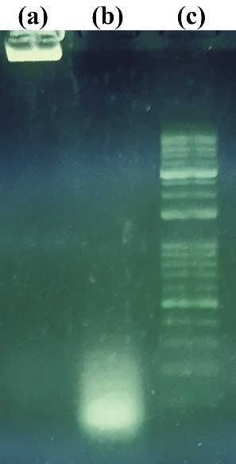

**Figure S3.** Gel retardation assay. Agarose gel electrophoresis indicating **A.** MSN-aptamer conjugate **B.** PA63 aptamer, and **C.** 1 Kb DNA ladder.

**C:\Users\Mohammad\Desktop\PHD article data\Untitled.tif**

**Figure S4.** A. Results of DLS, indicating the hydrodynamic size of nanoparticles B. Zeta potential analysis of the nanoparticles

C:\Users\Mohammad\Desktop\submit phd paper\Fig 9.tif

**Figure S5.** Light microscopic micrographs of the *S.aureus* biofilm investigated with ×100 magnification, **(a)** formation of strong biofilm on the surface of mice skull after 72 h, and **(b)** destruction of *S. aureus* biofilm on the mice bone after 48 h of treatment with 100µg/mL of the three-component system.

**Table S1.** Detail of interactions between PA3 aptamer and protein A of *S. aureus*

|  |  |  |  |
| --- | --- | --- | --- |
| **Type of interaction** | **Amino acid residue** | **Nucleotide residue** | **Distance (Ao)** |
| **Hydrophobic Interactions** | Tyr14 | T35 | 3.54 |
| Glu47 | T26 | 3.49 |
| Pro57 | T2 | 3.68 |
| **Hydrogen bonds** | Ala1 | G41 | 2.22 |
| Ala1 | G46 | 2.0 |
| Asn3 | T48 | 3.31 |
| Lys4 | C50 | 2.99 |
| Phe5 | G37 | 2.78 |
| Lys7 | G437 | 2.63 |
| Gln10 | G37 | 2.27 |
| Asn11 | T35 | 1.93 |
| Asn11 | A34 | 3.10 |
| Tyr14 | A36 | 2.5 |
| His18 | G33 | 2.09 |
| Asn21 | T2 | 2.7 |
| Glu25 | A23 | 3.31 |
| Gln26 | C24 | 3.47 |
| Gln26 | A23 | 2.28 |
| Ala46 | A28 | 2.24 |
| Lys49 | G31 | 3.03 |
| Lyz50 | G27 | 2.11 |
| Gln55 | A23 | 3.25 |
| Ala56 | C5 | 2.0 |
| Pro57 | C4 | 3.19 |
| **Salt Bridges** | Lys7 | G37 | 4.11 |
| Glu15 | G32 | 4.68 |
| Glu15 | G31 | 4.27 |
| Lys35 | G46 | 5.14 |
| Lys50 | G27 | 3.84 |
| Asp53 | G30 | 4.61 |
| Asp53 | G29 | 4.58 |
| Lys58 | C4 | 5.20 |
| Lys58 | T18 | 3.20 |
| \*Pi-Cation interaction | Lys50 | T26 | 3.87 |