**Supplementary information**

**Design synthesis,** [**Crystal Structures**](http://poshukach.com/redir?user_type=46&type=sr&redir=eJzLKCkpKLbS18_KLy3KS8wp1sssTS7Syy9K10_VzywuLk0t1jcyMLTQNzTSNzDQz0gyN7cw1M_MS0mt0Msoyc1hYDA0MzMytbQwNDZluL8xo2Gb6RbXgKtiF42mcbkAAJd5HpE&src=1c29a2&via_page=1) **and Biological Evaluation of Some**

**1,3-Thiazolidin-4-ones as Dual CDK2/EGFR Potent Inhibitors with Potential Apoptotic Antiproliferative Effects**

Hendawy N. Tawfeek*1,2, Alaa A. Hassan2, S. Bräse3, M. Nieger4, Yaser A. Mostafa5, Hesham A.M. Gomaa6, Bahaa G.M. Youssif5*,Essmat M. El-Shreef2*

1 Unit of Occupational of Safety and Health, Administration Office of Minia University, El-Minia 61519, Egypt.

2 Chemistry Department, Faculty of Science, Minia University, El-Minia 61519, Egypt.

3Institute of Biological and Chemical Systems, IBCS-FMS, Karlsruhe Institute of Technology, 76131 Karlsruhe, Germany.

4 Department of Chemistry, University of Helsinki, PO Box 55, A. I. Virtasen aukio 1, 00014 Helsinki, Finland.

5 Pharmaceutical Organic Chemistry Department, Faculty of Pharmacy, Assiut University, Assiut 71526, Egypt.

6 Pharmacology Department, College of Pharmacy, Jouf University, Sakaka 72314, Saudi Arabia.

1. **Single Crystal X-ray crystallographic data of compounds 5a,b,c,f, 4, 7 and (CaCl2(PPh3O)4-H2O)**

**1.1: Crystal Structure Determinations**

The single-crystal X-ray diffraction study was carried out on a Bruker D8 Venture diffractometer with a PhotonII detector at 123(2) K, 173(2) K or 298(2) K using Cu-K radiation (** = 1.54178 Å). Dual space methods (SHELXT for **5c**) [G. M. Sheldrick, *Acta Crystallogr.* 2015, **A71**, 3-8] were used for structure solution and refinement was carried out using SHELXL-2014 (full-matrix least-squares on *F2*) [G. M. Sheldrick, *Acta Crystallogr.* 2015, **C71**, 3-8]. Hydrogen atoms were localized by difference electron density determination and refined using a riding model (H(N, O) free). Semi-empirical absorption corrections were applied. For **5b, 5c** and **5f** an extinction correction were applied. The absolute configuration was determined by refinement of Parsons’ x-parameter [S. Parson, H. D. Flack, T. Wagner, *Acta Crystallogr.* 2013, **B69**, 249-259] for **5a**, **5b**, and **4**.

**1.1.1: Compound 5a**: C11H11N5O5S, Mr = 325.31 g mol-1, red needles, crystal size = 0.18 x 0.06 x 0.02 mm, orthorhombic, space group P212121 (no. 19), a = 5.1848 (3) Å, b = 14.8450 (8) Å, c = 18.0926 (10) Å, V = 1392.56 (13) Å3, Z = 4, Dcalcd = 1.552 Mg m-3, F(000) = 672, μ (CuKα) = 2.40 mm-1,  = 1.54178 Å, T = 298 K, 12579 measured reflections (2θmax = 144.2o), 2750 independent reflections [Rint = 0.023], 202 parameters, 1 restraint, R1 [for 2689 with I>2σ(I)] = 0.025, wR2 (for all data) = 0.065, S = 1.04, largest diff. peak and hole = 0.14 e Å-3 /-0.16 e Å-3, x = -0.001(6).

**1.1.2: Compound 5b:** C12H11N5O5S, Mr = 337.32 g mol-1, red blocks, crystal size = 0.26 x 0.08 x 0.06 mm, orthorhombic, space group P212121 (no. 19), a = 5.1883 (2) Å, b = 15.0248 (6) Å, c = 17.8627 (7) Å, V = 1392.45 (9) Å3, Z = 4, Dcalcd = 1.609 Mg m-3, F(000) = 696, μ (CuKα) = 2.42 mm-1,  = 1.54178 Å, T = 173 K, 15254 measured reflections (2θmax = 144.4o), 2750 independent reflections [Rint = 0.054], 212 parameters, 1 restraint, R1 [for 2747 with I>2σ(I)] = 0.029, wR2 (for all data) = 0.073, S = 1.07, largest diff. peak and hole = 0.18 e Å-3 /-0.20 e Å-3, x = 0.012(7).

**1.1.3: Compound 5c:** C16H13N5O5S, Mr = 387.37 g mol-1, red plates, crystal size = 0.14 × 0.06 × 0.02 mm, monoclinic, space group , C2/c (no.15),, a = 33.8272 (18) Å, b = 4.4453 (3) Å, c = 22.3463 (12) Å, *β* = 92.499 (4)°, V = 3357.1 (3) Å3, Z = 8, Dcalcd = 1.533 Mg m-3, F(000) = 1600, μ (CuKα) = 2.10 mm-1,  = 1.54178 Å, T = 173 K, 13234 measured reflections (2θmax = 133.2o), 2977 independent reflections [Rint = 0.083], 248 parameters, 1 restraint, R1 [for 2299 with I>2σ(I)] = 0.055, wR2 (for all data) = 0.149, S = 1.02, largest diff. peak and hole = 0.35 e Å-3 /-0.39 e Å-3.

**1.1.4: Compound 5f**:C16H13N5O5S, Mr = 387.37 g mol-1, red rods, crystal size = 0.20 × 0.04 × 0.02 mm, monoclinic, space group , C2/c (no.15), a = 24.822 (6) Å, b = 4.052 (1) Å, c = 34.137 (7) Å, *β* = 100.65 (3)°, V = 3374.3 (14) Å3, Z = 8, Dcalcd = 1.525 Mg m-3, F(000) = 1600, μ (CuKα) = 2.09 mm-1,  = 1.54178 Å, T = 298 K, 9669 measured reflections (2θmax = 132.8o), 2931 independent reflections [Rint = 0.086], 246 parameters, 210 restraints, R1 [for 2298 with I>2σ(I)] = 0.060, wR2 (for all data) = 0.166, S = 1.03, largest diff. peak and hole = 0.40 e Å-3 /-0.28 e Å-3.

**1.1.5: (CaCl2(PPh3O)4-H2O):** C72H60CaCl2O4P4 ∙ H2O, Mr = 1242.07 g mol-1, colourless blocks, crystal size = 0.30 × 0.20 × 0.20 mm, monoclinic, space group , P21/n (no. 14), a = 14.4629 (4) Å, b = 24.2767 (6) Å, c = 18.3834 (5) Å, *β* = 101.274 (1)°, V = 6330.1 (3) Å3, Z = 4, Dcalcd = 1.303 Mg m-3, F(000) = 2592, μ (CuKα) = 2.99 mm-1,  = 1.54178 Å, T = 123 K, 135494 measured reflections (2θmax = 144.4o), 12480 independent reflections [Rint = 0.027], 732 parameters, 10 restraints, R1 [for 12076 with I>2σ(I)] = 0.035, wR2 (for all data) = 0.089, S = 1.04, largest diff. peak and hole = 0.72 e Å-3 /-0.59 e Å-3. One phenyl moiety is disordered.



**Figure 1**: Molecular structure of compound (CaCl2(PPh3O)4-H2O)

CCDC 1939590: Experimental Crystal Structure Determination, 2019, DOI: 0.5517/ccdc.csd.cc2339fz.

**1.1.6: Compound 4:** C13H17N3S, Mr = 247.35 g mol-1, orange plates, crystal size = 0.18 × 0.09 × 0.03 mm, orthorhombic, space group Aba2 (no. 41), a = 16.6317 (3) Å, b = 20.0827 (4) Å, c = 8.0572 (2) Å, V = 2691.18 (10) Å3, Z = 8, Dcalcd = 1.221 Mg m-3, F(000) = 1056, μ (CuKα) = 1.98 mm-1,  = 1.54178 Å, T = 298 K, 21585 measured reflections (2θmax = 144.2o), 2594 independent reflections [Rint = 0.088], 127 parameters, 122 restraints, R1 [for 2493 with I>2σ(I)] = 0.040, wR2 (for all data) = 0.108, S = 1.06, largest diff. peak and hole = 0.24 e Å-3 /-0.17 e Å-3, x = -0.024(13).

**1.1.7: Compound 7:** C17H20ClN3O2S, Mr = 365.87 g mol-1, colourless plates, crystal size = 0.18 x 0.06 x 0.02 mm, orthorhombic, space group P212121 (no. 19), a = 6.7041 (3) Å, b = 32.8559 (13) Å, c = 8.6691 (4) Å, V = 1779.65 (14) Å3, Z = 4, Dcalcd = 1.366 Mg m-3, F(000) = 768, μ (CuKα) = 3.12 mm-1, ,    Å, T = 298 K, 18203 measured reflections (2θmax = 144.8o), 3505 independent reflections [Rint = 0.037], 217 parameters, R1 [for 2858 with I>2σ(I)] = 0.046, wR2 (for all data) = 0.128, S = 1.03, largest diff. peak and hole = 0.30 e Å-3 /-0.26 e Å-3

**2: Supplementary Information:**

CCDC 2177163 (**5c,** SB1441_HY_HA396), 2177164 (**5d**, SB1486_HY_HA395), 2177165 (**5e**, SB1502_HY_HA394), 2177166 (**5h**, SB1502_HY_HA392), 1939590 ( **(CaCl2(PPh3O)4-H2O**, Experimental Crystal Structure Determination, 2019, DOI: 0.5517/ccdc.csd.cc2339fz [complex_ha117]), 2177167 (**4**, SB1471_HY_HA345) and 2177168 (**7**, SB1442_HY_HA398) contain the supplementary crystallographic data for this paper. These data can be obtained free of charge from The Cambridge Crystallographic Data Centre via [www.ccdc.cam.ac.uk/data_request/cif](http://www.ccdc.cam.ac.uk/data_request/cif).

**2-1:X-ray crystal data of compound 5a**:



**Figure 2**: Molecular structure of compound **5a** identified according to IUPAC nomenclature as (*Z*)-2-(2-(2,4-dinitrophenyl)hydrazono)-3-ethylthiazolin-4-one

**Table 1**: Crystal data for compound **5a**

|  |  |
| --- | --- |
| C11H11N5O5S | *D*x = 1.552 Mg m-3 |
| *Mr* = 325.31 | Cu *K* radiation,  = 1.54178 Å |
| Orthorhombic, *P*212121 (no.19) | Cell parameters from 9900 reflections |
| *a* = 5.1848 (3) Å | ❑ = 2.4–72.1° |
| *b* = 14.8450 (8) Å | ❍ = 2.40 mm-1 |
| *c* = 18.0926 (10) Å | *T* = 298 K |
| *V* = 1392.56 (13) Å3 | Needles, red |
| *Z* = 4 | 0.18 × 0.06 × 0.02 mm |
| *F*(000) = 672 |  |

**Table 2**: Data collection for compound **5a**

|  |  |
| --- | --- |
| Bruker D8 VENTURE diffractometer with PhotonII CPAD detector | 2689 reflections with *I* > 2(*I*) |
| Radiation source: INCOATEC microfocus sealed tube | *R*int = 0.023 |
| rotation in  and , 1°, shutterless scans | max = 72.1°, min = 3.9° |
| Absorption correction: multi-scan  *SADABS* (Sheldrick, 2014) | *h* = -66 |
| *T*min = 0.746, *T*max = 0.958 | *k* = -1818 |
| 12579 measured reflections | *l* = -2122 |
| 2750 independent reflections |  |

**Table 3**: Refinement for compound **5a**

|  |  |
| --- | --- |
| Refinement on *F*2 | Secondary atom site location: difference Fourier map |
| Least-squares matrix: full | Hydrogen site location: difference Fourier map |
| *R*[*F*2 > 2(*F*2)] = 0.025 | H atoms treated by a mixture of independent and constrained refinement |
| *wR*(*F*2) = 0.065 | *w* = 1/[2(*F*o2) + (0.0367*P*)2 + 0.187*P*]  where *P* = (*F*o2 + 2*F*c2)/3 |
| *S* = 1.04 | ()max = 0.001 |
| 2750 reflections | max = 0.14 e Å-3 |
| 202 parameters | min = -0.16 e Å-3 |
| 1 restraint | Absolute structure: Flack x determined using 1073 quotients [(I+)-(I-)]/[(I+)+(I-)] (Parsons, Flack and Wagner, Acta Cryst. B69 (2013) 249-259). |
| Primary atom site location: dual | Absolute structure parameter: -0.001 (6) |

**Table 4**: Fractional atomic coordinates and isotropic or equivalent isotropic displacement parameters (Å2) for compound **5a**

|  |  |  |  |  |
| --- | --- | --- | --- | --- |
|  | *x* | *y* | *z* | *U*iso*/*U*eq |
| S1 | 0.07901 (10) | 0.64708 (3) | 0.39442 (3) | 0.04610 (15) |
| C2 | 0.1195 (4) | 0.53010 (12) | 0.38384 (9) | 0.0342 (4) |
| N3 | -0.0574 (3) | 0.48204 (10) | 0.42522 (8) | 0.0372 (3) |
| C31 | -0.0625 (5) | 0.38341 (13) | 0.42643 (11) | 0.0455 (5) |
| H31A | 0.0098 | 0.3606 | 0.3807 | 0.055* |
| H31B | -0.2399 | 0.3631 | 0.4296 | 0.055* |
| C32 | 0.0877 (6) | 0.34579 (16) | 0.49065 (18) | 0.0732 (8) |
| H32A | 0.0799 | 0.2812 | 0.4896 | 0.110* |
| H32B | 0.2642 | 0.3649 | 0.4872 | 0.110* |
| H32C | 0.0147 | 0.3673 | 0.5361 | 0.110* |
| C4 | -0.2289 (4) | 0.53217 (13) | 0.46624 (10) | 0.0387 (4) |
| O4 | -0.3987 (3) | 0.49955 (11) | 0.50324 (8) | 0.0514 (4) |
| C5 | -0.1830 (4) | 0.63177 (14) | 0.45889 (11) | 0.0433 (4) |
| H5A | -0.1385 | 0.6575 | 0.5065 | 0.052* |
| H5B | -0.3373 | 0.6614 | 0.4408 | 0.052* |
| N6 | 0.2831 (3) | 0.49034 (10) | 0.34242 (8) | 0.0372 (3) |
| N7 | 0.4403 (4) | 0.54830 (10) | 0.30305 (9) | 0.0391 (4) |
| H7 | 0.418 (5) | 0.6051 (13) | 0.3025 (13) | 0.047* |
| C8 | 0.6227 (3) | 0.51518 (11) | 0.25744 (9) | 0.0320 (3) |
| C9 | 0.6628 (4) | 0.42093 (12) | 0.25107 (10) | 0.0361 (4) |
| H9 | 0.5602 | 0.3817 | 0.2782 | 0.043* |
| C10 | 0.8495 (4) | 0.38686 (12) | 0.20570 (10) | 0.0386 (4) |
| H10 | 0.8716 | 0.3249 | 0.2015 | 0.046* |
| C11 | 1.0072 (4) | 0.44543 (12) | 0.16560 (10) | 0.0359 (4) |
| N11 | 1.2063 (3) | 0.40981 (11) | 0.11697 (9) | 0.0431 (4) |
| O111 | 1.1979 (4) | 0.32996 (10) | 0.10093 (11) | 0.0730 (6) |
| O112 | 1.3722 (3) | 0.46077 (10) | 0.09434 (8) | 0.0514 (4) |
| C12 | 0.9766 (4) | 0.53660 (12) | 0.16961 (10) | 0.0365 (4) |
| H12 | 1.0829 | 0.5747 | 0.1425 | 0.044* |
| C13 | 0.7853 (4) | 0.57149 (12) | 0.21450 (10) | 0.0362 (4) |
| N13 | 0.7574 (4) | 0.66853 (11) | 0.21470 (11) | 0.0532 (5) |
| O131 | 0.5796 (5) | 0.70326 (10) | 0.24932 (12) | 0.0756 (6) |
| O132 | 0.9136 (6) | 0.71356 (12) | 0.18115 (13) | 0.0961 (8) |

**Table 5**: Atomic displacement parameters (Å2) for compound **5a**.

|  |  |  |  |  |  |  |
| --- | --- | --- | --- | --- | --- | --- |
|  | *U*11 | *U*22 | *U*33 | *U*12 | *U*13 | *U*23 |
| S1 | 0.0510 (3) | 0.0346 (2) | 0.0527 (3) | 0.0049 (2) | 0.0113 (2) | 0.0005 (2) |
| C2 | 0.0346 (8) | 0.0357 (8) | 0.0322 (8) | 0.0033 (7) | -0.0009 (7) | -0.0003 (7) |
| N3 | 0.0382 (8) | 0.0368 (8) | 0.0366 (7) | 0.0002 (7) | 0.0047 (7) | 0.0000 (6) |
| C31 | 0.0494 (11) | 0.0364 (9) | 0.0506 (11) | -0.0066 (9) | 0.0080 (10) | -0.0018 (8) |
| C32 | 0.0743 (17) | 0.0465 (12) | 0.099 (2) | -0.0062 (14) | -0.0189 (17) | 0.0212 (13) |
| C4 | 0.0359 (9) | 0.0496 (10) | 0.0307 (8) | 0.0031 (9) | -0.0017 (8) | -0.0020 (7) |
| O4 | 0.0430 (8) | 0.0659 (9) | 0.0453 (7) | -0.0054 (8) | 0.0100 (7) | -0.0038 (7) |
| C5 | 0.0425 (10) | 0.0456 (10) | 0.0419 (9) | 0.0090 (9) | 0.0031 (8) | -0.0032 (8) |
| N6 | 0.0387 (8) | 0.0367 (7) | 0.0363 (7) | 0.0005 (7) | 0.0047 (7) | 0.0012 (6) |
| N7 | 0.0422 (9) | 0.0326 (7) | 0.0424 (8) | 0.0006 (7) | 0.0069 (7) | 0.0009 (6) |
| C8 | 0.0333 (8) | 0.0337 (8) | 0.0289 (7) | 0.0000 (7) | -0.0018 (7) | -0.0001 (6) |
| C9 | 0.0419 (10) | 0.0316 (8) | 0.0349 (9) | -0.0039 (7) | 0.0034 (8) | 0.0042 (7) |
| C10 | 0.0465 (11) | 0.0310 (8) | 0.0385 (9) | -0.0001 (8) | 0.0027 (8) | 0.0013 (7) |
| C11 | 0.0367 (10) | 0.0406 (9) | 0.0304 (8) | 0.0006 (7) | 0.0005 (7) | -0.0012 (7) |
| N11 | 0.0420 (9) | 0.0496 (9) | 0.0376 (8) | 0.0034 (8) | 0.0049 (7) | 0.0020 (7) |
| O111 | 0.0885 (13) | 0.0435 (8) | 0.0869 (12) | 0.0024 (8) | 0.0419 (11) | -0.0106 (8) |
| O112 | 0.0399 (7) | 0.0657 (9) | 0.0485 (8) | -0.0042 (7) | 0.0081 (7) | 0.0026 (7) |
| C12 | 0.0410 (10) | 0.0371 (9) | 0.0312 (8) | -0.0071 (8) | 0.0023 (7) | 0.0029 (7) |
| C13 | 0.0440 (10) | 0.0315 (8) | 0.0331 (8) | -0.0053 (8) | -0.0009 (8) | 0.0010 (7) |
| N13 | 0.0738 (13) | 0.0321 (8) | 0.0538 (10) | -0.0042 (9) | 0.0143 (10) | 0.0026 (7) |
| O131 | 0.0918 (14) | 0.0345 (7) | 0.1006 (14) | 0.0126 (9) | 0.0352 (13) | 0.0048 (8) |
| O132 | 0.135 (2) | 0.0385 (8) | 0.1148 (17) | -0.0154 (11) | 0.0635 (17) | 0.0076 (9) |

**Table 6**: Geometric parameters (Å, º) for compound **5a**.

|  |  |  |  |
| --- | --- | --- | --- |
| S1—C2 | 1.7597 (18) | N7—C8 | 1.348 (2) |
| S1—C5 | 1.805 (2) | N7—H7 | 0.851 (18) |
| C2—N6 | 1.276 (2) | C8—C13 | 1.419 (3) |
| C2—N3 | 1.382 (2) | C8—C9 | 1.419 (2) |
| N3—C4 | 1.377 (2) | C9—C10 | 1.366 (3) |
| N3—C31 | 1.465 (2) | C9—H9 | 0.9300 |
| C31—C32 | 1.506 (3) | C10—C11 | 1.397 (3) |
| C31—H31A | 0.9700 | C10—H10 | 0.9300 |
| C31—H31B | 0.9700 | C11—C12 | 1.365 (3) |
| C32—H32A | 0.9600 | C11—N11 | 1.456 (2) |
| C32—H32B | 0.9600 | N11—O112 | 1.216 (2) |
| C32—H32C | 0.9600 | N11—O111 | 1.221 (2) |
| C4—O4 | 1.208 (2) | C12—C13 | 1.383 (3) |
| C4—C5 | 1.503 (3) | C12—H12 | 0.9300 |
| C5—H5A | 0.9700 | C13—N13 | 1.448 (2) |
| C5—H5B | 0.9700 | N13—O132 | 1.213 (3) |
| N6—N7 | 1.383 (2) | N13—O131 | 1.228 (3) |
|  |  |  |  |
| C2—S1—C5 | 92.05 (9) | C2—N6—N7 | 113.98 (15) |
| N6—C2—N3 | 121.36 (16) | C8—N7—N6 | 120.12 (15) |
| N6—C2—S1 | 126.83 (14) | C8—N7—H7 | 116.7 (17) |
| N3—C2—S1 | 111.79 (13) | N6—N7—H7 | 122.9 (17) |
| C4—N3—C2 | 116.21 (15) | N7—C8—C13 | 122.49 (16) |
| C4—N3—C31 | 121.38 (17) | N7—C8—C9 | 120.81 (16) |
| C2—N3—C31 | 122.41 (16) | C13—C8—C9 | 116.70 (16) |
| N3—C31—C32 | 111.89 (18) | C10—C9—C8 | 121.17 (17) |
| N3—C31—H31A | 109.2 | C10—C9—H9 | 119.4 |
| C32—C31—H31A | 109.2 | C8—C9—H9 | 119.4 |
| N3—C31—H31B | 109.2 | C9—C10—C11 | 119.77 (17) |
| C32—C31—H31B | 109.2 | C9—C10—H10 | 120.1 |
| H31A—C31—H31B | 107.9 | C11—C10—H10 | 120.1 |
| C31—C32—H32A | 109.5 | C12—C11—C10 | 121.43 (17) |
| C31—C32—H32B | 109.5 | C12—C11—N11 | 118.36 (16) |
| H32A—C32—H32B | 109.5 | C10—C11—N11 | 120.20 (16) |
| C31—C32—H32C | 109.5 | O112—N11—O111 | 123.31 (18) |
| H32A—C32—H32C | 109.5 | O112—N11—C11 | 118.61 (16) |
| H32B—C32—H32C | 109.5 | O111—N11—C11 | 118.08 (17) |
| O4—C4—N3 | 123.58 (18) | C11—C12—C13 | 119.11 (17) |
| O4—C4—C5 | 123.98 (18) | C11—C12—H12 | 120.4 |
| N3—C4—C5 | 112.44 (17) | C13—C12—H12 | 120.4 |
| C4—C5—S1 | 107.46 (13) | C12—C13—C8 | 121.81 (16) |
| C4—C5—H5A | 110.2 | C12—C13—N13 | 116.47 (17) |
| S1—C5—H5A | 110.2 | C8—C13—N13 | 121.72 (18) |
| C4—C5—H5B | 110.2 | O132—N13—O131 | 121.67 (18) |
| S1—C5—H5B | 110.2 | O132—N13—C13 | 118.7 (2) |
| H5A—C5—H5B | 108.5 | O131—N13—C13 | 119.59 (18) |
|  |  |  |  |
| C5—S1—C2—N6 | 179.29 (17) | C13—C8—C9—C10 | 0.1 (3) |
| C5—S1—C2—N3 | 1.20 (14) | C8—C9—C10—C11 | 1.0 (3) |
| N6—C2—N3—C4 | -178.27 (16) | C9—C10—C11—C12 | -1.1 (3) |
| S1—C2—N3—C4 | -0.1 (2) | C9—C10—C11—N11 | -179.85 (17) |
| N6—C2—N3—C31 | 2.3 (3) | C12—C11—N11—O112 | 15.6 (3) |
| S1—C2—N3—C31 | -179.45 (15) | C10—C11—N11—O112 | -165.63 (17) |
| C4—N3—C31—C32 | -84.5 (3) | C12—C11—N11—O111 | -164.3 (2) |
| C2—N3—C31—C32 | 94.9 (2) | C10—C11—N11—O111 | 14.4 (3) |
| C2—N3—C4—O4 | 177.72 (17) | C10—C11—C12—C13 | 0.1 (3) |
| C31—N3—C4—O4 | -2.9 (3) | N11—C11—C12—C13 | 178.84 (16) |
| C2—N3—C4—C5 | -1.5 (2) | C11—C12—C13—C8 | 1.0 (3) |
| C31—N3—C4—C5 | 177.94 (17) | C11—C12—C13—N13 | -178.22 (18) |
| O4—C4—C5—S1 | -176.96 (16) | N7—C8—C13—C12 | 178.08 (17) |
| N3—C4—C5—S1 | 2.2 (2) | C9—C8—C13—C12 | -1.1 (3) |
| C2—S1—C5—C4 | -1.88 (14) | N7—C8—C13—N13 | -2.7 (3) |
| N3—C2—N6—N7 | 178.01 (16) | C9—C8—C13—N13 | 178.10 (18) |
| S1—C2—N6—N7 | 0.1 (2) | C12—C13—N13—O132 | -6.0 (3) |
| C2—N6—N7—C8 | 179.64 (16) | C8—C13—N13—O132 | 174.7 (2) |
| N6—N7—C8—C13 | 178.56 (17) | C12—C13—N13—O131 | 174.9 (2) |
| N6—N7—C8—C9 | -2.3 (3) | C8—C13—N13—O131 | -4.4 (3) |
| N7—C8—C9—C10 | -179.14 (18) |  |  |

**Table 7:** Hydrogen-bond geometry (Å, º) for compound **5a**.

|  |  |  |  |  |
| --- | --- | --- | --- | --- |
| *D*—H···*A* | *D*—H | H···*A* | *D*···*A* | *D*—H···*A* |
| C31—H31*A*···O132i | 0.97 | 2.48 | 3.278 (3) | 139 |
| N7—H7···O131 | 0.85 (2) | 1.94 (2) | 2.600 (2) | 134 (2) |

Symmetry code: (i) -*x*+1, *y*-1/2, -*z*+1/2.

**2.2: X-Ray crystal data of compound 5b**



**Table 8**: Crystal data for compound **5b**

|  |  |
| --- | --- |
| C12H11N5O5S | *D*x = 1.609 Mg m-3 |
| *Mr* = 337.32 | Cu *K* radiation,  = 1.54178 Å |
| Orthorhombic, *P*212121 (no.19) | Cell parameters from 9853 reflections |
| *a* = 5.1883 (2) Å | ❑ = 2.9–72.1° |
| *b* = 15.0248 (6) Å | ❍ = 2.42 mm-1 |
| *c* = 17.8627 (7) Å | *T* = 173 K |
| *V* = 1392.45 (9) Å3 | Blocks, red |
| *Z* = 4 | 0.26 × 0.08 × 0.06 mm |
| *F*(000) = 696 |  |

**Table 9**: Data collection for compound **5b**

|  |  |
| --- | --- |
| Bruker D8 VENTURE diffractometer with PhotonII CPAD detector | 2747 reflections with *I* > 2(*I*) |
| Radiation source: INCOATEC microfocus sealed tube | *R*int = 0.054 |
| rotation in  and , 1°, shutterless scans | max = 72.2°, min = 3.8° |
| Absorption correction: multi-scan  *SADABS* (Sheldrick, 2014) | *h* = -56 |
| *T*min = 0.589, *T*max = 0.864 | *k* = -1818 |
| 15254 measured reflections | *l* = -2222 |
| 2750 independent reflections |  |

**Table 10**: Refinement for compound **5b**

|  |  |
| --- | --- |
| Refinement on *F*2 | Hydrogen site location: difference Fourier map |
| Least-squares matrix: full | H atoms treated by a mixture of independent and constrained refinement |
| *R*[*F*2 > 2(*F*2)] = 0.029 | *w* = 1/[2(*F*o2) + (0.0428*P*)2 + 0.240*P*]  where *P* = (*F*o2 + 2*F*c2)/3 |
| *wR*(*F*2) = 0.073 | ()max < 0.001 |
| *S* = 1.07 | max = 0.18 e Å-3 |
| 2750 reflections | min = -0.20 e Å-3 |
| 212 parameters | Extinction correction: *SHELXL2014*/7 (Sheldrick 2014), Fc*=kFc[1+0.001xFc23/sin(2)]-1/4 |
| 1 restraint | Extinction coefficient: 0.0171 (13) |
| Primary atom site location: dual | Absolute structure: Flack x determined using 1117 quotients [(I+)-(I-)]/[(I+)+(I-)] (Parsons, Flack and Wagner, Acta Cryst. B69 (2013) 249-259). |
| Secondary atom site location: difference Fourier map | Absolute structure parameter: 0.012 (7) |

**Table 11:** Fractional atomic coordinates and isotropic or equivalent isotropic displacement parameters (Å2) for compound **5b**.

|  |  |  |  |  |
| --- | --- | --- | --- | --- |
|  | *x* | *y* | *z* | *U*iso*/*U*eq |
| S1 | 0.08717 (9) | 0.35132 (3) | 0.60244 (3) | 0.02437 (17) |
| C2 | 0.1282 (4) | 0.46741 (12) | 0.60942 (9) | 0.0194 (4) |
| N3 | -0.0514 (3) | 0.51303 (11) | 0.56685 (8) | 0.0218 (3) |
| C4 | -0.2248 (4) | 0.46218 (13) | 0.52751 (10) | 0.0217 (4) |
| O4 | -0.3972 (3) | 0.49270 (10) | 0.48985 (8) | 0.0280 (3) |
| C5 | -0.1779 (4) | 0.36345 (13) | 0.53778 (10) | 0.0239 (4) |
| H5A | -0.1347 | 0.3355 | 0.4892 | 0.029* |
| H5B | -0.3342 | 0.3343 | 0.5580 | 0.029* |
| C6 | -0.0491 (4) | 0.61059 (13) | 0.55969 (11) | 0.0250 (4) |
| H6A | 0.0250 | 0.6372 | 0.6056 | 0.030* |
| H6B | -0.2281 | 0.6326 | 0.5544 | 0.030* |
| C7 | 0.1063 (4) | 0.63913 (13) | 0.49308 (11) | 0.0274 (4) |
| H7 | 0.2830 | 0.6227 | 0.4910 | 0.033* |
| C8 | 0.0101 (5) | 0.68574 (15) | 0.43731 (12) | 0.0350 (5) |
| H8A | -0.1661 | 0.7030 | 0.4380 | 0.042* |
| H8B | 0.1168 | 0.7022 | 0.3964 | 0.042* |
| N9 | 0.2943 (3) | 0.50876 (11) | 0.64957 (8) | 0.0222 (3) |
| N10 | 0.4541 (3) | 0.45279 (11) | 0.68996 (9) | 0.0222 (3) |
| H10 | 0.428 (5) | 0.3952 (13) | 0.6893 (13) | 0.027* |
| C11 | 0.6364 (4) | 0.48749 (12) | 0.73546 (9) | 0.0190 (4) |
| C12 | 0.6676 (4) | 0.58117 (13) | 0.74209 (10) | 0.0221 (4) |
| H12 | 0.5592 | 0.6197 | 0.7140 | 0.027* |
| C13 | 0.8512 (4) | 0.61686 (12) | 0.78829 (10) | 0.0228 (4) |
| H13 | 0.8670 | 0.6796 | 0.7932 | 0.027* |
| C14 | 1.0152 (4) | 0.56043 (13) | 0.82820 (10) | 0.0211 (4) |
| C15 | 0.9958 (4) | 0.46936 (13) | 0.82325 (10) | 0.0201 (4) |
| H15 | 1.1099 | 0.4320 | 0.8505 | 0.024* |
| C16 | 0.8069 (4) | 0.43318 (12) | 0.77785 (10) | 0.0203 (4) |
| N17 | 0.7908 (4) | 0.33680 (11) | 0.77646 (9) | 0.0242 (4) |
| O18 | 0.6075 (3) | 0.30086 (9) | 0.74335 (9) | 0.0329 (4) |
| O19 | 0.9580 (3) | 0.29339 (10) | 0.80826 (9) | 0.0337 (4) |
| N20 | 1.2081 (3) | 0.59721 (11) | 0.87842 (9) | 0.0238 (4) |
| O21 | 1.1880 (4) | 0.67561 (10) | 0.89699 (10) | 0.0402 (4) |
| O22 | 1.3819 (3) | 0.54861 (10) | 0.90045 (8) | 0.0287 (3) |

**Table 12**: Atomic displacement parameters (Å2) for compound **5b**.

|  |  |  |  |  |  |  |
| --- | --- | --- | --- | --- | --- | --- |
|  | *U*11 | *U*22 | *U*33 | *U*12 | *U*13 | *U*23 |
| S1 | 0.0285 (3) | 0.0190 (2) | 0.0256 (3) | -0.00211 (18) | -0.00576 (18) | 0.00072 (17) |
| C2 | 0.0232 (8) | 0.0197 (8) | 0.0153 (8) | -0.0012 (7) | 0.0006 (7) | -0.0001 (6) |
| N3 | 0.0253 (8) | 0.0201 (8) | 0.0199 (7) | 0.0007 (7) | -0.0026 (7) | 0.0003 (6) |
| C4 | 0.0227 (9) | 0.0264 (9) | 0.0159 (8) | -0.0006 (8) | 0.0015 (7) | -0.0018 (7) |
| O4 | 0.0265 (7) | 0.0336 (7) | 0.0238 (6) | 0.0042 (7) | -0.0048 (6) | -0.0018 (5) |
| C5 | 0.0262 (9) | 0.0241 (9) | 0.0213 (8) | -0.0033 (8) | -0.0013 (7) | -0.0002 (7) |
| C6 | 0.0319 (10) | 0.0187 (9) | 0.0243 (9) | 0.0047 (8) | -0.0035 (8) | -0.0015 (7) |
| C7 | 0.0305 (10) | 0.0182 (8) | 0.0335 (10) | 0.0005 (8) | -0.0007 (8) | -0.0012 (7) |
| C8 | 0.0489 (13) | 0.0269 (10) | 0.0293 (11) | 0.0034 (10) | 0.0020 (9) | -0.0007 (9) |
| N9 | 0.0251 (8) | 0.0224 (8) | 0.0189 (7) | 0.0005 (7) | -0.0020 (6) | 0.0014 (6) |
| N10 | 0.0256 (8) | 0.0199 (8) | 0.0211 (8) | 0.0000 (6) | -0.0041 (7) | 0.0004 (6) |
| C11 | 0.0211 (8) | 0.0207 (8) | 0.0151 (8) | -0.0010 (7) | 0.0022 (7) | 0.0000 (7) |
| C12 | 0.0279 (9) | 0.0200 (8) | 0.0185 (8) | 0.0017 (8) | -0.0015 (7) | 0.0026 (7) |
| C13 | 0.0313 (10) | 0.0175 (8) | 0.0197 (8) | -0.0018 (8) | 0.0002 (8) | 0.0013 (7) |
| C14 | 0.0246 (9) | 0.0236 (9) | 0.0152 (8) | -0.0021 (7) | -0.0008 (7) | -0.0009 (7) |
| C15 | 0.0248 (8) | 0.0204 (9) | 0.0152 (8) | 0.0031 (7) | 0.0020 (7) | 0.0008 (7) |
| C16 | 0.0262 (10) | 0.0174 (8) | 0.0174 (8) | 0.0012 (8) | 0.0020 (7) | -0.0004 (6) |
| N17 | 0.0314 (9) | 0.0197 (8) | 0.0213 (7) | 0.0014 (7) | -0.0006 (7) | -0.0014 (6) |
| O18 | 0.0404 (8) | 0.0198 (7) | 0.0383 (8) | -0.0053 (7) | -0.0097 (7) | -0.0017 (6) |
| O19 | 0.0429 (9) | 0.0213 (7) | 0.0369 (8) | 0.0080 (6) | -0.0101 (7) | -0.0017 (6) |
| N20 | 0.0295 (9) | 0.0218 (8) | 0.0201 (7) | -0.0045 (7) | -0.0017 (7) | 0.0009 (6) |
| O21 | 0.0546 (10) | 0.0211 (7) | 0.0448 (9) | -0.0013 (7) | -0.0215 (8) | -0.0067 (7) |
| O22 | 0.0255 (7) | 0.0321 (7) | 0.0285 (7) | 0.0004 (6) | -0.0058 (6) | 0.0004 (6) |

**Table 13**: Geometric parameters (Å, º) for compound **5b**

|  |  |  |  |
| --- | --- | --- | --- |
| S1—C2 | 1.7615 (19) | N10—C11 | 1.352 (3) |
| S1—C5 | 1.805 (2) | N10—H10 | 0.88 (2) |
| C2—N9 | 1.282 (2) | C11—C12 | 1.422 (3) |
| C2—N3 | 1.384 (2) | C11—C16 | 1.422 (3) |
| N3—C4 | 1.374 (3) | C12—C13 | 1.370 (3) |
| N3—C6 | 1.471 (2) | C12—H12 | 0.9500 |
| C4—O4 | 1.210 (2) | C13—C14 | 1.397 (3) |
| C4—C5 | 1.515 (3) | C13—H13 | 0.9500 |
| C5—H5A | 0.9900 | C14—C15 | 1.375 (3) |
| C5—H5B | 0.9900 | C14—N20 | 1.453 (2) |
| C6—C7 | 1.500 (3) | C15—C16 | 1.383 (3) |
| C6—H6A | 0.9900 | C15—H15 | 0.9500 |
| C6—H6B | 0.9900 | C16—N17 | 1.451 (2) |
| C7—C8 | 1.316 (3) | N17—O19 | 1.225 (2) |
| C7—H7 | 0.9500 | N17—O18 | 1.243 (2) |
| C8—H8A | 0.9500 | N20—O22 | 1.225 (2) |
| C8—H8B | 0.9500 | N20—O21 | 1.228 (2) |
| N9—N10 | 1.384 (2) |  |  |
|  |  |  |  |
| C2—S1—C5 | 92.14 (9) | C2—N9—N10 | 113.58 (15) |
| N9—C2—N3 | 121.32 (16) | C11—N10—N9 | 119.90 (16) |
| N9—C2—S1 | 126.92 (14) | C11—N10—H10 | 119.8 (17) |
| N3—C2—S1 | 111.72 (13) | N9—N10—H10 | 120.0 (17) |
| C4—N3—C2 | 116.52 (16) | N10—C11—C12 | 120.77 (17) |
| C4—N3—C6 | 120.98 (16) | N10—C11—C16 | 122.29 (17) |
| C2—N3—C6 | 122.39 (16) | C12—C11—C16 | 116.93 (17) |
| O4—C4—N3 | 123.92 (18) | C13—C12—C11 | 121.12 (17) |
| O4—C4—C5 | 123.89 (18) | C13—C12—H12 | 119.4 |
| N3—C4—C5 | 112.18 (16) | C11—C12—H12 | 119.4 |
| C4—C5—S1 | 107.39 (13) | C12—C13—C14 | 119.57 (17) |
| C4—C5—H5A | 110.2 | C12—C13—H13 | 120.2 |
| S1—C5—H5A | 110.2 | C14—C13—H13 | 120.2 |
| C4—C5—H5B | 110.2 | C15—C14—C13 | 121.78 (18) |
| S1—C5—H5B | 110.2 | C15—C14—N20 | 117.95 (17) |
| H5A—C5—H5B | 108.5 | C13—C14—N20 | 120.25 (17) |
| N3—C6—C7 | 110.97 (15) | C14—C15—C16 | 118.74 (17) |
| N3—C6—H6A | 109.4 | C14—C15—H15 | 120.6 |
| C7—C6—H6A | 109.4 | C16—C15—H15 | 120.6 |
| N3—C6—H6B | 109.4 | C15—C16—C11 | 121.83 (17) |
| C7—C6—H6B | 109.4 | C15—C16—N17 | 116.31 (17) |
| H6A—C6—H6B | 108.0 | C11—C16—N17 | 121.86 (17) |
| C8—C7—C6 | 123.3 (2) | O19—N17—O18 | 122.07 (16) |
| C8—C7—H7 | 118.4 | O19—N17—C16 | 118.86 (17) |
| C6—C7—H7 | 118.4 | O18—N17—C16 | 119.06 (17) |
| C7—C8—H8A | 120.0 | O22—N20—O21 | 123.20 (17) |
| C7—C8—H8B | 120.0 | O22—N20—C14 | 118.59 (16) |
| H8A—C8—H8B | 120.0 | O21—N20—C14 | 118.21 (17) |
|  |  |  |  |
| C5—S1—C2—N9 | 179.31 (17) | N10—C11—C12—C13 | 179.76 (18) |
| C5—S1—C2—N3 | 1.34 (14) | C16—C11—C12—C13 | -1.0 (3) |
| N9—C2—N3—C4 | -178.29 (16) | C11—C12—C13—C14 | 1.6 (3) |
| S1—C2—N3—C4 | -0.2 (2) | C12—C13—C14—C15 | -0.9 (3) |
| N9—C2—N3—C6 | 5.5 (3) | C12—C13—C14—N20 | -178.94 (17) |
| S1—C2—N3—C6 | -176.42 (14) | C13—C14—C15—C16 | -0.5 (3) |
| C2—N3—C4—O4 | 177.64 (17) | N20—C14—C15—C16 | 177.63 (16) |
| C6—N3—C4—O4 | -6.1 (3) | C14—C15—C16—C11 | 1.1 (3) |
| C2—N3—C4—C5 | -1.4 (2) | C14—C15—C16—N17 | -178.31 (17) |
| C6—N3—C4—C5 | 174.88 (16) | N10—C11—C16—C15 | 178.84 (17) |
| O4—C4—C5—S1 | -176.79 (15) | C12—C11—C16—C15 | -0.3 (3) |
| N3—C4—C5—S1 | 2.27 (19) | N10—C11—C16—N17 | -1.8 (3) |
| C2—S1—C5—C4 | -1.99 (14) | C12—C11—C16—N17 | 179.04 (17) |
| C4—N3—C6—C7 | -84.3 (2) | C15—C16—N17—O19 | -7.6 (3) |
| C2—N3—C6—C7 | 91.7 (2) | C11—C16—N17—O19 | 172.99 (17) |
| N3—C6—C7—C8 | 120.5 (2) | C15—C16—N17—O18 | 172.12 (17) |
| N3—C2—N9—N10 | 178.36 (15) | C11—C16—N17—O18 | -7.3 (3) |
| S1—C2—N9—N10 | 0.6 (2) | C15—C14—N20—O22 | 16.8 (3) |
| C2—N9—N10—C11 | -179.17 (16) | C13—C14—N20—O22 | -165.08 (17) |
| N9—N10—C11—C12 | -0.4 (3) | C15—C14—N20—O21 | -162.91 (19) |
| N9—N10—C11—C16 | -179.58 (16) | C13—C14—N20—O21 | 15.3 (3) |

**Table 14**: Hydrogen-bond geometry (Å, º) for compound **5b**.

|  |  |  |  |  |
| --- | --- | --- | --- | --- |
| *D*—H···*A* | *D*—H | H···*A* | *D*···*A* | *D*—H···*A* |
| C7—H7···O4i | 0.95 | 2.56 | 3.388 (3) | 145 |
| N10—H10···S1 | 0.88 (2) | 2.44 (2) | 2.8971 (17) | 113 (2) |
| N10—H10···O18 | 0.88 (2) | 1.95 (2) | 2.599 (2) | 130 (2) |
| C13—H13···O19ii | 0.95 | 2.65 | 3.315 (2) | 127 |

Symmetry codes: (i) *x*+1, *y*, *z*; (ii) -*x*+2, *y*+1/2, -*z*+3/2.

**2.3: X-Ray crystal data of compound 5c**



**Table 15**: Crystal data for compound **5c**

|  |  |
| --- | --- |
| C16H13N5O5S | *F*(000) = 1600 |
| *Mr* = 387.37 | *D*x = 1.533 Mg m-3 |
| Monoclinic, *C*2/*c (no.15)* | Cu *K* radiation,  = 1.54178 Å |
| *a* = 33.8272 (18) Å | Cell parameters from 4545 reflections |
| *b* = 4.4453 (3) Å | ❑ = 3.9–66.4° |
| *c* = 22.3463 (12) Å | ❍ = 2.10 mm-1 |
|  = 92.499 (4)° | *T* = 173 K |
| *V* = 3357.1 (3) Å3 | Plates, red |
| *Z* = 8 | 0.14 × 0.06 × 0.02 mm |

**Table 16:** Data collection for compound **5c**

|  |  |
| --- | --- |
| Bruker D8 VENTURE diffractometer with PhotonII CPAD detector | 2299 reflections with *I* > 2(*I*) |
| Radiation source: INCOATEC microfocus sealed tube | *R*int = 0.083 |
| rotation in  and , 0.5°, shutterless scans | max = 66.6°, min = 2.6° |
| Absorption correction: multi-scan  *SADABS* (Sheldrick, 2014) | *h* = -3740 |
| *T*min = 0.611, *T*max = 0.971 | *k* = -45 |
| 13234 measured reflections | *l* = -2226 |
| 2977 independent reflections |  |

**Table 17:** Refinement for compound **5c**

|  |  |
| --- | --- |
| Refinement on *F*2 | Secondary atom site location: difference Fourier map |
| Least-squares matrix: full | Hydrogen site location: difference Fourier map |
| *R*[*F*2 > 2(*F*2)] = 0.055 | H atoms treated by a mixture of independent and constrained refinement |
| *wR*(*F*2) = 0.149 | *w* = 1/[2(*F*o2) + (0.0934*P*)2]  where *P* = (*F*o2 + 2*F*c2)/3 |
| *S* = 1.02 | ()max = 0.002 |
| 2977 reflections | max = 0.35 e Å-3 |
| 248 parameters | min = -0.39 e Å-3 |
| 1 restraint | Extinction correction: *SHELXL2014*/7 (Sheldrick 2014), Fc*=kFc[1+0.001xFc23/sin(2)]-1/4 |
| Primary atom site location: dual | Extinction coefficient: 0.00104 (15) |

**Table 18**: Fractional atomic coordinates and isotropic or equivalent isotropic displacement parameters (Å2) for compound **5c**

|  |  |  |  |  |
| --- | --- | --- | --- | --- |
|  | *x* | *y* | *z* | *U*iso*/*U*eq |
| S1 | 0.73418 (2) | 0.75514 (16) | 0.58830 (3) | 0.0418 (2) |
| C2 | 0.68521 (7) | 0.8449 (6) | 0.60223 (10) | 0.0346 (5) |
| N3 | 0.68202 (6) | 1.0503 (5) | 0.64816 (9) | 0.0382 (5) |
| C4 | 0.71712 (8) | 1.1420 (6) | 0.67587 (11) | 0.0419 (6) |
| O4 | 0.71959 (7) | 1.3275 (5) | 0.71560 (8) | 0.0528 (5) |
| C5 | 0.75203 (8) | 0.9817 (7) | 0.65108 (11) | 0.0448 (6) |
| H5A | 0.7649 | 0.8522 | 0.6823 | 0.054* |
| H5B | 0.7717 | 1.1296 | 0.6378 | 0.054* |
| N6 | 0.65339 (6) | 0.7483 (5) | 0.57496 (9) | 0.0362 (5) |
| N7 | 0.65912 (6) | 0.5412 (5) | 0.52987 (8) | 0.0356 (5) |
| H7 | 0.6821 (6) | 0.484 (6) | 0.5200 (13) | 0.043* |
| C8 | 0.62717 (7) | 0.4087 (5) | 0.50311 (10) | 0.0343 (5) |
| C9 | 0.58877 (7) | 0.4803 (6) | 0.52203 (11) | 0.0388 (6) |
| H9 | 0.5860 | 0.6168 | 0.5543 | 0.047* |
| C10 | 0.55576 (8) | 0.3575 (6) | 0.49486 (11) | 0.0418 (6) |
| H10 | 0.5304 | 0.4091 | 0.5082 | 0.050* |
| C11 | 0.55919 (8) | 0.1555 (6) | 0.44740 (11) | 0.0400 (6) |
| C12 | 0.59554 (7) | 0.0690 (6) | 0.42834 (10) | 0.0377 (6) |
| H12 | 0.5976 | -0.0727 | 0.3968 | 0.045* |
| C13 | 0.62915 (7) | 0.1936 (6) | 0.45618 (10) | 0.0352 (6) |
| N14 | 0.66660 (6) | 0.0886 (5) | 0.43588 (9) | 0.0396 (5) |
| O15 | 0.69764 (5) | 0.2009 (5) | 0.45841 (8) | 0.0480 (5) |
| O16 | 0.66738 (6) | -0.1094 (5) | 0.39768 (8) | 0.0530 (5) |
| N17 | 0.52364 (7) | 0.0298 (6) | 0.41829 (10) | 0.0475 (6) |
| O18 | 0.49128 (6) | 0.1300 (6) | 0.43266 (10) | 0.0614 (6) |
| O19 | 0.52686 (7) | -0.1708 (6) | 0.38171 (11) | 0.0695 (7) |
| C20 | 0.64336 (8) | 1.1654 (6) | 0.66603 (11) | 0.0404 (6) |
| H20A | 0.6270 | 1.2141 | 0.6295 | 0.049* |
| H20B | 0.6476 | 1.3542 | 0.6889 | 0.049* |
| C21 | 0.62102 (8) | 0.9470 (6) | 0.70359 (11) | 0.0424 (6) |
| C22 | 0.58231 (9) | 0.8740 (7) | 0.68682 (14) | 0.0539 (7) |
| H22 | 0.5704 | 0.9562 | 0.6511 | 0.065* |
| C23 | 0.56070 (12) | 0.6807 (9) | 0.72198 (18) | 0.0728 (10) |
| H23 | 0.5342 | 0.6305 | 0.7105 | 0.087* |
| C24 | 0.57837 (13) | 0.5620 (8) | 0.77407 (17) | 0.0750 (11) |
| H24 | 0.5638 | 0.4302 | 0.7983 | 0.090* |
| C25 | 0.61653 (13) | 0.6336 (7) | 0.79063 (13) | 0.0652 (10) |
| H25 | 0.6283 | 0.5502 | 0.8262 | 0.078* |
| C26 | 0.63836 (10) | 0.8278 (6) | 0.75589 (11) | 0.0498 (7) |
| H26 | 0.6648 | 0.8782 | 0.7679 | 0.060* |

**Table 19**: Atomic displacement parameters (Å2) for compound **5c**

|  |  |  |  |  |  |  |
| --- | --- | --- | --- | --- | --- | --- |
|  | *U*11 | *U*22 | *U*33 | *U*12 | *U*13 | *U*23 |
| S1 | 0.0420 (4) | 0.0560 (4) | 0.0278 (4) | 0.0020 (3) | 0.0073 (2) | -0.0030 (3) |
| C2 | 0.0459 (13) | 0.0384 (13) | 0.0200 (10) | 0.0002 (10) | 0.0078 (10) | 0.0039 (10) |
| N3 | 0.0490 (12) | 0.0427 (12) | 0.0233 (9) | 0.0011 (10) | 0.0075 (8) | -0.0014 (9) |
| C4 | 0.0545 (15) | 0.0467 (14) | 0.0247 (12) | -0.0032 (12) | 0.0037 (11) | 0.0050 (11) |
| O4 | 0.0703 (13) | 0.0571 (12) | 0.0308 (10) | -0.0024 (10) | -0.0011 (9) | -0.0096 (9) |
| C5 | 0.0485 (14) | 0.0556 (16) | 0.0302 (12) | -0.0035 (12) | 0.0004 (10) | 0.0016 (12) |
| N6 | 0.0453 (11) | 0.0403 (11) | 0.0237 (10) | 0.0024 (9) | 0.0095 (8) | -0.0010 (8) |
| N7 | 0.0389 (11) | 0.0430 (12) | 0.0253 (10) | 0.0023 (9) | 0.0088 (8) | -0.0039 (9) |
| C8 | 0.0418 (12) | 0.0373 (13) | 0.0245 (11) | 0.0016 (11) | 0.0084 (9) | 0.0039 (10) |
| C9 | 0.0417 (13) | 0.0447 (14) | 0.0307 (12) | 0.0011 (11) | 0.0099 (10) | -0.0035 (11) |
| C10 | 0.0421 (13) | 0.0496 (15) | 0.0344 (13) | 0.0048 (12) | 0.0092 (11) | -0.0026 (12) |
| C11 | 0.0412 (13) | 0.0465 (15) | 0.0327 (13) | -0.0006 (11) | 0.0051 (10) | 0.0004 (11) |
| C12 | 0.0461 (14) | 0.0420 (14) | 0.0255 (11) | 0.0016 (11) | 0.0067 (10) | -0.0019 (10) |
| C13 | 0.0418 (13) | 0.0412 (13) | 0.0232 (11) | 0.0038 (11) | 0.0075 (10) | 0.0025 (10) |
| N14 | 0.0440 (12) | 0.0490 (13) | 0.0264 (10) | 0.0042 (10) | 0.0100 (9) | -0.0026 (10) |
| O15 | 0.0401 (10) | 0.0617 (12) | 0.0430 (10) | -0.0001 (8) | 0.0115 (8) | -0.0112 (9) |
| O16 | 0.0520 (11) | 0.0677 (13) | 0.0399 (10) | 0.0070 (10) | 0.0094 (8) | -0.0211 (10) |
| N17 | 0.0454 (13) | 0.0563 (14) | 0.0410 (12) | -0.0025 (11) | 0.0046 (10) | -0.0053 (12) |
| O18 | 0.0410 (11) | 0.0799 (15) | 0.0635 (13) | 0.0006 (10) | 0.0065 (9) | -0.0154 (12) |
| O19 | 0.0555 (13) | 0.0830 (16) | 0.0699 (15) | -0.0063 (11) | 0.0026 (11) | -0.0371 (13) |
| C20 | 0.0528 (15) | 0.0414 (14) | 0.0280 (12) | 0.0058 (12) | 0.0120 (11) | 0.0002 (11) |
| C21 | 0.0568 (15) | 0.0411 (14) | 0.0309 (12) | 0.0061 (12) | 0.0181 (11) | -0.0030 (11) |
| C22 | 0.0545 (17) | 0.0594 (18) | 0.0492 (16) | 0.0020 (14) | 0.0169 (13) | -0.0009 (14) |
| C23 | 0.069 (2) | 0.073 (2) | 0.078 (2) | -0.0117 (18) | 0.0347 (19) | -0.005 (2) |
| C24 | 0.107 (3) | 0.059 (2) | 0.064 (2) | -0.010 (2) | 0.050 (2) | 0.0012 (17) |
| C25 | 0.112 (3) | 0.0513 (17) | 0.0351 (15) | 0.0066 (19) | 0.0315 (17) | 0.0014 (14) |
| C26 | 0.078 (2) | 0.0454 (15) | 0.0271 (13) | 0.0015 (14) | 0.0147 (13) | -0.0037 (11) |

**Table 20**: Geometric parameters (Å, º) for compound **5c**

|  |  |  |  |
| --- | --- | --- | --- |
| S1—C2 | 1.745 (3) | C12—C13 | 1.387 (4) |
| S1—C5 | 1.809 (3) | C12—H12 | 0.9500 |
| C2—N6 | 1.287 (3) | C13—N14 | 1.442 (3) |
| C2—N3 | 1.382 (3) | N14—O16 | 1.227 (3) |
| N3—C4 | 1.376 (4) | N14—O15 | 1.249 (3) |
| N3—C20 | 1.475 (3) | N17—O19 | 1.218 (3) |
| C4—O4 | 1.212 (3) | N17—O18 | 1.237 (3) |
| C4—C5 | 1.506 (4) | C20—C21 | 1.508 (4) |
| C5—H5A | 0.9900 | C20—H20A | 0.9900 |
| C5—H5B | 0.9900 | C20—H20B | 0.9900 |
| N6—N7 | 1.385 (3) | C21—C22 | 1.385 (4) |
| N7—C8 | 1.348 (3) | C21—C26 | 1.390 (4) |
| N7—H7 | 0.857 (17) | C22—C23 | 1.393 (5) |
| C8—C9 | 1.419 (3) | C22—H22 | 0.9500 |
| C8—C13 | 1.423 (3) | C23—C24 | 1.389 (6) |
| C9—C10 | 1.362 (4) | C23—H23 | 0.9500 |
| C9—H9 | 0.9500 | C24—C25 | 1.365 (6) |
| C10—C11 | 1.398 (4) | C24—H24 | 0.9500 |
| C10—H10 | 0.9500 | C25—C26 | 1.394 (4) |
| C11—C12 | 1.374 (4) | C25—H25 | 0.9500 |
| C11—N17 | 1.454 (3) | C26—H26 | 0.9500 |
|  |  |  |  |
| C2—S1—C5 | 91.26 (12) | C13—C12—H12 | 120.8 |
| N6—C2—N3 | 118.8 (2) | C12—C13—C8 | 122.3 (2) |
| N6—C2—S1 | 128.33 (19) | C12—C13—N14 | 116.4 (2) |
| N3—C2—S1 | 112.90 (18) | C8—C13—N14 | 121.3 (2) |
| C4—N3—C2 | 115.9 (2) | O16—N14—O15 | 121.6 (2) |
| C4—N3—C20 | 122.2 (2) | O16—N14—C13 | 119.8 (2) |
| C2—N3—C20 | 122.0 (2) | O15—N14—C13 | 118.6 (2) |
| O4—C4—N3 | 124.2 (3) | O19—N17—O18 | 122.9 (2) |
| O4—C4—C5 | 124.2 (2) | O19—N17—C11 | 119.0 (2) |
| N3—C4—C5 | 111.7 (2) | O18—N17—C11 | 118.0 (2) |
| C4—C5—S1 | 107.94 (18) | N3—C20—C21 | 113.5 (2) |
| C4—C5—H5A | 110.1 | N3—C20—H20A | 108.9 |
| S1—C5—H5A | 110.1 | C21—C20—H20A | 108.9 |
| C4—C5—H5B | 110.1 | N3—C20—H20B | 108.9 |
| S1—C5—H5B | 110.1 | C21—C20—H20B | 108.9 |
| H5A—C5—H5B | 108.4 | H20A—C20—H20B | 107.7 |
| C2—N6—N7 | 115.2 (2) | C22—C21—C26 | 119.9 (3) |
| C8—N7—N6 | 118.6 (2) | C22—C21—C20 | 119.4 (3) |
| C8—N7—H7 | 118 (2) | C26—C21—C20 | 120.7 (3) |
| N6—N7—H7 | 123 (2) | C21—C22—C23 | 120.3 (3) |
| N7—C8—C9 | 119.7 (2) | C21—C22—H22 | 119.8 |
| N7—C8—C13 | 123.9 (2) | C23—C22—H22 | 119.8 |
| C9—C8—C13 | 116.3 (2) | C24—C23—C22 | 119.3 (4) |
| C10—C9—C8 | 121.3 (2) | C24—C23—H23 | 120.3 |
| C10—C9—H9 | 119.3 | C22—C23—H23 | 120.3 |
| C8—C9—H9 | 119.3 | C25—C24—C23 | 120.4 (3) |
| C9—C10—C11 | 120.1 (2) | C25—C24—H24 | 119.8 |
| C9—C10—H10 | 119.9 | C23—C24—H24 | 119.8 |
| C11—C10—H10 | 119.9 | C24—C25—C26 | 120.7 (3) |
| C12—C11—C10 | 121.3 (2) | C24—C25—H25 | 119.6 |
| C12—C11—N17 | 119.2 (2) | C26—C25—H25 | 119.6 |
| C10—C11—N17 | 119.5 (2) | C21—C26—C25 | 119.3 (3) |
| C11—C12—C13 | 118.5 (2) | C21—C26—H26 | 120.3 |
| C11—C12—H12 | 120.8 | C25—C26—H26 | 120.3 |
|  |  |  |  |
| C5—S1—C2—N6 | -176.8 (2) | C11—C12—C13—N14 | 178.1 (2) |
| C5—S1—C2—N3 | 4.39 (19) | N7—C8—C13—C12 | -177.9 (2) |
| N6—C2—N3—C4 | 179.3 (2) | C9—C8—C13—C12 | 2.7 (3) |
| S1—C2—N3—C4 | -1.7 (3) | N7—C8—C13—N14 | 3.5 (4) |
| N6—C2—N3—C20 | -1.1 (3) | C9—C8—C13—N14 | -175.9 (2) |
| S1—C2—N3—C20 | 177.90 (18) | C12—C13—N14—O16 | -2.9 (3) |
| C2—N3—C4—O4 | 177.6 (2) | C8—C13—N14—O16 | 175.9 (2) |
| C20—N3—C4—O4 | -2.0 (4) | C12—C13—N14—O15 | 177.9 (2) |
| C2—N3—C4—C5 | -2.8 (3) | C8—C13—N14—O15 | -3.3 (3) |
| C20—N3—C4—C5 | 177.6 (2) | C12—C11—N17—O19 | 7.1 (4) |
| O4—C4—C5—S1 | -174.7 (2) | C10—C11—N17—O19 | -171.8 (3) |
| N3—C4—C5—S1 | 5.8 (3) | C12—C11—N17—O18 | -173.9 (3) |
| C2—S1—C5—C4 | -5.60 (19) | C10—C11—N17—O18 | 7.2 (4) |
| N3—C2—N6—N7 | -179.47 (19) | C4—N3—C20—C21 | -102.7 (3) |
| S1—C2—N6—N7 | 1.7 (3) | C2—N3—C20—C21 | 77.7 (3) |
| C2—N6—N7—C8 | 173.8 (2) | N3—C20—C21—C22 | -127.7 (3) |
| N6—N7—C8—C9 | -0.8 (3) | N3—C20—C21—C26 | 54.8 (3) |
| N6—N7—C8—C13 | 179.8 (2) | C26—C21—C22—C23 | -0.3 (4) |
| N7—C8—C9—C10 | 178.1 (2) | C20—C21—C22—C23 | -177.8 (3) |
| C13—C8—C9—C10 | -2.5 (4) | C21—C22—C23—C24 | 0.0 (5) |
| C8—C9—C10—C11 | 0.2 (4) | C22—C23—C24—C25 | -0.1 (5) |
| C9—C10—C11—C12 | 2.1 (4) | C23—C24—C25—C26 | 0.3 (5) |
| C9—C10—C11—N17 | -179.1 (2) | C22—C21—C26—C25 | 0.5 (4) |
| C10—C11—C12—C13 | -1.8 (4) | C20—C21—C26—C25 | 178.0 (2) |
| N17—C11—C12—C13 | 179.3 (2) | C24—C25—C26—C21 | -0.6 (4) |
| C11—C12—C13—C8 | -0.6 (4) |  |  |

**Table 21**: Hydrogen-bond geometry (Å, º) for compound **5c**

|  |  |  |  |  |
| --- | --- | --- | --- | --- |
| *D*—H···*A* | *D*—H | H···*A* | *D*···*A* | *D*—H···*A* |
| C5—H5*A*···O4i | 0.99 | 2.32 | 3.165 (3) | 143 |
| C5—H5*B*···O15ii | 0.99 | 2.54 | 3.352 (3) | 139 |
| N7—H7···O15 | 0.86 (2) | 1.95 (2) | 2.592 (3) | 130 (3) |
| C10—H10···O18iii | 0.95 | 2.56 | 3.251 (3) | 130 |

Symmetry codes: (i) -*x*+3/2, *y*-1/2, -*z*+3/2; (ii) -*x*+3/2, -*y*+3/2, -*z*+1; (iii) -*x*+1, -*y*+1, -*z*+1.

**2.4: X-Ray crystal data of compound 5f**



**Table 22**: Crystal data for compound **5f**

|  |  |
| --- | --- |
| C16H13N5O5S | *F*(000) = 1600 |
| *Mr* = 387.37 | *D*x = 1.525 Mg m-3 |
| Monoclinic, *C*2/*c (no.15)* | Cu *K* radiation,  = 1.54178 Å |
| *a* = 24.822 (6) Å | Cell parameters from 3747 reflections |
| *b* = 4.052 (1) Å | ❑ = 2.6–65.9° |
| *c* = 34.137 (7) Å | ❍ = 2.09 mm-1 |
|  = 100.65 (3)° | *T* = 298 K |
| *V* = 3374.3 (14) Å3 | Rods, red |
| *Z* = 8 | 0.20 × 0.04 × 0.02 mm |

**Table 23**: Data collection for compound **5f**

|  |  |
| --- | --- |
| Bruker D8 VENTURE diffractometer with PhotonII CPAD detector | 2298 reflections with *I* > 2(*I*) |
| Radiation source: INCOATEC microfocus sealed tube | *R*int = 0.086 |
| rotation in  and , 0.5°, shutterless scans | max = 66.4°, min = 2.6° |
| Absorption correction: multi-scan  *SADABS* (Sheldrick, 2014) | *h* = -2528 |
| *T*min = 0.580, *T*max = 0.971 | *k* = -44 |
| 9669 measured reflections | *l* = -4039 |
| 2931 independent reflections |  |

**Table 24**: Refinement for compound **5f**

|  |  |
| --- | --- |
| Refinement on *F*2 | Secondary atom site location: difference Fourier map |
| Least-squares matrix: full | Hydrogen site location: inferred from neighbouring sites |
| *R*[*F*2 > 2(*F*2)] = 0.060 | H-atom parameters constrained |
| *wR*(*F*2) = 0.166 | *w* = 1/[2(*F*o2) + (0.1046*P*)2 + 0.3359*P*]  where *P* = (*F*o2 + 2*F*c2)/3 |
| *S* = 1.03 | ()max = 0.001 |
| 2931 reflections | max = 0.40 e Å-3 |
| 246 parameters | min = -0.28 e Å-3 |
| 210 restraints | Extinction correction: *SHELXL2014*/7 (Sheldrick 2014), Fc*=kFc[1+0.001xFc23/sin(2)]-1/4 |
| Primary atom site location: dual | Extinction coefficient: 0.00134 (19) |

**Table 25**: Fractional atomic coordinates and isotropic or equivalent isotropic displacement parameters (Å2) for **5f**.

|  |  |  |  |  |
| --- | --- | --- | --- | --- |
|  | *x* | *y* | *z* | *U*iso*/*U*eq |
| S1 | 0.32690 (3) | 0.74856 (19) | 0.48499 (2) | 0.0598 (3) |
| C2 | 0.34766 (10) | 0.7721 (6) | 0.43863 (7) | 0.0438 (5) |
| N3 | 0.39702 (8) | 0.9373 (5) | 0.44098 (5) | 0.0459 (5) |
| C4 | 0.41877 (11) | 1.0677 (6) | 0.47834 (7) | 0.0503 (6) |
| O4 | 0.45665 (9) | 1.2560 (5) | 0.48459 (6) | 0.0649 (6) |
| C5 | 0.38912 (12) | 0.9431 (7) | 0.50978 (7) | 0.0584 (7) |
| H5A | 0.3807 | 1.1246 | 0.5262 | 0.070* |
| H5B | 0.4117 | 0.7854 | 0.5268 | 0.070* |
| N6 | 0.32201 (8) | 0.6610 (5) | 0.40540 (6) | 0.0464 (5) |
| N7 | 0.27374 (8) | 0.4917 (5) | 0.40704 (6) | 0.0469 (5) |
| H7 | 0.2637 | 0.4562 | 0.4295 | 0.056* |
| C8 | 0.24308 (9) | 0.3845 (6) | 0.37268 (7) | 0.0428 (5) |
| C9 | 0.25824 (10) | 0.4606 (6) | 0.33583 (7) | 0.0477 (6) |
| H9 | 0.2901 | 0.5804 | 0.3356 | 0.057* |
| C10 | 0.22711 (10) | 0.3620 (6) | 0.30049 (7) | 0.0499 (6) |
| H10 | 0.2378 | 0.4163 | 0.2766 | 0.060* |
| C11 | 0.17942 (10) | 0.1801 (6) | 0.30023 (7) | 0.0494 (6) |
| C12 | 0.16320 (10) | 0.0951 (6) | 0.33497 (7) | 0.0492 (6) |
| H12 | 0.1313 | -0.0264 | 0.3345 | 0.059* |
| C13 | 0.19483 (10) | 0.1919 (6) | 0.37103 (7) | 0.0445 (6) |
| N14 | 0.17625 (9) | 0.0865 (6) | 0.40652 (6) | 0.0547 (6) |
| O15 | 0.20110 (9) | 0.1839 (6) | 0.43925 (6) | 0.0732 (6) |
| O16 | 0.13695 (9) | -0.1008 (7) | 0.40358 (7) | 0.0813 (7) |
| N17 | 0.14695 (10) | 0.0716 (7) | 0.26239 (7) | 0.0652 (6) |
| O18 | 0.10519 (10) | -0.0862 (9) | 0.26272 (7) | 0.0986 (9) |
| O19 | 0.16391 (10) | 0.1383 (8) | 0.23189 (6) | 0.0925 (8) |
| C20 | 0.42611 (10) | 0.9535 (6) | 0.40794 (7) | 0.0449 (5) |
| C21 | 0.47827 (11) | 0.8236 (7) | 0.41315 (8) | 0.0546 (6) |
| H21 | 0.4944 | 0.7298 | 0.4374 | 0.066* |
| C22 | 0.50607 (12) | 0.8356 (8) | 0.38176 (9) | 0.0630 (7) |
| H22 | 0.5414 | 0.7501 | 0.3852 | 0.076* |
| C23 | 0.48309 (11) | 0.9704 (7) | 0.34540 (8) | 0.0579 (7) |
| C24 | 0.43064 (12) | 1.0990 (7) | 0.34132 (7) | 0.0576 (7) |
| H24 | 0.4143 | 1.1926 | 0.3171 | 0.069* |
| C25 | 0.40212 (11) | 1.0915 (7) | 0.37224 (7) | 0.0515 (6) |
| H25 | 0.3669 | 1.1790 | 0.3690 | 0.062* |
| C26 | 0.51329 (15) | 0.9766 (11) | 0.31095 (11) | 0.0900 (11) |
| H26A | 0.5026 | 0.7894 | 0.2941 | 0.135* |
| H26B | 0.5521 | 0.9686 | 0.3209 | 0.135* |
| H26C | 0.5044 | 1.1759 | 0.2959 | 0.135* |

**Table 26:** Atomic displacement parameters (Å2) for compound **5f**

|  |  |  |  |  |  |  |
| --- | --- | --- | --- | --- | --- | --- |
|  | *U*11 | *U*22 | *U*33 | *U*12 | *U*13 | *U*23 |
| S1 | 0.0628 (5) | 0.0771 (5) | 0.0413 (4) | -0.0050 (3) | 0.0143 (3) | -0.0022 (3) |
| C2 | 0.0456 (13) | 0.0441 (12) | 0.0403 (12) | 0.0046 (10) | 0.0044 (9) | 0.0008 (9) |
| N3 | 0.0474 (11) | 0.0514 (11) | 0.0373 (10) | -0.0010 (9) | 0.0038 (8) | 0.0006 (8) |
| C4 | 0.0570 (15) | 0.0507 (13) | 0.0396 (12) | 0.0049 (12) | -0.0008 (10) | -0.0003 (10) |
| O4 | 0.0711 (13) | 0.0667 (12) | 0.0517 (10) | -0.0161 (10) | -0.0017 (9) | -0.0063 (8) |
| C5 | 0.0714 (17) | 0.0622 (15) | 0.0400 (12) | 0.0024 (14) | 0.0059 (12) | -0.0007 (11) |
| N6 | 0.0431 (10) | 0.0529 (11) | 0.0435 (10) | -0.0003 (9) | 0.0085 (8) | -0.0028 (8) |
| N7 | 0.0434 (11) | 0.0578 (12) | 0.0396 (10) | -0.0014 (9) | 0.0083 (8) | 0.0001 (8) |
| C8 | 0.0394 (12) | 0.0453 (12) | 0.0436 (12) | 0.0088 (10) | 0.0078 (9) | 0.0003 (9) |
| C9 | 0.0449 (13) | 0.0529 (13) | 0.0461 (12) | 0.0033 (11) | 0.0103 (10) | 0.0025 (10) |
| C10 | 0.0480 (13) | 0.0580 (14) | 0.0448 (12) | 0.0053 (12) | 0.0113 (10) | 0.0015 (10) |
| C11 | 0.0409 (13) | 0.0583 (14) | 0.0473 (12) | 0.0066 (11) | 0.0034 (10) | -0.0067 (10) |
| C12 | 0.0378 (12) | 0.0558 (14) | 0.0534 (13) | 0.0002 (11) | 0.0070 (10) | -0.0013 (11) |
| C13 | 0.0394 (12) | 0.0488 (12) | 0.0462 (12) | 0.0058 (10) | 0.0107 (10) | 0.0025 (9) |
| N14 | 0.0461 (12) | 0.0679 (14) | 0.0524 (12) | 0.0045 (11) | 0.0152 (9) | 0.0102 (10) |
| O15 | 0.0673 (13) | 0.1101 (17) | 0.0446 (10) | -0.0095 (12) | 0.0163 (9) | 0.0061 (10) |
| O16 | 0.0649 (13) | 0.1061 (17) | 0.0762 (13) | -0.0263 (13) | 0.0212 (10) | 0.0148 (12) |
| N17 | 0.0561 (13) | 0.0871 (17) | 0.0506 (13) | 0.0016 (13) | 0.0051 (10) | -0.0144 (11) |
| O18 | 0.0732 (15) | 0.148 (2) | 0.0725 (15) | -0.0429 (16) | 0.0068 (12) | -0.0255 (15) |
| O19 | 0.0786 (15) | 0.151 (2) | 0.0485 (12) | -0.0146 (15) | 0.0124 (11) | -0.0159 (12) |
| C20 | 0.0443 (12) | 0.0460 (12) | 0.0431 (12) | -0.0009 (10) | 0.0049 (10) | -0.0011 (9) |
| C21 | 0.0443 (13) | 0.0639 (15) | 0.0528 (14) | 0.0050 (12) | 0.0014 (11) | 0.0117 (11) |
| C22 | 0.0458 (14) | 0.0741 (18) | 0.0707 (17) | 0.0079 (14) | 0.0146 (12) | 0.0108 (14) |
| C23 | 0.0561 (15) | 0.0602 (15) | 0.0605 (15) | -0.0017 (13) | 0.0186 (12) | 0.0019 (12) |
| C24 | 0.0644 (16) | 0.0659 (16) | 0.0423 (12) | 0.0082 (14) | 0.0096 (11) | 0.0064 (11) |
| C25 | 0.0484 (13) | 0.0624 (15) | 0.0423 (12) | 0.0109 (12) | 0.0051 (10) | 0.0032 (10) |
| C26 | 0.095 (2) | 0.104 (3) | 0.084 (2) | 0.009 (2) | 0.0492 (19) | 0.0126 (19) |

**Table 27**: Geometric parameters (Å, º) for compound **5f**

|  |  |  |  |
| --- | --- | --- | --- |
| S1—C2 | 1.755 (2) | C12—C13 | 1.389 (3) |
| S1—C5 | 1.800 (3) | C12—H12 | 0.9300 |
| C2—N6 | 1.276 (3) | C13—N14 | 1.438 (3) |
| C2—N3 | 1.385 (3) | N14—O16 | 1.225 (3) |
| N3—C4 | 1.394 (3) | N14—O15 | 1.237 (3) |
| N3—C20 | 1.449 (3) | N17—O18 | 1.220 (3) |
| C4—O4 | 1.199 (3) | N17—O19 | 1.223 (3) |
| C4—C5 | 1.497 (4) | C20—C25 | 1.373 (3) |
| C5—H5A | 0.9700 | C20—C21 | 1.378 (4) |
| C5—H5B | 0.9700 | C21—C22 | 1.378 (4) |
| N6—N7 | 1.391 (3) | C21—H21 | 0.9300 |
| N7—C8 | 1.347 (3) | C22—C23 | 1.380 (4) |
| N7—H7 | 0.8600 | C22—H22 | 0.9300 |
| C8—C9 | 1.412 (3) | C23—C24 | 1.385 (4) |
| C8—C13 | 1.422 (3) | C23—C26 | 1.507 (4) |
| C9—C10 | 1.367 (3) | C24—C25 | 1.375 (4) |
| C9—H9 | 0.9300 | C24—H24 | 0.9300 |
| C10—C11 | 1.393 (4) | C25—H25 | 0.9300 |
| C10—H10 | 0.9300 | C26—H26A | 0.9600 |
| C11—C12 | 1.365 (4) | C26—H26B | 0.9600 |
| C11—N17 | 1.459 (3) | C26—H26C | 0.9600 |
|  |  |  |  |
| C2—S1—C5 | 91.76 (12) | C13—C12—H12 | 120.3 |
| N6—C2—N3 | 120.8 (2) | C12—C13—C8 | 121.6 (2) |
| N6—C2—S1 | 126.9 (2) | C12—C13—N14 | 116.5 (2) |
| N3—C2—S1 | 112.21 (16) | C8—C13—N14 | 121.9 (2) |
| C2—N3—C4 | 115.1 (2) | O16—N14—O15 | 121.9 (2) |
| C2—N3—C20 | 122.65 (19) | O16—N14—C13 | 119.3 (2) |
| C4—N3—C20 | 122.1 (2) | O15—N14—C13 | 118.8 (2) |
| O4—C4—N3 | 124.2 (2) | O18—N17—O19 | 123.4 (2) |
| O4—C4—C5 | 124.1 (2) | O18—N17—C11 | 118.8 (2) |
| N3—C4—C5 | 111.7 (2) | O19—N17—C11 | 117.8 (2) |
| C4—C5—S1 | 107.67 (17) | C25—C20—C21 | 120.9 (2) |
| C4—C5—H5A | 110.2 | C25—C20—N3 | 120.9 (2) |
| S1—C5—H5A | 110.2 | C21—C20—N3 | 118.3 (2) |
| C4—C5—H5B | 110.2 | C20—C21—C22 | 118.7 (2) |
| S1—C5—H5B | 110.2 | C20—C21—H21 | 120.7 |
| H5A—C5—H5B | 108.5 | C22—C21—H21 | 120.7 |
| C2—N6—N7 | 115.5 (2) | C21—C22—C23 | 122.0 (3) |
| C8—N7—N6 | 118.45 (19) | C21—C22—H22 | 119.0 |
| C8—N7—H7 | 120.8 | C23—C22—H22 | 119.0 |
| N6—N7—H7 | 120.8 | C22—C23—C24 | 117.7 (2) |
| N7—C8—C9 | 120.3 (2) | C22—C23—C26 | 121.7 (3) |
| N7—C8—C13 | 123.2 (2) | C24—C23—C26 | 120.6 (3) |
| C9—C8—C13 | 116.5 (2) | C25—C24—C23 | 121.5 (2) |
| C10—C9—C8 | 121.5 (2) | C25—C24—H24 | 119.3 |
| C10—C9—H9 | 119.3 | C23—C24—H24 | 119.3 |
| C8—C9—H9 | 119.3 | C20—C25—C24 | 119.3 (2) |
| C9—C10—C11 | 120.1 (2) | C20—C25—H25 | 120.3 |
| C9—C10—H10 | 120.0 | C24—C25—H25 | 120.3 |
| C11—C10—H10 | 120.0 | C23—C26—H26A | 109.5 |
| C12—C11—C10 | 121.0 (2) | C23—C26—H26B | 109.5 |
| C12—C11—N17 | 119.3 (2) | H26A—C26—H26B | 109.5 |
| C10—C11—N17 | 119.7 (2) | C23—C26—H26C | 109.5 |
| C11—C12—C13 | 119.3 (2) | H26A—C26—H26C | 109.5 |
| C11—C12—H12 | 120.3 | H26B—C26—H26C | 109.5 |
|  |  |  |  |
| C5—S1—C2—N6 | 177.2 (2) | N7—C8—C13—C12 | 177.8 (2) |
| C5—S1—C2—N3 | -3.90 (19) | C9—C8—C13—C12 | -2.5 (3) |
| N6—C2—N3—C4 | 175.4 (2) | N7—C8—C13—N14 | -2.3 (4) |
| S1—C2—N3—C4 | -3.5 (3) | C9—C8—C13—N14 | 177.4 (2) |
| N6—C2—N3—C20 | -9.0 (3) | C12—C13—N14—O16 | 5.7 (3) |
| S1—C2—N3—C20 | 172.12 (17) | C8—C13—N14—O16 | -174.2 (2) |
| C2—N3—C4—O4 | -169.0 (2) | C12—C13—N14—O15 | -175.5 (2) |
| C20—N3—C4—O4 | 15.3 (4) | C8—C13—N14—O15 | 4.6 (4) |
| C2—N3—C4—C5 | 11.1 (3) | C12—C11—N17—O18 | 1.8 (4) |
| C20—N3—C4—C5 | -164.6 (2) | C10—C11—N17—O18 | -179.7 (3) |
| O4—C4—C5—S1 | 167.0 (2) | C12—C11—N17—O19 | -176.6 (3) |
| N3—C4—C5—S1 | -13.2 (3) | C10—C11—N17—O19 | 1.9 (4) |
| C2—S1—C5—C4 | 9.5 (2) | C2—N3—C20—C25 | 59.7 (3) |
| N3—C2—N6—N7 | 178.26 (19) | C4—N3—C20—C25 | -125.0 (3) |
| S1—C2—N6—N7 | -3.0 (3) | C2—N3—C20—C21 | -119.7 (3) |
| C2—N6—N7—C8 | 176.3 (2) | C4—N3—C20—C21 | 55.7 (3) |
| N6—N7—C8—C9 | -3.7 (3) | C25—C20—C21—C22 | 0.2 (4) |
| N6—N7—C8—C13 | 176.0 (2) | N3—C20—C21—C22 | 179.5 (2) |
| N7—C8—C9—C10 | -178.3 (2) | C20—C21—C22—C23 | -0.6 (5) |
| C13—C8—C9—C10 | 1.9 (3) | C21—C22—C23—C24 | 0.7 (5) |
| C8—C9—C10—C11 | -0.5 (4) | C21—C22—C23—C26 | -178.8 (3) |
| C9—C10—C11—C12 | -0.6 (4) | C22—C23—C24—C25 | -0.4 (4) |
| C9—C10—C11—N17 | -179.0 (2) | C26—C23—C24—C25 | 179.1 (3) |
| C10—C11—C12—C13 | 0.0 (4) | C21—C20—C25—C24 | 0.1 (4) |
| N17—C11—C12—C13 | 178.5 (2) | N3—C20—C25—C24 | -179.2 (2) |
| C11—C12—C13—C8 | 1.5 (4) | C23—C24—C25—C20 | 0.0 (4) |
| C11—C12—C13—N14 | -178.3 (2) |  |  |

**Table 28**: Hydrogen-bond geometry (Å, º) for compound **5f**

|  |  |  |  |  |
| --- | --- | --- | --- | --- |
| *D*—H···*A* | *D*—H | H···*A* | *D*···*A* | *D*—H···*A* |
| C5—H5*A*···O15i | 0.97 | 2.65 | 3.430 (4) | 138 |
| N7—H7···S1 | 0.86 | 2.52 | 2.934 (2) | 110 |
| N7—H7···O15 | 0.86 | 1.98 | 2.597 (3) | 127 |
| C25—H25···N6ii | 0.93 | 2.67 | 3.376 (3) | 133 |

Symmetry codes: (i) -*x*+1/2, -*y*+3/2, -*z*+1; (ii) *x*, *y*+1, *z*.

**2.5: X-ray crystal data of compound 4**



**Table 29**: Crystal data for compound **4**

|  |  |
| --- | --- |
| C13H17N3S | *D*x = 1.221 Mg m-3 |
| *Mr* = 247.35 | Cu *K* radiation,  = 1.54178 Å |
| Orthorhombic, *Aba*2 (no.41) | Cell parameters from 9931 reflections |
| *a* = 16.6317 (3) Å | ❑ = 4.4–72.0° |
| *b* = 20.0827 (4) Å | ❍ = 1.98 mm-1 |
| *c* = 8.0572 (2) Å | *T* = 298 K |
| *V* = 2691.18 (10) Å3 | Plates, orange |
| *Z* = 8 | 0.18 × 0.09 × 0.03 mm |
| *F*(000) = 1056 |  |

**Table 30**: Data collection for compound **4**

|  |  |
| --- | --- |
| Bruker D8 VENTURE diffractometer with PhotonII CPAD detector | 2493 reflections with *I* > 2(*I*) |
| Radiation source: INCOATEC microfocus sealed tube | *R*int = 0.088 |
| rotation in  and , 1°, shutterless scans | max = 72.1°, min = 4.4° |
| Absorption correction: multi-scan  *SADABS* (Sheldrick, 2014) | *h* = -2019 |
| *T*min = 0.715, *T*max = 0.942 | *k* = -2424 |
| 21585 measured reflections | *l* = -99 |
| 2594 independent reflections |  |

**Table 31**: Refinement for compound **4**

|  |  |
| --- | --- |
| Refinement on *F*2 | Secondary atom site location: difference Fourier map |
| Least-squares matrix: full | Hydrogen site location: mixed |
| *R*[*F*2 > 2(*F*2)] = 0.040 | H atoms treated by a mixture of independent and constrained refinement |
| *wR*(*F*2) = 0.108 | *w* = 1/[2(*F*o2) + (0.0604*P*)2 + 0.8892*P*]  where *P* = (*F*o2 + 2*F*c2)/3 |
| *S* = 1.06 | ()max = 0.001 |
| 2594 reflections | max = 0.24 e Å-3 |
| 157 parameters | min = -0.17 e Å-3 |
| 122 restraints | Absolute structure: Flack x determined using 1068 quotients [(I+)-(I-)]/[(I+)+(I-)] (Parsons, Flack and Wagner, Acta Cryst. B69 (2013) 249-259). |
| Primary atom site location: dual | Absolute structure parameter: -0.024 (13) |

**Table 32**: Fractional atomic coordinates and isotropic or equivalent isotropic displacement parameters (Å2) for compound **4**

|  |  |  |  |  |
| --- | --- | --- | --- | --- |
|  | *x* | *y* | *z* | *U*iso*/*U*eq |
| S1 | 0.63231 (5) | 0.18231 (4) | 0.17831 (11) | 0.0603 (3) |
| C2 | 0.67549 (16) | 0.21752 (13) | 0.3412 (3) | 0.0419 (6) |
| N3 | 0.73640 (13) | 0.26675 (11) | 0.3024 (3) | 0.0448 (5) |
| N4 | 0.72360 (15) | 0.31941 (12) | 0.3747 (3) | 0.0491 (6) |
| C5 | 0.78143 (18) | 0.37145 (14) | 0.3390 (4) | 0.0492 (6) |
| C6 | 0.7572 (2) | 0.43404 (15) | 0.3839 (6) | 0.0711 (11) |
| H6 | 0.7076 | 0.4402 | 0.4352 | 0.085* |
| C7 | 0.8065 (3) | 0.48810 (18) | 0.3530 (6) | 0.0818 (12) |
| H7 | 0.7891 | 0.5308 | 0.3794 | 0.098* |
| C8 | 0.8802 (3) | 0.47893 (19) | 0.2841 (6) | 0.0746 (10) |
| H8 | 0.9130 | 0.5155 | 0.2631 | 0.090* |
| C9 | 0.9070 (2) | 0.4153 (2) | 0.2449 (5) | 0.0722 (10) |
| H9 | 0.9580 | 0.4090 | 0.2005 | 0.087* |
| C10 | 0.85647 (19) | 0.36102 (17) | 0.2728 (5) | 0.0602 (8) |
| H10 | 0.8734 | 0.3181 | 0.2467 | 0.072* |
| N11 | 0.66463 (15) | 0.20502 (11) | 0.4983 (3) | 0.0439 (5) |
| H11 | 0.6920 (19) | 0.2257 (15) | 0.570 (4) | 0.053* |
| C12 | 0.60816 (17) | 0.15511 (14) | 0.5647 (3) | 0.0442 (6) |
| H12 | 0.6032 | 0.1194 | 0.4826 | 0.053* |
| C13 | 0.6429 (2) | 0.1252 (2) | 0.7218 (5) | 0.0722 (10) |
| H13A | 0.6540 | 0.1603 | 0.8015 | 0.087* |
| H13B | 0.6932 | 0.1028 | 0.6966 | 0.087* |
| C14 | 0.5832 (3) | 0.0754 (2) | 0.7964 (6) | 0.0916 (14) |
| H14A | 0.5782 | 0.0375 | 0.7224 | 0.110* |
| H14B | 0.6042 | 0.0593 | 0.9014 | 0.110* |
| C15 | 0.5036 (3) | 0.1042 (3) | 0.8238 (5) | 0.0929 (15) |
| H15A | 0.5074 | 0.1385 | 0.9080 | 0.111* |
| H15B | 0.4677 | 0.0699 | 0.8647 | 0.111* |
| C16 | 0.4688 (2) | 0.1339 (2) | 0.6662 (7) | 0.0864 (12) |
| H16A | 0.4180 | 0.1554 | 0.6914 | 0.104* |
| H16B | 0.4586 | 0.0987 | 0.5866 | 0.104* |
| C17 | 0.5264 (2) | 0.18474 (17) | 0.5904 (6) | 0.0722 (10) |
| H17A | 0.5052 | 0.1998 | 0.4847 | 0.087* |
| H17B | 0.5305 | 0.2230 | 0.6632 | 0.087* |

**Table 33**: Atomic displacement parameters (Å2) for compound **4**

|  |  |  |  |  |  |  |
| --- | --- | --- | --- | --- | --- | --- |
|  | *U*11 | *U*22 | *U*33 | *U*12 | *U*13 | *U*23 |
| S1 | 0.0654 (5) | 0.0729 (5) | 0.0426 (4) | -0.0152 (3) | -0.0039 (4) | -0.0055 (4) |
| C2 | 0.0388 (13) | 0.0423 (13) | 0.0447 (14) | 0.0008 (10) | -0.0004 (10) | 0.0009 (10) |
| N3 | 0.0439 (12) | 0.0463 (11) | 0.0443 (11) | 0.0000 (9) | 0.0010 (9) | 0.0012 (9) |
| N4 | 0.0462 (14) | 0.0520 (13) | 0.0491 (14) | -0.0016 (9) | 0.0060 (10) | -0.0064 (10) |
| C5 | 0.0488 (15) | 0.0473 (14) | 0.0515 (16) | -0.0066 (11) | -0.0046 (11) | 0.0002 (12) |
| C6 | 0.0591 (19) | 0.0519 (16) | 0.102 (3) | -0.0048 (15) | 0.0089 (18) | -0.0123 (17) |
| C7 | 0.080 (3) | 0.0451 (18) | 0.121 (4) | -0.0087 (16) | -0.003 (2) | -0.0036 (17) |
| C8 | 0.077 (2) | 0.063 (2) | 0.084 (3) | -0.0276 (16) | -0.0031 (19) | 0.0077 (19) |
| C9 | 0.0596 (19) | 0.089 (2) | 0.068 (2) | -0.0233 (17) | 0.0109 (16) | -0.0158 (18) |
| C10 | 0.0578 (17) | 0.0575 (17) | 0.065 (2) | -0.0076 (13) | 0.0020 (15) | -0.0148 (15) |
| N11 | 0.0462 (12) | 0.0446 (11) | 0.0410 (11) | -0.0106 (10) | -0.0024 (9) | -0.0004 (9) |
| C12 | 0.0488 (14) | 0.0418 (13) | 0.0422 (14) | -0.0118 (11) | 0.0027 (11) | -0.0031 (10) |
| C13 | 0.076 (2) | 0.078 (2) | 0.063 (2) | -0.0200 (18) | -0.0075 (16) | 0.0227 (18) |
| C14 | 0.110 (3) | 0.094 (3) | 0.071 (2) | -0.042 (2) | -0.007 (2) | 0.033 (2) |
| C15 | 0.110 (3) | 0.113 (3) | 0.056 (2) | -0.064 (3) | 0.027 (2) | -0.020 (2) |
| C16 | 0.064 (2) | 0.091 (3) | 0.104 (3) | -0.0222 (19) | 0.027 (2) | -0.007 (3) |
| C17 | 0.058 (2) | 0.0659 (19) | 0.093 (3) | -0.0022 (15) | 0.018 (2) | 0.0024 (18) |

**Table 34**: Geometric parameters (Å, º) for compound **4**

|  |  |  |  |
| --- | --- | --- | --- |
| S1—C2 | 1.655 (3) | C12—C17 | 1.499 (5) |
| C2—N11 | 1.303 (4) | C12—C13 | 1.516 (5) |
| C2—N3 | 1.450 (4) | C12—H12 | 0.9800 |
| N3—N4 | 1.226 (3) | C13—C14 | 1.533 (5) |
| N4—C5 | 1.449 (4) | C13—H13A | 0.9700 |
| C5—C6 | 1.369 (4) | C13—H13B | 0.9700 |
| C5—C10 | 1.374 (4) | C14—C15 | 1.461 (8) |
| C6—C7 | 1.383 (5) | C14—H14A | 0.9700 |
| C6—H6 | 0.9300 | C14—H14B | 0.9700 |
| C7—C8 | 1.359 (6) | C15—C16 | 1.518 (8) |
| C7—H7 | 0.9300 | C15—H15A | 0.9700 |
| C8—C9 | 1.390 (6) | C15—H15B | 0.9700 |
| C8—H8 | 0.9300 | C16—C17 | 1.527 (5) |
| C9—C10 | 1.394 (5) | C16—H16A | 0.9700 |
| C9—H9 | 0.9300 | C16—H16B | 0.9700 |
| C10—H10 | 0.9300 | C17—H17A | 0.9700 |
| N11—C12 | 1.474 (3) | C17—H17B | 0.9700 |
| N11—H11 | 0.84 (2) |  |  |
|  |  |  |  |
| N11—C2—N3 | 116.0 (2) | C13—C12—H12 | 107.9 |
| N11—C2—S1 | 128.9 (2) | C12—C13—C14 | 109.8 (3) |
| N3—C2—S1 | 115.1 (2) | C12—C13—H13A | 109.7 |
| N4—N3—C2 | 111.4 (2) | C14—C13—H13A | 109.7 |
| N3—N4—C5 | 114.4 (2) | C12—C13—H13B | 109.7 |
| C6—C5—C10 | 120.7 (3) | C14—C13—H13B | 109.7 |
| C6—C5—N4 | 114.5 (3) | H13A—C13—H13B | 108.2 |
| C10—C5—N4 | 124.8 (3) | C15—C14—C13 | 112.8 (4) |
| C5—C6—C7 | 119.9 (3) | C15—C14—H14A | 109.0 |
| C5—C6—H6 | 120.0 | C13—C14—H14A | 109.0 |
| C7—C6—H6 | 120.0 | C15—C14—H14B | 109.0 |
| C8—C7—C6 | 120.1 (4) | C13—C14—H14B | 109.0 |
| C8—C7—H7 | 119.9 | H14A—C14—H14B | 107.8 |
| C6—C7—H7 | 119.9 | C14—C15—C16 | 112.0 (3) |
| C7—C8—C9 | 120.4 (3) | C14—C15—H15A | 109.2 |
| C7—C8—H8 | 119.8 | C16—C15—H15A | 109.2 |
| C9—C8—H8 | 119.8 | C14—C15—H15B | 109.2 |
| C8—C9—C10 | 119.3 (3) | C16—C15—H15B | 109.2 |
| C8—C9—H9 | 120.4 | H15A—C15—H15B | 107.9 |
| C10—C9—H9 | 120.4 | C15—C16—C17 | 111.0 (4) |
| C5—C10—C9 | 119.4 (3) | C15—C16—H16A | 109.4 |
| C5—C10—H10 | 120.3 | C17—C16—H16A | 109.4 |
| C9—C10—H10 | 120.3 | C15—C16—H16B | 109.4 |
| C2—N11—C12 | 124.9 (2) | C17—C16—H16B | 109.4 |
| C2—N11—H11 | 120 (2) | H16A—C16—H16B | 108.0 |
| C12—N11—H11 | 115 (2) | C12—C17—C16 | 111.0 (3) |
| N11—C12—C17 | 111.0 (2) | C12—C17—H17A | 109.4 |
| N11—C12—C13 | 109.2 (2) | C16—C17—H17A | 109.4 |
| C17—C12—C13 | 112.9 (3) | C12—C17—H17B | 109.4 |
| N11—C12—H12 | 107.9 | C16—C17—H17B | 109.4 |
| C17—C12—H12 | 107.9 | H17A—C17—H17B | 108.0 |
|  |  |  |  |
| N11—C2—N3—N4 | -55.1 (3) | N3—C2—N11—C12 | -177.6 (2) |
| S1—C2—N3—N4 | 127.7 (2) | S1—C2—N11—C12 | -0.8 (4) |
| C2—N3—N4—C5 | -178.9 (2) | C2—N11—C12—C17 | -88.4 (4) |
| N3—N4—C5—C6 | 164.3 (3) | C2—N11—C12—C13 | 146.6 (3) |
| N3—N4—C5—C10 | -18.6 (4) | N11—C12—C13—C14 | 177.6 (3) |
| C10—C5—C6—C7 | 4.1 (6) | C17—C12—C13—C14 | 53.6 (4) |
| N4—C5—C6—C7 | -178.6 (4) | C12—C13—C14—C15 | -54.2 (5) |
| C5—C6—C7—C8 | -2.6 (7) | C13—C14—C15—C16 | 55.6 (5) |
| C6—C7—C8—C9 | -0.3 (7) | C14—C15—C16—C17 | -54.8 (5) |
| C7—C8—C9—C10 | 1.7 (6) | N11—C12—C17—C16 | -177.5 (3) |
| C6—C5—C10—C9 | -2.6 (5) | C13—C12—C17—C16 | -54.5 (5) |
| N4—C5—C10—C9 | -179.6 (3) | C15—C16—C17—C12 | 53.7 (5) |
| C8—C9—C10—C5 | -0.3 (6) |  |  |

**Table 35:** Hydrogen-bond geometry (Å, º) for compound **4**

|  |  |  |  |  |
| --- | --- | --- | --- | --- |
| *D*—H···*A* | *D*—H | H···*A* | *D*···*A* | *D*—H···*A* |
| N11—H11···N3i | 0.84 (2) | 2.37 (2) | 3.202 (3) | 169 (3) |

Symmetry code: (i) -*x*+3/2, *y*, *z*+1/2.

**2.6: X-ray crystal data of compound 7**



**Table 36**: Crystal data for compound **7**

|  |  |
| --- | --- |
| C17H20ClN3O2S | *F*(000) = 768 |
| *Mr* = 365.87 | *D*x = 1.366 Mg m-3 |
| Monoclinic, *P*21/*n (no.14)* | Cu *K* radiation,  = 1.54178 Å |
| *a* = 6.7041 (3) Å | Cell parameters from 7543 reflections |
| *b* = 32.8559 (13) Å | ❑ = 2.6–71.8° |
| *c* = 8.6691 (4) Å | ❍ = 3.12 mm-1 |
|  = 111.254 (2)° | *T* = 298 K |
| *V* = 1779.65 (14) Å3 | Plates, colourless |
| *Z* = 4 | 0.18 × 0.06 × 0.02 mm |

**Table 37**: Data collection for compound **7**

|  |  |
| --- | --- |
| Bruker D8 VENTURE diffractometer with PhotonII CPAD detector | 2858 reflections with *I* > 2(*I*) |
| Radiation source: INCOATEC microfocus sealed tube | *R*int = 0.037 |
| rotation in  and , 1°, shutterless scans | max = 72.4°, min = 2.7° |
| Absorption correction: multi-scan  *SADABS* (Sheldrick, 2014) | *h* = -88 |
| *T*min = 0.828, *T*max = 0.958 | *k* = -3640 |
| 18203 measured reflections | *l* = -910 |
| 3505 independent reflections |  |

**Table 38:** Refinement for compound **7**

|  |  |
| --- | --- |
| Refinement on *F*2 | Primary atom site location: dual |
| Least-squares matrix: full | Secondary atom site location: difference Fourier map |
| *R*[*F*2 > 2(*F*2)] = 0.046 | Hydrogen site location: difference Fourier map |
| *wR*(*F*2) = 0.128 | H-atom parameters constrained |
| *S* = 1.03 | *w* = 1/[2(*F*o2) + (0.0692*P*)2 + 0.4475*P*]  where *P* = (*F*o2 + 2*F*c2)/3 |
| 3505 reflections | ()max = 0.001 |
| 217 parameters | max = 0.30 e Å-3 |
| 0 restraints | min = -0.26 e Å-3 |

**Table 39**: Fractional atomic coordinates and isotropic or equivalent isotropic displacement parameters (Å2) for compound **7**

|  |  |  |  |  |
| --- | --- | --- | --- | --- |
|  | *x* | *Y* | *z* | *U*iso*/*U*eq |
| S1 | 0.64991 (10) | 0.57941 (2) | 0.15069 (7) | 0.05573 (19) |
| C2 | 0.6904 (3) | 0.60101 (6) | 0.3460 (3) | 0.0462 (5) |
| N3 | 0.8658 (3) | 0.58080 (5) | 0.4662 (2) | 0.0471 (4) |
| C4 | 0.9800 (4) | 0.55259 (6) | 0.4135 (3) | 0.0478 (5) |
| O4 | 1.1421 (3) | 0.53680 (5) | 0.5037 (2) | 0.0617 (4) |
| C5 | 0.8711 (4) | 0.54434 (7) | 0.2322 (3) | 0.0536 (5) |
| H5A | 0.8192 | 0.5165 | 0.2151 | 0.064* |
| H5B | 0.9712 | 0.5480 | 0.1759 | 0.064* |
| N6 | 0.5962 (3) | 0.62947 (6) | 0.3874 (2) | 0.0552 (5) |
| C7 | 0.4244 (4) | 0.65167 (7) | 0.2602 (3) | 0.0572 (6) |
| H7 | 0.4296 | 0.6456 | 0.1510 | 0.069* |
| C8 | 0.2093 (4) | 0.63948 (8) | 0.2630 (4) | 0.0729 (8) |
| H8A | 0.2094 | 0.6428 | 0.3743 | 0.087* |
| H8B | 0.1835 | 0.6110 | 0.2332 | 0.087* |
| C9 | 0.0304 (5) | 0.66503 (9) | 0.1438 (5) | 0.0862 (10) |
| H9A | 0.0202 | 0.6595 | 0.0313 | 0.103* |
| H9B | -0.1045 | 0.6574 | 0.1532 | 0.103* |
| C10 | 0.0680 (4) | 0.70953 (9) | 0.1782 (4) | 0.0761 (8) |
| H10A | -0.0438 | 0.7248 | 0.0954 | 0.091* |
| H10B | 0.0606 | 0.7156 | 0.2855 | 0.091* |
| C11 | 0.2809 (5) | 0.72247 (9) | 0.1767 (5) | 0.0882 (10) |
| H11A | 0.3047 | 0.7509 | 0.2083 | 0.106* |
| H11B | 0.2815 | 0.7198 | 0.0655 | 0.106* |
| C12 | 0.4613 (4) | 0.69689 (8) | 0.2953 (4) | 0.0779 (8) |
| H12A | 0.5956 | 0.7047 | 0.2852 | 0.094* |
| H12B | 0.4723 | 0.7023 | 0.4080 | 0.094* |
| N13 | 0.9383 (3) | 0.59269 (5) | 0.6318 (2) | 0.0471 (4) |
| C14 | 0.8688 (3) | 0.57227 (6) | 0.7404 (3) | 0.0474 (5) |
| O14 | 0.9400 (3) | 0.58012 (6) | 0.8858 (2) | 0.0691 (5) |
| C15 | 0.6963 (4) | 0.54086 (7) | 0.6596 (3) | 0.0539 (5) |
| H15A | 0.7422 | 0.5233 | 0.5889 | 0.065* |
| H15B | 0.5661 | 0.5545 | 0.5911 | 0.065* |
| Cl15 | 0.64419 (12) | 0.51116 (2) | 0.81093 (9) | 0.0733 (2) |
| C16 | 1.0996 (3) | 0.62432 (6) | 0.6820 (3) | 0.0467 (5) |
| C17 | 1.0389 (4) | 0.66452 (7) | 0.6559 (3) | 0.0644 (6) |
| H17 | 0.8949 | 0.6716 | 0.6107 | 0.077* |
| C18 | 1.1968 (5) | 0.69426 (8) | 0.6983 (4) | 0.0766 (8) |
| H18 | 1.1585 | 0.7215 | 0.6802 | 0.092* |
| C19 | 1.4086 (5) | 0.68372 (8) | 0.7666 (4) | 0.0695 (7) |
| H19 | 1.5135 | 0.7038 | 0.7945 | 0.083* |
| C20 | 1.4657 (4) | 0.64352 (8) | 0.7938 (3) | 0.0633 (6) |
| H20 | 1.6095 | 0.6364 | 0.8410 | 0.076* |
| C21 | 1.3114 (4) | 0.61369 (7) | 0.7515 (3) | 0.0548 (5) |
| H21 | 1.3505 | 0.5864 | 0.7700 | 0.066* |

**Table 40**: Atomic displacement parameters (Å2) for compound **7**

|  |  |  |  |  |  |  |
| --- | --- | --- | --- | --- | --- | --- |
|  | *U*11 | *U*22 | *U*33 | *U*12 | *U*13 | *U*23 |
| S1 | 0.0669 (4) | 0.0528 (3) | 0.0406 (3) | 0.0038 (3) | 0.0112 (2) | 0.0011 (2) |
| C2 | 0.0495 (11) | 0.0454 (11) | 0.0408 (11) | -0.0016 (9) | 0.0130 (9) | 0.0052 (9) |
| N3 | 0.0534 (10) | 0.0474 (10) | 0.0373 (9) | 0.0012 (8) | 0.0126 (7) | -0.0011 (7) |
| C4 | 0.0530 (12) | 0.0400 (10) | 0.0478 (12) | -0.0015 (9) | 0.0152 (10) | -0.0013 (9) |
| O4 | 0.0594 (10) | 0.0552 (9) | 0.0601 (10) | 0.0105 (8) | 0.0091 (8) | -0.0063 (8) |
| C5 | 0.0599 (13) | 0.0491 (12) | 0.0481 (12) | 0.0022 (10) | 0.0152 (10) | -0.0040 (10) |
| N6 | 0.0576 (11) | 0.0571 (11) | 0.0486 (10) | 0.0084 (9) | 0.0165 (8) | 0.0030 (8) |
| C7 | 0.0627 (14) | 0.0562 (13) | 0.0505 (13) | 0.0114 (11) | 0.0182 (11) | 0.0027 (10) |
| C8 | 0.0621 (16) | 0.0518 (14) | 0.094 (2) | -0.0076 (12) | 0.0156 (14) | 0.0093 (14) |
| C9 | 0.0542 (16) | 0.0703 (18) | 0.113 (3) | -0.0052 (13) | 0.0056 (16) | 0.0060 (17) |
| C10 | 0.0622 (16) | 0.0652 (17) | 0.093 (2) | 0.0150 (13) | 0.0191 (15) | 0.0054 (15) |
| C11 | 0.0753 (19) | 0.0563 (16) | 0.129 (3) | 0.0072 (14) | 0.0323 (19) | 0.0219 (17) |
| C12 | 0.0542 (15) | 0.0583 (15) | 0.114 (2) | -0.0048 (12) | 0.0218 (15) | 0.0126 (15) |
| N13 | 0.0535 (10) | 0.0478 (10) | 0.0357 (9) | -0.0033 (8) | 0.0112 (7) | -0.0019 (7) |
| C14 | 0.0507 (12) | 0.0460 (11) | 0.0441 (11) | 0.0063 (9) | 0.0154 (9) | 0.0017 (9) |
| O14 | 0.0872 (13) | 0.0756 (12) | 0.0446 (9) | -0.0168 (10) | 0.0240 (8) | -0.0064 (8) |
| C15 | 0.0580 (13) | 0.0527 (13) | 0.0515 (13) | -0.0033 (10) | 0.0206 (10) | 0.0011 (10) |
| Cl15 | 0.0781 (4) | 0.0705 (4) | 0.0747 (4) | -0.0105 (3) | 0.0318 (3) | 0.0136 (3) |
| C16 | 0.0538 (12) | 0.0449 (11) | 0.0399 (10) | -0.0026 (9) | 0.0152 (9) | -0.0023 (8) |
| C17 | 0.0591 (14) | 0.0498 (13) | 0.0783 (17) | 0.0056 (11) | 0.0176 (12) | -0.0021 (12) |
| C18 | 0.0807 (19) | 0.0446 (13) | 0.096 (2) | -0.0003 (13) | 0.0216 (16) | -0.0026 (13) |
| C19 | 0.0674 (16) | 0.0592 (15) | 0.0758 (17) | -0.0159 (12) | 0.0188 (13) | -0.0037 (13) |
| C20 | 0.0504 (13) | 0.0682 (16) | 0.0608 (15) | -0.0008 (11) | 0.0077 (11) | -0.0005 (12) |
| C21 | 0.0546 (13) | 0.0519 (12) | 0.0492 (12) | 0.0026 (10) | 0.0083 (10) | 0.0002 (10) |

**Table 41**: Geometric parameters (Å, º) for compound **7**

|  |  |  |  |
| --- | --- | --- | --- |
| S1—C2 | 1.764 (2) | C11—C12 | 1.524 (4) |
| S1—C5 | 1.807 (2) | C11—H11A | 0.9700 |
| C2—N6 | 1.252 (3) | C11—H11B | 0.9700 |
| C2—N3 | 1.421 (3) | C12—H12A | 0.9700 |
| N3—C4 | 1.381 (3) | C12—H12B | 0.9700 |
| N3—N13 | 1.394 (2) | N13—C14 | 1.368 (3) |
| C4—O4 | 1.202 (3) | N13—C16 | 1.448 (3) |
| C4—C5 | 1.498 (3) | C14—O14 | 1.203 (3) |
| C5—H5A | 0.9700 | C14—C15 | 1.518 (3) |
| C5—H5B | 0.9700 | C15—Cl15 | 1.768 (2) |
| N6—C7 | 1.467 (3) | C15—H15A | 0.9700 |
| C7—C8 | 1.506 (4) | C15—H15B | 0.9700 |
| C7—C12 | 1.519 (4) | C16—C21 | 1.372 (3) |
| C7—H7 | 0.9800 | C16—C17 | 1.377 (3) |
| C8—C9 | 1.521 (4) | C17—C18 | 1.389 (4) |
| C8—H8A | 0.9700 | C17—H17 | 0.9300 |
| C8—H8B | 0.9700 | C18—C19 | 1.370 (4) |
| C9—C10 | 1.495 (4) | C18—H18 | 0.9300 |
| C9—H9A | 0.9700 | C19—C20 | 1.371 (4) |
| C9—H9B | 0.9700 | C19—H19 | 0.9300 |
| C10—C11 | 1.494 (4) | C20—C21 | 1.375 (3) |
| C10—H10A | 0.9700 | C20—H20 | 0.9300 |
| C10—H10B | 0.9700 | C21—H21 | 0.9300 |
|  |  |  |  |
| C2—S1—C5 | 93.56 (10) | C10—C11—H11A | 109.4 |
| N6—C2—N3 | 120.55 (19) | C12—C11—H11A | 109.4 |
| N6—C2—S1 | 131.12 (17) | C10—C11—H11B | 109.4 |
| N3—C2—S1 | 108.33 (15) | C12—C11—H11B | 109.4 |
| C4—N3—N13 | 120.01 (17) | H11A—C11—H11B | 108.0 |
| C4—N3—C2 | 118.77 (18) | C7—C12—C11 | 111.9 (2) |
| N13—N3—C2 | 120.74 (17) | C7—C12—H12A | 109.2 |
| O4—C4—N3 | 123.6 (2) | C11—C12—H12A | 109.2 |
| O4—C4—C5 | 125.9 (2) | C7—C12—H12B | 109.2 |
| N3—C4—C5 | 110.53 (18) | C11—C12—H12B | 109.2 |
| C4—C5—S1 | 108.28 (15) | H12A—C12—H12B | 107.9 |
| C4—C5—H5A | 110.0 | C14—N13—N3 | 119.51 (17) |
| S1—C5—H5A | 110.0 | C14—N13—C16 | 123.28 (17) |
| C4—C5—H5B | 110.0 | N3—N13—C16 | 117.00 (16) |
| S1—C5—H5B | 110.0 | O14—C14—N13 | 120.8 (2) |
| H5A—C5—H5B | 108.4 | O14—C14—C15 | 125.1 (2) |
| C2—N6—C7 | 119.8 (2) | N13—C14—C15 | 114.12 (18) |
| N6—C7—C8 | 110.6 (2) | C14—C15—Cl15 | 110.82 (16) |
| N6—C7—C12 | 108.0 (2) | C14—C15—H15A | 109.5 |
| C8—C7—C12 | 110.1 (2) | Cl15—C15—H15A | 109.5 |
| N6—C7—H7 | 109.4 | C14—C15—H15B | 109.5 |
| C8—C7—H7 | 109.4 | Cl15—C15—H15B | 109.5 |
| C12—C7—H7 | 109.4 | H15A—C15—H15B | 108.1 |
| C7—C8—C9 | 111.5 (2) | C21—C16—C17 | 120.9 (2) |
| C7—C8—H8A | 109.3 | C21—C16—N13 | 119.37 (19) |
| C9—C8—H8A | 109.3 | C17—C16—N13 | 119.7 (2) |
| C7—C8—H8B | 109.3 | C16—C17—C18 | 118.7 (2) |
| C9—C8—H8B | 109.3 | C16—C17—H17 | 120.7 |
| H8A—C8—H8B | 108.0 | C18—C17—H17 | 120.7 |
| C10—C9—C8 | 111.7 (2) | C19—C18—C17 | 120.5 (3) |
| C10—C9—H9A | 109.3 | C19—C18—H18 | 119.7 |
| C8—C9—H9A | 109.3 | C17—C18—H18 | 119.7 |
| C10—C9—H9B | 109.3 | C18—C19—C20 | 119.9 (2) |
| C8—C9—H9B | 109.3 | C18—C19—H19 | 120.0 |
| H9A—C9—H9B | 107.9 | C20—C19—H19 | 120.0 |
| C11—C10—C9 | 111.7 (3) | C19—C20—C21 | 120.3 (2) |
| C11—C10—H10A | 109.3 | C19—C20—H20 | 119.8 |
| C9—C10—H10A | 109.3 | C21—C20—H20 | 119.8 |
| C11—C10—H10B | 109.3 | C16—C21—C20 | 119.6 (2) |
| C9—C10—H10B | 109.3 | C16—C21—H21 | 120.2 |
| H10A—C10—H10B | 108.0 | C20—C21—H21 | 120.2 |
| C10—C11—C12 | 111.4 (3) |  |  |
|  |  |  |  |
| C5—S1—C2—N6 | 177.7 (2) | C10—C11—C12—C7 | 54.7 (4) |
| C5—S1—C2—N3 | -1.00 (16) | C4—N3—N13—C14 | -91.5 (2) |
| N6—C2—N3—C4 | -173.1 (2) | C2—N3—N13—C14 | 96.5 (2) |
| S1—C2—N3—C4 | 5.7 (2) | C4—N3—N13—C16 | 83.4 (2) |
| N6—C2—N3—N13 | -1.0 (3) | C2—N3—N13—C16 | -88.6 (2) |
| S1—C2—N3—N13 | 177.82 (15) | N3—N13—C14—O14 | 174.9 (2) |
| N13—N3—C4—O4 | 0.6 (3) | C16—N13—C14—O14 | 0.4 (3) |
| C2—N3—C4—O4 | 172.8 (2) | N3—N13—C14—C15 | -6.4 (3) |
| N13—N3—C4—C5 | 179.52 (18) | C16—N13—C14—C15 | 179.06 (19) |
| C2—N3—C4—C5 | -8.3 (3) | O14—C14—C15—Cl15 | -9.8 (3) |
| O4—C4—C5—S1 | -174.4 (2) | N13—C14—C15—Cl15 | 171.61 (15) |
| N3—C4—C5—S1 | 6.7 (2) | C14—N13—C16—C21 | 78.9 (3) |
| C2—S1—C5—C4 | -3.22 (17) | N3—N13—C16—C21 | -95.7 (2) |
| N3—C2—N6—C7 | 176.15 (19) | C14—N13—C16—C17 | -102.5 (3) |
| S1—C2—N6—C7 | -2.4 (3) | N3—N13—C16—C17 | 82.8 (3) |
| C2—N6—C7—C8 | 105.6 (3) | C21—C16—C17—C18 | 1.3 (4) |
| C2—N6—C7—C12 | -133.9 (2) | N13—C16—C17—C18 | -177.2 (2) |
| N6—C7—C8—C9 | 174.5 (2) | C16—C17—C18—C19 | -0.8 (4) |
| C12—C7—C8—C9 | 55.2 (3) | C17—C18—C19—C20 | -0.1 (5) |
| C7—C8—C9—C10 | -55.9 (4) | C18—C19—C20—C21 | 0.5 (4) |
| C8—C9—C10—C11 | 55.1 (4) | C17—C16—C21—C20 | -0.9 (4) |
| C9—C10—C11—C12 | -54.4 (4) | N13—C16—C21—C20 | 177.6 (2) |
| N6—C7—C12—C11 | -175.7 (3) | C19—C20—C21—C16 | 0.0 (4) |
| C8—C7—C12—C11 | -54.9 (3) |  |  |

**Table 42:** Hydrogen-bond geometry (Å, º) for compound **7**

|  |  |  |  |  |
| --- | --- | --- | --- | --- |
| *D*—H···*A* | *D*—H | H···*A* | *D*···*A* | *D*—H···*A* |
| C15—H15*A*···O4i | 0.97 | 2.37 | 3.286 (3) | 158 |

Symmetry code: (i) -*x*+2, -*y*+1, -*z*+1.

**3: Spectral data**

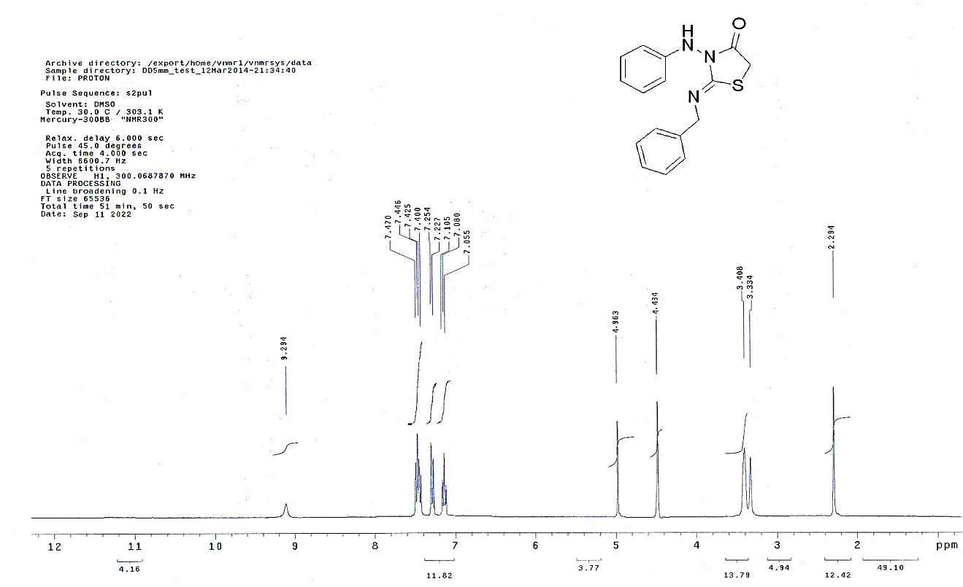

**Figure 4**: 1H-NMR of compound **3a**

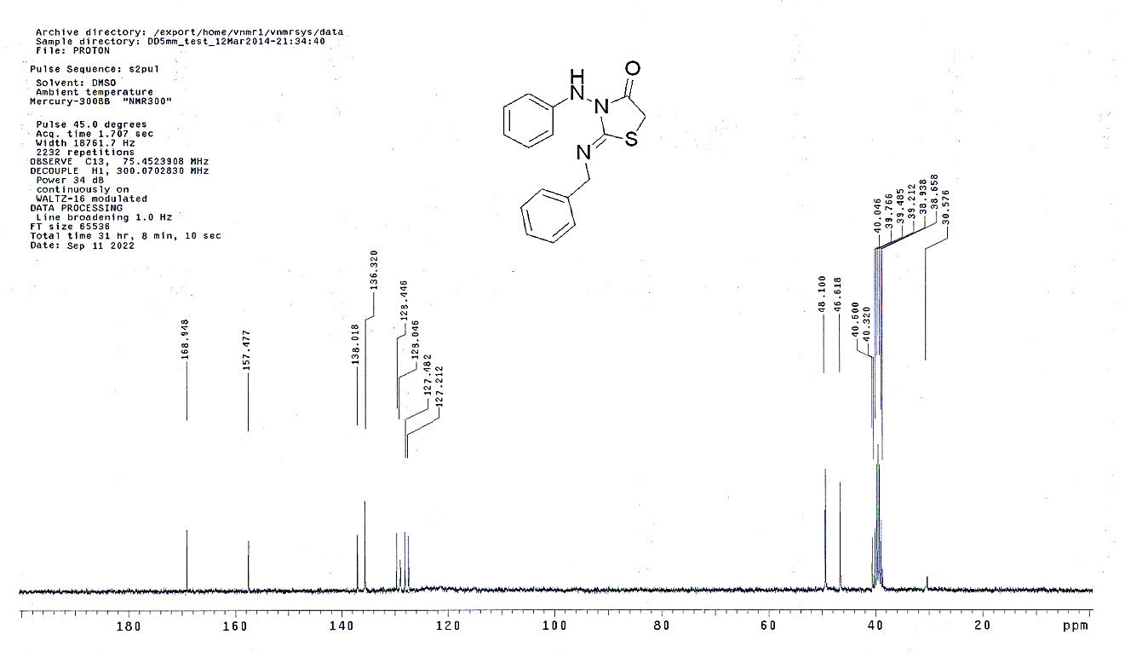

**Figure 5**: 13C-NMR of compound **3a**

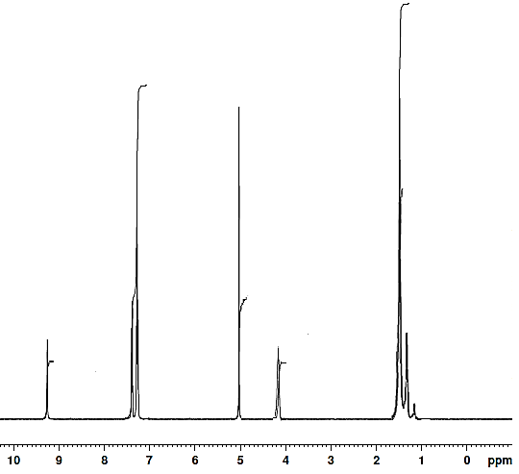

**Figure 6**: 1H-NMR of compound **3b**

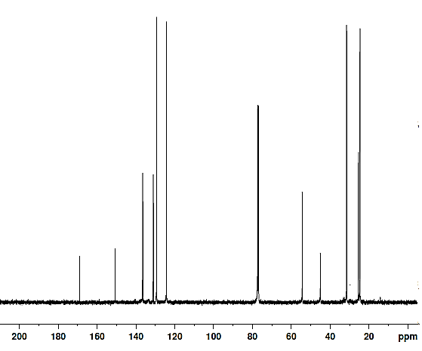

**Figure 7**: 13C-NMR of compound **3b**

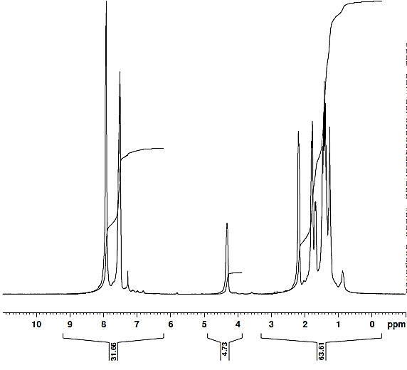

**Figure 8**: 1H-NMR of compound **4**

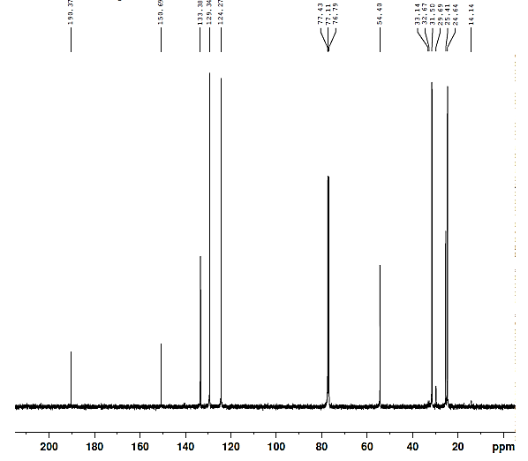

**Figure 9:** 13C-NMR of compound **4**

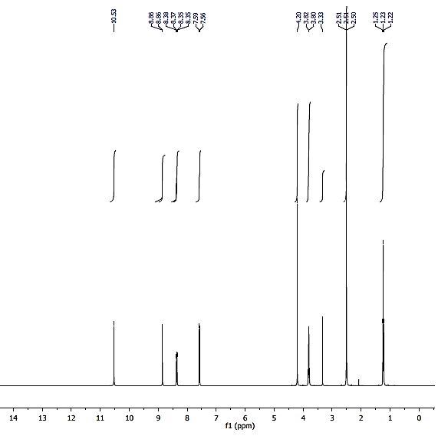

**Figure 10:** 1H-NMR of compound **5a**

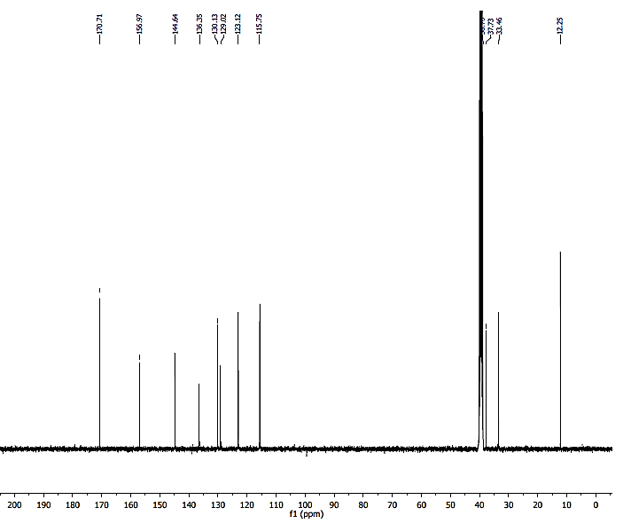

**Figure 11:** 13C-NMR of compound **5a**

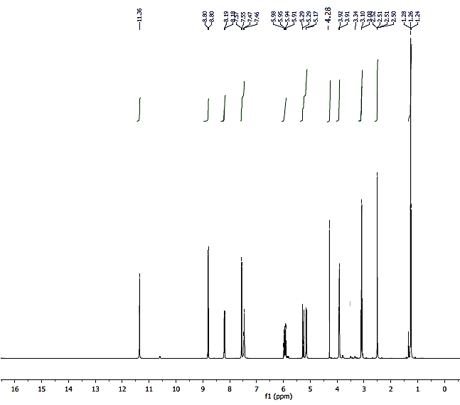

**Figure 12**: 1H-NMR of compound **5b**

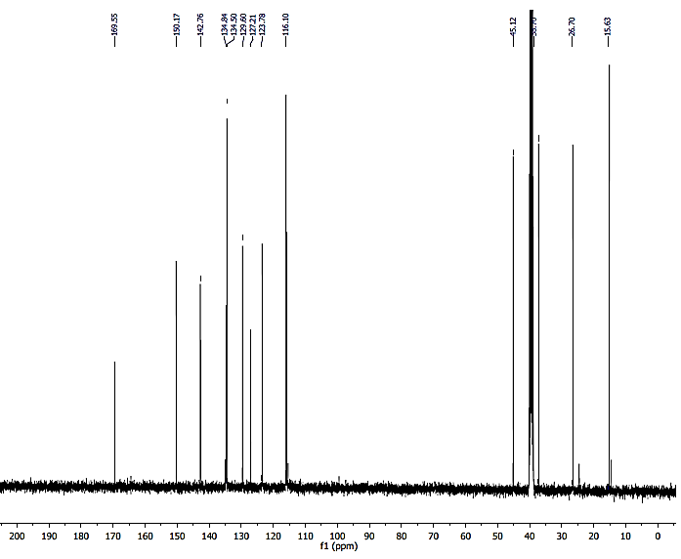

**Figure 13:** 13C-NMR of compound **5b**

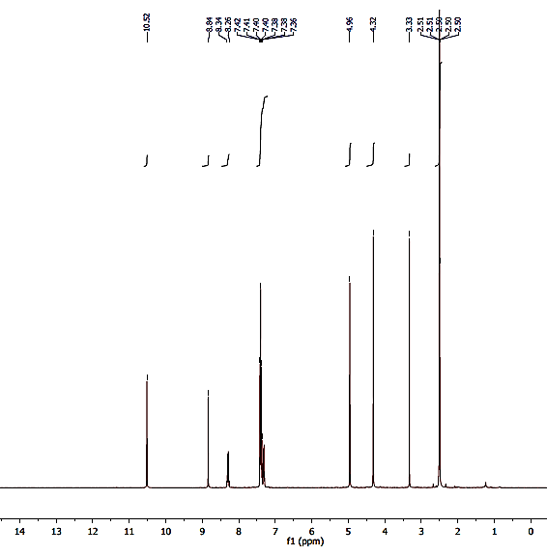

**Figure 14:** 1H-NMR of compound **5c**

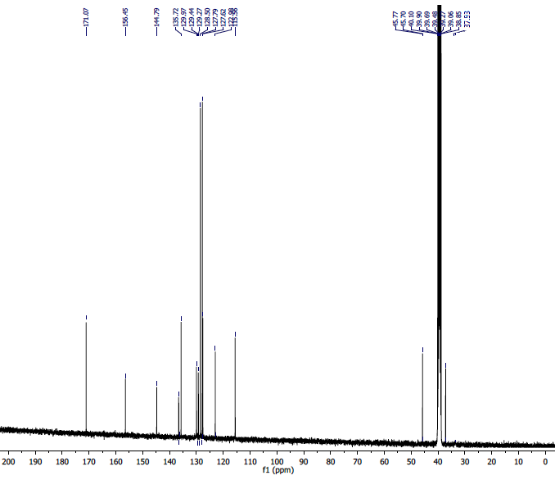

**Figure 15:** 13C-NMR of compound **5c**

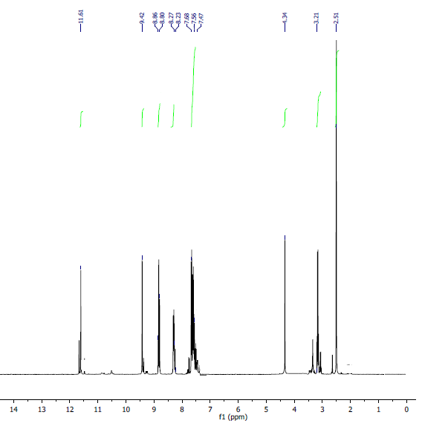

**Figure 16:** 1H-NMR of compound **5d**

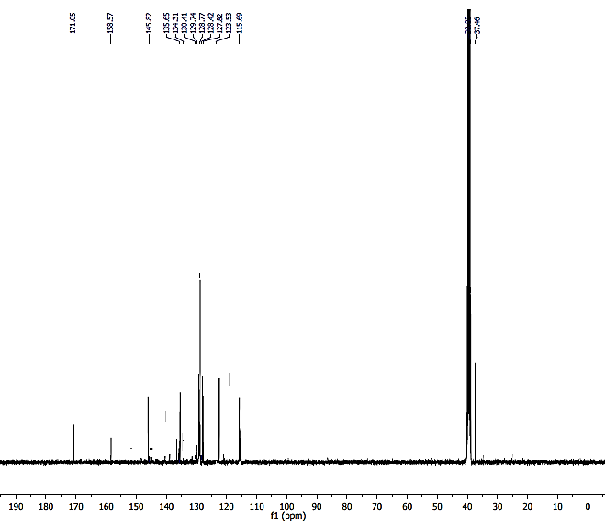

**Figure 17:** 13C-NMR of compound **5d**

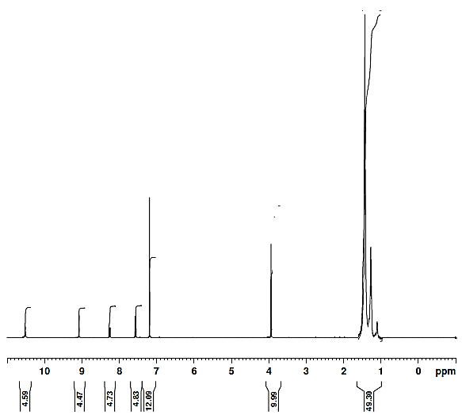

**Figure 18:** 1H-NMR of compound **5e**

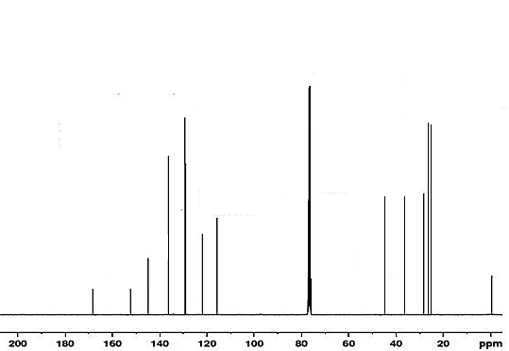

**Figure** **19:** 13C-NMR of compound **5e**

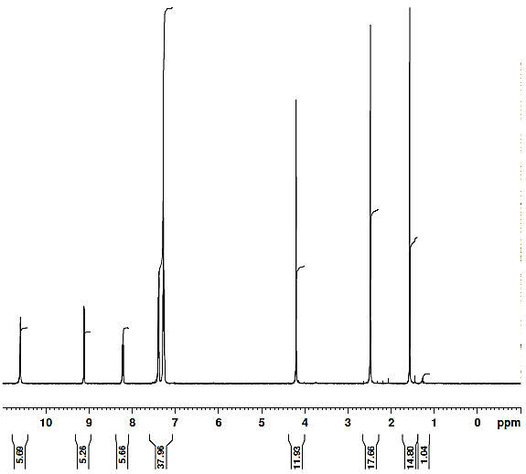

**Figure 20**: 1H-NMR of compound **5f**

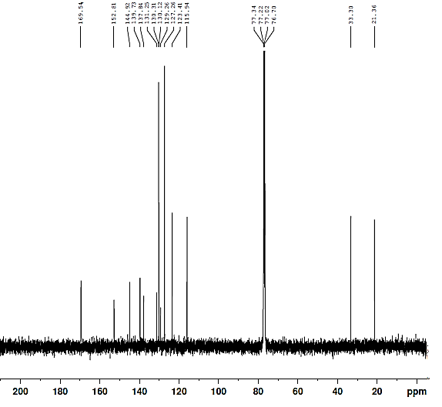

**Figure 21:** 13C-NMR of compound **5f**

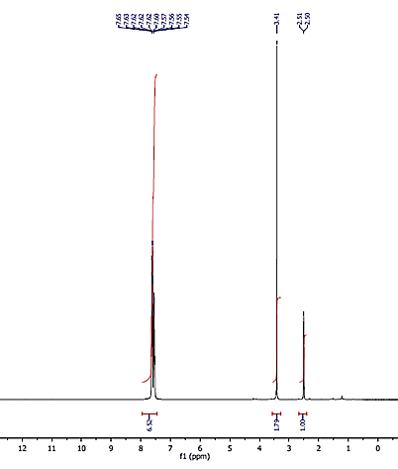

**Figure 22:** 1H-NMR of compound **(CaCl2(PPh3O)4-H2O)**



**Figure 23**: 13C-NMR of compound **(CaCl2(PPh3O)4-H2O)**