Biodesalination performance of Phormidium keutzingianum concentrated using two methods (immobilization and centrifugation)
Salma Shaikhoun^{a,‡}, Abdul Mannan Zafar ^{a,‡}, Yin-Hu Wu ^{b}, Ashraf Aly Hassan ^{a,}*
- Civil and Environmental Engineering Department and National Water and Energy Center, United Arab Emirates University, Al-Ain, 15551, Abu Dhabi, United Arab Emirates; (Email: 1. 201540007@uaeu.ac.ae; 2. 201990200@uaeu.ac.ae; 3. alyhassan@uaeu.ac.ae;)
- Environmental Simulation and Pollution Control State Key Joint Laboratory, State Environmental Protection Key Laboratory of Microorganism Application and Risk Control (SMARC), School of Environment, Tsinghua University, Room 524, Beijing 100084, PR China and Beijing Laboratory for Environmental Frontier Technologies, Beijing 100084, PR China (wuyinhu@mail.tsinghua.edu.cn)
*Correspondence: Ashraf Aly Hassan (alyhassan@uaeu.ac.ae); Civil and Environmental Engineering Department and National Water and Energy Center, United Arab Emirates University, Al-Ain, 15551, Abu Dhabi, United Arab Emirates.
‡ The authors contributed equally in this work.

While preparing the BG-11, an extra amount of NaCl was added to maintain a salt concentration of 1% in the BG-11 medium.
Table S1. BG-11 culture medium recipe for the growth of Phormidium keutzingianum as a supplemental nutrient source.
Sr. No. | Component | Amount | Final Concentration
 | NaNO₃ | 10 mL/L | 17.6 mM
 | K₂HPO₄ | 10 mL/L | 0.23 mM
 | MgSO₄.7H₂O | 10 mL/L | 0.3 mM
 | CaCl₂.2H₂O | 10 mL/L | 0.24 mM
 | Citric acid. H₂O | 10 mL/L | 0.031 mM
 | Na₂EDTA.2H₂O | 10 mL/L | 0.0027 mM
 | Na₂CO₃ | 10 mL/L | 0.19 mM
BG-11 Trace metal solution composition (Spiked 1mL per liter)
 | H₃BO₃ |  | 46 mM
 | MnCl₂.4H₂O |  | 9 mM
 | ZnSO₄.7H₂O |  | 0.77 mM
 | Na₂MoO₄.2H₂O |  | 1.6 mM
 | CuSO₄.5H₂O |  | 0.3 mM
 | Co(NO₃)₂.6H₂O |  | 0.17 mM
Therefore that salt quantity was also considered in the calculation of reactors. While the negative control calculations were direct, and weight of the salt amounts are displayed in Table S2.

Table S2. The amount of salt NaCl added in the reactors of 250 mL Schott bottles for the centrifuged algae. These values were calculated without the inclusion of centrifuged algae in the reactors.
Amount of Salt in reactor bottles
Sr. No. | Information | Reactor (weight of NaCl in grams / 250 mL)
 |  | 1 | 2 | 3
1 | Reactor (10 g/L) | 2.4027 | 2.4030 | 2.4043
2 | Reactor (30 g/L) | 7.2065 | 7.2052 | 7.2050
3 | Reactor (50 g/L) | 12.0019 | 12.0058 | 12.0106
4 | Reactor (70 g/L) | 16.8052 | 16.8066 | 16.8058
5 | Negative Control - 10 g/L | 2.5029 | 2.5028 | 2.5033
6 | Negative Control - 30 g/L | 7.5065 | 7.5089 | 7.5011
7 | Negative Control - 50 g/L | 12.5050 | 12.5025 | 12.5077
8 | Negative Control - 70 g/L | 17.5027 | 17.508 | 17.5065

Table S-3: ANOVA results for the parameters electrical conductivity (EC), pH, Chloride ions, and Nitrate ions.
ANOVA EC comparison results
 | DF | Sum of Squares | Mean Square | F Value | Prob>F
Model | 7 | 0.05304 | 0.00758 | 8.37696 | 2.09E-08
Error | 128 | 0.11579 | 9.05E-04
Total | 135 | 0.16883
ANOVA pH comparison results
 | DF | Sum of Squares | Mean Square | F Value | Prob>F
Model | 7 | 410.57783 | 58.65398 | 183.655 | 0.00E+00
Error | 128 | 40.87941 | 3.19E-01
Total | 135 | 451.45724
ANOVA Chloride ions comparison results
 | DF | Sum of Squares | Mean Square | F Value | Prob>F
Model | 7 | 0.19771 | 0.02824 | 3.17123 | 0.00536
Error | 76 | 0.67689 | 0.00891
Total | 83 | 0.8746
ANOVA Nitrate ions comparison results
 | DF | Sum of Squares | Mean Square | F Value | Prob>F
Model | 7 | 5.01E+06 | 716057.557 | 4.71869 | 1.94E-04
Error | 76 | 1.15E+07 | 151749.1757
Total | 83 | 1.65E+07

Section 1 Growth monitoring of ‘Centrifuged’ cyanobacteria
From Figure S1a, it is evident that the negative control for the saline concentration remained at the level of 0 absorbance values. However, the values started from very close to 0 initially for reactors but increases as the experiment continue. After 15 days of inoculation, the absorbance values of approx. 0.75, 0.5, 1.25, and 1.5 were observed for the salinities of 10, 30, 50, and 70 g/L, respectively. However, at the end of the experiment, the highest biomass was obtained in 10 g/L with an absorbance value of approx. ~2.0. The 30 g/L at the 70th day also showed an inclining trend compared to 50 and 70 g/L of salinity which showed a declining trend. There was a significant growth of P. keutzingianum observed for the case of centrifuged treatment method over 70 days. Only centrifuged method was measured for optical density because the algal cells remained in suspension and were in directly contact with saline water. Since the studied species grows naturally in a saline environment, P. keutzingianum performed well in hypersalinity as the growth was consistent for all the reactors of 10, 30, 50, and 70 g/L salinity. Various species grow differently under extreme salinities. However, P. keutzingianum was grown in the BG-11 nutrient medium with salt added to the concentrations of 10, 30, 50, and 70 g/L. One of the goals was to achieve maximum growth of the cyanobacteria and remove salt, including chlorides as a primary ion. From the literature studied accurately, there was a minimal investigation on P. keutzingianum for various projects; therefore, it is our novel interest to include the study on different salinities on this species.

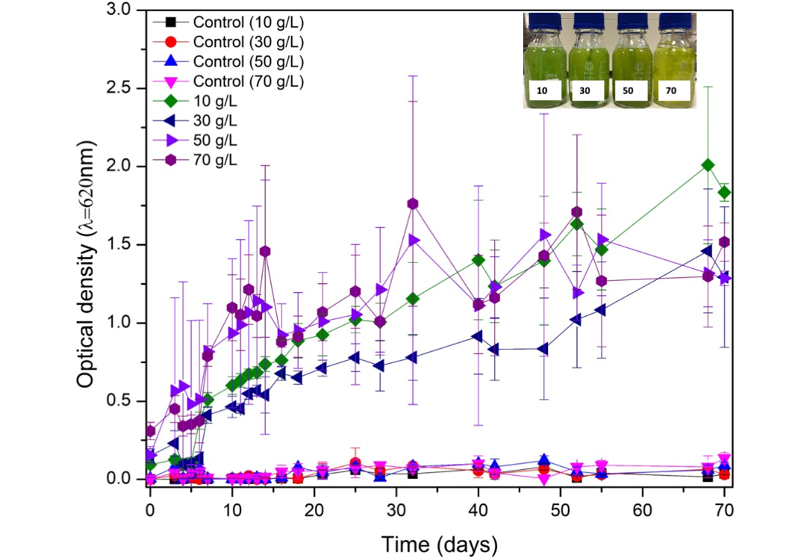
Figure S1. a) Optical density of the Phormidium keutzingianum in 10, 30, 50, and 70 g/L including control to estimate growth. b) Reactor images for the centrifuged algae at the end of the treatment cycle.
Lutzu and Dunford [1] cultivated P. keutzingianum in a produced wastewater generated from the oil and gas exploration sites using the hydraulic fracturing technique. Their study found that P. keutzingianum increased biomass in produced wastewater 3-folds more than the standard growth medium. Besides this, many other studies researched eukaryotic species, including Chlorella vulgaris and Scenedesmus sp. in salt stress studies, these species grew remarkably well under salinity stress [2–6]. The results collected from the previous study also corroborate our hypothesis that algae prone to salinities can uptake ions/minerals for their growth and survive in hypersalinity.
Figure S1b represents the condition of reactors at the end of the treatment cycle with the dense and lighter biomass collection in the salinities of 10, 30, 50, and 70 g/L. From Figure S1b, it is evident that increasing salinity reduces the cell density. All the reactors used to measure the optical density showed a significant difference in algae growth for the salinities of 10, 30, 50, and 70 g/L (p < 0.05). However, optical density measurements also showed a constant increase in absorbance, indicating a significant resistance to high salinities in the P. keutzingianum for such a prolonged duration. At the end of the experiment, the color of reactors in 70 g/L salinity started to turn greenish-yellow, indicating the death phase of P. keutzingianum due to hypersaline environment.

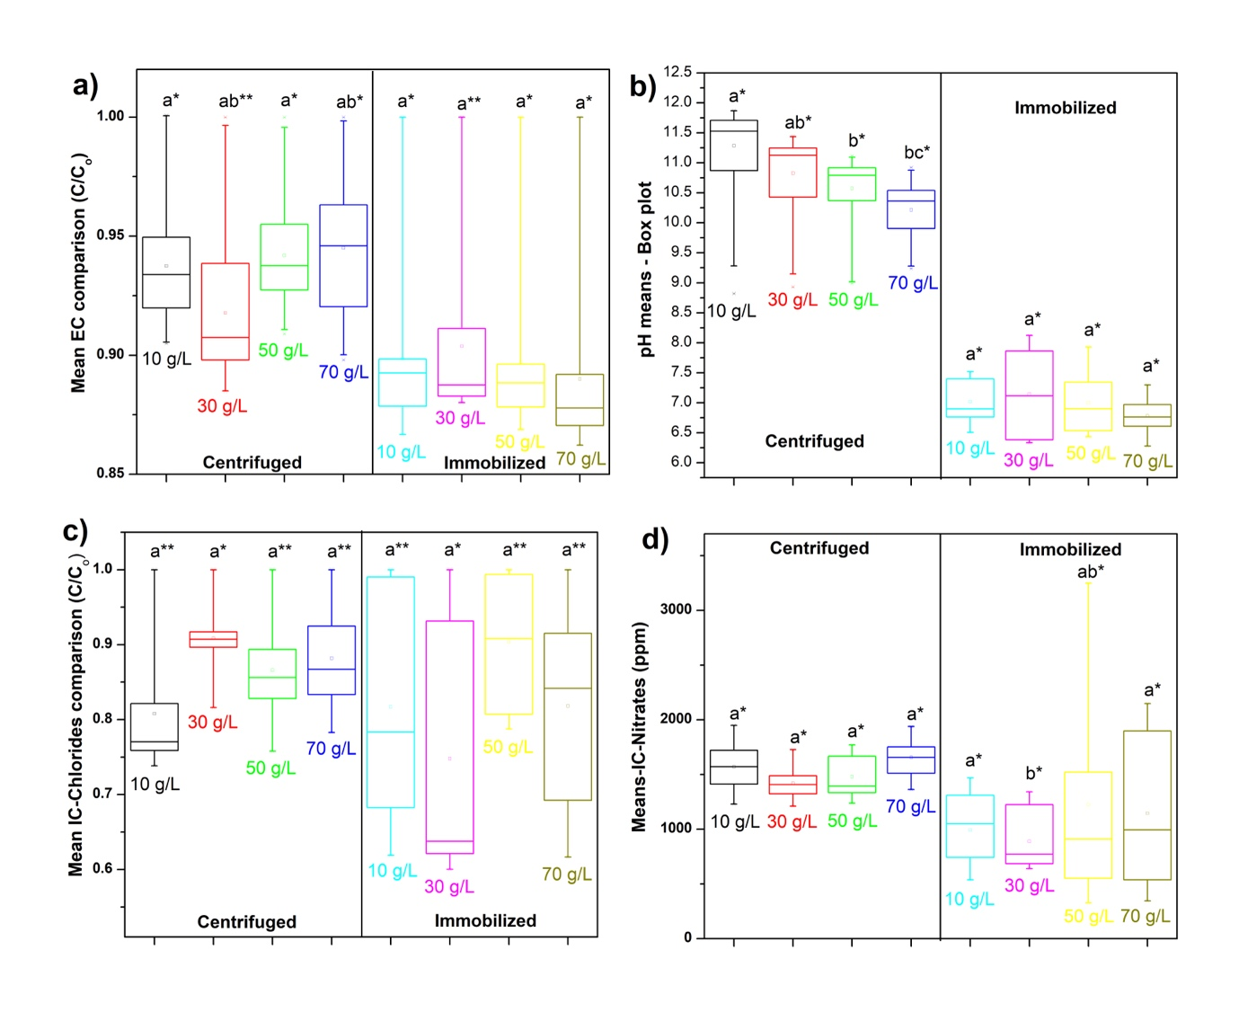
Figure S2: The corresponding boxplot generated from the Tukey’s t-test results. Letters indicate the significance of differences: *, the means are significantly different between the centrifuged and immobilized groups at the same salinity; **, the means are not significantly different between the centrifuged and immobilized groups at the same salinity.
References
[1] G.A. Lutzu, T.N. Dunford, Growing Algae in Produced Water Generated During Oil and Gas Production Using Hydraulic Fracturing Technique, Chem. Eng. Trans. 74 (2019) 1261–1266. https://doi.org/10.3303/CET1974211.
[2] A. Figler, B.-B. Viktória, D. Dobronoki, K. Márton, S. Nagy, I. Bácsi, Salt Tolerance and Desalination Abilities of Nine Common Green Microalgae Isolates, Water. 11 (2019) 2527. https://doi.org/10.3390/w11122527.
[3] A. Figler, K. Márton, V. B-Béres, I. Bácsi, Effects of Nutrient Content and Nitrogen to Phosphorous Ratio on the Growth, Nutrient Removal and Desalination Properties of the Green Alga Coelastrum morus on a Laboratory Scale, Energies . 14 (2021). https://doi.org/10.3390/en14082112.
[4] E. Sahle-Demessie, A. Aly Hassan, A. El Badawy, Bio-desalination of brackish and seawater using halophytic algae, Desalination. 465 (2019) 104–113. https://doi.org/10.1016/j.desal.2019.05.002.
[5] X. Gan, G. Shen, B. Xin, M. Li, Simultaneous biological desalination and lipid production by Scenedesmus obliquus cultured with brackish water, Desalination. 400 (2016) 1–6. https://doi.org/10.1016/j.desal.2016.09.012.
[6] X. Li, Y. Yuan, D. Cheng, J. Gao, L. Kong, Q. Zhao, W. Wei, Y. Sun, Exploring stress tolerance mechanism of evolved freshwater strain Chlorella sp. S30 under 30 g/L salt, Bioresour. Technol. 250 (2018) 495–504. https://doi.org/https://doi.org/10.1016/j.biortech.2017.11.072.

