**Supplementary materials**

**Supplementary discussion sections**

**Section S1: Point of zero charge and Zeta potential**

When the pH value of a surface of sorbent possesses a net zero or neutral charge is known as the point of zero charge (pHPZC). Study of pHPZC for any sorbent is of much significance which reveals the potentiality of any adsorbent surface to attract anionic or cationic adsorbates. If a given surface of sorbent is having positive charge at the solution with pH less than pHPZC, if an adsorbent surface is charged positively, then that adsorbent surface will uptake adsorbates which are anionic. Similarly, if a sorbent surface is negatively charged at the solution with pH more than pHPZC then the adsorbent will uptake cationic adsorbate [32]. Seven flasks holding 50 mL distilled water were placed at varied beginning pH values (pHi) to establish the zero point of charge of ACSLS (2-9). Each flask received 50 mg of ACSLS, which was shaken for 24 hours. The material was extracted from the solution mix to determine the aqueous solutions' final pH values (pHf). ∆pH = pHi - pHf was used to compute the pH difference. The pH plots versus pHi and pHPZC were assessed at the curve's intersection with the X-axis.

The zeta potential is the main factor which decides the colloidal dispersions’ stability. The extent of electrostatic repulsion between nearby and particles those are similarly charged in a dispersion is given by the value of zeta potential. High zeta potential will indicate the stability of the small particles i.e., the solution will have resistance against aggregation. When there is weak potential, forces of attraction might outweigh repulsiveness, causing the dissipation to break apart and flocculate. Colloids, those are having high zeta potential capacity (positive or negative) are termed as electrically stable, whereas those with a weak zeta potential coagulate or flocculate.

Zetasizer Nano ZS (Malvern Instruments) at 25 °C was considered to analyze zeta potential for ACSLS in a suspension of liquid. A He-Ne laser of 633 nm was used to provide light and an avalanche photodiode (APD) was used as the detector. For the measurement of zeta potential, electrophoretic light scattering process was applied. To give electrical support to the ionized surface of adsorbent, a dip cell (zen1002, Malvern Instruments) having two parallel Pd electrodes was utilized. At a temperature of 12.8° the signals were noted and the data analysis was carried out using Zetasizer Software. According to ISO13099 [33, 34], for evaluating ACSLS zeta potential in solution, the Smoluchowski model was used for the interpretation. The surface zeta potential was measured according to Malvern Instruments' approach [35] using a surface zeta potential cell with make: Malvern Instrument, model: zen1020.

The main difference between zeta potential and point of zero charge is that in point of zero charge, it is the pH of colloidal dispersion of the average charge of the colloidal particles when it becomes zero where as in case of zeta potential it is the difference between the stationary layer and the dispersion medium of the solution consisting colloidal dispersion.

**Supplementary figures**

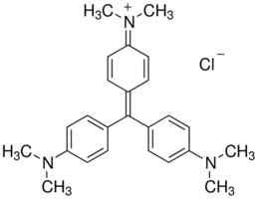

**Fig. S1**. Molecular structure of Crystal violet

**Fig. S2.** CV sorption onto different AC’s (Dye conc.= 100 mg/L, pH = 6.0, T = 318K, adsorbent dose = 100 mg/L)

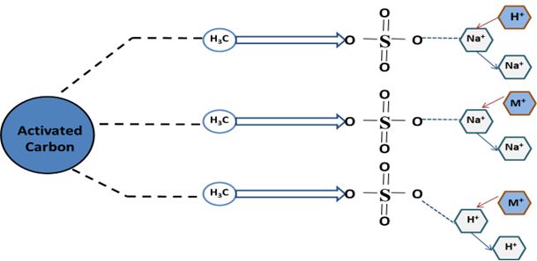

**Fig. S3.** Chemical phenomenon for CV sorption onto ACSLS surface

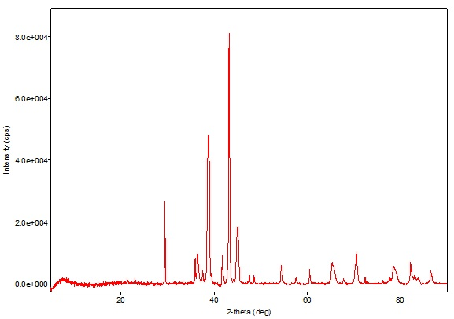

**(A) ACSLS before sorption**

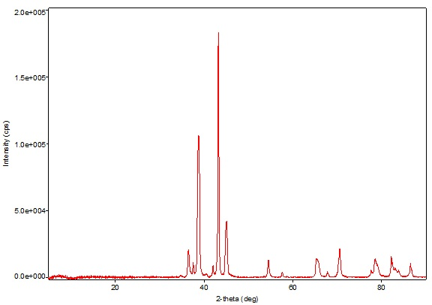

**(B) CV loaded ACSLS**

**Fig. S4**. XRD pattern for **(a)** Unused ACSLS **(b)** CV loaded ACSLS

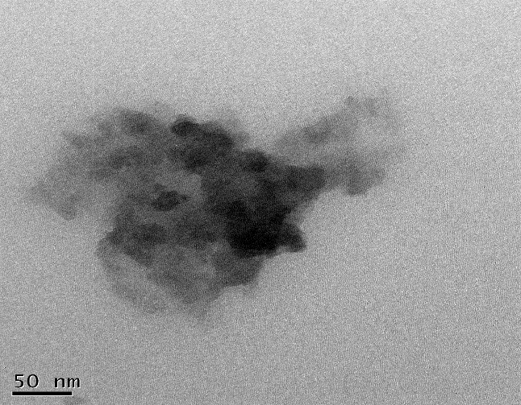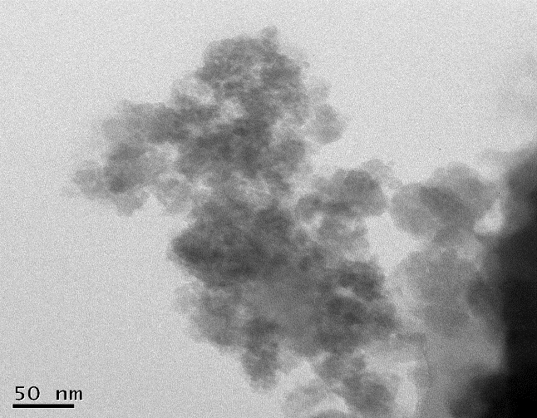

(A) Ionized active sites/Pores

(B) Adsorbed CV molecules

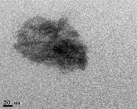

23.6 nm

**Fig. S5** HR-TEM images for **(a)** Unused ACSLS **(b)** CV loaded ACSLS

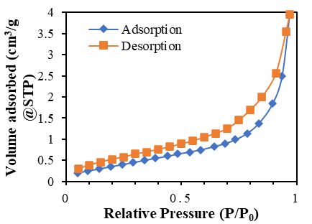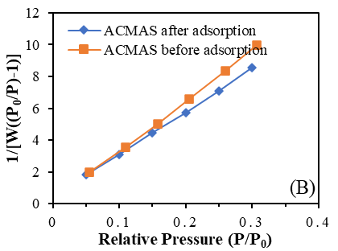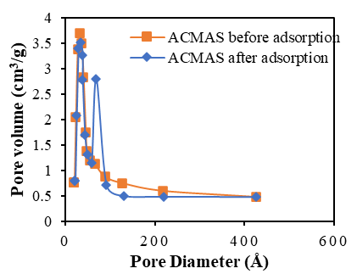

(A)

(C)

**Fig. S6.** Plot forBET Analysis **(a)** CV adsorption-Desorption plot for isotherms **(b)** Plot for surface area **(c)** Distribution of pore size for BJH desorption

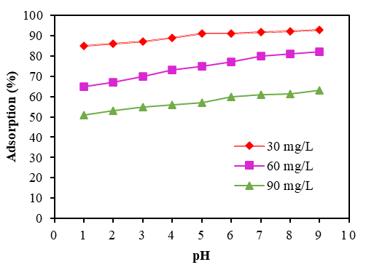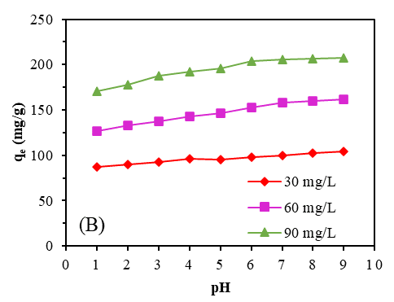

(A)

**Fig. S7**. **(a)** Adsorption rate and **(b)** adsorption capacity of CV onto ACMAS at T = 318K, contact time = 120 min and CV dose = 100 mg/L.

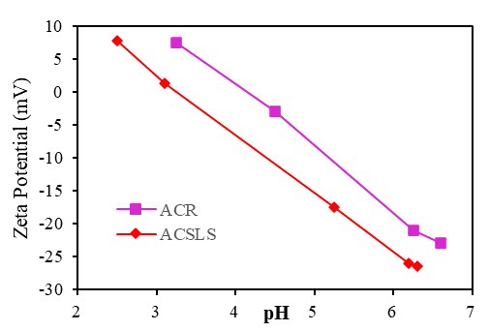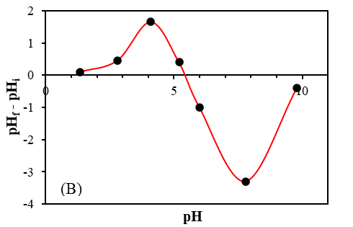

(A)

**Fig. S8**. plot for **(a)** Zeta potential for ACR and ACSLS **(b)** point of zero charge for ACSLS

**Fig. S9**. Arrhenius Plot between *ln Kp2 vs 1/T* (pH = 6.0, CV dose = 100 g/L, Time = 120 min)

**Fig. S10.** Plot for *q vs. t ½* consisting of multiple straight line for CV adsorption onto ACSLS (T= 293K, CV concentration = 25 mg/L, pH = 6.0)

**Fig. S11.** Film diffusion model for CV adsorption onto ACSLS (CV dye concentration = 25 mg/L, pH= 6.0, Time = 60 min,



**Fig. S12a** Break through curves at different flow rates (bed depth = 10 cm, CV dye conc. = 25 mg/L)



**Fig. S12b**. Breakthrough curves at different CV concentrations (Flow rate = 0.5 ml/min, bed depth = 10 cm.

**Fig. S12c.** Breakthrough curves for variation in bed depths (flow rate = 0.5 ml/min, CV conc. = 25 mg/L)

**Supplementary tables**

**Table S1**: BET analysis parameters

|  |  |  |
| --- | --- | --- |
| **Parameters** | **Adsorbent (ACMAS)** | |
| **Before adsorption** | **After adsorption** |
| Area of surface (m2/g) | 195.42 | 206.34 |
| Volume of pore (cm3/g) | 28.52 | 20.41 |
| Average pore size (nm) | 35.21 | 23.67 |

**Table S2.** BJH analysis parameters

|  |  |  |  |
| --- | --- | --- | --- |
| **Parameters** | **Operation** | **Adsorbent (ACMAS)** | |
| **Before adsorption** | **After adsorption** |
| Volume of pore (BJH) (cc/g) | A | 0.267 | 19.531 |
|  | D | 29.342 | 21.542 |
| Pore radius (BJH) (Å) | A | 22.521 | 24.654 |
|  | D | 342.443 | 296.312 |
| Area of surface (BJH) (m2/g) | A | 102.432 | 99.655 |
|  | D | 1857.541 | 1443.764 |

**Table S3:** Error Functions for CV sorption onto ACSLS

|  |  |  |  |  |
| --- | --- | --- | --- | --- |
| **Isotherm** | **Error Functions** |  | **Temperature** |  |
|  |  | **298** | **308** | **318** |
| **Langmuir** | SAE | 0.293 | 0.252 | 0.241 |
|  | SSE | 0.018 | 0.015 | 0.013 |
|  | HYBRID | 1.381 | 0.891 | 0.887 |
|  | MPSD | 3.424 | 3.746 | 3.587 |
|  | ARE | 3.642 | 2.879 | 2.471 |
|  | χ2 | 0.002 | 0.003 | 0.003 |
| **Freundlich** | SAE | 0.248 | 0.347 | 0.378 |
|  | SSE | 0.054 | 0.035 | 0.047 |
|  | HYBRID | 1.675 | 0.008 | -0.024 |
|  | MPSD | 4.781 | 6.645 | 6.742 |
|  | ARE | 2.997 | 3.745 | 4.014 |
|  | χ2 | 0.017 | 0.024 | 0.075 |
| **Temkin** | SAE | 0.247 | 0.279 | 0.279 |
|  | SSE | 0.017 | 0.026 | 0.028 |
|  | HYBRID | -0.245 | -0.324 | -0.279 |
|  | MPSD | 4.371 | 5.472 | 5.875 |
|  | ARE | 2.745 | 2.579 | 3.478 |
|  | χ2 | 0.008 | 0.014 | 0.017 |
| **Redlich- Peterson** | SAE | 0.245 | 0.257 | 0.278 |
|  | SSE | 0.012 | 0.014 | 0.013 |
|  | HYBRID | -0.214 | -0.113 | -0.152 |
|  | MPSD | 3.984 | 4.254 | 3.124 |
|  | ARE | 2.278 | 2.314 | 2.007 |
|  | χ2 | 0.007 | 0.006 | 0.006 |
| **Toth** | SAE | 0.234 | 0.245 | 0.241 |
|  | SSE | 0.013 | 0.014 | 0.012 |
|  | HYBRID | -0.124 | -0.134 | -0.213 |
|  | MPSD | 4.523 | 4.278 | 3.124 |
|  | ARE | 2.642 | 2.548 | 2.354 |
|  | χ2 | 0.012 | 0.019 | 0.014 |
| **Radke-Prausnitz** | SAE | 0.254 | 0.423 | 0.246 |
|  | SSE | 0.014 | 0.086 | 0.024 |
|  | HYBRID | -3.245 | -3.423 | -0.247 |
|  | MPSD | 4.785 | 6.245 | 5.247 |
|  | ARE | 3.124 | 5.247 | 2.578 |
|  | χ2 | 0.014 | 0.024 | 0.013 |
| **D-R** | SAE | 0.124 | 0.243 | 0.238 |
|  | SSE | 0.011 | 0.013 | 0.012 |
|  | HYBRID | -0.217 | -0.115 | 0.175 |
|  | MPSD | 4.017 | 4.245 | 3.241 |
|  | ARE | 2.195 | 2.297 | 2.010 |
|  | χ2 | 0.005 | 0.004 | 0.005 |

**Table S4.** Thermodynamic parameters for CV removal onto ACMAS

|  |  |  |  |  |
| --- | --- | --- | --- | --- |
| **Thermodynamic parameters** | | | | |
| Dye Conc. (mg/L) | Temperature (K) | ∆G  (KJ/mol) | ∆S  (KJ/mol/K) | ∆H  (KJ/mol) |
| 30 | 298 | -12.22 | 0.071 | 9.67 |
| 308 | -14.67 |
| 318 | -15.34 |
| 60 | 298 | -9.32 | 0.085 | 14.89 |
| 308 | -12.68 |
| 318 | -13.71 |
| 90 | 298 | -7.78 | 0.089 | 16.22 |
| 308 | -9.91 |
| 318 | -10.33 |

**Table S5**: Linear equations for Break through models

|  |  |
| --- | --- |
| **Model** | **Linear Equation** |
| Thomas | $$\ln{({C_{e}}/{C_{0} }-1)}= k_{TH} × q_{0} × m/Q-k_{TH} × C_{0} ×t$$ |
| Yoon Nelson | $$\ln{[{C_{e}}/{\left(C_{0}- C_{e}\right)}]}= k_{YN}×t- k_{YN} τ$$ |
| Bohart-Adam | $$\ln{({C_{e}}/{C_{0}})}= k_{AB} × C_{i} ×t-\left[\frac{kNoH}{ν}\right]$$ |
| Clark | $$\ln{{({C_{0}}/{C_{e})}}^{n-1}}-1=A×e^{-rt}$$ |

**Table S6**: Parameters for different column study models for different flow rates

|  |  |  |  |  |
| --- | --- | --- | --- | --- |
| **Column analysis Model** | **Constants** | **Flow rate, Q (mL/min)** | | |
| **0.5** | **1.0** | **1.5** |
| **Thomas** | ***q(mg/g)*** | 91.2 | 85.4 | 79.4 |
| $$k_{TH}$$ | 0.001 | 0.002 | 0.003 |
| ***R2*** | 0.988 | 0.999 | 0.997 |
| ***Slope*** | 0.01 | 0.02 | 0.01 |
| ***Intercept*** | 3.721 | 3.431 | 3.124 |
| **Yoon-Nelson** | ***kYN*** | 3.71 | 3.42 | 3.13 |
| ***τ*** | 3.42×10-3 | 3.25×10-3 | 3.37×10-3 |
| ***R2*** | 0.978 | 0.979 | 0.978 |
| ***Slope*** | -3.62 | -3.34 | -3.18 |
| ***Intercept*** | 0.012 | 0.008 | 0.009 |
| **Bohart-Adam** | ***N*** | 3.6×103 | 3.7×103 | 3.5×103 |
| ***kAB*** | 0.0008 | 0.0007 | 0.0005 |
| ***R2*** | 0.967 | 0.968 | 0.965 |
| ***Slope*** | 0.007 | 0.006 | 0.006 |
| ***Intercept*** | 2.419 | 1.972 | 1.859 |
| **Clark** | ***KC*** | 8.1×10-4 | 7.8×10-4 | 7.6×10-4 |
| ***R*** | 8.1×10-4 | 7.8×10-4 | 7.6×10-4 |
| ***A*** | 8.57 | 6.71 | 5.62 |
| ***R2*** | 0.948 | 0.957 | 0.956 |
| ***Slope*** | 0.007 | 0.006 | 0.006 |
| ***Intercept*** | 2.42 | 1.97 | 1.86 |

**Table S7**: ACSLS recycle-regeneration data using 1.0M HCl

|  |  |  |
| --- | --- | --- |
| **No. of Cycles** | **Residual concentration (mg/L)** | **CV removal %** |
| 1st | 0.14 | 94.5 |
| 2nd | 0.85 | 88.9 |
| 3rd | 1.96 | 80.3 |
| 4th | 2.73 | 70.5 |
| 5th | 3.58 | 62 |
| 6th | 4.98 | 49.9 |

**Table S8**. Adsorption capacity and % adsorption by using different conc. of NaOH and HCl for ACSLS regeneration

|  |  |  |  |  |
| --- | --- | --- | --- | --- |
| **Eluent** | **Concentration [M]** | **Ce (mg/L)** | **% Adsorption** | **qe (mg/g)** |
| NaOH | 0.2 | 4.89 | 49.4 | 1.32 |
| 0.4 | 4.04 | 56.1 | 1.54 |
| 0.6 | 3.12 | 70.3 | 1.67 |
| 0.8 | 2.49 | 72.5 | 1.85 |
| 1.0 | 1.51 | 81.7 | 1.97 |
| HCl | 0.2 | 3.57 | 64.1 | 1.67 |
| 0.4 | 3.01 | 70.3 | 1.81 |
| 0.6 | 2.27 | 75.8 | 1.92 |
| 0.8 | 1.93 | 80.2 | 2.21 |
| 1.0 | 0.14 | 94.6 | 2.46 |

**Table S9**: CV adsorption onto ACSLS in real water samples

|  |  |  |
| --- | --- | --- |
| **Water Sample** | **CV concentration (mg/L)** | **CV removal %** |
| Tap water | 30 | 94.6 |
| 60 | 81.2 |
| 90 | 54.7 |
| Raw water | 30 | 94.5 |
| 60 | 81.8 |
| 90 | 55.4 |
| Distilled water | 30 | 94.5 |
| 60 | 79.6 |
| 90 | 53.8 |
| Waste water | 30 | 94.5 |
| 60 | 81.6 |
| 90 | 55.8 |