**Structural elucidation,** **antioxidant and hepatoprotective activities of** **chemical composition from Jinsi Huangju (*Chrysanthemum morifolium*) flowers**

Sai Jiang a, Meng-Yun Wang a, Salman Zafar a,d, Qing-Ling Xie a, Yu-Qing Jian a,*, Han-Wen Yuan a, Bin Li a, Cai-Yun Peng a, Wen-Ming Chen b, Bin Liu c, Shi-Feng Liu e, Yao-Li Ou-Yang e, Wei Wang a,b,*

a *TCM and Ethnomedicine Innovation & Development International Laboratory, Innovative Material Medical Research Institute, School of Pharmacy,* *Hunan University of Chinese Medicine, Changsha 410208, China*

b *Department of Pharmaceutical Production Center, The First Hospital of Hunan University of Chinese Medicine, Changsha 410208, China*

c *College of Biology, Hunan University, Changsha 410082, China*

d *Institute of Chemical Sciences, University of Peshawar, Peshawar 25120, Pakistan*

e *Hunan Kangdejia Forestry Technology Co., Ltd., Yongzhou 425600, China*

* Corresponding authors.

E-mail address: cpujyq2010@163.com (Y.-Q. Jian.); wangwei402@hotmail.com (W. Wang)

Content

Table S1 Antibacterial activities of some compounds. 5

Figure S1. A comparative HPLC analysis of the derivative of glucose from the acidic hydrolysis of **1**-**4**, L-glucose and D-glucose. 5

Figure S2. The 1H NMR spectrum of **1** in CD3OD 6

Figure S3. The 13C NMR spectrum of **1** in CD3OD 6

Figure S4. The Dept spectrum of **1** in CD3OD 7

Figure S5. The HSQC spectrum of **1** in CD3OD 7

Figure S6. The HMBC spectrum of **1** in CD3OD 8

Figure S7. The 1H-1H COSY spectrum of **1** in CD3OD 8

Figure S8. The HRESIMS data of **1** 9

Figure S9. The IR spectrum of **1** 9

Figure S10. The 1H NMR spectrum of **2** in CD3OD 10

Figure S11. The 13C NMR spectrum of **2** in CD3OD 10

Figure S12. The Dept spectrum of **2** in CD3OD 10

Figure S13. The HSQC spectrum of **2** in CD3OD 11

Figure S14. The HMBC spectrum of **2** in CD3OD 11

Figure S15. The 1H-1H COSYspectrum of **2** in CD3OD 12

Figure S16. The HRESIMS data of **2** 12

Figure S17. The IR spectrum of **2** 13

Figure S18 The 1H NMR spectrum of **3** in CD3OD 13

Figure S19 The 1C NMR spectrum of **3** in CD3OD 14

Figure S20 The Dept spectrum of **3** in CD3OD 14

Figure S21 The HSQC spectrum of **3** in CD3OD 15

Figure S22 The HMBC spectrum of **3** in CD3OD 15

Figure S23 The 1H-1H COSY spectrum of **3** in CD3OD 16

Figure S24 The HRESIMS data of **3** in CD3OD 16

Figure S25 The IR spectrum of **3** in CD3OD 17

Figure S26 The 1H NMR spectrum of **4** in CD3OD 17

Figure S27 The 1C NMR spectrum of **4** in CD3OD 18

Figure S28 The Dept spectrum of **4** in CD3OD 18

Figure S29 The HSQC spectrum of **4** in CD3OD 19

Figure S30 The HMBC spectrum of **4** in CD3OD 20

Figure S31 The 1H-1H COSY spectrum of **4** in CD3OD 20

Figure S32 The HRESIMS data of **4** in CD3OD 20

Figure S33 The IR spectrum of **4** in CD3OD 21

Figure S34. The 1H NMR spectrum of **11** in CD3OD 21

Figure S35. The 13C NMR spectrum of **11** in CD3OD 22

Figure S36. The Dept spectrum of **11** in CD3OD 22

Figure S37. The HSQC spectrum of **11** in CD3OD 23

Figure S38. The HMBC spectrum of **11** in CD3OD 23

Figure S39. The 1H-1H COSY spectrum of **11** in CD3OD 24

Figure S40. The HRESIMS data of **11** 24

Figure S41. The IR spectrum of **11** 25

Figure S42. The experimental ECD spectra of **11** 25

Figure S44. The 13C NMR spectrum of **31** in CD3OD 26

Figure S45. The Dept spectrum of **31** in CD3OD 26

Figure S46. The HSQC spectrum of **31** in CD3OD 27

Figure S47. The HMBC spectrum of **31** in CD3OD 27

Figure S48. The 1H-1H COSY spectrum of **31** in CD3OD 28

Figure S49. The HRESIMS data of **31** 28

Figure S50. The IR spectrum of **31** 29

Figure S51. The 1H NMR spectrum of **5** in CD3OD 29

Figure S52. The 13C NMR spectrum of **5** in CD3OD 30

Figure S53. The 1H NMR spectrum of **6** in CD3OD 30

Figure S54. The 13C NMR spectrum of **6** in CD3OD 31

Figure S55. The 1H NMR spectrum of **7** in CD3OD 31

Figure S56. The 13C NMR spectrum of **7** in CD3OD 32

Figure S57. The 1H NMR spectrum of **8** in CD3OD 32

Figure S58. The 13C NMR spectrum of **8** in CD3OD 33

Figure S59. The 1H NMR spectrum of **9** in CD3OD 33

Figure S60. The 13C NMR spectrum of **9** in CD3OD 34

Figure S61. The 1H NMR spectrum of **10** in CD3OD 34

Figure S62. The 13C NMR spectrum of **10** in CD3OD 35

Figure S63. The 1H NMR spectrum of **12** in CD3OD 35

Figure S64. The 13C NMR spectrum of **12** in CD3OD 36

Figure S65. The 1H NMR spectrum of **13** in CD3OD 36

Figure S66. The 13C NMR spectrum of **13** in CD3OD 37

Figure S67. The 1H NMR spectrum of **14** in CD3OD + CDCl3 37

Figure S68. The 13C NMR spectrum of **14** in CD3OD + CDCl3 38

Figure S69. The 1H NMR spectrum of **15** in pyridin-*d*5 38

Figure S70. The 13C NMR spectrum of **15** in pyridin-*d*5 39

Figure S71. The 1H NMR NMR spectrum of **16** in CDCl3 39

Figure S72. The 13C NMR spectrum of **16** in CDCl3 40

Figure S73. The 1H NMR spectrum of **17** in CD3OD 40

Figure S74. The 13C NMR spectrum of **17** in CD3OD 41

Figure S75. The 1H NMR spectrum of **18** in CD3OD 41

Figure S76. The 13C NMR spectrum of **18** in CD3OD 42

Figure S77. The 1H NMR spectrum of **19** in CD3OD 42

Figure S78. The 13C NMR spectrum of **19** in CD3OD 43

Figure S79. The 1H NMR spectrum of **20** in CD3OD 43

Figure S80. The 13C NMR spectrum of **20** in CD3OD 44

Figure S81. The 1H NMR spectrum of **21** in CD3OD 44

Figure S82. The 13C NMR spectrum of **21** in CD3OD 45

Figure S83. The 1H NMR spectrum of **22** in CD3OD 45

Figure S84. The 13C NMR spectrum of **22** in CD3OD 46

Figure S85. The 1H NMR spectrum of **23** in CD3OD 46

Figure S86. The 13C NMR spectrum of **23** in CD3OD 47

Figure S87. The 1H NMR spectrum of **24** in CD3OD 47

Figure S88. The 13C NMR spectrum of **24** in CD3OD 48

Figure S89. The 1H NMR spectrum of **25** in CD3OD 48

Figure S90. The 13C NMR spectrum of **25** in CD3OD 49

Figure S91. The 1H NMR spectrum of **26** in CD3OD 49

Figure S92. The 13C NMR spectrum of **26** in CD3OD 50

Figure S93. The 1H NMR spectrum of **27** in CD3OD 50

Figure S94. The 13C NMR spectrum of **27** in CD3OD 51

Figure S95. The 1H NMR spectrum of **28** in CD3OD 51

Figure S96. The 13C NMR spectrum of **28** in CD3OD 52

Figure S97. The 1H NMR spectrum of **29** in CD3OD 52

Figure S98. The 13C NMR spectrum of **29** in CD3OD 53

Figure S99. The 1H NMR spectrum of **30** in CD3OD 53

Figure S100. The 13C NMR spectrum of **30** in CD3OD 54

Figure S101. The 1H NMR spectrum of **32** in CD3OD 54

Figure S102. The 13C NMR spectrum of **32** in CD3OD 55

Figure S103. The 1H NMR spectrum of **33** in CD3OD 55

Figure S104. The 13C NMR spectrum of **33** in CD3OD 56

Figure S105. The 1H NMR spectrum of **34** in CD3OD 56

Figure S106. The 13C NMR spectrum of **34** in CD3OD 57

Figure S107. The 1H NMR spectrum of **35** in CD3OD 57

Figure S108. The 13C NMR spectrum of **35** in CD3OD 58

Figure S109. The 1H NMR spectrum of **36** in CD3OD 58

Figure S111. The 1H NMR spectrum of **37** in CD3OD 59

Figure S112. The 13C NMR spectrum of **37** in CD3OD 60

Figure S113. The 1H NMR spectrum of **38** in CD3OD 60

Figure S114. The 13C NMR spectrum of **38** in CD3OD 61

Figure S115. The 1H NMR spectrum of **39** in CD3OD 61

Figure S116. The 13C NMR spectrum of **39** in CD3OD 62

Figure S117. The 1H NMR spectrum of **40** in CD3OD 62

Figure S118. The 13C NMR spectrum of **40** in CD3OD 63

Figure S119. The 1H NMR spectrum of **41** in CD3OD 63

Figure S120. The 13C NMR spectrum of **41** in CD3OD 64

Figure S121. The 1H NMR spectrum of **42** in CD3OD 64

Figure S122. The 13C NMR spectrum of **42** in CD3OD 65

Figure S123. The 1H NMR spectrum of **43** in CD3OD 65

Figure S124. The 13C NMR spectrum of **43** in CD3OD 66

Figure S125. The 1H NMR spectrum of **44** in CD3OD 66

Figure S126. The 13C NMR spectrum of **44** in CD3OD 67

## Table S1 Antibacterial activities of some compounds.

|  |  |  |  |
| --- | --- | --- | --- |
| Compounds | MIC (μg/mL) | | |
| *S. aureus* (ATCC6538) | *E. coli* (ATCC27853) | *P. aeruginosa* (ATCC27853) |
| **1** | - | - | ＞432 |
| **2** | ＞223.0 | - | - |
| **5** | ＞272.5 | 545.0 | 34.0 |
| **6** | 272.5 | 545.0 | 34.1 |
| **7** | - | - | - |
| **8** | 132.5 | ＞530.0 | 66.6 |
| **10** | - | - | - |
| **13** | ＞304 | - | 76.0 |
| **14** | ＞284.0 | - | - |
| **15** | 108.1 | 432.0 | 108.0 |
| **17** | - | - | 180.0 |
| **18** | - | - | 165.0 |
| **19** | 22.5 | - | 180.0 |
| **20** | - | - | 98.0 |
| **21** | - | - | 121.0 |
| **35** | - | - | 81.0 |
| **39** | - | - | 261.0 |
| **44** | - | - | 169.0 |
| ethanol extracts | 250.0 | - | 250.0 |
| PE extracts | 500.0 | - | - |
| EA extracts | - | - | - |
| oxacillin | 0.078 | 137.06 | 102.24 |

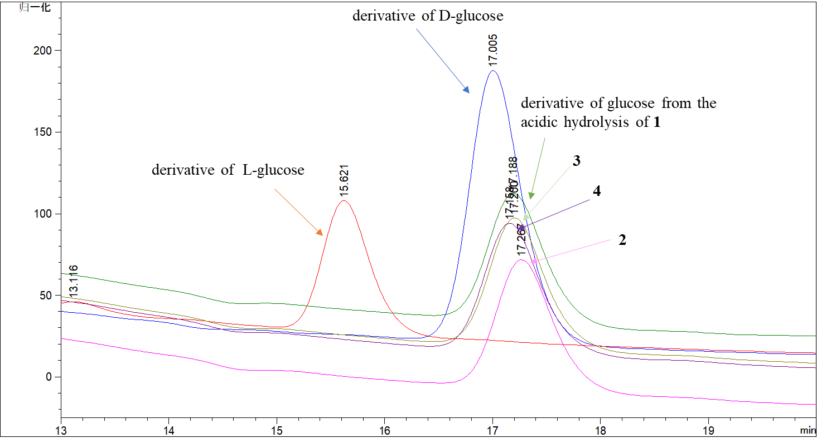

## Figure S1. A comparative HPLC analysis of the derivative of glucose from the acidic hydrolysis of **1**-**4**, L-glucose and D-glucose.

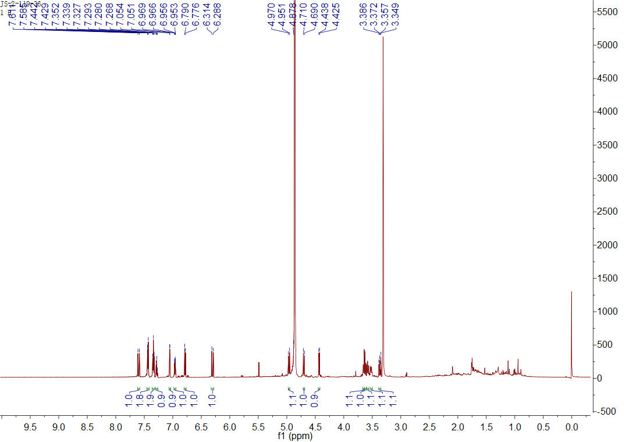

## Figure S2. The 1H NMR spectrum of **1** in CD3OD

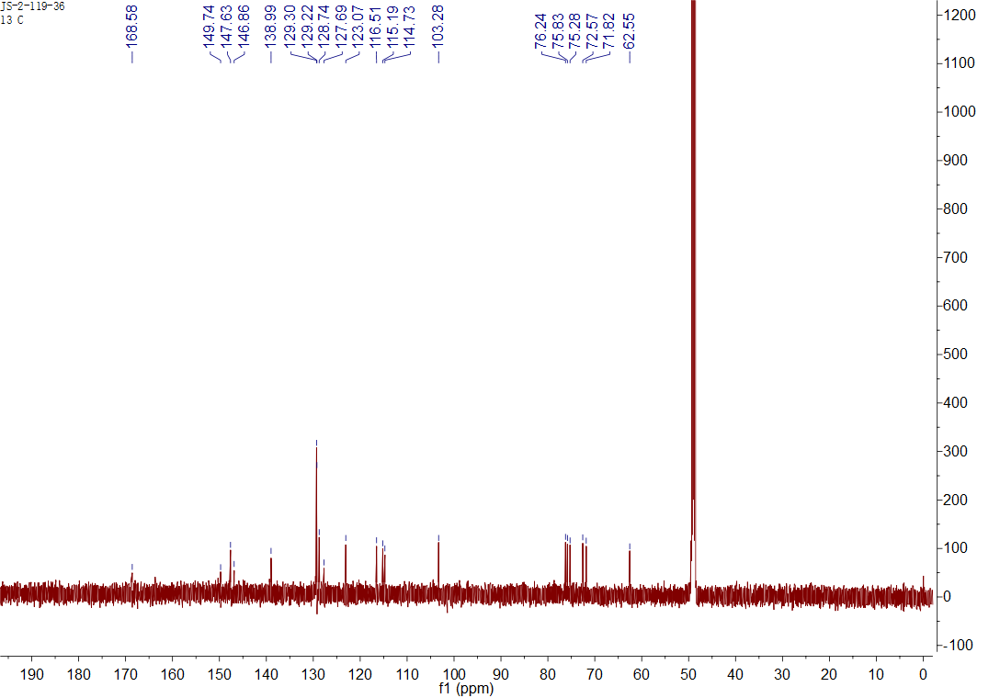

## Figure S3. The 13C NMR spectrum of **1** in CD3OD

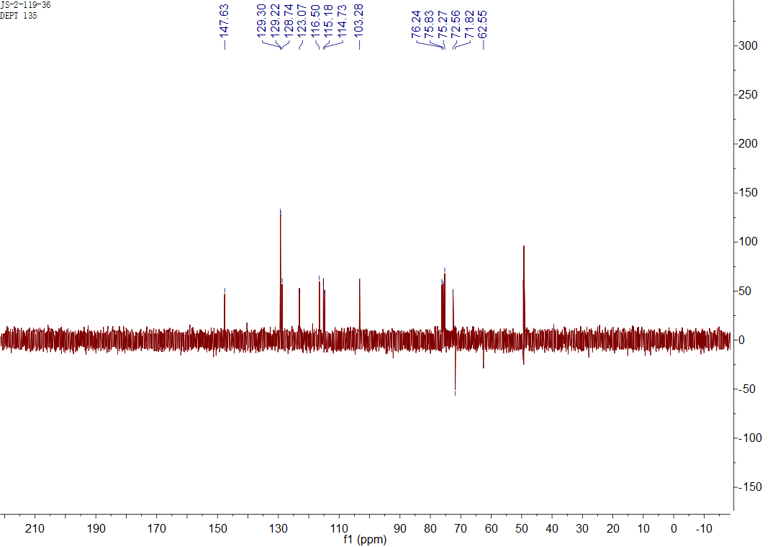

## Figure S4. The Dept spectrum of **1** in CD3OD

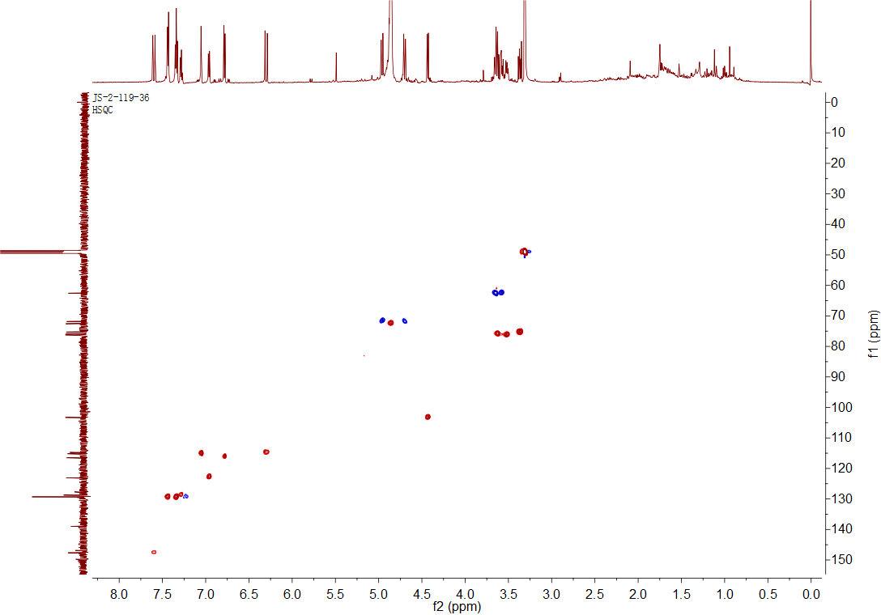

## Figure S5. The HSQC spectrum of **1** in CD3OD

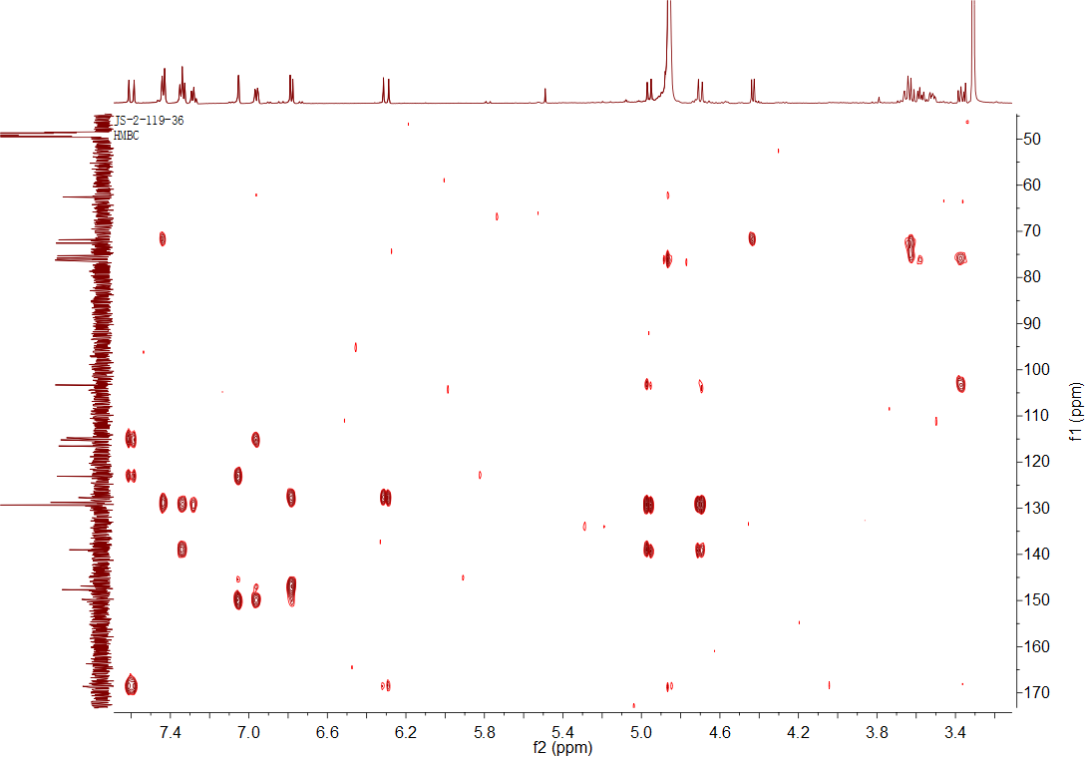

## Figure S6. The HMBC spectrum of **1** in CD3OD

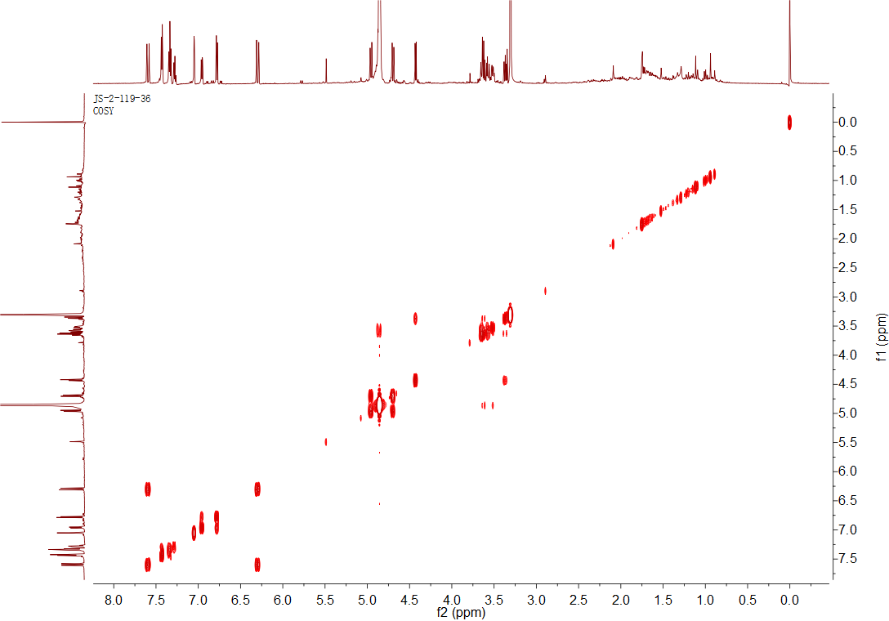

## Figure S7. The 1H-1H COSY spectrum of **1** in CD3OD

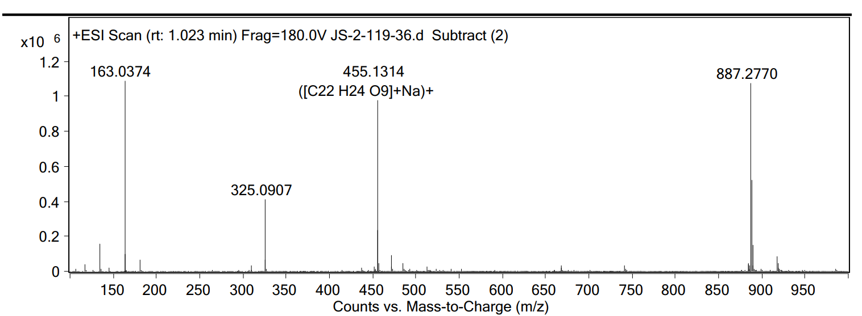

## Figure S8. The HRESIMS data of **1**



## Figure S9. The IR spectrum of **1**

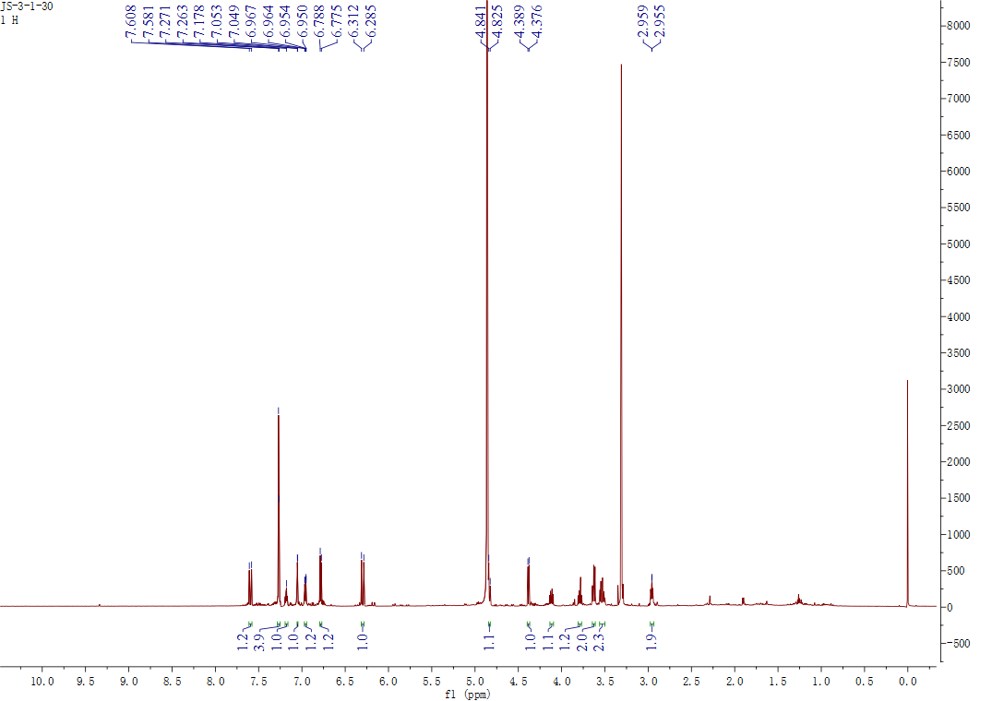

## Figure S10. The 1H NMR spectrum of **2** in CD3OD

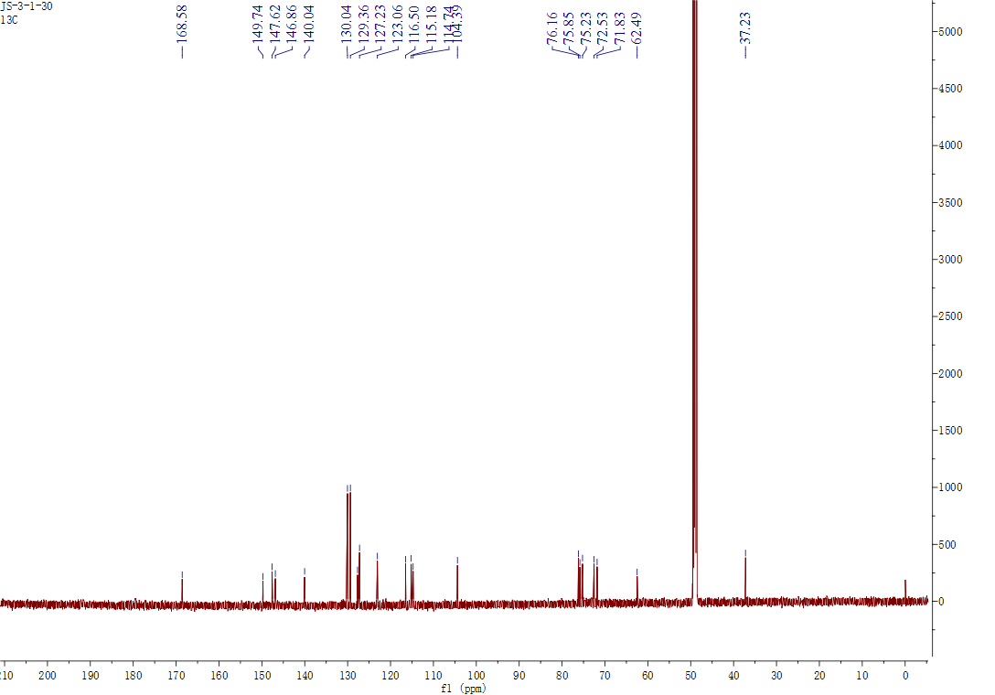

## Figure S11. The 13C NMR spectrum of **2** in CD3OD

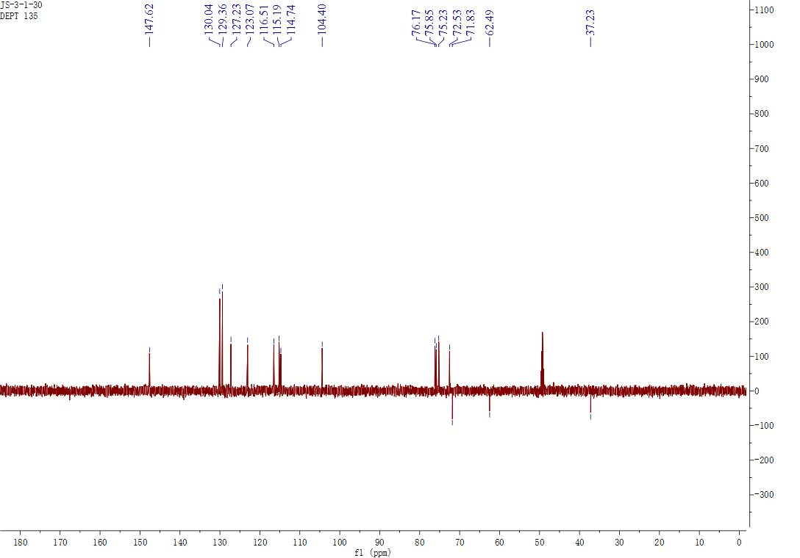

## Figure S12. The Dept spectrum of **2** in CD3OD

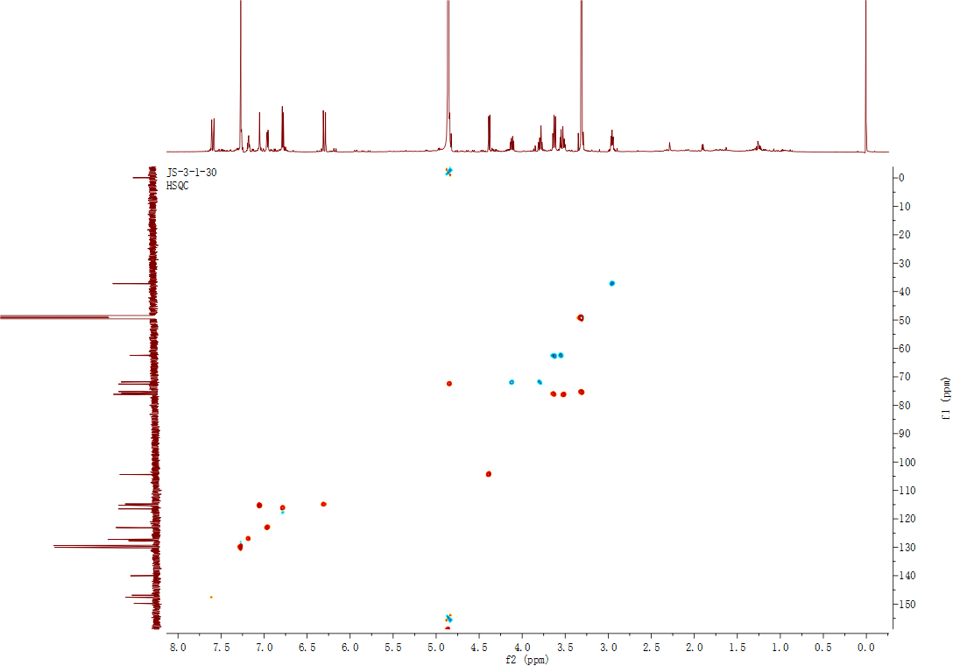

## Figure S13. The HSQC spectrum of **2** in CD3OD

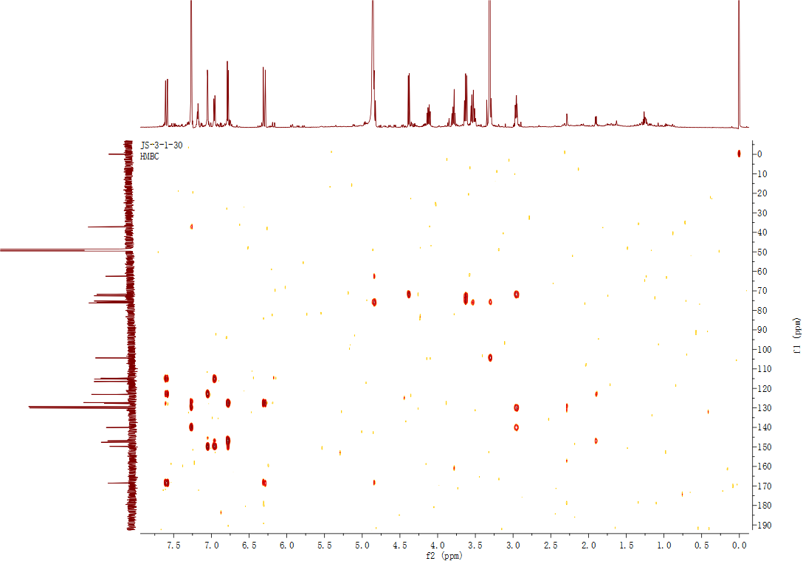

## Figure S14. The HMBC spectrum of **2** in CD3OD

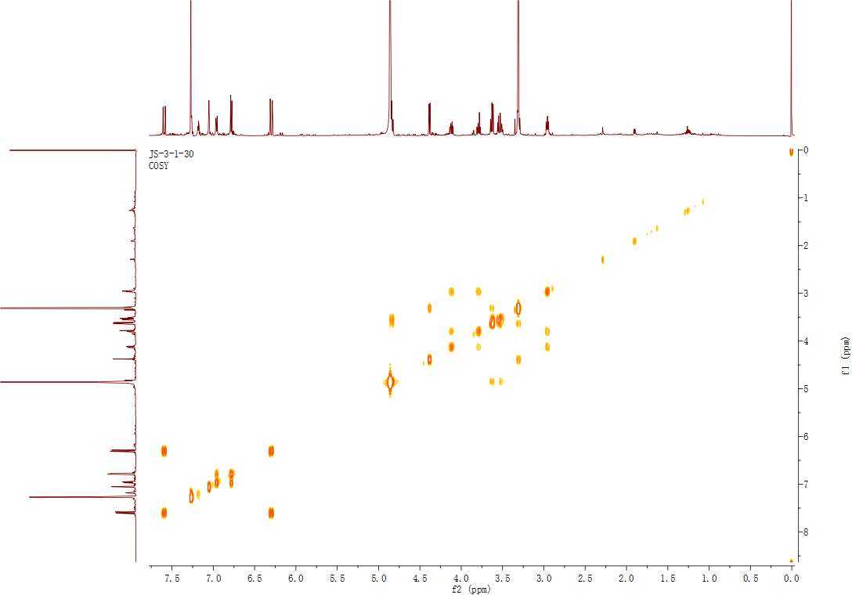

## Figure S15. The 1H-1H COSYspectrum of **2** in CD3OD

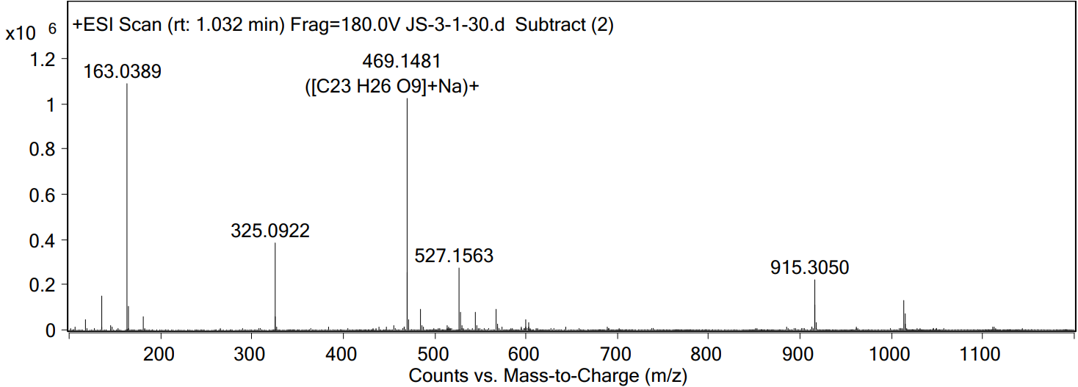

## Figure S16. The HRESIMS data of **2**



## Figure S17. The IR spectrum of **2**

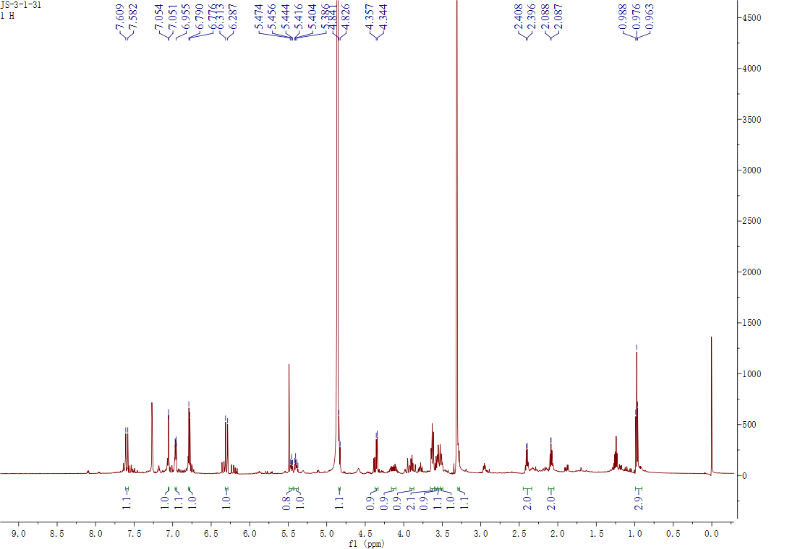

## Figure S18 The 1H NMR spectrum of **3** in CD3OD

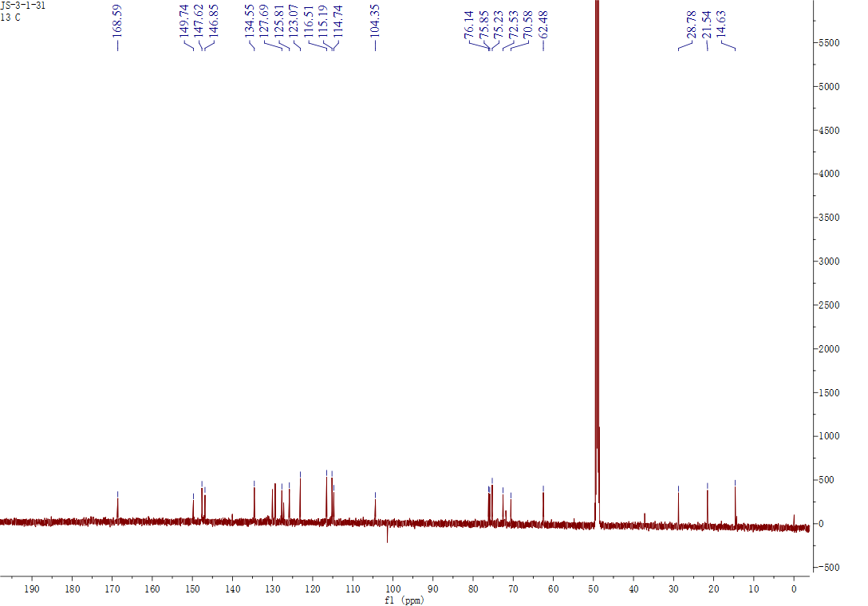

## Figure S19 The 1C NMR spectrum of **3** in CD3OD

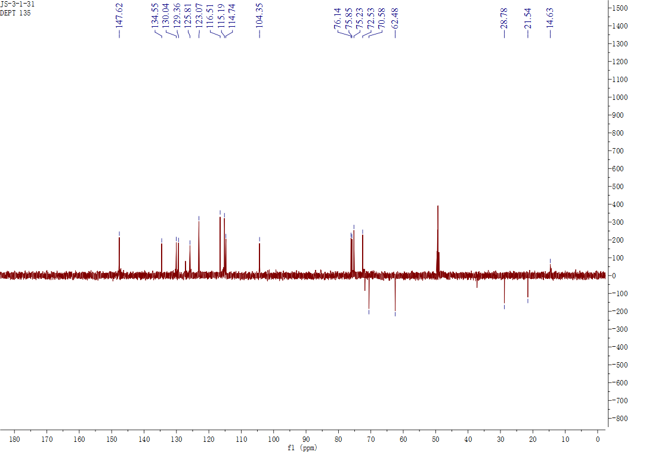

## Figure S20 The Dept spectrum of **3** in CD3OD

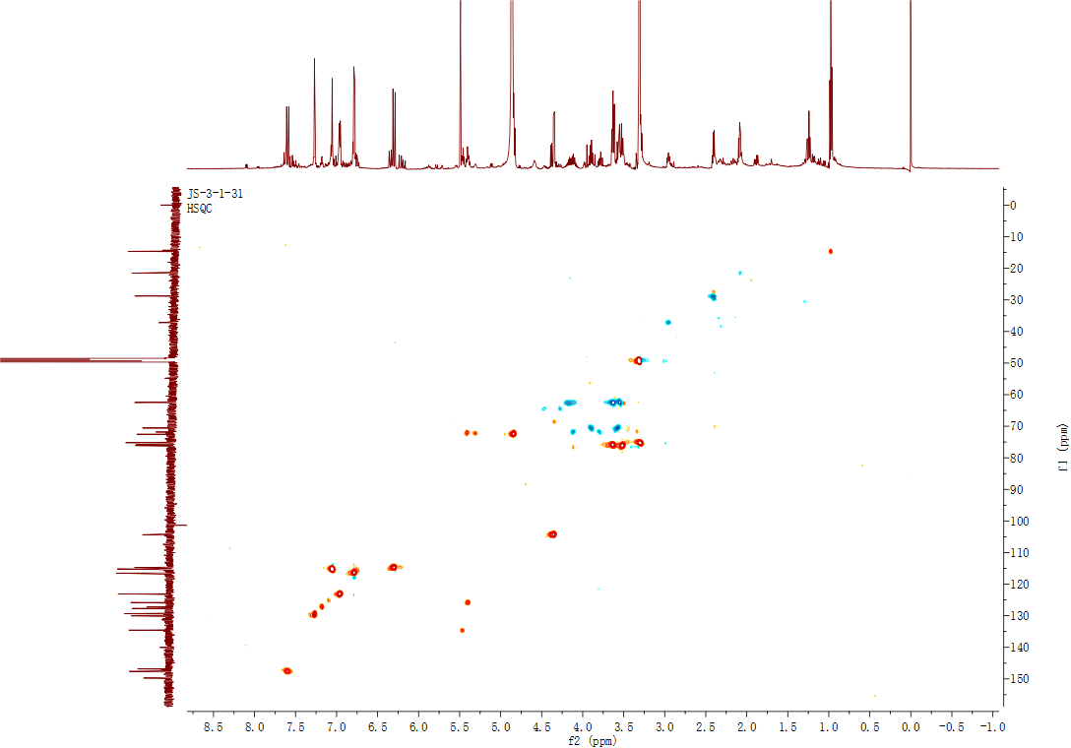

## Figure S21 The HSQC spectrum of **3** in CD3OD

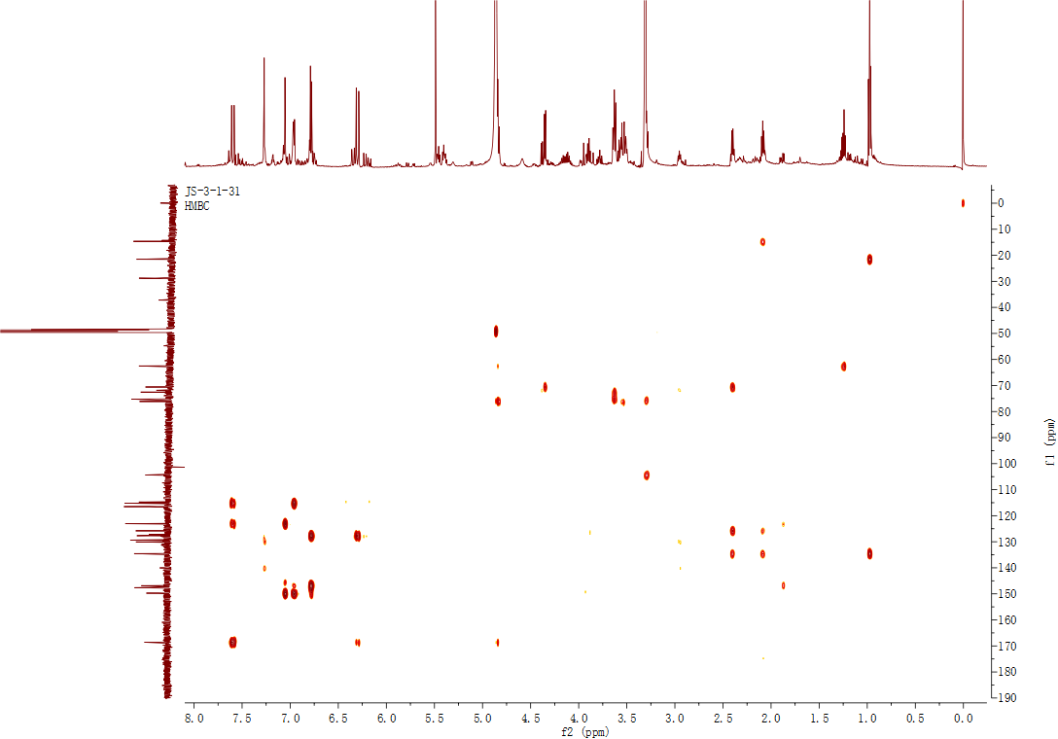

## Figure S22 The HMBC spectrum of **3** in CD3OD

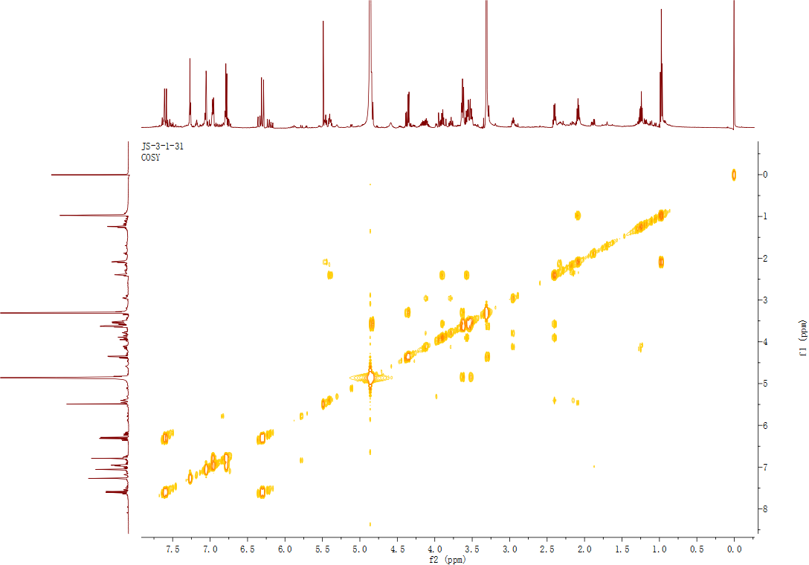

## Figure S23 The 1H-1H COSY spectrum of **3** in CD3OD

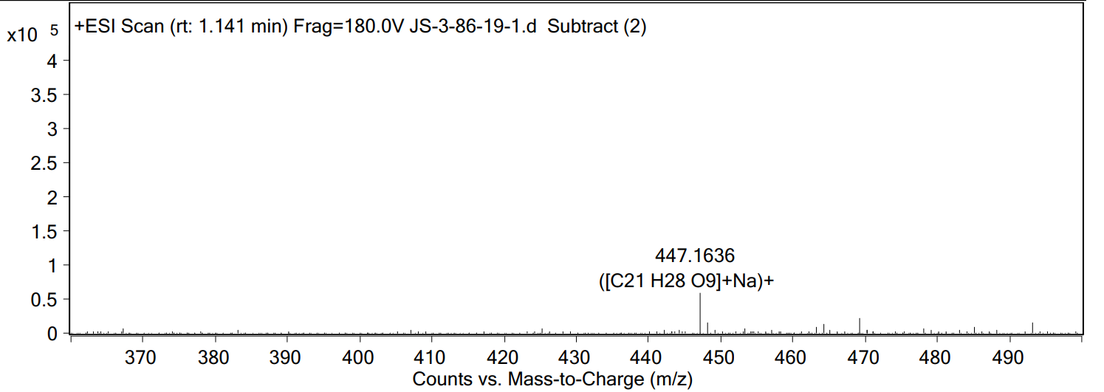

## Figure S24 The HRESIMS data of **3** in CD3OD



## Figure S25 The IR spectrum of **3** in CD3OD

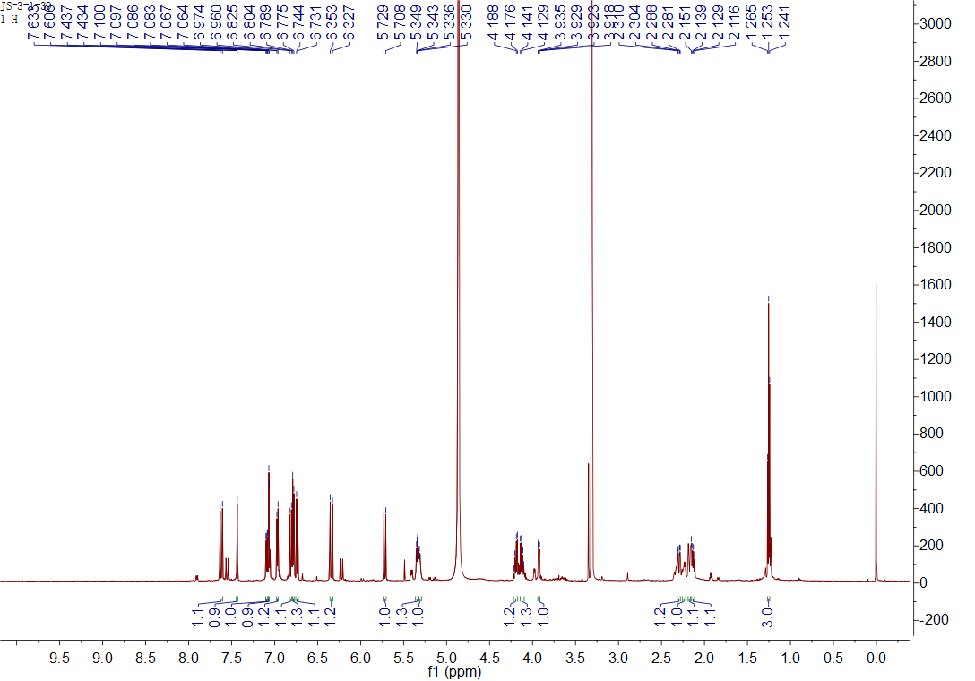

## Figure S26 The 1H NMR spectrum of **4** in CD3OD

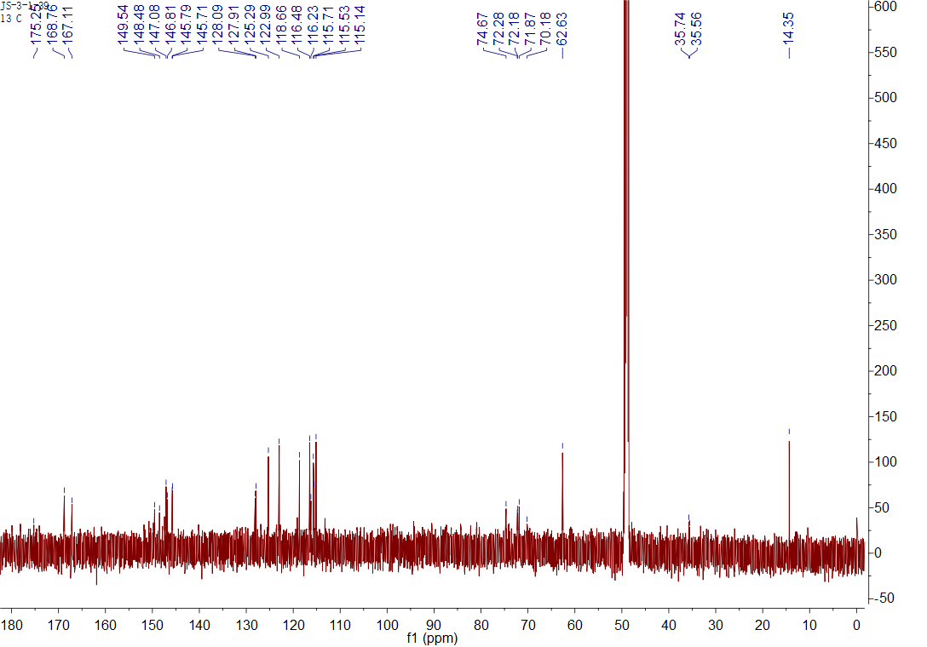

## Figure S27 The 1C NMR spectrum of **4** in CD3OD

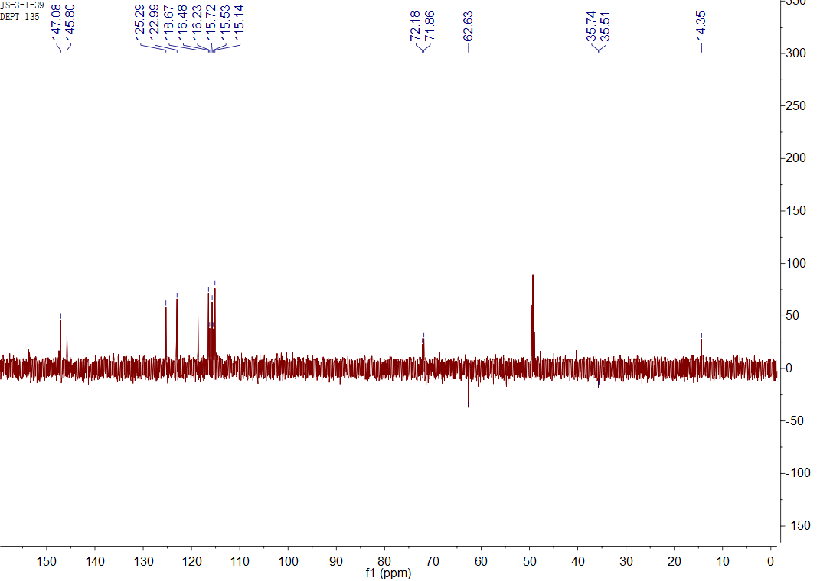

## Figure S28 The Dept spectrum of **4** in CD3OD

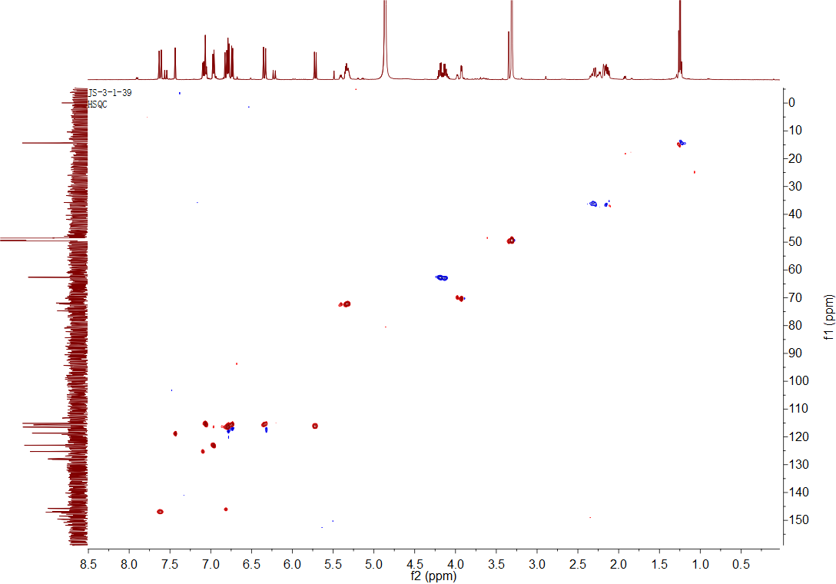

## Figure S29 The HSQC spectrum of **4** in CD3OD

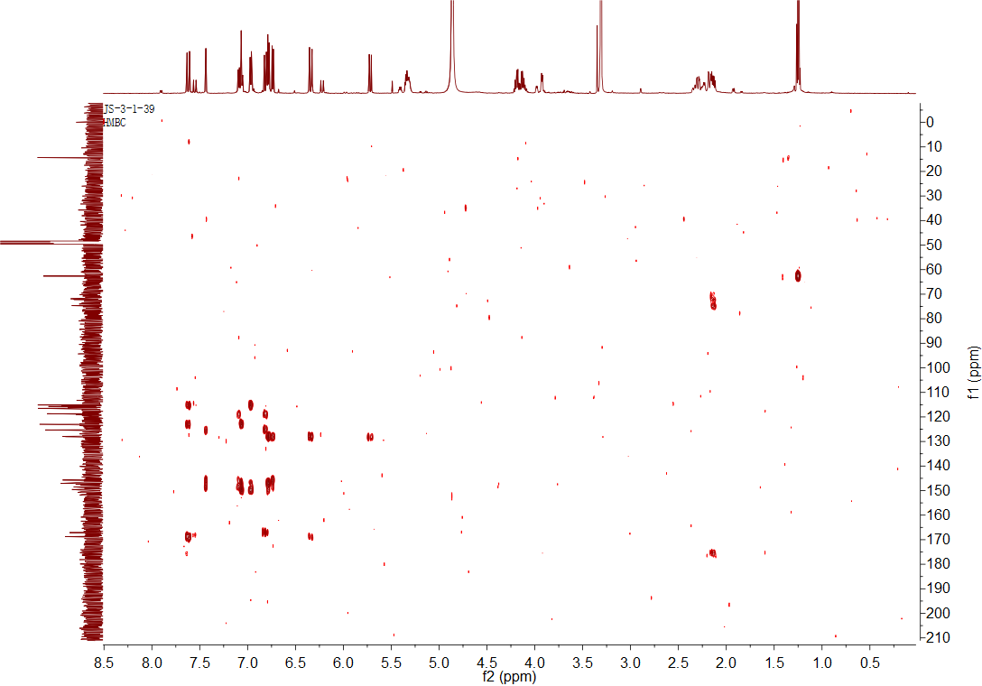

## Figure S30 The HMBC spectrum of **4** in CD3OD

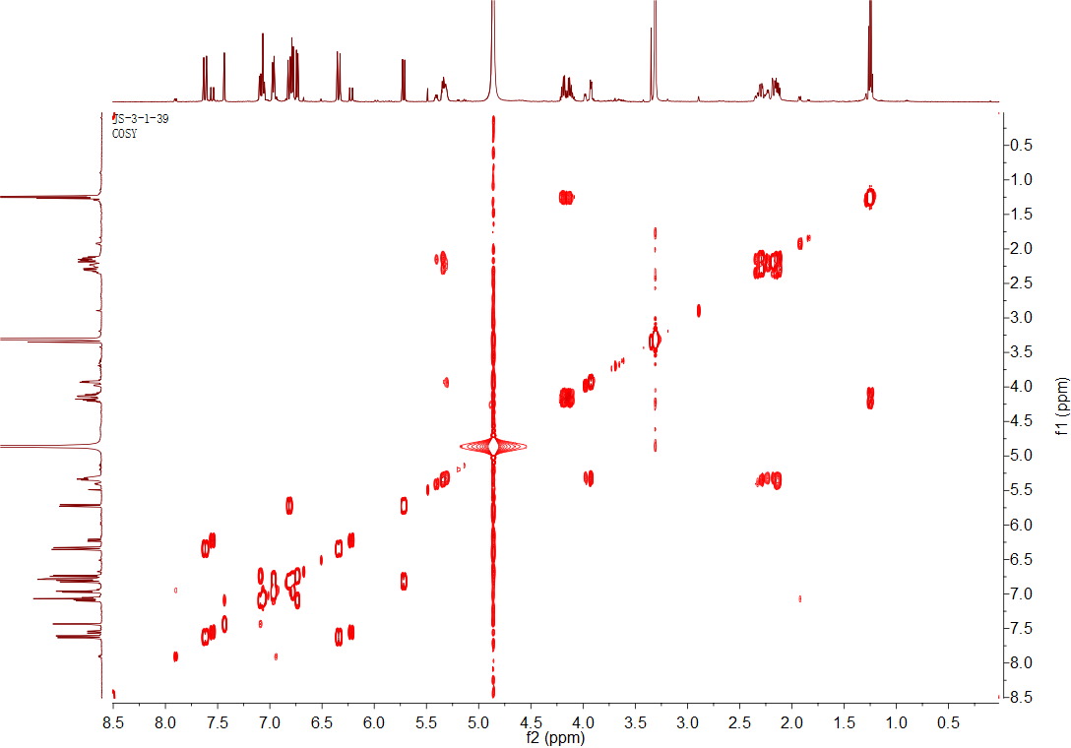

## Figure S31 The 1H-1H COSY spectrum of **4** in CD3OD

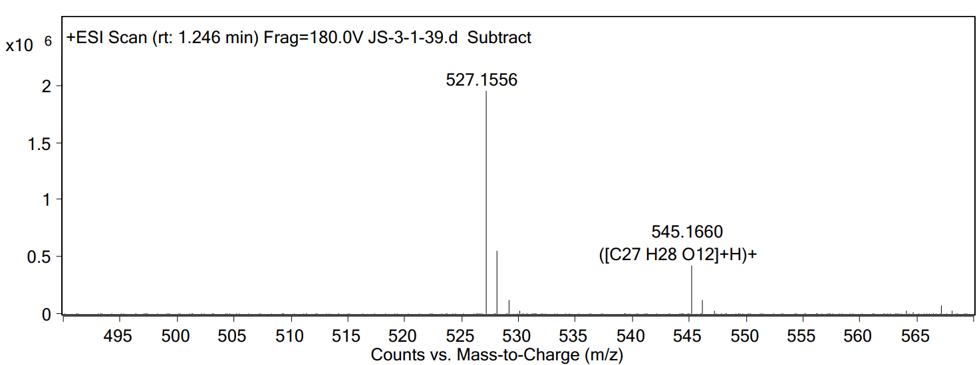

## Figure S32 The HRESIMS data of **4** in CD3OD



## Figure S33 The IR spectrum of **4** in CD3OD

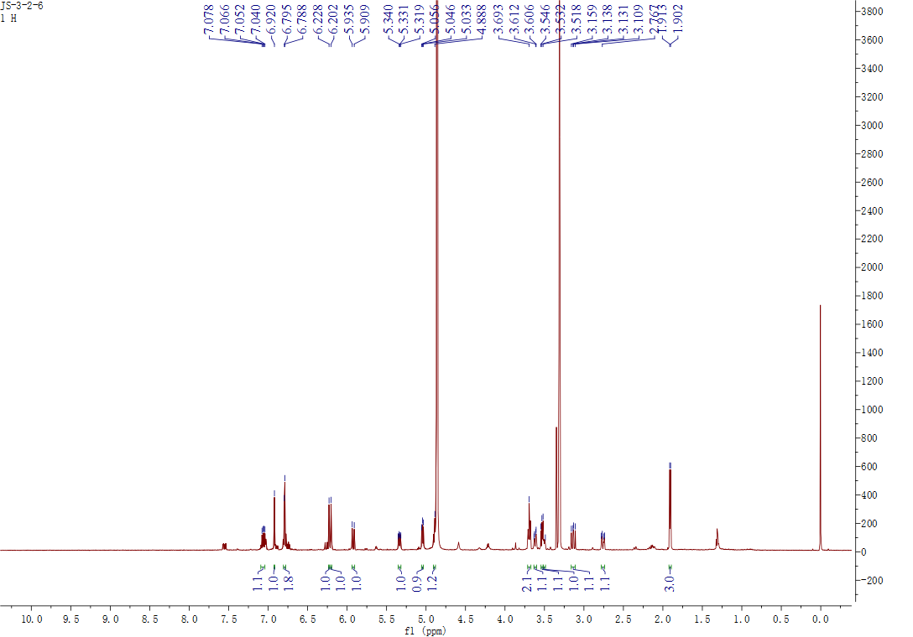

## Figure S34. The 1H NMR spectrum of **11** in CD3OD

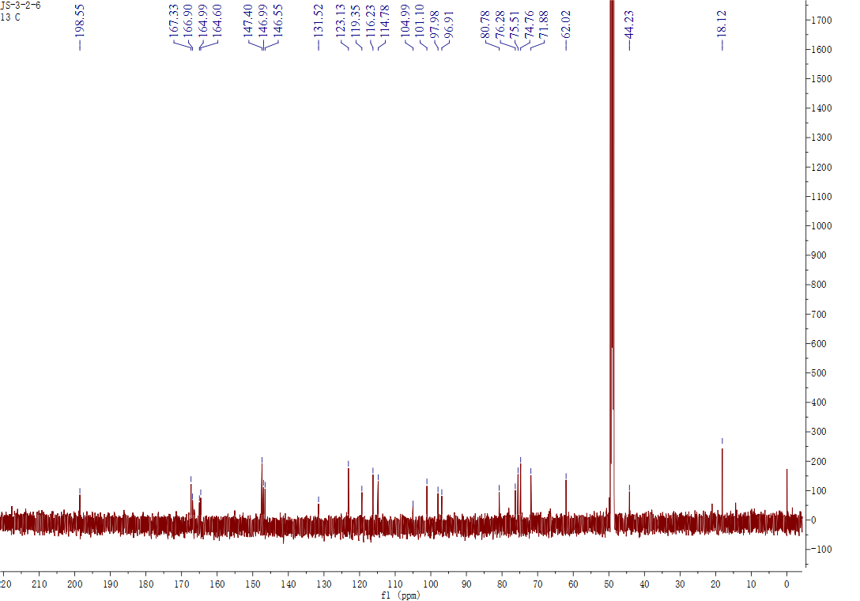

## Figure S35. The 13C NMR spectrum of **11** in CD3OD

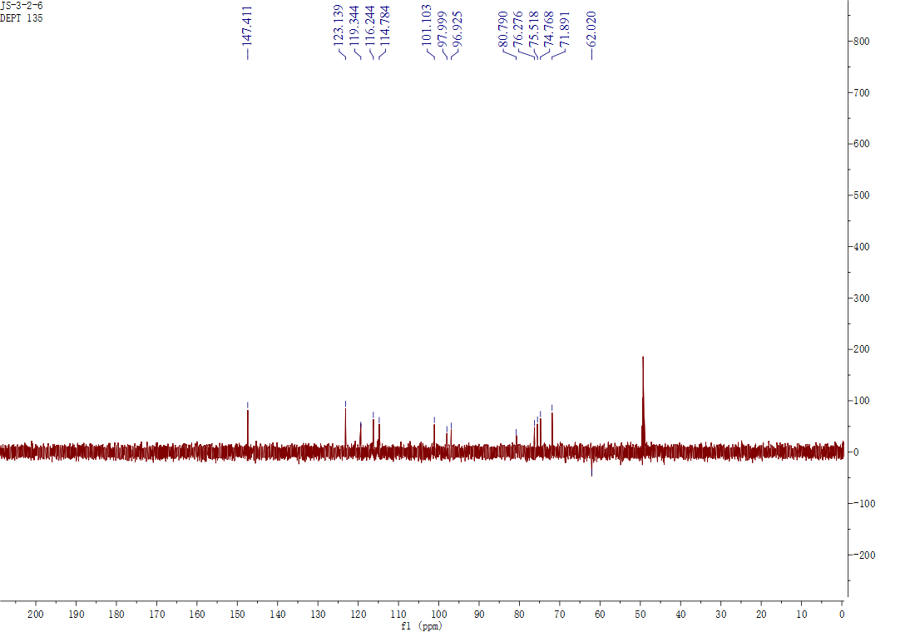

## Figure S36. The Dept spectrum of **11** in CD3OD

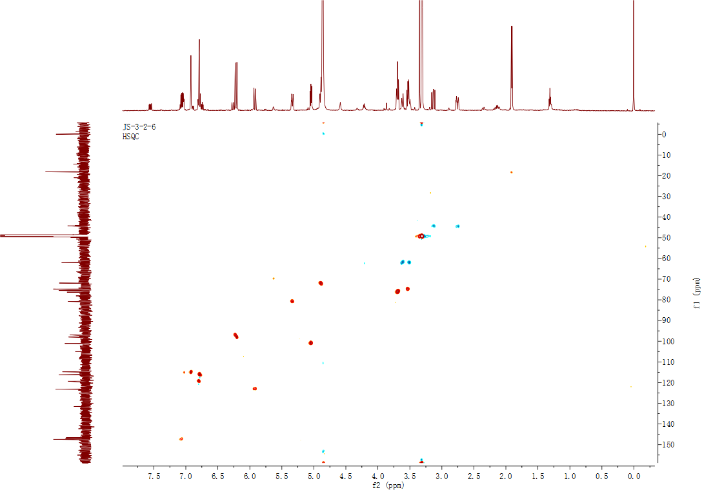

## Figure S37. The HSQC spectrum of **11** in CD3OD

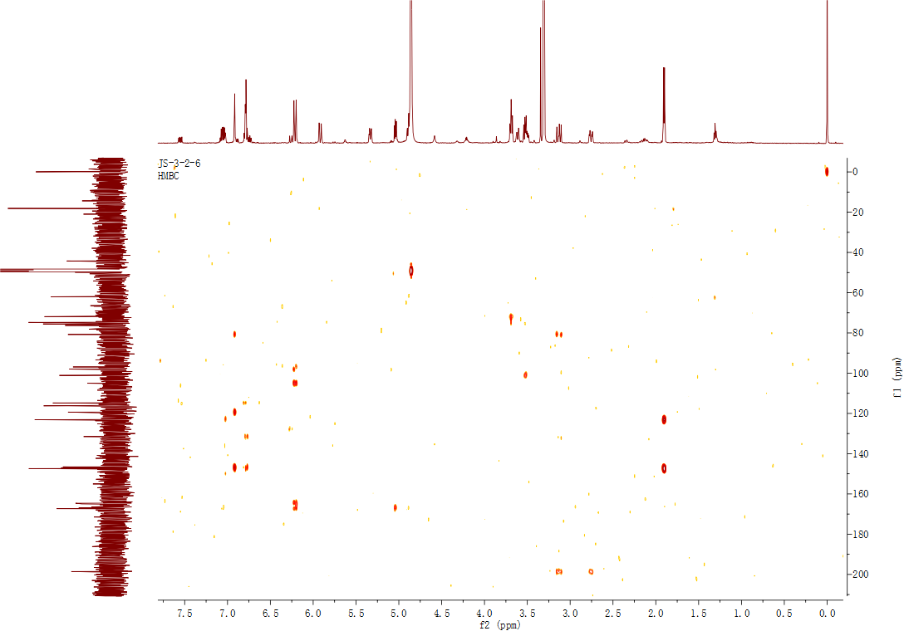

## Figure S38. The HMBC spectrum of **11** in CD3OD

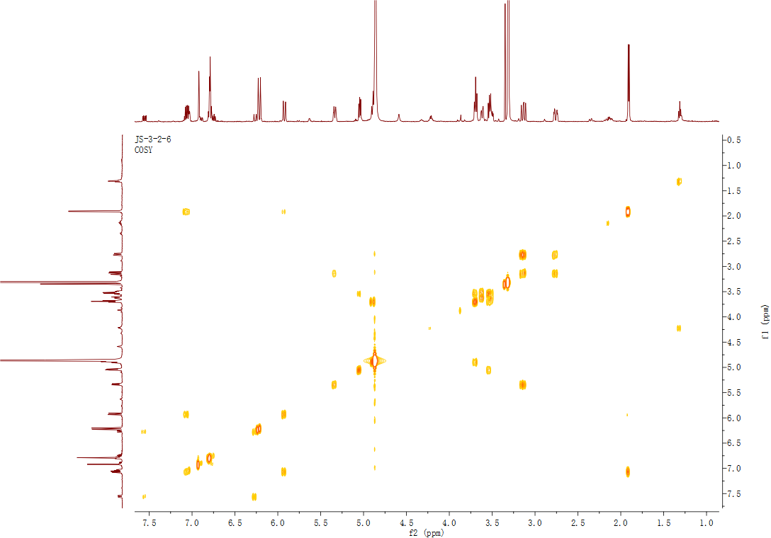

## Figure S39. The 1H-1H COSY spectrum of **11** in CD3OD

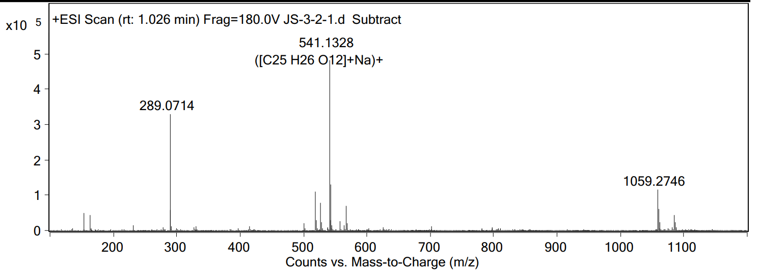

## Figure S40. The HRESIMS data of **11**



## Figure S41. The IR spectrum of **11**

## Figure S42. The experimental ECD spectra of **11**

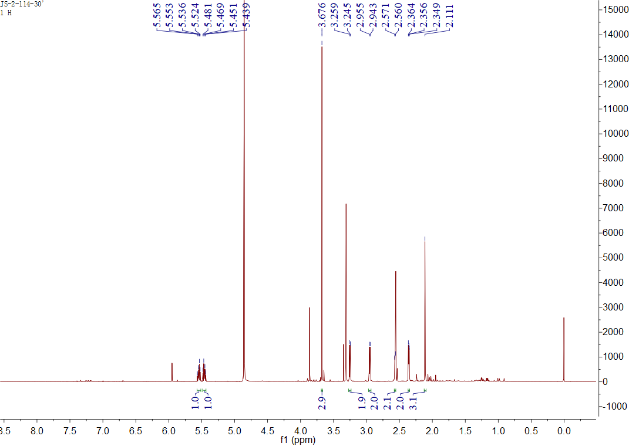

Figure S43. The 1H NMR spectrum of **31** in CD3OD

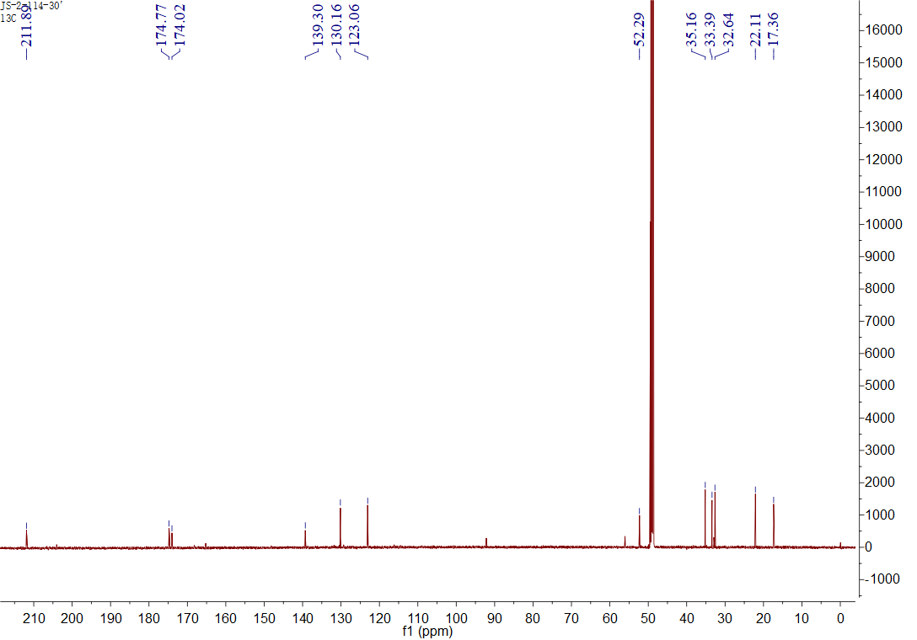

## Figure S44. The 13C NMR spectrum of **31** in CD3OD

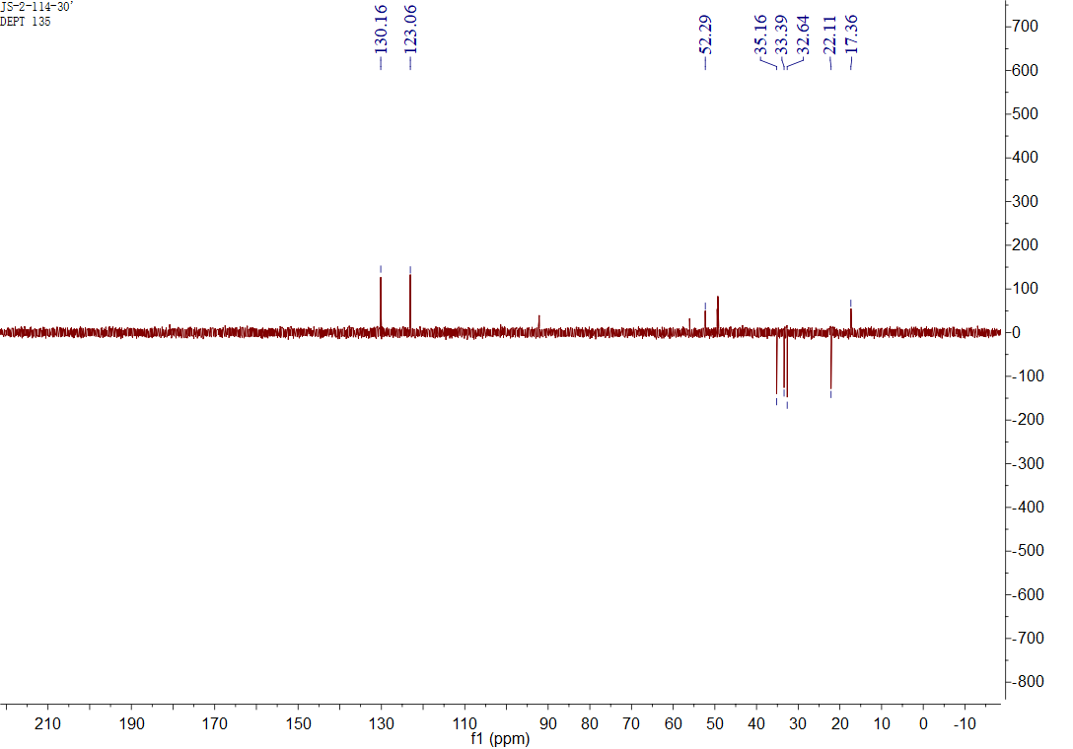

## Figure S45. The Dept spectrum of **31** in CD3OD

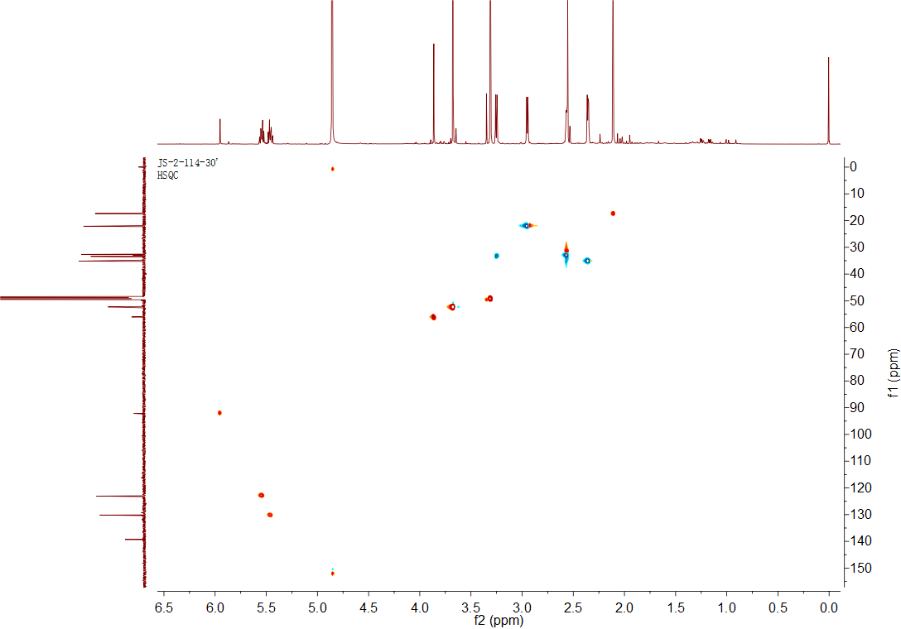

## Figure S46. The HSQC spectrum of **31** in CD3OD

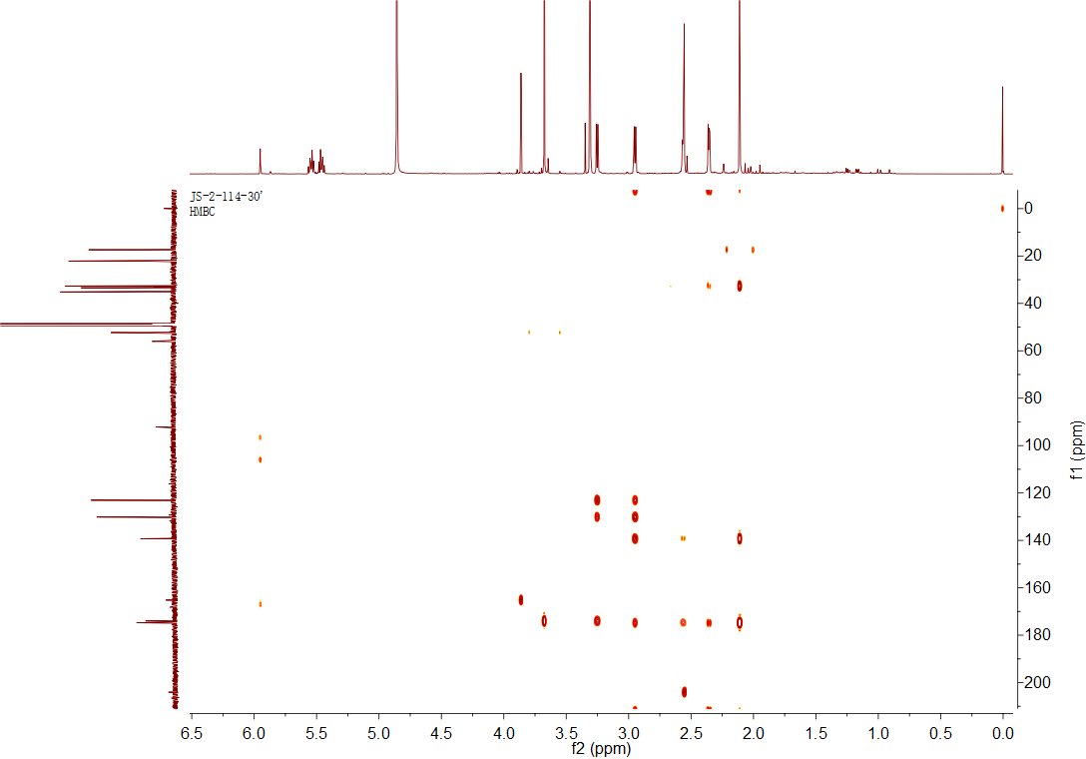

## Figure S47. The HMBC spectrum of **31** in CD3OD

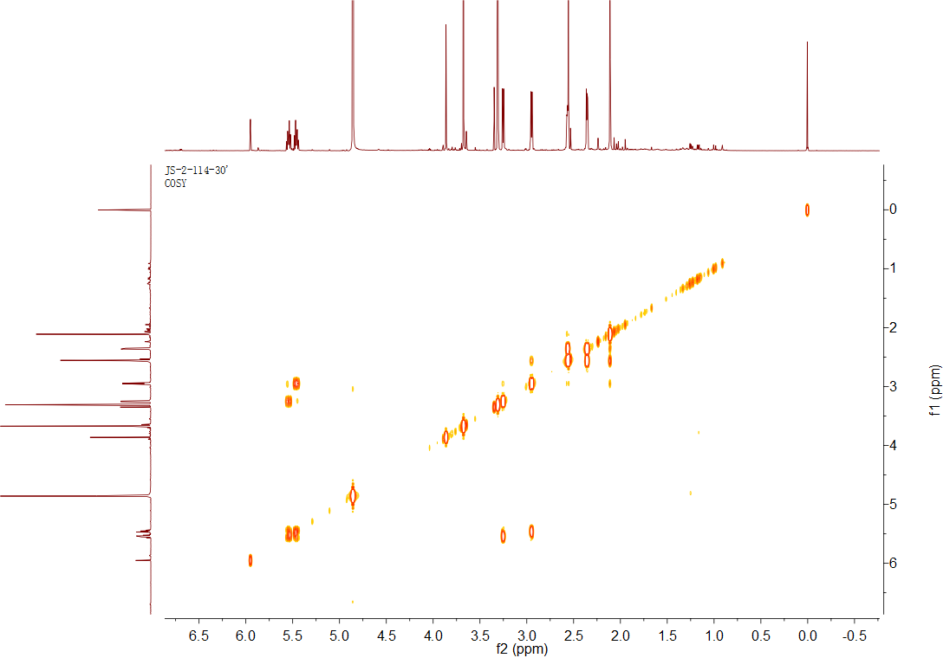

## Figure S48. The 1H-1H COSY spectrum of **31** in CD3OD

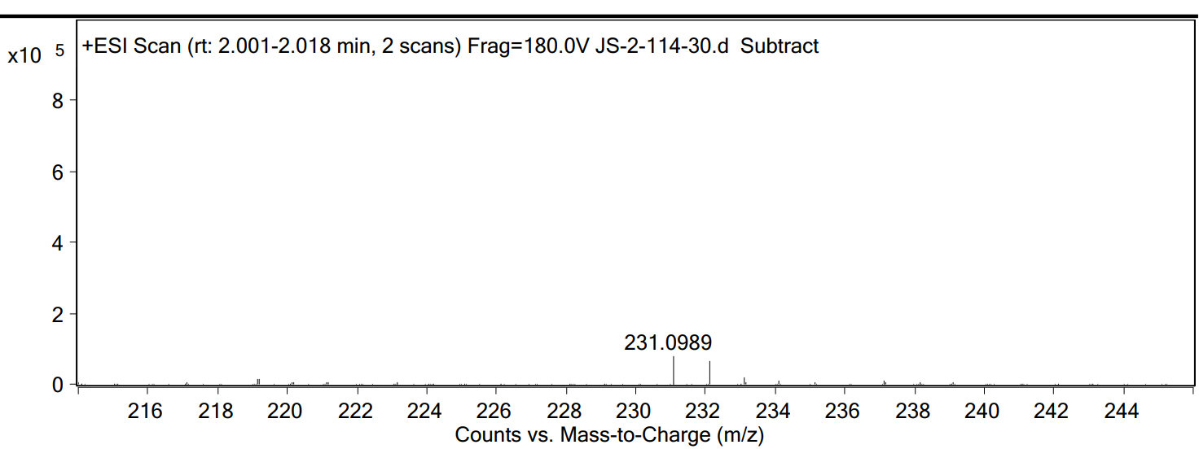

## Figure S49. The HRESIMS data of **31**



## Figure S50. The IR spectrum of **31**

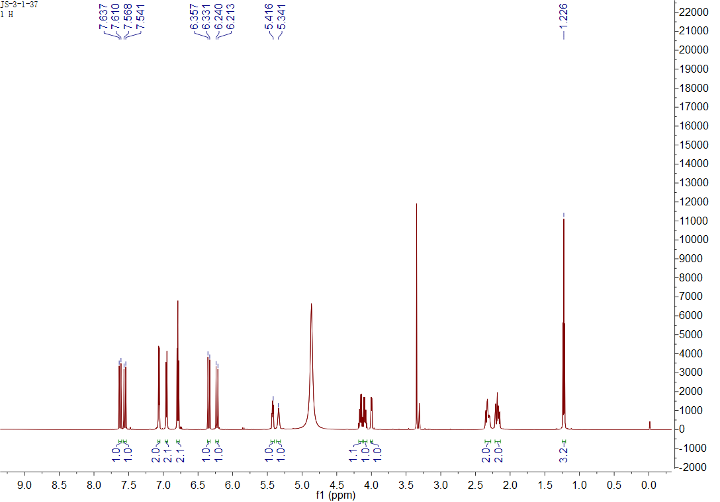

## Figure S51. The 1H NMR spectrum of **5** in CD3OD

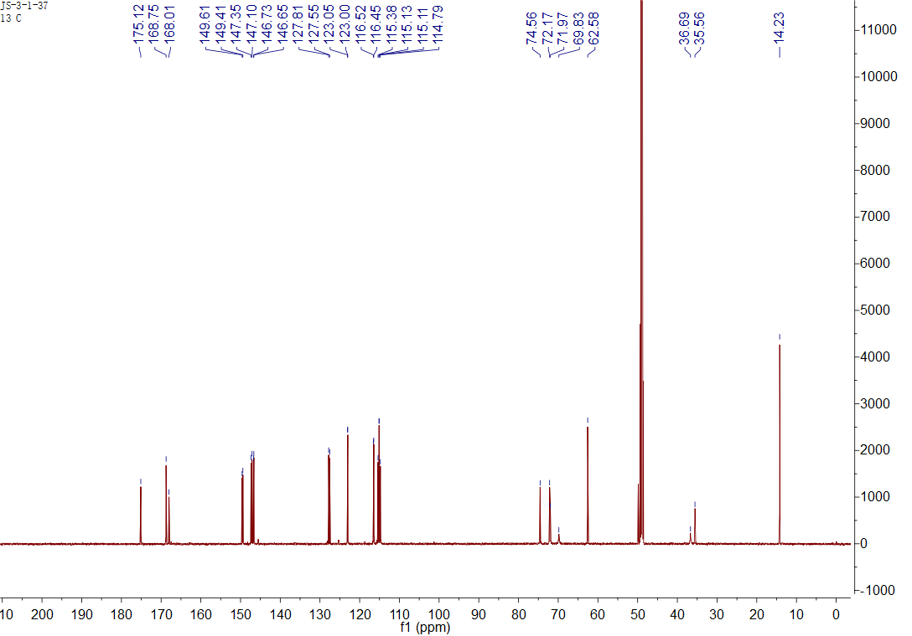

## Figure S52. The 13C NMR spectrum of **5** in CD3OD

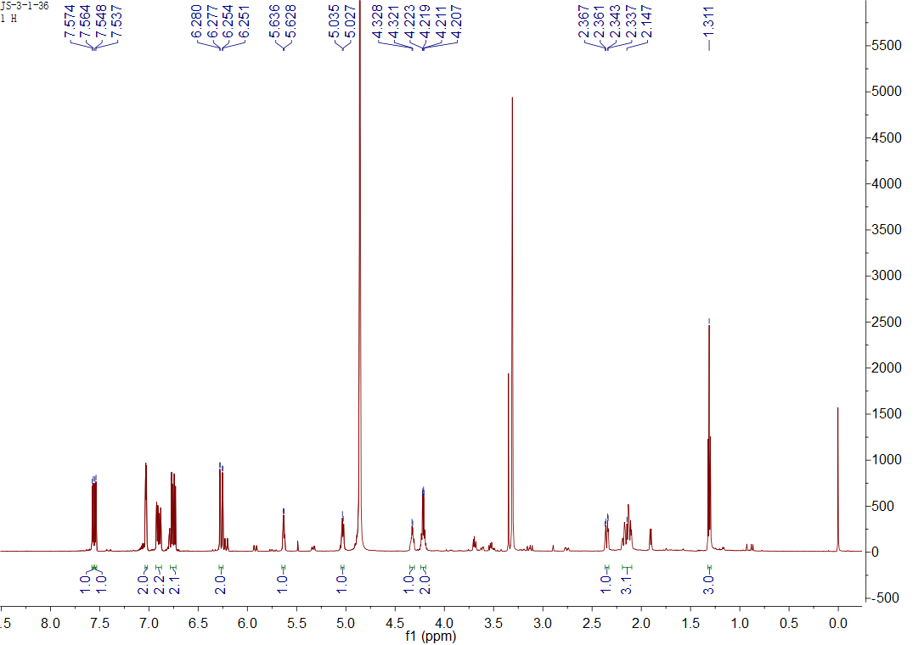

## Figure S53. The 1H NMR spectrum of **6** in CD3OD

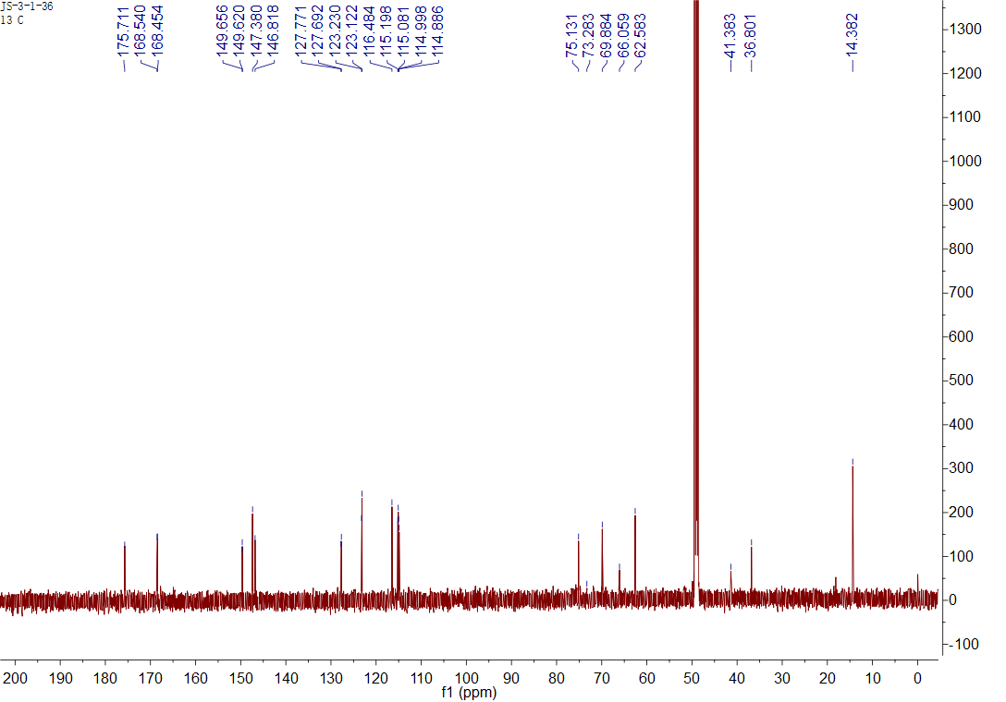

## Figure S54. The 13C NMR spectrum of **6** in CD3OD

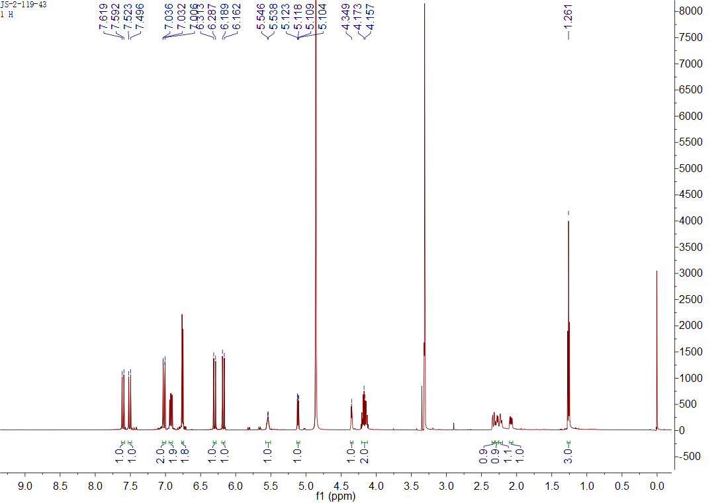

## Figure S55. The 1H NMR spectrum of **7** in CD3OD

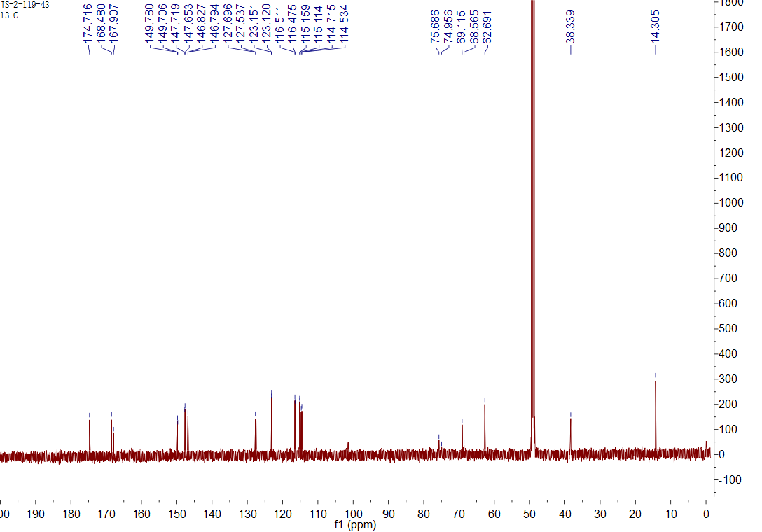

## Figure S56. The 13C NMR spectrum of **7** in CD3OD

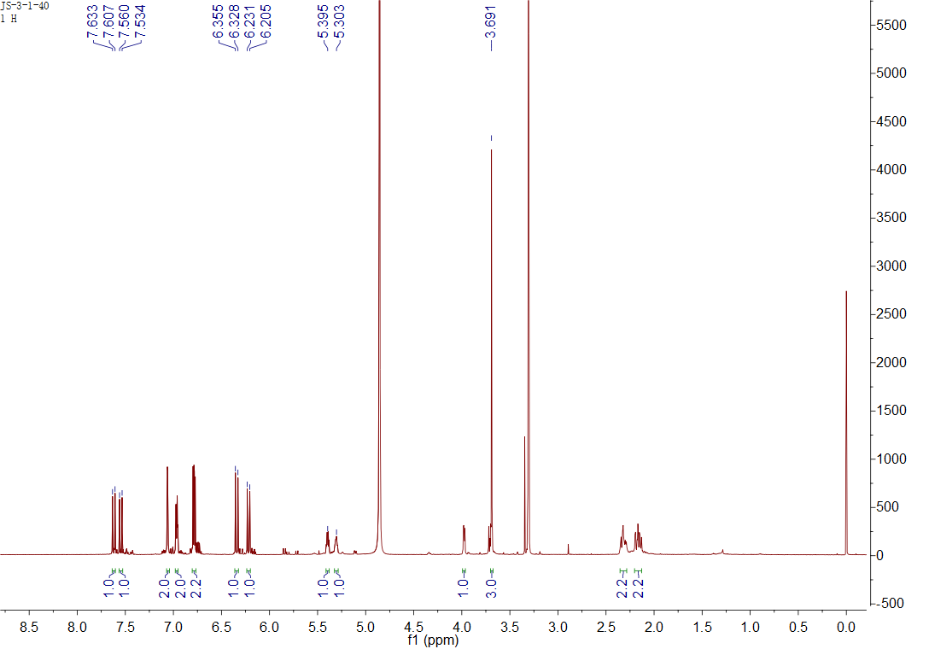

## Figure S57. The 1H NMR spectrum of **8** in CD3OD

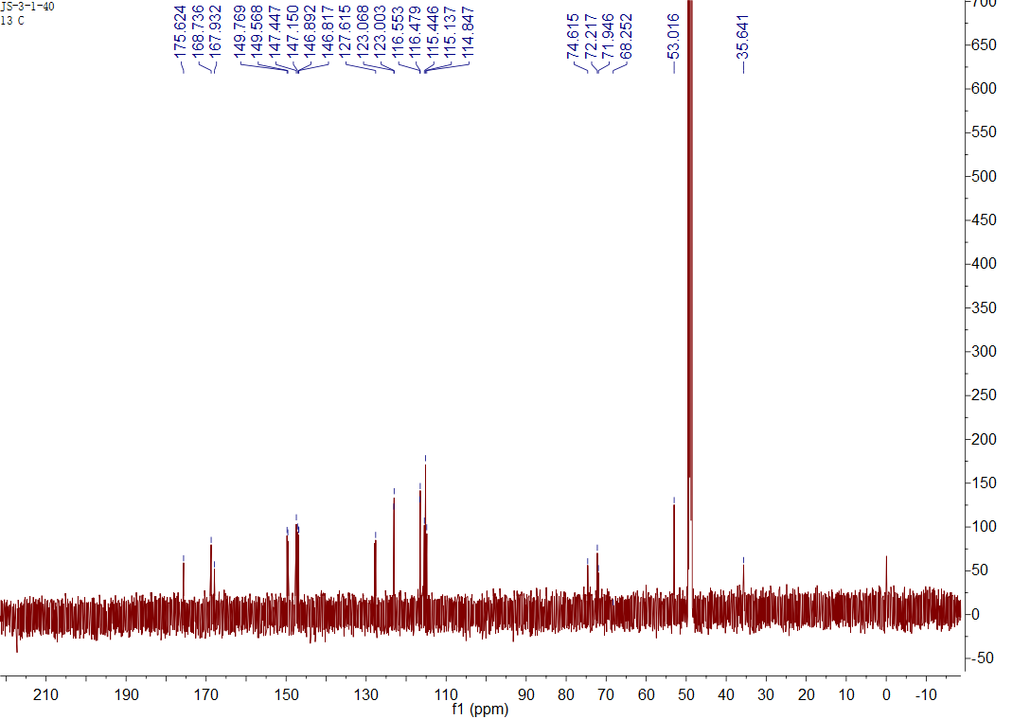

## Figure S58. The 13C NMR spectrum of **8** in CD3OD

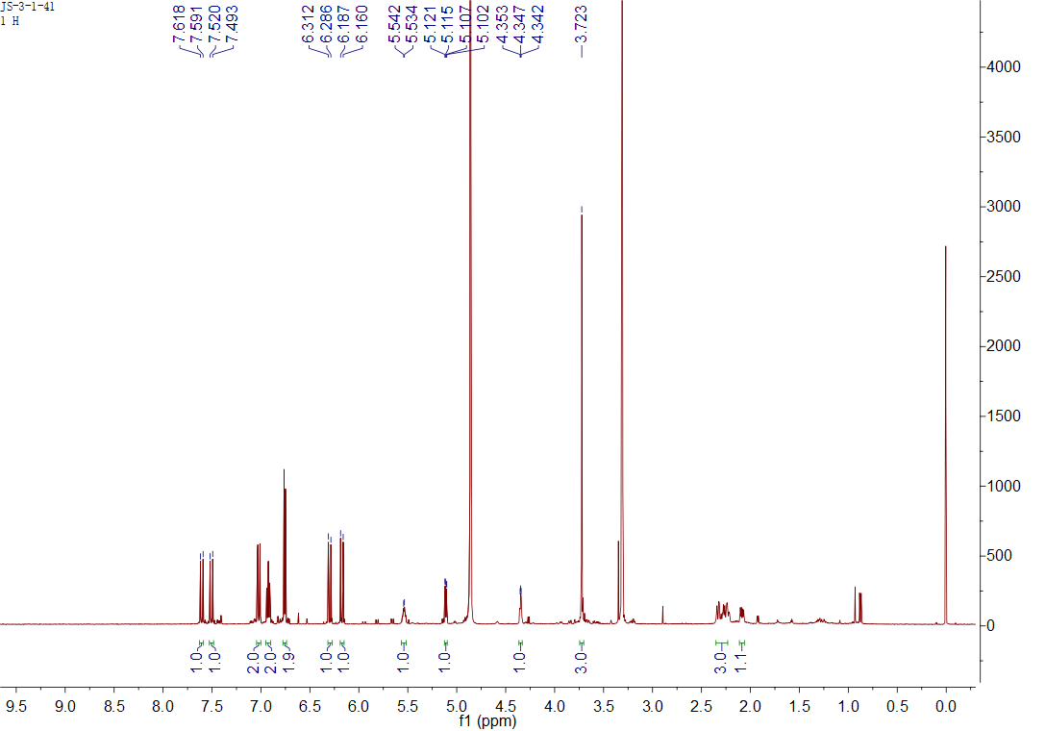

## Figure S59. The 1H NMR spectrum of **9** in CD3OD

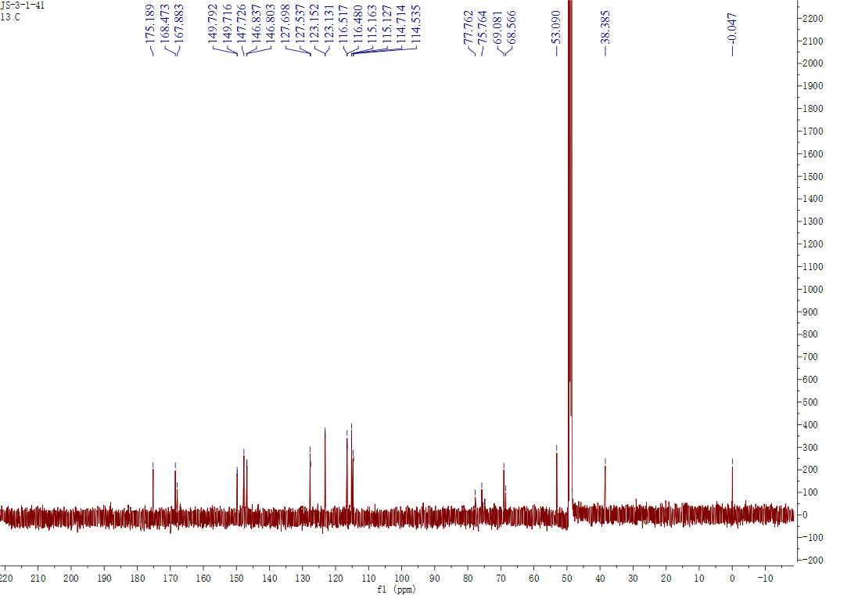

## Figure S60. The 13C NMR spectrum of **9** in CD3OD

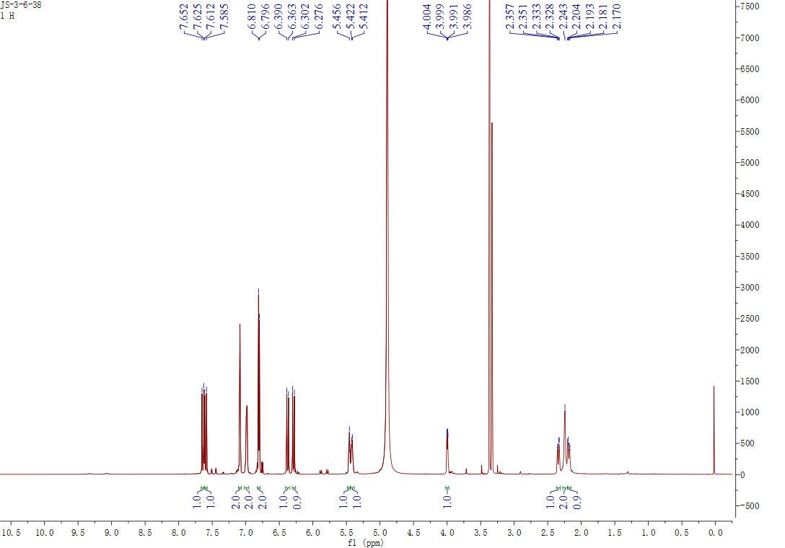

## Figure S61. The 1H NMR spectrum of **10** in CD3OD

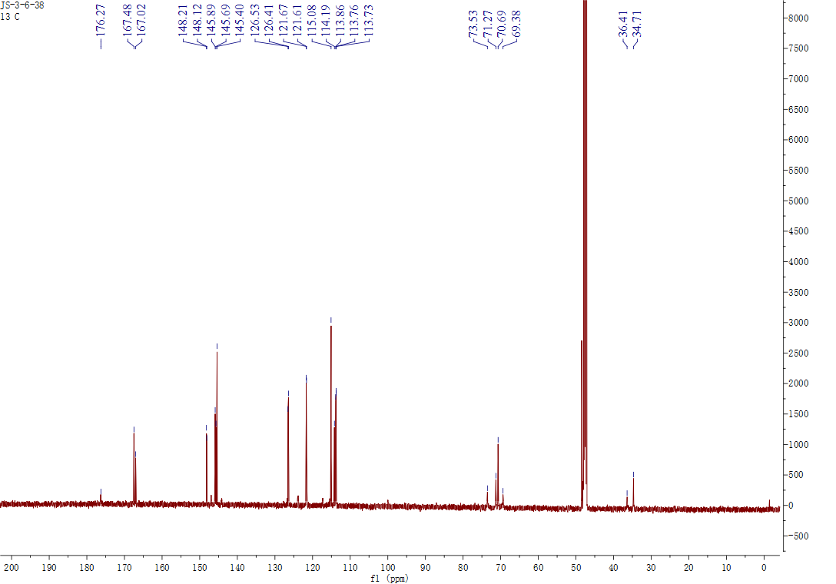

## Figure S62. The 13C NMR spectrum of **10** in CD3OD

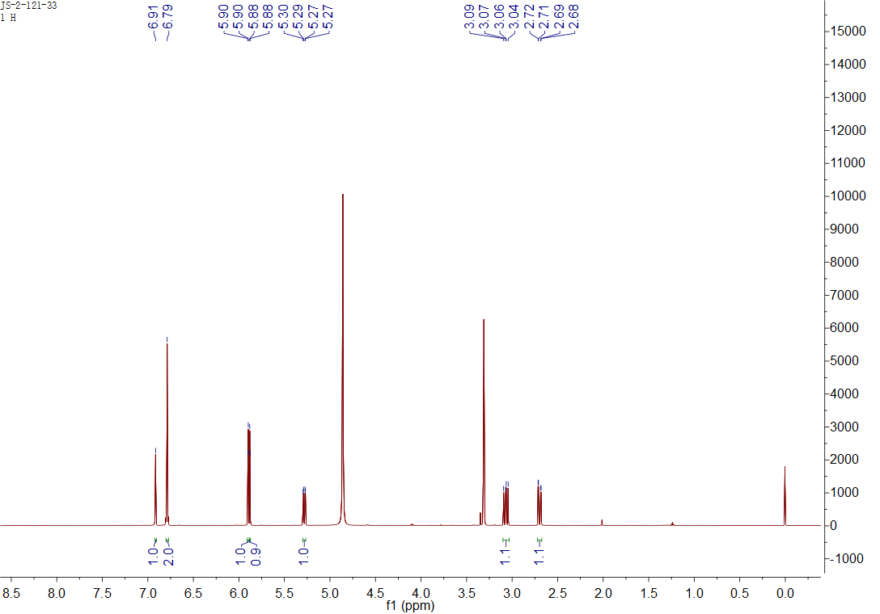

## Figure S63. The 1H NMR spectrum of **12** in CD3OD

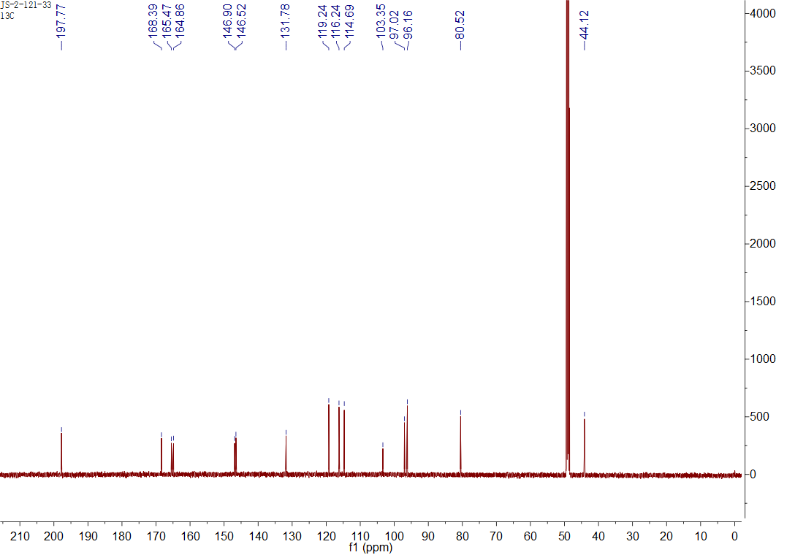

## Figure S64. The 13C NMR spectrum of **12** in CD3OD

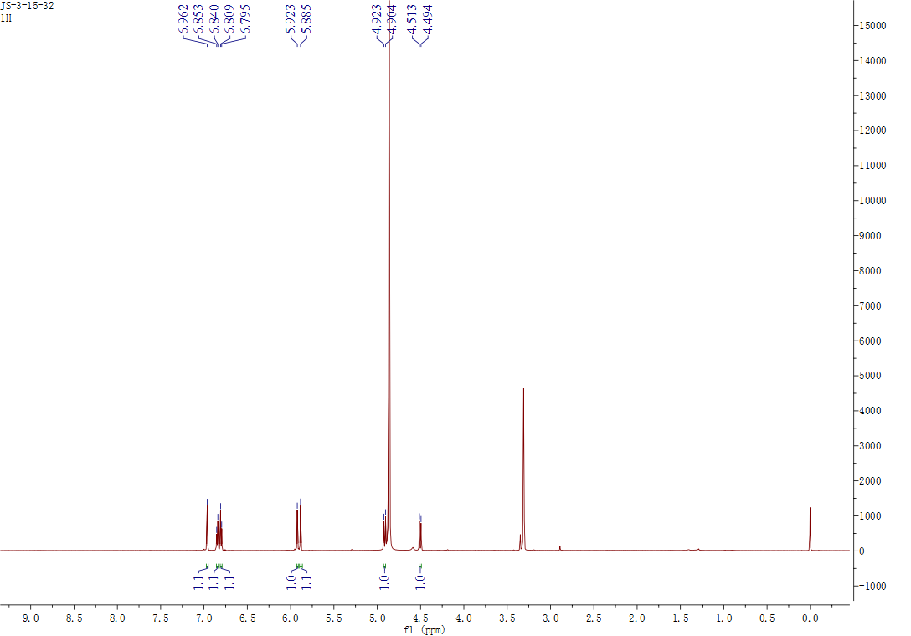

## Figure S65. The 1H NMR spectrum of **13** in CD3OD

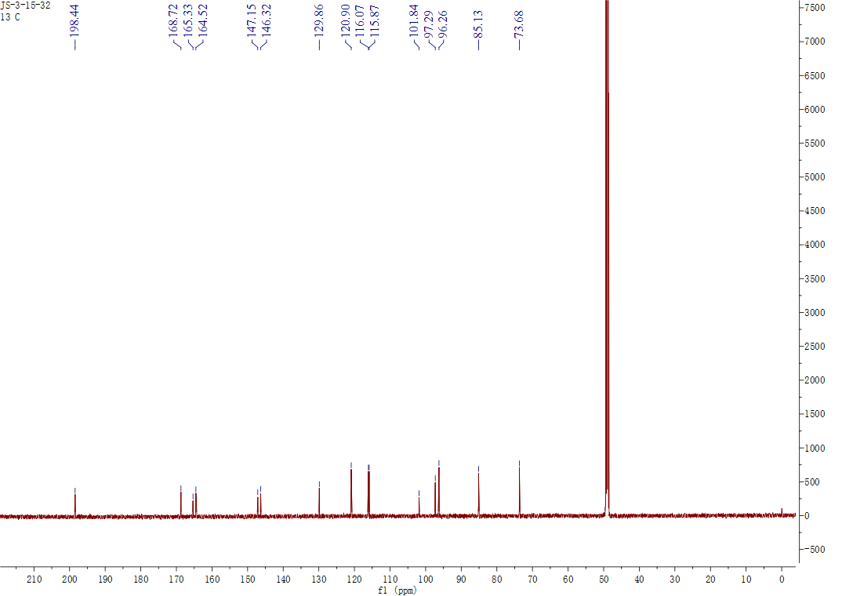

## Figure S66. The 13C NMR spectrum of **13** in CD3OD

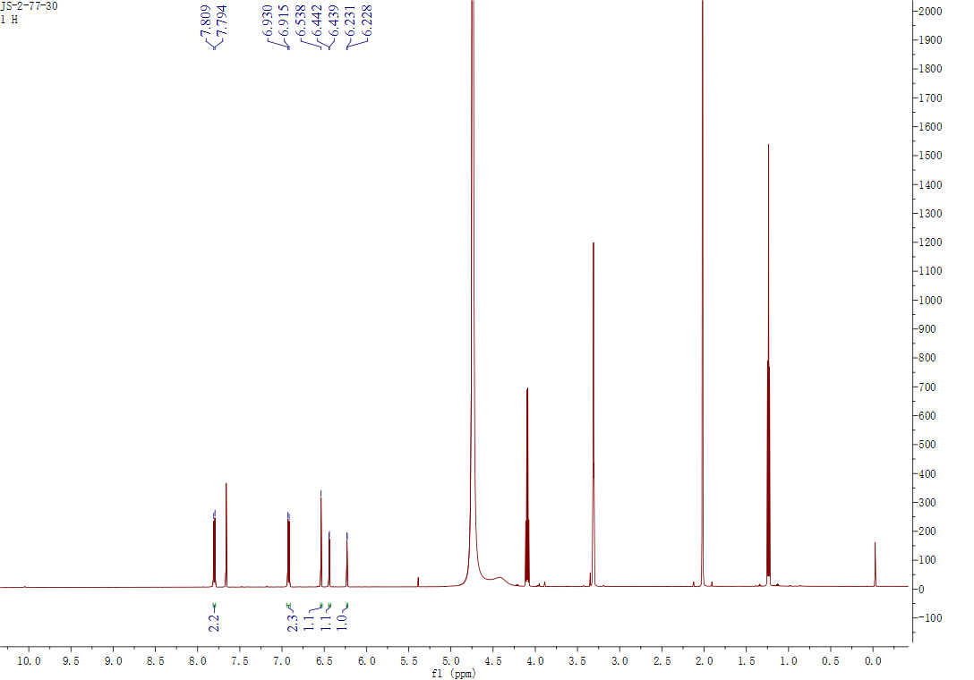

## Figure S67. The 1H NMR spectrum of **14** in CD3OD + CDCl3

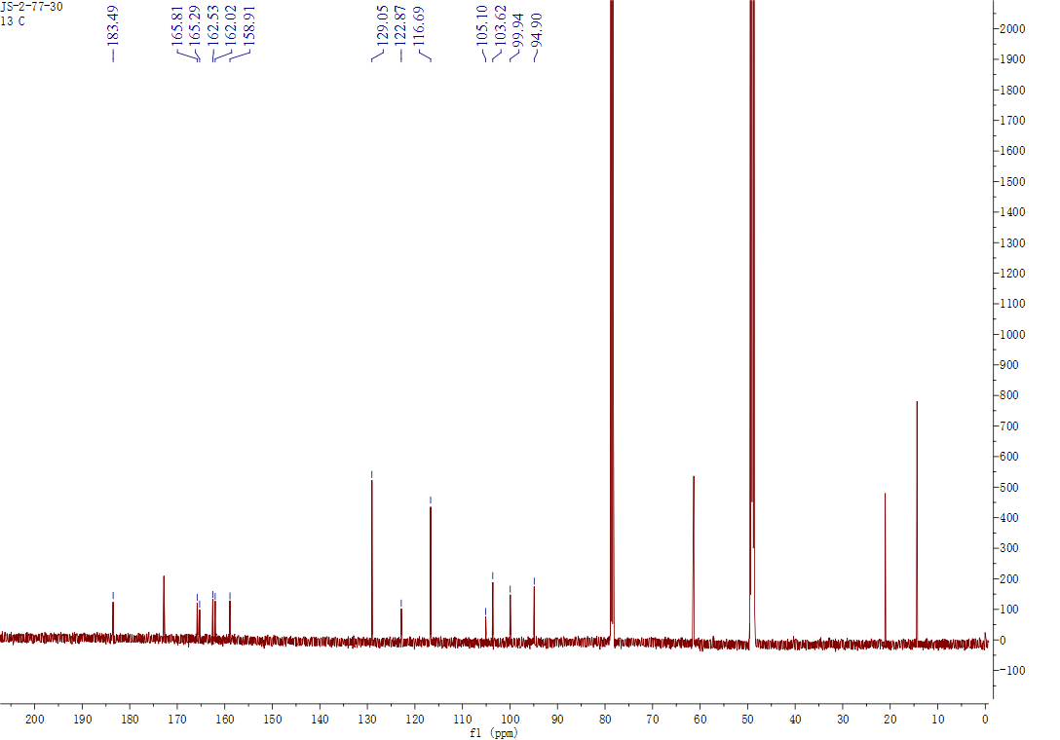

## Figure S68. The 13C NMR spectrum of **14** in CD3OD + CDCl3

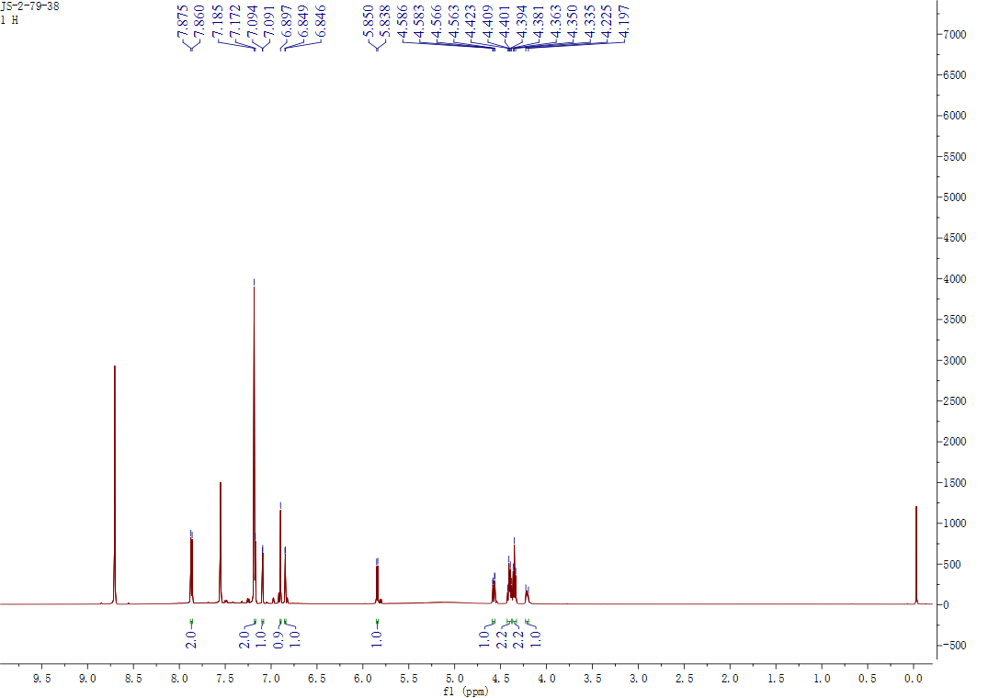

## Figure S69. The 1H NMR spectrum of **15** in pyridin-*d*5

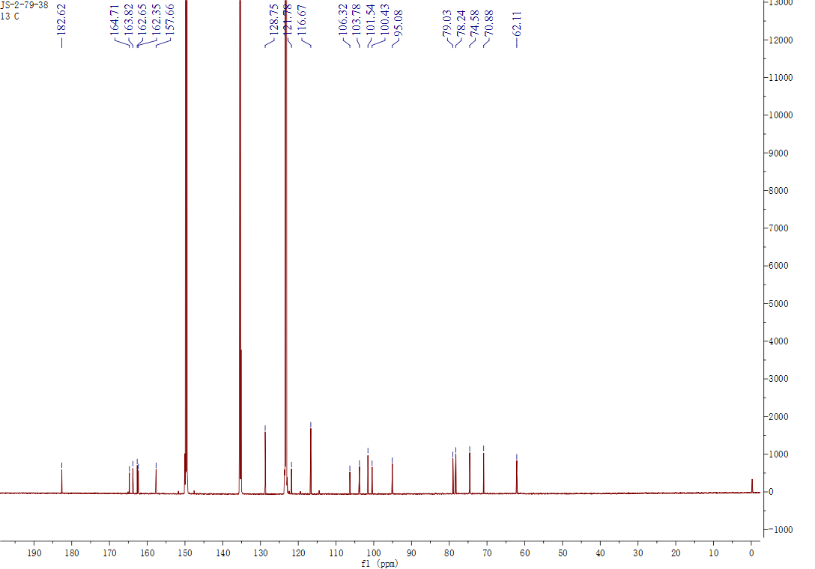

## Figure S70. The 13C NMR spectrum of **15** in pyridin-*d*5

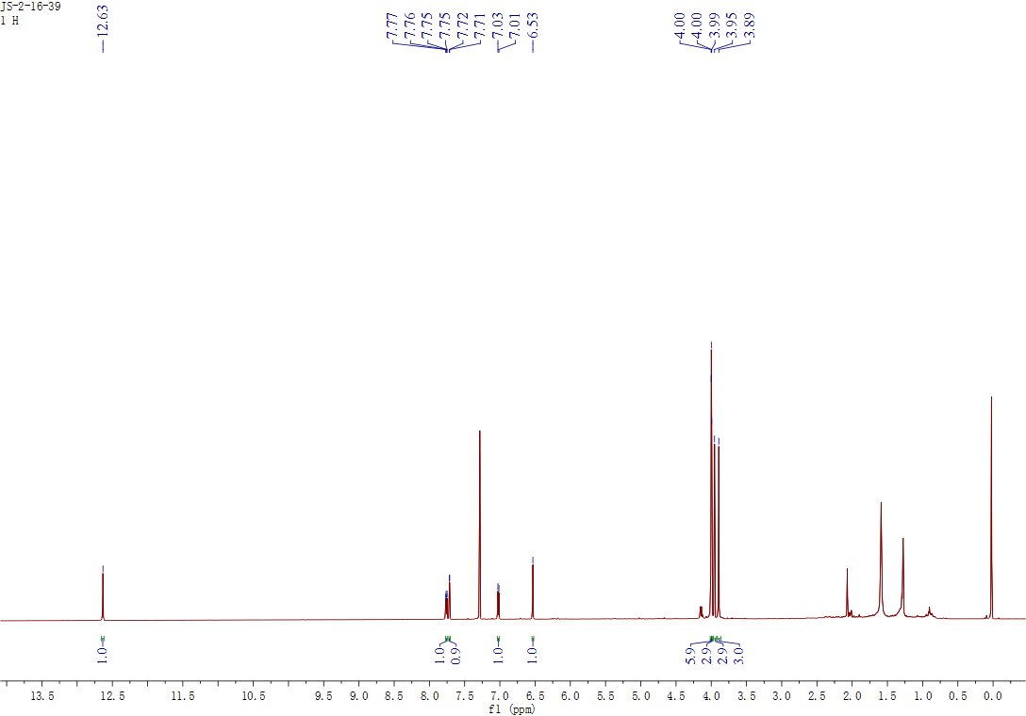

## Figure S71. The 1H NMR NMR spectrum of **16** in CDCl3

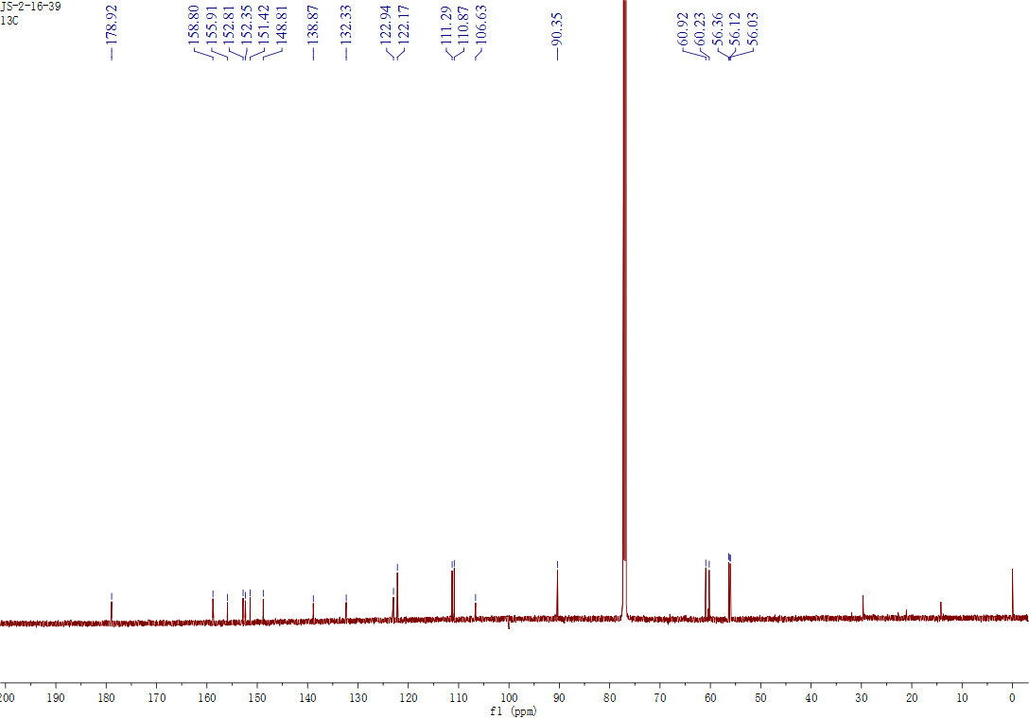

## Figure S72. The 13C NMR spectrum of **16** in CDCl3

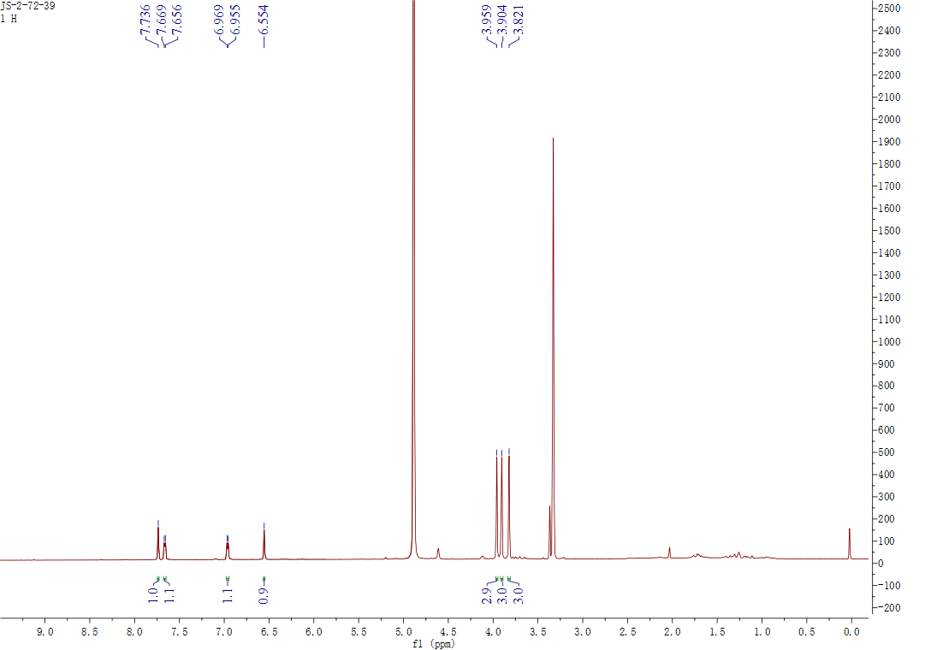

## Figure S73. The 1H NMR spectrum of **17** in CD3OD

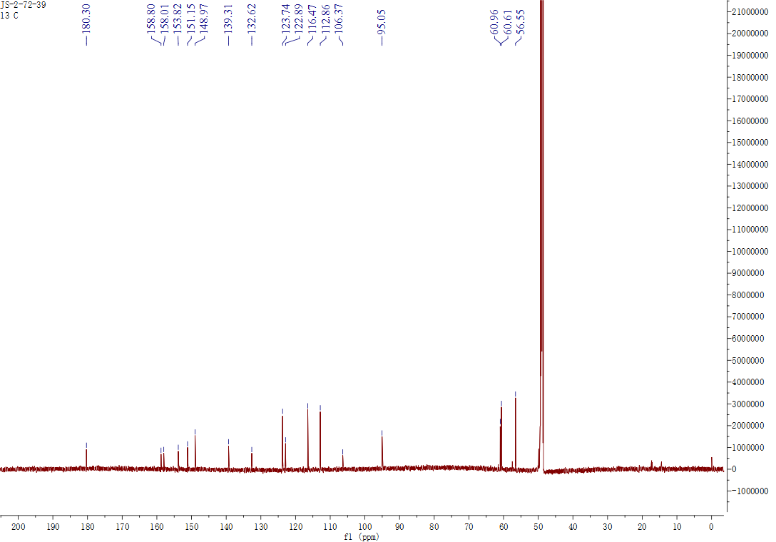

## Figure S74. The 13C NMR spectrum of **17** in CD3OD

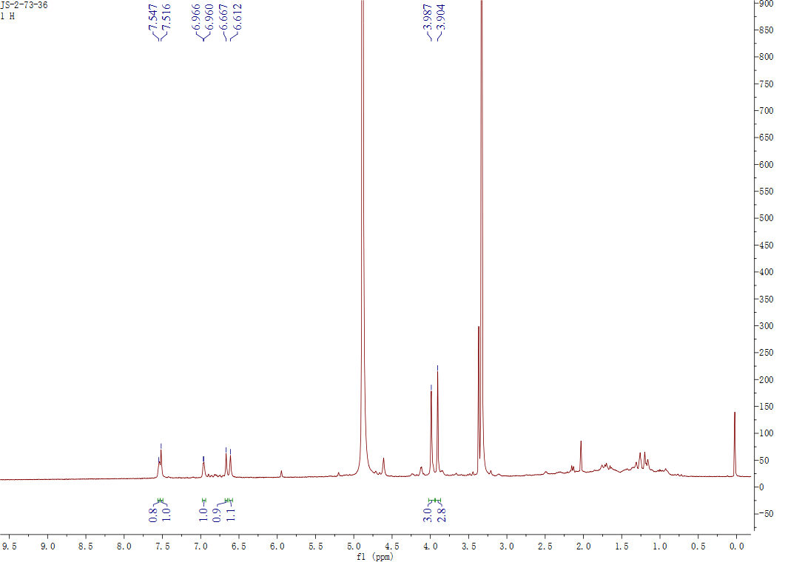

## Figure S75. The 1H NMR spectrum of **18** in CD3OD

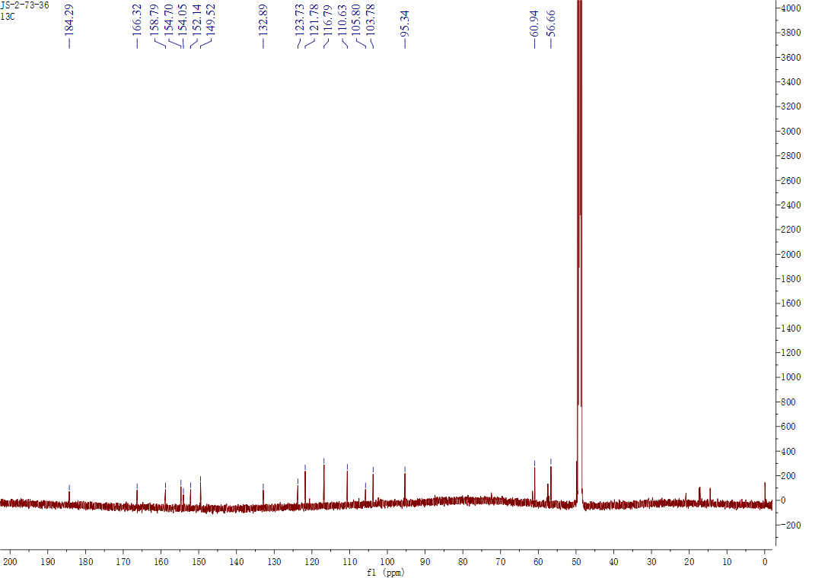

## Figure S76. The 13C NMR spectrum of **18** in CD3OD

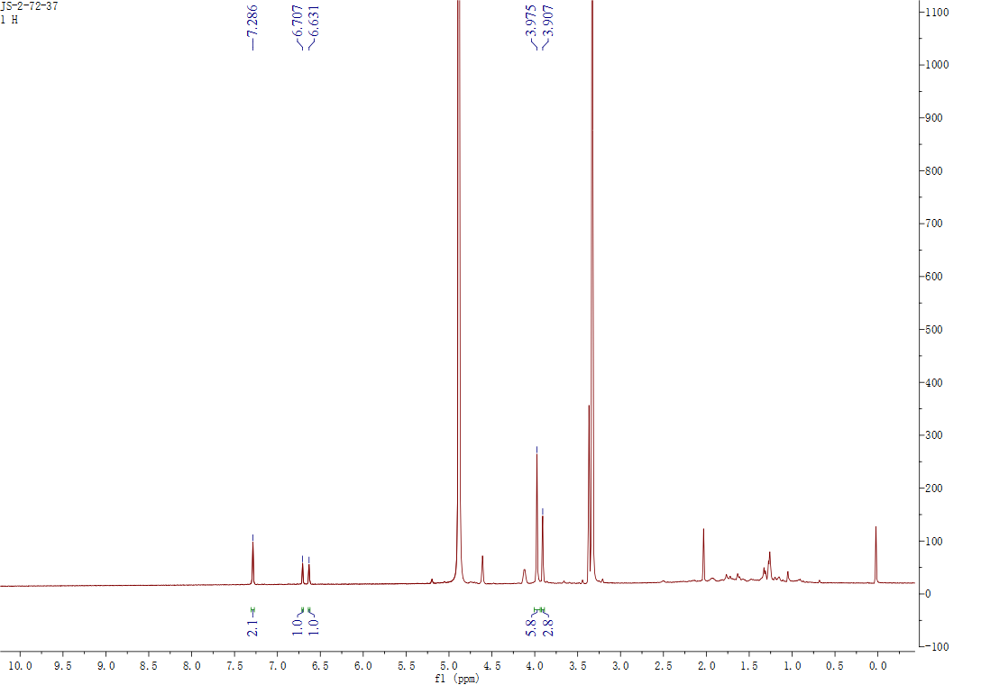

## Figure S77. The 1H NMR spectrum of **19** in CD3OD

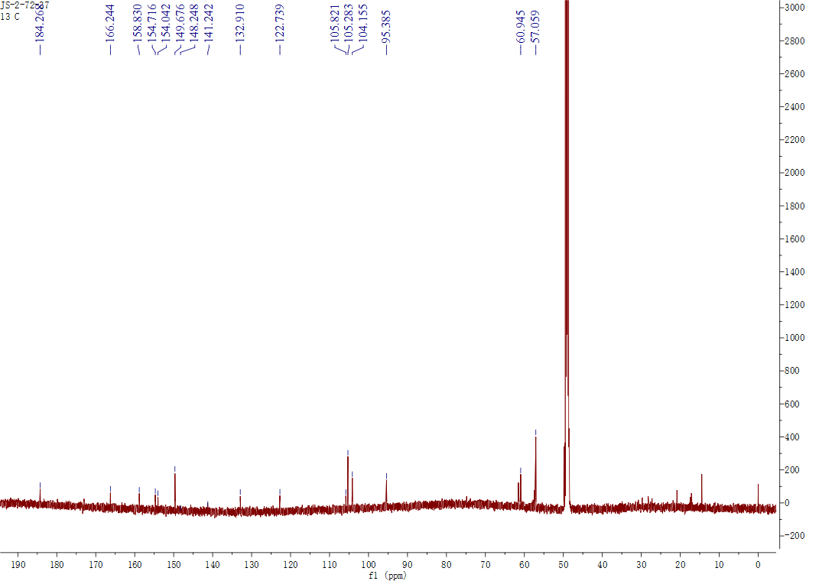

## Figure S78. The 13C NMR spectrum of **19** in CD3OD

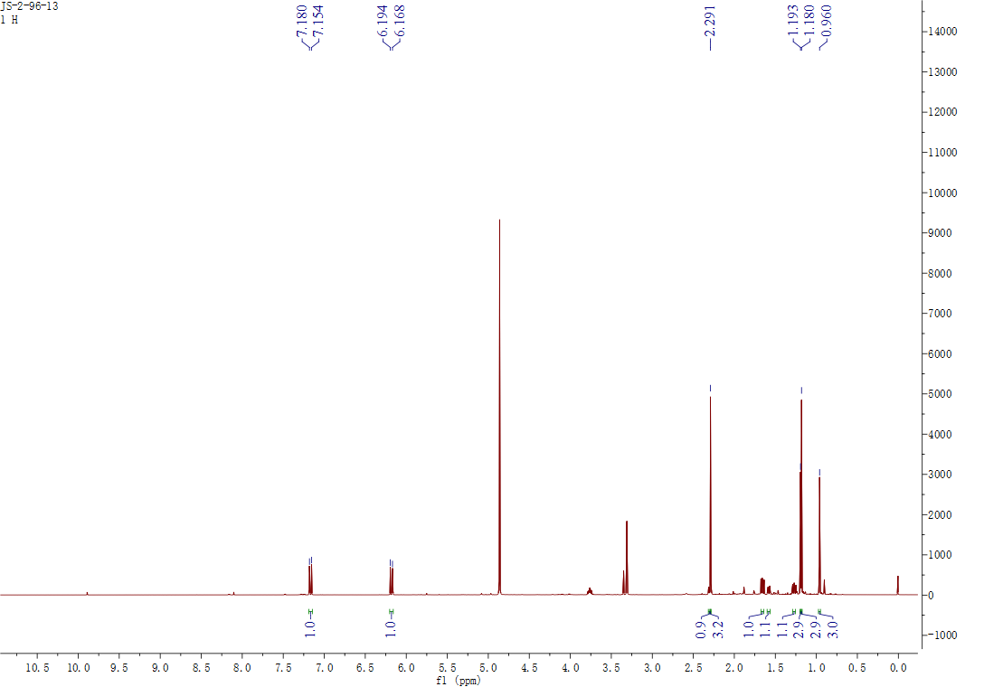

## Figure S79. The 1H NMR spectrum of **20** in CD3OD

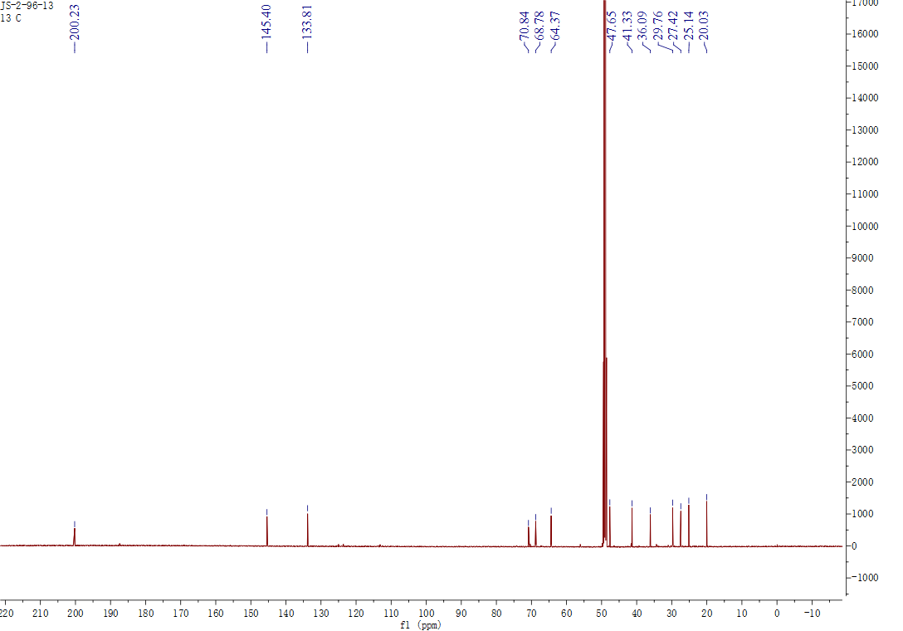

## Figure S80. The 13C NMR spectrum of **20** in CD3OD

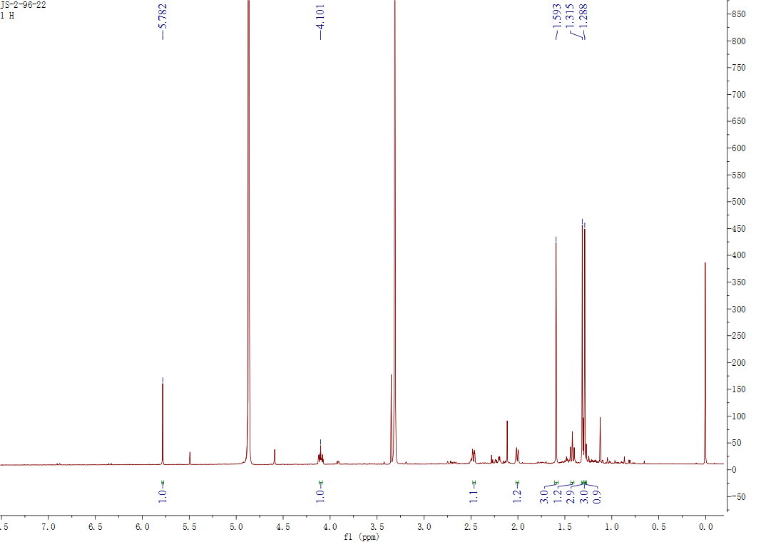

## Figure S81. The 1H NMR spectrum of **21** in CD3OD

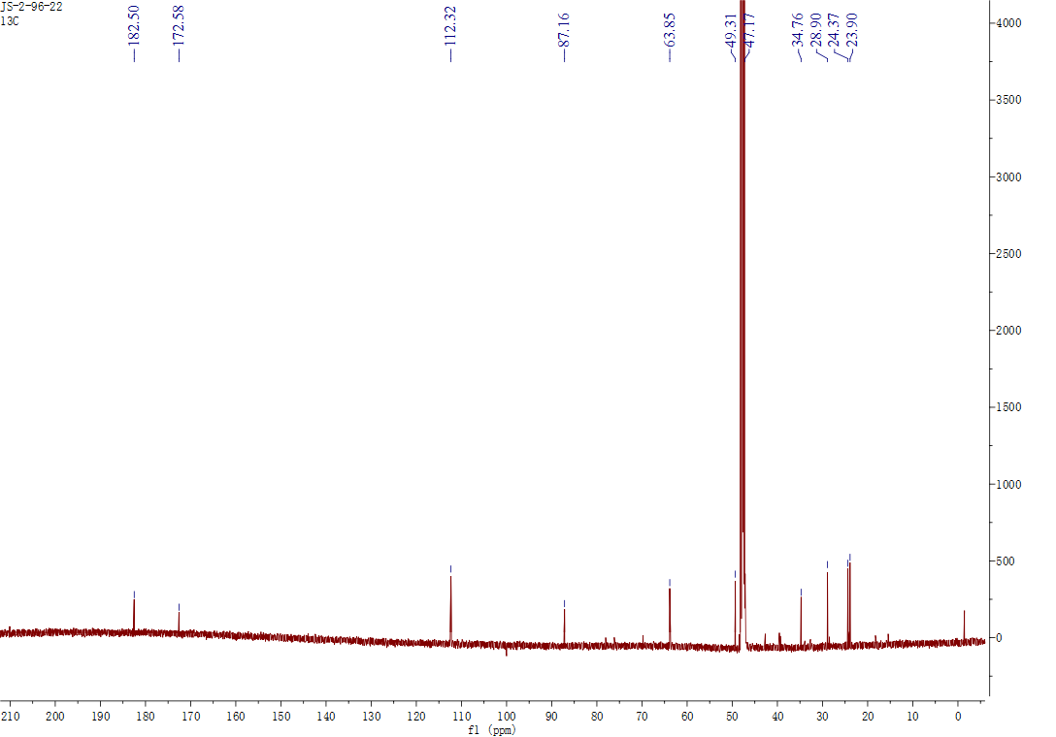

## Figure S82. The 13C NMR spectrum of **21** in CD3OD

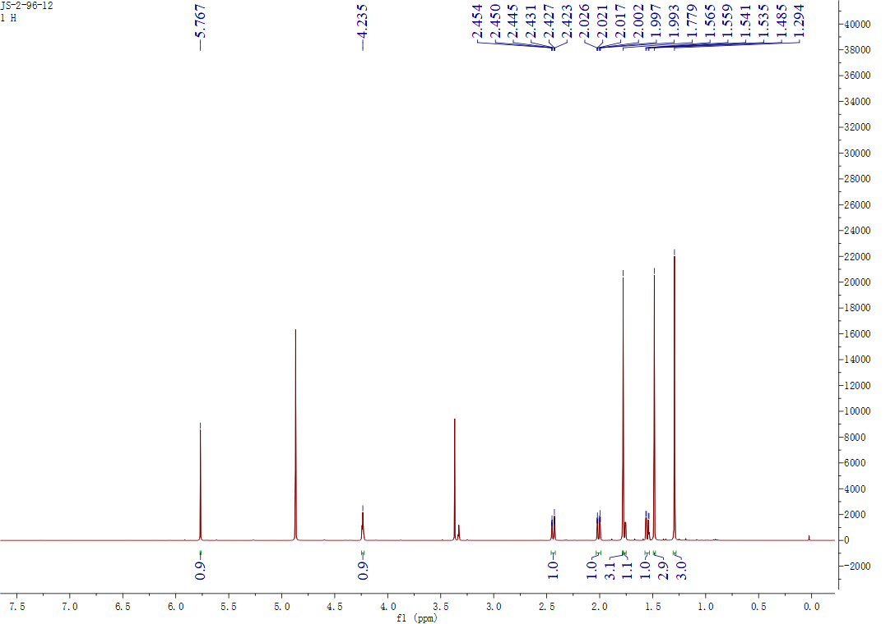

## Figure S83. The 1H NMR spectrum of **22** in CD3OD

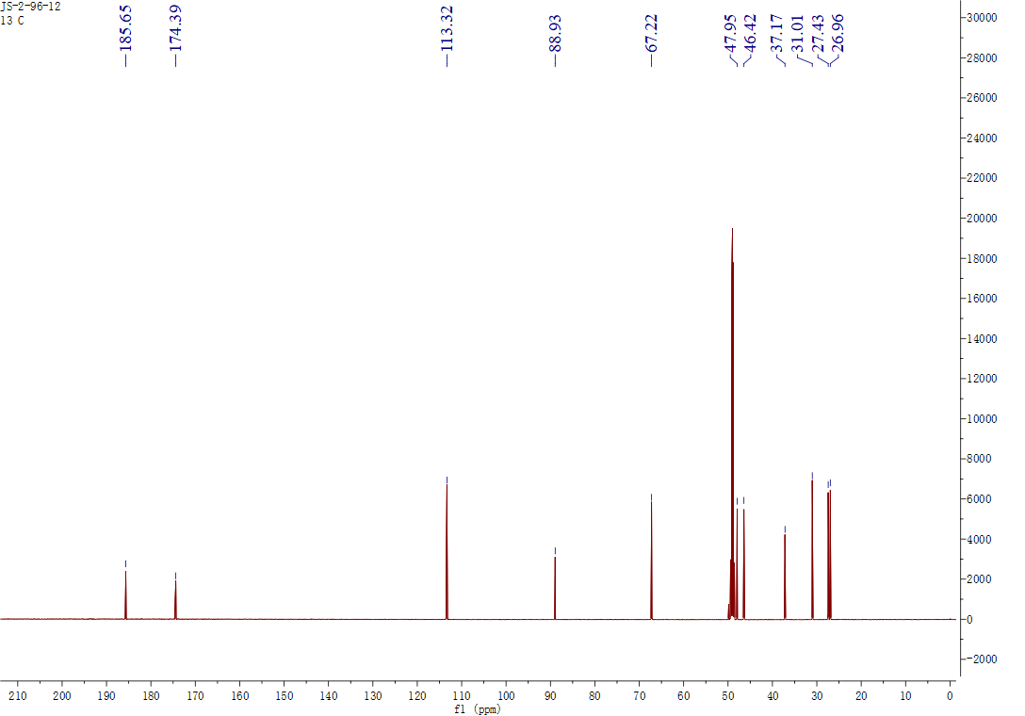

## Figure S84. The 13C NMR spectrum of **22** in CD3OD

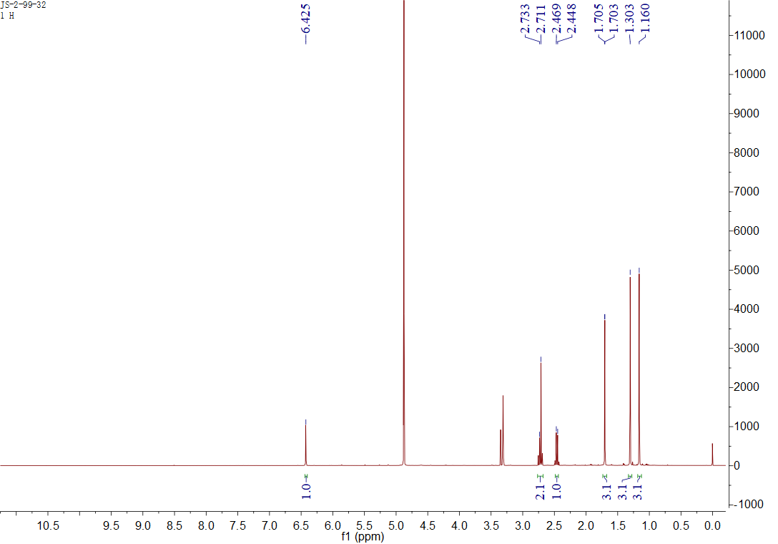

## Figure S85. The 1H NMR spectrum of **23** in CD3OD

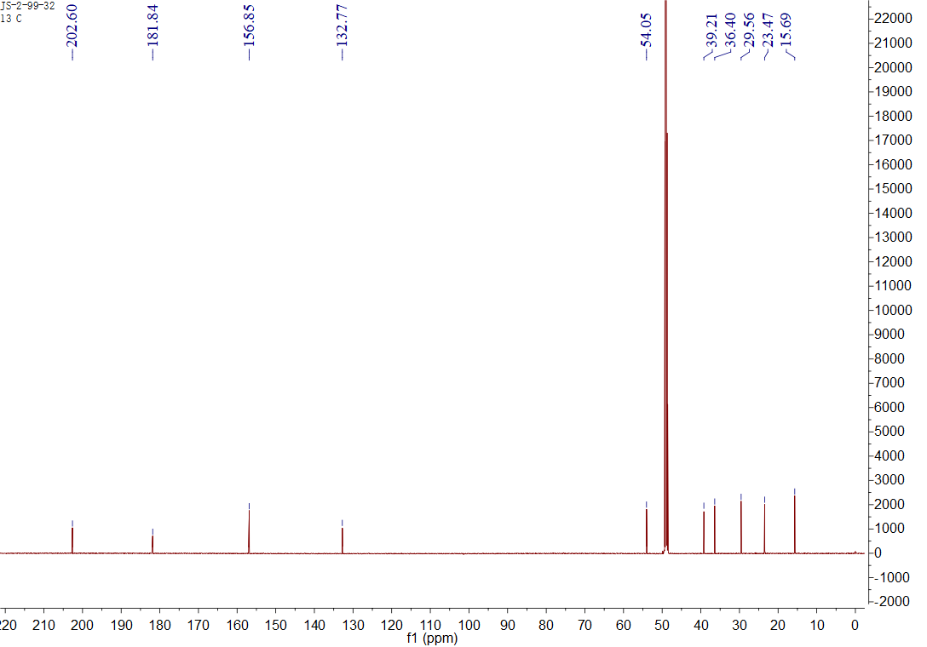

## Figure S86. The 13C NMR spectrum of **23** in CD3OD

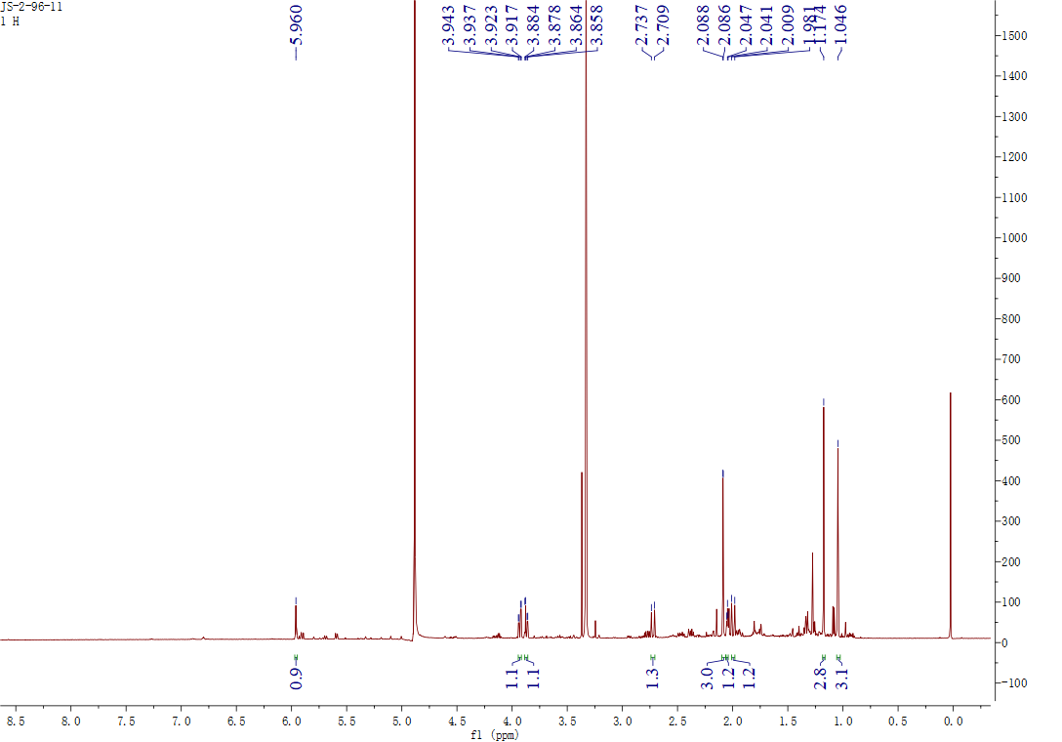

## Figure S87. The 1H NMR spectrum of **24** in CD3OD

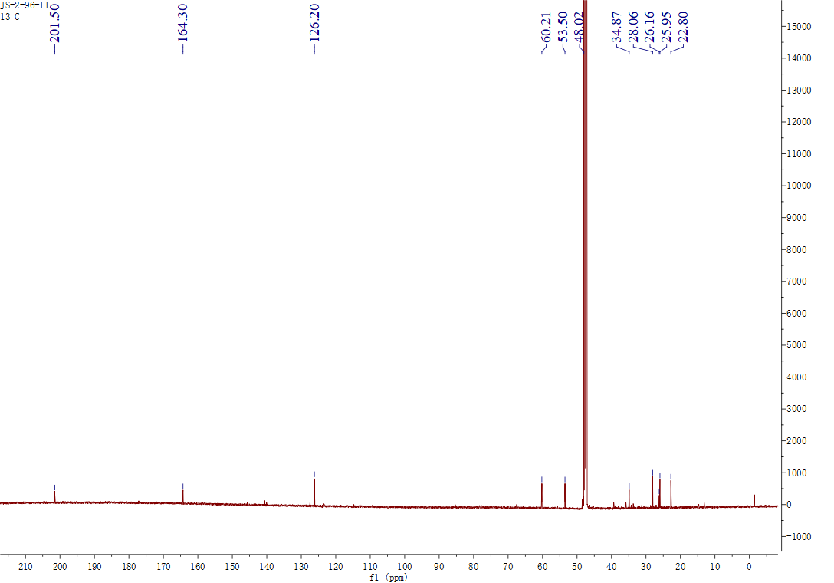

## Figure S88. The 13C NMR spectrum of **24** in CD3OD

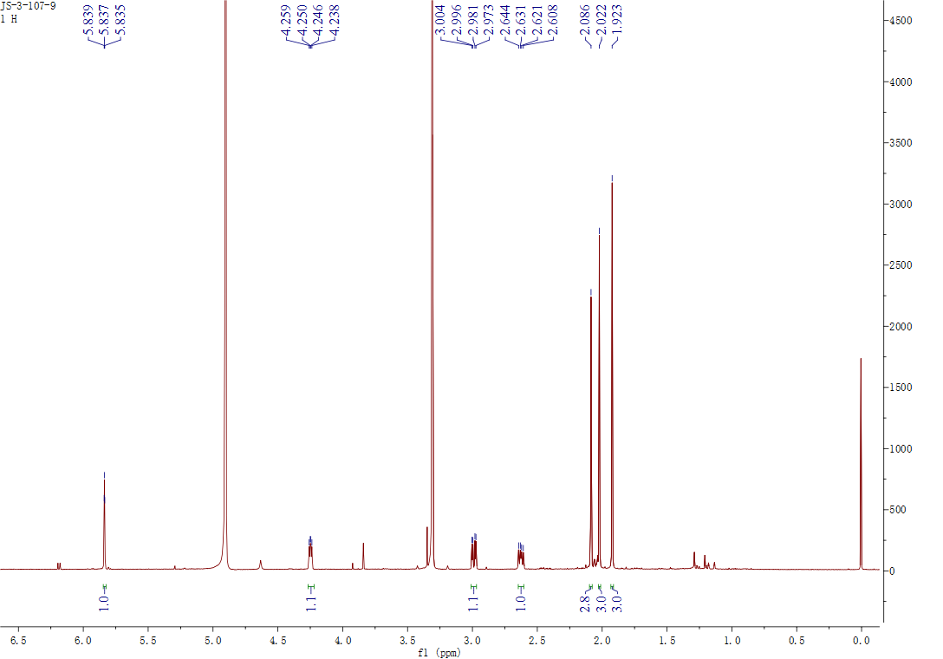

## Figure S89. The 1H NMR spectrum of **25** in CD3OD

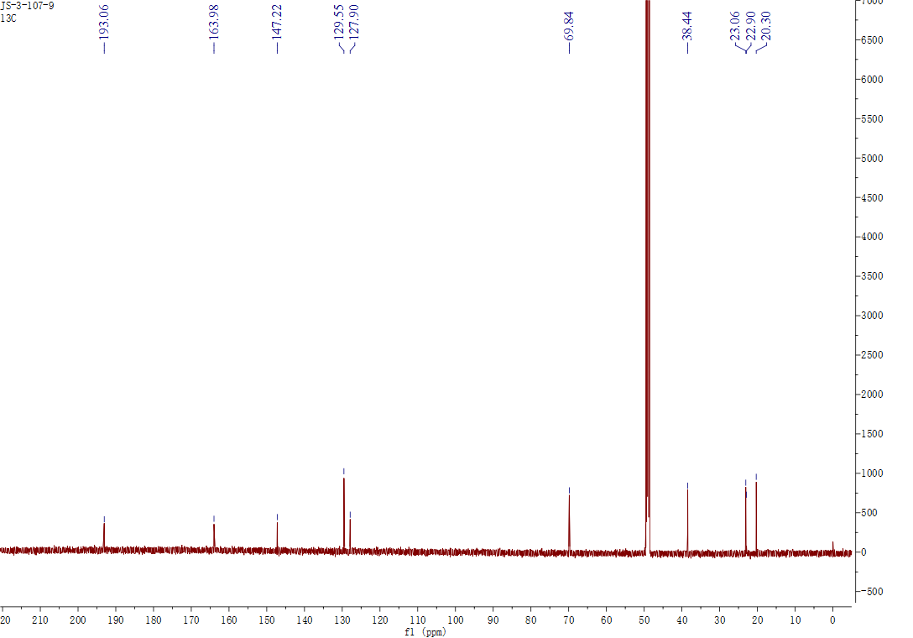

## Figure S90. The 13C NMR spectrum of **25** in CD3OD

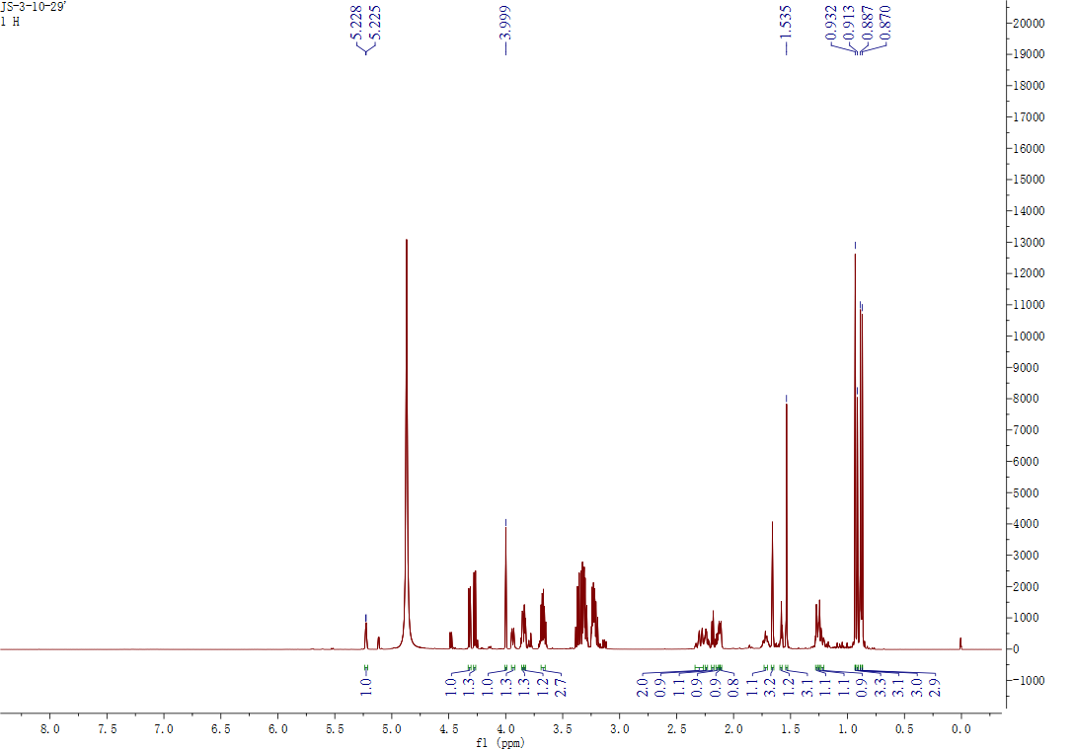

## Figure S91. The 1H NMR spectrum of **26** in CD3OD

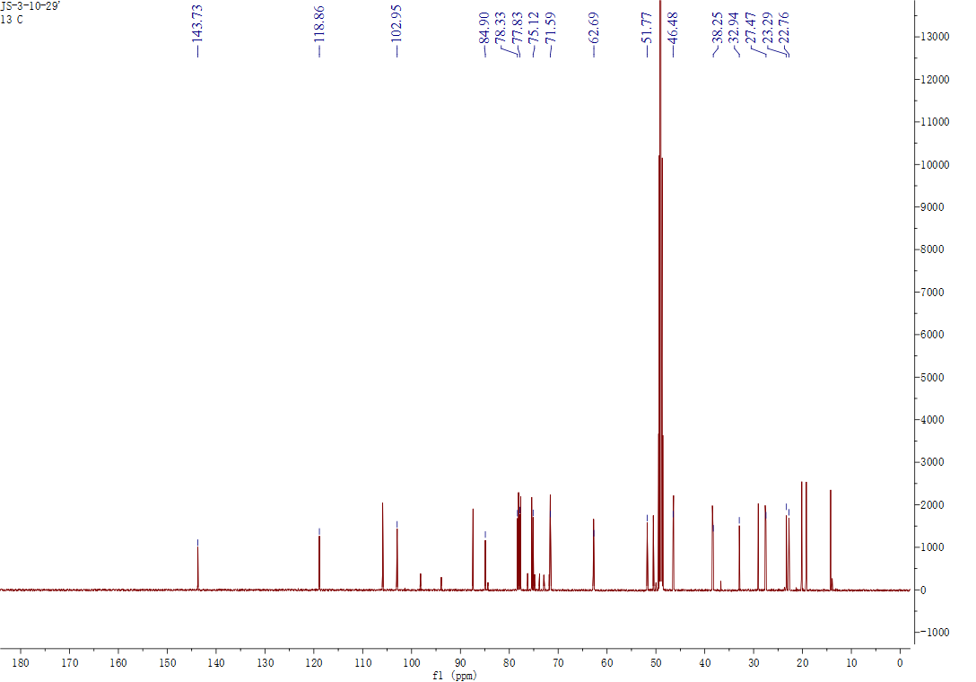

## Figure S92. The 13C NMR spectrum of **26** in CD3OD



## Figure S93. The 1H NMR spectrum of **27** in CD3OD

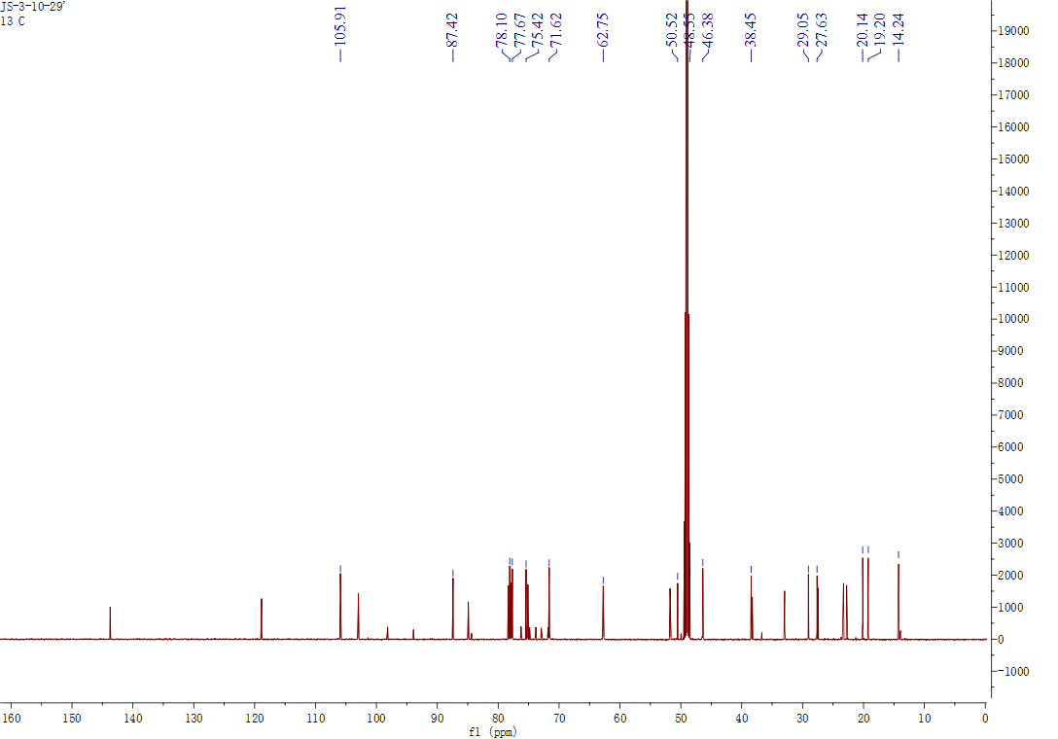

## Figure S94. The 13C NMR spectrum of **27** in CD3OD

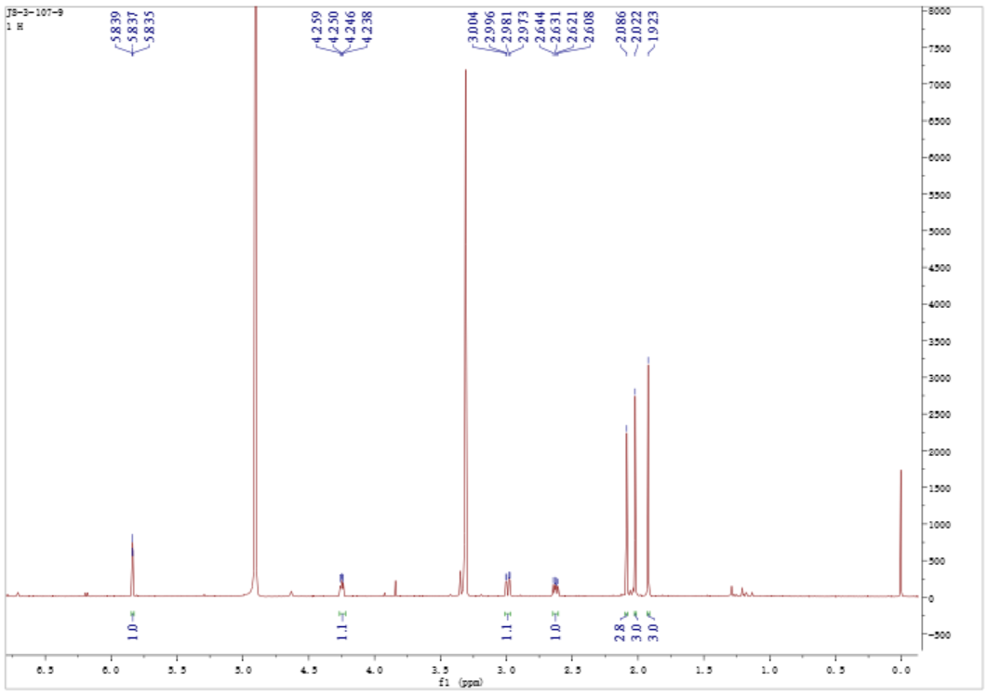

## Figure S95. The 1H NMR spectrum of **28** in CD3OD

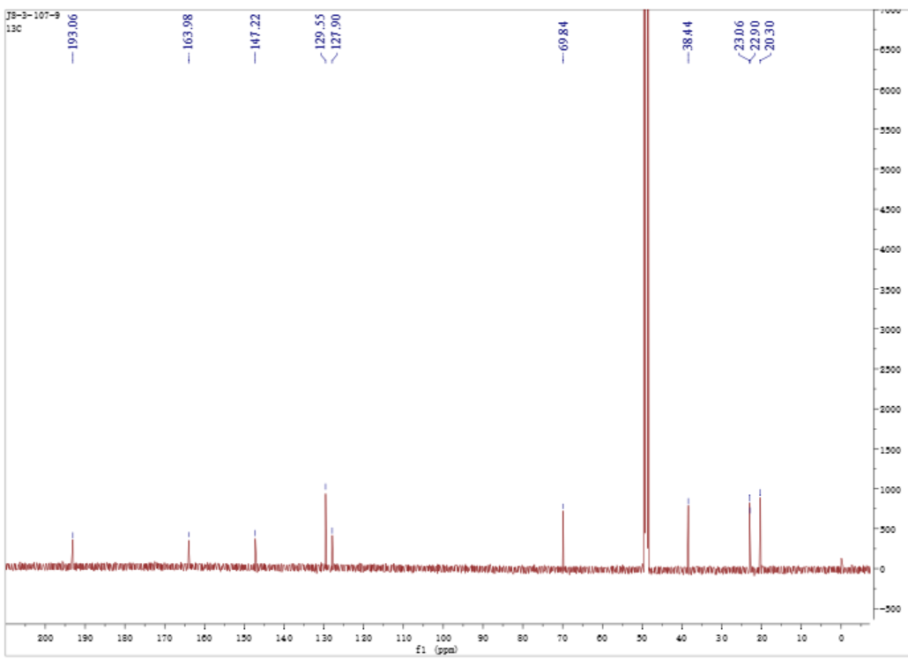

## Figure S96. The 13C NMR spectrum of **28** in CD3OD

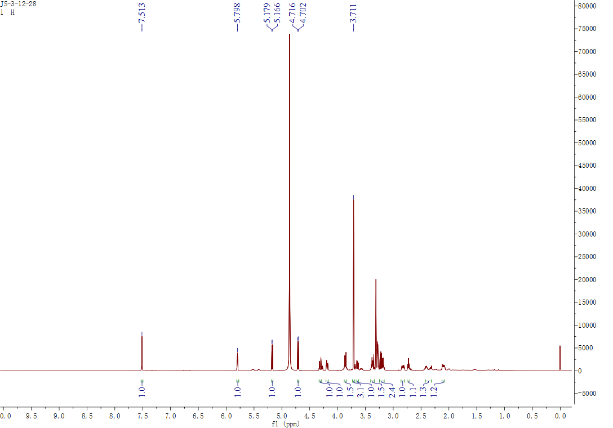

## Figure S97. The 1H NMR spectrum of **29** in CD3OD

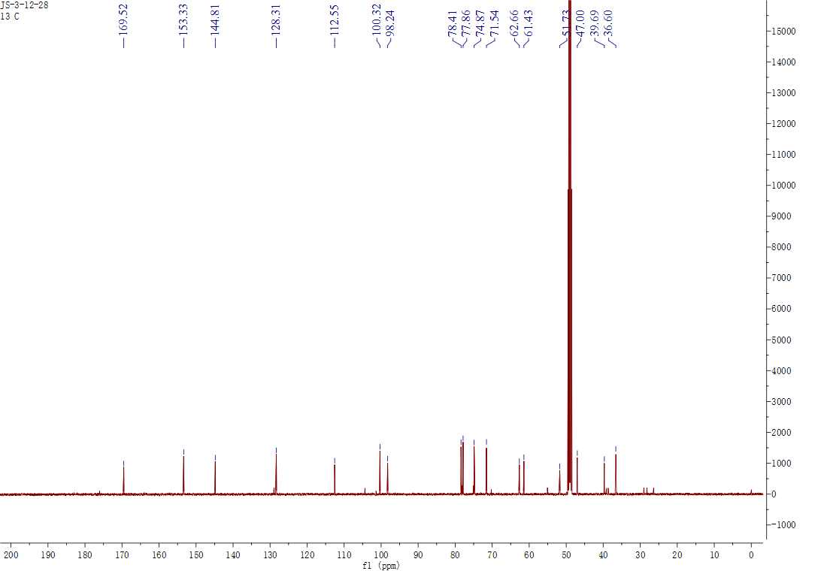

## Figure S98. The 13C NMR spectrum of **29** in CD3OD

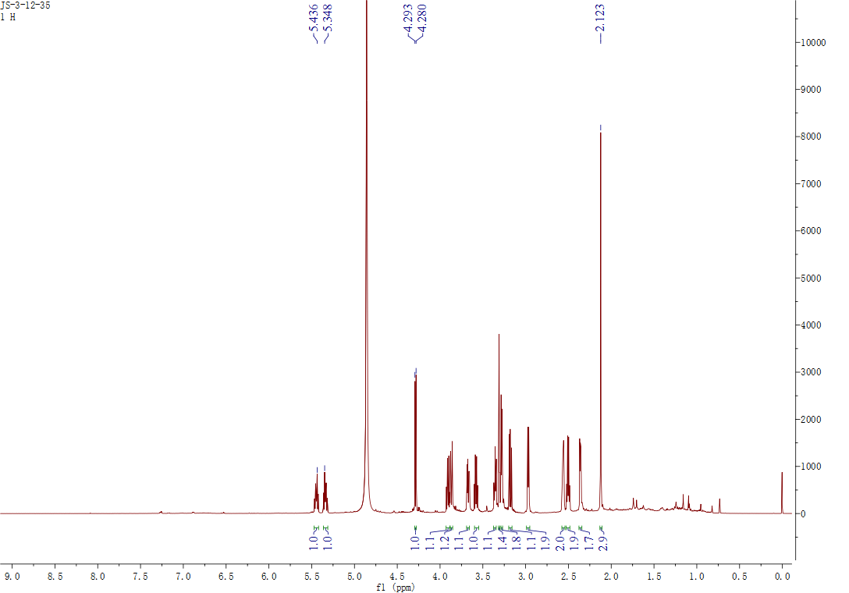

## Figure S99. The 1H NMR spectrum of **30** in CD3OD

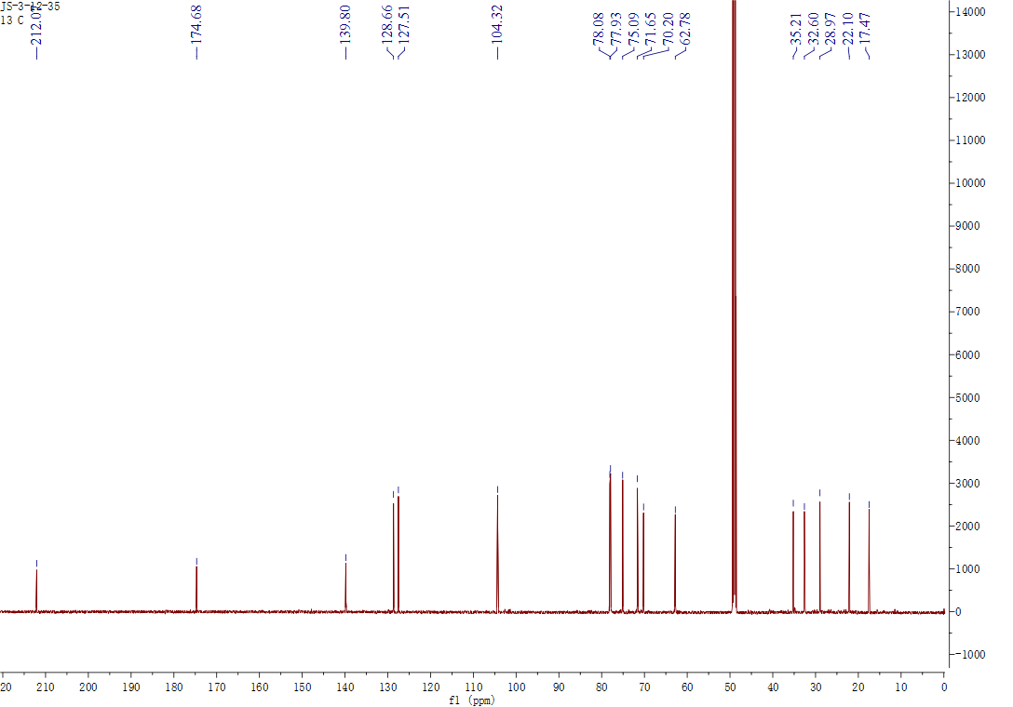

## Figure S100. The 13C NMR spectrum of **30** in CD3OD

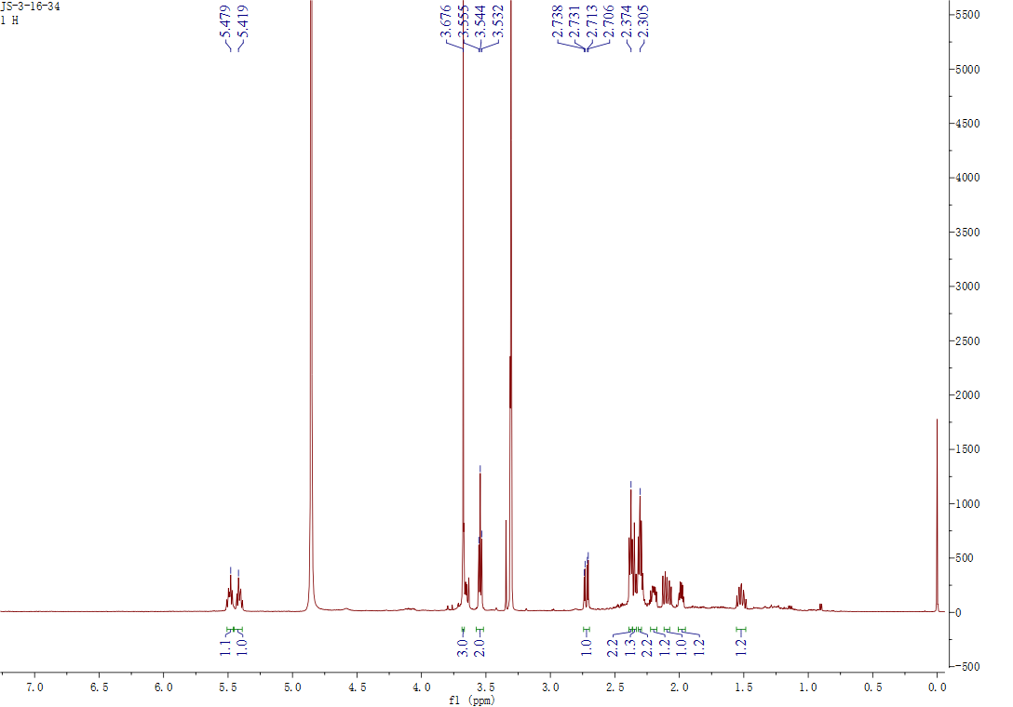

## Figure S101. The 1H NMR spectrum of **32** in CD3OD

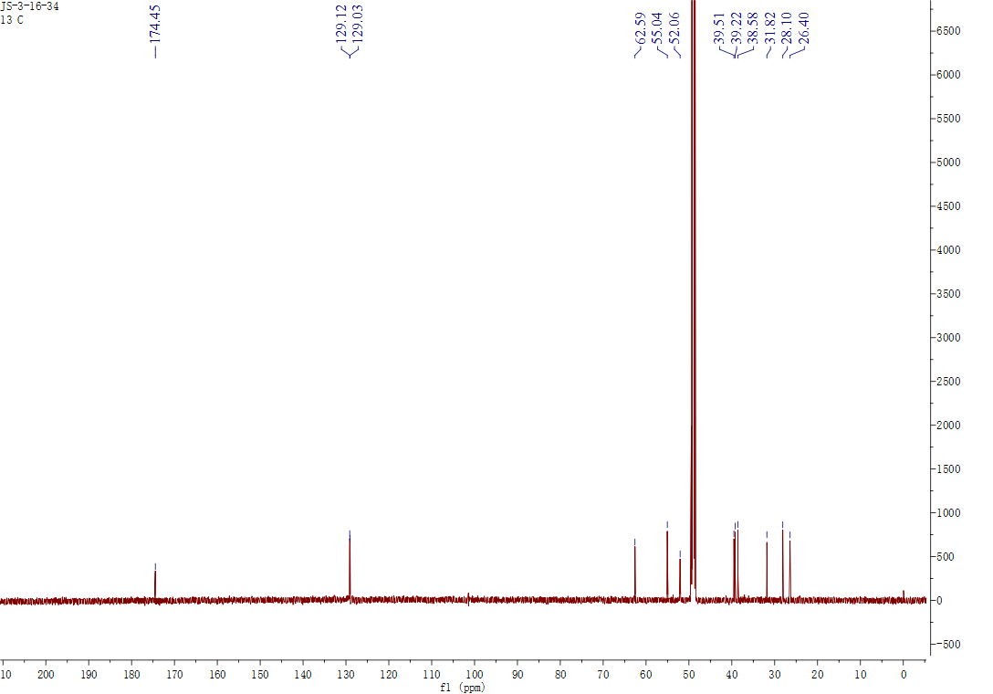

## Figure S102. The 13C NMR spectrum of **32** in CD3OD

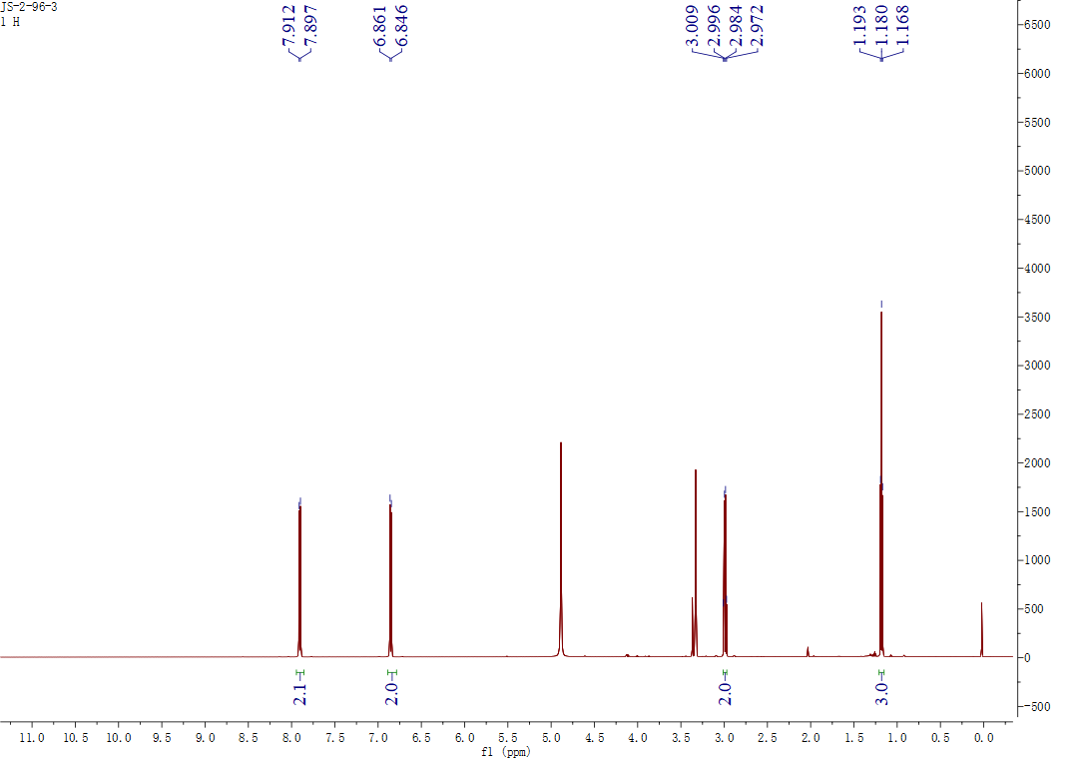

## Figure S103. The 1H NMR spectrum of **33** in CD3OD

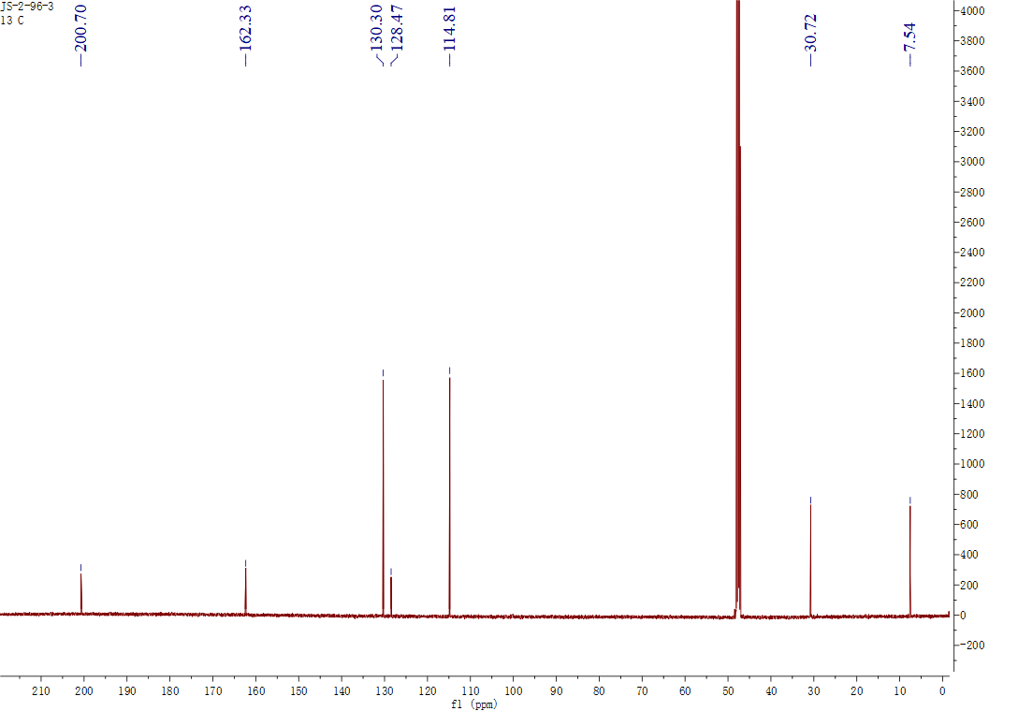

## Figure S104. The 13C NMR spectrum of **33** in CD3OD

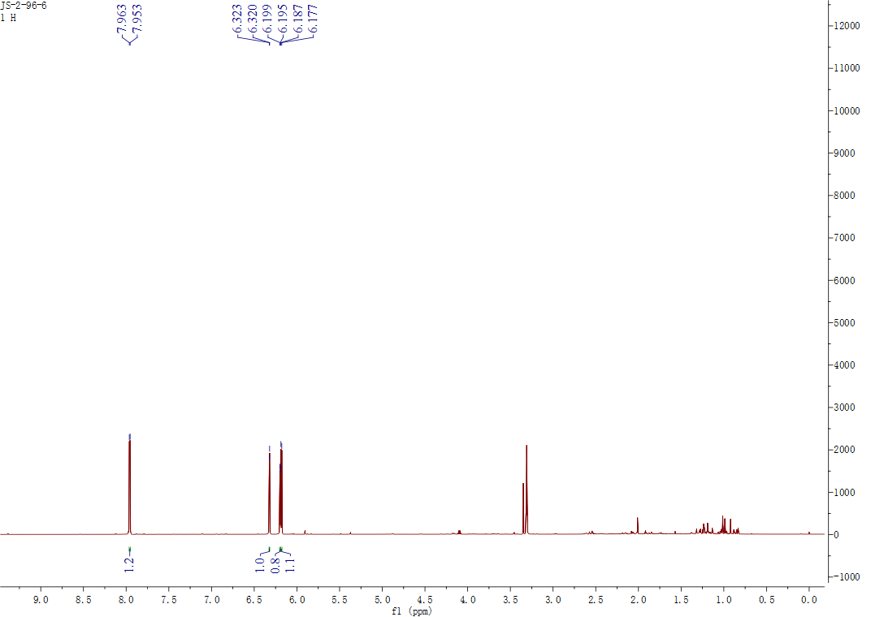

## Figure S105. The 1H NMR spectrum of **34** in CD3OD

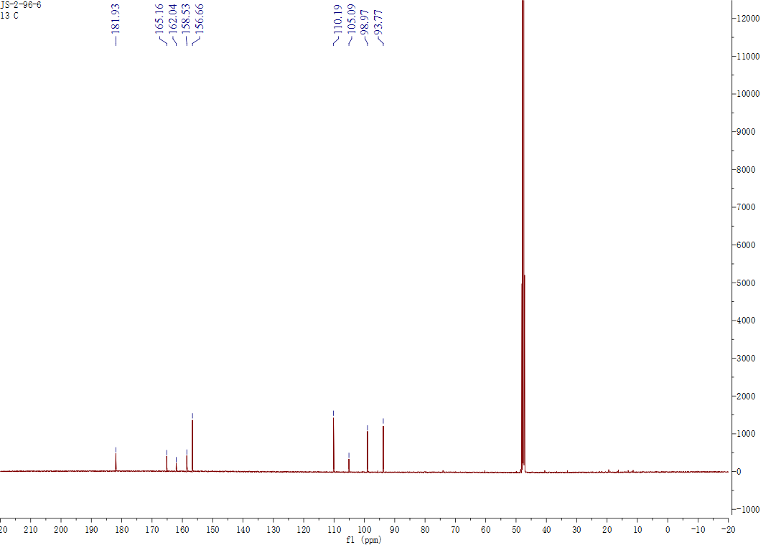

## Figure S106. The 13C NMR spectrum of **34** in CD3OD

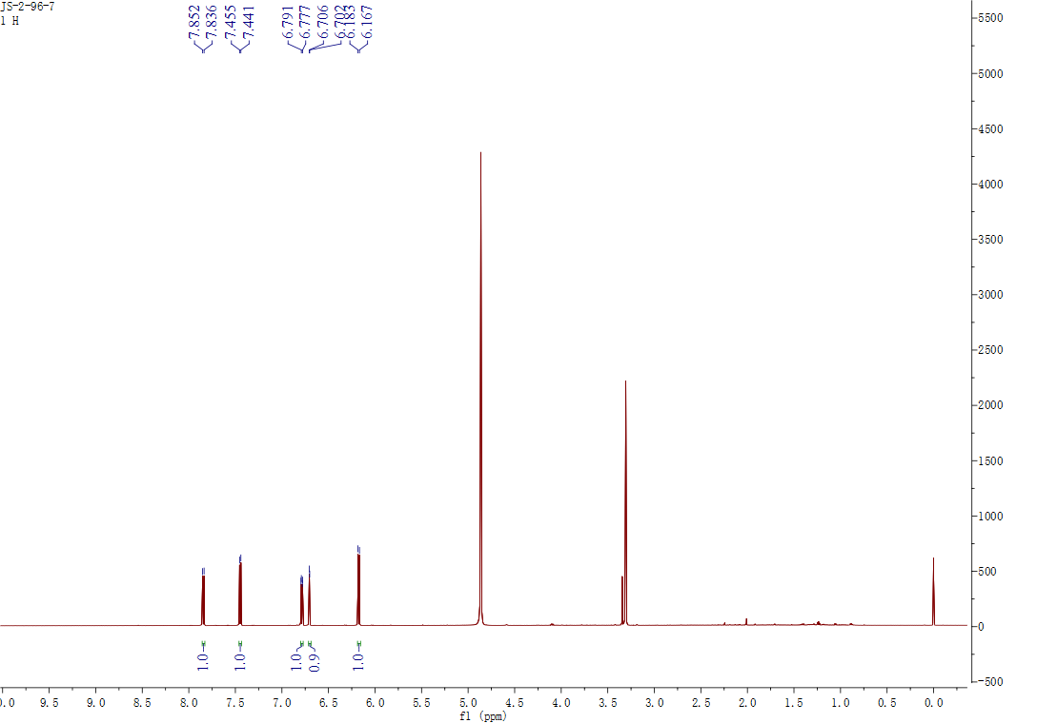

## Figure S107. The 1H NMR spectrum of **35** in CD3OD

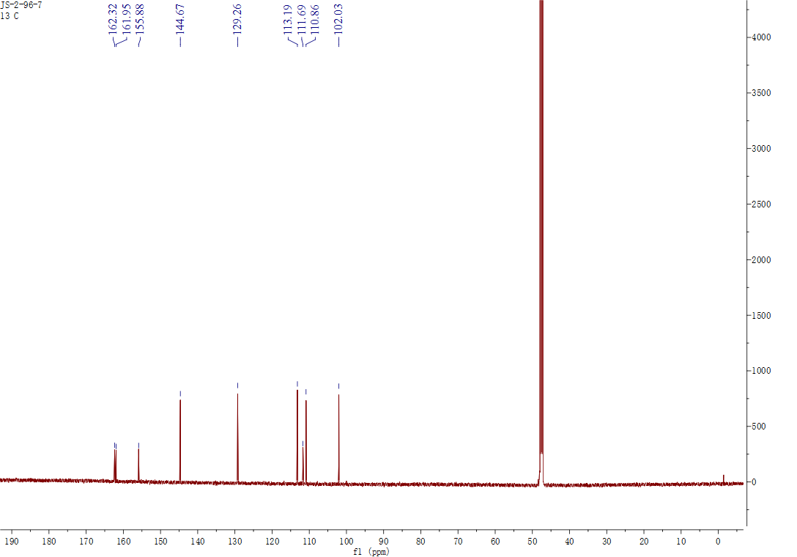

## Figure S108. The 13C NMR spectrum of **35** in CD3OD

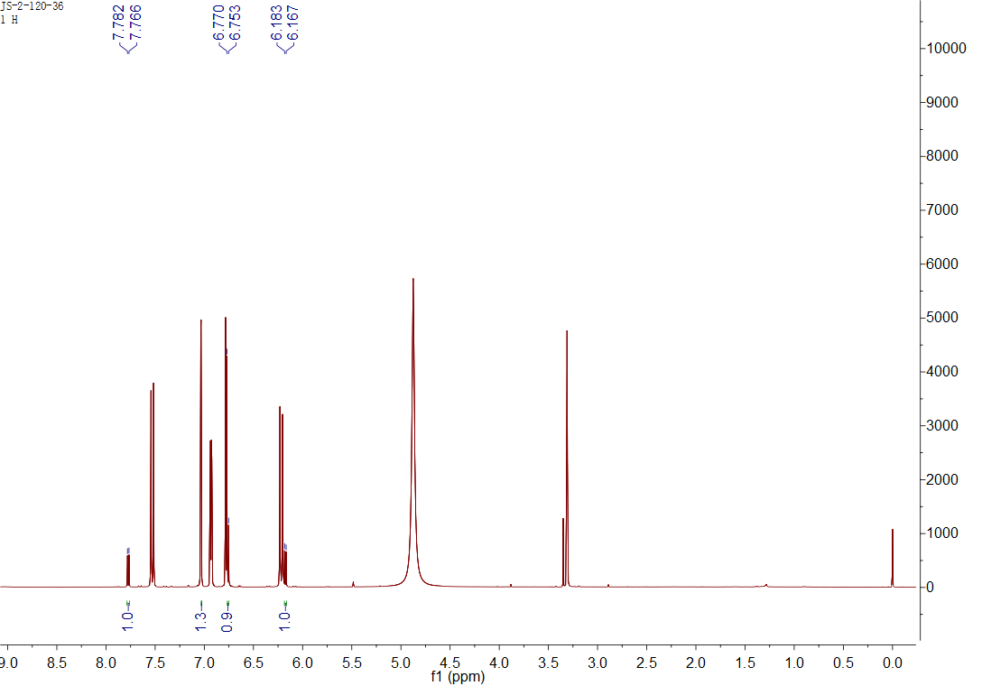

## Figure S109. The 1H NMR spectrum of **36** in CD3OD

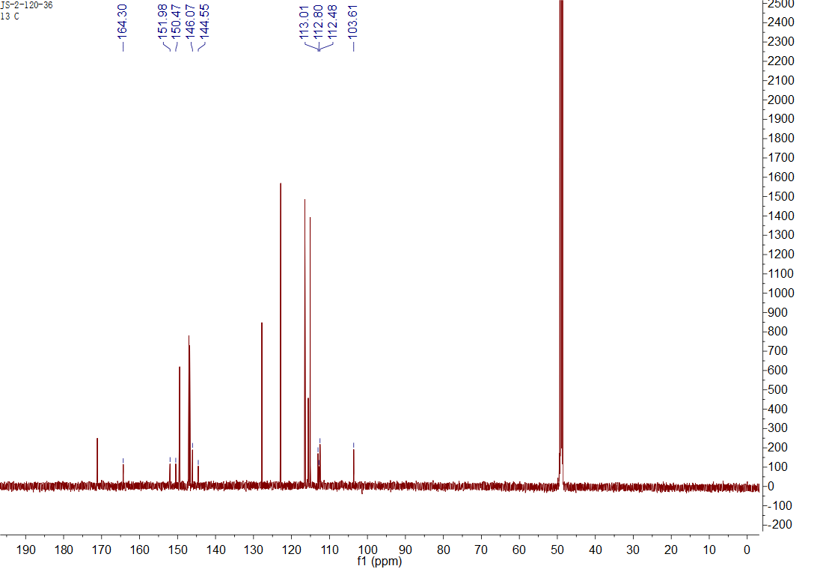

Figure S110. The 13C NMR spectrum of **36** in CD3OD

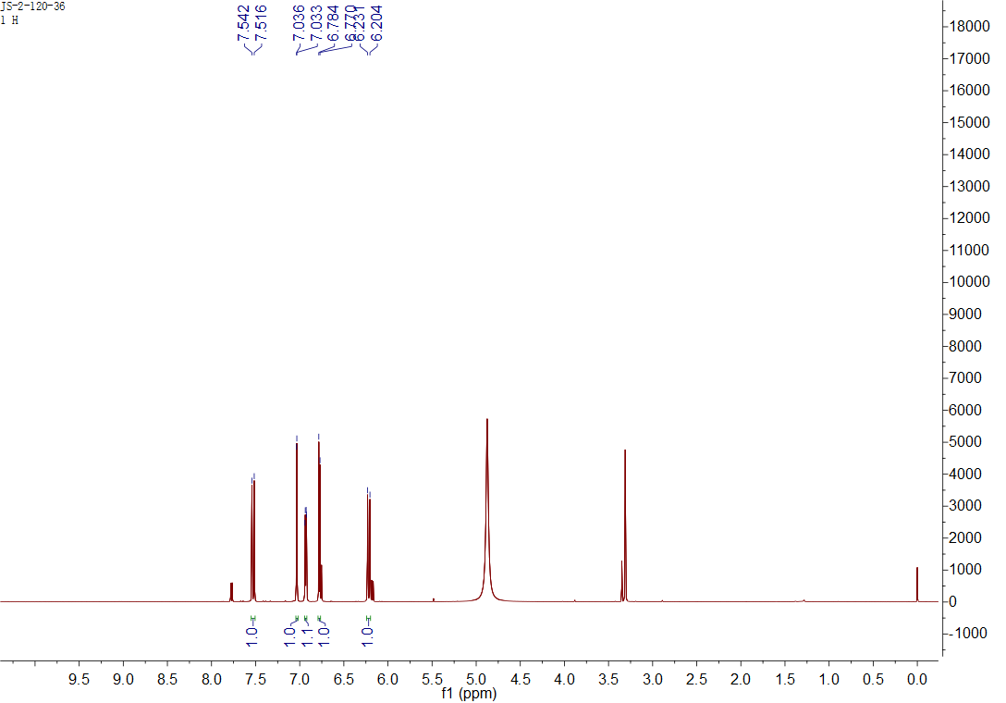

## Figure S111. The 1H NMR spectrum of **37** in CD3OD

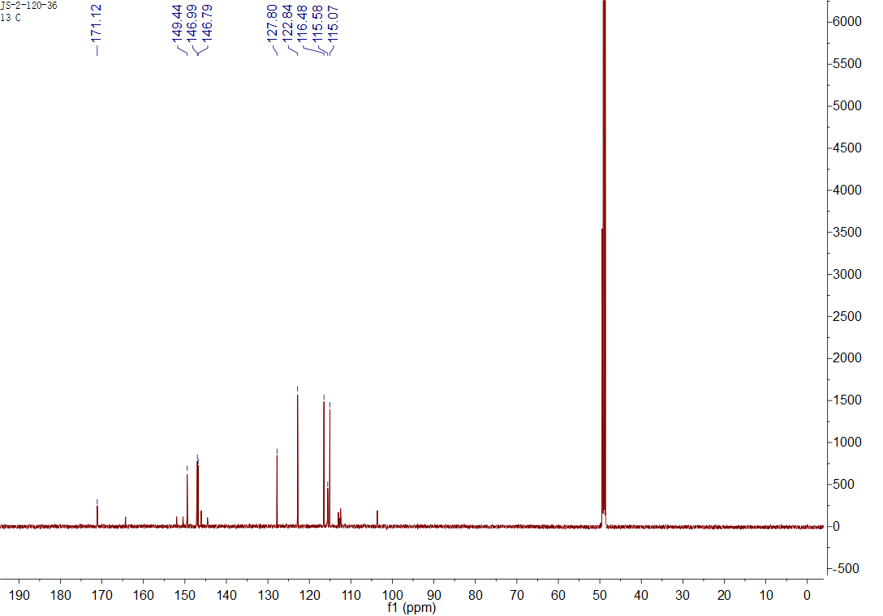

## Figure S112. The 13C NMR spectrum of **37** in CD3OD

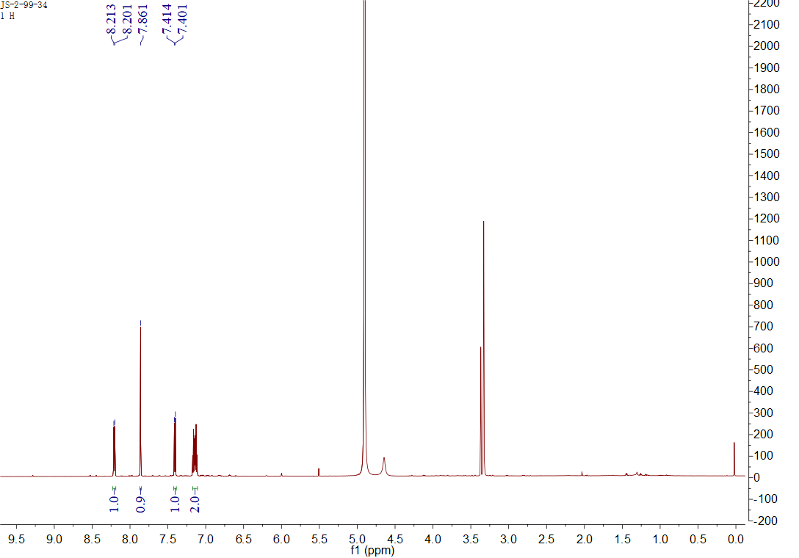

## Figure S113. The 1H NMR spectrum of **38** in CD3OD

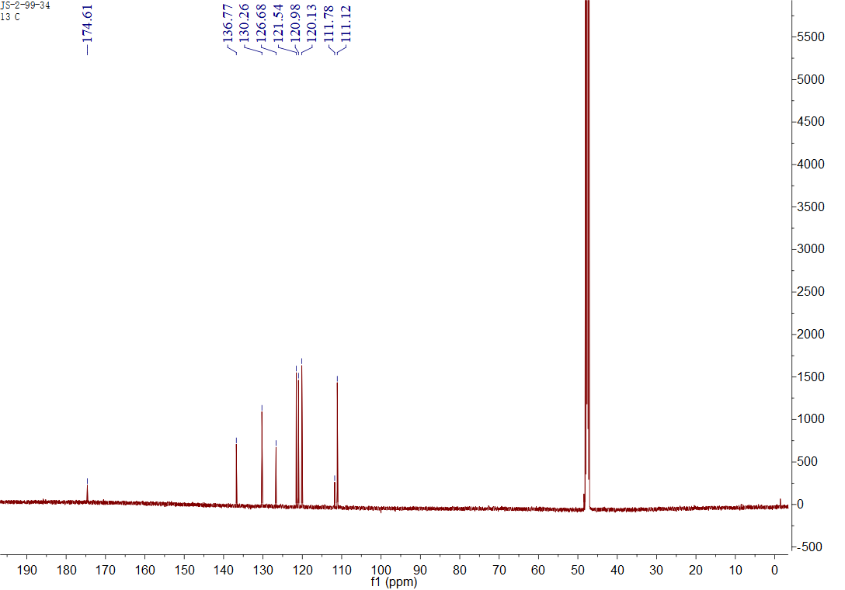

## Figure S114. The 13C NMR spectrum of **38** in CD3OD

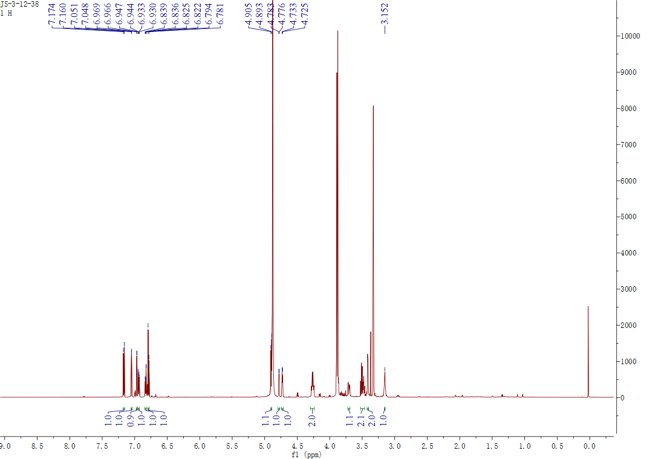

## Figure S115. The 1H NMR spectrum of **39** in CD3OD

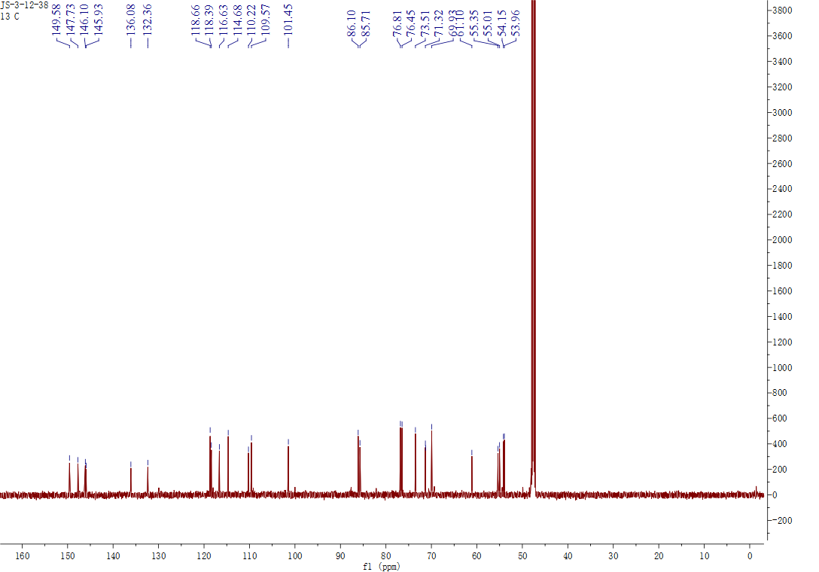

## Figure S116. The 13C NMR spectrum of **39** in CD3OD

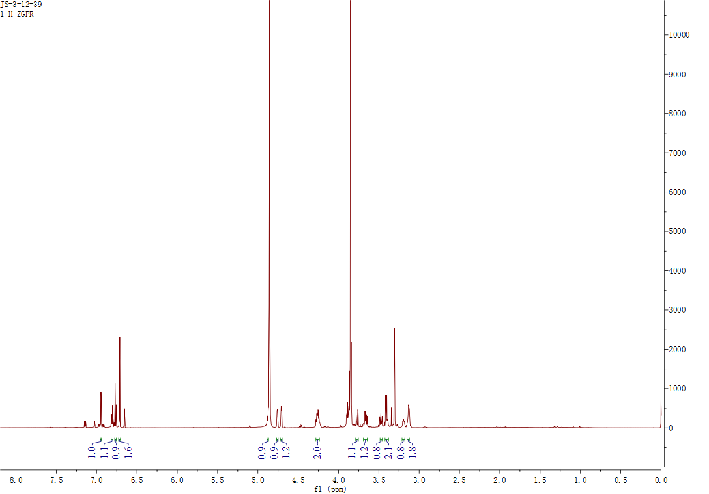

## Figure S117. The 1H NMR spectrum of **40** in CD3OD

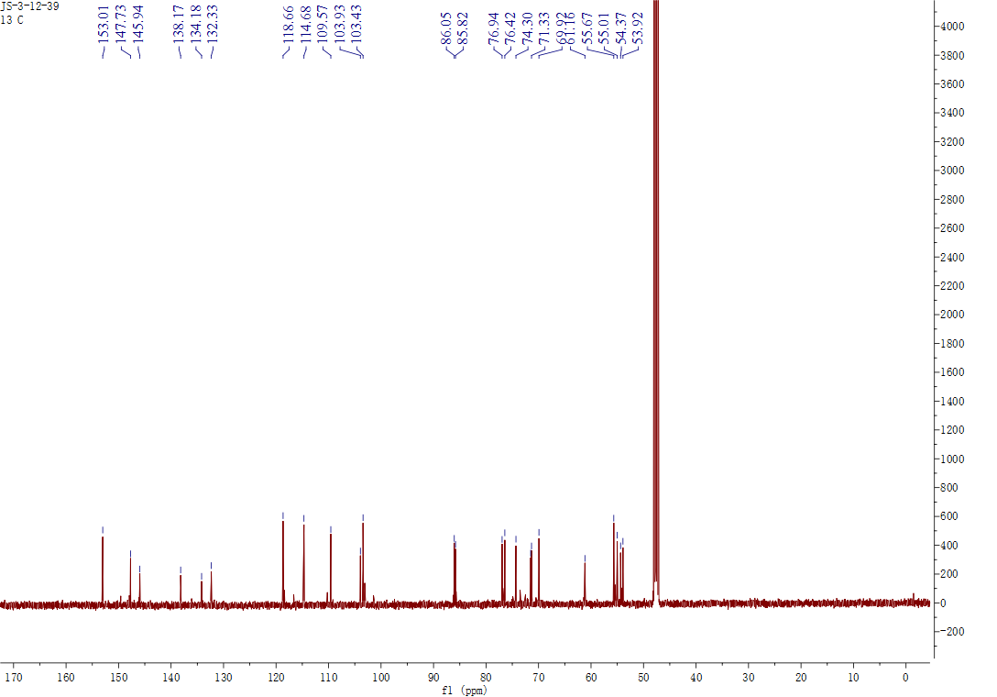

## Figure S118. The 13C NMR spectrum of **40** in CD3OD

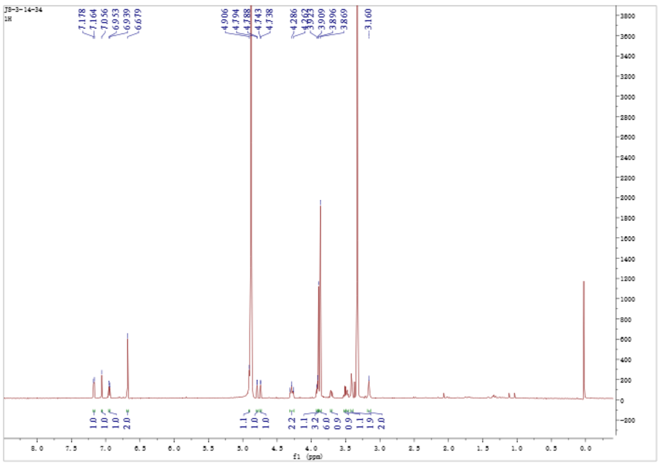

## Figure S119. The 1H NMR spectrum of **41** in CD3OD

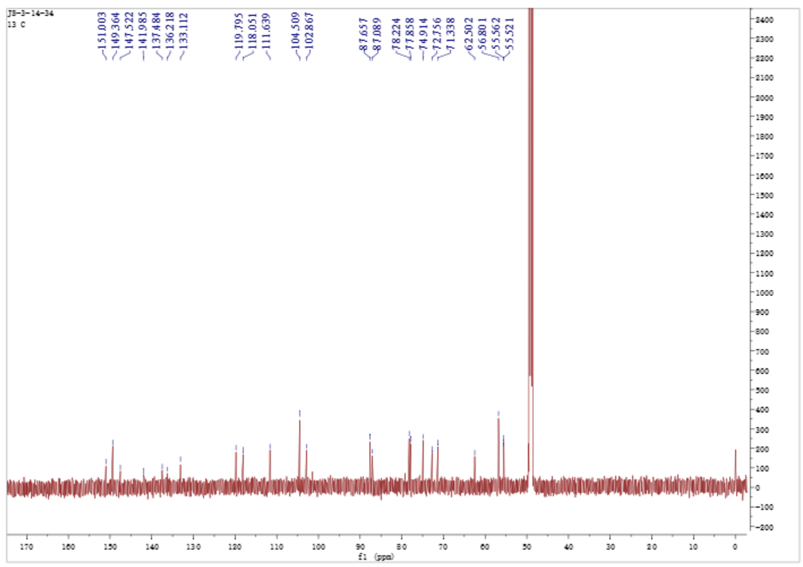

## Figure S120. The 13C NMR spectrum of **41** in CD3OD

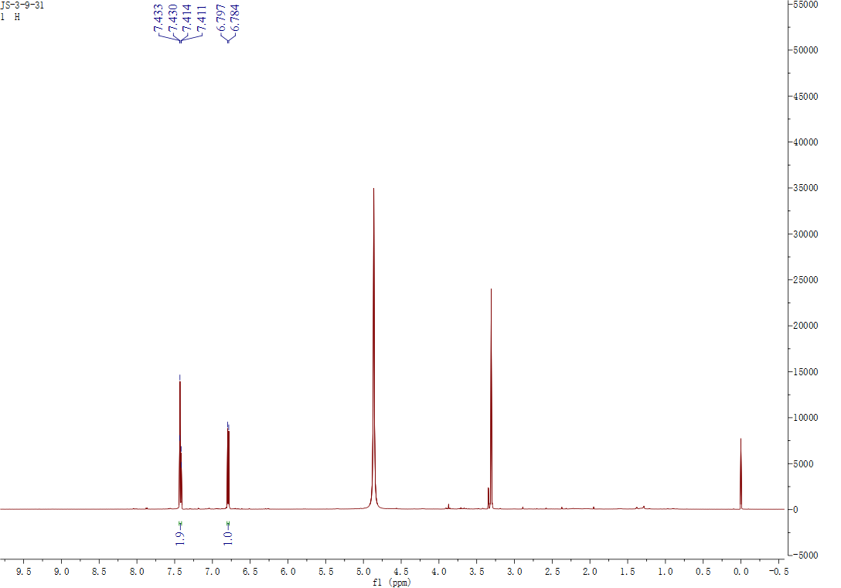

## Figure S121. The 1H NMR spectrum of **42** in CD3OD

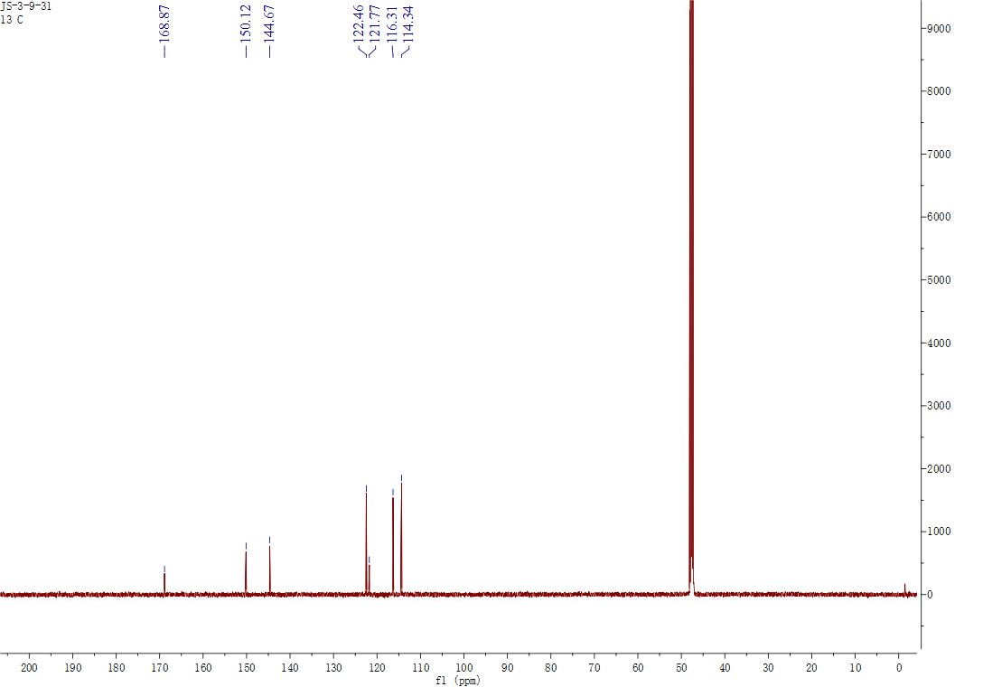

## Figure S122. The 13C NMR spectrum of **42** in CD3OD

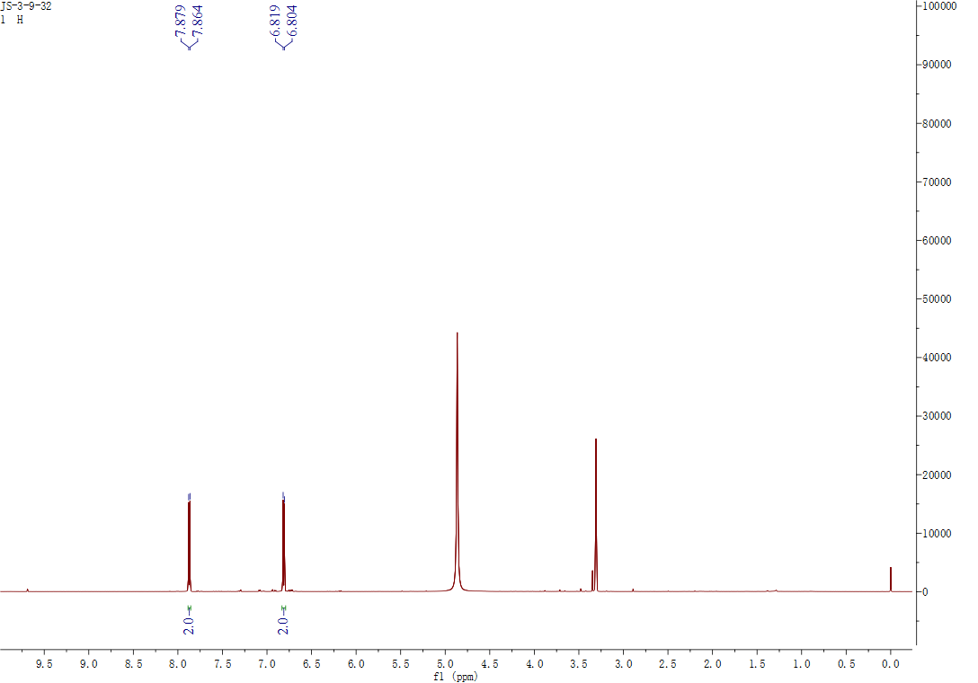

## Figure S123. The 1H NMR spectrum of **43** in CD3OD

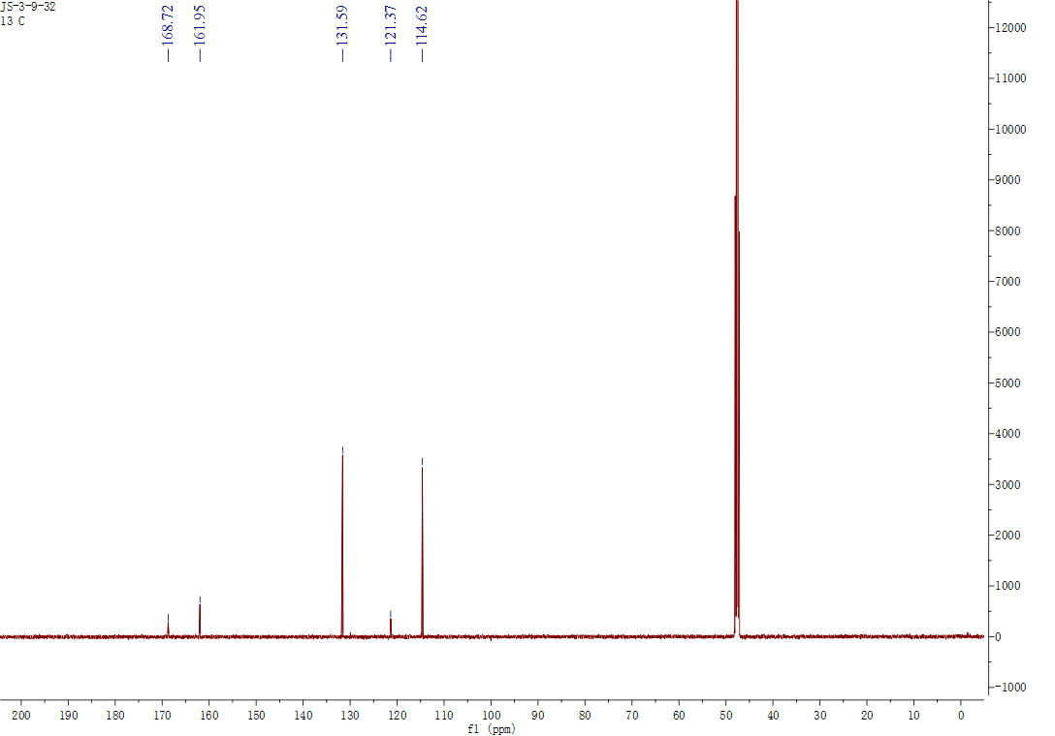

## Figure S124. The 13C NMR spectrum of **43** in CD3OD

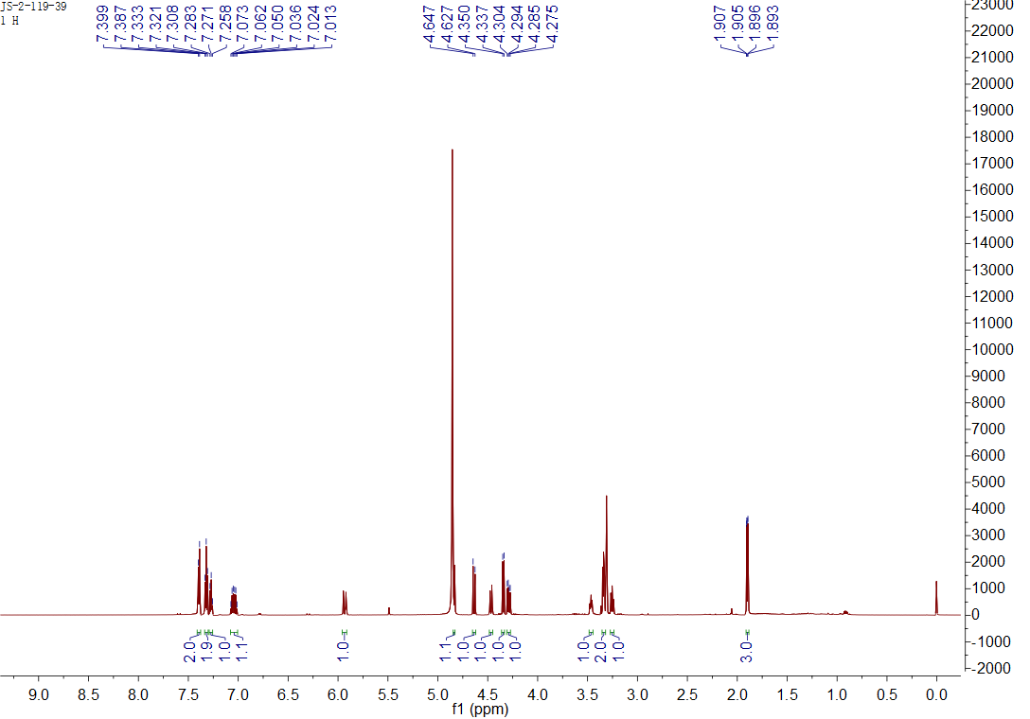

## Figure S125. The 1H NMR spectrum of **44** in CD3OD

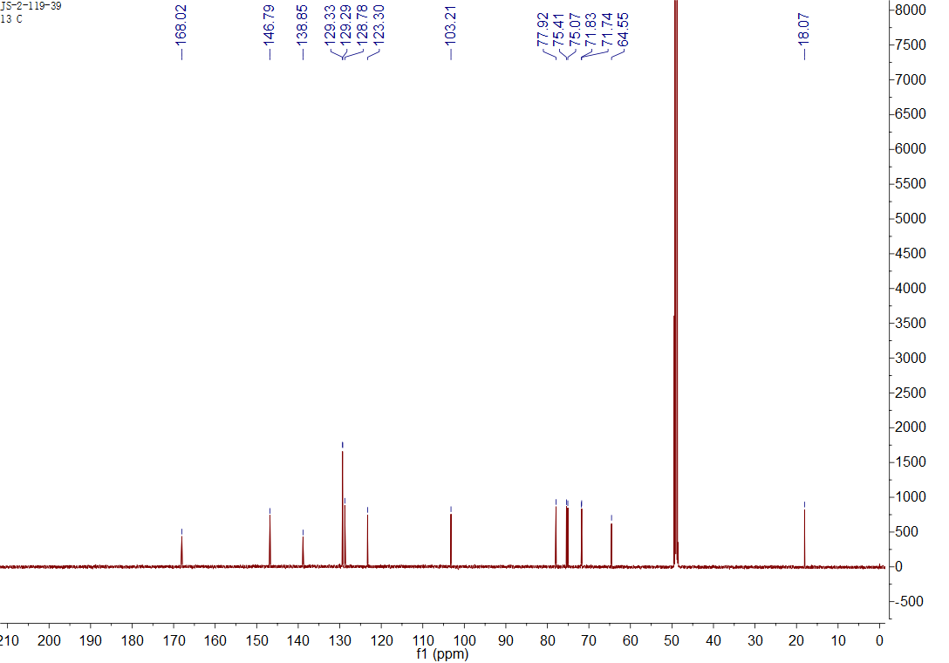

## Figure S126. The 13C NMR spectrum of **44** in CD3OD